Case report

ILEAL MASS PRESENTING AS INCARCERATED INGUINAL HERNIA: A RARE PRESENTATION

Abstract:
Background: This is a case report of ileal mass presenting as a content of incarcerated right inguinal hernia
Presentation of case: We present a case report of 75 years old male patient presented to the casualty with obstructed right inguinal hernia. Patient was stabilized and taken up for surgery. Perioperative findings revealed right indirect hernia with ileal loop with mass infiltrating right testis and bladder as the content. The loop of ileum containing the mass was resected and anastomosed, right orchidectomy done, bladder separated from the mass. Anatomical repair of the inguinal hernia was done and the sample was sent to histopathology. HPE revealed chronic inflammatory lesion of the ileum with no microscopic infiltration into the testis and surrounding soft tissue. Patient had uneventful recovery and was discharged .

(Key words: inguinal hernia, orchidectomy, incarceration, resection, anastomosis)

Introduction:
Hernia is an abnormal protrusion of an organ or tissue through an opening in the layer that normally confines it^{[1].} Inguinal hernia is the most common type of hernia in males and females. The content may be bowel or omentum. Most of the inguinal hernias are reducible, if not treated at early stage, the neck of the hernia can become constricted leading to irreducible hernia [7,8]. In an irreducible hernia if the content is bowel, it can become obstructed causing obstipation. If obstructed hernia loses its blood supply due to delayed treatment, it causes gangrene of the contents leading to strangulated hernia [9,10].
In case of irreducible and strangulated hernia emergency surgery is advised to prevent further complications which can be life threatening like gangrene of bowel and sepsis.

CASE PRESENTATION
Here is a 75 years male patient came to the casualty with complaints of swelling in the right inguinal region since past 4 years initially reducible, but now non reducible since 2 days. He also complained of vomiting since past 2 days and not passage of stools since 2 days. On examination patient was hemodynamically stable and diagnosed as right incarcerated inguinal hernia (figure 1). Erythematous skin color changes was noted in the skin over the right scrotum. Patient had no comorbidities. Clinical diagnosis of obstructed right inguinal hernia was made and patient was admitted and prepped for surgery. Ultrasonography was done which revealed obstructed right inguinal hernia with normal right testis. Patient was admitted under department of general surgery , routine blood investigations was done, catheterized, Ryle’s tube inserted and taken up for surgery.

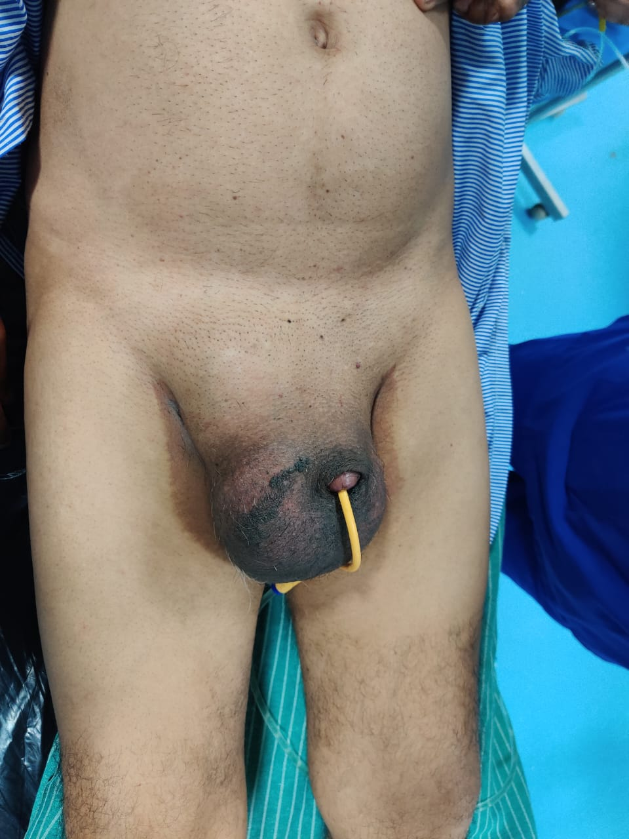
figure 1: Pre-operative picture which shows the right strangulated inguinal hernia with erythematous change in the right scrotum

Perioperative finding:
Patient was prepped and taken up for surgery under spinal anesthesia. Incision was made in right inguinal region and the sac was opened, 10cc serous collection was present which was drained . Small bowel was the content and was traced down to the testis which was found to be adherent to it (fig 2). The small bowel was also adherent to the lateral wall of the bladder proximally (fig 3). The small bowel was identified as ileum around 20 to 25cm proximal to the ileocolic junction. The mas was carefully separated from the testis. The ileal mass was found to be necrosed in the center with pus around 20cc which was aspirated On examination of testis, it was healthy and hydrocele was found with 50ml of fluid which was drained. Since the mass was necrotic with pus content, right orchidectomy was done. Anatomical repair of the inguinal hernia was done. There was no bowel perforation noted. The bladder as a content was confirmed by clamping the Foley’s catheter which caused distension, and later was separated carefully from the bowel. Since the ileal loops were healthy with good peristalsis, resection of the mass with 2cm of margin in either sides with end to end ileo-ileal anastomosis was done by lower midline incision in the abdomen. Abdominal drains placed in anastomotic site and pelvis and closure done. Patient was shifted to post-operative ward for further observation. The resected specimen was sent for histopathology (fig 4).
The resected specimen was examined and the lumen of the specimen was found to be patent. There was no signs of invasion in to the lumen (fig 5).
Patient recovered postoperatively, had no symptoms of obstruction or anastomotic leak and healthy on discharge. Patient was advised for regular followup.

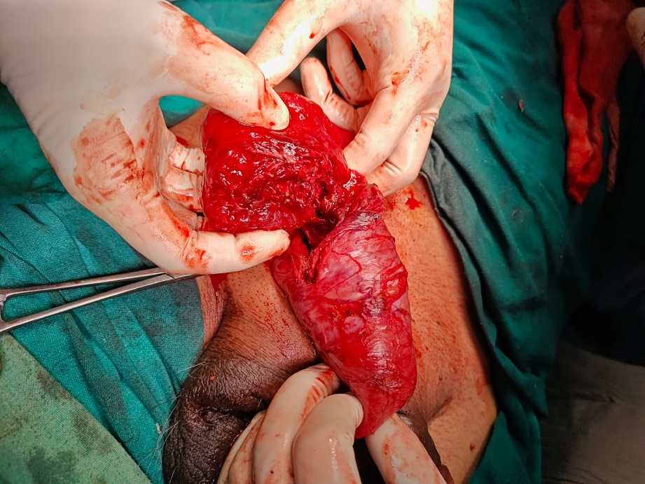
Figure 2: Image showing the ileal mass infiltrating the right testis with central necrosis of the ileal mass

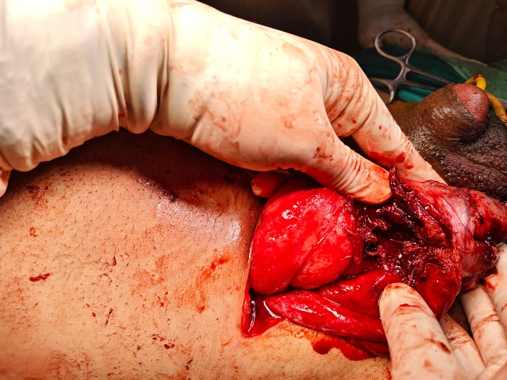
Figure 3: Image showing the filled bladder after clamping the foley’s catheter(structure just below the left thumb shown by arrow)

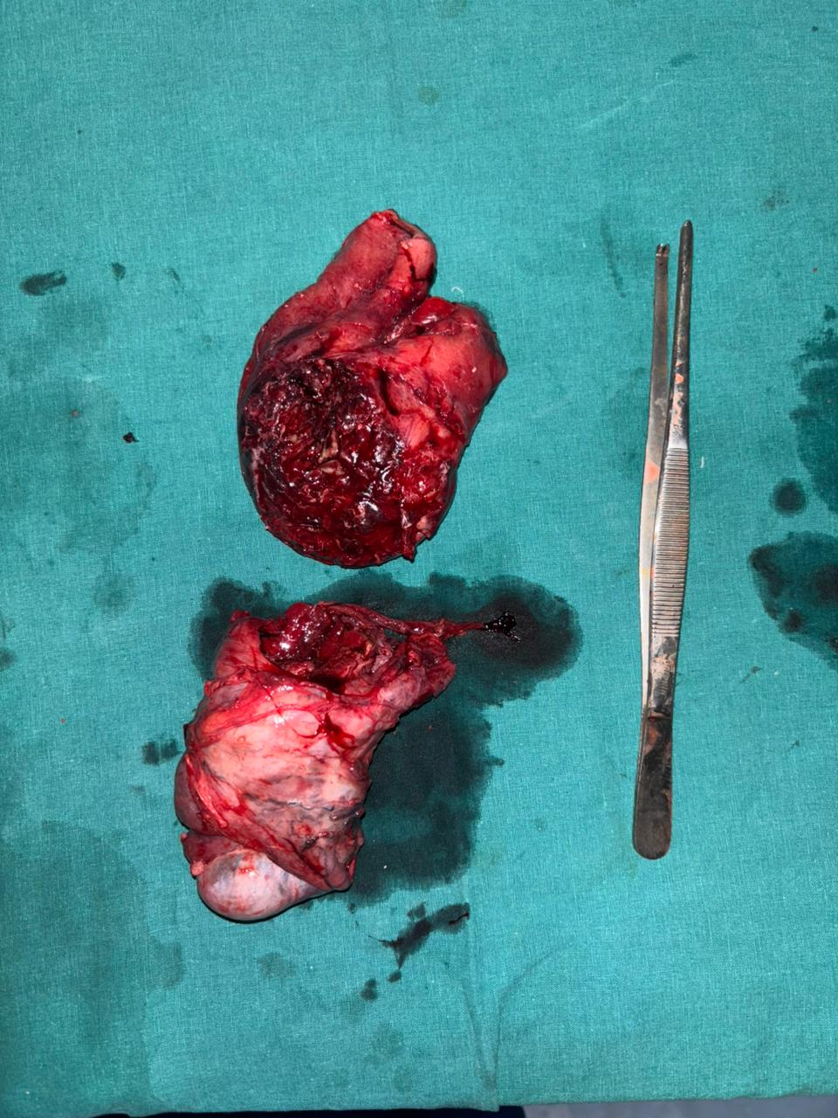
Figure 4: Resected specimen of ileum above and the right testis below
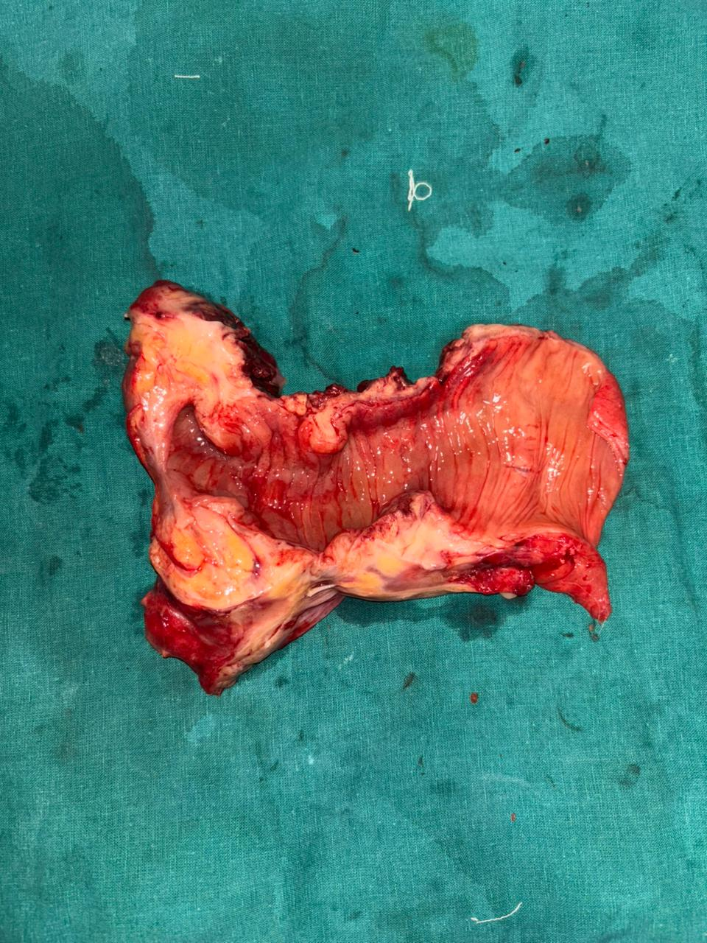
Figure 5: the resected specimen of the ileum showing patent lumen with mass in the wall of the bowel. There was no infiltration of the mass into the lumen

HISTOPATHOLOGY REPORT:
On examination of the resected specimen, it was noted that the lumen of the bowel was intact. There was no polypoidal or any lesions seen in the lumen at the site of the mass. Histopathology report was suggestive of ACUTE ON CHRONIC INFLAMMATION WITH DENSE FIBROBLASTIC PROLIFERATION AND COLLAGENISATION INVOLVING GUT WALL AND HERNIAL SAC. Testis and epididymis was reported to be normal. No special staining was done.

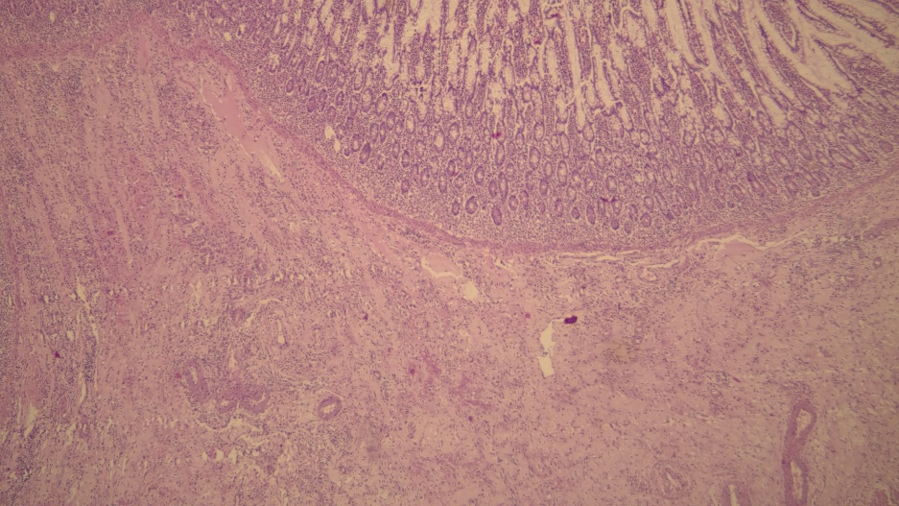
Figure 6: Ileal section showing proliferation of collagen and lymphoplasmacytic infiltrate of lamina propria
DISCUSSION:
Incarcerated hernia is a type of hernia where contents are irreducible and associated with intestinal obstruction. Here the blood supply is intact. It can progress to strangulation if left untreated. In strangulation there is arrest of blood supply which causes gangrene of the bowel. Here the case is of incarcerated type with ileum with mass as the content of the hernia. The mass was necrotic with pus in the centre which was adherent to the right testis. The decision of orchidectomy was taken on table after noticing the frank pus of the bowel mass. This was done to prevent the infection from spreading to the testis.
On examining the resected bowel specimen, the mass was firm in consistency and the lumen was intact and no ingrowth of the mass or pus or any gangrenous changes noted. The mass had compression effect on the bowel causing obstruction and subsequently obstipation. There was no infiltration into the testis, testis was normal on examination. Here the patient did not show any symptoms or signs of malignancy on presentation, instead it was suggestive of obstruction.
A similar case is being published by Ismini Kountouri et al, where the patient presented with complaints of left obstructed inguinal hernia. Perioperative findings was sigmoid mass as the content of indirect hernia infiltrating the testis. There was no luminal invasion. Resection of the sigmoid segment with left orchidectomy and colostomy was done. Bowel anastomosis was done a year later. The histopathology of the specimen was reported as REACTIVE NODULAR FIBROUS PSEUDOTUMOUR (RNFP) ^{[2]}
The above mentioned RNFP is a benign tumor commonly involving the gastrointestinal tract, and this tumor shares many features like the case presented in this article. Histology of RFNP involves proliferation of spindle cells with keloid like appearance in dense collagenous background, accompanied by lymphoplasmacytic infiltration. IHC is positive for vimentin and SMA, negative for CD34 and S100.^{[3]} To confirm the diagnosis of the lesion of this case, further evaluation with IHC markers is needed.
There are few rare cases online reporting malignant tumors of colon presenting as content of obstructed inguinal hernia. According to a case report by Siao Pei Tan et al,69 yr old male patient with synchronous ascending and transverse colon malignancy among which latter presented as left incarcerated inguinal hernia. Here groin incision was made to release the content and extended right hemicolectomy was done with resection of 10cm terminal ileum with primary ileal colonic anastomosis was done. Histopathology revealed adenocarcinoma of transverse colon with one focus of vascular invasion.^{[5]}
Another similar case was reported by Kevin Diao et al,48 years old male patient with transverse colon malignancy presented as left incarcerated inguinal hernia for which transverse colectomy with end to end colo colic anastomosis was done. Histopathology revealed adenocarcinoma of colon with transmural invasion with no metastasis .^{[5]}
Another case report by Jianfeng Zhang et al,70 years old male patient with sigmoid carcinoma presented as right incarcerated inguinal hernia which is rare given its left side anatomy. Radical sigmoid resection was done with end to end colo colic anastomosis was done. Histopathology revealed high grade intraepithelial neoplasia.^{[5]}
Another case report by Tien Yew Chern et al,83 years with ascending colon carcinoma presented as right incarcerated inguinal hernia for which right hemicolectomy was done. Histopathology revealed mucinous carcinoma of ascending colon.^{[6]}
In all the studies mentioned above, CECT(contrast enhanced computerized tomography) was done before taking the patient up for surgery. In our case CECT was not done as bowel mass was not suspected.

CONCLUSION:
Ileal mass presenting as inguinal hernia with bladder as content is a rare case which we do not come across often. CECT should be done if the patient is stable in cases of obstructed and strangulated inguinal hernia in old patients to rule out malignant causes. It can give additional information on the type of lesion and viability of bowel. If malignant, then the extent of disease also can be assessed in the scan and further treatment can be planned accordingly. In this case it is a benign disease which did not warrant further investigation or procedure. Hence it is always better to get additional investigations before proceeding to surgery in such cases.
CONSENT
As per international standards or university standards written ethical approval has been collected and preserved by the author(s).
ETHICAL APPROVAL
As per international standards or university standards written ethical approval has been collected and preserved by the author(s).
Disclaimer (Artificial intelligence)
Option 1:
Author(s) hereby declare that NO generative AI technologies such as Large Language Models (ChatGPT, COPILOT, etc.) and text-to-image generators have been used during the writing or editing of this manuscript.
Option 2:
Author(s) hereby declare that generative AI technologies such as Large Language Models, etc. have been used during the writing or editing of manuscripts. This explanation will include the name, version, model, and source of the generative AI technology and as well as all input prompts provided to the generative AI technology
Details of the AI usage are given below:
1.
2.
3.
REFERENCES
1.Williams NS, O'Connell PR, McCaskie AW, editors. Bailey & Love's Short Practice of Surgery. 28th ed. Boca Raton: CRC Press; 2022.
2.Kountouri I, Katsarelas I, Chatzinas D, Chandolias M, Dimasis P. An Incarcerated Inguinal Hernia Masking a Reactive Nodular Fibrous Pseudotumor: A Case Report. Cureus. 2024 Nov 4;16(11):e73027. doi: 10.7759/cureus.73027. PMID: 39640101; PMCID: PMC11618021.
3. Tan, S.P., Liau, SS., Habeeb, S.M. et al. Synchronous colonic carcinomas presenting as an inguinoscrotal hernial mass: a case report. J Med Case Reports 1, 36 (2007). https://doi.org/10.1186/1752-1947-1-36
4. Diao K, Ghosh A. Perforated Transverse Colon Cancer Presenting as an Incarcerated Inguinal Hernia. The American SurgeonTM. 2016;82(11):320-322. doi:10.1177/000313481608201112
5. Zhang J, Tang Y, Wu X, Wang G and Li T (2022) Sigmoid Colon Cancer Masquerading as a Right Incarcerated Inguinal Hernia: A Case Study and Literature Review. Front. Surg. 9:832771. doi: 10.3389/fsurg.2022.832771
6. Chern, T.Y., Tay, Y.K. & Perera, D.S. A rare case of ascending colon adenocarcinoma incarcerated in an inguinoscrotal hernia: case report and literature review. surg case rep 4, 48 (2018). https://doi.org/10.1186/s40792-018-0457-9
7. Alvarez, J. A., Baldonedo, R. F., Bear, I. G., Solis, J. A. S., Alvarez, P., & Jorge, J. I. (2004). Incarcerated groin hernias in adults: presentation and outcome. Hernia, 8, 121-126.
8. Kulah, B., Kulacoglu, I. H., Oruc, M. T., Duzgun, A. P., Moran, M., Ozmen, M. M., & Coskun, F. (2001). Presentation and outcome of incarcerated external hernias in adults. The American journal of surgery, 181(2), 101-104.
9. Baik, J., & Lee, Y. (2019). Reduction en-masse of inguinal hernia with incarcerated bowel: report of a rare case. The American Journal of Case Reports, 20, 1562.
10. Tinoco-González, J. (2015). Gastrointestinal stromal tumor (GIST) presenting as a groin mass mimicking and incarcerated hernia. International Journal of Surgery Case Reports, 6, 166-168.

