Case report

Cutaneous Leiomyosarcoma: Clinical Presentation, Histological Diagnosis, and Surgical Management

Abstract
Introduction: Cutaneous leiomyosarcoma is a rare malignant tumor derived from smooth muscle cells in the dermis or subcutaneous tissue. Due to its rarity and nonspecific clinical presentation, accurate diagnosis is often delayed and requires histopathological and immunohistochemical confirmation.
Methods: We report two cases of primary cutaneous leiomyosarcoma in middle-aged male patients. The first case involved a 59-year-old man with a slowly growing dorsal nodule over five years. The second case was a 57-year-old man with a painful nodular lesion on the right leg evolving over nine months. Both cases underwent clinical examination, imaging, histopathology, and immunohistochemistry for diagnosis. Surgical excision was performed in both patients.
Results: Histological analysis in both cases showed spindle-cell tumors with immunopositivity for smooth muscle actin and H-caldesmon.. Margins were initially involved in both cases, requiring re-excision. The second patient also underwent periosteal resection and reconstruction with a keystone flap, followed by adjuvant radiotherapy. No local recurrence or metastasis was observed at three-year follow-up for either patient.
Discussion: These cases highlight the diagnostic difficulty of CLM and the critical role of immunohistochemistry in its confirmation. Complete surgical excision with clear margins remains the gold standard. Adjuvant radiotherapy may be considered in cases with deep invasion or involved margins. Long-term follow-up is essential due to the risk of recurrence and metastasis, which can occur years after initial treatment.
Conclusion: Cutaneous and subcutaneous leiomyosarcomas pose challenges in terms of both diagnosis and therapeutic management. The risk of local recurrence and metastasis varies according to subtype, highlighting the importance of maintaining healthy excision margins, and the need for prolonged clinical and paraclinical follow-up

Keywords: Cutaneous leiomyosarcoma, Smooth muscle tumor, Soft tissue sarcoma, Cutaneous, Subcutaneous, Recurrence, Metastasis

Introduction
Leiomyosarcomas (LMS) of the skin are rare neoplasms of the smooth muscle cells of the skin and subcutaneous tissue [1]. They account for 5-10% of soft-tissue sarcomas and 0.04% of all cancers[1]. Divided into two subtypes: dermal or cutaneous, originating in the arrector pili muscle, dartos muscle or areolar complex in the dermis, and subcutaneous, originating in the vascular smooth muscle in the subcutaneous[1]. Cutaneous LMS has a more favorable prognosis than its subcutaneous counterpart, with a much lower rate of metastasis and mortality[5]. Diagnosis is often difficult, due to their non-specific clinical presentation and the rarity of the condition. Symptoms usually involve pain and changes in skin condition, manifested by the appearance of a skin-colored or erythematous mass, as well as ulcerations[5]. LMS are most commonly diagnosed in patients aged between 50 and 70, with a male predominance observed in the cutaneous subtype [2,3]. Standard treatment consists of complete surgical excision with clear margins, but may also require the use of radiotherapy or chemotherapy [5]. The risk of local recurrence and metastases justifies prolonged follow-up [4]. Against this background, we report two cases of cutaneous leiomyosarcoma diagnosed in our center, highlighting the diagnostic and therapeutic challenges associated with this pathology.

Case Presentation

Clinical Case 1

A 59-year-old male patient, a chronic smoker, presented with a nodular lesion that had been evolving for five years, located on the upper back. Clinical examination revealed an irregular, asymmetrical, erythematous and violaceous nodule measuring 5 × 2.5 cm (Fig. 1).

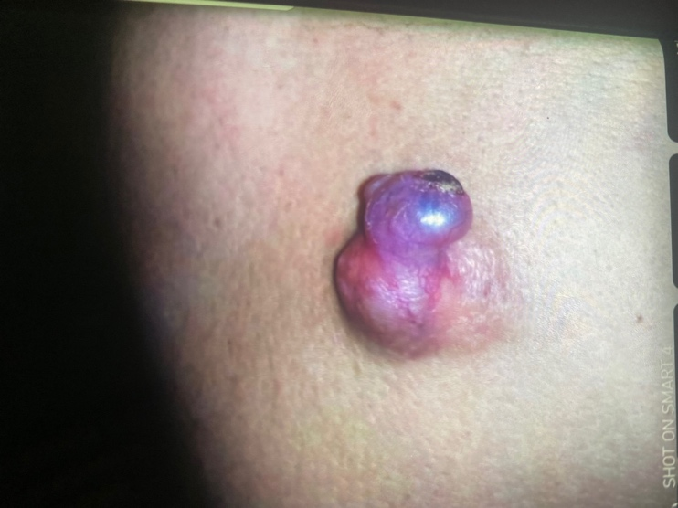
Figure 1: Leiomyosarcoma presenting as an irregular nodule with prominent vessels and slight hyperpigmentation on the back

Radiological assessment using computed tomography (CT) revealed a cutaneous tumor extending into the subcutaneous tissue, without evidence of muscle invasion.

Histological analysis demonstrated a spindle-cell tumor proliferation with a storiform architecture and moderate cytonuclear atypia. No atypical mitoses or necrotic foci were observed, and the mitotic index was less than 5 mitoses per 10 high-power fields (HPF) (Fig. 2).

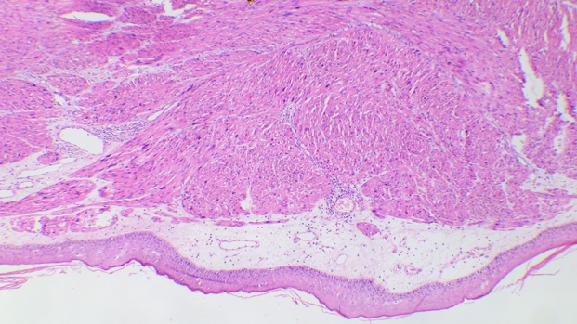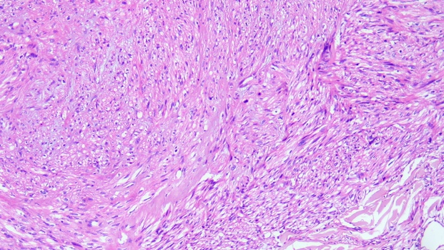
A
B
Figure 2: Histopathological image of cutaneous leiomyosarcoma A: Diffuse spindle cell neoplasm in the dermis Hematoxylin & Eosin (H&E) staining, x40 B: Higher magnification demonstrating markedly atypical spindle cells with mitotic figures. H&E staining, x200
Immunohistochemical studies showed positivity for smooth muscle actin and H-caldesmon, while CD34 was negative. PS100 was weakly positive, and EMA exhibited heterogeneous expression. The proliferative marker Ki67 was estimated at 20%.

Based on these findings, the diagnosis of cutaneous leiomyosarcoma was established.

A metastatic work-up, including thoraco-abdominopelvic CT and lymph node ultrasound, showed no evidence of secondary involvement.

Treatment consisted of an initial surgical excision with 1 cm margins, which were found to be involved. A re-excision was performed, achieving histologically clear (R0) margins. three-year follow-up revealed no recurrence.

Clinical Case 2

A 57-year-old male patient with no significant medical history presented with a nodular lesion on the right leg, evolving over the past nine months and becoming progressively tender. An initial excisional biopsy was performed (Fig. 3).
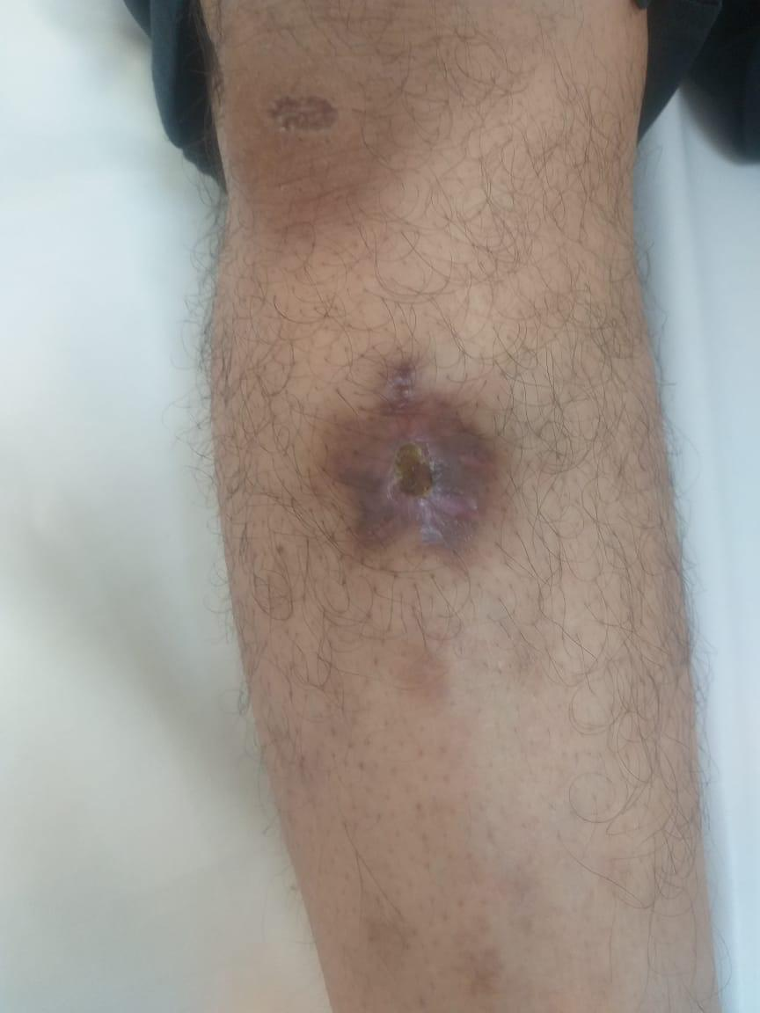

Figure 3: Well-demarcated hyperpigmented scar lesion measuring 2 cm located on the upper third of the anterior aspect of the leg.

Histological examination revealed a spindle cell tumor expressing H-caldesmon and smooth muscle actin (Fig. 4).

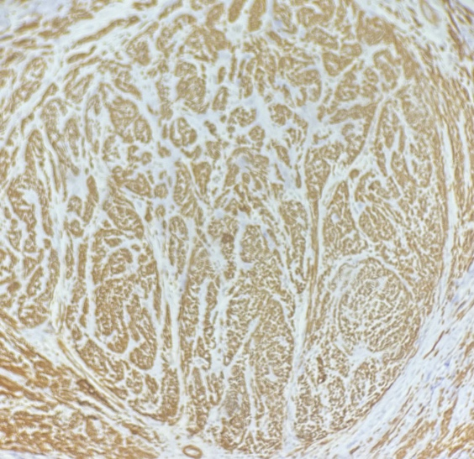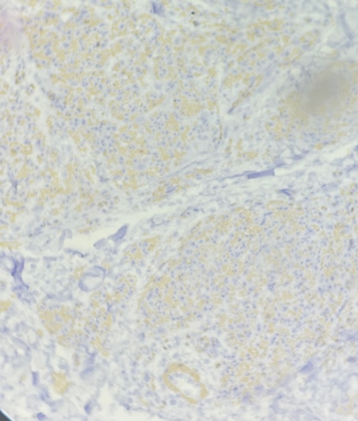
B
A

Figure 4: Immunohistochemical staining of tumor cells: A. Anti-H-caldesmon antibody. B. Anti-smooth muscle actin antibody.

Desmin and cytokeratin (CKAE1/AE3) expression was heterogeneous, while PS100 and CD34 were negative. Histoprognostic evaluation using the FNCLCC grading system classified the tumor as a grade 1 leiomyosarcoma.

Clinical examination showed a residual lesion in the form of a 2 cm hyperpigmented scar with a 1 cm crust on the upper third of the right leg.
MRI revealed a suspicious cutaneous and subcutaneous infiltration in contact with the bony cortex (Fig 5). The metastatic work-up, including lymph node ultrasound, thoraco-abdominopelvic CT, and bone scintigraphy, showed no evidence of dissemination.

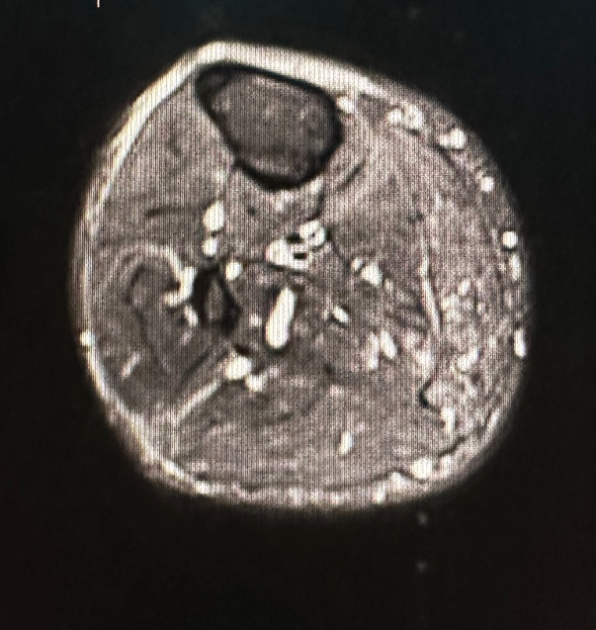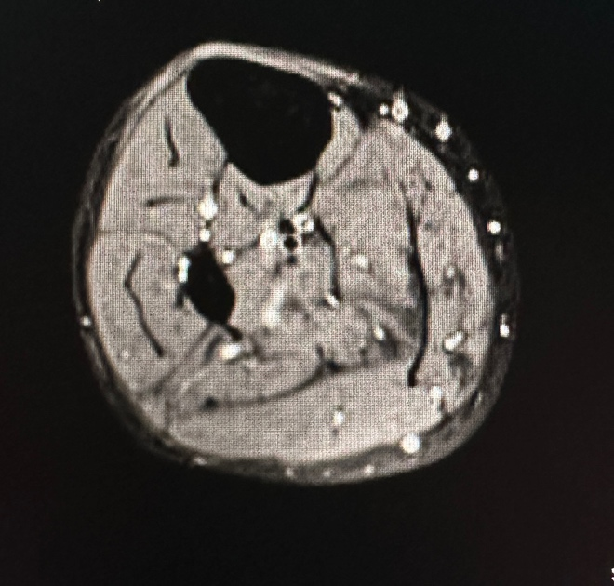
B
A

Figure 5: Right leg cutaneous leiomyosarcoma. A: Axial T2-weighted sequence post-gadolinium injection; B: Axial T1-weighted fat-saturated sequence post-gadolinium injection.”

The patient underwent surgical excision with 1 cm margins at the surface. Histopathological analysis revealed involved margins at the periosteum, leading to a re-excision including periosteal resection (Fig.6), followed by reconstruction with a keystone omega flap (Fig. 7).

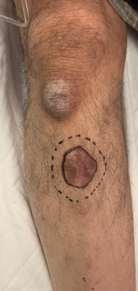
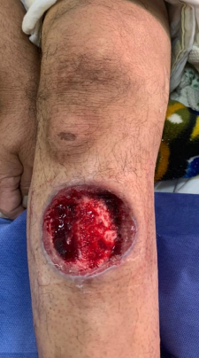
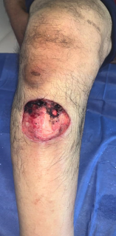
A
B
A
B
C

Figure 6: A - Pre-excision. B - Tumor excision with 1 cm margins, subperiosteal depth. C - PDS showing bone exposure.

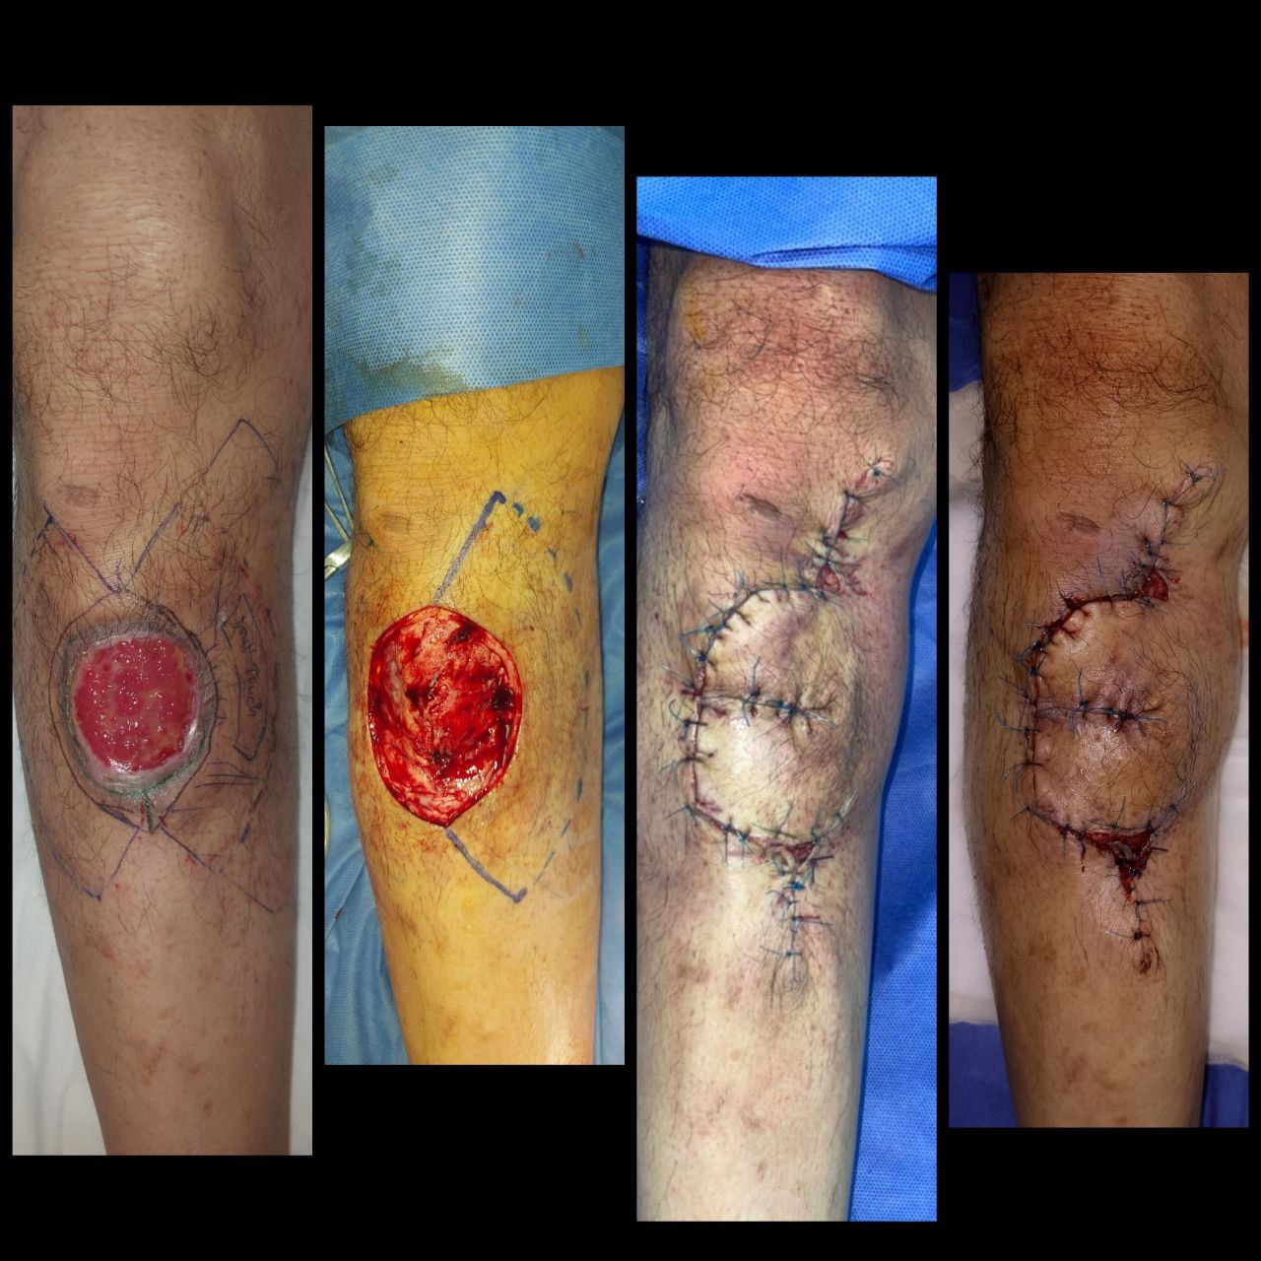
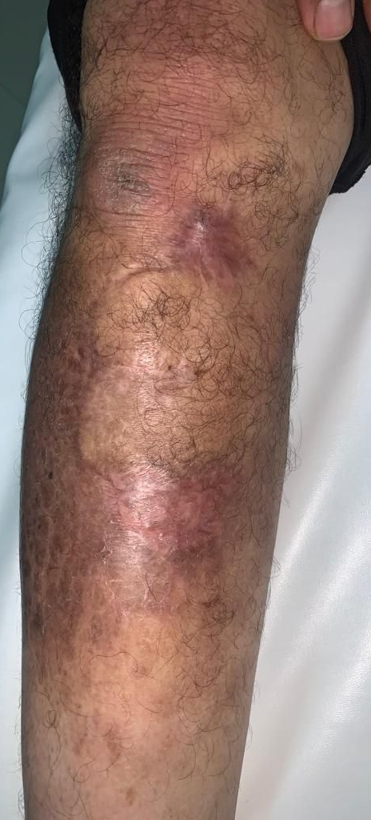

Figure 7: Coverage achieved using an omega-shaped keystone flap.

Adjuvant radiotherapy was administered. Three-year follow-up revealed no recurrence.

Discussion

Leiomyosarcomas of the skin are rare soft tissue tumors originating from smooth muscle cells of the skin or subcutaneous tissue [1]. Their clinical presentation is variable, ranging from asymptomatic nodules to more irregular and painful lesions. Diagnosis is often challenging due to the rarity of this entity and the lack of clinical specificity.
Histopathological examination and immunohistochemistry are essential for confirming the diagnosis. LMS are characterized by a proliferation of spindle cells expressing smooth muscle actin, desmin, and caldesmon [5]. Ki67, a marker of cellular proliferation, can also provide important information regarding tumor aggressiveness [6].
In our two cases, the lesions presented as nodules—one developing over several years on the back, and the other over several months on the leg. Histological and immunohistochemical studies confirmed the diagnosis of cutaneous LMS in both cases, with expression of classical smooth muscle markers and a Ki67 index of 20% in one case. These findings are consistent with the literature, emphasizing the importance of these techniques for accurate diagnosis.

LMS are traditionally classified into two subtypes: cutaneous and subcutaneous. The cutaneous subtype arises from the arrector pili muscles, whereas the subcutaneous subtype originates from the smooth muscle cells of blood vessels. The cutaneous subtype is considered less aggressive than the subcutaneous form [7]. However, the literature does not always agree on this classification, and some authors argue that it is more appropriate to describe LMS as having either a dermal or subcutaneous component rather than categorizing them into two distinct entities.

Cutaneous leiomyosarcomas show a predilection for middle-aged Caucasian males, particularly around the age of 50, with a male-to-female ratio of 3:1 [2,3], which aligns with our findings, where the average age was 58 years. In contrast, subcutaneous leiomyosarcomas occur more frequently between the ages of 50 and 80 [4] and, unlike cutaneous forms, affect both sexes equally [15].

LMS can arise in various parts of the body, with a predominance in the lower limbs according to several studies [4,8]. Localization in the head and neck region has also been reported [9]. In our clinical cases, one occurred on the back and the other on the leg. These locations are consistent with the literature, although the dorsal region is less commonly reported.
In both cases, the LMS was of cutaneous origin, in line with the study by Roy et al., who reported that 61.5% of their CLMs were cutaneous [5].

The standard treatment for LMS is complete surgical excision with clear margins. However, there is no consensus on the optimal width of these margins. Some studies suggest 1 cm margins [8,10], while others recommend 3 to 5 cm [11,12]. Achieving R0 margins is crucial to minimize the risk of local recurrence. Mohs micrographic surgery is a promising therapeutic option for cutaneous LMS and reinforces the importance of maintaining at least 1 cm margins for these lesions [13,14].

Surgical excision was the treatment of choice in our two cases. One case required re-excision due to initially involved margins. This illustrates the difficulty in achieving R0 margins from the outset and highlights the need for careful intraoperative assessment and adaptation of resection based on tumor characteristics.

The use of adjuvant radiotherapy or chemotherapy is not systematic but is discussed on a case-by-case basis, particularly for high-grade tumors, tumors with involved margins, or in the event of recurrence [10]. Roy et al. reported that 34.6% of patients in their study received radiotherapy [5]. Fujiwara et al. [16] demonstrated a reduction in local recurrence when adjuvant radiotherapy was used in high-grade superficial sarcomas with resection margins less than 5 mm.

In our case involving the leg, adjuvant radiotherapy was administered. This decision was justified by the re-excision involving the periosteum.

Leiomyosarcoma of the skin is a pathology with significant risks of recurrence and metastasis. The cutaneous subtype is relatively less aggressive but still carries a risk of local recurrence even after properly conducted surgical resection, with a recurrence risk of 24.4% and a distant metastasis rate ranging from 4.2% to 57.1%, according to the literature [5,17]. The subcutaneous subtype carries a higher risk of both local and metastatic recurrence (30% to 36.6% and 43.2%, respectively) [1,17].

The time to onset of recurrence and metastasis is variable, ranging from several months to years after initial treatment. The most frequent metastatic sites are the lungs, bones, liver, and skin [4,18].

Patient follow-up should be prolonged, typically for at least 5 to 10 years, with regular clinical evaluations and imaging studies as needed [5,19].

Both of our patients were followed for three years with no evidence of recurrence. While this timeframe is insufficient for a definitive prognosis, it is nonetheless encouraging. Roy et al. reported an average time to recurrence of 6.2 years, which justifies the need for long-term surveillance [5].

Conclusion

Cutaneous and subcutaneous leiomyosarcomas present challenges in both diagnosis and therapeutic management. Although these rare tumors generally have a favorable prognosis in strictly cutaneous forms, they require rigorous care. Complete surgical excision with clear margins is essential, and adjuvant treatments such as radiotherapy may be indicated in selected cases. Long-term follow-up is crucial to detect potential recurrences or metastases. Our case reports, when compared with the literature, contribute to a better understanding of this pathology and underscore the importance of a multidisciplinary and specialized approach to optimize patient care.
Conflict of Interest Statement

The authors declare no conflicts of interest related to this work.

Ethical Approval:

As per international standards or university standards written ethical approval has been collected and preserved by the author(s).

Consent
As per international standards or university standards, patient(s) written consent has been collected and preserved by the author(s).

Disclaimer (Artificial intelligence)

Option 1:

Author(s) hereby declare that NO generative AI technologies such as Large Language Models (ChatGPT, COPILOT, etc.) and text-to-image generators have been used during the writing or editing of this manuscript.

AI Usage Disclaimer:

The author(s) hereby declare that generative AI technologies such as Large Language Models have been used during the preparation of this manuscript solely for translation purposes. The original content of the manuscript was written in French, as the author(s) work in a French-speaking country where medical education and documentation are primarily in French. AI tools were used exclusively to translate the manuscript and supporting materials from French to English. No AI technologies were used for generating, editing, or rewriting the scientific content itself.

Details of the AI usage:
• Tools used: ChatGPT (OpenAI, GPT-4) and DeepL Translator
• Usage: Translation only (French to English)

Option 2:

Author(s) hereby declare that generative AI technologies such as Large Language Models, etc. have been used during the writing or editing of manuscripts. This explanation will include the name, version, model, and source of the generative AI technology and as well as all input prompts provided to the generative AI technology

Details of the AI usage are given below:
1.
2.
3.

References

[1] Kohlmeyer J, Steimle-Grauer SA, Hein R. Cutaneous sarcomas. J Dtsch Dermatol Ges. 2017;15(6):630–648.

[2] Llombart B, Serra-Guillén C, Requena C, et al. Leiomyosarcoma and pleomorphic dermal sarcoma: guidelines for diagnosis and treatment. Actas Dermosifiliogr (Engl Ed). 2019;110(1):4–11.

[3] Massi D, Franchi A, Alos L, et al. Primary cutaneous leiomyosarcoma: clinicopathological analysis of 36 cases. Histopathology. 2010;56(2):251–262.

[4] Winchester DS, Hocker TL, Brewer JD, et al. Leiomyosarcoma of the skin: clinical, histopathologic, and prognostic factors that influence outcomes. J Am Acad Dermatol. 2014;71:919–925.

[5] Roy C, Le Nail LR, De Pinieux G, Samargandi R. Primary cutaneous and subcutaneous leiomyosarcoma: a retrospective cohort of 26 cases focusing on clinical data and treatment. Ann Chir Plast Esthet. 2025;70(1):41–48.

[6] Idriss MH, Kazlouskaya V, Malhotra S, et al. Phosphohistone-H3 and Ki-67 immunostaining in cutaneous pilar leiomyoma and leiomyosarcoma (atypical intradermal smooth muscle neoplasm). J Cutan Pathol. 2013;40:557–563.

[7] Chalfant V, Schriber T, Sabri A, et al. Primary cutaneous leiomyosarcoma of the lower extremity: a case report and literature review. Cureus. 2021;13(4):e14282.

[8] Deneve JL, Messina JL, Bui MM, et al. Cutaneous leiomyosarcoma: a single institution experience of treatment and outcomes with a standardized margin of resection. Cancer Control. 2013;20(4):307–312.

[9] Soares Queirós C, Filipe P, Soares de Almeida L. Cutaneous leiomyosarcoma: a 20-year retrospective study and review of the literature. An Bras Dermatol. 2021;96(3):278–283.

[10] Glazer ES, Prieto-Granada C, Zager JS. Current approaches to cutaneous sarcomas: dermatofibrosarcoma protuberans and cutaneous leiomyosarcoma. Curr Probl Cancer. 2015;39(4):248–257.

[11] Fields JP, Helwig EB. Leiomyosarcoma of the skin and subcutaneous tissue. Cancer. 1981;47(1):156–169.

[12] Tsutsumida A, Yoshida T, Yamamoto Y, et al. Management of superficial leiomyosarcoma: a retrospective study of 10 cases. Plast Reconstr Surg. 2005;116(1):8–12.

[13] Starling J III, Coldiron BM. Mohs micrographic surgery for the treatment of cutaneous leiomyosarcoma. J Am Acad Dermatol. 2011;64:1119–1122.

[14] Kazlouskaya V, Lai YC, Khachemoune A. Leiomyosarcoma of the skin: review of the literature with an emphasis on prognosis and management. Int J Dermatol. 2020;59(2):165–172.

[15] Jensen ML, Jensen OM, Michalski W, et al. Intradermal and subcutaneous leiomyosarcoma: a clinicopathological and immunohistochemical study of 41 cases. J Cutan Pathol. 1996;23(5):458–463.

[16] Fujiwara T, Tsuda Y, Nail LRL, et al. The role of radiotherapy in the treatment of superficial soft-tissue sarcomas. Bone Joint J. 2020;102-B(8):1088–1094.

[17] Aneiros-Fernandez J, Retamero JA, Husein-Elahmed H, et al. Primary cutaneous and subcutaneous leiomyosarcomas: evolution and prognostic factors. Eur J Dermatol. 2016;26(1):9–12.

[18] Winchester DS, Hocker TL, Roenigk RK. Skin metastases of leiomyosarcoma (LMS): a retrospective review of 21 cases. J Am Acad Dermatol. 2015;72(5):910–912.

[19] Hmida L, Letaief F, Doghri R, et al. Cutaneous leiomyosarcoma on the trunk: an unusual presentation with an aggressive course—case report and literature review. Pan Afr Med J. 2018;31:190.

