***Case report***

**Golimumab-Triggered Palmoplantar Pustular Psoriasis in Ankylosing Spondylitis: Case Study and Evidence Review**

**Abstract**

Background: Golimumab, a human monoclonal antibody targeting tumor necrosis factor-alpha (TNF-α), is widely used to treat ankylosing spondylitis (AS). However, it can paradoxically trigger dermatological conditions, including psoriasis. This report details a rare instance of palmoplantar pustular psoriasis (PPP) induced by golimumab in an AS patient.

Case Presentation: A 39-year-old male smoker with HLA-B27-positive axial AS (BASDAI 4.6, BASFI 5.6) began golimumab (50 mg monthly) in October 2022 after inadequate NSAID response. Ten months later, he developed PPP with pustules on the palms and soles, plus psoriatic plaques on the thighs and legs. Golimumab was stopped, and treatment shifted to secukinumab (an anti-IL-17 agent) with topical corticosteroids, resulting in significant lesion improvement within weeks and ongoing AS control.

Conclusion: This case illustrates a rare paradoxical effect of golimumab, likely driven by altered immune regulation involving interferon-alpha (IFN-α) and IL-17 pathways. Discontinuing golimumab and initiating anti-IL-17 therapy was effective. Clinicians should monitor for skin-related side effects in AS patients on anti-TNF drugs, especially those with smoking history, and consider tailored therapeutic approaches. Further studies are needed to explore this phenomenon.

Keywords: Golimumab, ankylosing spondylitis, palmoplantar pustular psoriasis, anti-TNF therapy, paradoxical reaction, IL-17 inhibitor.

**Introduction**

Ankylosing spondylitis (AS) is a chronic inflammatory disorder primarily affecting the spine and sacroiliac joints, leading to pain and reduced mobility. The advent of biologic therapies, notably anti-TNF-α agents, has transformed AS management for patients unresponsive to traditional treatments like NSAIDs. Golimumab, a fully human anti-TNF-α antibody, has proven effective in controlling AS symptoms, as demonstrated in clinical studies. Yet, these therapies carry risks, including paradoxical adverse effects where conditions typically alleviated by TNF-α inhibition, such as psoriasis, emerge instead.  
Psoriasis, an immune-mediated skin disorder, occurs in 1–5% of patients on anti-TNF drugs, with palmoplantar pustular psoriasis (PPP) marked by sterile pustules on the palms and soles—being a less common but debilitating variant. The underlying mechanism may involve disrupted cytokine balance, potentially linked to plasmacytoid dendritic cell (pDC) activity and excessive IFN-α production. Risk factors like smoking may heighten susceptibility. Managing such complications often requires switching to alternative biologics, such as anti-IL-17 agents, which target different inflammatory pathways.  
We report a case of golimumab-induced PPP in a 39-year-old male with AS, emphasizing the need for vigilance and personalized treatment. This report, supported by a review of recent literature, explores the clinical presentation, potential mechanisms, and management strategies for this rare adverse effect.

**Case Presentation**

A 39-year-old male with a 15-year history of smoking was diagnosed with axial AS in 2018, confirmed by bilateral grade 4 sacroiliitis and HLA-B27 positivity. His disease was active, with a Bath Ankylosing Spondylitis Disease Activity Index (BASDAI) of 4.6 and Bath Ankylosing Spondylitis Functional Index (BASFI) of 5.6, indicating substantial functional limitation. He had no prior personal or family history of psoriasis or extra-articular manifestations. After failing multiple NSAIDs, golimumab (50 mg subcutaneous injection monthly) was initiated in October 2022, initially lowering his BASDAI to 3.2 after six months.  
In August 2023, ten months into golimumab therapy, the patient presented with new skin lesions. Physical examination revealed sterile pustules on the palms and soles, consistent with PPP, alongside erythematous, scaly plaques on the anterior thighs and legs. A dermatological consultation confirmed anti-TNF-induced psoriasis based on clinical features and the temporal association with golimumab initiation (Figure 1).

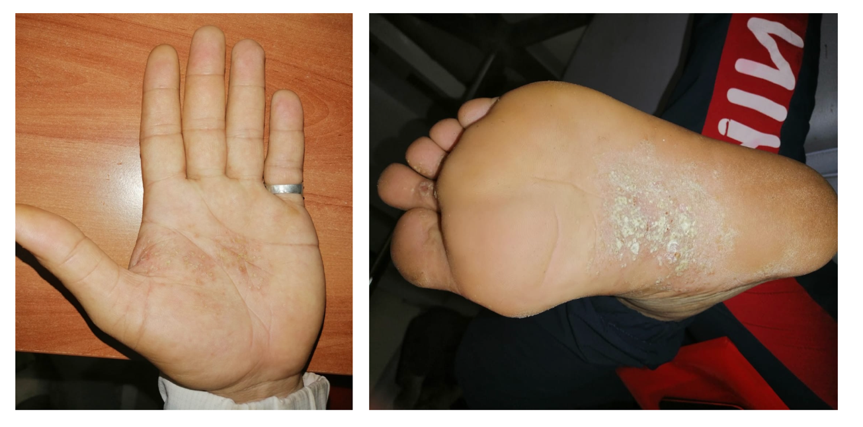

Figure 1: Golimumab-induced palmoplantar pustular psoriasis lesions in our patient

Golimumab was discontinued, and the patient started secukinumab (150 mg weekly for five weeks, then monthly) alongside topical clobetasol propionate (0.05%). Within four weeks, the palmoplantar pustules had nearly resolved, and the thigh/leg plaques showed gradual improvement. At the three-month follow-up, AS remained controlled (BASDAI 2.8), with no psoriasis recurrence. (Figure 2)

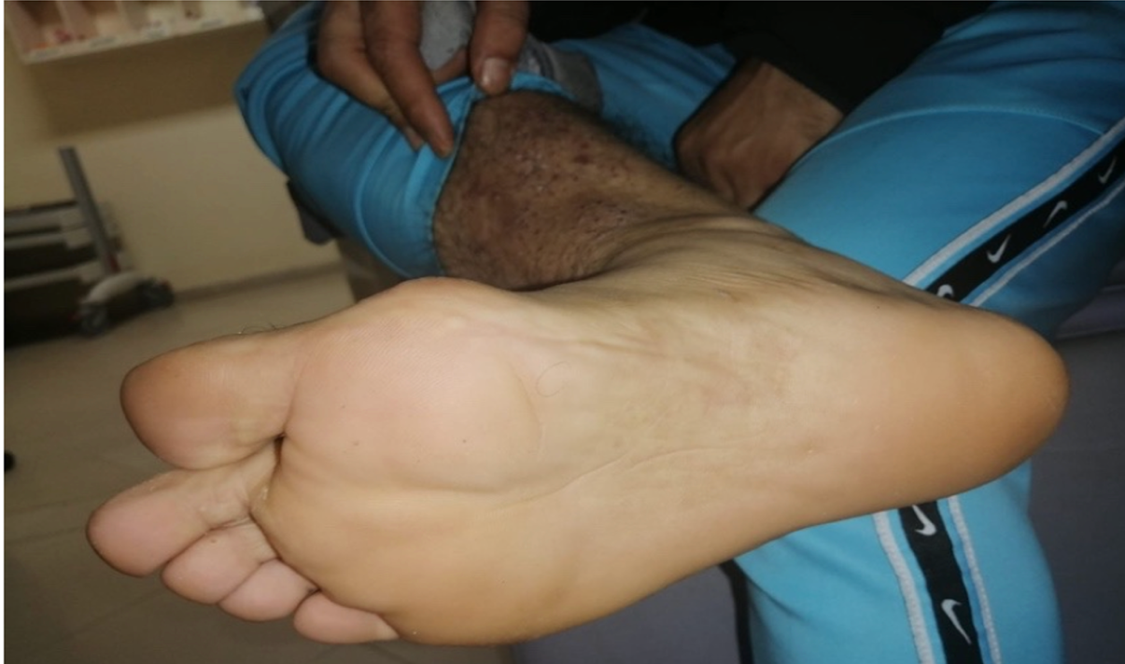

Figure 2: Blanching of pustular psoriasis lesions after discontinuation of golimumab

**Discussion**

The use of anti-TNF-α agents like golimumab has significantly improved outcomes for AS patients, yet paradoxical reactions, including psoriasis induction, remain a challenge. This case of golimumab-triggered PPP underscores a rare but clinically significant complication.

Epidemiology and Clinical Features

Paradoxical psoriasis linked to anti-TNF therapy affects approximately 1–5% of treated patients, with higher incidence in inflammatory bowel disease than rheumatologic conditions. PPP, characterized by sterile pustules, erythema, and scaling on the palms and soles, is less frequent but can severely impair quality of life. In this patient, PPP and psoriatic plaques emerged ten months after golimumab initiation, consistent with the typical latency of 3–24 months reported for anti-TNF-induced psoriasis. The absence of a prior psoriatic history and resolution after drug withdrawal support a drug-induced etiology.

Pathogenesis

The paradoxical induction of psoriasis by anti-TNF agents is not fully elucidated. TNF-α normally suppresses pDC activity, which produces IFN-α, a cytokine implicated in psoriatic inflammation. Anti-TNF drugs may disrupt this suppression, leading to elevated IFN-α and subsequent T-cell activation. Additionally, TNF-α inhibition may enhance the IL-17/IL-23 axis, a key driver of psoriasis. Studies suggest increased Th17 cell activity in patients on anti-TNF therapy, contributing to lesion formation. The patient’s smoking history likely amplified this risk, as nicotine is known to upregulate pro-inflammatory cytokines, including IL-17. Genetic predispositions, such as variations in IL-23 receptor genes, may also play a role, though specific data on anti-TNF-induced cases are limited.

Management Strategies

Treatment of anti-TNF-induced psoriasis varies by severity. Mild cases may respond to topical steroids or calcineurin inhibitors without stopping the biologic. However, severe PPP, as seen here, typically necessitates drug discontinuation. Switching to another anti-TNF agent is discouraged due to a high risk of recurrence. Anti-IL-17 therapies, such as secukinumab, offer a promising alternative, effectively targeting both psoriasis and AS. In this case, secukinumab led to rapid lesion improvement, supporting its efficacy. Emerging options include anti-IL-23 agents (e.g., risankizumab) and JAK inhibitors (e.g., upadacitinib), which show potential in managing paradoxical psoriasis. Phototherapy or systemic agents like acitretin may be considered for refractory cases. Collaboration between rheumatologists and dermatologists is essential for optimal care.

Comparison with Other Anti-TNF Agents

All anti-TNF drugs, including infliximab, etanercept, adalimumab, and golimumab, can induce psoriasis, with adalimumab and infliximab more commonly reported due to longer clinical use. Golimumab-related cases are less documented, possibly reflecting its later market entry. A recent analysis found no significant difference in psoriasis risk across anti-TNF classes, suggesting a shared mechanism. The rarity of golimumab-induced PPP highlights the need for ongoing surveillance, even with newer agents.

Future Directions

The scarcity of anti-TNF-induced PPP cases limits large-scale research. Identifying predictive biomarkers, such as serum IL-17 or IFN-α levels, could guide preemptive strategies. Genetic studies exploring HLA-Cw6 or IL-23R polymorphisms may clarify susceptibility. Novel approaches, like dual TNF-α/IL-17 inhibitors, could mitigate paradoxical effects while preserving AS control. Long-term data on anti-IL-17 and anti-IL-23 therapies are needed to refine treatment protocols.

**Conclusion**

This case of golimumab-triggered palmoplantar pustular psoriasis in a patient with ankylosing spondylitis illustrates a rare paradoxical adverse effect of anti-TNF therapy. The likely mechanism involves pDC activation, IFN-α dysregulation, and IL-17 pathway enhancement, with smoking as a contributing factor. Discontinuing golimumab and initiating secukinumab resulted in rapid PPP resolution and sustained AS management, validating this therapeutic shift. Clinicians should remain alert to cutaneous side effects, particularly in at-risk patients, and adopt individualized strategies. Future research should focus on biomarkers, genetic markers, and innovative therapies to prevent and manage such reactions. This report adds to the growing body of evidence on anti-TNF-induced psoriasis and underscores the value of multidisciplinary care.

**Limitations**

This report is constrained by its single-patient design and absence of histopathological confirmation, though the clinical diagnosis was robust. The three-month follow-up period is insufficient to assess long-term outcomes or recurrence risk. These gaps suggest caution in generalizing the findings

Disclaimer (Artificial intelligence)

Option 1:

Author(s) hereby declare that NO generative AI technologies such as Large Language Models (ChatGPT, COPILOT, etc.) and text-to-image generators have been used during the writing or editing of this manuscript.

Option 2:

Author(s) hereby declare that generative AI technologies such as Large Language Models, etc. have been used during the writing or editing of manuscripts. This explanation will include the name, version, model, and source of the generative AI technology and as well as all input prompts provided to the generative AI technology

Details of the AI usage are given below:

1. Author(s) hereby declare that NO generative AI technologies such as Large Language Models (ChatGPT, COPILOT, etc.) and text-to-image generators have been used during the writing or editing of this manuscript.

2.

3.

**References**

1 - [Shikha Singla](https://pubmed.ncbi.nlm.nih.gov/?term=%22Singla%20S%22%5BAuthor%5D) et  al, Paradoxical psoriasis with IL-17 inhibitors. Rheumatol Adv Pract. 2024 Jul 9;8(3):rkae082. doi: [10.1093/rap/rkae082](https://doi.org/10.1093/rap/rkae082)

2- [Zuzana Jiraskova Zakostelska](https://pubmed.ncbi.nlm.nih.gov/?term=%22Jiraskova%20Zakostelska%20Z%22%5BAuthor%5D) et al , Paradoxical Reactions to Anti-TNFα and Anti-IL-17 Treatment in Psoriasis Patients: Are Skin and/or Gut Microbiota Involved? Dermatol Ther (Heidelb). 2023 Mar 15;13(4):911–933. doi: [10.1007/s13555-023-00904-4](https://doi.org/10.1007/s13555-023-00904-4)

3- [Anna Gawdzik](https://www.semanticscholar.org/author/Anna-Gawdzik/1416338708) et al, Paradoxical Skin Reaction to Certolizumab, an Overlap of Pyoderma Gangrenosum and Psoriasis in a Young Woman Treated for Ankylosing Spondylitis: Case Report with Literature Review. Dermatol Ther (Heidelb) (2020) 10:869–879 <https://doi.org/10.1007/s13555-020-00398-4>

4- Xin-Yi Shao et al , A Patient with Adalimumab-Induced Refractory Paradoxical Palmoplantar Pustulosis Was Successfully Treated by Ixekizumab: A Case Report. Clinical, Cosmetic and Investigational Dermatology 2023:16 879–881.<https://doi.org/10.2147/CCID.S406164>

5- [Marien Siqueira Soto Lopes](https://pubmed.ncbi.nlm.nih.gov/?term=%22Soto%20Lopes%20MS%22%5BAuthor%5D" \t "_blank) et al , Paradoxical Reaction to Golimumab: Tumor Necrosis Factor α Inhibitor Inducing Psoriasis Pustulosa. Case Rep Dermatol. 2013 Nov 7;5(3):326–331. doi: [10.1159/000350930](https://doi.org/10.1159/000350930)

6- Yufeng Yin et al ,Efficacy and safety of IL-17 inhibitors for the treatment of ankylosing spondylitis: a systematic review and meta-analysis. Arthritis Research & Therapy (2020) 22:111 <https://doi.org/10.1186/s13075-020-02208-w>

7- [Khalid A. Alnaqbi](https://www.cureus.com/users/552529-khalid-a-alnaqbi) et al , Paradoxical Inflammatory Bowel Disease Induced by Golimumab in a Patient With Ankylosing Spondylitis: A Case Report and Systematic Review. Cureus. 2025 Jan 13;17(1):e77363. doi: [10.7759/cureus.77363](https://doi.org/10.7759/cureus.77363)

8- [Giovanni Damiani](https://onlinelibrary.wiley.com/authored-by/Damiani/Giovanni) et al, When IL-17 inhibitors fail: Real-life evidence to switch from secukinumab to adalimumab or ustekinumab.

[Dermatologic Therapy](https://onlinelibrary.wiley.com/journal/15298019)[Volume 32, Issue 2](https://onlinelibrary.wiley.com/toc/15298019/2019/32/2) e12793. <https://doi.org/10.1111/dth.12793>

9- Nikolai Loft MD et al, Efficacy of a second interleukin 17 inhibitor in patients with psoriasis: A systematic review and meta-analysis. [Journal of the American Academy of Dermatology](https://www.sciencedirect.com/journal/journal-of-the-american-academy-of-dermatology) [Volume 84, Issue 1](https://www.sciencedirect.com/journal/journal-of-the-american-academy-of-dermatology/vol/84/issue/1), January 2021, Pages 130-138. <https://doi.org/10.1016/j.jaad.2020.07.085>

10 - Rotraut Mössner et al, Manifestation of palmoplantar pustulosis during or after infliximab therapy for plaque-type psoriasis: report on five cases. Arch Dermatol Res (2008) 300:101–105 .DOI 10.1007/s00403-008-0831-8

11- [Daniela Anghel](https://onlinelibrary.wiley.com/authored-by/Anghel/Daniela) et al , Paradoxical pustular psoriasis in a patient with spondyloarthritis treated with secukinumab. [JEADV Clinical Practice](https://onlinelibrary.wiley.com/journal/27686566)[Volume 2, Issue 4](https://onlinelibrary.wiley.com/toc/27686566/2023/2/4) p. 951-954. <https://doi.org/10.1002/jvc2.253>

12- [Jingyu Ren](https://loop.frontiersin.org/people/2549413) et al , Paradoxical reaction to IL-17A inhibitor: a case report and literature review. Sec. Dermatology Volume 11 - 2024 | <https://doi.org/10.3389/fmed.2024.1364127>

13 - [Jae-Jeong Park](https://pubmed.ncbi.nlm.nih.gov/?term=%22Park%20JJ%22%5BAuthor%5D) et al , A Case of Tumor Necrosis Factor-α Inhibitors-induced Pustular Psoriasis. Ann Dermatol. 2010 May 18;22(2):212–215. doi: [10.5021/ad.2010.22.2.212](https://doi.org/10.5021/ad.2010.22.2.212)

14 - Marine Fauny et al , Paradoxical gastrointestinal effects of interleukin-17 blockers. Ann Rheum Dis 2020;79:1132–1138. doi:10.1136/annrheumdis-2020-217927

15- Qing-Yang Li et al ,Successful treatment of adalimumab-resistant palmoplantar pustulosis with secukinumab: a case report. Chinese Medical Journal 2020;133(24).  doi: 10.1097/CM9.0000000000001246

16- [Laura Țiburcă](https://pubmed.ncbi.nlm.nih.gov/?term=%22%C8%9Aiburc%C4%83%20L%22%5BAuthor%5D) et al , The Treatment with Interleukin 17 Inhibitors and Immune-Mediated Inflammatory Diseases. Curr Issues Mol Biol. 2022 Apr 26;44(5):1851–1866. doi: [10.3390/cimb44050127](https://doi.org/10.3390/cimb44050127)

 17- Alan Menter et al , Pustular Psoriasis: A Narrative Review of Recent Developments in Pathophysiology and Therapeutic Options. Dermatol Ther (Heidelb) (2021) 11:1917–1929 <https://doi.org/10.1007/s13555-021-00612-x>

18- James G. Krueger et al , IL-17A inhibition by secukinumab induces early clinical, histopathologic, and molecular resolution of psoriasis. [Journal of Allergy and Clinical Immunology](https://www.sciencedirect.com/journal/journal-of-allergy-and-clinical-immunology) [Volume 144, Issue 3](https://www.sciencedirect.com/journal/journal-of-allergy-and-clinical-immunology/vol/144/issue/3), September 2019, Pages 750-763. <https://doi.org/10.1016/j.jaci.2019.04.029>

19 - Özgür AKGÜL et al , New-Onset Palmoplantar Psoriasis During Treatment of Active Ankylosing Spondylitis with TNF-alpha Blocking Agent Adalimumab. Turk J Rheumatol 2011;26(3):269-270. doi: 10.5152/tjr.2011.044

20 - [Jillian Frieder](https://pubmed.ncbi.nlm.nih.gov/?term=%22Frieder%20J%22%5BAuthor%5D) et al,  Secukinumab: a review of the anti-IL-17A biologic for the treatment of psoriasis. Ther Adv Chronic Dis. 2017 Nov 16;9(1):5–21. doi: [10.1177/2040622317738910](https://doi.org/10.1177/2040622317738910)

21 - [Gillian C. de Gannes](https://jamanetwork.com/searchresults?author=Gillian+C.+de+Gannes&q=Gillian+C.+de+Gannes) et al ,Psoriasis and Pustular Dermatitis Triggered by TNF-α Inhibitors in Patients With Rheumatologic Conditions . Arch Dermatol. 2007;143(2):223-231. doi:10.1001/archderm.143.2.223

22- Kamran Ghoreschi et al ,  Therapeutics targeting the IL-23 and IL-17 pathway in psoriasis . [The Lancet](https://www.sciencedirect.com/journal/the-lancet) [Volume 397, Issue 10275](https://www.sciencedirect.com/journal/the-lancet/vol/397/issue/10275), 20–26 February 2021, Pages 754-766 .<https://doi.org/10.1016/S0140-6736(21)00184-7>

23 - Rotraut Mössner et al, Manifestation of palmoplantar pustulosis during or after infliximab therapy for plaque-type psoriasis: report on five cases. Arch Dermatol Res (2008) 300:101–105. DOI 10.1007/s00403-008-0831-8.

24 - Wang J, Wang C, Liu L, Hong S, Ru Y, Sun X, Chen J, Zhang M, Lin N, Li B and Li X (2023) Adverse events associated with anti-IL-17 agents for psoriasis and psoriatic arthritis: a systematic scoping review. Front. Immunol. 14:993057. doi: 10.3389/fimmu.2023.993057