***Case report***

**FROM CONFUSION TO CLARITY: MANAGEMENT OF RARE AND ELUSIVE , KIKUCHI-FUJIMOTO DISEASE**

ABSTRACT

KIKUCHI-FUJIMOTO disease (KFD), or HISTIOCYTIC NECROTIZING LYMPHADENITIS, is a benign and self-limited disease that mainly affects young women. Patients present with localized lymphadenopathy, fever, and leukopenia in up to half of the cases. It was first described by Dr Masahiro Kikuchi in 1972and independently by Y. Fujimoto. This article briefs about a case of KFD which was earlier misinterpreted as a space infection and its diagnosis and management.

Keywords: KIKUCHI-FUJIMOTO, lymphadenopathy, fever and leukopenia

INTRODUCTION

“KIKUCHI-FUJIMOTO DISEASE, alternatively referred to as HISTIOCYTIC NECROTIZING LYMPHADENITIS, is a rare yet self-limiting inflammatory condition initially documented by Japanese pathologists Kikuchi and Fujimoto in Japan in 1972” .[1] This disease primarily affects young and paediatric patients of Asian descent. The typical presentation is acute to subacute, characterized by painful, tender, cervical lymphadenopathy with systemic symptoms, such as fever, malaise, weight loss, arthralgias, and various skin manifestations.

An excisional lymph node biopsy is vital for confirming a definitive diagnosis, revealing a deficiency of neutrophils and eosinophils. “Immunohistochemistry reveals histiocytes positive for myeloperoxidase and CD68, T cells positive for CD8, and a minimal presence of B cells. Use of fine-needle aspiration is inadequate for confirming the diagnosis due to the limited tissue sample acquired.Distinguishing KIKUCHI-FUJIMOTO disease from lymphomas and infectious aetiology is critical, and additional support for the histologic diagnosis can be obtained through cultures and serological testing. Although the histology in SYSTEMIC LUPUS ERYTHEMATOSUS (SLE) lymphadenitis may bear a resemblance to KIKUCHI-FUJIMOTO disease, the presence of hematoxylin bodies in SLE lymphadenitis aids in its distinction from KIKUCHI-FUJIMOTO disease. SLE is the most prevalent autoimmune condition associated with KIKUCHI-FUJIMOTO disease. However, unlike SLE, KIKUCHI-FUJIMOTO disease typically follows a self-limiting course lasting several months, with a low recurrence rate of approximately 3% to 4%” [2]

“The management of KIKUCHI-FUJIMOTO disease primarily involves supportive care for patients, with the use of corticosteroids and immunosuppression reserved for cases of severe or recurrent disease” [3]. “The prognosis is excellent, with rare complications. Diagnostic challenges arise from the rarity of the disease, potentially leading to patients receiving inappropriate treatment for alternative aetiology. Therefore, raising awareness among clinicians and pathologists about this rare condition can significantly improve patient outcomes”. [4]

This article briefs about the diagnosis and management of a case of KFD which came to our hospital which was initially interpreted as space infection as the patient had swelling on her right lower jaw with a carious 47 tooth with periapical abscess which lead to a provisional diagnosis of space infection.

CASE REPORT

A 45 year old female patient, presented to our hospital with complains of pain and swelling on the right lower jaw region since 2 weeks. The pain was gradual in onset, dull, aching and continuous in nature radiating to the right forehead, ear and back of the neck. Patient also had fever and shivering since past 4 days for which she was on regular antibiotics and analgesics. Patient also complained of difficulty in swallowing since 2 days.

MEDICAL HISTORY

Patient gives h/o vertigo since 6 years. h/o asthma and is on a inhaler for the same. No known drug allergy. No previous hospitalisation or surgery was performed.

PAST DENTAL HISTORY

Patient had consulted a dentist for 47 tooth which was tender and root canal treatment first stage was performed.

ON GENERAL EXAMINATION :

Patient was conscious and well oriented to time,place and person.

Patient is moderately built and nourished.

No signs of pallor,icterus,cyanosis,clubbing,edema noted. Mild cervical lymphadenopathy noted on right side.

ON EXTRA-ORAL EXAMINATION

On Inspection

* Gross facial asymmetry noted with respect to the lower right region of the face extending from the lower border of the mandible to the upper 1/3rd of the neck extending to the posterior auricular region. No erythema or pus discharge was noted extra orally.

On Palpation

* Swelling is soft on the lower border of mandible and indurated on the neck and posterior auricular region
* Submandibular lymph nodes were palpable and tender.
* Localized rise in temperature noted over the swelling.

ON INTRA- ORAL EXAMINATION

* Mouth opening of 3 finger breadth noted.
* No swelling/ erythema/ sinus opening was noted
* No vestibular tenderness
* No vestibular obliteration noted .
* Inflammed operculum noted with respect to 48.

OPG revealed deep dentinal caries with respect to 47 and horizontally impacted 48 with surrounding bone loss.

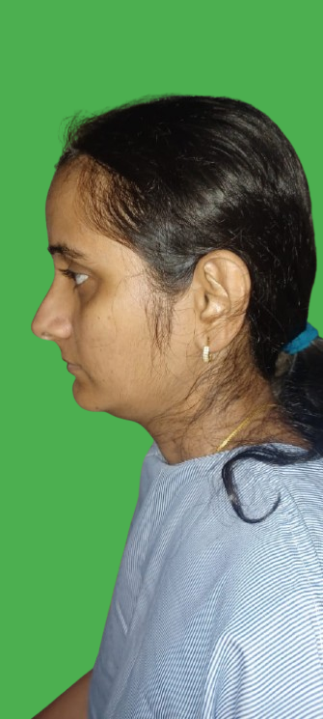

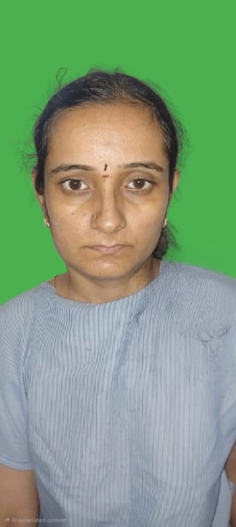

**Fig .1 PRE OP PROFILE** – MILD SWELLING NOTED IN THE SUBMANDIBULAR REGION EXTENDING TO THE BACK OF THE NECK AND THE SHOULDER

* Patient was advised admission for incision and drainage followed by lymph node biopsy.
* Post admission patient was put on intra venous antibiotics and analgesics to control the infection.
* Later basic blood investigations were performed prior surgery. MRI report revealed multiple conglomerate necrotic lymph nodes in right side of neck from level 2 to level 5 with significant peripheral fat stranding and edema- likely infective etiology like tuberculosis.

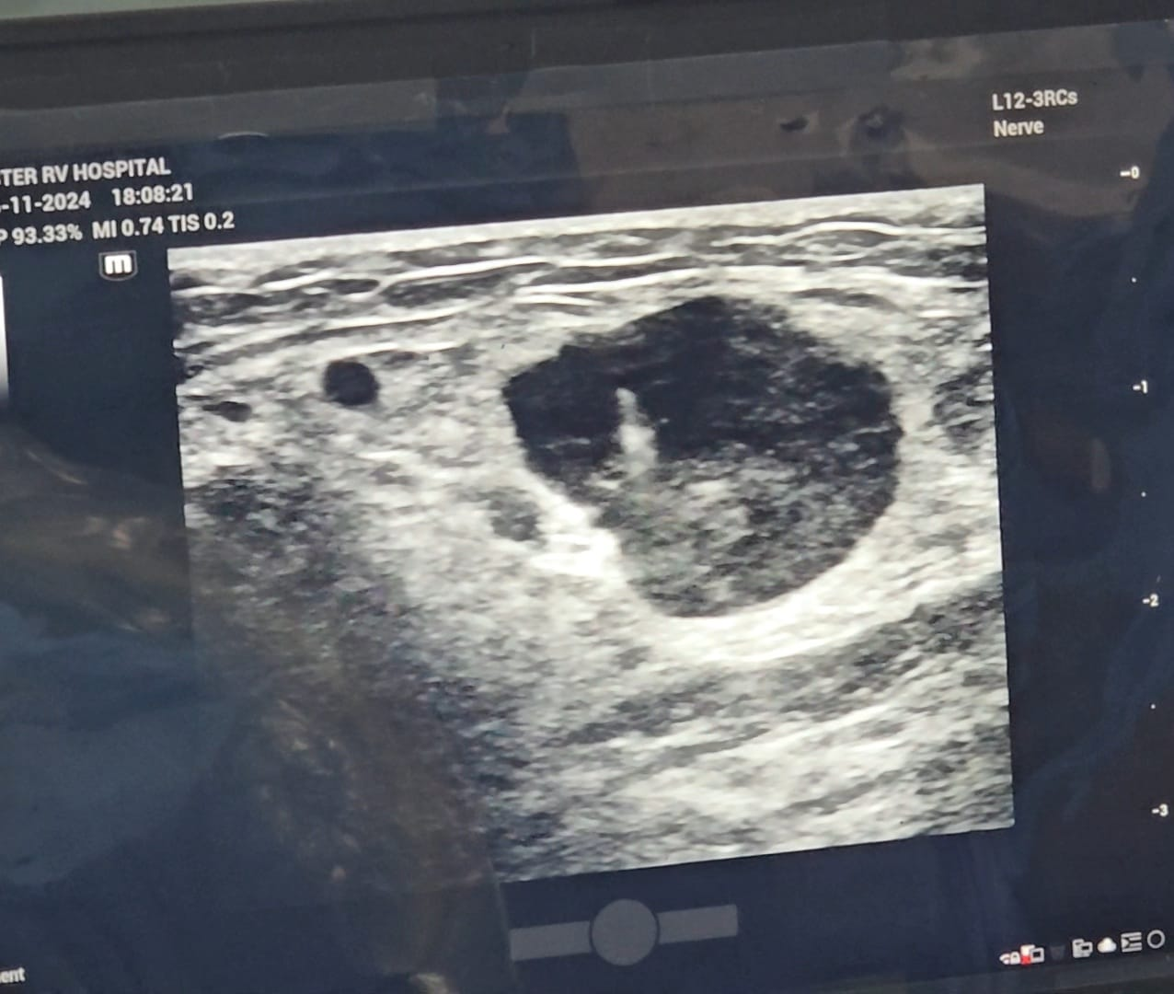

Fig .2 USG REVEALS ENLARGED LEVEL 3 LYMPH NODE

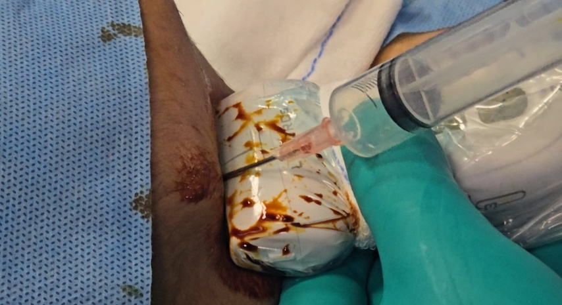

Fig .3 INTRA OPERATIVELY, WIDE BORE NEEDLE ASPRATION ON MOST DEPENDENT SITE SHOWS NO PUS; RULING OUT SPACE INFECTION

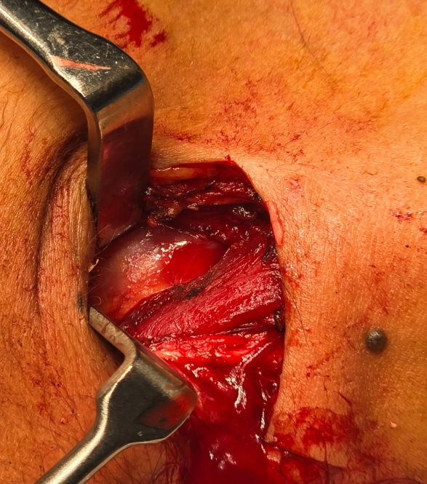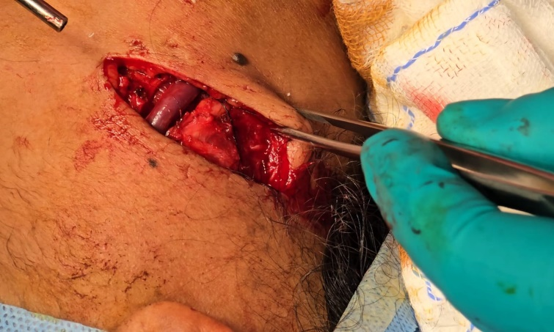

Fig. 4 A HORIZONTAL INCISON ALONG THE SKIN CREASE WAS GIVEN. AFTER CAREFUL DISSECTION OF TISSUE PLANES, ONE OF THE ENLARGED LEVEL 3 LYMPHNODES WAS REMOVED

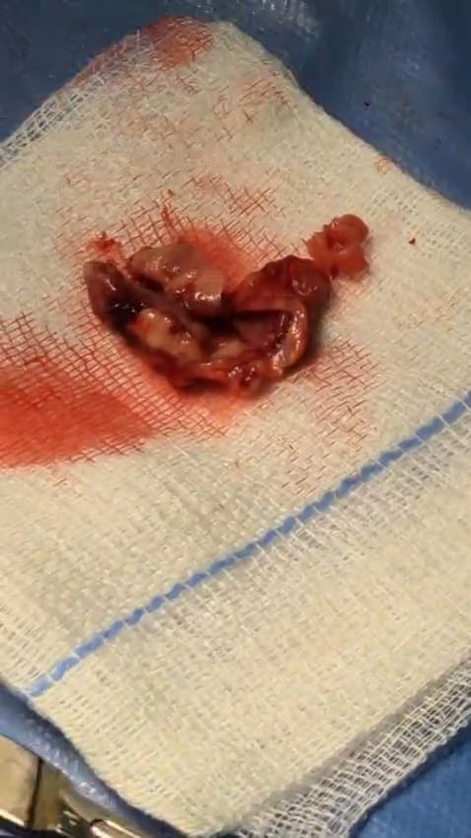

Fig.5 LYMPH NODE SPECIMEN WHICH IS REMOVED WAS CUT IN THE MID TO CHECK FOR CASEOUS NECROSIS.

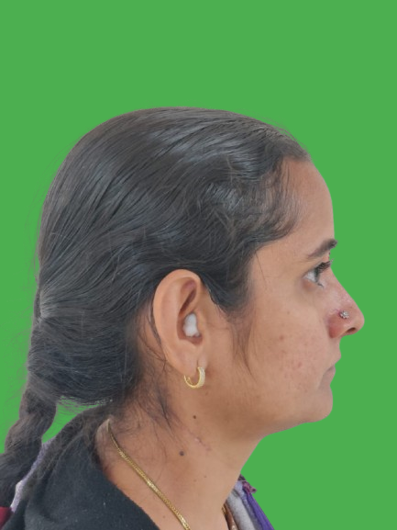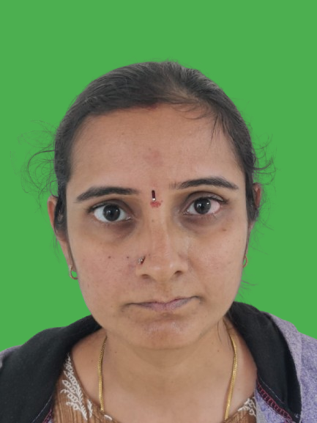

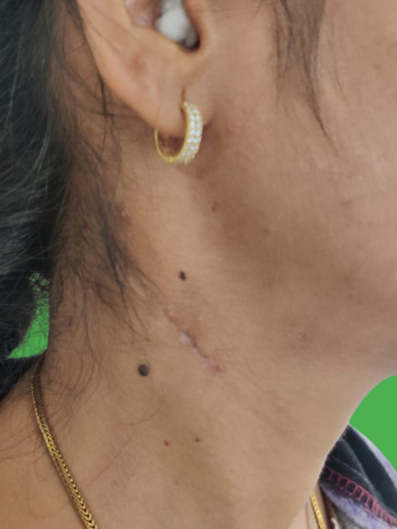

**Fig .6 3 MONTHS FOLLOW UP- minimal scarring and no post operative complications were noted.**

DISCUSSION

“KIKUCHI-FUJIMOTO DISEASE, is a rare, benign condition that primarily affects young adults, especially women. It is characterized by fever, lymphadenopathy (enlarged lymph nodes) and sometimes other systemic symptoms like night sweats, weight loss, and malaise. Despite being a self-limiting disease in most cases, KFD can be challenging to diagnose due to its nonspecific clinical presentation, which often mimics other infectious, autoimmune, or malignant conditions”.[5]

“The exact cause of Kikuchi-Fujimoto disease remains unclear, but several hypotheses have been proposed. The disease is thought to involve an immune-mediated response, potentially triggered by viral infections, such as EPSTEIN-BARR VIRUS (EBV), HUMAN HERPESVIRUS 6 (HHV-6), OR CYTOMEGALOVIRUS (CMV). Additionally, genetic factors may contribute to an individual's susceptibility to the disease, as there is a higher prevalence in certain ethnic groups, particularly in East Asian populations” [6]

“Diagnosing KIKUCHI-FUJIMOTO disease necessitates an excisional biopsy of an enlarged lymph node, with immunohistochemistry playing a crucial role in excluding other potential differential diagnosis .The condition is characterized by 3 histological stages, proliferative, necrotizing, and xanthomatous” [7]

“During the proliferative stage, there is follicular hyperplasia with infiltrates comprised of histiocytes and lymphocytes, with the notable absence of neutrophils and eosinophils. In the necrotizing stage, distinctive features include histiocyte nuclear breakdown (karyorrhexis) and multiple necrotic foci, while the overall lymph node architecture remains intact. Lastly, in the xanthomatous stage, there are foamy histiocytes with the regression of necrotic areas” [8]

“A notable absence of neutrophils or eosinophils is evident throughout all these stages, which serves as a crucial distinguishing feature between KIKUCHI-FUJIMOTO DISEASE and infectious aetiologies. Furthermore, microscopic examination and culture data typically yield negative results” [9]

“The most common clinical features of KIKUCHI-FUJIMOTO DISEASE include: Lymphadenopathy, Fever, Systemic Symptoms such as Fatigue, night sweats, malaise, weight loss, Rashes and Joint Involvement. The diagnosis of KIKUCHI-FUJIMOTO disease is challenging, as it shares clinical features with several other conditions, such as infections (e.g., TUBERCULOSIS, viral infections), LYMPHOMA, and SYSTEMIC LUPUS ERYTHEMATOSUS (SLE). The definitive diagnosis is made through lymph node biopsy, which reveals characteristic histopathological changes. Immunohistochemical staining may also reveal an abundance of CD8+ T-cells, which support the diagnosis”. [10]

“To differentiate KIKUCHI-FUJIMOTO DISEASE from infectious causes, cultures and stains for acid-fast bacilli and fungi, as well as microbiological data, are scrutinized and the results generally turn out negative in cases of KIKUCHI-FUJIMOTO DISEASE. Moreover, the clinical presentation and histological examination can reduce the likelihood of infectious etiologies. The absence of eosinophils, neutrophils, and viral inclusions in histology also contributes to ruling out infectious etiology in KIKUCHI-FUJIMOTO DISEASE. Moreover, negative results in infectious serology and cultures can further bolster the evidence that the histological findings are inconsistent with infectious causes. Several autoimmune differentials should be considered, including SLE, SARCOIDOSIS, and KAWASAKI DISEASE, when assessing a patient with suspected KIKUCHI-FUJIMOTO DISEASE”[11]

“In extremely rare cases, the immunological stress associated with KIKUCHI-FUJIMOTO DISEASE can potentially trigger HLH, a severe immunological response characterized by histiocytic proliferation, hemophagocytosis, systemic inflammatory response, and disseminated intravascular coagulation. HLH can be life-threatening and is linked to a mortality rate of 20% to 42%. HLH management typically involves using intravenous immunoglobulin and methylprednisolone to suppress the immune response. Pediatric patients with HLH generally experience more favorable outcomes compared to adults”. [12]

“No specific treatment is available for KIKUCHI-FUJIMOTO DISEASE, as it typically follows a self-limited course with spontaneous resolution occurring within 1 to 4 months or 1 to 6 months”.[13]

In most cases, KIKUCHI-FUJIMOTO disease resolves spontaneously within a few months, and no specific antiviral or antimicrobial treatment is required. “Supportive management is the mainstay of treatment and involves using antipyretics and analgesics to alleviate symptoms. Patients with severe disease may require a prolonged corticosteroid taper after ruling out infectious aetiology. Other treatments that have been successful in the past include hydroxychloroquine, minocycline, or intravenous immunoglobulin”.[14]

“KIKUCHI-FUJIMOTO DISEASE is usually monophasic. In adults, the recurrence rate is around 3% to 4%. However, in children, the recurrence rate may be higher, reaching 31% to 39% in some studies”. [15]

CONCLUSION

KIKUCHI-FUJIMOTO DISEASE is a rare and self-limiting condition characterized by fever and necrotizing lymphadenopathy, often seen in young women. Although the exact cause is not well understood, viral infections and autoimmune mechanisms are believed to play a role. Diagnosis is primarily based on lymph node biopsy, which reveals characteristic histopathological features. While the disease typically resolves without the need for aggressive treatment, corticosteroids may be used in more severe cases. The prognosis is generally excellent, though long-term follow-up may be necessary in some cases due to the risk of recurrence or autoimmune complications.

In this case, the lymph node sample was sent for histopathology report and real time pcr to rule out tuberculosis. The histopathology report revealed eosinophillic , granular material and karryohectic histiocytes. Neutrophils were sparse and plasma cells were rare. A dense inflammation was seen extending to perinodal fat indicating KIKUCHI FUJIMOTO DISEASE. patient was prescribed corticosteroids for 4 weeks. And patient was completely recovered with no complications.

Consent

As per international standards or university standards, Participants’ written consent has been collected and preserved by the author(s).

Disclaimer (Artificial intelligence)

Author(s) hereby declare that generative AI technologies such as Large Language Models, etc. have been used during the writing or editing of manuscripts. This explanation will include the name, version, model, and source of the generative AI technology and as well as all input prompts provided to the generative AI technology

Details of the AI usage are given below:

1. I have used CHAT GPT to reframe few sentences

2. version is GPT-4-turbo

3. I have used my own sentences as inputs and reframed using CHAT GPT

REFERENCES

1. Mahajan VK, Sharma V, Sharma N, Rani R. Kikuchi-Fujimoto disease: a comprehensive review. World Journal of Clinical Cases. 2023 Jun 6;11(16):3664.

2. Achappa B, Herath NC, Sebastian B, Dsouza NV, Raghuram PM, Holla R, Chowta N, Kini JR. Kikuchi-Fujimoto disease in a tertiary care teaching hospital in Coastal South India: A 8-year retrospective study. F1000Research. 2022 May 4;11:492.

3. Salamat S, Chan J, Jolly K, Powell G, Harrison K, Ahanger S, Hari C. Kikuchi–Fujimoto disease and prognostic implications. Head and neck pathology. 2020 Mar;14:272-5.

4. Kim HY, Jo HY, Kim SH. Clinical and laboratory characteristics of Kikuchi-Fujimoto disease according to age. Frontiers in Pediatrics. 2021 Nov 2;9:745506.

5. Sekiguchi S, Yamamoto Y, Hatakeyama S, Matsumura M. Recurrent aseptic meningitis associated with Kikuchi's disease (histiocytic necrotizing lymphadenitis): a case report and literature review. Internal Medicine. 2021 Jun 1;60(11):1779-84.

6. Gurung, Shekhar MBBSa; Pariyar, Ribek Sunam MBBSa; Karki, Saurab MBBSc; Gautam, Anu MBBSd; Sapkota, Hari MBBSb. Kikuchi–Fujimoto disease in a 20-year-old female: a case report. Annals of Medicine & Surgery 85(5):p 1894-1896, May 2023. | DOI: 10.1097/MS9.0000000000000372

7. Choi S, Choi HS, Ryu YJ, Kim JY, Paik JH, Ahn S, Lee H. Characterization of Kikuchi-Fujimoto disease in children and risk factors associated with its course. The Journal of Pediatrics. 2023 Sep 1;260:113515.

8. Chisholm KM, Bohling SD, Tsuchiya KD, Paulson VA. A malignant mimicker: features of Kikuchi-Fujimoto disease in the Pediatric population. Pediatric and Developmental Pathology. 2022 Sep;25(5):538-47.

9. Mallick A, Mohapatra MM, Babu VM, Rajaram M, Gocchait D, Warrier LS. All necrotizing nodes are not tuberculosis–A report of two cases. Indian Journal of Tuberculosis. 2022 Oct 1;69(4):695-8.

10. .Lelii M, Senatore L, Amodeo I, Pinzani R, Torretta S, Fiori S, Marchisio P, Bosis S. Kikuchi-Fujimoto disease in children: two case reports and a review of the literature. Italian journal of pediatrics. 2018 Dec;44:1-7.