Case report
Synchronous Metastasis of Renal Cell Carcinoma Presenting as a Primary Breast Tumor: A Rare Case Report

Abstract
In the context of cancer prevalence in India, breast cancer is the most common leading site for women, followed by cervical cancer.¹ Globally, kidney cancer accounts for approximately 2% of all neoplasms and cases of extramammary malignancies metastasizing to breast are extremely rare occurring in only 0.5-2% of cases². Metastatic renal cell carcinoma to the breast presenting as a breast primary rare entity and a very few sporadic cases are mentioned in the literature³. The article discusses a specific case involving a 70-year-old women who presented with right breast lump of short duration that was initially diagnosed as invasive breast carcinoma through a core needle biopsy. However, further radiological investigations revealed a large exophytic mass in the right kidney. After a multidisciplinary discussion, the case was determined to be a dual primary cancer, leading to a surgical treatment plan that included a lumpectomy with sentinel node biopsy and nephrectomy. The histopathological examination ultimately confirmed that the breast lump was a metastatic renal cell carcinoma, highlighting the rarity of such occurrences.
Key words: Renal cell carcinoma, Invasive breast carcinoma, Extramammary malignancy, Multidisciplinary discussion.
Introduction
“Kidney cancer accounts for approximately 5% of cancer incidence worldwide, with higher incidence and mortality rates in men. This difference can be explained by genetics, sex hormones, and modifiable risk factors such as uncontrolled hypertension, alcohol, and” obesity⁴. “The most common type of kidney cancer in the cortex is renal cell carcinoma (RCC), accounting for approximately 2% of adult” malignancies⁵ “and encompassing 80-85% of all renal neoplasms, predominantly the clear cell RCC subtype (75–85%). Other RCC subtypes include papillary, chromophobe, oncocytoma, and” other⁶. “About thirty percent of the patients diagnosed with renal cell carcinoma have metastasis at the time of” diagnosis⁵. “The most common metastasis in renal cell carcinoma occurs in the lungs, followed by the involvement of the bones, liver, lymph nodes, adrenal glands, and brain” ⁷. “Breast metastasis from extra-mammary primary tumors is extremely rare and ranges from 0.5% to 2%. Melanoma, lymphoma, and leukemia are the most common primary tumors with metastasis to the breast” ⁸. “Breast metastases from RCC can occur in both synchronous (at same time of primary cancer diagnosis) and metachronous (metastases appear later in the disease course) patterns with correspondence to the primary tumor” ^{9,10}. “Metastases in the breast from RCC are extremely rare, with only a few sporadic cases reported in the literature¹¹. “Overall, 25 such cases have been reported in the” literature: 11 cases presented with breast metastasis as the initial sign of the disease and 14 (two were bilateral) as metachronous lesions” ¹². We present a rare case of primary RCC with a synchronous breast lump, presented as breast lump, operated as two primaries owing to the core biopsy report of the breast lump.

Case presentation
A 70-year-old lady presented to the breast clinic with a history of palpable right breast lump for 2 weeks. On physical examination, a painless lump (approximate 2cm in size) firm to hard in consistency, located in the lower outer quadrant of right breast. It did not show any signs of fixation to the overlying skin or the underlying muscle. She had a past medical history of hypertension and insulin dependent diabetes mellitus.
Mammography revealed a 1.8 x 1.8 x 1.3 cm solitary mass in the right upper outer quadrant. A core needle biopsy of the lump was performed and interpreted as invasive breast carcinoma, Nottingham grade 2. The patient was referred to our hospital for further management. A staging PET-CT was performed prior to the surgery. PET-CT examination revealed a low grade FDG avid heterogeneously enhancing soft tissue mass in the lower outer quadrant of right breast. A low grade FDG avid partly enhancing large exophytic soft tissue mass measuring 7.5 x 7.3 x 7.1 cm, involving the mid and lower pole of the right kidney. Patient underwent right breast conversation surgery with sentinel lymph node biopsy and a robot assisted right radical nephrectomy.
Gross examination of the excised right breast lump showed a grey white firm fairly circumscribed lobulated tumor measuring 22x18x18mm. The closest margin (base) was 2mm away. Two sentinel nodes dissected were negative for metastasis. Received a specimen of right radical nephrectomy measuring 19.5x13.5x9.5cm. Externally it was covered by smooth and unremarkable perinephric fat. On cut section, the kidney measured 11.5x8.5x5.5cm. A well circumscribed, grey yellow lobulated and variegated exophytic tumor is identified measuring 7x7x5.8cm, involving the mid and lower pole of the kidney. Focal areas of hemorrhage and necrosis were seen. The tumor did not invade the renal sinus fat or the pelvicalyceal system. The tumor invaded the renal capsule and into the perinephric fat. The renal vein was free of tumor thrombus. The renal vessels and the ureteric cut margins were free of tumor.
The breast tumor studied on paraffin showed nested and alveolar growth pattern of tumor cells surrounded by a network of arborizing thin-walled vessels (Figure 1A). Individual tumor cells were polygonal to round with distinct cell membranes, central round nucleus and distinct nucleolus visible on 100x with abundant clear cytoplasm (Figure 2A).
The kidney showed a Conventional clear cell renal cell carcinoma, ISUP nuclear grade 3 of the right kidney (Figure 1B and 2B). Tumor necrosis was seen, amounting to about 30-35% of the volume. Sarcomatoid and rhabdoid areas were not seen. The segmental branches of renal vein showed tumor emboli. Lymphovascular emboli were also identified. The tumor breaches through the renal capsule to invade into the perinephric adipose tissue. No renal vein thrombus identified.
Immunohistochemistry was performed on the breast tumor. The tumor cells expressed Ck7 (Figure 3A), pax-8, vimentin (Figure 3B) and CA-IX (Figure 3C) diffusely. Negative for Gata-3(Figure 3D), E-cadherin, GCDFP-15, Melan-A, HMB-45, TTF1, Napsin-A, Synaptophysin, ER and breast myoepithelial markers. The adjacent benign breast ducts expressed Gata-3, E-Cadherin and showed retained expression of myoepithelial markers. Hence, it was concluded that the breast tumor was a solitary synchronous metastasis from a renal cell carcinoma of the right kidney.
Discussion
“RCC is a urological carcinoma that accounts for 3% of all adult” malignancies¹³. RCC metastases to the breast have been rarely reported. Recently in 2014, Falco et al., has reported a case of breast metastasis from renal primary ¹⁴. “According to Gravis et al., metastatic RCC to the breast was observed in only two patients among a total of 558 metastatic RCC” patients¹⁵.
Patients with RCC clinically present with metastatic disease in twenty-thirty percent of cases, and twenty-forty percent of patients with a nephrectomy for clinically localized illness can develop metastasis. Numerous studies in the past with authors like Bumpus have mentioned that metastatic renal cancer can regress spontaneously and the first such case was recorded in 1928¹⁶.
“The most common sources of breast metastasis reported in the literature are lymphoma, leukemia and melanoma. Other uncommon sources include carcinomas of the ovary, stomach and lung. According to Sung Hee Mun, metastasis to the breast may rarely occur from hypernephromas, carcinoid tumors, and other rare malignancies as carcinomas of the liver, endometrium, tonsil, pancreas, perineum, pleura, bladder and cervix”¹⁷.
“Clinically, metastatic lesions in the breast present as painless swellings with rapid growth. Unlike primary tumours, the skin is not involved and the axillary node involvement is variable. Mammogram shows well-circumscribed lesions, which lack microcalcifications” ¹⁸. This finding of mammography closely mimics a breast primary.
“The interval from diagnosis of a primary tumor to the detection of breast metastases varies from a few months to years. RCC recurrence occurs either in a synchronous or in a metachronous manner. Vassalli et al. reported that in 14 cases, breast masses were found 1–18 years following nephrectomy for RCC. In 7 cases, the initial signs of metastatic disease of metastatic RCC to the breast were present at the time of” nephrectomy³. Our case had short history (2 weeks) of breast lump.
“Thyavihally et al discussed 3 years and 5 years post metastatic lesion resection survival in RCC with metachronous solitary metastasis, which was found to be 58% and 35%, respectively. However, synchronous metastasis had a 3-year survival of only <20%”¹⁹.
It is well known that patients with metastatic RCC have poor prognosis and a high relapse rate within 6 months, our patient continues to have no other evidence of metastasis on follow up scans post 1year following surgery. Hence favoring a surgical resection alone in patients with solitary metastasis to breast and a close follow up. This supports the evidence to favor surgical resection in oligometastatic RCC to the bones and lungs ²⁰.
Stereotactic “ablative radiotherapy (thermal ablation in particular) is currently the most studied treatment option for patients who are at high risk for surgical operations. Stereotactic ablative radiotherapy is approved for localized RCC and has been shown to have favorable outcomes when compared with other modality of radiotherapy” ²¹. Stereotactic ablative radiotherapy is currently under investigation for metastatic RCC treatment ²².
Conclusion
This manuscript presents a rare case of synchronous metastasis of renal cell carcinoma (RCC) to the breast, highlighting an unusual presentation that can easily be misdiagnosed as a primary breast malignancy. By documenting this case, the authors contribute valuable insights into the complexities of cancer metastasis, particularly the need for heightened clinical awareness and thorough diagnostic evaluation in similar cases. This event contradicts prevailing paradigms of organ-specific metastasis and offers new avenues for investigation of cellular migration, diagnostic dilemma, and therapeutic strategy.The presentation of this unusual case encourages clinicians and researchers to entertain differential diagnoses outside the ordinary in analogous presentations. Furthermore, this report adds to the limited literature on breast metastases from extramammary sources, thereby enriching the scientific community's understanding of metastatic patterns and potentially guiding future research and clinical practices.
Ethical Approval:

As per international standards or university standards written ethical approval has been collected and preserved by the author(s).

Consent
As per international standards or university standards, patient(s) written consent has been collected and preserved by the author(s).

Disclaimer (Artificial intelligence)
Option 1:
Author(s) hereby declare that NO generative AI technologies such as Large Language Models (ChatGPT, COPILOT, etc.) and text-to-image generators have been used during the writing or editing of this manuscript.
Option 2:
Author(s) hereby declare that generative AI technologies such as Large Language Models, etc. have been used during the writing or editing of manuscripts. This explanation will include the name, version, model, and source of the generative AI technology and as well as all input prompts provided to the generative AI technology
Details of the AI usage are given below: Option 1 (NO AI technology has been used for writing up this article.)
1.
2.
3.

References
- Chaturvedi M, Sathishkumar K, Sudarshan KL, Nath A, Das P, Mathur P, et al. Women cancers in India: incidence, trends and their clinical extent from the national cancer registry programme cancer Epidemiology.2022;80:102248. https://doi.org/10.1016/j.canep.2022.102248.

- Hajdu SI and Urban JA, “Cancers metastatic to the breast,” Cancer, vol. 29, no. 6, pp. 1691–96, 1972.
- Vassalli L, Ferrari VD, Simoncini E, et al. Solitary breast metastases from a renal cell carcinoma. Breast Cancer Res Treat. 2001;68:29–31.

- Peired AJ, Campi, R, Angelotti ML, Antonelli G, Conte C, Lazzeri E, Becherucci F, Calistri L, Serni S, Romagnani P. Sex and Gender Differences in Kidney Cancer: Clinical and Experimental Evidence. Cancers 2021;13:4588. [CrossRef].

- Padala SA, Barsouk A, Thandra KC, Kalyan S, Mohammed A, Vakiti A, Rawla P, Barsouk A. Epidemiology of renal cell carcinoma. World J. Oncol. 2020;11:79–87.

- Christensen M, Hannan R. The Emerging Role of Radiation Therapy in Renal Cell Carcinoma. Cancers 2022;14:4693. [CrossRef].

- Bianchi M, Sun M, Jeldres C, Shariat SF, Trinh QD; et al. Distribution of metastatic sites in renal cell carci-noma: A population-based analysis. Ann. Oncol. 2012;23:973–80. [CrossRef].

- McLauglin SA, Thiel DD, Smith SL, Wehle MJ, and Menke DM, “Solitary breast mass as initial presentation of clinically silent metastatic renal cell carcinoma,” Breast, vol. 15, no. 3, pp. 427–429, 2006.

- Anderson WF, Katki HA, Rosenberg PS. Incidence of breast Cancer in the United States: current and future trends. J Natl Cancer Inst 2011;103:1397–402.

- DeSantis C, Ma J, Bryan L, et al. Breast cancer statistics, 2013. CA Cancer J Clin 2014;64:52–62.

- Xu, Y.; Hou, R.; Lu, Q.; Deng, Y.; Hu, B. Renal clear cell carcinoma metastasis to the breast ten years after nephrectomy: A case report and literature review. Diagn. Pathol. 2017;12:76. [CrossRef] [PubMed].

- Arjunan R, Kumar D, Kumar KV, Premlatha CS. Breast Cancer with Synchronous Renal Cell Carcinoma: A Rare Presentation. J Clin Diagn Res. 2016;10:XD03-XD05.

- Campbell SC, Flanigan RC, Clark JI. Nephrectomy in metastatic renal cell carcinoma. Curr Treat Option On. 2003;4:363–72.

- Falco G, Buggi F, Sanna PA, Dubini A, Folli S. Breast metastases from a Renal Cell Carcinoma. A case report and review of the literature. Int J Surg Case Rep. 2014;5:193–95.
- Gravis G, Chanez B, Derosa L, et al. Effect of glandular metastases on overall survival of patients with metastatic clear cell renal cell carcinoma in the antiangiogenic therapy era. Urol Oncol. 2016;34:167. e17-23.

- Bhardwaj T, Hiwale KM, Vagha S. Renal Cell Carcinoma Clear Cell Variant with Chromophobe Differentiation -A Rare Case Presentation. J. Pharm. Res. Int. 2021;33:479-85.
- Mun SH, Ko EY, Han BK, Shin JH, Kim SJ, Cho EY. Breast metastases from extramammary malignancies: typical and atypical ultrasound features. Korean J Radiol. 2014;15:20–8.

- Forte A, Peronace MI, Gallinaro LS, Bertagni A, Prece V, Montesano G, Palumbo P, Nasti AG: Metastasis to the breast of a renal carcinoma: a clinical case. Eur Rev Medical Pharmacological Sci. 1999:3:115-18.

- Thyavihally YB, Mahantshetty U, Chamarajanagar RS, et al. Management of renal cell carcinoma with solitary metastasis. World J Surg Oncol. 2005;3:48.

- Bhat S. Role of surgery in advanced/metastatic renal cell carcinoma. Indian J Urol. 2010;26:167–76.

- Campbell SP, Song DY, Pierorazio PM, et al. Stereotactic ablative radiotherapy for the treatment of clinically localized renal cell carcinoma. J Oncol. 2015;2015:1–6.

- Cheung P, Thibault I, Bjarnason GA. The emerging roles of stereotactic ablative radiotherapy for metastatic renal cell carcinoma. Curropin Support Palliat Care. 2014;8:258–64.

Figures
Figure 1A: Lobulated appearance of breast tumor with rich vascularity (H and E stain, 4x).
Figure 1B: Conventional clear cell carcinoma of the right kidney (H and E stain, 4x).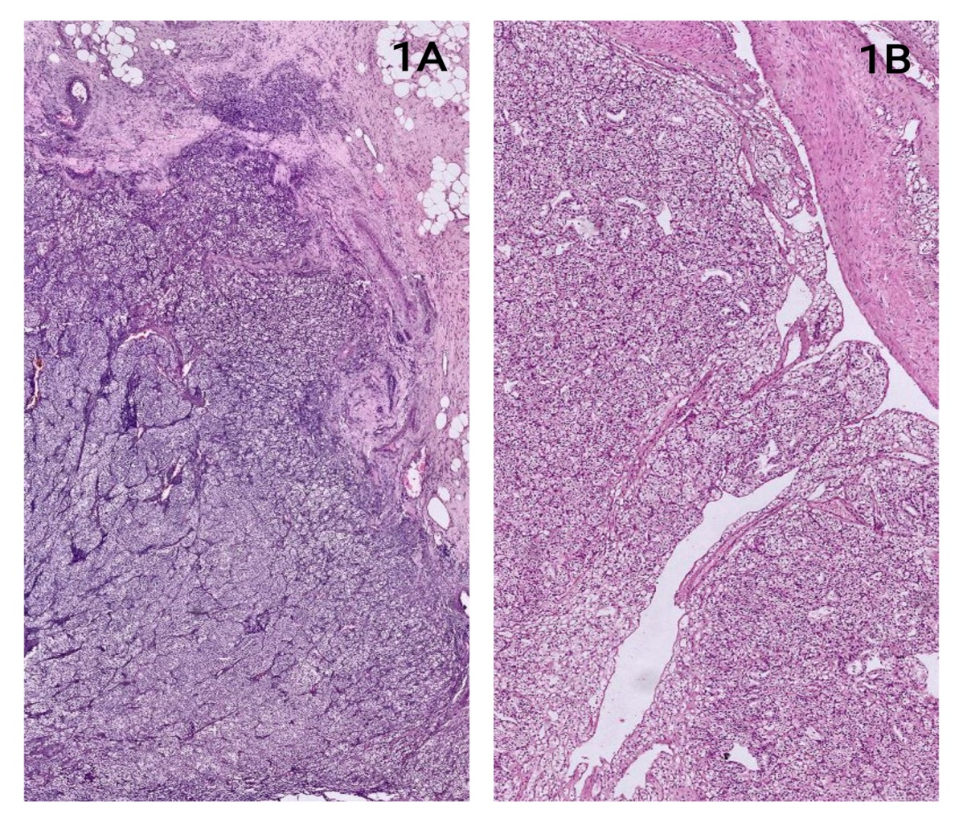

Figure 2A: Tumor cells in breast arranged in nested pattern showing abundant clear cytoplasm separated by arborizing thin walled vessels (H and E stain, 10x).
Figure 2B: Tumor cells of kindey arranged in nests and sheets showing abundant clear cytoplasm and prominent nucleoli, separated by arborizing thin walled vessels (H and E stain, 10x).
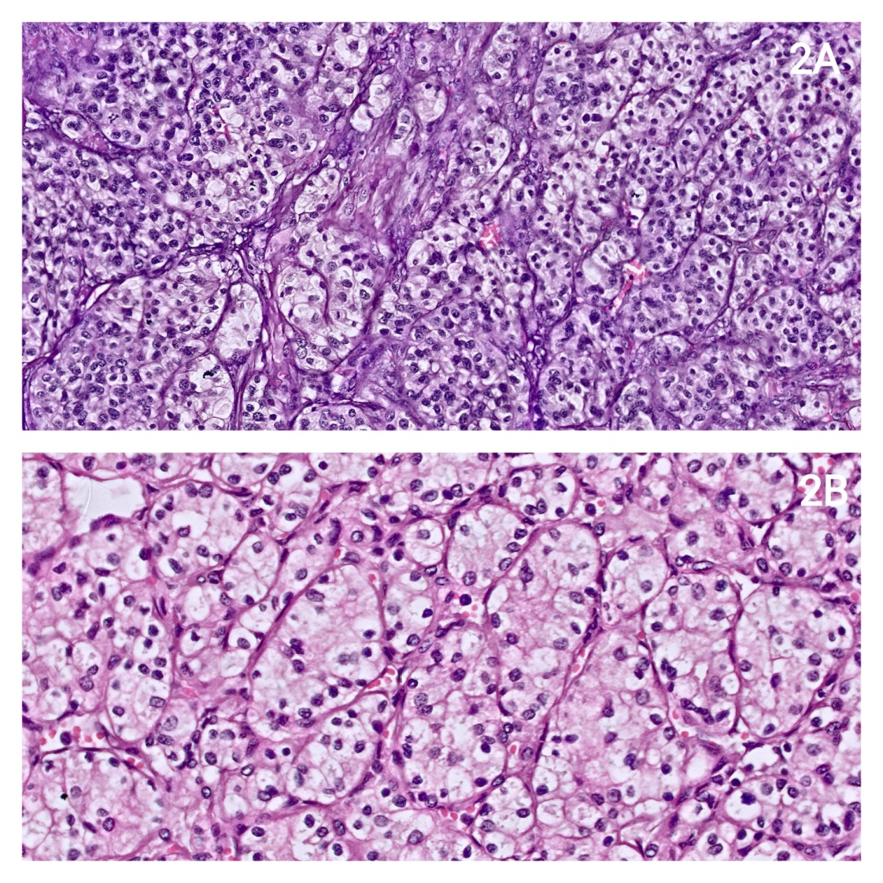

Figure 3A: The tumor cells of the breast express CK7 diffusely (H and E stain, 4x).
Figure 3B: The tumor cells of the breast express vimentin diffusely, however the benign breast ducts in the right upper corner are negative (H and E stain, 4x).
Figure 3C: The tumor cells of the breast express CA-IX diffusely, however the benign breast ducts in the right upper corner are negative (H and E stain, 4x).
Figure 3D: The tumor cells of the breast are negative for GATA-3, however the benign breast ducts in the left lower corner are positive (H and E stain, 4x).
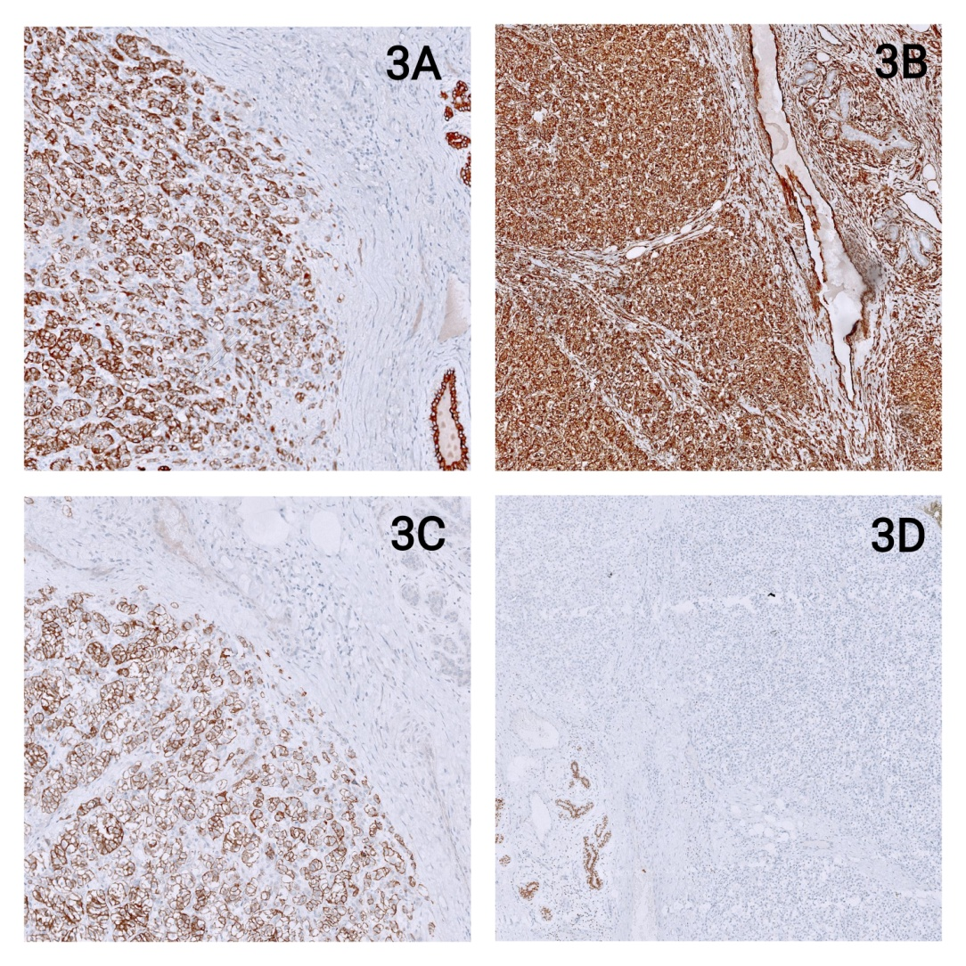

Legends for figures:
Figure 1A: Lobulated appearance of breast tumor with rich vascularity (H and E stain, 4x).
Figure 1B: Conventional clear cell carcinoma of the right kidney (H and E stain, 4x).
Figure 2A: Tumor cells in breast arranged in nested pattern showing abundant clear cytoplasm separated by arborizing thin walled vessels (H and E stain, 10x).
Figure 2B: Tumor cells of kindey arranged in nests and sheets showing abundant clear cytoplasm and prominent nucleoli, separated by arborizing thin walled vessels (H and E stain, 10x).
Figure 3A: The tumor cells of the breast express CK7 diffusely (H and E stain, 4x).
Figure 3B: The tumor cells of the breast express vimentin diffusely, however the benign breast ducts in the right upper corner are negative (H and E stain, 4x).
Figure 3C: The tumor cells of the breast express CA-IX diffusely, however the benign breast ducts in the right upper corner are negative (H and E stain, 4x).
Figure 3D: The tumor cells of the breast are negative for GATA-3, however the benign breast ducts in the left lower corner are positive (H and E stain, 4x).

