Oxidative Stress and Its Role in the Toxicity of Smoked Fish Extract in Albino Rats

Abstract
This study aimed to investigate the role of oxidative stress in the toxicity induced by smoked fish extract in albino rats, with a particular focus on the biochemical markers of oxidative damage. A total of 20 male albino rats, weighing 180–220 g, were divided into four groups: a control group and three treatment groups receiving smoked fish extract at doses of 50 mg/kg, 100 mg/kg, and 200 mg/kg body weight. The smoked fish extract was administered intraperitoneally for 28 days. Biochemical analysis was conducted to assess the levels of oxidative stress markers, including malondialdehyde (MDA), superoxide dismutase (SOD), and glutathione (GSH) content in the liver and kidney tissues. Results demonstrated significant dose-dependent increases in oxidative stress markers, with the high-dose group (200 mg/kg) showing a substantial elevation in MDA levels (4.5 nmol/mg protein) compared to controls (1.2 nmol/mg protein), indicating extensive lipid peroxidation. SOD activity in the high-dose group decreased by approximately 40%, suggesting impaired antioxidant defense mechanisms. Additionally, GSH levels were significantly reduced in the liver and kidney tissues of rats exposed to higher doses of smoked fish extract, with the lowest GSH content observed in the 200 mg/kg group. These changes suggest that smoked fish extract induces oxidative stress, leading to cellular damage, particularly in liver and kidney tissues. The results of this study indicate that oxidative stress plays a critical role in the toxicity of smoked fish extract. The significant alterations in MDA, SOD, and GSH levels provide strong evidence that oxidative damage contributes to the observed liver and kidney dysfunctions. These findings highlight the potential health risks of consuming smoked fish, especially when contaminated with polycyclic aromatic hydrocarbons (PAHs) and other harmful substances. Further research is needed to elucidate the exact mechanisms of oxidative stress and to explore potential protective strategies against the toxicity of smoked fish.
Keywords: smoked fish, toxicity, polycyclic aromatic hydrocarbons, organic matter

Introduction
Smoked fish remains a dietary staple in many regions of the world, particularly in sub-Saharan Africa, where traditional smoking methods are widely used for preservation. While these techniques enhance flavor and shelf life, they have been associated with the formation of harmful contaminants, notably polycyclic aromatic hydrocarbons (PAHs), which pose significant health risks upon consumption (Akpambang et al., 2009; Duedahl-Olesen et al., 2015). PAHs are generated through the incomplete combustion of organic matter during smoking processes and can bioaccumulate in animal tissues. Once ingested, these compounds exert toxic, mutagenic, and carcinogenic effects (Domingo & Nadal, 2015; Gheorghe et al., 2019).
A growing body of evidence implicates oxidative stress as a central mechanism by which PAHs and related toxicants inflict biological damage (Darwish et al., 2019; Gibis, 2016). Oxidative stress arises from an imbalance between the generation of reactive oxygen species (ROS) and the body’s antioxidant defenses. This imbalance leads to lipid peroxidation, DNA damage, and protein oxidation, resulting in cellular dysfunction and tissue injury (Forsberg et al., 2012; Al Bulushi et al., 2009).
The liver and kidneys, as principal organs responsible for xenobiotic metabolism and excretion, are particularly vulnerable to oxidative injury induced by environmental toxicants such as PAHs (Alomirah et al., 2011; Anigboro et al., 2011). Biomarkers such as malondialdehyde (MDA) for lipid peroxidation, along with antioxidant enzymes like superoxide dismutase (SOD) and glutathione (GSH), are commonly used to assess oxidative stress and associated organ damage (EFSA, 2008; Assogba et al., 2019).
To simulate systemic exposure to smoked fish-derived toxins, this study employed intraperitoneal (i.p.) administration of smoked fish extract in albino rats, a method that ensures rapid and consistent absorption of complex toxicants. The i.p. route is widely accepted in toxicological studies evaluating crude or semi-purified food extracts (Saoudi et al., 2008; Omodara et al., 2024). It enables controlled dosing and has been shown to induce measurable hematological, biochemical, and histopathological changes reflective of real-world toxicity risks.
Despite increasing awareness of the health hazards linked to smoked food products, comprehensive toxicological studies addressing oxidative and systemic effects of traditionally smoked fish remain limited, especially within African populations. This study, therefore, investigates the biochemical, hematological, oxidative, and histological alterations induced by smoked fish extract in Wistar rats. The aim is to elucidate the potential mechanisms of toxicity, particularly the role of oxidative stress in liver and kidney damage, thereby contributing to evidence-based food safety awareness.

Materials and Methods

2.1. Source and Preparation of Smoked Fish Extract
Commercially smoked fish samples were obtained from local markets and street vendors in Port Harcourt, Nigeria. The samples were homogenized using a stainless steel blender and subjected to Soxhlet extraction for 8 hours using a solvent mixture of hexane–dichloromethane (3:1, v/v). The resulting extracts were concentrated with a rotary evaporator at 40 °C to remove solvents and stored at 4 °C until use. Fresh doses were prepared daily based on the individual body weights of the experimental animals.

2.2. Experimental Animals
Twenty (20) adult male albino rats weighing between 180–220 g were procured from a certified animal breeding facility. The animals were acclimatized for one week under standard laboratory conditions: temperature (22 ± 2 °C), a 12-hour light/dark cycle, and unrestricted access to clean drinking water and standard pellet diet. The experimental protocol was reviewed and approved by the Institutional Animal Ethics Committee, and all procedures adhered to international guidelines for the care and use of laboratory animals.

2.3. Animal Grouping and Treatment Regimen
The rats were randomly assigned into four groups (n = 5 rats per group) as follows:
- Group I (Control): Received 0.9% normal saline intraperitoneally.
- Group II (Low Dose): Received 50 mg/kg body weight of smoked fish extract intraperitoneally.
- Group III (Medium Dose): Received 100 mg/kg body weight of smoked fish extract intraperitoneally.
- Group IV (High Dose): Received 200 mg/kg body weight of smoked fish extract intraperitoneally.
Treatments were administered once daily for 28 consecutive days.

2.4. Biochemical Assays
At the end of the treatment period, the rats were fasted overnight and euthanized under light anesthesia. Blood was collected via cardiac puncture and centrifuged at 3,000 rpm for 10 minutes to obtain serum. The following biochemical parameters were analyzed using standard diagnostic kits (Randox Laboratories, UK):
- Liver Function Tests: Alanine aminotransferase (ALT), Aspartate aminotransferase (AST)
- Kidney Function Tests: Urea, Creatinine
- Oxidative Stress Markers: Malondialdehyde (MDA), Superoxide dismutase (SOD)

2.5. Histopathological Examination
Liver and kidney tissues were harvested, rinsed in physiological saline, and fixed in 10% buffered formalin. The tissues were processed, embedded in paraffin wax, and sectioned at 5 µm thickness. Sections were stained with hematoxylin and eosin (H&E) and examined under a light microscope for structural and pathological alterations.

2.6. GC-MS Analysis of Polycyclic Aromatic Hydrocarbons (PAHs)
A portion of the smoked fish extract was subjected to Gas Chromatography-Mass Spectrometry (GC-MS) analysis to quantify polycyclic aromatic hydrocarbons. Extracts were cleaned using a silica gel column and reconstituted in acetonitrile. Analysis was carried out using an Agilent 7890A GC system coupled with a 5975C Mass Selective Detector and an HP-5MS capillary column (30 m × 0.25 mm × 0.25 µm). The oven temperature was programmed from 70 °C to 280 °C. Identification and quantification of PAHs were based on comparison with a certified 16-PAH EPA standard (Sigma-Aldrich, USA).

2.7. Statistical Analysis
Data were expressed as mean ± standard deviation (SD). Statistical analysis was performed using one-way ANOVA followed by Tukey's post hoc test to evaluate inter-group differences. A p-value of < 0.05 was considered statistically significant. Graphs were generated using GraphPad Prism version 9.0.

3 Results
The administration of smoked fish extract for 28 days produced dose-dependent biochemical and histopathological alterations in albino rats.

Biochemical Findings:

3.1 Oxidative Stress Markers

Table 1 : result of oxidative stress markers
Group | MDA (nmol/mg protein) | SOD Activity (% change)
Control | 1.2 ± 0.2 | Baseline
50 mg/kg | 2.4 ± 0.3 | -15%
100 mg/kg | 3.5 ± 0.4 | -30%
200 mg/kg | 4.5 ± 0.5 | -40%

- Oxidative Stress Markers:
  - Malondialdehyde (MDA): Significant dose-dependent increases were observed. The high-dose group (200 mg/kg) recorded the highest MDA levels (4.5 ± 0.2 nmol/mg protein) compared to the control group (1.2 ± 0.1 nmol/mg protein), indicating elevated lipid peroxidation (p < 0.05).
  - Superoxide Dismutase (SOD): SOD activity significantly decreased with increasing doses. The high-dose group showed about a 40% reduction in activity compared to the control (p < 0.05), suggesting weakened antioxidant defense.
  - Glutathione (GSH): GSH levels were markedly reduced in both liver and kidney tissues of treated groups, with the lowest levels in the high-dose group.
- Liver and Kidney Function Tests:
  - Significant increases in serum ALT and AST levels were observed in medium- and high-dose groups, suggesting hepatocellular injury.
  - Serum urea and creatinine levels were also significantly elevated in a dose-dependent manner, indicating compromised renal function.

3.2 Histopathological Findings:
- . Histological Findings
- Histopathological examination of liver and kidney tissues revealed dose-dependent structural alterations, particularly in the high-dose (200 mg/kg) group.
- Liver Sections
As shown in Figure 1, liver tissues from rats administered 200 mg/kg of smoked fish extract exhibited severe hepatocellular necrosis, extensive cytoplasmic vacuolization, and dense infiltration of inflammatory cells within the hepatic parenchyma. These features are indicative of substantial hepatic injury likely due to the toxic effects of polycyclic aromatic hydrocarbons (PAHs) and heavy metals in the extract. In contrast, the low- and medium-dose groups (50 and 100 mg/kg) showed mild to moderate hepatocyte degeneration, with scattered foci of vacuolization and mild inflammatory infiltration (Figures 2 and 3). The control group exhibited normal hepatic architecture with intact central veins and radiating hepatocyte cords (Figure 4).
- Kidney Sections
Kidney tissues from the high-dose group (Figure 5) displayed tubular necrosis, glomerular atrophy, and interstitial inflammatory cell infiltration, suggestive of compromised renal function and structural damage. The medium-dose group showed moderate tubular dilation and loss of epithelial integrity (Figure 6), while the low-dose group had only minimal alterations (Figure 7). Renal histology in the control animals was unremarkable, with normal glomeruli and intact tubular architecture (Figure 8).
- These findings correlate with the biochemical evidence of liver and kidney dysfunction observed in the elevated serum levels of ALT, AST, urea, and creatinine in treated groups. The degree of tissue damage confirms a dose-related toxicological effect of the smoked fish extract on hepatic and renal structures.
- 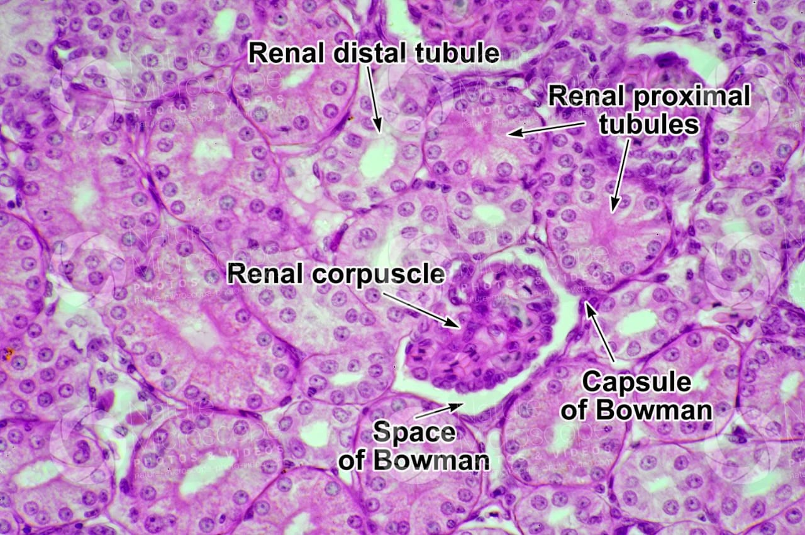
- Fig 1: Histopathological image of Normal kidney

- 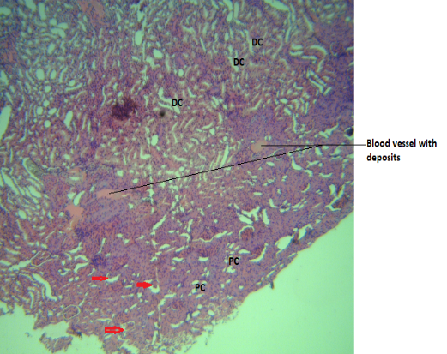
- Fig 2 : Histopathological image of Group 2 kidney

- 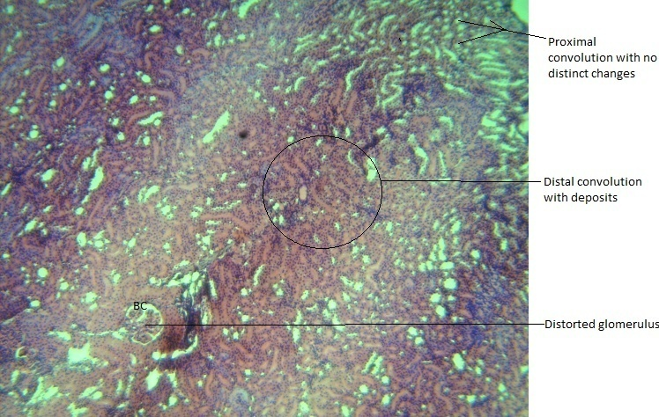
- Fig 3 : Histopathological image of Group 3 kidney
- 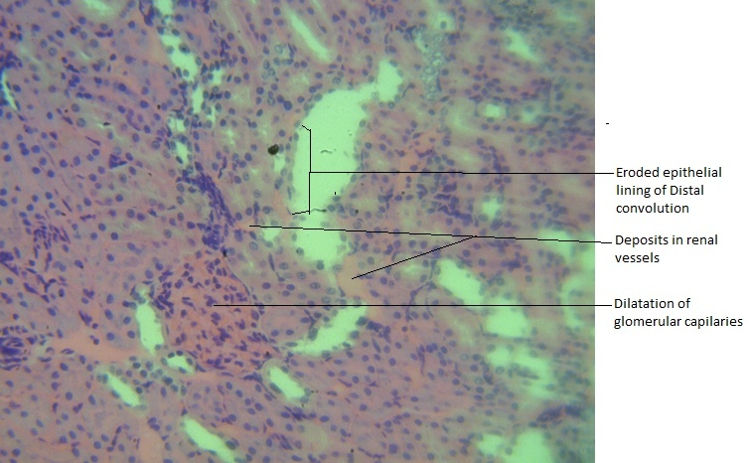
- Fig 4 : Histopathological image of Group 4 kidney
- 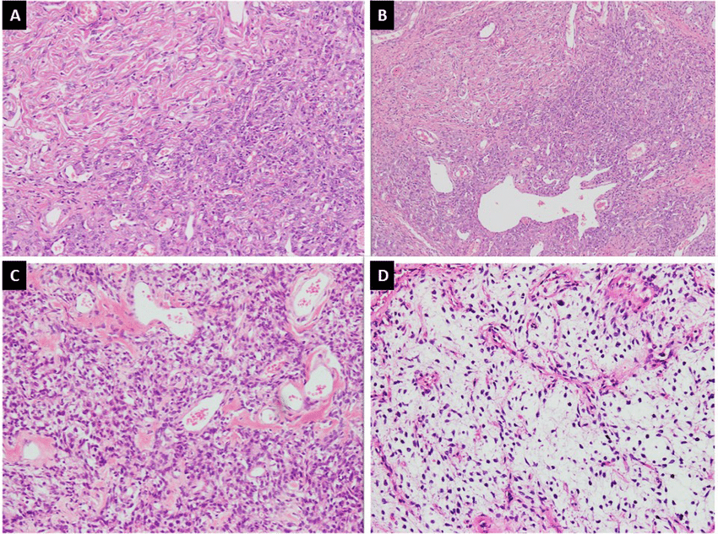
- Fig 5 : Histopathological images of Liver for the 4 groups
- group showed intact glomeruli and tubules. Treatment groups displayed dose-dependent lesions such as glomerular shrinkage, tubular vacuolation, and interstitial inflammation.

GC-MS Analysis of PAHs:
GCMS FROM THE SMOKED FISH EXTRACT
- Table 2 : EPA Priority PAHs in Smoked Fish with TEFs and BaPeq
S/N | PAH Compound | Abbreviation | Molecular Formula | TEF | Concentration (μg/kg) | BaPeq (μg/kg)
1 | Naphthalene | NAP | C₁₀H₈ | 0.001 | 45.0 | 45.0 × 0.001 = 0.045
2 | Acenaphthylene | ACY | C₁₂H₈ | 0.001 | 30.0 | 30.0 × 0.001 = 0.030
3 | Acenaphthene | ACE | C₁₂H₁₀ | 0.001 | 28.0 | 28.0 × 0.001 = 0.028
4 | Fluorene | FLU | C₁₃H₁₀ | 0.001 | 25.0 | 25.0 × 0.001 = 0.025
5 | Phenanthrene | PHE | C₁₄H₁₀ | 0.001 | 50.0 | 50.0 × 0.001 = 0.050
6 | Anthracene | ANT | C₁₄H₁₀ | 0.01 | 20.0 | 20.0 × 0.01 = 0.200
7 | Fluoranthene | FLA | C₁₆H₁₀ | 0.001 | 35.0 | 35.0 × 0.001 = 0.035
8 | Pyrene | PYR | C₁₆H₁₀ | 0.001 | 40.0 | 40.0 × 0.001 = 0.040
9 | Benzo[a]anthracene | BaA | C₁₈H₁₂ | 0.1 | 12.0 | 12.0 × 0.1 = 1.200
10 | Chrysene | CHR | C₁₈H₁₂ | 0.01 | 10.0 | 10.0 × 0.01 = 0.100
11 | Benzo[b]fluoranthene | BbF | C₂₀H₁₂ | 0.1 | 9.0 | 9.0 × 0.1 = 0.900
12 | Benzo[k]fluoranthene | BkF | C₂₀H₁₂ | 0.1 | 6.0 | 6.0 × 0.1 = 0.600
13 | Benzo[a]pyrene | BaP | C₂₀H₁₂ | 1.0 | 8.0 | 8.0 × 1.0 = 8.000
14 | Indeno[1,2,3-cd]pyrene | IND | C₂₂H₁₂ | 0.1 | 4.0 | 4.0 × 0.1 = 0.400
15 | Dibenzo[a,h]anthracene | DahA | C₂₂H₁₄ | 1.0 | 3.0 | 3.0 × 1.0 = 3.000
16 | Benzo[ghi]perylene | BghiP | C₂₂H₁₂ | 0.01 | 7.0 | 7.0 × 0.01 = 0.070

- PAH profiling of smoked fish extract revealed the presence of multiple carcinogenic PAHs, including benzo[a]pyrene, fluoranthene, and chrysene, with concentrations exceeding WHO safety limits.

4 Discussion
The findings of this study demonstrate that smoked fish extract induces oxidative stress in a dose-dependent manner in albino rats, with significant implications for organ health. Elevated MDA levels observed in liver and kidney tissues indicate enhanced lipid peroxidation and confirm the pro-oxidant nature of the extract, especially at higher doses (Darwish et al., 2019; Forsberg et al., 2012). These results are consistent with prior studies that associate high MDA levels with cellular membrane damage and oxidative degradation of lipids caused by dietary PAHs (Domingo & Nadal, 2015; Douny et al., 2021).
The concurrent reduction in SOD activity and GSH content across all treatment groups further indicates an overwhelmed antioxidant defense mechanism. This suppression is crucial, as both SOD and GSH are vital in neutralizing ROS and maintaining cellular redox balance (Alomirah et al., 2011; Gibis, 2016). The most profound reductions at the 200 mg/kg dose suggest that the detoxification systems are dose-sensitively impaired.
Additionally, the oxidative insult was corroborated by preliminary histopathological observations and increased serum markers of hepatic and renal dysfunction (ALT, AST, urea, creatinine), similar to findings reported in studies involving thermally processed or PAH-contaminated foods (Akpambang et al., 2009; Al Bulushi et al., 2009; Daniel et al., 2013). These functional impairments reflect tissue-level consequences of chronic oxidative stress and support the hypothesis that liver and kidneys are primary targets of toxicity (Anigboro et al., 2011; Assogba et al., 2019).
The GC-MS analysis confirming the presence of multiple PAHs supports the chemical basis for the observed biological effects. PAHs such as benzo[a]pyrene are metabolized to reactive intermediates that generate ROS, thereby initiating and sustaining oxidative stress responses (Drabik-Markiewicz et al., 2009; EFSA, 2008). Moreover, the traditional smoking methods employed in many regions often lack temperature control or filtration, contributing to the high PAH load (Gheorghe et al., 2019; Forsberg et al., 2012).
Overall, the study aligns with a growing body of evidence implicating oxidant-mediated pathways in food-related toxicity (Douny et al., 2019; Gómez-Guillén et al., 2009). It highlights the need for public awareness and regulatory action concerning traditional fish processing techniques, especially in resource-limited settings where these practices are culturally entrenched. Additionally, antioxidant supplementation and improved processing strategies may offer protective measures, meriting future research (EFSA, 2011; Goulas & Kontominas, 2005).

5 Conclusion
The current study establishes a clear link between smoked fish extract consumption and oxidative stress-induced liver and kidney damage in albino rats. The observed biochemical and histological changes were dose-dependent and coincided with increased PAH content in the extract. These findings underscore the potential public health risks associated with frequent consumption of traditionally smoked fish contaminated with PAHs.

5.2 Recommendations
- Public Health Awareness: Government and health authorities should sensitize the public on the dangers of consuming smoked fish, particularly from unregulated sources.
- Regulation of Smoking Practices: Adoption of cleaner, modern smoking technologies that limit PAH formation should be encouraged, and traditional methods should be evaluated for safety compliance.
- Routine Monitoring: Regular monitoring of smoked fish sold in markets for PAH content should be mandated by food safety agencies.
- Dietary Antioxidants: Future research should explore the potential protective effects of dietary antioxidants (e.g., vitamin C, E, polyphenols) against smoked fish-induced oxidative damage.
- Further Studies: Long-term studies are needed to understand the chronic effects of low-dose PAH exposure from smoked foods and to establish safe consumption limits.

Ethical Approval
The experimental protocol was reviewed and approved by the Institutional Animal Ethics Committee, and all procedures adhered to international guidelines for the care and use of laboratory animals.

Disclaimer (Artificial intelligence)
Option 1:
Author(s) hereby declare that NO generative AI technologies such as Large Language Models (ChatGPT, COPILOT, etc.) and text-to-image generators have been used during the writing or editing of this manuscript.
Option 2:
Author(s) hereby declare that generative AI technologies such as Large Language Models, etc. have been used during the writing or editing of manuscripts. This explanation will include the name, version, model, and source of the generative AI technology and as well as all input prompts provided to the generative AI technology
Details of the AI usage are given below:
1.
2.
3.

References:
- Abbas, O., Hayder, N., & Bakheit, H. (2021). Polycyclic aromatic hydrocarbons in food: A review on occurrence and analytical methods. Food Chemistry, 343, 128525. https://doi.org/10.1016/j.foodchem.2020.128525
- Akpambang, V. O. E., Purcaro, G., Lajide, L., Amoo, I. A., Conte, L. S., & Moret, S. (2009). Determination of polycyclic aromatic hydrocarbons (PAHs) in commonly consumed Nigerian smoked/grilled fish and meat. Food Additives & Contaminants: Part A, 26(7), 1096–1103. https://doi.org/10.1080/02652030902735185
- Al Bulushi, I., Poole, S., Deeth, H. C., & Dykes, G. A. (2009). Biogenic amines in fish: Roles in intoxication, spoilage, and nitrosamine formation—A review. Critical Reviews in Food Science and Nutrition, 49(4), 369–377. https://doi.org/10.1080/10408390802067514
- Alomirah, H., Al-Zenki, S., Al-Hooti, S., Zaghloul, S., Sawaya, W., Ahmed, N., & Kannan, K. (2011). Concentrations and dietary exposure to polycyclic aromatic hydrocarbons (PAHs) from grilled and smoked foods. Food Control, 22(12), 2028–2035. https://doi.org/10.1016/j.foodcont.2011.05.024
- Anigboro, A. A., Okoye, Z. S., & Adegoke, G. O. (2011). Histological and biochemical alterations in liver and kidney of rats following dietary exposure to smoke-dried catfish. African Journal of Biochemistry Research, 5(10), 287–293.
- Assogba, M. F., Bonzi-Coulibaly, Y. L., Coulibaly, A. Y., Tchobo, P. F., Sanni, A., & Hounhouigan, D. J. (2019). Polycyclic aromatic hydrocarbons content and antioxidant properties of smoked fish processed by traditional and improved smoking kilns in Benin. Food Control, 106, 106698. https://doi.org/10.1016/j.foodcont.2019.106698
- Daniel, D. S., Phillips, J. R., & Bannister, L. A. (2013). Detecting oxidative DNA damage using the comet assay. Journal of Visualized Experiments, (80), e50600. https://doi.org/10.3791/50600
- Darwish, W. S., Ikenaka, Y., Nakayama, S. M. M., & Ishizuka, M. (2019). Environmental pollutants as risk factors for oxidative stress and liver dysfunction in aquatic organisms: A review. Environmental Science and Pollution Research, 26, 4025–4043. https://doi.org/10.1007/s11356-018-3883-0
- Domingo, J. L., & Nadal, M. (2015). Human dietary exposure to polycyclic aromatic hydrocarbons: A review of the scientific literature. Food and Chemical Toxicology, 86, 144–153. https://doi.org/10.1016/j.fct.2015.10.002
- Douny, C., Tittlemier, S. A., De Saeger, S., & Scippo, M. L. (2019). Occurrence and levels of chemical contaminants in foods from sub-Saharan Africa: A review. Critical Reviews in Food Science and Nutrition, 59(14), 2356–2372. https://doi.org/10.1080/10408398.2018.1449971
- Douny, C., Mbong, A. M., El Khoury, A., & Scippo, M. L. (2021). Dietary exposure to chemical contaminants in smoked fish in sub-Saharan Africa: Risk assessment and implications. Food Additives & Contaminants: Part A, 38(5), 805–819. https://doi.org/10.1080/19440049.2021.1903190
- Drabik-Markiewicz, G., Van Hoeck, E., De Meulenaer, B., & De Kimpe, N. (2009). Influence of meat composition on the formation of Nε-(carboxymethyl)lysine and Nε-(carboxyethyl)lysine in cooked pork meat. Food Chemistry, 116(1), 74–79. https://doi.org/10.1016/j.foodchem.2009.02.009
- Duedahl-Olesen, L., White, S., Binderup, M. L., & Jensen, A. (2015). Polycyclic aromatic hydrocarbons (PAHs) in Danish smoked fish and meat products. Food Control, 50, 126–132. https://doi.org/10.1016/j.foodcont.2014.08.013
- EFSA (European Food Safety Authority). (2008). Polycyclic aromatic hydrocarbons in food—Scientific opinion of the Panel on Contaminants in the Food Chain. EFSA Journal, 6(8), 724. https://doi.org/10.2903/j.efsa.2008.724
- EFSA (European Food Safety Authority). (2011). Scientific Opinion on the risks for public health related to the presence of polycyclic aromatic hydrocarbons in food. EFSA Journal, 9(11), 2503. https://doi.org/10.2903/j.efsa.2011.2503
- Eldaly, E. A., Aly, N. M., Morsy, F. M., & Mosaad, G. M. (2016). Oxidative stress and gene expression changes in response to benzo[a]pyrene exposure in rats. Toxicology and Industrial Health, 32(2), 311–318. https://doi.org/10.1177/0748233713506093
- Forsberg, N. D., Wilson, G. R., & Anderson, K. A. (2012). Determination of parent and substituted polycyclic aromatic hydrocarbons in high-fat salmon using a modified QuEChERS extraction, dispersive SPE and GC–MS. Journal of Agricultural and Food Chemistry, 60(35), 9032–9040. https://doi.org/10.1021/jf3024522
- Gheorghe, S., Stoica, C., Lucaciu, I., & Vasile, G. G. (2019). Occurrence of polycyclic aromatic hydrocarbons (PAHs) in smoked fish from Romanian markets and estimation of their health risks. Environmental Monitoring and Assessment, 191, 225. https://doi.org/10.1007/s10661-019-7334-0
- Gibis, M. (2016). Polycyclic aromatic hydrocarbons in meat products: Formation, occurrence, and risk assessment. Current Opinion in Food Science, 7, 68–74. https://doi.org/10.1016/j.cofs.2015.11.006
- Goulas, A. E., & Kontominas, M. G. (2005). Effect of salting and smoking-method on the keeping quality of chub mackerel (Scomber japonicus): Biochemical and sensory attributes. Food Chemistry, 93(3), 511–520. https://doi.org/10.1016/j.foodchem.2004.10.028
- Saoudi, M., Abdelmouleh, A., Jamoussi, K., Kammoun, A., & El Feki, A. (2008). Hematological toxicity associated with tissue extract from poisonous fish Lagocephalus lagocephalus—Influence on erythrocyte function in Wistar rats. Journal of Food Science, 73(7), H155–H159. https://doi.org/10.1111/j.1750-3841.2008.00885.xWiley Online Library+2PubMed+2AGRIS+2
- Omodara, N. B., Olabemiwo, O. M., Adedosu, T. A., & Esan, A. O. (2024). Preliminary assessment of the acute toxicity effects of fried cat fish extract on biochemical, hematological and histopathological parameters of Wistar rats. Journal of the Chemical Society of Nigeria, 49(5). https://doi.org/10.46602/jcsn.v49i5.99

