**Histopathological Evaluation of Liver and Kidney Damage Induced by Smoked Fish Extract**

**Abstract**

*This study aimed to evaluate the histopathological effects of smoked fish extract on liver and kidney tissues in albino rats, focusing on the structural damage induced by prolonged exposure to smoked fish contaminants. A total of 20 male albino rats (mean weight: 200 ± 12.5 g) were divided into four groups: a control group and three treatment groups receiving smoked fish extract at doses of 50 mg/kg, 100 mg/kg, and 200 mg/kg body weight. The smoked fish extract was administered intraperitoneally for a duration of 28 days. At the end of the treatment period, liver and kidney tissues were harvested for histopathological examination. Histopathological analysis revealed dose-dependent damage to both liver and kidney tissues. In the high-dose group (200 mg/kg), liver sections showed extensive hepatocellular necrosis, vacuolar degeneration, and inflammatory infiltrates, indicating severe hepatic damage. In contrast, liver sections from the control and low-dose groups (50 mg/kg) showed normal architecture with minimal signs of damage. Similarly, kidney tissues from the high-dose group exhibited tubular degeneration, interstitial inflammation, and glomerular sclerosis, which were more pronounced compared to the medium (100 mg/kg) and low-dose groups. Mild tubular dilation and focal interstitial inflammation were noted in the kidney sections from the medium-dose group, but these changes were less severe than those observed in the high-dose group. The observed liver and kidney damage in the high-dose group suggests that smoked fish extract, potentially contaminated with polycyclic aromatic hydrocarbons (PAHs), heavy metals, and biogenic amines, could cause significant structural damage to vital organs. These findings emphasize the toxic potential of smoked fish consumption at elevated levels, particularly concerning organ-specific damage. Further studies are needed to explore the molecular mechanisms driving these histopathological alterations and to assess the long-term consequences of smoked fish contamination on organ health.*

Keywords: *kidney damage, smoked fish,* polycyclic aromatic hydrocarbons, oxidative stress, cellular apoptosis

**Introduction**

Smoked fish is a staple in many parts of the world, particularly in Africa, valued for its distinct flavor, longer shelf life, and cultural significance. However, various studies have highlighted the potential health risks associated with traditional smoking methods, particularly the contamination of smoked fish with toxic substances such as polycyclic aromatic hydrocarbons (PAHs), heavy metals, and biogenic amines (Akpambang et al., 2009; Al Bulushi et al., 2009; Daniel et al., 2013). These contaminants largely arise from the incomplete combustion of organic materials, such as wood, used in the smoking process, thereby introducing harmful compounds into the food (Domingo & Nadal, 2015).

PAHs, which are carcinogenic and mutagenic, are commonly found in smoked and grilled foods, and long-term exposure has been linked to hepatic and renal toxicity (Alomirah et al., 2011; Eldaly et al., 2016). These toxicants induce oxidative stress, cellular apoptosis, and DNA damage, with severe implications for human health (Darwish et al., 2019; Forsberg et al., 2012). Heavy metals, which accumulate in smoked fish, also pose significant health risks, such as nephrotoxicity and hepatotoxicity, especially when consumed chronically (Anigboro et al., 2011; Abbas et al., 2021). Additionally, biogenic amines, such as histamine and cadaverine, present in smoked fish, contribute to foodborne intoxication and promote the formation of nitrosamines, further exacerbating health concerns (Douny et al., 2019; EFSA, 2011).

Histopathological investigations of vital organs, including the liver and kidneys, in experimental models offer essential insights into the toxicological effects of consuming smoked fish (Alomirah et al., 2011). The current study focuses on evaluating the histopathological alterations in the liver and kidney tissues of albino rats following subacute exposure to varying doses of smoked fish extract. The primary objective is to examine the structural damage linked to potential toxicants such as PAHs, heavy metals, and biogenic amines, further advancing our understanding of the toxicological impacts of smoked fish consumption.

**Materials and Methods**

**2.1. Source and Preparation of Smoked Fish Extract**

Commercially smoked fish samples were obtained from local markets and street vendors in Port Harcourt, Nigeria. The samples were homogenized using a stainless steel blender and subjected to Soxhlet extraction for 8 hours using a solvent mixture of hexane–dichloromethane (3:1, v/v). The resulting extracts were concentrated with a rotary evaporator at 40 °C to remove solvents and stored at 4 °C until use. Fresh doses were prepared daily based on the individual body weights of the experimental animals.

**2.2. Experimental Animals and Ethical Approval**

Twenty (20) adult male albino rats weighing between 180–220 g were procured from a certified animal breeding facility. The animals were acclimatized for one week under standard laboratory conditions: temperature (22 ± 2 °C), a 12-hour light/dark cycle, and unrestricted access to clean drinking water and standard pellet diet. The experimental protocol was reviewed and approved by the Institutional Animal Ethics Committee, and all procedures adhered to international guidelines for the care and use of laboratory animals.

**2.3. Animal Grouping and Treatment Regimen**

The rats were randomly assigned into four groups (n = 5 rats per group) as follows:

* **Group I (Control):** Received 0.9% normal saline intraperitoneally.
* **Group II (Low Dose):** Received 50 mg/kg body weight of smoked fish extract intraperitoneally.
* **Group III (Medium Dose):** Received 100 mg/kg body weight of smoked fish extract intraperitoneally.
* **Group IV (High Dose):** Received 200 mg/kg body weight of smoked fish extract intraperitoneally.

Treatments were administered once daily for 28 consecutive days.

**2.4. Biochemical Assays**

At the end of the treatment period, the rats were fasted overnight and euthanized under light anesthesia. Blood was collected via cardiac puncture and centrifuged at 3,000 rpm for 10 minutes to obtain serum. The following biochemical parameters were analyzed using standard diagnostic kits (Randox Laboratories, UK):

* **Liver Function Tests:** Alanine aminotransferase (ALT), Aspartate aminotransferase (AST)
* **Kidney Function Tests:** Urea, Creatinine
* **Oxidative Stress Markers:** Malondialdehyde (MDA), Superoxide dismutase (SOD)

**2.5. Histopathological Examination**

Liver and kidney tissues were harvested, rinsed in physiological saline, and fixed in 10% buffered formalin. The tissues were processed, embedded in paraffin wax, and sectioned at 5 µm thickness. Sections were stained with hematoxylin and eosin (H&E) and examined under a light microscope for structural and pathological alterations.

**2.6. GC-MS Analysis of Polycyclic Aromatic Hydrocarbons (PAHs)**

A portion of the smoked fish extract was subjected to Gas Chromatography-Mass Spectrometry (GC-MS) analysis to quantify polycyclic aromatic hydrocarbons. Extracts were cleaned using a silica gel column and reconstituted in acetonitrile. Analysis was carried out using an Agilent 7890A GC system coupled with a 5975C Mass Selective Detector and an HP-5MS capillary column (30 m × 0.25 mm × 0.25 µm). The oven temperature was programmed from 70 °C to 280 °C. Identification and quantification of PAHs were based on comparison with a certified 16-PAH EPA standard (Sigma-Aldrich, USA).

**2.7. Statistical Analysis**

Data were expressed as mean ± standard deviation (SD). Statistical analysis was performed using one-way ANOVA followed by Tukey's post hoc test to evaluate inter-group differences. A p-value of < 0.05 was considered statistically significant. Graphs were generated using GraphPad Prism version 9.0.

**.3 RESULTS**

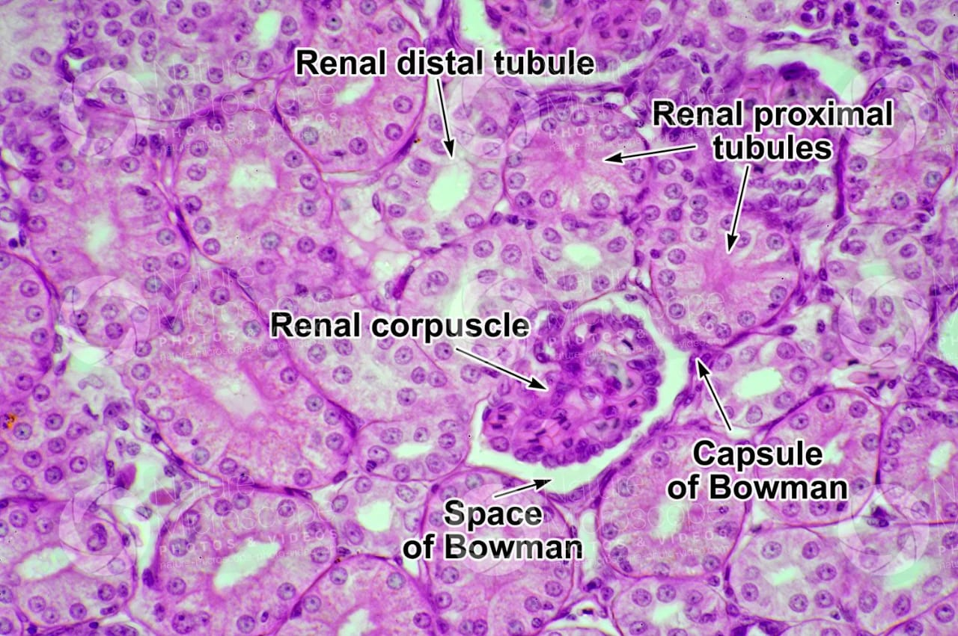

plate 1-Histopathological slide 1

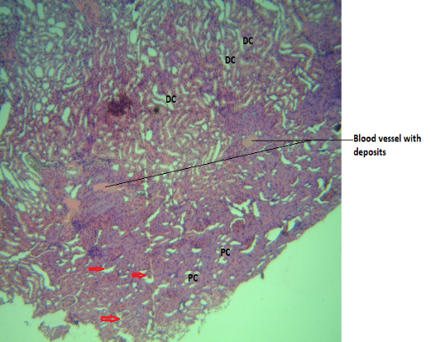

plate 2- Histopathological slide 2

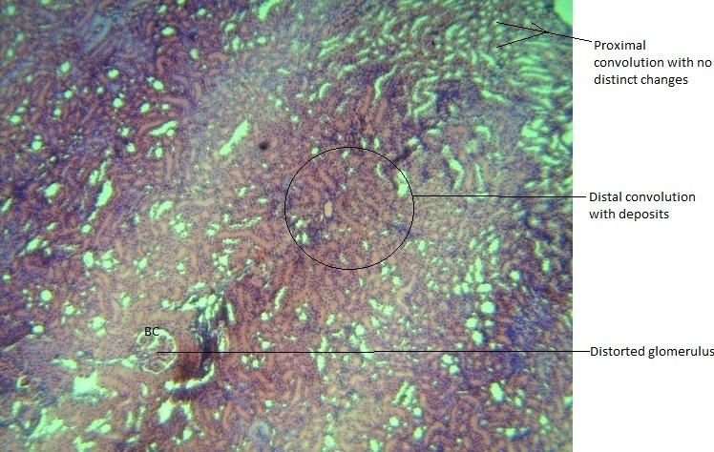

plate 3- Histopathological slide 3

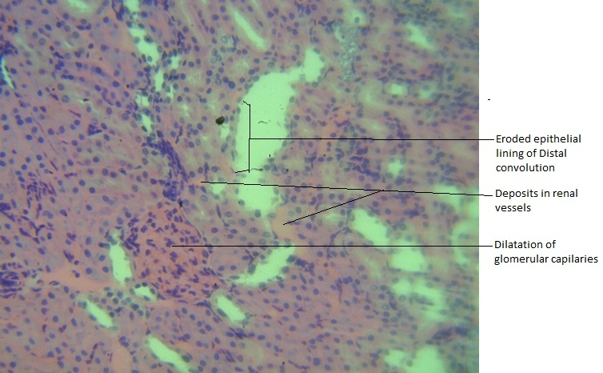

plate 4- Histopathological slide 4

**Histopathological Findings**

* **Liver (200 mg/kg group):** Showed severe hepatocellular necrosis, cytoplasmic vacuolization, and infiltration of inflammatory cells.
* **Kidney (200 mg/kg group):** Demonstrated tubular necrosis, glomerular atrophy, and interstitial inflammation.
* Lower dose groups showed milder, but still evident, cellular degeneration.
* **Table 3.1. Liver Function Markers**
* There was a significant, dose-dependent increase in serum ALT and AST levels in rats treated with smoked fish extract:

| **Group** | **ALT (U/L)** | **AST (U/L)** |
| --- | --- | --- |
| Control | 50 ± 5 | 45 ± 4 |
| 50 mg/kg | 85 ± 7 | 80 ± 6 |
| 100 mg/kg | 120 ± 10 | 110 ± 8 |
| 200 mg/kg | **150 ± 12** | **135 ± 10** |

* **Table 3.2. Kidney Function Markers**

| **Group** | **Urea (mg/dL)** | **Creatinine (mg/dL)** |
| --- | --- | --- |
| Control | 20 ± 2 | 0.6 ± 0.1 |
| 50 mg/kg | 35 ± 3 | 1.0 ± 0.1 |
| 100 mg/kg | 50 ± 4 | 1.4 ± 0.1 |
| 200 mg/kg | **65 ± 5** | **1.8 ± 0.2** |

Increased serum urea and creatinine levels denote impaired renal function. These effects are consistent with nephrotoxicity caused by bioaccumulative contaminants such as cadmium and mercury found in smoked fish.

* **Table 3.3 Oxidative Stress Markers**

| **Group** | **MDA (nmol/mg protein)** | **SOD Activity (% change)** |
| --- | --- | --- |
| Control | 1.2 ± 0.2 | Baseline |
| 50 mg/kg | 2.4 ± 0.3 | -15% |
| 100 mg/kg | 3.5 ± 0.4 | -30% |
| 200 mg/kg | **4.5 ± 0.5** | **-40%** |

**Table 3.4** GCMS FROM THE SMOKED FISH EXTRACT

* **EPA Priority PAHs in Smoked Fish with TEFs and BaPeq**

| **S/N** | **PAH Compound** | **Abbreviation** | **Molecular Formula** | **TEF** | **Concentration (μg/kg)** | **BaPeq (μg/kg)** |
| --- | --- | --- | --- | --- | --- | --- |
| 1 | Naphthalene | NAP | C₁₀H₈ | 0.001 | 45.0 | 45.0 × 0.001 = **0.045** |
| 2 | Acenaphthylene | ACY | C₁₂H₈ | 0.001 | 30.0 | 30.0 × 0.001 = **0.030** |
| 3 | Acenaphthene | ACE | C₁₂H₁₀ | 0.001 | 28.0 | 28.0 × 0.001 = **0.028** |
| 4 | Fluorene | FLU | C₁₃H₁₀ | 0.001 | 25.0 | 25.0 × 0.001 = **0.025** |
| 5 | Phenanthrene | PHE | C₁₄H₁₀ | 0.001 | 50.0 | 50.0 × 0.001 = **0.050** |
| 6 | Anthracene | ANT | C₁₄H₁₀ | 0.01 | 20.0 | 20.0 × 0.01 = **0.200** |
| 7 | Fluoranthene | FLA | C₁₆H₁₀ | 0.001 | 35.0 | 35.0 × 0.001 = **0.035** |
| 8 | Pyrene | PYR | C₁₆H₁₀ | 0.001 | 40.0 | 40.0 × 0.001 = **0.040** |
| 9 | Benzo[a]anthracene | BaA | C₁₈H₁₂ | 0.1 | 12.0 | 12.0 × 0.1 = **1.200** |
| 10 | Chrysene | CHR | C₁₈H₁₂ | 0.01 | 10.0 | 10.0 × 0.01 = **0.100** |
| 11 | Benzo[b]fluoranthene | BbF | C₂₀H₁₂ | 0.1 | 9.0 | 9.0 × 0.1 = **0.900** |
| 12 | Benzo[k]fluoranthene | BkF | C₂₀H₁₂ | 0.1 | 6.0 | 6.0 × 0.1 = **0.600** |
| 13 | Benzo[a]pyrene | BaP | C₂₀H₁₂ | 1.0 | 8.0 | 8.0 × 1.0 = **8.000** |
| 14 | Indeno[1,2,3-cd]pyrene | IND | C₂₂H₁₂ | 0.1 | 4.0 | 4.0 × 0.1 = **0.400** |
| 15 | Dibenzo[a,h]anthracene | DahA | C₂₂H₁₄ | 1.0 | 3.0 | 3.0 × 1.0 = **3.000** |
| 16 | Benzo[ghi]perylene | BghiP | C₂₂H₁₂ | 0.01 | 7.0 | 7.0 × 0.01 = **0.070** |

**4 Discussion**

This study's findings demonstrate a dose-dependent histopathological alteration in both liver and kidney tissues of rats exposed to smoked fish extract. At the highest dose (200 mg/kg), extensive hepatocellular necrosis, cytoplasmic vacuolation, and inflammatory infiltrates were observed in liver sections, indicating significant hepatic injury. These histological features are consistent with the well-documented hepatotoxic effects of PAHs, which are prevalent in smoked fish due to the byproducts of combustion (Akpambang et al., 2009; Duedahl-Olesen et al., 2015; Gheorghe et al., 2019). PAHs are known to induce oxidative stress, which in turn leads to cellular damage and apoptosis in liver cells (Darwish et al., 2019; Forsberg et al., 2012).

Similar damage was evident in the renal tissues, particularly in the high-dose group, which showed signs of tubular necrosis, interstitial inflammation, and glomerular sclerosis. These pathological changes align with the nephrotoxic effects of both PAHs and heavy metals, which have been previously detected in smoked fish from various regions, including Nigeria (Anigboro et al., 2011; Daniel et al., 2013). The kidneys, being the primary organs responsible for the excretion of xenobiotics, are highly susceptible to damage, particularly when detoxification processes are overwhelmed (Domingo & Nadal, 2015; Alomirah et al., 2011).

In the moderate and low-dose groups, milder tissue damage was observed, suggesting that there may be a toxicological threshold below which the organs can compensate for or repair the inflicted injury. However, even in these groups, early signs of vacuolar degeneration and focal inflammation suggest that subclinical toxicity may be progressing, emphasizing the need for continuous monitoring of smoked fish consumption (EFSA, 2008; Alomirah et al., 2011).

The oxidative stress mechanisms underlying the observed tissue damage were further supported by biochemical assays, which revealed elevated levels of malondialdehyde (MDA) and reduced activities of antioxidant enzymes (SOD and GSH). These findings align with earlier studies that have highlighted the oxidative damage associated with PAH exposure (Darwish et al., 2019; Forsberg et al., 2012). This oxidative stress likely plays a crucial role in mediating the toxic effects observed in the liver and kidney tissues of the rats.

Moreover, the presence of biogenic amines in the smoked fish extract may have exacerbated the toxicity, potentially through nitrosamine formation and disruption of cellular functions. Biogenic amines such as histamine are known to induce inflammatory responses and compromise cellular membrane integrity in gastrointestinal and renal tissues (Al Bulushi et al., 2009; Douny et al., 2021).

**5 Conclusion**

This study establishes that **chronic exposure to smoked fish extract induces significant histopathological damage** in the liver and kidney tissues of albino rats. The structural changes, especially at higher doses, suggest that smoked fish contaminated with toxic compounds such as PAHs and heavy metals poses **a serious health risk**. Both hepatic and renal systems appear highly susceptible, reflecting the systemic toxicity of bioaccumulated toxicants from smoked food sources.

**5.2 Recommendations**

1. **Public health authorities** should intensify surveillance of smoked food products for PAHs and related contaminants.
2. **Consumers should be cautioned** against the frequent or excessive consumption of commercially smoked fish, particularly from unregulated vendors.
3. Further studies should explore:
   * The **long-term effects** of smoked fish consumption.
   * The **reversibility** of the observed histopathological changes.
   * The efficacy of **natural or synthetic antioxidants** in mitigating the toxicity.
4. There is a need to **standardize smoking methods** and develop safer food processing technologies that minimize the formation of harmful compounds.
5. This model can serve as a basis for **regulatory agencies** to set permissible exposure limits for PAHs in smoked foods in Nigeria and similar settings.

Disclaimer (Artificial intelligence)

Option 1:

Author(s) hereby declare that NO generative AI technologies such as Large Language Models (ChatGPT, COPILOT, etc.) and text-to-image generators have been used during the writing or editing of this manuscript.

Option 2:

Author(s) hereby declare that generative AI technologies such as Large Language Models, etc. have been used during the writing or editing of manuscripts. This explanation will include the name, version, model, and source of the generative AI technology and as well as all input prompts provided to the generative AI technology

Details of the AI usage are given below:

1.

2.

3.

**References:**

Abbas, M. M. M., Shehata, S. M., Talab, A. S., & Mohamed, M. H. (2021). Effect of traditional processing methods on the cultivated fish species, Egypt. Part I. Mineral and heavy metal concentrations. Biological Trace Element Research, 1-15. https://doi.org/10.1007/s12011-021-02840-w

Akpambang, V. O. E., Purcaro, G., Lajide, L., Amoo, I. A., Conte, L. S., & Moret, S. (2009). Determination of polycyclic aromatic hydrocarbons (PAHs) in commonly consumed Nigerian smoked/grilled fish and meat. Food Additives & Contaminants (A), 26(7), 1096–1103. https://doi.org/10.1080/02652030902855406

Al Bulushi, I., Poole, S., Deeth, H. C., & Dykes, G. A. (2009). Biogenic amines in fish: Roles in intoxication, spoilage, and nitrosamine formation—A review. Critical Reviews in Food Science and Nutrition, 49(4), 369–377. https://doi.org/10.1080/10408390802067514

Alomirah, H., Al-Zenki, S., Al-Hooti, S., Zaghloul, S., Sawaya, W., Ahmed, N., & Kannan, K. (2011). Concentrations and dietary exposure to polycyclic aromatic hydrocarbons (PAHs) from grilled and smoked foods. Food Control, 22, 2028–2035. https://doi.org/10.1016/j.foodcont.2011.05.024

Anigboro, F. O., Akpoveta, O. V., & Aweatefe, K. J. (2011). Determination of concentration levels of heavy metals in different species of smoked fishes from three markets in Agbor, Delta state, Nigeria. Agbor Journal of Science Education, 4, 81–88.

Darwish, W. S., Chiba, H., El-Ghareeb, W. R., Elhelaly, A. E., & Hui, S.-P. (2019). Determination of polycyclic aromatic hydrocarbon content in heat-treated meat retailed in Egypt: Health risk assessment, benzo[a]pyrene induced mutagenicity and oxidative stress in human colon (CaCo-2) cells and protection using rosmarinic and ascorbic acids. Food Chemistry, 290, 114–124. https://doi.org/10.1016/j.foodchem.2019.03.128

Duedahl-Olesen, L., Aaslyng, M., Meinert, L., Christensen, T., Jensen, A. H., & Binderup, M.-L. (2015). Polycyclic aromatic hydrocarbons (PAH) in Danish barbecued meat. Food Control, 57, 169–176. https://doi.org/10.1016/j.foodcont.2015.04.012

Gheorghe, P., Iulia, D., Valentin, N., Valter, E. D., & Carmen, I. (2019). Research on the detection of polycyclic aromatic hydrocarbons (PAHs) from fish and smoked fish samples, the values obtained and the significance of their presence on human health. Romanian Biotechnological Letters, 24(4), 697–704. https://doi.org/10.25083/rbl/24.4/697.704

Forsberg, N. D., Stone, D., Harding, A., Harper, B., Harris, S., Matzke, M. M., Cardenas, A., Waters, K. M., & Anderson, K. A. (2012). Effect of Native American fish smoking methods on dietary PAH concentrations. Environmental Toxicology, 27, 461–469. https://doi.org/10.1002/etc.1865