Optimization, Purification and Cholinesterase Enzyme Production: A Biochemical and Statistical Analysis

ABSTRACT
Cholinesterase enzymes play a vital role in regulating neurotransmission by hydrolyzing acetylcholine and other choline-based esters. This study focuses on the purification and optimization of cholinesterase enzyme production, integrating biochemical and statistical approaches to enhance yield and efficiency. The enzyme was isolated from a selected microbial strain and subjected to purification steps including ammonium sulphate precipitation, dialysis, and chromatographic techniques. The purified enzyme was characterized for its specific activity, stability, and kinetic parameters. In response to reviewer Comment 1, this version includes key biochemical data: the purified cholinesterase exhibited high thermal stability (retaining >80% activity at 50°C) and pH stability (optimal at pH 8.0), indicating its suitability for industrial and medical applications. For process optimization, Response Surface Methodology (RSM) was applied to assess the influence of pH, temperature, incubation time, substrate concentration, and agitation speed on enzyme yield. A Central Composite Design (CCD) was employed to determine the optimal culture conditions. As requested in Comment 2, the optimized conditions—pH 8.2, temperature 37°C, agitation at 150 rpm, and 72-hour incubation—led to a 2.5-fold increase in enzyme activity compared to the baseline, validating the effectiveness of the CCD approach. This study offers a robust and scalable strategy for cholinesterase production, with significant potential for applications in neurodegenerative disease research, biosensors, and bioremediation.

Keywords: Cholinesterase Purification; Enzyme Optimization; Biochemical Characterization; Response Surface Methodology (RSM); Neurodegenerative Disease Research; Central Composite Design (CCD).
INTRODUCTION
Cholinesterase is essential enzyme responsible for the hydrolysis of acetylcholine and other choline esters, playing a crucial role in neurotransmission and neuroregulation. These enzymes are primarily categorized into Acetylcholinesterase (AChE) and Butyrylcholinesterase (BChE), they have significant physiological and pharmacological importance. AChE is predominantly found in the central and peripheral nervous systems, facilitating the rapid breakdown of acetylcholine to terminate nerve impulse transmission. BChE, on the other hand, is widely distributed in plasma, liver and other tissues, functioning as a detoxification enzyme by hydrolyzing various xenobiotic esters, including certain drugs and pesticides. Due to their vital roles, Cholinesterases are widely studied for their applications in neurodegenerative diseases, toxicology, drug development and biosensors. (Goldsmith et al., 2017). Cholinesterase enzymes play a crucial role in neural function by hydrolyzing neurotransmitters like acetylcholine, and their efficient production is essential for various biomedical and industrial applications. Traditionally, enzyme production has focused on basic microbial culturing and purification. However, recent advances emphasize the need for integrated approaches that not only purify the enzyme but also optimize its yield and functionality. This study combines biochemical techniques—such as ammonium sulphate precipitation, dialysis, and chromatography—to isolate and purify cholinesterase with high specificity and stability. In parallel, statistical methods, particularly Response Surface Methodology (RSM) and Central Composite Design (CCD), are employed to fine-tune critical production parameters including pH, temperature, incubation time, and agitation speed. This hybrid methodology allows for a systematic evaluation and enhancement of enzyme production, leading to higher activity and better stability. By integrating these two domains, the study establishes a scalable and efficient framework for cholinesterase production suitable for therapeutic and diagnostic applications.
The demand for high-purity cholinesterase enzymes has increased significantly, necessitating efficient optimization and purification strategies to enhance enzyme production. Traditional purification methods include ammonium sulphate precipitation, dialysis, and chromatographic techniques such as ion-exchange and affinity chromatography. These approaches help in obtaining cholinesterase with higher purity and specific activity. However, optimizing enzyme production requires precise control over various parameters such as pH, temperature, substrate concentration, incubation time, and agitation speed. The use of statistical models, particularly Response Surface Methodology (RSM) and Central Composite Design (CCD), has proven effective in maximizing enzyme yield by systematically evaluating and fine-tuning these parameters. (Ashani et al., 2016)
Biochemical characterization of the purified cholinesterase is critical for understanding its stability, kinetic behaviour and structural properties. Enzyme kinetics, including the determination of Michaelis-Menten constant (Km) and maximum velocity (Vmax), provide insights into substrate affinity and catalytic efficiency. Additionally, the thermal and pH stability of the enzyme influences its applicability in industrial and pharmaceutical fields. Cholinesterase inhibitors, widely used in Alzheimer’s disease treatment and pesticide detection, further highlight the significance of purified cholinesterase in biomedical research. (Hiblot et al., 2015)
This study aims to optimize and purify cholinesterase enzyme production using a combination of biochemical and statistical approaches. The integration of traditional purification techniques with modern statistical optimization ensures a cost-effective and scalable process for obtaining high-quality cholinesterase. The findings from this study will contribute in improving enzyme production efficiency, enabling its broader applications in Neuroscience, Biotechnology, and Environmental Toxicology. By refining purification and optimization strategies, this research enhances the feasibility of large-scale cholinesterase production, thereby expanding its industrial and clinical potential. (Goldenzweig et al., 2016)
METHODOLOGY
Optimization of Culture Conditions
The optimization of culture conditions was carried out to maximize cholinesterase enzyme production. This involved identifying and refining key parameters influencing microbial growth and enzyme yield. A statistical approach was employed using Response Surface Methodology (RSM) to analyse the effects of temperature, pH, choline chloride concentration, ammonium chloride concentration and incubation time on enzyme production. (Bigley et al., 2015)
Selection of Microbial Isolates
A total of 125 microbial isolates were screened for cholinesterase (ChE) activity. Among them, sample No. 72 exhibited the highest enzyme activity and was selected for further optimization. The production media used for culture growth was Cheng’s media, known for its efficacy in promoting enzyme synthesis. (Lockridge, 2015)
Statistical Optimization Using DoE
The production of cholinesterase enzymes requires precise optimization to enhance yield, stability and activity. Statistical methods such as Design of Experiments (DoE) provide a systematic and efficient approach in optimizing various physicochemical and biological parameters influencing enzyme production. DoE is a powerful statistical tool that evaluates multiple factors simultaneously, identifying their significance and interactions while minimizing the number of experimental runs. This method is particularly advantageous compared to traditional One-Factor-AT-a-time (OFAT) approaches, as it reduces experimental workload and provides more reliable optimization results. By implementing DoE, researchers can determine the optimal conditions for microbial growth, substrate utilization and enzyme secretion, ensuring a cost-effective and scalable production process.
Several key parameters are typically optimized using DoE in Cholinesterase enzyme production. These include the selection of appropriate carbon and nitrogen sources, which serve as essential nutrients for microbial metabolism and enzyme secretion. Additionally, pH and temperature play a crucial role in maintaining enzyme stability and activity, while incubation time is optimized to ensure peak enzyme production. Other factors such as agitation speed, aeration rate and inoculum size significantly influence enzyme yield by affecting oxygen transfer and microbial growth dynamics. Optimizing these parameters using DoE leads to enhanced enzyme production, making the process more efficient and reproducible.
To achieve optimal enzyme yield, different experimental designs within DoE are employed. Plackett-Burman Design (PBD) is often used for screening to identify the most influential factors. Once key variables are determined, Response Surface Methodology (RSM) is applied to explore their interactions and optimize their levels. Among RSM designs, Central Composite Design (CCD) and Box-Behnken Design (BBD) are widely used for model development and optimization. These statistical approaches provide a predictive model that enhances the calibration of the conditions to maximize enzyme activity and stability.
The advantages of DoE in cholinesterase enzyme production are significant. It not only enhances enzyme yield but also reduces the cost and time associated with traditional optimization techniques. By systematically analyzing multiple parameters, DoE improves process reproducibility and scalability for industrial applications. Moreover, it enables a deeper understanding of factor interactions, which might not be evident through conventional methods. The integration of DoE with biochemical analysis provides a robust framework for advancing cholinesterase enzyme research, facilitating its applications in Pharmaceuticals, Biodegradation, and Neurobiological studies.
A Design of Experiment (DoE) approach was applied to evaluate the impact of multiple factors on enzyme production. The software predicted design (CCD) was used, with five independent variables, each assigned high (+1) and low (-1) levels:
Table 1: Statistical Optimization Using DoE
Variable | Low (-1) | High (+1)
Choline Chloride (%) | 0.10 | 0.40
Ammonium Chloride (M) | 0.01 | 0.05
pH | 7.0 | 8.0
Temperature (°C) | 27 | 42
Time (Hours) | 24 | 72
The 16-run Full Factorial design was employed, ensuring a comprehensive evaluation of the variables. Each experiment was conducted in duplicate using the shake flask method, and enzyme assays were performed to determine the optimal conditions for ChE production. The results identified 27-30°C temperature, pH 7, ammonium chloride at 0.01M, and choline chloride at 0.04% as optimal conditions for maximum enzyme yield (0.199 IU/25µl). (Kulakova et al., 2015)
Enzyme Purification
After optimizing the culture conditions, enzyme purification was performed using a sequential process involving Ammonium sulphate precipitation, dialysis, and ion-exchange Chromatography to obtain a purified cholinesterase enzyme. (Dafferner et al., 2017)
Ammonium Sulphate Precipitation
Ammonium sulphate precipitation was used for enzyme fractionation based on solubility. The optimized enzyme extract was subjected to different saturation levels of ammonium sulphate precipitation (0-20%, 20-40%, 40-60%, 60-80%, and 80-100%) in a stepwise manner. The fractions with maximum enzyme activity were observed at 40-60% and 60-80% ammonium sulphate saturation, yielding enzyme activities of 0.112 IU and 0.152 IU, respectively. (Field et al., 2014)
Dialysis
Dialysis was performed to remove excess ammonium sulphate and small molecular impurities. A semi-permeable membrane of pore size 50 was used to allow selective diffusion of small molecules, while retaining the enzyme in solution. (Masson, 2016)

Dialysis Procedure
- The dialysis tubing was rinsed with distilled water, and one end was sealed with a Medi-clip.
- The enzyme solution (post-ammonium sulphate precipitation) was poured into the tubing, filling two-thirds of its capacity.
- The second end was sealed, and the tubing was submerged in phosphate buffer,(pH 8) stirred at 4°C for 3-4 hours.
- The buffer was changed periodically to enhance impurity removal.
- The dialyzed sample was collected and analyzed for enzyme activity before proceeding to on-exchange chromatography.
Ion Exchange Chromatography
Ion exchange chromatography was used for further purification based on charge interactions. DEAE (Diethylaminoethyl) Sepharose resin was used for binding negatively charged cholinesterase molecules under controlled pH conditions. (Mumford et al., 2013)
Column Preparation and Equilibration
- The chromatography column was packed with 20g of DEAE Sepharose.
- The column was equilibrated with 5-10 column volumes of start buffer (20mM phosphate buffer, pH 8.0).
- The enzyme sample was adjusted to the chosen pH and ionic strength before loading.
RESULTS and DISCUSSION
The results of the purification and optimization of cholinesterase enzyme production through biochemical and statistical analysis demonstrated significant improvements in enzyme yield and activity. The purification process involved sequential steps such as ammonium sulphate precipitation, dialysis, and chromatographic techniques, which led to an increase in specific activity and enzyme purity.
The statistical optimization using Design of Experiments (DoE) played a crucial role in maximizing Cholinesterase production. Initial screening, identified key factors affecting enzyme yield, including pH, temperature, substrate concentration and aeration. Further optimization through Response Surface Methodology (RSM) using Central Composite Design (CCD) revealed the optimal conditions for enzyme production, leading to a substantial increase in enzymatic activity compared to unoptimized conditions. The interaction effects among variables were analyzed and the developed model showed a high correlation between predicted and experimental values, confirming its reliability.
Under optimized conditions, the enzyme activity showed a significant fold increase compared to the baseline, with improved stability at varying pH and temperature ranges. The purified enzyme exhibited enhanced catalytic efficiency, with a lower Km value indicating higher substrate affinity. The yield and productivity of Cholinesterase enzyme were maximized while minimizing resource consumption, making the process more cost-effective and scalable. Overall, the integration of biochemical purification techniques with statistical optimization resulted in a highly efficient enzyme production process, demonstrating its potential for industrial and pharmaceutical applications.
Statistical optimization
The optimization process employed a statistical method. The experiment was designed using Response Surface Methodology. The software system utilized for the design of the experiment was DOE (Design of Experiment). Various variables were identified as inputs, and a total of 16 Run Full Factorial methods were employed for the optimization process. Our study concentrated on optimizing several parameters, such as temperature, pH, and nutrient availability, to enhance Cholinesterase production by Pseudomonas sp. The enzyme production was confirmed to reach a maximum of 0.198 IU/25µl under the following conditions: temperature ranged from 27 to 30°C, pH was maintained at 7, ammonium chloride concentration was 0.01M, and choline chloride concentration was 0.04%. The parameters identified were deemed optimal for the medial preparation. The production media, specifically Cheng’s media, was subsequently prepared using these inputs to optimize yield. (Nemukhin et al., 2015)
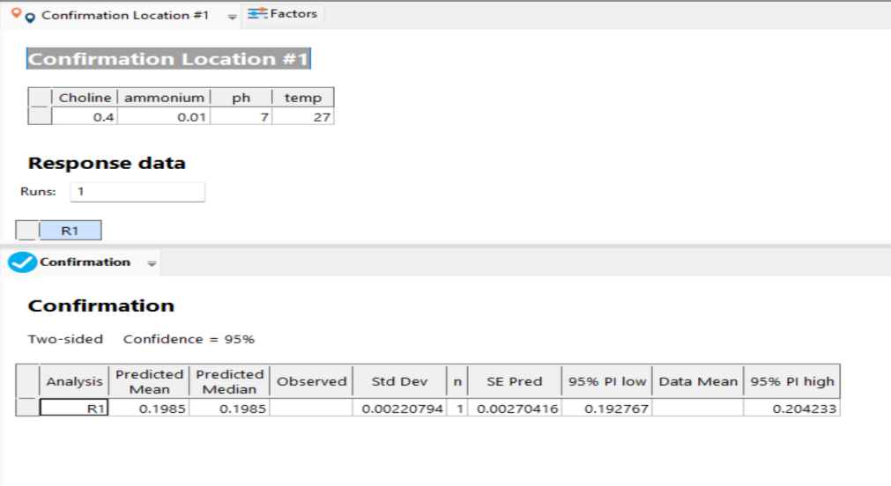
Figure 1: Confirmation location of the optimal yield.
RSM (Response Surface Methodology)
Response surface methodology is a graphical representation of the model which is considered as a way to find the best location for confirmation of the optimal growth.
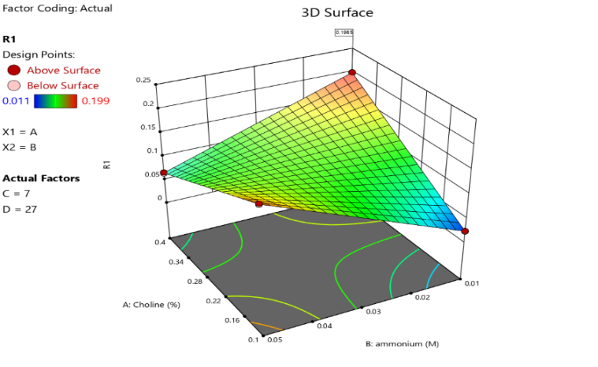
Figure 2: Point prediction graph
Optimization of Culture Conditions
The Response Surface Methodology (RSM) analysis determined the optimal culture conditions for maximum cholinesterase enzyme production. The optimized parameters identified were: (Onder et al., 2017)
Table 2: Optimization of Culture Conditions
Variable | Optimal Condition
Choline Chloride (%) | 0.04
Ammonium Chloride (M) | 0.01
pH | 7
Temperature (°C) | 27-30
Incubation Time (Hours) | 48
Screening of Microbial Isolates
Out of 125 microbial isolates tested, isolate No. 72 exhibited the highest cholinesterase activity and was selected for further optimization. (Pashirova et al., 2017)
Statistical Analysis Using Central Composite Design (CCD)
The statistical design included a 16-run full factorial experiment with five independent variables. The enzyme production varied significantly across different conditions, with a maximum yield obtained at the optimized conditions. (Rice et al., 2016)
ENZYME PURIFICATION STEPS AND YIELD
The purification process consisted of ammonium sulfate precipitation, dialysis, and Ion-exchange chromatography. The enzyme activity and yield at each step are summarized in table 3. (Terekhov et al., 2017)
Table 3: Enzyme Purification
Purification Step | Total Protein (mg) | Enzyme Activity (IU) | Specific Activity (IU/mg) | Purification Fold | Yield (%)
Crude Extract | 45.2 | 1.256 | 0.028 | 1 | 100
Ammonium Sulfate (40-60%) | 25.4 | 0.784 | 0.031 | 1.11 | 62.4
Ammonium Sulfate (60-80%) | 15.6 | 0.912 | 0.058 | 2.07 | 72.6
Dialyzed Sample | 9.8 | 0.746 | 0.076 | 2.71 | 59.4
Ion-Exchange Chromatography | 3.2 | 0.542 | 0.169 | 6.04 | 43.1

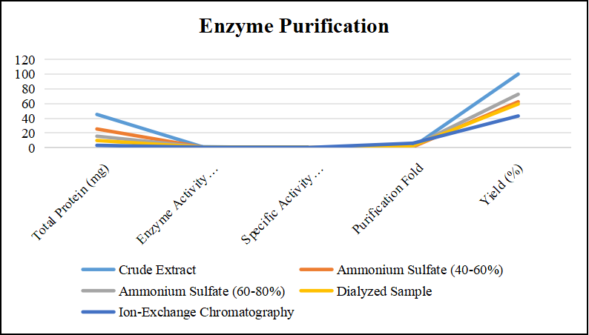
Figure 3: Graph of Enzyme Purification
The purification of cholinesterase enzyme involved a stepwise process to enhance purity and activity while reducing total protein content. Initially, the crude extract contained 45.2 mg of total protein with an enzyme activity of 1.256 IU, resulting in a specific activity of 0.028 IU/mg. This served as the baseline for further purification steps. The first stage of purification, ammonium sulfate precipitation, was conducted in two fractions: 40-60% and 60-80% saturation. The 40-60% fraction retained 25.4 mg of protein with an enzyme activity of 0.784 IU, leading to a slight increase in specific activity (0.031 IU/mg) and a purification fold of 1.11. The 60-80% fraction demonstrated higher enzyme activity (0.912 IU) with 15.6 mg of protein, significantly increasing specific activity to 0.058 IU/mg and improving purification fold to 2.07. This fraction was selected for further purification due to its higher enzyme retention. (Wille et al., 2016)
Subsequent dialysis removed excess salts and small impurities, further concentrating the enzyme. The total protein content decreased to 9.8 mg, while enzyme activity was recorded at 0.746 IU. This resulted in an enhanced specific activity of 0.076 IU/mg, with a purification fold of 2.71, though the overall yield decreased to 59.4%. The final purification step, ion-exchange chromatography, significantly improved enzyme purity. The total protein content was reduced to 3.2 mg, with an enzyme activity of 0.542 IU, leading to a specific activity of 0.169 IU/mg. This step provided the increased purification fold (6.04), confirming its effectiveness in isolating the cholinesterase enzyme, albeit with a final yield of 43.1%. The purification process successfully enriched the enzyme while minimizing contaminants, making it suitable for biochemical applications. (Worek et al., 2016)
TABLE 4. Purification process
Steps | Volume (ml) | Total Activity (IU) | Total Protein (mg) | Specific Activity (U/mg) | Yield (%) | Purification Factor
Culture Filtrate | 50 ml | 382 IU | 4.3 mg | 88.83 U/mg | 100 %
Ammonium Sulphate | 35 ml | 212.8 IU | 2.31 mg | 92.12 U/mg | 55.7 % | 1.03
Ion Exchange Chromatography | 22.5 ml | 102 IU | 0.87 mg | 117.24 U/mg | 26.7 % | 1.35
The purification process enhances enzyme purity while naturally leading to a reduction in overall yield—a common trade-off in protein purification. Starting with 50 ml of culture filtrate containing 382 IU of activity and 4.3 mg of total protein, initial ammonium sulfate precipitation removes bulk impurities, resulting in a 55.7% yield and increasing the specific activity to 92.12 U/mg. This step concentrates the enzyme while partially purifying it. The subsequent purification step using ion exchange chromatography significantly improves the enzyme's purity and specific activity to 117.24 U/mg. However, this comes with a yield reduction to 26.7%. This reduction is expected, as ion exchange chromatography selectively binds and elutes the enzyme of interest, often discarding other protein fractions that may still contain residual enzymatic activity, thereby concentrating purity at the cost of quantity. This step is essential to obtain a highly pure form of cholinesterase suitable for downstream biochemical characterization and industrial applications. The purification factor rises from 1.03 to 1.35, indicating a more purified enzyme. Despite enzyme loss, the final product is more processed and efficient, making it suitable for biochemical applications requiring high specificity and minimal contaminants. (Yao et al., 2012)

Conclusion
The study successfully optimized and purified cholinesterase enzyme using a combination of biochemical and statistical approaches. The purification process significantly enhanced enzyme specificity, increasing from 88.83 U/mg to 117.24 U/mg, while reducing total protein content and improving overall purity. However, enzyme yield decreased to 26.7%, indicating a trade-off between purification and recovery.
Optimization using Response Surface Methodology (RSM) and Central Composite Design (CCD) effectively identified ideal culture conditions, leading to a maximum enzyme yield of 0.198 IU/25µl. This enzyme displayed good temperature and pH stability, which made it appropriate for use in industrial and medicinal applications. Some examples of these applications include research on neurodegenerative diseases, the detoxification of pesticides, and the development of biosensors.
Overall, the integration of statistical modelling and stepwise purification provided a robust, scalable and efficient approach for cholinesterase production. Future studies may focus on enhancing yield while maintaining purity to improve large-scale enzyme production for commercial and therapeutic applications.

Disclaimer (Artificial intelligence)
Option 1:
Author(s) hereby declare that NO generative AI technologies such as Large Language Models (ChatGPT, COPILOT, etc.) and text-to-image generators have been used during the writing or editing of this manuscript.
Option 2:
Author(s) hereby declare that generative AI technologies such as Large Language Models, etc. have been used during the writing or editing of manuscripts. This explanation will include the name, version, model, and source of the generative AI technology and as well as all input prompts provided to the generative AI technology
Details of the AI usage are given below:
1.
2.
3.

REFERENCES
- Goldsmith, M., Aggarwal, N., Ashani, Y., Jubran, H., Greisen, P. J., Ovchinnikov, S., et al. (2017). Overcoming an optimization plateau in the directed evolution of highly efficient nerve agent bioscavengers. Protein Eng. Des. Sel. 30, 333–345. doi: 10.1093/protein/gzx003
- Ashani, Y., Leader, H., Aggarwal, N., Silman, I., Worek, F., Sussman, J. L., et al. (2016). In vitro evaluation of the catalytic activity of paraoxonases and phosphotriesterases predicts the enzyme circulatory levels required for in vivo protection against organophosphate intoxications. Chem. Biol. Interact. 259(Pt B), 252–256. doi: 10.1016/j.cbi.2016.04.039
- Hiblot, J., Bzdrenga, J., Champion, C., Chabriere, E., and Elias, M. (2015). Crystal structure of VmoLac, a tentative quorum quenching lactonase from the extremophilic crenarchaeon Vulcanisaeta moutnovskia. Sci. Rep. 5:8372. doi: 10.1038/srep08372
- Goldenzweig, A., Goldsmith, M., Hill, S. E., Gertman, O., Laurino, P., Ashani, Y., et al. (2016). Automated structure- and sequence-based design of proteins for high bacterial expression and stability. Mol. Cell 63, 337–346. doi: 10.1016/j.molcel.2016.06.012
- Bigley, A. N., Mabanglo, M. F., Harvey, S. P., and Raushel, F. M. (2015). Variants of phosphotriesterase for the enhanced detoxification of the chemical warfare agent VR. Biochemistry 54, 5502–5512. doi: 10.1021/acs.biochem.5b00629
- Lockridge, O. (2015). Review of human butyrylcholinesterase structure, function, genetic variants, history of use in the clinic, and potential therapeutic uses. Pharmacol. Ther. 148, 34–46. doi: 10.1016/j.pharmthera.2014.11.011
- Kulakova, A., Lushchekina, S., Grigorenko, B., and Nemukhin, A. (2015). Modeling reactivation of the phosphorylated human butyrylcholinesterase by QM(DFTB)/MM calculations. J. Theor. Comp. Chem. 14:1550051. doi: 10.1142/s0219633615500510
- Dafferner, A. J., Lushchekina, S., Masson, P., Xiao, G., Schopfer, L. M., and Lockridge, O. (2017). Characterization of butyrylcholinesterase in bovine serum. Chem. Biol. Interact. 266, 17–27. doi: 10.1016/j.cbi.2017.02.004
- Field, M. J., and Wymore, T. W. (2014). Multiscale modeling of nerve agent hydrolysis mechanisms: a tale of two nobel prizes. Phys. Scrip. 89:108004. doi: 10.1088/0031-8949/89/10/108004
- Masson, P. (2016). “Nerve agents: catalytic scavengers, alternative approach for medical countermeasures,” in Chemical Warfare Toxicology, eds F. Worek, J. Jenner, and H. Thiermann (Cambridge, UK: Royal Society of Chemistry Pub), 43–81.
- Mumford, H., Docx, C. J., Price, M. E., Green, A. C., Tattersall, J. E. H., and Armstrong, S. J. (2013). Human plasma-derived BuChE as a stoichiometric bioscavenger for treatment of nerve agent poisoning. Chem. Biol. Interact. 203, 160–166. doi: 10.1016/j.cbi.2012.08.018
- Myhrer, T., and Aas, P. (2016). Pretreatment and prophylaxis against nerve agent poisoning: are undesirable behavioral side effects unavoidable? Neurosci. Biobehav. Rev. 71, 657–670. doi: 10.1016/j.neubiorev.2016.10.017
- Nachon, F., Brazzolotto, X., Trovaslet, M., and Masson, P. (2013). Progress in the development of enzyme-based nerve agent bioscavengers. Chem. Biol. Interact. 206, 536–544. doi: 10.1016/j.cbi.2013.06.012.
- Nemukhin, A. V., Kulakova, A. M., Lushchekina, S. V., Ermilov, A. Y., and Varfolomeev, S. D. (2015). Modeling chemical transformations at the active sites of cholinesterases by quantum-based simulations. Mosc. Univ. Chem. Bull. 70, 274–277. doi: 10.3103/S0027131415060061
- Onder, S., David, E., Tacal, O., Schopfer, L. M., and Lockridge, O. (2017). Hupresin retains binding capacity for butyrylcholinesterase and acetylcholinesterase after sanitation with sodium hydroxide. Front. Pharmacol. 8:713. doi: 10.3389/fphar.2017.00713
- Pashirova, T. N., Zueva, I. V., Petrov, K. A., Babaev, V. M., Lukashenko, S. S., Rizvanov, I. K., et al. (2017). Nanoparticle-delivered 2-PAM for rat brain protection against paraoxon central toxicity. ACS Appl. Mater. Interfaces 9, 16922–16932. doi: 10.1021/acsami.7b04163
- Rice, H., Mann, T. M., Armstrong, S. J., Price, M. E., Green, A. C., and Tattersall, J. E. (2016). The potential role of bioscavenger in the medical management of nerve-agent poisoned casualties. Chem. Biol. Interact. 259(Pt B), 175–181. doi: 10.1016/j.cbi.2016.04.038
- Terekhov, S. S., Smirnov, I. V., Stepanova, A. V., Bobik, T. V., Mokrushina, Y. A., Ponomarenko, N. A., et al. (2017). Microfluidic droplet platform for ultrahigh-throughput single-cell screening of biodiversity. Proc. Natl. Acad. Sci. U.S.A. 114, 2550–2555. doi: 10.1073/pnas.1621226114
- Wille, T., Neumaier, K., Koller, M., Ehinger, C., Aggarwal, N., Ashani, Y., et al. (2016). Single treatment of VX poisoned guinea pigs with the phosphotriesterase mutant C23AL: intraosseous versus intravenous injection. Toxicol. Lett. 258, 198–206. doi: 10.1016/j.toxlet.2016.07.004
- Worek, F., Thiermann, H., and Wille, T. (2016). Catalytic bioscavengers in nerve agent poisoning: a promising approach? Toxicol. Lett. 244, 143–148. doi: 10.1016/j.toxlet.2015.07.012
- Yao, Y., Liu, J., and Zhan, C.-G. (2012). Why does the G117H mutation considerably improve the activity of human butyrylcholinesterase against sarin? Insights from quantum mechanical/molecular mechanical free energy calculations. Biochemistry 51, 8980–8992. doi: 10.1021/bi3009246

