Study of the role of catalyst in fluidised catalytic cracking (FCC) of atmospheric residue

**Abstract**

For several years now, the oil market has been transforming in the face of growing global demand for fuels, while at the same time, demand for heavy fuel oil is declining (Danial-Fortan, 2010). At the same time, dwindling conventional oil resources are gradually being replaced by increasingly heavier oils, such as tar sands. To respond to this market trend, it is essential to valorise these oil residues by converting them into lighter fractions. This article presents a literature review on the study of the role of catalysts in fluid catalytic cracking of atmospheric residues. It consists of three main parts: the first deals with crude oil and the various refining processes, the second with the various catalytic cracking processes and the study of the FCC unit, and the third with the study of some industrial catalysts and their impact on the performance of the FCC unit. Crude oil, a complex mixture of hydrocarbons and a few metals, is one of the world's most important sources of energy. In its crude state, it cannot be used by consumers. It must therefore undergo the first transformation (atmospheric or fractional distillation) in order to fractionate it into different fractions or cuts. Likewise, some of these fractions require further purification and quality improvement treatments, such as catalytic cracking in fixed, moving and fluidised beds, etc. Fluid catalytic cracking (the most widely used of all catalytic processes), a process for converting high-molecular-weight petroleum fractions into low-molecular-weight fractions in the presence of a catalyst, is one of the most important conversion processes in a refinery. The catalyst is a species that accelerates a chemical reaction and is not found in the reaction products, so it plays an essential role in catalytic cracking reactions. FCC unit catalysts are generally based on Zeolite, which comes in several types, the assembly of noble metals such as Ni, Co, Mo, W,..., supported by alumina. The efficiency or yield of the unit depends on the operating conditions (temperature and pressure), the feedstock, such as atmospheric residue, vacuum residue, vacuum diesel, etc., and the catalyst used. The FCC products reported by most researchers are LPG, gasoline, diesel and coke, whose yield in gasoline is the highest conversion rate. Apart from all the above, this study also presents a state of the art on the various techniques for analysing heavy petroleum products and residues.

**Keywords:** FCC; Catalyst; Zeolite; Crude oil; Atmospheric residue.

1. **Introduction**

Crude oil provides a significant contribution to a country's economy, resulting in a diverse range of [petroleum products](https://www.sciencedirect.com/topics/materials-science/petroleum-product) that can be used to create significant income(Emenike et al.,2022). It is a complex mixture of hydrocarbons such as kerosenes, olefins, naphthenes and aromatics, as well as traces of metals such as nickel, vanadium, arsenic, copper, etc. (Wauquier, 1994; Heinemann and Speight, 2017; Speight, 2021; Riazi, 2005). For several years now, the oil market has been transforming in the face of growing global demand for fuels, while at the same time, demand for heavy fuel oil is declining (Danial-Fortan, 2010). At the same time, dwindling conventional oil resources are gradually being replaced by increasingly heavier oils, such as tar sands. To respond to this market trend, it is essential to valorise these oil residues by converting them into lighter fractions. Residues can be converted using a variety of existing processes (Danial-Fortan, 2010 and Tissot and Welte, 1984).

Thermal cracking is the process of placing waste plastics in a [pyrolysis](https://www.sciencedirect.com/topics/chemical-engineering/pyrolysis) reactor and heating them directly under anaerobic or anoxic state conditions, so that the C-C and C-H bonds are broken to obtain hydrocarbons with different lengths of molecules, which are further distilled to obtain different types of fuel oils(Hu et al.,2024; Kumar et al.,2023). It was the first and is today one of the most widely used processes in refineries for these conversion operations. However, the major drawback of this process is the formation of coke at a high yield. To resolve the coke production rate, researchers undertook research that led to the invention of the catalytic cracking process. This has become one of the most important and widely used processes in the world (Haridoss, 2017). The catalytic cracking process was developed in 1920 by Eugene Houdry for residue upgrading and was commercialised in 1930 (Al Humaidan et al., 2013). The Houdry process was based on a fixed-bed cyclic configuration. The catalytic cracking process has been continuously refined from its origin, fixed-bed technology, to the latest fluidised-bed catalytic cracking technology. The feedstock for catalytic cracking is normally light gas oil from a vacuum distillation column (Haridoss, 2017). Catalytic cracking enables the conversion of low-value, high-molecular-weight hydrocarbons into higher-value (low-molecular-weight) products such as gasoline, LPG and diesel, as well as very important petrochemical feedstocks such as propylene, isobutylene, isobutane, butene and butane (Chen et al., 1996 and Wilczura-Wachnik). Catalytic cracked gasoline is the main product of FCC, obtained with a yield of around 50%, and represents around 25 to 30% of the gasoline pool in Western European refineries.FCC is the workhorse of modern crude oil refinery. Its regenerator plays a critical role in optimising the overall profitability by efficiently restoring the catalyst activity and enhancing the heat balance in the riser reactor (Oloruntoba et al.,2022; Tasneem et al.,2024). The main negative feature of these FCC gasolines vis-à-vis commercial fuels is their high sulfur content, and thus constitute the main vector for the presence of sulfur in fuels (Julien et al., 2015). To meet the constraints of sulfur specifications, hydrocarbons produced from catalytic cracking processes are conventionally treated by hydrotreating. The hydrotreating process involves contacting the hydrocarbon feedstock with hydrogen in the presence of a catalyst so as to convert the sulfur contained in the impurities into hydrogen sulfide, which can then be separated and converted into elemental sulfur (Julien et al., 2015).

Standard Oil of New Jersey developed its own cracking process rather than pay the high royalties demanded at the time. They commercialised the Fluid Catalytic Cracking (FCC) process within 3 years, starting in 1939 and culminating in 1942 with the start-up of PCLA#1 at their refinery in Baton Rouge, Louisiana. The inherent superiority of the fluid process in transferring both heat and catalyst ultimately made it the catalytic cracking process of choice (Brueske et al., 2015).

The main catalytic processes used in the refining of crude oil or its residues are hydrocracking, hydrotreating and fluid catalytic cracking (FCC). Hydrocracking processes convert residual oil to a lower boiling point under the action of high-temperature hydrogen (Haridoss, 2017 and IFP, 2003). These processes are particularly suited to feedstocks rich in coke precursors (aromatics, polyaromatics and asphaltenes), sulfur, nitrogen and metals. The latter are poisons for cracking catalysts.   
Numerous studies on catalytic cracking have shown that the main objective of this unit is to break down high-molecular-weight hydrocarbons into low-molecular-weight, lower-boiling hydrocarbons, particularly gasoline (Boukezoula, 2019 and Kraus, 2015). Originally, the first cracking operations for heavy oil, or petroleum residue, were thermal cracking, but the discovery of a catalyst that could produce a higher yield of gasoline with a higher octane number soon led to the use of catalytic cracking technology. Today, the most commonly used catalytic cracking unit is the fluid catalytic cracker (FCC). A barrel of crude represents around 30% of direct gasoline, but demand is close to 60% per barrel. This shows the need for an efficient catalytic cracking unit to increase gasoline production (Haridoss, 2017 and Danial-Fortan, 2010). To achieve this, it is also important to focus on the choice of catalyst to be used, based on its activity, selectivity and stability. Generally speaking, a catalyst is a substance that speeds up the rate of a reaction, but does not appear in the reaction products. In the petroleum industry, and particularly in catalytic cracking, the catalyst is a sand-like solid material which is made fluid by the vapours and hot liquids introduced into the FCC (just as water transforms sand into quicksand) (Speronello et al., 1984).

To meet consumers' demand for finished light products such as gasoline, kerosene, diesel oil, etc., which meet marketing standards, the refining industry has developed several processes, including fluid catalytic cracking. The study of the catalyst's role in the latter is one of the main objectives of our study. Specific objectives include the study of the FCC unit, the reaction mechanism, reaction kinetics and the thermodynamic limits of FCC, as well as the activity, selectivity and stability of several catalysts reported in the literature.

Almost all biological reactions and most industrial syntheses require a catalyst. Catalysis is currently the most important technology for environmental protection, i.e. for preventing emissions of various toxic chemicals (Wilczura-Wachnik). A well-known example is the catalytic converter for automobiles.   
The term "catalysis" was introduced by Berzelius in 1836. Describing various reactions, he discovered that catalysts possess special powers that can influence the affinity of chemical compounds (Wilczura-Wachnik). In the same environmental context as this study, the following five issues are probably the most important: increasing energy efficiency; reducing nitrogen oxide emissions; reducing sulphur oxide emissions; reducing emissions of volatile organic compounds; reducing water pollution (IFP, 2003).Our study will cover petroleum (composition and classification), petroleum characterisation techniques, petroleum residues, refining principles and processes, different FCC technologies, different types of catalysts and their impact on fluid catalytic cracking processes (comparative study of the efficiency of some catalysts in fluid catalytic cracking).

1. **Analytical techniques and characterisation of crude oil, heavy residues and petroleum products**

To successfully transform a petroleum fraction or a heavy petroleum residue, the feedstock must be characterised. This step is crucial for the smooth operation of a refining process such as reforming, cracking, hydroconversion, hydrocracking, visbreaking, hydrodesulfurization, hydrotreating, etc. Heavy oil fractions are high-boiling fractions (350°C+) enriched with the most polar compounds, such as resins and asphaltenes. Asphaltenes contain a multitude of molecules of varying aromaticity, with different levels of heteroatoms, metals and functional groups. Asphaltenes constitute a heterogeneous medium of dispersed molecules in terms of size and chemical composition. There is no single asphaltene unit (Merdrignac and Espinat, 2007). Table 1 below illustrates some of the characteristics of the atmospheric residue load.

**Table 1:** Characteristics of vacuum residue Feedstock (Olafadehan et al., 2018)

|  |  |  |
| --- | --- | --- |
| Property | Value | Test methods |
| Boiling point | ˃ 500°C |  |
| Specific gravity à 70°C | 0.993 g/cm3 | ASTM-1298 |
| Conradson carbon residue | 19 wt % | ASTM-1298 |
| Sulphur content | 5 wt % | IP 63 |
| Asphaltene content (+ resin) | 6 wt % | IP 143 |
| Aromatic content | 89 wt% | ASTM D2007 adopted  from Rossini and Mair |
| Saturate content | 11 wt% | ASTM D2007 adopted  from Rossini and Mair |
| Metals |  |  |
| Nickel |  | 138 ppm |
| Vanadium |  | 1643 ppm |

According to numerous researchers, Delvaux de FENFFE (1988), Avidan et al.(1989), Swistek (1992), Matar and Hatch (1994), Wauquier, Tome 1 (1994), Raseeve (2003), Riazi (2005), Gary et al. (2007), Leffler (2008), Danial-Fortan (2010), Fahim et al.(2010), Ngi (2010), Jean-Louis ( 2011), Boursier (2014), Hassen (2015), Saliha (2016), Harche (2017), Speight and Heinemann (2017), Boukezoula (2019), Dehouche (2020), Oumarou (2020), Moulian (2020), Mhemed (2021), Abderrazak and Fethi (2022), Zafiryadis et al.(2022) and Laxalde (2012)) the various techniques for analyzing and characterizing crude oils, heavy petroleum residues and petroleum derivatives. The techniques used to analyse and characterise crude oil, petroleum residues, and petroleum derivatives are as follows:

* TBP distillation;
* ASTM distillation;
* Density, specific gravity and API density;
* Refractive index and CH weight ratio;
* Analysis of sulfur content, residual carbon (CCR), sediment, water, ash, metals...SARA analysis (asphaltene precipitation, chromatography on maltenes), PONA, ndM and Kw;
* Chromatographic analysis techniques such as GC, GC-DIF;
* Spectrometric and spectroscopic analysis;
* Elemental analysis by X-ray fluorescence.

According to Oumarou (2020), the composition of a petroleum residue can be determined by GC-DIF (SFigure 1).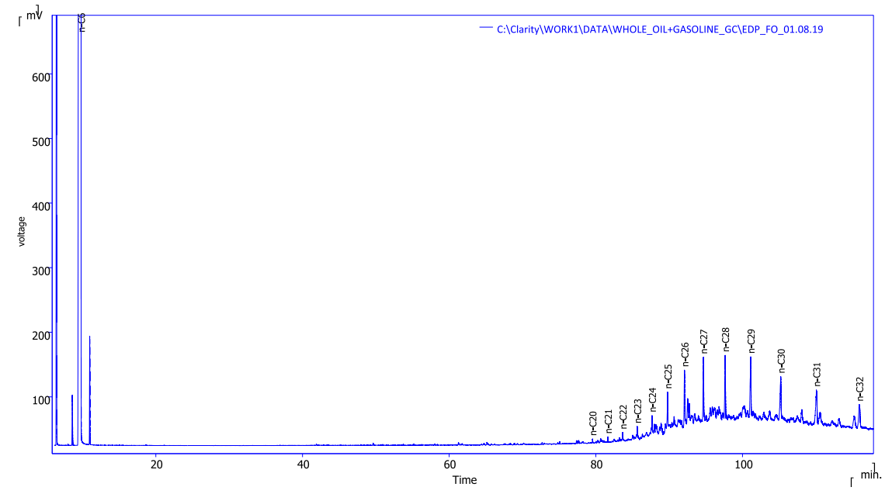

**Figure 1:** CG-DIF profile of an oil residue from SORAZ (Oumarou, 2020).

Similarly, Figure 2 shows a GC-DIF profile of a petroleum product after cracking.

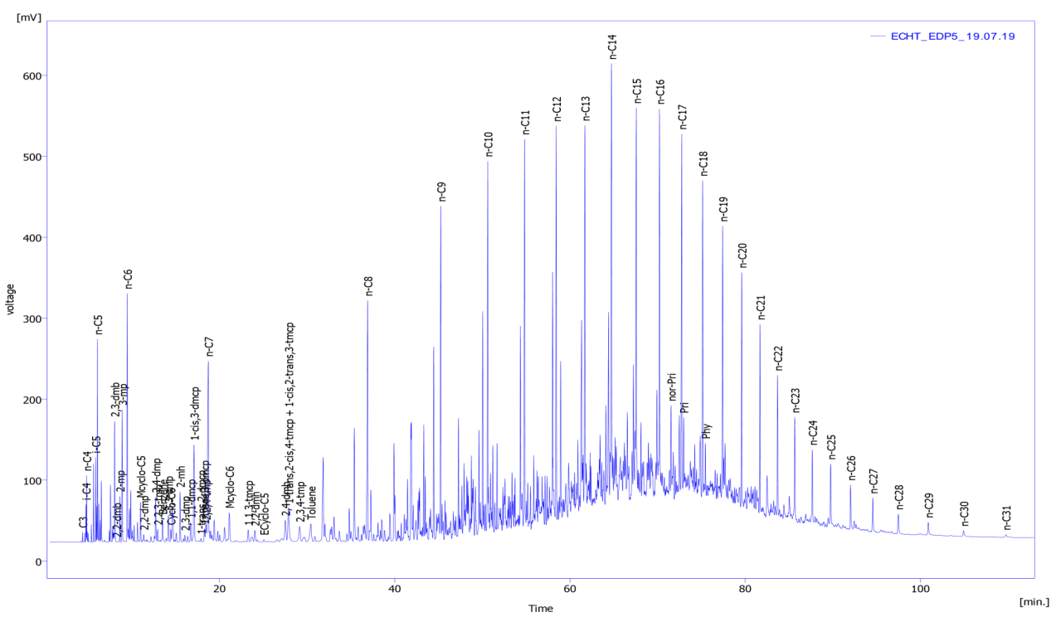

**Figure 2:** CG-DIF profile of a product after SORAZ cracking (Oumarou, 2020).

1. Petroleum refining

Petroleum refining is a heavy industry designed to transform a mixture of hydrocarbons (crude oil) into energy products, such as fuels, and non-energy products, such as petrochemical raw materials, lubricants, kerosenes and bitumens. Crude oils are processed in refineries, which are highly automated, continuous-fire plants of varying degrees of complexity, depending on the range of products manufactured and the quality of the crude oil (Saulnier, 2008).

Petroleum refining begins with atmospheric distillation, or fractionation of crude oil to separate it into different hydrocarbon groups. Atmospheric distillation was the very first oil refining process, developed in 1861 to produce kerosene, with gas, naphtha, gas oil, tar, etc. as intermediate products (Kraus, 2015). The products obtained depend directly on the characteristics of the crude oil processed. Most of these distillation products are then transformed into more usable products by modifying their physical and molecular structures through cracking, reforming and other conversion processes. The resulting products are then subjected to various treatment and separation processes, such as extraction, hydrocracking and sweetening, to produce finished products (Hassen, 2015 and Dehouche, 2020).

A petroleum refinery is made up of a set of processes that transform crude oil with low commercial value into usable (or high commercial value) products such as gas, gasoline, diesel and jet fuel (Sadeghbeigi, 2000; Oumarou, 2020).

Conversion processes, such as cracking, combining and rearranging, alter the size and structure of hydrocarbon molecules and thus transform fractions into more interesting products (see Table 2) (Kraus, 2015).

**Table 2:** Overview of oil refining processes (Kraus, 2015).

|  |  |  |  |  |  |
| --- | --- | --- | --- | --- | --- |
| **Nom du procédé** | **Action** | **Méthode** | **But** | **Matières premières** | **Produits** |
| **Procédés de fractionnement** | | | | | |
| Atmospheric distillation | Separation | Thermal | Fraction separation | Desalted crude oil | Gas, diesel, distillates, residues |
| Vacuum distillation | Separation | Thermal | Crack-free separation | Atmospheric distillation tower residues | Diesel fuel, lubricant bases, residues |
| **Conversion processes - decomposition** | | | | | |
| Catalytic cracking | Alteration | Catalytic | Gasoline upgrading | Gas oil, coke distillate | Petrol, petrochemical feedstocks |
| Cokefaction | Polymerization | Thermal | Vacuum residue conversion | Tailings, heavy oil, tars | Naphta, gazole, coke |
| Hydrocracking | Hydrogenation | Catalytic | Conversion to lighter hydrocarbons | Diesel, cracker oil, residues | Lighter, better quality products |
| Steam reforming | Decomposition | Thermal/ catalytic | Hydrogen production | Desulfurized gas, O2 , steam | Hydrogen, CO,CO2 |
| Steam crackingr | Decomposition | Thermal | Cracking of large molecules | Heavy fuel oil/atmospheric distillation tower distillates | Cracked naphtha, coke, residues |
| Viscoreduction | Decomposition | Thermal | Viscosity reduction | Atmospheric distillation tower residues | Distillates, tars |
| **Conversion - unification processes** | | | | | |
| Alkylation | Combination | Catalytic | Combination of olefins and isoparaffins | Isobutane tower/cracking olefins | Iso-octane (alkylat) |
| Grease mix | Combination | Thermal | Combination of soaps and oils | Lubricating oils, fatty acid, alkyl-metal | Lubricating greases |
| Polymerisation | Polymerisation | Catalytic | Combination of two or more olefins | Cracking olefins | High-octane naphtha, petrochemical feedstocks |
| ***Conversion processes - alteration/rearrangement*** | | | | | |
| Catalytic reforming | Alteration/ dehydrogenation | Catalytic | Improved low-octane naphtha | Coker/hydrocracker naphtha | Reformat/high-octane aromatics |
| Isomerization | Rearrangement (conversion) | Catalytic | Converting straight-chain hydrocarbons into branched-chain hydrocarbons | Butane, pentane, hexane | Isobutane/pentane/hexane |
| **Treatment processes** | | | | | |
| Amino treatment | Treatment | Absorption | Removal of acid contaminants | Sour gas, hydrocarbons with CO2 and H2S | Acid-free hydrocarbon gases and liquids |
| Desalting (pre-treatment) | Dehydration | Absorption | Removal of contaminants | Crude oil | Desalted crude oil |
| Drying and softening | Traitment | Absorption/ thermal | Removal of water and sulfur compounds | Liquid hydrocarbon, LPG, alkylated raw materials | Sweetened and dried hydrocarbons |
| Extraction au furfural | Extraction par les solvants | Absorption | Upgrading middle distillates and lubricants | Heavy recycling oils and lubricating bases | High-quality diesel fuel and lubricating oils |
| Hydrodesulfurization | Traitment | Catalytic | Removal of sulfur and contaminants | Sulfur/gasoline-rich residues | Desulfurized olefins |
| Hydrotreatment | Hydrogenation | Catalytic | Removal of impurities / saturation of hydrocarbons | Residues, cracked hydrocarbons | Cracking feedstock, distillates, lubricants |
| Phenol extraction | Solvent extraction | Absorption/ thermal | Improved viscosity index and color of lubricants | Lubricating oil bases | High-quality lubricating oils |
| Solvent deasphalting | Treatment | Absorption | Asphalt removal | Vacuum distillation tower residues, propane | Heavy lubricating oil, bitumen |
| Solvent dewaxing | Traitment | Cooling/ filtration | Kerosene removal from lubricant bases | Lubricating oils for vacuum distillation towers | Dewaxed lubricant bases |
| Solvent extraction | Solvent extraction | Absorption/ precipitation | Separation of unsaturated aromatic compounds | Gazole, reformat, distillats | High-octane gasoline |
| Softening | Treatment | Catalytic | H2S removal, mercaptan conversion | Untreated distillates/gasoline | High-quality distillates/gasoline |

Conversion yields a number of hydrocarbon molecules not normally found in crude oil, but which are important for refining.

1. Refining process history The various refining processes and their brief history are given in the following Table 3 (Kraus, 2015).

**Table 3:** Refining process history

Year Process Role By-products

1862 Atmospheric distillation Kerosene production Naphta, tar,…

1870 Vacuum distillation Lubricants (original) Residual bitumen

1913 Thermal cracking Increased gasoline production Residue, heavy fuel oil

1916 Softening Reduced sulfur content and odor Sulfur

1930 Thermal Reforming Improved octane number Residues

1932 Hydrogenation Sulfur removal Sulfur

1932 Cokefaction Production of gasoline bases Coke

1933 Solvent extraction Improvement in the lubricant viscosity Aromatic products

1935 Solvent dewaxing Flow point improvement Paraffins

1935 Catalytic polymerization Improved yield in gasoline and Petrochemical feedstocks

octane number

1937 Catalytic Cracking High-octane gasoline Petrochemical feedstocks

1939 Viscoreduction Viscosity reduction Distillates and Tar

1940 Alkylation Improved fuel efficiency Aviation gasoline

and octane number

1940 Isomerisation Alkylation charge production Naphta

1942 FCC Improved fuel efficiency Petrochemical feedstocks

and octane number

1950 Desasphalting Increased cracking load Tar

1952 Catalytic Reforming Naphtha conversion from Aromatic products

lower quality

1954 Hydrodesulfurization Sulfur removal Sulfur

1956 Inhibitor softening Mercaptan eliminator Disufures

1957 Catalytic isomerization Conversion to molecules in Alkylation charges

high-octane molecules

1960 Hydrocracking Higher quality and lower sulfur content Charges d’alkylation

1974 Catalytic dewaxing Flow point improvement Paraffins

1975 Residual hydrocracking Improved fuel efficiency Heavy residues

1. **The principle of refining**

Oil, also known as "black gold", is rarely used in its raw state. It must first undergo a number of transformations before it can be used. This is the role of the refinery. Oil refining is an industrial process that transforms crude oil into various finished products such as gasoline, heavy fuel oil or naphtha (Abderrazzak and Fethi, 2022 and Oumarou, 2020). Since crude oil is a heterogeneous mixture of various hydrocarbons (molecules made up of carbon and hydrogen atoms), it is unusable in its crude state (there are several types of crude oil, distinguished by their viscosity and sulfur content, among other factors). Its components must be separated to obtain the final products that can be used directly. A refinery must be designed to process a wide range of crude oils. Some are adapted to a particular crude when the estimated resource of that crude is sufficiently large (Abderrazzak and Fethi, 2022).

A simplified diagram of a simple refinery showing the location of the FCC unit is given by Zeydan et al., 2007 (figure 3).

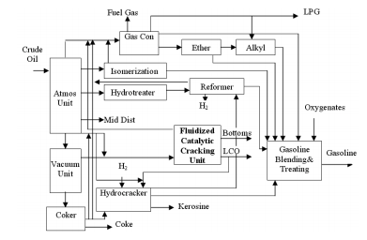

**Figure 3:** Simplified diagram of a simple refinery showing the location of the FCC unit (Zeydan, 2007).

This type of simplified diagram of a modern refinery, showing the location of the refining processes and especially that of the FCC used by Zeydan (2007), was also used by Mahfoud (2016), except that the latter improved this process by showing the flows of the different products (Figure 4).

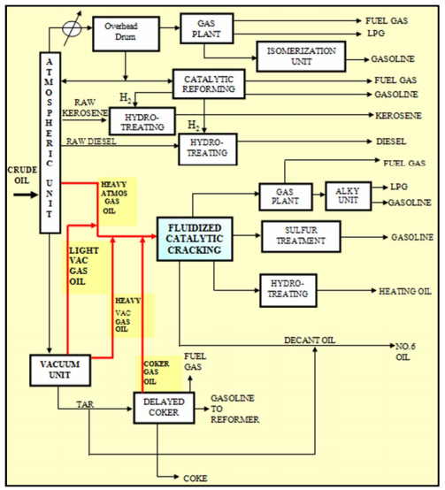

Figure 4: simplified diagram of a simple refinery illustrating the location of the FCC unit (Mahfoud, 2016).

1. **Catalytic cracking**

The main advantage of cracking processes (whether thermal or catalytic, with or without hydrogen addition) is that they increase the quantity of light products (Mahfoud, 2016 and Saulnier, 2008). Catalytic cracking, on the other hand, has the advantage of being able to process hydrocarbons with a relatively high sulfur and metal content, while guaranteeing a high proportion of light products in the high-value-added output (Saulnier, 2008).Catalytic cracking is a catalytic conversion process in which high-molecular-weight hydrocarbons in a distillation fraction above around 350°C are broken down into low-molecular-weight hydrocarbons over an acid catalyst at a temperature of around 500°C and at low pressure, the bulk of which consists of a gasoline cut ranging from C5+ to 200 or 220°C (Bonifay and Marcilly, 2001).

All the independent variables of catalytic cracking have a significant effect on conversion, which is truly a dependent variable but can be demonstrated as a function of API gravity as well as various other factors (Maples, 2000). The detailed effects of a change in conversion depend on how conversion is altered, i.e. temperature, space velocity or catalyst/oil ratio and catalyst activity (Cornet, Engineering Technique). Increasing conversion increases yields of naphtha and all light products (Mahfoud, 2016) up to a conversion level of 60-80% by volume in most cases. At this high conversion level, side reactions become sufficient to cause a decrease in olefin and naphtha yields. However, feedstock, operating conditions, catalyst activity and other parameters are the points at which this occurs (Speight and Heineman, 2017). At present, catalytic cracking is the most widely used conversion process (Haridoss, 2017), and the most important in refining in terms of tonnages of feed treated and the quantity of catalyst used (Bonifay and Marcilly, 2001 and Murray, 2016). According to most researchers, catalytic cracking reduces the quantity of residues and is carried out at high temperature, low pressure and in the presence of a suitable catalyst. Kraus (2015) reported that during this process, molecular structure rearrangement takes place, transforming heavy hydrocarbon feedstocks into lighter fractions, e.g. kerosene, gasoline, liquefied petroleum gases, heating oil and petrochemical feedstocks. The catalyst is selected to achieve the highest possible reactivity and attrition resistance.

1. **History of catalytic cracking**

The first attempts to fractionate heavy petroleum cuts date back to 1912; they were followed around 1920 by the development of the McAfee process for batch cracking in the presence of Alcl3 as catalyst; this process was used at the Gulf refinery in Port Arthur for 14 years (Wauquier, 1994). In 1923, French engineer Eugène Houdry undertook studies that led to the fixed-bed catalytic cracking process, the first unit of which was commissioned in 1936 with a natural clay (montmorillonite) catalyst. In 1940, this catalyst was replaced by a more active and selective synthetic silica-alumina catalyst (Bonifay and Marcilly, and Wauquier, 1994).

1. **Different types of catalytic cracking process**

A number of different catalytic cracking designs are currently in use around the world, including fixed-bed reactors, moving-bed reactors, fluidised-bed reactors and once-through units. Fluidised bed and moving bed reactors are widely used in refineries around the world (IFP, 2003 and Wauquier, 1994). All catalytic cracking processes have the following three essential basic functions (Oumarou, 2020 and Kraus, 2015):

* Reaction: the feedstock reacts with the catalyst and is fragmented into different hydrocarbons;
* Regeneration: The catalyst is reactivated by burning coke;
* Fractionation: The cracking products are separated into various fractions.

According to Leprince (1998), the catalytic cracking process generally comprises three sections, but four sections are also possible:

* Reaction section;
* Fume treatment section;
* Catalyst management section;
* Products fractionation section.

Nowadays, the catalytic cracking processes, most widely used in refineries around the world and studied by numerous researchers, such as Kraus (2015), Oumarou (2020), are of three types, namely:

* The moving bed catalytic cracking process;
* The fixed bed catalytic cracking process;
* The fluidised bed catalytic cracking process.

All three processes have the same objective, which is to produce sufficient quantities of fuels such as naphtha and diesel (LCO and HCO), mainly of good quality, although they do not use the same technology and therefore have different operating conditions. But our study will be limited to the case of the fluidised catalytic cracking (FCC) process.

1. **Fluid catalytic cracking (FCC)**

Process Fluid catalytic cracking is a process in which heavy molecular weight hydrocarbon molecules are converted to light molecular weight hydrocarbon molecules. The hydrocarbon feedstock enters a tubular transport bed reactor (riser) via atomising nozzles and comes into contact with the hot catalyst from the regenerator (Gupta et al., 2007 and Ellis et al., 1998). The fluid catalytic cracking unit (FCCU) plays an essential role in the economics of a modern refinery, as it enables the production of high-value-added products in a refinery (Gupta et al., 2005). Fluid catalytic cracking continues to play a key role in an integrated refinery as a primary conversion process. For many refiners, the catalytic cracking unit is the key to profitability, as the proper operation of the unit determines whether the refiner can or will remain competitive in today's market (Sadeghbeigi, 2000). Most existing FCC processes have been designed or modified by six major technology licensors:

1. ABB Lummus Global ;
2. Exxon Research and Engineering (ER&E) ;
3. Kellogg Brown & Root-KBR (Formerly the M. W Kellogg company) ;
4. Shell Oil Company ;
5. Stone & Webster Engineering Corporation (SWEC)/IFP ;
6. UOP (Universal Oil Products).

Although the mechanical configuration of the various FCC processes may differ, their common objective is to transform low-value raw materials into high-value products (Sadeghbeigi, 2000). Many researchers have demonstrated that, worldwide, around 45% of gasoline comes from the FCC process and auxiliary units, such as the alkylation unit. Since the first FCC unit was commissioned in 1943, it has undergone constant modifications with the sole aim of increasing its efficiency and yield of light products such as gasoline and diesel.

The fluidised catalytic cracking process has undergone many advances (evolution) as shown in Table 4 below, reported by Letzsch (2015).

**Table 4:** Major advances in fluid catalytic cracking

|  |
| --- |
| **Date Process**  1942 First FCC unit on stream (Exxon)  1947 Stacked configuration (UOP) Compact with small inventory 1  1948 Spray-dried catalyst (improved fluidisation)  1952 Synthetic high alumina (higher stability)  1955 Reactor riser cracking (Shell)  1959 Semisynthetic catalyst (addition of clay)  1960 Improved metallurgy (Higher regenerator temperatures)  1961 Heavy oil cracking (Phillips-Kellogg)  1964 Zeolitic catalysts introduced (Mobil)  1972 Complete CO combustion process (Amoco)  1974 Combustion promoters (Mobil)  1975 Metals passivation (Phillips)  1981 Two independent regenerators for unlimited regeneration temperature (Total)  1982 High-performance feed injectors  1982 Dense bed catalyst coolers (Ashland/UOP)  1987 Vapour quench (Amoco)  1987 Mix temperature control (Total)  1988 Close-coupled cyclones (Mobil)  1991 Deep catalytic cracking (RIPP/Sinopec)  1996 Enhanced stripping designs (Total/Koch-Glitsch)  2002 Catalytic pyrolysis (RIPP/Sinopec)  2005 Gasoline cracking (Kellogg)  2007 Dual diameter risers (RIPP)  2011 Downflow reactor (Nippon/Aramco/Technip-Stone &Webster/Axens) |

**9.1 FCC process principle**

Fluid catalytic cracking (FCC) is a cracking process which consists of fractionating heavy petroleum fractions into light petroleum fractions at high temperatures of the order of 400°C or even 500°C at low pressure. The FCC principle is based on a cyclic reaction-regeneration system (Figure 5).

**Smoke Spent catalyst Produts**

**Reactor**

**Regenerator**

;

Regenerated catalyst

Charge

Air ch Air chaud aud récirculation

Feed

Hot air

**Figure 5:** FCC fluid catalytic cracking principle (Andreux, 2009).

**9.2 Different FCC process configurations**

As mentioned above, there are several fluid catalytic cracking process configurations. These include:

* SWEC FCC process configuration (figure 6)

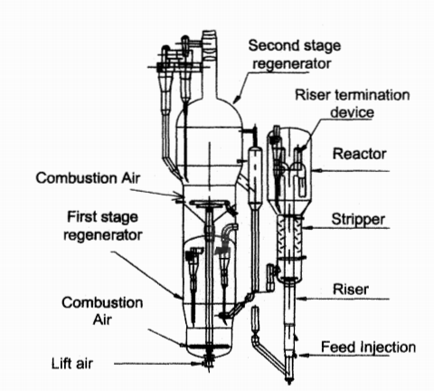

**Figure 6:** Simplified diagram of the FCC process (SWEC configuration)

* FCC process according to UOP configuration (figure 7)

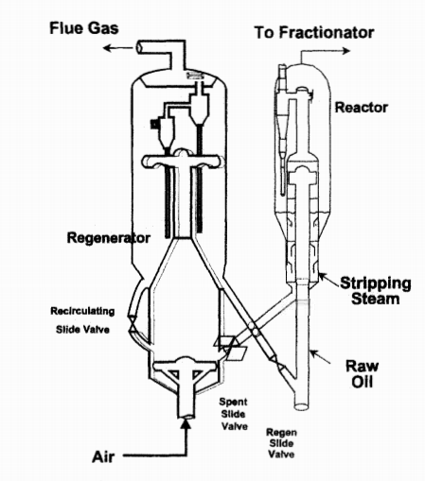

**Figure 7:** Simplified diagram of the FCC process (UOP configuration)

* FCC process in COLORADO configuration (figure 8)

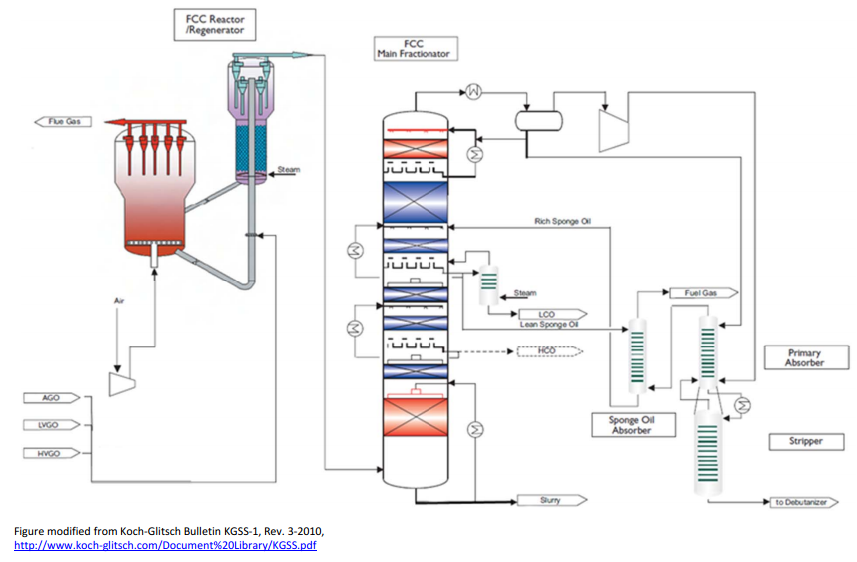

**Figure 8:** Simplified diagram of the FCC process (COLORADO configuration)

The process includes the fractionation column, unlike previous processes. In a refinery, however, all FCC processes have a fractionation section. This has already been mentioned above (see section 6).

* Catalytic cracking process in EXENS configuration (figure 9)

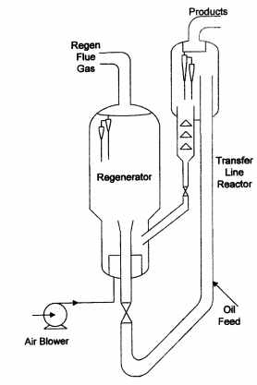

**Figure 9:** Simplified diagram of the FCC process (EXENS configuration)

* Figure 10 below shows a very special FCC process with slurry recycling. It is known as the FCC Model III (figure 10)

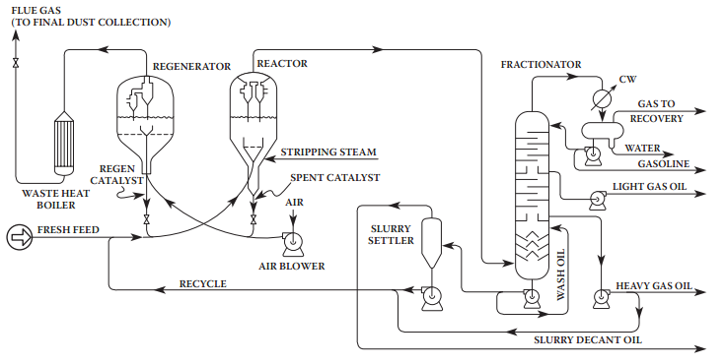

**Figure 10:** Simplified diagram of the FCC process, Model III (Gary et al., 2007)

This type of FCC process is similar to that proposed by Speight and Heinemann

Gary et al., 2007 reported the following set of new FCC unit configurations (Figure 11). In a very legible and visible way, the processes have been given previously.

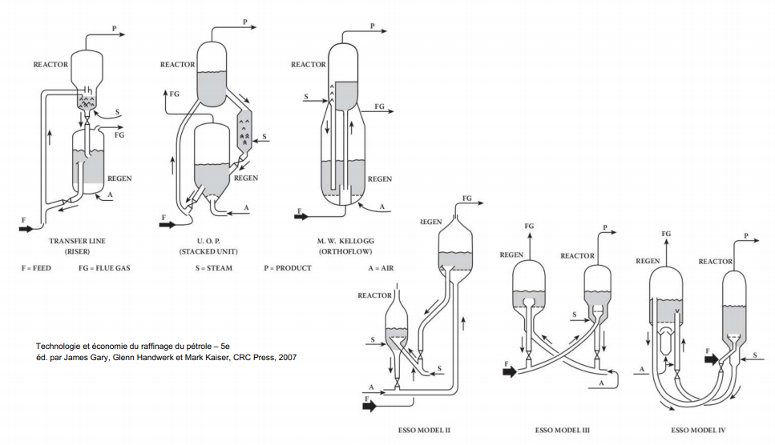

**Figure 11:** New CFC configurations

All the processes shown above are CFC processes, some of which have the same configuration and some of which do not. Figure 13 shows a number of CFC configurations and some special models, such as II, III and IV. Generally speaking, these processes have similar configurations and operate under almost identical conditions. It should also be noted that they share the same objective and have the same cyclic system (figure 12).

Reagent

Catalyst

Reac-cat

Reactant-catalyst

Product

**Figure 12:** diagram of the FCC cyclic system (Wilczura-wachnik)

Of all FCC configurations, the most widely used in refineries worldwide (ACAFE, 2015) are:

* Fluid Catalytic Cracking or Craquage Catalytique Fluide (FCC) for distillates.
* Fluid catalytic cracking processes are adapted to distillate.
* Residue ;
* R2R mixtures (TOTAL - IFP) : 1 reactor 2 regenerators;
* RCC (UOP): Resid Catalytic Cracking.

FCC processes, compared with other thermal cracking processes, are the most widely used for cracking heavy feedstocks. Worldwide, there are at least 720 fluid catalytic cracking (FCC) processes, 184 visbreaking processes, 232 coking processes including flexicokers, 275 hydrocracking processes, and 133 hydrotreating and hydroconversion processes in operation (ACAFE, 2015)

**9.3 FCC process description**

An FCC unit is designed to upgrade heavy petroleum cuts (long carbon chains). Transformation takes place by introducing the hydrocarbons to be transformed into a catalysed environment at high temperatures (around 500°C) (Saulnier, 2015 and Wauquier, 1994).

The catalyst used is a solid, usually made up of silica and alumina, which has the acidic character required for catalytic cracking reactions. It takes the form of a very fine powder (30 to 150µm particle diameter) with a low bulk density (less than 1800kg/m3), which belongs to category A according to the classes defined by Geldart (1973) (figure 13). This powder is therefore easily fluidised (Saulnier, 2015).

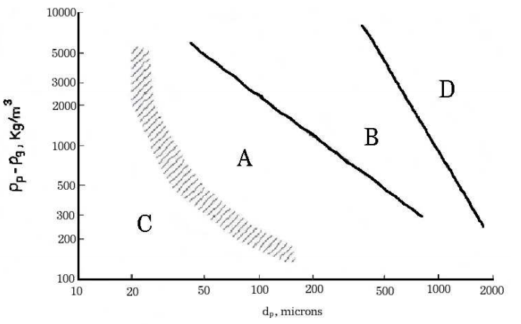

**Figure 13:** Classification of coke formed in the FCC unit according to Geldart (1973)

The bulk density of the catalyst is generally in the order of 1300 to 1600kg/m3, with a grain size of around 60 to 80 µm. The grains are polyhedral in shape and have a crystalline structure (figure 14).

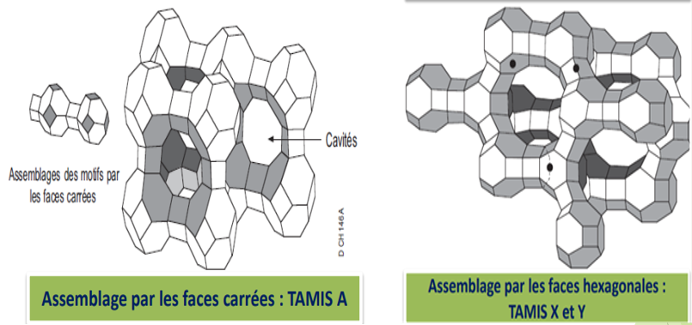

**Figure 14:** crystalline structure of catalyst powder (ACAFE, 2015)

The presence of the catalyst significantly improves yield (ACEFE, 2012 and ACAFE, 2015) compared with thermal cracking. However, the reactions produce coke in solid form, which settles on the catalyst particles and inhibits their activity (speight, 2021 and Letzsch, 2015, Wauquier, 1994). Den Hollander et al (1999) classified the coke produced into four types:

* Thermal coke: coke deposited on the surface of particles as a result of thermal degradation caused by contact between hydrocarbon droplets and particles;
* Absorbed coke: This is coke resulting from the strong and irreversible absorption of hydrocarbons on the catalyst surface;
* Catalytic coke: This is coke deposited on catalytic sites as a product of the cracking reaction;
* Contaminant coke: This is coke deposited as a result of excessive dehydrogenation reactions.

A "good" charge is one that produces high gasoline yields and low coke and gas emissions. According to Abderrazak and Fethi(2022), Saulnier (2015), Almeida (2002), Wu et al. (2009), ACEFE (2012) and ACAFE (2015), cracking products are of several types and can be classified according to their volatility as follows:

* Light gas (or Fuel Gas, which will be noted as FG): H2, H2S, CH4, etc, which comprises short carbon chains;
* Liquefied petroleum gas (or LPG for Liquefied Petroleum Gas): C3 and C4 chains;
* Gasoline;
* Light Cycle Oil (LCO);
* Heavy Cycle Oil (HCO), which can be considered as a feedstock, since it can be recycled as such;
* Coke, the solid reaction product that remains fixed on the catalyst.

According to ACEFE (2012), the usual operating conditions for FCC are: high temperature 520-540°C and low pressure 2 to 3 bars, and the catalyst is specific to each unit. The yield for gas + LPG is 20%, for gasoline 40-50%, for LCO 15-20%, for HCO 5-10% and for coke 5% (figure 15).

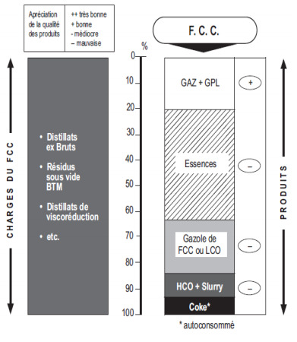

**Figure 15:** FCC unit loads, products and output (ACFE, 2012).

The chemistry of catalytic cracking has been studied fairly comprehensively. Its mechanisms are explained by Latrille-Pitault (1994).

Numerous researchers, Andeux (2009), Danial-Fortrain (2010), Zeydan (2007), Saulnier (2015), Bret-Rouzaut and Favennec (2011), etc, have described the FCC process in three zones (example in Figure 9) as follows:

* The cracking zone, referred to here as the "Transfer Line Reactor" on the right (left in the case of SORAZ) of the figure, which consists of a vertical tube whose characteristic dimensions are (for Figure 9):
* a height of around twenty meters (20m);
* a diameter of around one meter (≈1).
* The zone for separating cracking products and catalyst powder at the top of the cracking zone, consisting of a cylinder known as a "disengager-stripper", whose characteristic dimensions are (for figure 6):
* a height of around ten meters;
* a diameter of around five meters.
* The coke combustion zone, referred to here as the "Regenerator" on the left of the figure, which consists of a cylinder whose characteristic dimensions are :
* a height of around ten meters;
* a diameter generally between five and ten meters.

According to IFP (2003), the FCC unit consists of three distinct sections: the reactor-regenerator section, which includes the air blower and recovery boiler; the main fractionator section, which includes the wet gas compressor; and the unsaturated gas plant section. In the FCC process, oil and oil vapour preheated to 250 to 425°C are brought into contact with hot catalyst (zeolite) at around 680 to 730°C in the extension tube reactor. To enhance vaporisation and subsequent cracking, the feedstock is atomised with steam (IFP, 2003 and ACEFE, 2012). The various zones mentioned above can be found in any FCC process in refineries around the world today. This makes the FCC process the most widely used refining process.

* ***Different catalytic cracking reactions in a fluidised bed***
* **The riser**

The riser is where the cracking reaction takes place by injecting the heavy feedstock at the bottom of the riser into a hot, circulating catalyst bed. In this part, coke, the solid product of the reaction, settles on the catalyst and deactivates it: it is an undesirable product of the reaction, as it slows it down (Saulnier, 2015). Almost all cracking takes place in the feed riser (Rashmi Pahwa and Gupta, 2016), which is connected to a catalyst/vapour separator. Hot catalyst is discharged into the catalyst stripper, while steam is passed through secondary cyclones to remove any remaining catalyst, then to the main fractionator and gas plant for product separation (Merdrignac and Espinat, 2007; Abderrazak and Fethi, 2022; Leffler, 2008; Lestwsch, 2008; and Speight, 2021). The spent catalyst enters a multi-stage stripper where the hydrocarbons in the absorbent bed are displaced with steam and exit with the product from the reactor ceiling. This prevents unwanted hydrocarbons from entering the regenerator, consuming air and possibly causing excessive catalyst deactivation (Letzsch, 2015).

* ***Cracking reactions***

Researchers such as Hediwa (2021), Oumarou (2020), and Venuto and Habib (1979) have studied fluidised-bed catalytic cracking reactions. According to Venuto and Habib (1979) and Ihediwa (2021), FCC reactions can be schematized as follows (Figure 16).

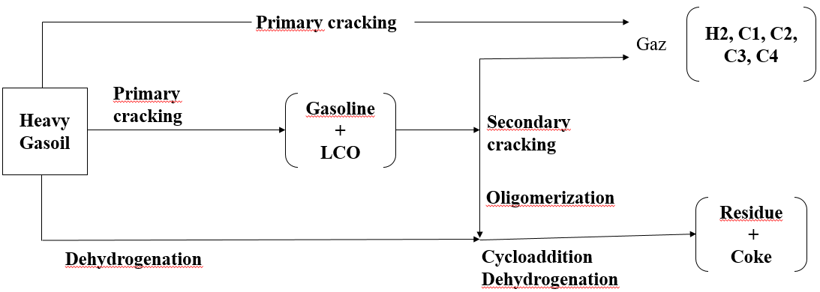

**Figure 16:** FCC reactions (Venuto and Habib, 1979 and Ihediwa, 2021)

The following Table 5 illustrates many of the reactions likely to occur in catalytic cracking reactors (Encyclopaedia Britannica).

**Table 5:** Main fluidised catalytic cracking reactions

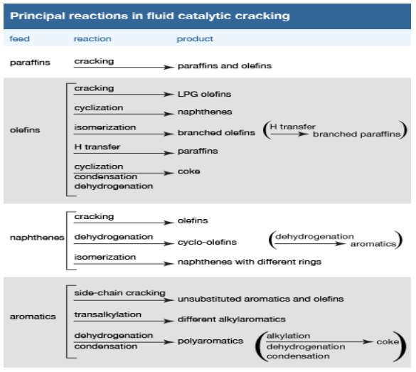

During catalytic cracking, the products formed are the results of a primary and a secondary reaction (Hatch and L.F, 1969). Primary reactions are those involving initial carbon-carbon bond scission and carbonium ion neutralisation (Mitchell and B.R, 1980). According to Gary et al. (2007), cracking reactions are as follows:

* *Paraffins → Paraffins + olefins*
* *Alkyl naphthene → Naphthene + olefin*
* *Alkyl aromatic → Aromatic + olefin*

According to Gates et al.(2023) and Gupta et al.(2005), in the FCC reactor, the following seven main reactions take place:

* Cracking of alkanes (kerosenes)

CnH2n+2→ CmH2m + Cp H2p+2 with n=m+p

* Cracking of alkenes (olefins)

CnH2n → CmH2m + Cp H2p with n=m+p

* Scission-β of aromatic alkyl chains

ArCnH2n+1 → Ar CmH2m+1 + Cp H2p+2 with n= m+p and Ar= aromatic ring

* Cracking of cycloalkanes (naphthenes)

CnH2n → CmH2m (olefins)

* Hydrogen transfer
* Cycloalkane + alkenes → aromatics + alkane
* Coke precursor + alkenes → coke + alkanes
* Isomerization

Alkenes → branched alkenes

* Condensation reaction

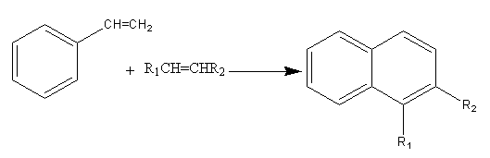

* **Reaction mechanism**

Thomas (1949) proposed a mechanism whereby carbonium ions are initially formed by a small amount of thermal cracking of n-paraffins to form olefins. These olefins add a proton from the catalyst to form large carbonium ions, which decompose according to the beta rule (carbon-carbon bond scission takes place at the carbon in the beta position relative to carbonium ions and olefins) to form small carbonium ions and olefins. Ruse et al.(1980) and Ritter et al.(1981) explained that small carbonium ions propagate the chain reaction by transferring a hydrogen ion from an n-paraffin to form a small kerosene molecule and a new large carbonium ion. According to Gary et al.(2007), as an example of a typical n-paraffin hydrocarbon cracking reaction, consider the borrowing sequence for n-octane (where R=CH3CH2CH2CH2CH2-) in five steps as follows:

**First stage:** Mild thermal cracking reaction

nC8H18 → CH4 + R— CH = CH2

**Second stage**: Proton displacement

O

R– CH = CH2 + H20 + Al –O –Si → R–CH–CH3+ [HO –A1–O–Si]-

O

**Third stage:** scission de béta

R–CH– CH3 → CH3–CH2=CH2 + CH–CH2–CH2–CH3

**Fourth stage:** rearrangement to a more stable structure.

The order of stability of carbonium ions is as follows: tertiary ˃ secondary ˃ primary, and the fifth step, which and that of hydrogen ion transfer.

* **Reactivity**

The following Table 6 summarises the reactivity of certain hydrocarbon families and the main cracking reactions.

**Table 6:** Reactivity of different hydrocarbon families and main cracking reactions (Marcilly, 1991).

|  |  |
| --- | --- |
| Reactivity of different families | Olefins > Alkyl aromatics (including cumene) > alkyl naphthenes and isoparaffins > n-paraffins and naphthenic ring >> core (very stable) |
| Cracking reactions | Increases with load size and degree of branching |
| Isomerization reactions | Improves the octane number of gasoline |
| Hydrogen transfer reactions | Consume olefins and produce aromatics to be limited in order to increase the  olefin content of C3 and C4 cuts |
| Condensation reactions | Lead to coke formation |
| Homolytic reactions | Produce methane and C2 |

* **Conversion yield**

Fluidised-bed catalytic cracking produces high liquid yields and small quantities of gas and coke (Marcilly, 1995; Gary et al., 2007; Andreux,2009; Saliha, 2016; Hediwa, 2021; Colorado, 2015; Jérémie, 1996 and Wauquier tome1, 1994).

Liquid mass yields are generally 90% to 93%; liquid volume yields are often over 100% (volume swelling) (Rule of thumb). The remaining mass yield is split between gas and coke (Colorado, 2015).

The yield pattern is determined by a complex interplay between feed characteristics and reactor conditions that determine the severity of operation (Colorado, 2015). According to Colorado, the product conversion yield is given by the following equation 1:

**% product yield=100×(Product volume) / (Feed volume) (Eq.1)**

Thus, the conversion (according to the manual) defined in relation to what remains in the original boiling range of the raw material is given by the following equation 2:

**Conversion = 100% (% oil yield of cycle) (Eq.2)**

The following Table 7 is a typical example of FCC yield correlation.

**Table 7:** FCC yield correlation from Gary et al., (2007).

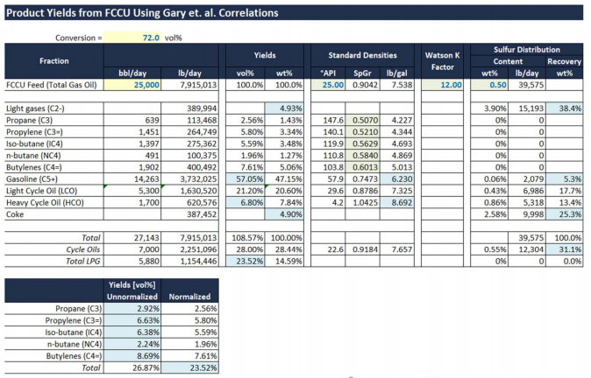

According to Marcilly (1995), Gary et al., (2007), Andreux (2009), Saliha (2016) and Hediwa (2021), the temperature, nature of the charge and catalyst play an important role in FCC conversion and yield. Table 8 below illustrates some of the products and yields of an FCC unit.

**Table 8:** Illustration of some products and yields of an FCC unit.

|  |  |
| --- | --- |
| **Products** | **Typical yields (% by weight)** |
| $$C_{2}^{-}$$ | **2-5** |
| $C_{3}$**totals** | **4-6** |
| $C_{4}$**totals** | **6-11** |
| **Gasoline ($C_{5}^{+}-220°C)$** | **40-55** |
| **Light Cycle Oil (220-360°C)** | **15-20** |
| **Heavy Cycle Oil (360°C, +)** | **8-15** |
| **Coke** | **5-6.5** |
| **Light Olefins** |  |
| $$C_{3}^{=}$$ | **2.5-5.5** |
| $${iC}_{4}^{=}$$ | **0.7-2.6** |
| $${nC}_{4}^{=}$$ | **2.5-5.5** |
| $$iC_{4}$$ | **1-3.5** |
| $$nC_{4}$$ | **0.3-1** |
| $${iC}_{5}^{=}$$ | **1.5-8** |
| $${nC}_{5}^{=}$$ | **1.5-7** |

* **Stripping**

Once the cracking reactions are complete, the spent catalyst must be stripped of the hydrocarbons that would accompany it to the regenerator (Letzsch, 2015; Riazi, 2005; IFP, 2015; Wauquier, 1994; and Leffler, 2008). This is done in a staged fluidised bed where steam enters from the bottom and pushes the gas-phase hydrocarbons out of the top of the bed. Design parameters for new units are given in Figure 17, which is a common disc and doughnut design (Letzsch, 2015).

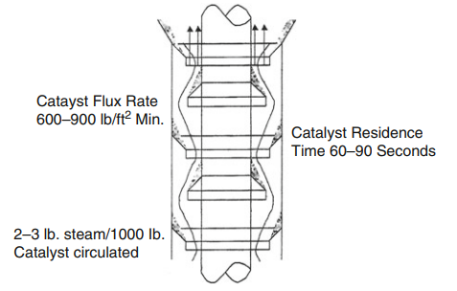

**Figure 17:** Stripper disc and donut ( Letzsch, 2015)

Baffles improve contact between the steam and the catalyst and increase the number of contact stages. As shown in Figure 13, seven stripping stages are sufficient to remove at least 95% of the hydrocarbons. Each of these design parameters is important for the proper operation of the stripper. A minimum amount of steam is required to displace hydrocarbons in the emulsion and bubble phases of the fluidised bed. The flow rate determines the speed of the catalyst through the bed. If the catalyst's downward velocity becomes too high, it will carry hydrocarbons and steam with it, adversely affecting stripper performance. Residence time is a function of stripper catalyst stock and catalyst circulation rate. Overall, stripper efficiency depends on the number of stages and their efficiency (Letzsch, 2015).

According to Letzsch (2015), although the disc and doughnut design presented has proved both reliable and effective, there are other variations on this design. Holes can be placed in the baffles to improve contact, skirts can be lengthened to provide a larger ΔP of gas, vent tubes have been used to allow gas from the bottom of the baffles to pass to the next stage, and crowd rods or bridges can be substituted as contact devices. The use of structured packing has been reported with excellent results. Lower steam consumption, better contact and utilisation of almost the entire stripper cross-section are advantages seen with the new designs. Horizontal trays with small holes configured as distillation trays have been tested in the laboratory and put into service in the field. Some of the commercial packaging designs are shown in figure 18.

According to Letzsch (2015), although the disk and doughnut design presented has proven to be both reliable and effective, there are other variations of this design. Holes can be placed in the baffles to improve contact, skirts can be lengthened to provide a larger ΔP of the gas, vent tubes have been used to allow gas to pass from the bottom of the baffles to the next stage, and crowd rods or bridges can be replaced as contact devices.The use of a structured liner has been reported with excellent results. Reduced steam consumption, improved contact, and utilization of almost the entire stripper cross section are advantages noted with the new designs. Horizontal trays with small holes, configured as distillation trays, have been tested in the laboratory and fielded. Some of the commercial package designs are shown in figure 20.

Stripping is a mass transfer process. Analogous to improvements in distillation performance through better tray designs, improved methods of contacting spent catalyst with steam have made strippers more efficient and reduced the cost of their refurbishment.

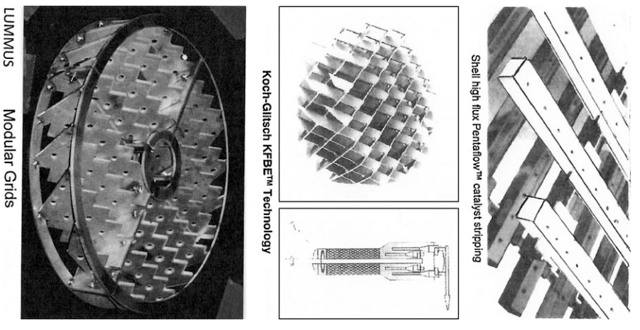

**Figure 18:** Commercial stripper packaging designs

* **Regenerator**

In the regenerator, coke is burnt to prepare the catalyst for its return to the reactor. For this purpose, compressed air is blown to the bottom of the regenerator. Coke on regenerated catalyst (CRC) reaches a very low percentage but is not completely removed, and the regenerated catalyst varies in colour from grey, light to black (Bouziden et al., 2002).

The aim of the regenerator is to remove the coke that accumulates on the catalyst in the reactor without damaging the catalyst. Numerous studies have been carried out on coke combustion rates in a fluidised bed of cracking catalyst. Equation 3 describes the main regeneration operating variables (Letzsch, 2015):

$\frac{dc}{dt}=k×C_{i}×L_{m}O_{2}×e^{\frac{A}{RT}}$***(Eq.3)***

Where $k$ is the rate constant, $C_{i}$ initial carbon on the catalyst, $L_{m}O_{2}$ log mean oxygen concentration, **A** activation energy, **R** gas constant and **T** the temperature.

The principle of regeneration is also detailed by Letsch et al., 2015 as follows: The contact between oxygen and the catalyst is significantly improved as the air flow rate or surface velocity increases in the regenerator. As velocity increases, the bed passes through three stages. A bubbling bed occurs at low surface velocities (up to around 1.8 ft/s or 55 cm/s). Here, relatively distinct bubbles form and pass through the bed. A turbulent bed (1.8 to 4.0 ft/s or 55 to 122 cm/s) occurs at higher surface velocities, in which an emulsion forms and the rate of oxygen diffusion is considerably increased. At higher velocities, a fast fluidised bed (4 to 8 ft/s or 122 to 244 cm/s) is produced, in which turbulence is maximised. A return line from the recovered catalyst to the combustion chamber is required to provide sufficient residence time and mixing temperature for the coke to burn off completely. Gary et al. 2007 provide a simplified diagram of the regenerator in the FCC process (figure 19).

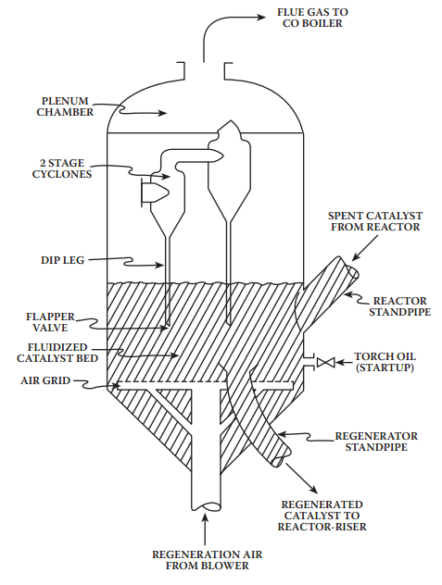

**Figure 19:** FCC regenerator (Gary et al., 2007)

* **Different Catalyst Regeneration Reactions**

Almost all catalyst regeneration reactions take place in the regenerator. Several researchers Almeida (2015), Kasat et al.(2002), Arbel et al.(1995) ,Johan , (2018), and Cabrera et al., (1988) have studied the following coke combustion reactions during catalyst regeneration:

C(s) + 1/2O2(g) → C𝑂(g) **(Eq.4)**

C(s) + 𝑂2(g) → C𝑂2(g) **(Eq.5)**

C𝑂(g) + 1/2𝑂2(g) → C𝑂2(g) **(Eq.6)**

C𝑂(g) + 1/2𝑂2(g) → C𝑂2(g) **(Eq.7)**

2𝐻(s) + 1/2𝑂2(g) → 𝐻2𝑂(g) **(Eq.8)**

Kasat et al., (2002) state that reactions **(Eq.6)** and **(Eq.7)** are, respectively, heterogeneous and homogeneous carbon monoxide combustion reactions. According to Guisnet and Mignard (2000), the catalyst fed from the desorber (stripper) to the regenerator by simple gravity has a coke content of around 1%, the latter having an H/C ratio ≤ 0.4. Combustion of the coke in air starts with hydrogen atoms, producing water (see the last equation in the above reaction), while the carbon can be converted into CO2 (reaction (1) with ∆H= -393 Kj.mol-1 of C) or carbon monoxide (reaction **(Eq.5)** with ∆H= -283 Kj.mol-1 of C). A significant amount of heat is therefore lost when coke combustion is not complete (involvement of reaction **(Eq.5)**). In the case of conventional charges, perfect combustion is the goal, as it enables perfect control of the energy released. However, this is no longer the case when vacuum residues are included in the charge, as the coke yield is very high. To maintain sufficient flexibility in unit operation, various solutions have been found: two-stage regeneration or introduction of coolants into the regenerator (Von et al., 1997 and Biswas and Maxwell, 1990). The operating parameters of the regenerator are the temperature, which is between 680 and 760°C, and the residence time, which is between 5 and 10 minutes (Guisnet and Mignard, 2000).

1. **Thermal balance of the FCC unit (basis of its operation)**

Thermal autonomy is one of the main principles underlying the operation of the FCC unit. The thermal heat released during the coke combustion reaction must therefore not only compensate for the calories consumed during cracking, but also for the thermal losses of the reactor and regenerator, the heat of vaporization of the feedstock (the heat transported by the catalyst from the regenerator to the riser), the production of the steam required for feedstock dispersion, desorption (stripping or pickling),..., etc,(Biswas and Maxwell, 1990). Therefore, knowledge of the coke content of the catalyst at the generator inlet is necessary for the thermal equilibrium of the FCC unit. This content is maintained at a desired value (1-1.5% by weight) by adjusting the catalyst/charge ratio. For example, if the coke combustion temperature is low (insufficient), the temperature of the regenerated catalyst will be too low, resulting in a drop in the temperature of the catalyst-charge mixture in the riser, and hence a reduction in conversion. The quantity of coke formed will decrease, accelerating the drop in catalyst temperature, etc., which could lead to total unit shutdown. The solution is to increase the flow rate of regenerated catalyst, and therefore the energy supplied to the riser and the catalyst/charge ratio. This not only increases conversion (and the energy consumed by cracking), but also the coke content of the catalyst, resulting in a rise in the temperature of the regenerated catalyst. If the temperature is very high, the flow rate of the regenerated catalyst has to be reduced. Thus, step by step, a thermal balance is achieved between the energy consumed and the energy produced. It should be noted, however, that increasing the catalyst/charge ratio modifies the selectivity of the cracking process (increased gas yield, etc.) and quickly comes up against industrial constraints. One of the two most important bottlenecks in FCC units is the compressor capacity of the cracked gases, the other being that of the air compressor (generally called the air blower) feeding the generator.

1. **FCCU fluid catalytic cracking unit catalysts**

Many processes in a refinery use a catalyst to improve process efficiency (Table 10). The initial impetus came from the need to increase gasoline supplies in the 1930s and 1940s. Given that cracking could almost double the volume of gasoline in a barrel of crude oil, cracking was justifiable on that basis alone (Speight and Heineman, 2017).

Several solid catalysts are used in refining processes in a variety of physical forms, ranging from pellets to granules and dusts, and with varying compositions too (Krauss, 2015). Catalysts are at the heart of oil refining processes and make a major contribution to solutions that meet the refining goals of the future. The refining industry, which began life in the USA in 1863, today processes around 88 million barrels of crude oil per day, corresponding to a capacity of around 4.4 billion tonnes per year, in some 650 refineries operating worldwide (Marcilly, 2003). The strong development of this industry in the second half of the 20th century is closely linked to that of catalysis.

Today, the various processes used in oil refining involve different classes of catalysts, mainly heterogeneous, including the families of acid solids, metals, sulfides, bi-functional solids and finally oxides. Table 9 below summarises the main processes, charges and catalysts used in the refining industry (Guisnet and Mignard, 2000).

**Table 9:** different processes and their catalysts, charges and objectives (Guisnet and Mignard, 2000)

|  |  |  |  |
| --- | --- | --- | --- |
| **Process** | **Type de catalyseur** | **Type de Charge** | **Objectifs** |
| Reforming  catalytic | PtSn, PtRe  supported on Al2O3-Cl | Atmospheric distillation naphtha | Improved octane ratings |
| Hydrocracking | NiMo, NiW,  Supported on SiAl amorphe, Zeolite Y | Distillation  under vacuum | Middle distillate production |
| Catalytic cracking | USY, ZSM5 | Distillation  under vacuum | High NO gasoline propylene, LPG, middle and heavy distillates |
| Hydroraffining | NiMo, CoMo supported on Al2O3 | Diesel, kerosene, cracked gasoline | Elimination of heteroatoms, reduction of aromatics |

Catalysts are substances that accelerate reactions (Lepage, 1971; Emam, 2013) by offering an alternative pathway for breaking and creating bonds. The key to this alternative pathway is a lower activation energy than that required for the uncatalyzed reaction. Catalysts are often specific to a particular reaction, and this is particularly true for enzymes that catalyse biological reactions, for example, in carbohydrate fermentation to produce biofuel ( Haridoss, 2017). There is no general classification of catalysts, as different criteria can be taken into account. These generally include: state of aggregation, structure, composition and field of application. The most popular classification depends on the state of aggregation in which the catalysts act. There are: heterogeneous, homogeneous and enzymatic catalysts (figure 20).

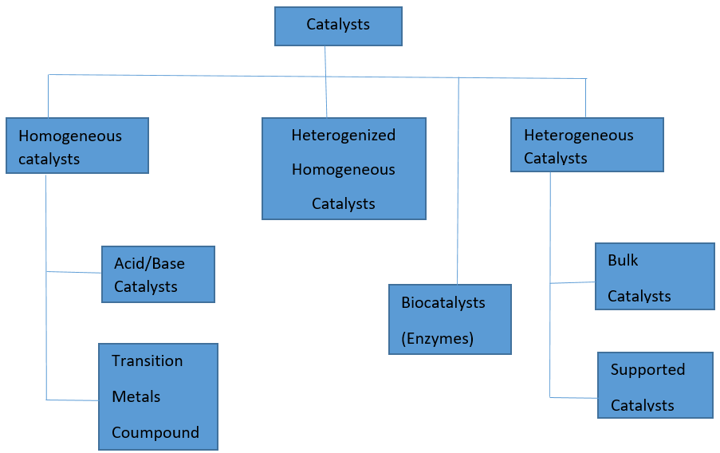

**Figure 20:** Different types of catalysts (Haridoss, 2017)

According to Agrawal, commercial catalysts for the FCC unit are based on Y zeolites as the main component with ZSM-5 as an additive.

There are three types of commercial catalysts:

* Acid-treated natural alumino-silicates;
* Amorphous synthetic silica alumina combinations;
* Crystalline synthetic silica alumina catalysts called zeolites or molecular sieves.

For a schematic representation of the zeolite, pore and Bronsted acid site structure of 10-hydrogen zeolite and zeolite acting as a molecular sieve and catalyst during the formation of 1,4-dimethylbenzene from methylbenzene (see Figures 21 and 22, respectively).

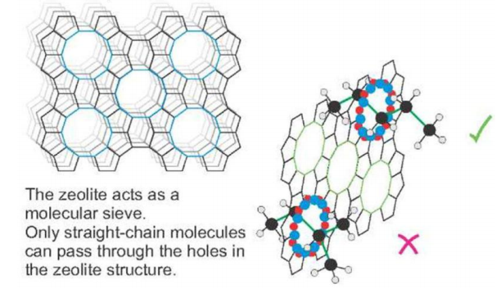 **Figure 21:** zeolite structure (Haridoss, 2017)

Song et al., 1999 show the zeolite pore and the Bronsted acid site in hydrogen zeolite with 10 tetrahedral atoms in a ring (Figure 22).

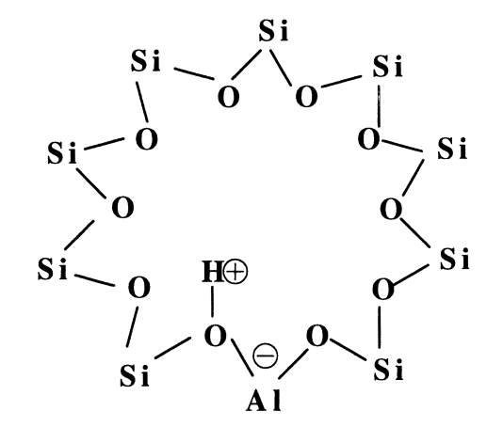

**Figure 22:** A schematic presentation of the zeolite pore and the Bronsted acid site in hydrogen zeolite with 10 tetrahedral atoms in a ring (Song et al., 1999).

Some molecular sieves and their pore sizes are illustrated in Table 10 below.

**Table 10:** Representation of some molecular sieves and their pore sizes

|  |  |  |  |
| --- | --- | --- | --- |
| structure type | No of T atoms | Pore size | Pore shape |
| Zeolite A | 8 | 4.1 Å | Circular |
| Erionite | 8 | 3.6×5.1 Å | Elliptical |
| Ferrierite | 10 | 4.2×5.4 Å | Elliptical |
| ZSM-5 | 10 | 5.3×5.6 Å | Elliptical |
| ZSM-12 | 12 | 5.5×5.9 Å | Elliptical |
| Mordenite | 12 | 6.7×7.0 Å | Elliptical |
| Faujasite (X,Y) | 12 | 7.14 Å | Circular |
| Beta | 12 | 7.6×6.4 Å | Elliptical |
| Linde L | 12 | 7.1 Å | Circular |
| VPI-5 | 18 | 12.1 Å | Circular |
| MCM-41 | ˃ 18 | 15-100 Å | Circular |

Figure 23 below shows a simplified clay catalyst production diagram developed by Oumarou (2020) using Niger clay.

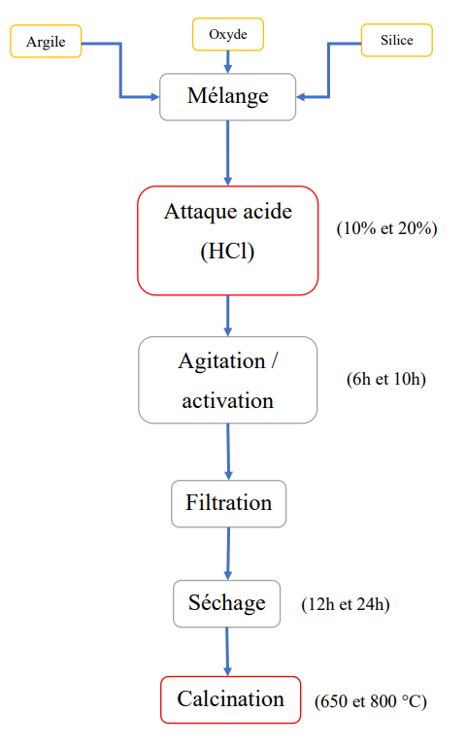

**Figure 23:** Preparation steps for clay-based FCC catalysts (Oumarou, 2020).

There are several manufacturing techniques for industrial catalysts, but many catalysts have been developed by numerous manufacturers to meet industrial consumption requirements.

**Conclusion**

Crude oil is initially made up of numerous hydrocarbons, and fluid catalytic cracking of the residue has made it possible to increase the yield of light hydrocarbons such as LPG, naphtha, kerosene and diesel. Before cracking, the feedstock must be characterised by various techniques such as SARA distribution, PONA, ndm, API density,... and the characterisation factor. These characterisation techniques, combined with chromatography, provide better insight into the composition of the feedstock to be treated. The various FCC catalytic cracking processes have an exponential impact on product yield, depending on their configuration (Model I, II, III, IV, etc.). ). This literature review has enabled us to understand that this yield depends on the operating parameters of the FCC unit, including temperature, pressure, rate and catalyst space velocity (VVH). The nature of the FCC unit feedstock, the catalyst used and its rate also play a very important role in the conversion rate. However, the catalysts most commonly used in fluid catalytic cracking operations give better light hydrocarbon yields than other alumina-supported W, Ni and V catalysts. This study highlighted the reaction mechanism and the various FCC reactions. However, increasing the reaction temperature favours coke formation (types A, B, C and D) and reduces the yield of light products.

**Disclaimer (Artificial intelligence)**

Option 1:

Author(s) hereby declare that NO generative AI technologies such as Large Language Models (ChatGPT, COPILOT, etc.) and text-to-image generators have been used during the writing or editing of this manuscript.

Option 2:

Author(s) hereby declare that generative AI technologies such as Large Language Models, etc. have been used during the writing or editing of manuscripts. This explanation will include the name, version, model, and source of the generative AI technology and as well as all input prompts provided to the generative AI technology

Details of the AI usage are given below:

1.

2.

3.

**References**

1. ACAFE (African Academy of Energy) (2015). Engineer training at SORAZ: Fluidized catalytic cracking. August 10-22, 2015.
2. ACEFE (2012), support de formation des ingénieurs à la SORAZ.
3. A.D.M. Oumarou (2020). Thesis: valorization of a petroleum residue by cracking using new clay-based semi-synthetic catalysts: case of a residue from Niger.
4. Al Humaidan F, Lababidi MSH, Al-Rabiah H (2013). Thermal cracking kinetics of Kuwaiti vacuum residues in Eureka process. Fuel 103:923- 931.
5. Ankit Kumar Agrawal(2012). Effect On Naphtha Yield, Overall Conversion And Coke Yield Through Different Operating Variables In Fcc Unit Using Aspen-Hysys Simulator.
6. Baba Ahmed Abderrazzak and Boudahri Fethi (2022). Handout: Refining and Petrochemicals (downloaded from Google).
7. B.P Tissot and D.H Welte (1984). Petroleum formation and occurrence.ISBN: 3-540-13281-32.
8. Carlos A. Cabrera, Northbrook ; Daniel N. Myers, Arlington Heights ; Harold U (1988). Régénération du catalyseur.
9. Caroline Saulnier (2008).Thèse : Modélisation numérique tridimensionnelle de l'écoulement réactif triphasique gaz-goutte-particule au sein d'un réacteur à lit fluidisé FCC. P. 255.
10. China salhediwa (2021). Rapport (Master of science) : Craquage catalytique fluide.
11. Colorado School Of Mines (2015). Overview of Catalytic Cracking.
12. C.R. Marcilly, R.R. Bonifay (1996), Catalytic cracking of resid feedstocks. Arab. J. Sci. Technol. 21(48),627-65.
13. Damien Delvaux De Fenffe (1988). Thesis: Etude géochimique de la Matière organique Sédimentaire Par pyrolyse: Caractérisation des roches à kérogène et des bitumes par pyrolyse comparative et analyse cinétique, Application au secteur pétrolier du Baza "ire - Angola. P 278
14. European Patent Application: EP 2 886 629 A1 (2015). Bulletin 2015/26. Applicant: IFP énergies nouvelles (92852 Rueil- Malmaison Cedex (FR)). Inventors: Gornay, Julien; Leflaive, Philibert; Touzalin, Olivier; Pucci, Annick and Largeteau, Delphine.
15. E. A. Emam (2013). "Clays as catalysts in petroleum refining industry", ARPN J. Sci. Technol. vol. 3, no. 4. Encyclopaedia Britanica https // www.Britanica .com/Technology/Petroleum-refining/ catalytic cracking. Accessed 16/09/2023.
16. Frederik Zafiryadis, Anker Degn Jensen, Weigang Lin, Elisabeth Akoh Hove, Morten Boberg Larsen, Hao Wu (2022). Injection of gas-liquid jets into gas-solid fluidized beds: A review. Particuology. Journal homepage: www.elsevier.com/locate/partic
17. Gerd Ndab-Tah Nji (2010). Thesis: Characterization of Heavy Oils and Bitumens. P 380.
18. Heinz Heinemann and James G. Speight (2017). Handbook of petroleum refining.
19. Hiba Aouled Mhemed (2021). Thesis: Energy and environmental valorization of used tire waste: improvement of pyrolysis liquid products by catalysis. P 257.
20. H.H. Murry (2006): Applied clay mineralogy: occurrences, processing and applications of kaolins, bentonites, palygorskitesepiolite, and common clays, vol. 2.
21. IFP, (2007). Oil & Gas Science and Technology - Rev. Vol. 62
22. James H. Gary, Glenn E. Handwerk, Mark J. Kaiser (2007). Petroleum refining: technology and economics. 5th ed. ISBN-13: 978-0-8493-7038-0 (acid-free paper).
23. J. Laxalde (2012), Thesis: "Analyse des produits lourds du pétrole par spectroscopie infrarouge", Université de Lille 1.
24. Jérôme Bayle (1996). Thesis: Etude du contact gaz-solide dans un réacteur à co-courant descendant par la mise en (oeuvre du craquage catalytique du cumène). P 307
25. Marcilly C (2003), Present status and future trends in catalysis for refining and petrochemicals, J. Cat. 216 , 1-2, 47-62.
26. Merdrignac and D. Espinat (2007). Physicochemical Characterization of Petroleum Fractions: the State of the Art, IFP-Lyon.
27. Michel Guisnet and Samuel Mignard (2000). Fluid catalytic cracking: process, catalyst and chemistry.
28. Mitchell, B.R., Ind. Eng(1980). Chem. Prod. Res. Dev. 19 , p. 209.
29. Mithat Zeydan (2007). The comparison of artificial Intelligence and traditional approaches in FCCU Modeling. International Journal of Industrial Ingineering. ISSN 1072-4761.
30. M.R.Riazi (2005). Characterization and properties of petroleum fractions.1st ed. P: 421. ISBN: 0-8031-3361-8.
31. Nadjet Dehouche (2019-2020). Course handout. Subject: Introduction to Refining and Petrochemistry. Level: 2nd year Process Engineering. Downloaded from [www.google.com](http://www.google.com)
32. N.Y. Chen, W.E. Garwood and F.G. Dwyer (1996). Shape Selective Catalysis in Industrial Applications (Dekker, New York).
33. Olaosebikan Abidoye Olafadehan, Opeyemi Praise Sunmola, Adeleke Jaiyeola, Vincent Efeovbokhan, Olubunmi Grace Abatan (2018). Modelling and simulation of an industrial RFCCU-riser reactor for catalytic cracking of vacuum residue. Applied Petrochemical Research. <https://doi.org/10.1007/s13203-018-0212-y>.
34. Pierre Danial-Fortain (2010). Thèse de doctorat : Étude de la réactivité des résidus pétroliers en Hydroconversion.
35. Rahul B. Kasat, D. Kunzru, D. N. Saraf, et Santosh K. Gupta (2002). Multiobjective Optimization of Industrial FCC Units Using Elitist Nondominated Sorting Genetic Algorithm. Ind. Eng. Chem. Res. 2002, 41, 4765-4776.
36. Robert C. Ellis, Xuan Li, and James B. Riggs (1998). Modeling and Optimization of a Model Catalytic Cracking Unit IV Fluidized. Vol. 44, No. 9 .AIChE Journal.
37. Serge Raseeve (2003).Thermal and Catalytic Processes in Petroleum Refining. ISBN : 0-8247-0952-7.
38. Société de Raffinage de Zinder (SORAZ) (2010) : Règlements d'opération Relatifs aux installations conjointes No.1.
39. Speronello, B.K. et Reagan, W.R (1984). Oil Gas J. 82, 139.
40. Sundaram Haridoss (2017), Influence of Catalyst and Its Applications in Petroleum Refineries- A Overview. J. Chem. & Cheml. Sci. Vol.7(7), 540-549.
41. T. F. Boukezoula (2019).Thèse : Contribution à l'étude des catalyseurs bifonctionnels appliqués au reformage catalytique et optimisation de leurs conditions de mise en œuvre. Corrélation entre distributions des sites actifs et performances attendues dans un réacteur à lit fixe.
42. Thomas, C.L (1949), Ind. Eng. Chem.
43. Venuto P.B. et Habib E.T. (1979). Fluid catalytic cracking with zeolite catalysts, (Marcel Dekker, New York).
44. William L. Leffler (2008). Petroleum Refining in Nontechnical Language - 4th ed. p. cm. Inclut un index. ISBN 978-1-59370-158-1.
45. Emenike, E. C., Adeleke, J., Iwuozor, K. O., Ogunniyi, S., Adeyanju, C. A., Amusa, V. T., ... & Adeniyi, A. G. (2022). Adsorption of crude oil from aqueous solution: a review. *Journal of Water Process Engineering*, *50*, 103330.
46. Oloruntoba, A., Zhang, Y., & Hsu, C. S. (2022). State-of-the-art review of fluid catalytic cracking (FCC) catalyst regeneration intensification technologies. *Energies*, *15*(6), 2061.
47. Tasneem, N., Ahmed, S., & Hossain, M. M. (2024). Enhancement of Olefins from Fluid Catalytic Cracking Processes: A Review on Effects of Catalysts and Kinetics. *Arabian Journal for Science and Engineering*, 1-22
48. Kumar, K.S., Munıamuthu, S. and Mohan, K.R., 2023. Measurement of temperature flow analysis by condition monitoring system for WTG gear box to evaluate the thermal performance associated with plant load factor. *Journal of Thermal Engineering*, *9*(4), pp.979-987
49. Hu, B., Wang, S., Yan, J., Zhang, H., Qiu, L., Liu, W., ... & Ge, X. (2024). Review of waste plastics treatment and utilization: Efficient conversion and high value utilization. *Process Safety and Environmental Protection*, *183*, 378-398.