**Assessment of the Spatial Distribution of Sawmills in Akwa Ibom State, Nigeria: Implications for Urban Planning and Environmental Management**

**Abstract**

The development of urban centres in Akwa Ibom State has improved the construction industry's prospects. However, there is rising public concern regarding the impact of environmental health and safety factors, as well as town planning, on the industry. The unregulated activities of the sawmilling industry significantly affect its employment potential, economic value, and wooden resources for furniture and house-building purposes. This study investigates the sawmill industry in terms of its geography within Akwa Ibom State, Nigeria, considering the consequences on urban development and the environment. With the aid of field surveys and questionnaire administration, UAV aerial surveys, combined with the GIS technologies implemented in this study, revealed the sociological and health repercussions associated with designated sawmills, dismantling within territorial sociologies, as well as many sociological struggles regarding activism challenges. The findings obtained through the ANN analysis indicated that sawmill industries, in particular, have a concentrated distribution centre in urban areas such as Uyo, Ikot Ekpene, and Eket, which are timber industrialised towns because of advanced infrastructure development. Some other findings noted grave environmental and health concerns, particularly concentrated on the air, noise pollution, and poor occupational safety among sawmill employees. Gender and age distribution in the demographic data showed a marked disproportionate distribution where male workers aged 31 to 45 dominated. Many of these workers were untrained in formal safety procedures and devoid of protective clothing. The research concludes that this pattern of industry distribution greatly undermines public and environmental health. The study suggests that planners should adopt a responsive policy approach toward ecological, public health, and other multi-sectoral spatial planning for construction, industrial zoning policy, further, active enforcement of occupational health and safety measures, comprehensive ecological monitoring, and preventative policy frameworks to achieve these goals.

**INTRODUCTION**

In contemporary times, wood is still widely used for constructional purposes. Sawmilling is defined as the process of converting round wood from the forests into lumber by using a variety of machines. The sawmill industry is among the popular microenterprises that have contributed to the advancement and growth of the economy (Kabir et al., 2024). The sawmilling industry originated in Nigeria with the establishment of the first pit-sawing facility (Kanu et al., 2024). However, the unregulated activities of the sawmilling industry in Nigeria significantly affect its employment potential, economic value, and wooden resources for furniture and house-building purposes. The development of urban centres in Akwa Ibom State has also improved the construction industry's prospects. On the other hand, there is rising public concern regarding the impact of environmental health and safety factors, as well as town planning, on the industry.

Waste generation is a concomitant aspect of the sawmill industry. It cannot be eliminated, but can be mitigated and well managed. Some of the issues associated with unmanaged sawmill waste, such as urban environmental degradation, reduce the aesthetic value of buildings in that vicinity, generate aggressive odours during the rainy season and pollute the air with smoke when the wastes are burnt irrepressibly (Ebekozien et al., 2023; Falola et al., 2024). The operation of sawmills comes with the added burden of health and environmental risks. Stanley & Inuope (2021) reported that the sawmill area in Port Harcourt is a region of high air-quality pollutants which includes particulate matter (PM₂.₅ and PM₁₀), volatile organic compounds (VOCs), and sulfur dioxide (SO₂) that is emitted at levels above those recorded for South Africa and even WHO standards. In addition, waste wood poses a growing threat to the environment and waste management (Osuntuyi, 2022). The noise and wood dust produced within sawmills have adverse consequences on the health of the workers, exacerbating respiratory and auditory conditions. Sawmill workers in Abeokuta are especially at risk: they have been reported to have stunted pulmonary function and respiratory symptoms that are much more advanced than non-exposed individuals (Olujimi et al, 2019). Furthermore, Eziyi et al (2021) noted that there was a greater lack of noise-abatement hearing protection among staff in Osun State, thereby increasing vulnerability to noise-induced hearing loss. The spread of sawmills frequently illustrates the lack of proper urban planning in combination with zoning. Residential areas, schools, and marketplaces often overlap with the locations of operating sawing facilities. These sites are within reach of many people, so the prospective exposure to environmental emissions and noise pollution becomes a serious concern. A more advanced method of zoning these industrial sites has not been developed or controlled. Information Dynamics Geographic Systems has intricate workflows for map development, as well as features of industrial analysis that GPs are able to deploy. Sensitive and health impacts policy aids are able to aid decision making in conjunction with spatial clustering concerning proximity to critical sensitive uses. The matter of spatial management of sawmills in Akwa Ibom State is highly significant but has not been covered in depth so far. This is what drives participation in this research, which applies sophistication with GIS in ascertaining the spatial distribution of sawmills in Akwa Ibom State and analysing the consequences for urban infrastructure and environmental planning. Their objectives of this study will be: (1) to identify the spatial distribution of the sawmills, (2) to evaluate the operational milieu and the health effects (3) to propose policies, strategies, and instruments for the management of Sustainable Development of the Region.

**MATERIALS AND METHODS**

**Study Area**

As shown in Figure 1, Akwa Ibom State is placed within 5° 53’N and 4° 32’ latitude and 7°25’ and 8°25’ East longitude. The state is bounded on the east by Cross River State, Rivers and Abia State on the West, and the Atlantic Ocean to the South, extending in length from Ikot Abasi in the west to Oron in the east for 129 kilometres. The name of the state originates from the Qua Iboe River that flows within the state and empties into the Bight of Bonny (Onyeakagbu, 2021). The entire area of the study is the Qua Iboe River Basin, which has an area of 8,412 km2. In the western part of the lower Cross River basin, in combination with the eastern region of the Imo River basin, this region is what defines the state. Flat, low-lying lands are one of the three distinctive terrains found in Akwa Ibom State. The second terrain is an expansive elevated region decorated with hills that stunningly contrast with the flat plains. The altitude of Akwa Ibom State ranges from 45 to 70 meters above sea level. It has three senatorial districts made up of 31 Local Government Areas (Petters et al. 1994).

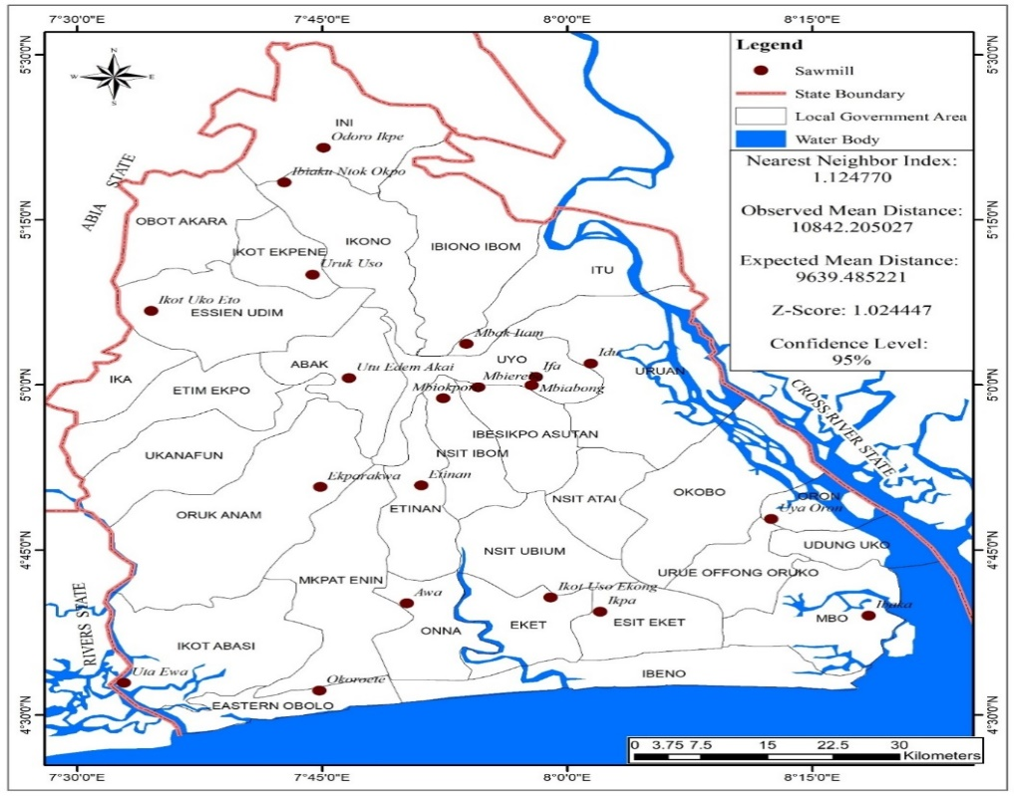

Fig 1: Map of Akwa Ibom State showing locations of the sampled sawmills

**Research design**

The research design employed in evaluating the study to identify and map the spatial distribution of sawmills in Akwa Ibom State was a cross-sectional study with a mixed-methods approach.

**Source of data**

To successfully achieve the study objective, a combination of quantitative and qualitative data was obtained. Quantitative data includes counts and statistical analyses, while qualitative data involves descriptions, interviews, and observations. The research also paid attention to ethical issues when collecting, storing, and analysing sensitive data related to individuals, their health, and safety. Therefore, codes such as SMW (Sawmill Workers) with numbers such as (001-00384) were used to represent the sampled sawmill workers in each of the sampled sawmills within the three Senatorial Districts of the study area.

**Method of data collection:** Data were collected using the Geographic Information System Approach, semi-structured questionnaires, checklists, Key Informant Interviews (KII), field observations, and scientific measurements, which were done in situ.

**Techniques of data analysis**: The data collected from the field were analysed using both descriptive and inferential statistical techniques, and the following procedures and methods were employed to produce conclusions pertinent to the study's goals. Descriptive analysis, which included simple averages, percentages, tables, maps, and charts, was used to show the summary of details from attribute data. Conventional and geo-statistical inferential statistical techniques were adopted to test the formulated hypothesis. Further, the photo-elucidation technique was also employed to show the medical examination processes carried out with sawmill workers during the fieldwork exercise. The techniques adopted for testing the hypotheses are as follows:

Hypothesis one: H0: The locational pattern of sawmills in Akwa Ibom State is not random.

H1: The locational pattern of sawmills in Akwa Ibom State is random.

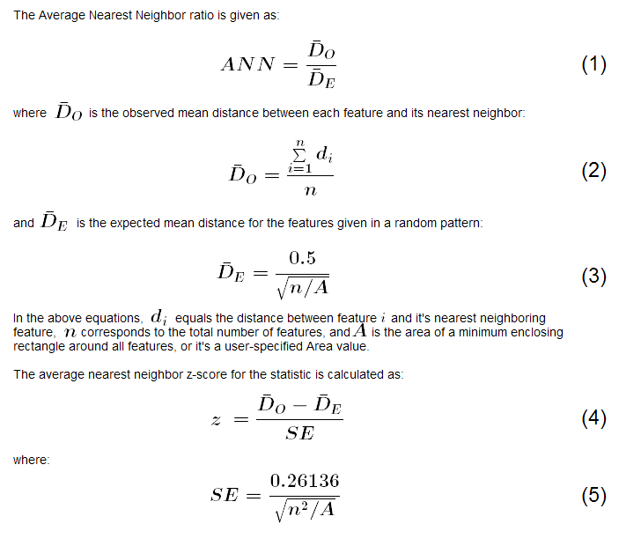

The analysis of the spatial distribution of sawmills in Akwa Ibom State was carried out using the Average Nearest Neighbour (ANN) spatial analytic tool. This tool measures “average nearest neighbour distance” which is the distance from each feature centroid to its nearest neighbour centroid. The average is less than that of a random distribution, a clustered distribution is attributed to features being analysed. If the average distance is higher than a random distribution, features are said to be dispersed. In ANN analysis, the criterion of the z-score and p-value gives measures of statistical significance; thus, the decision to reject the null hypothesis (Environmental Systems Research Institute, ESRI, 2013). While collecting the field data, a Garmin Etrex 10 portable Global Positioning System (GPS) was used to record the X (longitude), Y (latitude), as well as Z (name and attribute) coordinates of the sawmills in the three senatorial districts of Akwa Ibom State. These coordinates were subsequently processed using Microsoft Excel and then prepared for mapping and spatial analysis using GIS.

Two sets of data were collected: one consisted of twelve major sawmill branches across the regions, with two sawmills sampled from each local government area, and another described the spatial distribution of sawmill machines within these branches. Using ArcGIS, the data were mapped and visually represented to show the distribution of sawmills and machines. Sawmill workers’ exposure to machines concerning the hearing, sight, and lung health of workers was evaluated with mean centre analysis in ArcToolbox, focusing on their distances to the machines. This analysis finds a geographic centre produced by averaging the X and Y coordinates of feature centroids, calculating a centre of concentration among features.

**Sampling techniques**

The study sawmills were purposively selected, and the research adopted a stratified random sampling method to select 32 sawmill workers (respondents) from the target population (sawmill workers) within the 12 sawmills across the twelve (12) LGAs within the three (3) senatorial districts of Akwa Ibom State. The list of sawmill workers was obtained from the workers registered at the Akwa Ibom State Sawmill Association Secretariat at Itam Sawmill and respondents were chosen based on the different sections that they worked in.

**RESULTS**

In this research, an exhaustive assessment of functional sawmills within Akwa Ibom State's three senatorial districts was conducted, and based on their sizes, they were subdivided into three categories: large, medium, and small sawmills. The analysis included all registered employees, who comprised chainsaw operators, log hauliers, drivers, mechanics, sawmill machinery operators, and employer supervisors, thus covering the entire registered workforce of the sawmill. The total study population comprises those who work in the various categories in the sawmills, specifically 18,112 sawmill workers who were part of the sample. As well, the focus was placed on the medium- and large-scale enterprises due to their relatively more active engagements compared to the smaller ones. This was purposeful owing to the fact that medium and large-scale ones have a relatively higher workforce and also serve as representatives of the vast majority of enterprises in the country. The target population was men and women aged eighteen (18) years and older, as depicted in Table 1. Sample Table 2 indicates the total number of sawmill workers counted per Sample sawmill, which stood at 32. The investigations consisted of Akwa Ibom's sawmills' geographic analyses and demographics of the sawmill workers, their employment-related health hazards, and sawmill-related occupational risks. A Figure was presented of the data acquired through the GIS. A total of 20 registered sawmills have been counted throughout the Senatorial districts of Akwa Ibom State. The spatial distribution is as follows: Akwa Ibom North East (Uyo) Senatorial District had 6, Akwa Ibom North West (Ikot Ekpene) 7, and Akwa South (Eket) 7. The Uyo senatorial district dominated in the number of sawmills within its metropolis, which can be attributed to limbs for paying timber for timberlands, timber, construction, and the like. It is also worth mentioning that sawmills were settled in the urban areas as opposed to the forest reserve areas. A fair number of those surveyed as sawmill workers were male, and accounted for 68 % of the sample. The workers aged 31 to 45 were predominantly 45.8%. The majority of the sawmill employees were married (47.4%), as shown in Table 3. Their marital status indicates that they relied on income from sawmill operations to work to sustain their family, which constitutes their livelihood. The literacy levels among most of the timber factory workers are relatively favourable since 30.7% have attained Secondary Education, 3% had no education, OND/NCE was held by 4.3%, 16% of the workers held degrees, and 6.8% were post graduates. Inganos kwenju walu pahika wakhushi ekhanialoek strategic university. Incomes of workers actively engaged in sawmill operations indicated that a good number of workers earn between Naira 201,000 and Naira 300000 per month. The survey results also show that a reasonably higher number of employees claim salaries of between Naira 100000 and Naira 200000 (32.6%). Towards the end of the tenure, a greater percentage of workers have around 6 to 10 years of work (43.0%), which means there is a moderate retention rate of employees despite shift-end dangers. Only 10.9% have over 15 years of work experience, which suggests a high attrition turnover, probably due to health issues or retirement.

**Table 1: Population of Sawmills and Workers in Akwa Ibom State**

|  |  |
| --- | --- |
| **Sawmills in Akwa Ibom State** | **The population of sawmill workers** |
| Abak Sawmill | 1,250 |
| Ikot Ekpene Timber Market | 900 |
| Ikono Sawmill | 750 |
| Essien Udim Timber Market | 1,300 |
| Oruk Anam Timber Market | 620 |
| Ini Timber Market | 1,150 |
| Ibiaku Ntuk Okpo Sawmill | 800 |
| Ibesikpo Timber Market | 985 |
| Idu Uruan Timber | 1770 |
| Itam Timber Market | 1510 |
| Mbiabong Sawmill | 720 |
| Mbiokporo Sawmill | 690 |
| Etinan Sawmill | 450 |
| Eket Timber Market | 575 |
| Uya Oron Sawmill | 400 |
| Ikot Abasi Timber Market | 430 |
| Ibaka Mbo Sawmill | 500 |
| Awa Sawmill | 700 |
| Mkpat Enin Sawmil | 1,200 |
| Ikpa Sawmill Esit Eket | 1412 |
| **Total** | **18,112** |

**Table 2: Sample Size**

|  |  |  |
| --- | --- | --- |
| **Sample sawmills** | **Population of sawmill workers** | **Sample size** |
| Itam Timber | 1,250 | 32 |
| Idu Uruan Sawmill | 900 | 32 |
| Ibesikpo Timber Market | 750 | 32 |
| Mbia-Obong Sawmill | 1,300 | 32 |
| Ikot Ekpene Timber Market | 620 | 32 |
| Ikono Sawmill | 1,150 | 32 |
| Essien Udim Timber Market | 800 | 32 |
| Abak Sawmill/Wood Market | 520 | 32 |
| Eket Timber | 770 | 32 |
| Ikot Abasi Sawmill | 510 | 32 |
| Oron Timber Market | 720 | 32 |
| Mkpat Enin Sawmill | 690 | 32 |
| **Total** | **10,040** | **384** |

**Table 3: Demographic characteristics of sawmill workers**

|  |  |  |
| --- | --- | --- |
| **Gender of sawmill workers** | **Frequency** | **Percentage (per cent)** |
| Male | 264 | 68.7 |
| Female | 120 | 31.3 |
| **Total** | **384** | **100** |
| **Ages of sawmill workers** | **Frequency** | **Percentage (per cent)** |
| 18-30 years | 84 | 21.9 |
| 31-45 years | 176 | 45.8 |
| 46-60 years | 108 | 28 |
| 60 years and above | 16 | 4.2 |
| **Total** | **384** | **100** |
| Marital status | **Frequency** | **Percentage (per cent)** |
| Single | 117 | 30.5 |
| Married | 182 | 47.4 |
| Divorced | 48 | 12.5 |
| Windowed | 37 | 9.6 |
| **Total** | **384** | **100** |
| **Educational profile** | **Frequency** | **Percentage (per cent)** |
| No Education | 12 | 3 |
| FSLC/JSS/SSCE | 118 | 30.7 |
| OND/NCE | 166 | 4.3 |
| Degree | 62 | 16 |
| Post graduate | 26 | 6.8 |
| Total | **384** | **100** |
| **Average monthly income** | **Frequency** | **Percentage (per cent)** |
| Less than 100.000 | 41 | 10.7 |
| 100.000-200.000 | 125 | 32.6 |
| 201.000-300.000 | 149 | 38.8 |
| 301.000-400.000 | 38 | 9.9 |
| Above 401.000 | 31 | 8 |
| **Total** | **384** | **100** |
| **Years of work experience** | **Frequency** | **Percentage (per cent)** |
| Less than a year | 16 | 4.2 |
| 1-5 years | 86 | 22.4 |
| 6-10 years | 166 | 43 |
| 11-15 years | 74 | 19.3 |
| Above 15 years | 42 | 10.9 |
| **Total** | **384** | **100** |

**Discussion**

Studying the geographical distribution of sawmills in Akwa Ibom State indicates that there is a marked concentration of these industries in the urban areas, especially in the Uyo metropolis. This corroborates findings of other studies where economic activities, like as sawmilling, tend to be concentrated in urban centres due to the availability of market, infrastructure, and other resources (Bello & Mijinyawa, 2010). Such regional concentration brings an overwhelming problem concerning environmental and occupational health. Sawmill operations are known to emit pollutants in wood dust as well as noise, and contribute to air and noise pollution. Some studies show that the prevalence of wood dust exposure is associated with many respiratory conditions, including chronic bronchitis and asthma (Faremi et al., 2014). Moreover, a lack of adequate protective measures compounds the situation. Most of the sawmill workers are men aged 31-45, which signifies that the demographic for these workers is considered to be in the labour force. Under these conditions, however, with ever-present occupational hazards and a lack of safety precautions, productivity is likely to be lower, but healthcare and economic costs will be higher. The findings of Faremi et al. (2014) reported an insufficient interaction level with some surgical safety protocols among the Nigerian sawmill workers. This study enhanced spatial analysis and spatial inventorying using GIS for the sawmills. GIS has greatly assisted in the illustration of industrial spatial agglomerations, which aids in making decisions regarding urban development and the environment (Weng, 2010).

**CONCLUSION**

The research emphasises the acute need for attention to comprehensive town planning and ecological management in Akwa Ibom State. The geographic agglomeration of sawmills within urban areas has notable economic benefits, but results in severe socio-ecological and public health challenges, simultaneously with overwhelming environmental stresses and public health threats.

To address these issues:

1. Form policies regarding the location of industrial activities with residential areas because of the health-friendliness of these neighbourhoods.

2. Improve safety measures for employees of the sawmill through formal training sessions, proper protective equipment, health and wellness assessments, and regular screening exams.

3. Monitoring of air and noise pollution should be carried out in areas with a high concentration of sawmills.

4. Use of GIS in the planning and zoning of urban areas should be done so as to control the growth of industrial facilities and preserve the environment.

This study has examined the spatial distribution of Akwa Ibom State. The distribution pattern suggested an optimism of sawmill clustering in urban centres, particularly in Uyo, which is undergoing infrastructural development and construction works. As Uyo is a rapidly growing urban centre, sawmills are crucial timber suppliers for sustaining numerous constructions ongoing within the region, providing several jobs (direct and indirect) to the locals. Notable too is the negative impact sawmills have on the environment and the health of people. The concentration of sawmills located in this region is, to some degree, overpopulated, which is likely to increase emissions that can greatly endanger an individual’s health. If there were adequate planning, proper policy frameworks, and adequate protective arrangements for workers, those emissions could be lessened, lessening, and a supportive and healthier environment within the locality for the communities and workers.

Disclaimer (Artificial intelligence)

Option 1:

Author(s) hereby declare that NO generative AI technologies such as Large Language Models (ChatGPT, COPILOT, etc.) and text-to-image generators have been used during the writing or editing of this manuscript.

Option 2:

Author(s) hereby declare that generative AI technologies such as Large Language Models, etc. have been used during the writing or editing of manuscripts. This explanation will include the name, version, model, and source of the generative AI technology and as well as all input prompts provided to the generative AI technology

Details of the AI usage are given below:

1.

2.

3.

**REFERENCES**

Aletan, O. E., and Garba, E. O. (2020). Environmental Implication of Sawmill Industries on Adjoining Residents in Kwara State, Nigeria. *Int. J. Sci. Res. in Multidisciplinary Studies* Vol, 6(3).

K.J. Awosan, M.T.O. Ibrahim, E.U. Yunusa, B.A. Isah, U.M. Ango, A. Michael (2018) Knowledge of workplace hazards, safety practices and prevalence of workplace-related health problems among sawmill workers in Sokoto, Nigeria. *International Journal of Contemporary Medical Research.* 5(10):J5-J12.

Onyeakagbu, A. (2021). See how all the 36 Nigerian states got their names. Pulse.ng. Retrieved 22 December 2021.

Petters, S. W., Iwok, E. R., & Uya, O. E. (1994). Akwa Ibom State: The land of Promise—A Compendium. Gabumo Press, Nigeria, pp. 19–244.

Saunders, M., Lewis, P. & Thornhill, A. (2007) Research Methods for Business Students. 4th Edition, Financial Times Prentice Hall, Edinburgh Gate, Harlow.

Smith, M. F. (2002): Sampling Considerations in Evaluating Cooperative Extension Programs. Florida Cooperative Extension Service Bulletin PE-1.Institute of Food and Agricultural Sciences. University of Florida.

Bello, S. R., & Mijinyawa, Y. (2010). Assessment of injuries in small scale sawmill industry of south western Nigeria. *Agricultural Engineering International: CIGR Journal*, 12(1), 151–157.​

Faremi, F. A., Ogunfowokan, A. A., Mbada, C. E., Olatubi, M. I., & Ogungbemi, A. V. (2014). Occupational hazard awareness and safety practices among Nigerian sawmill workers. *International Journal of Medical Science and Public Health*, 3(10), 1244–1248. https://doi.org/10.5455/ijmsph.2014.260620142&#8203;:contentReference[oaicite:21]{index=21}

Weng, Q. (2010). *Remote sensing and GIS integration: Theories, methods, and applications*. McGraw-Hill.​

Eziyi, J. A., Akinwumi, I. O., Olabanji, I. O., Ashaolu, O. O., & Amusa, Y. B. (2021). Noise pollution: Knowledge, attitudes and practice of sawmill workers in Osun State, Nigeria. *Nigerian Journal of Health Sciences*, 21(1), 1–8. <https://nigerianhsjournal.ng/index.php/njhs/article/view/126>​[nigerianhsjournal.ng](https://nigerianhsjournal.ng/index.php/njhs/article/view/126?utm_source=chatgpt.com)

Olujimi, O. O., Nofiu, M. A., Oguntoke, O., & Soaga, J. A. (2019). Occupational exposure to wood dust and prevalence of respiratory health issues among sawmill workers in Abeokuta Metropolis, Ogun State, Nigeria. *Journal of Natural Sciences Engineering and Technology*, 18(1), 1–12. <https://journal.funaab.edu.ng/index.php/JNSET/article/view/2274>​[FUNAAB Journal](https://journal.funaab.edu.ng/index.php/JNSET/article/view/2274?utm_source=chatgpt.com)

Osuntuyi, E. O. (2022). Environmental effects of sawmilling industry and relevance of wood wastes in Nigeria. *International Journal of Educational Research*, 6(1), 45–52. <https://ijojournals.com/index.php/er/article/view/525>​[IJO Journals](https://ijojournals.com/index.php/er/article/view/525?utm_source=chatgpt.com)

Stanley, H. O., & Inuope, O. A. (2021). Assessment of air pollution and health hazard associated with selected sawmills in Port Harcourt Metropolis. *South Asian Journal of Research in Microbiology*, 9(4), 17–34. <https://doi.org/10.9734/sajrm/2021/v9i430215>​

Kanu, C., Chikwendu, M. U., Onyeizu, R. U., & Egu, E. C. (2024). Comparative study of wood waste generations on sawmilling industries in Oyo State, Nigeria. *Journal of Research in Forestry, Wildlife and Environment*, *16*(2), 171-180.

Ebekozien, A., Aigbedion, M., Duru, O. S. D., Udeagwu, O. H., & Aginah, I. L. (2023). Hazards of wood sawmills in Nigeria’s cities: the role of fourth industrial revolution technologies. *Journal of facilities management*, *21*(1), 84-101.

Kabir, G., Idumah, F., Awe, F., Odediran, F., & Ukoha, P. (2024). Analysis of Technical Efficiency of Sawmill Industry in Ogbomoso Area of Oyo State, Nigeria: A Stochastic Frontier Approach. *Ethiopian Journal of Environmental Studies & Management*, *17*(3).

Falola, A., Mukaila, R., Olanrewaju, A. S., Musa, M. O., & Abarike, C. A. (2024). Occupational hazards in sawmill industry and its effect on sawmill output in Nigeria. *Safety in Extreme Environments*, *6*(4), 333-342.