Catch Per Unit Effort, Catch Composition and Economic Analysis of Fishing Gears Operating in Dal Lake: A Baseline Study for Fisheries Management
Abstract
A field study was conducted on the cast net and gill net fishery and species composition in the Hazratbal and Bod Dal basins of Dal lake, Srinagar Jammu & Kashmir. The study was conducted from February 2015 to May 2015 with the objectives of assessing the catch composition using cast net and gillnet and evaluating the income of the fishers. A total of nine species of fishes were identified in the catches of cast net and gillnet in the lake which included Cyprinus carpio, Carassius carassius, Schizothorax niger, Schizothorax esocinus, Schizothorax curvifrons, Crossocheilus diplochilus, Triplophysa spp., Puntius conchonius and Ctenopharyngodon idella. The dominant species during the study period was C. carpio which contributed 63.97% of the total catch by biomass and 41.64% by number on the whole. It dominated the catch by biomass as well as number in both the basins followed by C. carassius which contributed 32.09% by number and 20.5% by biomass. In both the basins of Dal Lake, maximum catch (by biomass) was found in the month of May and minimum catch in the month of February. The maximum number of specimen were recorded in the month of April in the Hazratbal basin and May in the Bod Dal basin of Dal Lake, Srinagar Jammu & Kashmir. The study further underscores the economic assessments like initial investment, fixed cost, operating cost and the returns of the fishermen who operate different gears in the Dal Lake, Jammu & Kashmir.
Key words
Dal Lake, Fisheries, catch per unit effort, fishing gear, biomass
- Introduction
Fisheries sector has been the fastest growing food production system for the last three decades. The FAO reported a surge in global fisheries and aquaculture production in 2022, reaching 223.2 million tones, a 4.4% increase from 2020. The FAO projects a 2.2% increase in global fisheries and aquaculture production to nearly 192 million tonnes in 2024. Jammu and Kashmir is endowed with vast and varied fishery resources which offer immense potential for augmenting fish production for domestic consumption and export. The Economic Survey of Jammu & Kashmir indicates a significant growth in the fishery sector with compound annual growth rate (CAGR) at 13.67% (Economic Survey J&K, 2024-25) and production of about 28 thousand tonnes according to the latest report of Fisheries Department (2023-2024).
Dal Lake situated in the northeast of Srinagar (the capital of Jammu and Kashmir) in Kashmir valley, is one of the most beautiful lakes in India. The lake is probably of fluvial origin, formed from the oxbows of river Jhelum. Around 1200 AD, the lake spread over an area of 75 km². At present, it covers about 21.1 km² and has a maximum depth of 5.4 m, and a shoreline of 15.4 Km (Raina, 2002). Of the total area, only about 11.4 km² is open water and the rest is under floating gardens most of which have now settled permanently. The lake has a large mountainous catchment spread over an area of 316 km². The lake is multi basined with an average depth varying from 1.4 to 1.8 meters. The Dal Lake is being fed by a stream Telbal Nalla from north which brings water from high altitude Marsar Lake.
Economic indicators such as cost and earnings of fishermen play an important role in the economic analysis and therefore, provide useful information for sustainable fisheries management, planning and policy-making. These indicators can be used in monitoring and assessing the economic and social performance of fisheries sector. However, no such work has been conducted in Dal Lake. Fishing cost varies depending on the type of fishery and the gear employed. When fishing costs are known, various types of social and economic analysis on local fisheries are possible, notably the data can be utilized to assess the current economic status of the sector. Information on fishing cost in Jammu & Kashmir is scarce and incomplete. The major reason for this is the unavailability of significant data and efforts are required to obtain such information to generate the base line data. Fishers are also understandably reluctant to disclose such information. In addition, government agencies also need to record and disseminate such information systematically.
The work done on the fish catch and effort in Kashmir has been limited. Also the work on the efficiency of fishing gears including the cost and returns with respect to the particular gear is also negligible. The changing ecological condition of the Lake over the years has also affected the fish catch and composition. It was with this background that the present research work was carried out.
- Materials and methods
2.1 Study area
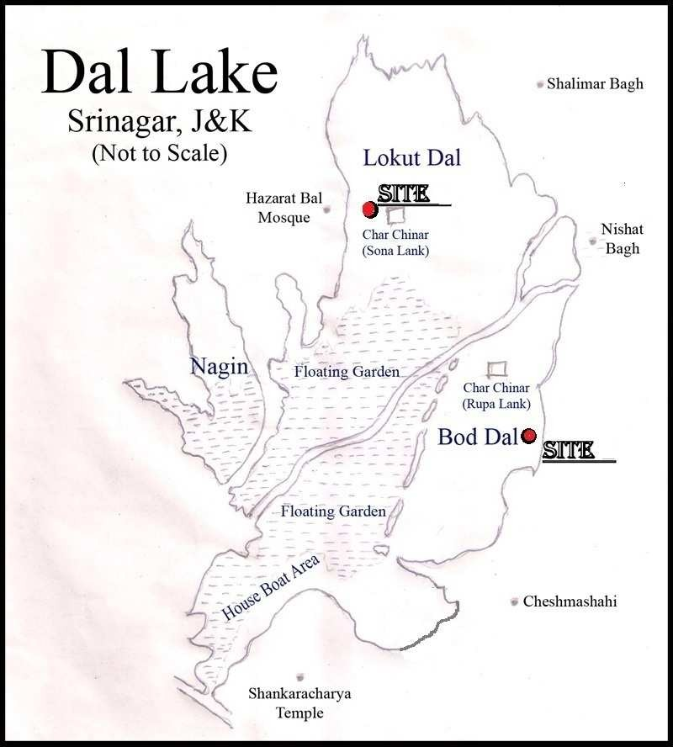

Fig 1-Study Area
The study was conducted in the Dal Lake from the following two
basins:
    - Hazratbal Basin (Plate1a)
    - Bod Dal (Plate1b)
Dal Lake is situated in the northeast of Srinagar (the summer capital of Jammu and Kashmir) in Kashmir valley, is one of the most beautiful lakes in India. The lake is probably of fluvial origin, formed from the oxbows of river Jhelum. At present, it covers about 21.1 km² and has a maximum depth of 5.4 m, and a shoreline of 15.4 km (Raina, 2002). Of the total area, only about 11.4 km² is open water and the rest is under floating gardens most of which have now settled permanently.

During the research programme on Dal Lake, fishing was done directly hiring the local fishermen along with their craft and gears monthly at each basin (Bod Dal and Hazratbal) for estimation of catch per unit effort, from 1st February to 31st May. For calculating the fishing effort, two fishermen were hired, one for rowing the boat and other for fishing with nets (Cast net and Gill net). Fishing time was divided into soaking time of net, actual fishing time and total fishing time. The man hours in the water body were calculated by taking into account the total trip time inclusive of actual fishing time and time taken to reach the fishing ground and return.
Fishing was usually carried out during morning hours. The gears used were analysed. Their dimensions and mesh sizes were recorded. While fishing one fisherman maneuvered the boat with the oar while the other fisherman casted the net in the water body. Fishing was randomly done throughout the basin for four hours a day during winter season (February and March) and five hours during summer season (April and May).
The cast net was casted on sighting a fish shoal and on the basis of accuracy in efforts, the net was thrown in a manner such that it unfolds its full mouth area on the surface of the water. The net was allowed to stay for about 3 minutes and then it was retrieved back into the boat by pulling the rope skillfully and the fishes caught in its pockets were removed into the boat. The time taken for completing the operation was noted. The gill nets were fixed in the late evenings (18:00 hours) and the catch was collected in the morning (07:00 hours). The weight of the total catch, species composition and effort from each gear from each basin was recorded. The cost of construction and mode of operation of each gear was studied. Catch per Unit Effort is the catch of fish by number or biomass for a unit of fishing effort; here the total weight of fish that is the biomass was taken into consideration for calculation and description. The number of crew members involved in the fishing were recorded and used for determining the catch per unit effort as g/man-hour. CPUE for each gear was calculated as per Kurianand Willmann (1982) by taking time of operation of gear as time of effort and expressed in g/man-hr. This is the standard method used for calculating the catch per unit effort. For monthly catch composition, the mean of catches of 10% of the total fishing boats in the basin was taken. As the fish composition of the Dal Lake is not uniform throughout the year and varies from season to season, monthly data was taken to estimate the catch composition. The mean value was taken in order to have an accurate notion of the data.
Economics of operation was assessed by cost and earning data obtained personally during field surveys and also by using the pre tested questionnaires (one time and monthly). Parameters like fixed cost, variable cost, labour cost, depreciation, interest, operating cost, profit and income were used to determine the economics of fishers.
2.2 Identification of fishes
The samples of the fishes were brought to the laboratory (Faculty of Fisheries, Rangil, SKUAST-Kashmir) for identification. Identification of fishes was done with the help of standard taxonomic works (Day, 1878; Hora, 1936; Kullander et al., 1999). Various morphological characters and meristic characteristics were taken into consideration for proper identification of fishes. The morphometric parameters taken in consideration were total length, standard length, and depth of the body, length of head, width of head and diameter of eye. The meristic characters taken were number of spine and rays in the various fins, scales on the lateral line and the length and number of barbells.
2.3 Statistical analysis
The data for catch composition was analyzed using MS Excell & SPSS (20) version for windows. The Statistical Package for the Social Sciences (SPSS) is powerful statistical software used for data analysis. It enables users to analyze large datasheets, explore relationships between variables, and make informed decisions on data insights.
- Results and Discussion
The catch per unit effort recorded using cast net and gill net in Hazratbal basin for the month of April was 249 and 276 g/man-hour respectively. In the month of April as temperature starts increasing and the improvement in the fishing hours was observed. The number of working days recorded in the month was 25 while as average working hours were 5 (Table 1 and 2).
The catch composition recorded for the month of May included Cyprinus carpio var. communis, Cyprinus carpio var specularis, Carassius carassius, Schizothorax niger and Schizothorax esocinus. The common carp dominated the catch using cast net with highest catch of 72.89% by biomass and 49.12% by number while as the native Snow trouts comprised 3.93% by biomass and 4.95% by number. Carassius carassius showed a contribution of 23.17% by biomass and 45.94% by number. The total specimen caught using cast net was 283.
The catch composition in the basin using gillnet was also quite significant. Common carp contributed 86.83% by biomass and 73.63% by number. Carassius carassius contributed 27.39% by biomass and 24.64% by number. Schizothorax niger contributed 1.39% by biomass and 1.45% by number while as S. esocinus contributed 1.55% by biomass and 1.74% by number. The total number of specimen caught in the month of May using gillnet was 345.
The catch per unit effort recorded using cast net and gillnet in the Hazratbal basin for the month of May was 341 and 337g/man-hour respectively. The number of working days recorded in the month was 25 while as average working hours were 5 (Table 1 and 2).
Overall catch in the basin during the study period was dominated by the Common carp with 66.44 mean per cent by biomass while as Schizothoracids remained low with a mean per cent of 5.99 by biomass. The highest catch per unit effort, recorded using cast net was in the month of March with an effort of 347 g/man-hour, while the lowest was 202 g/man-hour in the month of February (Fig. 6). Using the gillnet the highest catch per unit effort measured was 337 g/man-hour recorded for the month of May, while the lowest was 129 g/man-hour for the month of February (Fig. 4 and 5).
3.1 Monthly catch composition and CPUE at Bod Dal basin

The Bod Dal of the Dal lake basin as the name indicates is the larger basin connected to Gagribal from one end and Nishat from the other. In Bod Dal basin, the catch in the month of February consisted of Cyprinus carpio var. communis, Cyprinus carpio var. specularis, Carassius carassius, Schizothorax niger, Schizothorax esocinus, Schizothorax curvifrons, Crossocheilus diplochilus, Puntius conchonius and Triplophysa spp.
In the month of February temperature being quite low hence reducing the fishing hours. The number of working days calculated in the month was 23 while as average working hours were 4. The catch caught using cast net included Common carp with biomass of 32.66% while its contribution by number was 16.09%. Carassius carassius contributed 20.76% by biomass and 17.57% by number. Schizothorax niger comprised 13.840% by biomass and 7.43% by number. Schizothorax esocinus contributed 6.780% by biomass and 3.47% by number. Schizothorax curvifrons formed 8.962% by biomass and 3.71% by number. Crossocheilus diplochilus contributed 12.03% by biomass and 44.55% by number as the fish is too small in size. Triplophysa spp. was also caught using cast net with biomass of 0.25% and number of 1.73%. The small sized P. conchonius contributed 4.701% by biomass and 5.45% by number. The CPUE obtained for the month of February using cast net was 262 g/man- hr. (Table 1)
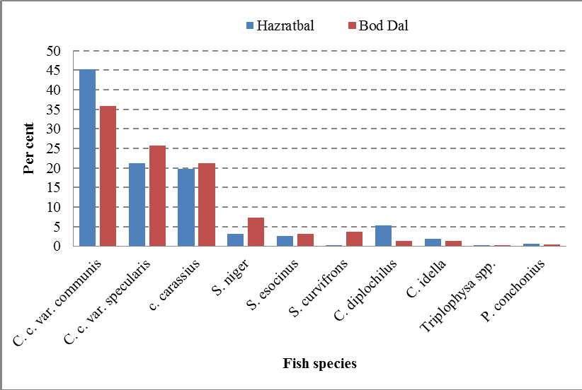
Fig. 2: Percentage contribution of fishes by biomass to total (mean) catch at the two basins
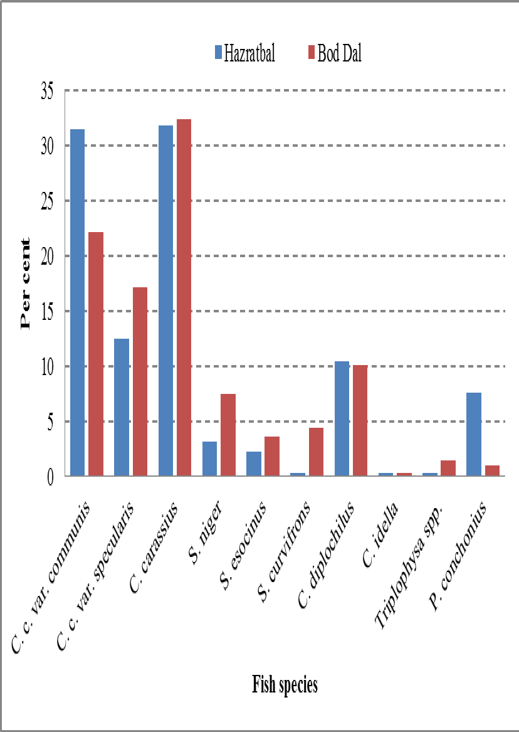
Fig. 3: Percentage contribution of fishes by number to total (mean) catch at the two basins

Common carp was caught in a better proportion in Bod Dal basin using gill net with biomass of 49.30%. By number the Common carp contributed 33.23%. The Crucial carp was seen to contribute 18.74% by biomass and 39.56% by number. The native snow trouts showed a higher frequency. Schizothorax niger contributed 12.86% by biomass and 11.71% by number. The contribution of
S. esocinus was 7.06% by biomass) and 5.38% by number while S. curvifrons formed 12.036% by biomass and 10.13% by number. Small sized fishes like C. diplochilus, Triplophysa spp. and P. conchonius were not caught by gillnet. The total number of specimen caught in the said basin in the month of February using cast net was 404 while that by gillnet was 316. The CPUE obtained for gillnet was 218 g/man-hr. (Table 2 and 5). During the month of March, the number of fish specimen caught using cast net were 508. Common carp contributed 45.75% by biomass and 20.47% by number. Carassius carassius comprised 23.77% by biomass and 27.56% by number. Schizothorax niger contributed 12.30% by biomass and 7.48% by number. Schizothorax esocinus comprised 1.86% by biomass and 1.38% by number. Schizothorax curvifrons was seen to be at 4.61% by biomass and 3.15% by number. Crossocheilus diplochilus constituted 9.29% by biomass and 36.42% by number. Triplophysa spp. was also caught by cast net and was seen to contribute 0.09% by biomass and 0.98% by number. Puntius conchonius had a biomass of 2.32% and contributed 2.56% by number. The CPUE obtained for the month of March using cast net was 369 g/man-hr. (Table 1).
Using gillnet Common carp contributed 54.35% by biomass and 39.58% by number. Carassius carassius contributed 21.99% by biomass and 37.50% by number. Schizothorax niger comprised 21.99% of the total catch by biomass and 37.50% by number. Schizothorax esocinus constituted 5.60% of the catch by biomass and 5.95% by number. Schizothorax curvifrons contributed 6.70% by biomass and 6.55% by number. One specimen of C. idella with a biomass of 200 g was also caught using gill net. The CPUE obtained using gill net was 279g/man- hr. (Table2).
In the month of April, the Common carp contributed 63.06% by biomass and 46.61% by number using cast net. Carassius carassius contributed 18.91% by biomass and 29.24% by number. Schizothorax niger contributed 8.33% by biomass and 7.63% by number. Schizothorax esocinus comprised 4.21% by biomass and 3.81% by number. Schizothorax curvifrons contributed 5.03% by biomass and 4.24% by number. About 20 specimens of Triplophysa spp. were caught with a biomass of 0.46%. The total number of specimen caught during the month using cast net was 236 (Table 4). The CPUE obtained using cast net was 204 g/man-hr. (Table1).
Using gillnet a total of 354 specimens of fishes were caught. The Common carp was seen to contribute 66.07% by biomass and 46.9% by number. Carassius carassius constituted 9.77% by biomass and 35.59% by number. Schizothorax niger contributed 11.40% by biomass and 8.47% by number. Schizothorax esocinus comprised 6.17% by biomass and 4.52% by number. Schizothorax curvifrons contributed 2.89% by biomass and 2.82% by number. Six specimens of Ctenopharyngodon idella were also caught which contributed 3.70% by biomass and 1.69% by number. The CPUE obtained using gill net was 242 g/man-hr. (Table 2).
In the month of May, the catch composition using cast net comprised of 433 specimens of different fish species. The common carp constituted 67.65% by biomass and 51.74% by number. Carassius carassius contributed 27.10% by biomass and 42.26% by number. Schizothorax niger comprised 2.21% by biomass and 2.31% by number. Schizothorax esocinus contributed 1.04% by biomass and 1.62% by number. Schizothorax curvifrons constituted 2.00% by biomass and 2.08% by number. The CPUE obtained using cast net for the month of May was 406g/man-hr. (Table 1).
Using gillnet 412 specimen were caught during the month of May. The common carp dominated the catch by constituting 76.14% of biomass and 59.95% by number. The Crucian carp followed with a contribution of 14.01% (biomass) and 29.85% (number). Schizothorax niger contributed 4.44% by biomass and 4.37% by number. Schizothorax esocinus contributed 2.49% by biomass and 2.91% by number. Schizothorax curvifrons contributed 2.91% by biomass and 2.9% by number. The CPUE obtained using gill net for the month of May was 372.22 g/man-hr (Table 1).
The overall catch in the basin during the study period was dominated by the Common carp with 61.49% (mean) by biomass. The native Snow trouts contributed 14.17% (mean) by biomass. The species of Schizothorax were very low in the catches. In these species, the eggs are laid at the bottom in running waters, under stones, gravel and debris (Sehgal, 1970). The Schizothoracids spawns during the months of March to June (Yousuf, 1996; Bhat et al., 2010). There is one major stream Telbal nallah which affords spawning facilities for Schizothoraxspp. The Schizothoracids from the lake migrate to the peripheral streams for spawning that could be one of the reasons for low catch of schizothoracids in the month of May. The highest catch per unit effort, recorded using cast net was in the month of May with 406 g/man-hour, while the lowest was 204 g/man-hour for April (Figs. 4 and 6). Using the gillnet the highest catch per unit effort measured was 372 g/man-hour recorded for the month of May, while the lowest was 218g/man-hour for the month of February (Fig.4).
The common carp was found to dominate the catch by number as well as biomass (Figs. 2 and 3). The mean percentage composition of common carp to the total catch in the entire study period was found to be 66.44% at Hazratbal and 62.52% at Bod Dal basin. The native Schizothoracids which were abundant in the Lake three decades ago (Das and Subla, 1964) at present formed just 5.99% of the total mean catch at Hazratbal basin and 14.17% at Bod Dal basin respectively (Figs.2and3).
Table 1: Catch per unit effort recorded using Cast net
Month | Fishing hours | Persons involved | Gear used | CPUE (g/man-hr.)
 |  |  |  | Hazratbal | Bod Dal
February | 4 | 2 | Cast Net | 202 | 262
March | 4 | 2 | Cast Net | 347 | 369
April | 5 | 2 | Cast Net | 249 | 204
May | 5 | 2 | Cast Net | 341 | 406
Mean | - | - | - | 284.75 | 310.25

Table 2: Catch per unit effort recorded using Gill net
Month | Fishing hours | Persons involved | Gear used | CPUE (g/man-hr.)
 |  |  |  | Hazratbal | Bod Dal
February | 12 | 1 | Gill Net | 129 | 218
March | 12 | 1 | Gill Net | 233 | 279
April | 12 | 1 | Gill Net | 276 | 242
May | 12 | 1 | Gill Net | 337 | 372
Mean |  |  |  | 243.65 | 278.06

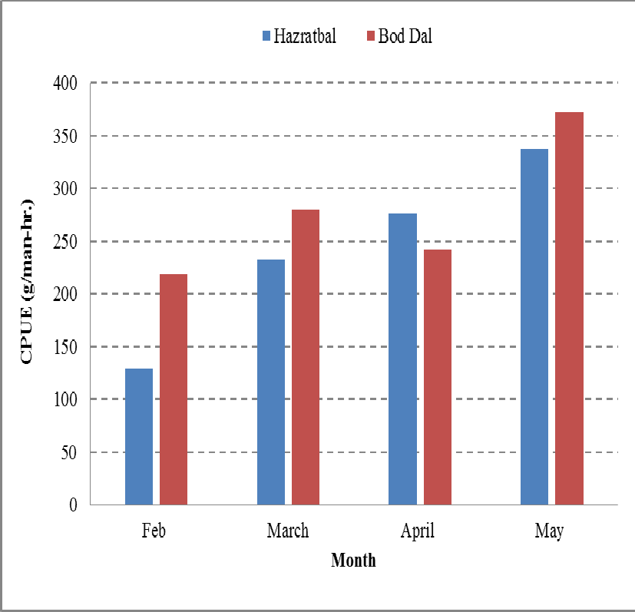
Fig. 4: CPUE (g/man-hr.) using gillnet at the two basins
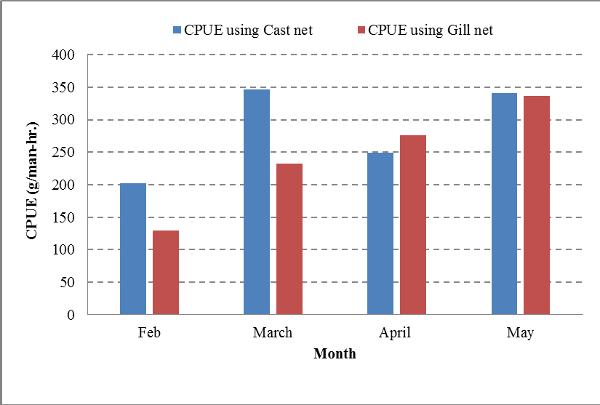

Fig. 5: CPUE obtained at Hazratbal using Cast net and Gill net

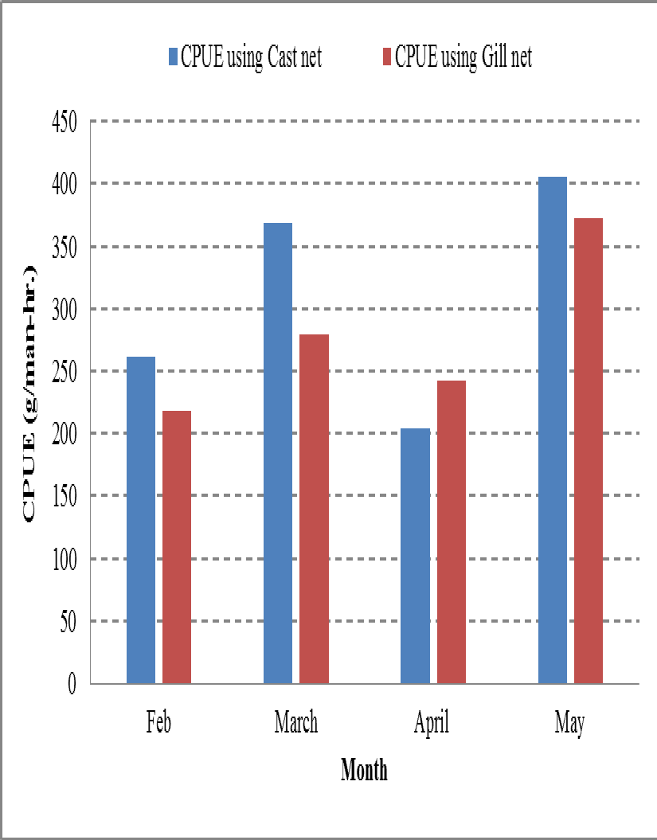

Fig. 6: CPUE obtained at Bod Dal basin using Cast net and Gill net

3.2 Fishing Gears and Crafts
3.2.1 Crafts
During the study, wooden plank built boats were recorded with an overall length (OAL) range between 5m-10m and width range between 0.8m – 1.2m. The given boats have been used in the study. A Plank boat is a wooden, non-mechanized, manually operated boat. The wooden boat is locally manufactured. These crafts were made up of locally available wood-Deodar, which is costly but durable. It does not decompose in water and remains sturdy throughout. Locally it is known as ‘Naav’. They are often navigated by two boat men. The boats are painted by synthetic paints. The average age of plank boat is nearly 10-12 years. Fishing gears such as cast net, rod and line and gill net are operated from the boat. The dimensions of the fishing boat locally known as ‘Naav’ are given in Table8.
Table 8: Average values of fishing craft (Naav) in Dal Lake
Description | Average value (Mean)
Length (OAL) (m) | 6.1±0.27
Breadth (m) | 0.62±0.144
Depth (m) | 0.24±0.017
3.2.2 Fishing Gears
Several types of fishing gears are traditionally used in Dal Lake for fish harvesting, e.g. cast net, gillnet, long line and rod and line. Cast net (Plate 10) is the most commonly used net. It is a throw net. A cast net is made up of three parts: the upper section (net band), the middle section (a conical-shaped net mesh), and the lower section. The lower section of the net have pockets with fixed iron weights. A variety of synthetic twines as for example polyamide monofilaments, polypropylene, polyvinyl chloride or nylon rope are used to construct the nets and the lifespan of net varies considerably depending on the fishery (Deshpande et al., 2020; Syversen et al., 2020). One sinker per 0.2 m net is introduced and made of iron and zinc alloy which are found locally. The net has a pocket at the anterior end to which the sinkers are attached. At the posterior end a strong rope is attached to handle the net. Time per hauling is 3-5 min. One net is operated by one person. No fish attractive device is used. The practitioner casts using both hands and the shoulder, throwing the net onto the surface of water in an area likely to have the targeted fish (Plate 10(a) & (b)). When hurled into the air, the net spreads out into a circular shape and expands; as the net hits the water surface, the weighted edges of the net descend into the water in a circular shape, spread out like a parachute, and trap the targeted fish within the circular section (Plate 10(c)). Finally, when the weighted portions of the net reach the bottom of the Lake, the top band of the net is pulled, cinching the net closed into a sack like shape within the water. With the weight dragging along the Lake bottom, the net is slowly drawn back to the caster’s hands, collecting the captured fish within the net. In most cast nets, the internal part of the lower section of the net (the section with rounded margins) forms a pouch like structure in which the fish are caught. No chemical or medicine is used, only dried under the sun and put in a safe and dry place.
The length of cast net, when hung is 4.0 m and diameter of the net when spread is 4.8 m. The mesh size varies between 1.2 to 3.0 cm bar to bar. The net is provided with iron or lead sinkers of about 8-10 kg weight around the peripheral cord. They are cylindrical in shape with a length of 17 mm and diameter of 10 mm. The fishermen throw the net in a manner such that the net falls on the surface of the water fully expanded. Earlier the rope used to be kept intact by the fisherman while throwing the net but nowadays they just release the rope along with the net. They later use a long wooden pole locally called as shome to locate the cast net. This practice has been adopted because of growing drowning incidents of fishermen while using cast net. It requires considerable strength, balance and skill to cast the net in such a way that it forms a flat circular shape just on reaching the water surface. As soon as the net touches the surface it sink down fast because of the weight. Fish directly under it get enclosed in the net. On hauling in the net with the rope at the vertex, it closes onto the fish and their gills get entangled. The cord is then located and the net is pulled back into the boat. This net can only be operated from a boat. The life expectancy of a cast net is 4-5 years. It costs Rs. 3000 for its construction. Depending upon the number of meshes the cast net is known by different names such as: Guranzaal (1200 meshes), Thapthatzaal (1100 meshes), Dal zaal (1000 meshes), Naushathzaal (900 meshes), Nuchkulzaal (800 meshes), Pouchkulzaal (500 meshes) and Ara zaal (400 meshes) (Yousuf, 1996; Bhat et al., 2015). Among these Noushathzaal, Guranzaal and Dal zaal are used in Dal Lake. The fishermen in Dal Lake operate these gears throughout the year. They locally call it ‘Duph’ or ‘Zaal’. Specifications of cast net used in Dal lake are given in Table4 and5.
Gill nets are the most suitable nets for fishing in deeper regions of the Lake. The gill nets locally called ‘Shaitan zaal’ are 15 to 40 m long and 1.5 to 3 m wide with mesh size ranging between 45 mm and 75 mm. Gill nets used in Dal Lake are made up of thin nylon monofilaments usually sea green in colour. They have a short life expectancy of one year, after which they have to be replaced. Locally made sinkers are used. The use of these nets has seriously affected the regenerative capacity of the fish fauna. It has been observed that the communities themselves had imposed restrictions on the use of lower mesh size nets due to decline in fish catch. Promotion of gill nets was also undertaken by the State Government Department at selected locations but due to declining fish catch in the Lake, the Department of Fisheries has imposed ban on gill netting. Despite the fact, gill netting is still being practiced in some parts of the water body, especially in the winter months due to low catch and modus operandi of the cast net.
Table 9: Specifications of cast net used in Dal Lake
Piece | Length (m) | Mesh Bar to Bar (mm) | Mesh Knot to Knot (mm)
First | 1.2 | 15 | 23
Second | 0.4 | 10 | 12
Third | 0.4 | 10 | 12
Fourth | 0.2 | 10 | 13
Fifth | 0.2 | 12 | 15
Sixth | 0.4 | 15 | 23

Table10: Specifications of different local types of Cast nets operated along the Dal Lake, Jammu and Kashmir
Local name | Length (m) | No. of pieces | Total meshes | Mesh size knot to knot | Period of operation
Naushathzaal | 4 | 6 | 900 | 15-30 | Whole year
Guranzaal | 3.2 | 9 | 1200 | 10 | May-August

Long lining locally known as ‘Wael Razz’ is a primitive method of fishing in which a nylon line measuring about 1000 meters in length is generally used in the Lakes. These are fitted where fish are expected to be in shoals. It can be of varied lengths. In Dal Lake long lines of length 30-100m are used. The Department of Fisheries, Govt. of Jammu and Kashmir, has permitted a length of 500m for long lining. They are attached by branch lines at regular intervals and the distance from one hook to other hook in Dal Lake is maintained at 1 m. Hooks of sizes ranging from 3-6 are used in Dal Lake. Hook is either made up of stainless steel or iron. The line rope is made up of multifilament nylon usually black in colour. In order to sink the rope in water, pebbles having weight 50-60 grams are used, the distance between two pebbles is 1 m. Hooks containing earthworms are attached to the line to lure the fish. Trash fish, soaked wheat and sometimes maize flour mixed with Jaggery (Gur) is also used as bait. The period of fishing with long line ranges from 4-6 hours. Hook and line is the fishing gear requiring the lowest investment: the large nylon lines are locally twisted. The cost is between Rs. 150 and Rs. 700. The nylon snoods, aluminium/iron hooks and iron/stone weight cost between Rs. 50- 100 depending on the number of hooks and length of line. Due to the very high frequency of losses, the cost of the snoods and hooks is generally considered as an operating expenditure rather than as an investment. The life expectancy of a long line is about four to six months, after which it has to be replaced. In Dal it is usually set in the evening and the catch is collected in the morning. This method is usually used to catch Schizothorax spp. and Common carp in Dal Lake. In Dal Lake the line fishing is mainly done from June to September months.
Rod and line locally known as ‘Bislai’ (Plate 12) is also an important gear used in Dal Lake. It consists of a rod made up of bamboo which is about 5m long attached to a line made up of monofilament nylon, provided with a hook at its termination. The line is provided with a float like structure above the hook which helps in sensing that the fish has been hooked. The hooks used in Bislai are of various shapes like straight, bent, reversed, flattened, angular, and double or may have barbs. A mixture of soaked wheat flour or baked rice and grinded trash fish is used as bait. It is used usually as a recreation by tourists as well as the local people. Young boys both from fisherman and non-fisherman community go for bislai fishing on their off days. Bislai can be operated from the bank as well as the boat. Many Bislai can also be operated from a single boat by a single person. It is usually practiced in the warmer months of May, June, July and August.
In fishing accessories fishers use a long wooden pole called as Shum which is made up of wood mainly Budhul, it is used to handle the net to catch the fish; its length is 10-12 ft. Fishers use it while operating cast nets as well as gill nets. It is an essential tool used while fishing. It helps in searching suitable fishing grounds for using cast net and also in reaching back the net once it is thrown in the waterbody.
3.3 Economics
3.3.1 Initial investment
The boats operating at Dal Lake were mostly purchased during the period from 1995 to 2005. Due to the cost escalation of fishing boats and continuous replacements of damaged parts by the fishermen in subsequent years, there was not much difference in the purchase value and the present resale value of the boats. However, the average value of the units at the time of observation was considered in working out the economics of fishing operations. The average investment of boats operating at Dal Lake was Rs. 30,000 for boats and Rs. 4,000 for both the gears (cast net and gillnet).
3.3.2 Fixed cost
Depreciation of the fishing unit and interest for investment constitute the fixed cost. Depreciation is worked out on the basis of the expected life of the fishing boat and accessories and the interest was calculated at the rate of 15% per annum. The average expected life of gears was 5 years for cast net and hence the depreciation was calculated at 20%. Life expectancy for gillnet was one year and thus depreciation was calculated at 100% for gillnet while as for boat depreciation was calculated at 10%. The annual interest for investment on gill net worked out at Rs. 4,677 and Rs. 4,988 for the cast net. The annual fixed cost came out to be Rs. 7,898 for gill net and Rs. 8,639 for cast net (Table6).
3.3.3 Operating costs and returns
The day to day expenses incurred for the working of the boat is termed as operating expenses or variable costs. The expenses on wages, repairing and maintenance are the major components of variable cost of a fishing boat. The cost of repairing and maintenance of the unit is entirely borne by the owner. The gross return of a unit is the sale value of the catch landed by it.
The average operating costs and returns in Dal Lake during 2014-2015 are given in Table 11. The table reveals that the annual average variable cost of a unit worked out at Rs. 11,500 for gill net and Rs. 16,500 for cast net. The highest net profit was obtained from gillnet i.e. Rs. 103454/unit/annum. The net operating income of cast net was Rs 88431/= while that of gillnet was Rs 111358/= (Table 6). The annual catch of a boat during the year was 918 kg for gill net and 786 kg for cast net. The revenue realised were found to be minimum during November- February and maximum during June-September.
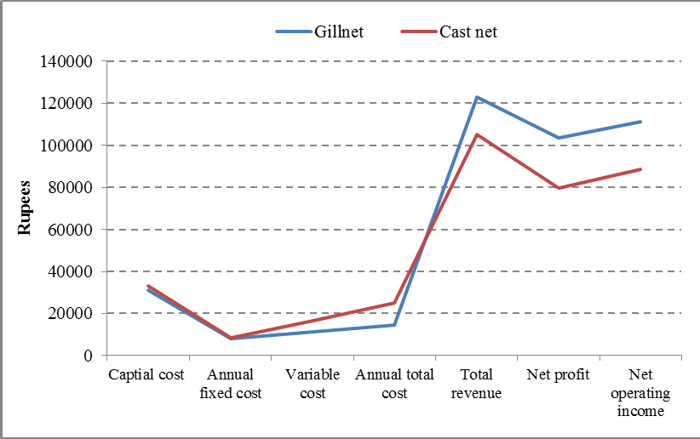
Fig. 7: Operating costs and returns of Gill net and Cast net

Table 11: Costs and returns of the fishers of Dal Lake
S.  No | Description |  | Cast net | Gill net
S.  No |  |  | Amount (in Rs)
1. | Capital cost | (a) Vessel | 30000 | 30000
1. | Capital cost | (b) Net | 3000 | 1000
1. | Capital cost | (c) rope | 55 | 100
1. | Capital cost | (d) Sinkers | 200 | 80
1. | Capital cost | Total | 33255 | 31180
2. | Annual Fixed Cost | (a) Depreciation
2. | Annual Fixed Cost | Vessel @ 10% | 3000 | 3000
2. | Annual Fixed Cost | Net @ 20%(cast net) &  100%(Gillnet) | 600 | 1000
2. | Annual Fixed Cost | Rope @ 20% | 11 | 11
2. | Annual Fixed Cost | Sinkers @ 20% | 40 | 16
2. | Annual Fixed Cost | (b) Interest for  investment@15% | 4988 | 4677
2. | Annual Fixed Cost | Total | 8639 | 8704
3. | Variable cost | (a) Maintenance of vess | 1000 | 1000
3. | Variable cost | (b) License | 500 | 500
3. | Variable cost | (c) Family labour | 15000 | 10000
3. | Variable cost | Total | 16500 | 11500
4. | Total Annual cost | (2+3) | 25139 | 20204
5. | Total catch (kg) |  | 786 | 918
6. | Total Revenue(Rs.) |  | 104931 | 122857
7. | Net operating Income | (6-3) | 88431 | 111358
8. | Net profit | (6-4) | 79792 | 103454

3.4 Statistical analysis
The data presented in the Table 7 reveals that the gears used for fish catch and the sites are statistically significantly associated in case of Cyprinus carpio var. communis, Carassius carassius and Schizothorax niger. It was observed that the maximum catch of Cyprinus carpio var. communis was obtained using gillnet at both the sites. In case of Carassius carassius highest catch was obtained using cast net at Hazratbal basin and gillnet in Bod Dal basin. The highest catch of Schizothorax niger was obtained using cast net in Hazratbal and gillnet in Bod Dal. Further statistically non-significant association was observed in case of Cyprinus carpio var. specularis, Schizothorax esocinus and Schizothorax curvifrons using both gears for catch. In case of Crossocheilus diplochilus, Ctenopharyngodon idella, Triplophysa spp. and Puntius conchonius the catch was very low.
Table 12: P-values calculated for the catch composition of Dal Lake
Fish species caught |  | Catch by number
 |  | Hazratbal Basin | Bod Dal Basin | P  Value
Cyprinus carpio var.  Communis | Cast net | 309 | 289 | <0.05
Cyprinus carpio var.  Communis | Gill net | 486 | 359
Cyprinus carpio var.  Specularis | Cast net | 145 | 214 | >0.05
Cyprinus carpio var.  Specularis | Gill net | 188 | 292
CarassiusCarassius | Cast net | 469 | 463 | <0.01
CarassiusCarassius | Gill net | 339 | 500
Schizothoraxniger | Cast net | 51 | 96 | <0.01
Schizothoraxniger | Gill net | 32 | 119
Schizothoraxesocinus | Cast net | 24 | 37 | >0.05
Schizothoraxesocinus | Gill net | 28 | 65
Schizothoraxcurvifrons | Cast net | 4 | 50 | >0.05
Schizothoraxcurvifrons | Gill net | 2 | 76
Crossocheilusdiplochilus | Cast net | 486 | 365 | NS*
Crossocheilusdiplochilus | Gill net | 0 | 0
Ctenopharyngodonidella | Cast net | 0 | 0 | NS*
Ctenopharyngodonidella | Gill net | 11 | 7
Triplophysaspp. | Cast net | 14 | 32 | NS*
Triplophysaspp. | Gill net | 0 | 0
Puntius conchonius | Cast net | 31 | 35 | NS*
Puntius conchonius | Gill net | 0 | 0
*NS= Non Significant

3.5 Craft and Gears
3.5.1 Crafts
During the study, wooden plank built boats were recorded with overall length (OAL) range between 5m-10m and width range between 0.5m-0.75m. The same crafts were used in the given study. These crafts were made up of locally available wood-Deodar, which is costly but durable. It does not decompose in water and remains sturdy throughout. Locally it is known as ‘Naav’. They are often navigated by two boat men. No modifications have been seen as such in the crafts used. Qureshi et al. (2014) also reported similar observations. They reported use of primitive wooden boats for fishing, transportation and navigation in Kashmir waters. ‘Naav’ due to its longevity and durability and small size are being preferred by the local fishermen over the other crafts.
3.5.2 Fishing Gears
The gears and methods mainly used for fishing in Kashmir valley are Long line, Hook and Line, Scoop net, Rod & line, Narsoo, Cast net, Gill net, Trap, Poisoning and Dynamiting. Among various fishing nets, cast net is the main type of gear used in the valley (Sunder et al., 1978; Yousuf, 1996; Dar et al., 2010). The main fishing gear used in the Dal Lake is the cast net which is made of six pieces each with different mesh sizes (CIFRI, 1977). Similar observations were seen in the current study. Several types of fishing gears were seen in Dal Lake for fish harvesting, such as cast net, gill net, long line and rod and line.
Cast net can only be operated from a boat. The life expectancy of a cast net is 4-5 years. It costs Rs. 3000 for its construction. Depending upon the number of meshes the cast net is known by different names such as: Guranzaal (1200 meshes), Thapthatzaal (1100 meshes), Dal zaal (1000 meshes), Naushathzaal (900 meshes), Nuchkulzaal (800 meshes), Pouchkulzaal (500 meshes) and Ara zaal (400 meshes). Among these Noushathzaal, Guranzaal and Dal zaal are used in Dal Lake. They locally call it duph or zaal. No detailed work had been done in this regard. Sunder et al. (1978), Zutshi and Vass (1982), Yousuf (1996) and Dar et al. (2010) mentioned cast net as the main gear being used in water bodies of Kashmir. CIFRI (1977) mentioned a six piece cast net each with different mesh sizes as the main fishing gear being used in Dal Lake.
Gillnets locally called ‘Shaitanzaal’ in Dal Lake are 15 to 40 m long and 1.5 to 3m wide with mesh size ranging between 45 mm and 75 mm. Gill nets used in Dal Lake are made up of thin nylon monofilaments usually sea green in colour.
They have a short life expectancy of one year, after which they have to be replaced. Locally made sinkers are used. The use of these nets has seriously affected the regenerative capacity of the fish fauna. It has been observed that the communities themselves had imposed restrictions on the use of lower mesh size nets due to decline in fish catch. Promotion of gill nets was also undertaken by the State Government Department at select locations but due to declining fish catch in the Lake, the Department of Fisheries have imposed ban on gill net. Despite the fact, gill netting is still being practiced in some parts of the water body, especially in the winter months due to low catch and modus operandi of the cast net.
Long lining locally known as ‘Wael razz’ is a primitive method of fishing in which a nylon line measuring about 1000 meters in length is generally used in the Lakes. In Dal Lake long lines of length 30-100 m is used. In Dal Lake the line fishing is mainly done from June to September months. Bislai or rod and line is also an important gear used in Dal Lake. It is usually practiced in the warmer months of May, June, July and August.
In fishing accessories fishers use a long wooden pole called as ‘Shum’, which is made up of wood mainly budhul, it is used to handle the net to catch the fish; its length is 10-12 ft. Fishers use it while operating cast nets as well as gill nets. It is an essential tool used while fishing. It helps in searching suitable fishing grounds for using cast net and also in reaching back the net once it is thrown in the water body.

3.6 Technical Efficiency
Technical efficiency measurement in fisheries is considered as a key factor, particularly when input controls are in place.
Fishing time was divided into soaking time of net, actual fishing time and total fishing time. The man hours in the water body were calculated by taking into account the total trip time inclusive of actual fishing time and time taken to reach the fishing ground and return. In the present study the catch per unit effort (CPUE) recorded using cast net varied from 204 to 406 g/man-hour at Bod Dal basin and 202 to 347 g/man-hour at Hazratbal basin. The mean catch per unit effort recorded using cast net was 310.25 g/man-hour at Bod Dal basin and 284.75 g/man-hour at Hazratbal basin. Using the gillnet, the catch per unit effort varied from 218g to 372 g/man-hour at Bod Dal and 129 to 337g/man-hour at Hazratbal. The mean catch per unit effort recorded using gillnet was 278.06g/man-hour at Bod Dal basin and 243.65 g/man-hour at Hazratbal basin. Basin wise mean CPUE at Bod Dal basin was higher (294.15) than Hazratbal basin (264.2). The mean of catch per man effort from both the basins using both gears was recorded as 279.17g. CIFRI (1977) reported the fish catch per man hour in the range of 156- 978 g at Saidakadel and 117-797 g at Hazratbal. Sunder et al. (1978) reported the mean CPUE of Dal Lake as 369 g/per man-hour. Shafi et al. (2005) reported highest CPUE of 1015 g in Nishat basin and the lowest CPUE of 122 g/man-hour at Hazratbal. They reported the mean CPUE 0f 198.33 g at Hazratbal and 604 g/man-hour at Nishat basin with overall mean catch per man effort as 382g. The catch per man hour recorded by them at Hazratbal varied from 125-335 g. Thus it can be inferred that catch per man effort has decreased relatively. However, on the whole there has not been much change in the fishing effort in the Lake during the past four decades, although the relative abundance of the different fish species has changed.
The current catch composition information would be useful in formulation of management strategies, such as regulating fishing pressure, effort and conservation measures to sustain utilization of the fishery resources. The CPUE is used in the assessment of fish populations and is an important indicator of fishery performance.

3.7 Revenue and Economics

Items included to calculate total capital cost were vessel cost, gear cost, and cost of other miscellaneous items with more than one year life span. The total capital cost i.e. the cost of boat was Rs. 30,000 and Rs. 4,000 for gears. The annual average variable cost of a unit worked out at Rs. 11,500 for gill net and Rs. 16,500 for cast net. The highest net profit was obtained from gillnet i.e. Rs. 103454/unit/annum. The net operating income of cast net was Rs 88431 while that of gillnet was Rs 111358. The variable cost of gill net was also less compared to the cast net. The revenue realized were found to be minimum during November- February and maximum during June-September.
4.0 Conclusion
A total of nine species of fishes were identified in the catches of cast net and gillnet in the Lake. The fishes of the Lake comprised of Cyprinus carpio var. communis (Scale carp), Cyprinus carpio var. specularis (Mirror carp), Carassius Carassius (Crucian carp), Schizothorax niger (Alghad snowtrout), Schizothorax esocinus (Chirruh snowtrout), Schizothorax curvifrons (Sattar snowtrout), Crossocheilus diplochilus, Puntius conchonius, Triplophysa spp. and Ctenopharyngodon idella. Common carp (C. carpio) formed the major share of the catch by contributing 63.97% of the total catch by biomass and 41.64% by number. Overall the Schizothoracids contributed 10% of the total catch.
Different types of gears like cast net, gill net, rod and line and long line were found operating in the lake. Among these gears cast net was mainly used followed by gill net, rod and line and long line. The mean CPUE recorded at Bod Dal basin was 294.15 g/man-hr. while that at Hazratbal basin was 264.2 g/man-hr. The mean of catch per man effort from both the basins using both gears was recorded as 279.17 g/ man-hr.
Disclaimer (Artificial intelligence)
Option 1:
Author(s) hereby declare that NO generative AI technologies such as Large Language Models (ChatGPT, COPILOT, etc.) and text-to-image generators have been used during the writing or editing of this manuscript.
Option 2:
Author(s) hereby declare that generative AI technologies such as Large Language Models, etc. have been used during the writing or editing of manuscripts. This explanation will include the name, version, model, and source of the generative AI technology and as well as all input prompts provided to the generative AI technology
Details of the AI usage are given below:
1. NILL
2. NILL
3.NILL

References

Anonymous, (2006). Food and Agricultural Organization (FAO), United Nations.
Bhat, F. A., Yousuf, A. R., Balkhi, M. H., Mahdi, M. D. and Shah, F. A.( 2010). Length-biomass relationship and morphometric characteristics of Schizothorax spp. in the River Lidder of Kashmir.
Indian Journal of Fisheries 57: 73-76.
Dar, S. A., Najar, A. M. and Ashraf, M. (2010). Indigenous Technical Knowledge (ITK) in fisheries sector in Central and Northern region of India. Narendra Publishing House, New Delhi pp. 165.
Das, S. M. and Subla, B. A. (1964). The Ichthyofauna of Kashmir, Part II. The speciation of Kashmir fishes. Ichthyologica 3: 57-62.
Day, F. (1878). The Fishes of India, A natural history of the fishes known to inhabit the seas and freshwaters of India, Burma and cylone. Reproduced in 1958,Willaim Dowen and Sons, London pp. 778.
Deshpande, P.C., Philis, G., Brattebø, H., Fet, A.M., 2020. Using material ow analysis (MFA) to generate the evidence on plastic waste management from commercial fishing gears in Norway. Resour. Conserv. Recycl. 5 (2020), 100024 https://doi.org/ 10.1016/j.rcrx.2019.100024.

Hora, S. L. (1936). Yale North Indian Expedition, Article XVIII. Report on fisheries, Part I, Cobitidae Mem. Canadian Academic Science 10: 299- 321.
Kullander, S. O., Fang, F., Delling, B. and Ehlander, E. (1999). The fishes of the Kashmir valley. In: River Jehlum, Kashmir valley, Impacts on the Aquatic Environment (Ed. Nyman, L.) pp. 99-168.
Kurian, J. and Willman, R. (1982). Economics of artisanal and mechanized fisheries in Kerala. Small scale fisheries promotion in South Asia. FAO/UNDP Working Paper 34: 113.Proc. Indian National Science Academy 48(2): 234-241.
Qureshi, N. W., Kadtan, N. V. and Keshave, J. V. (2014). Exploring the fisheries of Wular Lake, Kashmir, India. Aquaculture Asia 2: 17-21.
Raina, A. N. (2002). In: Geography of Jammu and Kashmir State. Radha Krishan Anand and Company Pacca Danga Jammu pp. 1-2.
Shafi, S., Bhat, F. A., Parveen, M. and Yousuf, A. R. (2005). Catch composition of fish from Dal Lake, Kashmir. Journal of Research and Development 5: 111-114.
Sunder, S., Bhagat, M. J., Joshi, C. B. and Ramakrishna, K. V. (1978). Fishing methods and fish catch composition of Dal Lake, Srinagar (J&K) during 1969-72. Journal of Inland Fish Society India 10: 9-18.
Syversen, T., Vollstad, J., Lilleng, G., Hanssen, B.J., 2020. Slitasje på skeredskap - kvantisering av slitasje fra ulike redskapstyper (In Norwegian) SINTEF, 2020. ISBN: 97882140644
Yousuf, A. R. (1996). Fishery Resources of Kashmir In: Ecology, Environment and Energy. (Eds. A. H. Khan and A. K. Pandit) pp. 75-120.
Zutshi, D. P. and Vass, K. K. 1982. Limnological studies on Dal lake Srinagar, Proc. Indian National Science Academy 48(2): 234-241

