Green Trails & Golden Fields: Agri-Ecotourism in Rajasthan, India

Abstract:
Ecotourism involves environmentally conscious tours to natural environment, promoting local communities and fostering educational experiences. Integrating agriculture with eco-tourism, also known as agri-ecotourism, combines agricultural experiences with sustainable travel practices. Agri-ecotourism refers to a business model that combines agricultural activities with tourism, drawing visitors to farms, ranches, and other agricultural enterprises for entertainment or educational purposes. This approach helps to generate income for the owners. It also includes heritage tourism, village tourism, farm tourism, pilgrim tourism, adventure tourism, nature tourism, which lead to development of community, eradication of poverty and protection of cultural heritage. The diverse landscape and rich cultural heritage of Rajasthan make the state an ideal destination for tourists. Agri-ecotourism offers significant potential by combining sustainable agriculture with tourism, promoting rural development and environmental conservation.
Keywords: Agri-eco tourism, Sustainability, Agriculture, Rural Economy

Introduction:
India, with over 17% of the world's population, is largely agrarian—around 61.5% of its population depends on agriculture, mostly small-scale farmers with holdings under 4 hectares. Despite agricultural advancements like the Green Revolution, rural India still faces socio-economic and institutional challenges. With 85% of the population linked to agriculture and 90 million farmers spread across 6.25 lakh villages, there's growing interest in agri-tourism as a means of income diversification. Agri-tourism blends farming with tourism, offering visitors authentic rural experiences like farm stays, produce picking, and animal care. Since its launch in 2004 in Baramati, this model has supported rural economies, encouraged sustainable farming, and preserved local culture. India’s rich biodiversity, traditional practices, and rural lifestyle offer immense potential for agro-eco-tourism, contributing to sustainable development goals. As tourism contributes significantly to India's GDP and employment, integrating it with agriculture can promote green growth, community engagement, and rural revitalization.
Action Planning: Enhancing the shared understanding and dialogue, the community collectively identifies priority issues and development objectives. Through a participatory approach, they create action plans that outline specific steps and activities to address the identified challenges in agri tourism. (Sisodiya & Shekhawat, 2023).
Agri-tourism and its components: Phillip et al. (2010) and Arroyo et al. (2013) outlined different types of agri-tourism based on visitor engagement. These range from non-working farm tourism, where farms serve only as scenic backdrops, to working farms offering varying levels of interaction. Passive contact agri-tourism allows minimal visitor involvement, while indirect contact focuses on farm products like meals or produce. Staged direct contact involves guided tours of farm activities, and authentic direct contact enables visitors to actively participate in farming tasks, often in exchange for food or accommodation.
Agri-tourism encompasses farm tourism, heritage and cultural tourism, and eco-tourism, offering visitors experiences like enjoying homemade food on farms, exploring rural heritage sites and cultural landmarks, and engaging with nature through activities such as birdwatching and learning about local flora and fauna.
Unique experiences provided by agro-tourism to urban traveler: Tourists opting for agro-tourism are attracted towards agro-tourism because of a variety of innovative products which they cannot enjoy with traditional tourism. Thus, agro-tourism is getting a very good response from urbanites.
The innovative products provided by agro-tourism are:
- Farm stay and farm tours
- Cow milking
- Rural art and craft
- Various farm rides and animal rides like – bullock cart, tractor, horse etc.
- Visiting a dairy, piggery, poultry, sweetwater fishing etc.
- Processing of farm products
- Demonstration of farm activities
- Special events and festivals like music festivals, harvest festivals and other rural festivals (Jatra, Mela etc.).
Positive economic and socio-cultural impacts: Rural tourism, particularly agri-tourism, positively impacts rural areas by generating employment and income, fostering business and cultural exchange, boosting demand for local products, improving public services, and enhancing education, health, and agricultural awareness among both locals and visitors.
Agri-ecotourism in India – Bottlenecks and challenges ahead: Agri-ecotourism in India faces several challenges, including limited financial support for small farmers, inadequate infrastructure and skilled manpower, lack of education and marketing strategies, regulatory hurdles, and psychological barriers such as mistrust, communication issues, and reluctance among rural communities.
Agri-ecotourism parks in Rajasthan:
- The country retreat Pali – is situated in Bankali, Sumerpur tehsil of Pali district of Rajasthan. its spread over 130 acres of lush farmland. Its owner has a vast knowledge of agriculture. People can find here Activities like –bird watching, animal herding, cycling village tour, dance program, farm activities, safari camel riding, cooking lessons on Rajasthan food, etc. also they have fully air conditioned rooms attractively furbished with a royal touch.
- Jor ki Dhani innovation house Sikar – is situated at Katrathal in Sikar district of Rajasthan. This region called Shekhawati it includes three or four districts Churu, Jhunjhunu, and Sikar. Inn Shekhwati jor ki Dhani means the first settlement. Its owner Mr. Kaan Singh Nirwan Ji has a very deep love for cows and the nature of the earth .they offer products like ghee. Spices clothes toys etc. and have hutts maid with shrubs and soil to stay .they provide satwik bhojan .activities like –horse riding fair roaming, watching the natural beauty and participate in their daily routine.
- Ikki bagh Jaipur – situated in Jheejha village of Moondli tehsil of Jaipur district of Rajasthan. Ikaki bagh is a vision of Jaidev Rathore who lives in Jaipur. this place is registered as an individual producer by the ROCA. This place is associated with some NGOs that have international volunteers who provide products from their manufacturing. Activities here are; camel or horse riding, safari, watching natural beauty, dining, fair or festival celebration, and farm stay. they are also supported by TERI, RSOCA and USDA.
- Green world foundation Jaipur – is a farm stay and organic farming place started by Indraj Jaat in 2017 at Chirada, Khora Shyam Das in Jaipur district. They offer natural produces to visitors they have farms to stay and participate in their activities. camel or horse riding, they have natural swimming pools mud houses, cattle herding, bird, animals etc. they also produce organic fruits, and veggies and offer them to visitors.
Table-I: Agro-Tourism is a way towards sustainability (Khangarot, G., & Sahu, P. (2019) :
Social | - Experience of village life  - Know about agriculture and dairy activities  - Enjoying rural activities and games  - Development of social skills and relationships
Economic | - Buying organic foods  - Sell of handmade gift items  - Attend villages fairs and festivals  - Diversification of farms activities
Environmental | - Impetus for sustainable tourism  - Sensitize towards nature  - Pollutions free environment
AGRO TOURISM DEVELOPMENTCORPORATION (ATDC):
Mr. Pandurang Taware father of the Agri-tourism concept in India and founder of Agri Tourism Development Corporation (ATDC), 2005 in Maharashtra and also Winner of the Global Responsible Tourism Award in 2011 for the ‘Best contribution to conserving cultural heritage’
The Agri Tourism Development Corporation (ATDC) promotes rural tourism in Maharashtra by helping farmers with project planning, financial aid, training, marketing, and connecting them with both domestic and international tourists. It aims to blend urban and rural cultures while boosting rural incomes. Essential infrastructure includes lodging, fresh food, basic amenities, traditional rides, cultural experiences, and safety measures. Agri-ecotourism offers employment, improves farmers' living standards, and drives rural economic growth. However, challenges like a lack of awareness, weak communication, limited capital, unorganized operations, and climatic hardships persist. To overcome these, farmers can form cooperatives, use media for promotion, partner with institutions, train in hospitality, adopt IT, understand visitor needs, and maintain good customer relations to ensure a sustainable and rewarding tourism experience.

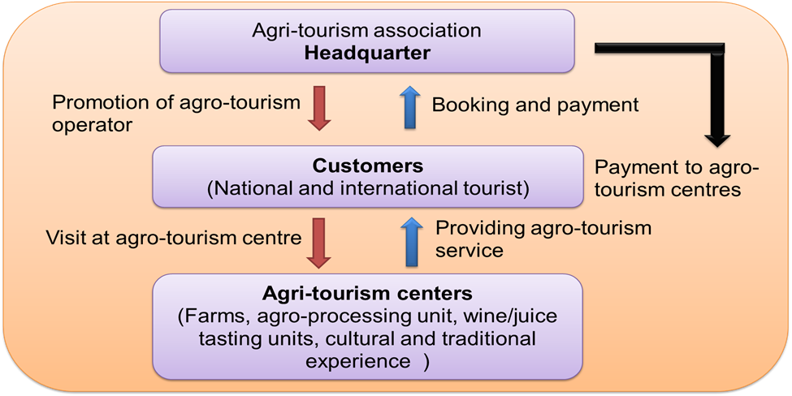
Figure 1: Model of ATDC
Agriculture Extension in South Asia model on Agri-tourism: Tourism offers well-known benefits such as regional development, infrastructure growth, increased government revenue, job creation, and fostering peace in conflict areas. To harness these benefits through agritourism, governments and stakeholders must take joint responsibility in promoting it. Key steps include collaboration between agripreneurs and the tourism sector, training local manpower, enhancing information sharing through digital platforms, integrating agritourism into major tour packages, and promoting India as an agritourism destination globally. Strengthening Extension and Advisory Services (EAS) is vital to identify and support potential agritourism ventures. With targeted training programs and capacity-building efforts, farmers can become agripreneurs, leading to sustainable tourism growth that benefits both the economy and society.
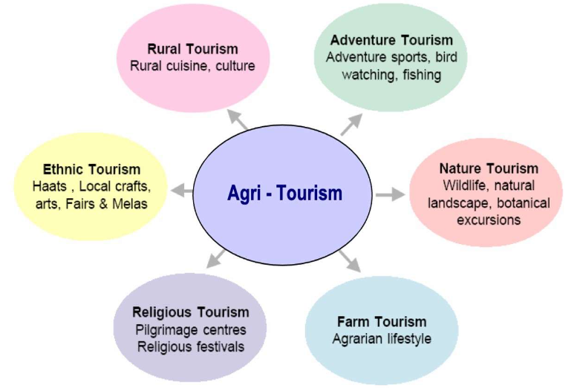
Figure 2: Agri-tourism components
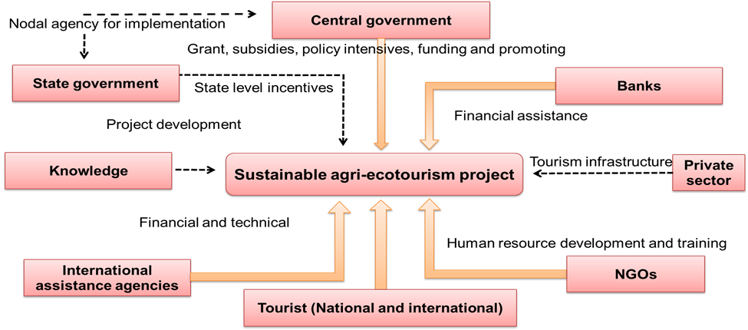
Figure 3: Conceptual framework of Agri-tourism by AESA
Learning about Agri-ecotourism through the Dale’s cone of experience: Edgar Dale's Cone of Experience, also known as the "Learning Pyramid," is a visual model that shows how people learn best through progressively concrete experiences. At the base are hands-on, sensory-rich activities like seeing, touching, and doing—methods shown to enhance retention. At the top are abstract methods like reading or listening, which typically result in lower retention. The model emphasizes that active participation leads to deeper learning, making it a valuable guide for educators and trainers to design more engaging, experiential instruction, such as incorporating study trips to observe real-life applications.
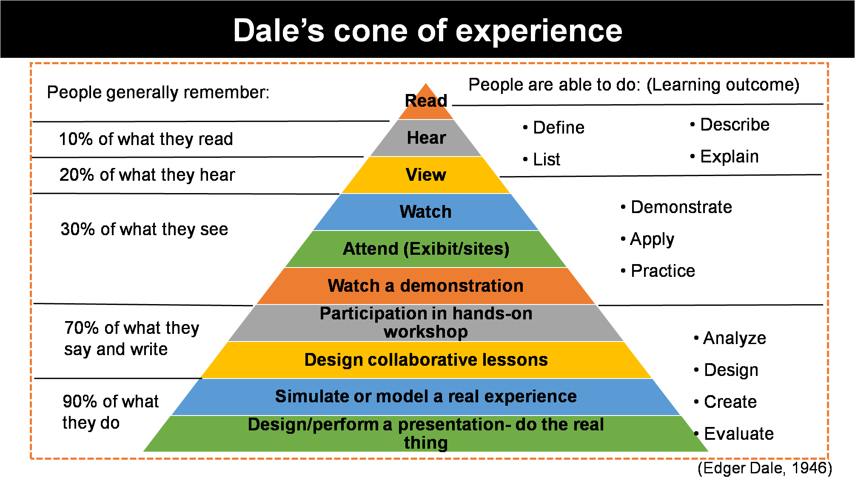
Figure 4: Dales cone of experience
9) Annual tourist visits in India and Rajasthan:
- India
According to the World Economic Forum's Travel and Tourism Development Index (TTDI) 2024 report, India is ranked 39th out of 119 countries. In 2021, India was ranked 54th.
- Rajasthan
In 2023, Rajasthan saw 179 million domestic tourists and 1.7 million international tourists. This is a significant increase from 2020, when 15.1 million domestic tourists visited the state. The number of foreign tourists has also increased since the pandemic.
Rajasthan's tourism sector contributes about 12% to the state's GDP. The state is a popular tourist destination for both Indians and foreigners, and is known for its many famous temples and Sufi shrines.
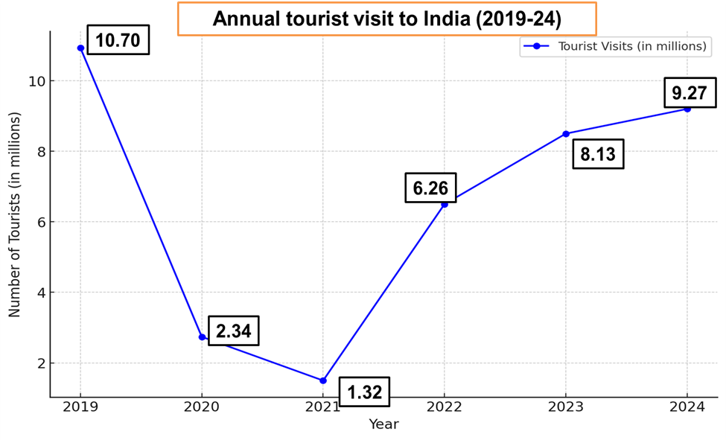
Figure 5: Annual tourist visit graph to India
Source: PIB, 2024

Figure 6: Annual tourist visit in Rajasthan
Source: PIB, 2024

Figure 7: Annual agriculture tourist visit in Rajasthan
Source: PIB, 2024
Geographical Indication (GI) Tags of Rajasthan: A Geographical Indication (GI) tag is an official recognition given to products that originate from a specific region and possess qualities, reputation, or methods unique to that location. GI tags apply to agricultural items, foodstuffs, handicrafts, industrial goods, musical instruments, and manufactured products. In Rajasthan, two notable GI-tagged products include Sojat mehndi, known for its rich red stain and traditional use during celebrations, and Bikaneri bhujia, a spiced snack rooted in Bikaner’s heritage since 1877. These tags help protect product authenticity, boost local economies, preserve cultural heritage, and assure quality to consumers.
Role of Extension Advisory System in Promotion of Agri-ecotourism: The Extension Advisory System (EAS) plays a vital role in advancing agri-ecotourism by linking agricultural expertise with tourism potential, thereby driving sustainable rural development. It does so by raising awareness and training farmers in hospitality and tourism skills, building capacity through eco-friendly practices and marketing strategies, and encouraging sustainable farming aligned with environmental conservation. EAS also fosters partnerships, enhances infrastructure, promotes cultural preservation, and helps farmers diversify income sources. Furthermore, it aids in navigating policies and accessing financial assistance, empowering rural communities to embrace agri-ecotourism as a viable and sustainable livelihood option.
Funding agencies in Promotion of Agri-ecotourism:
A wide array of national and international funding agencies play a crucial role in promoting agri-ecotourism by offering financial aid, technical support, and infrastructure development. In India, government bodies like the Ministry of Tourism, Ministry of Agriculture, NABARD, and SFAC support through schemes such as Swadesh Darshan, NRLM, and Venture Capital Assistance. Globally, institutions like the World Bank, ADB, IFAD, and UNDP back sustainable tourism with grants, loans, and capacity-building initiatives. NGOs like WWF, TNC, and GEF also contribute by focusing on biodiversity and rural livelihoods. CSR initiatives by private companies, crowdfunding platforms like GoFundMe and Kickstarter, and academic grants further strengthen the sector. Regional tourism boards and EU rural development programs also promote agri-ecotourism to boost rural economies and sustainable development.
Contribution of State Government in Promotion of Agri-eco tourism:
The role of state tourism development in promoting agri-ecotourism is both strategic and transformative. It encompasses everything from policymaking and infrastructure development to marketing, training, and sustainability initiatives. States like Maharashtra, Kerala, and Himachal Pradesh are leading examples of how government-backed initiatives can turn rural landscapes into vibrant tourist destinations. By offering financial incentives, building roads, organizing training programs, and promoting local culture and green practices, state tourism boards make agri-ecotourism more accessible, sustainable, and economically viable. These efforts not only boost rural incomes but also preserve cultural heritage and natural resources.
The conceptual framework developed by Djuwendah et al. (2023) for assessing the sustainability of community-based agro-ecotourism in West Java integrates multiple dimensions—ecological, economic, social, technological, and institutional—to evaluate the overall sustainability of agro-ecotourism initiatives. Central to the framework is the active participation of local communities, ensuring that stakeholders such as village officials, farmers, and local entrepreneurs are directly involved in planning and managing tourism activities. The framework uses Multi-Dimensional Scaling (MDS) and Monte Carlo simulations as analytical tools to determine the sustainability index and identify sensitive attributes that most influence the system. These dimensions are interlinked, recognizing that sustainable agro-ecotourism depends not only on environmental conservation but also on economic viability, social cohesion, technological support, and strong institutional backing. Furthermore, the framework serves as a policy feedback mechanism, helping policymakers prioritize interventions in areas such as eco-friendly farming, cultural preservation, infrastructure development, and digital integration to enhance long-term sustainability.
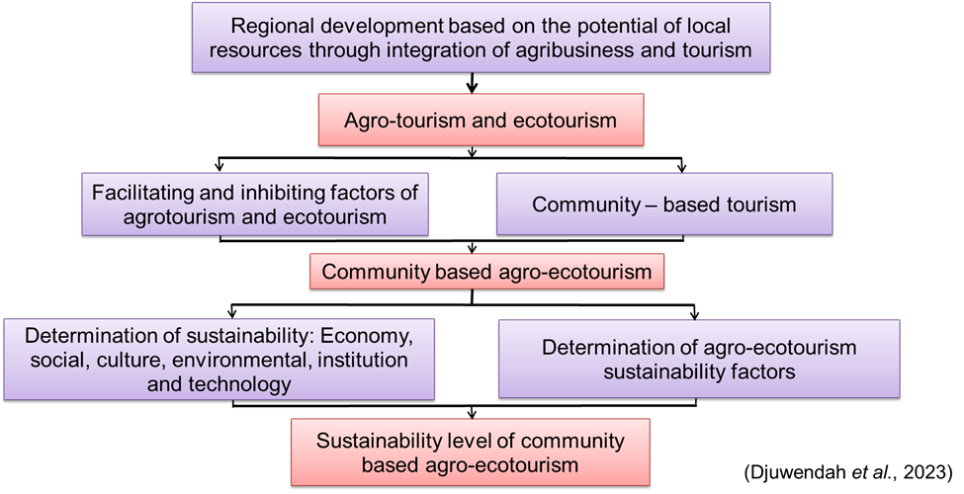
Figure 8: Conceptual framework (Djuwendah et al., 2023)
Table2 : Community-based agro-ecotourism sustainability in West Java (Djuwendah et al., 2023)
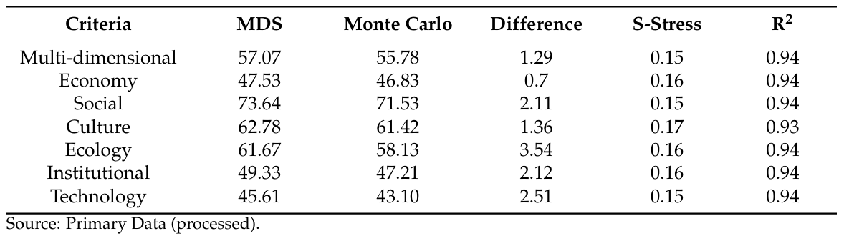

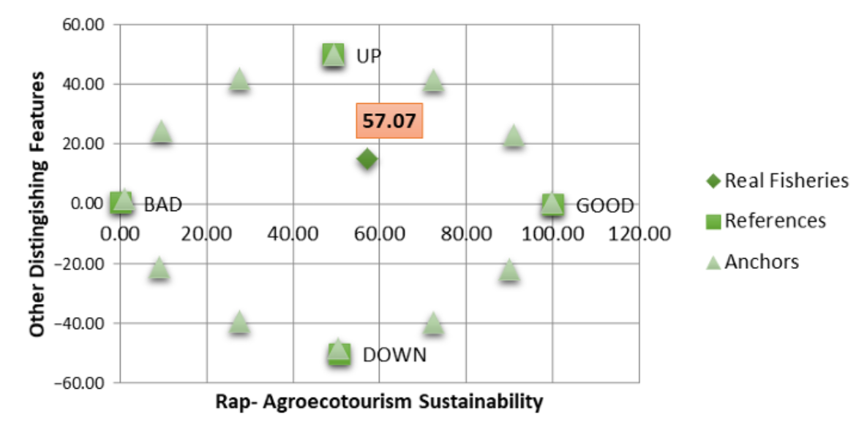
Figure 9: Community based Rap-agroecotourism sustainability index (Djuwendah et al., 2023)

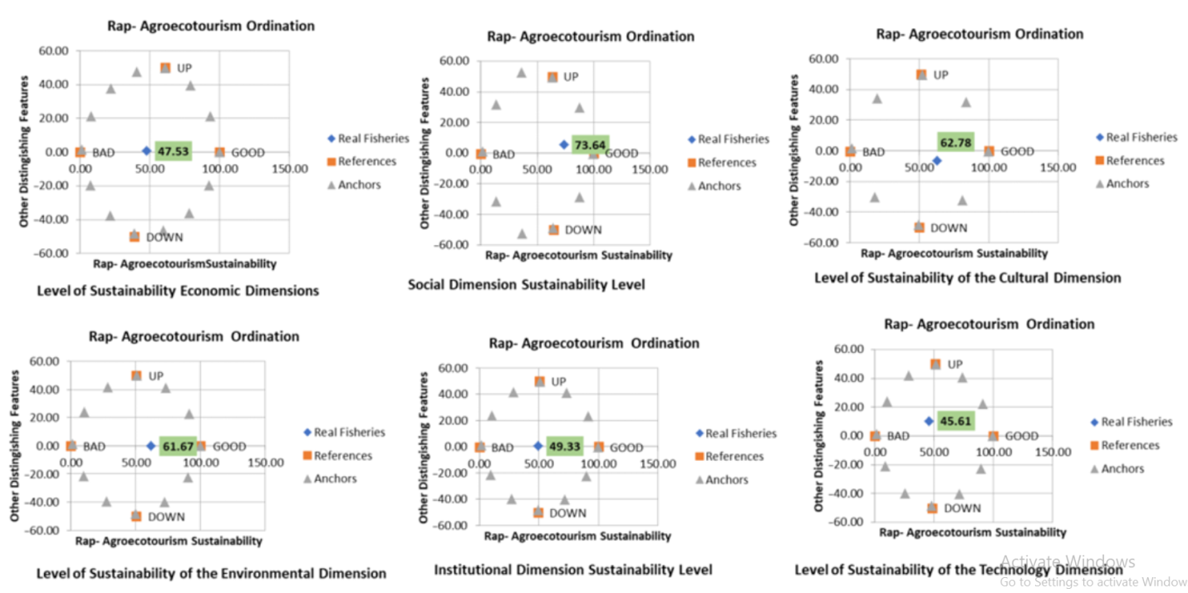
Figure 10: Community based agro-ecotourism sustainability index (Djuwendah et al., 2023)

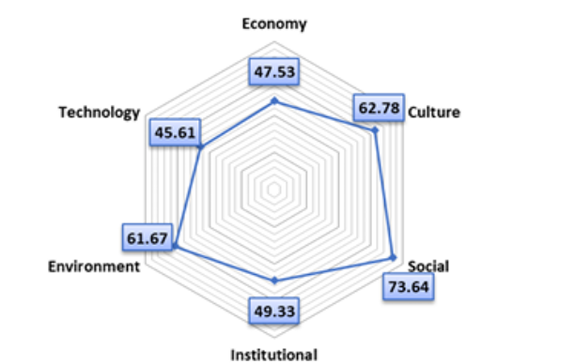
Figure 11: Result outcome (Djuwendah et al., 2023)
Community-based agro-ecotourism in West Java is currently moderately sustainable, but several areas require focused improvement to ensure its long-term viability. Key challenges lie in the technological, economic, and institutional dimensions, where enhanced support and innovation are needed. Critical factors affecting sustainability include inadequate transportation infrastructure, ineffective waste management, limited external partnerships, and the gradual erosion of cultural heritage. To address these issues, policy efforts should prioritize the promotion of eco-friendly agricultural practices, the preservation of traditional cultural values, and the development of robust technological infrastructure. Strengthening these areas will not only improve the sustainability of agro-ecotourism in West Java but also contribute to inclusive rural development and environmental conservation.
Conclusion:
Agri-ecotourism supports rural development by offering alternative income, preserving cultural heritage, and promoting environmental sustainability. It benefits small farmers and local businesses while encouraging eco-friendly practices and cultural engagement. To maximize its impact, active collaboration among communities, governments, and tourism operators is essential, along with investments in infrastructure and strong, sustainable policies. With a holistic approach, agri-ecotourism can ensure long-term benefits for rural communities while protecting their natural and cultural resources.
Disclaimer (Artificial intelligence)
Option 1:
Author(s) hereby declare that NO generative AI technologies such as Large Language Models (ChatGPT, COPILOT, etc.) and text-to-image generators have been used during the writing or editing of this manuscript.
Option 2:
Author(s) hereby declare that generative AI technologies such as Large Language Models, etc. have been used during the writing or editing of manuscripts. This explanation will include the name, version, model, and source of the generative AI technology and as well as all input prompts provided to the generative AI technology
Details of the AI usage are given below:
1.
2.
3.

Reference:
- Arroyoa, Claudia Gil, Barbieri, Carla and Rich, Samantha Rozier (2013). Defining agritourism: A comparative study of stakeholders’ perceptions in Missouri and North Carolina, Tour. Mgmt., 37: 39-47.
- Augustyn, M. 1998. National strategies for rural tourism development and sustainability: The polish experience. J. Sustain. Tour. 6(3): 191–209.
- Brune, S., Knollenberg, W., and Vila, O. 2023. Agritourism resilience during the COVID-19 crisis. Ann. Tour. Res. 99: 103538.
- Budeanu, A. (2015). Sustainable tourism, progress, challenges, and opportunities: introduction to this special volume. Journal of Cleaner Production. https://doi.org/10.1016/j.jclepro.2015.10.027.
- Chandel, R. S., Kanga, S., Singh, S. K., Durin, B., Orsulic, O. B., Dogancic, D., and Hunt, J. D. 2023. Assessing sustainable ecotourism opportunities in Western Rajasthan, India, through advanced geospatial technologies. Sustainability 15: 11473.
- Chandel, R.S.; Kanga, S. Sustainable Management of Ecotourism in Western Rajasthan, India: A Geospatial Approach. Geo-J. Tour. Geo-Sites 2020, 29, 521–533.
- Chavan, R. R., Bhola, S. S. (2015). Indian Tourism Market: An Overview of Emerging Trends and Development Indian Tourism Market: An Overview of Emerging Trends and Development. Global Journal of Commerce and Management Perspective. 3(4). Pg. 113–122.
- Dercan, B., Gataric, D., Bubalo Zivkovic, M., Belij Radin, M., Vukoicic, D., and Kalenjuk Pivarski, B., et al. 2023. Evaluating farm tourism development for sustainability: A case study of farms in the peri-urban area of Novi Sad (Serbia). Sustainability 15: 12952.
- Djuwendah, E., Karyani, T., Wulandari, E., and Pradono, P. 2023. Community-based agro-ecotourism sustainability in West Java, Indonesia. Sustainability 15: 10432.
- Ficci (2017). Report on Agro tourism advantages in Rajasthan. 14. https://www.tourism.rajasthan.gov.in/annual-progress-report.html/ .Accessed/.Accessed 31 August 2022.
- Ghatage, D. L. N., Kumbhar, V. M. (2015). Growth and Performance of Tourism Industry in India. Hameed, B., Khalid, A. (2018). Impact of Ecotourism in Ensuring the Sustainable Development of Tourism Industry in India. International Journal of Recent Research Aspects. 5(2). Pg. 46–50.
- Gossling, S. (1999). ‘Ecotourism: a means to safeguard biodiversity and ecosystem functions?’, Ecological Economics, 29, 303-320.
- https://timesofindia.indiatimes.com/city/jaipur/Rajasthanto-promote-agri tourism-in-bigway/articleshow/55390155.cms/.Accessed 3 September 2022.
- https://www.researchgate.net/publication/352166661_Agrotourism_in_Rajasthan_A_way_to_bring_down_issues_in_our_surrounding_ environment/.Accessed 1st September 2022.
- https://www.statista.com/statistics/1026993/india-tourist-arrivals-in rajasthan-by/Acse/. Accessed 1 September 2022.
- https://pib.gov.in/PressReleseDetailm.aspx?PRID=2097921&reg=3&lang=1
- Ingavale, D. (2015). Agri Tourism – A Business Model of Agri Tourism Development Corporation. PARIPEX-INDIAN JOURNAL OF RESEARCH. 4(1). Pg. 76–77.
- Jagtap, M. D., Nichit, M. B., Benke, S. R. (2010). Agrotourism: The performance, problems, and prospects for the farmers in Maharashtra. International Journal of Commerce and Business Management. 3(1). Pg. 153–156.
- Kapoor, Bharat., Chauhan, Parminder. (2017). Opportunities and Challenges of Rural Tourism in Rajasthan. International Journal of Research in Economics and Social Sciences. 7(1). Pg. 1–13.
- Khangarot, G., & Sahu, P. (2019). Agro-Tourism: A dimension of sustainable tourism development in Rajasthan. JIMS 8M, 24(4), 21. https://doi.org/10.5958/0973-9343.2019.00030.9
- McLaren, D. Rethinking Tourism and Ecotravel; Kumarian Press: West Hartford, CT, USA, 1998.
- Phillip, Sharon, Hunter, Colin and Blackstock, Kirsty (2010). A typology for defining agritourism. Tour. Mgmt., 31(6):754 758 .
- Saxena, G. 2022. Rural tourism in India - A Perspective on the role of rural middle class in engendering the experience economy. In: Indian Tourism. Emerald Publishing Limited, 143-156p.
- Sharma, K.K. & Mehra, S.P. (2009). ‘The Thar of Rajasthan (India): Ecology and Conservation of a desert ecosystem’, in C. Sivaperuman, Q.H. Baqri, G. Ramaswamy, & M. Naseema (eds.), Faunal Ecology and Conservation of the Great Indian Desert, pp. 1-11, Springer-Verlag Berlin Heidelberg.
- Sisodiya, M. S., & Shekhawat, S. (2023). Participatory Extension Approaches: Engaging Farmers in the Extension Process. International Year of Millets 2023, 77.
- Srivastava Surabhi. (2016). Agritourism as a Strategy for the Development of Rural Areas Case Study of Dungrajya Village, Southeast Rajasthan, India. Journal of Medical and Dental Science Research, 3(6), 35–39.
- Suwanna, A., Pisitsenakul, S., & Passadee, L. (2019). Participatory Research in Preparing Sustainable Tourism Strategy Plan in Head Watershed of Chiang Mai, Thailand (pp. 0–16). (conference paper)
- Working plan Jodhpur, 2013-14 to 2022-23, Forest Division Jodhpur, Prepared by M.S. Rathore, Directed by S.K. Jain & A.K. Singh, Project advisor A.C. Chaubey, State Government of Rajasthan.
- www.researchgate.net/figure/Districts-of-Rajasthan-having-potential-of Agro-tourism-Development-Author_fig2_338481029/. Accessed 3 September 2022. https://www.researchgate.net/publication/352166661_Agrotourism_in_Rajasthan_A_way_to_bring_down_issues_in_our_ surrounding_/.Accessed 3 September 2022.

