Original Research Article

Molecular Dynamics Simulation of The Correlation Between Structural and Dynamics Heterogeneity at Higher Temperatures in SiO₂ Liquid

ABSTRACT
In this paper, we present the results of a molecular dynamics simulation for SiO₂ liquid to study the correlation between structural and dynamics heterogeneity. The evolution of structural changes at higher temperatures has been analyzed through the help of the SiO_{x}- and OSi_{y} units/clusters, bond angle distribution, Voronoi polyhedrons features and specified set of atoms. The result shows that SiO₂ liquid comprises a tetrahedral-network, some small SiO₅-, SiO₆-clusters and boundary region atoms which strongly depends on temperature. As temperature increases, the SiO₄-, SiO₅- and SiO₆ units become more distorted. Voronoi polyhedrons radius distribution of atoms is well fitted to a Gaussian form. We investigate the 10% most mobile (SMA) and 10% most immobile (SIMA) atoms in the system. We found that mobile or immobile atoms are non-uniformly distributed, forming spatially distinct mobile and immobile regions. These atoms form clusters whose size grows rapidly with temperature decreasing. The self diffusion pathway is explained by the movement of the small SiO_{x}-clusters, and bond-breaking Si-O in tetrahedral-network to form SiO₅-, SiO₆ clusters and boundary region atoms distributed heterogeneously (DH) in the network-forming liquid.
Keywords: Voronoi polyhedrons, mobile, immobile, bond-breaking, dynamics heterogeneity.
1. INTRODUCTION
Understanding the characteristics of SiO₂ liquid is of great interest due to their anomalous properties and their enormous technological applications [1-5]. Experimental results reported that, at ambient pressure, liquid SiO₂ possesses mainly the tetrahedron network structure, in which Si-O bond distance is equal to 1.62 Å, the Si-O-Si and O-Si-O angle distribution shows a maximum at 144º and 109º respectively, which indicates the difference between vitreous and crystalline forms of SiO₂ [5]. Using molecular dynamics (MD) simulation, it showed that the structural factors of SiO₂ liquid reproduces well experimental data, but the angle distribution is too broad to be compatible with experiment [6-9]. Although these simulations agree with experimental data and capture directional bonding, limitations in model size restrict their applicability to large scale structural studies to study the SiO₂ liquid [10-13]. However, the effect of temperature on structural evolution is still not well understood.
As we known, a diffusion process in the network-forming liquid is crucial in glass and material sciences, as the quenching of oxide melts may produce new glasses with novel properties. In addition, many kinetic processes occurred in this liquid is also described by the diffusion. Many important results have been obtained by MD simulations. However, the correlation between structural and DH at higher temperatures in SiO₂ liquid is still not well understood, especially the temperature effects on DH has been poorly understood yet.
Therefore, the main goal of this work, we conduct a topological analysis based on the help of the SiO_{x}- and OSi_{y} units, clusters, bond angle distribution, Voronoi polyhedrons features and specified set of atoms in order to give new insights into the structural as well as DH at higher temperatures in SiO₂ liquid.
2. COMPUTATIONAL PROCEDURE
We have prepared a liquid model consisting of 1000 Si and 2000 O atoms at different higher temperatures and ambient pressure by MD simulation. The density is chosen to 3.0 g/cm³ that is close to the real density of SiO₂ liquid. The van Beest–Kramer–van Santen (BKS) potential [14,15] and the Verlet algorithm are used to integrate the motion equation. The MD time step is set to 0.48 fs. Initial configuration of the model is created by randomly placing all atoms in a simple cubic box. The model is heated up to 6500 K to remove the effect of remembering initial configuration. Equilibrated melt has been obtained at 6500 K by relaxing initial configuration within 5×10⁵ steps. Next, the model is cooled down to 6000, 5500, 5000, 4500, 4000, 3500, 3000, 2500 and 2000 K (nine models) within 4×10⁵ steps for each temperature point. Next, a long relaxation for each temperature point has been done in isothermal-isobaric NPT ensemble (the number of atoms (N), temperature (T) and pressure (P) are conserved) within 6×10⁵ time steps to equilibrate the models. After that, the nine models have been relaxed in NVE ensemble (the number of atoms (N), volume (V) and temperature (T) are conserved) within 6×10⁵ steps to reach the equilibrium. Additional simulations of 6×10⁵ steps were performed to collect statistical data. To determine the coordination number, we used the cut-off distance that is chosen as the first minimum after the first peak of the radial distribution function (RDF) g_{Si-O}(r), r_{Si-O}=2.28 Å.
In this paper, we have defined the some physical qualities as follow: the Si-O bond is linked by Si and O atoms of which the distance is smaller than r_{Si-O}. The basic unit SiO_{x} and OSi_{y} includes of a central atom and coordinated atoms, with x=4, 5, 6, y=2, 3 are the number of coordinated atoms of SiO_{x} and OSi_{y} units, respectively. Si-O bonds are called a subnet if they comprised Si and O atoms which are linked with each other via bridging oxygen. SiO_{x}-cluster is the Si-O subnet comprising SiO_{x}. It is noted that most of Si atoms belonging SiO_{x}-cluster has the same coordination number. We detect the set of the atoms which are belonged into four clusters: SiO₄, SiO₅- and SiO₆- clusters and boundary region (BR) atoms. According to definition follows that the atoms of SiO_{x}-clusters are located nearby in separate space regions, BR atoms reside in the boundary between those clusters. The size of SiO_{x}-cluster is defined as the number of atoms in it. To clarify the network structure, we have calculated the fraction of basic units SiO_{x}, OSi_{y}; the fraction of BR and SiO_{x}-cluster atoms, respectively.
3. RESULTS AND DISCUSSION
To test the reliability of built models, our simulation has compared to x-ray diffraction data reported in ref. [5]. Fig.1 shows the total RDF g(r) and structure factors S(q) of SiO₂ liquid. Details about the calculation of g(r) and S(q) can be found in ref. [13]. We can see that the simulation curves fit well the shapes as well as positions of peaks, but the height of first peak is slightly higher. However, in general, the structural characteristics g(r) and S(q) for our model agree well with the x-ray diffraction data.
More detailed changes in structure with temperature can be found in the distribution of SiO_{x} and OSi_{y} units. Fig.2 shows that as temperature increases the number of SiO₄- and OSi₂ units monotony decreases whereas the SiO₅- and OSi₃ units in contrast increases with temperature. It is clear that the most of the SiO₄ units are replaced by SiO₅ units with temperature increasing. On the other hand, we can notice that the curves displayed the number of SiO₄- and SiO₅ units versus temperature have two regions corresponding to rapid and gradual replacing SiO₄ by SiO₅ units.
More details about short-range order (SRO) can be analyzed from bond angle distribution in the coordinate units. From Fig.3, it can be seen that the O-Si-O angle distributions become broader as temperature increases. The major changes are a decrease in the height of main peak of O-Si-O angle distributions with temperature. Upon heating the curves for O-Si-O is shifted to smaller angles. Let us to see O-Si-O angle distribution for SiO₄ unit, at 2000 K, the main peak of the curve locates at 105⁰ and at 6000 K, it locates at 100º. Likely, these values for SiO₅ locate 90⁰ and 85º, and 90⁰ to 80⁰ for SiO₆ unit. It notes that the the ideal tetrahedral network structure, the O-Si-O angle is equal to 109.4⁰ and 147º for the Si-O-Si angle. The connectivity of two adjacent structural units SiO_{x} (x = 4, 5, 6) described by Si-O-Si angle distributions strongly depends on temperature. As temperature increases from 2000 to 6000 K, the position of main peak of curve is shifted to smaller angle (e.g. from 147⁰ to 122⁰) and at high temperatures a second peak is appeared. It is evidence to that the system changes from a mostly corner-sharing tetrahedral network to a network which contains also SiO₅ and SiO₆ units linked to each other by the corners as well as by the edges and/or faces. Also, the SiO₄-, SiO₅- and SiO₆ units become more perfect with temperature decreasing. Therefore, unlike compression [15], the SRO strongly changes upon temperature.
Table 1. The characteristics of Dx-cluster at different temperatures in SiO₂ liquid
Temperature (K) | 2000 | 2500 | 3000 | 3500 | 4000 | 4500 | 5000 | 5500 | 6000
SiO₄-clusters | 1 | 1 | 1 | 3 | 6 | 4 | 17 | 18 | 31
SiO₅-clusters | 27 | 33 | 44 | 76 | 86 | 83 | 100 | 109 | 112
SiO₆-clusters | 0 | 0 | 2 | 4 | 6 | 3 | 8 | 14 | 10
Total clusters | 28 | 34 | 47 | 83 | 98 | 90 | 125 | 141 | 153
The largest size of SiO₄-clusters/network  (number of atoms) | 2835 | 2768 | 2672 | 2408 | 2176 | 2070 | 1701 | 1597 | 1481

To clarify the structural heterogeneity in liquid, we use a simulation data visualization method. Fig.4 displays the partial distribution of SiO₄, SiO₅ and SiO₆ units at 2000, 2500, 3500 and 6000 K. As seen, the coordination SiO₄ units are formed a SiO₄-network, meanwhile SiO₅- and some SiO₆ units are not-uniform distributed, but they tend to form clusters of SiO₅- and SiO₆ units in space. It means that the structure of SiO₂ liquid comprises the SiO₄-network and some small clusters of SiO₅ and SiO₆ units. As temperature increases, SiO₄-network structure is shrunk and the number of SiO₅- and SiO₆ clusters increases. It is interesting that the SiO₅- and SiO₆-clusters are non-distributed in liquid. Thus, we can conclude that the liquid exhibits structural heterogeneity which is caused by the small SiO₅- and SiO₆ clusters. This trend also is showed in Table 1. It can be seen that the number total of clusters increases from 28 to 153 upon temperature. For example, at 6000 K, there are 112 small SiO₅-clusters and 10 SiO₆-clusters. In addition, liquid always exists a tetrahedral-network structure with size larger than 1481 atoms. It notes that the SiO4 clusters are most in net-work packing, and SiO5 in net-work with individual, and SiO6 tend to be individual.
As shown in Fig.5 (upper), with temperature increasing the number of atoms in SiO₄-network significantly decreases, in BR region in contrary increases meanwhile that in SiO₅- and SiO₆-clusters slightly increases. It means that under temperature increasing, the bond-breaking Si-O in SiO₄-network increases and then forms SiO₅- and SiO₆ units. This trend also is observed from Fig.5 (lower). Namely, as temperature increases from 2000 to 6000 K, the volume occupied of SiO₄-network decreases from 36.8 to 19.2 nm³, the volume occupied by BR atoms increases from 1.9 to 17.2 nm³. Meanwhile, that in SiO₅- and SiO₆-clusters slightly increases from 0.2 to 2.3 and 0 to 0.07 nm³, respectively. Interestingly, the curves for volume of occupied by SiO₄-network, SiO₅-, SiO₆-clusters and BR atoms corresponds to that for the dependence of SiO_{x} units (x = 4, 5, 6) fraction on temperature as seen in Fig.2.
Next, we focus on some important physical quantities in liquids such as Voronoi polyhedrons (VP) radius distribution, the volume of VP to specify the structural transition mechanism. In order to show the features about the VP, we detect the VP volume of Si, O atoms. The fraction of Si and O atoms as a function of VP volume is shown in Fig.6. One can see that the Voronoi polyhedron radius distribution (VPRD) is well fitted to a Gaussian function given by
(1)
where n_{VT} (T is Si or O atom) is the average number of VP per SiO₂ unit, n_{VSi}=0.48775, n_{VO}=0.49725; r_{T} (is equal to 7.5 and 15 Å for Si, O) and σ_{T} (is equal to 1.08636 and 2.66067 Å for Si, O) is average VP radius and width of the VPRD, respectively. Both parameters r_{T} and σ_{T} significantly changes under temperature. It is interesting to note that as temperature decreases, the transformation from distorted to perfect SiO_{x} units is accompanied change of VP volume and radius. Fig.7 shows that upon temperature increasing, VP volume of O atoms monotonously decreases, VP volume of Si atoms in contrary increases, indicating that the SRO modifies strongly under temperature. Note that this result is also similar to that in Fig.3.
Next, to investigate the dynamics heterogeneity, we used the link-cluster function F_{link}(r, t). More details about the detecting F_{link}(r, t) can be seen elsewhere [14,15]. Thereby, we determine sets of 10% mobile (SMA), 10% immobile (SIMA) and 10% random (SRA) atom. Clearly, the mean square displacement (MSD) of SMA is larger than that of remaining atoms. In contrary, for the SIMA, MSD is smaller than that of remaining atoms. Here, the SRA are randomly chosen in liquid. The SMA, SIMA and SRA are detected in liquid at the moment t = 6×10⁵ MD steps. Fig.8 shows the link-cluster function F_{link}(r,t) at different temperatures. As seen, as r varies from 1.28 to 1.93 Å, at different temperatures, F_{link}(r, t) for SIMA, SMA and SRA drops drastically, and then F_{link}(r, t) decreases gradually. At 3500 K, F_{link}(r, t) for SRA differs from the one for SMA and SIMA, but the difference is less pronounced compared to the case of 2000, 2500 and 3000 K. We conclude that at lower temperatures, the selective atoms are non-uniformly distributed in the space, while the spatial distribution of random atoms is more homogeneous. Above 3500 K, F_{link}(r, t) for SRA lead to be similar for SMA and SIMA. It means that at lower temperatures, the structure of liquid is strongly heterogeneous. The system is more and more homogeneous at higher temperatures. This trend also is showed in Fig.9. It is clear that at lower temperatures, the most mobile and immobile atoms are non-uniform distributed strongly in space, but instead they lead to cluster with each other into the separate clusters. As seen, as temperature decrease from 5000 to 2000 K, the number of mobile and immobile clusters decreases from 259 to 128 and from 261 to 180, respectively, as temperature decreases. Clearly, the number of the mobile and immobile clusters decreases, and therefore whose size grows with temperature decreasing. In addition, the mobile clusters of atoms represent a diffusion channel/string-like for the self diffusion of atoms. The degree of homogeneity in liquids leads to increase strongly at higher temperatures.
Finally, the diffusion pathways in SiO₂ liquid will be focused study. The dependence of mean square displacement (MSD) on simulation time at 2000, 2500, 3500 and 4000 K is showed in Fig.10. It can be seen that the MSDs show linear dependence on time, indicating diffusive behavior. This means that the self diffusion coefficients can be detected by Einstein equation
(2)
where N is the number total of atoms in model, r_{Ti}(t) is the position of T-atom (T is Si or O) at time t. To determine the diffusion coefficients, at each models has been relaxed over 5×10⁵ MD steps and then the MSD is computed. Fig.10 (lower) shows the dependence of D_{T} at different temperatures. It can be seen that the self diffusion coefficients of both Si and O atoms significantly increases with increasing temperature. At temperature lower than 3000 K, the self diffusion coefficient slowly increases; D_{Si} and D_{O} are slightly different. Unlikely, at temperature higher than 3000 K, the self diffusion coefficient of Si and O atoms fastly increases. In addition, beyond 3000 K, at temperature each, D_{O} > D_{Si}. This informs that the temperature significantly acts to the mobility of atoms in liquid.
It is noted that the diffusion mechanism in liquid can be clarified through its structural features. Conventionally, the diffusion of Si or O atoms in the SiO₂ liquid can be performed by two pathways: i/ The movement of the small SiO_{x}-clusters which is similar with movement of a single particle in the SiO₄-network; ii/ The bond-breaking Si-O in SiO_{x} units (e.g. SiO₄ units) and subsequent movement of Si or O atoms to another SiO_{x} units. It is clear that the first pathway leads to very low diffusivity, due to steric hindrance and spatial constraints on cluster motion of small SiO_{x}-clusters requires a large space. Thus, at lower temperatures, the diffusion is performed mainly by the first pathway which the small SiO₅-clusters are moved in the SiO₄-network. At higher temperatures, the diffusion is performed mainly by the second pathways, which the bond-breaking Si-O in SiO₄ units significantly increases to transform SiO₄ to SiO₅, SiO₅ to SiO₆, OSi₂ to OSi₃ and BR atoms. Obviously, it can be suggested that the bond-breaking Si-O is occurred mainly at boundary of SiO₄-network where is located of the most mobile atoms. As a result, this bond-breaking process leads to increase the number of small SiO₅-, SiO₆-clusters which is indicated from analysis of structural changes as shown in Figs.2, 4 and 5, and BR atoms. The self diffusion coefficients of Si and O atoms make therefore increase strongly. The above analysis shows there are the correlation between structural and DH at different temperatures in liquid.
4. CONCLUSION
Models of SiO₂ liquid at different temperature and ambient pressure have been investigated. Several conclusions are made as follows:
i) The SiO₂ liquid structure consists of a tetrahedral SiO₄ network coexisting with temperature-dependent SiO₅ and SiO₆ clusters. As temperature decreases, the SiO₄-, SiO₅- and SiO₆ units become more perfect. VPRD of atoms is well fitted to a Gaussian form.
ii) The relatively most mobile/immobile atoms are non-uniformly distributed in the mobile/immobile regions. We found that these atoms form clusters whose size grows with decreasing temperature. As a result, the degree of DH increases with temperature decreasing.
iii) A key finding of this study is that diffusion at higher temperatures occurs primarily through two pathways: 1/ the movement of the small SiO_{x}-clusters; 2/ the bond-breaking Si-O in SiO₄-network to form the small SiO₅, SiO₆ units and BR atoms which are distributed very heterogeneously in the network structure. Meanwhile, at lower temperatures, the diffusion is only performed mainly by the movement of the small SiO₅-, SiO₆- clusters and BR in liquid.
DISCLAIMER (ARTIFICIAL INTELLIGENCE)
Author(s) hereby declare that NO generative AI technologies such as Large Language Models (ChatGPT, COPILOT, etc.) and text-to-image generators have been used during the writing or editing of this manuscript.
COMPETING INTERESTS
Author hasdeclared that no competing interests exist.
REFERENCES
[1] Karki, Bijaya B., Dipesh Bhattarai, and Lars Stixrude. "First-principles simulations of liquid silica: Structural and dynamical behavior at high pressure." Physical Review B—Condensed Matter and Materials Physics 76.10 (2007): 104205.
[2] Lei, Zhang, et al. "Study on the mechanism of interaction between cations and the surface of nano-SiO₂ particle in the salt solution by using molecular dynamics simulation." Journal of Molecular Liquids 402 (2024): 124798.
[3] Wei, Yidan, et al. "Revealing the structure of SiO₂ and its effects on electrical properties." Materials Today Communications 38 (2024): 107874.
[4] Phillips, Jr C. "Topology of covalent non-crystalline solids I: Short-range order in chalcogenide alloys." Journal of non-crystalline solids 34.2 (1979): 153-181.
[5] Mei, Q., C. J. Benmore, and J. K. R. Weber. "Structure of liquid SiO₂: a measurement by high-energy X-ray diffraction." Physical review letters 98.5 (2007): 057802.
[6] Trave, Andrea, et al. "Pressure-Induced Structural Changes in Liquid SiO₂ from Ab Initio Simulations." Physical review letters 89.24 (2002): 245504.
[7] Sharma, Ruchi, Anirban Mudi, and Charusita Chakravarty. "Diffusional anomaly and network dynamics in liquid silica." The Journal of chemical physics 125.4 (2006).
[8] Tata, B. V. R., P. S. Mohanty, and M. C. Valsakumar. "Glass transition and dynamical heterogeneities in charged colloidal suspensions under pressure." Physical review letters 88.1 (2001): 018302.
[9] Yang, Yongjian, et al. "Investigation of the thermal conductivity of SiO₂ glass using molecular dynamics simulations." Journal of the American Ceramic Society 107.12 (2024): 7836-7849.
[10] Otsuka, Shunya, et al. "Molecular Dynamics Simulation of High-Energy Beam Irradiation of SiO₂ Single Crystal with Three Different Morphologies: No Free Surface, with a Free Surface, and Thin Films." ECS Journal of Solid State Science and Technology 13.11 (2024): 114005.
[11] Mai Thi Lan, Pham Tri Dung, and Nguyen Van Hong. "Structural phase transformation and oxygen packing fraction in amorphous SiO₂." Molecular Simulation 51.2 (2025): 115-121.
[12] Li, You, et al. "Molecular dynamics simulations of the micro mechanism of functionalized SiO₂ nanoparticles and carbon nanotubes modified epoxy resin adhesives." Polymer Composites 46.2 (2025): 1587-1603.
[13] Gutiérrez, G., Belonoshko, A. B., Ahuja, R., & Johansson, B. (2000). Structural properties of liquid Al₂O₃: A molecular dynamics study. Physical review E, 61(3), 2723.
[14] Hung, P. K., et al. "Two-domain structure and dynamics heterogeneity in a liquid SiO₂." Journal of Non-Crystalline Solids 484 (2018): 124-131.
[15] Nguyen Thu Nhan, Nguyen Van Hong, and Mai Thi Lan. "Effect of pressure on the structure of SiO₂ at the glass transition temperature." Silicon 15.10 (2023): 4473-4480.

Fig. 1. The total RDF (left) and structure factors (right) of SiO₂ liquid: experiment taken from ref. [1] and present simulation data (for model 3000K).

Fig. 2. The dependence of SiO_{x} and OSi_{y} (x = 4, 5, 6; y = 2, 3) fraction on temperature for SiO₂ liquid.
.

Fig. 3. The bond angle distribution upon temperature: a), b), c) O-Si-O in SiO₄, SiO₅ and SiO₆, respectively; d) Si-O-Si links SiO_{x} units.

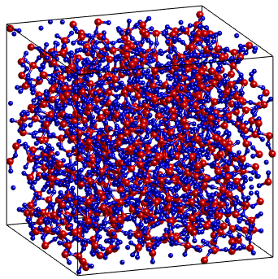
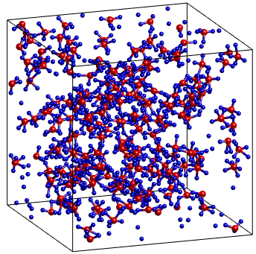
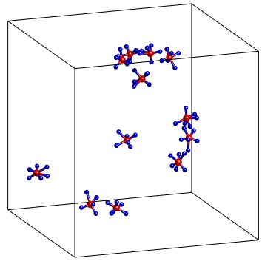
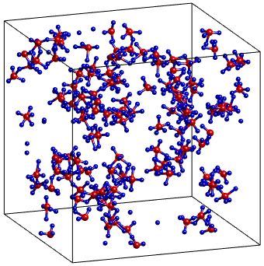
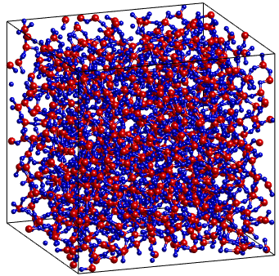
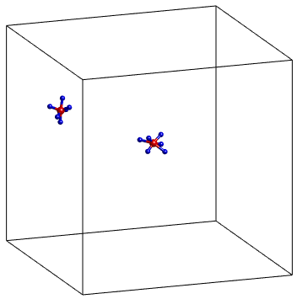
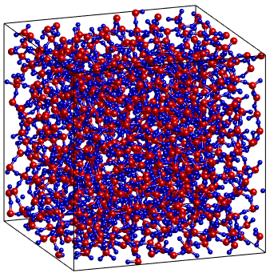
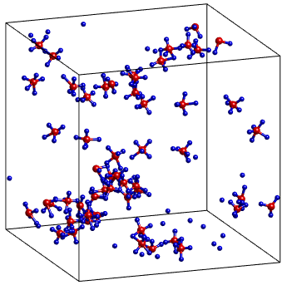
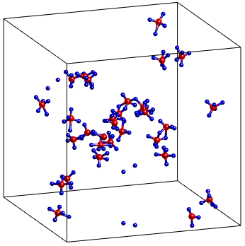
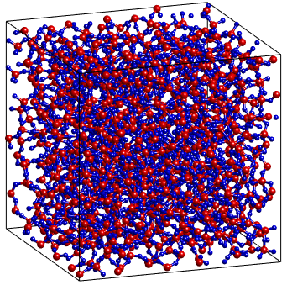
6000 K
SiO₄
SiO₅
SiO₆
3500 K
SiO₄
SiO₅
SiO₆
2500 K
SiO₄
SiO₅
2000 K
SiO₄
SiO₅
Fig. 4. Spatial distribution of SiO₄, SiO₅ and SiO₆ units in models at temperature of 2000, 2500, 3500 and 6000 K and the schematic illustration of SiO₅-cluster includes 66 atoms at 3500 K: Here Si and O atoms are in red and blue ball, respectively. At 2000, 2500 K there is not SiO₆ units.

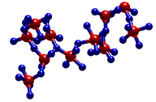
SiO₅-clusters
(66 atoms)

Fig. 5. The temperature dependence of atoms (upper) and volume (lower) of Dx domains and BR. Here V_{DR}, V_{Dx} is the volume occupied by BR and Dx atoms, respectively.

Fig. 6. Fraction of Si and O as a function of Voronoi volume at 3000 K. The fraction of Si, O is given respectively as n(υ_{Si})/n_{Si} and n(υ_{O})/n_{O} where n(υ_{Si}), n(υ_{O}) is the number of Si and O having volume υ_{Si} and υ_{O}, respectively; n_{Si}, n_{O} is the total number of Si and O, respectively.

Fig. 7. The Voronoi volume of Si, O atoms as a function of temperature

Fig. 8. The cluster-link function at different temperature for moments: t = 143.4 ps (b). The tim tobs is equal to 143.4 ps. It can be seen that F_{link}(r,t) drops drastically as r varies from 1.3 to 1.9 Å.

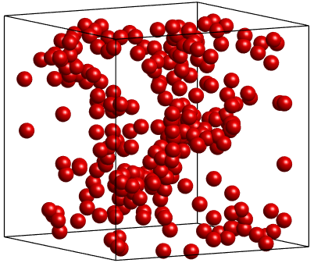
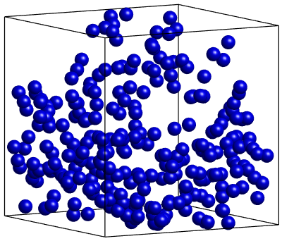
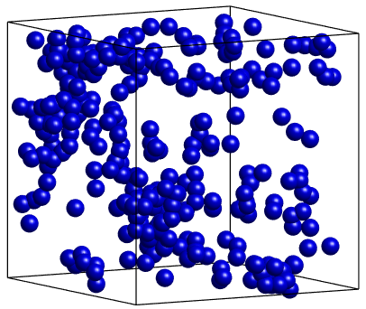
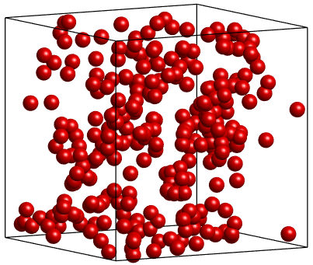
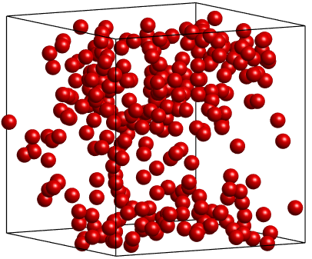
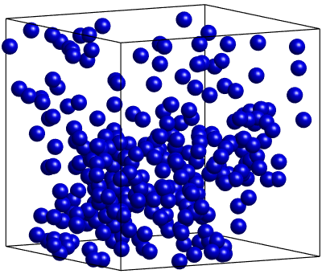
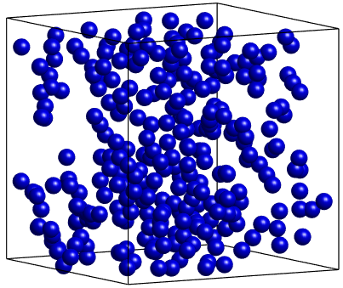
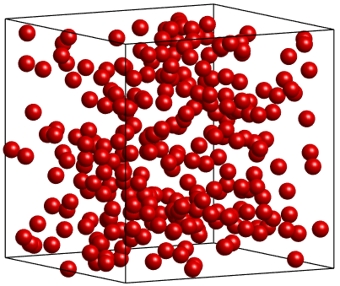
Fig. 9. Snapshot of the positions of 10% the most mobile, 10% the most immobile in SiO₂ liquid at 2000, 2500, 3500 and 5000 K. Here the red, blue spheres represents the most mobile and immobile positions, respectively.
2000 K
SMA; 128 clusters
SIMA; 180 clusters
2500 K
SMA; 133 clusters
SIMA; 197 clusters
3500 K
SMA; 241 clusters
SIMA; 201 clustes
5000 K
SIMA; 261 clusters
SMA; 259 clusters

Fig. 10. MSD of Si and O atoms at different temperature (upper) and the diffusivity as a function of temperature (lower).

