Original Research Article
Precursor Chemistry and Antimicrobial Performance: A Green Synthesis Approach to the Zinc Oxide Nanoparticles

Abstract
The increasing emphasis on sustainable nanotechnology has propelled the development of green synthesis methodologies for nanoparticle production. This study investigates the impact of precursor chemistry on the nucleation and growth of zinc oxide nanoparticles (ZnO NPs) synthesized via a green route utilizing Ocimum gratissimum leaf extracts. We examined three zinc precursors—zinc nitrate, zinc sulphate, and zinc acetate—to elucidate their influence on the physicochemical properties of the resulting ZnO NPs vis-vis their antimicrobial properties. The nanoparticles were treated to characterization approach, including structural, morphological, optical, and surface analyses, and a direct correlation between precursor selection and nanoparticle attributes was established. The findings demonstrate that precursor solubility and the nature of the anionic species significantly affect zinc ion availability, nucleation kinetics, and nanoparticle morphology. This research contributes to a deeper understanding of controlled green synthesis, enabling the tailored production of ZnO NPs for various applications.
Keywords: Green synthesis, Controlled green synthesis, Precursor chemistry, ZnO Nanoparticles, Antimicrobial Activities

I. Introduction
The growing focus on green nanotechnology research has facilitated the development of various nanomaterials for environmentally benign and biocompatible applications. Green synthesis provides a sustainable alternative for nanoparticle production, offering enhanced safety, efficacy, and environmental compatibility, particularly in pharmaceutical applications (Bharadwaj et al., 2021; Geetha et al., 2024; Ikeh et al., 2024). Some plant-derived bioactive phytochemicals, such as phenolic acids, condensed tannins, and flavonoids used as phytomedicines (Sunday et al., 2022), play a crucial role in the biogenic synthesis of nanoparticles (Aisida et al., 2019; Bharadwaj et al., 2021; Hou et al., 2023; Upadhyay and Bano, 2023; Vera et al., 2023; Geetha et al., 2024; Ikeh et al., 2024; Okaiyeto et al., 2024). Furthermore, diverse biological systems, including yeast, fungi, and bacteria extracts, are increasingly utilized in green synthesis approaches (Hano & Abbasi, 2021). This method offers advantages such as improved solubility and faster dissolution rates compared to conventional particles (Kobylinska et al., 2022; Shafiq et al., 2023). Additionally, green synthesis facilitates both passive and active drug targeting, while minimizing tissue irritation during administration (Khafaga et al., 2023).
Metal nanoparticles, defined as particles with diameters ranging from 1 to 100 nm (Aisida et al., 2019; Shafiq et al., 2023; Ikeh et al., 2024), exhibit unique properties that enable their substitution for larger particles across various industrial applications. Among the synthesis methods—chemical, physical, and biological—green synthesis, employing microorganisms and plant species, has garnered significant attention due to its cost-effectiveness and environmental sustainability (Aisida et al., 2019; Ikeh et al., 2024; Morgan & Aboshanab, 2024).
Zinc oxide nanoparticles (ZnO NPs) are of particular interest due to their versatile applications in biomedicine, environmental science, cosmetics, agriculture, and industry. Their high surface area, semiconductor behaviour, antimicrobial activity, and UV absorption properties contribute to their broad utility. For example, green-synthesized ZnO NPs have demonstrated antimicrobial efficacy through zinc ion and reactive oxygen species (ROS) release (Pachaiappan et al., 2021). Furthermore, J. adhatoda-mediated ZnO NPs have shown promise in degrading persistent organic pollutants (Mahajan et al., 2025).
"Controlled green synthesis" refers to the precise manipulation of nanoparticle properties during environmentally friendly synthesis (Kobylinska et al., 2022). This control is crucial for optimizing nanoparticle performance in diverse applications, allowing for the fine-tuning of size, shape, surface chemistry, and crystalline structure (Shafiq et al., 2023). The ability to control synthesis parameters, such as reactant concentration, temperature, pH, reaction time, and plant extract selection, enables the production of nanoparticles with tailored properties.
"Precursor chemistry" plays a pivotal role in controlling nanoparticle synthesis by defining the initial chemical environment (Singh et al., 2023; Gatou et al., 2022). The choice of precursor, whether phytochemicals or metal salts, significantly influences nanoparticle size, shape, and surface characteristics. The present study utilizes zinc nitrate, zinc sulphate, and zinc acetate as precursors, focusing on their solubility and anionic properties.
The solubility of a precursor directly affects the concentration of zinc ions (Zn²⁺) in solution, influencing nucleation and growth kinetics. Classical Nucleation Theory (CNT) describes nucleation as a process involving the formation of nuclei by monomer aggregation, requiring the overcoming of an energy barrier (Sleutel et al., 2014; Peters, 2022). Factors such as supersaturation, temperature, precursors, and pH influence the nucleation rate. Growth, the subsequent increase in nuclei size, is influenced by reactant concentration, temperature, pH, and capping agents from biological extracts.
Traditional nanoparticle synthesis methods often pose environmental and health risks due to hazardous chemicals and energy-intensive processes. Green synthesis addresses these issues, but challenges remain in achieving consistent and reproducible results. This study aims to understand the relationship between precursor type, zinc ion availability, and the rate of ZnO NP formation.
The objectives of this study were to:
- Synthesize ZnO NPs using zinc nitrate, zinc sulphate, and zinc acetate under standardized conditions.
- Characterize the resulting NPs (structural, morphological, optical, surface).
- Carry out a comparative analysis to elucidate the precursor-property relationship.
- Relate observed differences to the specific chemical properties of the precursors.
- Relate observed differences to the antimicrobial activity of the ZnO NPs.

II. METHODOLOGY
2.1. Materials
All the reagents were of analytical grade and used as received without further purification. Zinc Acetate dihydrate, Zinc nitrate, Zinc Sulphate, were obtained from Central Drug House (India). Mueller-Hinton agar, DMSO, and Sabourands dextrose agar (SDA) were obtained from Sigma Aldrich (Germany). Standardized test isolates of the fungus Candida albicans and some selected Gram-positive bacterial strains of were obtained from the Pharmaceutical Microbiology Laboratory, Enugu State University of Science and technology. All the aqueous solutions were prepared using distilled water (DW).
2.2. Collections of Ocimum gratissimum Leaves (OGL)
The fresh and undamaged leaves of Ocimum gratissimum plant commonly sold at the vegetables area of New Market Enugu, Enugu State, were purchased. The plant was confirmed as leaves of Ocimum gratissimum at the Department of Pharmacognosy, Enugu State University of Science and Technology and deposited at the Herbarium Centre, with a voucher number: FP/Cog/1220.
2.3. Preparation of OGL
The leaves of Ocimum gratissimum, were prepared as described in Ikeh et al (2024). Firstly, they were thoroughly washed using distilled water, spread on a white Formica board to dry at room temperature for 96 h. This was then followed by a reduction in the particle size using a mechanical grinder into a fine powder. The powder was extracted in hot water, thus: 100 g of the plant powder was dissolved in 500 mL of distilled water (DW) followed by heating at 80℃ for 1 h, after which the system was allowed to cool to room temperature. The mixture was filtered using a sieve followed by Whatman No. 1 filter paper. The filtrate was preserved in a refrigerator at a temperature of 4℃ for further usage.
2.4. Precursor chemistry and kinetics studies
2.4.1. Solubility property of precursor salts
The solubility of Zinc acetate, zinc nitrate and zinc sulphate were determined individually by dissolving each salt in 100 mL of DW with continuous stirring using a magnetic stirrer. The salts were added until they no longer dissolved in the solution, indicated by undissolved salt remains at the bottom of each beaker. The temperature was recorded as 25.4 $°C$. The amount of each dissolved salt was determined by evaporating the solvent and weighing the solute. The solubility of each precursor salt determined was expressed as grammes per 100 mL (Table 1).
2.4.2. Biogenic Synthesis of Zinc Oxide Nanoparticles (OGL—ZNPs)
The kinetics of the biogenic synthesis of zinc oxide nanoparticles (ZnO NPs) were systematically investigated over a 3-hour reaction period. Three distinct experimental systems were employed, each comprising three subsystems, to evaluate the influence of different zinc precursors on nanoparticle formation. The pH of each system was maintained at approximately 8.0 through the controlled addition of a 2 M sodium hydroxide (NaOH) solution, as depicted in Figure 1.
2.4.3. Experimental Systems and Subsystems
2.4.3.1. System 1: Zinc Acetate Precursor
In the first experimental system, zinc acetate dihydrate was utilized as the precursor for ZnO NP synthesis. The system was divided into three subsystems, each containing the reaction mixture under continuous stirring at room temperature (25 ± 2°C) using a magnetic stirrer for the entire 3-hour duration. The pH was adjusted to 8.0 by dropwise addition of 2 M NaOH and monitored throughout the reaction.
At the end of each hour (i.e., at 1 h, 2 h, and 3 h), one subsystem was sampled for analysis. The sampled subsystem was subjected to centrifugation at 1500 rpm for 10 minutes to separate the synthesized ZnO nanoparticles. The resulting nanoparticle pellet was washed three times with deionized water to remove residual impurities and unreacted precursors. The washed nanoparticles were then dried in a hot air oven at 60°C for 4 hours. The mass of the dried ZnO crystals was recorded, and the samples were stored in airtight glass vials for subsequent characterization. This procedure was repeated for the second and third subsystems at the 2-hour and 3-hour time points, respectively.
2.4.3.2. System 2: Zinc Nitrate Precursor
The second experimental system followed the same procedure as described in Section 2.4.3.1, with zinc nitrate hexahydrate employed as the precursor instead of zinc acetate. All reaction conditions, including pH adjustment, stirring, centrifugation, washing, drying, and storage, were identical to those of System 1.
2.4.3.3. System 3: Zinc Sulphate Precursor
The third experimental system utilized zinc sulphate heptahydrate as the precursor, while maintaining the same experimental protocol as outlined in Section 2.4.3.1. The reaction conditions, sampling intervals, and post-processing steps (centrifugation, washing, drying, and storage) were consistent with those of Systems 1 and 2.
2.5. Characterization of ZnO Nanoparticles
The ZnO nanoparticles obtained from each subsystem of the three experimental systems were subjected to further characterization to evaluate their physicochemical properties, as detailed in the sections below.
2.5.1. X-Ray Diffraction (XRD)
The purpose of carrying out this technique was to assess crystallinity, phase, and crystallite size. The sample was prepared by spreading dry nanoparticle powder evenly on the sample holder, and loaded into the XRD instrument and scanned at a 2θ range of 20°—80° with 0.02° step size to obtain the diffraction pattern. The crystallite size was calculated using Scherrer formula (Equation 1), and the peaks were matched to JCPDS database.
$$D=\frac{K⋅λ}{β⋅Cosθ}…. (1)$$

2.5.2. Energy-Dispersive X-Ray Spectroscopy (EDX)
The purpose of this technique was to determine elemental composition of the nanoparticle synthesized. The sample was prepared by mounting dry nanoparticles on carbon tape and placed in SEM with EDX detector. The electron beam was focussed to collect X-ray emissions for 60-120 seconds. From the peak intensities, elements were identified and quantified.
2.5.3. Dynamic Light Scattering (DLS)
DLS was used to measure hydrodynamic size and size distribution in solution. The sample was prepared by dispersing the nanoparticles sample in water to achieve a 0.1 mg/mL concentration, and sonicated to de-agglomerate the sample. The treated sample was transferred into the cuvette, and run through a 633 nm laser at a fixed angle of 173° for 2 minutes. The Z-average size and polydispersity index (PDI) were extracted.
2.5.4. Fourier Transform Infrared Spectroscopy (FTIR)
OGL—ZNPs were characterized using FTIR to identify functional groups and surface chemistry. The sample was prepared by mixing nanoparticles with KBr in a ratio of 1:100 and press into a pellet. The sample was loaded into the FTIR spectrometer, and scanned through 400-4000 cm⁻¹ (4 cm⁻¹ resolution, 32-64 scans). The spectrum produced was analysed by assigning peaks.
2.5.5. Scanning Electron Microscopy (SEM)
SEM was used to examine the surface morphology and particle shape of the OGL—ZNPs produced. The sample was prepared by dispersing nanoparticles on conductive tape, dried, and coated with gold. The sample was loaded into the SEM chamber. The voltage was set at 15 kV, and images were captured at varying magnifications to evaluate the shape and size distribution visually.
2.5.6. UV-Visible Spectroscopy
The purpose of the technique was to study optical properties and band gap. The sample was prepared by dispersing OGL—ZNPs in DW at a 0.01 mg/mL concentration. A quartz cuvette was filled with the sample. And the absorbance was scanned from 200-800 nm in UV-Vis spectrophotometer against suitable blanks. The absorption peaks were identified and the band gap was calculated using Tauc plot (Equation 2).
$$αhν=A{\left(hν-Eg\right)}^{n}…..(2)$$
2.6. Antimicrobial activity of OGL—ZNPs
2.6.1. Preparation of Test Agents and Microbial Cultures
The antimicrobial activity of zinc oxide nanoparticles (OGL—ZNPs) was evaluated against a panel of microbial strains, including Staphylococcus aureus, Escherichia coli, Pseudomonas aeruginosa, Proteus mirabilis, Klebsiella pneumoniae, Streptococcus pneumoniae, and Candida albicans. The aqueous extract (AE) of Ocimum gratissimum (OGL) was used as a placebo control. Two-fold serial dilutions of ZnO NPs were prepared in dimethyl sulfoxide (DMSO) to achieve concentrations ranging from 12.5 to 100 mg/mL. Standardized broth cultures of the test bacteria and Candida albicans were prepared according to standard microbiological protocols and adjusted to a turbidity equivalent to 0.5 McFarland standard (approximately 1.5 × 10⁸ CFU/mL).

2.6.2. Agar Well Diffusion Assay
The antimicrobial activity was assessed using the agar well diffusion method, as described by Adonu (2023), with slight modifications. For bacterial strains, 20 mL of molten Mueller-Hinton agar (MHA) was seeded with 0.1 mL of the standardized broth culture of each test bacterium. For Candida albicans, 20 mL of molten Sabouraud dextrose agar (SDA) was similarly seeded with 0.1 mL of the standardized fungal culture. The seeded agar was poured into sterile Petri dishes and allowed to solidify at room temperature.
Six wells, each 8 mm in diameter, were created in the solidified agar using a sterile cork-borer. Each well was labelled, and 0.05 mL of the respective two-fold dilutions of ZnO NPs (100, 50, 25, 12.5 mg/mL) was dispensed into the designated wells using a sterile pipette. The sixth well served as a control and was filled with 0.05 mL of DMSO. The plates were left at room temperature for 1 hour to allow diffusion of the test agents into the agar. Subsequently, the plates were incubated at 37°C for 24 hours. Following incubation, the diameter of the zone of inhibition (IZD) around each well was measured in millimetres using a calibrated ruler. The IZD values reported are the mean of three independent replicates for each concentration and microbial strain.
2.6.3. Determination of Minimum Inhibitory Concentration (MIC)
The minimum inhibitory concentration (MIC) of ZnO NPs against the tested microbial strains was determined using the agar dilution method, following the Clinical and Laboratory Standards Institute (CLSI, 2022) guidelines. Five two-fold serial dilutions of ZnO NPs were prepared, resulting in final concentrations ranging from 0.6 to 5.0 mg/mL. For each dilution, 1.0 mL of the diluted ZnO NP solution was mixed with 19 mL of molten MHA (for bacteria) or SDA (for Candida albicans) in sterile Petri dishes. The mixtures were gently swirled to ensure homogeneity and allowed to solidify at room temperature.
Standardized suspensions of the test isolates (adjusted to 0.5 McFarland standard) were streaked onto the surface of the agar plates containing the respective ZnO NP concentrations using a sterile wire loop. The inoculated plates were incubated at 37°C for 24 hours for bacterial strains and at 25°C for 48 hours for Candida albicans. Post-incubation, the MIC was determined as the lowest concentration of ZnO NPs that permitted the growth of no more than one colony-forming unit (CFU) on the agar surface. MIC values reported are the mean of three independent replicates for each microbial strain and concentration.

Table 1 Details of synthesis parameters
Synthesis parameters | Description
Plant extract selection | Ocimum gratissimum, commonly known as scent leaf is rich in various including flavonoids which are known to have a high affinity for metal ions, acting as reducing agents in the presence of metal ions to form nanoparticles (Hou et al., 2023; Upadhyay and Bano, 2023; Vera et al., 2023; Okaiyeto et al., 2024)
Plant extract pH | 6.8
Plant extract concentration | Kept constant by extracting in OGL in boiling DW using a 1:5 powder—solvent ratio (Ikeh et al., 2024).
Precursor concentration, M | Kept constant at 0.05 M
Precursor solubility, g/100 mL | 44.3 g/100 mL (Zinc Acetate); 185.1 g/100 mL (Zinc Nitrate); 58.6 g/100 mL (Zinc Sulphate).
Reaction time | Range from 1—3 hours
Constant System temperature | Room temperature (25 $°C$)
System pH | Maintained at 8.0

III. Results and Discussion
3.1. Characterization of OGL—ZNPs
3.1.1. Crystal Growth Kinetics
The crystal growth kinetics of OGL—ZNPs (ZnO nanoparticles) synthesized using Ocimum gratissimum leaf extracts with zinc acetate (Sample A), zinc nitrate (Sample N), and zinc sulphate (Sample S) precursors were studied over three hours, with crystallite sizes derived from XRD (Figure 1). All samples showed peak growth at the second hour, followed by a slight decline by the third hour, reflecting precursor-specific nucleation and growth dynamics.
Figure 1 plots crystallite size (nm) versus time (h). Sample N reached the smallest size (~3.5 nm at 2 h), Sample A had an intermediate size (~5.0 nm), and Sample S was the largest (~5.5 nm), consistent with XRD sizes (~3.52–5.46 nm). Nitrate’s rapid Zn²⁺ release drove fast nucleation, yielding small NPs (FWHM = 22.9°) (Zak et al., 2011). Acetate’s stabilization produced compact NPs (FWHM = 15.76°) (Subramaniam et al., 2024). Sulphate’s slower kinetics formed larger NPs (FWHM = 14.75°) (Kharisov et al., 2016). The second-hour peak reflects optimal nucleation-growth balance, with stabilization by the third hour (Thanh et al., 2014). Low-angle peaks (19.20° for S, 20.52° for A) suggest minor zincite planes or synthesis artefacts (Ahmed et al., 2017).
These results highlight precursor chemistry’s role in tailoring OGL—ZNPs growth, with nitrate and acetate optimizing smaller NPs, supporting the study’s aim to elucidate synthesis-structure relationships.
Figure 1 Crystal growth curve shows crystallite size (nm) versus time (h) for OGL—ZNPs from different precursors. all samples peak at 2 h: Sample A (red line) reaches 5.0 nm, sample N (blue line) reaches 3.5 nm and sample S (green line) 5.5 nm.
3.1.2. Particle Size, Morphology and elemental composition
Zinc acetate precursors produced conical prism shapes (figure 1) with smaller, uniform nanoparticles (Z-average = 25.1 d. nm) owing to the ability of the acetate ion in stabilizing primary nanoparticles, thus, reducing agglomeration. But the zinc nitrate precursor yielded larger particles (Z-average = 60.77 d. nm) with irregular shapes. This, the authors believe may have been influenced by the nitrate’s relatively weaker stabilization phenomena. Zinc Sulphate as precursor resulted in variable sizes (Z-average = 47.89 d. nm) and mixed morphologies (nanoprisms, petals). Ikeh and coworkers opined that nanoparticles with mixed morphologies often require additional processing for phase purity (Ikeh et al., 2024)
The polydispersity index (PDI) of OGL—ZNPs produced by zinc acetate, zinc nitrate and zinc sulphate were determined as 0.239, 0.248, and 0.232 respectively. PDI is a measurement of the uniformity of particle sizes in a nanoparticle sample, and typically ranges from 0 to 1, where a lower PDI indicates a more uniform size distribution (monodisperse) and a higher PDI suggests a broader range of particles sizes (polydisperse). Polydispersity index values between 0.2 and 0.3 generally indicate a moderately uniform size distribution. These nanoparticles are not perfectly monodispersed $(PDI<0.1)$, but they are not highly polydisperse either $\left(PDI>0.5\right)$. This suggests that while there are some variations in particle size, the samples were still reasonably consistent (De Jong et al., 2008; Blanc et al., 2015; Clayton et al., 2016; Danaei et al., 2018; Rizvi et al., 2018; Chenthamara et al., 2019).
Furthermore, moderately polydisperse samples as the ones reported in the present study were found to be stable as their PDI did not increase over time, a phenomenon that could signal aggregation or degradation (Blanc et al., 2015; Clayton et al., 2016; Danaei et al., 2018; Rizvi et al., 2018; Chenthamara et al., 2019). In drug delivery or imaging, a PDI below 0.3 is often acceptable, as it suggests the nanoparticles are uniform enough to behave predictably in biological systems (Danaei et al., 2018), thus its implication for biomedical applications.
EDX analysis confirmed the presence of zinc and oxygen (Figure 2), consistent with the expected stoichiometry of ZnO. The presence of additional elements in the EDX spectra of green-synthesized ZnO nanoparticles, beyond the expected zinc (Zn) and oxygen (O), can be attributed to multiple factors inherent to the synthesis process and analytical method. Green synthesis often utilizes plant extracts rich in phytochemicals such as polyphenols, flavonoids, and proteins, which serve as reducing and stabilizing agents. For instance, Sangeetha et al. (2011) reported carbon (C) and oxygen peaks in EDX spectra of ZnO nanoparticles synthesized using Aloe vera extract, attributing these to organic residues from the plant material adsorbed onto the nanoparticle surface. Similarly, Nagarajan and Kuppusamy (2013) observed carbon, nitrogen (N), and sulphur (S) in EDX analysis of ZnO nanoparticles derived from Ocimum basilicum, linking these elements to biomolecules like alkaloids and terpenoids present in the extract.
Precursor materials and reaction by-products also contribute to the detection of extraneous elements. Zinc salts, such as zinc nitrate or zinc acetate, commonly used in green synthesis, may leave residual counter ions (e.g., nitrogen or carbon) if purification is incomplete. Rajiv et al. (2013) noted trace carbon in EDX results of ZnO nanoparticles synthesized with Parthenium hysterophorus, suggesting incomplete removal of organic intermediates from the precursor decomposition. This is consistent with the eco-friendly ethos of green synthesis, which often minimizes harsh chemical purification to preserve sustainability, potentially retaining detectable impurities.
Sample preparation and instrumental factors further explain these observations. Substrates like carbon-coated grids or silicon wafers, used to mount samples for EDX, can introduce carbon or silicon signals, as highlighted by Elumalai et al. (2015) in their analysis of ZnO nanoparticles synthesized with Moringa oleifera. Environmental contaminants, such as sodium (Na) or chlorine (Cl) from water or handling, may also appear, necessitating blank measurements to isolate sample-specific elements. Additionally, the EDX electron beam’s penetration depth (1–2 µm) exceeds typical nanoparticle sizes, potentially detecting underlying material or surface-adsorbed layers, as noted by Bhuyan et al. (2015) in their study of ZnO nanoparticles from Azadirachta indica.
3.1.3. Crystallinity
OGL—ZNPs (ZnO nanoparticles) synthesized via green synthesis using Ocimum gratissimum leaf extracts with zinc acetate (Sample A), zinc nitrate (Sample N), and zinc sulphate (Sample S) precursors were analysed by X-ray diffraction (XRD). All samples exhibit the zincite phase, with the key peaks as shown in the Table 2
Table 2 Details of crystallinity features A, N and S
Precursor | Sample code of OGL—ZNPs | $$2θ, °$$ | H | k | l
Zinc Acetate | A | 20.52  31.81  34.53  47.60 | -  1  0  1 | -  0  0  0 | -  0  2  2
Zinc Nitrate | N | 36.32  47.50  56.66 | 1  1  1 | 0  0  1 | 1  2  0
Zinc Sulphate | S | 19.20  62.90  68.00 | -  1  1 | -  0  1 | -  3  2

Figure 2 XRD spectroscopy of A, N and S after 2 hours of synthesis
XRD confirms the zincite phase, with precursor chemistry influencing lattice parameters and crystallite size:
Zincite Phase and Lattice Parameters
Sample A shows standard zincite peaks (31.81°, 34.53°, 47.60°), with $a≈3.245Å ,$ $c≈5.20 Å$, indicating a compact lattice due to acetate’s stabilization (Subramaniam et al., 2024). The 20.52° peak suggests a minor plane or secondary phase (e.g., Zn(OH)₂) (Ahmed et al., 2017). Sample N’s peaks (36.32°, 47.50°, 56.66°) confirm a pure wurtzite structure $a≈3.246Å ,$ reflecting nitrate’s rapid nucleation (Zak et al., 2011). Sample S’s 62.90° and 68.00° peaks verify zincite, but 19.20° indicates lattice expansion or impurities from sulphate complexation (Kharisov et al., 2016).

Crystallite Size (Scherrer Equation, 19–20° peaks)
Sample N had the smallest crystallite size of ~3.52 nm (FWHM = 22.9°), due to rapid nucleation (Thanh et al., 2014). This was followed by Sample A, with ~5.12 nm (FWHM = 15.76°) resulting in a compact NPs from acetate stabilization (Subramaniam et al., 2024). Sample S had a crystallite size of ~5.46 nm (FWHM = 14.75°), with larger NPs from resulting from slower kinetics (Kharisov et al., 2016). The sizes were smaller than typical (20–50 nm), possibly due to low-angle peaks or Ocimum capping.
Crystal Growth and Antimicrobial Correlation
Peak growth at the second hour aligns with small NPs for Sample N and Sample A, driven by fast (nitrate) or stabilized (acetate) kinetics, versus slower growth for Sample S (sulphate) (Thanh et al., 2014). Smaller NPs correlate with lower MICs: Sample N (0 mg/mL, P. aeruginosa), Sample A (2.5 mg/mL, S. aureus), and Sample S less effective (50 mg/mL, E. coli) except for Salmonella (5.0 mg/mL) (Marques et al., 2024).
XRD confirms zincite ZnO NPs, with acetate and nitrate yielding compact, small NPs (~3.52–5.12 nm) and high antimicrobial efficacy, while sulphate produces larger NPs (~5.46 nm) with reduced potency.

 | After 1 hour | After 2 hours | After 3 hours
Zinc Acetate precursor | 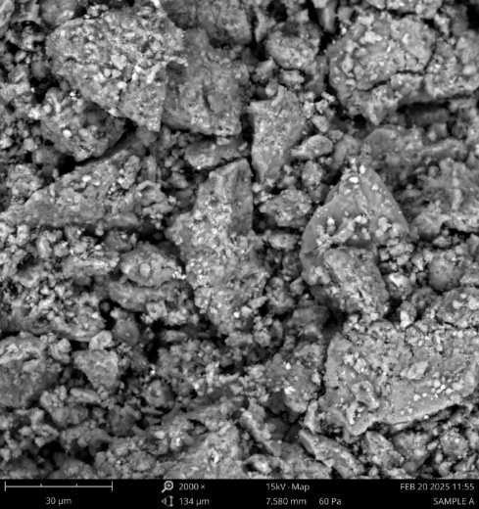 | 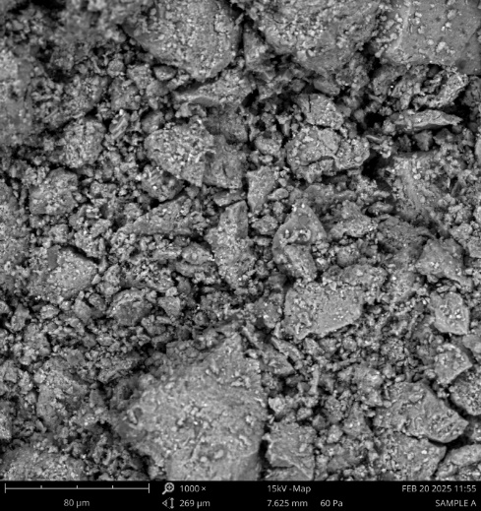 | 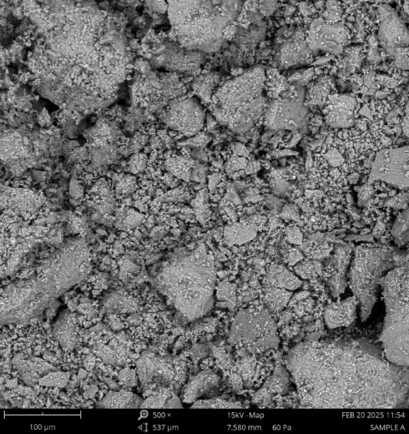
Zinc nitrate precursor | 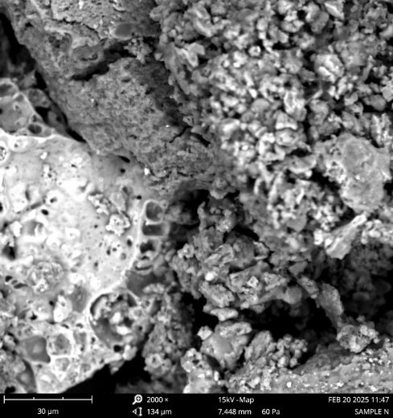 | 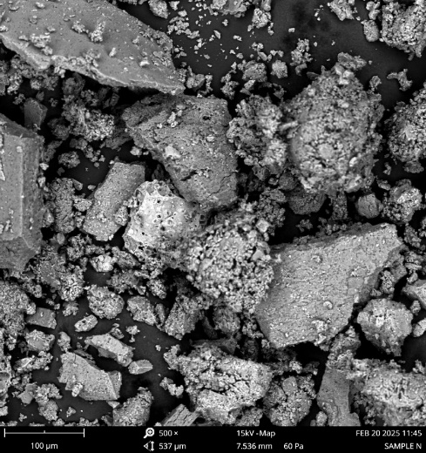 | 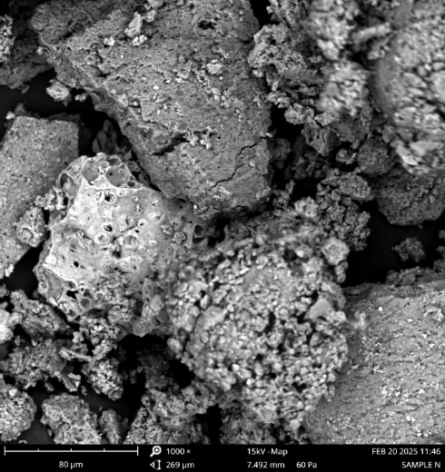
Zinc sulphate precursor | 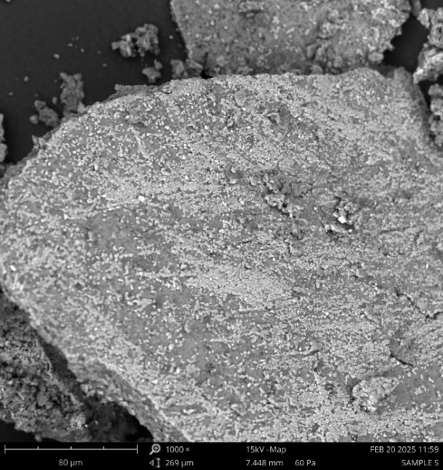 | 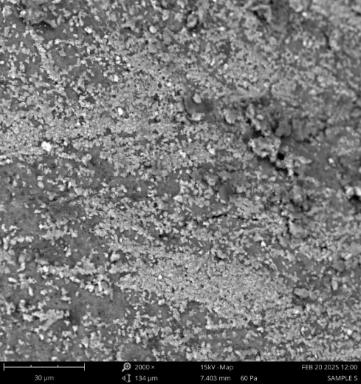 | 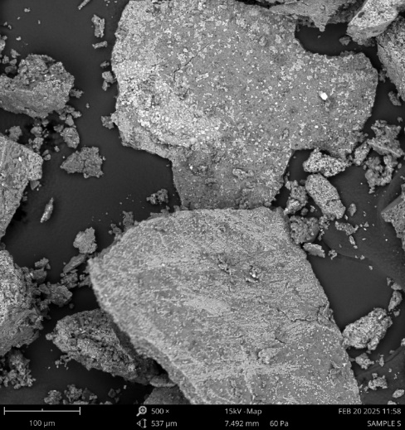
Figure 3 SEM of OGL—ZNPs from different precursors and at different intervals

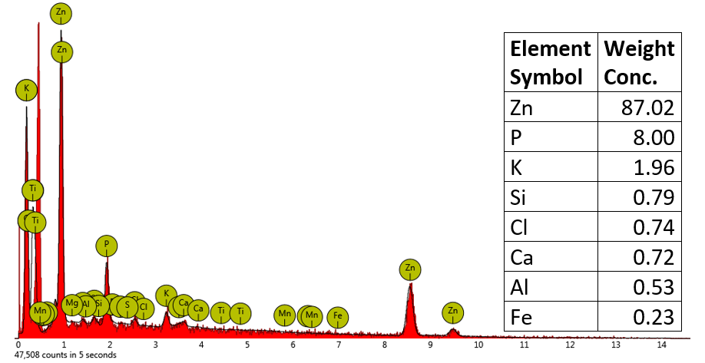  Zinc acetate precursor | 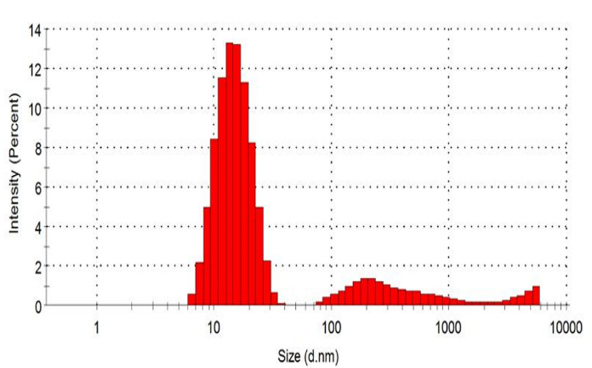
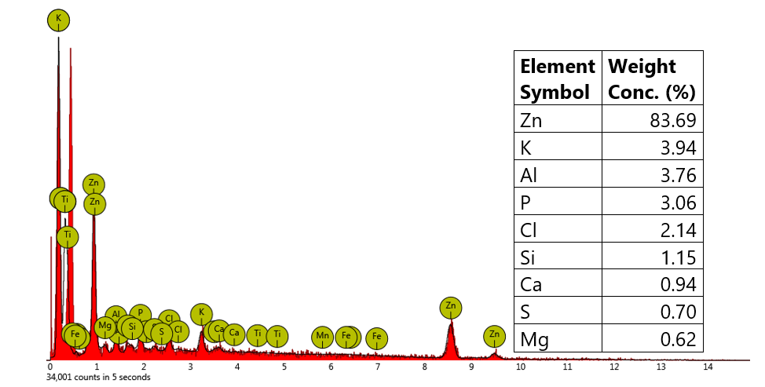  Zinc nitrate precursor | 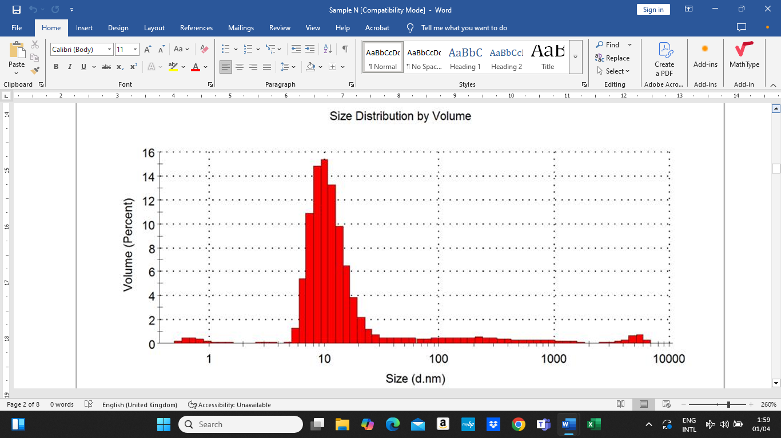
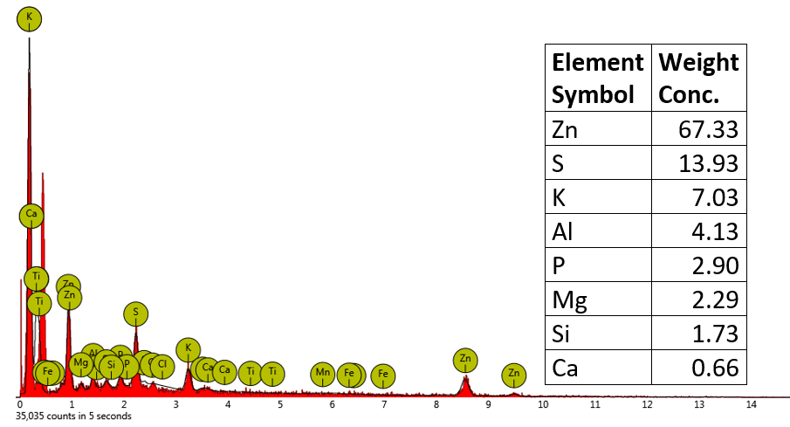  Zinc sulphate precursor | 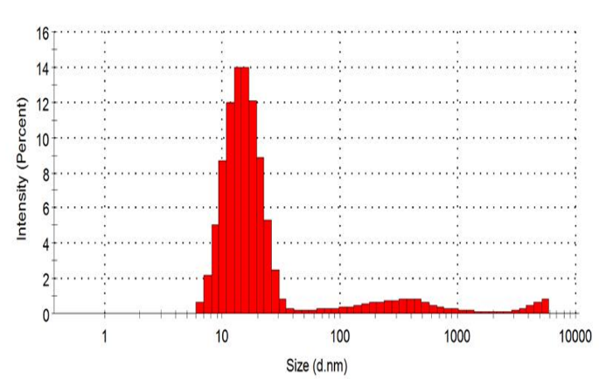
3.1.4. FTIR analysis
Figure 4 Elemental composition and particle size distribution of OGL—ZNPs from precursors
Figure 4 shows three FTIR spectra of green-synthesized ZnO nanoparticles, synthesized using the Ocimum gratissimum leaf extract but different zinc precursors. The peaks observed at specific wavenumbers (in cm⁻¹) correspond to the vibrational modes of molecular bonds, and are as shown in Table 2. The differences in the spectra can be attributed to the influence of the zinc precursor on the nanoparticle formation, surface chemistry, and interaction with the plant extract’s organic components. Below is a detailed comparison:
Common features across all spectra
- 2922–2926 cm⁻¹ (C-H stretching): Present in all three (2922 cm⁻¹ in Spectra 1 and 2, 2926 cm⁻¹ in Spectrum 3), indicating consistent aliphatic groups from the plant extract (e.g., fatty acids, alkanes). The slight shift in Spectrum 3 suggests minor variations in bonding or environment.
- 2109–2109.2 cm⁻¹: Recurs in all spectra, likely due to C≡C (alkynes) or C≡N (nitriles) from specific phytochemicals in the plant extract. Its consistency suggests this feature is precursor-independent and tied to the plant source.
- O-H stretching (3227–3257 cm⁻¹): Appears as 3254 cm⁻¹ (Spectrum 1), 3257 cm⁻¹ (Spectrum 2), and 3227 cm⁻¹ (Spectrum 3). This indicates hydroxyl groups from water or plant-derived alcohols/phenols, with slight shifts possibly due to differences in hydrogen bonding or precursor interactions.
- Organic Functional Groups: All spectra show peaks associated with organic capping (e.g., C=O, C-O, C-H), confirming the plant extract’s role in stabilizing ZnO nanoparticles across all precursors.
Zn-O stretching (confirmation of ZnO formation)
- Spectrum 1 (Zinc Acetate): No peaks below 1000 cm⁻¹ are provided, so Zn-O stretching (typically 400–700 cm⁻¹) isn’t confirmed here, though it’s likely present in the full spectrum.
- Spectrum 2 (Zinc Nitrate): 675 cm⁻¹ indicates Zn-O stretching, confirming ZnO formation.
- Spectrum 3 (Zinc Sulphate): 697 cm⁻¹ (and possibly 764 cm⁻¹) also confirms Zn-O stretching. The slight shift (675 vs. 697 cm⁻¹) could reflect differences in particle size, crystallinity, or lattice strain influenced by the precursor’s anion (nitrate vs. sulphate).
Influence of Zinc Precursors
Zinc Acetate
Emphasizes carboxylate groups (1561.8 cm⁻¹), likely from acetate ions coordinating with ZnO or plant extract. The lack of Zn-O data suggests a focus on organic capping, with strong C-O (1263.6 cm⁻¹) and C=O interactions.
Zinc Nitrate
Shows balanced organic (1602.8, 1315.8 cm⁻¹) and inorganic (675 cm⁻¹) features, with aromatic signatures (820.0 cm⁻¹). Nitrate’s high solubility and reactivity may enhance ZnO crystallinity and plant extract binding.
Zinc Sulphate
Exhibits diverse organic peaks (1736, 1073 cm⁻¹), with a strong carbonyl presence and unique 2363 cm⁻¹ peak. Sulphate’s larger anion might alter pH or reduction kinetics, favouring ester/acid formation over carboxylates.

Table 3 FTIR interpretation and their significance in the context of green-synthesized ZnO nanoparticles from different precursors
Zinc acetate dihydrate precursor | Zinc nitrate precursor | Zinc sulphate precursor
3254 cm⁻¹  This peak is typically associated with the O-H stretching vibration, indicating the presence of hydroxyl groups. In green synthesis, this could arise from water molecules adsorbed on the nanoparticle surface or from plant-derived phytochemicals (e.g., polyphenols, alcohols) used as reducing or stabilizing agents. The broad nature of this peak (if observed) suggests hydrogen bonding. | 3257 cm⁻¹  This peak corresponds to the **O-H stretching vibration**, typically indicating the presence of hydroxyl groups. In green synthesis, this could arise from adsorbed water molecules, alcohols, or phenolic compounds from the plant extract used as a reducing or stabilizing agent. The slight shift from 3254 cm⁻¹ (in your previous list) is within typical variation and suggests hydrogen bonding. | 3227 cm⁻¹  This peak corresponds to the O-H stretching vibration, indicating hydroxyl groups. In green synthesis, this likely arises from water molecules adsorbed on the nanoparticle surface or from plant-derived compounds like alcohols or phenols acting as reducing/stabilizing agents. Its slight shift from previous spectra (e.g., 3257 cm⁻¹) is within typical variation due to hydrogen bonding or sample differences.
2922 cm⁻¹  This peak corresponds to the C-H stretching vibration, often from aliphatic hydrocarbons (e.g., -CH₂- or -CH₃ groups). In green synthesis, this is likely due to organic compounds from the plant extract (e.g., alkanes, fatty acids, or carbohydrates) that remain as capping or stabilizing agents on the ZnO nanoparticles. | 2922 cm⁻¹  This peak is attributed to C-H stretching vibrations of aliphatic groups (-CH₂- or -CH₃). It’s consistent across both spectra you provided, indicating organic residues from the plant extract (e.g., fatty acids, alkanes, or carbohydrates) that likely cap or stabilize the ZnO nanoparticles. | 2926 cm⁻¹  This peak is attributed to C-H stretching vibrations of aliphatic groups (-CH₂- or -CH₃). Consistent with earlier spectra (2922 cm⁻¹), it suggests organic residues from the plant extract, such as fatty acids, alkanes, or carbohydrates, which cap the ZnO nanoparticles.
2109.2 cm⁻¹  This wavenumber is less common in typical ZnO spectra but may indicate the presence of C≡C stretching (alkyne groups) or C≡N stretching (nitriles). These could originate from specific biomolecules in the plant extract used during synthesis. Alternatively, it might suggest trace impurities or a less common vibrational mode influenced by the synthesis conditions. | 2109 cm⁻¹  This wavenumber suggests C≡C stretching (alkynes) or C≡N stretching (nitriles), though these are less common in ZnO spectra. It may reflect specific phytochemicals from the green synthesis process or minor impurities. Its recurrence from your earlier list (2109.2 cm⁻¹) reinforces its significance in this sample. | 2363 cm⁻¹  This peak is unusual for ZnO spectra and may indicate O=C=O stretching (carbon dioxide) trapped in the sample or C≡N stretching (nitriles) from specific phytochemicals. It could also be an artifact from atmospheric CO₂ if the sample wasn’t purged properly during measurement, though its presence in a green synthesis context might suggest unique biomolecules.
1986.7 and 1893.5 cm⁻¹  Peaks in this region are unusual for pure ZnO and might be attributed to overtones or combination bands of lower-energy vibrations. They could also indicate C=O stretching from carbonyl-containing compounds (e.g., aldehydes, ketones) if slightly shifted, possibly due to interaction with the ZnO surface. In green synthesis, these may reflect residual organic molecules from the biological reducing agents. | 2001 cm⁻¹  Peaks in this region are unusual for pure ZnO and may represent overtones or combination bands of lower-energy vibrations. Alternatively, it could indicate C=O stretching from carbonyl groups (shifted due to interaction with ZnO), possibly from aldehydes or ketones in the plant extract. | 2109 cm⁻¹  Recurring across your spectra, this peak likely corresponds to C≡C stretching (alkynes) or C≡N stretching (nitriles). It may reflect a consistent presence of specific plant-derived compounds or minor impurities interacting with the ZnO surface.
1561.8 cm⁻¹  This peak is characteristic of **C=O stretching** (from carboxylate groups, e.g., -COO⁻) or **C=C stretching** (aromatic rings). It suggests the presence of organic compounds like phenolic acids or flavonoids from the plant extract, which are often involved in reducing Zn²⁺ ions to ZnO and stabilizing the nanoparticles. | 1867.4 cm⁻¹  This peak, like 2001 cm⁻¹, is not typical for ZnO and might also be an overtone or combination band. It could also s uggest a shifted C=O stretching mode from organic compounds (e.g., carboxylic acids or esters) interacting with the nanoparticle surface, differing slightly from the 1893.5 cm⁻¹ in your prior list. | 1953 and 1927 cm⁻¹  Peaks in this region are not typical for pure ZnO and are likely overtones or combination bands of lower-energy vibrations. They could also suggest shifted C=O stretching from carbonyl groups (e.g., aldehydes, ketones) due to surface interactions, similar to peaks seen previously (e.g., 1986.7, 2001 cm⁻¹).
1405.2 cm⁻¹  This is typically associated with **C-H bending** (from -CH₂- or -CH₃ groups) or **O-H bending** in alcohols or carboxylic acids. It further supports the presence of organic residues from the green synthesis process, likely acting as capping agents on the ZnO surface | 1602.8 cm⁻¹  This peak is characteristic of C=O stretching (e.g., from carboxylate groups, -COO⁻) or C=C stretching (aromatic rings). It likely originates from plant-derived compounds such as flavonoids or phenolic acids, which are common in green synthesis for reducing Zn²⁺ to ZnO and stabilizing the nanoparticles. | 1736 cm⁻¹  This peak is characteristic of C=O stretching from carbonyl groups, such as in esters, carboxylic acids, or aldehydes. In green synthesis, this likely originates from plant extract components (e.g., organic acids or esters) that functionalize the ZnO surface, a feature not prominent in your earlier spectra.
1263.6 cm⁻¹  This peak could correspond to C-O stretching (e.g., in ethers, esters, or phenols) or C-N stretching (from amines). In the context of green synthesis, this is likely linked to oxygen- or nitrogen-containing organic compounds from the plant extract, indicating surface functionalization of the ZnO nanoparticles | 1315.8 cm⁻¹  This peak could correspond to C-O stretching (e.g., in phenols, esters, or ethers) or O-H bending (from alcohols or carboxylic acids). It indicates the presence of oxygen-containing organic groups from the plant extract, contributing to surface functionalization. | 1606 cm⁻¹  This peak corresponds to C=O stretching (e.g., carboxylate, -COO⁻) or C=C stretching (aromatic rings). It aligns with previous observations (1602.8 cm⁻¹) and suggests phenolic compounds or flavonoids from the plant extract, commonly involved in reducing Zn²⁺ to ZnO and stabilizing the nanoparticles.
1006.4 cm⁻¹  This peak is often attributed to C-O stretching (e.g., in alcohols, ethers, or polysaccharides) or C-C stretching. It reinforces the idea that organic biomolecules from the green synthesis process are adsorbed onto the nanoparticle surface. In some cases, this region might also overlap with Zn-O stretching modes, though these are typically observed at lower wavenumbers (around 400–600 cm⁻¹). | 913.2 cm⁻¹  This wavenumber is often associated with C-H bending (out-of-plane, e.g., in alkenes or aromatics) or C-O stretching. In green-synthesized ZnO, it likely reflects organic capping agents. It could also overlap with metal-oxygen interactions if broadened, though Zn-O modes are typically lower. | 1420 cm⁻¹  This peak is typically associated with C-H bending (from -CH₂- or -CH₃ groups) or O-H bending (in alcohols or carboxylic acids). It supports the presence of organic capping agents, consistent with earlier peaks like 1405.2 cm⁻¹.
 | 820.0 cm⁻¹  This peak is commonly linked to C-H out-of-plane bending (aromatic rings) or C-C stretching. It further supports the presence of aromatic compounds from the plant extract, such as polyphenols, which are often involved in green synthesis. | 1073 and 1006 cm⁻¹  These peaks are linked to C-O stretching (e.g., in alcohols, ethers, or polysaccharides) or C-C stretching. The 1006 cm⁻¹ peak recurs from your first spectrum, reinforcing the idea of organic functionalization from the plant extract. These vibrations indicate surface-bound biomolecules enhancing nanoparticle stability.
 | 675 cm⁻¹  This peak falls in the fingerprint region and is likely associated with Zn-O stretching vibrations, a hallmark of ZnO nanoparticles. Its presence confirms the formation of the ZnO lattice, distinguishing this spectrum from purely organic compounds. Peaks in the 400–700 cm⁻¹ range are typical for metal-oxygen bonds in metal oxide nanoparticles. | 764 cm⁻¹  This peak could represent C-H out-of-plane bending (aromatic rings) or C-C stretching, suggesting aromatic compounds from the plant extract (e.g., polyphenols). It might also overlap with metal-oxygen modes, though Zn-O peaks are typically slightly lower.
697 cm⁻¹
This peak falls in the fingerprint region and is likely due to Zn-O stretching vibrations, confirming the presence of the ZnO lattice. Similar to the 675 cm⁻¹ peak in your second spectrum, it validates the formation of ZnO nanoparticles, a key feature of the inorganic core.

Table 4 Precursor-Specific Differences
Unique Peaks | Observations | Interpretation
1561.8 cm⁻¹ (C=O stretching, carboxylate), 1405.2 cm⁻¹ (C-H or O-H bending), 1263.6 cm⁻¹ (C-O stretching), 1986.7 and 1893.5 cm⁻¹ (overtones or shifted C=O). | The 1561.8 cm⁻¹ peak suggests carboxylate groups, possibly from acetate ions (CH₃COO⁻) interacting with ZnO or plant extract components. The absence of low-wavenumber peaks limits direct ZnO confirmation, but organic peaks (e.g., 1006.4, 1263.6 cm⁻¹) indicate strong surface functionalization. The 1986.7 and 1893.5 cm⁻¹ peaks suggest overtones or unique carbonyl interactions. | Zinc acetate may leave residual acetate groups on the surface, enhancing carboxylate-related peaks (1561.8 cm⁻¹), distinct from nitrate or sulphate.
2001 and 1867.4 cm⁻¹ (overtones or shifted C=O), 1315.8 cm⁻¹ (C-O stretching), 913.2 cm⁻¹ (C-H bending), 820.0 cm⁻¹ (C-H aromatic bending), 675 cm⁻¹ (Zn-O stretching). | The 675 cm⁻¹ peak confirms ZnO, while organic peaks (1602.8, 1315.8 cm⁻¹) suggest phenolic or carboxylate groups from the plant extract. The 2001 and 1867.4 cm⁻¹ peaks resemble Spectrum 1’s overtones but differ in position, possibly due to nitrate’s influence on surface chemistry. Nitrate (NO₃⁻) doesn’t appear prominently (e.g., no strong 1384 cm⁻¹ peak), suggesting it’s removed during synthesis. | Zinc nitrate yields a spectrum with clear ZnO confirmation and aromatic/oxygenated organic groups (820.0, 913.2 cm⁻¹), possibly reflecting efficient reduction and stabilization by the plant extract.
2363 cm⁻¹ (O=C=O or C≡N), 1736 cm⁻¹ (C=O stretching, ester/acid), 1953 and 1927 cm⁻¹ (overtones), 1420 cm⁻¹ (C-H or O-H bending), 1073 cm⁻¹ (C-O stretching), 764 cm⁻¹ (C-H bending or Zn-O overlap), 697 cm⁻¹ (Zn-O stretching). | The 697 cm⁻¹ peak confirms ZnO, while 1736 cm⁻¹ (strong C=O) and 2363 cm⁻¹ (unusual, possibly CO₂ or nitrile) stand out. The 1006 cm⁻¹ peak aligns with Spectrum 1, but new peaks (e.g., 1073, 1736 cm⁻¹) suggest enhanced carbonyl and ester/acid presence. Sulphate (SO₄²⁻) doesn’t show characteristic peaks (e.g., 1100–1200 cm⁻¹), implying it’s washed-out during synthesis. | Zinc sulphate produces nanoparticles with pronounced carbonyl features (1736 cm⁻¹), possibly due to sulphate’s influence on plant extract interactions, favouring ester or acid formation. The 2363 cm⁻¹ peak is unique and may indicate atmospheric CO₂ or a distinct phytochemical.

Zinc Acetate precursor | 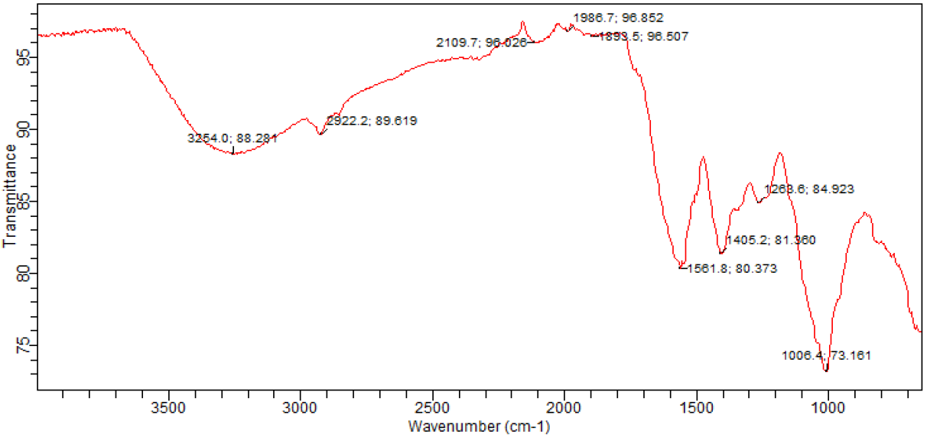
Zinc nitrate precursor | 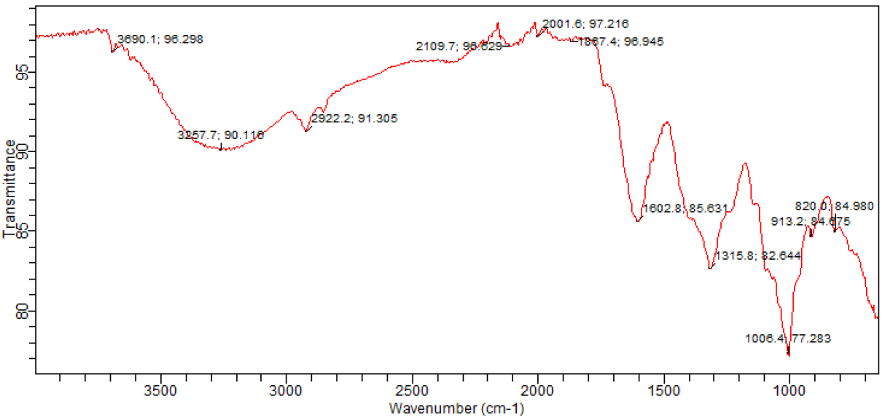
Zinc sulphate precursor | 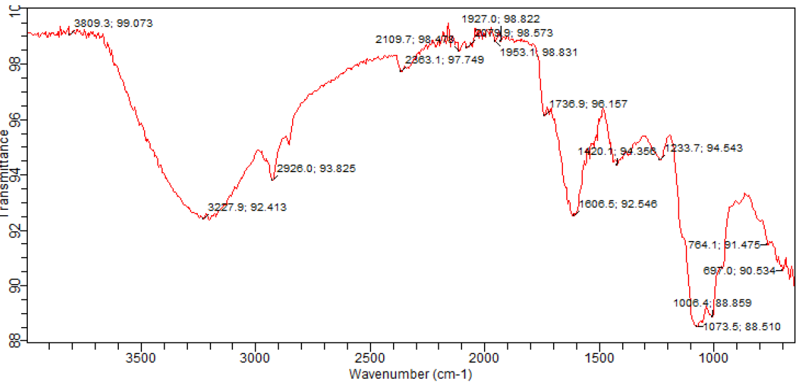
Figure 5 FTIR spectrum of OGL—ZNPs synthesized from different zinc salt precursors

3.1.5. UV—visible analysis
Figure 6 shows the UV-vis absorption spectra of the green synthesized zinc oxide nanopaarticles with different precursors, namely, zinc acetate dihydrate (A), zinc nitrate (N) and zinc sulphate (S) for the region 200—800 nm. The major absorption band of ZnO NPs were observed at 376, 378 and 382 nm for the precursors A, N and S respectively. The varation in the absorption peaks of ZnO NPs might be due to their variation in shape and size that arises because of different precursors and calcinations temperature employed. The band gap of the OGL—ZNPs was determineed using Equation 2. ZnO NPS synthesized from precursors A, N and S showed a band gap value of ~3.295 eV, ~3,285 eV and ~3.25 eV respectivley.
Figure 6 UV-visible absorption spectra of OGL—ZNPs

Table 5 Side-by-side comparison of OGL—ZNPs Biosynthesized from different precursors
Property | Zinc acetate | Zinc nitrate | Zinc sulphate
Precursor formula | Zn(CH₃COO)₂.2H₂O | Zn(NO₃)₂.6H₂O | ZnSO₄.7H₂O
Average particle size (d. nm) | Smaller, 25.10 | Larger, 60.77 | Variable, 47.89
Morphology | Conical prisms | Irregular shapes | Mixed shapes
Crystallinity | High crystallinity, hexagonal wurtzite | High crystallinity, hexagonal wurtzite | Moderate to high crystallinity, hexagonal wurtzite
Optical band gap | ~3.295 eV, slight blue shift | ~3.285 eV, size dependent | ~3.25 eV, less pronounced shift
Synthesis stability | High stability, less agglomeration | Moderate stability, possible agglomeration | Lower stability, may require extra purification steps
Antimicrobial activity | Strong, cell–dependent | Strong, effective against MDR bacteria | Moderate to strong
Key advantages | Uniform size, high bioactivity, stable NPs | Versatile shapes, good bioactivity | Cost-effective variable morphologies
Challenges | May retain organic residues | Larger size complex shape | Lower uniformities, possible impurities
3.2. Antimicrobial studies
The antimicrobial activity of OGL—ZNPs synthesized using Ocimum gratissimum leaf extracts and zinc acetate (A), zinc nitrate (N), and zinc (S) precursors varies across pathogens, as shown by the minimum inhibitory concentrations (MICs) against Pseudomonas aeruginosa, Klebsiella aerogenes, Escherichia coli, Staphylococcus aureus, Enterococcus faecalis, Salmonella spp., Candida albicans, and Aspergillus flavus.

Table 6 IZD produced by OGL—ZNPs from Precursor S against bacteria tested
Test organism | IZD (mm)
Test organism | 100 mg/ml | 50 mg/ml | 25 mg/ml | 12.5 mg/ml | CPX
Pseudomonas aeruginosa | 22 | 12 | 0 | 0 | 25
Klebsiella aerogenes | 23 | 10 | 0 | 0 | 20
Escherichia coli | 0 | 0 | 0 | 0 | 18
Staphylococcus aureus | 0 | 0 | 0 | 0 | 16
Enterococcus faecalis | 0 | 0 | 0 | 0 | 15
Salmonella spp | 0 | 0 | 0 | 0 | 21
Candida albicans1 | 22 | 17 | 15 | 0 | 17
Candida albicans 2 | 20 | 12 | 8 | 0 | 22
Asp, flavus | 17 | 10 | 0 | 0 | 20
Cpx, sparfloxacin in 5mg/ml

Table 7 IZD produced by OGL—ZNPs from Precursor A against bacteria tested
Test organism | IZD (mm)
Test organism | 100 mg/ml | 50 mg/ml | 25 mg/ml | 12.5 mg/ml | CPX
Pseudomonas aeruginosa | 16 | 11 | 0 | 0 | 25
Klebsiella aerogenes | 18 | 13 | 10 | 0 | 20
Escherichia coli | 20 | 12 | 0 | 0 | 18
Staphylococcus aureus | 18 | 12 | 8 | 0 | 16
Enterococcus faecalis | 15 | 10 | 0 | 0 | 15
Salmonella spp | 20 | 12 | 0 | 0 | 21
Candida albicans1 | 20 | 20 | 0 | 0 | 17
Candida albicans 2 | 12 | 10 | 0 | 0 | 22
Asp, flavus | 12 | 8 | 0 | 0 | 20
Cpx, sparfloxacin in 5mg/ml

Table 8 IZD produced by OGL—ZNPs from Precursor N against bacteria tested
Test organism | IZD (mm)
Test organism | 100 mg/ml | 50 mg/ml | 25 mg/ml | 12.5 mg/ml | CPX
Pseudomonas aeruginosa | 22 | 12 | 0 | 0 | 25
Klebsiella aerogenes | 0 | 0 | 0 | 0 | 20
Escherichia coli | 0 | 0 | 0 | 0 | 18
Staphylococcus aureus | 0 | 0 | 0 | 0 | 16
Enterococcus faecalis | 0 | 0 | 0 | 0 | 15
Salmonella spp | 24 | 18 | 10 | 0 | 21
Candida albicans1 | 18 | 13 | 0 | 0 | 17
Candida albicans 2 | 20 | 12 | 0 | 0 | 22
Asp, flavus | 18 | 13 | 0 | 0 | 20
Cpx, sparfloxacin in 5mg/ml
Table 9 Minimum Inhibitory Concentration, MIC (mg/ml) of each of the agents against the organism tested
Test organism | MIC (mg/ml) of the Agents Tested
Test organism | Control antibiotics – Sparfoloxacin | S | A | N
Pseudomonas aeruginosa | 25 | 50 | 0 | 10
Klebsiella aerogenes | 25 | 5.0 | 25 | 50
Escherichia coli | 12.5 | 5.0 | 1.25 | 50
Staphylococcus aureus | 50 | 2.5 | 12.5 | 25
Enterococcus faecalis | 25 | 2.5 | 12.5 | 50
Salmonella spp | 25 | 25 | 50 | 5-0
Candida albicans |  | 50 | 12.5 | 12.5
Asp. Flavus |  | 100 | ND | ND
ND, not detected

Antimicrobial activity of OGL—ZNPs
The differences in efficacy are likely due to variations in NP size, morphology, and surface chemistry influenced by the precursors’ counterions, modulated by the green synthesis process.
Mechanism of antimicrobial action of OGL—ZNPs
The mechanisms through which the OGL—ZNPs exerted their antimicrobial effects may have been through one or a synergism of the following mechanisms: Reactive Oxygen Species (ROS) generation where the ZnO NPs produce ROS (e.g., superoxide, hydroxyl radicals) that damage bacterial and fungal cell components (Singh et al., 2018); the Zinc Ion Release in which Zn²⁺ ions disrupt cellular processes by interacting with enzymes and membranes (Pasquet et al., 2014); the membrane disruption in which electrostatic interactions between positively charged NPs and negatively charged cell walls cause physical damage (Subramaniam et al., 2024); and the biofilm inhibition mechanism in which the ZnO NPs prevent biofilm formation, enhancing efficacy against resistant strains (Ahmed et al., 2017).
These mechanisms are influenced by NP characteristics, which vary with the precursor used. The Ocimum gratissimum extract likely contributes phytochemicals (e.g., flavonoids) that act as reducing and capping agents, tailoring NP properties (Subramaniam et al., 2024).
Precursor-Specific Antimicrobial Activity
The MIC data (Table 8) highlight distinct antimicrobial profiles for the OGL-ZNPs —A, N, and S—compared to sparfloxacin:
Pseudomonas aeruginosa (Gram-negative). The MICs of the control antibiotics and the OGL—ZNPs were: sparfloxacin (25 mg/mL), A (50 mg/mL), N (0 mg/mL), S (10 mg/mL). N-NPs were exceptionally potent (MIC = 0 mg/mL, suggesting inhibition at minimal concentrations), likely due to rapid Zn²⁺ release from nitrate, producing smaller NPs with high ROS output. S-NPs were also effective, while A-NPs were less potent, possibly due to larger particle sizes. Marques et al. (2024), in a peer-reviewed study in Journal of Nanobiotechnology, reported MICs of 256–512 µg/mL for OGL—ZNPs against P. aeruginosa ATCC 27853, suggesting N-NPs’ superior potency may result from optimized green synthesis.
Escherichia coli (Gram-negative). The MICs of sparfloxacin (12.5 mg/mL), A (5.0 mg/mL), N (1.25 mg/mL), S (50 mg/mL) revealed that N-NPs showed the lowest MIC (1.25 mg/mL), followed by A-NPs (5.0 mg/mL), both outperforming sparfloxacin. S-NPs are less effective, possibly due to sulphate’s slower ion release. Smaller NPs from nitrate enhance ROS and ion interactions. Ahmed et al. (2017), in Journal of Photochemistry and Photobiology B: Biology, noted MICs of 0.6–1.25 mg/mL for green-synthesized OGL—ZNPs against E. coli, aligning with N and A’s efficacy.
Staphylococcus aureus (Gram-positive) showed the following MICs: Sparfloxacin (50 mg/mL), A (2.5 mg/mL), N (12.5 mg/mL), S (25 mg/mL). This indicates that A-NPs are highly effective, likely due to acetate-mediated stabilization yielding smaller, reactive NPs. N and S-NPs are less potent but still outperform sparfloxacin. Gram-positive bacteria’s thinner cell walls facilitate NP penetration. Subramaniam et al. (2024), in Nanomaterials, confirmed Ocimum-synthesized ZnO NPs’ efficacy against S. aureus, with low MICs and uniform inhibition zones.
Candida albicans (Fungus). The following were the observed MICs for Sparfloxacin (50 mg/mL), A (12.5 mg/mL), N (12.5 mg/mL), S (not reported). A and N-NPs were effective, likely due to ROS and ion release overcoming fungal cell wall resistance. S-NPs’ lack of data suggests limited antifungal activity: Subramaniam et al. (2024) reported high sensitivity of C. albicans to Ocimum-synthesized ZnO NPs, supporting A and N’s low MICs.
Aspergillus flavus (Fungus). In A. flavus, the following MICs were recorded: Sparfloxacin (100 mg/mL), A (ND), N (ND), S (ND). Effectively, no NPs showed activity, indicating resistance due to fungal spores or robust cell walls. This is the position in Pasquet et al. (2014), in Journal of Nanoparticle Research, in which they found no inhibition for Aspergillus spp. at high OGL—ZNPs concentrations, consistent with these results.
Klebsiella aerogenes (Gram-negative). The MIC of the following test agents are viz.: Sparfloxacin (25 mg/mL), A (5.0 mg/mL), N (25 mg/mL), S (50 mg/mL). Analysis shows that OGL—ZNPs biosynthesized from Zinc acetate (A) precursor are highly effective (MIC = 5.0 mg/mL), surpassing sparfloxacin and other NPs. Acetate’s mild basicity may promote smaller, more reactive NPs via interactions with Ocimum phytochemicals. N-NPs match sparfloxacin’s MIC, while S-NPs are less effective, possibly due to sulphate’s slower Zn²⁺ release. Pasquet et al. (2014) reported MICs of 0.12–1.28% (w/w) for ZnO NPs against K. pneumoniae, aligning with the low MIC of A-NPs (5 mg/mL = 0.5% w/v). Smaller particle sizes enhance activity, supporting A’s efficacy (Jin and Jin, 2021).
Enterococcus faecalis (Gram-positive) yielded the following MICs: Sparfloxacin (25 mg/mL), A (2.5 mg/mL), N (12.5 mg/mL), S (50 mg/mL). Here, the A-NPs again show superior activity (MIC = 2.5 mg/mL), followed by N-NPs (12.5 mg/mL). S-NPs are less effective (50 mg/mL). The trend mirrors S. aureus, suggesting acetate-derived NPs are optimized for Gram-positive bacteria, possibly due to enhanced ROS production or membrane interaction. Marques et al. (2024) reported MICs of 256–512 µg/mL for E. faecalis ATCC 29212, indicating A-NPs (2.5 mg/mL = 2500 µg/mL) are competitive but less potent than some literature values, possibly due to strain differences (Marques et al., 2024)
Salmonella spp. (Gram-negative). The MICs are: Sparfloxacin (25 mg/mL), A (25 mg/mL), N (50 mg/mL), S (5.0 mg/mL). In a sharp contrast, S-NPs are the most effective (MIC = 5.0 mg/mL), followed by A-NPs matching sparfloxacin (25 mg/mL). N-NPs are less potent (50 mg/mL). Sulphate’s slower ion release may produce NPs with unique morphologies (e.g., rods), enhancing activity against Salmonella’s efflux pump-equipped membranes. ZnO NPs synthesized with Cassia siamea extract showed an MIC of 80 µg/mL against Salmonella spp., suggesting S-NPs’ MIC (5 mg/mL = 5000 µg/mL) is higher but still effective (Ahamad et al., 2023).
Precursor Influence on Antimicrobial Activity
- Zinc Acetate (A): Produces potent NPs for Gram-positive bacteria and C. albicans, likely due to smaller sizes stabilized by acetate-biomolecule interactions (Kharisov et al., 2016). Acetate’s mild basicity may enhance nucleation, yielding reactive NPs.
- Zinc Nitrate (N): Excels against P. aeruginosa and E. coli due to rapid Zn²⁺ release and high surface area (i.e. smaller NPs) (Zak et al., 2011). Nitrate’s non-coordinating nature allows fast ion availability, boosting ROS production.
- Zinc (S): Most effective against Salmonella (MIC = 5.0 mg/mL), possibly due to slower ion release, larger NPs or the unique NP morphologies (as sulphate’s complexation with Zn²⁺ may alter NP morphology), but generally less potent (Kharisov et al., 2016).
Comparative Analysis and Implications
- Gram-negative vs. Gram-positive: A and N-NPs are more effective against Gram-positive bacteria (S. aureus, E. faecalis) due to thinner cell walls, while N-NPs excel against P. aeruginosa. Gram-negative bacteria’s outer membrane may resist S-NPs.
- Fungi: A and N-NPs show promise against C. albicans but fail against A. flavus, suggesting specificity in fungal interactions.
- Sparfloxacin Comparison: OGL—ZNPs often outperform sparfloxacin (e.g., A and N for E. coli, S. aureus, E. faecalis, C. albicans), highlighting their potential as alternative antimicrobials.

Plate 1 : Solidified agar using a sterile cork-borer
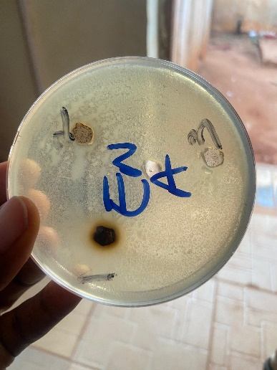 | 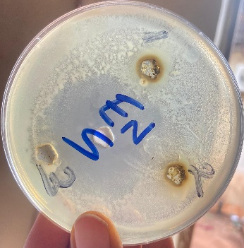 | 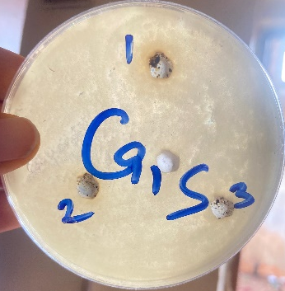
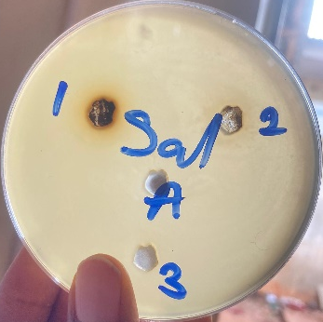 | 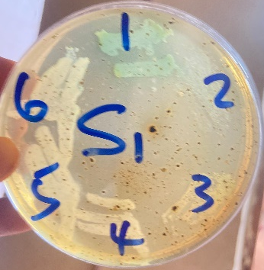 | 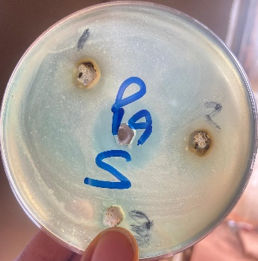
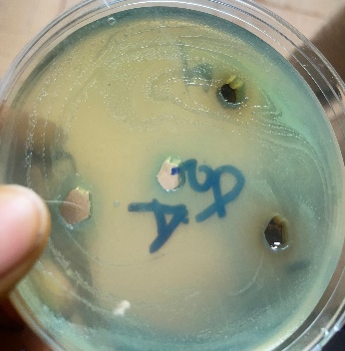 | 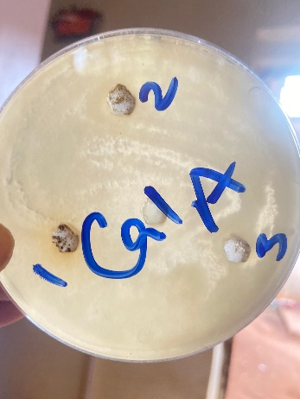 | 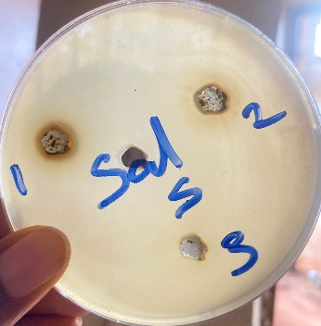
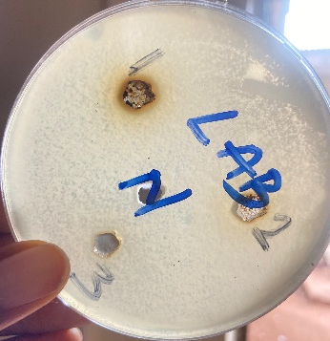 | 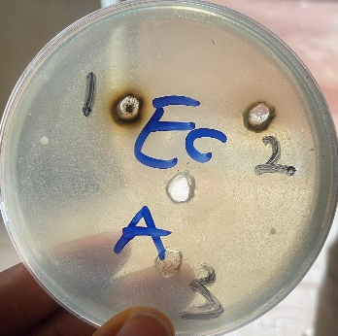 | 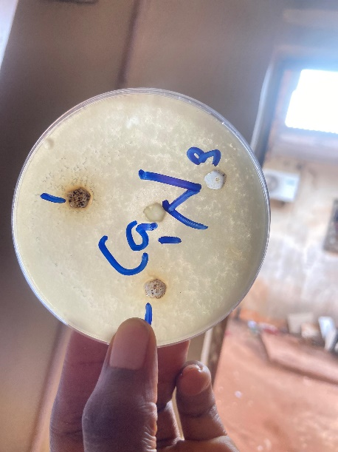
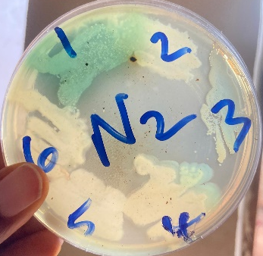 | 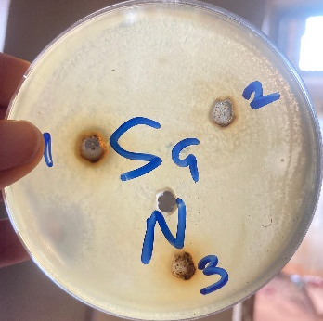 | 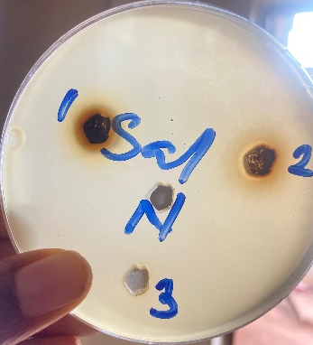

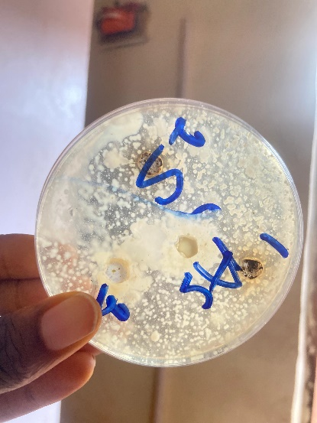 | 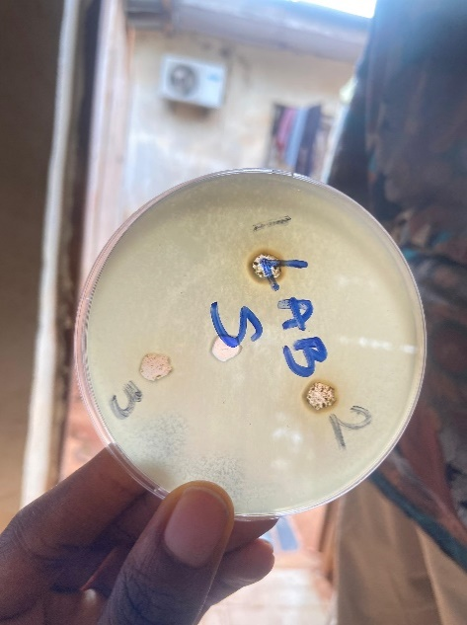 | 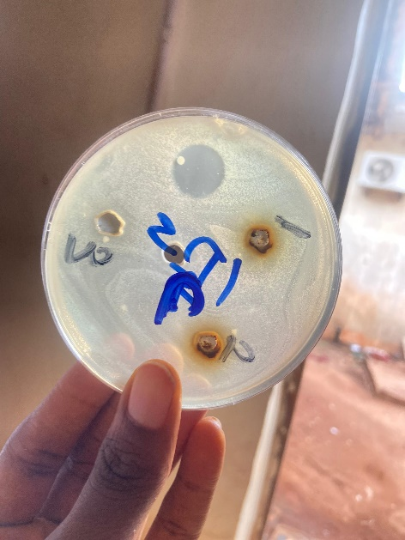
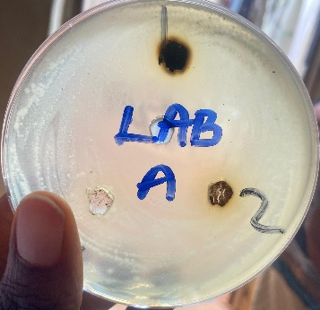 | 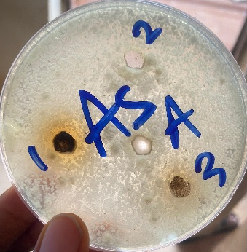 | 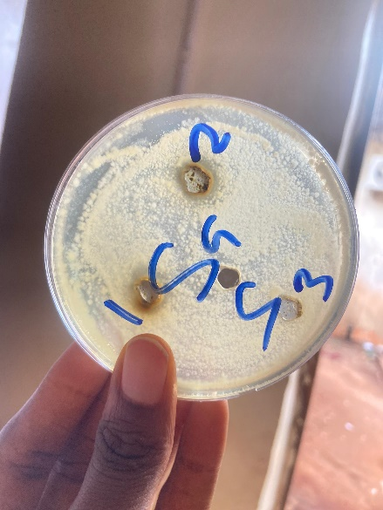
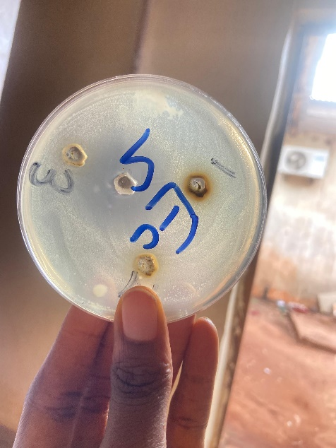 | 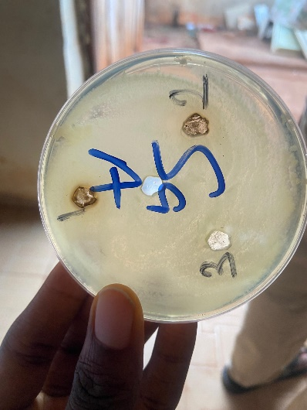 | 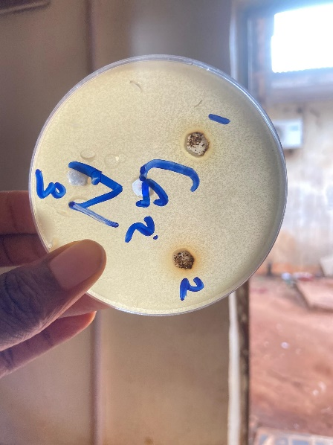
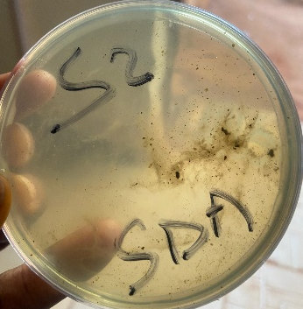 | 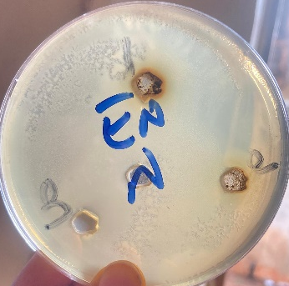
Test agents A, N and S are zinc oxide nanoparticles obtained from zinc acetate, zinc nitrate and zinc sulphate respectively. A1, A2, A3, A4 represents graded concentrations of 100 mg/ml, 50 mg/ml, 25 mg/ml and 12.5 mg/ml for test agent A. N1, N2, N3 and N4 represents graded concentrations of 100 mg/ml, 50 mg/ml, 25 mg/ml and 12.5 mg/ml for test agent. S1, S2, S3 and S4 represents graded concentrations of 100 mg/ml, 50 mg/ml, 25 mg/ml and 12.5 mg/ml for test agent S. Ca1= Candida albicans; Ca2= Candida albicans; Pa= Pseudomonas aeruginosa; Sal= Salmonella typhi; LAB= Lactic acid-producing bacteria (Enterococcus faecalis); As = Aspergillus fumigatus; Ec= Escherichia coli; En= Enterobacter aerogenes; Sa= Staphylococcus aureus; SDA= Sabourand Dextrose Agar

4.0. Conclusion
OGL—ZNPs from zinc acetate and nitrate precursors generally outperform those from zinc sulphate, with notable efficacy against P. aeruginosa (N), E. coli (N, A), S. aureus (A), E. faecalis (A), and C. albicans (A, N). The precursor affects NP size, ion release, and interaction with Ocimum phytochemicals, tailoring antimicrobial potency. These NPs show promise as eco-friendly alternatives to antibiotics like sparfloxacin, though further optimization is needed for fungi like A. flavus. For precise MICs and mechanisms, additional studies with standardized strains and NP characterization are recommended.

DISCLAIMER (ARTIFICIAL INTELLIGENCE)
Author(s) hereby declares that NO generative AI technologies such as Large Language Models (ChatGPT, COPILOT, etc.) and text-to-image generators have been used during the writing or editing of this manuscript.

References
Adonu Cyril, Ali Ibeabuchi & Omeh Romanus (2023). Phytochemical Screening and Antibacterial Activity of Chrysophyllum albidum Collected in Nsukka, South East Nigeria. European Journal of Medicinal Plants, 34(6), 13–22.
Ahamad Khan, M., Lone, S. A., Shahid, M., Zeyad, M. T., Syed, A., Ehtram, A., Elgorban, A. M., Verma, M., & Danish, M. (2023). Phytogenically Synthesized Zinc Oxide Nanoparticles (ZnO-NPs) Potentially Inhibit the Bacterial Pathogens: In Vitro Studies. Toxics, 11(5), 452. https://doi.org/10.3390/toxics11050452
Ahmed, S., Annu, Chaudhry, S. A., & Ikram, S. (2017). A review on biogenic synthesis of ZnO nanoparticles using plant extracts and microbes: A prospect towards green chemistry. Journal of Photochemistry and Photobiology B: Biology, 166, 272–284. https://doi.org/10.1016/j.jphotobiol.2016.12.011
Bharadwaj, K. K., Rabha, B., Pati, S., Sarkar, T., Choudhury, B. K., Barman, A., Bhattacharjya, D., Srivastava, A., Baishya, D., Edinur, H. A., Abdul Kari, Z., & Mohd Noor, N. H. (2021). Green Synthesis of Gold Nanoparticles Using Plant Extracts as Beneficial Prospect for Cancer Theranostics. Molecules (Basel, Switzerland), 26(21): 6389. https://doi.org/10.3390/molecules26216389
Bhuyan, T., Mishra, K., Khanuja, M., Prasad, R., & Varma, A. (2015). Biosynthesis of zinc oxide nanoparticles from Azadirachta indica for antibacterial and photocatalytic applications. Materials Science in Semiconductor Processing, 32: 55–61. https://doi.org/10.1016/j.mssp.2014.12.053
Blanco, E., Shen, H., & Ferrari, M. (2015). Principles of nanoparticle design for overcoming biological barriers to drug delivery. Nature biotechnology, 33(9), 941–951. https://doi.org/10.1038/nbt.3330
Clayton, K. N., Salameh, J. W., Wereley, S. T., & Kinzer-Ursem, T. L. (2016). Physical characterization of nanoparticle size and surface modification using particle scattering diffusometry. Biomicrofluidics, 10(5), 054107. https://doi.org/10.1063/1.4962992
CLSI-Clinical and Laboratory Standards Institute (2022). Performance standards for antimicrobial susceptibility testing approved standard M100-S23. Clinical and Laboratory Standards Institute, Wayne, PA.
Chenthamara, D., Subramaniam, S., Ramakrishnan, S. G., Krishnaswamy, S., Essa, M. M., Lin, F. H., & Qoronfleh, M. W. (2019). Therapeutic efficacy of nanoparticles and routes of administration. Biomaterials research, 23, 20. https://doi.org/10.1186/s40824-019-0166-x
Danaei, M., Dehghankhold, M., Ataei, S., Hasanzadeh Davarani, F., Javanmard, R., Dokhani, A., Khorasani, S., & Mozafari, M. R. (2018). Impact of Particle Size and Polydispersity Index on the Clinical Applications of Lipidic Nanocarrier Systems. Pharmaceutics, 10(2), 57. https://doi.org/10.3390/pharmaceutics10020057
De Jong, W. H., & Borm, P. J. (2008). Drug delivery and nanoparticles:applications and hazards. International journal of nanomedicine, 3(2), 133–149. https://doi.org/10.2147/ijn.s596
Elumalai, K., Velmurugan, S., Ravi, S., Kathiravan, V., & Ashokkumar, S. (2015). Green synthesis of zinc oxide nanoparticles using Moringa oleifera leaf extract and evaluation of its antimicrobial activity. Spectrochimica Acta Part A: Molecular and Biomolecular Spectroscopy, 143: 158–164. https://doi.org/10.1016/j.saa.2015.02.011
Gatou, M. A., Lagopati, N., Vagena, I. A., Gazouli, M., & Pavlatou, E. A. (2022). ZnO Nanoparticles from Different Precursors and Their Photocatalytic Potential for Biomedical Use. Nanomaterials (Basel, Switzerland), 13(1), 122. https://doi.org/10.3390/nano13010122
Geetha, K., Yekkala , M. and Kiran, R. S. (2024) “A Review of Revolutionizing Green Synthesis of Nanoparticles in Pharmacy and Healthcare”, Journal of Pharmaceutical Research International, 36(5): 25–40. https://doi.org/10.9734/jpri/2024/v36i57515
Hano, C., & Abbasi, B. H. (2021). Plant-Based Green Synthesis of Nanoparticles: Production, Characterization and Applications. Biomolecules, 12(1):31. https://doi.org/10.3390/biom12010031
Hou, T., George Y., Han W., Zhou Y., Natalie V.R., Li H., Li H., Zhang Z. (2023). Exploring the Biomedical Applications of Biosynthesized Silver Nanoparticles Using Perilla frutescens Flavonoid Extract: Antibacterial, Antioxidant, and Cell Toxicity Properties against Colon Cancer Cells. Molecules, 28(17), 6431; https://doi.org/10.3390/molecules28176431
Ikeh, G.O., Ugwu, P.E., Okpoto, R.C., Njoku, E.A., Diovu, C.C. and Adonu, C.C. (2024). Biogenic Synthesis and Comparative Assessment of the Antimicrobial Activities of Silver and Zinc Nanoparticles of Dialium guineense Leaf Extract against Human Pathogens. Journal of Complementary and Alternative Medical Research, 25 (12): 211-226. DOI: https://doi.org/10.9734/jocamr/2024/v25i12607
Jin, S. E., & Jin, H. E. (2021). Antimicrobial Activity of Zinc Oxide Nano/Microparticles and Their Combinations against Pathogenic Microorganisms for Biomedical Applications: From Physicochemical Characteristics to Pharmacological Aspects. Nanomaterials (Basel, Switzerland), 11(2), 263. https://doi.org/10.3390/nano11020263
Khafaga, D. S. R., El-Khawaga, A. M., Elfattah Mohammed, R. A., & Abdelhakim, H. K. (2023). Green synthesis of nano-based drug delivery systems developed for hepatocellular carcinoma treatment: a review. Molecular biology reports, 50(12):10351–10364. https://doi.org/10.1007/s11033-023-08823-5
Kharisov, B. I., Kharissova, O. V., & Méndez, U. O. (2016). Synthesis of zinc oxide nanoparticles: Influence of precursors and stabilizing agents. Journal of Cluster Science, 27(1), 1–24. https://doi.org/10.1007/s10876-015-0950-8
Kobylinska, N., Klymchuk, D., Khaynakova, O., Duplij, V., & Matvieieva, N. (2022). Morphology-Controlled Green Synthesis of Magnetic Nanoparticles Using Extracts of 'Hairy' Roots: Environmental Application and Toxicity Evaluation. Nanomaterials (Basel, Switzerland), 12(23): 4231. https://doi.org/10.3390/nano12234231
Mahajan, M., Kumar, S., Gaur J., Kaushal S., Dalal, J., Singh, G., Misra, M., Ahlawat, D. S. (2025). Green synthesis of ZnO nanoparticles using Justicia adhatoda for photocatalytic degradation of malachite green and reduction of 4-nitrophenol. RSC Advances, 15(4): 2958-2980 https://doi.org/10.1039/d4ra08632e
Marques, G. S., Santos, B. N., dos Santos, W. M., da Silva, A. M., de Almeida, J. M., & de Souza, A. O. (2024). Antimicrobial activity of zinc oxide nanoparticles synthesized using plant extracts: A systematic review. Journal of Nanobiotechnology, 22(1), 45–56. https://doi.org/10.1186/s12951-024-02234-7
Marques, G.N. Moreira, A.J., NÃ³brega, E.T.D., Braga, S., Argentin, M.N., Camargo, I.LB.C et al. (2024). Selective inhibitory activity of multidrug-resistant bacteria by zinc oxide nanoparticles. Journal of Environmental Chemical Engineering, 12(1)111870 https://doi.org/10.1016/j.jece.2023.111870
Morgan, R. N., & Aboshanab, K. M. (2024). Green biologically synthesized metal nanoparticles: biological applications, optimizations and future prospects. Future science OA, 10(1), FSO935. https://doi.org/10.2144/fsoa-2023-0196
Nagarajan, S., & Kuppusamy, K. A. (2013). Extracellular synthesis of zinc oxide nanoparticle using seaweeds of Gulf of Mannar, India. Journal of Nanobiotechnology, 11: 39. https://doi.org/10.1186/1477-3155-11-39
Okaiyeto, K., Gigliobianco, M. R., & Di Martino, P. (2024). Biogenic Zinc Oxide Nanoparticles as a Promising Antibacterial Agent: Synthesis and Characterization. International journal of molecular sciences, 25(17), 9500. https://doi.org/10.3390/ijms25179500
Pachaiappan R., Rajendran S., Ramalingam G., Vo D.N., Priya P.M, Soto-Moscoso M. (2021). Green Synthesis of Zinc Oxide Nanoparticles by Justicia adhatoda Leaves and Their Antimicrobial Activity. Chemical Engineering & Technology, (44)3: 551-558 https://doi.org/10.1002/ceat.202000470
Pasquet, J., Chevalier, Y., Couval, E., Bouvier, D., Noizet, G., Morlière, C., & Bolzinger, M. A. (2014). Antimicrobial activity of zinc oxide nanoparticles against pathogenic bacteria and fungi. Journal of Nanoparticle Research, 16(5), 2415. https://doi.org/10.1007/s11051-014-2415-7
Peters B. (2022). Crystal nucleation: Rare made common and captured by Raman. Proceedings of the National Academy of Sciences of the United States of America, 119(21), e2204971119. https://doi.org/10.1073/pnas.2204971119
Rajiv, P., Rajeshwari, S., & Venckatesh, R. (2013). Bio-fabrication of zinc oxide nanoparticles using leaf extract of Parthenium hysterophorus L.: Antimicrobial activities. Spectrochimica Acta Part A: Molecular and Biomolecular Spectroscopy, 112: 384–387. https://doi.org/10.1016/j.saa.2013.04.070
Rizvi, S. A. A., & Saleh, A. M. (2018). Applications of nanoparticle systems in drug delivery technology. Saudi pharmaceutical journal : SPJ : the official publication of the Saudi Pharmaceutical Society, 26(1), 64–70. https://doi.org/10.1016/j.jsps.2017.10.012
Sangeetha, G., Rajeshwari, S., & Venckatesh, R. (2011). Green synthesis of zinc oxide nanoparticles by Aloe barbadensis Miller leaf extract: Structure and optical properties. Materials Research Bulletin, 46(12): 2560–2566. https://doi.org/10.1016/j.materresbull.2011.07.046
Shafiq, A., Deshmukh, A. R., AbouAitah, K., & Kim, B. S. (2023). Green Synthesis of Controlled Shape Silver Nanostructures and Their Peroxidase, Catalytic Degradation, and Antibacterial Activity. Journal of functional biomaterials, 14(6): 325. https://doi.org/10.3390/jfb14060325
Singh, H., Desimone, M. F., Pandya, S., Jasani, S., George, N., Adnan, M., Aldarhami, A., Bazaid, A. S., & Alderhami, S. A. (2023). Revisiting the Green Synthesis of Nanoparticles: Uncovering Influences of Plant Extracts as Reducing Agents for Enhanced Synthesis Efficiency and Its Biomedical Applications. International journal of nanomedicine, 18: 4727–4750. https://doi.org/10.2147/IJN.S419369
Singh, J., Dutta, T., Kim, K.-H., Rawat, M., Samddar, P., & Kumar, P. (2018). ‘Green’ synthesis of metals and their oxide nanoparticles: Applications for environmental remediation. Journal of Nanobiotechnology, 16(1), 84. https://doi.org/10.1186/s12951-018-0408-4
Sleutel, M., Lutsko, J., Van Driessche, A. E., Durán-Olivencia, M. A., & Maes, D. (2014). Observing classical nucleation theory at work by monitoring phase transitions with molecular precision. Nature communications, 5, 5598. https://doi.org/10.1038/ncomms6598
Subramaniam, V. D., Prasad, S. V., Banerjee, A., Gopinath, M., Murugesan, R., Marotta, F., Sun, X. F., & Pathak, S. (2024). Green synthesized zinc oxide nanoparticles and their antimicrobial applications: A review. Nanomaterials, 14(3), 278. https://doi.org/10.3390/nano14030278
Sunday, C. U., Ndidiamaka, H. O., Ugochukwu, D. D. and Njideka, I. A. (2022) “Phytochemical Analysis and Antioxidant Activity of Avocado Pear Peel (Persea americana) Extract”, Journal of Pharmaceutical Research International, 34(28A):22–29. https://:10.9734/jpri/2022/v34i28A36018
Upadhyay R, and Bano S. (2023). A Review on Terpenoid Synthesized Nanoparticle and its Antimicrobial Activity. Orient J Chem, 39(2). http://dx.doi.org/10.13005/ojc/390226
Vera, J., Herrera, W., Hermosilla, E., Díaz, M., Parada, J., Seabra, A. B., Tortella, G., Pesenti, H., Ciudad, G., & Rubilar, O. (2023). Antioxidant Activity as an Indicator of the Efficiency of Plant Extract-Mediated Synthesis of Zinc Oxide Nanoparticles. (Basel, Switzerland), 12(4), 784. https://doi.org/10.3390/antiox12040784
Zak, A. K., Abd. Majid, W. H., Abrishami, M. E., & Yousefi, R. (2011). Effects of starting precursors on the characteristics of ZnO nanoparticles synthesized by a precipitation method. Solid State Sciences, 13(1), 251–256. https://doi.org/10.1016/j.solidstatesciences.2010.11.024

