**Corrosion Inhibition of Aluminum and Copper in Hydrochloric Acid Solutions using Extracts of Almond Leaves (*Terminalia Catappa*) Leaves (TCE).**

**Abstract**: The corrosion inhibition efficiency of Almond leaves extract on copper and aluminum in 0.5M hydrochloric acid solution was studied using weight loss method, Scanning Electron Microscope (SEM) and Fourier Transform Infrared Spectroscopy (FTIR).

The results drawn from the different techniques are comparable and exhibit minimum discrepancy. Inhibition efficiency was found to increase with increase in concentration. However, temperature affected both metals differently. Inhibition efficiency increased with increase in temperature to maximum of 48.31% at 323K corrosion inhibition of copper and decreased as temperature increased and was maximum 92.23% at 303K

The inhibition was assumed to occur via adsorption of the TCE molecules on the metallic surface according to Langmuir adsorption isotherm for copper and Flory Huggins isotherm for aluminum. Both kinetic and thermodynamics parameters were calculated and discussed. SEM analysis revealed that the addition of inhibitor slows down the corrosion processes for the two metals. The FTIR Spectroscopy identified the functional groups responsible for the adsorption of the molecules on the metals through the intensities and wave number of the dominant peak.

**Keywords**: Terminalia Catappa Extraction, Corrosion, Inhibition, HCl, Aluminum, Copper

1. **INTRODUCTION**

Corrosion of metals and their alloys such as aluminum and copper has resulted to mechanical failure of equipment due to their exposure to acidic and alkaline media [21]. This has necessitated the use of corrosion inhibitors, which are usually added in minute quantities, to slow down the rate of corrosion of the metal or metal alloy [4]. Plant extracts have found use as alternatives to synthesized organic and inorganic products in corrosion inhibition of metals, due to concerns of general environmental and health safety. The plant extracts are obtained through various extraction techniques such as Soxhlet extraction, maceration and supercritical fluid extraction and fractionation or differential re- extraction can be used to separate the constituents of a plant extract [19]. The effect of corrosion includes rupturing of these corroded materials, spills, loss of integrity of materials and flow problems. Corrosion inhibitors offer surface protection for the metals by adsorption of their active functionalities on metal surface [3]. The inhibitor effectiveness varies with properties, such as its chemical composition, concentration and operating temperature [3, 4]. The almond tree is a medium sized tree with spreading branches. Its leaves are lance shaped and toothed. Typical phytochemicals that are found in almond leaves are: protocatechuic acid, methyl quercetin, catechinp-hydroxybenzoic acid, vanillic acid, [flavonoids](http://www.phytochemicals.info/phytochemicals/flavonoids.php), [resveratrol](http://www.phytochemicals.info/phytochemicals/resveratrol.php), [kaempferol](http://www.phytochemicals.info/phytochemicals/kaempferol.php). The major phytochemicals present in its extract include alkaloids, phenolic compounds, flavonoids, tannins, oils and steroids which all have conjugated aromatic structure, long aliphatic chains such as contain the heteroatoms O, N and S [18, 19]. These functional groups all have corrosion inhibiting properties with free electron pairs available to bond with metal surface [16]. The structures of these phytochemicals are shown in the figure below.









Fig 1.1 Phytochemicals present in Almond leaves.

Hydrochloric acid is widely used in the oil industry for acidizing purposes. Hence it is used as a corrosion medium in this study.

**2.** **EXPERIMENTAL**

**2.1. Preparation of Metal Coupons**

The sheets of aluminum and copper with thickness 1.0mm and purity 98.76% were mechanically cut into 2 cm by 5 cm coupons and subjected to chemical treatments. The two samples were first polished by scrubbing with sandpaper, degreased by immersion in absolute ethanol and drying in acetone. It was then immersed in a solution of 0.5M HCl for 30 minutes at room temperature and then rinsed with distilled water. They were dried with clean cloth and finally stored in desiccators prior to the commencement of the experiment.

**2.2 Preparation of Inhibitor solutions.**

The aqueous extract of Almond leaves was prepared by extraction of the ground matured almond leaves with water. Almond leaves were obtained in their fresh form and subjected to drying under a shadow to avoid denaturing of its natural constituent. The leaves were pulverized using a grinding machine to obtain a very fine powder. 200g of dried Almond leaves were soaked in 2 liters of deionized water for 48 hours. The mixture was filtered with a 12μm Whatman filter paper to separate filtrate from residue. Filtrate gotten was left to evaporate to dryness and the extract gotten. The process was repeated in order to get more extract which was used to prepare the inhibitor solution at different concentrations of 0.1, 0.2, 0.3, 0.4 and 0.5 g/dm3 in HCl solutions.

**2.3.** **Weight loss technique.**

Weight loss method is done by observing the change in weight with time. As the time increases the change in weight loss increases. Various calculations can be made from the results gotten from this method and this can be used to interpret some properties of the inhibitor used.The corrosion rate (*CR*), inhibition efficiency (ε*WL*) and degree of surface coverage (θ) were calculated as follows;

**CR = $\frac{87.6∆ W_{mean}}{ρAt}$ (1)**

$ε_{WL}$**= 100 ($\frac{R_{b-R_{i} }}{R_{b}}$) (2)**

**Θ = 0.01 $ε_{inh}$ (3)**

These measurements were conducted according to the ASTM standard method [12, 21]. Where ΔW mean is the mean weight loss of the metal, CR and CRinh are the corrosion rates (cmh-1) in the absence and presence of the inhibitor, respectively; ρ is the density of the metal, A is the average surface area (cm2) of the metal specimens; and t is the immersion time (h). This procedure was repeated at other temperatures, namely, 30o C, 40o C, and 50o C, maintained in a water bath.

**2.4 FTIR STUDY**

FTIR spectra of the pure sample of terminalia catappa extract and of the extract film formed on the metal surface after immersion in the solution containing 0.5g/dm3 of the inhibitor were recorded. This was done for both aluminum and copper. The spectra were measured using a FTIR-8400S Spectrophotometer.

**2.5 Scanning Electron Microscope (SEM) Study**

Metal samples of both aluminum and copper were collected, washed and rinsed in acetone. After drying, the metals were differently immersed in two different solutions. The first solution contained distilled water and HCl only, the second solution contained distilled water, the inhibitor and HCl. After 24 hours, the metals were collected from the different solutions and another metal not immersed into any of the solution were all collected for SEM analysis. This was done for both aluminum and copper. SEM images were taken and recorded for all the sample metals.

**3. Results and discussion**

**3.1. Thermometric study**

The corrosion rate, inhibition efficiency and surface coverage obtained from weight-loss measurements for the corrosion of copper and aluminum in 0.5M HCl containing different concentrations of TCE were calculated. The average percentage inhibition efficiency of different concentrations of TCE in 0.5M HCl solution at different temperatures for copper and aluminum are presented in the tables below.

Table 3.1: Variation of % inhibition efficiency with concentration at different temperatures

|  |  |  |  |
| --- | --- | --- | --- |
| ALUMINUM | % Inhibition Efficiency | | |
| Concentration TCE | 323K | 313K | 303K |
| 0.1 | 11.96 | 10.71 | 7.39 |
| 0.2 | 15.41 | 12.46 | 10.38 |
| 0.3 | 28.89 | 24.53 | 20.22 |
| 0.4 | 40.41 | 35.57 | 30.06 |
| 0.5 | 48.34 | 40.04 | 35.11 |

Table 3.2: Variation of % inhibition efficiency with concentration at different temperatures

|  |  |  |  |
| --- | --- | --- | --- |
| COPPER | % Inhibition Efficiency | | |
| Concentration TCE | 323 K | 313 K | 303 K |
| 0.1 | 88.57 | 90.19 | 92.23 |
| 0.2 | 85.16 | 87.77 | 90.28 |
| 0.3 | 72.33 | 75.76 | 79.47 |
| 0.4 | 67.27 | 73.26 | 74.39 |
| 0.5 | 64.65 | 69.68 | 70.82 |

**3.2 Effect of Inhibitor Concentration and Temperature on the inhibitor efficiency of TCE on the Metals**

Observing table 3.2, it is evident that as the temperature of the system increased from 303K to 323K, the inhibition efficiency decreased from 92.24% to 88.57% for copper. This pattern of temperature dependence on the inhibition efficiency is similar to reports by other researchers [1, 4, 15]. This shows that the extract was less efficient at higher temperatures and there was increased rate of dissolution of the metal.

For aluminum, the inhibition efficiency of the inhibitor increases as the temperature increases from 35.12% at 30OC to 48.34% at 50OC. This is in line with the observation of [2, 6, 10]. Temperature is one of the major factors that affect the performance of corrosion inhibitors [10].

The trend for aluminum is a feature of Chemisorption but other factors such as the ∆H and ∆G values need to be put into considerations before conclusions can be made.

As earlier reported [5], a decrease in the inhibition efficiency with increasing temperature indicates physisorption on the metal surface. Similar observations have been reported by [13, 17]. Plots of logarithm of corrosion rate (log k), with reciprocal of absolute temperature (1/T) for aluminum in 0.5 M HCl for the TCE is obtained [11] and straight lines with slope of –Ea*/ 2.303R and intercept of A were obtained according to Arrhenius-type equation (4).

$k=A\exp{({-Ea}^{*}}/RT)$**(4)**

Where: k is the corrosion rate, A is a constant and depends on a metal type and electrolyte, and Ea* is the apparent activation energy.

**3.3 Adsorption study**

**3.3.1 Langmuir Adsorption Isotherm**

Adsorption isotherm gives information on metal-inhibitor interaction [18] and the reaction of metal surface and inhibitor. The best fit was obtained with the Langmuir isotherm for copper. By plotting Cinh/θ against Cinh, [where cinh is the inhibitor concentration and θ the surface coverage], three straight lines with correlation coefficients (R2) of 0.9968¸ 0.9819, 0.9935 at 303 K, 313 K and 323 K respectively were obtained. The high values of correlation coefficient suggest that the adsorption of TCE on the Copper metal surface follow Langmuir adsorption isotherm. The expression for the model is given in Eq. (5) below.

$\frac{{Cin}_{h}}{θ}=\frac{1}{K_{ads}}$**+ ${ Cin}_{h}$ (5)**

Where *Cinh* is the concentration of inhibitor *Kads* is the adsorption–desorption equilibrium constant (M-1), which is used to determine the free energy change of adsorption (∆*Gads*) according to Eq. (2) [12].

${∆G}_{ads}= -RTln ({55.5K}_{ads})$**(6)**

Where 55.5 represent the concentration of water in the solution, *R* is the universal gas constant and *T* is the absolute temperature.

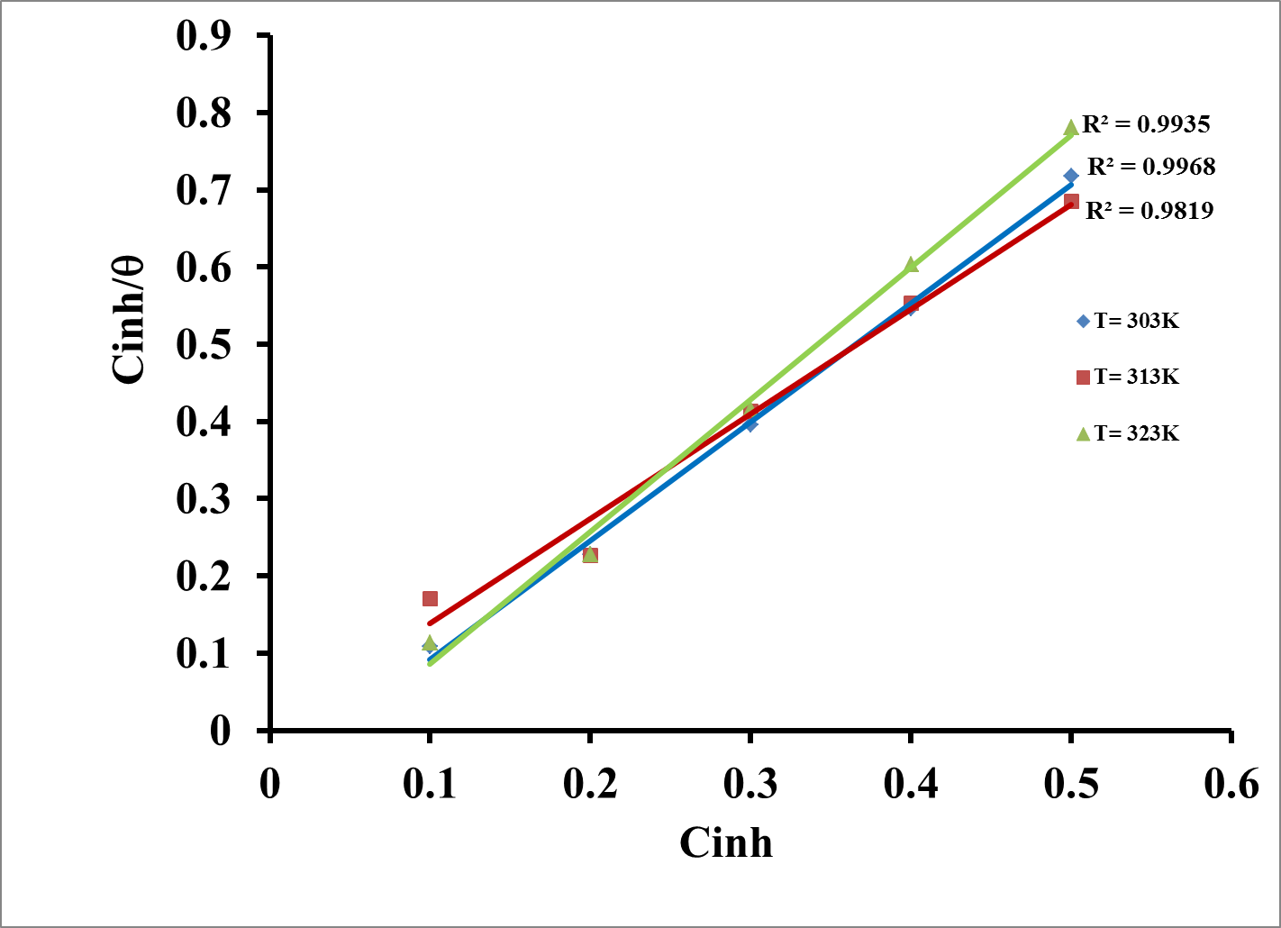

**Fig 3.1 Langmuir Adsorption Isotherm of TCE on Copper in 0.5M HCl solution at different temperatures**.

**3.3.2 Flory Huggins Adsorption Isotherm**

Flory Huggins adsorption isotherm with R2 values, 0.9481, 0.9471 and 0.8937 at 303k to 323k best described the adsorption type. By plotting Log θ against Log (1-θ ) , [where θ is the surface coverage], three straight lines for the three different temperatures were obtained with correlation coefficients (R2) of 0.9480¸ 0.9471, 0.8930 at 303 K, 313 K and 323 K respectively were obtained as seen in fig 3.2 - fig 3.4. The high values of correlation coefficient when compared to other isotherms, suggest that the adsorption of TCE on the aluminum metal surface follow Flory Huggins adsorption isotherm. This pattern of adsorption isotherm is also seen in [11,12].

**Log $(\frac{θ}{C}$) = Log (k) + a (1- θ**) (7)

Where K = adsorption- desorption equilibrium constant C= Concentration of Inhibitor θ = surface coverage

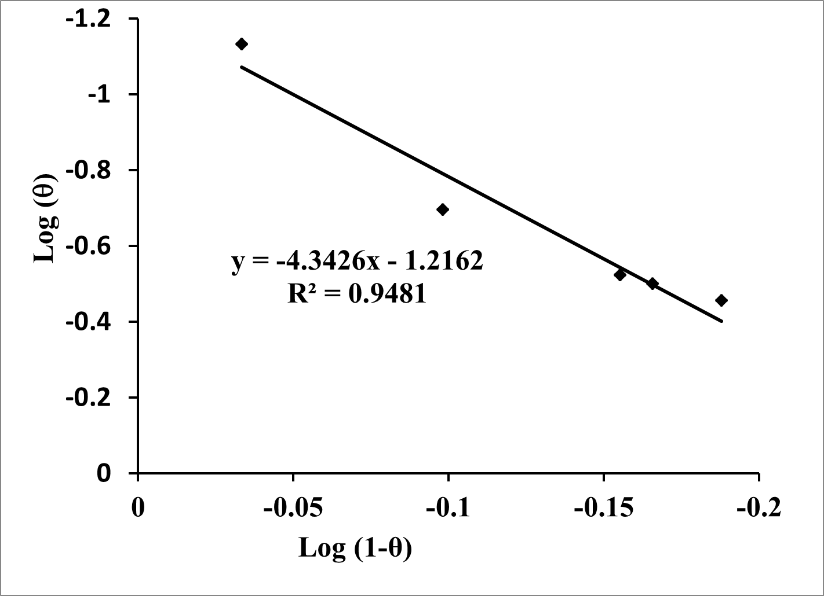

**Fig 3.2 Flory Huggins Isotherm of TCE on aluminum in 0.5M HCl solution at 303 K**

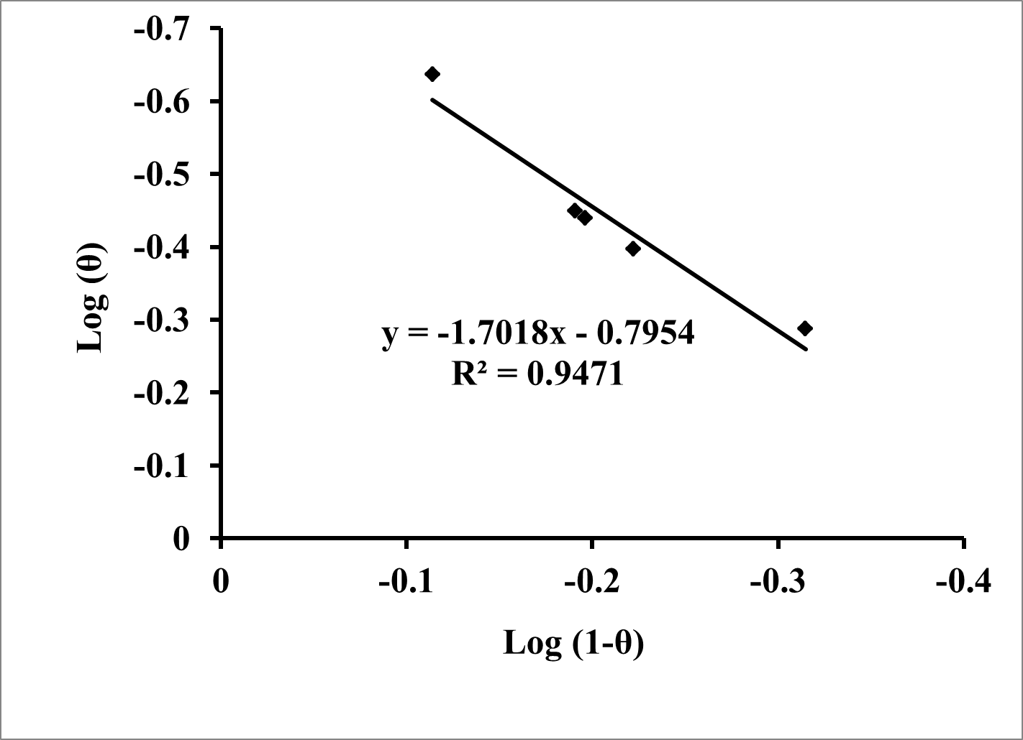

Fig 3.3 Flory Huggins Isotherm of TC**E** on Aluminium in 0.5M HCl solution at 313K

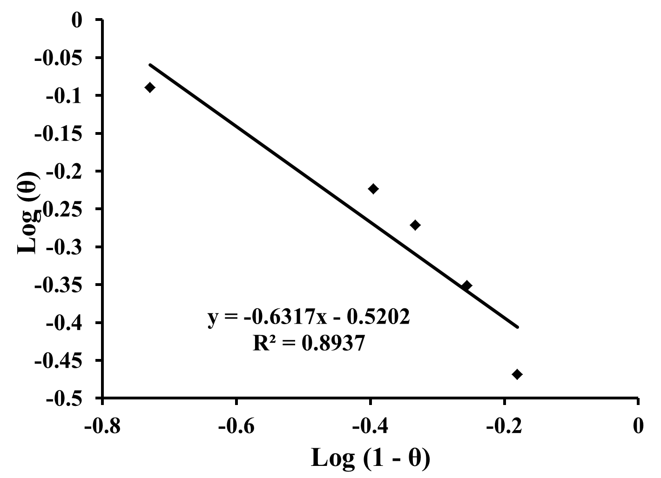

**Fig 3.4 Flory Huggins Isotherm of TCE on Aluminium in 0.5M HCl solution at 323K**

**3.5 FTIR study:**

This technique was carried out in order to predict the functional group(s) of the inhibitor involved in the adsorption process. Before the immersion of the metal into the solution, the prominent spectral peaks provide information on the functional groups in the compound. After its immersion, some of the peaks are either lost or are less prominent due to the involvement of the corresponding functional group(s) in adsorption. The FTIR spectra of pure TCE and the film for copper and aluminum are shown in fig 3.5 and 3.6 and tables 3.5 and 3.6.

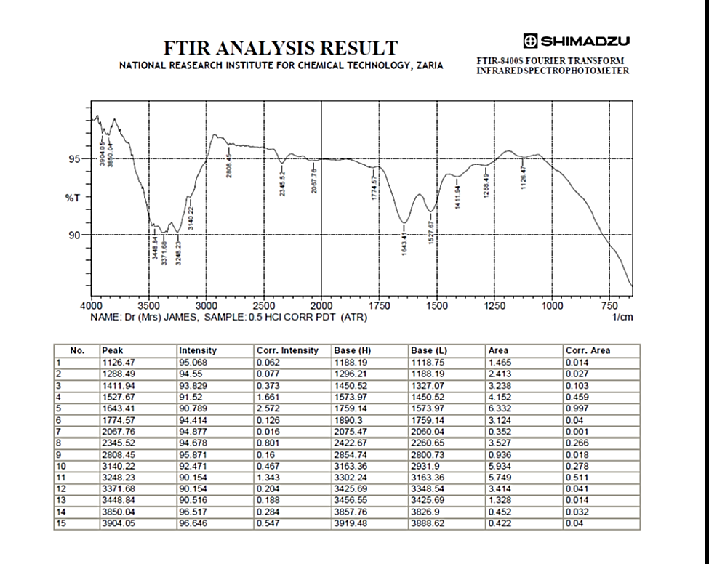

**OKOYE CHINWENDU PATIENCE. SAMPLE: ALMOND LEAVES**

Fig 3.5 FTIR SPECTRUM OF PURE TERMINALIA CATAPPA EXTRACT

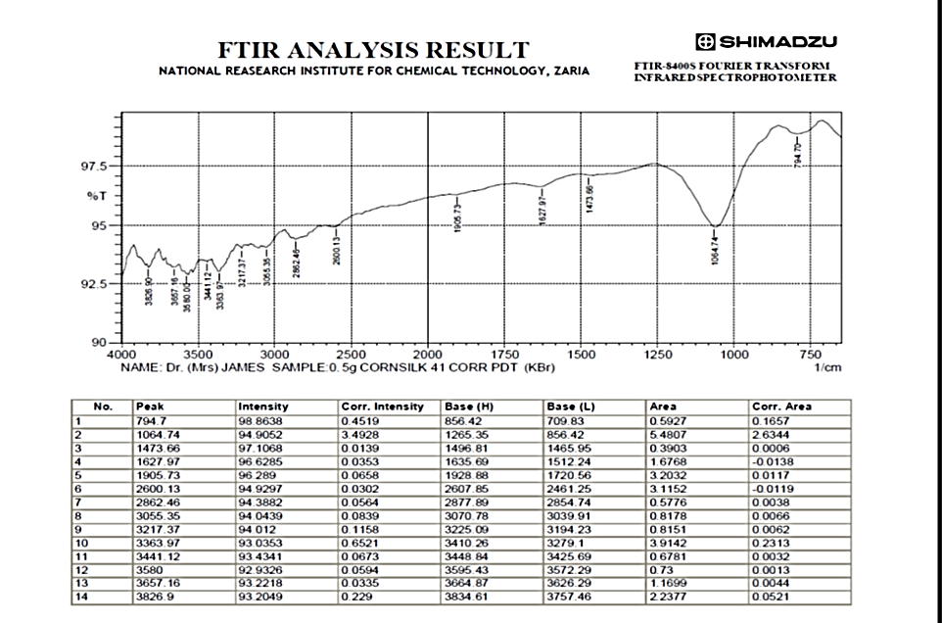

**OKOYE CHINWENDU PATIENCE. SAMPLE: ALMOND LEAVES**

Fig 3.6 FTIR SPECTRUM OF TERMINALIA CATAPPA EXTRACT ON ALUMINUM

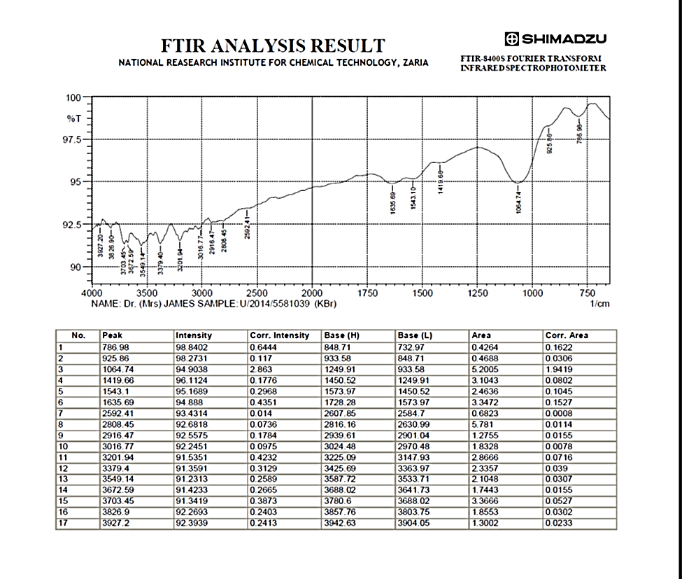

**NAME: OKOYE CHINWENDU PATIENCE. SAMPLE: ALMOND** LEAVES

Fig 3.7 FTIR SPECTRUM OF TERMINALIA CATAPPA EXTRACT ON COPPER

TABLE 3.5: TIR SPECTRA FOR PURE TERMINALIA CATAPPA EXTRACT

|  |  |  |  |  |
| --- | --- | --- | --- | --- |
| S.no | Peak value | | Stretching | Interpretation |
| 1 | 3904.05 | | O-H Stretching Sharp | Free Alcohol |
| 2 | 3850.04 | | O-H Stretching  Broad | Free Alcohol |
| 3 | 3448.84 | | N-H Stretching sharp | Primary amine |
| 4 | 3371.68 | | N-H Stretching sharp | Aliphatic primary amine |
| 5 | 3248.23 | | O-H Stretching | Carboxylic acid |
| 6 | 3140.22 | | O-H Stretching | Alcohol Intramolecular bonded |
| 7 | 2808.45 | | C-H Stretching | Alkane |
| 8 | 2345.52 | | O=C=O Stretching | Carbondioxide |
| 9 | 2067.76 | | N=C=S Stretching | Isothiocyanate |
| 10 | 1774.57 | | C=O Stretching | Conjugated anhydride |
| 11 | 1643.41 | | C=C Stretching | Alkene disubstituted Cis |
| 12 | 1527.67 | | N-O Stretching | Nitro compound |
| 13 | 1411.94 | | O-H bending | Carboxylic acid |
| 14 | 1288.49 | | C-O Stretching | Aromatic ester |
| 15 | 1126.47 | | C-O Stretching | Aliphatic ether |
| Table 3.6: | | FT  FTIR SPECTRA FOR TERMINALIA CATAPPA EXTRACT FILM ON COPPER | | |

|  |  |  |  |
| --- | --- | --- | --- |
| 1 | 3826.90 | O-H Stretching | Free Alcohol |
| 2 | 3657.16 | O-H Stretching | Free Alcohol |
| 3 | 3580.00 | O-H Stretching | Intermolecular alcohol bonded |
| 4 | 3441.12 | N-H Stretching | Primary amine |
| 5 | 3363.97 | N-H Stretching | Aliphatic primary amine |
| 6 | 3217.37 | N-H Stretching | Aliphatic primary amine |
| 7 | 3055.35 | O-H Stretching | Intermolecular alcohol bonded |
| 8 | 2862.46 | C-H Stretching | Intermolecular alcohol bonded |
| 9 | 2600.13 | S-H Stretching | Thiol |
| 10 | 1905.73 | C-H Stretching | Aromatic compound |
| 11 | 1627.97 | C=C Stretching | Stretching alkene disubstituted |
| 12 | 1473.66 | C-H Stretching | Alkanes |
| 13 | 1064.74 | C-O Stretching | Ethers |
| 14 | 794.70 | C-H Stretching | Aromatic compound |

Table 3.7

FTIR SPECTRA FOR TERMINALIA CATAPPA EXTRACT FILM ON ALUMINIUM

|  |  |  |  |  |  |  |  |
| --- | --- | --- | --- | --- | --- | --- | --- |
| |  |  |  | | --- | --- | --- | | S.no |  |  | | Peak value | Stretching | |  | | --- | | Interpretation | |
| 1 | 3927.20 | O-H stretching | Free Alcohol |
| 2 | 3826.90 | O-H stretching | Free Alcohol |
| 3 | 3703.45 | O-H stretching | Free Alcohol |
| 4 | 3672.59 | O-H stretching | Free Alcohol |
| 5 | 3549.14 | O-H stretching | Intermolecular alcohol bonded |
| 6 | 3379.40 | N-H Stretching | Aliphatic primary amine |
| 7 | 3201.94 | N-H Stretching | Aliphatic primary amine |
| 8 | 3016.77 | O-H stretching | Intermolecular alcohol bonded |
| 9 | 2916.47 | O-H stretching | Intermolecular alcohol bonded |
| 10 | 2808.45 | C-H stretching | Alkane |
| 11 | 2592.41 | S-H stretching | Thiol |
| 12 | 1635.69 | C=C Stretching | Alkene disubstituted Cis |
| 13 | 1543.10 | N-O Stretching | Nitro compounds |
| 14 | 1419.66 | C-H Bending | Alkane methyl group |
| 15 | 1064.74 | C-O Stretching | Primary Alcohol |
| 16 | 925.86 | C=C Bending | Alkene mono substituted |
| 17 | 786.98 | C=C Bending | Alkene trisubstituted |

**3.6 Scanning Electron Microscopy**

Figures 3.8 present SEM micrographs of Aluminum coupon: (a) exposed in 1M HCl, (b) exposed in 1 M HCl in the presence of 0.5M of TCE at 303 K (c) unexposed

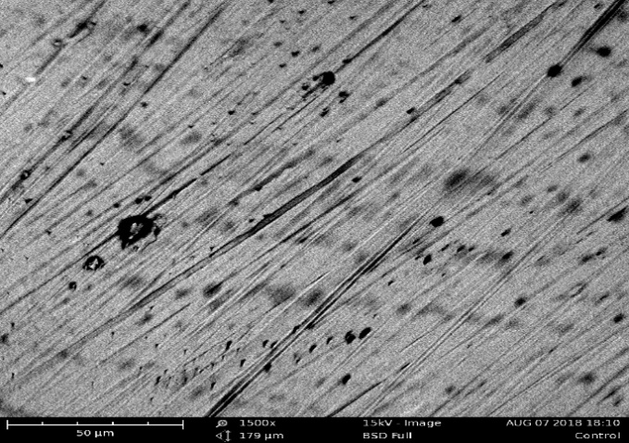

**Fig 3.8a: Copper coupon exposed in 1M HCl,**

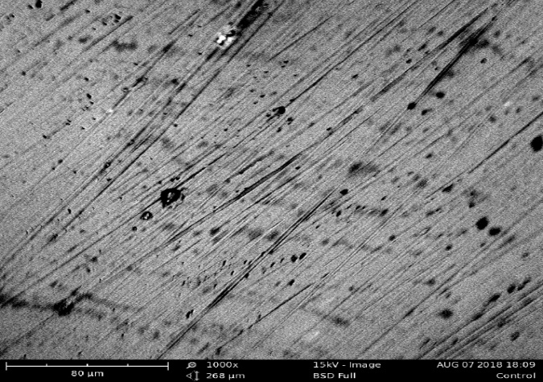

**Fig 3.8b: Copper coupon exposed in 1 M HCl in the presence of 0.5M of TCE at 303 K**

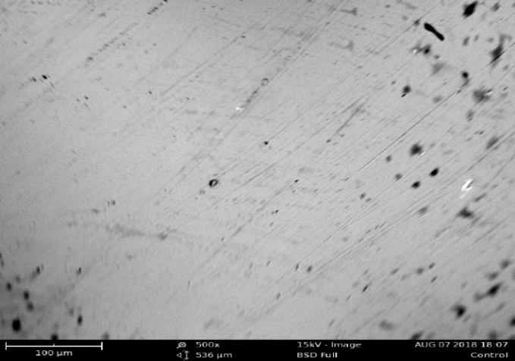

**Fig 3.8c: Unexposed copper coupon**

Figures 3.9 presentSEM micrographs of Aluminum coupon: (a) exposed in 1M HCl, (b) exposed in 1 M HCl in the presence of 0.5M of TCE at 303 K (c) unexposed

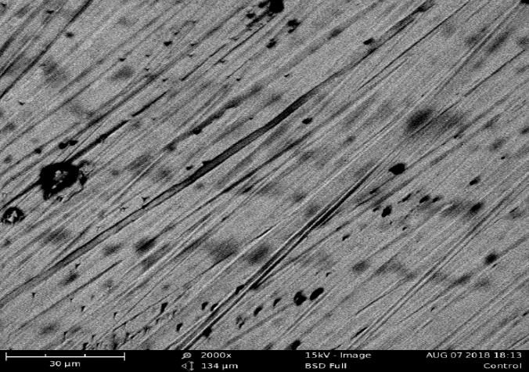

**Fig 3.9a: Aluminum coupon exposed in 1M HCl,**

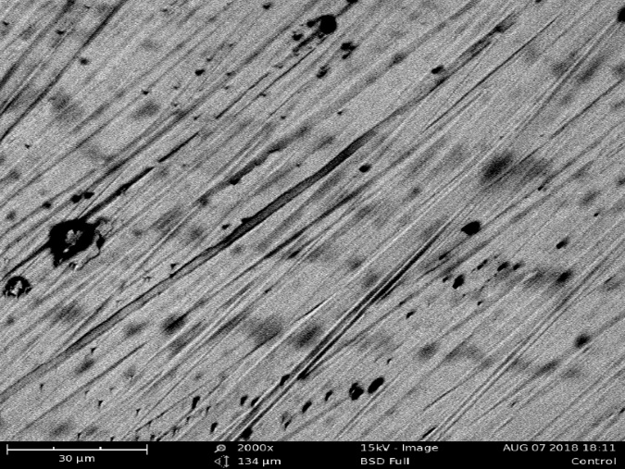

**Fig 3.9b: Aluminum coupon exposed in 1 M HCl in the presence of 0.5M of TCE at 303 K**

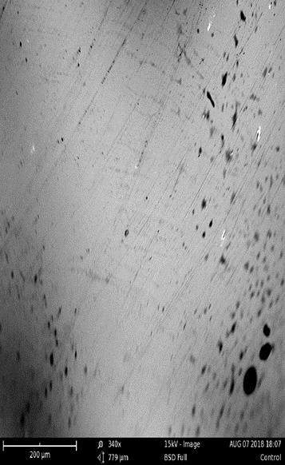

**Fig 3.9c: Unexposed aluminum coupon**

The result of SEM analysis shows that the surface of the copper coupon not immersed in any of the solution was considerably smoother with minimal undulation (fig3.8c) [7,8]. The surface of the coupon immersed in the free acid (fig 3.8a) was severely pitted by acid corrosion while the coupon (fig 3.8b) immersed in the solution containing the highest concentration of inhibitor (0.5g/dm3) possess similar affinities for the active molecules of the inhibitors. In that case, the adsorption of some molecules on a portion of the surface differentially blankets the acid from attacking that portion by steric hindrance or a micelle-like conformation of adsorbed molecules [22]. Same is the case for aluminum coupon.

**4. CONCLUSION**

It can be concluded from this study that;

* The extract used as inhibitor retarded the acid corrosion of copper in 0.5M HCl solution to an appreciable extent (inhibition efficiency of 48.34 percent) as they were being physically adsorbed on the metal surface and 92.24 percent for aluminum.
* TCE is more effective at higher temperatures for aluminum and works better at lower temperatures for copper.
* The adsorption characteristics of almond leaves for Copper conform to Langmuir adsorption isotherm while that of Aluminum conform to Flory Huggins adsorption isotherm.
* The FTIR results show that there are changes in the functional group of the pure extract and that of the film from both aluminum and copper coupons.
* The SEM results for both aluminum and copper show that the inhibitor reduces the corrosion rate of the metals.

This novel knowledge provides more conviction for the utilization and application of this extract as Corrosion Inhibitor for Copper and other metals in various industries.

**FUNDING**

This Research was self-sponsored.

**CONFLICT OF INTEREST STATEMENT**

On behalf of all authors, the corresponding author states that there is no conflict of interest.

**REFERNCES**

[1] Alaneme, K., Daramola, Y., S.J.Olusegun, & Afolabi, A. (2015). Inhibition and adsorption characteristics of Rice husk extract on mild steel immersed in 1M Sulphuric Acid and HCl solutions. *International journal of Electrochemical Science*, 11 (9), 3553-3567.

[2] Al-Baghdadi, S., Noori, F., Ahmed, W., & Al-Amiery, A. (2016). Thiadiazole as a potential corrosion inhibitor for mild steel in 1 MHCl. *J. Adv. Electrochem.*, 3 (6), 67-69.

[3] Dariva, C., & Galio, A. (2014). *Corrosion inhibitors—principles,mechanisms and applications, Dev. Corros. Prot.* Retrieved from http://dx.doi.org/10.5772/57255.

[4] Ebenso, E., Eddy, N. O., & Odiongenyi, A. (2008). Corrosion Inhibitive Properties and Adsorption Behavior of Ethanol Extract of Piper guinenses as a Green Corrosion Inhibitor for Mild Steel in H2SO4. *African Journal of Pure and Applied Chemistry, 2*(11), 107-115.

[5] Emran, M., Aisha, M., Al-Turkustani, & Khadijah., M. (2018). Evaluating the Behavior of Aluminum Corrosion in Hydrochloric Acid in the Presence Aqueous Extract of Olive Seeds. *International Journal of Innovative Research in Science, Engineering and Technology*.,3 (8), 1211- 1267

[6] I.O. Arukalam*, N. I. (2014). Studies on acid corrosion of aluminium by a naturally occurring polymer (Xanthan gum). *International Journal of Scientific & Engineering Research, 5*(3), 663-673.

[7] Ituen, E. E., Akaranta, A. O., & James., A. A. (2017). Electrochemical and anticorrosion properties of5-hydroxytryptophan on mild steel in a simulated well-acidizing fluid. *Journal of Taibah University for Science*, 5 (11), 788–800.

[8] Johnson, A. (2012). *Corrosion inhibition of Aluminum in 0.5 M Sulphuric Acid using Almond leaves., MSc. Thesis, University of Port Harcourt.*

[9] Kairi, N., & Kassim, J. (2013). The effect of temperature on the corrosioninhibition of mild steel in 1 M HCl solution by Curcuma longaextract. *Int. J. Electrochem. Sci., 8*, 7138- 7155.

[10] M. Larouj1, K. O. (2017). Thermodynamic study of corrosion inhibition of carbon steel in acidic solution by new pyrimidothiazine derivative. *Journal of Materials and Environmental Sciences, 8*(11), 3921-3931.

[11] Obot, I., Ebenso, E., & Kabanda, M. (2013). Environmental Chemical Eng. 1.

[12] Oguzie, E. (2007). Corrosion inhibition of aluminium in acidic and alkaline media by Sansevieria trifasciata extract. *Corros. Sci.*(49), 1527-1539.

[13] Omotosho, O., Ajayi, O., Ajanuku, K., & Ifepe, V. (2012). Environment Induced Failure of Mild Steel in 2 M Sulphuric Acid using Chromolaena odorata. *Journal of Material and Environmental Science, 3*(1), 66- 75.

[14] Orie, K., & Christain, M. (2015). The Corrosion inhibition of Aluminum metal in 0.5M sulphuric acid using extract of breadfruit peels. *International Research Journal of Engineering and Technology, 2*(8), 2395-0072.

[15] Paulina Arellanes- Lozada, O. .., Natalya, V., Irina, L., & Ramirez. (2014). Evaluation of Corrosion inhibhihbn ionic effect of *the camer* . Corros. Sci., 2(19), 133- 142

[16] Popova, A., Sokolova, E., Raicheva, S., & ., M. C. (2003). AC and DC study of the temperature effect on mild steel corrosion in acid media in the presence of benzimidazole derivatives,. *Corros. Sci.*, 11 (4), 33-35.

[17] Quraishi, M., Singh, A., Singh, V., & Yadav, D. (2010). *Materials and Chemical Science.* 2(9), 791- 822

[18] Rajeswari, V., Kesavan, D., Gopiraman, M., Viswanathamurthi, P., Poonkuzhali, K., & Palvannan., T. (2014). Corrosion inhibition of Eleusineaegyptiaca and Croton rottleri leaf extracts on cast iron surfacein 1 M HCl medium. *Appl. Surf. Sci.* , 537–545.

[19] Sarker, S., Latif, Z., & Gray, I. (2006). *Natural Product Isolation* (2nd ed.). New Jersey: Humana Press Inc.

[20] Singh, A., & Quraishi, M. (2010). A novel corrosion inhibitor for mild steel corrosion in HCl acid solution. *Journals of Materials and Environmental Sc*

*ience, 1*(2), 101-110.

[21] Verma, E. E. (2016). Adsorption behavior of glucosamine based pyrimidine-fused heterocycles as green corrosion inhibitors for mild steel:experimental and theoretical studies. *J. Phys. Chem. C*, 11598 - 11611.