Original Research Article

Development and Evaluation of Functional Properties, Anti-Nutritional Factors, and Sensory Profile for Complementary Infant Food

Abstract

Background: Adequate nutrition during the first five years of life is critical for optimal physical and cognitive development. In low-resource settings, complementary foods are often nutritionally inadequate, contributing to childhood malnutrition.
Objective: This study aimed to develop and evaluate sorghum–peanut composite flours for use in infant complementary food, focusing on functional properties, anti-nutritional factors, and sensory acceptability.
Methods: Sorghum and peanut seeds were purchased from the local market in Jigjiga, Somali Region, Ethiopia. After cleaning, dehulling, and milling, composite flours were prepared in various blend ratios. Functional properties (water absorption capacity and water absorption index), anti-nutritional components (tannin and phytate contents), and sensory qualities (color, aroma, taste, mouthfeel, and overall acceptability) were analyzed using standard procedures. Statistical analysis was conducted using Design Expert® software version 13.
Results: The water absorption capacity of the composite flours ranged from 128.15% to 133.96%, significantly influenced (P ≤ 0.01) by sorghum–peanut blending ratios. Anti-nutritional factors decreased with increased peanut content. Sensory evaluation indicated improved acceptability at higher peanut inclusion levels, particularly in taste and overall preference.
Conclusion: The incorporation of peanut flour into sorghum significantly improved the functional and sensory qualities while reducing anti-nutritional factors, indicating its potential as a low-cost, nutrient-enriched complementary food for infants in resource-limited communities.

Keywords: Sorghum, Peanut, Complementary Food, Functional Properties, Anti-Nutritional Factors, Sensory Evaluation

Introduction

Proper nutrition plays a critical role in supporting healthy growth and cognitive development in children, especially within their first five years, a pivotal period for achieving developmental potential (Roberts et al., 2022). However, in many developing nations, including Ethiopia, impoverished nursing mothers and caregivers often face challenges in providing adequate nutrition. This is frequently due to financial constraints and limited knowledge on utilizing locally available foods for infant nourishment (Samuel et al., 2021). Consequently, rates of moderate to severe acute malnutrition are high, leading to increased illness, mortality, and hospitalizations among young children (Michaelsen et al., 2009).
Traditional complementary foods commonly used in developing regions are often nutritionally inadequate and may contribute significantly to growth stunting and impaired cognitive development in children (Adesanmi et al., 2020). These complementary foods are typically introduced to infants between 6 months and 2 years of age, as breast milk alone becomes insufficient to meet their increasing nutritional requirements (Taha et al., 2020). Fortified, nutritious, and commercially produced complementary foods are frequently unavailable or unaffordable for low-income families in these regions. This situation highlights an urgent need for affordable, locally sourced, nutrient-dense complementary foods that can address malnutrition while being culturally acceptable and easy to prepare.
Groundnut (Arachis hypogaea L.), commonly known as peanut, is a legume widely cultivated in Ethiopia and rich in essential oils, proteins, amino acids, fatty acids, and micronutrients (Sushma et al., 2021). Peanuts are typically consumed as snacks or used to enrich the protein content and flavor of various dishes (Rossi-Márquez et al., 2021). Sorghum, a drought-tolerant cereal widely grown in the region, is an important energy source but tends to produce porridges with high viscosity and low energy density, which limits its suitability as a complementary food.
Processing methods for complementary foods should aim to enhance nutritional quality by enriching nutrient content and reducing anti-nutritional factors. However, many caregivers, particularly those with low socioeconomic status, lack sufficient knowledge of these aspects, which hampers optimal complementary feeding practices (Oluwajuyitan et al., 2020). Despite the known nutritional benefits of sorghum and peanuts individually, there is limited research on the development and systematic evaluation of composite complementary foods made from these ingredients. In particular, little is known about how different blends affect the functional, anti-nutritional, and sensory properties of such foods, which are critical factors for acceptability and nutritional efficacy. This study addresses this gap by evaluating the functional, anti-nutritional, and sensory properties of sorghum blended with peanuts using a scientifically designed experimental approach. The findings aim to inform the development of affordable, nutrient-rich complementary foods suitable for infants in low-resource settings.

MATERIALS AND METHODS

Raw Materials and sample preparation, Blending Ratio based complementary food

The study used white sorghum grains sourced from the local market in Jigjiga, Somali Region, Ethiopia. Both sorghum and peanuts were purchased locally, with approximately 5 kg of each sample collected. Sorghum flour was prepared following the method developed by Almeida-Dominguez et al. (1993), while peanut flour was prepared according to the method by Arab et al. (2010). A D-optimal mixture design involving seven formulations was employed for the experiment, with sorghum ranging from 70 to 100 g and peanuts from 0 to 30 g in the blend.

Experimental Design and Methodology

This study employed a D-optimal mixture design to systematically evaluate the effects of varying proportions of sorghum and peanut flours on the functional, anti-nutritional, and sensory properties of the complementary food. Seven formulations were generated with sorghum ranging from 70% to 100% and peanut flour from 0% to 30%. The raw materials were cleaned, dehulled, and milled into flour following standardized procedures. Functional properties such as water absorption capacity and water absorption index were measured alongside anti-nutritional factors like tannins and phytates, while sensory evaluation was conducted to assess product acceptability.

Functional Properties

Water absorption capacity

The WAC was determined according to the method described by Akubor (2005). One-gram sample was mixed with 10 mL of distilled water (specific gravity 0.904 kg/m3) and allowed to stand at ambient temperature (31 ± 2 °C) for 30 min and then centrifuged at 3,000 rpm for 30 min using a centrifuge model 800-1D. WAC was determined by the following formula:
$WAC=\frac{Weight of water bound}{Weight of sample (dry basis)}x100\% (1)$

Water absorption index

The Water Absorption Index (WAI) was evaluated according to the method by Anderson et al. (1969). A 3 g portion of each flour sample was suspended in 30 mL of distilled water within a tared 60-mL centrifuge tube. The mixture was stirred with a glass rod for one minute at room temperature (25°C), followed by centrifugation at 3000 × g for 10 minutes. After centrifugation, the supernatant was discarded, and WAI was determined based on the weight of the gel remaining, expressed as grams of gel per gram of dry flour.

$WAI=\frac{weight of sediment (g)}{weight of the sample (g)} (2)$

Determination of ant-nutrient properties of SBP flour

Tannins

Tannin content was measured following the procedure outlined by Maxson and Rooney (1972). About 1.000 g of the sample was accurately weighed and combined with 10 ml of 1% HCl in methanol in a screw-cap test tube. The mixture was then shaken on a mechanical shaker and allowed to sit at room temperature for 24 hours. After this period, the solution was centrifuged at 3000 rpm for 30 minutes. Subsequently, 1 ml of the supernatant was transferred to a new test tube and mixed with 5 ml of vanillin-HCl reagent, prepared by mixing equal parts of 8% HCl in methanol and 4% vanillin in methanol. Catechin standards, prepared in concentrations ranging from 0.5 to 12 mg/100 ml, were used to generate a calibration curve. A standard curve with an R² value of 0.993 was constructed by plotting absorbance against concentration. The slope and intercept of this curve were applied to calculate the condensed tannin content using the following formula:
$$Tannin in mg/100g=\frac{Absorbance-Intercept}{Slope x Density x weight of the sample } (3)$$

Phytate content

The determination of phytate content was carried out using the method described by Vantraub and Lapteva (1988). Approximately 0.5 g of the sample was extracted with 10 ml of 2.4% HCl using a mechanical shaker (Eberbach) for 1 hour at room temperature. The clear supernatant was then used for phytate estimation. To 3 ml of the supernatant, 1 ml of Wade reagent (containing 0.03% FeCl₃·6H₂O and 0.3% sulfosalicylic acid in water) was added. The mixture was vortexed for 5 seconds, and the absorbance was measured at 500 nm using a UV-VIS spectrophotometer (Beckman DU-64, USA). A standard curve was generated by plotting the absorbance against concentration, with the slope and intercept used for the calculation. The sodium salt of phytic acid was used as a standard to construct the calibration curve. The phytate content was then calculated using the following formula:
$$Phytate in mg/100g=\frac{Absorbance-Intercept}{Slope x Density x weight of the sample } (4)$$

Sensory analysis of sorghum blended with peanut flour

The sensory evaluation of the sorghum blended with peanut (SBP) formulated from sorghum and peanut flour was conducted using 10 untrained panelists. The selection and screening of panelists were based on their interest in participating and evaluating the SBP product. Participants were informed in advance about the evaluation process and the purpose of assessing the product's sensory attributes. The evaluation occurred in a quiet room, free from distracting fragrances, and under natural daylight to ensure optimal conditions. Using a five-point hedonic scale, panelists were asked to assess the SBP samples based on appearance, aroma, taste, texture, and overall acceptance. After testing each sample, panelists rinsed their mouths with water between tastings. For each attribute, samples were rated on a five-point hedonic scale (1 = dislike very much; 5 = like very much).

Data analysis

All experimental analyses were conducted in triplicate to ensure the reliability and reproducibility of the results. Statistical analysis and modeling of the results will be carried out using Design Expert® software version 13. The software will be employed to evaluate the significance of the observed differences among treatment groups through appropriate statistical tools, including analysis of variance (ANOVA) and regression analysis, where applicable. A probability value of p ≤ 0.05 will be considered statistically significant, while p ≤ 0.01 will be regarded as highly significant.

- RESULTS AND DISCUSSION

Functional properties of SBP flour

The functional properties, including bulk density, water absorption capacity, and oil absorption capacity, of both the composite flour and each ingredient are outlined in Table 1. The ANOVA (analysis of variance) outcomes are also displayed in Table 1. Models were fitted for each functional property, revealing that the lack-of-fit p-values were not significantly different at the 5% level (P < 0.05). Diagnostic assessments, such as residual normality plots, showed that residuals for all measured responses followed a normal distribution.

Table 1. Functional properties of SBP flour samples
Std | Run | Block | SBP |  | Functional properties
Std | Run | Block | A: | B:
Std | Run | Block | Sorghum  (g) | Peanut (g) | Bulk Density (g/ml) | Water Absorption Capacity (%) | Water Absorption Index (g)
7 | 1 | Block 1 | 70 | 30 | 0.68 | 133.95 | 3.71
3 | 4 | Block 1 | 85 | 15 | 0.62 | 131.17 | 3.68
6 | 3 | Block 1 | 100 | 0 | 0.59 | 128.46 | 3.63
2 | 2 | Block 1 | 70 | 30 | 0.67 | 133.96 | 3.72
5 | 5 | Block 1 | 77.5 | 22.5 | 0.63 | 132.99 | 3.70
1 | 6 | Block 1 | 100 | 0 | 0.60 | 128.15 | 3.62
4 | 7 | Block 1 | 92.5 | 7.5 | 0.61 | 129.97 | 3.65
SBP= Sorghum Blended peanut, A= Sorghum, B= Peanut

Bulk Density

Table 1 shows that sorghum blended with peanut flour has a highly significant effect (P ≤ 0.01) on bulk density. The functional properties of bulk density ranged from 0.59 to 0.68 g/ml. The bulk density observed in this study is lower than the values reported by Alemayehu (2014), who found bulk density values ranging from 0.81 to 0.84 g/ml. As illustrated in Figure 1, the bulk density of SBP flour samples increased with the higher proportions of sorghum and peanut flour. This result is consistent with the findings of Masood, Butt, and Rizwana (2010), who reported an increase in bulk density in composite flour containing soybean protein. Similarly, Jenfa et al. (2024) noted that the bulk density of sorghum-orange‐fleshed sweet potato composite flour increased as the sorghum content increased. High-energy foods typically have low density, while high-density foods tend to have low energy. The lower bulk density in this study may be attributed to the higher protein and fat content in peanut flour compared to sorghum. The low bulk density of these blends is advantageous in the formulation of complementary foods, as noted by Akubor and Ukwuru (2003). The regression model for bulk density is presented in Equation 1, which indicates a quadratic model with two variables.

$$Y={0.67}_{x_{1}}+{0.59}_{x_{2}}-{0.06}_{x_{1}x_{2}}………………………………………………..eq.1$$
Where Y= Bulk density, X₁= Sorghum, X₂=Peanut, X₁X₂=Sorghum and Peanut
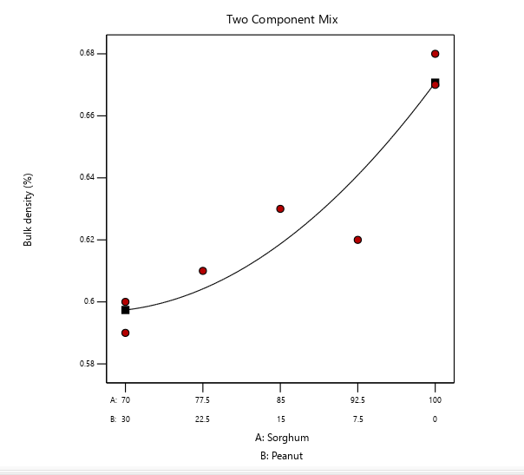

Figure 1. The contour line shows the bulk density while the black points show the treatment formulations of the SBP flour

Figure 1 shows that the bulk density of the two-component mixture increased as the peanut ratio decreased. This trend is consistent with the findings reported by Chen et al. (2023), who observed that the bulk density of complementary foods increases with higher proportions of maize flour, which has a greater bulk density than soybean flour.

Water absorption capacity

Water absorption capacity (WAC) measures the amount of water needed to achieve the right consistency for gruel, making it suitable for feeding infants. It depends on the availability of hydrophilic groups to bind water molecules and the ability of macromolecules to form gels (Onweluzo & Nwabugwu, 2009). WAC also indicates the amount of water available for gelatinization. In the present study, the WAC of the composite flour ranged from 128.15% to 133.96% (Table 1). As shown in Table 2, the results reveal a strong linear significance (P ≤ 0.01) of the mixture proportions of sorghum and peanut on WAC. The highest WAC, 133.96%, was observed with 70 grams of sorghum and 30 grams of peanut flour, while the lowest, 128.15%, was recorded with 100 grams of sorghum and 0 grams of peanut flour. As shown in Figure 2, WAC increases with higher proportions of peanut flour, likely due to the higher protein content in peanuts. Low WAC values are typically associated with mostly intact starch granules, while high values result from protein denaturation, starch gelatinization, and fiber swelling. Damaged or transformed starches exhibit high WAC and can form paste at room temperature through gelatinization (Nwabueze, 2006). The regression model for WAC is presented in Equation 2, which follows a quadratic model with two variables.
$$Y={128.30}_{x_{1}}+{134.01}_{x_{2}}+{0.94}_{x_{1}x_{2}}…………………………………………………..eq.2$$
Where Y= Water absorption capacity, X₁= Sorghum, X₂=Peanut, X₁X₂=Sorghum and Peanut

According to Figure 2, the contour line indicates that water absorption capacity (WAC) increased as the proportion of peanut flour increased. This suggests that peanuts have a high protein content. Proteins possess both hydrophilic and hydrophobic properties, enabling them to interact with water in foods. Additionally, the high-fat content in peanuts can also contribute to an increase in WAC. These findings are consistent with the study by Sobowale et al. (2024), which reported that the WAC of sorghum flour increased when blended with Bambara groundnut flour. Furthermore, the results of the present study indicate that peanuts have higher protein and fat content than sorghum, which may reduce the hydration capacity of sorghum (Olurin et al., 2021).
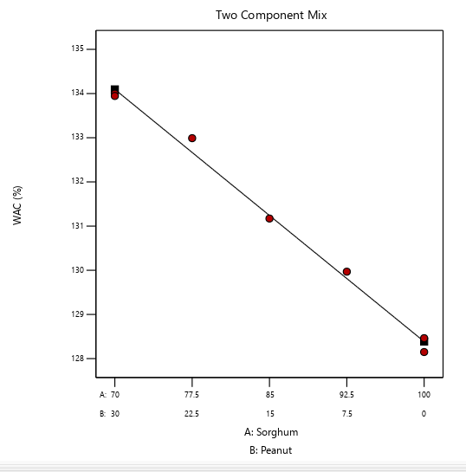
Figure 2. The contour line shows the water absorption capacity, while the black points show the treatment formulations of the SBP flour

Water Absorption Index

As indicated in Table 2, the mixture proportions of sorghum and peanut flour show a strong linear significance (P ≤ 0.01) on the water absorption index (WAI). The WAI measures the volume occupied by a substance after swelling in an excess of water. Table 1 shows that the WAI of the sorghum-peanut blend (SBP) sample flour increases as the proportion of peanut flour increases, enhancing the WAI of sorghum. The highest WAI was observed in run-1 and run-2, which used 70 grams of sorghum and 30 grams of peanuts, respectively. Conversely, the lowest WAI was recorded in run-3 and run-6, with 100 grams of sorghum and no peanut flour.
The WAI results from this study are consistent with previous studies on extruded sorghum and legumes (Pelembe et al., 2002). This increase in WAI may be attributed to the partial gelatinization of starch, which enhances the availability of hydrophilic groups in the food matrix, and to the increased gel-forming capacities of other macromolecules, such as dietary fiber and proteins (Andersson & Hedlund, 1990). Figure 3 illustrates that the WAI increases as the proportion of peanut flour increases. The regression model for WAI, presented in Equation 3, indicates a quadratic relationship with two variables.
$$Y={3.62}_{x_{1}}+{3.72}_{x_{2}}+{0.02}_{x_{1}x_{2}}………………………………………..eq.3$$
Where Y= Water absorption index, X₁= Sorghum, X₂=Peanut, X₁X₂=Sorghum and Peanut
Figure 3. The contour line shows the water absorption index, while the black points show the treatment formulations of the SBP flour
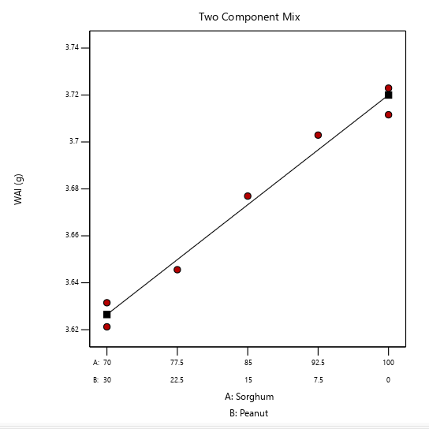

Table 2. The regression coefficient of a quadratic polynomial, R2, and lack of fit for functional properties of SBP flour
Source | Bulk Density (%) | Water Absorption Capacity (%) | Water Absorption Index (g)
Model | 0.93* | 36.71** | 0.01**
Linear mixture | 0.93** | 36.65** | 0.01**
A | 5.39* | 128.30 | 3.62**
B | 6.29* | 134.01 | 3.72**
AB | -0.05 | 0.94 | 0.02
Adj. R² | 0.97 | 0.99 | 0.97
Lack of fit | 0.45 | 0.32 | 0.64
Std. Dev. | 0.07 | 0.20 | 0.01
C.V. % | 1.25 | 0.15 | 0.18
Mean | 5.83 | 131.24 | 3.67
A= Sorghum, B= Peanut, *Significant at P≤ 0.05 level, **Significant at P≤ 0.01

Major anti-nutritional contents

The analysis of anti-nutritional components (tannin and phytate) in the individual ingredients and the composite flour (SBP) samples yielded the results presented in Table 3. At a 5% probability level (P ≤ 0.05), the fitted models for anti-nutritional factors showed that the lack-of-fit p-values were not significantly different, indicating a good model fit. A normality plot of the residuals, used as a diagnostic technique, confirmed that the residuals of all response variables were normally distributed.
Table 3. Major anti-nutritional contents of porridge and ingredients flour samples
Std | Run | Block | SBP |  | Anti-nutritional
Std | Run | Block | A: | B:
Std | Run | Block | Sorghum (g) | Peanut (g) | Phytate (%) | Tannin (%)
7 | 1 | Block 1 | 70 | 30 | 98.84 | 0.20
2 | 2 | Block 1 | 85 | 15 | 122.45 | 0.31
6 | 3 | Block 1 | 100 | 0 | 143.95 | 0.45
3 | 4 | Block 1 | 70 | 30 | 99.79 | 0.21
5 | 5 | Block 1 | 77.5 | 22.5 | 117.03 | 0.30
1 | 6 | Block 1 | 100 | 0 | 146.97 | 0.45
4 | 7 | Block 1 | 92.5 | 7.5 | 129.70 | 0.33
Std= Standard, SBP= Sorghum Blended peanut, A= Sorghum, B= Peanut

Phytate contents

As shown in Table 3, the linear model for sorghum blended with peanut flour demonstrated strong linear significance (P ≤ 0.01). The analysis revealed that the phytate content in the SBP sample flour ranged from 98.84% to 146.03%. These results indicate that the anti-nutritional factors in the SBP sample flour increased as the proportion of peanut flour decreased, suggesting that sorghum has higher levels of anti-nutritional factors compared to peanuts. Thus, increasing the proportion of peanut flour can be a beneficial strategy to reduce phytate levels. The effect of the blending ratio on phytate content is depicted in the mixture contour graph (Figure 4), and the regression model, represented in Equation 4, indicates a quadratic relationship between the two variables.
$$Y={144.36}_{x_{1}}+{100.52}_{x_{2}}+{2.61}_{x_{1}x_{2}}…………………………………………………..eq.4$$
Where Y= Phytate content, X₁= Sorghum, X₂=Peanut, X₁X₂=Sorghum and Peanut
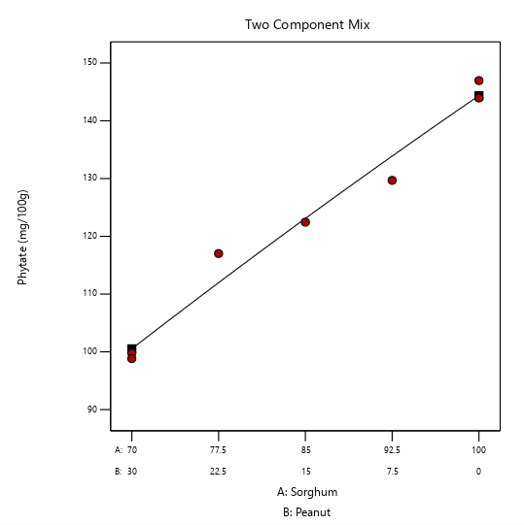
Figure 4. The contour line shows the phytate content while the black points show the treatment formulations of the SBP flour

This study aligns with findings from research conducted by Alemayehu (2014), which reported that the phytate content increased from 95.94 to 115.13 mg/100g as the proportion of sorghum flour in the composite flour increased from 40% to 55%. As illustrated by the curve in Figure 4, the results of this study indicate that the phytate content increased with a higher proportion of sorghum in the blend. The lowest phytate content was observed at a blending ratio of 70:30 grams of sorghum to peanut flour, respectively.

Tannin contents

As indicated in Table 3, the tannin content for sorghum blended with peanut flour exhibited a strong linear relationship (P ≤ 0.01) within the linear model. The data reveal that the tannin level in the SBP sample flour increased as the proportion of peanut flour decreased, implying that sorghum has a naturally higher tannin content than peanuts. Figure 5 illustrates that raising the proportion of peanut flour can effectively help lower the tannin content in the composite flour. The tannin content in the SBP samples ranged from 0.20% to 0.45%, which reflects sorghum’s inherently higher tannin content in comparison to peanuts.
These findings align with prior studies that identified a higher tannin concentration in local red sorghum, ranging from 1.29 mg/100g to 3946.94 mg/100g, compared to the Meko variety. Specifically, tannin levels in Meko sorghum flour were recorded at 1.29 mg/100g, while Shimelis and Rakshit (2005) reported that the Meko variety had tannin levels below the detectable limit in their study aimed at enhancing the energy and nutrient density of sorghum-based complementary foods. The regression model for tannin content, given in Equation 5, is a quadratic model involving two variables.

$$Y={0.44}_{x_{1}}+{0.22}_{x_{2}}-{0.07}_{x_{1}x_{2}}…………………………………………………..eq.5$$
Where Y= Tannin content, X₁= Sorghum, X₂=Peanut, X₁X₂=Sorghum and Peanut

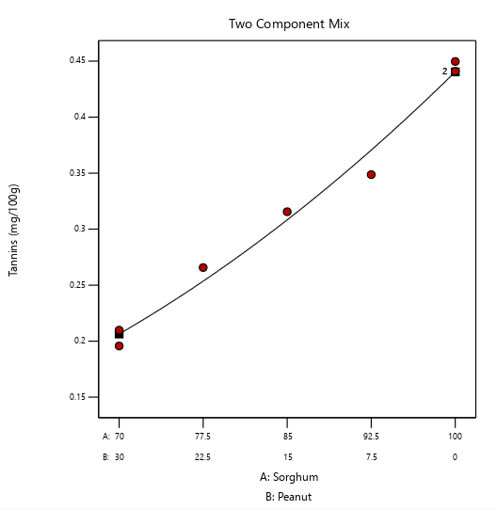

Figure 5. The contour line shows the tannin content, while the black points show the treatment formulations of the SBP flour

Evaluation of the sensory properties of SBP products by untrained panels

The results of the sensory evaluation are presented in Table 4. The average sensory assessments of the SBP product’s color, scent, taste, mouthfeel, and overall acceptability showed that the inclusion of peanut flour significantly influenced the sensory attributes of the product.
The mean scores for sensory characteristics ranged from 3.40 to 4.71 for color, 3.40 to 4.70 for scent, 4.15 to 4.84 for flavor, 4.34 to 4.87 for mouthfeel, and 4.50 to 4.83 for overall acceptability, indicating a general preference for the porridge. Achieving a product that satisfies all five sensory attributes is challenging in most cases; thus, the optimal formulation should aim to maximize consumer satisfaction (Moskowitz, 1994).

Table 4. Sensory mean scores for the SBP sample evaluated by untrained panels
Std | Run | Block | SBP |  | Sensory Properties
Std | Run | Block | A: | B:
Std | Run | Block | Sorghum (g) | Peanut (g) | Color | Aroma | Taste | MF | OA
7 | 1 | Block 1 | 70 | 30 | 4.71ª | 4.70ª | 4.84^{b} | 4.80^{b} | 4.83^{b}
2 | 2 | Block 1 | 85 | 15 | 4.27^{d} | 4.27^{d} | 4.65^{d} | 4.69^{d} | 4.73^{d}
6 | 3 | Block 1 | 100 | 0 | 3.40^{g} | 3.40^{g} | 4.15^{g} | 4.43^{f} | 4.50^{g}
3 | 4 | Block 1 | 70 | 30 | 4.63^{b} | 4.63^{b} | 4.88ª | 4.87ª | 4.86ª
5 | 5 | Block 1 | 77.5 | 22.5 | 4.47^{c} | 4.47^{c} | 4.71^{c} | 4.72^{c} | 4.75^{c}
1 | 6 | Block 1 | 100 | 0 | 3.55^{f} | 3.551^{f} | 4.16^{f} | 4.34^{g} | 4.59^{f}
4 | 7 | Block 1 | 92.5 | 7.5 | 4.20e | 4.20e | 4.57e | 4.46e | 4.70e
Means with the same superscript letters are not significantly different (p<0.05). MF = Mouth feel, OA= Over all acceptability. The values indicated that 1. Dislike Very Much, 2. Dislike, 3. Neither Like or Dislike 4. Like 5. Like Very Much

- Limitations of the study

This study was limited by the scope of functional properties analyzed and the scale of sensory evaluation. Future research should explore additional functional and nutritional parameters and include larger, more diverse consumer panels. Moreover, exploring the shelf-life stability and bioavailability of nutrients in sorghum-peanut blends would provide deeper insights for commercial applications.

- Conclusion

This study comprehensively evaluated the functional, anti-nutritional, and sensory properties of sorghum blended with peanut flour. The results showed a significant impact (P ≤ 0.01) of blending on bulk density and functional properties such as water absorption capacity (WAC) and water absorption index (WAI). The highest WAC and WAI observed in samples with increased peanut flour content suggest improved hydration properties, which are crucial for developing complementary foods with desirable texture and digestibility. Furthermore, the reduction in anti-nutritional factors-tannins, and phytates, with higher peanut flour proportions, enhances the bioavailability of essential minerals and overall nutritional quality of the composite flour, making it more suitable for infant nutrition. Sensory evaluation indicated that peanut flour positively influenced the color, aroma, taste, and mouthfeel, significantly improving overall acceptability. These findings emphasize that sorghum-peanut blends can provide a nutritionally improved, functionally appropriate, and sensory-pleasing complementary food. To strengthen future studies, a detailed presentation of the standard calibration curves and reference standard concentration ranges used for tannin and phytate estimations is recommended, as their omission limits reproducibility and accuracy assessment.

Ethics Approval and Consent to Participate

This study was conducted in accordance with ethical standards and received approval from the Institutional Review Board at the Somali Region Pastoral and Agropastoral Research Institute. All participants provided written informed consent before their inclusion in the study. The research adhered to ethical guidelines to ensure the confidentiality and rights of the participants.

Consent for Publication

All authors have agreed to the submission and publication of this manuscript. We confirm that the manuscript, including any identifiable information, does not violate any confidentiality agreements and that consent for publication has been obtained from all relevant parties.

Availability of Data and Materials

The data generated and analyzed during this study are available from the corresponding author upon reasonable request.

Competing Interests

The authors declare that they have no competing interests.

Disclaimer (Artificial intelligence)

Option 1:

Author(s) hereby declare that NO generative AI technologies such as Large Language Models (ChatGPT, COPILOT, etc.) and text-to-image generators have been used during the writing or editing of this manuscript.

Reference

Abeshu, M. A., Lelisa, A., & Geleta, B. (2016). Complementary Feeding: Review of Recommendations, Feeding Practices, and Adequacy of Homemade Complementary Food Preparations in Developing Countries – Lessons from Ethiopia. Frontiers in Nutrition, 3. https://doi.org/10.3389/fnut.2016.00041
Adesanmi, A. R., Malomo, S. A., & Fagbemi, T. N. (2020). Nutritional quality of formulated complementary diet from defatted almond seed, yellow maize and quality protein maize flours. Food Production, Processing and Nutrition, 2(1). https://doi.org/10.1186/s43014-020-00037-7
Akubor, P. I., & Ukwuru, M. U. (2003). Functional properties and biscuit making potential of soybean and cassava flour blends. Plant Foods for Human Nutrition, 58(3), 1–12. https://doi.org/10.1023/b:qual.0000040344.93438.df
Alemayehu, E. (2014). Complementary food product development from sorghum enriched with chickpea and orange fleshed sweet potato: the case of dawuro zone, south western ethiopia.
https://repository.ju.edu.et/handle/123456789/2292.
Andersson, Y., & Hedlund, B. (1990). Extruded wheat flour: Correlation between processing and product quality parameters. Food Quality and Preference, 2(4), 201–216. https://doi.org/10.1016/0950-3293(90)90012-j
Butt, M. S., & Batool, R. (2010). Nutritional and Functional Properties of Some Promising Legumes Protein Isolates. Pakistan Journal of Nutrition, 9(4), 373–379. https://doi.org/10.3923/pjn.2010.373.379
Chen, P., Chen, N., Zhu, W., Wang, D., Jiang, M., Qu, C., Li, Y., & Zou, Z. (2023). A Heat and Mass Transfer Model of Peanut Convective Drying Based on a Two-Component Structure. Foods, 12(9), 1823. https://doi.org/10.3390/foods12091823
Jenfa, M. D., Adelusi, O. A., Aderinoye, A., Coker, O. J., Martins, I. E., & Obadina, O. A. (2024). Physicochemical compositions, nutritional and functional properties, and color qualities of sorghum–orange‐fleshed sweet potato composite flour. Food Science &amp; Nutrition, 12(4), 2364–2378. Portico. https://doi.org/10.1002/fsn3.3922
Maxson, E. D., & Rooney, L. W. (1972). Two Methods of Tannin Analysis for Sorghum Bicolor (L.)Moenchgrain1. Crop Science, 12(2), 253–254. Portico. https://doi.org/10.2135/cropsci1972.0011183x001200020035x
Michaelsen, K. F., Hoppe, C., Roos, N., Kaestel, P., Stougaard, M., Lauritzen, L., Mølgaard, C., Girma, T., & Friis, H. (2009). Choice of Foods and Ingredients for Moderately Malnourished Children 6 Months to 5 Years of Age. Food and Nutrition Bulletin, 30(3_suppl3), S343–S404. https://doi.org/10.1177/15648265090303s303
Moskowitz, H. R. (1994). Product optimization: approaches and applications. Measurement of Food Preferences, 97–136. https://doi.org/10.1007/978-1-4615-2171-6_5
Nwabueze, T. U. (2006). Gelatinization and viscosity behavior of single-screw extruded african breadfruit (treculia africana) mixtures. Journal of Food Processing and Preservation, 30(6), 717–731. https://doi.org/10.1111/j.1745-4549.2006.00100.x
Olurin, T. O., Abbo, E. S., & Oladiboye, O. F. (2021). Production and evaluation of breakfast meal using blends of sorghum, bambara nut and date palm fruit flour. Agro-Science, 20(3), 30–36. https://doi.org/10.4314/as.v20i3.5
Oluwajuyitan, T. D., Ijarotimi, O. S., & Fagbemi, T. N. (2020). Nutritional, biochemical and organoleptic properties of high protein-fibre functional foods developed from plantain, defatted soybean, rice-bran and oat-bran flour. Nutrition &amp; Food Science, 51(4), 704–724. https://doi.org/10.1108/nfs-06-2020-0225
Onweluzo, J. C., & Nwabugwu, C. C. (2009). Development and Evaluation of Weaning Foods from Pigeon Pea and Millet. Pakistan Journal of Nutrition, 8(6), 725–730. https://doi.org/10.3923/pjn.2009.725.730
Roberts, M., Tolar-Peterson, T., Reynolds, A., Wall, C., Reeder, N., & Rico Mendez, G. (2022). The Effects of Nutritional Interventions on the Cognitive Development of Preschool-Age Children: A Systematic Review. Nutrients, 14(3), 532. https://doi.org/10.3390/nu14030532
Rossi-Márquez, G., Helguera, M., Briones, M., Dávalos-Saucedo, C. A., & Di Pierro, P. (2021). Edible Coating from Enzymatically Reticulated Whey Protein-Pectin to Improve Shelf Life of Roasted Peanuts. Coatings, 11(3), 329. https://doi.org/10.3390/coatings11030329
Samuel, F. O., Akintayo, B., & Eyinla, T. E. (2021). Complementary Feeding Knowledge and Practices of Caregivers in Orphanages Improved after Nutrition Education Intervention in Ibadan, Nigeria. Open Journal of Nursing, 11(07), 642–652. https://doi.org/10.4236/ojn.2021.117054
Shimelis, E. A., & Rakshit, S. K. (2005). Proximate composition and physico-chemical properties of improved dry bean (Phaseolus vulgaris L.) varieties grown in Ethiopia. LWT - Food Science and Technology, 38(4), 331–338. https://doi.org/10.1016/j.lwt.2004.07.002
Sobowale, S. S., Bamidele, O. P., & Adebo, J. A. (2024). Physicochemical, functional, and antinutritional properties of fermented Bambara groundnut and sorghum flours at different times. Food Chemistry Advances, 4, 100729. https://doi.org/10.1016/j.focha.2024.100729
Sushma Tiwari, T. A., M. K. Tripathi, N. G., Ritu Sastya, R. S. S., & Gupta, V. (2021). Assessment for Yield and Nutritional Profiling of Groundnut with the Help of Allele Specific Markers for Desirable Fatty Acids. International Journal of Current Microbiology and Applied Sciences, 10(2), 1625–1637. https://doi.org/10.20546/ijcmas.2021.1002.193
Taha, Z., Garemo, M., & Nanda, J. (2020). Complementary feeding practices among infants and young children in Abu Dhabi, United Arab Emirates. BMC Public Health, 20(1). https://doi.org/10.1186/s12889-020-09393-y

