**Evaluation and Green Synthesis of Titanium Dioxide Nanoparticles (TiO2) NPs using Leaf Extract of *Melia azedarach***

**Abstract**

Emerging industries are greatly impacted by nanoparticles (NPs) and nanotechnologies, which are becoming more and more restricted in their applications across a variety of fields, including mechanical systems and biological sciences. Due to titanium dioxide (TiO2) NPs' exceptional durability, strong electrical conductivity, nontoxicity, capacity to absorb UV radiation, and antibacterial activity, studies have grown interested in the size and form of these particles. The present work was aimed at green synthesis characterisation of (TiO2) Titanium dioxide nanoparticles using *Melia Azedarach* leaf extract. Healthy leaves of *Melia Azedarach* were collected from the Coimbatore district. Tamil Nadu. India. Green synthesis of TiO2 nanoparticles was performed, and the sol-gel process was carried out at low temperatures (usually less than 100 °C) and in the liquid state. Synthesised nanoparticles were characterised by means of SEM (Scanning Electron Microscopy), TEM (Transmission Electron Microscopy), XRD (X-Ray diffraction analysis), UV(Vis spectroscopy), FTIR (Fourier-transform infrared spectroscopy) and EDAX (Energy-dispersive X-ray analysis). XRD research to be conducted to expose the crystalline nature of Titanium dioxide nanoparticles. Transmission Electron Microscopy (TEM) and Scanning Electron Microscopy (SEM) images exposed the shape and size. SEM analysis revealed the small spherical nanoparticles with a size range from 25nm to 87 nm. TEM (Transmission Electron Microscopy) analysis shows the size in the range of 15–45 nm. XRD (X-Ray diffraction analysis) analysis shows that peaks were observed at 25.36, 26.54, 37.05, 37.78, 38.54, 48.12, 54.02, and 55.04° can be assigned to the crystal 101, 110, 04, 103, 2 lines of the anatase and rutile structures of the synthesised titanium dioxide nanoparticles. UV(Vi’s spectroscopy) UV–Vis spectra of the green synthesised TiO2 NPs were recorded using a dual-beam spectrophotometer (Shimadzu UV-2450 PC) in the range of 200–900 nm. EDAX (Energy-dispersive X-ray analysis) Chemical composition and crystalline nature of the green synthesised TiO2 were obtained by the EDAX analysis. Generally, it is known that TiO2 display typical optical absorption peaks 4.3-5.3 KeV due to surface plasmon resonance. The study concluded that green technology through biosynthesis provides excellent insights that can encourage and foster researchers and novices to continue and expand their exploration of nature's potential, as well as the development of efficient and sustainable methods for the synthesis of nanoparticles with desirable properties that are applicable in various fields.

**Keywords:** Titanium dioxide nanoparticles (TiO2)-(NPS), Green synthesis, *Melia Azedarach* and Multiple applications of Physics

**Introduction**

Many academics have been working on creating long-lasting and ecologically friendly nanoparticles during the past few years. Emerging industries are greatly impacted by nanoparticles (NPs) and nanotechnologies, which are becoming more and more restricted in their applications across a variety of fields, including mechanical systems and biological sciences. NPs can be combined utilising numerous techniques like physical, substance or organic, otherwise called green synthesis. Titanium dioxide (TiO₂) semiconductor nanoparticles are one sort of significant and promising photocatalysts in photocatalysis as a result of their extraordinary optical and electronic properties (Ram et al., 2021). Due to titanium dioxide (TiO2) NPs' exceptional durability, strong electrical conductivity, nontoxicity, capacity to absorb UV radiation, and antibacterial activity, studies have grown interested in the size and form of these particles. These qualities also make TiO2 NPs a suitable material for nanostructures. TiO2 NPs can reduce friction and wear through a combination of a rolling effect, a mending effect, a polishing effect, and the formation of a protective film. Their tribological performance is comparable to that of the traditional extreme-pressure and anti-wear additive zinc dialkyl dithiophosphate (ZDDP) (Zheng et al., 2025). Nanoparticles are created by physical, chemical, and biological processes; despite their small size, they have a huge surface area (Prammitha Rajaram *et al*.,2023).

Metal nanoparticles such as Ag, Au, MgO, CuO, Al, TiO2, etc., which are effective against various drug-resistant bacterial, viral and fungal strains, have received attention in recent years (Rai and Bai, 2011). TiO2 nanoparticles are more remarkable nanomaterials due to their photocatalytic properties, chemical stability and non-toxicity. It has huge applications in the cosmetic industry, solar cells, electrochemical devices, pollution control and antibacterial coatings (Amarnath *et al*., 2013). The continuous exploration of TiO2 NPs is driven by the quest to enhance their multifunctionality, aiming to create next-generation products with superior performance (Thakur et al., 2024). In recent years, the synthesis of nanoparticles using a green approach has increased. There are reports on the synthesis of TiO2 nanoparticles using various plant extracts (Nasrollahzadeh and Sajadi, 2015, 2016; Rostami-Vartooni *et al*., 2016; Nasrollahzadeh *et al*., 2016; Maham *et al*., 2017).

The bioactivity of such an herbal plant is mainly due to the occurrence of a high level of limonoid compounds in addition to other phenolic acids and flavonoid glycosides, especially rutin (Dougnon, 2022). On the other hand, *M. azedarach* is native to Africa, Asia and northern Australia and is commonly used as an antiparasitic and antifungal agent with significant free radical scavenging activity (Maciel *et al*., 2006, Farag *et al*., 2011). The leaves of *M. azedarach* L. contain significant amounts of nimbolinin-type limonoids that have various therapeutic effects, including antimicrobial, antioxidant, and anticancer potential (Kanwal *et al*., 2011).

There are many methods for the synthesis of TiO2 NPs, such as batch and semi-batch two-step mixing method or microemulsion method. But the sol-gel method is the simplest and most effective bottom-up approach. The word sol-gel is made up of two words, sol and gel. The word sol means a colloidal solution formed in a continuous liquid, while the word gel means a solid molecule dispersed in a liquid. The chemical solution is treated as a catalyst. Gelation is a process in which a sol or a solution transforms into a gel, and the continuity of solid structure gives the gel elasticity. Sols are thermodynamically unstable, due to their large surface area to volume ratio. However, they can be stabilised by introducing an energy barrier on the solid particles present in the sol (Ullattil & Periyat, 2017). There are many titanium precursors, including TiCl3, Ti (OCH(CH3)2)4 (TTIP), TiCl4, and Ti (OBu) (Ramesh, 2013). TiO2 NPs help result in cytotoxicity to the tumour cells, which allows you to assist in reducing the cancerous activities among all patients of all age groups (Zhangjian Chen *et al*.,2020).

**2. Experimental**

**2.1. Materials**

Healthy leaves of *Melia Azedarach* were collected from the Coimbatore district. Tamil Nadu. India. For antimicrobial activity, bacterial pathogens, viz. *E. coli*, *Klebsiella pneumoniae*, *Bacillus subtilis*, *Staphylococcus aureus* and *Salmonella typhi* were obtained from PSG-Postgraduate Institute of Medical Education and Research (PSG-PGIMER), Coimbatore district. Tamil Nadu. India.

**2.2. Preparation of *Melia Azedarach*** **leaf broth**

Briefly, 20 g of finely chopped fresh leaves of *Melia Azedarach* were thoroughly washed with distilled water and then boiled in 100 mL of sterile doubly distilled water for 30 min in a water bath (Fig.1.). The resulting extract was then filtered to remove particles and stored at 4°C for further use.

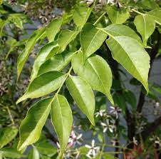 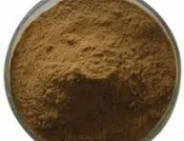

**a**

**b**

**Fig. 1. *Melia azedarach* leaves (a) and *Melia azedarach* powder (b)**

**2.3. Green synthesis of TiO2 nanoparticles**

Green synthesis of TiO2 nanoparticles was performed as previously described by Krishnasamy *et al*. (2015) with modifications. Briefly, 10 mL of *Melia Azedarach* leaf broth was added to 90 mL of 5 mM aqueous titanium dioxide for nanoparticle synthesis. The titanium dioxide nanoparticles were purified by repeated centrifugation at 7826 x g for 20 min using doubly distilled water and the pellet was dispersed in deionised water. Finally, heat treatment was performed at 60 °C for 1 h and stored for further use. A stock solution was prepared by suspending the nanoparticles in methanol to give a final concentration. 10 mg/ml. The stock solution was sonicated for 15 min, and each assay was performed within 1–2 h after sonication. The suspension was kept at 4°C.

**2.4. Sol-Gel Process**

The sol-gel process is carried out at low temperatures (usually less than 100 °C) and in the liquid state. The final product is, of course, a solid, and these solids are formed as a result of a polymerisation process that involves the formation of M-OH-M or M-O-M (where M represents a metal atom) between the metal atoms in the raw materials. The synthesis of aerogels using the sol-gel process consists of two steps, which are as follows (Wang *et al*., 2018, Zhang *et al*., 2016, Chen *et al*., 2021 and Ji *et al*., 2020): (I). The first stage involves the formation of individual colloidal solid particles with dimensions of nanometers. (II). The second stage involves the association of colloidal particles in a solvent to form a gel.

**2.5. Sol-gel route**

All reagents used were of analytical grade, and no further purification was performed before use. The sol-gel synthesised TiO2 was obtained from titanium isopropoxide (TTIP) was dissolved in absolute ethanol, and distilled water was added to the solution in a molar ratio of Ti:H20=1:4. Nitric acid was used to adjust the pH and to limit the hydrolysis process of the solution. The solution was stirred vigorously for 30 min to form the salts. After ageing for 24 hours, the sols were transformed into gels. In order to obtain nanoparticles, the gels were dried at 120 °C for 2 h to maximally evaporate water and organic material. After that, the dry gel was sintered at 450 °C for 2 h, and then the desired nanocrystalline TiO2 was obtained.

**2.6. Characterisation of green-synthesised TiO2-NPs**

**2.6.1. UV–Visible spectroscopy**

UV-vis spectroscopy is based on the adsorption mechanism of spectroscopy. The principle of UV-visible spectroscopy relies on the interception of ultraviolet or visible light by chemical compounds that produce distinct spectra. This mechanism operates under the UV-visible spectrum at a wavelength of 200–800 nm. Different metal nanoparticles operate at different wavelengths, ranging from 2 to 100 nm. A wavelength of 250–400 nm is commonly used to characterise nanoparticles. A graph is made between absorbance and wavelength to see the UV-vis spectrum of the synthesised nanoparticles.

**2.6.2. X-ray diffraction analysis (XRD)**

X-ray diffraction analysis of TiO2 nanoparticles was performed using a Smart Lab 9 kW rotating anode X-ray diffractometer (Rigaku Corporation) at diffraction angles (29) from 200 to 800 (scan range) at a scan rate of 20/min.

**2.6.3. Scanning Electron Microscopy (SEM)**

The morphology and size and synthesised TiO2 nanoparticles were analysed by a field emission scanning electron microscope (NOVA NANOSEM 450, FEI, USA).

**2.6.4. Energy-dispersive X-ray analysis (EDAX)**

Energy-dispersive X-ray analysis was used to obtain the composition and elemental analysis of the nanoparticles. The EDAX detector was attached to the SEM instrument.

**2.6.5. Fourier-transform infrared spectroscopy (FTIR)**

The FTIR spectroscopy study of the synthesised nanoparticles was carried out using a Cary 630 FTIR (Agilent Technologies, India) in the spectral range from 4000 to 400 cm-1.

**2.6.6. Transmission electron microscopy (TEM)**

Transmission electron microscopy (FP 5022/22-Tecnai G2 20 S-TWIN, FEI, USA) was performed to characterise the size and shape of TiO2 nanoparticles.

**2.6.7. Statistical analysis**

All experiments were performed in triplicate, and mean and standard error were determined using GraphPad Prism 5.0.

**3. Results and discussion**

**3.1. Green synthesised TiO2-NPs and its UV–vis characterisation**

The addition of *M. azedarach* aqueous extract to the TiO2-NPssolution creates a change in the colour of the reaction mixture from yellow to brown (Fig.2). Such a change in colour occurred because of the active molecules present in the *M. azedarach* aqueous extract of the TiO2-NPs. Moreover, it has been established that TiO2-NPsshow strong surface plasmon resonance (SPR) properties, a consequence of the collective oscillations of free electrons on the metallic particle surface. These oscillations are defined by the particle size, which therefore determines the specific wavelength range of the absorption in the visible spectrum. Indeed, the UV-visible spectrum confirmed the formation of TiO2-NPsby showing a typical silver surface plasmon resonance at a wavelength of about 400nm (Fig.2). The presence of a single surface plasmon resonance peak in the absorption spectrum of the formed TiO2-NPsgives evidence of their spherical shape. Similarly, many other reports confirmed that the resonance peak of TiO2-NPscolloidal solutions appears in this region. UV–Vis spectra of the green synthesised TiO2 NPs were recorded using a dual-beam spectrophotometer (Shimadzu UV-2450 PC) in the range of 200–900 nm. Shows the absorption spectrum of the aqueous extract of *Melia Azedarach* leaves and the synthesised TiO2 NPs. The absorption maximum at 317.6 nm supports the formation of TiO2 NPs (Zangeneh,2019). UV-Vis spectroscopy is used to study the absorption spectra of TiO2 NPs that are produced using *Trema Orientalis* leaf extract. An estimated absorption band was found close to 351 nm. Using the following Kubelka-Munk equation, we were able to determine the optical bandgap of the produced TiO2 NPs by using the Tauc relation. The absorbance, A, d, and photon energy are represented in the Tauc equations (Equation 1) as α, eV, and d, respectively, representing the thickness of the sample and the UV light travelling through it (Norouzzadeh *et al*.,2020).

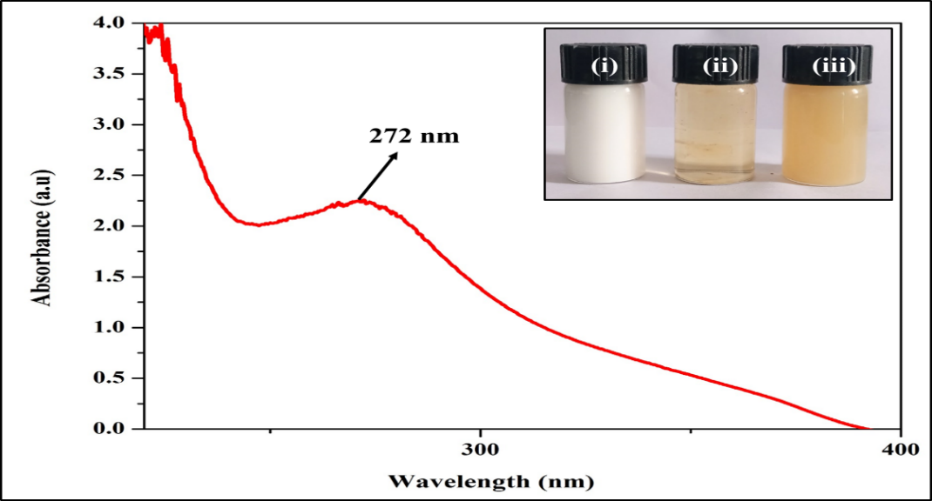

**Fig 2. UV-Visible spectrum and Chromatic variation of TiONPs after adding extract with 2mM of titanium solution (i) Extract, (ii) titanium and (iii) TiO2NPs**

**3.2. SEM and Energy-dispersive X-ray analysis (EDAX)**

The SEM surface morphology and size of the TiO2 nanoparticles were investigated by scanning electron microscopy (SEM), which revealed that the TiO2 nanoparticles were spherical and ranged in size from 0.5µm to 1µm (Fig. 3a, b) (Muthukrishnan *et al*.,2019). Chemical composition and crystalline nature of the green synthesised TiO2 were obtained by the EDAX analysis. Generally, it is known that TiO2 display typical optical absorption peaks 4.3-5.3 KeV due to surface plasmon resonance (Fig.3. c) (Muthukrishnan *et al*.,2019). Using the SEM image, the surface morphology of the produced TiO2 was examined an uneven particle structure was detected in the produced TiO2 nanoparticles. The formation of aggregate nanoparticles after the nanoparticles were uniformly distributed throughout the surface showed that the powder particles are very slightly agglomerated (Purkait *et al*.,2020).

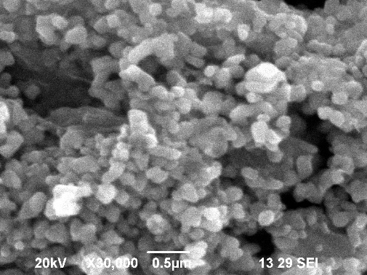 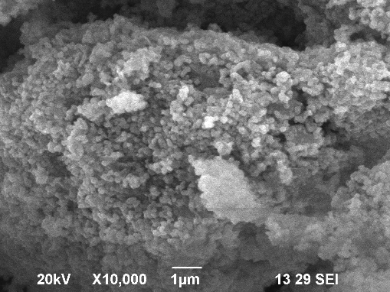

**a**

**b**

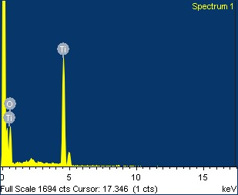

**c**

**Fig.3. (a) The SEM images of green synthesized TiO2-NPs at X30,000 (b) at X10,000, and (c) EDX images for TiO2-NPs**

**Table 1. EDAX elemental analysis of green-synthesised TiO2**

|  |  |  |  |
| --- | --- | --- | --- |
| **S.No** | **Element** | **Mass (%)** | **Atom (%)** |
| 1. | Ti | 59.25 | 31.96 |
| 2. | O | 36.08 | 57.99 |
| 3. | C | 4.67 | 10.05 |
|  | Total | 100.00 |  |

**3.3. XRD**

The XRD patterns of green synthesised TiO2 nanoparticles were observed at Scan Axis Gonio Start Position [°2Th.]10.0231 End Position [°2Th.]80.9231 Step Size [°2Th.] 0.0500 Scan Step Time [s10.7950 Scan Type Continuous PSD Mode Scanning PSD Length [°2Th.] 2.12Offset [°2Th.] 0.0000 Divergence Slit Type Fixed Divergence Slit Size[°] 0.4785 Specimen Length[mm]10.00 Measurement Temperature [°C] 25.00Anode Material CuK-Alpha1 [Å]1.54060K-Alpha2 [Å]1.54443K-Beta[Å]1.39225K-A2 / K-A1 Ratio0.50000Generator Settings 30 mA, 40 kV Diffractometer Type 0000000011024644 Diffractometer Number-0Gonio meter Radius [mm]240.00 Dist. Focus-Diverg. Slit [mm] 91.00(Fig. 4). These results were confirmed using Joint Committee on Energy Diffraction Standards (JCPDS) The average crystalline size of the synthesized nanoparticles was 41.9 nm calculated using the Scherrer equation (D = Kλ/βcosθ). λ is the X-ray wavelength (CuKα = 0.15406 nm), K is a constant taken as 0.89, β is the line width at half maximum (FWHM) of the peak, and θ is the diffraction angle. The average crystalline size of the synthesised nanoparticles is 15–45 nm, calculated according to the Scherrer formula based on the XRD pattern (Patterson, 1939). XRD was used to examine the crystalline nature of the produced TiO2 NPs. The XRD plot revealed major peaks that corresponded to the (101), (112), (211), and (301) planes of TiO2 with 2θ values of 25.360, 36.200, 37.200, 54.240, 56.610, and 69.530. The anatase phase is represented by the lattice parameters found for TiO2 NPs (JCPDS file no. 84-1285) (Hudlikar *et al*.,2012).



**Fig.4. XRD patterns of green synthesised TiO2-NPs using *M. azedarach* leaf extract**

**Table 2. XRD patterns of green synthesised TiO2-NPs using *M. azedarach* leaf extract**

|  |  |  |  |  |
| --- | --- | --- | --- | --- |
| Pos. [°2Th.] | Height [cts] | FWHM Left [°2Th.] | d-spacing [Å] | Rel. Int. [%] |
| 14.2051 | 88.83 | 0.1476 | 6.23505 | 85.43 |
| 19.9824 | 24.71 | 0.2952 | 4.44352 | 23.77 |
| 32.0700 | 103.99 | 0.1968 | 2.79098 | 100.00 |
| 42.4555 | 20.67 | 0.2952 | 2.12921 | 19.88 |
| 47.8083 | 22.13 | 0.2952 | 1.90257 | 21.28 |

**3.4. FTIR**

The FTIR spectrum of the biosynthesised titanium dioxide nanoparticles showed peaks at 3443.96, 2025.46 cm-1, 1633.37 cm-1, 1383.94 cm-1,1270.75 cm-1,1102.04 cm-1 and 665.79cm-1 (Fig. 5). The peak at 3581.96 corresponds to O–H stretching of alcohols and phenolic compounds, the peak at 1166.92 is attributed to C=C groups of aromatic rings. The peak at 1102.04 indicates the C=O vibration of the carboxylic acid and the peak at 665.79 corresponds to the Ti–O–Ti stretching vibration of the titanium dioxide nanoparticles. The presence of the C-O stretch of the ester group, which is classified as hydrolyzable tannic acid present in M. azedarach leaf extract and is the main biomolecule responsible for the formation and stabilisation ofTiO2-NPs. Similar observations were also reported by Vasconcelos *et al*. (2011) and Yilmaz *et al*. (2011).



**Fig. 5. FT-IR spectrum of green synthesised TiO2-NPs using *Melia azedarach* leaf extract**

**3.5. TEM**

TEM studies showed that the nanoparticles have a spherical shape with a smooth surface and a size in the range of 10–20 nm, which is in close agreement with the size estimated by the Scherrer formula based on the XRD pattern (Fig. 6) (Dougnon,2022).

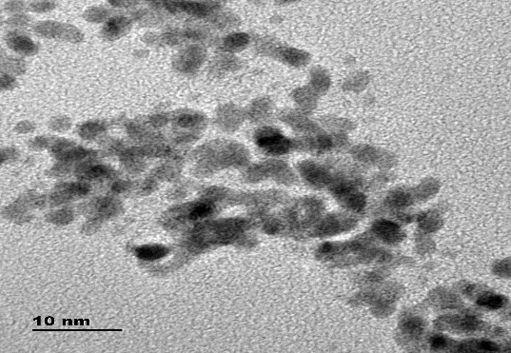 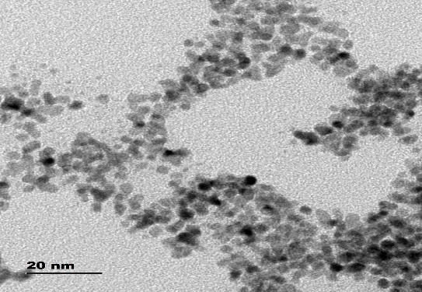

**a**

**b**

**Fig. 6. The TEM images of green synthesized TiO2-NPs using *M. azedarach* leaf extract at a)10nm and b)20nm scale**

**4. Conclusion**

The green synthesis of titanium dioxide nanoparticles was achieved due to the presence of terpenoids, flavonoids and proteins in *Melia azedarach,* as these bioactive compounds were responsible for the synthesis of these nanoparticles. Synthesis using a green approach is a simple, cheap and environmentally friendly process that reduces the use of toxic chemicals. The interest in green synthesis is due to its advantages of being harmless to the environment. Different plant parts are used for synthesis purposes, and their characterisation using different techniques helps to generate TiO2 NPs of different shapes and sizes. To summarize, green technology through biosynthesis, as discussed in the paper, provides excellent insights that can encourage foster researchers and novices to continue and expand their exploration of nature's potential, as well as the development of efficient and sustainable methods for the synthesis of nanoparticles with desirable properties, that are applicable in various fields.

Disclaimer (Artificial intelligence)

Option 1:

Author(s) hereby declare that NO generative AI technologies such as Large Language Models (ChatGPT, COPILOT, etc.) and text-to-image generators have been used during the writing or editing of this manuscript.

Option 2:

Author(s) hereby declare that generative AI technologies such as Large Language Models, etc. have been used during the writing or editing of manuscripts. This explanation will include the name, version, model, and source of the generative AI technology and as well as all input prompts provided to the generative AI technology

Details of the AI usage are given below:

1.

2.

3.

**Reference:**

1.Rai, R.V., Bai, J.A., 2011. Nanoparticles and their potential application as antimicrobials. Science against microbial pathogens: communicating current research and technological advances. Microbiology Series 3. Formatex, Spain, pp. 197–209.

<https://pdfssemanticscholar.org/1d44/3a4aa4a23dc545ea09c2f12fe77b603f4f6d.pdf>.

2. Amarnath, C.A., Nanda, S.S., Papaefthymiou, G.C., Yi, D.K., Paik, U., 2013. Nanohybridization of low-dimensional nanomaterials: synthesis, classification and application. Critic. Rev. Solid State Mater. Sci. 38, 1–56.

5. Kumar, R., Ghoshal, G., Jain, A., Goyal, M., 2017. Rapid green synthesis of silver nanoparticles (AgNPs) using (Prunus persica) plants extract: exploring its antimicrobial and catalytic activities. J. Nanomed. Nanotechnol. 8, 1–8.

6. Nasrollahzadeh, M., Sajadi, S.M., 2015. Synthesis and characterization of titanium dioxide nanoparticles using Euphorbia heteradena Jaub root extract and evaluation of their stability. Ceram. Int. 41, 14435–14439.

7.Nasrollahzadeh, M., Sajadi, S.M., 2016. Green synthesis, characterization and catalytic activity of the Pd/TiO2 nanoparticles for the ligand-free Suzuki–Miyaura coupling reaction. J. Colloid Interface Sci. 465, 121–127.

8.Nasrollahzadeh, M., Atarod, M., Jaleh, B., Gandomirouzbahani, M., 2016. In situ green synthesis of Ag nanoparticles on graphene oxide/TiO2 nanocomposite and their catalytic activity for the reduction of 4-nitrophenol, congo red and methylene blue. Ceram. Int. 42, 8587–8596.

9. Rostami-Vartooni, A., Nasrollahzadeh, M., Salavati-Niasari, M., Atarod, M., 2016. Photocatalytic degradation of azo dyes by titanium dioxide supported silver nanoparticles prepared by a green method using Carpobrotus acinaciformis extract. J. Alloys Compd. 689, 15–20.

10. Maham, M., Nasrollahzadeh, M., Bagherzadeh, M., Akbari, R., 2017. Green synthesis of palladium/titanium dioxide nanoparticles and their application for the reduction of methyl orange, congo red and rhodamine B in aqueous medium. Combinat. Chem. High Throughput Screen. 20, 787–795.

11. Dougnon G, Ito M. (2022) Essential oils from Melia azedarach L. (Meliaceae) leaves: chemical variability upon environmental factors. J Nat Med 76: 331–341. https://doi.org/10.1007/s11418-021-01579-x PMID: 34664195.

12. Maciel M, Morais SM, Bevilaqua C, Camurc¸a-Vasconcelos A, Costa C, et al. (2006) Ovicidal and larvicidal activity of Melia azedarach extracts on Haemonchus contortus. Veterinary parasitology 140: 98– 104. https://doi.org/10.1016/j.vetpar.2006.03.007 PMID: 16621294.

13. Farag M, Ahmed MH, Yousef H, Abdel-Rahman A-H. (2011) Repellent and insecticidal activities of Melia azedarach L. against cotton leafworm, Spodoptera littoralis (Boisd.). Zeitschrift fu¨r Naturforschung C 66: 129–135. https://doi.org/10.1515/znc-2011-3-406 PMID: 21630586.

14. Kanwal Q, Ishtiaq H, Siddiqu H, Javaid A. (2011) Antimicrobial activity screening of isolated flavonoids from Azadirachta indica leaves. Journal of the Serbian Chemical Society 76.

15.Allahverdiyev, A.M.; Abamor, E.S.; Bagirova, M.; Rafailovich, M. Antimicrobial effects of TiO2 and Ag2O nanoparticles against drug-resistant bacteria and leishmania parasites. *Futur. Microbiol.* 2011, *6*, 933–940. [[Google Scholar](https://scholar.google.com/scholar_lookup?title=Antimicrobial+effects+of+TiO2+and+Ag2O+nanoparticles+against+drug-resistant+bacteria+and+leishmania+parasites&author=Allahverdiyev,+A.M.&author=Abamor,+E.S.&author=Bagirova,+M.&author=Rafailovich,+M.&publication_year=2011&journal=Futur.+Microbiol.&volume=6&pages=933%E2%80%93940&doi=10.2217/fmb.11.78)] [[CrossRef](https://doi.org/10.2217/fmb.11.78" \t "_blank)]

16.Portela, R.; Hernández-Alonso, M.D. Environmental Applications of Photocatalysis. In *Design of Advanced Photocatalytic Materials for Energy and Environmental Applications*; Springer: London, UK, 2013; pp. 35–66. [[Google Scholar](https://scholar.google.com/scholar_lookup?title=Environmental+Applications+of+Photocatalysis&author=Portela,+R.&author=Hern%C3%A1ndez-Alonso,+M.D.&publication_year=2013&pages=35%E2%80%9366)] [[CrossRef](https://doi.org/10.1007/978-1-4471-5061-9_3" \t "_blank)]

17.Subhapriya, S.; Gomathipriya, P. Green synthesis of titanium dioxide (TiO2) nanoparticles by Trigonella foenum-graecum extract and its antimicrobial properties. *Microb. Pathog.* 2018, *116*, 215–220. [[Google Scholar](https://scholar.google.com/scholar_lookup?title=Green+synthesis+of+titanium+dioxide+(TiO2)+nanoparticles+by+Trigonella+foenum-graecum+extract+and+its+antimicrobial+properties&author=Subhapriya,+S.&author=Gomathipriya,+P.&publication_year=2018&journal=Microb.+Pathog.&volume=116&pages=215%E2%80%93220&doi=10.1016/j.micpath.2018.01.027)] [[CrossRef](https://doi.org/10.1016/j.micpath.2018.01.027" \t "_blank)]

18.Ismael, M.; Wark, M. Photocatalytic activity of CoFe2O4/g-C3N4 nanocomposite toward degradation of different organic pollutants and their inactivity toward hydrogen production: The role of the conduction band position. *FlatChem* 2022, *32*, 100337. [[Google Scholar](https://scholar.google.com/scholar_lookup?title=Photocatalytic+activity+of+CoFe2O4/g-C3N4+nanocomposite+toward+degradation+of+different+organic+pollutants+and+their+inactivity+toward+hydrogen+production:+The+role+of+the+conduction+band+position&author=Ismael,+M.&author=Wark,+M.&publication_year=2022&journal=FlatChem&volume=32&pages=100337&doi=10.1016/j.flatc.2022.100337)] [[CrossRef](https://doi.org/10.1016/j.flatc.2022.100337" \t "_blank)]

19.Kashale, A.A.; Gattu, K.; Ghule, K.; Ingole, V.H.; Dhanayat, S.; Sharma, R.; Chang, J.-Y.; Ghule, A.V. Biomediated green synthesis of TiO2 nanoparticles for lithium ion battery application. *Compos. Part B Eng.* 2016, *99*, 297–304. [[Google Scholar](https://scholar.google.com/scholar_lookup?title=Biomediated+green+synthesis+of+TiO2+nanoparticles+for+lithium+ion+battery+application&author=Kashale,+A.A.&author=Gattu,+K.&author=Ghule,+K.&author=Ingole,+V.H.&author=Dhanayat,+S.&author=Sharma,+R.&author=Chang,+J.-Y.&author=Ghule,+A.V.&publication_year=2016&journal=Compos.+Part+B+Eng.&volume=99&pages=297%E2%80%93304&doi=10.1016/j.compositesb.2016.06.015)] [[CrossRef](https://doi.org/10.1016/j.compositesb.2016.06.015" \t "_blank)]

20.Zahir, A.A. Synthesis of Nanoparticles Using Euphorbia prostrata Extract Reveals a Shift from Apoptosis to G0/G1 Arrest in Leishmania donovani. *J. Nanomed. Nanotechnol.* 2014, *5*, 1–12. [[Google Scholar](https://scholar.google.com/scholar_lookup?title=Synthesis+of+Nanoparticles+Using+Euphorbia+prostrata+Extract+Reveals+a+Shift+from+Apoptosis+to+G0/G1+Arrest+in+Leishmania+donovani&author=Zahir,+A.A.&publication_year=2014&journal=J.+Nanomed.+Nanotechnol.&volume=5&pages=1%E2%80%9312&doi=10.4172/2157-7439.1000213)] [[CrossRef](https://doi.org/10.4172/2157-7439.1000213" \t "_blank)][[Green Version](https://www.omicsonline.org/open-access/synthesis-of-nanoparticles-using-euphorbia-prostrata-extract-reveals-a-shift-from-apoptosis-to-gg-arrest-in-leishmania-donovani-2157-7439.1000213.pdf)]

21.Allahverdiyev, A.M.; Abamor, E.S.; Bagirova, M.; Rafailovich, M. Antimicrobial effects of TiO2 and Ag2O nanoparticles against drug-resistant bacteria and leishmania parasites. *Futur. Microbiol.* 2011, *6*, 933–940. [[Google Scholar](https://scholar.google.com/scholar_lookup?title=Antimicrobial+effects+of+TiO2+and+Ag2O+nanoparticles+against+drug-resistant+bacteria+and+leishmania+parasites&author=Allahverdiyev,+A.M.&author=Abamor,+E.S.&author=Bagirova,+M.&author=Rafailovich,+M.&publication_year=2011&journal=Futur.+Microbiol.&volume=6&pages=933%E2%80%93940&doi=10.2217/fmb.11.78)] [[CrossRef](https://doi.org/10.2217/fmb.11.78" \t "_blank)]

22.Portela, R.; Hernández-Alonso, M.D. Environmental Applications of Photocatalysis. In *Design of Advanced Photocatalytic Materials for Energy and Environmental Applications*; Springer: London, UK, 2013; pp. 35–66. [[Google Scholar](https://scholar.google.com/scholar_lookup?title=Environmental+Applications+of+Photocatalysis&author=Portela,+R.&author=Hern%C3%A1ndez-Alonso,+M.D.&publication_year=2013&pages=35%E2%80%9366)] [[CrossRef](https://doi.org/10.1007/978-1-4471-5061-9_3" \t "_blank)]

23.Belver, C.; Bedia, J.; Gómez-Avilés, A.; Peñas-Garzón, M.; Rodriguez, J.J. Semiconductor Photocatalysis for Water Purification. In *Nanoscale Materials in Water Purification*; Elsevier: Hoboken, NJ, USA, 2019; Volume 108, pp. 581–651. [[Google Scholar](https://scholar.google.com/scholar_lookup?title=Semiconductor+Photocatalysis+for+Water+Purification&author=Belver,+C.&author=Bedia,+J.&author=G%C3%B3mez-Avil%C3%A9s,+A.&author=Pe%C3%B1as-Garz%C3%B3n,+M.&author=Rodriguez,+J.J.&publication_year=2019&pages=581%E2%80%93651)] [[CrossRef](https://doi.org/10.1016/b978-0-12-813926-4.00028-8" \t "_blank)]

24.Valentín, L.; Nousiainen, A.; Mikkonen, A. Introduction to Organic Contaminants in Soil: Concepts and Risks. In *Emerging Organic Contaminants in Sludges*; Springer: Berlin/Heidelberg, Germany, 2013; Volume 24, pp. 1–29. [[Google Scholar](https://scholar.google.com/scholar_lookup?title=Introduction+to+Organic+Contaminants+in+Soil:+Concepts+and+Risks&author=Valent%C3%ADn,+L.&author=Nousiainen,+A.&author=Mikkonen,+A.&publication_year=2013&pages=1%E2%80%9329)] [[CrossRef](https://doi.org/10.1007/698_2012_208" \t "_blank)]

25.Kim, J.K.; Jang, J.-R.; Choi, N.; Hong, D.; Nam, C.-H.; Yoo, P.J.; Park, J.H.; Choe, W.-S. Lysozyme-mediated biomineralization of titanium–tungsten oxide hybrid nanoparticles with high photocatalytic activity. *Chem. Commun.* 2014, *50*, 12392–12395. [[Google Scholar](https://scholar.google.com/scholar_lookup?title=Lysozyme-mediated+biomineralization+of+titanium%E2%80%93tungsten+oxide+hybrid+nanoparticles+with+high+photocatalytic+activity&author=Kim,+J.K.&author=Jang,+J.-R.&author=Choi,+N.&author=Hong,+D.&author=Nam,+C.-H.&author=Yoo,+P.J.&author=Park,+J.H.&author=Choe,+W.-S.&publication_year=2014&journal=Chem.+Commun.&volume=50&pages=12392%E2%80%9312395&doi=10.1039/C4CC04820B&pmid=25188309)] [[CrossRef](https://doi.org/10.1039/C4CC04820B" \t "_blank)] [[PubMed](http://www.ncbi.nlm.nih.gov/pubmed/25188309)]

26.Salomatina, E.V.; Loginova, A.S.; Ignatov, S.; Knyazev, A.V.; Spirina, I.V.; Smirnova, L. Structure and Catalytic Activity of Poly (Titanium Oxide) Doped by Gold Nanoparticles in Organic Polymeric Matrix. *J. Inorg. Organomet. Polym. Mater.* 2016, *26*, 1280–1291. [[Google Scholar](https://scholar.google.com/scholar_lookup?title=Structure+and+Catalytic+Activity+of+Poly(Titanium+Oxide)+Doped+by+Gold+Nanoparticles+in+Organic+Polymeric+Matrix&author=Salomatina,+E.V.&author=Loginova,+A.S.&author=Ignatov,+S.&author=Knyazev,+A.V.&author=Spirina,+I.V.&author=Smirnova,+L.&publication_year=2016&journal=J.+Inorg.+Organomet.+Polym.+Mater.&volume=26&pages=1280%E2%80%931291&doi=10.1007/s10904-016-0409-4)] [[CrossRef](https://doi.org/10.1007/s10904-016-0409-4" \t "_blank)]

27.Ramakrishnan, V.M. M. Natarajan, A. Santhanam, V. Asokan, D. Velauthapillai, Size controlled synthesis of TiO2 nanoparticles by modified solvothermal method towards effective photo catalytic and photovoltaic applications, Mater. Res. Bull. 97 (2018) 351–360.

28.Meghmala S. Waghmode, Aparna B. Gunjal, Javed A. Mulla, Neha N. Patil, Neelu N. Nawani, Studies on the titanium dioxide nanoparticles: biosynthesis, applications and remediation, SN Appl. Sci. 1 (4) (2019) 1–9.

29.Chausali, N. J. Saxena, R. Prasad, Recent trends in nanotechnology applications of bio-based packaging, J. Agric. Food Res. (2022), [https://doi.org/10.1016/j. jafr.2021.100257](https://doi.org/10.1016/j.%20jafr.2021.100257).

30.Wang, M.C. Jiang, S. Zhang, X. Song, Y. Tang, and H. M. Cheng, “Reversible calcium alloying enables a practical room-temperature rechargeable calcium-ion battery with a high discharge voltage,” *Nature Chemistry*, vol. 10, no. 6, pp. 667–672, 2018.

View at: [Publisher Site](https://doi.org/10.1038/s41557-018-0045-4) | [Google Scholar](https://scholar.google.com/scholar_lookup?title=Reversible%20calcium%20alloying%20enables%20a%20practical%20room-temperature%20rechargeable%20calcium-ion%20battery%20with%20a%20high%20discharge%20voltage&author=M.%20Wang&author=C.%20Jiang&author=S.%20Zhang&author=X.%20Song&author=Y.%20Tang&author=H.%20M.%20Cheng&publication_year=2018)

31.Zhang, X. Y. Tang, F. Zhang, and C. S. Lee, “A novel aluminum-graphite dual-ion battery,” *Advanced energy materials*, vol. 6, no. 11, Article ID 1502588, 2016.

View at: [Publisher Site](https://doi.org/10.1002/aenm.201502588) | [Google Scholar](https://scholar.google.com/scholar_lookup?title=A%20novel%20aluminum-graphite%20dual-ion%20battery&author=X.%20Zhang&author=Y.%20Tang&author=F.%20Zhang&author=C.%20S.%20Lee&publication_year=2016)

32.Chen, R. Y. Cheng, P. Wang et al., “Facile synthesis of a sandwiched Ti3C2Tx MXene/nZVI/fungal hypha nanofiber hybrid membrane for enhanced removal of Be(II) from Be(NH) complexing solutions,” *Chemical Engineering Journal*, Lausanne, Switzerland, vol. 421, Article ID 129682, 2021.

View at: [Publisher Site](https://doi.org/10.1016/j.cej.2021.129682) | [Google Scholar](https://scholar.google.com/scholar_lookup?title=Facile%20synthesis%20of%20a%20sandwiched%20Ti3C2Tx%20MXene%2FnZVI%2Ffungal%20hypha%20nanofiber%20hybrid%20membrane%20for%20enhanced%20removal%20of%20Be(II)%20from%20Be(NH)%20complexing%20solutions&author=R.%20Chen&author=Y.%20Cheng&author=P.%20Wang&publication_year=2021)

33.Ji, X. C. Hou, Y. Gao, Y. Xue, Y. Yan, and X. Guo, “Metagenomic analysis of gut microbiota modulatory effects of jujube (Ziziphus jujuba Mill.) polysaccharides in a colorectal cancer mouse model,” *Food & Function*, vol. 11, no. 1, pp. 163–173, 2020.

View at: [Publisher Site](https://doi.org/10.1039/C9FO02171J) | [Google Scholar](https://scholar.google.com/scholar_lookup?title=Metagenomic%20analysis%20of%20gut%20microbiota%20modulatory%20effects%20of%20jujube%20(Ziziphus%20jujuba%20Mill.)%20polysaccharides%20in%20a%20colorectal%20cancer%20mouse%20model&author=X.%20Ji&author=C.%20Hou&author=Y.%20Gao&author=Y.%20Xue&author=Y.%20Yan&author=X.%20Guo&publication_year=2020)

34.Ramakrishnan, V.M. M. Natarajan, A. Santhanam, V. Asokan, D. Velauthapillai, Size controlled synthesis of TiO2 nanoparticles by modified solvothermal method towards effective photo catalytic and photovoltaic applications, Mater. Res. Bull. 97 (2018) 351–360.

35. Meghmala S. Waghmode, Aparna B. Gunjal, Javed A. Mulla, Neha N. Patil, Neelu N. Nawani, Studies on the titanium dioxide nanoparticles: biosynthesis, applications and remediation, SN Appl. Sci. 1 (4) (2019) 1–9.

36. Chausali, N. J. Saxena, R. Prasad, Recent trends in nanotechnology applications of bio-based packaging, J. Agric. Food Res. (2022), [https://doi.org/10.1016/j. jafr.2021.100257](https://doi.org/10.1016/j.%20jafr.2021.100257).

37.Zhangjian Chen, Shuo Han, Shupei Zhou, Huimin Feng, Ying Liu, Guang Jia, Review of health safety aspects of titanium dioxide nanoparticles in food application, Nano Impact 18 (2020), 100224.

38.Zangeneh. M.M. Green synthesis and chemical characterization of silver nanoparticles from aqueous extract of Falcaria vulgaris leaves and assessment of their cytotoxicity and antioxidant, antibacterial, antifungal and cutaneous wound healing properties. Appl. Organomet. Chem (2019) 4963-4976.

39.Muthukrishnan.S,Bhakya.S.Kumar.T.S.Rao.M.V.[Biosynthesis, characterization and antibacterial effect of plant-mediated silver nanoparticles using Ceropegia thwaitesii–An endemic species](https://www.sciencedirect.com/science/article/pii/S0926669014006281). Ind. Crop. Prod.63 (2015)119-124.

40. Prammitha Rajaram, Ambrose Rejo Jeice, Kumarasamy Jayakumar Review of green synthesized TiO2 nanoparticles for diverse applications. [Surfaces and Interfaces](https://www.sciencedirect.com/journal/surfaces-and-interfaces).2023, 102912.

41. Hudlikar M, Joglekar S, Dhaygude M, Kodam K. Green synthesis of TiO2 nanoparticles by using aqueous extract of Jatropha curcas L. latex. Materials Letters. 2012; 75:196- 9.

42. Norouzzadeh P, Mabhouti K, Golzan MM, Naderali R. Investigation of structural, morphological and optical P. Purkait et al. / Green Synthesis of TiO2 Nanoparticle J. Water Environ. Nanotechnol., 5(3): 191-203.2020.

43. Purkait P., Bhattacharyya A., Roy S., Maitra S., Chandra Das G., Ghosh Chaudhuri M. Green Synthesis of TiO2 Nanoparticle: Its Characterization and Potential Application in Zoxamide Photodegradation. J. Water Environ. Nanotechnol., 2020; 5(3): 191-203. DOI: 10.22090/jwent.2020.03.001.

44. Ullattil, S. G., & Periyat, P. (2017). Sol-gel synthesis of titanium dioxide. *Sol-gel materials for energy, environment and electronic applications*, 271-283.

45. Zeng, K., Cheng, L., Hu, W., & Li, J. (2025). Synthesis, Stability, and Tribological Performance of TiO2 Nanomaterials for Advanced Applications. *Lubricants*, *13*(2), 56.

46. Thakur, N., Thakur, N., Kumar, A., Thakur, V. K., Kalia, S., Arya, V., ... & Kyzas, G. Z. (2024). A critical review on the recent trends of photocatalytic, antibacterial, antioxidant and nanohybrid applications of anatase and rutile TiO2 nanoparticles. *Science of The Total Environment*, *914*, 169815.

47. Ram, V. V., Arivarasu, L., Rajeshkumar, S., & Thangavelu, L. (2021). Green Synthesis and Characterisation of Mucuna Pruriens Mediated Titanium Dioxide Nanoparticles Using Transmission Electron Microscope. *Journal of Pharmaceutical Research International*, *33*(62B), 362–370.