Development of protein rich whey beverage with incorporation of soy protein and pea protein

.

|  |
| --- |
| **Aims:** To develop protein rich whey beverage with incorporation of soy protein and pea protein  **Study design:** Randomized design was used to make the formulations were prepared based on the three protein sources with three levels of their concentrations.  **Place and Duration of Study:** Department of Food technology, Parul Institute of Applied Science and Department of Dairy and Food Technology, Parul Institute of Technology, Parul University, Vadodara, Gujarat India between November 2023 and April 2024.  **Methodology** The present study was carried out to incorporate soy protein concentrate and pea protein powder for the development of protein rich whey beverage. There were 3 levels of soy protein concentrate, 3 levels of pea protein powder and 3 levels of whey used in the obtaining 9 different formulations of whey beverages. The whey beverage was prepared using each combination and evaluated for sensory and physico-chemical properties including pH, acidity (% LA), protein content (%), Ash content (%) and Total solids content (%). The sensory evaluation was done based on 9-point hedonic scale for flavor, consistency, acidity and overall acceptability.  **Results:** The results of sensory analysis showed that S4 (2 % soy protein concentrate, 1 % pea protein powder and 97 % whey) and S5 (2 % soy protein concentrate, 2 % pea Protein powder and 97 % whey) have significantly (p≤0.05) highest scores in all sensory attributes. The pH values were in range of 4.50±0.010- 4.85±0.001 for all sample combination, while acidity values were 0.128-0.148 % LA for all the samples. Based on the all physico-chemical analysis. The best formulation for whey beverage was obtained in S5 which contains the 2 % soy protein concentrate, 2 % pea Protein powder and 96 % whey providing highly nutrition components and valuable essential amino acids from all three protein sources  **Conclusion:** The developed protein rich whey beverage has highly nutrition components and provides the valuable essential amino acids from all three protein sources. The developed protein rich beverage has very good market potential to all group of consumers. |

*Keywords: Whey, Pea protein, Soy protein, Beverage*

1. INTRODUCTION

Introduction

The global demand for protein-rich beverages has surged in recent years, driven by increasing consumer awareness of health, nutrition, and sustainability. Protein is a critical macronutrient essential for muscle repair, immune function, and overall metabolic health. With the rise in plant-based diets and concerns over the environmental impact of animal-derived proteins, the food industry is exploring innovative ways to incorporate plant-based proteins into functional beverages. Whey protein, a byproduct of cheese production, is widely recognized for its high biological value, rapid digestibility, and rich amino acid profile, making it a staple in protein beverages. However, combining whey with plant-based proteins such as soy and pea protein offers a promising approach to enhance nutritional profiles, improve sustainability, and cater to diverse dietary preferences. This research article explores the development of a protein-rich whey beverage incorporated with soy and pea proteins, addressing the nutritional, sensory, and technological challenges of such formulations.

Whey protein is a complete protein containing all nine essential amino acids, with a high proportion of branched-chain amino acids (BCAAs), particularly leucine, which is crucial for muscle protein synthesis. According to a Naclerio & Seijo (2019)., whey protein’s superior amino acid profile makes it a gold standard for protein supplementation, particularly in sports nutrition and geriatric populations. However, the environmental footprint of dairy production, coupled with lactose intolerance and dairy allergies in certain populations, necessitates the exploration of alternative protein sources. Plant-based proteins, such as soy and pea, have gained traction due to their sustainability, affordability, and nutritional benefits. Soy protein, known for its high protein digestibility-corrected amino acid score (PDCAAS) of 1.0, is comparable to animal proteins and has been extensively studied for its health benefits, including cholesterol reduction and cardiovascular health improvement (Messina et al., 2022). Pea protein, an emerging plant-based protein, is hypoallergenic, rich in lysine, and has a PDCAAS of approximately 0.89, making it a complementary protein when combined with whey (Gorissen et al., 2018).

The incorporation of plant-based proteins into whey-based beverages addresses several consumer-driven trends. A 2023 report by the International Food Information Council (IFIC) highlighted that 65% of consumers are actively seeking protein-rich foods, with 30% preferring plant-based or blended protein sources due to environmental and ethical concerns. The global plant-based protein market is projected to reach USD 23.4 billion by 2027, growing at a CAGR of 8.6% from 2020, according to a report by Grand View Research. This growth is fueled by the rising popularity of veganism, flexitarian diets, and concerns over the carbon footprint of animal agriculture, which accounts for approximately 14.5% of global greenhouse gas emissions, as reported by the Food and Agriculture Organization (FAO) in 2020. Combining whey with soy and pea proteins not only diversifies the protein source but also reduces reliance on dairy, aligning with sustainable food production goals.

From a nutritional perspective, blending whey with soy and pea proteins creates a balanced amino acid profile. Whey is rich in sulfur-containing amino acids (e.g., methionine and cysteine) but relatively low in lysine, while pea protein is lysine-rich but deficient in methionine. Soy protein, being well-balanced, complements both. A 2020 study by Berrazaga et al. demonstrated that combining plant-based proteins with dairy proteins enhances the anabolic response in muscle tissue, making such blends ideal for post-exercise recovery. Moreover, soy and pea proteins contribute bioactive compounds, such as isoflavones in soy, which have antioxidant and anti-inflammatory properties, and phenolic compounds in pea protein, which may support gut health (Daba & Morris, 2022). These functional benefits enhance the appeal of blended protein beverages for health-conscious consumers.

Technologically, formulating a whey-based beverage with soy and pea proteins presents challenges related to solubility, texture, and sensory attributes. Whey protein is highly soluble and imparts a smooth mouthfeel, but plant-based proteins often exhibit lower solubility and a gritty texture, which can negatively impact consumer acceptance. A 2024 study by Liu et al. investigated the physicochemical properties of whey-soy protein blends and found that optimizing pH and heat treatment improved protein solubility and emulsion stability. Similarly, pea protein’s tendency to form aggregates can be mitigated through high-pressure homogenization, as reported by Luo et al. (2022). Sensory challenges, such as the beany flavor of soy and the earthy notes of pea protein, require careful formulation strategies, including the use of natural flavorings and masking agents. Recent advancements in protein processing, such as enzymatic hydrolysis and microencapsulation, have shown promise in improving the sensory profile of plant-based protein beverages (Wang et al., 2018).

The development of protein-rich beverages also aligns with public health goals to combat protein deficiency and support active lifestyles. According to the World Health Organization (WHO), protein-energy malnutrition remains a global health concern, particularly in developing regions, where plant-based proteins can provide an affordable solution. In developed countries, the aging population and rising prevalence of sarcopenia have increased the demand for high-quality protein sources. A 2020 meta-analysis by Aas et al. (2020) confirmed that protein supplementation, particularly with whey and plant-based proteins, improves muscle mass and strength in older adults. Additionally, the growing fitness industry, with an estimated 184 million gym members worldwide in 2022 (Statista, 2023), has fueled demand for convenient, protein-enriched beverages for post-workout recovery.

Sustainability is a key driver in the formulation of blended protein beverages. The production of plant-based proteins requires significantly less water and land compared to dairy. For instance, producing 1 kg of pea protein emits approximately 4 kg of CO2-equivalent, compared to 60 kg for whey protein, according to a 2021 life cycle assessment by Poore and Nemecek. By incorporating soy and pea proteins, manufacturers can reduce the environmental impact of their products while maintaining nutritional quality. Furthermore, the use of whey, a byproduct of cheese production, valorizes dairy waste, contributing to a circular economy.

Consumer acceptance of blended protein beverages depends on taste, convenience, and affordability. A 2023 survey by Mintel revealed that 52% of consumers are willing to try plant-dairy protein blends if they offer comparable taste and texture to traditional dairy beverages. Price sensitivity remains a barrier, particularly in low-income markets, where plant-based proteins can offer a cost-effective alternative. The development of scalable processing technologies, such as ultrafiltration and spray-drying, has reduced production costs, making blended protein beverages more accessible (Smithers, 2012).

In conclusion, the development of a protein-rich whey beverage with soy and pea protein incorporation represents a convergence of nutritional science, consumer trends, and sustainable food production. This research aims to address the formulation challenges, optimize sensory and nutritional properties, and contribute to the growing body of knowledge on blended protein beverages. By leveraging the complementary strengths of whey, soy, and pea proteins, this study seeks to offer a viable solution for health-conscious consumers, environmentally aware markets, and public health initiatives.

2. material and methods / experimental details / methodology

**2.1 Materials**

All the raw materials used during conducting experiment were purchased from the local shop. The chemicals and glassware used during experiments were analytical grade and purchased from standard supplier. Whey was prepared from milk at laboratory level. Soy protein and pea protein were purchased from the local supplier in Vadodara, Gujarat, India.

**2.2 Methods**

*2.2.1. Formulation of ingredients for preparation of whey beverage*

The different protein sources were used for the preparation of formulation of whey beverage.

**Table. 1 Formulation for protein rich whey beverage with soy protein and pea protein**

|  |  |  |  |
| --- | --- | --- | --- |
| Sample Code | Whey (%) | Soy protein concentrate (%) | Pea protein powder (%) |
| S1 | 98% | 1% | 1% |
| S2 | 97% | 1% | 2% |
| S3 | 96% | 1% | 3% |
| S4 | 97% | 2% | 1% |
| S5 | 96% | 2% | 2% |
| S6 | 95% | 2% | 3% |
| S7 | 96% | 3% | 1% |
| S8 | 95% | 3% | 2% |
| S9 | 94% | 3% | 3% |

Based on the preliminary experiments 3 different protein sources were chosen with 3 different levels of concentration giving nine different formulations for the protein enrich whey beverage preparations. The nine obtained formulations are mentioned in Table 1 and production process for the preparation of protein rich whey beverage as shown in flowchart (Figure 1).

*2.2.2 Method for preparation of whey beverage*

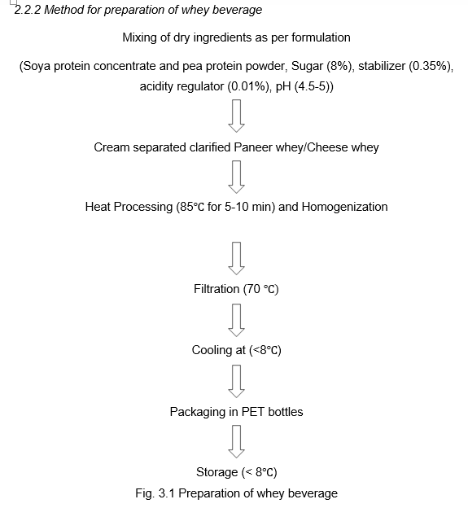

**Figure 1 Process flow chart for production of protein-enrich rich whey beverage**

*2.2.3. Physico-chemical analysis of prepared whey beverage.*

The beverage samples were analyzed for Total solids, pH, and Titratable acidity. The protein and ash contents were determined using semi-micro Kjeldahl and gravimetric method, respectively as per FSSA (2016).

*2.2.3.1 pH analysis*: -The pH value of whey beverage was estimated using laboratory automatic pH meter as per procedure given by FSSA (2016).

*2.2.3.2 Protein analysis*: - The estimation of protein was carried out by estimation of the total nitrogen in the sample, which was determined by the Macro Kjeldahl method (AOAC, 2000). Nitrogen was converted into % protein by multiplying with a conversion factor of 6.38 whey and 6.25 for other proteins.

% Nitrogen = $\frac{[(ml of blank-ml of sample) x Normality of alkali x Nitrogen equivalent weight}{ (Sample weight x 100)}$

% Protein = %Nitrogen x conversion factor

*2.2.3.3 Total Ash content: -* The total ash content (%) and Total solids content (%) were analyzed gravimetrically as per the method given by FSSA (2016).

*2.2.3.4 Acidity (% LA): -* Acidity value was also analyzed as per FSSA (2016).

2.2.3.5. Total Solids (TS, %w /w): Total Solids content were analyzed by Gravimetric method as per FSSA (2016).

*2.2.3.6 Sensory evaluation: -*

The samples of protein rich whey beverages were evaluated by a semi-trained panel of judges using a 9-point hedonic scale (Larmond, 1977) for the sensory attributes of Flavor/Taste, Color and Appearance, Consistency, Acidity and overall acceptability.

3. results and discussion

The compositional analysis of different formulations of the whey beverage incorporated with soya protein and pea protein. The beverage sample of each formulation was subjected different physico-chemical analysis such as pH, protein content, total ash, acidity, and total solids.

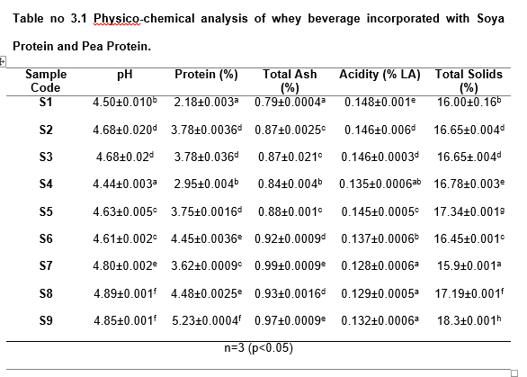**3.1 pH value:** The pH values range from 4.44 to 4.89, indicating slight acidity across all samples. The sample S9 has the highest pH, while S4 has the lowest. The variability of pH is due to the different composition and mineral content of soy protein and pea protein. The difference in proportion of whey in the final product also decides the pH value of the final product. (Zhao *et al.*, 2024)

**Table 2. Physico-chemical analysis of whey beverage incorporated with Soya Protein and Pea Protein**

**3.2 Protein Content:** The protein content varies from 2.18% to 5.21%. S9 has the highest protein content, while S1 has the lowest. Total Ash: Total ash content ranges from 0.79% to 0.99%. S7 has the highest ash content, while S1 has the lowest. The protein and ash content of the final product mostly depends on the formulation having higher proportion of whey, soy protein concentrate and pea protein powder will show higher amount of their proportion in final beverage. The more the protein content leads to more instability problems and also due to synergy with other protein fractions also leads to cloudiness in the prepared beverages (Gupta *et al.,* 2023). However optimum concentration of protein content leads to provide the good mouthfeel and optimum consistency of the optimized beverage. The sugar content also varied as per the bitterness increase and the preferred taste was obtained with S5 which contains the 2 % soy protein concentrate, 2 % pea protein powder and 97 % whey.

**3.3 Acidity (% LA):** Acidity, measured as percentage lactic acid, varies from 0.128% to 0.148%. S7 has the lowest acidity, while S2 and S3 have the highest. The low acidity scores are attributes to the bittering effect of the soy protein concentrate and pea protein powder (Zaman *et al*.,2023).

**3.4 Total Solids (%):** Total solids content ranges from 15.90% to 18.30%. S9 has the highest total solids content, while S7 has the lowest. The higher total solids content leads more viscous product and shown higher sensory score of consistency as well. The formulation of S5 beverage is best suited for with very good sensory scores and also contains the higher amount of protein content in final product.

Overall, the data indicates variability in the compositional characteristics of the whey beverage with different levels of soya protein and pea protein incorporation. S9 stands out with the highest protein and total solids content, while S1 has the lowest protein content and S7 has the lowest total solids content. The acidity levels are relatively consistent across the samples despite that the acidity scores were varied due to the more bitterness in the formulations containing higher protein content. Soy protein and peanut protein demonstrates promising nutritional characteristics for incorporation into beverage. With a TS content of 16.78 %, it presents itself as a low-moisture product, which is favorable for maintaining shelf stability over time. The ash content of 0.88% suggests a moderate mineral composition, offering potential nutritional benefits.

While specific energy content is not provided, the presence of 2.6 grams of protein, 6 grams of carbohydrates, and 2.8 grams of fat per serving indicates a balanced 44 macronutrient profile. Notably, the 1.6 grams of crude fiber offer digestive health benefits. Furthermore, the acidity level of 4.63% is within moderate bounds, which is crucial for sensory attributes and product stability.

Overall, soy protein and peanut protein could serve as a valuable addition in whey Beverage, potentially enhancing its nutritional content with essential minerals, fiber, and other bioactive compounds. However, to ascertain its full potential, further experimentation and sensory evaluations are necessary to gauge its impact on taste, color, texture, and overall consumer acceptability.

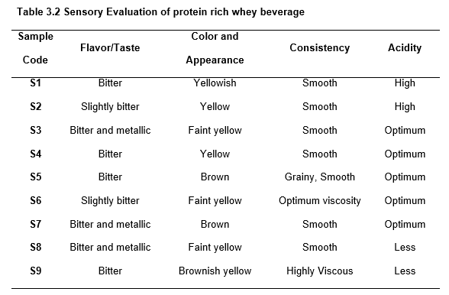**3.5 Sensory evaluation**: Sensory evaluation of the prepared beverage was carried out using 9-point hedonic scale. The sensory evaluation of protein-rich whey beverages (Tables 3 and 4) reveals variations in flavour/taste, colour, consistency, and acidity across nine formulation samples (S1–S9).

**Table 3. Sensory Evaluation of protein rich whey beverage**

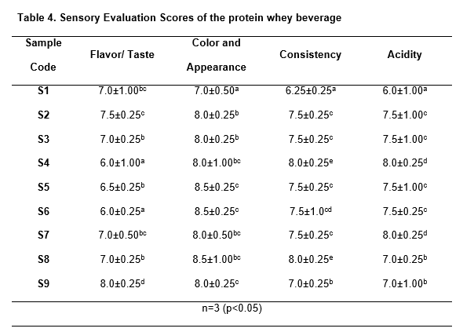Flavour profiles ranged from bitter for samples S1, S4, S5 & S9 to slightly bitter for samples S2 & S6 and bitter-metallic for sample S3, S7 & S8, while S9 scoring highest (8.0±0.25) despite bitterness, indicating better acceptability (Leksrisompong et al., 2012). Color varied from yellowish (S1, S2, S4) to faint yellow (S3, S6, S8) and brown (S5, S7, S9), with S5, S6, and S8 scoring highest (8.5±0.25), suggesting preference for faint yellow or brown hues similar

**Table 4. Sensory Evaluation Scores of the protein whey beverage**

was observed with whey beverage (Smithers, 2008).

Consistency was mostly smooth, except for grainy S5 and highly viscous S9; S4 and S8 scored best (8.0±0.25) for smooth textures (Barukčić et al., 2019). Acidity was high (S1, S2), optimum (S3–S7), or less (S8, S9), with S4 and S7 scoring highest (8.0±0.25) for optimum acidity (Zaman et al., 2023). S1 performed poorly across attributes, while S4, S6, and S8 were most preferred. Formulations should reduce bitterness, optimize viscosity, and maintain optimum acidity for improved acceptability.

**4. CONCLUSION**

In conclusion, the incorporation of soy protein concentrates and pea protein into whey-based beverages represents a promising avenue for expanding the diversity and nutritional profile of protein-rich products. While whey protein remains a popular choice for its superior digestibility and sensory properties, SPC and pea protein offer comparable nutritional value and potential health benefits, alongside the advantages of sustainability and plant-based sourcing. However, challenges related to flavor, texture, and consumer acceptance must be addressed through targeted formulation strategies and process optimization. The optimum acceptable sensory scores were obtained with the formulation of 2 % soy protein concentrate, 2 % pea Protein powder and 96 % whey. The bitter taste was obtained when the protein content was increased form 4 % in the beverage however consistency scores were increased at higher level of protein content. Future research should focus on elucidating the mechanisms underlying the physiological effects of SPC and pea protein, as well as exploring novel applications and ingredient combinations to maximize their functional potential in protein-rich beverages. By leveraging the unique properties of these alternative protein sources, beverage manufacturers can cater to evolving consumer preferences and contribute to the development of innovative and nutritious products in the global market.

AcknowledgEments

The First author acknowledges the Parul University, Vadodara for providing the research facilities and support to carry out the research work.

Competing interests

All authors have no conflict of interest in publishing this research publication.

Authors’ Contributions

All authors have equal contribution in conceptualization, experimentation, statistical analysis and preparation of this manuscript. All authors read and approved the final manuscript.

References

Aas, S. N., Seynnes, O., Benestad, H. B., & Raastad, T. (2020). Strength training and protein supplementation improve muscle mass, strength, and function in mobility-limited older adults: a randomized controlled trial. Aging Clinical and Experimental Research, 32, 605-616. <https://doi.org/10.1007/s40520-019-01234-2>

AOAC International. (2000). *Official methods of analysis of the Association of Official Analytical Chemists*. Association of official analytical chemists.

Barukčić, I., Lisak Jakopović, K., & Božanić, R. (2019). Valorisation of whey and buttermilk for production of functional beverages–an overview of current possibilities. *Food technology and biotechnology*, *57*(4), 448-460. <https://doi.org/10.17113/ftb.57.04.19.6460>

Berrazaga, I., Salles, J., Laleg, K., Guillet, C., Patrac, V., Giraudet, C., Le Bacquer, O., Gueugneau, M., Denis, P., Pouyet, C. and Pion, A., (2020). Anabolic properties of mixed wheat-legume pasta products in old rats: impact on whole-body protein retention and skeletal muscle protein synthesis. Nutrients, 12(6), p.1596. <https://doi.org/10.3390/nu12061596>

Daba, S. D., & Morris, C. F. (2022). Pea proteins: Variation, composition, genetics, and functional properties. Cereal Chemistry, 99(1), 8-20. <https://doi.org/10.1002/cche.10439>

Food and Agriculture Organization (FAO). (2020). Greenhouse gas emissions from agriculture. http://www.fao.org

Gorissen, S. H., Crombag, J. J., Senden, J. M., Waterval, W. H., Bierau, J., Verdijk, L. B., & van Loon, L. J. (2018). Protein content and amino acid composition of commercially available plant-based protein isolates. Amino acids, 50, 1685-1695. <https://doi.org/10.1007/s00726-018-2640-5>

Grand View Research. (2020). Plant-based protein market size, share & trends analysis report. https://www.grandviewresearch.com

Gupta, A., Sanwal, N., Bareen, M. A., Barua, S., Sharma, N., Olatunji, O. J., & Sahu, J. K. (2023). Trends in functional beverages: Functional ingredients, processing technologies, stability, health benefits, and consumer perspective. *Food Research International*, *170*, 113046. <https://doi.org/10.1016/j.foodres.2023.113046>

International Food Information Council (IFIC). (2023). 2023 Food and Health Survey. https://www.ific.org

Larmond, E. (1977). Laboratory methods for sensory evaluation of food (Vol. 1284). Agriculture Canada.

Leksrisompong, P., Gerard, P., Lopetcharat, K., & Drake, M. (2012). Bitter taste inhibiting agents for whey protein hydrolysate and whey protein hydrolysate beverages. *Journal of food science*, *77*(8), S282-S287. <https://doi.org/10.1111/j.1750-3841.2012.02800.x>

Liu, Y., Gao, F., Xia, B., Deng, J., Liang, S., & Wang, C. (2024). Physicochemical, structural, and emulsifying properties of stable blended whey and soy protein colloidal dispersion prepared by pH‐shifting and ultrasound. International Journal of Dairy Technology, 77(2), 324-337. <https://doi.org/10.1111/1471-0307.13064>

Luo, L., Wang, Z., Deng, Y., Wei, Z., Zhang, Y., Tang, X., & Li, P. (2022). High-pressure homogenization: A potential technique for transforming insoluble pea protein isolates into soluble aggregates. Food Chemistry, 397, 133684. <https://doi.org/10.1016/j.foodchem.2022.133684>

Manual of Methods of Analysis of Dairy and Dairy Products 2011 (<https://fssai.gov.in/upload/uploadfiles/files/Manual_Dairy_07_10_2022.pdf>)

Messina, M., Duncan, A., Messina, V., Lynch, H., Kiel, J., & Erdman Jr, J. W. (2022). The health effects of soy: A reference guide for health professionals. Frontiers in Nutrition, 9, 970364. <https://doi.org/10.3389/fnut.2022.970364>

Naclerio, F., & Seijo, M. (2019). Whey protein supplementation and muscle mass: current perspectives. Nutrition and Dietary Supplements, 37-48. <https://doi.org/10.2147/NDS.S166195>

Poore, J., & Nemecek, T. (2018). Reducing food’s environmental impacts through producers and consumers. Science, 360(6392), 987-992. <https://doi.org/10.1126/science.aaq0216>

Smithers, G. W. (2008). Whey and whey proteins—From ‘gutter-to-gold’. *International dairy journal*, *18*(7), 695-704. <https://doi.org/10.1016/j.idairyj.2008.03.008>

Smithers, G. W., & Augustin, M. A. (Eds.). (2012). Advances in dairy ingredients. John Wiley & Sons.

Statista. (2023). Global fitness industry statistics. https://www.statista.com

Wang, S., Chelikani, V., & Serventi, L. (2018). Evaluation of chickpea as alternative to soy in plant-based beverages, fresh and fermented. Lwt, 97, 570-572. <https://doi.org/10.1016/j.lwt.2018.07.06>

Zaman, Q. U., Sahar, A., Sameen, A., Ahmad, M. H., Muhammad, N., Huma, N., … Al-Farga, A. (2023). Development and Storage Stability of Whey Sugarcane Based Functional Beverage. *International Journal of Food Properties*, *26*(1), 752–763. <https://doi.org/10.1080/10942912.2023.2183170>

Zhao, R., Fu, W., Li, D., Dong, C., Bao, Z., & Wang, C. (2024). Structure and functionality of whey protein, pea protein, and mixed whey and pea proteins treated by pH shift or high-intensity ultrasound. *Journal of Dairy Science*, *107*(2), 726-741. <https://doi.org/10.3168/jds.2023-23742>