**Innovative Use of Paddy Straw Ash in Concrete: Boosting Strength and Sustainability**

**ABSTRACT**

The increasing demand for sustainable building materials has prompted the use of agricultural waste products in concrete production. This paper explores the potential of using paddy straw ash (PSA), a by-product of rice farming, as a partial replacement for cement in concrete. The effects of various replacement levels of PSA on the compressive strength, durability and workability of concrete are evaluated. Compressive strength tests on mortar samples with varying PSA replacement levels (0–25%) revealed that optimal strength was achieved with 5–10% PSA substitution. The study demonstrates that PSA can improve the sustainability of concrete by enhancing its strength and reducing its environmental impact, while also making use of agricultural waste.

**Keywords:** Paddy Straw Ash, Concrete, Sustainability, Pozzolanic material, Durability

1. **INTRODUCTION**

The construction industry is one of the largest consumers of natural resources and energy, with cement production being one of its most significant contributors to environmental pollution. The global demand for concrete has led to an over-exploitation of raw materials, contributing to the depletion of natural resources and an increase in carbon emissions. In an effort to mitigate these challenges, there has been a growing focus on the incorporation of alternative materials in concrete production (Chowdhury et al., 2015; Raheem & Ikotun, 2020; Lorika et al*.,* 2023). One such material is **Paddy Straw Ash (PSA)**, a by-product of rice farming that is typically burned and discarded, causing environmental pollution.

Paddy straw is one of the most abundant agricultural residues globally, especially in rice-producing countries. However, the open burning of paddy straw releases harmful pollutants into the atmosphere, contributing to air pollution and greenhouse gas emissions. Utilization of paddy straw for power generation or in brick kiln represents effective method of converting waste into wealth and minimizes open burning of rice straw after harvesting. While using paddy straw as fuel, these power plants are facing challenge of managing ash content produced after burning of paddy straw. Paddy straw bales are a viable and sustainable option for fuelling industrial boilers. They provide an efficient way to utilize agricultural waste, contribute to environmental conservation and can offer cost benefits. However burning of these bales has a relatively high ash content compared to other fuels which goes up to 20% (Dogra *et at*., 2024).

The disposal of PSA poses serious environmental problems. If the waste PSA is not managed properly, the use of paddy straw as a fuel cannot be completely considered as ‘green’. Effective ash management systems are necessary to handle the ash produced during combustion (Jain & Khattra, 2024).

A promising solution to manage PSA can be achieved by using it as partial replacement to cement or sand (fine aggregates) in making concrete mixes or cement mortar. This approach not only helps in effectively managing the ash but also enhances the sustainability of construction practices. After water, cement is the most widely used material on the planet (Imbabi *et al*., 2021). Manufacturing of cement contributes greenhouse gases both directly through the production of carbon dioxide when calcium carbonate is thermally decomposed, producing lime and carbon dioxide and also through the use of energy, particularly from the combustion of fossil fuels and thus making the cement unsuitable for the sustainable development. The emission of CO2 due to cement manufacturing and improper disposal of PSA leads to air pollution and land fill problem.

One of the solutions which shows path to mitigate these environmental issues can be achieved by using PSA as the partial replacement of cement without any adverse effects. Paddy straw ash is pozzolanic (Singh and Patel, 2023) and satisfies the minimum requirements of ASTM class N, F and C pozzolana and is suitable for use in Portland cement replacement. Therefore, it is required to experimentally investigate the use of PSA in concrete or cement mortar. Utilization of waste PSA would introduce a decentralized method of waste management, in particular, for rural areas, where farmers are producing paddy and facing a shortage of construction materials because of the high cost. Cement mortar produced by incorporating waste PSA without any pre-processing as a cement replacement, combined the sustainability with waste management and environmental management leading to produce a green, cleaner production: strong, durable and eco-friendly material.

The concept of utilizing PSA as a supplementary cementitious material has gained significant attention in recent years as a way to not only dispose of this waste product but also enhance the sustainability of concrete (Agrawal et al., 2017). PSA is rich in **silica (SiO₂)**, which can react with calcium hydroxide Ca(OH)₂ from cement during hydration, forming additional **calcium silicate hydrate (C-S-H)** gel, a binder responsible for concrete's strength. **Saraswathy** and **Song (2007)** investigated the effects of incorporating **Rice Husk Ash (RHA)** into concrete on its **corrosion resistance**, particularly for reinforced concrete exposed to aggressive environments. This research provided insight into how using rice husk ash in concrete can enhance the durability of concrete structures, especially in mitigating corrosion-related issues, which are a significant problem in marine and other aggressive environments.

The use of PSA in concrete offers several benefits, including improved **compressive strength, reduced permeability** and **enhanced durability** against environmental stresses such as sulfate and chloride attacks (Ganesan *et al*., 2008; Ferraro & Nanni, 2012; Siddika et al., 2018; Nisar & Bhat, 2021). Furthermore, incorporating PSA in concrete provides an effective solution for waste management by reducing the environmental impact of both agricultural waste and cement production (Agrawal et al., 2023). The adoption of such sustainable practices is critical to the future of the construction industry, which is increasingly prioritizing eco-friendly alternatives.

Carricondo *et al*., (2020) investigated the potential of RSA to immobilize phosphorus in agricultural soils, preventing its runoff into wetlands. The findings indicated that RSA can effectively bind excess phosphorus in the soil, reducing its solubility and preventing its migration into water bodies. The application of RSA not only reduces phosphorus loading but also offers a sustainable solution for rice straw waste management, minimizing air pollution from open burning.

Previous studies have explored the use of various agricultural waste products, including rice husk ash and PSA, as substitutes for cement (Ferraro et al., 2016, Memon et al., 2018, Oliko et al., 2020, Ubi et al., 2021 and Agrawal & Malviya, 2025). Several researchers have concluded that the use of PSA in concrete can improve compressive strength, reduce permeability and enhance durability by contributing to the pozzolanic reactions. This paper aims to investigate the performance enhancement of cement mortar through the partial replacement of cement with PSA. It evaluates the effects of varying PSA content on the **mechanical properties** (such as compressive strength) and **durability** (such as resistance to chemical attacks) of concrete. The study also focuses on the potential of PSA as an effective and sustainable alternative material, offering a holistic approach to improving concrete's performance while reducing environmental impact.

The study was conducted with the main objectives as

* To evaluate the effect of PSA as a partial replacement for cement in concrete.
* To analyze the workability, strength and durability of concrete incorporating PSA.
* To recommend the optimal percentage of PSA replacement in concrete mixes.

1. **MATERIALS AND METHODS**

**2.1 Materials**

The materials used include Portland cement, sand and PSA and the tests are carried out following the relevant standards.

### 2.1.1 Portland Cement

Although all material, cement is very often the most important because it is usually the delicate link in the chain. The function of cement is first of all to bind the sand and paddy straw ash together and second to fill up the voids in between sand and ash particles to form a compact mass. Ordinary Portland Cement (43 grade) was used for this study. The composition of OPC consists mainly of compounds of lime, silica, alumina and iron oxide, with specified percentage ranges for each.

* + 1. **Paddy Straw Ash**

8.8 Lac million ton per annum of Paddy straw is burnt in various biomass based power plants in Punjab. PSA was obtained from one of these power plants. The chemical composition of **PSA** is summarized below in Table 1. The chemical composition table of provides important insights into its potential application as a supplementary cementitious material in concrete.

**Table 1 Chemical composition of PSA**

|  |  |
| --- | --- |
| **Chemical Composition** | **% of PSA** |
| CaO | 4.96 |
| SiO2 | 76.00 |
| Al2O3 | 0.69 |
| Fe2O3 | 0.63 |
| MgO | 2.65 |

**2.1.3 Fine and Coarse Aggregates**

#### ****Fine Aggregate****

The fine aggregate used was **naturally available river sand**, free from impurities such as clay, silt, and organic matter with **Fineness Modulus** 2.65, **Specific Gravity** 2.60 and confirmed to lie within **Zone II**. It was dried, sieved, and graded according to **IS 383:2016**. The sand exhibited **good workability and flow characteristics**, making it ideal for blending with cementitious materials, including PSA.

#### ****Coarse Aggregate****

Crushed stone aggregates of nominal size 20 mm and 10 mm in the proportion of 50:50 were used throughout the experimental study. The aggregates were washed to remove dust and dirt and were dried to surface dry condition. The properties of coarse aggregates such as specific gravity and fineness modulus were determined.

* 1. **Methods**

**2.2.1 Sample Nomenclature and Mix Proportions**

To evaluate the effect of Paddy Straw Ash (PSA) as a partial replacement for cement, mortar cubes were prepared with a constant cementitious material to sand ratio of 1:3 by weight. The replacement levels of PSA varied from 0% to 25%, replacing cement by weight. The total binder content (cement + PSA) was kept constant at 420 grams for all mixes and the quantity of standard sand was fixed at 1260 grams. A total of 9 specimens were prepared for each mix (3 cubes each for 3, 7, and 28-day strength testing).

**Table 2 Mix Proportions of Mortar Cubes with PSA**

|  |  |  |  |  |  |  |
| --- | --- | --- | --- | --- | --- | --- |
| **Sample nomenclature** | **PSA (%)** | **(Cement+PSA): sand** | **Cement (grams)** | **Sand (grams)** | **PSA (grams)** | **Number of specimens** |
| PSA 0 | 0 | 1:3 | 420 | 1260 | 00 | 9 |
| PSA 5 | 5 | 1:3 | 399 | 1260 | 21 | 9 |
| PSA 10 | 10 | 1:3 | 378 | 1260 | 42 | 9 |
| PSA 15 | 15 | 1:3 | 357 | 1260 | 63 | 9 |
| PSA 20 | 20 | 1:3 | 336 | 1260 | 84 | 9 |
| PSA 25 | 25 | 1:3 | 315 | 1260 | 105 | 9 |

Cubical specimens of 10 mm x 10 mm x 10 mm. were prepared. After placing of the mix in the mould the specimens were finished smooth and after that it was vibrated. After 24 hours of casting specimens were demoulded and immersed in water. Different batches were adopted for different ages of curing. And the testing was done after curing of 7 days, 14 days and 28 days.

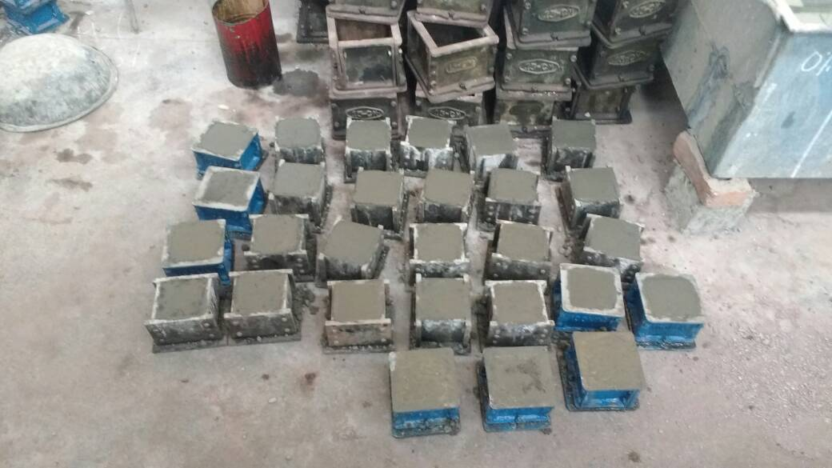

**Fig.1. Casted Cube Specimens**

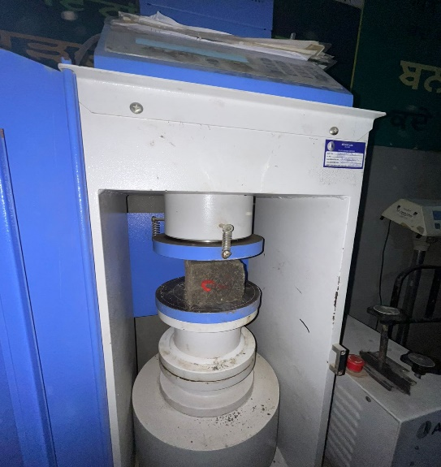The compressive strength of concrete cubes was tested under Universal Testing Machine of 200 KN capacity as shown in figure 2. The load was applied gradually without shock till the failure of the specimen occur and thus the compressive strength of concrete cubes was found.

**Fig. 2. Universal Testing Machine**

**2.2.2 Silicon Activity Index (SAI)**

The Silicon Activity Index (SAI) is a measure of the pozzolanic activity of a material such as Paddy Straw Ash (PSA). It reflects the material’s ability to react with calcium hydroxide (Ca(OH)₂) in the presence of water to form additional cementitious compounds, predominantly calcium silicate hydrate (C-S-H), which contributes to strength development in cement-based materials. SAI is commonly used to evaluate the effectiveness of Supplementary Cementitious Materials (SCMs) such as fly ash, silica fume, slag, and agricultural waste ashes (e.g., PSA), which are typically rich in silicon dioxide (SiO₂).

The presence of high SiO₂ content enables these materials to undergo secondary hydration reactions that improve the microstructure and mechanical properties of hardened cementitious composites. In addition to indicating the pozzolanic potential of a material, the SAI also provides insights into the sustainability and performance enhancement of cementitious systems through the use of alternative binders. Higher SAI values generally correspond to better pozzolanic reactivity and contribute positively to the mechanical strength, durability, and environmental performance of concrete.

1. **RESULTS AND DISCUSSION**

**3.1 Fineness of Cement**

The **fineness of cement** (Table 3) was determined to assess the particle size distribution and surface area of cement particles. It affects the rate of hydration and thus the strength development and workability of the cement paste. Finer cement provides more surface area for hydration and results in faster strength development.

The test was carried out using **standard IS sieve No. 90 µm** and the percentage of residue retained on the sieve was measured. The fineness is expressed as the **percentage by weight of the cement retained on the sieve.**

**Table 3 Fineness test for cement**

|  |  |  |  |
| --- | --- | --- | --- |
| **Weight of cement (W) gm.** | **Sample 1** | **Sample 2** | **Sample 3** |
| 100 | 100 | 100 |
| I.S. sieve size | 90 | 90 | 90 |
| Sieving time | 15 | 15 | 15 |
| Weight retained on sieve (W1) g | 8.5 | 10 | 9 |
| Percent weight on sieve $\frac{W1}{W}×100$% | $$\frac{8.5}{100}×100$$ | $$\frac{10}{100}×100$$ | $$\frac{9}{100}×100$$ |
| Mean percentage | 8.5 | 10 | 9 |

The average value of fineness of cement specimen was 9.2%. According to IS:4031 (Part 1) – 1996, **the residue on the 90 µm sieve should not exceed 10% by weight**. Since the average value here is **9.17%,** the cement sample meets the fineness requirement and was suitable for use.

**3.2 Sieve Analysis of Fine Aggregates**

Sieve analysis was carried out to determine the particle size distribution of fine aggregates. The test was performed as per **IS: 2386 (Part I) – 1963** and the grading was evaluated against **IS: 383 – 1970** to classify the aggregates into appropriate grading zones. This helps assess the suitability of the sand for use in concrete or mortar. For this test, a 500 g sample of fine aggregate was sieved through a standard set of IS sieves. The fineness modulus (F.M.) was then calculated to represent the average particle size.

**Table 4 Sieve analysis of fine aggregates**

Total weight of sample= 500 g

|  |  |  |  |  |  |
| --- | --- | --- | --- | --- | --- |
| **IS- Sieve designation** | **Weight retained on sieve (g)** | **%age weight retained on sieve** | **Cumulative percentage**  **weight retained on sieve** | **%age passing** | **%age passing for grading zone-II as IS:383-1970** |
| 10 mm | Nil | Nil | Nil | 100 | 100 |
| 4.75 mm | 39 | 7.8 | 7.8 | 92.2 | 90-100 |
| 2.36 mm | 48 | 9.6 | 17.4 | 83.6 | 75-100 |
| 1.18 mm | 58 | 12.6 | 29 | 72 | 55-90 |
| 600 micron | 97 | 19.4 | 48.4 | 52.6 | 35-55 |
| 300 micron | 125 | 25 | 73.4 | 27.6 | 8-30 |
| 150 micron | 112 | 25.4 | 95.8 | 5.2 | 0-10 |
| PAN | 21 | 4.2 | 100 |  |  |

Cumulative percentage weight= 271.8

Fineness modulus= 271.8/100=2.71

The **Fineness Modulus o**fthe fine aggregate is **2.71**, which falls within the normal range for **medium sand.** Based on the **percentage passing values**, the sample **conforms to Grading Zone II.** Therefore, the fine aggregates are **suitable for use in general concrete work**.

**3.3 Comparison of Chemical Composition: Cement vs PSA**

**Fig. 3. Comparison of composition of cement & PSA**

**3.4 Effect of PSA replacement on Standard Consistency of Cement**

The standard consistency of cement paste is the amount of water required to produce a paste of standard viscosity. Replacing cement with PSA influences the water demand due to PSA's higher surface area, porosity and amorphous silica content as can be seen from figure 4.

**Fig. 4. Effect of PSA replacement on standard consistency of cement**

* 1. **Setting times of Cement**

Understanding the effect of PSA on setting time is critical for determining the feasibility of its use in construction applications, especially where workability and finishing time are concerns. From figure it is clear that both **initial and final setting times increase** with PSA content due to reduced calcium compounds and delayed pozzolanic reactions. The trend supports PSA use in applications where **extended working time is beneficial**, though adjustments in **curing time and admixture use** may be necessary.

**Fig 5 Effect of PSA on setting time of cement mortar**

### 3.6 Compressive Strength of Cement Mortar with PSA Replacement

This test investigates how partially replacing cement with PSA affects the compressive strength of mortar over time. Mortar cubes were cast and tested at 7, 14, and 28 days. The values of compressive strength after 7 days, 14 days and 28 days of curing period are shown respectively in figure 6, figure 7 and figure 8.

**Fig 6 Compressive strength after 7 days of curing**

**Fig 7 Compressive strength after 14 days of curing**

**Fig 8 Compressive strength after 28 days of curing**

The percentage increase in compressive strength of specimens was determined and is given in table 5. The same has been shown graphically in figure 9.

**Table 5 Percentage increase in compressive strength of the specimens**

|  |  |  |  |
| --- | --- | --- | --- |
| **Sample nomenclature** | **Compressive Strength (N/mm2)** | | |
| **7 Days** | **14 Days** | **28 Days** |
| PSA 5 | 10.6 | 9.09 | 8.72 |
| PSA 10 | 13.82 | 10.60 | 9.39 |
| PSA 15 | 7.98 | 7.57 | 5.03 |
| PSA 20 | -2.12 | -6.06 | -4.69 |
| PSA 25 | -10.10 | -9.46 | -9.39 |

**Fig 9 Percentage increase in compressive strength**

**3.7 Silicon Activity Index**

The Silicon Activity Index (SAI) is a key parameter used to evaluate the pozzolanic activity of supplementary cementitious materials (SCMs) such as Paddy Straw Ash (PSA). It measures the relative compressive strength of cementitious composites containing SCMs compared to a control mix without the SCM. A high SAI indicates the effective contribution of the pozzolanic material toward strength development through the formation of additional calcium silicate hydrate (C–S–H) in the presence of calcium hydroxide. As per ASTM C618, an SAI value of **75% or above** is considered acceptable for a material to be classified as pozzolanic. **Table 6** below presents the SAI values obtained for each mix.

**Table 6 Silicon Activity Index (SAI)**

|  |  |  |  |
| --- | --- | --- | --- |
| **Sample nomenclature** | **SAI** | | |
| **7 DAYS** | **14 Days** | **28 Days** |
| PSA 5 | 110.63 | 109.09 | 108.7248 |
| PSA 10 | 113.82 | 110.60 | 100.6173 |
| PSA 15 | 107.97 | 107.57 | 96.01227 |
| PSA 20 | 97.87 | 93.93 | 90.73482 |
| PSA 25 | 89.89 | 90.53 | 95.07042 |

**3.8 Establishment of equations for estimation strength of samples.**

To better understand and predict the effect of Paddy Straw Ash (PSA) replacement on compressive strength, polynomial regression models were developed for 7, 14, and 28-day curing periods. The equation corresponding to 7 days, 14 days and 28 days were established on the basis of experimental data and best fit technique.

y = −0.0507x2+0.7071x+18.8 for 7 days of curing

y = −0.0471x2+0.6843x+26.4 for 14 days of curing

y = −0.0529x2+0.7007x+29.8 for 28 days of curing

The derived regression equations enable reliable prediction of compressive strength for mortar mixes with varying PSA content. These models demonstrate that PSA can effectively enhance early and later-age strength up to an optimal dosage (~10%) and provide a mathematical basis for mix proportioning and performance forecasting in future studies or field applications.

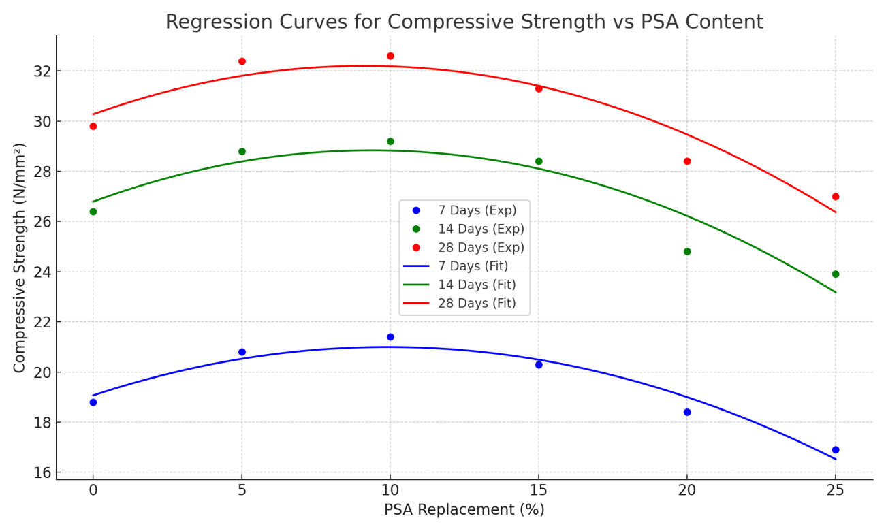

**Fig. 10 Regression curves for compressive strength vs PSA content**

Figure 10 shows the regression curves for compressive strength at 7, 14, and 28 days as a function of PSA replacement percentage. The plots show a clear peak around 10% PSA, confirming the optimal replacement level for strength enhancement.

1. **CONCLUSIONS**

This study focused on the evaluation of **PSA** as a **partial replacement of cement** in mortar mixes. The investigation was carried out through a series of experimental procedures including material characterization, physical testing, compressive strength assessment and mathematical modeling. The major outcomes of the study can be summarized as follows:

* Increasing PSA content leads to a significant increase in water demand for achieving standard consistency. This trend must be considered in **mix design**, as it can affect **workability, setting time, and strength development**. Appropriate use of **plasticizers** or water-reducing agents may be needed in mixes with higher PSA content.
* The incorporation of PSA as a partial replacement for cement **delays the setting time**, with both initial and final setting times increasing significantly with higher PSA content. This can be **beneficial or require adjustments** depending on the application, such as the use of **accelerators** in cold weather.
* The Silicon Activity Index results confirm the effectiveness of Paddy Straw Ash as a pozzolanic material. All mixes met the ASTM C618 criteria for pozzolanicity. The **optimal replacement level was found to be 10%,** providing the best balance between strength development and sustainability. PSA can therefore be considered a viable alternative for partial cement replacement in mortar and concrete production, contributing to both **material performance** and **environmental conservation.**

• The reuse of PSA not only contributes to **waste management and environmental protection**, but also promotes **resource conservation** in the construction industry. It not only provides a valuable solution to managing agricultural waste but also creates a concrete material that is more durable, environmentally friendly and cost-effective. With continued innovation and research, paddy straw ash could play a crucial role in the future of green construction materials.

**DISCLAIMER (ARTIFICIAL INTELLIGENCE)**

Author(s) hereby declare that NO generative AI technologies such as Large Language Models (ChatGPT, COPILOT, etc.) and text-to-image generators have been used during the writing or editing of this manuscript.

**COMPETING INTERESTS DISCLAIMER:**

Authors have declared that they have no known competing financial interests OR non-financial interests OR personal relationships that could have appeared to influence the work reported in this paper.

**REFERENCES**

Agrawal, A., & Malviya, N. (2025). Advanced geopolymer concrete with coconut fiber reinforcement: optimizing strength, durability, and predictive modelling for sustainable construction. Architecture, Structures and Construction, *5*(1), 1-16.

Agrawal, A., Shrivastava, A., & Khatri, R. (2023). An Experimental Study of Introducing the Human Hair as a Fibre Material in Concrete. Journal of Ceramics and Concrete Sciences, 8(1), 17-23.

Agrawal, M. A., Shrivastav, M. J., Lange, M. A., & Chourasia, M. S. (2017). Analysis for Compressive Strength with Fly Ash in Concrete. Journal of Civil and Construction Engineering, 3(3).

Carricondo Anton, J. M., Gonzalez Romero, J. A., Mengual Cuquerella, J., Turegano Pastor, J. V., & Oliver Villanueva, J. V. (2020). Alternative use of rice straw ash as natural fertilizer to reduce phosphorous pollution in protected wetland ecosystems. International Journal Of Recycling of Organic Waste in Agriculture (Online), 9(1), 61-74.

Chowdhury, S., Mishra, M., & Suganya, O. M. (2015). The incorporation of wood waste ash as a partial cement replacement material for making structural grade concrete: An overview. Ain Shams Engineering Journal, 6(2), 429-437.

Dogra, R. (2024). Briquettes as an Alternative Fuel to Wood for Circular Economy in Paddy Straw. International Journal of Bio-resource and Stress Management, 15(6), 01–06.

Ferraro, C. C., Paris, J. M., Townsend, T., & Tia, M. (2016). Evaluation of alternative pozzolanic materials for partial replacement of Portland cement in concrete.

Ferraro, R. M., & Nanni, A. (2012). Effect of off-white rice husk ash on strength, porosity, conductivity and corrosion resistance of white concrete. Construction and Building Materials, 31, 220-225.

Ganesan, K., Rajagopal, K., & Thangavel, K. (2008). Rice husk ash blended cement: Assessment of optimal level of replacement for strength and permeability properties of concrete. Construction and building materials, 22(8), 1675-1683.

Imbabi, M. S., Carrigan, C., & McKenna, S. (2012). Trends and developments in green cement and concrete technology. International Journal of Sustainable Built Environment, 1(2), 194-216.

Jain, R., & Khattra, S. K. (2024). Innovative Implications of Paddy Straw in Concrete: A Review. Advances in Research, 25(4), 325–330.

Lorika, D. A., Hamad, B., Yehya, A., & Salam, D. A. (2023). Evaluating the use of mucilage from opuntia ficus-indica as a bio-additive in production of sustainable concrete. Construction and Building Materials, 396, 132132.

Memon, S. A., Javed, U., Haris, M., Khushnood, R. A., & Kim, J. (2021). Incorporation of wheat straw ash as partial sand replacement for production of eco-friendly concrete. Materials, 14(8), 2078.

Memon, S. A., Wahid, I., Khan, M. K., Tanoli, M. A., & Bimaganbetova, M. (2018). Environmentally friendly utilization of wheat straw ash in cement-based composites. Sustainability, 10(5), 1322.

Nisar, N., & Bhat, J. A. (2021). Experimental investigation of Rice Husk Ash on compressive strength, carbonation and corrosion resistance of reinforced concrete. Australian Journal of Civil Engineering, 19(2), 155-163.

Oliko, C., Kabubo, C. K., & Mwero, J. N. (2020). Rice straw and eggshell ash as partial replacements of cement in concrete. Engineering, Technology & Applied Science Research, 10(6), 6481-6487.

Raheem, A. A., & Ikotun, B. D. (2020). Incorporation of agricultural residues as partial substitution for cement in concrete and mortar–A review. Journal of Building Engineering, 31, 101428.

Saraswathy, V., & Song, H. W. (2007). Corrosion performance of rice husk ash blended concrete. Construction and building materials, 21(8), 1779-1784.

Siddika, A., Mamun, M. A. A., & Ali, M. H. (2018). Study on concrete with rice husk ash. Innovative Infrastructure Solutions, 3, 1-9.

Singh, R., & Patel, M. (2023). Strength and durability performance of rice straw ash-based concrete: an approach for the valorization of agriculture waste. International Journal of Environmental Science and Technology, 20(9), 9995-10012.

Ubi, S. E., Nkra, P. O., & Agbor, R. B. (2021). Stabilization of Earth Block Using Rice Husk Ash as Partial Replacement in Cement. Current Journal of Applied Science and Technology, 40(12), 12–22.