**Impact of Cardiovascular Diseases on Endodontic Treatment: An Integrative Review of Risk Factors**

**ABSTRACT**

|  |
| --- |
| **Introduction:** The current knowledge of cardiovascular diseases highlights the need for a deeper understanding of the association between endodontic infections and cardiovascular risk. Considering the potential relationship between cardiovascular risk factors and oral conditions, it is essential to establish guidelines that support an integrated approach to oral and systemic health.  **Aim:** To analyze through an integrative review the influence of cardiovascular diseases on endodontic treatment and their main associated risk factors.  **Material and Methods**: A comprehensive search was conducted in the PubMed, Google Scholar, and Virtual Health Library databases using the English descriptors: inflammation, cardiovascular diseases, and root canal. Filters were applied for language (Portuguese and English), full-text availability, and publication date between 2019 and 2024. Initially, 17,774 references were identified. After applying the eligibility criteria and selecting by title, abstract, and full-text reading, 8 articles were included in the review.  **Results:** Periapical lesions, root-filled teeth, and tooth loss were associated with myocardial infarction. Comorbidities such as diabetes, hypertension, dyslipidemia, and smoking exacerbated oral-systemic interactions. Endodontic infections were linked to systemic inflammation, with elevated expression of hs-CRP, IL-1β, ADMA, ET-1, and MMP-2.  **Discussion:** The findings reinforce the importance of integrating oral and systemic health, especially in patients with cardiovascular predisposition. Identifying risk factors and controlling oral inflammation may contribute to improved clinical outcomes.  **Conclusion:** Proper endodontic therapy offers both local and systemic benefits, serving as a relevant resource in the prevention of cardiovascular complications associated with oral infections. |

*Keywords: Inflammation; Cardiovascular Diseases; Root Canal,* Endodontic Treatment, oral

**1. INTRODUCTION**

In Brazil, non-communicable chronic diseases (NCDs) became the leading cause of death in 2019, accounting for approximately 54.7% of all fatalities. Among the systemic disorders affecting the population, the most prominent are cardiovascular diseases (CVDs), diabetes, chronic respiratory diseases, and cancers. The current scenario of systemic conditions, with emphasis on cardiovascular diseases, highlights the need for a more accurate understanding of the association between endodontic infections and the reduction of potential cardiovascular risks in individuals (Alim; Guneser; Dincer, 2020; Brasil, 2021; Bezamat, 2022).

CVDs encompass various disorders of the heart and blood vessels, including coronary artery disease (CAD), peripheral arterial disease, congenital heart defects, cerebrovascular disease, and deep vein thrombosis. Each year, over 17 million deaths are attributed to CVDs, representing 45% of all deaths caused by NCDs worldwide (Oliveira et al., 2020). The main contributing factors to coronary diseases include a sedentary lifestyle, poor dietary habits, excessive alcohol consumption, smoking, and stress (WHO, 2021).

Patients with cardiovascular diseases show a strong correlation with oral health problems, making rigorous oral hygiene control essential. Inflammatory conditions, whether local or systemic, may be triggered by risk factors such as hypertension, dyslipidemia, and smoking, resulting in an increased prevalence of periapical abscesses, reduced salivary flow, and impaired bone healing. Oral conditions such as dental caries, gingivitis, periodontitis, fungal infections, and xerostomia are frequently associated with systemic diseases (Kim et al., 2021; Dash et al., 2022; Koletsi et al., 2021).

Dental caries is the most prevalent disease affecting hard dental tissues. Its complications can lead to or exacerbate systemic diseases, thereby compromising quality of life (Farges et al., 2015). It is the primary cause of root canal infections and the ensuing inflammatory process known as apical periodontitis (AP), which results from inflammatory mediators produced by pathogens (Sebring et al., 2021; Sebring et al., 2023; Arora et al., 2024).

Teeth that have undergone endodontic treatment may have their healing process influenced by systemic diseases associated with chronic inflammation, which interfere with the pathogenesis of apical periodontitis (Aminoshariae; Kulild; Foudad, 2020). Cardiovascular diseases are associated with an increased risk of asymptomatic apical periodontitis, whose development has been investigated through the early manifestation of inflammatory biomarkers considered predictive of future cardiovascular events (Chauhan et al., 2019; Cowan et al., 2020).

Given the interrelationship between cardiovascular diseases and their impact on endodontic treatment, it is crucial that dental surgeons understand this subject matter. Therefore, considering the possible connection between cardiovascular risk factors and oral conditions, it is necessary to establish parameters that better support the management of oral diseases that could further compromise the patient’s overall health status.

Thus, the aim of this article was to analyze, through an integrative review, the impact of cardiovascular diseases on endodontic treatment and their main risk factors.

**2. material and methods**

**2.1 Study Design**

This study is an integrative literature review, based on scientific articles retrieved from the following databases: PubMed, Google Scholar, and the Virtual Health Library.

**2.2 Research Question**

The PICO strategy adopted in this study was structured as follows: the population (P) comprises individuals with cardiovascular diseases; the intervention (I) refers to endodontic treatment; the comparison (C) involves individuals without cardiovascular diseases or those who have not undergone endodontic treatment; and the outcome (O) is the identification of evidence supporting the association between cardiovascular conditions and outcomes of endodontic treatment. This study was guided by the following research question: “Is there evidence supporting the association between cardiovascular diseases and endodontic treatment?”

**2.3 Search Strategy**

The search strategy was developed using descriptors registered in the Brazilian database Health Sciences Descriptors, “Descritores em Ciências da Saúde (DeCS)”: inflammation; cardiovascular diseases; root canal. These were combined using the Boolean operator "AND," resulting in the following search strategies: “*inflammation AND cardiovascular diseases AND root canal therapy*”or “inflamação AND doenças cardiovasculares AND canal radicular”.

**2.4 Eligibility Criteria**

Articles were included if they addressed the topic, were available in full text, published within the last five years (2019–2024), and written in either English or Portuguese. Eligible articles contained the keywords in English: *inflammation*, *cardiovascular diseases*, *root canal*, and their corresponding terms in Brazilian Portuguese: *inflamação*, *doenças cardiovasculares*, and *canal radicular*. Studies were excluded if they were not published in the pre-selected languages, were of other types of reviews, were not available in full text, consisted only of simple abstracts, or did not address the research question upon reading the abstracts and full texts.

**2.5 Data Collection**

Data collection was carried out by a single researcher from January to April 2024. The initial selection was based on reading the titles, abstracts, and conclusions of the articles. Pre-selected studies were then evaluated in full, during which the eligibility criteria were applied (Fig. 1).

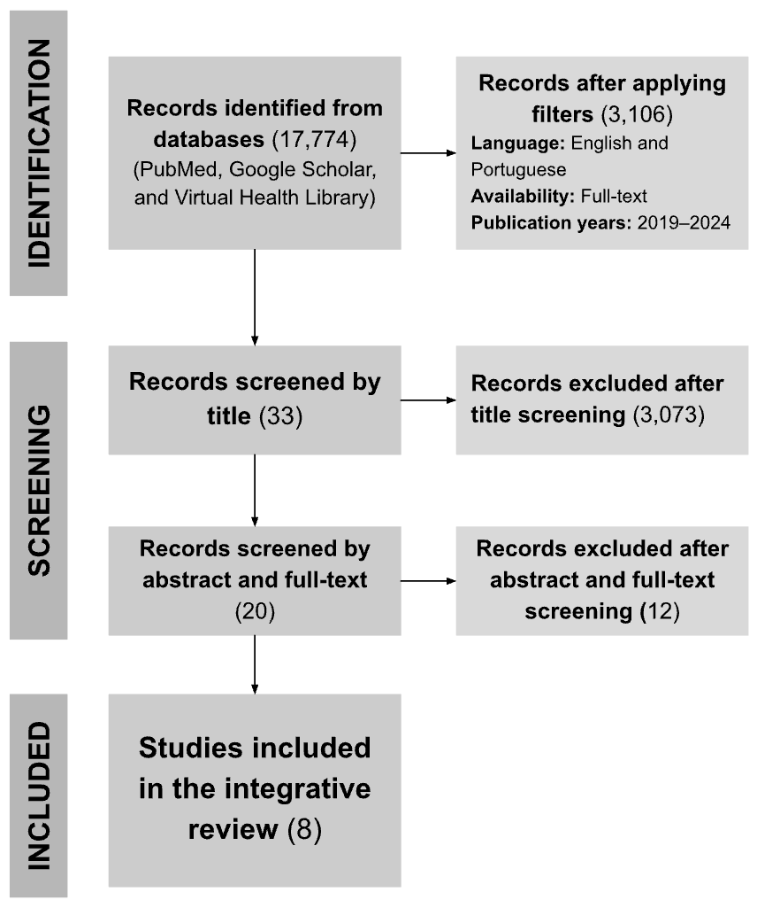

**Source:** Authors (2024)

**Fig. 1.** Flowchart of article selection and inclusion from the searched databases.

**2.6 Data Collection**

After the selection process, the studies were organized in a Google Sheets spreadsheet and categorized according to the following variables: year of publication, authors, title, objective, and conclusion.

**3. results and discussion**

The searches conducted in the selected databases yielded a total of 17,774 references. Filters were then applied, including language (English and Portuguese), full-text availability, and publication period from 2019 to 2024, resulting in 3,106 articles. After title screening, 33 articles were selected. Following abstract and full-text reading, 20 articles were retained. Ultimately, 8 articles met all the eligibility criteria and were included in this integrative review (Table 1).

**Table 1.** General characterization of the studies included in this review according to year, authorship, title, objective, and main conclusions.

| YEAR | **AUTHORSHIP** | **TITLE** | **OBJECTIVE** | **CONCLUSION** |
| --- | --- | --- | --- | --- |
| 2019 | Giuggia *et al.* | Variation in vascular and blood indicators of early endothelial dysfunction after endodontic therapy: A clinical and biomolecular study | To investigate the expression of early endothelial dysfunction markers in young adults with chronic apical periodontitis, before and after endodontic treatment. | Early vascular ED may be caused by AP, but it is reversible with effective endodontic treatment. |
| 2019 | Messing *et al.* | Investigating potential correlations between endodontic pathology and cardiovascular diseases using epidemiological and genetic approaches | Investigating the potential association between endodontic pathology and CVD using epidemiological and genetic approaches. | Significant associations were found between endodontic pathology and various cardiovascular diseases and cardiovascular risk factors, particularly hypertension. |
| 2020 | Aminoshariae *et al.* | The impact of cardiovascular diseases and endodontic outcomes: A systematic review of longitudinal studies | Assessing whether CVD is a risk factor for endodontic outcomes. | CVD may be a risk factor for endodontic outcomes. |
| 2021 | Sebring *et al.* | Endodontic inflammatory disease: A risk indicator for a first myocardial infarction. | Studying the association between endodontic inflammatory disease and a first MI. | Results support the assumption that endodontic inflammatory disease is associated with CVD, as untreated cavities, periapical lesions, and root fillings were significantly associated with a first MI. |
| 2022 | Dash *et al.* | Prevalence and quality of endodontic treatment in patients with cardiovascular diseases and associated risk factors | Determining the prevalence and quality of endodontic treatment by radiographically evaluating periapical periodontitis and endodontic treatment status in CVD patients. | High-risk cardiac and heart disease populations showed poor oral health. A strong association was found between periapical radiolucency, endodontically treated teeth, and periodontal bone loss in CVD and CVD risk patients. |
| 2022 | Bakhsh *et al.* | The impact of apical periodontitis, non-surgical root canal retreatment, and periapical surgery on serum inflammatory biomarkers | Measuring serum molecular inflammation markers in patients undergoing non-surgical root canal retreatment and periapical surgery for AP, and determining if these levels are influenced by the size of the apical radiolucencies at baseline and treatment outcome. | Both symptomatic and asymptomatic AP contribute to elevated serum molecular inflammation markers. Successful endodontic treatment and periapical surgery result in long-term reduction in inflammatory markers. |
| 2023 | Al-Abdulla *et al.* | Successful endodontic treatment reduces serum levels of cardiovascular disease risk biomarkers – High-sensitivity C-reactive protein, asymmetric dimethylarginine, and matrix metalloproteinase-2 | Investigating serum biomarkers of inflammation 2 years after non-surgical Re-RCT and PS. | Chronic AP treatment success is correlated with improvements in metabolic syndrome indicators, better glycemic control, and reduction in systemic inflammatory biomarkers related to cardiovascular disease risks. |
| 2023 | Sebring *et al.* | Primary apical periodontitis correlates with elevated interleukin-8 levels in a Swedish population: A report from the PAROKRANK study | Exploring associations between filled teeth, primary and secondary AP, and inflammatory biomarkers in the blood of patients with first MI and corresponding controls. | This study supports the notion that inflammation in the periapex of a tooth caused by an endodontic infection is more than a local process. Thus, the systemic influence of the infection cannot be disregarded. It is still unknown if the observed changes in plasma inflammatory marker levels, due to the endodontic condition, have any deteriorating effect on systemic health. |

**Abbreviations:** Apical periodontitis (AP); Asymmetric dimethylarginine (ADMA); Cardiovascular disease (CVD); Cardiovascular risk (CVR); C-reactive protein (CRP); Endothelial dysfunction (ED); Matrix metalloproteinase-2 (MMP-2); Myocardial infarction (MI); Non-surgical root canal retreatment (Re-RCT); Periapical periodontitis (PA); Periapical surgery (PS); Root canal treatment (RCT). **Source:** Authors (2024).

An individual's systemic condition is directly linked to their oral health, and harmful effects on oral health can exacerbate general health issues (Malik et al., 2023). Inflammatory changes associated with the oral environment have emerged as a contributing factor to the onset of cardiovascular events, becoming a recurring concern (Koletsi et al., 2021). In this context, the present integrative review focused on the relationship between cardiovascular diseases and their influence on endodontic therapy, emphasizing the main risk predispositions affecting treatment success.

According to the study by Sebring et al. (2021), clinical characteristics were found to have a significant association with an increased risk of myocardial infarction. The number of remaining teeth, presence of carious lesions, periapical lesions in younger patients, and root-filled teeth in older individuals may be related to systemic inflammation due to greater exposure to endodontic infection. In a subsequent study, Sebring et al. (2023) found that the frequency of root-filled teeth was associated with variations in levels of inflammatory cytokines, particularly IL-8, which plays a role in acute immune responses and is linked to the development and severity of apical periodontitis (AP). These findings support the theory that apical periodontitis can contribute to systemic complications, requiring greater attention in predisposed patients, especially those presenting the aforementioned clinical features.

Regarding risk factors, Dash et al. (2022) identified the primary conditions observed in patients with cardiovascular disease (CVD) and those at cardiovascular risk (CVR): dyslipidemia, diabetes, smoking, and hypertension. Dyslipidemia and hypertension are associated with periodontal events that may trigger endothelial dysfunction and result from poor oral hygiene. Diabetes and smoking, respectively, lead to oral and immune system alterations, promoting oral dysbiosis and increasing cardiovascular risk. These findings are in line with Sebring et al. (2023), who demonstrated that such conditions influence bone healing, immune responses of the pulp, and tissue repair processes, particularly when impaired by hyperglycemia.

Two additional studies (Messing et al., 2019; Aminoshariae et al., 2020) also correlate hypertension with endodontic disease. Messing et al. (2019) conducted epidemiological and genetic association studies investigating a possible connection between cardiovascular disease and endodontic pathology, establishing the significance of cumulative risk factors in the development of hypertension and cardiovascular problems in patients with endodontic alterations. Similarly, Aminoshariae et al. (2020) identified hypertension as a risk factor for myocardial infarction, demonstrating that individuals with cardiovascular disease are 67% more likely to experience unsatisfactory endodontic treatment outcomes when compared to a healthy population, thereby affirming the relationship between cardiovascular and oral health.

Regarding inflammatory biomarkers, three studies (Bakhsh et al., 2022; Al-Abdulla et al., 2023; Giuggia et al., 2019) highlighted a reduction in their levels following successful endodontic treatment and improvement in endothelial dysfunction. Bakhsh et al. (2022) conducted a longitudinal cohort study revealing a correlation between apical periodontitis (AP) and elevated systemic inflammation. The biomarkers hs-CRP, IL-1β, FGF-23, and ADMA were found at higher levels in patients with AP, promoting systemic inflammation and increasing the risk of cardiovascular disease.

Supporting the above findings, Al-Abdulla et al. (2023) investigated the impact of endodontic treatment—specifically nonsurgical retreatment and periapical surgery—on serum levels of biomarkers associated with cardiovascular disease. Levels of hs-CRP, ADMA, and MMP-2 significantly decreased two years after treatment, indicating a long-term reduction in systemic inflammation. Elevated MMP-2 levels were associated with tissue repair and remodeling processes throughout the first year, with a more significant and effective progression in healing observed two years post-treatment.

The study conducted by Giuggia et al. (2019) demonstrated increased levels of ET-1, E-selectin, VCAM-1, and ICAM-1 in patients with endodontic lesions compared to a healthy control group. The findings suggest that apical lesions may trigger the overexpression of ET-1, leading to endothelial dysfunction. Following endodontic treatment, reductions in ET-1, ICAM-1, and E-selectin levels were observed, indicating both lesion resolution and improvement in endothelial dysfunction.

Thus, appropriate endodontic therapy appears to confer both local and systemic benefits. Performing endodontic treatment is essential to rule out the potential for systemic manifestations arising from oral infections. Interdisciplinary action is necessary for maintaining oral health and addressing its impact on systemic health. Therefore, further research is crucial to better understand cardiovascular disease as a potential risk factor for endodontic treatment outcomes. Future studies should aim to explore the extent to which successful endodontic interventions may reduce cardiovascular risks, thereby contributing to preventive strategies in at-risk populations.

**4. Conclusion**

Evidence indicates that the presence of clinical characteristics, risk factors, and inflammatory biomarkers is significantly associated with cardiovascular disease and endodontic alterations. It is noteworthy that effective endodontic treatment can reduce the levels of inflammatory biomarkers linked to cardiovascular risk and improve endothelial dysfunction. Therefore, the promotion and maintenance of oral health may help minimize systemic events.

Disclaimer (Artificial intelligence)

The authors declare that AI technology, specifically GPT-4o, was used fairly and solely for rewriting and editing this manuscript, with the specific purpose of correcting the English grammar of the translated text, which was originally written in Brazilian Portuguese. No additional content was added to the text; the AI's role was limited to verifying and refining the accuracy of the translation. The details of AI usage are as follows:

1. The original manuscript, written in Brazilian Portuguese, was translated into English, and AI was employed to ensure that the final text adhered to the grammatical standards of academic English.
2. Specific prompts were designed to guide the AI in providing grammatical corrections and verifying the translation’s alignment with academic conventions.

**References**

Alim, B. A., Guneser, M. B., & Dincer, A. N. (2020). Cardiologists’ and cardiovascular surgeons’ attitudes toward managing endodontic infections and oral health in patients with cardiovascular diseases. *Postgraduate Medicine*, 132(2), 156–161.<https://doi.org/10.1080/00325481.2020.1714205>

Al-Abdulla, N., Majeed, A., Al-Huwaizi, H. F., Almulaiky, Y. Q., Al-Janabi, M., & Alhashimi, N. H. et al. (2023). Successful endodontic treatment reduces serum levels of cardiovascular disease risk biomarkers—high‐sensitivity C‐reactive protein, asymmetric dimethylarginine, and matrix metalloprotease‐2. *International Endodontic Journal*, 56(12), 1499–1516.<https://doi.org/10.1111/iej.13979>

Aminoshariae, A., Kulild, J., & Fouad, A. (2020). The impact of cardiovascular disease and endodontic outcome: A systematic review of longitudinal studies. *Clinical Oral Investigations*, 24, 3813–3819.<https://doi.org/10.1007/s00784-020-03596-8>

Bakhsh, A., Alzahrani, M. A., Alrahlah, A., Alghamdi, F., Almohaimeed, M., & Al-Ahmari, S. et al. (2022). The impact of apical periodontitis, non‐surgical root canal retreatment and periapical surgery on serum inflammatory biomarkers. *International Endodontic Journal*.<https://doi.org/10.1111/iej.13786>

Brasil. Ministério da Saúde. (2021). *Plano de Ações Estratégicas para o Enfrentamento das Doenças Crônicas e Agravos não Transmissíveis no Brasil 2021–2030*. Brasília: Ministério da Saúde. https://www.gov.br/saude/pt-br/centrais-deconteudo/publicacoes/svsa/doencas-cronicas-nao-transmissiveis-dcnt/09-plano-de-dant2022_2030.pdf

Chauhan, N., Bansal, A., Mahajan, P., Gupta, V., Rana, A., & Arora, A. et al. (2019). Association of apical periodontitis with cardiovascular disease via noninvasive assessment of endothelial function and subclinical atherosclerosis. *Journal of Endodontics*, 45(6), 681–690.<https://doi.org/10.1016/j.joen.2019.03.003>

Dash, G., Nayak, M. T., Rao, A., & Paul, S. (2022). Prevalence and quality of endodontic treatment in patients with cardiovascular disease and associated risk factors. *Journal of Clinical Medicine*, 11(20), 6046.<https://doi.org/10.3390/jcm11206046>

Farges, J. C., Alliot-Licht, B., Renard, E., Ducret, M., Gaudin, A., & Smith, A. J. et al. (2015). Dental pulp defence and repair mechanisms in dental caries. *Mediators of Inflammation*, 2015, 1–16.<https://doi.org/10.1155/2015/230251>

Giuggia, B., Pinna, R., Lumbau, A., Milia, E., & Campisi, G. (2019). Variation of vascular and blood indicators of early endothelial dysfunction after root canal therapy: A clinical and biomolecular study. *Giornale Italiano di Endodonzia*, 33(1), 51–56.<https://doi.org/10.32067/gie.2019.33.01.07>

Kim, J., Choi, S., Lee, J. Y., Kim, K. J., Kim, H. S., & Kim, Y. et al. (2021). Association between oral health and cardiovascular outcomes in patients with hypertension: A nationwide cohort study. *Journal of Hypertension*, 40(2), 374–381.<https://doi.org/10.1097/hjh.0000000000003022>

Koletsi, D., Trianti, M., Eliades, T., & Belibasakis, G. N. (2021). Cardiovascular disease and chronic endodontic infection. Is there an association? A systematic review and meta-analysis. *International Journal of Environmental Research and Public Health*, 18(17), 9111.<https://doi.org/10.3390/ijerph18179111>

Malik, R., Zahid, M., Sultana, S., Khan, M., Rahman, S., & Fatima, M. et al. (2023). Impact of dental treatment on oral health-related quality of life of patients. *Cureus*. https://doi.org/10.7759/cureus.38625

Messing, M., Sääf, M., Lund, B., Lager, A., Reit, C., & Renvert, S. et al. (2019). Investigating potential correlations between endodontic pathology and cardiovascular diseases using epidemiological and genetic approaches. *Journal of Endodontics*, 45(2), 104–110.<https://doi.org/10.1016/j.joen.2018.10.014>

Oliveira, G. M. M., Brant, L. C. C., Polanczyk, C. A., Biolo, A., Nascimento, B. R., & Malta, D. C. et al. (2020). Estatística cardiovascular – Brasil 2020. *Arquivos Brasileiros de Cardiologia*, 115(3), 308–439.<https://doi.org/10.36660/abc.20200812>

Sebring, D., Johansson, L., Jansson, L. E., Frisk, F., & Frisk, M. et al. (2021). Endodontic inflammatory disease: A risk indicator for a first myocardial infarction. *International Endodontic Journal*.<https://doi.org/10.1111/iej.13634>

Sebring, D., Johansson, L., Frisk, F., & Frisk, M. (2023). Primary apical periodontitis correlates to elevated levels of interleukin‐8 in a Swedish population: A report from the PAROKRANK study. *International Endodontic Journal*, 57(1), 12–22.<https://doi.org/10.1111/iej.13987>

World Health Organization. (2023). *Cardiovascular diseases (CVDs)*.<https://www.who.int/news-room/fact-sheets/detail/cardiovascular-diseases-(cvds)>

Bezamat, M. (2022). An updated review on the link between oral infections and atherosclerotic cardiovascular disease with focus on phenomics. *Frontiers in physiology*, *13*, 1101398. <https://doi.org/10.3389/fphys.2022.1101398>

Koletsi, D., Iliadi, A., Tzanetakis, G. N., Vavuranakis, M., & Eliades, T. (2021). Cardiovascular disease and chronic endodontic infection. Is there an association? A systematic review and meta-analysis. *International journal of environmental research and public health*, *18*(17), 9111.

Arora, S., Kumari, M., & Kochhar, R. (2024). Association of endodontic pathology and cardiovascular disease: A scoping review. *Endodontology*, *36*(3), 210-215.

Cowan, L. T., Lakshminarayan, K., Lutsey, P. L., Beck, J., Offenbacher, S., & Pankow, J. S. (2020). Endodontic therapy and incident cardiovascular disease: The Atherosclerosis Risk in Communities (ARIC) study. *Journal of public health dentistry*, *80*(1), 79-91.