Development of Aluminium Boiling Pot Incorporated with Fractally Generated Internal Cylindrical Fins

ABSTRACT
Aluminium boiling pots as typical in heated liquid-filled vessels are indispensable for heating purposes especially for domestic water boiling. Available information on its current design showed that it required prolonged heating duration, leading to high consumption of fuel such as Liquefied Petroleum Gas (LPG). Internal cylindrical fins are used in heated liquid-vessels, but with limited heat transfer enhancement. Fractal induced surfaces being self-similar geometrical-objects have high potential for heat transfer enhancement, but there is dearth of information in their use for aluminium boiling pot’s integrated with internal cylindrical fins. Therefore, a 7-litre Experimental Aluminium Boiling Pot (EABP) and internal cylindrical fins (Ø5×140 mm) were designed and fabricated in this study. The EABP had base-thickness, height, internal-diameter and external-diameter of 10, 155, 258 and 274 mm, respectively and 121 fractal placement locations for the internal cylindrical fins. The chemical constituents of all the critical elements in the aluminium used to fabricate the EABP and the internal cylindrical fins fall within the allowable composition for food grade aluminium. Hence, the use of the EABP for boiling water poses no danger to human health. The pot performance when filled with liquid and containing selected number of internal cylindrical fins placed according to affine rules can be evaluated for arbitrary Iterated Fractal System (IFS). The EABP when incorporated with fractally positioned internal cylindrical fins will provide solutions for household sectors on how water heating can be done faster with minimal LPG’s cost.

Keywords: Aluminium boiling pot, Fractal objects, Internal cylindrical fins, Heat transfer enhancement

1.0 Introduction
Without cookware, humans cannot easily heat water and cook their foods. Pots are used in almost all households, kitchens and restaurants for heating water and to prepare various meals (Guma and Uche, 2019a). Aluminium pots are commonly used cookware because of their ability to heat and cool more quickly, light-weight and fair strength, excellent corrosion resistance, low cost due to availability of raw materials, ease to be fabricated, formed and machined, unsurpassable recyclability and casting properties of the raw materials, durability, etc, compared to most other food-grade metal containers (Guma and Durami, 2019).
Foundry technology is one of the vital bases for rapid industrial development of any nation. Sand casting is the most versatile, widely used and important method of casting and accounts to about 70 % of all foundry products (Guma, 2010; Guma, 2012; Ogboi, 2018; Guma and Ogboi, 2019). Metals that can be sand-cast include ferrous metals such as steel, cast iron and many non-ferrous metals, but aluminium is the most commonly used metal in the metal casting industries due to its comparatively far more properties of casting merit than other metals (Guma and Uche, 2019b).
Over the years, many interesting studies have been done in improving cook stove efficiency. Khan and Saxena (2013) used several burner head designs to study how well an LPG cooking stove performed. Ali (2014) conducted performance tests on a home LPG stove using a conventional burner and porous material. Obada et al. (2014) designed and built burner system that runs on biogas. The parametric research of gas burners with high efficiency and minimal emissions was the focus of Hou and Chou (2013). Anafi et al. (2018) developed a low-cost pressurized kerosene stove. The pressured kerosene stove outperformed the traditional kerosene stove (wick stove) in terms of heat generation and carbon soot production, according to the findings of their performance test. The performance and emission characteristics of the pongamia oil-kerosene blend used in commercial kerosene stoves were studied by Shetty et al. (2015). An enhanced charcoal cooking stove was designed, manufactured, and its performance evaluated by Komolafe and Awogbemi (2010). Masekameni et al. (2015) examined the emissions and thermal performance of three liquid fuel stoves- a kerosene stove, an ethanol gel stove, and a prototype methanol stove. Varun et al. (2018) used waste cooking oil – kerosene blends to study the efficiency and emission properties of commercial kerosene stoves. Tesfay et al. (2024) compared the performance of three recently created biomass stove prototypes with conventional and Mirt stoves.
One of the most crucial aspects of fuel conservation is the water boiling pot's contact surface with the flame. The pot itself has an improved thermal efficiency because of its design and unobstructed heat transfer capabilities. In order to minimize wasted flames escaping through the pot's edges, the flame beneath the water boiling pot should be in direct contact with the pot itself. This reduces efficiency because excess flame that rises above the pot skirt's size is lost to the atmosphere. The round-bottomed pots are more stable because of their lower center of gravity. The use of flat-bottom pots, which became widespread due to European influence, is prevalent in many locations these days (Singh and Sahu, 2017). WHO (2008) defined efficiency as the sum of heat transfer efficiency and combustion efficiency. Heat transfer efficiency may be significantly influenced by the shape of the pot bottom. The concept that a flat-bottom pot is a "standard pot" stems from the fact that most writers examined stove efficiency but did not conduct many trials with water boiling pots. The geometry of the pot and the relationship between pot design and heat transfer efficiency were not expressly addressed by Baldwin (1987) when he discussed pot efficiency.
Singh and Sahu (2017) enhanced the boiling heat transfer of pots by redesigning the pots’ bottom surface through surface modification with flue tube arrangement. The authors compared the thermal efficiency of three different modified bottom surfaces with flue tubes to those of a conventional flat bottom pot. According to this research, the boiling pot with flue tube modified bottom produced an efficiency that was 9-10 % greater than the pot with a flat bottom. It was further revealed from their study that boiling point is reached earlier in modified bottom pot with flue tube compared to other pots. Singh and Sahu (2018) also corroborated the earlier study of Singh and Sahu (2017) through the use of boiling pots with modified bottom surfaces made of vertical tubes. According to their results, boiling pots with modified bottom surfaces made of vertical tubes had an efficiency that was 25-29 % higher than pots with an unaltered flat bottom. Additionally, their findings demonstrated that the boiling point is achieved faster in modified pots than in unaltered pot.
Wang et al. (2022) also enhanced the boiling heat transfer ability of cookware through surface modification by the addition of fins on the base of the wok and observed that when 42 fins are considered for the study, overall efficiency of cookware is enhanced by approximately 8 % compared to the basic cookware that lacks this kind of heat exchange. Naphon (2014) carried out the thermal efficiency of fabricated domestic cooking pots modified with spirally twisted tape and with or without insulation. The author’s results obtained from the modified cooking pot compared with those from the standard cooking pots. It was found that the modified cooking pot required 15-20 % less energy than the standard cooking pot to bring water to boiling.
The heat conductivity of a locally manufactured cast aluminum pot was analyzed by Fierkwap and Ilouno (2021). According to the authors' investigation, the kind and composition of materials used to make a pot can affect its thermal characteristics. Cast aluminum pots have different thermal qualities from one another. 162.36 W/m/K was found to be the average thermal conductivity of the cast aluminum pots. This suggests that it will conduct more heat through its layer and that food and water will not often react with it. The authors also disclosed that, in comparison to other pots, cast aluminum pots have a reasonably high thermal conductivity, which saves a significant amount of time during cooking and water heating.
The impacts of fractal surface geometries and boundaries have been a topic of interest for fractal study in engineering. It has proven possible to organise an object's conductivity by arranging fractal patterns. Kacimov and Obnosov (2000) found that by organising distinct materials with different thermal conductivities using a Sierpinski carpet pattern, the overall thermal conductivity may be changed to suit needs. According to Adrover (2010), the surface fractal dimension has a significant impact on the thermal boundary layer for convection; surfaces with a higher fractal dimension transport more heat. Anton (2017) conducted a study on the thermal efficiency of a double-pipe heat exchanger with a Koch snowflake fractal pattern. Several heat transfer enhancement techniques can be applied to double-pipe heat exchangers to increase their efficacy. In particular, the Koch snowflake fractal pattern was included into the cross-section of a heat exchanger's inner pipe. The heat exchanger's surface area increased when the Koch snowflake fractal pattern was used. Based on the study, it was discovered when compared to a conventional double-pipe heat exchanger with a circular cross-section; a double-pipe heat exchanger with a cross-section in line with the second iteration of the Koch snowflake fractal pattern produced an increase in the overall heat transfer coefficient and heat transfer rate of 18 % and 75 %, respectively.
Guo et al. (2024) conducted an experimental study on the use of fractal fins to enhance heat transfer of phase change materials. The authors created and produced fractal fins modeled after plant leaves to increase the phase change unit's heat charging capacity. Their findings demonstrated that fractal fins have superior heat transfer enhancement effects compared to rectangular fins because the enhancement of heat conduction surpasses the suppression of natural convention. Oskouei et al. (2023) used the Fibonacci sequence as the basis for their fin design. In comparison to conventional longitudinal fins, experimental and numerical results demonstrate that this fin's total melting time of latent heat thermal energy storage is shortened by 20%, solidification speed is increased by 45%, and the temperature distribution is more uniform due to the secondary flow produced by the Fibonacci fins. Jiang et al. (2023) used numerical simulation to examine how the melting process in the rectangular phase change unit was affected by various position ratios, length ratios, and fin counts of tree-like fins. Zhang et al. (2022) created a fin that was modeled after snowflakes and conducted experiments to compare units with the same volume fraction that had longitudinal fins, no fins, and snowflake fins. The melting and solidification durations of units with snowflake fins can be shortened by 32.23% and 51.81%, respectively, as compared to longitudinal fins. Snowflake fins are also clearly more advantageous for the process of heat discharge.
The impact of combining various fractal fins on the melting process was examined by Luo et al. (2022). Numerical simulation was used to compare the effects of the fins' distance from one another, their heat transfer area, and their combination on the fins' thermal characteristics. According to the findings, the composite fractal fin heat exchanger's phase change materials' total melting time is up to 68% less than that of the traditional fractal fin heat exchanger. Through numerical simulations and experiments, Shi et al. (2022) examined the impact of the fractal fins' length, width, and bifurcation angle on the enhancement of heat transfer in a double-channel finned tube. They also examined the melting processes when the two tubes were in different operating states for heat charging and discharging. Using spider webs as inspiration, Wu et al. (2020) created mesh fins that enhanced solidification performance and reduced the total solidification time by 47.9% when compared to longitudinal fins of the same volume.
Some researchers in the time past such as Wang et al. (2022), Sing and Sahu (2017) and Sing and Sahu (2018) enhanced boiling pot’s heat transfer through the use of fins, surface modification with flue tube and modified surface geometry. But, enhancements of boiling pot’s heat transfer through the use of fractally generated internal cylindrical fins have not been captured. Hence, despite the potential of fractals for heat transfer enhancement, the scholarly discourse remains scant, particularly regarding their use in aluminium boiling pots. Consequently, the aim of the study was to design and fabricate an aluminium water boiling pot that incorporates internal cylindrical fins whose position/location are fractally generated using affine rules. A computer source codes that can generate arbitrary Iterated Fractal System (IFS) as well as their corresponding internal cylindrical fins placement locations on the bottom plate of the pot was also implemented.

2.0 Materials and Methods

2.1 Materials
The materials used include aluminium wire and aluminium alloy. Aluminium wire was procured for the construction of the internal cylindrical fins. The EABP was produced by sand casting from aluminium alloy.
2.2 Chemical Analysis
The chemical analysis of the percentage elemental weight chemical constituents of the aluminium alloy and aluminium wire used for the fabrication of the EABP and internal cylindrical fins, respectively, were carried out with EDX3600B X-ray Fluorescence Spectrometer at the National Agency for Science and Engineering Infrastructure (NASENI), Km 4, Ondo Road, Akure, Ondo State, Nigeria. The EDX3600B X-ray Fluorescence Spectrometer applies XRF technology to conduct fast and accurate analysis of complex composition. Akure is located between latitude 7°17’ N and longitude 5°4’ E (Olajuyigbe et al., 2016).
2.3 Design of the Experimental Aluminium Boiling Pot
A 7-litre EABP was designed and fabricated by sand casting using aluminium alloy. The detailed drawings of the experimental pot are shown in Figure 1.

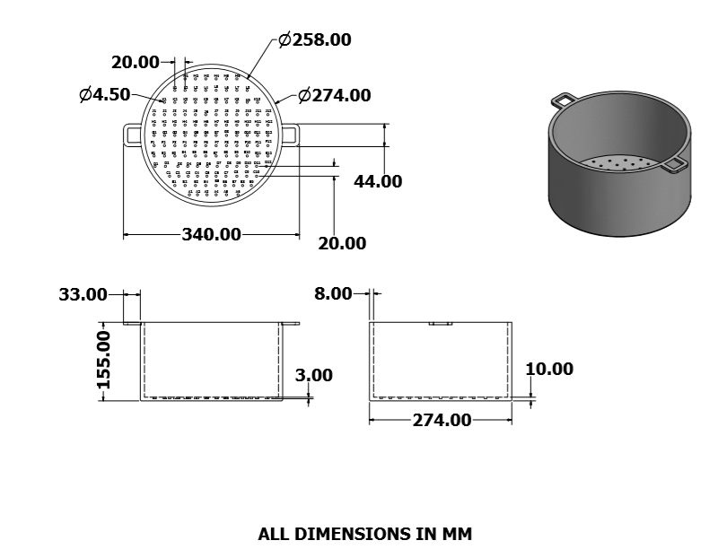
Figure 1: EABP
2.4 Design of the Bottom Plate of the Experimental Aluminium Boiling Pot
The bottom plate of the EABP was divided into twenty four (24) grid lines at an equal interval of 10 mm along both horizontal and vertical axes. The coordinates of each of the formed points at 20 mm interval on both vertical (A, B, C…H, J, K, L, M) and horizontal (1, 2, 3…, 12) axes on the bottom plate of the pot were marked and properly labelled as shown in Figure 2. These formed points are one hundred and twenty one (121) in number and they are the potential fractal placement locations for the internal cylindrical fins. Holes of diameter Ø4.5 mm were drilled to a depth of 3 mm through the 121 potential fractal placement locations for the internal cylindrical fins heat transfer surfaces.
Preliminary investigation on the study revealed that better performance of the internal cylindrical fins can be achieved without causing the leakages of the pot when placed at fractal locations formed at 20 mm interval on both axes on the bottom plate of the pot.
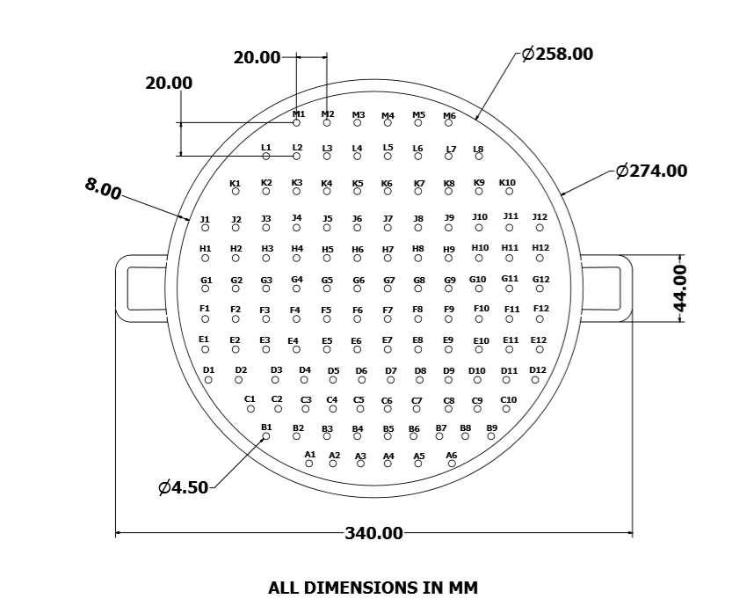
Figure 2: Bottom Plate of the EABP Showing the Internal Cylindrical Fins’ Potential Placement Locations
The one hundred and twenty one potential fractal placement locations for the internal cylindrical fins are labelled from A1(8,2), A2(10,2), A3(12,2), A4(14,2), A5(16,2), A6(18,2), B1(6,4), B2(8,4), B3(10,4), B4(12,4), B5(14,4), B6(16,4), B7(18,4), B8(20,4), B9(22,4), C1(4,6), C2(6,6), C3(8,6), C4(10,6), C5(12,6), C6(14,6), C7(16,6), C8(18,6), C9(20,6), C10(22,6), D1(2,8), D2(4,8), D3(6,8), D4(8,8), D5(10,8), D6(12,8). D7(14,8), D8(`16,8), D9(18,8), D10(20,8), D11(22,8), D12(24.8), E1(2,10), E2(4,10), E3(6,10), E4(8,10), E5(10,10), E6(12,10), E7(14,10), E8(16,10), E9(18,10), E10(20,10), E11(22,10), E12(24,10), F1(2,12), F2(4,12), F3(6,12), F4(8,12), F5(10,12), F6(12,12), F7(14.12), F8(16,12), F9(18,12), F10(20,12), F11(22,12), F12(24,12), G1(2,14), G2(4,14), G3(6,14), G4(8,14), G5(10,14), G6(12,14), G7(14,14), G8(16,14), G9(18,14), G10(20,14), G11(22,14), G12(24,14), H1(2,16), H2(4,16), H3(6,16), H4(8,16), H5(10,16), H6(12,16), H7(14,16), H8(16,16), H9(18,16), H10(20,16), H11(22,16), H12(24,16), J1(2,18), J2(4,18), J3(6,18), J4(8,18), J5(10,18), J6(12,18), J7(14,18), J8(16,18), J9(18,18), J10(20,18), J11(22,18), J12(24,18), K1(4,20), K2(6,20), K3(8,20), K4(10,20), K5(12,20), K6(14,20), K7(16,20), K8(18,20), K9(20,20), K10(22,20), L1(6,22), L2(8,22), L3(10,22), L4(12,22), L5(14,22), L6(16,22), L7(18,20), L8(20,22), M1(8,24), M2(10,24), M3(12,24), M4(14,24), M5(16,24) and M6(18,24) respectively.
2.5 Design of Internal Cylindrical Fins
The heat transfer internal cylindrical fins were designed to be of equal dimension Ø5140 mm and chamfered at one end to diameter Ø3 mm in order to be comfortably fitted into any of the 121 placement locations on the bottom plate of the EABP. The one hundred and forty (140) millimetre length of the fins was selected in order to transfer heat to at least ninety percent (90 %) of the entire height of the pot when placed at the fractal fin locations on the bottom plate of the pot. Figure 3 shows the diagram of the heat transfer internal cylindrical fins.
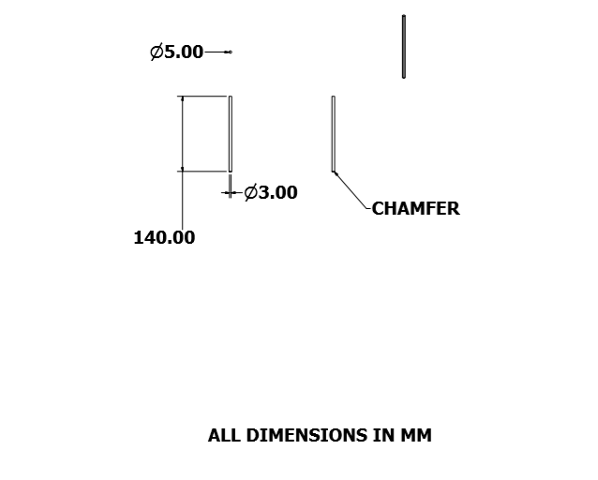Figure 3: Internal Cylindrical Fin

2.6 Fabrication Procedures of the 7-Litre Experimental Aluminium Boiling Pot
Sand casting was used as the fabrication method of the EABP because of its simplicity and almost any material can be cast, no limit to size, shape or weight. The casting was carried out at the Foundry Unit of Olusegun Obasanjo Centre for Engineering Innovation, The Federal Polytechnic, Ado-Ekiti, Ekiti State, Nigeria. Ado-Ekiti is situated between longitude 05° 06' 18" and 05°24' 00" East of the Greenwich Meridian and latitude 07° 32' 11" to 07°40' 28" North of the Equator (Aroge et al., 2023). The basic steps taken are:
Step 1: Pattern Production
The pattern of the EABP was made from an existing pot. The pot was cut into two equal halves in order to form the two pieces of the pattern. The explicit drawing of the pattern is shown in Figure 4.
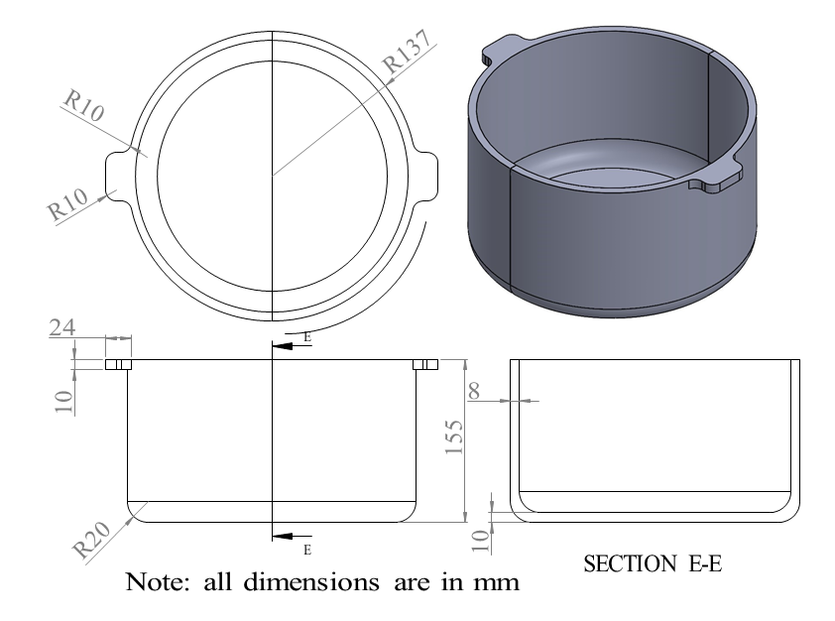
Figure 4: Pattern
Step 2: The moulding box consists of the drag and cope. It was made from wooden materials. The drag is the lower part of the moulding box and consists of two equal halves, while the upper part is called the cope. The flask which is the assembly of the drag and cope is shown in Figure 5.
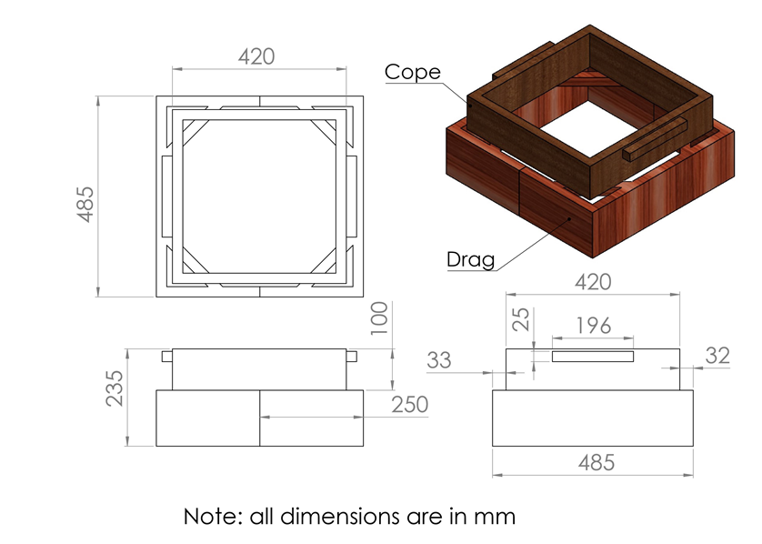 Figure 5: Flask
Step 3: The upper part of the moulding box called the cope is placed on the drag containing the pattern, filled with sand and gently hammered with provision made for the runner on top of the cope for the entrance of the molten metal as shown in Plate 3.2.
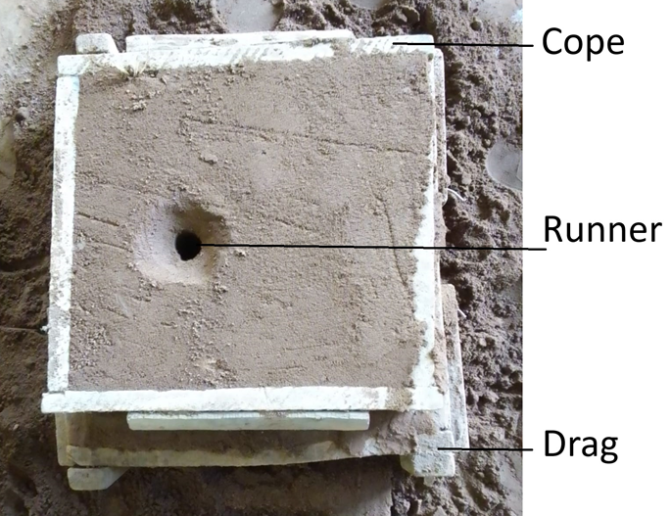
Plate 1: Assembly of Cope and Drag Showing the Runner.

Step 4: The cope and the two halves of the drag were dissembled in order to remove the pattern from the mould cavity as shown in Plate 3.3.
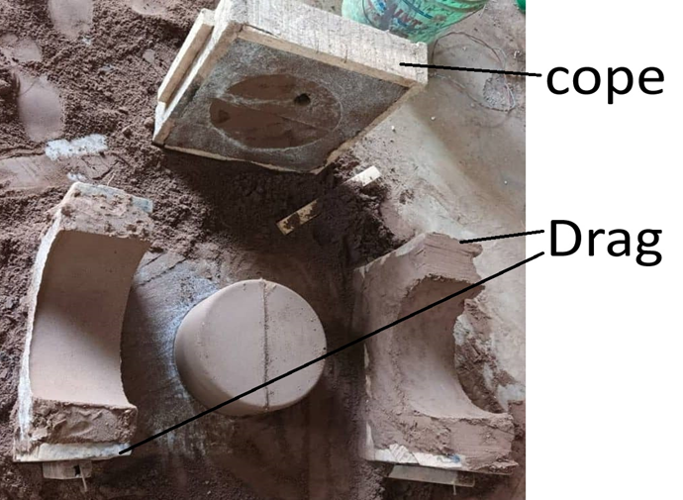
Plate 2: Dissembled Cope and Drag

Step 5: The cope and drag are assembled together while the molten metal is poured into the mould cavity through the runner. After pouring, the metal is left to cool and solidify. On completion, the sand moulds are removed from the flask and the cast aluminium pot knocked out while the removal of sharp edges of the cast aluminium pot was done by using grinding machine and the potential fractal placement locations of the internal cylindrical fins on the bottom plate of the pot were marked out and drilled accordingly.
2.7 Iterated Fractal System (IFS) Algorithms Computer Source Codes
The IFS fractals can be obtained by playing ‘Chaos Game’ with their corresponding affine functions that are finite in number. According to Scheinerman (1996), affine functions are of the general form given by equation (1). Therefore a function ‘g’ is defined by specification of value for six numbers ‘a’ through ‘f’. Similarly and with respect to equation (1) a matrix ‘A’ and its corresponding determinant ‘DET’ can also be defined respectively as in equations (2) and (3). For this study, the IFS based algorithms computer source codes for the generation of arbitrary selected fractal objects and their corresponding internal cylindrical fins’ placement locations on the bottom plate of the pot were illustrated by the flowchart in Figure 6. The flowchart derived its strength from equations (1) to (3) for finite affine functions called ‘Iaff’ to play the ‘Chaos Game’ and obtain 2-dimensional Cartesian coordinate solutions of associated arbitrary IFS fractal. The solutions were thereafter transformed to potential cylindrical fin locations from which locations for number experimental fins are selected on first appearance basis.
(1)

(2)

(3)

START

Read Ngrids

Read Nat, Xstat, Ystat, Itrade, Ndpt, Iseedd

X(1) = Xstat
Y(1) = Ystat
Iseed = Iseedd

Read iaff

Sum = 0

i = 1, iaff

B

A

A
B
i < iaff
Sum = Sum + det
Pr (i) = Det
Det = abs (coe (i, 1)* coe (i, 4 – coe (i, 3) * coe (i, 2))
Read
Coe (i,j), j = 1, 6
AAAAA

YES

NO
Prob (1) = 0.0

D
i = 2, iaff+1

Prob (i) = Prob (i-1) + Pr (i-1) / Sum

C

D
C

i < iaff + 1

YES
iset = i-1
Prob (i-1)<= xx
xx<= Prob (i)

i = 2, iaff + 1
Xx = ran (iseed)
Iset = 1
E
j = 2, itrade

G

YES

F

G
i < iaff + 1
F

YES

E
NO
j < itrade
x(j) = coe (iset,1)*x(j-1) + coe(iset,2)*y(j-1) + coe (iset,5)
y(j) = coe (iset,3)*x(j-1) + coe(iset,4)*y(j-1) + coe(iset,6)

YES

NO
H
j =1
x(j) = x(itrade)
y(j) = y(itrade)
Ix = Nint(x(j)*float(Ngrids))
Iy = Nint(y(j)*float(Ngrids))
Ixy(1,1) = Ix
Ixy(1,2) = Iy

Prob(i-1) <= xx
Xx <= Prob(i)
iset = i-1
i = 2, iaff + 1
Xx = ran(iseed)
Iset = 1
I
j = 2, Ndpt
Write j, x(j), y(j), Ix, Iy
H

YES

NO
i < iaff + 1

YES

NO

J
I
j < Ndpt
Write j, x(j), y(j), Ix, Iy
x(j) = coe(iset,1)*x(j-1)+coe(iset,2)*y(j-1)+coe(iset,5)
y(j) = coe(iset,3)*x(j-1)+coe(iset,4)*y(j-1)+coe(iset,6)
Ix = Nint(x(j)*float(Ngrids))
Iy = Nint(y(j)*float(Ngrids))
Ixy(j,1) = Ix
Ixy(j,2)= Iy

J

YES

NO
L
K
K = 1, NHTF
Read Number of Heat Transfer Fingers (NHTF)

STOP
L
K < NHTF
Write K, (Ixy(Np,J),j = 1,2)
Xr = ran(iseed)
Np = Nint (Xr*float(Ndpt))
K

YES

NO

Figure 6: The Selected Fractal Objects Algorithms/ Flowchart

The chaos game based algorithms computer source codes illustrated in the flowchart can generates arbitrary IFS fractal objects such as Koch Curve, Xmas Tree, Triangle, Fractal-L and Fractal-T among others and their corresponding internal cylindrical fins’ placement locations on the bottom plate of the fabricated experimental aluminium boiling pot.
2.8 Formation of Experimental Aluminium Boiling Pot Incorporated with Internal Cylindrical Fins.
Experimental Aluminium Boiling Pots denoted by EABP3, EABP5, EABP7 and EABP9 were obtained by placing 3, 5, 7 and 9 internal cylindrical fins, respectively, on the bottom plate of the experimental pot at placement locations determined by arbitrarily selected generated IFS fractal objects.
3.0 Results and Discussion
3.1 Chemical Composition
Aluminium alloys can contain elements in quantities that negate health safety. So, when aluminium is used in the food industry, there are rules as to what the content of each aluminium alloy must be for food industry applications. There are maximum tolerances laid down according to European food law EN 602 (2007) in connection with the use of aluminium in the food industry. The maximum content of certain elements in aluminium alloys used in the food industry are shown in second row of Table 1 (Ogboi, 2018; Technical Document Guidelines, 2002; Foods Standard Agency Guidance, 2008). The third and fourth row of Table 1 show the percentage content of each of the constituent element of the aluminium alloy and aluminium wire used in the fabrication of the EABP and internal cylindrical fins, respectively, as determined by EDX3600B X-ray Fluorescence Spectrometer.
Table 1: The Percentage Content of Certain Elements in Aluminium Alloy and Aluminium Wire Used in the Fabrication of the EABP and the Internal Cylindrical Fins Compared with Maximum Allowable Contents of Aluminium Alloys Used in the Food Industry
Element | Si | Fe | Cu | Mn | Mg | Cr | Ni | Zn | Zi | Ti | Al | Remark
Max. Content  By mass (%) | 13.50 | 2.00 | 0.60 | 4.00 | 11.00 | 0.35 | 3.00 | 0.25 | 0.30 | 0.30 |  | Ogboi (2018); Technical Document Guidelines (2002); Foods Standard Agency Guidance (2008))
Aluminium Alloy | 10.72 | 2.17 | 2.67 | 0.15 | 6.83 | 0.01 | 0.24 | 1.88 | 0.00 | 0.39 | Balance | Present Study
Aluminium Wire | 13.90 | 1.11 | 0.00 | 0.03 | 5.36 | 0.01 | 0.04 | 0.24 | 0.00 | 0.00 | Balance | Present Study

From Table 1, it can be observed that all the critical chemical elements in the aluminium alloy and aluminium wire used to fabricate the EABP and the internal cylindrical fins fall within the allowable composition for food processing applications. In addition, aluminum reacts with acidic water and food, causing the metal to leach into the water and food and thereby make its way into the body. To ensure the aluminum remains intact, the fabricated EABP and the internal cylindrical fins can be subjected to an electrochemical process called anodization. This forms a much thicker layer of non-reactive aluminum oxide, creating what is known as anodized or hard-anodized aluminum. As a result, most aluminum cookware is either coated with a non-stick layer or is anodized (Ali Sultan et al., 2023; Ali et al., 2021). Avoiding use of the EABP for boiling acidic water can drastically reduce aluminium exposure to leaching effect. The use of EABP for boiling acidic water can increase aluminium leaching.
3.2 The Fabricated 7-litre Experimental Aluminium Boiling Pot and Internal Cylindrical Fins.
The fabricated 7-litre EABP is shown in Plate 3. The pot weighs 3348 g. It has base thickness, height, internal diameter and external diameter of 10, 155, 258 and 274 mm, respectively. Also, the EABP was produced with a feature of one hundred and twenty one (121) placement locations for the internal cylindrical fins as shown in Plate 4.
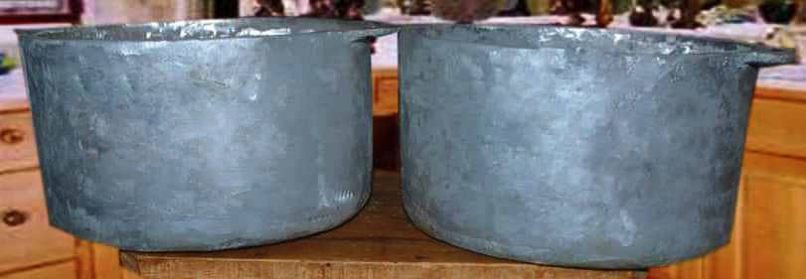
Plate 3: 7-litre EABPs

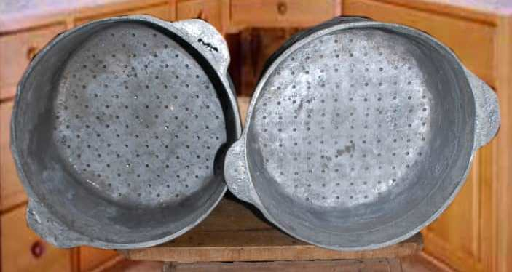
Plate 4: 7-litre EABPs Showing the Internal Cylindrical Fins’ Potential Placement Locations
The fabricated internal cylindrical fins are shown in Plate 5.
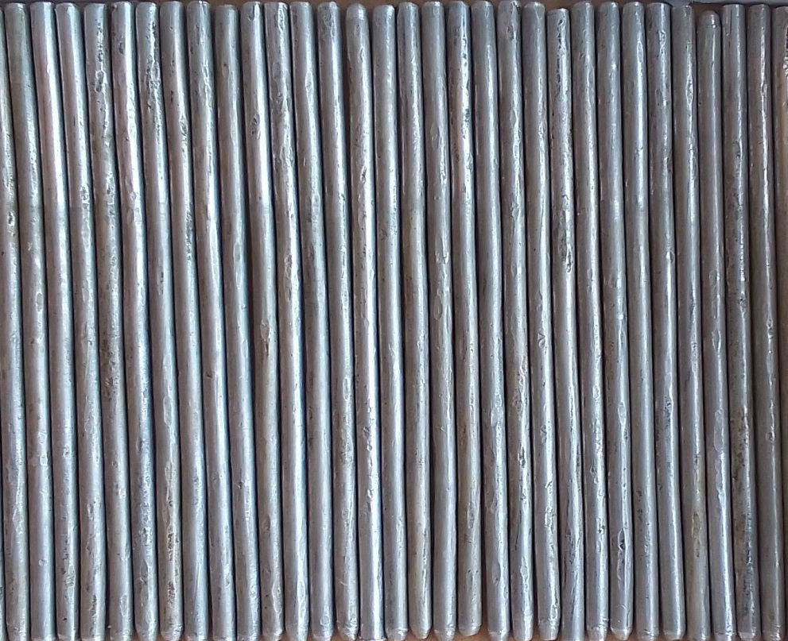
Plate 5: Heat Transfer Internal Cylindrical Fins (Ø5140 mm)

3.3 Fabricated Experimental Aluminium Boiling Pot Incorporated with Internal Cylindrical Fins
Some of the EABPs formed by placing 3 and 5-internal cylindrical fins on the bottom plate of the pot using Xmas Tree affine rule respectively are shown in Plates 6 and 7.
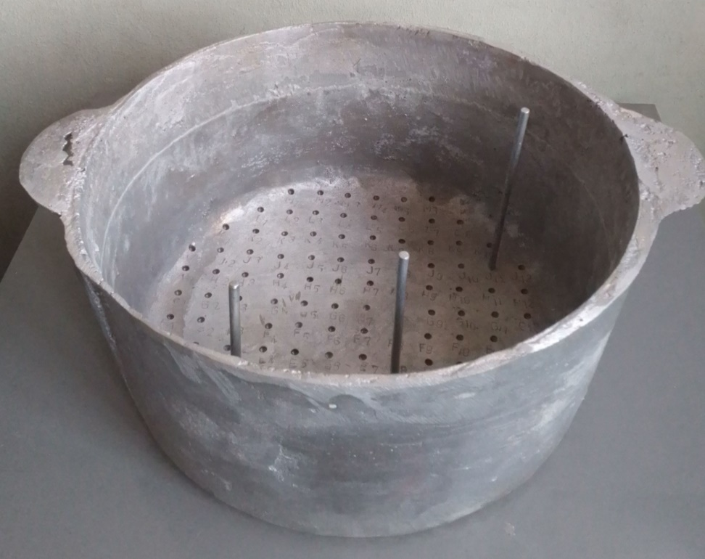
Plate 6: The EABP Incorporated with Xmas Tree Rule Using 3-Internal Cylindrical Fins

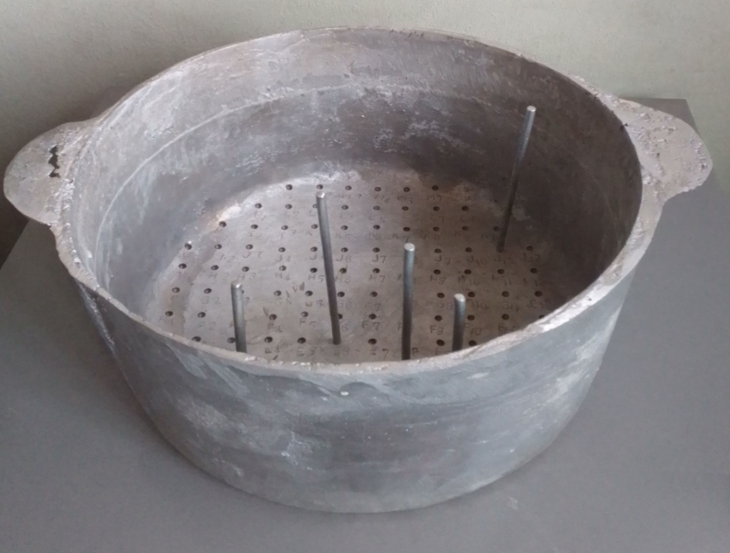
Plate 7: The EABP Incorporated with Xmas Tree Rule Using 5-Internal Cylindrical Fins
4.0 Conclusion
In this study, a novel water boiling pot was successfully developed. This pot has a feature that can accommodate internal cylindrical fins whose placement locations were determined by Iterated Fractal System that are generated using chaos game method. The fins are capable of improving the boiling pot performance when compared to traditional water boiling pot in terms of shortest boiling time as well as fuel consumption.

Disclaimer (Artificial intelligence)
Option 1:
Author(s) hereby declare that NO generative AI technologies such as Large Language Models (ChatGPT, COPILOT, etc.) and text-to-image generators have been used during the writing or editing of this manuscript.
Option 2:
Author(s) hereby declare that generative AI technologies such as Large Language Models, etc. have been used during the writing or editing of manuscripts. This explanation will include the name, version, model, and source of the generative AI technology and as well as all input prompts provided to the generative AI technology
Details of the AI usage are given below:
1.
2.
3.

5.0 References
Adrover, A. (2010). Laminar convective heat transfer across fractal boundaries. Europhysics Letters, 90(1): 1-6. DOI 10.1209/0295-5075/90/14002

Ali, F.; Israr, M.; Ur Rehman, S.; Azizullah, A.; Gulab, H.; Idrees, M and Al-Zuaibr, F. M. (2021). Health risk assessment of heavy metals via consumption of dietary vegetables using wastewater for irrigation in Swabi, Khyber Pakhtunkhwa. Pakistan. PLoS ONE, 16, e0255853.

Ali, S.M.M. (2014). Performance of domestic LPG cooking stove with porous media. Open Access Library Journal, 1: 1-5 doi:10.4236/oalib.1100864

Ali Sultan, S. A.; Ahmed Khan, F.; Wahab, A.; Fatima, B.; Khalid, H.; Bahader, A.; Saﬁ, S. Z.; Selvaraj, C.; Ali, A. and Alomar, S.Y. (2023). Assessing leaching of potentially hazardous elements from cookware during cooking: A serious public health concern. Toxics, 11, 640. https://doi.org/10.3390/ toxics1107064
Anafi, F.O., Obada, D.O., Balogun, M.B. and Dambvo, L. (2018). Development, evaluation and soot formation characteristics of a low-cost pressurized kerosene stove. The Journal of the Association of Professional Engineers of Trinidad and Tobago, 46(1): 13-21

Anton, G. (2017). Thermal performance of a double-pipe heat exchanger with a koch snowflake fractal design. Electronic Theses and Dissertation, 1697, Georgia Southern University. http://digitalcommons.georgiasouthern.edu/etd/1697

Aroge, S. K., Ojo, R. S., Suru, W. P., Odeyemi, F. G. and Adewole, B. E. (2023). Geospatial distribution pattern of primary schools in Ado Local Government Area of Ekiti State. International Journal of Advances in Engineering and Management, 5(1): 1110-1127, DOI: 10.35629/5252-050111101127

Baldwin, S. F. (1987). Biomass stoves: Engineering design, development, and dissemination, Volunteers in Technical Assistance (VITA), Centre for Energy and Environmental Studies, Princeton University, New Jersey 08544 USA, 15.

Scheinerman, E. R. (1996): Invitation to Dynamical Systems, Prentice Hall, Inc. A Simon & Schuster Company, Upper Saddle River, New Jersey 07458, pp.271-316.

Foods Standard Agency (2008). Guidance on legal compliance and best practice for business documentation. Materials, and Articles in Contact with Food, September.

Fierkwap, S. B. and Houno, J. (2021). Analysis of the thermal conductivity of locally made cast aluminium pots. International Journal of Innovative Scientific and Engineering Technology Research, 9(2): 23-32.

Guma T.N., and Durami Jahleel, A. (2019). Assessment of alkaline food environment corrosion with some menus at a cadet mess on the tensile strength of aluminum 6063 alloy. International Journal for Research in Applied Science & Engineering Technology, Volume 7, Issue 1, January.

Guma, T. N. and Ogboi U. L. (2019). Sand mould design for casting an aluminum Pot - A basic procedure of supplementing artisanal practice. European Journal of Engineering Research and Science, 4(4): 24-30.

Guma, T. N. and Uche, O. L. (2019a). A typification of foundry practices for correct artisanal sand casting of aluminium pots. International Journal of Engineering Applied Sciences and Technology, 4(4): 169-17

Guma, T. N. and Uche, O. L. (2019b). Sand mould design for casting an aluminium pot – a basic procedure of supplementing artisanal practices. European Journal of Engineering Research and Science, 4(4): 24-30

Guma, T. N (2010). Effect of ‘illo’ clay and corn flour additives on the foundry properties of Kaduna River Sand in Nigeria. Journal of Chemical, Mechanical and Engineering Practice, Volume 1, Numbers 2 & 3, December.

Guma, T. N. (2012). Characteristic Foundry Properties of Kaduna River Sand. Research Inventy International Journal of Engineering and Science, Vol. 1, Issue 11, December, pp. 03-08.

Guo, Z., Xu, L., Sun, F. and Sun, S. (2024). Experimental investigation on heat transfer enhancement of phase change materials by fractal fins. Journal of Energies, 17, 2657. https://doi.org/10.3390/en17112657 http://www.mdpi.com/journal/energies

Hou, S.S. and Chou, C.H. (2013). Parametric study of high-efficiency and low-emission gas burners. Journal of Advances in Materials Science and Engineering. 2013: 1-8. http://dx.doi.org/10.1155/2013/154957

Jiang, J., Hong, Y., Li, Q. and Du, J. (2023). Numerical analysis on heat transfer and melting characteristics of a solid-liquid phase change process in a rectangular cavity inserted with bifurcated fractal fins. Int. Commun. Heat Mass Transf., 142, 106616.

Kacimov, A. R., and Obnosov, Y. V. (2000). Conduction through a grooved surface and Sierpinski fractals. International Journal of Heat and Mass Transfer, 43(4): 623-628.

Khan, M.Y. and Saxena, A. (2013). Performance of LPG cooking stove using different design of burner heads. International Journal of Engineering Research & Technology, 2(7): 656-659.

Komolafe, C.A. and Awogbemi, O. (2010). Fabrication and performance evaluation of an improved charcoal cooking stove. The Pacific Journal of Science and Technology, 11(2): 51-58

Luo, X. M., Gu, J. A., Ma, H. Q., Xie, Y., Li, A.Y., Wang, J.Y. and Ding, R.X. (2022). Numerical study on enhanced melting heat transfer of PCM by the combined fractal fins. Journal of Energy Storage, 45, 103780.

Masekameni, M.D., Makonese, T. and Annegam, H.J. (2015). A comparison of emissions and thermal efficiency of three improved liquid fuel stoves. Proceedings of the 2015 International Conference on the Domestic Use of Energy (DUE), pp 71-76. IEEE Conference Publications, DOI: 10.1109/DUE.2015.7102965, pp. 71-76. Retrieved on January, 15, 2024.

Naphon, M. (2014). Thermal efficiency enhancement of domestic cooking pots. Asian Journal of Engineering and Technology, Volume 02, Issue 05, 424-429

Obada, D.O., A.I. Obi, M. Dauda and F.O. Anafi (2014). Design and construction of a biogas burner. Palestine Technical University Research Journal, 2(2): 35-42.

Ogboi, L. U. (2018). Sand casting design, production and testing of a 30-litre capacity aluminium pot using locally available materials in Kaduna metropolis. A Research Project Submitted to the Department of Mechanical Engineering, Faculty of Engineering, Nigerian Defence Academy, Kaduna, in Partial Fulfillment of the Requirement for the Award of Postgraduate Diploma in Mechanical Engineering (PGDME), Nigerian Defence Academy, Kaduna, Nigeria.

Olajuyigbe, A., Omole, K., Bayode, T., and Adenigba, A. (2016). Crime mapping and analysis in the core area of Akure, Nigeria. Journal of Remote Sensing and GIS, 5(4): 178, doi: 10.4172/2469-4134.1000178

Oskouei, B., Bayer, S. and Ozgur. (2023). Experimental and numerical investigation of melting and solidification enhancement using Fibonacci-inspired fins in a latent thermal energy storage unit. International Journal of Heat and Mass Transfer, 210, 124180.

Shetty, D., Sahu, D., Kumar, R. and Bekal, S. (2015). Performance and emission characteristics of pongamia oil-kerosene blend used in commercial kerosene stove. Energy and Power, 5(1A): 19-27.

Singh, S. S. and Sahu, K. B. (2018). Experimental investigation of thermal efficiency of boiling pot with modified surface geometry. International Journal of Mechanical and Production Engineering Research and Development, 8(1): 479-486

Singh, S. S. and Sahu, K. B. (2017). Experimental investigation of enhancement of boiling heat transfer of pots having surface modification with flue tube. Journal of Chemical and Pharmaceutical Sciences, Special Issue 7: 127-130

Shi, S., Niu, J., Wu, Z., Luo, S., Gao, X., Fang, Y. and Zhang, Z. (2022). Experimental and numerical investigation on heat transfer enhancement of vertical triplex tube heat exchanger with fractal fins for latent thermal energy storage. International Journal of Heat and Mass Transfer, 198, 123386.

Technical Document Guidelines on Metals and Alloys used as Food Contact Materials (2002). Council of Europe’s Policy Statements Concerning Materials and Articles intended to come into contact with foodstuffs. Policy Statement Concerning Metals and Alloys-13 02.

Tesfay, A.H., Tsegay, K., Kahsay, M.B., Haliu, M.H. and Adaramola, M.S. (2024). Performance comparison of three prototype biomass stoves with traditional and mirt stoves for baking injera. Energy, Sustainability and Society, 14:11, pp. 1-14 https://doi.org/10.1186/s13705-024-00443-6

Varun, V.S., Pramod, B.V.N. and Shetty, D. (2018). Performance and emission characteristics of commercial kerosene stoves using waste cooking oil-kerosene blends. International Conference on Mechanical, Materials and Renewable Energy, 377 (2018) 012213 DOI: 10.1088/1757-899X/377/012213, pp. 1-8.

Wang, J., Zhang, W., Yang, T., Yu, Y. Z., Liu, C. and Li, B. (2022). Numerical and experimental investigation on heat transfer enhancement by adding fins on the pot in a domestic gas stove. Energy, Volume 239, Part E, 122439 https://doi.org/10.1016/j.energy.2021.122439

World Health Organisation (2008). Evaluating household energy and health interventions, a catalogue of methods, pp. 15.

Wu, L., Zhang, X. and Liu, X. (2020). Numerical analysis and improvement of the thermal performance in a latent heat thermal energy storage device with spider web-like fins. Journal of Energy Storage, 32, 101768.

Zhang, Y., Lu, B., Wang, Z., Zhu, J., Zhang, J. and Wang, C. (2022). Experimental investigation on the charging and discharging performance enhancement of a vertical latent heat thermal energy storage unit via snowflake fin design. International Journal of Heat and Mass Transfer, 199, 123455.

