Leveraging Predictive Analytics for Resource Optimization in Non-Profit Organizations

ABSTRACT

Aim: This study explores the use of predictive analytics for optimizing resource management and operational efficiency within non-profit organizations (NPOs) with a focus on recent trends in technology developments.
Study Design: A comprehensive review of literature in relation to the use of predictive analytics within the non-profit organization sector, especially between 2020 and 2025, with a focus on data-driven decision-making and improvement frameworks.
Methodology: The review adopted a systematic literature review approach, gathering articles from peer-reviewed journals like Google Scholar, Scopus, SSRN, and Business Source Complete.
Results: The study integrated knowledge from 15 recent papers to show that predictive analytics improves the efficiency of fundraising, volunteer management, beneficiary targeting, and allocation of inventory. Technologies like machine learning algorithms, regression models, and time-series forecasting significantly contribute to forecasting donor behavior, demand cycles, and operational constraints. Implementation challenges including data privacy concerns, algorithmic bias risks, and organizational capacity limitations were consistently identified across studies.
Conclusions: Predictive analytics presents a transformative opportunity for non-profits to maximize the use of limited resources. However, challenges such as data quality, organizational capacity, ethical considerations around data use, and appropriate governance frameworks require tailored approaches to maximize the potential of analytics in the non-profit environment.

Keywords: Predictive Analytics, Non-Profit Organizations, Data-Driven Decision-Making, Operational Efficiency.

1. INTRODUCTION

Non-profit organizations (NPOs) play a significant role in addressing the needs of society, delivering humanitarian aid, providing medical care, facilitating education, and facilitating social change among different groups. Compared to their for-profit organizations, NPOs are more likely to be working under serious limitations like restricted funds, shortages of staff, unpredictable donor patterns, and increasing demands for transparency and accountability [1]. Research by Alanazi [37] further confirms that these operational challenges significantly impact organizational performance, particularly in developing country contexts where resource constraints are most acute. In such a complex operational environment, the need for innovative solutions to maximize resource management and impact effectiveness has become critical. One such innovation that has gained a huge following in recent years is predictive analytics.

Predictive analytics is the application of statistical techniques, machine learning algorithms, and historical data to forecast future trends and behavior [2]. In non-profit management, predictive analytics assists organizations to anticipate needs, effectively manage resources, and enhance overall strategic planning. For example, it may be used to forecast donation patterns, identify high-value donors, predict volunteer rate participation, and estimate demand for specific services in target groups [2, 3].

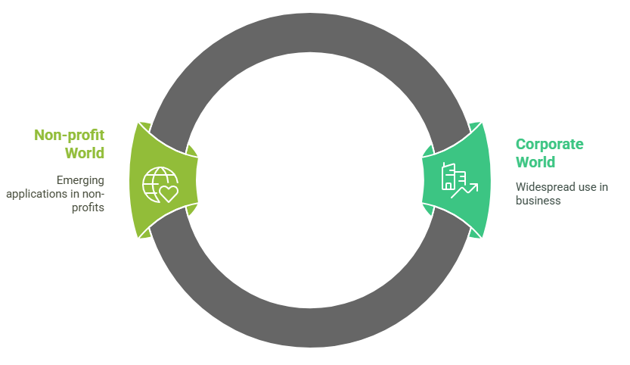

Figure 1: The Rise of Predictive Analysis

While predictive analytics has already gained widespread use in the corporate world for supply chain streamlining, customer experience targeting, and bottom-line improvement, its use in the non-profit world is only just starting out. Yet innovative NPOs are beginning to integrate these tools into a number of areas of functionality. In donor management, for instance, predictive models can forecast which donors are most likely to give, how much they will donate, and when they are likely to give, making it possible for strategic engagement planning to maximize fundraising effectiveness [4, 5].

In program planning and service delivery, predictive analytics has been helpful in predicting needs in disadvantaged communities, optimizing logistics for aid distribution, and improving response time during crises [6]. Non-profits operating in healthcare, food distribution, and education have used these tools to identify at-risk populations, predict service use, and allocate available resources accordingly. Evidence-driven decision-making at such level, therefore, increases the operation effectiveness and also ensures that invaluable resources are deployed in areas of their greatest need, improving outcomes as well as realizing maximum social value [6].

Furthermore, predictive analytics has great potential to improve volunteer management. By analyzing past trends and volunteer behaviors, NPOs are able to forecast attendance, allocate assignments according to ability, and boost volunteer satisfaction and recruitment [7, 8]. Similarly, NPO human resource departments can use analytics to predict employee turnover and identify capacity shortages so that anticipatory recruitment and staff development can be undertaken.

Despite these potential benefits, the adoption of predictive analytics within non-profit operations is fraught with its own problems. Several NPOs are hindered by limited technical skills, no budget to acquire advanced analysis software, and organizational reluctance to embrace change [9, 10]. In addition, ethical issues—those pertaining to data privacy, informed consent, and algorithmic bias—pose serious risks when operating with sensitive data from vulnerable populations [1]. These concerns highlight the need for capacity building, ethical guidelines, and participatory data governance mechanisms in order to allow the sustainable use of predictive analytics.

Non-profit organizations (NPOs) are crucial support pillars in society that answer to several issues ranging from poverty reduction, healthcare accessibility, educational equity, disaster response, and human rights advocacy. Unlike their for-profit counterparts, though, NPOs are generally subject to constrained financial resources, small staff, and heightened responsibility to donors and beneficiaries. These limitations can temper their effectiveness in delivering services, growing impact, and being responsive to emergent requirements. As the increasing use of information characterizes contemporary times, taking advantage of technology—most significantly predictive analytics—is a strong vector through which NPOs can enhance decision-making, optimize resource utilization, and deliver on their mandates more effectively [11].

Through predicting service needs, forecasting funding gaps, and identifying operational inefficiencies, non-profits are able to anticipate and distribute their resources where they are needed most. In disaster relief, predictive models can forecast where aid will be needed based on weather information and historical trends of disasters. Similarly, food banks can use data to forecast demand in communities and manage supply chains to prevent wastage and shortages. These data-driven approaches allow NPOs to shift from reactive decision-making to proactive evidence-based practices [12,13].

By analyzing giving patterns, social media behavior, and demographics, non-profits can determine potential donors, predict donation amounts, and tailor outreach efforts. Not only does this drive fundraising with greatest efficiency but also fosters stronger relationships with supporters over the long term. In volunteer management, predictive models allow organizations to predict volunteer attendance, schedule shifts strategically, and assign positions that are in line with personal interest and skill [14].

Despite greater awareness regarding these benefits, predictive analytics application in the non-profit space is as limited as its application in for-profit organizations. A majority of NPOs are deprived of the technical competence, trained personnel, and resources necessary to leverage advanced analytical tools. In addition, some of them are hesitant to adopt data-driven initiatives since they fear misuse of data privacy, ethical issues, and organizational resistance. There is also a preference for direct service delivery at the cost of technology and data system investments, further limiting the sector from embracing predictive analytics fully [15].

Non-profits vary greatly in terms of size, scope, and purpose, and this affects the way that they collect and use data [16]. Whereas large international organizations may have the budgets to invest in data science teams and the latest technologies, smaller community-based agencies are typically operating with limited technical support. This creates a digital divide within the sector, wherein a select number of agencies are in a position to utilize predictive analytics effectively, whereas others remain behind [1]. There is a massive gap between large global organizations and small local NPOs in readiness for technology and data maturity. While global NPOs have access to use data scientists and high-end infrastructure, local NPOs often do not have the capacities and capabilities required to collect, analyze, and act on data insights. This will create a digital divide which will further exacerbate differences in service delivery and organizational performance.

Although a growing body of literature examines the technical applications and intrinsic worth of predictive analytics in the non-profit sector, relatively little is understood about its strategic uptake, long-term sustainability, and practical incorporation into core operational activities. Few studies include detailed evaluations of real-world impacts in the field or best practices appropriate to low-resource environments. Also, the moral implications of predictive decision-making in humanitarian environments remain to be investigated. This study seeks to fill these gaps by bringing together current knowledge, highlighting practical applications, and suggesting a path towards ethical and scalable adoption of predictive analytics in non-profit organizations.

2. METHODOLOGY

The research approach taken in this review was founded on a systematic peer review method intended to offer extensive and objective evaluation of the literature available on the application of predictive analytics for optimizing resources in non-profits. The key aim was to identify peer-reviewed empirical research from real-life situations exploring the extent to which predictive analytics has been applied by non-profits to enhance efficiency, automate processes, and maximize social returns. In order to do this, the search strategy for the literature included a comprehensive and systematic search of a range of scholarly databases, namely Google Scholar, Scopus, SSRN, and Business Source Complete.

There were 256 records identified initially across the four databases. Exactly 92 articles were found in Google Scholar, 68 in Scopus, 50 in SSRN, and 46 in Business Source Complete. 72 duplicate entries were removed after excluding them, leaving 184 unique records to screen. Each of them was read closely to check how relevant they would be for this research. Including criteria demanded clearly stated application of predictive analytics across non-profit processes, emphasizing contribution to resource planning, prediction of donors or volunteers, and business decision-making.

144 studies had to be discarded in the initial screening due to a host of reasons. The majority of them focused on predictive analytics in the private sector or government organizations, which, although relevant in terms of methodology, were not applicable to the specific organizational setting and resource constraints of non-profit organizations. Some other research was excluded because it was published prior to 2020, thus not reflecting the most recent technological developments and practices. 40 full-text articles were then assessed for eligibility following this process. Of these, 15 only met all the inclusion criteria and were included in the final qualitative analysis. The excluded full-text studies were mostly disqualified based on the premise that they lacked a clear non-profit setting focus, failed to address resource optimization directly, or failed to give practical applications of predictive analytics. Others were published in non-English journals, which imposed linguistic barriers that may compromise the interpretive and synthesis accuracy.

This strategy allowed for a concentrated and systematic selection of relevant literature to the extent of only including studies with direct applicability to the research topic. The studies included are diverse in their depiction of non-profit activity from providing healthcare, humanitarian aid, provision of education services, to mobilization of donors. They also depict a variety of applications for predictive tools from basic regression formulas to advanced machine learning programs.

Some limitations that came inherent in the methodology existed. First, while every effort was made to search for a wide range of databases, the possibility remains that some pertinent studies, particularly those published in specialist or local journals not indexed by the selected databases, were not searched. Also, excluding non-English research may have biased international representation of best practice, particularly from nations where non-profit innovation is taking place but poorly represented in foreign journals. Although the utilization of exclusively recent studies ensured relevance to current technological capabilities, it could have excluded pioneering studies that contributed to the establishment of predictive analytics within the industry. Other than the above limitation, methodological rigor applied in the literature search and selection ensures that the findings reported are valid, current, and of practical utility. Such a methodology provides a sound platform upon which one can make important conclusions about how non-profit organizations can effectively utilize predictive analytics in optimizing their scarce resources and overall mission delivery.

3. RESULTS AND DISCUSSION

This section consolidates evidence from 15 peer-reviewed journals and discusses the common applications, implications, and limitations of predictive analytics in non-profit organizations (NPOs). The reviews include donor behavior forecasting, program targeting, volunteer management, and inventory allocation. These applications are largely driven by the growing availability of digital records, cloud-based platforms, and cost-effective machine learning (ML) tools that make data-driven strategies increasingly accessible to NPOs [6, 17].

3.1 Overview of Predictive Analytics Applications in Non-Profits

The consolidation of the selected studies found that predictive analytics has been applied to a wide range of NPO operation areas. These have included donor engagement, volunteer coordination, targeting programs, and supply chain improvement. An example is a case study by Ling et al. [18], which demonstrated how humanitarian NPO applied logistic regression and decision trees in segmenting donors based on gift-giving patterns and achieved a increase in campaign response rates. Predictive models have helped organizations discover high-probability donors, make estimates of donation values, and establish the best time to hold fundraising campaigns. These features are crucial as they enable NPOs to achieve maximum revenue at a minimum cost of marketing. This phenomenon is also prominent in the example of donor interaction, where machine learning algorithms are used to predict donor behavior [19].

3.2 Driving Fundraising Outcomes with Predictive Tools

Indeed, one of the largest applications of predictive analytics is fundraising optimization. Predictive analytics models rank solicitation of donors by giving points to supporters based on a metric of likelihood of contribution again, potential donation amount, and potential for long-term involvement.

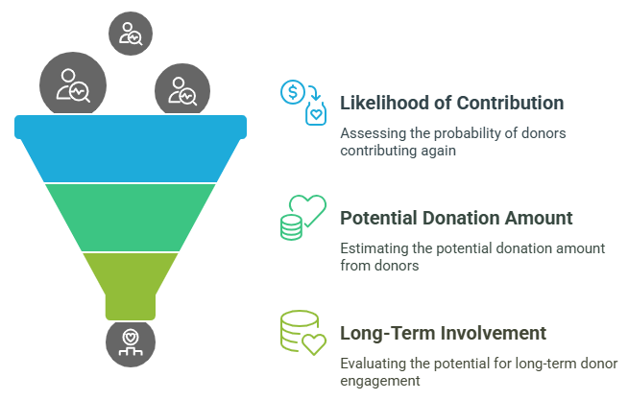

Figure 2: Donor Solicitation Optimization in Predictive Analytics

Kauten et al. [19], determined that integrating ML-predictive scores into donor database management systems enabled the ability to increase donor retention by over 18% in one year. Techniques such as cluster analysis and ensemble models have been particularly good at identifying hidden donor segments and optimizing engagement campaigns accordingly. In addition, time-series forecasting models have been of vital importance to predict donation cycles, particularly season and crisis-driven giving behavior [20, 21]. These give NPOs the ability to align campaigns with optimum donation seasons to maximize revenue without additional marketing expenditure.

3.3 Volunteer Management: Enhancing Task Matching and Attendance

Volunteer management is also an area where predictive analytics has enhanced planning and operational effectiveness. By analyzing historical volunteer attendance, skill sets, and feedback records, non-profits are better able to predict volunteer attendance, route volunteers to the correct tasks, and reduce absenteeism. de-Miguel-Molina et al. [22], found that neural network-based predictive scheduling systems increased the accuracy of volunteer assignment significantly enhancing program delivery outcomes. Apart from scheduling, predictive technology is also employed to spot volunteers at risk of disengagement so that organizations can carry out timely retention interventions. These may take the shape of recognition programs, competency-based training, or direct communication [23, 24].

3.4 Enhancing Targeting and Impact through Predictive Models

Predictive models have been successful in fine-tuning the targeting of services to the neediest. Pek et al. [25] described how an education-focused NPO in a local area used random forest classifiers for processing school and socio-economic data, and the outcome was a fine-tuning improvement in targeting vulnerable students for scholarship and support programs. Geospatial and temporal predictive models enabled anticipatory resource deployment in humanitarian relief and health care. Ogwu and Izah [26], demonstrated how a public health NPO used spatial-temporal models to forecast disease epidemics in under-served populations to pre-position medical equipment and personnel.

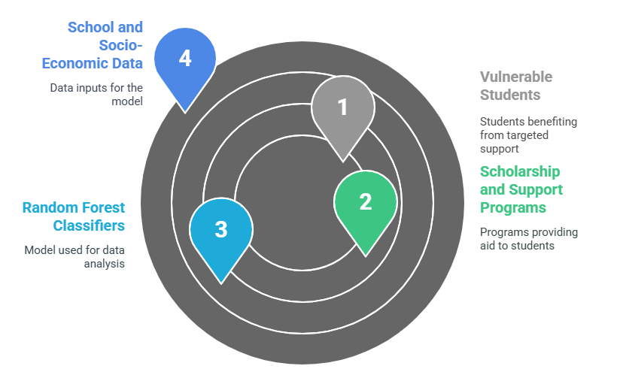

Figure 3: Predictive Model Impact on Education Support

3.5 Inventory and Supply Chain Optimization

Predictive analytics also facilitates inventory and supply chain management through demand cycle forecasting and consumption of resources. A food distribution charity, according to a study conducted by Paul and Davis [27], applied ARIMA models and demand clustering in order to better optimize levels in distribution centers. This cut wastage of food by 15% and increased delivery reliability. Also, Bayesian forecasting and reinforcement learning has proved to be effective methods for dynamic allocation in the context of uncertainty [28, 29]. These methods allow NPOs to dynamically reroute supplies in response to adaptive reallocations to demand, logistics, or contributions in real time.

Table 1: Summary of Predictive Analytics Applications in Non-Profit Organizations

Application Area | Key Benefits | Common Predictive Tools
Fundraising & Donor Retention | Improved donor segmentation, increased retention, optimized campaign timing | Logistic regression, decision trees, machine learning classifiers
Volunteer Management | Enhanced volunteer-task matching, reduced absenteeism, improved scheduling | Neural networks, behavioral modeling, predictive scheduling systems
Service Delivery Optimization | Targeted service delivery, reduced emergency response times | Random forests, geospatial forecasting, temporal models
Inventory & Supply Chain | Minimized waste, optimized resource allocation and distribution | ARIMA models, demand clustering, reinforcement learning
Strategic Planning | Informed decision-making, adaptability to change | Time-series analysis, Bayesian forecasting models

3.6 Integration Challenges and Ethical Considerations

Despite the clear benefits of predictive analytics, there are some implementation issues. NPOs generally lack internal capability— both in terms of skilled personnel and technical infrastructure —to implement sophisticated analytics models. Mayer and Fischer [30] and Gooyabadi et al. [31], indicated that less than 30% of the sample NPOs had in-house data analysts to rely on, and therefore they were completely dependent on external professionals or off-the-shelf packages that may not be best harmonized with organizational goals. Moreover, ethics of data use are still a pertinent issue. Predictive analytics often has dealings with sensitive beneficiary data, and tight data governance protocols must be in place. Algorithmic bias, transparency, and informed consent for purposes have been issues, especially in humanitarian and health contexts [21, 32, 33,34, 38]. Erroneous or discriminatory forecasts can lead to exclusion of vulnerable groups or misdistribution of vital services, and thus further exacerbate existing inequalities.

3.7 Strategies for Scalable and Responsible Adoption

To bridge the gap between potential and practical adoption, several studies recommend a phased implementation strategy. Initial focus should be placed on low-risk, high-value applications such as donation forecasting and volunteer scheduling, followed by gradual integration into more complex domains like program design and impact measurement [21]. This staged approach can help NPOs build technical confidence while demonstrating early wins.

Cross-industry collaborations between non-profits, tech firms, and universities are increasingly considered a long-term capacity building model [35, 36, 39]. Successful partnerships in which training fellowships and toolkits, designed with the collaboration of universities, have upskilled staff in data management and analysis to develop a data-literacy workforce.

Ethical problems can also be addressed by establishing open and participatory data governance frameworks. These frameworks need guidelines regarding data ownership, anonymization policy, community-driven consent, and regular audits for algorithmic fairness.

3.8 Future Outlook and Research Directions

With increasingly accessible and easier-to-use predictive analytics tools, their adoption within non-profit work streams is expected to accelerate. With the growing presence of open-source platforms and low-code/no-code analytics tools, the entry barrier for smaller organizations is being brought down. Nevertheless, in the long run, and for it to be equitable, future progress must focus on capacity building, ethical adherence, and inclusive innovation.
Future research should also focus on longitudinal analyses that investigate the long-term efficacy of predictive interventions for prolonged periods. These analyses would give very valuable information about scalability, adaptability, and ethics surrounding predictive analytics in resource-constrained environments.

CONCLUSION

This review has laid out the potential for transformation by predictive analytics to achieve enhanced efficiency in operations as well as strategic-level decision-making in major areas of business in non-profits such as donor retention, volunteer management, delivery of services, and inventory optimization. Drawing insights from a range of studies, it is evident that machine learning techniques are being successfully leveraged to drive impact and improve outcomes. Nevertheless, the large-scale deployment of these technologies remains plagued by infrastructure limitations, capability gaps, and pressing questions of ethics, particularly with respect to data governance and algorithmic justice. Strategic recommendations such as phased deployment, capacity building, and cross-sector collaboration are necessary to enable fair and ethical rollout. As predictive technologies continue to evolve, future research should focus on longitudinal evaluations and the development of context-appropriate, ethically sound frameworks that support sustainable integration within the non-profit sector.

Disclaimer (Artificial intelligence)

Author(s) hereby declare that NO generative AI technologies such as Large Language Models (ChatGPT, COPILOT, etc.) and text-to-image generators have been used during the writing or editing of this manuscript.

REFERENCES

1. Thrassou A, Vrontis D, Efthymiou L, Theofanous G. Delineating Non-Profit Organisations: Economy, Industries and Context. InNon-Profit Organisations, Volume II: Economy, Industries and Context 2024 (pp. 1-20). Cham: Springer Nature Switzerland.

2. Arunkumar M, Rajkumar K, Jeyaseelan WR, Natraj NA. Data Mining, Machine Learning, and Statistical Modeling for Predictive Analytics with Behavioral Big Data. Tehnički vjesnik. 2025;32(1):72-77.

3. Adekunle BI, Chukwuma-Eke EC, Balogun ED, Ogunsola KO. A predictive modeling approach to optimizing business operations: A case study on reducing operational inefficiencies through machine learning. Int J Multidiscip Res Growth Eval. 2021;2(1):791-799.

4. Cacciarelli D, Boresta M. What drives a donor? A machine learning‐based approach for predicting responses of nonprofit direct marketing campaigns. Journal of Philanthropy and Marketing. 2022 May;27(2):e1724.

5. Kagzi M, Khanra S, Paul SK. Machine learning for sustainable development: leveraging technology for a greener future. Journal of Systems and Information Technology. 2023;25(4):440-479.

6. Jeble S, Kumari S, Venkatesh VG, Singh M. Influence of big data and predictive analytics and social capital on performance of humanitarian supply chain: Developing framework and future research directions. Benchmarking: An International Journal. 2020 Mar 21;27(2):606-33.

7. Alsolbi I. Leveraging Potentials of Big Data for Better Decision-Making And Value Creation in Nonproft Organisations. University of Technology Sydney (Australia); 2023.

8. Alsolbi I, Agarwal R, Unhelkar B, Al-Jabri T, Samarawickrama M, Tafavogh S, Prasad M. A conceptual design of an AI-enabled decision support system for analysing donor behaviour in nonprofit organisations. Information. 2023;14(10):578.

9. Godefroid ME, Plattfaut R, Niehaves B. Identifying key barriers to nonprofit organizations' adoption of technology innovations. Nonprofit Management and Leadership. 2024;35(1):237-259.

10. Hackler D, Saxton GD. The strategic use of information technology by nonprofit organizations: Increasing capacity and untapped potential. Public administration review. 2007;67(3):474-87.

11. Singh N, Mthuli SA. The big picture of non-profit organisational sustainability: A qualitative system dynamics approach. Systemic Practice and Action Research. 2021;34(3):229-249.

12. Singh S, Rajest SS, Hadoussa S, Obaid AJ, Regin R, editors. Data-driven intelligent business sustainability. IGI Global; 2023 Dec 5.

13. Oriekhoe OI, Ashiwaju BI, Ihemereze KC, Ikwue U. Review of big data in FMCG supply chains: US company strategies and applications for the African market. International Journal of Management & Entrepreneurship Research. 2024;6(1):87-103.

14. Kaur MP, Smith S, Pazour JA, Schumacher AD. Optimization of volunteer task assignments to improve volunteer retention and nonprofit organizational performance. Socio-Economic Planning Sciences. 2022 Dec 1;84:101392.

15. Zong Z, Guan Y. AI-driven intelligent data analytics and predictive analysis in Industry 4.0: Transforming knowledge, innovation, and efficiency. Journal of the Knowledge Economy. 2024:1-40.

16. McCosker A, Yao X, Albury K, Maddox A, Farmer J, Stoyanovich J. Developing data capability with non-profit organisations using participatory methods. Big Data & Society. 2022 Jan;9(1):20539517221099882.

17. Soelton M, Noermijati N, Rohman F, Mugiono M. Improving the performance NON-profit organizations?. Academy of Strategic Management Journal. 2021;20:1-3.

18. Ling SW, Batcha NK, Logeswaran R. Machine Learning Model for Predicting Potential Donors Using Logistic Regression. Journal of Applied Technology and Innovation (e-ISSN: 2600-7304). 2020;4(4):34.

19. Kauten C, Gupta A, Qin X, Richey G. Predicting blood donors using machine learning techniques. Information Systems Frontiers. 2022:1-6.

20. Sharma E, Davis L, Ivy J, Chi M. Data to Donations: Towards In-Kind Food Donation Prediction across Two Coasts. In2021 IEEE Global Humanitarian Technology Conference (GHTC) 2021 Oct 19 (pp. 281-288). IEEE.

21. Jikiemi E. Enhancing Non-Profit Project Outcomes through Predictive Modelling and Real-Time Data Analysis. Available at SSRN 4901476. 2024 Jul 20.

22. de-Miguel-Molina B, Boix-Domenech R, Martínez-Villanueva G, de-Miguel-Molina M. Predicting volunteers’ decisions to stay in or quit an NGO using neural networks. VOLUNTAS: International Journal of Voluntary and Nonprofit Organizations. 2024;35(2):277-91.

23. Li Y, Luo X. Application of Intelligent Schedule Management in Volunteer Service System. In2024 IEEE First International Conference on Data Intelligence and Innovative Application (DIIA) 2024 Nov 23 (pp. 1-5). IEEE.

24. Tan JW. Volunteer Management: A Data Mining Approach. Public Organization Review. 2025 Mar 14:1-8.

25. Pek RZ, Özyer ST, Elhage T, Özyer T, Alhajj R. The role of machine learning in identifying students at-risk and minimizing failure. IEEE Access. 2022 Dec 28;11:1224-43.

26. Ogwu MC, Izah SC. Technologies for Predictive Modeling of Tropical Diseases. InTechnological Innovations for Managing Tropical Diseases 2025 Feb 20 (pp. 109-130). Cham: Springer Nature Switzerland.

27. Paul S, Davis LB. An ensemble forecasting model for predicting contribution of food donors based on supply behavior. Annals of Operations Research. 2022 Dec 1:1-29.

28. Kiuchi A. Recurrent Neural Network Based Reinforcement Learning for Inventory Control with Agent-based Supply Chain Simulator. In2024 IEEE 20th International Conference on Automation Science and Engineering (CASE) 2024 Aug 28 (pp. 1903-1909). IEEE.

29. Cui Y, Yao F. Integrating deep learning and reinforcement learning for enhanced financial risk forecasting in supply chain management. Journal of the Knowledge Economy. 2024 Apr 8:1-20.

30. Mayer DJ, Fischer RL. Exploring data use in nonprofit organizations. Evaluation and Program Planning. 2023 Apr 1;97:102197.

31. Gooyabadi AA, GorjianKhanzad Z, Lee N. Nonprofit Digital Transformation: Choice or Mandate?. InNonprofit Digital Transformation Demystified: A Practical Guide 2023 Dec 15 (pp. 51-65). Cham: Springer Nature Switzerland.

32. Santos J. Emerging Paradigms in Non-Profit Governance: A Comprehensive Analysis of Disruptive Innovations. InNew Trends for the Governance of Non-Profit Organizations 2025 (pp. 1-86). IGI Global Scientific Publishing.

33. Marapatla PR. AI-Driven Donor Management: Revolutionizing Nonprofit Fundraising through Predictive Analytics. Technology (IJRCAIT). 2025 Jan;8(1):1064-1076.

34. Okeke, K.; Omojola, S. Enhancing Cybersecurity Measures in Critical Infrastructure: Challenges and Innovations for Resilience. J. Sci. Res. Rep. 2025, 31, 474-484

35. Ba Y, Nair S, Kedia M. Cross-sector collaboration, nonprofit readiness, and sustainability transitions. Environmental Innovation and Societal Transitions. 2024 Dec 1;53:100933.

36. Omojola, S., & Okeke, K. (2025). Cloud-Based Solutions for Scalable Non-profit Project Management Systems. Advances in Research, 26(2), 418–427. https://doi.org/10.9734/air/2025/v26i21309

37. Alanazi TM. Market orientation impact on organisational performance of non-profit organisation (NPOs) among developing countries. Journal of Economics, Management and Trade. 2018;21(1):1-6.

38. Cheng L, Varshney KR, Liu H. Socially responsible ai algorithms: Issues, purposes, and challenges. Journal of Artificial Intelligence Research. 2021 Aug 28;71:1137-81.

39. Santhoshkumar SP, Susithra K, Prasath TK. An overview of artificial intelligence ethics: issues and solution for challenges in different fields. Journal of Artificial Intelligence and Capsule Networks. 2023 May 2;5(1):69-86.

