Techniques for Assessment of Vertical Spray Pattern: A Review

ABSTRACT
This paper reviews various techniques for assessing vertical spray patterns. Determination of spray characteristics is one of the most important tasks in the development of the sprayer. Uneven spray characteristics will result in loss of pesticide in the form of drift and wastage of chemicals. Many of the horizontal patternators are available to test the nozzle for field crops. Orchard crops often have varying canopy heights and densities, which can lead to uneven spray distribution if not properly managed. By evaluating the vertical spray pattern, farmers can adjust sprayers to match the specific characteristics of the canopy, reducing pesticide waste, minimizing environmental impact, and improving coverage in the target areas. The different techniques for assessing spray patterns include image analysis of water-sensitive papers, analysis of droplets by laser or ultrasonic techniques, computational fluid dynamics, thermography and vertical patternators.
Keywords: Spray characteristics, Vertical patternator, Droplet size, Thermography, Image analysis
1. Introduction
“Testing and inspection of sprayers is one key element to rationalize plant protection product use. The evaluation of the vertical distribution pattern is crucial in improving the quality of product applications. In fact, this test allows: 1) to direct the spray only on the tree crown, reducing the off-target, 2) to regulate nozzle orientation to achieve a correct spray pattern and 3) to reduce differences between right and left side distribution in traditional sprayer with an axial fan” (Ade and Venturi, 1995).
“The calibration of sprayers is a crucial issue in achieving high effectiveness in pesticide spray application. During the calibration of orchard sprayers, a key point is to obtain a vertical pattern of liquid distribution that matches as correct as possible the tree’s canopy. In fact, the equipment should direct the spray only on the target (usually the tree crown), in order to reduce the off-target (drift and run-off) and to optimize the chemical treatment” (Biocca et al., 2005).

“Assessment of the vertical spray profile is one of the main steps to adjust sprayers for bush and tree crops, as it allows verifying that the spray plume matches the target canopy profile. Orchard crops often have varying canopy heights and densities, which can lead to uneven spray distribution if not properly managed. Proper adjustment of the vertical spray profile is a key aspect of optimizing pesticide application with air-assisted sprayers for orchards and vineyards. The spray profile, in fact, shall be adequate to the target canopy profile in order to address the spray plume only in correspondence with the target and to minimize off-target losses” (Allochis et al., 2013).
Some studies have determined as much as 45% of losses of pesticides during spray application. To reach an optimal spray liquid profile, the selection of the proper nozzle pattern according to the shape and distance of the target as well as adjustment of airflow rate is necessary. Several studies have demonstrated that vertical patternators are a suitable tool for assessing vertical liquid distribution (Balsari et al., 2007; Pergher, 2004).
On the other hand, the characteristics of the droplets have an important effect on spray distribution. Nowadays most of the orchard sprayers use hollow or full cone nozzles (Bahlol et al., 2020). When considering droplet size and velocity, the finer the droplet the lower the drop velocity (Nuyttens et al., 2009). This is especially sensible when the size of the tree to be sprayed is large because the droplet has to travel a long distance from the nozzle to the target. This effect could be reduced by increasing the size of the droplets. Low drift nozzles permit an increase in droplet size while reducing the volume of drops <100 μm in the spray (Zande et al., 2018), which leads a reduction of drift by 50% (Grella et al., 2017). Droplet size is a critical factor influencing the effectiveness and efficiency of pesticide application(Kavya et al. 2024; Nordin et al., 2021). “Smaller droplets can penetrate the dense canopy of paddy plants more effectively, reaching target pests and diseases” (Chen et al., 2020;Hu et al., 2021). “However, excessive droplet drift can lead to off-target pesticide deposition, environmental contamination, and reduced pesticide efficacy” (Wongsuk et al., 2024).

“Different methods are ordinarily employed to assess the vertical distribution pattern (i.e. the amounts of liquid sprayed at various heights. They include: image analysis of water-sensitive papers” (Moor et al., 2020, Salyani et al., 2013, & Mangado et al., 2013), analysis of droplets by laser or ultrasonic techniques (Miralles et al., 1996 & Tekelıoglu and Parkin, 2002), assessment of deposits (or tracers) on numerous passive adsorbent samplers (Miller et al., 1992; Pergher, 2001; Hoffmann et al., 2003) Computational Fluid Dynamics (CFD) (Dekeyser et al., 2013), thermography (Menesatti et al., 2008) and vertical patternators.
“Vertical patternators sample the spray at different heights by intercepting and collecting the droplets with various tools as metallic trays, plates covered with adsorbent material, funnel-shaped collectors and lamellae, that can be mounted horizontally (very common) or vertically” (Biocca et al., 2005; Gil & Badiola 2007; Pergher & Gubiani 1997). “The patternators are employed both for the certification of new sprayers and for the testing of equipment in use during their periodical inspection and calibration” (Gil 2007). “Other researchers studied the performance of patternators or compared the obtained assessment of spray with the real deposit on the plants” (Pergher, 2004).
An attempt was made to review the different types of spray assessment techniques for the vertical sprayers and the procedure involved in them.

2. Image analysis of water-sensitive papers
Water-sensitive paper is a specially coated paper that changes colour, usually turning blue from yellow, when it comes into contact with water, allowing users to visually assess the distribution and coverage of a liquid spray pattern (Simoes et al., 2025). The standard size of water-sensitive paper is 26 X 76 mm. It is primarily used in agriculture to evaluate the uniformity of pesticide application on crops by showing where spray droplets land on a target surface and the size and amount of spray droplets. The exposed water-sensitive paper should be scanned to a digital image immediately and it should be sealed in an air-tight cover to prevent further exposure to moisture. The image analysis can be done by using the following methods
2.1 Using Image J (DepositScan) software
“A spray deposition recognition system was developed by integrating a portable business card scanner, a portable computer, and a program called “DepositScan”. A publicly available image program (ImageJ) and a proprietary custom-developed program were combined to develop DepositScan. DepositScan specifically quantifies spray deposit distributions on any paper-type collector that could show visual differences between spray deposits and the background. Water-sensitive paper, oil-sensitive paper, or Kromekote® cards could be used as collectors” (Zhu et al., 2011). DepositScan first requires the user to scan samples and then convert them to produce 8-bit gray scale images, then calculates the number of deposits and area of each deposit in the selected section of the image the menu bar is shown in Fig.1. Finally, “results such as individual droplet size, droplet distribution, total number of droplets, droplet density, amount of spray deposits per unit area and percentage of area coverage are displayed and saved” (Sie et al., 2017). The Depositscan can measure the droplet diameter as low as 17µm. Because of pixel limitations, the accuracy of DepositScan decreases along with the decreased size of the spot. The Deposit Scan can be downloaded free of cost from the website http://www.ars.usda.gov/mwa/wooster/atru/depositscan.
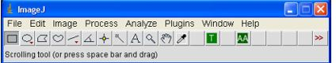
Fig.1: Menu bar of DepositScan software
2.3 Using MATLAB software
“The water-sensitive paper that was used for collecting the droplet spectrum was scanned and the WSP was converted to a grayscale image with colour space transform. The droplets were extracted by binarizing the grayscale image with the global Otsu threshold. The binary image was classified into overlapping droplets image and non-overlapping droplets image with roundness criterion. The concave point was detected for the contour image of overlapping droplets. The contour of the overlapping spots was segmented based on the detected concave point and grouped. The ellipse fitting was used to estimate the complete contour of individual droplets contained within overlapping spots. The spray quality information was obtained by particle analysis of the image with non-overlapping droplets and the image with ellipse fitting and saved as an Excel document” (Xun, L., 2024). The parameters like WSP area, percent coverage, droplet density, number of droplets, and number of non-overlapping droplets, DV_{0.1}, DV_{0.5} and DV_{0.9} can be obtained. The flowchart showing the procedure involved in the analysis of water-sensitive paper is given in Fig.2 (Xun and Gil, 2024 & Ghiani et al., 2020).
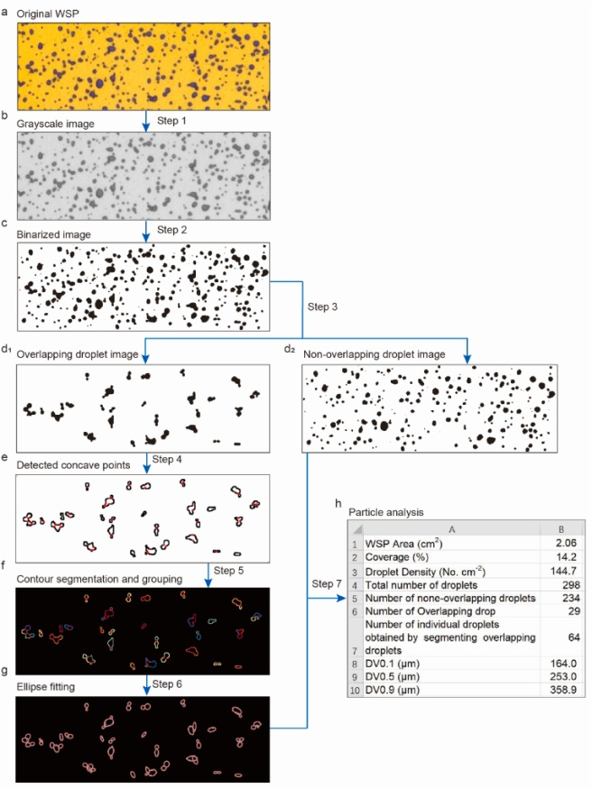
Fig.2: Procedure involved in analysis of water-sensitive paper using Matlab software.
2.3 Using Dropleaf app
The WSP exposed to the pesticide solution can be directly taken a photo or it can be saved in the gallery. The photograph will be converted into a greyscale image to discriminate the card surface from drops. The gray scale image is subjected to threshold-based binarization, where the gray values below the threshold become black while the images more than the threshold become white. The skeletonization of the boundary will be done to mark the inner region of the drop from the closest white mark. The skeleton image is refined to mark the drops properly. The refinement is based on the threshold value which was defined by the user based on the number and structure of the drops. The properly marked drops are further identified by using marker-based watershed segmentation. After the segmentation, the parameters like coverage area, volume median diameter and relative span of each segment will be computed. The procedure is shown in Fig. 3
Fig.3: Image processing course of dropleaf.
The usage of the dropleaf app involves the following steps. The scanned image was fed to the drop leaf app through the camera or from the gallery of the mobile. The area of the WSP needs to be selected and the resolution needs to be selected. The image may be set for processing which will give the result for the WSP. The results include mean diameter, droplet density, spray coverage and median diameter. The app is simple to use with an option to store the data. The usage of the dropleaf app is shown in Fig.4. The Mobile app is available in Google Play Store https://play.google.com/store/apps/details?id=upvision.dropleaf. (Bruno et al., 2021)
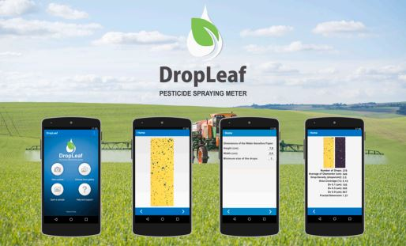
Fig.4: Dropleaf mobile application
3. Use of sensors and capacitors
Wang et al., 2019 used “a leaf-like capacitor (Yingtai Tech., Tianjin, China) for the implementation of the droplet deposit sensing system. The sensor was designed based on a capacitor with 84 parallel coppers. The coppers were separated into two groups and connected respectively as two electrode plates of the capacitor. The whole structure of the capacitor was packaged (painted) with insulation material of ceramic”. “The capacitance varies according to the dielectric constant of the media composition, the air or the spray, inside the gap of the electrodes” (Lim et al., 2016). “The dielectric constant changes when the ratio of each component in the media composition varies. A linear model can be fitted to calculate the deposit mass of the spray according to the measurement of the capacitance of the capacitor with droplets depositing side. The leaf-like capacitor could provide the analogue signals to indicate its capacitance. The sensor is implemented with an operational amplifier circuit. With a capacitor in fixed capacitance, the leaf-like capacitance sensor will share different voltages when the dielectric constant inside it is changed. The capacitor was linked to an analog-to-digital converter (ADS1115, Texas Instruments, Dallas, TX, USA), which could convert the analog signal of the real-time capacitance into the digital voltage signals. The digital signal was then processed by a 32-bit microcontroller (STM32F4 EXPLORER, ST Microelectronics, Geneva, Switzerland). The microcontroller could read the input digital signal and display the voltage information representing the analogue signal on a thin film transistor-liquid crystal display (TFT screen). Linear models of deposit mass to the voltage signals were developed due to different herbicide sprays in this research and installed in the microcontroller. Thus, the microcontroller could calculate the deposit results of each measurement and then display that on the TFT screen. All the measurement results were recorded with a trans-flash Card (SD card) which was mounted on the microcontroller processing board” (Wang, P., et al., 2019)
4. Thermography
Infrared thermography converts the thermal energy emitted by an object in the infrared spectrum of electromagnetic radiation into an image. Spray visualization is generally carried out to give qualitative information of the spray flow field. It also provides information of the geometric features of the spray which includes spray pattern, spray cone angle, and spray coverage. Traditionally, spray visualization has been achieved by several optical methods, including but not limited to, high-speed photography (Mangado et al., 2013; Pergher, 2001; Miralles et al., et al., 1996 & Tekelıoglu and Parkin, 2002) Schlieren technique (Menesatti et al., 2008; Ade & Venturi,1995). Shadowgraph technique (Pergher and Gubiani 1998; Pascuzzi et al., 2004; Menesatti et al., 2008), and holography (Gil and Badiola, 2007; Gil, 2007). “An infrared thermography-based visualization and characterization technique that uses infrared imaging to characterize and visualize the entire flow field of a liquid spray. The technique employs an emitter which is a uniformly heated blackbody background as a thermal radiation source, and a receiver which is an infrared detector. The method provides a two-dimensional image in which the value associated with each pixel on an intensity scale, accounts for the amount of infrared energy emitted by the source which while traveling through the spray is attenuated. For a given fluid, this attenuation is a function of droplet size, spray density, and the complex refractive index (m = n − ik) of the material being sprayed. The infrared detector, therefore, receives a damped signal as a result of the attenuation of the emitter intensity. This damped image is recorded to provide an attenuation image of the spray. This image is post-processed to study the droplet transport within the spray” (Nelason et al., 2010).
5. Vertical patternators
Patternators are the device to quantify the flow from the nozzle and check the spray pattern. The different types of vertical patternators are discussed below.
5.1 Cornell patternaor
“Nine 0.35 m×1.20 m wide fly screens were connected via hooks to two 4.25 m high, 10 cm × 5 cm wooden boards. A small gutter was attached, at an angle, to the bottom edge of each screen. The gutter sloped to one end where a plastic hose was connected which ran down to a box containing graduated measuring cylinders. The spray cloud hit the fly screen, the air passing through and the liquid ran down the front of the screen, into the gutter and then, via the plastic hose into the collecting cylinders. The collected liquid in the cylinders will be analyzed for spray pattern” (Gil et al., 2013). Fig.5 shows the constructional details Cornell patternator.
5.2 Paper patternator

“It consists of a stand with high-quality photographic printer paper along with a dye for visualizing spray deposition. It was proposed by Dr.Andrew Landers of Cornell University. Although more expensive, water-sensitive paper (WSP) can also be used in a paper patternator” (Keen 2012). The paper pattenator is shown in Fig. 6

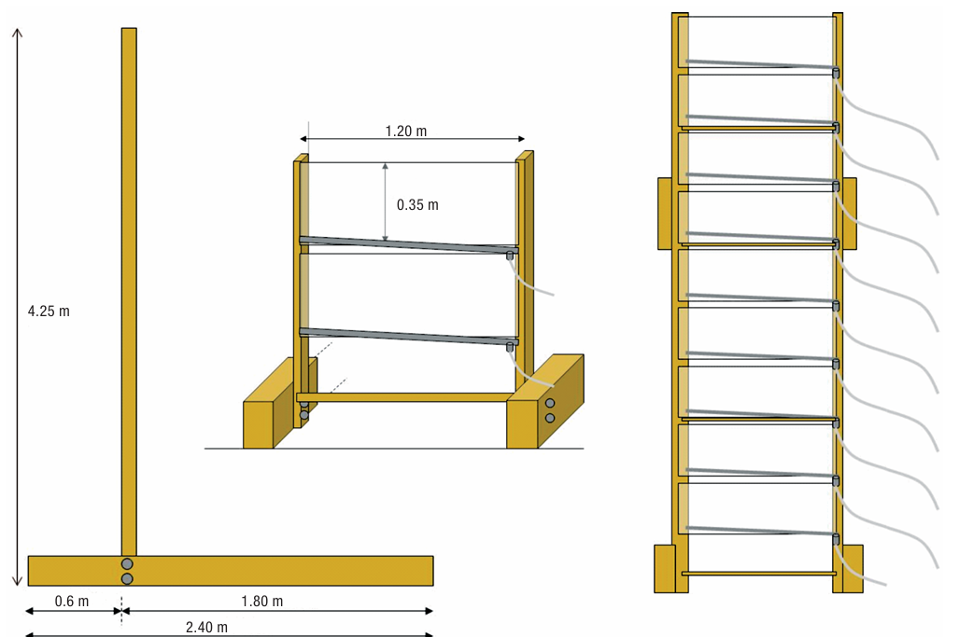
Fig.5 Constructional details of Cornell patternetor

5.3 Modified Cornell Patternator

This was the modified form of the Cornell patternator. The main aim of this modified cornell patternator is to reduce the cost. The generated spray was collected with the help of window screens. A fiberglass window screen of 18 x 16 mesh was used for the patternator. The Patternators are based on multiple panels with a standard size of 3 feet wide by 1 foot tall. The panel size was based on the capturing capacity of the panels. The modified cornell patternator is shown in Fig. 6.
5.4 SARE Patternator

This type of patternator contains painted plywood panels to catch the spray from the air blast sprayer. The patternator was developed for a height of 8 feet for vineyard usage. The patternator was divided into a number of sections and each section can be quantified. The dimensions of the alternator include seven sections of three feet by one foot. The height can be increased with the extension provision.
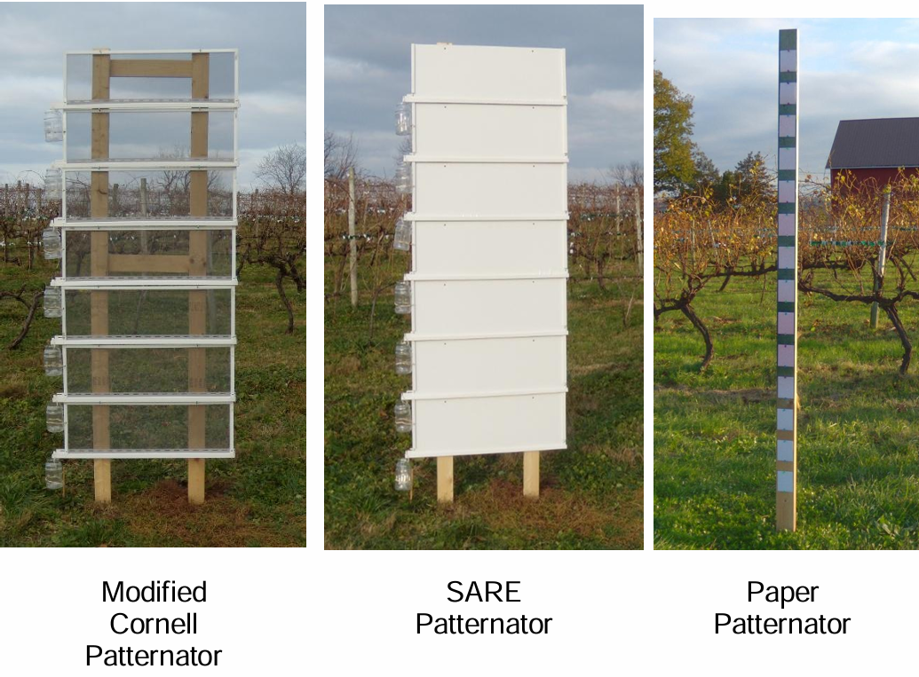

Fig.6: Different types of patternators

5.5 SARE with Screens Patternator
The patternator was the combined form of a modified cornell patteantor and sare patternator. It is based on using painted plywood panels covered with screens to catch the spray from the air blast sprayer. Fibreglass window screens of 16 X 1 mesh were used on patternator. The 8 feet height patternator was divided into numerous sections that will allow quantification of liquid in each section. The size of each section is three feet by one foot with a provision to increase the number of sections if a taller alternator is required.
5.6 Lamellate patternator
The lamellate patternator is equipped with 96 horizontal lamellae made of plastic inserted in a stainless steel frame.The vertical resolution of this test bench is 100mm, corresponding to the collecting surface of three lamellas (the liquid collected by three consecutive lamellae is conveyed to a graduated tube). The first lamelle is positioned at 310 mm in height from the ground. The total height of the test bench is 3500 mm, total width is 1800 mm (Allochis et al., 2014)
6. CFD analysis
The CFD can be used for measuring the spray liquid distribution and droplet size distribution. For the assessment of the spray distribution of the orchard sprayers, a vertical lamellae patternator wall (Pachler Metalltechnik GmbH, Kirchberg, Austria) was used. The patternator with a height of 3.20 m consisted of horizontal lamellae which separated the liquid spray from the airflow. The separated liquid was collected in sections with a height of 0.10 m and drained off in measuring cylinders after tipping over the wall. The filling height of the cylinders was automatically read by ultrasonic sensors. The droplet size distribution was described using a Rosine-Rammler distribution.
$$R=exp\left[-{\left(\frac{d}{d_{e}}\right)}^{γd}\right]$$

Where R is the fraction by mass of droplets greater than the diameter d, γd a measure of dispersion and d_{e} a measure of fineness and equal to the diameter at which R is 0.368 (Dekeyser et al., 2013).

7. Use of imaging techniques
The imaging techniques will be used to capture the droplet spectrum from the nozzle and can analyse the droplet characteristics. Different types of imaging techniques are as follows.
7.1 Image analysis
In image analysis, the light is used to image an ensemble of droplets followed by the software analysis of the snapshot to determine the droplet sizes. Subsequent snapshots will give the velocity of droplets.
A short, double light pulse is used to illuminate a screen that is photographed such that the droplets show dark spots against a bright background. A digital camera will be used to two snapshots of the particles. Software like Oxford VisiSizer analyzes the images and image threshold to identify the droplets to get droplet sizes and velocity.
“Stroboscopic imaging technique developed in-house, with a comparable working principle as the VisiSizer. It uses a Nikon D5600 digital camera with a Sigma 105 mm1:2.8 DG Macro HSM lens and a shutter speed of 1/2.5s, F13 and ISO400 in a dark room. It measures droplets in a range from 20 μm to 3000 μm. A time machine opens the shutter of the camera and simultaneously triggers a short light pulse of 0.5 μs with a Vela One flashlight apparatus. This light pulse illuminates a diffuser that is situated behind the spray. The droplets from the spray are halfway between the diffuser and the camera. In-house developed software uses the sharpness of the droplet edges to automatically decide which droplets are in focus, taking into account that this effect depends on the droplet size. The data of the in-focus droplets of all photographs are translated into droplet size distributions” (Sijs et al., 2021).
7.2 Phase doppler particle analysis (PDPA)
In the PDPA technique, two laser beams are focused such that they intersect each other. The measurement point is defined by this intersection, where the laser beams interfere and generate a set of parallel equidistant fringes. As a droplet passes the fringes, it scatters light. The receiving optics placed at a well-chosen off-axis location project a portion of the scattered light onto multiple detectors. Each detector converts the optical signal into a Doppler burst with a frequency proportional to the particle velocity. The phase shift between the Doppler signals from different detectors is proportional to the particle’s diameter. PDPA is highly suited to measure the velocities and local structure of sprays. However, complications are known to occur when droplets are inhomogeneous, for instance, when they contain an internal structure, such as air inclusions, caused by, for example, surfactants, or emulsion droplets. The light passing through the droplets will interfere internally and cause an erroneous calculation of the droplet diameter.
7.3 laser diffraction
“With the laser diffraction technique, a laser beam hits the droplets, followed by reflection, diffraction, or absorption. The diffraction angle is inversely proportional to the size of the droplet, and so the light diffraction pattern allows us to obtain the droplet size distribution using Mie theory or Fraunhofer diffraction light theory, and assuming that the droplet has a spherical shape. Laser diffraction is widely applied as it has a wide dynamic range, allows fast measurements, and is repeatable with a high degree of precision” (Dayal et al., 2004).
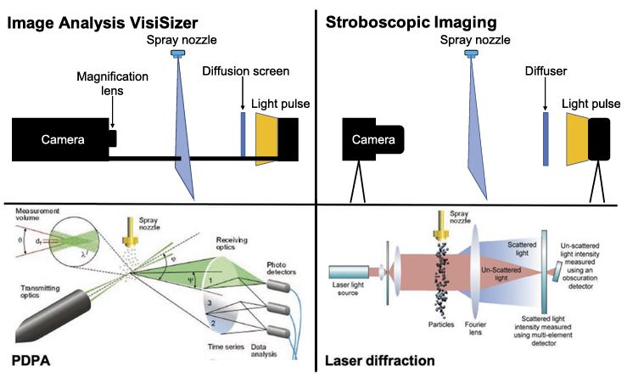
Fig 7: Different imaging techniques for droplet analysis
8. Conclusion
The spray pattern can be assessed by using imaging techniques, software, CFD analysis and patternators. The water-sensitive papers though expensive, can be analyzed using software like DepositScan, Matlab etc, which will readily give the data regarding droplets. Many android applications like Dropleaf, and DropSacn will give the analysis results of water-sensitive papers that can be stored for analysis. Capacitors and sensors can be used to read the change in physical quantity like the di-electric constant for measuring the drop characteristics. CFD analysis can also be used to measure droplet characteristics with the help of patternators and models. Patternators can be used for the study of droplet spectrum. Imaging techniques like image analysis, stroboscope, Phase Doppler particle analysis and laser diffraction will analyze the droplet spectrum based on the reflecting or scattering properties.

Disclaimer (Artificial intelligence)
Option 1:
Author(s) hereby declare that NO generative AI technologies such as Large Language Models (ChatGPT, COPILOT, etc.) and text-to-image generators have been used during the writing or editing of this manuscript.
Option 2:
Author(s) hereby declare that generative AI technologies such as Large Language Models, etc. have been used during the writing or editing of manuscripts. This explanation will include the name, version, model, and source of the generative AI technology and as well as all input prompts provided to the generative AI technology
Details of the AI usage are given below:
1.
2.
3.

9. References
Ade, G., & Venturi, P.(1995). Evaluations of some systems for controlling the vertical distribution of orchard sprayers. Journal of Agricultural Engineering, 4, 230-239.
Allochis, D., Balsari. P., Tamagnone, M., Marucco, P., Vai, P., & Bozzer, C. (2013). Performances evaluation of different vertical patternators. Julius-Kühn-Archiv. 120-132. (10.5073/jka.2015.449.0021)
Bahlol, H. Y., Chandel, A. K., Hoheisel, G. A., Khot, L. R. (2020). The smart spray analytical system: Developing understanding of output air-assist and spray patterns from orchard sprayers. Crop Protection, 127, 104977. (doi: 10.1016/j.cropro.2019.104977.)
Balsari, P., Gioelli, F., Tamagnone, M. (2007). A new vertical pattenator for determination of vertical spray pattern. Second European Workshop on Standardized Procedure for the Inspection of Sprayers - SPISE 2. PP 106-110.
Biocca, M., & Gallo, P. (2014) Comparison between horizontal and vertical lamellate patternators for air-blast sprayers. The Open Agriculture Journal, 8,12-17.
Biocca, M., Mattera, E., Imperi, G. (2005). A new vertical patternator to evaluate the distribution quality of vineyards and orchards sprayers. FRUTIC 05, Information and technology for sustainable fruit and vegetable production, Sep 12-16, Montpellier: France, pp. 653-660.
Brandoli, B., Spadon, G., Esau, T., Hennessy, P., Carvalho, A. C. P. L., Yahia, S. A. & Rodrigues, J. F. (2021). DropLeaf: A precision farming smartphone tool for real-time quantification of pesticide application coverage. Computers and Electronics in Agriculture, 180:105906. (https://doi.org/10.1016/j.compag.2020.105906.)
Cotteux, E., Rombaut, M., & Douzals, J. P. (2013). Comparison of vertical and horizontal collecting methods for spray deposits in crop canopy and airborne spray drift assessment. 12th Workshop on Spray Application Techniques in Fruit Growing.
Dayal, P., Shaik, M. S., & Singh, M. (2004). Evaluation of different parameters that affect droplet-size distribution from nasal sprays using the Malvern Spraytec®. J. Pharm. Sci. 93, 1725–1742. (DOI: 10.1002/jps.20090)
Dekeyser, D., Duga, A. T., Verboven, P., Endalew, A.M., Hendrickx, N., & Nuyttens, D. (2013). Assessment of orchard sprayers using laboratory experiments and computational fluid dynamics modelling. BiosystEng; 114(2), 157-69. (DOI:10.1016/j.biosystemseng.2012.11.013)
Garcera, C., Moltó, E., Izquierdo, H., Balsari, P., Marucco, P., Grella, M., Gioelli, F., & Chueca, P. (2022). Effect of the Air blast Settings on the Vertical Spray Profile: Implementation on an On-Line Decision Aid for Citrus Treatments. Agronomy 12, 1462. (https://doi.org/10.3390/agronomy12061462)
Ghiani, L., Sassu, A., Piccirilli, D., Marcialis, G. L., &Gambella, F. (2020). Development of a Matlab code for the evaluation of spray distribution with water-sensitive paper. Innovative Biosystems Engineering for Sustainable Agriculture, Forestry and Food Production. pp.845-853
Gil, E., & Badiola. (2007). Design and verification of a portable vertical patternator for vineyard spray calibration. Applied engineering in agriculture, 23(1), 35-42. (doi: 10.13031/2013.22328)
Gil, E., Landers, A., Gallart, M., &Llorens. J. (2013).Development of two portable patternators to improve drift control and operator training in the operation of vineyard sprayers. Spanish Journal of Agricultural Research, 11(3), 615-625. (10.5424/sjar/2013113-3638)
Gil E. (2007). Inspection of sprayers in use: a European sustainable strategy to reduce pesticide use in fruit crops. Appl Eng Agric. 23 (1), 49-56. (DOI:10.13031/2013.22330)
Grella, M., Gallart, M., Marucco, P., Balsari P., & Gil E. (2017). Ground deposition and airborne spraydrift assessment in vineyard and orchard: The influence of environmental variables and sprayer settings. Sustainability, 9 (5), 728. (doi:10.3390/su9050728)
Hoffmann, WC., Hewitt, AJ., Barber, JAS., Kirk, IW., Brown, JR. (2003). Field swath and drift analyses techniques. Pap Number AA03-007,
Lim, L. G., Pao, W. K., Hamid, N. H., & Tang, T.B. (2016). Design of helical capacitance sensor for holdup measurement in two-phase stratified flow: A sinusoidal function approach. Sensors, 16, 1032. (https://www.mdpi.com/1424-8220/16/7/1032#)
Martin, K. R. (2012) development of low cost vertical patternator. Paaternator.com (https://www.patternator.com/index.html)
Menesatti, P., Biocca, M., D’Andrea, S., & Pincu M. (2008). Thermography to analyze distribution of agricultural sprayers. Quant Infrared Thermogr J, 5(1), 81-96. (DOI:10.3166/qirt.5.81-96)
Miller, DR., Yendol, WE, McManus, ML. (1992). On the field sampling of pesticide spray distributions using Teflon spheres and flat cards. J Environ Sci Health Part B, 27(2), 185-208.
Nelson, K. A., Abraham J. S., & Kozo, S.(2010). Infrared thermography-based visualization of droplet transport in liquid sprays. Infrared Physics & Technology, 53(3), 218-226, (https://doi.org/10.1016/j.infrared.2009.12.002.)
Nuyttens, D., Taylor, W. A., Schampheleire, M. D., Verboven, P., & Dekeyser D. (2009). Influence of nozzle type and size on drift potential by means of different wind tunnel evaluation methods.Biosystems Engineering, 103,271–280. (doi: 10.1016/j.biosystemseng.2009.04.001.)
Pergher, G., & Gubiani, R. (1997). A comparison of methods for assessing vertical spray distributions from air- assisted sprayers. Bulletin OEPP/EPPOBulletin 27, 227-234. (https://doi.org/10.1111/J.1365-2338.1997.TB00639.X)
Pergher, G., (2001). Recovery rate of tracer dyes used for spray deposit assessment. Transactions of the ASAE, 44(4). (DOI: 10.13031/2013.6240)
Pergher, G. (2004). Field evaluation of a calibration method for air-assisted sprayers involving the use of a vertical patternator. Crop Protection 23, 437–446. (doi:10.1016/j.cropro.2003.09.015)
Sarghini, F., & Pergher, G. (2013). Numerical and experimental analysis of vertical spray control patternators. Journal of Agricultural Engineering. XLIV(s2) e73, 368-372. (doi:10.4081/jae.2013.s2.e73)
Sehsah (2016). Vertical patternator for evaluation of the hydraulic sprayers. Misr J. Ag. Eng., 33 (4), 1239 – 1254. (DOI:10.21608/mjae.2016.97595)
Simões, I., Sousa, A.J.,Baltazar, A.& Santos, F. (2025).Spray Quality Assessment on Water-Sensitive Paper Comparing AI and Classical Computer Vision Methods. Agriculture, 15, 261.(https://doi.org/10.3390/agriculture15030261)
Sies, M. F., Madzlan, N. F., Asmuin, N., Sadikin, A.,&Zakaria, H. (2017). Determine spray droplets on water sensitive paper (WSP) for low pressure deflector nozzle using image J. IOP Conf. Series: Materials Science and Engineering, 243,012047. (doi:10.1088/1757-899X/243/1/012047)
Sijs,D.,Kooij,S.,Holterman,H. J. Zande,J. van de.,& Bonn, D. (2021). Drop size measurement techniques for sprays:Comparison of image analysis, phase Dopplerparticle analysis, and laser diffraction. AIP Advances.11, 015315.(doi: 10.1063/5.0018667)
Xun, L. and Gil, E., 2024,A novel methodology for water-sensitive papers analysis focusing on the segmentation of overlapping droplets to better characterize deposition pattern, Crop Protection,Vol.176, 106492,(https://doi.org/10.1016/j.cropro.2023.106492.)
Zande, J.van de, Schlepers, M., Hofstee, J. W., Michielsen, J. M. G. P., &Wenneker, M. (2018).Effect of air distribution and spray liquid distribution of a cross-flow fan orchard sprayer on spray deposition in fruit trees. Seventh European Workshop on standardisedprocedure for the inspection of sprayers – SPISE 7. Pp 186-192.
Zhu, H., Salyani, M., & Fox, R. D. (2011).A portable scanning system for evaluation of spray deposit distribution.Computers and electronics in agriculture. 76:38-43. (doi:10.1016/j.compag.2011.01.003)
Kavya, T., Sushilendra, Sunil Shirwal, Vijayakumar Palled, A. G. Sreenivas, and Ananda N. 2024. “Influence of Spray Parameters of a UAV Sprayer on Droplet Size in Paddy Spraying”. Journal of Scientific Research and Reports 30 (11):749-61. https://doi.org/10.9734/jsrr/2024/v30i112602.
Nordin, M. N., Jusoh, M. S. M., Bakar, B. H. A., Ahmad, M. T., Mail, M. F., Vun, C. T., ... & Zolkafli, A. K. (2021). Study on water distribution of spraying drone by different speed and altitude. Advances in Agricultural and Food Research Journal, 2(2).
Chen, S., Lan, Y., Zhou, Z., Ouyang, F., Wang, G., Huang, X., ... & Cheng, S. (2020). Effect of droplet size parameters on droplet deposition and drift of aerial spraying by using plant protection UAV. Agronomy, 10(2), 195.
Hu, H., Ren, X., Ma, X., Li, H., Ma, Y., Wang, D., ... & Ma, Y. (2021). Control effect on cotton aphids of insecticides sprayed with unmanned aerial vehicles under different flight heights and spray volumes. International Journal of Precision Agricultural Aviation, 4(1).
Wongsuk, S., Qi, P., Wang, C., Zeng, A., Sun, F., Yu, F., ... & Xiongkui, H. (2024). Spray performance and control efficacy against pests in paddy rice by UAV‐based pesticide application: effects of atomization, UAV configuration and flight velocity. Pest Management Science, 80(4), 2072-2084.
Xun, L. (2024). Towards a sustainable use of plant protection products in orchards: implementation of canopy-adapted spray technology and new developments for spray efficiency evaluation.
Wang, P., Yu, W., Ou, M., Gong, C., & Jia, W. (2019). Monitoring of the pesticide droplet deposition with a novel capacitance sensor. Sensors, 19(3), 537.

