**Smart Irrigation in Nigeria: A Panacea to Curbing Hunger and Food Insecurity**

**Abstract:**

Nigeria has enormous agricultural potential, covering an area of over 923,768 square kilometres. However, despite Nigeria's economy heavily relying on agriculture and petroleum, poverty and hunger still exist. The primary causes of famine and food shortage in Nigeria are insecurity and conflict, poor farming methods, erratic weather patterns, insufficient water management plans, inadequate infrastructure, inadequate government regulations and low agricultural investment. Other concerns include inequality and poverty, food waste and losses after harvest. This project proposes designing an Internet of Things (IoT)-enabled irrigation system that comprises a lithium battery, ESP8266 microcontroller, solar panel, capacitive moisture sensor, and the Blynk smartphone app. The solar panel charges the lithium battery that powers the system, and the charge controller regulates charging and prevents overcharging and deep discharge. The ESP8266 microcontroller evaluates the real-time data gathered from the soil by the moisture sensor to determine whether to activate the DC pump to irrigate the area. The device efficiently irrigates crops based on monitored moisture levels, saving water and increasing agricultural productivity. The Internet of Things (IoT) combines smart sensors, networked devices and cloud computing to continuously gather, process and analyze data, allowing for automation and real-time monitoring, removing human intervention and enabling remote system control, predictive maintenance and instantaneous decision-making. Industry sectors such as agriculture can benefit from IoT's automated responses and data-driven insights to improve safety, increase productivity and optimize operations.

***Keywords****: Smart Irrigation, Solar energy, Agriculture, Water Conservation &* IoT*.*

**1. Introduction**

One of Nigeria's biggest problems is still food insecurity, as millions of people struggle every day to obtain enough wholesome food. Food insecurity affected more than 19 million Nigerians in 2021, according to the Food and Agriculture Organization (FAO, 2021). This condition was made worse by several socioeconomic and environmental variables. Nigeria's enormous agricultural potential is still mostly unrealized because of limited finance for the agricultural sector, unstable rainfall, poor road networks, insecurity and inadequate irrigation systems. Due to its reliance on rain-fed agriculture and traditional agricultural practices, Nigeria's vast amount of fertile land—more than 923,768 square kilometers is only partially exploited. These issues may be resolved with the help of smart irrigation technology, which guarantees effective water management and higher agricultural output (Franke, 2024).

In Nigeria, where farmers are susceptible to climate variability and unpredictable weather patterns because the country's agriculture is primarily dependent on rain, the implementation of smart irrigation—which makes use of real-time data, sensors, automated water delivery systems and precision agriculture—can significantly boost food production and reduce hunger. Nigeria lacks an efficient irrigation system, which leads to seasonal farming and lower agricultural yields despite the country's abundance of water sources, including the Niger and Benue Rivers (Eze et al., 2020). Conversely, countries such as Israel and India have successfully used smart irrigation to increase agricultural productivity despite water shortages.

In addition to the problems with irrigation, Nigeria's insecurity has a significant negative effect on agricultural output. With armed banditry in the northwest, conflicts between farmers and herders in the north and the growing insurgency in the northeast, many farmers have been forced from their farms, resulting in decreased food production. If security issues are not resolved, smart irrigation cannot reach its full potential. Nigeria can still increase food production while addressing losses related to insecurity by promoting climate-resilient crops and implementing regulated irrigation in safer areas (Gyang et al., 2017).

Another significant barrier to food security is the poor road system that hinders food distribution across the country. According to World Bank research, in 2022, more than 57% of Nigeria's rural roads are in poor condition, making it difficult for farmers to deliver their goods to markets. Inadequate infrastructure leads to post-harvest losses and increased food costs. Smart irrigation, improved transportation networks, and modern storage facilities may all help to ensure that food reaches customers efficiently and alleviate food shortages.

The lack of investment in the agriculture sector also hinders the utilization of smart irrigation and other advanced technology. Although Nigeria's agriculture sector contributes significantly to the country's GDP, government investment in this sector is still low compared to other industries (CBN, 2021). With the right funding, smart irrigation could revolutionize agriculture by precisely managing water, reducing reliance on rainfall and increasing crop yields. Many farmers cannot obtain credit facilities from banks and use outdated farming methods, which lowers production.

**2. Literature Review a National Smart Agriculture Task Force tasked with developing strategic plans,**

In 2016, Masaba and his colleagues developed and implemented an advanced smart irrigation system aimed at enhancing water and energy efficiency. The design features a microcontroller that acts as the central processing unit, along with sensors that measure various environmental parameters such as soil moisture, temperature, and humidity. The system controls water pumps and sprinklers to irrigate designated areas based on its assessments. Utilizing a decision-making algorithm, it employs a truth table for analyzing sensor data and determining irrigation needs. The system operates by collecting real-time environmental data through its sensors. The microcontroller processes this data using a predefined truth table to ascertain whether irrigation is necessary. If irrigation is required, it activates the water pumps and sprinklers to water only the dry areas, thereby avoiding unnecessary irrigation of moist regions. The implementation of this smart irrigation system has shown significant improvements in water usage by focusing solely on areas in need, which has resulted in reduced water wastage. Moreover, the selective activation of the water pumps contributes to lower energy consumption. Notably, the system can be adjusted to accommodate specific environmental conditions, making it versatile for various agricultural contexts. Its modular design also facilitates easy expansion and integration into existing farming infrastructures.

Ososanya et al. (2015) developed a solar-powered automated irrigation system that optimizes water usage based on soil moisture levels. The design incorporates several key components and features, including a sensor network of soil moisture, humidity, and temperature sensors to gather real-time data from agricultural fields. Additionally, wireless communication enables the transmission of sensor data to a remote monitoring station. The control system managed the solenoid valves, regulating water flow according to soil moisture readings. Photovoltaic panels provide the necessary energy to operate the sensors, microcontroller, and valves, ensuring sustainability and reducing operational costs. The implementation of this system has resulted in several significant outcomes. It has achieved water conservation by preventing over-irrigation and minimizing evaporation losses, leading to notable water savings. Energy efficiency was also enhanced, lowering energy costs and promoting environmental sustainability. Furthermore, optimized watering schedules have improved crop yields and facilitated better resource utilization.

In 2024, Mbanasor and his team researched climate-smart agriculture (CSA) practices among crop farmers in Southeast Nigeria. The aim was to assess the awareness, adoption, and intensity of CSA practices, as well as to identify the factors influencing their adoption. Although there is some level of adoption of CSA practices, the study found that the intensity and comprehensiveness of implementation are inadequate to address the adverse effects of climate change. Additionally, the findings revealed that various factors, including gender, household size, farming experience, education level, labour force size, income, exposure to extension services, access to credit, and membership in cooperative societies, significantly influenced the adoption of CSA practices.

In 2017, Zhao et al. developed an advanced smart irrigation system that leverages long-range (LoRa) wireless communication technology to improve water-use efficiency in agriculture. The system features a LoRa-based wireless sensor network that employs soil moisture sensors connected via LoRa modules. This configuration allows for the monitoring of field conditions over extensive distances while utilizing minimal power. Key components include Microcontroller Units (MCUs) that process sensor data and control irrigation valves accordingly, a gateway module that aggregates data from the sensor nodes and transmits it to a central server for analysis and storage, and a user interface that provides farmers with real-time data visualization and manual control options through a web-based platform. The implementation of this system demonstrated reliable data transmission over several kilometres, making it well-suited for large agricultural fields. Automated irrigation based on real-time soil moisture information resulted in optimized water usage and enhanced crop health. Additionally, the efficient battery operation of the sensor nodes significantly reduced the need for frequent maintenance.

In 2015, a team led by Zaier developed a fully automated, wireless irrigation control system designed to optimize groundwater usage on a farm scale. This initiative aimed to address the issues of excessive groundwater pumping and seawater intrusion in coastal aquifers, particularly in Oman. The smart irrigation system comprised several key components, including a wireless sensor network (WSN) that uses Xbee modules to establish connectivity. Each crop field contained multiple slave nodes, except for one designated master node per field. The master node has two sensors and a solenoid valve to sequentially control irrigation across the field by communicating with the slave nodes. The Xbee modules and solenoid valves are powered by lithium batteries, which are charged via solar panels to promote energy efficiency and sustainability. The system underwent testing across 14 farms to assess its performance in real-world agricultural settings. Each farm has a single collecting node connected to a host computer through the TCP/IP protocol. The host computer operated an irrigation management and monitoring application that tracked crop conditions and controlled the valves based on predefined thresholds and timers.

The results of the tests indicated that the system effectively automated irrigation processes, significantly reducing the need for manual intervention and subjective decision-making. By monitoring soil moisture levels and adjusting irrigation accordingly, the system optimized groundwater usage, thereby contributing to sustainable water management practices. Furthermore, the solar-powered components ensured efficient operation without reliance on external power sources.

Laksiri et al. (2019) developed a cost-effective, IoT-based smart irrigation system tailored specifically for Sri Lankan agriculture, to enhance water efficiency and enable remote monitoring and control. This system integrates several key components, including soil moisture sensors that evaluate moisture levels in the soil to determine irrigation requirements. It also employs environmental sensors to gather essential field data, such as temperature, humidity, and rainfall. With IoT integration, sensor data can be transmitted to a remote database, allowing for real-time monitoring and management via the Internet. A user-friendly interface enables users to remotely view sensor readings and manually control the irrigation system. Furthermore, a weather prediction algorithm analyzes the collected environmental data to forecast weather conditions and adjust irrigation schedules accordingly. The implementation of this system demonstrated effective water management, remote monitoring and control, and overall cost-effectiveness.

In 2021, a research team led by Henner Gimpel investigated the development and implementation of a smart and sustainable irrigation system. This study aimed to tackle the increasing concern of water scarcity, particularly its effects on urban trees, which are exacerbated by rising temperatures and climate change. Utilizing a design science research approach, the study illustrates how IoT technology and data analytics can be the foundation for an intelligent and sustainable irrigation system. The design of this system was a collaborative effort, drawing on theoretical insights and expert contributions from various stakeholders, IoT specialists, and botanists. To assess their design, a prototype smart irrigation system was implemented and evaluated in Germany. This pilot program included the installation of 18 sensors across eight urban trees. The findings demonstrated significant potential for water conservation. Moreover, it was revealed that for approximately 5,000 young trees, the smart irrigation system could decrease water distribution or wastage by up to 1 million litres in a single irrigation round during the spring season.

Mezouar et al. (2022) introduced an advanced smart irrigation system incorporating several essential electronic components: a soil moisture sensor positioned at the root zone of a plant, a temperature sensor, and a water flow sensor linked to the valve of a water pump. These sensors are integrated with an Arduino UNO microcontroller, a relay module, a DC pumping motor, and a battery. The system operates by monitoring soil moisture and temperature levels, automatically activating or deactivating the water pump based on real-time soil moisture readings to ensure that irrigation occurs at optimal intervals. The data collected from the sensors is transmitted to a computer for compilation into a comma-separated values (CSV) dataset, facilitating the creation of graphs for analysis. The authors concluded that such innovative solutions are crucial for reducing costs, saving time, and optimizing resource use in agriculture.

In 2015, Sahu and Behera introduced a low-cost smart irrigation control system aimed at optimizing water usage, minimizing manual labour, and enhancing crop productivity, specifically for farmers in regions like India. Their system features soil moisture sensors strategically placed in agricultural fields to monitor soil moisture levels in real time. A microcontroller (Arduino-UNO with ATMEGA318) serves as the system's brain, processing data from the soil moisture sensors. The system also includes automated water pump control that efficiently activates and deactivates the pump as needed. The anticipated outcomes of this proposed system include cost-effectiveness, water conservation, reduced labour efforts, improved efficiencies (such as energy and time savings), and the potential for increased crop yields.

Abdelhamid et al. (2025) designed and assessed a solar-powered smart irrigation system aimed at promoting sustainable urban agriculture. The researchers set up two drip irrigation systems for peppermint cultivation: a conventional system (a standard drip irrigation setup powered by photovoltaic panels) and a smart irrigation system (a more advanced configuration that uses sensors and an Arduino-based controller to monitor and manage irrigation based on real-time data). The smart irrigation system was composed of several key components, including soil moisture sensors, DHT11 temperature and humidity sensors, voltage and current sensors for photovoltaic panels, an Arduino Mega 2560 microcontroller, as well as DC pumps and solenoid valves. The findings indicated that the smart irrigation system led to a 28.1% reduction in water and energy consumption compared to the conventional system. Furthermore, the smart system achieved a notable reduction in carbon dioxide emissions, producing 0.181 kg CO₂/m²/year compared to 0.252 kg CO₂/m²/year for the standard system.

**3**. **Challenges of Agriculture in Nigeria**

**3.1 Poor Infrastructure:**

Poor road networks play a significant role in causing food insecurity and famine in Nigeria by disrupting the agricultural supply chain. Poor roads make it difficult for farmers to transport their produce to markets, leading to high post-harvest losses, especially for perishable goods like fruits, vegetables and dairy products. The increased cost of transportation due to bad roads raises food prices, making essential commodities unaffordable for low-income households. Additionally, poor infrastructure limits farmers’ access to necessary agricultural inputs, such as fertilizers, seeds and modern equipment, reducing food production.

In rural areas, where farming is the main livelihood, poor road networks prevent farmers from reaching profitable markets, discouraging large-scale agricultural investment and leading to food shortages. During natural disasters like floods, fragile road networks collapse, further cutting off food supply chains and worsening hunger (Leonard & Abimaje, 2024). To address these challenges, the Nigerian government must invest in road infrastructure to enhance food distribution, reduce costs and ensure stable food availability for all citizens (Anthony et al., 2024).

**3.2 Unreliable Irrigation Systems:**

Due to inadequate infrastructure, maintenance, and investment, Nigeria's irrigation system is still unreliable. One significant issue is that many rural areas, both domestically and internationally, lack access to pipe-borne water, which makes it challenging to guarantee a steady supply of water for agricultural operations. Most Nigerian farmers rely on rainfall, which is unpredictable and seasonal due to climate change. Since many Nigerian farmers use rain-fed agriculture, irregular water supplies result in low crop yields and frequent crop failures.

Small-scale farmers, the backbone of Nigeria's agricultural sector, are particularly affected because they lack the resources to implement modern irrigation techniques, which limits the agribusiness sector's ability to drive economic growth and poverty reduction (Oriola, 2009). This unreliable irrigation system has had a significant impact on the country's agriculture, reducing crop yields, particularly during the dry season, increasing reliance on imported food and creating food insecurity.

In Nigeria, famine and food insecurity are greatly increased by unreliable irrigation systems that lower agricultural productivity (Bashir & Choi, 2018). Since many Nigerian farmers depend on rain-fed farming, an inconsistent water supply leads to low agricultural yields and frequent crop failures. An inability to supply enough water to crops due to malfunctioning irrigation systems leads to poor harvests, fewer food accessible and higher food prices, which raises the risk of hunger and malnutrition by making basic foods costly for many people (Adadu & Eyoma, 2024).

* 1. **Government Policies:**

Poor government policies on agriculture significantly contribute to food insecurity and famine in Nigeria. One major issue is inadequate investment in agricultural infrastructure, such as roads, storage facilities and irrigation systems, leading to high post-harvest losses and reduced productivity. Additionally, inconsistent agribusiness policies, including the sudden removal of subsidies on fertilizers, seeds and petrol, make essential inputs unaffordable for small-scale farmers (Gyang et al., 2017).

According to Balogun et al. (2015), inadequate policies raise the danger of famine by causing low food production, high prices and widespread hunger. Implementing sustainable policies that boost agricultural productivity, upgrade infrastructure and assist regional farmers is necessary for the government to address this crisis. (Abubakar et al., 2021).

**4. Smart Agriculture**

* 1. **The Role of Smart Agriculture**

Smart agriculture uses advanced technology, such as automated irrigation, machine learning and the Internet of Things (IoT), to enhance food production. The following components are required:

* **IoT Sensors**: Devices that monitor soil moisture, temperature, and weather conditions.
* **Automated Systems**: Drip and sprinkler irrigation systems equipped with timers and controls.
* **Data Analytics**: Platforms for analyzing environmental data to inform irrigation schedules.

**4.2 Benefits of Smart Irrigation**

1. **Water Efficiency**: Reduces water wastage by targeting the root zones of crops.
2. **Increased Crop Yields**: Maintains optimal soil moisture for improved plant health.
3. **Cost Savings**: Lower labour costs and minimize water expenses.
4. **Climate Resilience**: Adapts to changing weather patterns and mitigates climate risks.

**5. System Design and Implementation**

**5.1 Components of the circuits:** The proposed smart irrigation system consists of the following:

* **ESP8266 microcontroller:** Developed for Internet of Things applications. Espressif Systems produced the ESP8266, a low-cost microcontroller with built-in Wi-Fi (802.11 b/g/n), a 32-bit Tensilica L106 processor operating at 80/160 MHz, support for TCP/IP networking, and GPIO, SPI, I2C, UART and ADC interfaces that facilitate easy communication with sensors, actuators, and other devices. It can be programmed using the Arduino IDE, MicroPython, and AT commands and has a built-in flash memory for firmware storage. It is often used in Internet of Things projects, smart home automation and remote sensing due to its compact size, low power consumption and reliable connectivity.
* **Capacitive Soil Moisture Sensor:** Made up of two conductive plates separated by soil, which acts as a dielectric, this electronic device uses variations in capacitance to determine the moisture content of soil. The capacitance is affected by changes in the dielectric constant, which is changed by changes in soil moisture. The electrical signal produced by the sensor is proportionate to the moisture level. It is robust and suitable for long-term soil monitoring applications in horticulture, agriculture and environmental studies than resistive sensors because it does not corrode as easily due to not being exposed to water directly.
* **DHT11 Sensor:** A low-cost digital sensor that measures temperature and humidity, the DHT11 has a capacitive humidity sensor and a thermistor to provide accurate environmental readings. It can measure temperature between 0 and 50°C with ±2°C accuracy and humidity between 20 and 90% RH with ±5% accuracy. It communicates via a single-wire digital interface, making it easy to integrate with microcontrollers like Arduino and ESP8266. Because of its small size and low power consumption, the DHT11 is widely used in weather monitoring, HVAC systems, and Internet of Things applications.
* **0.96″ I2C OLED Display:** Operating at 3.3V–5V, the 0.96″ I2C OLED Display is a small, energy-efficient screen that uses organic light-emitting diode (OLED) technology to display graphics and text without a backlight. It usually has a resolution of 128×64 pixels and connects to microcontrollers via the I2C (Inter-Integrated Circuit) protocol, requiring only two signal wires (SDA and SCL) for data transmission. It is powered by the SSD1306 driver and provides monochrome (white, blue, or yellow) output with high contrast and quick response time.
* 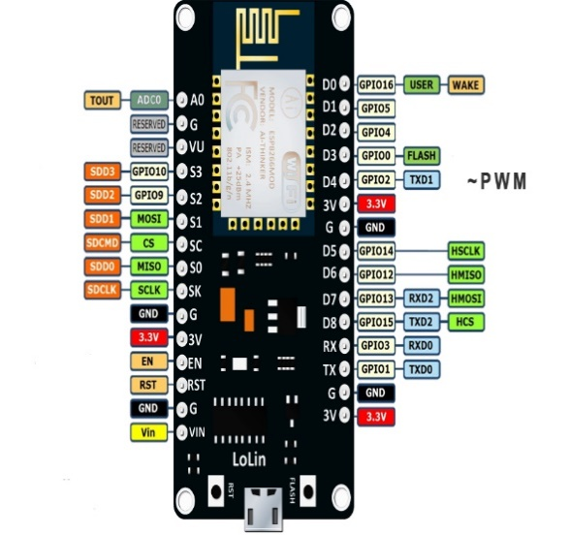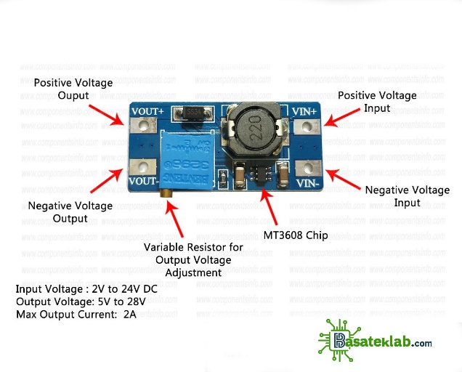**Relay-Controlled Mini Water Pump:** It automates irrigation based on soil moisture levels

**Fig 1.0 0.96″ I2C OLED Display Fig 2.0 DHT11 (digital temperature and humidity sensor module**

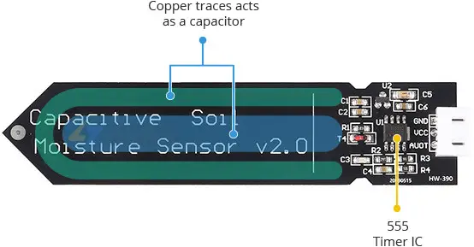 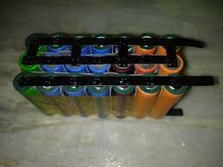

**Fig 3.0 Capacitive Soil Moisture Sensors Fig 4.0 lithium battery**

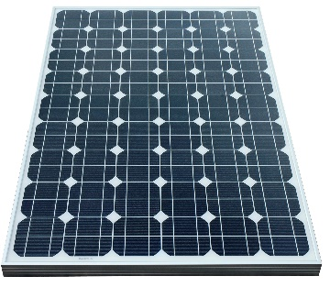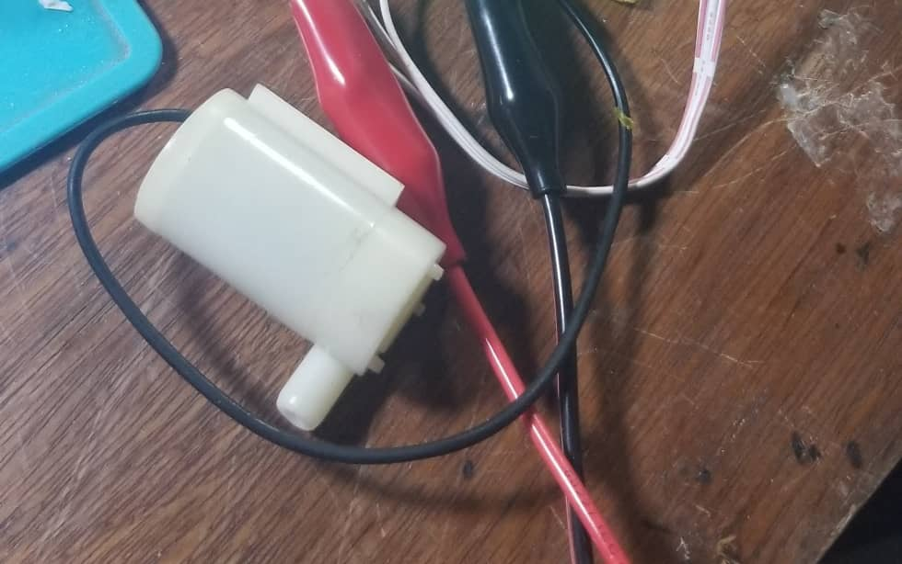

**Fig 5.0 Monocrystalline solar panel Fig 6.0 DC Water pump**

**6. Methodology**

Several techniques can be used to design irrigation systems, but the method used for this design is the capacitive measurement technique based on capacitance technology. Its foundation is capacitive measuring, which has several benefits over resistive measurement.  With only one probe and no exposed metal to rust, these sensors do not damage plants by putting electricity into the ground (Salamat, 2015).

**Soil Moisture Sensor**

**OLED Display**

**WIFI Module (ESP8266)**

**Relay Module**

**DC water Pump**

**Temp/Humidity Sensor (DHT11)**

**Power Supply**

**Fig. 7.0 Block Diagram of a Smart Irrigation System**

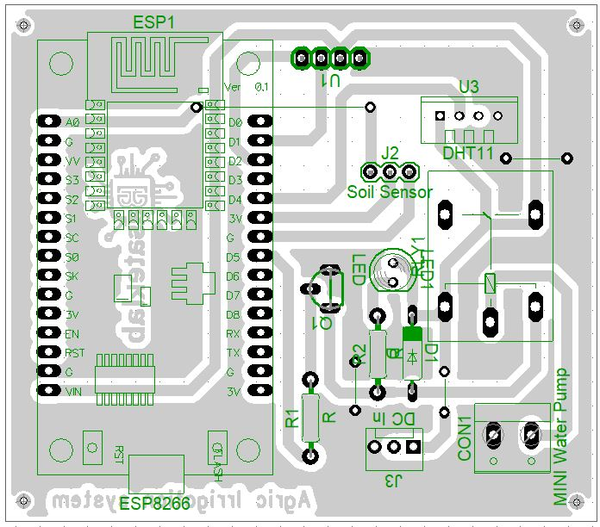

**Fig. 8.0 Layout Diagram of Smart Irrigation System**

The firmware code for the ESP8266 microcontroller was developed using the Arduino IDE, specifically designed to program the ESP module. This firmware enables the transmission of control commands to the cloud server (Thingspeak), and the application was developed in C++.

**6.1 Setting up the Blynk web dashboard and Mobile App**



**Fig. 9.0 Blynk Cloud Server Environment**

The setup of a remote server allowed the user and the device to communicate remotely to monitor the system's performance and status. To accomplish this, Blynk was used to create a cloud account. Creating the account connected to the gadget was done via https://blynk.io./. as seen in Fig 9.0 above. When the account was created, a new template was created by selecting "add new template" and inputting the template's details.

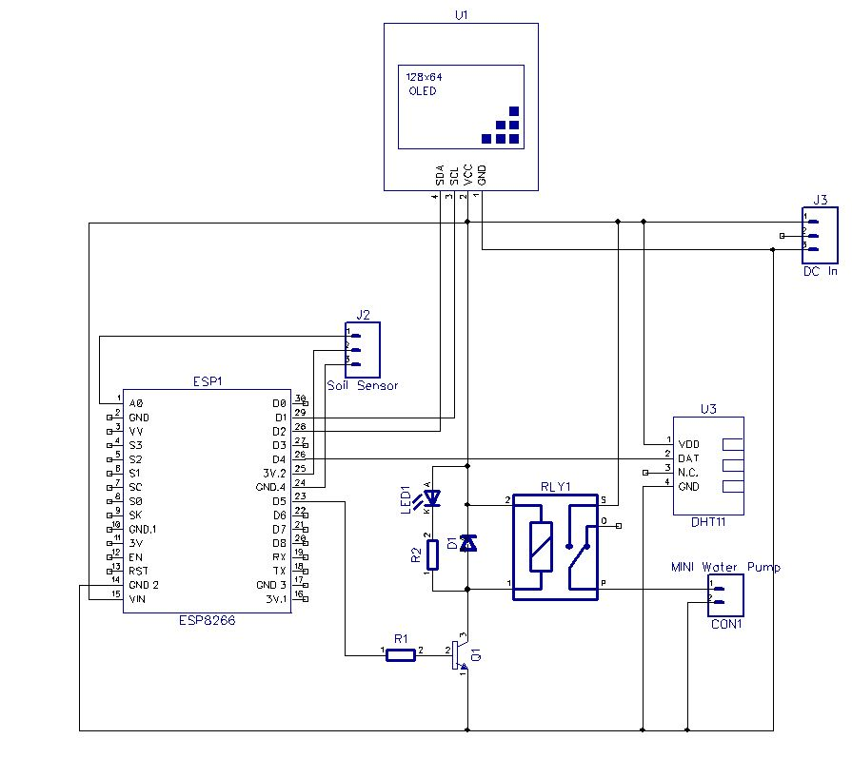

**Fig. 10.0 Circuit Diagram of a Smart Irrigation System**

The complete circuit design for the Internet of Things-based agricultural irrigation system is shown in Fig. 10.0. The Espressif ESP8266 microcontroller, on which the control system is based, enables remote device monitoring and control. The mobile device running the web-based user interface acts as the client, and the ESP8266 microcontroller module connects to the WI-FI network and acts as a server. Using an IP address and a web browser, the user can access the web-based user interface on their laptop or mobile device. The digital pins D5 of the ESP modules are configured as output and are used to turn on the relays. The power supply for the system is generated from a 9V DC source using DC-DC converter module voltage regulators attached to J3. The controlled output from the regulator is then supplied to the power pins of the ESP8266’s V_CC and GND pins. Each time one of the application’s control buttons is pressed, the corresponding data is sent via a cloud environment to the server (ESP8266). The ESP module subsequently processes the data before sending it to the relay driver circuit, which controls the electric motor that pumps water for the plant.

**7. Testing and Results**

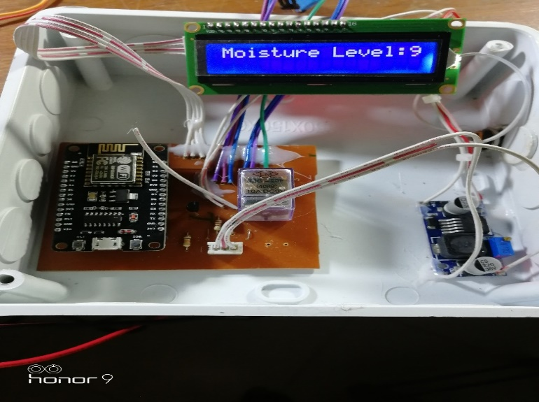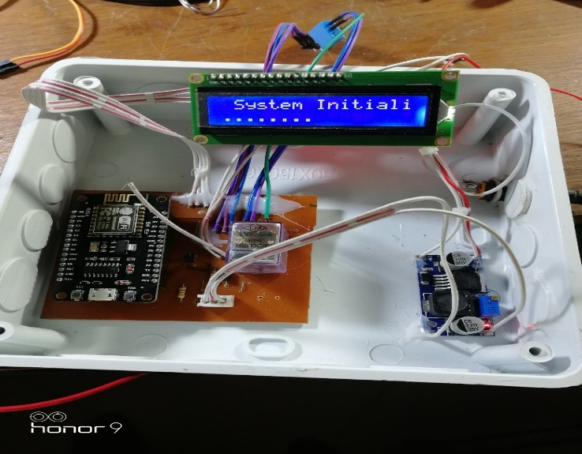

**Fig 11a: Powering on the system Fig. 11b: Testing the sensitivity of the moisture sensor**

**The IoT-based system is depicted as initializing in Figure 11a. The 0.96-inch I2C OLED display shows the message "system initialization," indicating that the system is starting up, as illustrated in the diagram. The soil moisture sensor was tested and embedded in the farm's soil. During the project's testing phase, the water pump was submerged in water, and the irrigation outlet pipe was positioned in the field. Furthermore, the moisture sensor was also buried underground. As soon as the system was powered on, the LCD initialized and began displaying information regarding the soil moisture level and the status of the water pump.**

**6. Conclusion**

An IoT-enabled irrigation system that comprises a lithium battery, ESP8266 microcontroller, solar panel, capacitive moisture sensor and the Blynk smartphone app was designed and implemented. The solar panel charges the lithium battery that powers the system, and the charge controller regulates charging and prevents overcharging and deep discharge. The ESP8266 microcontroller evaluates the real-time data gathered from the soil by the moisture sensor to determine whether to activate the DC pump to irrigate the area. The device efficiently irrigates crops based on monitored moisture levels, saving water and increasing agricultural productivity. This system combines smart sensors, networked devices and cloud computing to continuously gather, process and analyze data, allowing for automation and real-time monitoring, removing human intervention and enabling remote system control, predictive maintenance and instantaneous decision-making. The agribusiness sector can benefit from IoT's automated responses and data-driven insights to improve safety, increase productivity and optimize operations.

Smart irrigation transcends mere technological advancement; it is crucial for achieving food security, fostering economic growth, and ensuring a resilient agricultural sector. By implementing this concept, Nigeria has the potential to enhance its self-sufficiency in food production, paving the way for a future where hunger is a thing of the past.

**7. Recommendations**  
• The government should subsidize programs promoting the use of smart farming equipment to encourage farmers to embrace modern technology.   
 • To promote innovation in agriculture, the government should support public-private partnerships with digital companies.

• Stakeholders and the government should provide training programs that teach farmers about IoT-based agricultural technologies.

Disclaimer (Artificial intelligence)

Author(s) hereby declare that NO generative AI technologies such as Large Language Models (ChatGPT, COPILOT, etc.) and text-to-image generators have been used during the writing or editing of this manuscript.

**References**

Abdelhamid, M. A., Abdelkader, T. K., Sayed, H. A., Zhang, Z., Zhao, X., & Atia, M. F. (2025). Design and evaluation of a solar powered smart irrigation system for sustainable urban agriculture. Scientific Reports, 15(1), 11761. <https://doi.org/10.1038/s41598-025-94251-3>.

Abubakar, A., Gambo, J., & Umar, S. (2021). An overview of the effect of some agricultural policies in Nigeria -1960-2020. *Nigeria Agricultural Journal*, *52*(3), 151–162.

Adadu, A., & Eyoma, F. (2024). Assessing the impact of solar-powered irrigation systems on water availability for crop production in Abuja. *IOSR Journal of Humanities and Social Science*, *28*(12, Ser. 4), 1–10.

Anthony, O., Ibe, C., Ejem, E., & Uzondu, C. (2024). Estimating the direct economic impacts of poor road infrastructure disruptions on road freight systems in Nigeria. *International Journal of Traffic and Transportation*, *13*(1), 1–5. <https://doi.org/10.5923/j.ijtte.20241301.01>

Balogun, O., Ayantoye, K., Akinwole, O., & Alabi, O. (2015). Leadership and governance: Dilemma of agricultural development in Nigeria. *The Nigerian Journal of Sociology and Anthropology*, *13*(1), 1–15.

Bashir, A., & Choi, K. (2018). A review of the evaluation of irrigation practice in Nigeria: Past, present and prospects. *African Journal of Agricultural Research*, *13*(40), 2087–2097. <https://doi.org/10.5897/AJAR2018.13403>

CBN. (2021). *Annual report on the Nigerian agricultural sector*. Central Bank of Nigeria.

El Mezouar, A., El Fazziki, A., & Sadgal, M. (2022). Smart irrigation system. *IFAC-PapersOnLine*, *55*(10), 3298-3303.

FAO. (2021). *The state of food security and nutrition in Nigeria*. Food and Agriculture Organization.

Franke, T. (2024). Smart irrigation: Revolutionizing water management in agriculture. *International Research Journal of Plant Science*, *15*(3), 1–2. <https://doi.org/10.14303/irjps.2024.39>

Gimpel, H., Graf-Drasch, V., Hawlitschek, F., & Neumeier, K. (2021). Designing smart and sustainable irrigation: A case study. *Journal of Cleaner Production*, *315*, 128048.

Gyang, T., Ogoh, A., & Ekpa, D. (2017). Poor governance and agricultural development in Nigeria. *Innovative Techniques in Agriculture*, *1*(5), 246–255.

Laksiri, H. G. C. R., Dharmagunawardhana, H. A. C., & Wijayakulasooriya, J. V. (2019, December). Design and optimization of IoT based smart irrigation system in Sri Lanka. In *2019 14th Conference on Industrial and Information Systems (ICIIS)* (pp. 198-202). IEEE.

Leonard, J., & Abimaje, F. (2024). Optimizing Nigerian road reliability by defining poor road causes, maintenance strategies and application. *Engineering Science and Technology Journal*, *15*(7). <https://doi.org/10.51594/estj/v5i7.1290>

Masaba, K., Ntakirutimana, A., & Ustun, T. S. (2016). Design and implementation of a smart irrigation system for improved water-energy efficiency. In *4th IET Clean Energy and Technology Conference (CEAT 2016)*. Stevenage UK: IET. <https://doi.org/10.1049/cp.2016.1357>.

Mbanasor, J. A., Kalu, C. A., Okpokiri, C. I., Onwusiribe, C. N., Nto, P. O., Agwu, N. M., & Ndukwu, M. C. (2024). Climate smart agriculture practices by crop farmers: evidence from south east Nigeria. *Smart Agricultural Technology, 8*, 100494.

Oriola, E. (2009). Breaking the vicious cycle of irrigation farming system for sustainable food security in Nigeria. *African Research Review*, *3*(1). <https://doi.org/10.4314/afrrev.v3i1.43570>

Ososanya, E. T., Haghani, S., Mahmoud, W. H., Lakeou, S., & Diarra, S. D. (2015). Design and implementation of a solar-powered smart irrigation system. In *2015 ASEE Annual Conference & Exposition*. <https://doi.org/10.18260/p.23792>.

Sahu, C. K., & Behera, P. (2015). A low cost smart irrigation control system. In *2015 2nd International conference on electronics and communication systems (ICECS)*, 1146-1152.

Salamat, A. (2015). A comparative study of resistive and capacitive humidity sensors. *Journal of Emerging Technologies and Innovative Research*, *2*(6). ISSN 2349-5162

World Bank. (2022). *Nigeria rural road network and agricultural growth report*.

Zaier, R., Zekri, S., Jayasuriya, H., Teirab, A., Hamza, N., & Al-Busaidi, H. (2015). Design and implementation of smart irrigation system for groundwater use at farm scale. In *2015 7th International Conference on Modelling, Identification and Control (ICMIC)*, 1-6.  Doi: 10.1109/ICMIC.2015.7409402.

Zhao, W., Lin, S., Han, J., Xu, R., & Hou, L. (2017). Design and implementation of smart irrigation system based on LoRa. In *2017 IEEE Globecom Workshops (GC Wkshps)*, 1-6. Doi: 10.1109/GLOCOMW.2017.8269115.