Factors Determining the profits of the street vendors: A Study of Jammu District
Abstract:
Street vending forms a vital part of the informal economy, contributing significantly to livelihoods, particularly in urban and semi-urban areas. This study investigates the factors determining the profits of street vendors in the Jammu district of Jammu and Kashmir. Drawing on a sample of 366 street vendors—comprising both native and migrant vendors—the study employs primary data collection methods and multiple regression analysis to explore economic, social, and operational variables influencing profitability. The study highlights the role of initial investment, daily sales , and the nature of goods sold as significant determinants of profits. Conversely, factors such as educational attainment and average working hours are found to have no substantial impact. Additionally, the study examines the emerging role of technology, finding that vendors utilizing online transactions tend to earn higher profits, underscoring the growing relevance of digital payments in informal markets. The demographic profile of the vendors reveals that a majority are male, with a substantial proportion being migrants. Most vendors operate independently, with commodities ranging from fruits and vegetables to fast food and flowers. Challenges such as limited access to prime vending locations, competition, and lack of financial support are prevalent. The present study fills a critical gap in the literature by focusing on the street vending sector in Jammu, a region often overlooked in studies of urban informal economies. By providing insights into profitability drivers and challenges, the study offers valuable recommendations for policymakers and urban planners. These include facilitating access to vending spaces, promoting digital literacy, and providing microfinance options to support initial investments. The findings also emphasize the need for targeted interventions to ensure sustainable livelihoods for street vendors while integrating them more effectively into the urban economy.
Key Words: Informal Economy, Street Vendors, J&K

Introduction
Street vending is a key mode of retail trading. Despite being one of the country's oldest kinds of retail, street vending serves as an important link in the formal sector's supply chain. It is the most apparent part of the informal sector and is a global phenomena . Like the other informal industries, it employs a significant number of people and is distinguished by low income, self-employment, a lack of social protection, and so on. Street vendors are an important part of the informal sector in the Jammu district since they not only make a living by peddling but also provide handy services to the bulk of the population living in urban areas.
Street vendors are the primary distributors of a wide range of everyday consumption products such as vegetables, fruits, shoes, readymade clothing, toys, stationery, and newspapers. As a result, they are the solution to some of the urban woes that plague the population. As a result, the importance of this industry cannot be overlooked. They have a tremendous impact on local economic growth and the development of metropolitan economies around the world.
They can suffer harassment from local authorities, as well as social security and storage issues. Protection from local authorities and the state government can allow these impoverished people to work without fear. Despite their contributions, a lot of things influence their profitability. Millions of people throughout the world make a living by selling various goods and services on the streets. There is a prevalent idea that street vending will diminish as economies expand; yet, it is actually increasing in many places. Amod K. (2000). Studies undertaken in developing nations have looked into the numerous elements that influence street sellers' revenue levels. For example, Adhikari (2017) did a study in Nepal and discovered that the capital investment, the number of workers employed, and the educational level of street sellers were all important factors influencing their earnings. Similarly, Inderianti, Hardiani, and Rosmeli (2020) identified fixed and operational capital, working hours, length of business operations, and location as important factors impacting the income of street vendors, particularly those in the sweets sector.
Further research, such as that conducted by Septiawan, Nurjanah, and Mustika (2019), investigated the impact of capital, age, and working hours on the earnings of street vendors. Similarly, Wibowo, Kaukab, and Putranto's (2021) research emphasized the importance of capital, operational duration, location, and working hours in increasing the income of street sellers. Hanum (2017) discovered through multiple regression analysis that capital, working hours, and business lifespan all had a substantial impact on street sellers' earnings in Kuala Simpang. Other research, including one by Ernawati, Rochmah, and Aprilliyani (2020), found that the length of business operations and working hours had a substantial impact on street sellers' revenue levels. Siagian (2021) emphasized the relevance of capital in influencing the earnings of street vendors in Grogol, West Jakarta. These findings illustrate the broad array of factors that determine street vendors' profitability and the critical role they play in urban economies, particularly in developing nations.

Significance of the Study:
- Although there is literature on street vending in developing countries, most studies focus on urban centers outside Jammu and Kashmir. The unique socio-economic dynamics of the Jammu district, particularly the impact of migration and cultural differences, remain underexplored.
- While digital payments and online transactions are growing in India, their specific impact on the profitability and operations of street vendors in Jammu has not been adequately studied.
- Previous studies often isolate variables like initial investment and education. This research aims to understand the combined effects of these factors alongside working hours, nature of goods, and technological adoption.
Objectives:
1. To identify and analyze key determinants of street vendors’ profits: This includes examining the impact of economic variables such as initial investment, daily sales volume, and investigate their average working hours.
2. To understand the socio-economic and demographic characteristics of street vendors: This involves studying factors such as gender, migration status, educational attainment, age of entry into street vending, and years of experience.
3. To assess the role of technological adoption in street vending: Explore how the use of online transactions and digital payment methods influences street vendors’ sales and profitability.
Hypotheses:
H1: There is no significant positive relationship between initial investment and daily profits of street vendors.
H2: A higher daily sales volume does not significantly increase the profits of street vendors.
H3: The use of online transactions does not significantly affect the profits of street vendors.
H4: The educational attainment of street vendors does not have a significant impact on their profitability.
H5: There is no significant impact of online transactions on the profitability of street vendors compared to those who rely solely on cash transactions.
H6: Average working hours do not have a significant effect on the profitability of street vendors

Methodology:
This study employed a cross-sectional, quantitative design to investigate the factors influencing the profitability and working conditions of street vendors in Jammu district. The research focused on diverse urban and semi-urban vendors, ensuring representation of various demographics, such as gender and migration status, and types of goods sold. A total of 366 vendors were selected through stratified random sampling to capture this diversity. Data was collected using a structured questionnaire that explored key economic, social, and operational variables, including initial investment, daily sales, types of commodities sold, educational level, working hours, and technology usage, such as online transactions. For data analysis, descriptive statistics were used to summarize the socio-economic profiles of the vendors, while multiple regression analysis identified significant predictors of profitability, such as initial investment, sales volume, nature of goods, educational attainment, and technological adoption. Additionally, ANOVA was applied to assess profit variances across groups based on gender and migration status. The dependent variable for this study was daily profit, with independent variables categorized as economic factors (initial investment, daily sales), social factors (educational attainment, migration status), and operational factors (average working hours, use of online transactions). This comprehensive methodology aims to provide actionable insights into the economic and social dynamics of street vending in Jammu district.
Analysis:
Table. 1. Socio-Economic Profile of Street Vendors
- Gender | Total (366) | Percent
Male | 341 | 93.2
Female | 25 | 6.8
- Resident status | Total (366) | Percent
Migrant | 235 | 60.4
Native | 131 | 35.8
- Educational attainment | Total (366) | Percent
Illiterate | 149
5th-8th | 109 | 29.8
9th-12th | 97 | 26.5
Graduation | 11 | 3
- Average working hours | Total (366) | Percent
Less than 5 hours | 23 | 6.3
5-7 hours | 75 | 20.5
8-11hours | 193 | 52.7
12-14 hours | 75 | 20.5
- Initial investment | Total (366) | Percent
Below 5000 | 95 | 25.9
5000-10,000 | 219 | 59.9
10,000-15,000 | 52 | 14.2
- Total profit per day | Total (366) | Percent
100-300 | 101 | 27.6
300-600 | 111 | 30.3
600-900 | 96 | 26.2
900-1500 | 58 | 15.8
- Sales per day | Total (366) | Percent
100-500 | 22 | 5.7
500-1000 | 82 | 22.4
1000-1500 | 131 | 35.8
1500-2000 | 86 | 23.5
Above 2000 | 45 | 12.3
- Online transactions at vending place | Total (366) | Percent
Yes | 195 | 53.3
No | 171 | 46.2
- Type of commodities sold | Total (366) | Percent
Fruits | 70 | 19.1
Vegetables | 82 | 22.4
Both fruits and vegetables | 144 | 39.3
Flowers | 27 | 7.4
Fast food | 28 | 7.7
Source: Primary Survey
The study surveyed a sample of 366 street vendors in Jammu, as shown in the table, out of the total sampled street vendors most are male (93.2%) and migrants (60.4%). Educational levels vary, with 40.7% being illiterate and only 3% graduates. Over half (52.7%) work 8-11 hours daily, with a majority investing ₹5,000-₹10,000 (59.9%). Daily profits range widely, with 30.3% earning ₹300-₹600. Sales typically fall between ₹1,000-₹1,500 (35.8%), and 53.3% use online transactions. Vendors predominantly sell fruits, vegetables, or both (80.8%), with smaller proportions offering flowers or fast food.
Model specification: To determine the determinants of profit, multiple linear regression is applied.
Y = B0 + β1X1 + β2X2 + β3X3 + β4X4+ β5X5 +β6X6 +e
where Y=profits per day ; X1= Sales per day ; X2= Initial investment ; X3= Age of entry in street vending; X4= Educational attainment; X5=Online transactions; X6=Average working hours β=beta co effcient. B0=constant, e=other factors not included in the study (0.05 random error).
Before running multiple linear regression, few of its assumptions were tested. Testing of the assumptions are as follows :
Table 2. Tests of Normality
 | Kolmogorov-Smirnovª |  |  | Shapiro-Wilk
 | Statistic | df | Sig. | Statistic | Df | Sig.
total profit per day | .094 | 366 | .200 | .866 | 366 | .410
a. Lilliefors Significance Correction
Result: Since the significance value >0.05 as depicted in Kolmogorov Smirnov and Shapiro Wilk test, thus the data is normally distributed.

Table 3. Multicollinearity Test
S.No | Independent variables | Collinearity tolerance | Statistics VIF
1 | Sales per day | .742 | 1.347
2 | Initial investment | .751 | 1.331
3 | Age of entry in street vending | .933 | 1.072
4 | Educational attainment | .973 | 1.028
5 | Online transactions | .932 | 1.073
6 | Average working hours | .938 | 1.066
Result: Statistically, when the tolerance value ranges from 0.1 to 1.0 and the VIF ranges from 1 to 10, multi-co-linearity does not exist. In order for a variable to be declared not to have the presence of multicollinearity, the VIF value must be below 10 (VIF <10)(Shreshta,2020). Thus, we conclude that there is no multicollinearity among the independent variables.
Histogram :The second and most important premise in regression analysis is to check the dependent variable for a normal distribution, as shown by the histogram. The histogram indicates how well the data aligns with the normality assumption. A symmetrical, bell-shaped curve with the highest frequency of scores in the middle and lower frequencies towards the extremes is referred to as normal (Pallant, 2020).
The black line on the histogram represents a "normal" curve, indicating that the assumption of normality of frequencies is valid.

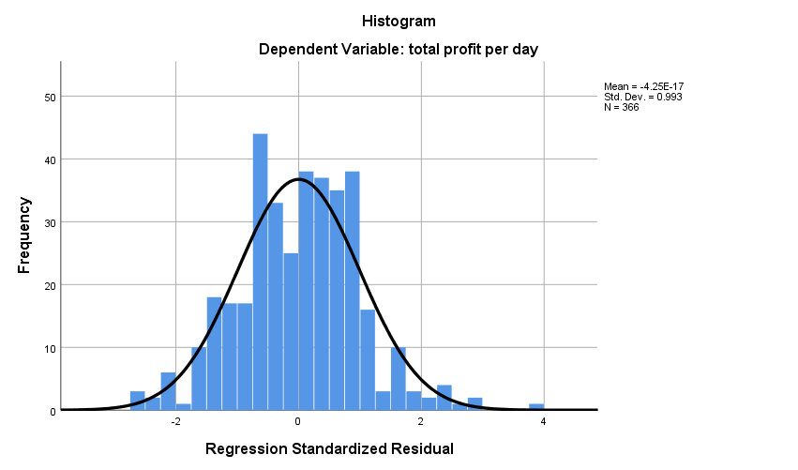
Fig 1- Histogram showing profit variability

Fig 2- Histogram showing normal P-P-P plot of regression

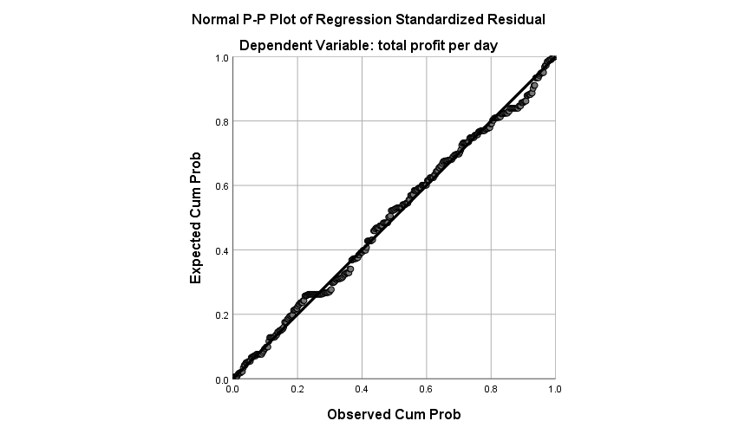

Auto-correlation - Durban Watson statistic shows whether there is autocorrelation. According to Turner (2020) values from 1 to 3 are acceptable for DW statistics.
As shown in the table below, the value of Durbin- Watson is 1.727. Hence, we conclude that there is no auto correlation.
Table 4. Model Summary (Result of Multiple Linear Regression Model)
Model | R | R Square | Adjusted R Square | Std. Error of the Estimate | Durbin-Watson
1 | .648ª | .420 | .410 | .799 | 1.727
a. Predictors: (Constant), average working hours in a day, age of entry in street vending, educational attainment, do you use online transactions in your vending place, initial investment, what is your sale per day
b. Dependent Variable: total profit per day
Result: The above table shows the model summary. r square shows what percent of variance in dependent variable (profits per day) explains with independent variable. Hence r2 =.648 indicates that 64 % of variance in the level of profits is explained by the independent variables.
Table 5. ANOVA
Model |  | Sum of Squares | Df | Mean Square | F | Sig.
1 | Regression | 165.890 | 6 | 27.648 | 43.259 | .000^{b}
1 | Residual | 229.447 | 359 | .639
1 | Total | 395.336 | 365
a. Dependent Variable: total profit per day
b. Predictors: (Constant), average working hours in a day, age of entry in street vending, educational attainment, do you use online transactions in your vending place, initial investment, what is your sale per day
Result: This table determines whether the model is significant enough to determine the outcome. Based on the values shown in the table, we can conclude, the model is efficient as well as significant.
Table 6. Coefficients of Independent Variables
S.No | Independent variables | B(unstandardized co efficient) | Std error | Beta(Standardized co efficient) | t | Sig
 | Constant | .139 | .167 | .587 | .832 | .406
1 | Sales per day | .561 | .045 | .587 | 4.572 | .000
2 | Initial investment | .091 | .044 | .095 | 2.055 | .041
3 | Age of entry in street vending | 2.33 | .066 | .148 | 3.559 | .000
4 | Educational attainment | .067 | .048 | .057 | 1.394 | .164
5 | Online transactions | .168 | .078 | .090 | 2.154 | .032
6 | Average working hours | .112 | .054 | .086 | 2.080 | .038
The above table shows the strength of the relationship i.e. the significance of the variable in the model and magnitude with which it impacts the dependent variable. This analysis helps in performing the hypothesis testing for a study.
Results: The analysis reveals that a 1% increase in sales leads to a 0.56% rise in profits, while a 1% increase in initial investment results in a 0.091% profit growth. Similarly, a 1% increase in the age of entry into street vending boosts profits by 2.33%, and a 1% increase in online transactions enhances profits by 0.168%. Additionally, a 1% increase in average working hours contributes to a 0.112% increase in profits. In hypothesis testing, if the significance value (Sig.) is less than 0.05, the null hypothesis is rejected, indicating a significant impact. Conversely, if the Sig. is greater than 0.05, the null hypothesis is not rejected, suggesting no significant effect. In this study, the null hypothesis was rejected for all independent variables, except for the education level of the vendors. This implies that, aside from education, all other factors—such as sales volume, initial investment, age of entry, online transactions, and working hours—have a significant impact on the profitability of street vendors.
Based on the regression analysis result regression model equation was seems like the following:
Y = 0.139 + 0.561 X1 + 0.091 X2 + 2.33 X3 + 0.067 X4 + 0.168 X5 + 0.112 X6 + 0.05
Conclusion: The study on street vendors in the Jammu district provides valuable insights into the factors influencing their profitability and working conditions. Findings of the study showed that economic factors such as sales volume and initial investment have the most substantial impact on daily profits. Operational aspects like average working hours and the adoption of online transactions also significantly affect profitability, emphasizing the relevance of digital payments in the informal economy. Interestingly, educational attainment does not have a significant effect, suggesting that practical business factors outweigh formal education in this context.
Despite their critical role in the urban economy, street vendors face challenges like limited access to prime vending locations and financial constraints. This study emphasizes the need for targeted policy measures such as fostering digital literacy, offering microfinance opportunities, and ensuring secure vending zones. These interventions are critical for promoting the sustainable inclusion of street vendors into urban economic frameworks, enhancing their livelihoods, and mitigating their vulnerabilities.
References :
Amod K. (2000), “Vendors, Police & Governance”, in Seminar, No. 491, July, pp.32 – 35.
Adhikari, D. B. (2017). Informal Street food trade: A source of income generation in urban Nepal. Economic Journal of Development Issues, 1-17.
Burgess, M., Haugerud, H., Straumsnes, S., & Reitan, T. (2002). Measuring system normality. ACM Transactions on Computer Systems (TOCS), 20(2), 125-160.s
Ernawati, F. Y., Rochmah, S., & Apriliyani, D. (2020, November). Analysis of the Influence of Capital, Working Hours, Length of Business on Street Vendors’ Income (Case Study of Street Vendors in the Yard of PT Mercindo Global Manufaktur Bawen). In Proceeding of National Seminar & Call for Paper STIE AAS (Vol. 3, No. 1, pp. 137-149).
Febriani, M., & Setyowati, E. (2023, October). Analysis of Factors Affecting the Income of Street Seller at Karangpandan. In International Conference on Economics and Business Studies (ICOEBS-22-2) (pp. 101-110). Atlantis Press.
Herman, H. (2021). Analysis of Factors Affecting Traders' Income on Traditional Markets in Indonesia. ADPEBI International Journal of Business and Social Science, 1(1), 28-36.
Inderianti, R. A., Hardiani, H., & Rosmeli, R. (2020). Analysis of factors affecting the income of street vendors in Jambi City (case study of sweet stalls in Telanaipura District). E-Journal of Economic Perspectives and Regional Development, 9(3), 109-118.
Shrestha, N. (2020). Detecting multicollinearity in regression analysis. American Journal of Applied Mathematics and Statistics, 8(2), 39-42.
Siagian, A. O. (2021). The Influence of Factors on Street Vendors' Income in Grogol, West Jakarta. Journal of Economy and Currency Study (JECS), 3(1), 1-10.
Turner, P. (2020). Critical values ​​for the Durbin-Watson test in large samples. Applied Economics Letters, 27(18), 1495-1499.
Wibowo, Ana Fatma Fitriana, M. Elfan Kaukab, and Agus Putranto. "Street vendors' income and influencing factors." Journal of Economics, Business and Engineering (JEBE) 2.2 (2021): 206-216.

