Journal Name: | Journal of Scientific Research and Reports
Manuscript Number: | Ms_JSRR_137069
Title of the Manuscript: | Strategic Cropping for Economic Sustainability: A Case Study on Income Optimization in Agriculture
Type of the Article | Research Paper

PART 1: Comments

 | Reviewer’s comment  Artificial Intelligence (AI) generated or assisted review comments are strictly prohibited during peer review. | Author’s Feedback (It is mandatory that authors should write his/her feedback here)
Please write a few sentences regarding the importance of this manuscript for the scientific community. A minimum of 3-4 sentences may be required for this part. | Economic Sustainability is achievable when productive resources are allocated efficiently and crops are selected based on the unique characteristics of each region. To enhance Economics sustainability in agricultural practices, establishing optimal cropping patterns is essential, So LP approach is most useful model of products and profitability increasing for farmers.
Is the title of the article suitable?  (If not please suggest an alternative title) | Alternative Title: In my opinion, the appropriate title for this research is:  Optimal Cropping Pattern for Economic Sustainability Using linear Programming Model
Is the abstract of the article comprehensive? Do you suggest the addition (or deletion) of some points in this section? Please write your suggestions here. | - The Sampling method and Sample size didn’t specified.  - The software used in data analysis should be specified.  - The year of data collection should be specified.  - If the future study and suggestions are specified in the abstract, it will be good
Is the manuscript scientifically, correct? Please write here. | One of the most important decisions that farmers face is what to produce. By land allocation, it is possible to determine the maximum income from the consumption of a certain number of production factors, or at least the amount of costs for a certain combination of products.
Are the references sufficient and recent? If you have suggestions of additional references, please mention them in the review form. | The DOI number or research link must be added for each reference.
Is the language/English quality of the article suitable for scholarly communications? | The related problems of the manuscript have been highlighted, I hope it will be corrected.  Beside there are some grammatical errors in the manuscript, it Grammarly or paperpal is used, I think the manuscript will be corrected.
Optional/General comments | In the conclusion section, your research has not been compared to previous research according to literature review.  The results and outputs of the Excel solver should be converted to a screenshot form, this will show that your research results are real. For example  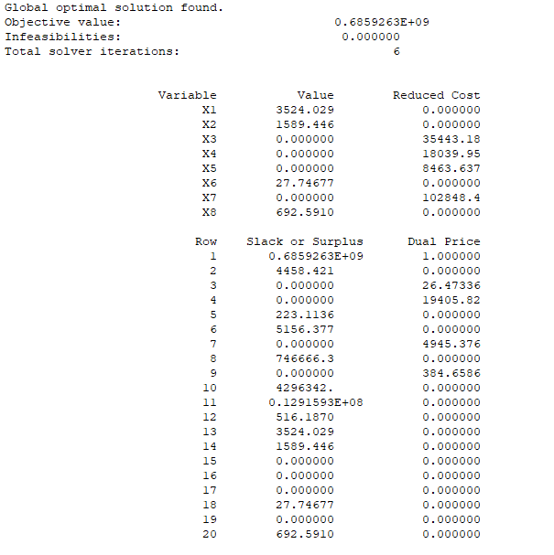

PART 2:

 | Reviewer’s comment | Author’s Feedback (It is mandatory that authors should write his/her feedback here)
Are there ethical issues in this manuscript? | (If yes, Kindly please write down the ethical issues here in details)

Reviewer details:
Zia Ur Rahman Rasikh, Laghman University, Afghanistan

