Protected Cultivation Technologies for Off-Season Vegetable Production: A Review
Abstract
Off-season production of vegetables is becoming ever more important in the provision of round-the-year availability, improved price to farmers, and improved livelihood. Protected cultivation technologies, like greenhouses, net houses, polyhouses, low tunnels, and hydroponic systems, provide a potential mean for vegetable cultivation under regulated conditions. The technologies reduce the effects of adverse climatic conditions and provide an optimal growth condition, thus increasing productivity, quality, and minimizing pest incidence. This review paper discusses several protected cultivation technologies, their usage, benefits, problems, and future potential for developing India's off-season vegetable production.
Keywords: Protected cultivation, off-season vegetables, polyhouse, low tunnel, net house, microclimate, yield improvement
1. Introduction
India, being a largely agrarian economy, depends significantly on agriculture for food security, employment, and rural livelihood. Of the agricultural sub-sectors, horticulture, especially vegetable production, is crucial to nutritional security, farmers' economic empowerment, and income generation (Joosten et al., 2015). With shifting food consumption patterns, growing urbanization, and rising health awareness among consumers, demand for fresh, high-quality vegetables has been growing rapidly throughout the year (Eigenbrod, and Gruda, 2015).
In spite of this increasing demand, vegetable production in India continues to be highly seasonal and strongly dependent on climatic conditions like temperature, rain, humidity, and sunlight (Solankey et al., 2021). Seasonality creates huge supply variations and price changes in the market, impacting both farmers and consumers. In off-seasons, the availability of fresh vegetables becomes short, pushing prices up, and there is a heavy dependency on cold storage or long-distance transportation, which can affect freshness and nutritional quality (Filson, and Adekunle, 2017).
Table 1: Suitable vegetable varieties for year round cultivation under low cost poly house (Phookan and Saikia, 2003)

Crops | Varieties | Season
I-Year
Tomato | Naveen, Karnataka | May-Aug
French bean | Kentucky Wonder, Contender | Sept-Nov
Cauliflower | White Marble, Indam | Dec-Feb
Coriander | CO-1, Mehak | May-April
RGreen manure | Sesbania Spp. | May
II-Year
Tomato | Naveen, Karnataka | June-Sept
French bean | Kentucky Wonder, Contender | Oct-Dec
Chilli | KA-2,Arka Lohit | Jan-April
Cowpea | Arka Suman | May-June
Other crops
Okra | Arka Anamika | May- June
Palak | All Green, Pusa Jyoti | June-July
(Source, Jayasurya et al., 2021)

Table 2: Comparison of cost of production of vegetables under different low cost protected structures (Chauhan et al., 2016) ^{[3]}

Sr. No | Kind of protected structures | Cost (Rs/ m²) | Suitable crops | Duration of crops (days) | Yield (t/ 1000 m²) | Cost (Rs./ Kg)
1 | Insect proof net house | 80-100 | Sweet pepper | 200-240 | 3.5-4.0 | 15-16
2 | Plastic low tunnels | 5-6 | Summer squash | 90-95 | 5.0-6.0 | 1.5-2.0
2 | Plastic low tunnels | 5-6 | Musk melon | 110-120 | 2.0-3.0 | 3.0-4.0
2 | Plastic low tunnels | 5-6 | Bitter gourd | 110-120 | 1.0-1.5 | 4.0-5.0
2 | Plastic low tunnels | 5-6 | Bottle gourd | 80-90 | 2.0-3.0 | 3.0-4.0
(Source, Jayasurya et al., 2021)

For their solution, protected cultivation has grown up as an innovative and environmentally friendly method of modern agriculture (Ameta, et al., 2019). Protected cultivation involves the utilization of specialized structures and methods to control the surrounding microclimate to the physiological requirements of crops (Kumar et al., 2022). Regulating environmental conditions like temperature, light intensity, humidity, and carbon dioxide level, these systems provide optimal growing conditions for around-the-year production of vegetables (Krishna et al., 2024). Covered structures act as physical shields that shield crops from harsh weather, pest attacks, and diseases, thereby improving crop quality and yield (Pathak et al., 2023).
Table 3: Off-season vegetable production under temporary protected low height polyhouse

Crop | Variety | Spacing (cm) | Crop Duration  (Months) | Total Production  (kg 1000m²) | Estimated sale Price (Rs/Kg) |  | Cost of Cultivation  (Rs) | Total Income  (Rs) | Net Profit  (Rs)
 |  |  |  |  | Farmer | Market
French bean | Contender  Pusa Parvathi | 50×7 | 110 | 950 | 40 | 70-80 | 20,000 | 38,000 | 18,500
Summer Squash | Pusa Alankar Australian Green  DS-8 | 50×50  50×50 | 115 | 4500 | 15 | 40- 50 | 20,250 | 67,500 | 47,250
Amaranthus | Pusa Lal  Chaulai Pusa Kiran | 50×50 | 120 | 1500 | 20 | 40 – 50 | 15,000 | 30,000 | 15,000
(Source, Jayasurya et al., 2021)

Second year onwards profit: French bean: Rs.33,000/-, Summer squash: Rs.59,500/-, Amaranth: Rs.25,000/-
Protection of cultivation facilitates cultivation of high-value vegetables even during unfavorable climatic seasons, which results in prolonged growing seasons, enhanced efficiency in input use (water, nutrients, and labor), and enhanced income (Kumar, and Singh, 2020). Polyhouses, net houses, shade nets, low tunnels, walk-in tunnels, and soilless culture systems (such as hydroponics) have emerged with vast possibilities for off-season vegetable production with higher uniformity and yield (Rajiv, and Kumari, 2023).
In addition, protected cultivation aids in the diversification of cropping systems and provides a chance to grow exotic and climate-sensitive vegetables that are otherwise challenging to produce under open field conditions (Bhattacharyya, et al., 2020). It also helps in climate-resilient agriculture by reducing the effect of erratic weather conditions like unseasonal rains, temperature fluctuations, or hailstorms (Singh et al., 2021).
The current review paper seeks to investigate the key protected cultivation technologies embraced in India and their relevance to facilitating off-season production of vegetables. The paper offers an inside look into the functional design, merits, drawbacks, and appropriate crops for each technology with the aim of heightening awareness and encouraging expanded use among farmers, scientists, and policy makers.
Techniques of Vegetable Off-Season Cultivation
Off-season vegetable cultivation involves the growing of vegetables at a time when they would not naturally be grown in a given area because of climatic constraints (Krishna et al., 2024). Some revolutionary techniques and technologies have made it possible for farmers to cultivate vegetables outside their natural seasons to meet year-round supply, improved market prices, and increased farm revenue (Singh et al. 2024). The major techniques are:
Changing Sowing and Planting DateiKr
By preponing or postponing the planting season by a slight margin, some vegetables can be cultivated outside their normal season by the farmers (Gyawali, et al., 2022). For example, summer vegetables which are normally planted between March and May and harvested between June and August can be grown off-season by planting during January to February and harvesting during April to June, particularly in warmer regions. This time manipulation enables the prevention of peak climatic stress and early market entry with better prices.
Utilizing Agro-Climatic Diversity
India's diverse topography and climatic regions provide special possibilities for cultivating the same crop in different periods in different places. This spatial heterogeneity is utilized by:
Agriculturalists planting crops such as cauliflower, cabbage, and peas during summer and monsoon and marketing them in the plains as off-season fruits.
Farmers on plains cultivating vegetables such as tomato, brinjal, and sweet pepper during winter, and then sending them to high-altitude areas where such conditions are not found during that time.
This technique utilizes geographical climate benefits to make vegetables available throughout the year.
Selection of Early, Mid, and Late-Maturing Varieties of cauliflower
Crop varieties with different growth periods and stress resistance are essential for off-season production. Hybrid and better varieties have enhanced resistance to poor conditions and provide longer harvest seasons. For instance:
Early crops such as Pusa Deepali, Pusa Meghna, and Pusa Kartik Sankar (cauliflower) are planted early and harvested in September. Mid-season crops like Pusa Synthetic, Pusa Himjyoti, and Pusa Shubhra are harvested in November. Late crops, such as the Snowball group, are ready for harvest in January. Staggered production through strategic use of these crops results in improved market regulation and less gluts.
Controlled Environment Agriculture (Protected Cultivation)
Given that temperature and climate fluctuations are the principal hindrances in off-season growth, protective covers are used to establish desirable microclimates (Gruda et al., 2019). Some leading technologies are:
Classification of Greenhouses
Greenhouses are categorized depending on different factors like cost, form, size, and environmental control level.
1. Classification Based on Cost
Greenhouses have been widely classified into three types depending on construction costs:
a. Low-Cost Greenhouses
Low-cost greenhouses are developed using locally sourced materials like bamboo or wood for the structure. Such greenhouses are glazed with polyethylene sheets that are UV-stabilized (Ashok, and Sujitha, 2021). There is no control system for the environment in this kind of greenhouse, and therefore it is fit for general protection purposes. The cost of construction is generally Rs. 250 to Rs. 300 per square meter (Ashok, and Sujitha, 2021).
Table 4: Off-season vegetable production under low cost polyhouse of 1000 m² (Yadav et al., 2014)
Crop | Variety | Spacing (cm) | Crop  Duration (Moths) | Total  Production (kg 1000 m²) | Estimated sale Price(Rs/Kg) |  | Cost of Cultivation (Rs) | Total  Income (Rs) | Net  Profit (Rs)
 |  |  |  |  | Farmer | Market
Gherkin | DG-6 | 50×50 | 4 | 2,300 | 30 | 50-60 | 25,500 | 69,000 | 43,500
Cherry Tomato | Cherry Red  Cherry Yellow | 60×50 | 5 | 2,000 | 30 | 80-100 | 26,250 | 60,000 | 33,750
Bitter gourd | Gynoecious | 60×50 | 4 | 2,000 | 25 | 50- 60 | 26,250 | 50,000 | 23,750
Cucumber | Parthenocarpic | 50×50 | 4 | 2,500 | 25 | 40-50 | 25,500 | 62,00 | 37,00

(Source, Jayasurya et al., 2021)
Second year onwards profit: Gherkin: Rs.59000/-, Cherry tomato: Rs.50000/-, Bitter gourd: Rs.40000/-, Cucumber: Rs.52500/-
b. Medium-Cost Greenhouses
Medium-cost greenhouses typically have galvanized iron (GI) or mild steel (MS) pipe frames. MS pipes are inexpensive but are liable to rust, which will gradually weaken the greenhouse covering. These greenhouses are also provided with UV-stabilized polyethylene sheets. The cost of construction is between Rs. 800 and Rs. 1000 per square meter (Ashok, and Sujitha, 2021).
c. High-Cost Greenhouses
High-cost greenhouses are built by using aluminum or GI pipes and glazed by using either a double-layer polyethylene sheet or polycarbonate sheets. These houses are equipped with fully automated environment control systems. They are fitted with sensors and controllers for controlling temperature, humidity, and soil moisture, providing optimal conditions for high-value crop cultivation. The price of building such greenhouses is more than Rs. 2000 per square meter (Ashok, and Sujitha, 2021).
Classification Based on Shape
Greenhouses can also be classified based on their shape of structure. Common ones are:
- Quonset type
- Modified Quonset type
- Gable or Standard Peak type
- Even span
- Uneven span
- Multi-span gutter-connected type
- Lean-to type
Each form possesses design benefits, depending on the use, soil conditions, and crop needs.
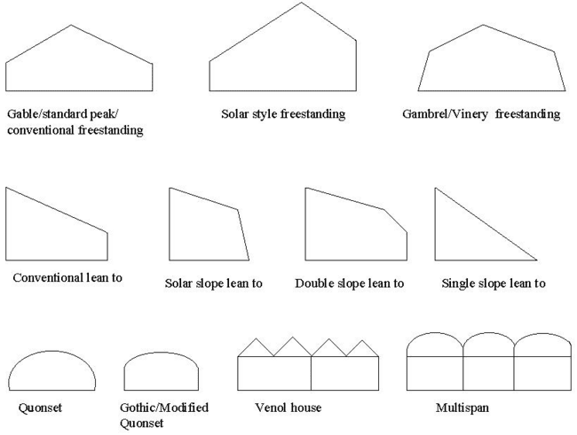
Image. 1. Various type greenhouse structure standing
UNEVEN SPAN
- ROOF SLOPES ARE OF UNEQUAL WIDTH
- IN HILLY TERRAIN
RIDGE AND FURROW
- A SHAPED GREEN HOUSES CONNECTED TO EACH OTHER ALONG THE EAVE
Categories of Protected Cultivation Technologies
Protected cultivation covers a range of structures and systems that protect crops from adverse exterior conditions while furnishing ideal growth and development conditions (Gupta et al., 2024). Every technology is suited for specific crop needs, climatic adversities, and resource limitation (Sharma et al., 2024). The following are the chief categories of protected cultivation technologies employed in India:
Polyhouse Farming
Polyhouse farming is one of the most sophisticated and most commonly practiced forms of protected agriculture (Dahiya, and Singh, 2018). A polyhouse is a framed building, typically of galvanized iron or bamboo, and clad with transparent or semi-transparent polyethylene sheets. Polyhouses facilitate control over temperature, humidity, light, and carbon dioxide levels, thus enabling all-year-round production of vegetables irrespective of external weather conditions (Jadhav and Rosentrater, 2017). Polyhouses are particularly ideal for high-value and sensitive crops like capsicum (bell pepper), tomato, cucumber, lettuce, and exotic leafy greens. Additions like drip irrigation, foggers or misters, ventilators, and thermal screens are usually incorporated into these buildings to make them more efficient (Sanap, et al., 2022). The key benefits are increased productivity per unit area, improved quality produce, lower pesticide use, and enhanced water-use efficiency.
These are medium-sized covered structures constructed with polythene films and bamboo/GI pipe frames. They facilitate vertical crop growth of tomato and cucurbits. Suitable for marginal and small farmers in hilly areas, polythene houses encourage off-season production with better quality and quantity (Krishna et al., 2024).
Net House Cultivation
Net houses are buildings covered with insect-proof netting materials, usually composed of UV-stabilized polyethylene. These structures serve as physical barriers to insect pests, thus reducing the application of chemical pesticides, which is especially advantageous in leafy vegetables and cucurbits (Fernández, et al., 2018). Net houses allow proper air circulation and penetration of light while minimizing the effect of direct solar radiation and wind pressure. Bitter gourd, ridge gourd, cucumber, tomato, and spinach are some of the commonly grown crops in net houses (Singh, et al., 2009). Depending on the need, net houses may be classified as shaded net houses to decrease light intensity and white or transparent net houses for overall cultivation.

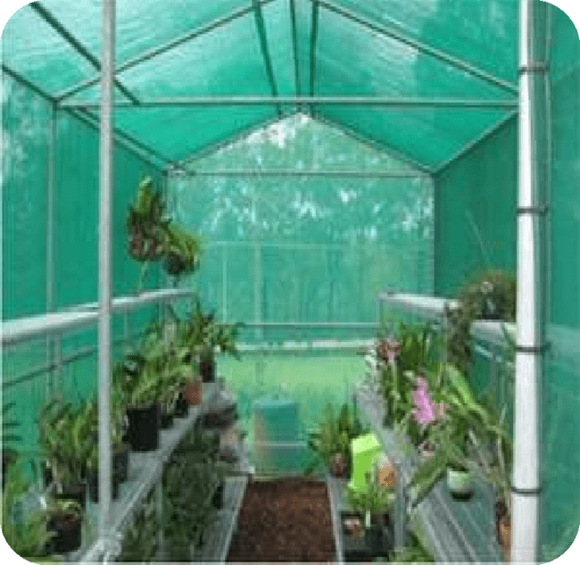

Image 2. Net House Cultivation

Greenhouses / Glass Houses
Technologically advanced glass or UV-stabilized polyfilm structures, greenhouses provide fine control over temperature, humidity, irrigation, and light. While costly, they permit vegetable growth throughout the year, particularly of high-value vegetables (Malam et al., 2024). Greenhouses are also beneficial for disease and pest control, better quality production, and efficient use of land, thus well-suited to commercial vegetable farmers (Savic, and Ilin, 2022).
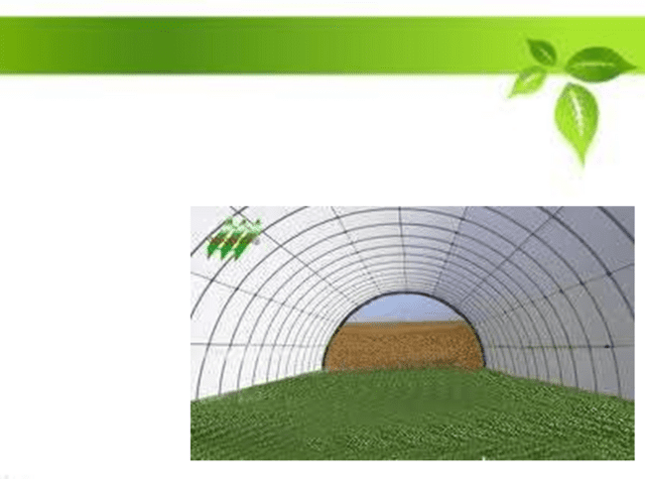
Image 3. Greenhouse structure
Low Tunnel Technology
Low tunnel technology, or row covers or mini greenhouses, encompasses the utilization of low-cost, temporary polyethylene structures placed on crop rows (Kumar, and Singh, 2022). These tunnels are usually made of flexible galvanized iron or bamboo hoops covered with transparent plastic film. They are employed primarily for early or off-season production, shielding against low temperatures and frost. Low tunnels facilitate faster germination by raising soil and air temperature and allow for 10 to 20 days earlier harvesting compared to open-field production. Crops commonly grown under low tunnels include cucumber, muskmelon, watermelon, pumpkin, and other cucurbits (Rajiv, and Kumari, 2023).
These are inexpensive plastic structures constructed from polythene sheets resting on bamboo or GI wire hoops, creating a row-cover tunnel over beds (Jayasurya, et al., 2021). Used mainly in winter for seedlings of summer vegetables, they cover the crops from frost, rain, and cold wind, thus bringing forward harvests by 30–40 days (Ummyiah, et al., 2017). Tomato, muskmelon, cucumber, summer squash, and bottle gourd are some of the crops that greatly gain under tunnel cultivation, particularly in northern India.
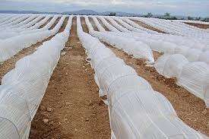

Image 4. low Tunnel
Table 5: Performance of vegetable crops grown under low tunnel (Singh et al., 1999).

Sl.No | Crop | Transplanting time | Harvesting time | Crop Advancement | Expected Cost benefit Ratio
1 | Summer Squash | Frist week of December | First week of February | 60 days | 1:3 to 1:4
2 | Muskmelon | Third week of January to  First week of February | Second week of April to Last week of April | 30-40 days | 1:2.5 to 1:3.5
3 | Bottle gourd | Third week of January to  First week of February | Second week of April to Last week of April | 30-40 days | 1:2.5 to 1:3.5
4 | Bitter gourd | Third week of January to  First week of February | Second week of April to Last week of April | 30-40 days | 1:3 to 1:4
5 | Water melon | Third week of January to First week of February | Second week of April to Last week of April | 30-40 days | 1:2 to 1:2.5
6 | Cucumber | Third week of January to  First week of February | First week of February | 30 days | 1:3 to 1:4
(Source, Jayasurya et al., 2021)

Walk-in Tunnel
Walk-in tunnels are medium-sized protective structures that are taller than low tunnels and allow farmers to enter and manage crops easily (Banjare, et al., 2024). These tunnels are generally semi-circular or gothic-shaped and constructed using GI pipes or bamboo frames covered with polyethylene sheets. They are most suited for nursery rearing, vegetable seedling cultivation, and growing short-duration crops like lettuce, spinach, coriander, fenugreek, and basil. Walk-in tunnels are cost-effective, inexpensive to build, and ideal for marginal farmers. They facilitate improved air movement and are less labor-intensive than bigger polyhouses (Deb 2023).
These are wider than low tunnels and permit human entry within for farm work. Made of bamboo or GI pipes, they are covered with plastic or shade nets. They are usually 4 meters wide and 30 meters long (120 m²) and are ideal for growing cucumber, summer squash, bottle gourd, etc., during cold winter seasons (December to mid-February) (Sharma, and Gautam, 2017).
2.5 Shade Net Structures
Shade netting includes knitted or woven nets of cover that gives crops partial shade by breaking the strength of light (Stamps, 2009). The use of these structures is mainly done in summer seasons to minimize solar radiation, temperature, and evaporation loss. Shade nets are marketed at different percentages of shades (e.g., 35%, 50%, and 75%) depending on the varying light needs of crops (Mahmood, et al., 2018). They are used extensively for the development of nursery, shade crops, and hardening of transplants. The appropriate crops include medicinal plants, leafy greens, and herbs. Because of their affordability, portability, and flexibility, shade net structures are especially preferred by small and peri-urban farmers Ogendi, M. N. (2022).
Shade houses are ventilated, simple structures covered with shade nets (25–90% shade), which filter out sunlight and control temperature and humidity (Kotilainen et al., 2018). Especially useful for hot summer (May–September), these houses facilitate crops such as leafy vegetables (beet leaf, coriander), early radish, and cauliflower. Black nets prove to be the best in lowering temperature and are used for heat-sensitive crops.
Table 6: Performance of vegetable crops inside agro shade net (Sindhu and Chatterjee, 2020)

Tomato |  |  |  |  |  | Capsicum
Net House | Fruit Weight (g) | Yield Kg/pt | TSS (0 Brix) | Vit. C (mg/100g) | Acidity (%) | Fruit Weight(g) | Yield Kg/pt
NH-1 | 54.0 | 3.62 | 5.8 | 32.76 | 0.78 | 45.7 | 2.7
NH-2 | 57.9 | 3.83 | 6.3 | 34.02 | 0.78 | 57.4 | 2.5
NH-3 | 48.8 | 3.97 | 6.1 | 34.18 | 0.92 | 77.6 | 2.6
NH-4 | 45.6 | 3.71 | 7.0 | 36.18 | 1.03 | 62.5 | 2.7
Open field | 42.0 | 2.17 | 5.6 | 32.72 | 0.72 | 35.8 | 1.3
(Source, Jayasurya et al., 2021)

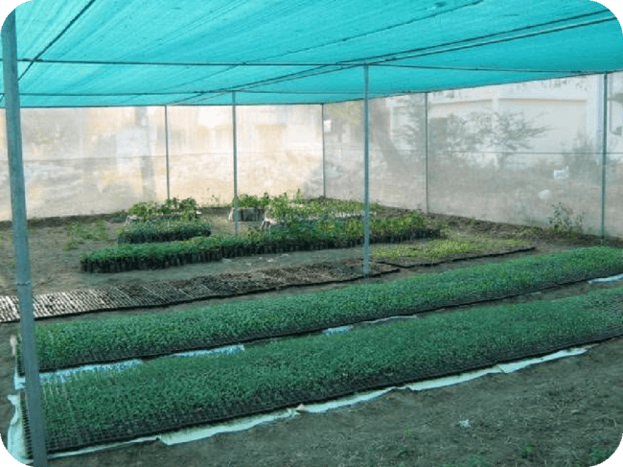

Image 5. Shade Net Structures

Hot Beds
A conventional technique utilizing natural manures such as fresh cow dung, poultry dung, or sheep manure, which produce heat due to microbial fermentation (Baeza, et al.,2011). This heat is utilized for rapid germination and early seedling development in cold regions. Hot beds are a cost-effective technique which gives a warm root zone in early crop establishment, thereby leading to early maturity and transplanting (Reddy, and Reddy, 2016).

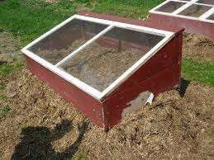
Image 6. Hot bed
Rain Shelter
A rain shelter is a covering structure used to protect crops from excessive rain, hail, and excessive moisture (Claire, et al., 2018). It is a light frame covered with a transparent or semi-transparent plastic sheet or UV-stabilized polyethylene film. Rain shelters reduce the incidence of disease due to prolonged wetness and are particularly beneficial for high-value crops such as tomatoes and capsicum. They permit enough light passage but prevent excessive moisture from reaching the plants (Masaki, 1987).
Lath House
Lath house refers to a partial shade building created by spacing wooden slats, bamboo strips, or plastic netting at fixed intervals to diffuse sunlight (Gupta et al., 2024). Such an arrangement provides partial shading and shields plants from direct sunlight, wind, and light showers. Lath houses are utilized primarily for the cultivation of shade plants, nurseries, or the acclimatization of tissue culture plants prior to field transplanting. They provide moderate temperatures and minimize transpiration loss (Ghosh, 2018).
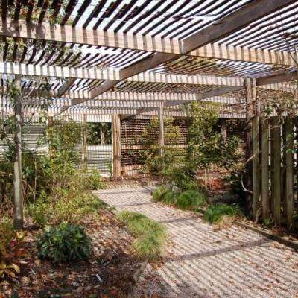

Image 7. Lath house
Cold Frame
Cold frame is a small, low-height structure utilized for hardening off the seedlings, for the development of early-season crops, or for extending the growing season (Rajesh, et al., 2020). It is usually constructed of a wood or metal frame covered on top with a clear top glass or plastic allowing sun in and retaining heat. Cold frames establish a warm microclimate that is higher than the ambient environment, sheltering plants from frost and low temperatures (Slathia, et al., 2018). They are passive systems and do not use artificial heat, and hence are an affordable option for small-scale utilization.
Hydroponics and Soilless Culture
Hydroponics is a recent method of plant culture without soil by utilizing nutrient-rich water solutions within controlled environments. The most prevalent systems in hydroponics are deep water culture (DWC), nutrient film technique (NFT), drip systems, and aeroponics. The method is of great relevance to urban and peri-urban agriculture, rooftop gardens, and vertical farms where land is not an issue. Lettuce, basil, kale, tomato, strawberry, and cucumber are the most basic crops cultivated under hydroponics. The major benefits of hydroponics include effective utilization of water and nutrients, low pest and disease occurrence, high-density planting, and pesticide-free crops. But it involves huge initial investment, technical expertise, and continuous monitoring of water quality and nutrient level.
Greenhouse Glazing (Covering Material)
Greenhouse glazing is the material used to cover greenhouse buildings. Glazing selection is important and depends on various aspects like durability, light transmission ability, affordability, and its effect on heating and cooling effectiveness (Kumar, and Singh, 2020).
Light Spectrum and Plant Requirements
Solar radiation comprises different wavebands, classified on the basis of wavelength and levels of energy from radio waves to visible light. With an increase in wavelength, the energy content is reduced. Plants use mostly light in the 400–700 nanometers (nm) range, termed Photosynthetically Active Radiation (PAR), that is required for photosynthesis (Pazuki et al., 2017).
Radiations below 380 nm (Ultraviolet or UV) and above 770 nm (Infrared or IR) are usually detrimental to plant growth. Therefore, greenhouse glazing materials must permit high transmission of PAR and exclude damaging UV and excessive IR radiation.
Types of Greenhouse Glazing Materials
1. Glass
Glass is renowned for having the highest light transmission among all glazing materials and possessing a long lifespan. It is, however, the most costly and possesses a comparatively high heat transfer coefficient, rendering it less energy-efficient. Glass is suitable where maximum light is needed, but its price and possible heat loss must be properly weighed (Both, 2002).
2. Plastic Films
Plastic sheets are extensively used in greenhouse applications because they are lightweight, tough, flexible, hydrophobic, translucent, and inexpensive. Plastic products most commonly applied are Low-Density Polyethylene (LDPE), Polyvinyl Chloride (PVC), and Polycarbonate (PC). These plastics are preferably LDPE for its easy and low-cost availability. Long exposure to sunlight, heat, and oxidation, together with contact with sulfur or halogen-based agrochemical crop protection chemicals, however, contributes to degradation of the plastic film. To reinforce the durability of such films, UV stabilizers and antioxidants are incorporated during processing (Fadel et al., 2016).
Types of LDPE greenhouse films are:
Cross-laminated films
Multilayered films (with different properties in each layer). Specialty films like anti-drip, anti-dust, UV-filtering, anti-sulphur, thermic, and diffused light films.
UV Stabilizer Systems employed in plastic films are:
HALS (Hindered Amine Light Stabilizers) + UV Absorbers: These films are normally transparent, with maximum light transmission and absorption of harmful UV rays. Co-stabilizers are incorporated to give protection against sulfur-based degradation. Nickel-quencher + UV Absorbers: These films tend to be greenish or yellowish in color, with a small reduction in light intensity but good UV stabilization and chemical resistance, especially against sulfur and halogens. Choosing the right kind of film is necessary for maximum plant growth, particularly in colder climates with low natural light. Plastic film thickness is in microns or GSM (grams per square meter). The films with a thickness of 200 microns or 120–150 GSM are usually used for greenhouse covering (Brostow, et al., 2020)
3. Rigid Plastics
Rigid plastics like polycarbonate and acrylic are also utilized for greenhouse glazing. These are cheaper than glass and last for 7 to 20 years. They are typically produced as twin-walled sheets, with air gap between the walls that serves as insulation (Montero et al., 2013). Although the initial light transmission of rigid plastics is high, it may reduce over time as a result of yellowing due to UV radiation. These sheets are light in weight, need less support structures, and are simple to install on flat surfaces. But they can be hard to install on arched roofs of greenhouses (Teitel, et al., 2017).
Greenhouse Construction Procedure
- Choose a good location for building the greenhouse.
- Demarcate the greenhouse area boundary.
- Dig foundation trenches for fixing support pipes.
- Securely fix the foundation pipes with cement concrete.
- Set the hoops (arced metal supports) into the foundation pipes.
- Build the ridge line by welding or fixing it to the hoops.
- Fix the glazing material with mild steel (MS) strips or screws.
- Anchor any surplus material into a channel around the outer edge of the greenhouse.
- Construct a proper drainage system around the greenhouse to avoid waterlogging.
3. Benefits of Protected Cultivation for Off-Season Production
Protected cultivation technologies have several benefits that make them particularly useful for off-season vegetable production (Jain et al., 2023). These benefits are both agronomic and economic in nature, leading to increased crop productivity, resource use efficiency, and farmer profitability (Jayasurya et al., 2021).
Climate Control
One of the greatest benefits of protected cultivation lies in the opportunity to control the microclimatic factors, including temperature, humidity, intensity of light, and carbon dioxide concentration. These controlled conditions promote year-round growing of vegetables without regard to weather conditions outside. It also assures consistent crop development during phenologically critical phases and thus increases productivity (Ramasamy, et al., 2021).
Pest and Disease Management
Physical barriers like polyhouses and net houses prevent insect pests and pathogens. Insect-proof nets, shade nets, and closed conditions minimize the application of chemical pesticides, leading to safer produce and reduced input costs. This is particularly useful in leafy vegetable, cucurbits, and other pest-vulnerable crop cultivation (Sahu et al., 2020).
Water and Nutrient Efficiency
Protected cultivation systems usually include water-saving irrigation methods like drip irrigation and fertigation. These are designed for efficient delivery of water and nutrients to the plant root zone, thus minimizing wastage and maximizing input-use efficiency. This is especially critical in water-limited areas as well as for high-value crops (Sharma et al., 2023).
Increased Yields and Better Quality
Vegetables produced under controlled environments are likely to show increased production per unit of area because of optimal growth conditions and minimal biotic or abiotic stress. Moreover, the produce is usually of better quality regarding size, color, texture, and shelf life and hence commands premium market prices.
Off-season and Early Production
Shielded structures allow farmers to advance or postpone the growth period, planting vegetables prior to or subsequent to the regular season. Off-season cultivation gives an added advantage of being competitive in the market as fresh produce appears during times when demand is not high and price is high (Singh, 1990).
Income Generation and Market Access
Through support of high-value crop cultivation and guaranteed year-round production, protected cultivation helps the farmer to raise incomes. Marketability to the niche market as well as city consumers adds extra profit potential to these crops such as capsicum, cucumber, cherry tomato, lettuce, and specialty herbs (Kumar, and Singh, 2020).
4. Constraints and Challenges
Though the apparent advantages are numerous, protected cultivation technology uptake in India is hindered by a number of constraints, particularly among smallholder and resource-limited farmers. These need to be overcome through focused interventions for the promotion of large-scale uptake.
High Initial Investment:
The financial cost incurred in building polyhouses, irrigation system installation, and implementing automation technology can be very expensive. This is a big hindrance for marginal and small farmers since they do not have access to finance and credit facilities.
Technical Knowledge and Skill Requirements
Optimum performance in protected cultivation necessitates expertise in aspects of microclimate management, fertigation, IPM, and crop planning. Inadequate training and extension support often result in poor performance and deter adoption.
Maintenance and Durability Problems
Materials like polyethylene films, shade nets, and GI pipes degrade with exposure to weather. Periodic replacement and maintenance contribute to operational expenses and impact long-term sustainability, especially when sub-standard materials are used.
Marketing and Post-Harvest Management
Higher off-season production requires effective supply chains, cold storage facilities, and market linkages to prevent post-harvest losses and price collapses. Lack of sound post-harvest infrastructure is a major bottleneck for most farmers.
Policy and Institutional Gaps
While government programs offer subsidies and assistance, access to them is usually hampered by bureaucratic bottlenecks, ignorance, and poor coordination between implementing agencies. There is also a shortage of trained human resources to offer on-ground technical support.
5. Government Support and Initiatives
The Government of India has realized the potential of protected cultivation in increasing agricultural productivity, especially for off-season vegetable production. For this purpose, various initiatives have been initiated under national and state-level schemes to encourage the use of these technologies.
National Horticulture Mission (NHM) and Mission for Integrated Development of Horticulture (MIDH) are two major schemes that offer financial support and technical services to farmers for establishment of protected cultivation facilities like polyhouses, net houses, and low tunnels. These missions also give subsidies for installation of the irrigation system, fertigation units, and other infrastructure, thus reducing the cost of protected cultivation for small farmers.
Apart from schemes at the center, state governments have also introduced measures and financial incentives as per local requirement. These are in the form of subsides for infrastructure, exemption from tax, and low-interest loans for protected cultivation ventures. Moreover, training and workshops are organized periodically to develop the technical skills of farmers and extension personnel to maintain the protected systems with greater efficiency.
In spite of all these efforts, there remains a requirement for more awareness and organized access to such schemes, especially for marginal farmers who might not be completely aware of the available support systems. Improvement in the delivery of government schemes at the grassroots level is essential to fast-track the use of protected cultivation technologies.

Table 7: Prospects and Challenges of Protected Cultivation
Prospects | Challenges
Increased production: Low-cost structures can boost vegetable yields by ~4 times per unit land. | Availability of materials: Essential items like GI pipes and poly sheets are often costly and not locally available.
High-quality crop: Clean, market-preferred produce. | Skilled labor shortage: Expertise in installation, operation, and maintenance is lacking, especially in rural areas.
Intensive crop production: Enables higher cropping intensity than open-field systems. | Regional variation: Lack of standardized cultivation practices across different agro-climatic zones.
Healthy seedling production: Yields robust, disease-resistant seedlings. | Limited awareness: Many farmers remain unaware of the advantages of protected cultivation.
High-purity hybrid seed production: Prevents cross-pollination. | Inadequate design: Screen/net houses and polyhouses face design limitations affecting functionality and cost.
Disease-free seed production: Controlled environments minimize seed-borne diseases. | R&D gaps: Limited region-specific research and weak plasticulture development under AICRP on PEASEM.
Weather and pest protection: Structures shield crops from climate stress and pest attacks. | Higher education needs: Greenhouse-related R&D needs academic support through curriculum enhancement.
Off-season production: Year-round cultivation meets demand and enhances profitability. | Structural failures: Poor wind resistance and climate-agnostic designs lead to frequent damage.
Extended growing seasons: For example, in Ladakh, the season extends from 4–5 to ~10 months. | Lack of operational skills: Many greenhouse operators lack necessary technical know-how.
High-quality planting material: Favorable environments enhance propagation success. | Need for skill centers: States should establish training hubs for protected cultivation.
Enhanced produce availability: Can bridge production gaps in many regions. | Education-work integration: Students should have options to work and learn in greenhouses.
Resource conservation: Efficient use of water, fertilizers, and agro-chemicals. | Biodegradable glazing need: Eco-friendly materials for greenhouse covers are still not mainstream.
Job creation: Estimated 5 jobs per hectare; significant potential for rural employment. | Marketing gaps: Cold chain, traceability, and market linkage infrastructure are underdeveloped.
Farmer income boost: Higher returns improve livelihood and GDP contribution. | Lack of insurance: Few comprehensive, farmer-friendly insurance schemes are available.
Meets urban demand: Helps feed growing urban populations with fresh produce.
Production in non-terrestrial spaces: Possibilities for farming in oceans, underground, etc.
Bridges supply-demand gaps: Helps mitigate seasonal shortages of crops.

Future Prospects
The future of protected cultivation in India is bright, with a range of trends and innovations ready to further increase its efficacy and acceptance. These technologies can overcome current limitations and make protected farming more efficient, sustainable, and scalable.
Integration with Smart Farming
The combination of smart farming technology with protected cultivation offers a tremendous opportunity for the optimal growing environment. Automation networks, sensors, and artificial intelligence (AI)-driven monitoring equipment can be deployed to optimize climate control (temperature, humidity, light, and CO₂) and enhance resource management (water and nutrients). The technologies can facilitate real-time monitoring and remote control, lowering labor costs and reducing human error, while enhancing efficiency and productivity.
Tailored Structures for Targeted Regions and Crops
Future advancements in protected cultivation are likely to concentrate on tailoring the infrastructure to accommodate particular climatic conditions and crop demands. This might entail the development of polyhouses, net houses, and tunnels designed to accommodate local weather conditions, regional pests, and individual crop requirements. Tailoring could maximize the advantages of protected cultivation for more crops, including those not yet effectively utilized in such setups.
Urban and Vertical Farming
With increased urbanization and scarce arable land in urban areas, urban and vertical farming are taking center stage. The integration of protected cultivation with rooftop farming and vertical farming systems is a creative response to address the increasing demand for food in urban areas. Such systems have the potential to lower transport costs significantly, increase the freshness of produce, and enhance food security in highly populated cities.
Capacity Building
A key area for future growth is capacity building for farmers, extension workers, and entrepreneurs in protected cultivation technologies. It is essential to develop specialized training programs that cover not only technical aspects such as climate control, pest management, and fertigation but also business management and marketing strategies. Building a skilled workforce will empower farmers to fully leverage the potential of protected cultivation.
Public-Private Partnerships (PPPs)
Promoting public-private partnerships can become a critical enabler for fast-tracking innovation and investment in protected cultivation. Multi-stakeholder models involving government agencies, private sector companies, research centers, and farmers can assist in framing cost-efficient solutions, exchanging information, and large-scale scaling up of technologies. PPPs can also assist in the development of more robust market linkages to enable farmers to access superior channels of distribution and high-value markets for their off-season produce.
7. Conclusion
Protected cultivation technologies are a revolutionary method of vegetable cultivation in India that presents a sustainable answer to the problems of seasonality, climatic fluctuations, and market unpredictability. Through the adjustment of the growing environment, these systems improve the productivity, quality, and profitability of the vegetable crop, thus ensuring food security, enhanced farmer revenue, and sustainable agriculture.
Although the adoption of protected cultivation has many advantages, challenges like high capital requirements, technical issues, and poor infrastructure need to be overcome for its large-scale adoption. With enhanced government support, capacity building, and innovation through new technology and public-private partnerships, India can realize the full potential of protected cultivation.
Ultimately, with continued investment, knowledge dissemination, and policy support, protected cultivation can play a crucial role in achieving India's goals of climate-resilient agriculture and year-round vegetable production, making it a cornerstone of modern horticultural practices.

Reference
Ameta, K. D., Kaushik, R. A., Dubey, R. B., & Rajawat, K. S. (2019). Protected cultivation-An Entrepreneurship for modern agriculture. Biotech Today: An International Journal of Biological Sciences, 9(1), 35-40.
Ashok, A. D., & Sujitha, E. (2021). Greenhouse structures, construction and design. Int. J. Chem. Stud, 9(1), 40-45.
Baeza, E. J., Stanghellini, C., & Castilla, N. E. (2011, October). Protected cultivation in Europe. In International Symposium on High Tunnel Horticultural Crop Production 987 (pp. 11-27).
Banjare, C., Mahanta, D., Sahu, P., & Choudhary, R. (2024). A comprehensive review on protected cultivation: Importance, scope and status. International Journal of Environment and Climate Change, 14(7), 46-55.
Bhattacharyya, P., Pathak, H., Pal, S., Bhattacharyya, P., Pathak, H., & Pal, S. (2020). Crop management for climate-smart agriculture. Climate smart agriculture: Concepts, challenges, and opportunities, 85-111.
Both, A. J. (2002). Greenhouse glazing. Horticultural Engineering Newsletter. Rutgers Cooperative Extension, 17, 5-6.
Brostow, W., Lu, X., Gencel, O., & Osmanson, A. T. (2020). Effects of UV stabilizers on polypropylene outdoors. Materials, 13(7), 1626.
Chauhan, V.B.S., Mukherjee, A., Pati, K., Hanume Gowda, K., & Bansode, V.V. (2016). Low cost protected cultivation of vegetable crops for sustainable farm income. In: Training manual of Model Training Course on "Root and Tuber Crops Based Integrated Farming System: A Way Forward to Address Climate Change and Livelihood Improvement" (pp. 41–46). Conducted by ICAR–Central Tuber Crop Research Institute (CTCRI), 19–26 September 2016.
Claire, D., Watters, N., Gendron, L., Boily, C., Pépin, S., & Caron, J. (2018). High productivity of soilless strawberry cultivation under rain shelters. Scientia Horticulturae, 232, 127-138.
Dahiya, P., & Singh, K. (2018). Polyhouse farming: a new concept of agriculture. Bhartiya Krishi Anusandhan Patrika, 33(1), 109-112.
Deb, A. D. P. (2023). Advances of protected cultivation of vegetable crops in India as well as global scenario: A review.
Eigenbrod, C., & Gruda, N. (2015). Urban vegetable for food security in cities. A review. Agronomy for Sustainable Development, 35, 483-498.
Fadel, M. A., Hammad, B. A. B., AlHosany, F., & Iwaimer, O. (2016). Greenhouses covering materials: A comparative study. Agricultural Engineering International: CIGR Journal, 18(1), 48-57.
Fernández, J. A., Orsini, F., Baeza, E., Oztekin, G. B., Muñoz, P., Contreras, J., & Montero, J. I. (2018). Current trends in protected cultivation in Mediterranean climates. Eur. J. Hortic. Sci, 83(5), 294-305.
Filson, G. C., & Adekunle, B. (2017). Eat Local, Taste Global: How Ethnocultural Food Reaches Our Tables. Wilfrid Laurier Univ. Press.
Ghosh, A. (2018). Greenhouse Technology. New India Publishing Agency.
Gruda, N., Bisbis, M., & Tanny, J. (2019). Influence of climate change on protected cultivation: Impacts and sustainable adaptation strategies-A review. Journal of Cleaner Production, 225, 481-495.
Gupta, J., Sharma, D., & Chauhan, A. (2024). Classification and suitability of protected structures. In Protected Cultivation (pp. 35-61). Apple Academic Press.
Gupta, J., Sharma, D., & Chauhan, A. (2024). Classification and suitability of protected structures. In Protected Cultivation (pp. 35-61). Apple Academic Press.
Gyawali, P., Khanal, S., & Bhandari, S. (2022). Need to take precedence for off seasonal vegetable farming? Issues in context of Nepal. Turkish Journal of Agriculture-Food Science and Technology, 10(12), 2495-2503.
Jadhav, H. T., & Rosentrater, K. A. (2017). Economic and environmental impact analysis of vegetable production in bamboo polyhouse vs galvanized iron pipe polyhouse. In 2017 ASABE Annual International Meeting (p. 1). American Society of Agricultural and Biological Engineers.
Jain, S., Kore, D. S., GK, K., Mohapatra, A., Baksh, H., Kumar, V., & Haokip, S. W. (2023). A Comprehensive review on protected cultivation of horticultural crops: Present status and future prospects. Int. J. Environ. Clim. Chang, 13(11), 3521-3531.
Jayasurya, P., Chatterjee, S., Biswas, A., Viswanath, M., & Roy, A. (2021). Low cost protected structures for off-season vegetable production: a review. The Pharma Innovation Journal, 10(7), 778-783.
Joosten, F. J., Dijkxhoorn, Y., Sertse, Y., & Ruben, R. (2015). How does the fruit and vegetable sector contribute to food and nutrition security? (No. 2015-076). LEI.
Kotilainen, T., Robson, T. M., & Hernandez, R. (2018). Light quality characterization under climate screens and shade nets for controlled-environment agriculture. PLoS One, 13(6), e0199628.
Krishna, H., Hebbar, S., Kumar, P., Sharma, S., Kumar, R., Tiwari, S. K., ... & Behera, T. K. (2024). Navigating challenges and prospects in off-season Vegetable Production. Vegetable Science, 51, 97-105.
Krishna, H., Hebbar, S., Kumar, P., Sharma, S., Kumar, R., Tiwari, S. K., ... & Behera, T. K. (2024). Navigating challenges and prospects in off-season Vegetable Production. Vegetable Science, 51, 97-105.
Kumar, D., & Singh, B. (2020). Vegetables cultivation under protected conditions. Progressive agriculture, 20(1and2), 148-152.
Kumar, R., & Singh, V. P. (2022). Plasticulture Engineering and Technology. CRC Press.
Kumar, S., Bairwa, D. S., Kumar, K., Yadav, R. K., & Yadav, L. P. (2022). Climate regulation in protected structures: A review. Journal of Agriculture and Ecology, 13, 20-34.
Mahmood, A., Hu, Y., Tanny, J., & Asante, E. A. (2018). Effects of shading and insect-proof screens on crop microclimate and production: A review of recent advances. Scientia Horticulturae, 241, 241-251.
Malam, K. V., Malam, V. R., & Kanzaria, D. R. (2024). Hi-Tech Horticulture. CRC Press.
Masaki, T. (1987). Vegetable Cultivation under the Plastic Rain Shelters. Jpn. Agr. Res, 20, 180-184.
Montero, J. I., Teitel, M., Baeza, E., Lopez, J. C., & Kacira, M. (2013). Greenhouse design and covering materials. Good Agricultural Practices for greenhouse vegetable crops, 35.
Ogendi, M. N. (2022). Production Systems and Occurrence Level of Urban and Peri-Urban Agriculture in Nairobi County, Kenya (Doctoral dissertation, JKUAT-CoANRE).
Pathak, M., Barik, S., Dash, S. K., & Moharana, D. P. (2023). Impact of climate change on leafy and salad vegetables production. In Advances in Research on Vegetable Production Under a Changing Climate Vol. 2 (pp. 109-126). Cham: Springer International Publishing.
Pazuki, A., Aflaki, F., Pessarakli, M., Gurel, E., & Gurel, S. (2017). Plant responses to extended photosynthetically active radiation (EPAR). Adv. Plants Agric. Res, 7(3), 313.
Phookan, D.B., & Saikia, S. (2001). Vegetable production under naturally ventilated plastic house cum rain shelter. In: Satapathy, K.K., & Kumar, A. (Eds.), Plasticulture Intervention for Agriculture Development in North Eastern Region (pp. 127–141). ICAR Research Complex for NEH Region.
Rajesh, T., Ramesh, D., Nagateja, K. S. S. N., & Vamshi, P. (2020). Chapter-1 Plant Protection using Cold Frame. Chief Editor Dr. Varsha Rani, 103(1).
Rajiv, & Kumari, M. (2023). Protected cultivation of high-value vegetable crops under changing climate. In Advances in Research on Vegetable Production Under a Changing Climate Vol. 2 (pp. 229-266). Cham: Springer International Publishing.
Ramasamy, S., Lin, M. Y., Wu, W. J., Wang, H. I., & Sotelo-Cardona, P. (2021). Evaluating the potential of protected cultivation for off-season leafy vegetable production: prospects for crop productivity and nutritional improvement. Frontiers in Sustainable Food Systems, 5, 731181.
Reddy, P. P., & Reddy, P. P. (2016). Protected cultivation (pp. 1-11). Springer Singapore.
Sahu, B., Dalai, S., & Mallikarjunarao, K. (2020). Cultivation of off-season vegetables under protected conditions. Protected cultivation and smart agriculture. New Delhi Publishers, New Delhi, 161-166.
Sanap, D., Shah, N. G., & Agnihotri, S. B. (2022). Design and development of bamboo polyhouse as entrepreneurship model of nutri-garden. Journal of Agricultural Engineering, 59(1), 74-85.
Savic, D., & Ilin, Z. M. (2022). Advantages of Growing Vegetable Crops in Modern Greenhouses. In Vegetable Crops-Health Benefits and Cultivation. IntechOpen.
Sharma, A., Lata, H., Sood, P., Thakur, A., Sharma, K. C., & Sharma, P. (2023). Off-season vegetable growing for nutrition and entrepreneurship. In Vegetables for nutrition and entrepreneurship (pp. 279-296). Singapore: Springer Nature Singapore.
Sharma, H. R., & Gautam, N. (2017). Advances in the production technology of cucurbits. Advances in production technology of commercial vegetable crops. Department of Vegetable Science, Dr YS Parmar University of Horticulture and Forestry, Solan, 108-123.
Sharma, K. K., Chawla, S., & Singh, M. C. (2024). Protected cultivation: Technology, constraints, and its global status. In Protected Cultivation (pp. 1-34). Apple Academic Press.
Sindhu, V., & Chatterjee, R. (2020). Off-season vegetable cultivation under protected structures: A promising technology for doubling farmers' income. International Archives of Applied Science and Technology, 11, 208–214.
Singh, D. V. (1990). Production and marketing of off-season vegetables. Mittal Publications.
Singh, G., Kaur, M. M., Magar, P. N., Sharma, P., Choudhary, S., & Dhakar, M. B. (2024). Recent Trends and Innovations in Horticultural Science. Chyren Publication.
Singh, H. P., Dhankhar, S. S., & Dahiya, K. K. (2009). Horticultural crops. Stadium Press (India) Pvt Limited.
Singh, N., Diwedi, S.K., & Paljor, E. (1999). Ladakh Mein Sabjion Ki Sanrakshit Kheti (in Hindi). Regional Research Laboratory of DRDO, Leh. Published by DRDO, 56 APO.
Singh, R., Machanuru, R., Singh, B., & Shrivastava, M. (2021). Climate-resilient agriculture: enhance resilience toward climate change. In Global climate change (pp. 45-61). Elsevier.
Slathia, D., Nisa, M. U., Reshi, M., Dolkar, T., & Hussain, S. (2018). Protected cultivation of ornamentals. Global Journal of Bio-Science and Biotechnology, 7(2), 302-311.
Solankey, S. S., Kumari, M., Akhtar, S., Singh, H. K., & Ray, P. K. (2021). Challenges and opportunities in vegetable production in changing climate: Mitigation and adaptation strategies. Advances in Research on Vegetable Production Under a Changing Climate Vol. 1, 13-59.
Stamps, R. H. (2009). Use of colored shade netting in horticulture. HortScience, 44(2), 239-241.
Teitel, M., Vitoshkin, H., Geoola, F., Karlsson, S., & Stahl, N. (2017, August). Greenhouse and screenhouse cover materials: Literature review and industry perspective. In International Symposium on New Technologies for Environment Control, Energy-Saving and Crop Production in Greenhouse and Plant 1227 (pp. 31-44).
Ummyiah, H. M., Wani, K. P., Khan, S. H., & Magray, M. M. (2017). Protected cultivation of vegetable crops under temperate conditions. Journal of Pharmacognosy and Phytochemistry, 6(5), 1629-1634.
Yadav, M. K., & Kumar, S. (2024). Cultivation of tomato, capsicum and cucumber under protected cultivation: Extensive analysis. AGBIR Vol.40 No.02 Mar
Yadav, R.K., Kalia, P., Choudhary, H., Husain, Z., & Dev, B. (2014). Low-cost polyhouse technologies for higher income and nutritional security. International Journal of Agriculture and Food Science Technology, 5, 191–196.

