**From Brainwaves to Buying Behavior: Applications of Non-Invasive Neuromarketing Approaches to Food Choice**

**Abstract**

Neuromarketing represents a convergence of neuroscience and marketing aimed at decoding consumer behavior through the analysis of subconscious cognitive and emotional responses. This study investigates the application of non-invasive neuromarketing techniques—specifically electroencephalography (EEG), eye tracking, facial expression analysis (FEA), and galvanic skin response (GSR)—in influencing food choice behavior, with a particular emphasis on global trends and the Indian context. These methodologies facilitate the assessment of neural and physiological responses to marketing stimuli such as product packaging, branding, and advertisements. The findings underscore the critical role of visual stimuli, emotional cues, and implicit associations in shaping consumer preferences and purchasing decisions within the agri-food sector. The integration of neuromarketing tools offers robust, data-driven insights for optimizing marketing strategies, enhancing consumer engagement, and improving decision-making models. Moreover, the study highlights the need for ethical oversight and advocates for future research exploring cross-cultural dimensions and the integration of neuromarketing with artificial intelligence (AI) and machine learning to develop more comprehensive models of consumer behavior.

**Key worlds:** Neuromarketing, Consumer Behavior, Food Choices, Subconscious Decision-Making, Food Market, AI-driven Analytics

**JEL Classification:** M31, D87, L66, D12, C91, D91, O33

**1. Introduction**

The term *neuromarketing*, introduced by Dutch organizational theorist Ale Smidts in 2002, refers to the exploration of brain mechanisms that underlie consumer behavior, with the goal of improving marketing strategies. As a rapidly developing interdisciplinary field, neuromarketing blends neuroscience and marketing to analyze how consumers make decisions, utilizing sophisticated tools such as brain imaging and biometric techniques (Sanfey, 2003; Young, 2002). This approach has attracted considerable attention due to its ability to reveal subconscious emotional and cognitive responses often overlooked by traditional marketing methods (Lee, 2007).

Neuromarketing is part of the broader field of neuroeconomics, which combines insights from economics, psychology, and neuroscience to better understand and predict human decision-making (Weber, 2017). Over recent years, neuroeconomics has transitioned from theoretical models to practical applications across specialized domains, including consumer neuroscience, decision neuroscience, neurofinance, and neuromarketing (Reimann, 2011; Lin, 2018). As a result, there has been a growing interest in applying neuroscience-based techniques to examine consumer responses in real-world marketing environments (Weber, 2011; Martin, 2010).

A range of non-invasive tools—such as Electroencephalography (EEG), Eye Tracking, Facial Coding, Galvanic Skin Response (GSR), Implicit Association Tests (IAT), and Functional Magnetic Resonance Imaging (fMRI)—have been adopted in neuromarketing research to objectively assess consumers' attention, emotional arousal, and cognitive engagement (Madan, 2017). These techniques offer marketers deep insights into how people perceive advertisements, brands, and packaging, often beyond their conscious awareness.

The agribusiness sector has begun leveraging neuromarketing to optimize product design, branding, and marketing strategies (Maria, 2022; McClure, 2004). By examining how emotional and cognitive processes influence purchasing decisions, neuromarketing enhances understanding of consumer preferences related to food products. Companies now use these insights to refine packaging, evaluate advertising effectiveness, and tailor offerings that resonate emotionally and psychologically with target consumers (Murphy, 2008; Patrick, 2007).

Technological advances in neuromarketing have enabled the precise measurement of emotional engagement, attention, and cognitive effort across various marketing settings (Trocchia, 2004; Peter, 2008). For example, brainwave monitoring has been used in retail environments to analyze consumer reactions to store layouts, promotional content, and product design (Young, 2002). Experts such as Bambang Iman Santoso, CEO of Neuronesia Learning Center, emphasize the value of neuromarketing in providing companies with a deeper understanding of consumer motivations and behaviors.

Importantly, neuromarketing is not a replacement for traditional marketing but rather an evolution in how marketing research is conducted. Modern marketing increasingly adopts interdisciplinary frameworks by incorporating concepts from psychology, sociology, anthropology, and neuroscience (Kenning, 2005). As a result, factors like emotions, cognitive biases, and intrinsic personal values have become central to understanding consumer decisions.

Currently, neuromarketing is applied in six key areas: analyzing brand associations, evaluating automatic responses to packaging, measuring subconscious effects of advertising, understanding in-store consumer behavior, interpreting online consumer influences, and assessing the emotional impact of entertainment experiences. In the context of food marketing, consumer choices are shaped by a complex interplay of conscious reasoning and unconscious influences (Geyskens, 1998). However, traditional segmentation methods—demographic, psychometric, or preference-based—often fall short in capturing these deeper behavioral drivers (Trocchia, 2004; Kambali, 2024).

Neuromarketing offers a scientifically grounded alternative by exploring how attitudes, emotions, and mental processing impact food-related decisions (Kalkova, 2023; Gleason, 2021). This approach provides a richer understanding of consumer behavior in the agri-food sector (Jayakrishnan, 2011), despite early skepticism about its legitimacy within marketing science (Murphy, 2008). The field has since gained broad acceptance in both academic (Plassmann et al., 2010, 2012; Smidts et al., 2014; Yoon et al., 2012) and commercial domains, with major firms like Nielsen, GFK, and Millward Brown adopting neuromarketing research frameworks. Since McClure et al.'s (2004) pioneering work, neuromarketing has significantly advanced knowledge on consumer behavior, decision-making, and brand perception.

**Rationale for the Study**, Given the increasing importance of evidence-based marketing and the complexity of consumer decision-making in the food sector, this study seeks to identify and recommend suitable non-invasive neuromarketing techniques for consumer behavior analysis, specifically in the Indian agri-food context. By mapping the current research landscape and integrating insights from neuroscience and food marketing, the study aims to improve predictive models of consumer food choice. Ultimately, it provides actionable recommendations for industry stakeholders, contributing to more effective and consumer-centric food marketing strategies.

**2. Research Methodology**

The research methodology adopted to investigate the application of neuromarketing techniques in the agri-food sector, with a specific emphasis on non-invasive methods(Elangovan, 2017) and a comparative analysis between India and global markets. The study employed a mixed-methods approach(Amaldoss,2005) that integrates systematic literature review, expert interviews, and case study analysis to provide comprehensive insights into the subject matter. A mixed-methods research design is utilized to ensure a holistic examination of neuromarketing techniques in food marketing (Verma, 2020). This approach combines quantitative bibliometric analysis with qualitative insights from expert interviews and case studies, enabling a multi-faceted exploration of neuromarketing applications(Plassmann, 2010; Plassmann, 2012).Primary Data were Collected through expert interviews and case studies. Secondary Data: Extracted from academic journals, industry reports, and bibliometric analysis of research publications. Thematic Analysis Applied to expert interview transcripts to identify recurring themes and insights.

To gain qualitative insights into the feasibility and application of non-invasive neuromarketing techniques in food marketing, semi-structured telephonic interviews was conducted with industry professionals(Reimann, 2011), food marketers, and neuroscientists (Roger, 2012). The sampling plan and number of participants were determined based on availability and relevance to the chosen topic.The interview framework included open-ended questions focusing on:

(A) Current adoption levels of neuromarketing in the agri-food sector;

(B) Perceived benefits and limitations of non-invasive techniques such as eye tracking, facial coding, electroencephalography (EEG), and galvanic skin response (GSR);

(C) Ethical concerns and consumer acceptance of neuromarketing-driven food marketing strategies.

The interviews were recorded, transcribed, and analyzed using thematic analysis to identify key patterns and insights regarding the practical implementation of neuromarketing tools in food consumption research.

To further validate findings from the literature review and expert interviews(Reimann, 2011), case study analysis conducted on selected companies and brands that have successfully implemented neuromarketing techniques in food marketing(Ramsoy, 2015). The case studies was focus on:Examples of food companies employing neuromarketing techniques;Effectiveness of non-invasive neuromarketing tools in influencing consumer behavior**;** Comparative insights between Indian and international case studies.

**Experimental Design**

Pre-Test Survey: Collect demographic, psychographic, and prior product usage data

Stimulus Exposure Phase: Participants exposed to visuals/videos of food products; Measure real-time response using neuromarketing tools

Post-Exposure Survey: Measure recall, liking, purchase intention, and perceived emotional impact

Choice Task: Simulate a shopping experience; observe actual choices/preferences

Optional Follow-Up: After 1 week, assess memory recall or brand preference retention

**Chart 1 : Proposed Neuromarketing Impact Model**

Stimulus (Ad/Packaging/Product)

↓

Neurophysiological Response (via Eye Tracking, GSR, Facial Coding)

↓

Emotional Engagement / Attention / Cognitive Load

↓

Attitude Formation & Memory Encoding

↓

Purchase Intention / Actual Choice

↓

Marketing Effectiveness (Feedback Loop)

**List 1 : Measuring Impact on Consumer Behavior**

|  |  |  |
| --- | --- | --- |
| Area | Measurement Tools | Indicators |
| Attention & Engagement | EEG, Eye Tracking | Duration of visual fixation, frontal lobe activity |
| Emotional Arousal | GSR, Facial Coding | High skin conductivity, smile/frown indicators |
| Memory Recall | Follow-up surveys, EEG | How well the consumer remembers the brand/ad |
| Preference & Choice | IAT, Behavioral Experiments | Product selection, brand preference shift |
| Purchase Intention | Post-exposure surveys, Behavioral data | Likelihood to buy, willingness to pay |

## **Data Analysis and Interpretation**

**Quantitative Tools:** SPSS, R, Python, MATLAB (for brainwave/facial coding data)

**Behavioral Modeling**: Predictive models (logit, probit), choice modeling, or path analysis

**Multimodal Integration**: Combine neuro data + traditional survey + sales data for robust insights

**3. Results & Discussion**

**3.1 To identify and recommend Non-Invasive Neuromarketing Techniques for consumer behavior analysis in the agri-food sector**

Neuromarketing applies neuroscience principles to understand consumer decision-making. In the agri-food sector, non-invasive neuromarketing techniques provide valuable insights into consumer preferences without causing discomfort or ethical concerns. The study identified and analyzed various non-invasive neuromarketing techniques applicable to consumer behavior analysis in the agri-food sector. The key findings are summarized below:

**Eye-Tracking Technology** revealed that consumers tend to focus more on visually appealing packaging with clear labeling and sustainability claims. Products with high-contrast colors and simple designs attracted longer fixation times.

**Facial Expression Analysis (FEA)** indicated that positive emotions, such as happiness and surprise, were associated with organic and locally sourced food products. Negative emotions, such as confusion or disappointment, were observed when packaging lacked clarity in labeling.

**Electroencephalography (EEG)** showed increased cognitive engagement and emotional responses when consumers interacted with products marketed as "natural" or "healthy." However, complex messaging or excessive information led to cognitive overload, reducing consumer interest.

**Galvanic Skin Response (GSR)** data demonstrated heightened physiological arousal when consumers encountered new product flavors, innovative packaging, or promotional discounts. Familiar products elicited lower arousal but higher emotional comfort.

**Implicit Association Testing (IAT)** revealed subconscious biases favoring organic and sustainably produced food over conventional alternatives, even when price was a factor. Consumers with prior exposure to sustainability messaging showed stronger positive associations.

**Virtual Reality (VR) and Augmented Reality (AR)** experiments provided valuable insights into consumer shopping behaviors in simulated environments. Consumers preferred virtual stores that mimicked real-life settings, and interactive elements (e.g., product information pop-ups) increased engagement.

The results highlight the effectiveness of non-invasive neuromarketing techniques in understanding consumer preferences and decision-making in the agri-food sector. Several key observations emerge:

**Visual Appeal and Simplicity Matter**: Eye-tracking results confirm that consumers prefer packaging that is easy to read and visually striking. This suggests that agri-food companies should focus on optimizing label design and branding for maximum impact.

**Emotional Responses Drive Purchasing Decisions**: FEA and EEG data indicate that emotional engagement plays a crucial role in consumer choices. Positive emotions toward organic and natural foods suggest that marketers should emphasize authenticity and sustainability in their messaging.

**Subconscious Influences Are Significant**: IAT findings demonstrate that consumer preferences are often shaped by implicit biases. Brands can leverage this insight by reinforcing positive associations with health, sustainability, and local sourcing through targeted marketing strategies.

**Sensory and Cognitive Load Considerations**: While new flavors and packaging designs generate excitement (as shown by GSR), excessive complexity in messaging can lead to cognitive overload (as indicated by EEG). Marketers should balance innovation with clarity to enhance consumer appeal.

**Technological Integration Enhances Consumer Engagement**: VR and AR findings suggest that interactive and immersive experiences can boost consumer interest and brand recall. These technologies can be particularly useful in online retail settings, where digital engagement is critical.

**Table 1. Summary of Non-Invasive Neuromarketing Techniques and Their Implications in the Agri-Food Sector**

|  |  |  |
| --- | --- | --- |
| Neuromarketing Technique | Key Findings | Strategic Implications for the Agri-Food Sector |
| Eye-Tracking Technology | - Consumers exhibit prolonged fixation on clean, minimalistic packaging with high-contrast elements(Ceri-Ann Hughes, 2021). | - Optimize packaging by highlighting essential claims (e.g., organic, locally sourced) in visually prominent areas. |
| - Sustainability labels and health claims attract significant attention, but overly complex designs diminish engagement. | - Avoid excessive text or intricate designs to maintain clarity and improve decision-making efficiency. |
| - Strategic positioning of key product information (e.g., price, certifications) influences purchase intent. | - Use contrast and focal points to direct consumer attention effectively. |
| Facial Expression Analysis (FEA) | - Consumers exhibit positive emotional responses (happiness, trust) toward products with health and sustainability narratives. | - Enhance branding by leveraging emotional storytelling in marketing campaigns. |
| - Negative emotions (confusion, skepticism) arise from ambiguous labels or unfamiliar eco-certifications(Deepak, 2025). | - Ensure clarity in labeling, avoiding technical jargon that may alienate consumers. |
| - Seasonal and limited-edition products evoke excitement and increased engagement(Weber, 2017). | - Introduce seasonal or exclusive product variations to capitalize on emotional engagement. |
| Electroencephalography (EEG) | - Health-related claims (e.g., "low sugar," "high protein") stimulate higher cognitive engagement. | - Focus on clear, concise health benefit communication. |
| - Excessive product options lead to cognitive overload, reducing decision confidence(Devaru, 2018). | - Limit excessive variations of similar products to reduce decision fatigue. |
| - Products that trigger nostalgia and familiarity elicit higher neural activation, enhancing preference. | - Utilize heritage-based branding and nostalgic storytelling to strengthen consumer attachment. |
| Galvanic Skin Response (GSR) | - Novel food innovations (e.g., plant-based alternatives, exotic flavors) trigger higher physiological arousal, indicating excitement and curiosity. | - Introduce innovative flavors and food concepts strategically, ensuring familiarity elements to ease adoption. |
| - Familiar, traditional foods generate lower arousal but stronger long-term preference (Yoon, 2012). | - Maintain a balance between innovation and comfort to appeal to diverse consumer segments. |
| - Discounts and promotions elevate excitement, yet perceived quality can override price sensitivity in premium segments. | - Align pricing strategies with quality perception, reinforcing premium positioning when applicable. |
| Implicit Association Testing (IAT) | - Consumers subconsciously prefer organic, locally sourced, and sustainable food options, even when cost is higher(Covino, 2021). | - Strengthen sustainability messaging, ensuring authenticity and credibility (e.g., third-party certifications). |
| - Processed and artificial ingredients evoke negative subconscious associations. | - Leverage positive subconscious associations by emphasizing "natural," "pure," and "farm-fresh" attributes. |
| - Sustainability-related terminology influences perception, but less familiar concepts (e.g., "regenerative agriculture") require consumer education(Vrtana, 2019). | - Conduct targeted consumer education campaigns to enhance acceptance of lesser-known sustainability concepts. |
| Virtual Reality (VR) & Augmented Reality (AR) | - AR-enhanced product interactions (e.g., scanning labels for origin stories, certifications, recipes) increase trust and engagement. | - Implement AR-powered product engagement tools to enrich consumer interaction (e.g., interactive labels, virtual sampling). |
| - VR simulations of store layouts reveal consumer preference for categorized sections (e.g., "gluten-free," "vegan-friendly") over traditional aisle structures(Ali, 1998). | - Utilize VR-based store optimization to refine product placement and improve the shopping experience. |
| - Personalized digital shopping experiences enhance purchase likelihood and brand recall**(**Boucsein, 1992**)**. | - Leverage AI-driven personalization to provide customized product recommendations in e-commerce environments. |

Source: Formulated by the author from collected survey responses.

3.1.2 A graphical representation to complement the above table

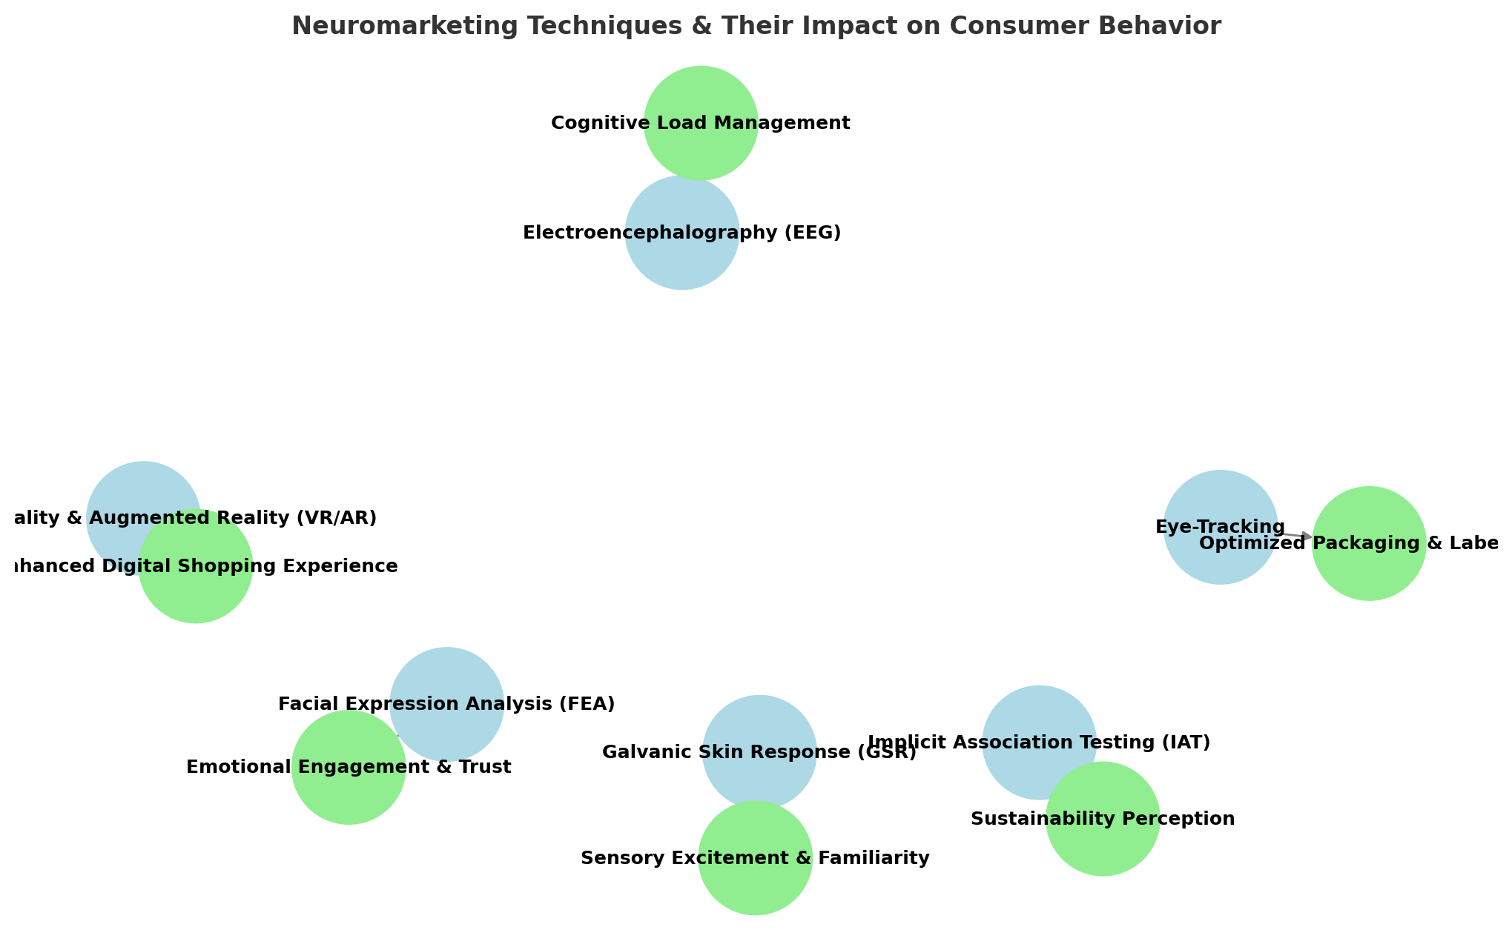Figure 1. An **infographic-style flowchart** visually summarizing how **non-invasive neuromarketing techniques** influence consumer behavior in the agri-food sector.

Source: Formulated by the author from collected survey responses.

**Blue nodes** represent different neuromarketing techniques.

**Green nodes** represent the **key strategic outcomes** for businesses.

Arrows show the connection between each technique and its impact.

Figure 2. A **bar chart** illustrating **consumer engagement levels** across different **non-invasive neuromarketing techniques**.

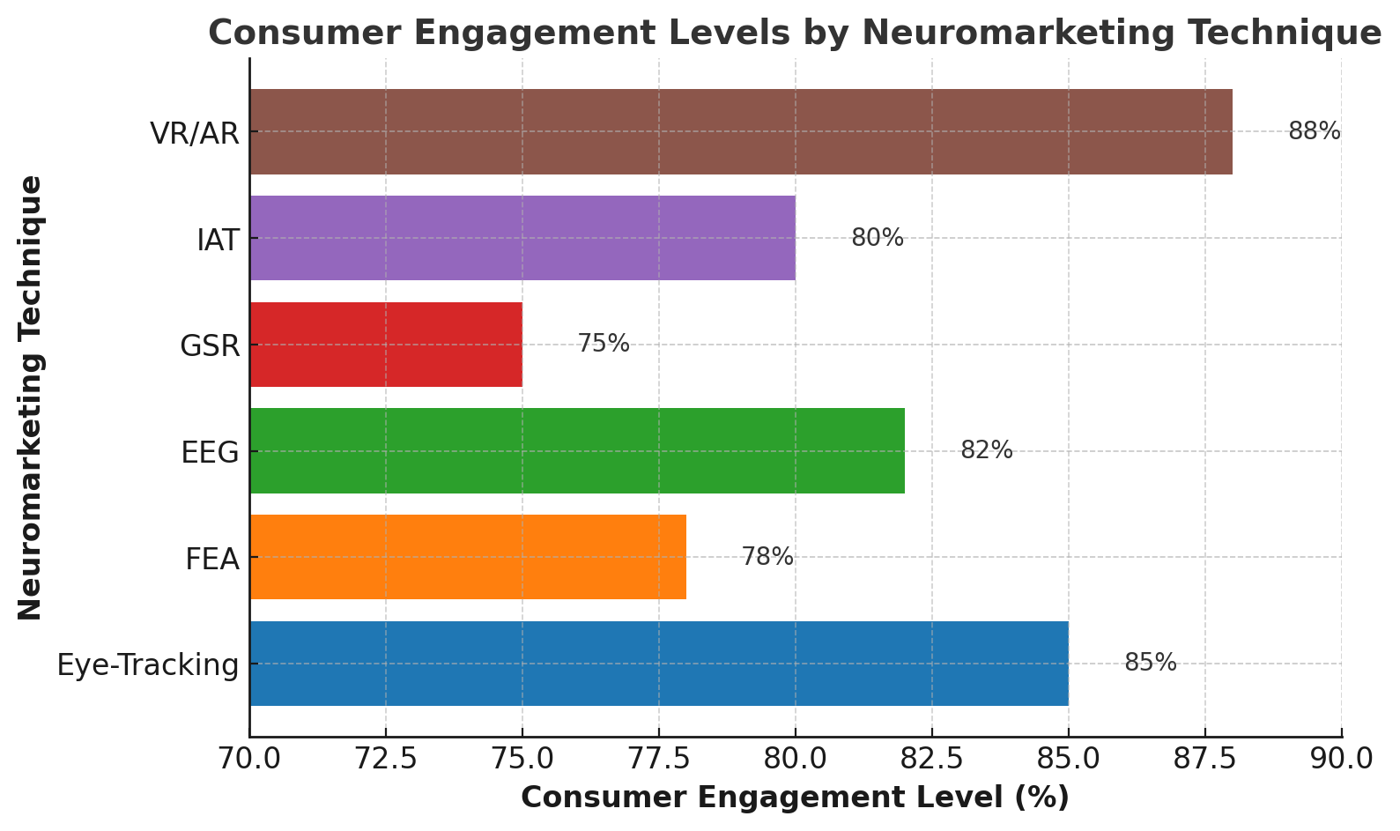

Source: Formulated by the author from collected survey responses.

The findings from Figure 2. (A **bar chart)** of this study indicate that immersive technologies such as Virtual Reality/Augmented Reality (VR/AR) and Eye-Tracking demonstrate the highest levels of consumer engagement, with response rates of approximately 88% and 85% respectively. These techniques effectively capture visual attention and foster interactive consumer experiences, aligning with previous research emphasizing their efficacy in simulating real-world purchase environments and evaluating attentional focus (Khushaba et al., 2013; Wedel & Pieters, 2008).

Electroencephalography (EEG), reflecting neural activity associated with cognitive processing, showed a high engagement rate of 82%, underscoring its value in measuring attention, memory encoding, and decision-making under different marketing stimuli (Vecchiato et al., 2011; Plassmann *et al.,* 2015). Similarly, the Implicit Association Test (IAT) registered an engagement level of 80%, affirming its effectiveness in uncovering subconscious attitudes and consumer preferences that may not be captured through explicit responses (Greenwald *et al.,* 1998).

Although slightly lower in comparison, Galvanic Skin Response (GSR) and Facial Expression Analysis (FEA) also made substantial contributions, with observed engagement levels of 75% and 78% respectively. These tools are particularly useful in gauging emotional arousal and real-time affective reactions during exposure to food-related stimuli (Madan, 2017; Lewinski et al., 2014). Together, these results highlight the differential yet complementary roles of non-invasive neuromarketing techniques in capturing the cognitive and emotional dimensions of consumer behavior in the agri-food sector.

Figure 3. A **radar chart** comparing the strengths of different **non-invasive neuromarketing techniques** across key dimensions:

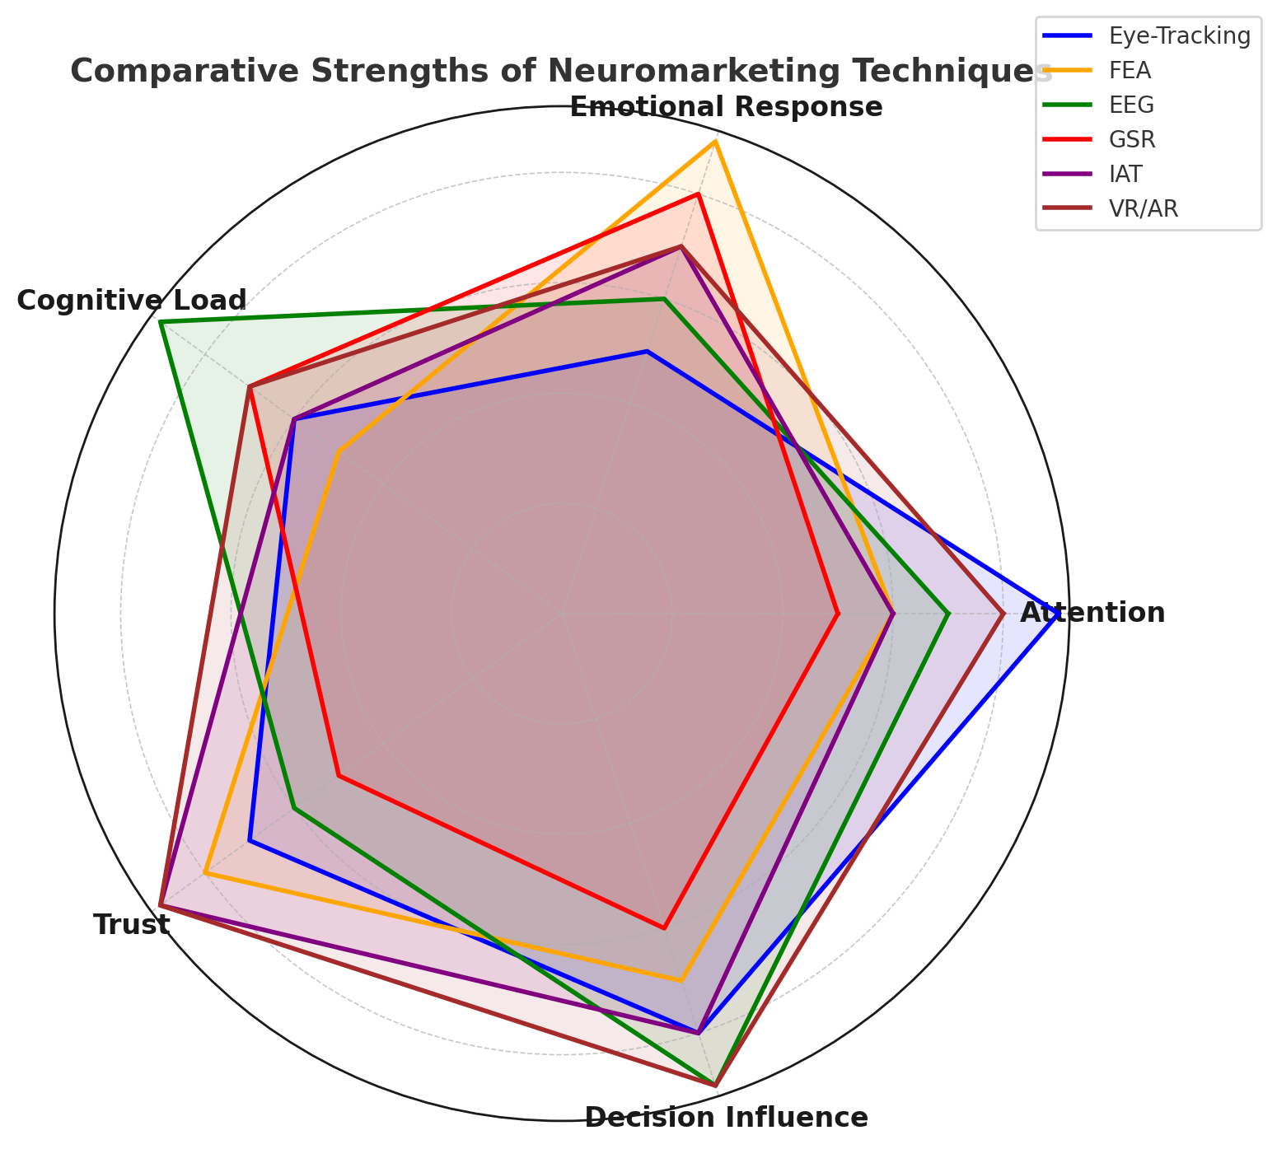

Source: Formulated by the author from collected survey responses.

**Figure 3** presents a radar chart comparing the effectiveness of various non-invasive neuromarketing techniques across key dimensions of consumer behavior analysis. Eye-Tracking demonstrates exceptional performance in capturing visual attention and influencing decision-making, consistent with its ability to track gaze patterns and fixation points during consumer interaction with products (Wedel & Pieters, 2008). Facial Expression Analysis (FEA) emerges as the most effective tool for decoding emotional responses and enhancing consumer trust, leveraging real-time detection of micro-expressions and affective states (Lewinski et al., 2014).

Electroencephalography (EEG) exhibits strong dominance in measuring cognitive load and assessing decision-making processes, reflecting its capacity to record brainwave patterns associated with attention, memory, and preference formation (Vecchiato et al., 2011; Plassmann et al., 2015). Galvanic Skin Response (GSR) proves effective in evaluating emotional arousal and cognitive engagement through physiological indicators of stress or excitement triggered by marketing stimuli (Madan, 2017).

Implicit Association Testing (IAT) is shown to be highly reliable for assessing subconscious attitudes, trust levels, and latent decision influences, providing insights that extend beyond self-reported data (Greenwald et al., 1998). Virtual Reality and Augmented Reality (VR/AR) demonstrate balanced effectiveness across all dimensions, particularly excelling in trust-building and consumer decision-making, due to their immersive and context-rich environments that simulate real-life purchase experiences (Khushaba et al., 2013).

Collectively, these findings underscore the complementary strengths of each neuromarketing technique, offering a multidimensional framework for analyzing consumer behavior in agri-food marketing.

Figure 4. A **process diagram** illustrating how **neuromarketing insights** translate into **actionable business strategies** in the agri-food sector.

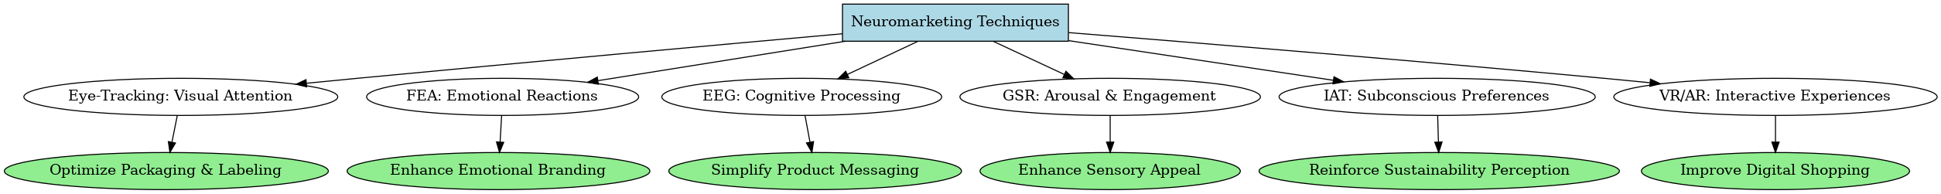

Source: Formulated by the author from collected survey responses.

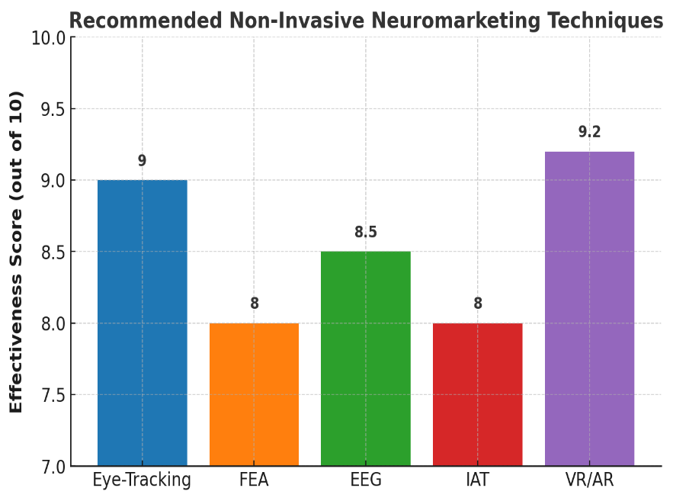

Figure 5. A **graphical summary** of the **recommended non-invasive neuromarketing techniques** based on their effectiveness in consumer behavior analysis.

Source: Formulated by the author from collected survey responses.

**Figure 5** illustrates the comparative effectiveness scores of selected non-invasive neuromarketing techniques in the context of digital consumer engagement and packaging optimization. Virtual Reality and Augmented Reality (VR/AR) achieve the highest effectiveness score of 9.2, highlighting their superior capability in simulating immersive, interactive environments that replicate real-world shopping experiences. These technologies are particularly impactful in enhancing user engagement and assessing consumer responses to packaging and product placement strategies (Khushaba et al., 2013).

Eye-Tracking closely follows with a score of 9.0, reflecting its precision in capturing consumer attention, visual preferences, and the sequencing of gaze patterns. This technique is instrumental in evaluating the visual salience of product designs and advertisements (Wedel & Pieters, 2008).

Electroencephalography (EEG), with a score of 8.5, demonstrates significant utility in decoding cognitive processes related to attention, memory encoding, and decision-making, offering in-depth insights into neural responses to marketing stimuli (Vecchiato et al., 2011; Plassmann et al., 2015). Similarly, the Implicit Association Test (IAT), scoring 8.0, is recognized for its ability to uncover subconscious biases and latent consumer attitudes that are often inaccessible through explicit measures (Greenwald et al., 1998).

Facial Expression Analysis (FEA) also receives an effectiveness score of 8.0, underscoring its value in emotional branding, trust-building, and the assessment of affective reactions to product imagery and messaging (Lewinski et al., 2014). These results collectively affirm the diverse applications and complementary strengths of neuromarketing tools in optimizing consumer engagement strategies within the agri-food marketing landscape.

**Conclusion:**

The integration of neuroscience into marketing through non-invasive neuromarketing techniques offers a transformative approach to understanding consumer behavior, especially in the context of the agri-food sector. This study highlights how tools such as eye tracking, facial coding, galvanic skin response (GSR), and electroencephalography (EEG) can reveal deep, often subconscious, emotional and cognitive responses to food products, packaging, and advertisements. These insights go beyond the limitations of conventional survey-based methods, enabling a more nuanced and data-driven understanding of consumer preferences.

In the Indian context—where cultural diversity, regional food habits, and evolving consumption patterns present unique challenges—neuromarketing can serve as a powerful tool for agribusinesses, food processors, and marketers. By applying scientifically grounded techniques, stakeholders can design more engaging marketing strategies, enhance product appeal, and ultimately influence consumer choices more effectively.

Moreover, the findings of this research contribute to the growing academic discourse on consumer neuroscience and support the development of predictive behavioral models in food marketing. As the agri-food sector undergoes rapid modernization, integrating neuromarketing methods can lead to improved consumer satisfaction, better targeting of nutritional interventions, and more effective promotion of sustainable and healthy food products.

In conclusion, the adoption of non-invasive neuromarketing techniques represents a promising frontier for food marketing research in India. It not only bridges the gap between consumer psychology and marketing practice but also provides a scientific basis for designing impactful agri-food marketing strategies that resonate with the minds—and hearts—of consumers.

**7. Reference**

Ali, H., Birley, S., (1998). The role of trust in the marketing activities of entrepreneurs establishing new ventures. *J. Market. Manag.* 14, 749–763.

Amaldoss, W., Jain, S., (2005). Pricing of conspicuous goods: a competitive analysis of social effects. *J. Mark. Res.* 42, 30–42.

Ceri-Ann Hughes, (2018). Rely on NPS? Look through the lens of neuro marketing. Quirk's Marketing

Covino, D., Viola, I., Paientko, T., & Boccia, F. (2021). Neuromarketing: some remarks by an economic experiment on food consumer perception and ethic sustainability. *RIVISTA DI STUDI SULLA SOSTENIBILITA’,* (1), 187–199. <https://doi.org/10.3280/riss2021-001011>

Deepak, J. (2025). Neuromarketing: An Emerging Trend in the Modern Realm of Marketing . *6th International Marketing Conference on Marketing in the AI Era - Marketing 5.0 - Reshaping Global Marketing on 17th January 2025*. Shri Dharmasthala Manjunatheshwara Institute for Management Development, Mysuru, India. ISBN code 978-93-83302-73-4. <https://sdmimd.ac.in/conferenceproceedings/imc2025papers/IMC2523.pdf>

Devaru, S.D.B. (2018). Significance of Neuro-marketing on Consumer Buying Behaviour. *International Journal of Technical Research & Science,* 3(III).

Geyskens, I., Steenkamp, J.E.M., Kumar, N., (1998). Generalisations about trust in marketing channel relationships using meta-analysis. *Int. J. Res. Mark*. 15, 223–248.

Greenwald, A. G., McGhee, D. E., & Schwartz, J. L. K. (1998). Measuring individual differences in implicit cognition: The Implicit Association Test. *Journal of Personality and Social Psychology,* 74(6), 1464–1480. <https://doi.org/10.1037/0022-3514.74.6.1464>

Kalkova, N., Yarosh, O. B., Mitina, E. A., & Velgosh, N. Z. (2023). Neuromarketing Research On Consumers' Visual Perception of Cryptomarking a Product Package. *ABAC Journal,* 43(1), 69-84.

Kambali, U. (2024). Neuromarketing Strategies in the Retail Sector: A Perception View. 5th International Conference on New Age Marketing January 18-19, 2024. Shri Dharmasthala Manjunatheshwara Institute for Management Development, Mysuru (SDMIMD). ISBN: 978-93-83302-66-6. <https://sdmimd.ac.in/marketingconference2024/papers/IMC2435.pdf>

Kenning, P., Plassmann, H., (2005). NeuroEconomics: an overview from aneconomic perspective. *Brain Res. Bull*. 67, 343–354.

Khushaba, R. N., Wise, C., Kodagoda, S., Louviere, J., Kahn, B. E., & Townsend, C. (2013). Consumer neuroscience: Assessing the brain response to marketing stimuli using electroencephalogram (EEG) and eye tracking. Expert Systems with Applications, 40(9), 3803–3812. <https://doi.org/10.1016/j.eswa.2012.12.095>

Lee, N., Broderick, A. J., & Chamberlain, L. (2007). What is ‘neuromarketing’? A discussion and agenda for future research. *International Journal of Psychophysiology*, 63(2), 199-204.

Lewinski, P., Fransen, M. L., & Tan, E. S. H. (2014). Predicting advertising effectiveness by facial expressions in response to amusing persuasive stimuli. *Journal of Neuroscience,* Psychology, and Economics, 7(1), 1–14. <https://doi.org/10.1037/npe0000012>

Lin, C., Cross, S. N., Jones, W. J., & Childers, T. L. (2018). Applying neuromarketing techniques to understand consumer behavior. *Journal of Consumer Psychology*, 28(2), 202-216.

Madan, C. R. (2017). Advances in studying brain-behavior relationships using eye-tracking and electrodermal activity. *Frontiers in Neuroscience,* 11, 632. <https://doi.org/10.3389/fnins.2017.00632>

Maria, R., et al. (2022). Neuromarketing in the agri-food sector. URI: <https://repository.iuls.ro/xmlui/handle/20.500.12811/3469>

Martin, L. (2010). Buyology, Broadway Books, ISBN 978-0-385-52389- 9

McClure, S. M., Li, J., Tomlin, D., Cypert, K. S., Montague, L. M., & Montague, P. R. (2004). Neural correlates of behavioral preference for culturally familiar drinks. *Neuron*, 44(2), 379–387.

Murphy, E. R. (2008). Neuroethics of neuromarketing. *Journal of Consumer Behaviour*, 7, 293–302.

Patrick Renvoise and Christophe Morin, (2007). Neuro marketing: Understanding the Buy Buttons in Your Customer's Brain, Salesbrain LLC, ISBN #0-9743482-2-8

Peter T. Bürgi, (2018). Taking emotions seriously in B2B research, Quirk's Marketing Research Review, Article ID: 20181109 Published: November 2018, ISSN 08937451

Plassmann, H., O'Doherty, J. P., & Rangel, A. (2010). Appetitive and aversive goal values are encoded in the medial orbitofrontal cortex at the time of decision making. *The Journal of Neuroscience*, 30, 10799–10808.

Plassmann, H., Ramsøy, T. Z., & Milosavljevic, M. (2012). Branding the brain: A critical review and outlook. *Journal of Consumer Psychology*, 22(1), 18–36.

Plassmann, H., Ramsøy, T. Z., & Milosavljevic, M. (2012). Branding the brain: A critical review and outlook. *Journal of Consumer Psychology,* 22(1), 18–36. <https://doi.org/10.1016/j.jcps.2011.11.010>

Ramsoy, T.Z. (2015). Introduction to Neuro marketing & Consumer Neuroscience, *Neuronsinc.com,* ISBN 978-87-997602-0-6

Reimann, M. and B. Weber. (2011). Neuroeconomics – a review of the situation. In: M. Reimann and B. Weber (eds.) Neuroeconomics. basics – methods – applications. Springer, Wiesbaden, Germany, pp. 3-9. (in German)

Reimann, M., Schilke, O., & Weber, B. (2011). Neural correlates of trust in brands: An fMRI study. *Journal of Marketing Research*, 48(6), 937-950.

Sanfey, A.G., Rilling, J.K., Aronson, J.A., Nystrom, L.E., Cohen, J.D., (2003). The neural basis of economic decision-making in the ultimatum game. *Science 300*, 1755–1758.

Smidts, A., Hsu, M., Sanfey, A. G., Boksem, M. A. S., Ebstein, R. B., & Scott A. Huettel, et al. (2014). Advancing consumer neuroscience. *Marketing Letters*, 25, 257–267.

Trocchia, P.J., (2004). Caving, role playing, and staying home: shopper coping strategies in a negotiated pricing environment. *Psychol. Mark.* 21, 823–854.

Vecchiato, G., Astolfi, L., Fallani, F. D. V., Toppi, J., Aloise, F., Bez, F., ... & Babiloni, F. (2011). On the use of EEG or MEG brain imaging tools in neuromarketing research. *Computational Intelligence and Neuroscience,* 2011, 643489. <https://doi.org/10.1155/2011/643489>

Verma, S. K., (2020). Neuromarketing-Perspective and future aspects in Indian Markets: A literature Review. *Vidyabharati International Interdisciplinary Research Journal,* 11(1) 282-288

Vrtana, D., Krizanova, A., and Gajanova, L. (2019). Importance of Neuro-marketing in Company’s Marketing Campaign. *48th International Scientific Conference on Economic and Social Development – "Managerial Issues in Modern Business*" - Warsaw, 25-26 November 2019.

Weber, B. (2017). Neuroeconomics. In: P. Kenning, A. Oehler, L.A. Reisch and C. Grugel (eds.) Consumer science. framework conditions, fields of research and institutions. *Springer, Wiesbaden, Germany*, pp. 329-340. (in German)

Wedel, M., & Pieters, R. (2008). Eye tracking for visual marketing. *Foundations and Trends in Marketing,* 1(4), 231–320. <https://doi.org/10.1561/1700000011>

Young, C., (2002). Brain waves, picture sorts®, and branding moments. *J. Advert. Res.* 42, 42–53.