### *Original Research Article*

Phytochemical Composition of Bioactive Compounds in *Tagetes minuta* Flower and Leaf Essential Oil Using FTIR and Antimicrobial Techniques for Exploring Therapeutic Uses

ABSTRACT

|  |
| --- |
| The essential oils derived from *Tagetes minuta* flowers and leaves possess significant therapeutic potential due to their diverse phytochemical composition and bioactivity. This study employs Fourier Transform Infrared Spectroscopy (FTIR) and antimicrobial assays to comprehensively characterize the bioactive compounds present in the essential oils and evaluate their efficacy against various microbial pathogens. FTIR analysis revealed the presence of hydroxyl (O-H), carbonyl (C=O), and aromatic (C=C) functional groups, which contribute to the observed biological activities. Antimicrobial assays demonstrated broad-spectrum activity, with notable efficacy against bacteria. Comparative analysis highlighted significant differences between the chemical profiles of flower and leaf oils, with flower oil exhibiting a higher concentration of phenols and terpenoids. These findings underscore the therapeutic potential of essential oils from T. minuta as natural antimicrobial agents, offering a promising alternative for pharmaceutical applications. This work also provides a foundation for future studies aimed at isolating and optimizing specific bioactive compounds for enhanced efficacy. |

*Keywords: Tagetes minuta*, *Essential oils, Bioactive compounds, FTIR, Antimicrobial*

**Introduction**

In the recent years, there has been a growing global shift toward natural and plant-based therapeutic solutions due to rising concerns over antibiotic resistance, chemical-induced side effects, and environmental sustainability. The increasing consumer preference for herbal-based healthcare, preventive medicine and wellness products has fueled interest in plant-derived bioactive compounds with multifunctional properties **(Kumar et al., 2024 and Swamy, 2020)**. Essential oils extracted from medicinal plants have emerged as promising alternatives in pharmaceutical, cosmetic, and textile industries due to their antimicrobial, antioxidant, and therapeutic potential **Bolouri et al., 2022.** In the textile sector, the integration of bioactive compounds into fabrics has gained traction for developing functional textiles. The relative industries are constantly evolving with the use of novel, innovative and modern tools and ingredients towards more effective, safe, natural, and eco-friendly solutions to satisfy the demands and improve the well-being of the customers. Antimicrobial, skin-soothing, and therapeutic properties are opening new avenues for sustainable and wellness-driven applications **(Thakker & Sun., 2021, Ghosh et al., 2025 and Walia et al., 2020).**

Among medicinal plants, *Tagetes minuta* (wild marigold) is recognized for its rich phytochemical composition and broad-spectrum bioactivity **Verma et al., 2024.** Its essential oils, extracted from flowers and leaves, are known to contain diverse bioactive compounds, including terpenoids, flavonoids, and thiophenes, which contribute to their antimicrobial, anti-inflammatory, and antioxidant properties **(Raina et al., 2018; Verma et al., 2024).** The chemical profile of these essential oils varies significantly between plant parts, influencing their therapeutic efficacy and potential applications in healthcare and functional textiles.

Fourier Transform Infrared Spectroscopy (FTIR) has emerged as a powerful tool for characterizing the functional groups present in essential oils, enabling a deeper understanding of bioactivity of phytochemicals present in the oils reflecting their therapeutic potent. FTIR analysis helps identify key functional groups such as hydroxyl (-OH), carbonyl (C=O), and aromatic (C=C), which are responsible for the biological activities of essential oils **(Sood et al., 2020).** The antimicrobial potential of *T. minuta* essential oils has been widely recognized, with notable efficacy against pathogens such as *Staphylococcus aureus* and *Candida albicans*, making them a viable alternative to synthetic antimicrobial agents **(Sultana et al., 2020).**

Despite its well-documented therapeutic properties, *T. minuta* remains largely unexplored in textile applications. The antimicrobial and bioactive properties of its essential oils present a unique opportunity for developing functional textiles with enhanced protective and wellness benefits **Wanzala et al., 2016; Verma et al., 2024 and Salehi et al., 2018.** Incorporating *T. minuta* essential oils into textiles could lead to innovative applications across various sectors, including healthcare (antimicrobial hospital textiles), sportswear (odor-resistant fabrics), and personal care (wellness textiles with skin-soothing effects). This study aims to bridge this gap by employing FTIR spectroscopy and antimicrobial assays to characterize and evaluate the bioactive compounds in *T. minuta* essential oils. By establishing a scientific basis for their integration into textiles, this research paves the way for expanding the potential of *T. minuta* in technical and sustainable textile applications.

The review on *T. minuta* essential oil established that this oil has been utilized in traditional medicine for treating respiratory infections, gastrointestinal disorders, and inflammatory conditions under ayurvedic treatment. The integration of antimicrobial techniques with phytochemical analysis not only validates the therapeutic properties of these oils but also enhances their applicability in health care and pest management. Recent agro-technological advancements have further improved the yield and quality of *T. minuta* essential oils, optimizing their production for technical applications **(Bandana et al., 2018; Mathela et al., 2018).**

Hence this study aimed to provide a comprehensive analysis of the phytochemical composition of bioactive compounds in essential oils extracted from flower and leaf of *T. minuta* using FTIR and antimicrobial potential thereof further by correlating the chemical composition with biological activities, the research seeks to establish a robust foundation for the therapeutic and industrial utilization of *T. minuta* essential oils. Despite the extensive use of essential oils in combating microbial infections, the antimicrobial properties of Tagetes minuta essential oils remain largely underexplored against specific pathogens. While these oils have been traditionally recognized for their therapeutic potential, comprehensive studies on their efficacy against diverse microbial strains are still limited. To bridge this gap, the present study aims to systematically evaluate the antimicrobial activity of T. minuta essential oils. Specifically, this research will (1) assess their antimicrobial efficacy against two Gram-positive bacteria, two Gram-negative bacteria, and one fungal strain using the agar well diffusion method and (2) characterize the bioactive compounds responsible for this activity through Fourier-transform infrared spectroscopy (FTIR).

**2. Materials and Methods**

### **The study was conducted at Govind Ballabh Pant University of Agriculture and Technology (GBPUA&T) Pantnagar, Uttarakhand**

### ****2.1 Collection of materials****

### ****2.1.1 *Tagetes minuta* Essential oils****

The essential oils (leaves and flowers) of *Tagetes minuta* L. utilized in the antimicrobial assays, were collected from Central Institute of Medicinal and Aromatic Plants (CIMAP), a CSIR institute located in Lucknow, Uttar Pradesh.

**2.1.2 Bacterial strains (gram negative and gram positive)**

The strains of microbes viz., *Escherichia coli, Pseudomonas spp.* RRC15*, Bacillus altitudinis, Bacillus paramycoides.* These strains were obtained from the Department of Microbiology, College of Basic Sciences and Humanities, GBPUA&T, Pantnagar.

**2.1.3 Fungal strain**

The fungal strain *Aspergillus niger* was obtained from Department of Plant Pathology, College of Agriculture, GBPUA&T, Pantnagar.

#### ****2.2 Characterization of Tagetes minuta essential oils through FTIR****

FTIR spectroscopy is based on the principle that molecular vibrations absorb infrared (IR) radiation at specific frequencies. Each type of bond within a molecule (e.g., C-H, O-H, C=O) absorbs IR radiation at frequencies, producing a unique spectrum. The essential oils were analysed utilising a Fourier transform infrared spectroscopy phase II spectrometer. FTIR spectra were obtained using Bruker software and subsequently analysed to determine the functional groups present in the essential oil **(Coates, 2000).** Spectra were obtained with Bruker software over the range of 600-3900 cm⁻¹, which corresponds to the mid infrared region. This region exhibits specific vibrational bands associated with functional groups, allowing the determination of the sample composition based on this mid-IR spectral fingerprint. One drop of essential oil was placed in the sample holder of the FTIR spectrometer (PerkinElmer Spectrum 100). The spectra were recorded over the mid-infrared region (600–3900cm⁻¹) at a resolution of 4 cm⁻¹~~,~~. Peaks corresponding to specific wavenumbers were identified and interpreted using standard spectral libraries and literature to determine the functional groups. The functional groups were correlated with known bioactivities, such as antimicrobial and antioxidant properties.

#### ****Antimicrobial assays****

The antimicrobial activity of the essential oils was assessed against a panel of microbial pathogens by Agar Well Diffusion method. The strains used were two **Gram-positive bacteria i.e.** Bacillus paramycoides and Bacillus *altitudinis*, two **Gram-negative bacteria such as** Escherichia coli and Pseudomonas aeruginosa and one fungal strain i.e. Aspergillus niger.

* 1. **Preparation of Microbial Culture**

The bacterial test organisms were inoculated on nutrient broth and were incubated at 370C for 24 hrs. And fungal strains were sub cultured in PDA (Potato Dextrose Agar) media and incubated at 270C for 48 hrs and stored in a refrigerator until further used.

* + 1. **Antibacterial assay**

The antibacterial potential of the selected essential oils was evaluated using the agar well diffusion method, as described by **Gakuubii et al. (2016),** with slight modifications to suit the experimental setup.

A fresh bacterial suspension was prepared by culturing the test organism in nutrient broth for 24 hours. Simultaneously, nutrient agar medium (2% agar) was prepared, sterilized, and poured aseptically into sterile Petri dishes. Once solidified, uniform wells measuring 5 mm in diameter were carefully made in the agar surface, using a sterile cork borer.

The bacterial culture (100 µL) was evenly spread across the agar surface using a sterile L-shaped spreader to ensure consistent distribution. Subsequently, 20 µL of the essential oil was dispensed into each well using a sterile micropipette. As controls, streptomycin were used as positive references to benchmark antibacterial activity, while DMSO served as the negative control to validate the specificity of the essential oil’s action.

The inoculated plates were then incubated at 37°C for 24 hours. Post incubation, the antibacterial activity was assessed by measuring the diameter of the inhibition zones around each well. The zone size, recorded in millimeters, was used as an indicator of the antimicrobial effectiveness of the tested essential oils

* + 1. **Antifungal assay**

The antifungal efficacy of the essential oils was determined through a modified agar well diffusion method. The procedure involved several key steps to ensure accuracy and reproducibility. Initially, the fungal strain was collected from Department of Plant Pathology, GBPUAT, Pantnagar and purified through successive culturing on Potato Dextrose Agar (PDA) to obtain a pure strain. A one-week-old fungal culture was selected for the antifungal assay.

PDA was prepared under sterile conditions and poured into sterile Petri plates. After solidification, 5 mm wells were created using a sterile cork borer. A mycelial disc from the actively growing fungal culture was excised and carefully placed at the center of each agar plate. Following inoculation, 20 µL of essential oil was introduced into each well using a sterile micropipette. Carbendazim (0.2% w/v) was used as a positive control due to its known antifungal properties, while DMSO served as the negative control to confirm the specificity of the essential oil’s activity.

The inoculated plates were incubated at 28°C for a period of seven days. Upon completion of the incubation, the antifungal activity was evaluated by measuring the diameter of the inhibition zones around each well using a ruler, with results recorded in millimeters.

All experimental treatments were conducted in triplicate to ensure consistency and statistical validity. The average values of inhibition zones are presented in Table 1.

**3**. **Results and Discussion**

#### ****3.1 FTIR analysis of Leaf and Flower Essential Oils****

The FTIR spectrum reveals the functional groups and chemical bonds present in the sample. Key peaks were observed at specific wave numbers, corresponding to characteristic molecular vibrations. The main functional groups identified are presented in **fig 1, 2 and table 1.**

The **O–H stretching** vibrations observed at **3,082.6 cm⁻¹** in the leaf oil and **3,751.4 cm⁻¹** in the flower oil suggest the presence of hydroxyl-containing compounds. Such O–H stretching bands are commonly documented in essential oils, indicating the existence of alcohols or phenolic compounds that contribute to antioxidant properties. For instance, a study on the photoactivity of natural products emphasizes the role of hydroxyl groups in the bioactivity of plant-derived compounds **(Siewert & Stuppner., 2019)**.

The **C–H stretching** bands around **2,957 cm⁻¹** in both oils are characteristic of aliphatic hydrocarbons, commonly found in essential oils. These bands are associated with the stretching vibrations of methyl and methylene groups, which are prevalent in various terpenes. A comprehensive review on the efficacy of plant-based mosquito repellents discusses the significance of such aliphatic compounds in the context of essential oils **(Ojewumi et al., 2021)**.

The **C=O stretching** bands at approximately **1,844 cm⁻¹** indicate the presence of carbonyl groups, typical of esters and ketones. These functional groups are often linked to compounds such as dihydrotagetone and tagetone, which have been identified as major constituents in T. minuta essential oils. Research on the antimicrobial and antioxidant properties of plant extracts has highlighted the importance of carbonyl-containing compounds in contributing to bioactivity **(Ramallo et al., 2011)**.

The **C=C stretching** vibrations observed near **1,618 cm⁻¹** and **1,576 cm⁻¹** are indicative of aromatic rings and alkenes, respectively. These features suggest the presence of compounds like ocimenes and limonene, known for their significant biological activities. A study on the photoactivity of natural products underscores the relevance of such unsaturated structures in the bioactivity of phytochemicals **(Siewert & Stuppner., 2019)**.

Furthermore, the **C–O stretching** and **O–H bending** bands around **1,468 cm⁻¹** point towards the existence of esters and acids, common in essential oils and contributing to their characteristic aromas and therapeutic properties. The fingerprint region of the FTIR spectra, displaying multiple absorption peaks between **1,364.5 to 399.7 cm⁻¹** for leaf oil and **1,288.0 to 827.0 cm⁻¹** for flower oil, provides a distinct spectral pattern for each oil.

The spectral variations between leaf and flower essential oils highlight differences in **chemical composition and functional group intensities**. The **stronger O–H stretching band in TMF** suggests a higher concentration of hydroxyl-containing compounds, potentially contributing to its higher **antioxidant and antimicrobial activity**. The **slight shifts in C=O and C=C bands** indicate structural variations in carbonyl and aromatic compounds, which may influence the **biological activity** of the oils.



**Fig 1:** **FTIR spectral analysis of *Tagetes minuta* Leaf Essential Oils**



**Fig 2:** **FTIR spectral analysis of *Tagetes minuta* Flower Essential Oils**

**Table 1. Comparative FTIR analysis of *Tagetes minuta* Leaf and Flower Essential Oils**

| **Functional Group/Mode** | **Intensity (Leaf Oil)** | **Intensity (Flower Oil)** | **Wavenumber (cm⁻¹) (Leaf)** | **Wavenumber (cm⁻¹) (Flower)** |
| --- | --- | --- | --- | --- |
| O–H stretching | Medium | Strong | 3,082.6 | 3,751.4 |
| C–H stretching (aliphatic) | Medium | Medium | 2,957.1 | 2,956.9 |
| C=O stretching (esters/ketones) | Strong | Strong | 1,844.9 | 1,844.4 |
| Amide I (C=O & N–H, proteins/peptides) | Strong | Strong | 1,711.5 | 1,710.2 |
| C=C stretching (aromatic rings) | Medium | Medium | 1,618.8 | 1,618.9 |
| C=C stretching (alkenes) | Medium | Medium | 1,576.9 | 1,576.3 |
| C–O stretching, O–H bending (esters, acids) | Medium | Medium | 1,468.0 | 1,467.1 |
| C–H bending (alkanes) | Weak | Weak | 1,408.9 | 1,362.1 |
| Fingerprint region (unique to sample) | Various | Various | 1,364.5 – 399.7 | 1,288.0 – 827.0 |

* 1. **Antimicrobial Efficiency of *Tagetes minuta* Leaf and Flower Essential Oil**

The graphical representation of antimicrobial activity elucidates the effectiveness of the essential oils extracted from *Tagetes minuta* leaves and flowers against selected bacterial strains. The results are depicted as a function of inhibition zones (in mm) at various concentrations, providing a comparative assessment of antimicrobial efficacy.

**3.2.1 Inhibition zone analysis**

The antimicrobial activity of ***Tagetes minuta*** essential oils was assessed by measuring the diameter of inhibition zones, revealing significant differences in efficacy. **The leaf essential oil** exhibited higher inhibition zones against Escherichia coli and Staphylococcus aureus at elevated concentrations, suggesting its potent antibacterial properties **(table 2 and Fig 3**). In contrast, the **flower essential oil** demonstrated a broader spectrum of activity, effectively inhibiting the growth of all tested bacterial strains **(table 2 and Fig 4**). These findings indicate a **concentration-dependent** increase in antimicrobial efficacy for both leaf and flower essential oils, with the highest inhibition zones observed at the maximum tested concentration of **100 µL/mL**, confirming their potential in bacterial growth inhibition. The antibacterial activity of ***T. minuta*** essential oils is well-documented in previous studies. **Tahir and Khan (2012)** reported that crude extracts from the leaves, fruits, and flowers exhibited strong inhibitory effects against Escherichia coli, Klebsiella pneumoniae, Pseudomonas aeruginosa, Salmonella typhi, and Staphylococcus aureus, aligning with the findings of this study. Similarly, **(Anthony et al., 2015)** demonstrated the efficacy of ethanolic extracts of ***T. minuta*** against Streptococcus viridans, Bacillus licheniformis, Bacillus subtilis, and Pasteurella multocida, further supporting the antimicrobial potential of this plant. The results of this study reinforce the growing body of evidence supporting plant-derived antimicrobial agents as viable alternatives to synthetic antibiotics, which are often associated with adverse side effects and increasing bacterial resistance **(Guglielmi, et al., 2020; Angelini, 2024)**. The demonstrated efficacy of *T. minuta* essential oils highlights their potential application in natural antimicrobial formulations, contributing to the development of pharmaceutical and therapeutic alternatives to combat pathogenic bacteria.

**C:\Users\dell\OneDrive\Desktop\Untitled.tiff**

**Fig 3:** Inhibition zone of *Tagetes minuta* leaf essential oil against four bacterial strains at four concentrations (40, 60, 80, and 100 µL/mL)

C:\Users\dell\OneDrive\Desktop\12.tiff

**Fig 4:** Inhibition zone of *Tagetes minuta* flower essential oil against four bacterial strains at four concentrations (40, 60, 80 and 100 µL/mL)

**Table 2. Comparison of zone of inhibition in mm among essential oil against different bacterial strains**

|  |  |  |  |  |  |
| --- | --- | --- | --- | --- | --- |
| Essential oil | Concentrations | Tested bacterial strains | | | |
| ***E. coli*** | ***P. aeruginosa*** | **Bacillus paramycoides (NID1)** | **Bacillus *altitudinis* (ST15)** |
| TML | 40 µL/mL | NZ | NZ | NZ | NZ |
|  | 60 µL/mL | 1.40 ± 0.264 | 1.27 ± 0.061 | NZ | NZ |
|  | 80 µL/mL | 2.55 ± 0.231 | 4.37 ± 0.258 | 1.26 ± 0.115 | NZ |
|  | 100 µL/mL | 5.43 ± 0.058 | 4.63 ± 0.153 | 1.99 ± 0.153 | 0.99 ± 0.058 |
| TMF | 40 µL/mL | 2.31 ± 0.021 | 1.11 ± 0.061 | NZ | 1.19 ± 0.100 |
|  | 60 µL/mL | 2.99 ± 0.060 | 2.01 ± 0.258 | 0.87 ± 0.153 | 1.54± 0.060 |
|  | 80 µL/mL | 3.41 ± 0.061 | 2.46 ± 0.058 | 1.46 ± 0.258 | 1.59 ± 0.058 |
|  | 100 µL/mL | 5.67 ± 0.050 | 2.71 ± 0.153 | 1.87 ± 0.061 | 1.66 ± 0.115 |
| Streptomycin | 10 µg/mL | 14.31 ± 0.023 | 20.19 ± 0.058 | 23.41 ± 0.258 | 19.36 ± 0.063 |

Data are means of 3 replicates at four concentration (40, 60, 80 and 100 µL/mL) and are represented as mean ± SD, where NZ = no zone of inhibition. These findings suggest that *T. minuta* essential oils could serve as effective natural antibacterial agents, with potential applications in pharmaceutical and therapeutic industries.

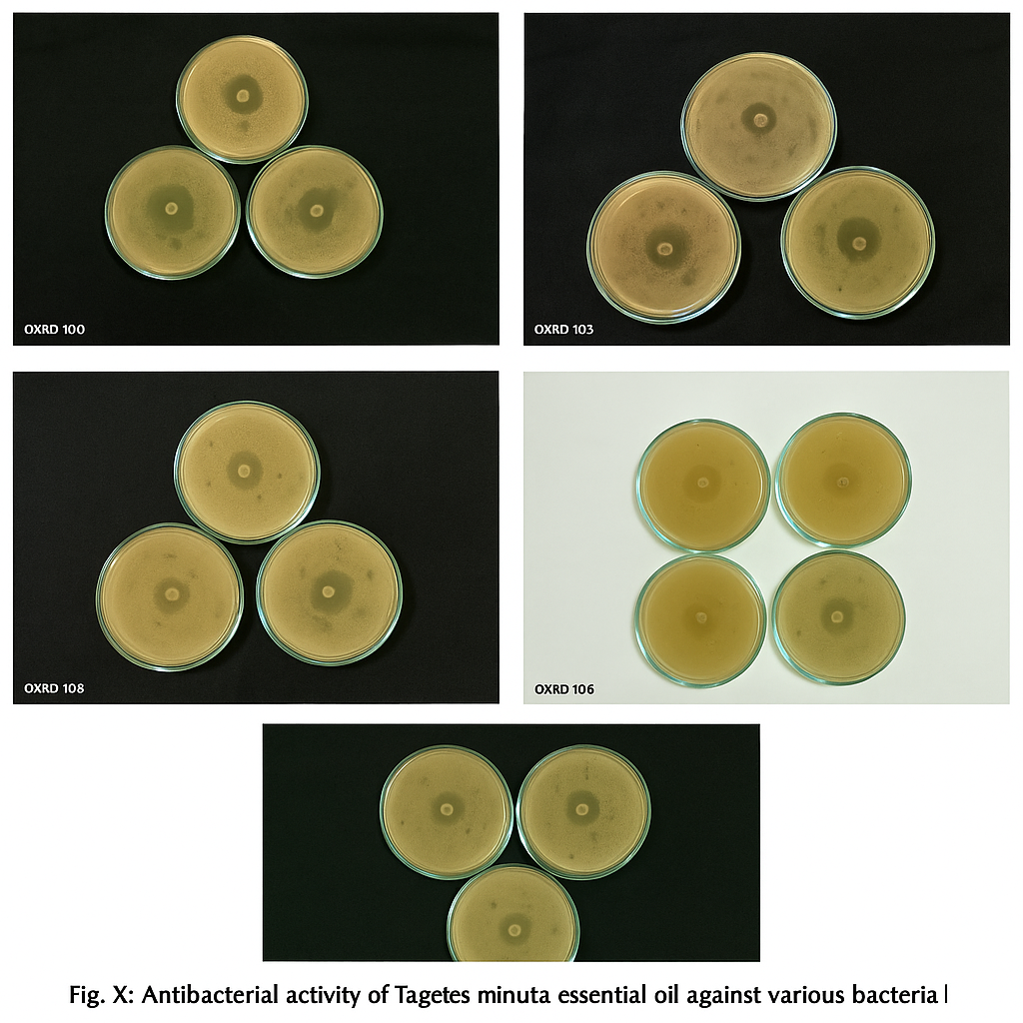

**Fig 5: Antibacterial activity of *Tagetes minuta* flower and leaf essential oil**

**3.3 Antifungal activity analysis**

The antifungal activity of *Tagetes minuta* essential oils against *Aspergillus niger* is presented in **table 3** and **Fig 6 &7.** The results indicate that the flower essential oil (TMF) exhibited significantly higher antifungal efficacy compared to the leaf essential oil (TML) across all tested concentrations. No inhibition was observed for TML at 40 and 60 µL/mL, while moderate inhibition zones were recorded at 80 µL/mL (0.33 mm) and 100 µL/mL (0.41 mm). In contrast, TMF demonstrated slight inhibition at 60 µL/mL (0.5 mm), with a marked increase in antifungal activity at 80 µL/mL (0.83 mm) and 100 µL/mL (0.91 mm). These findings highlight a concentration-dependent antifungal activity, with TMF consistently demonstrating superior inhibition against *A. niger* compared to TML. The results are consistent with previous studies reporting the broad-spectrum antifungal properties of essential oils. The bioactive constituents of *T. minuta* essential oil, including limonene, 1,8-cineole, α-pinene, β-pinene, and camphor, have been extensively documented for their potent antifungal effects against Rhizoctonia solani, Fusarium oxysporum, Penicillium digitatum, Aspergillus niger, Verticillium fungicola, and Trichoderma harzianum (**Grange & Ahmed, 1988; Matasyoh et al., 2007; Marei et al., 2012,** **Saha et al., 2012; Vambe, 2025**). The presence of these bioactive compounds in *T. minuta* essential oil likely contributes to its antifungal efficacy, reinforcing its potential as a natural alternative to synthetic antifungal agents.

C:\Users\dell\OneDrive\Desktop\5.tiff

**Fig 6:** Zone of inhibition for A. niger by TML and TMF essential oils at varying concentrations.

**Table 3. Comparison of zone of inhibition in mm of essential oils against fungal strains**

|  |  |  |
| --- | --- | --- |
| Essential oil | Concentrations | Fungal Strain   1. *Niger* |
| TML | 40 µL/mL | NZ |
| 60 µL/mL | NZ |
| 80 µL/mL | 0.33 ± 0.053 |
| 100 µL/mL | 0.41 ± 0.021 |
| TMF | 40 µL/mL | NZ |
| 60 µL/mL | 0.5 ± 0.153 |
| 80 µL/mL | 0.83 ± 0.060 |
| 100 µL/mL | 0.91 ± 0.053 |

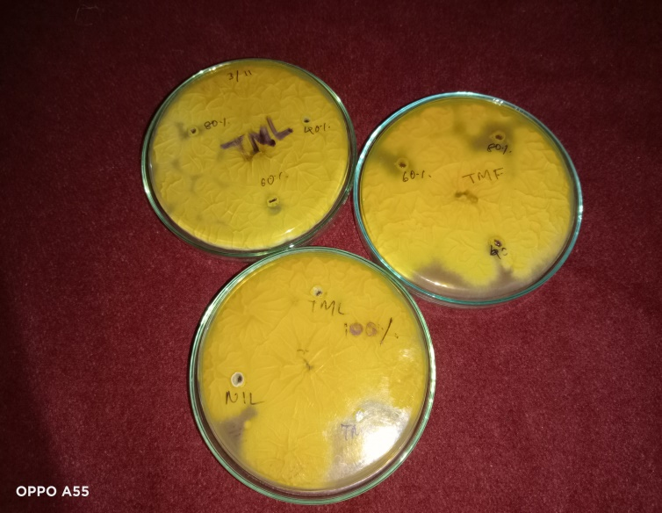

**Fig 7:** Zone of inhibition for Tagetes minuta (flower and leaf) essential oil

**5. Conclusion**

This study demonstrates the phytochemical diversity and antimicrobial efficacy of Tagetes minuta flower and leaf essential oils. FTIR analysis confirmed the presence of key functional groups, such as hydroxyl, carbonyl, and aromatic compounds, which contribute to the bioactivity of these essential oils. The flower oil, with its higher phenolic and terpenoid content, shows superior activity against bacterial and fungal strains, suggesting its suitability for textile treatments requiring enhanced microbial resistance.

The strong inhibition against bacterial and fungal strains indicates that these bioactive compounds could be effectively incorporated into textiles to impart durable antimicrobial properties, enhancing hygiene and protection in applications such as medical textiles, sportswear, and functional fabrics.

These findings pave the way for sustainable and eco-friendly textile innovations, encouraging further research into the wash durability, mechanical performance, and large-scale application of *T. minuta* based antimicrobial textile treatments. Future studies should focus on isolating specific bioactive compounds, exploring synergistic combinations, and evaluating the oils' efficacy in clinical and agricultural settings.

**References**

1. **Kumar, P., Verma, A., Ashique, S., Bhowmick, M., Mohanto, S., Singh, A., ... & Haider, T. (2024).** Unlocking the role of herbal cosmeceutical in anti-ageing and skin ageing associated diseases. *Cutaneous and Ocular Toxicology*, *43*(3), 211-226.
2. **Swamy, M. K. (2020).** *Plant-derived bioactives*. Springer Singapore.
3. **Walia, S., Bhatt, V., & Kumar, R. (2020).** Influence of drying processing on essential oil Yield and Composition of Wild Marigold (Tagetes minuta L.) in the western Himalayas. *Journal of Essential Oil Bearing Plants*, *23*(4), 686-696.
4. **Wanzala, W., Wagacha, J. M., Dossaji, S. F., & Gakuubi, M. M. (2016).** Bioactive properties of Tagetes minuta L.(Asteraceae) essential oils: A review.
5. **Verma, N., Aggarwal, N., & Sood, P. (2024).** Exploring the phytochemistry and biological potential of T. minuta (L.): A comprehensive review. *South African Journal of Botany*, *168*, 175-195.
6. **Salehi, B., Valussi, M., Morais-Braga, M. F. B., Carneiro, J. N. P., Leal, A. L. A. B., Coutinho, H. D. M., ... & Sharifi-Rad, J. (2018).** Tagetes spp. essential oils and other extracts: Chemical characterization and biological activity. *Molecules*, *23*(11), 2847.
7. **Bolouri, P., Salami, R., Kouhi, S., Kordi, M., Asgari Lajayer, B., Hadian, J., & Astatkie, T. (2022).** Applications of essential oils and plant extracts in different industries. *Molecules*, *27*(24), 8999.
8. **Thakker, A. M., & Sun, D. (2021).** Sustainable plant-based bioactive materials for functional printed textiles. *The Journal of the Textile Institute*, *112*(8), 1324-1358.
9. **Ghosh, J., Repon, M. R., Pranta, A. D., Rupanty, N. S., Khan, F., & Noor, T. (2025).** Bioactive component integrated textiles: A promising source of medicine and healthcare. *Journal of Engineered Fibers and Fabrics*, *20*, 15589250241308561.
10. **Verma, N., Aggarwal, N., & Sood, P. (2024).** Exploring the phytochemistry and biological potential of T. minuta (L.): A comprehensive review. *South African Journal of Botany*, *168*, 175-195.
11. **Raina, R., Kumari, M., &Jadhav, R. (2018).**Essential oil composition of African marigold (*Tagetes minuta* L.).*Journal of Aromatic Plants, 6*(3), 104-112.
12. **Sood, M., Kumar, N., &Chandel, S. (2020).** Management of *Tagetes minuta* under different sowing methods and plant densities in mid-hill conditions of Himachal Pradesh (India).*International Journal of Current Microbiology and Applied Sciences, 9*(5), 451-459.
13. **Sultana, S., et al. (2020).** Evaluating biological activities of the seed extracts from *Tagetes minuta* L. found in northern Pakistan. *Journal of Medicinal Plant Research, 14*(3), 73-82.
14. **Bandana, K., Raina, R., &Kumari, M. (2018).***Tagetes minuta*: An overview. *Journal of Pharmacognosy and Phytochemistry, 7*(2), 2416-2422. Retrieved from <https://www.chemijournal.com>
15. **Mathela, R. K., Singh, A. K., &Upadhyay, R. K. (2018).**New agro-technology to increase the productivity of wild marigold (*Tagetes minuta*) under sub-tropical northern Indian plains.*International Journal of Essential Oil Research, 10*(4), 55-60.
16. **Tahir L and Khan N. 2012**.Antibacterial potential of crude leaf, fruit and flower extracts ofTagetesminutaL.*Journal of Public Health and Biological Sciences*.1(3):74-78.
17. **Vambe, M., Coopoosamy, R. M., Arthur, G. D., & Naidoo, K. (2025).** Biological properties, chemical profiles and safety of essential oils from South African aromatic plants: a literature review. *Journal of Essential Oil Research*, *37*(1), 1-19.
18. **Angelini, P. (2024).** Plant-derived antimicrobials and their crucial role in combating antimicrobial resistance. *Antibiotics*, *13*(8), 746.
19. **Guglielmi, P., Pontecorvi, V., & Rotondi, G. (2020).** Natural compounds and extracts as novel antimicrobial agents. *Expert Opinion on Therapeutic Patents*, *30*(12), 949-962.
20. **Anthoney T, Jackie KO, Terer EK and Edwin M. 2015**.Invitro antibacterial activity ofethanolic-aqua extract ofTagetes minutaleaves harvested from The University ofEastern Africa, Baraton, Nandi County, Kenya.International *Journal of Pharmacy & LifeSciences*.6(5):4452-4460.
21. **Grainge M and Ahmed S. 1988.** Handbook of plants with pest-control properties. Wiley, NewYork. pp 67-77
22. **Matasyoh JC, Kiplimo JJ, Karubiu NM and Hailstorks TP. 2007**. Chemical composition andantimicrobial activity of essential oil of Tarchonanthus camphorates.Food Chemistry.101:1183-1187.
23. **Marei, G. I. K., Rasoul, M. A. A., & Abdelgaleil, S. A. (2012).** Comparative antifungal activities and biochemical effects of monoterpenes on plant pathogenic fungi. *Pesticide biochemistry and physiology*, *103*(1), 56-61.
24. **Saha S, Walia S, Kundu A, Kumar B and Joshi D. 2012.** Antifungal acetylinicthiophenes fromTagetes minuta: potential biopesticide*. Journal of Applied Botany and Food Quality*.85:207-2.
25. **Siewert, B., & Stuppner, H. (2019).** The photoactivity of natural products–an overlooked potential of phytomedicines. *Phytomedicine*, *60*, 152985.
26. **Ojewumi, M. E., Obanla, O. R., & Atauba, D. M. (2021)**. A review on the efficacy of Ocimum gratissimum, Mentha spicata, and Moringa oleifera leaf extracts in repelling mosquito. *Beni-Suef University Journal of Basic and Applied Sciences*, *10*, 1-12.
27. **Ramallo, I. A., Salazar, M. O., Mendez, L., & Furlan, R. L. (2011)**. Chemically engineered extracts: source of bioactive compounds. *Accounts of Chemical Research*, *44*(4), 241-250.