Pragmatic Approach to the removal of Cu (II) ions from Aqueous Solution using Silica: A kinetic, Isothermal and Thermodynamic study.

Abstract: The main objective of this study was to investigate the removal of Copper (II) ions [Cu (II)] from aqueous solution by adsorption unto pure silica. The silica was characterized by using Fourier Transform Infra-Red (FT-IR) spectral analysis before and after adsorption of the metal ions. The optimum condition for the adsorption of Cu (II) ions was studied in a batch system by considering the extent of adsorption with respect to pH, contact time, initial Copper (II) ion concentration and temperature. Maximum adsorption was recorded at a pH of 7.0 and equilibrium sorption was achieved within 50 minutes of the process. It was observed that the optimum amount of Cu (II) ions absorbed by pure silica was 9.13 mg/g representing 98.86 % at the optimum pH of 7.0. Three kinetic models: Elovich, Pseudo first-order and Pseudo second-order were applied in the analyses. Desorption studies showed that only 24.33 % of the metal ion was desorbed with appropriate eluting agents. The experimental results showed that pure silica is a good adsorbent for the removal of Cu (II) ions from aqueous solutions and may possibly be useful for treating industrial waste waters.
Key words: adsorption, Cu (II) ions, kinetic models, desorption, batch system.

INTRODUCTION
Many developing nations, Nigeria inclusive, have been faced with the challenge of heavy metal ion pollution as a result of increasing level of industrialization and urbanization. Unrestricted mining, industrial and commercial activities in most cities coupled with industrial wastes which are not properly treated before discharge pollute our environment with heavy metals, which eventually reach man through the food chain (Onojake, Iwuoha and Osakwe, 2015). Many industrial processes such as mining, petroleum exploration and spillage, disposal of untreated and partially treated industrial effluents, indiscriminate use of metal containing fertilizers and pesticides in agricultural fields produce aqueous effluents containing metal contaminants such as aluminium, chromium, copper, cobalt, cadmium, manganese, iron, zinc, nickel, mercury and lead (Odoemelam, Onyeije and Eddy, 2012). Traditional technologies available for the removal of heavy metals from aqueous solutions include oxidation and reduction, chemical precipitation, ion exchange, membrane separation, reverse osmosis, electrolysis, phyto-extraction and use of adsorbents (Eddy and Odoemelam,2009). However, the advantages and disadvantages of each of these methods have been extensively reviewed (Adebayo, Adegoke and Sidiq, 2016). Among these methods, adsorption has been found to be one of the most efficient processes for the removal of heavy metal ions from aqueous solution (Eddy and Odoemelam, 2009. Zhang et al. (2020) developed quartenized salicylaldehyde Schiff base modified SBA-15 mesoporous silica for detection, absorption and recovering of Cu²⁺ ions from water. Saddik et al. (2022) provided an adsorbent for the removal of Cu²⁺ ions from aqueous solutions, in the form of silica-based adsorbent functionalized by 2-phenylimidazo [1,3-a] pyridine-3-carbaldehyde, which showed high adsorbability of up to 100 mg/g at pH of 6 and at 25ºC. Bilgiç et al (2022) also produced silica versus pillar [5] arene adsorbent for the removal of Cu²⁺ ions from aqueous solution, which presented maximum adsorption capacity of 79.3651 mg/g at 328 K. Qin et al. (2024) developed an adsorbent, by grafting glycidyl methacrylate onto polypropylene and animating it with N-methyl-D-glucamine, for the selective adsorption of boron amidst sodium, calcium and magnesium ions, which showed maximum adsorption capacity for boron of 18.03$±1$at pH 6.4. Yu et al. (2023) produced an adsorbent for boron by grafting glycidyl methacrylate onto PP melt-down fibre and reacting with N-methyl-D-glucosamine. The adsorbent (PP-g-GMA-NMDG gave adsorbent capacity of 41.65 mg/g for boron at pH 6. The work of Kanungo et al. (2023) is a review that discussed the methods for the production of nanostructured materials to be used for drug delivery.
Zhang et al. (2019) prepared two adsorbents namely SBA-15 functionalized with N-propyl-2-pyridylamine and ethylenediaminepropyl-2-pirydylamine and used them for the adsorption of copper (II) and lead (II) ions from aqueous solutions at pH of 5.0 and obtained maximum adsorption values of 35.87 and 48.26 mg/g for copper (II) ions and 82.05 and 106.62 mg/g for Pb(II) respectively. Humelnicu et al. (2022) determined the maximum adsorption capacities of silica SBA-15 and titanosilicate ETS-10 adsorbents for copper²⁺ ion removal from aqueous media at pH 5. ETS-10 asorbent gave a higher adsorption value for cu²⁺ ions than SBA-15 as 172.53 mg/g and 52.71 mg/g respectively. Awual (2017) assessed the potential of silica conjugate nanomaterial for the removal of cu²⁺ ions from environmental samples, and obtained a maximum adsorption capacity of 183.81 mg/g. Ahmadpoor et al. (2019) synthesized a novel bead consisting of Fe₅C₂@SiO₂ nanoparticles and used it to remove copper (II)ions from aqueous solution.at pH range of 3-4 at adsorbent concentration of 0.41 g/L and achieved adsorption of 97.4 %. Kukwa et al. (2020) extracted silica from rice husk, modifier d it with 1M trioxonitrate (V) acid, and applied it for the removal of copper (II), Zn (II), Mn (II) and Pb (II) ions from aqueous solution, within the temperature range of 28ºC to 43ºC and a pH of 8 and beyond. Their findings show an increase in the percent removal of ions with increase in adsorbent concentration up to 99.48 % with Cu (II) giving the best percentage in the order of removal. Abuhatab et al. (2020) assessed the removal of Zn ²⁺, Cu²⁺, and Cr²⁺ ions from aqueous solution using NiO-MgO silica-based nanoparticles within the time interval of 60 minutes and a pH range of 7-11, achieving a maximum adsorption capacity of 37.69, 69.68 and 209.51 for zinc, copper and chromium ions respectively., and an increase in adsorption capacity was observed with increase in pH within the range studied.
Zafar et al. (2020). (2020) evaluated the removal of copper 2+ ions with chemically treated rice hub as adsorbate. The chemical treatment was carried out with sodium hydroxide, which enhanced the surface adsorption and increased the surface efficiency up to 97 % within 30 minutes. Mahatmanti et al. (2021) a good adsorbent for copper (II), Zinc (II) and Cd (II) ion removal, by treating chitosan with silica and adding polyethylene glycol plasticizer, to enhance the physical, mechanical strength and ease of diffusion of metal ions through the membrane surface. The results showed maximum adsorption for Cu (II) and Zn (II) ions at pH of 6. Wu et al. (2021) synthesized Schiff base functiionalized with polyamidoamine dendrimer, and utilised it to adsorb copper (II) and Ag (I) ions from aqueous solution and obtained maximum adsorption at pH for both ions at 180 and 150 minutes for Cu (II) and Ag (I) ions respectively. Humelnicu et al. (2022) investigated the removal of Cu (II) ions from water with silica SBA-15 and titanosilicate ETS-10 adsorbents and recorded maximum adsorption of 52.71 mg/g at pH 5 for SBA-15, and 172.53 mg/gnat pH 6 for ETS-10. Qin et al. (2018) assessed the removal of Ni (II), Cu (II), Zn (II) and Co (II) ions from simulated aqueous solution with calcium silicate powder (CSP), and obtain maximum adsorption capacity of 420.17, 680.93, 251.89 and 235.29 mg/g respectively at concentration of 100 mg/lL for CSP. Ahmadi et al. (2023) evaluated the efficacy of sorbents administered to rats in the reduction of heavy metal concentrations in rats. The use of Philipsite sorbent reduced the zinc and copper content in the blood of rat 1.6 times. This helps to achieve good health for human beings who will consume safe products. Simón et al. (2022) assessed mixture of agro waste products such as pine sawdust, sunflower and corn residues as adsorbents for nickel (II), Zinc (II) and Cadmium (II) ions from aqueous solution. These served as better alternatives to the synthetic adsorbents, and gave maximum adsorption capacity of above 50%. Elgarahy et al. (2021) reviewed biosorbents as better alternatives than the conventional adsorbents for the removal of heavy metals from waste water.

METHODS
Pure chromatographic grade silica (mesh size 60-200um), Copper sulphate pentahydrate, distilled deionized water were used. Standard solution of 1000 mg/L of copper was prepared as stock solution from its salt, copper (II) sulphate pentahydrate (CuSO₄.5H₂O). this was done by dissolving 2.50g of the copper salt in 1000 cm³ of distilled deionized water. From the stock solution, working solutions of varying initial concentrations were prepared by serial dilution using distilled deionized water.
The concentration of Cu (II) ions was analysed with Buck Scientific Atomic Adsorption Spectrophotometer (AAS) model 210/211 VGP. The wavelength used for the copper metal ions was: Cu=324.8 nm. Fourier Transform Infra-Red (FT-IR) spectra were recorded on Shimadzu FTIR-84005 machine (Norwalk, CT, USA) using KBr pellets. The Ph measurements were made using Corning Scholar 425 digital pH meter (NY USA). Batch adsorption processes were carried out using thermostatic water bath shaker, SHZ-82 (Searchtech Instruments) at 150 rpm.
Batch Adsorption Experiments
The adsorption study was carried out by adding 0.2g of the silica to 25 cm³ of the different concentrations of the metal ions in a 100 cm³ beakers. The flasks were agitated on a stirrer at a constant speed of 150 rpm. At the end of the experiment, the residual Copper (II) ions concentration was analysed using AAS. The amount of metal of copper ions adsorbed by the silica (mg/g) was calculated according to equation 1.
q_{e} = (C_{o} – C_{e})v/m 1
where q_{e} (mg/g) is the amount adsorbed, C_{o} (mg/L) is the initial Copper (II) ion concentration in solution, C_{e} (mg/L) is the residual/equilibrium concentration of copper ions in solution, v is the volume of Copper ion solution in litre, while m is the mass of the silica used. The optimum contact time was determined to be 40 minutes and used in all the adsorption experiments. Uptake experiments of copper ions at different pHs (i.e. 2, 4, 6, 8 and 10) were carried out by placing 0.2 g of silica into a beaker containing 25 ml solution of Copper (II) ions with initial concentration of 50 mg/L. The pH was adjusted using 0.1 M HCl and 0.1 M NaOH. The residual concentration of copper ions was determined using AAS. The amount of copper ions adsorbed by the adsorbents was calculated using equation 1. The results showed that the maximum amount adsorbed was at pH 7.0.
Kinetic Adsorption Experiment
The kinetic study used 0.2g of the pure silica at the optimum pH. Data was obtained after treatment of a series of 25 ml of the silica with 50 mg/L of copper solution. These series of samples were quenched at time intervals of 20, 30, 40, 50 and 60 minutes by filtration. The concentration of the filtrate was analyzed by AAS. The results were used to obtain the adsorption kinetics.
DESORPTION STUDIES
A desorption experiment was carried out with Copper (II) ions to ascertain if the adsorption unto silica was by physisorption or chemisorption. This was conducted with 0.1 M solutions of HCl, H₂SO₄, NaCl, Na₂CO₃ and NaOH as eluting agents. The metal-ion loaded (spent) silica was used for the study. The percentage desorption was calculated using the relationship:
% Desorption = Ce/Ci x 100
Where Ce = Equilibrium Concentration, Ci = Initial Concentration.

RESULTS
Characterization of materials
The pure silica was characterized using FT-IR. The TF-IR spectra (figure 1) showed absorption bands at 3406-3226(b), 1089(vsp), 809(m) and 461(s) cm-1 corresponding to the stretching vibrations of silanol OH, asymmetric stretching vibration of Si-O, symmetric stretching vibration of Si-O-Si, and asymmetric Si-O-Si bonding respectively.
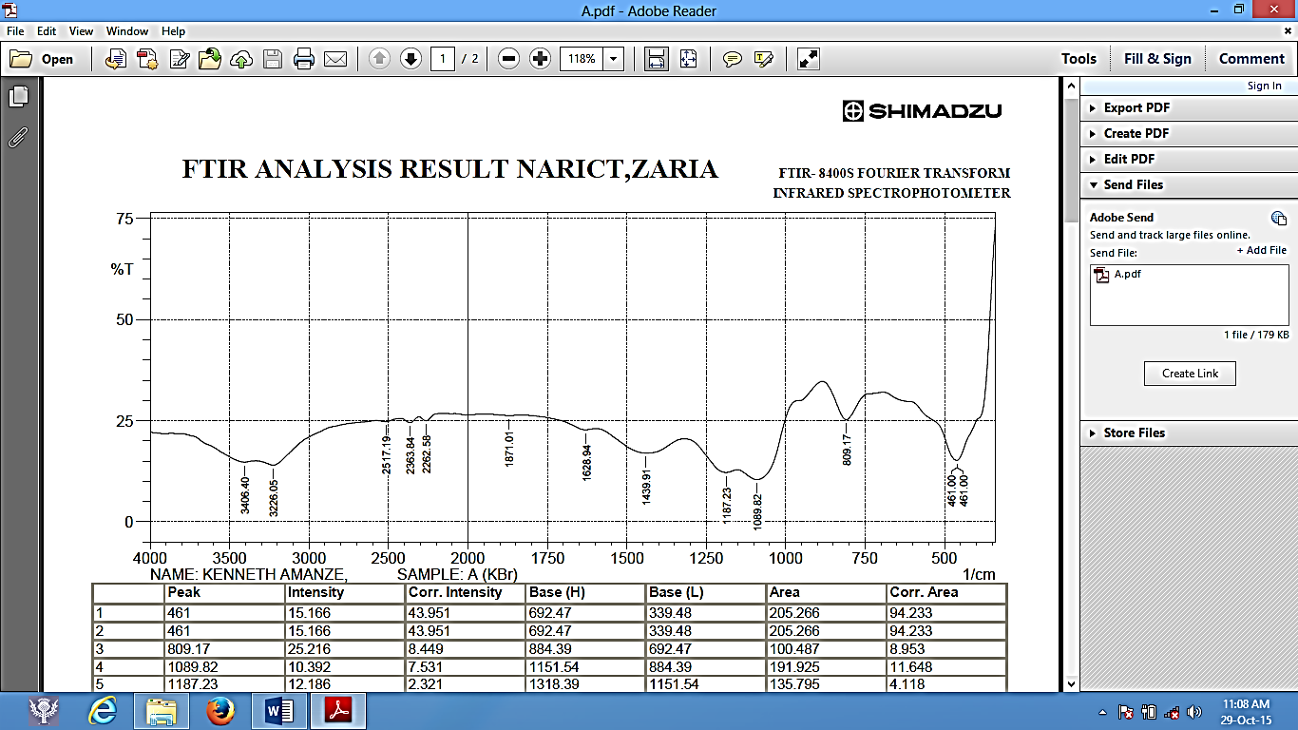1/cm
Figure 1 FTIR Analysis of Pure Silica.
The bonding of Cu(II) ions unto silica is depicted in figure 2.
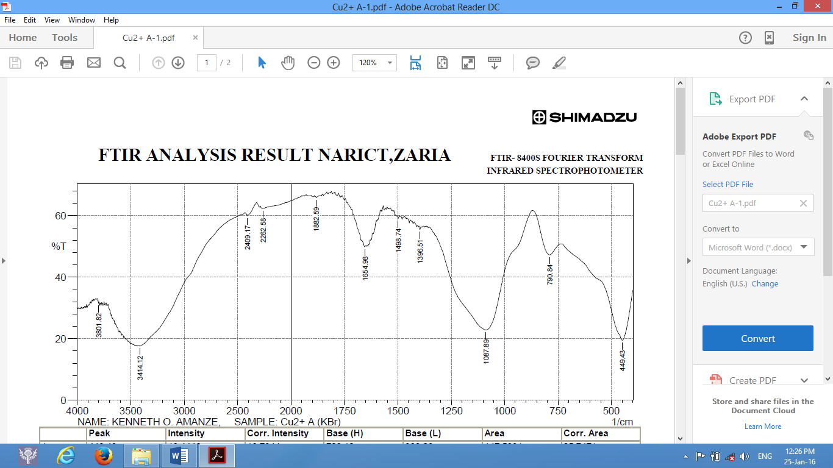1/cm
Figure 2 FTIR Analysis of Copper(II) ions bonded unto pure silica

After adsorption of Cu (II) ions, peak frequencies decreased: 1439 to 1395 cm⁻¹; 1187 to 1087 cm⁻¹ and 461 to 449 cm⁻¹.

Adsorption Kinetics
The results from adsorption is shown in figure 3. Generally, the adsorption increased with increased concentration of the copper(II) ions. At any given concentration, the Cu(II) adsorption quickly rose and then reached the plateau, which is the equilibrium capacity, in 40 minutes.

Figure 3 Variation of amount of Cu (II) ions adsorbed with initial concentration onto pure silica

Three Kinetic Models: Elovich, Pseudo first-order and Pseudo second-order were applied in the analyses. But Pseudo first-order gave a very low correlation coefficient, R², values and was not reported here. The Elovich and Pseudo second-order which gave a fair and very high R² values respectively were reported for the kinetic studies.
The Elovich model is guided by the expression:
dqt/dt = α exp(-βqt) 2
Where α is the initial adsorption rate in mg g⁻¹ min⁻¹ and β is the desorption constant (g mg⁻¹) during the experiment. Chien and Clayton [5] simplified Elovich’s equation by applying the boundary conditions qt = 0 at t = 0 and qt = qt at t = t and equation 2 becomes:
qt = 1/β ln (αβ) + 1/β ln (t) 3
Thus, a plot of qt aqainst ln (t) would give a straight line if adsorption data fit into the model. From the plots, the constants α and β can be determined from the intercept and slope respectively. The Elovich kinetic plot is shown in fiqure 4.

Figure 4 Elovich kinetic model for adsorption of Cu (II) ions unto pure Silica.

The Elovich kinetic data for copper ions adsorption unto pure silica is shown in table 1.

Table 1 Elovich Kinetic data for pure silica
 | α ( mg g⁻¹ min⁻¹) | β ( g mg⁻¹ ) | R²
 | 12.790 | 0.636 | 0.7150
The pseudo second-order reaction is guided by the expression:
t/qt = 1/(k₂q_{e})² + t/q_{e} 4
where q_{e} is the amount of Cu(II) ions adsorbed at equilibrium, qt is the amount of Cu(II) ions on the surface of the silica at time t and k₂ is the rate constant of the pseudo second-order adsorption kinetics. A plot of t/qt against t yields a straight line if the pseudo second-order kinetics is applied. The constants qe and k₂ were determined from the slope and intercept of the plots respectively. The plots are shown in figure 5.

Figure 5 Pseudo second-order kinetics of adsorption of Cu(II) ions onto pure silica.
The kinetic data for the Pseeudo second-order assessment are listed in table 2

Table 2 Pseudo second-order kinetic data of pure silica
 | k₂[g/(min mg)] | q_{e}(mg/g) | R²
 | 0.3200 | 0.1023 | 0.9833

DESORPTION
Results from desorption studies showed that only 24.33 % of the Copper(II) ions were desorbed with the eluting agents: acids, bases and neutral solutions.

DISCUSSION
The results show that the optimum amount of Cu (II) ions adsorbed by pure silica was 91.3 mg/g representing 98.86 % at the optimum pH of 7.0. Thus, silica provides an excellent surface for the attachment of copper (II) ion, as a result of the peak ionization of the functional groups on the silica surface. The fitting of adsorption kinetic data into Pseudo second-order model generally explains that the rate-limiting step of the adsorption typifies chemisorption mechanism. The results from Figures 4 and 5 with Tables 1 and 2 show that there is a good adsorbent-adsorbate interaction at the interface. It therefore suggests a possible exchange of valencies or sharing of electrons between Cu (II) ions and the silica silanol surface leading to a chemical reaction. The low value of the desorption constant, β, from Elovich (equation 2 and Table 1), show that adsorption process is irreversible and further buttressed the earlier prediction that the rate-limiting step of the process is chemical reaction. Desorption reports showed that only 24.33 % of the Cu (II) ions were desorbed with appropriate eluting agents. The experimental results showed that pure silica is a good adsorbent for the removal of Cu (II) ions from aqueous solutions and may possibly be useful for treating industrial waste waters and may be useful in detoxifying our already polluted environment. Saddik et al. (2022) produced maximum adsorption of 100 mg/g for the removal of copper from aqueous medium at pH 6 using functionalized silica base adsorbent. The present work achieved a maximum adsorption capacity of 93.3 mg/g with pure silica at pH 7. Bilgiç et al (2022) used silica and pillar [5] arene adsorbent to obtain maximum adsorption of 79.3651 mg/g for the removal of copper (II) ions at temperature of 328 K. Zhang et al. (2019) obtained maximum values of 35.87 and 48.26 mg/g for copper (II) ion removal with two adsorbents: SBA-15 functionalized with N-propyl-2-pyridylamine and ethylenediaminepropyl-2-pirydylamine respectively at pH 5.0. Humelnicu et al. (2022) obtained maximum adsorption capacity of 172.53 and 52.71 mg/g using silica SBA-15 and titanosilicate ETS-10 adsorbents for the removal of Cu (II) ion from aqueous media at pH 5. Awual (2017) also obtained the maximum adsorption capacity of 183.81 mg/g by using silica conjugate nanomaterial to remove Cu (II) ions from environmental samples. Ahmadpoor et al. (2019) achieved a maximum adsorption of 97.4 % for copper (II) ions and its consequent removal from aqueous medium at pH range of 3-4 with the aid of novel bead of Fe₅C₂@SiO₂ nanoparticles.

REFERENCES

Abuhatab, S., El-Qanni, A., Al-Qalaq, H., Hmoudah, M., & Al-Zerei, W. (2020). Effective adsorptive removal of Zn2+, Cu2+, and Cr3+ heavy metals from aqueous solutions using silica-based embedded with NiO and MgO nanoparticles, Journal of environmental management, 268, 110713.
Adebayo, G.B, Adegoke, H.I & Sidiq, F. (2016). Adsorption of Pb(II) by modified and activated carbon prepared from Daniella oliveri stem bark. Journal of Chemical Society of Nigeria 41(1):19-26.
Ahmadi, M., Kalinin, I., & Tomchuk, V. (2023). Removal of heavy metals using sorbents and biochemical indexes in rats. Ukrainian journal of veterinary sciences, 14 (4): 9-22
Ahmadpoor, F., Shojaosadati, S., & Mousavi, S. (2019). Magnetic silica coated iron carbide/alginate beads: Synthesis and application for adsorption of Cu (II) from aqueous solutions, International journal of biological macromolecules, 128, 941-947.
Awual, M. (2017). New type mesoporous conjugate material for selective optical copper (II) ions monitoring & removal from polluted waters. Chemical Engineering Journal, 307, 85-94.
Bilgiç, A., Cimen, A., Kursunlu, A., Karapınar, H., & Guler, E. (2022). Synthesis, characterization, and application of functionalized pillar[5]arene silica gel (Si-APTMS-pillar[5]arene) adsorbent for selectivity and effective removal of Cu(II) ion. Journal of Materials Research, 37, 3587-3598.
Chien, S.H. & Clayton, W.R (1980). Application of Elovich equation to the kinetics of phosphate release and sorption on soils. Soil Science Society American Journal 44:265-268.
Eddy, N.O. & Odoemelam,S.A. (2009). Modelling of the adsorption of Zn2+ from aqueous solution by modified and unmodified tiger nut shell. African Journal of Pure and Applied Chemistry Vol. 3 (8), pp 145-151.
Elgarahy, A., Elwakeel, K., Mohammad, S., & El-Shoubaky, G. (2021). A critical review of biosorption of dyes, heavy metals and metalloids from wastewater as an efficient and green process, 4, 100209.
Humelnicu, D., Zinicovscaia, I., Humelnicu, I., Ignat, M., Yushin, N., & Grozdov, D. (2022). Study on the SBA-15 Silica and ETS-10 Titanosilicate as Efficient Adsorbents for Cu(II) Removal from Aqueous Solution. Water, 14 (6), 857
Humelnicu, D., Zinicovscaia, I., Humelnicu, I., Ignat, M., Yushin, N., & Grozdov, D. (2022). Study on the SBA-15 Silica and ETS-10 Titanosilicate as Efficient Adsorbents for Cu(II) Removal from Aqueous Solution. Water, 14 (6): 857
J., Qin, G., Zhang, Y., Sun, J., Wang, S., & Jiang, L. (2018). Heavy metal removal from aqueous solutions by calcium silicate powder from waste coal fly-ash. Journal of Cleaner Production, 182, 776-782.
Kanungo, S., Gupta, N., Rawat, R., Jain, B., Solanki, A., Panday, A., Das, P., & Ganguly, S. (2023). Doped Carbon Quantum Dots Reinforced Hydrogels for Sustained Delivery of Molecular Cargo. Journal of Functional Biomaterials, 14 (3), 166
Kukwa, R., Kukwa, D., Oklo, A., Ligom, T., Ishwah, B., & Omenka, J. (2020). Adsorption Studies of Silica Adsorbent Using Rice Husk as a Base Material for Metal Ions Removal from Aqueous Solution. Journal of Chemical Engineering, 8 (2), 48-53.
Mahatmanti, F., Kusumastuti, E., Rengga, W., , N., & Siswanta, D. (2021). Chitosan-silica- polyethylene Glycol (Ch/Si/P) Solid Membrane for Removal of Cu(II), Zn(II) and Cd(II) Ions from Aqueous Solutions. Challenges and Advances in Chemical Science, 1, 54- and 5 .5 for Cd (II) ions.72
Odoemelam, S.A., Onyeije U.C. & Eddy N.O. (2012). Adsorption study on the removal of As³⁺ from aqueous solution using modified and unmodified pawpaw stem. Book of proceedings annual international conference, workshop and exhibition, Chemical Society of Nigeria (CSN) 2:227-231.
Onojake, M.C., Iwuoha, G. & Osakwe, J.O. (2015). Banana peel as low cost adsorbent for the removal Ni (II), Cu (II) and Fe (II) from industrial effluents. Journal of Chemical Society of Nigeria, 40 (2):59-62.
Qin, Y., Jiang, H., Luo, Z., Geng, W., & Zhu, J. (2024). Preparation and Performance Study of Boron Adsorbent from Plasma-Grafted Polypropylene Melt-Blown Fibers. Polymers, 16 (11), 1460.
Saddik, R., Hammoudan, I., Tighadouini, S., Roby, O., Radi, S., Al-Zaben, M., Bacha, A., Masand, V., & Almarhoon, Z. (2022). Mesoporous Silica Modified with 2-Phenylimidazo[1,2-a] pyridine-3-carbaldehyde as an Effective Adsorbent for Cu(II) from Aqueous Solutions: A Combined Experimental and Theoretical Study. Molecules, 27 (16), 5168
Simón, D., Palet, C., Costas, A., & Cristóbal, A. (2022). Agro-Industrial Waste as Potential Heavy Metal Adsorbents and Subsequent Safe Disposal of Spent Adsorbents. Water, 14(20): 3298
Wu, K., Wang, B., Tang, B., Luan, L., Xu, W., Zhang, B., & Niu, Y. (2021). Adsorption of aqueous Cu (II) and Ag(I) by silica anchored Schiff base decorated polyamidoamine dendrimers: Behavior and mechanism. Chinese Chemical Letters, 33 (5): 2721-2725
Yu, N., Jiang, H., Luo, Z., Geng, W., & Zhu, J. (2023). Boron Adsorption Using NMDG-Modified Polypropylene Melt-Blown Fibers Induced by Ultraviolet Grafting. Polymers, 15 (10), 2252
Zafar, S., Khan, M., Lashari, M., Khraisheh, M., Almomani, F., Mirza, M., & Khalid, N. (2020). Removal of copper ions from aqueous solution using NaOH-treated rice husk. Emergent Materials, 3, 857 - 870.
Zhang, Y., Cao, X., Sun, J., Wu, G., Wang, J., & Zhang, D. (2019). Synthesis of pyridyl Schiff base functionalized SBA-15 mesoporous silica for the removal of Cu(II) and Pb(II) from aqueous solution. Journal of Sol-Gel Science and Technology, 94, 658-670.
Zhang, Y., Cao, X., Wu, G., Wang, J., & Zhang, T. (2020). Quaternized salicylaldehyde Schiff base modified mesoporous silica for efficiently sensing Cu(II) ions and their removal from aqueous solution. Applied Surface Science, 527, 146803.

