Spatiotemporal LULC Dynamics in the Upper Ghod Basin Using RS-GIS

ABSTRACT

|  |
| --- |
| The land use is nothing but the utilization of the land for various purposes and land cover refers to biological and physical materials on the earth’s surface. The land use and land cover is very essential for better understanding of landscape dynamics during a known period having sustainable management. Land Use / Land Cover (LULC) maps describe the vegetation, water and natural features on the land surface. Land Use/Land Cover (LULC) maps are crucial for understanding and managing human and environmental impacts on landscapes, particularly in agriculture, urban development as well as in climate change. It provides a baseline for monitoring change, facilitates resource management and planning and support sustainable development. The present study was undertaken for the Upper Ghod river basin, in Pune district, Maharashtra, India with the objectives of preparing of Land Use / Land Cover (LULC) map and changes in LULC dynamics using remote sensing and GIS. The geographical area of the region under study is 4054.5 km2, which is located in semi- arid region of Maharashtra.  The LULC were generated using QGIS software for different classes, which were prepared using LISS-III images for the year 2008 and 2018 with supervised image classification (Maximum likelihood classifier). The six land use classes, viz. agricultural, settlement, waste land, water body, open scrub and forest were generated. The study revealed that the area under wasteland decreased by 15 % in the span of 10 years. The change in settlement and agriculture is detected to be increased by 143.51% and 3.78% respectively, whereas the area in water bodies was increased by 9.11%. In addition, the area under forest canopy was reduced in the protected regions by 19.45 %. The open scrub is reduced by 22.56 % in the span of one decade. Institutional factors that improved access to water resources were the major drivers of change, especially in the context of agriculture. The study demonstrates the use of satellite remote sensing techniques for monitoring LULC, for predicting the future land use changes and aids in planning adaptation strategies for sustainable development. |

*Keywords:* Remote sensing, GIS, Land use, Land cover, Change detection.

1. INTRODUCTION

Land, as a finite resource, undergoes constant changes due to processes like rapid urbanization, evolving agricultural practices, and growing environmental concerns. These changes significantly impact the socio-economic fabric and the carrying capacity of ecosystems. The complete information on the spatial distribution of the land use/land cover categories the pattern of their change is a requisite for orchestrating, utilizing and management of the land resources of the country. Land Use / Land Cover (LULC) maps describe the vegetation, water and natural features on the land surface. Land use and land cover maps serve as powerful tools for visualizing LULC changes. Although the terms land cover and land use are often used interchangeably, their actual meanings are quite distinct. Land use is defined by the practices and modifications people undertake on certain land cover types, including the necessary inputs, to facilitate production and maintain transformations (Masayi *et al*., 2020). Land use refers to how humans utilize the land for various purposes, comprising economic and cultural activities like agricultural, industrial, urban development, mining and recreation etc., whereas land cover refers to the physical and biological material present on the Earth's surface. It includes both natural elements like forests, grasslands, water bodies, deserts, and wetlands, as well as human-made features such as urban areas, roads, and agricultural fields. Land cover refers to the surface cover on the ground, whether vegetation, water bodies, urban infrastructure, forest, fallow land or other. Identification of land cover establishes the baseline from which monitoring activities like change detection can be performed and provides the ground cover information for baseline thematic maps.  In general, land cover means what's physically present on the land, while land use describes how that land is used. Urbanization profoundly impacts environmental change, especially in developing countries.

Remote sensing is the science and art of obtaining information about an object, area or phenomenon through the analysis of data acquired by a device that is not in contact with object, area, or phenomenon under investigation, (Lillesand and Kiefer, 2008). Remote sensing is also defined as gathering information about the Earth's surface from a distance without making direct physical contact (Eamus *et al*., 2015). It provides a large variety and amount of data about the Earth's surface for detailed analysis and change detection with the help of various spaceborne and airborne sensors. Remote sensing is used as an effective tool to keep track of land changes (Wirawan and Chernovita, 2023). A Geographic Information System (GIS) is a system designed to operate, store, capture, examine and present spatial or geographic data. The remote sensing and GIS integrated together yields better mapping and monitoring of natural resources.

Change detection is the process of identifying differences in the state of an object or phenomenon by observing it at different time period (Singh, 1989). The change detection using remote sensing and GIS is a powerful method of monitoring and analyzing changes on the Earth’s surface over time. To monitor land changes, remote sensing is used as an effective tool (Samuel and Hanna, 2023). Timely and accurate change detection of Earth's surface features provides the foundation for better understanding relationships and interactions between human and natural phenomena to better manage and use resources. (Lu *et al*., 2004). By leveraging advanced technologies and methodologies, we can gain valuable insights into environmental changes for policy decisions and sustainable development. To detect land use and land cover change, a comparison of two or more satellite images acquired at different times can be used to evaluate the temporal or spectral reflectance differences that have occurred between them (Yesmin *et al*., 2014). Considering the climatic and topographic condition of upper Ghod river basin with advancement of geospatial technique the present study was planned for LULC change detection using remote sensing and GIS.

2. material and methods

**2.1The study area**

The present research study was undertaken for upper Ghod river basin which is located in Ambegoan, Junner, Shirur tehsil in Pune district, Maharashtra. The Ghod River is a tributary of Bhima River. The river originates at Aupe village, in western ghat at 1029 meters above msl. The study area lies between 18⁰ 37' 40'' to 19⁰ 13' 44'' N latitude and 73⁰ 29' 31'' to 74⁰ 31' 40'' E longitude. The present study area is considered from the origin of the river to the confluence with Kukadi River which is having length of 126 km from origin to confluence. The Kukadi River is one of the tributaries of the Ghod. The study area receives rainfall around 300 mm and it decreases progressively towards the east to around 500 mm. The upper reaches receives more rainfall but most of it lost as runoff. The upper reaches of the basin are dominated by paddy cultivation and vegetables like tomato, potato, onion and flowers and food grains such as wheat, gram, sugarcane, jowar are grown in the middle and lower reaches of the basin. The Ghod River basin exemplifies the intricate balance between natural resources, cultural heritage, and the needs of a growing population. The location map of the study area is depicted in Figure 1.

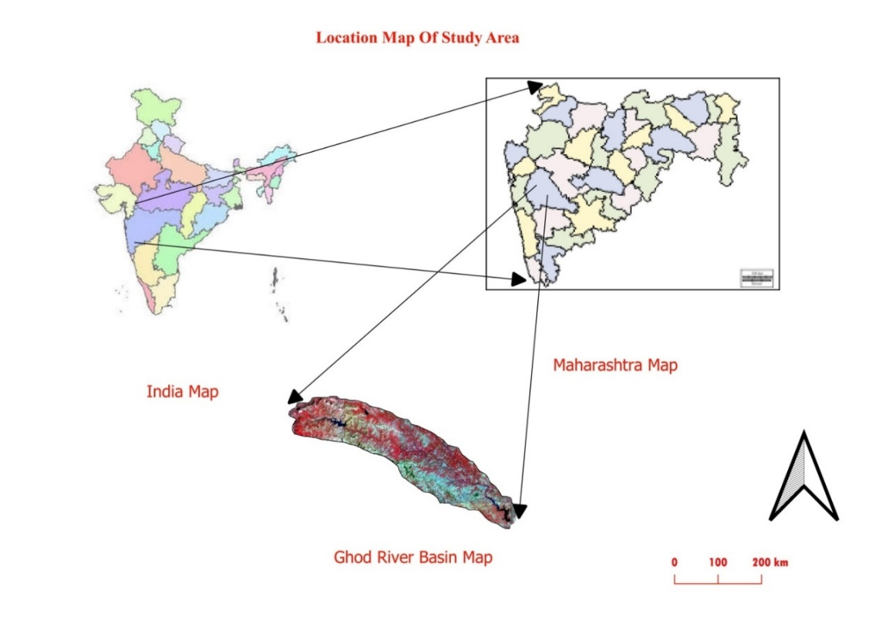

**Figure 1:** Location map of study area

**2.2 Data used:** The freely available LISS-III (spatial resolution 23.5 m) data were downloaded from Bhuvan portal and processed in GIS environment using QGIS and ArcGIS software for years 2008 and 2018. The standard FCC image for the year 2008 and 2018 is shown in Figure 2.

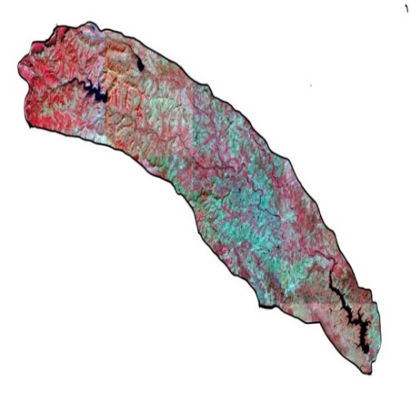 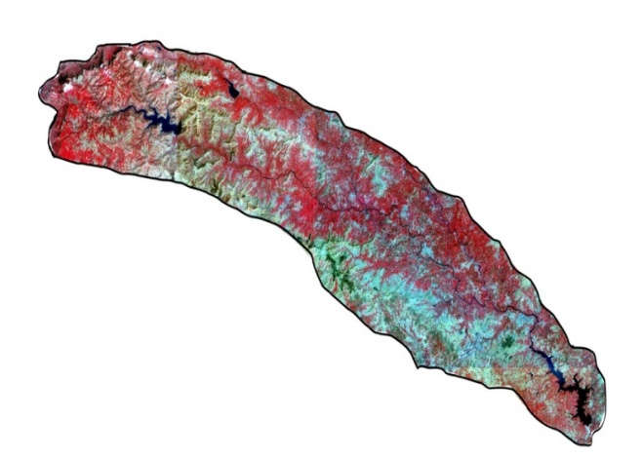

Fig. 2 (a): LISS-III image for year 2008. Fig. 2(b): LISS-III image for year 20018.

**2.3 Land Use and Land Cover:**

The image processing and digital image classification technique was adopted to prepare land use and land cover map (Singh *et al*., 2010). Land cover refers to the biological and physical materials on the Earth’s surface (Herold *et al*. [2006](https://link.springer.com/article/10.1007/s10346-022-02020-4#ref-CR44)). It comprises natural elements, such as water bodies, forests, exposed rock or soil, and surfaces modified by humans, such as roads, buildings, and agriculture. The Standard False Color Composite (FCC) was used for mapping LULC for the years 2008 and 2018. The different land use/land cover classes with their details viz. Agricultural land, Forest land, settlement, forest land, water body, agricultural land, open scrub etc. shown in Table 1. The classification scheme (Anderson *et al*., 1971) developed gives a rather broad classification where the land use/land cover was identified by a single digit. In the digital image supervised classification technique, images from 2008 and 2018 were independently classified. A supervised classification method was carried out using signature training sets for each class. The Maximum Likelihood Algorithm was employed to detect the land cover types. The area under different land use and land covers is given in Table 2.

**Table No.1:** Details of land use / land cover classes

|  |  |  |
| --- | --- | --- |
| **Sr. No.** | **Class** | **Details** |
| **1** | Agricultural Land | Crop Fields, cultivated land |
| **2** | Forest Land | Land that is mainly covered by forest |
| **3** | Settlement | Settlement including residential; Concrete made structure |
| **4** | Waste Land | Land without scrub, Sandy area, Dry grasses, rocky areas, etc. |
| **5** | Water Body | Ponds Lake, Canal, Dams, River, etc. |
| **6** | Open Scrub | Field without crops |

**2.4 Change detection:**

Land use and land cover change detection plays a pivotal role in understanding the intricate relationship between human activities and the natural environment, offering insights into the dynamics of our planet's surface (Chughtai *et al*., 2021). Change detection, is a pivotal application of remote sensing technology, involving identifying and analyzing alterations in land surface features over time, which provides valuable insights into environmental dynamics, urban expansion and management practices. Change detection analysis encompasses a broad range of methods used to identify, describe and quantity differences between images of the same scene at different times or under different conditions many of the tools can be used independently or in combination as part of a change detection analysis. Land use and land cover change is a critical indicator of alterations to the Earth's terrestrial surface, predominantly driven by human activities (Ayenikafo and Wang, 2021).

The changes in different LULC classes were calculated and analyzed for the year 2008 and 2018. The change detection statistics refer to the quantitative method used to identify and measure changes in data over time, commonly in time series, images or spatial data. The percentage of LULC change (trend) for individual LULC classes was calculated using the following formula (Kindu *et al*., 2013 and Mulatu *et al*., 2024)

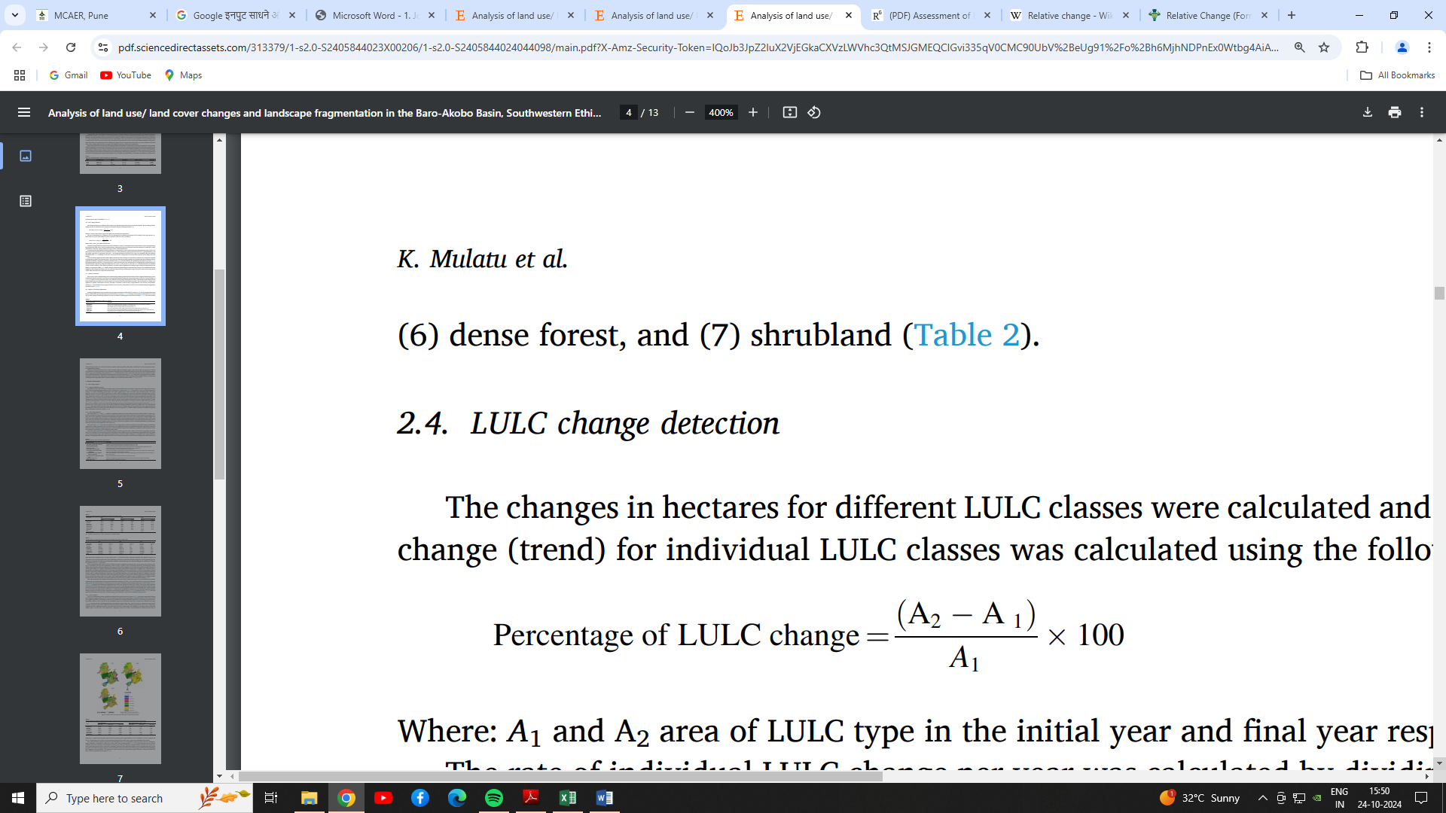

Where: A1 and A2 areas of LULC type in the initial year (2008) and final year (2018) respectively. The rate of individual LULC change per year was calculated by dividing the percentage of LULC change by the time interval, i.e., 2008 to 2018 (10 years) by using the following equation,

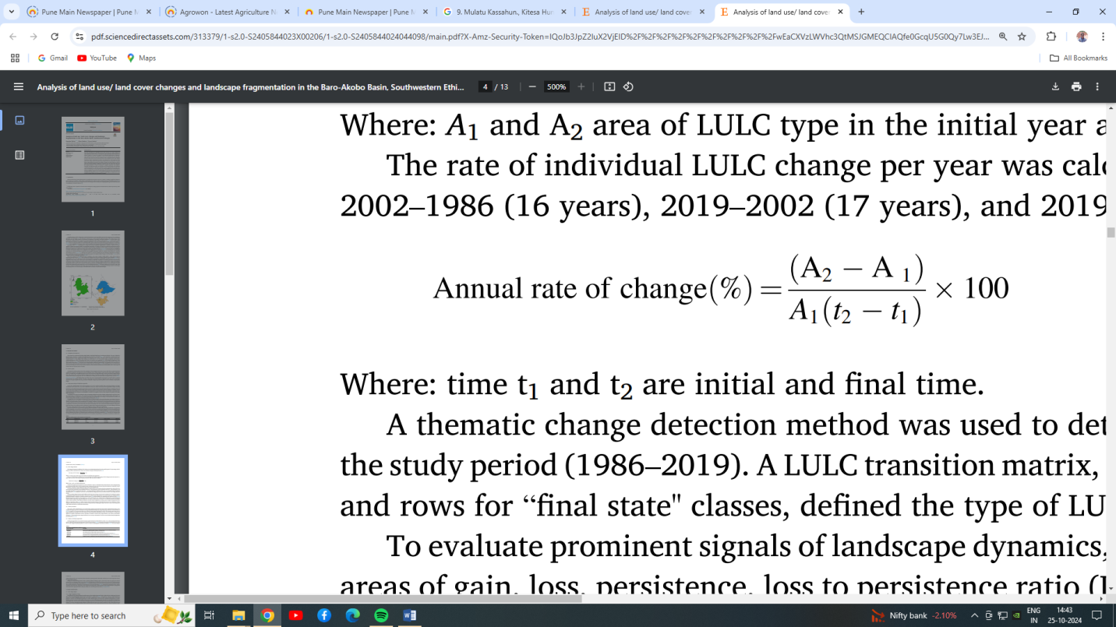

Where: time t1 and t2 are the initial and final time.

The general methodology adopted for the preparation of LULC and change detection in the upper Ghod river basin is given in Fig.3.

3. results and discussion

Change detection is the process of identifying differences in the state of an object or phenomenon by observing it at different times (Singh, 1989). A post-classification change detection method was applied. The upper Ghod river basin was classified into six LULC classes using a supervised image classification technique. The LULC map for years 2008 and 2018 is presented in Figure 4(a) and Figure 4(b). The land use land cover map shows the spatial and temporal variation in the area. The finding reveals that there were drastic and rapid increases in the built-up area and decreases in agricultural area.

LISS III (2008 and 2018) data from Bhuvan portal

Mosaic Operation

Change detection of year 2008 and 2018

Analysis of result and map preparation

LULC map for year 2008 and 2018

Supervised image classification

Extraction of Data

Layer stacking of image

Digital image enhancement

**Fig.3:** Methodology for LULC change detection in upper Ghod river basin

The analysis of spatial changes indicates that agriculture land increases from 37.79 % to 39.22 % during the years 2008 and 2018. The expansion of crop area appears mainly along Ghod river course. Considerable percentage of fallow land has also then converted to agricultural land. The influence of the Ghod dam results into increase in availability of irrigation which is the main reason for changing scenario. The forest is decreased from 29.91 % to 24.09 % in the ten years between 2008 and 2018. Overall results of forest cover shows that there is also decrease in forest cover. The settlement is increased from 5.63 % to 13.71 % in a decade as a consequence of natural increase in population, heavy influx of migration from rural to urban areas, demand for settlements. With the increasing facilities it is expected to increase the settlement area in the forthcoming years. The decrease in waste land use category from 0.60 % to 0.51 %. During these years it results of increased irrigation facilities of the area. Previously unused lands have been converted to crop lands and it will not be surprising to predict that it is merely the question of time before they completely disappear from the scene. The open scrub has been decreased from 22.56 % to 18.64 % during 10 year period of 2008 to 2018. Increase in settlement is the main reason of change. The water body has been increased from 3.51 % to 3.83 % in 2008 and 2018.

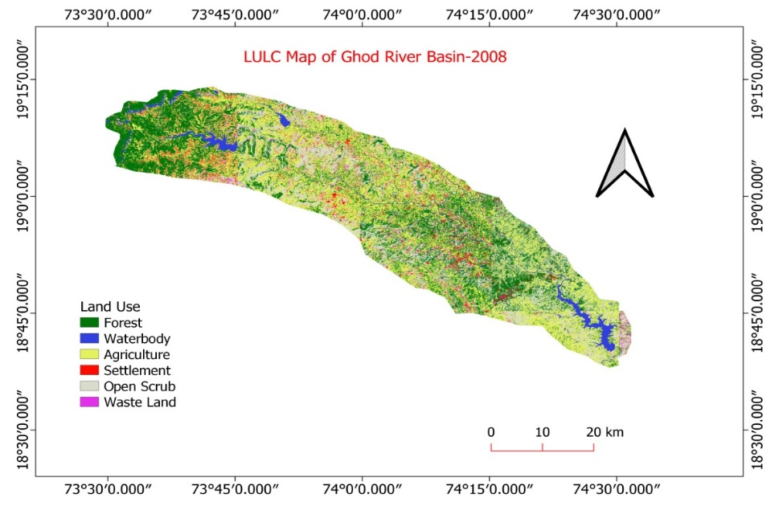

**Figure 4-**LULC Map of the Ghod River basin- 2008

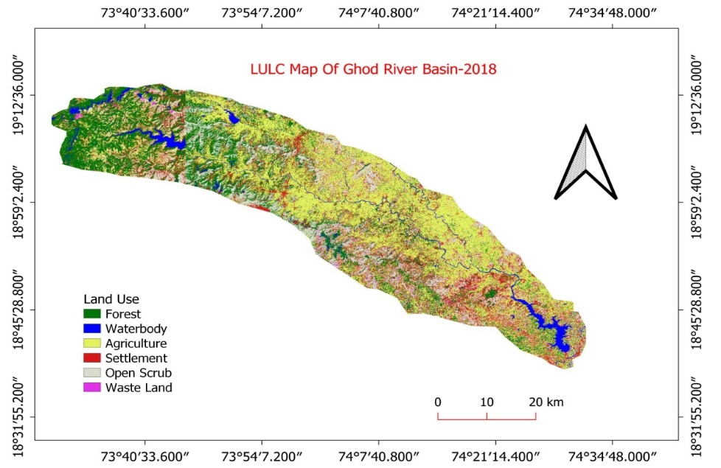

**Figure 5-**LULC Map of the Ghod River basin- 2018

The land use land cover area calculated from the LISS-III image is tabulated in terms of km2, % area and % change and annual rate of change % in Table 2.

**Table No.2:** LULC area (km2), % area, % change for year 2008 and 2018

|  |  |  |  |  |  |  |  |
| --- | --- | --- | --- | --- | --- | --- | --- |
| **Sr. No.** | **LULC class** | **2008** | | **2018** | | **Total Change%** | Average Annual rate of change (%) |
|  |  | **Area (km2)** | **Area (%)** | **Area (km2)** | **Area (%)** |
| 1. | Agriculture | 1532.176 | 37.79 | 1590.052 | 39.22 | **+3.78** | **0.38** |
| 2 | Forest land | 1212.644 | 29.91 | 976.750 | 24.09 | **-19.45** | **-1.95** |
| 3 | Open scrub | 914.566 | 22.56 | 755.690 | 18.64 | **-17.37** | **-1.74** |
| 4 | Settlement | 228.660 | 5.63 | 555.941 | 13.71 | **+143.51** | **14.35** |
| 5 | Water body | 142.90 | 3.51 | 155.241 | 3.83 | **+9.11** | **0.91** |
| 6 | Waste land | 24.289 | 0.60 | 20.850 | 0.51 | **-15** | **-1.50** |
|  | **Total area** | **4054.527** | **100** | **4054.527** | **100** |  |  |

The percentage area of each land use class for years 2008 and 2018 is also depicted in Figure 6.

**Figure 6-** Change detection of year 2008 and 2018

**3.1 Driving force:** Land use/land cover can change due to natural or human factors. Natural factors such as flooding, drought and volcanic eruption etc., result in a change of land use/land cover. Human factors such as demographic pressure, level of poverty and the economic and institutional structures of resource use may be some of the indirect causes of land use/land cover change. Moreover, with an increase in population and economic growth, human activities have occupied more land (Mather, 1986). Changes in the way which people live their lives may change the function of the land, and the human factors, such as population and their activities, may be the driving forces in changes in land use and cover. Robinson (1979) argued that the initial driving forces to be considered are population, income, technology and price.

The present study reveals that the agricultural land in 2008 was 37.79 %, which increased to 39.22 % in 2018. The area under settlement in 2008 was 5.63 % was increased up to 13.71 % of the total area. Whereas area under wasteland in 2008 was found to be 0.60 % was decreased upto 0.51 % in 2018. The 29.91 % area under forest land in 2008 was reduced to 24.09 % in 2018. The area under the water body in 2008 was 3.51 % of total study area and was about 3.83 % in 2018. The area under open scrub in 2008 was 22.56 % of total study area and was 18.64 % in 2018.

The LULC classes agriculture land, settlement and water body have increased over a decade, with the agriculture area increasing to 3.78 % from 2008 to 2018. While forest, witnessed a drastic decrease up to 15 % over the period of 10 years. The major changes have occurred in settlement, which shows a continuous increase i.e. 5.63% in 2008 to 13.71 % and at the same time, forest showed a decrease in area (29.91% in 2008 to 24.09% in 2018). The study further reveals that major land use change in the study area is in settlement. It has increased by 143.51 % due to an increase in population, influx migration from rural to urban areas and demand for settlements. The second major category of land use change in the study area is water bodies, which increased by 9.11 %. The agriculture has increased by 3.78 % due to an increase in irrigation facilities. The area under the fourth category of the land i.e. forest, decreased by 19.45 %. Waste land is decreasing, agricultural lands are increasing. All these results infer and establish the apprehensions of the locals that the area is turning more into a settlement and agricultural land. Frequent high-frequency rains and lack of proper soil conservation structure lead to degradation of soil. It can also be inferred from the results that it is not always a human factor which is responsible for the degradation of soil.

4. Conclusion

* The LULC map prepared for the upper Ghod river basin shows that major Land Use / Land Cover category is agriculture for the years 2008 (37.79 %) and 2018 (39.22%)
* The change detection for the years 2008 and 2018 shows that there is a major 143.51 % increase in settlement and a decrease in forest of about 19.45 % of the total geographical area of the basin.
* Remote sensing and GIS can be potential tools for monitoring the further degradation of natural resources of the basin and for aiding land use policy options.
* The results also further show that waste land converted into agricultural land, which is of good significance for the changes in land use classes. Such a type of study is helpful for monitoring land use changes in the basin.

References

1. Ali Hassan Chughtai, Habibullah Abbasi and Ismail Rakip Karas (2021).A review on change detection method and accuracy assessment for land use land cover. [Remote Sensing Applications: Society and Environment](https://www.sciencedirect.com/journal/remote-sensing-applications-society-and-environment).22.100482. 1-13.
2. Anderson J. R., (1771). Land use classification schemes used in selected recent geographic applications of remote sensing. 37 (4): 379-387.
3. Ayenikafo O. M. and Wang, Y. F. (2021). Land Use/Land Cover changes analysis In Sudano Guinean region of Benin. Applied Ecology and Environmental Research. 19(1):715-726.
4. Eamus D, Huete A and Yu Q. (2015) An Overview of Remote Sensing. In: *Vegetation Dynamics: A Synthesis of Plant Ecophysiology, Remote Sensing and Modelling*. Cambridge University Press; 2016:155-166.
5. Herold M, Latham J.S., Di Gregorio A, and Schmullius C.C. (2006) Evolving standards in land cover characterization. Journal of Land Use Sciences.1:157–168.  <https://doi.org/10.1080/17474230601079316>.
6. Kindu M., T. Schneider, D. Teketay, T. Knoke (2013). Land use/land cover change analysis using Object-based classification approach in Munessa-Shashemene landscape of the Ethiopian highlands. Remote Sensing, 5: pp. 2411-2435
7. Lillesand T. M. and R. W. Kiefer, (2008). Remote Sensing and Image Interpretation, textbook of Jain Wiley and Sons, Asia Private Limited Singapore 6th edition.
8. Lu. D. P. Mausel, E. Brondizio and E. Moran (2004). Change detection techniques. International Journal of Remote Sensing.25 (12): 2365-2407.
9. Masayi, N., Mugatsia T. and Paul O. (2020). Land Use Changes and Impacts on Livelihoods of the Communities Adjacent to Mt Elgon Forest Ecosystem. *Journal of Geography, Environment and Earth Science International* 24(7):1-12. <https://doi.org/10.9734/jgeesi/2020/v24i730239>.
10. Mather A. S., (1986). Land use. Longman, New York: 286.
11. Mulatu Kassahun., Kitesa Hundera, and Feyera Senbeta (2024).Analysis of land use/ land cover changes and landscape fragmentation in the Baro-Akobo Basin, Southwestern Ethiopia. Heliyon. [10(7)](https://www.sciencedirect.com/journal/heliyon/vol/10/issue/7). 1:13.
12. Robinson C. J., (1979). A critical review of the change detection and urban classification literature, Computer Sciences Corporation, Silver Spring, MD.
13. Samuel Tommy Cadalora Wirawan and Hanna Pryllisca Chernovita (2023). Analysis of Vegetation Changes Using Satellite Imagery and Normalized Difference Vegetation Index (NDVI): A Case Study in Tuntang District, Semarang District. Journal of Information Systems and Informatics. 5 (4): 1809-1820.
14. Singh A., (1989). Digital Change detection techniques using remotely-sensed data. International Journal of Remote Sensing*.* 10 6): 989-1003.
15. Tanaka A. Mbendana, Anesu D. Gumbo, Simbarashe Jombo, Ephias Mugari, Evison Kapangaziwiri (2025). Application of change detection techniques driven by expert opinions for small-area studies in developing countries. [Scientific African](https://www.sciencedirect.com/journal/scientific-african).vo.27. 1-13
16. Yesmin R, A S M Mohiuddin, M J Uddin and M A Shahid (2014).Land use and land cover change detection at Mirzapur Union of Gazipur District of Bangladesh using remote sensing and GIS technology. IOP Conf. Ser.: Earth Environ. Sci. **20** 012055 **DOI** 10.1088/1755-1315/20/1/012055