***Short ~~c~~Communication***

**The First report of Gold Mineralisation ~~at~~ in the Bansiyal area, Sikar District, Rajasthan: An IOCG Earth System of Mineralisation**

Abstract

The Khetri Copper Belt is known for copper mineralisation in Rajasthan. The North Khetri is specifically rich in copper mineralisation while the south Khetri belt is marked with the small isolated deposits of copper with sharing nearly similar depositional and lithotectonic environment. One such location is at Bansiyal in the Sikar District, Rajasthan, where copper mineralisation is known from as early as 1994 and hosted within the Ajabgarh metasediments of Delhi ~~s~~Supergroup of rocks. We report here the occurrence of gold for the first time from the area to the tune of 74ppb, which is 7 times higher than the threshold required for (which is 10ppb, as a convention) exploration. The Gold occurrence here is associated with copper and ~~I~~iron. The Cu values up to 1.3% and Fe2O3 up to 52% ~~certainly~~ indicate~~s~~ enrichment of these elements. Other trace elements like Cr, V and Sc have also slight enrichment indicating towards the possibility of this mineralisation being an IOCG earth system of mineralisation.

**Keywords:** Iron Oxide Copper Gold (IOCG), Hydrothermal Minerali~~z~~sation, Bansiyal, Ajabgarh rocks,Gold minerali~~z~~sation.

**Introduction**

The state of Rajasthan is blessed by Mother Nature with enormous mineral wealth. The state has 100% of Lead-Zinc production of India along with Silver and ~~also~~ has a lion’s share in Copper production in India~~.~~(43%,. IBM yearbook 2022) There are quite a few ~~N~~new copper fields have come up in Rajasthan in recent years, Including ~~T~~the Neem ka Thana copper belt where low-grade copper ore of the order of 150 MT has been proved by GSI. Besides there are other areas like Mundiyawas Khera block ~~in~~ in the Alwar district of Rajasthan. Kamalpura in the Bhilwara district, is also one of them. and ~~T~~there are many more small deposits ~~but which are out of present context~~. Besides these ~~K~~known and established copper deposits, mineralisation is reported from number of places from North and ~~s~~South Khetri belt. The North Khetri is an old known copper deposit, which is the synonym of copper in Rajasthan. The ~~s~~South Khetri belt also has many occurrences with small amounts of resources proved~~.~~, ~~I~~including Bokri-M~~m~~alwali, Tunda, Makri (Srivastava et al., 1972,~~,~~Sharma, B.1976, Sharma, A.K., 1998~~,~~) etc. One such location is the Bansiyal area, located in the ~~s~~Survey of India toposheet ~~N~~number 45M/13 and lies very close to the Bokari – Malwali - Makri~~,~~ copper prospects offering an obvious possibility of mineralisation because it shares similar Litho-tectonic setup with these known copper prospects.

The Geological Survey of India (GSI) carried out work in this area during three different stages and has reported copper mineralisation on the surface and ~~also~~ reported occurrence of old workings. “Operation Hard rock” (1967-68) AEM anomalies were reported in the area. Misra and Rao (1994) carried out detailed mapping and geochemical sampling in the Bansiyal southwest block and have traced minerali~~z~~sed zone that hosts in the contact of dolomite and meta-basic sills, up to 800m in strike length and recorded twenty-five numbers of old workings and malachite staining in the zone. Singh and Karunakaran (2016-17) carried out detailed mapping in the area and reported Copper anomaly up to 1Km strike length with values of copper ranging from 0.2% to as high as 1.3% ~~Cu~~.

With the above background, fieldwork was carried out by geologist’s team from Vardan Environet LLP, Gurgaon in the area. It was observed that the area exposes meta-sedimentary sequence of Ajabgarh Group of rocks including tremolite marble/~~A~~amphibole marble, dolomite, ~~Q~~quartzite and quartz-mica schist, biotite schist and intercalated ironstone or ~~H~~hematite quartzite and magnetite quartzite. The contact between amphibole marble, quartz-mica schist and micaceous quartzite, is marked with the series of old workings. The stringers of chalcopyrite and pyrite minerali~~z~~sation are observed during the field work in the marble and micaceous quartzite, besides the roof and walls of these small old workings. These Ajabgarh meta-sediments belong to the North Delhi fold belt and are intensely deformed. There are evidences of three phases of deformation recorded in the rocks of the area specially the calcareous litho-units display it more profusely. There ~~are~~is map scale boudinages of quartzite present in the area resulting due to interference of first and second deformation. There is ~~E~~evidence~~s~~ of shearing marked by occurrence of sigmoidal quartz grains on the S2 surface in quartzite; besides grain rotation present in the thin intra-formational gritty layers are recorded (Fig. 2A). There are some suspected eyed folds also displayed in calcareous rocks but a caution is needed due to plastic nature of the dolomite and marble.

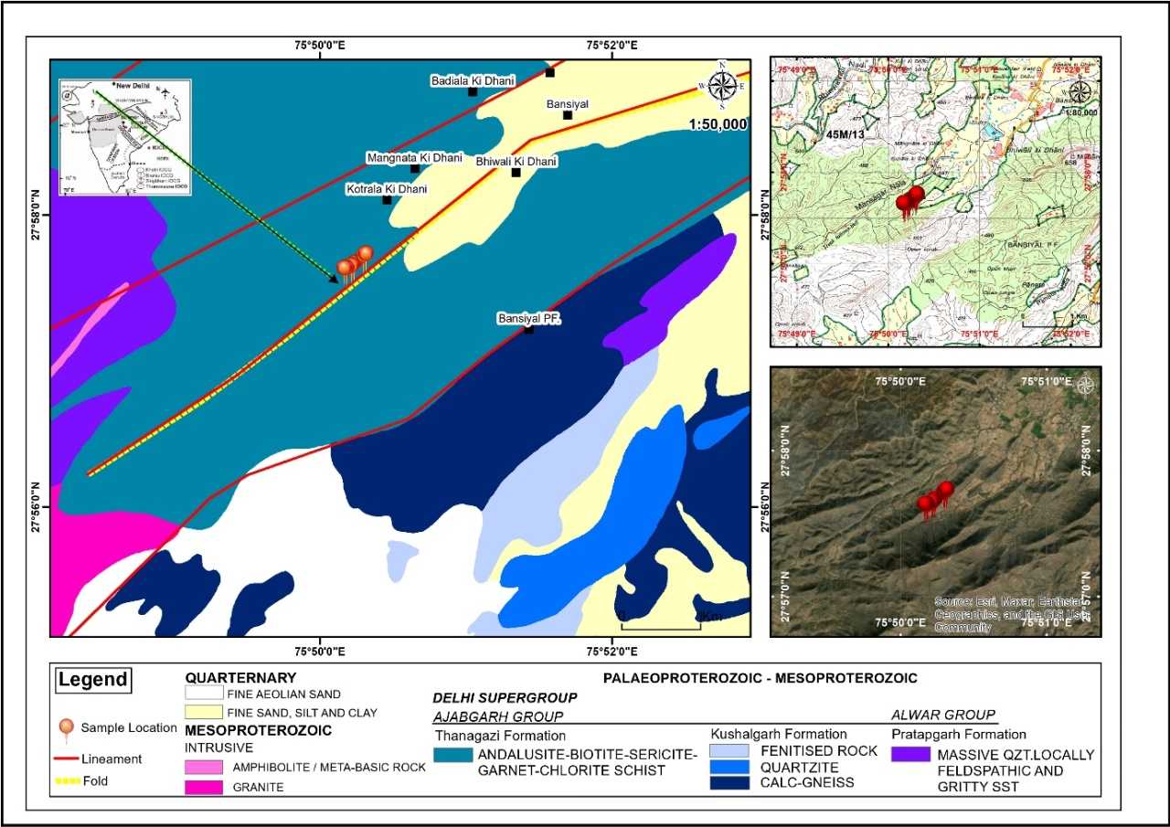

Fig. 1: Location of Samples on the Geological Map of Study Area~~,~~ (Source-NGDR Portal, MoM, Govt. of India), On SOI Toposheet and Google map. (Pl. cite ‘Fig. 1’ in the text)

The mineralisation is indicated on the surface by presence of slag spreads in the area, profuse malachite staining present along the walls of the old workings curiously along the tail portions of the lensoid bodies of the quartzite suggesting it to be structurally controlled. Along the tail portion of the map scale boudinages, profuse quartz venation has taken place, and these quartz veins contain thick encrustations of malachite along the exposed walls of the old workings (Fig. 2D)~~.~~, ~~B~~besides containing pyrite and chalcopyrite grains disseminated within these veins. The area also exposes lensoidal bodies of hematite along with some magnetite intercalated with quartzite and dolomite/ amphibole marble. The samples collected from the area analysed significant copper values up to 0.8% Cu. **The presence of Gold, (up to 75 ppb~~,~~ (table-4) against the 10-ppb benchmark for further exploration) which is being reported for the first time from the area, seems to have been missed out by earlier workers. Yet another significant finding is Fe2O3 up to 52 % (Table 3) within the hematite quartzite lenses sandwiched between these Ajabgarh lithounits.**

**Controls of Mineralisation**: The apparent mineralisation controls appear to be structural as majority of the old workings in the area are located on the tail part of the map scale boudins of quartzite and other lithologies specifically along the contact zone of Calcareous litho-units and the Arenaceous package. Along the tails of these boudinages, thick and thin quartz veins are emplaced~~ment,~~ which act~~s~~ as carriers of mineralisation in this area. The shearing evidence~~s~~, venation along the boudin margins, occurrence of sigmoidal vugs filled with pyrite (Fig. 2B) and chalcopyrite suggest strong structural control on mineralisation. It can be interpreted convincingly from the presence of above field features, supported by chemical and petrographic evidences, that the mineralisation in the area has been caused by a mineralising fluid containing Cu-Au-Fe-S in the mineralising system and the factors like oxygen fugacity and PT conditions of the fluid during the metamorphism can generate various elemental concentrations resulting in to deposits at different depths and at different locales. Hence, the association of Gold with copper and presence of iron in the minerali~~z~~sing system, presence of strong structural control and hydrothermal nature of mineralisation, slight raised levels of the Cr, V~~anadium,~~ and Sc indicates towards the possible magmatic/deep source of fluid and enrichment of mineralising fluid (Carew et al., 2006, Huang~~,~~ et al., 2013) in multi-metal commodity can be interpreted as occurrence of the IOCG system of mineralisation.

Table 1: Location of Collected Samples

|  |  |  |  |  |
| --- | --- | --- | --- | --- |
| **Sample Code** | **Location** | **Longitude** | **Latitude** | **~~Characteristics~~**  **Rock type** |
| BNL1 | Bansiyal | 75°50’13” E | 27°57’37” N | Ferruginous quartzite |
| BNL2 | Bansiyal | 75°50’10” E | 27°57’36” N | Ferruginous quartzite |
| BNL3 | Bansiyal | 75°50’10” E | 27°57’36” N | Ferruginous quartzite |
| BNL4 | Bansiyal | 75°50’18” E | 27°57’41” N | Ferruginous ~~A~~actinolite-bearing dolomite |
| BNL5 | Bansiyal | 75°50’19” E | 27°57’42” N | Quartz vein with ~~M~~malachite strain, Gossan |
| BNL6 | Bansiyal | 75°50’19” E | 27°57’42” N | Quartz vein with ~~M~~malachite strain, Gossan |

Table 2: GSI XRF Report ~~of~~on Major Oxides (in wt.%)**.**

|  |  |  |  |  |  |  |  |  |  |  |  |
| --- | --- | --- | --- | --- | --- | --- | --- | --- | --- | --- | --- |
| **Sample Code** | **SiO2~~%~~** | **Al2O3~~%~~** | **Fe2O3~~%~~** | **MnO~~%~~** | **CaO~~%~~** | **MgO~~%~~** | **Na2O~~%~~** | **K2O ~~%~~** | **TiO2 ~~%~~** | **P2O5 ~~%~~** | **Fe/Ti ~~Ratio.~~** |
| Bnl-1 | 22.76 | 2.76 | 59.82 | 4.87 | 1.52 | 3.92 | 0.5 | 0.05 | 0.42 | 0.04 | 82.38 |
| Bnl-2 | 65.25 | 1.22 | 7.78 | 1.23 | 14.8 | 1.61 | 0.3 | 0.11 | 0.08 | 0.06 | 56.51 |
| Bnl-3 | 28.23 | 1.32 | 18.4 | 0.97 | 22.95 | 7.57 | 0.25 | 0.18 | 0.07 | 0.39 | 67.81 |
| Bnl-4 | 18.28 | 1.67 | 10 | 0.88 | 32.67 | 9.32 | 0.18 | 0.49 | 0.07 | 0.18 | 87.27 |
| Bnl-5 | 88.60 | 1.41 | 3.24 | 0.08 | 1.66 | 0.79 | 0.18 | 0.33 | 0.05 | 0.07 | 38.87 |
| Bnl-6 | 88.62 | 2.08 | 1.94 | 0.02 | 1.55 | 0.64 | 0.96 | 0.20 | 0.03 | 0.05 | 37.95 |

Table 3: GSI XRF Reportof Trace Elements **(~~Concentration~~ in ppm).**

|  |  |  |  |  |  |  |  |  |  |  |  |  |  |  |  |
| --- | --- | --- | --- | --- | --- | --- | --- | --- | --- | --- | --- | --- | --- | --- | --- |
| **Sample Code** | **Ba** | **Co** | **Cr** | **Cu** | **Ga** | **Nb** | **Ni** | **Pb** | **Rb** | **Sc** | **Sr** | **Th** | **V** | **Zn** | **Fe/Ti ~~Ratio.~~** |
| Bnl-1 | 983 | 72 | 446 | 157 | 6 | 3 | 5 | 32 | 10 | 45 | 28 | 6 | 138 | 38 | 82.38 |
| Bnl-2 | 216 | 15 | 98 | 1278 | 5 | 3 | 2 | 5 | 4 | 10 | 23 | 4 | 9 | 22 | 56.51 |
| Bnl-3 | 83 | 58 | 89 | 393 | 2 | 2 | 38 | 6 | 7 | 45 | 72 | 5 | 151 | 56 | 67.81 |
| Bnl-4 | 118 | 17 | 22 | 21 | 4 | 2 | 21 | 6 | 8 | 44 | 144 | 5 | 91 | 43 | 87.27 |
| Bnl-5 | 105 | 13 | 388 | 8036 | 3 | 3 | 33 | 10 | 26 | 10 | 12 | 5 | 5 | 36 | 38.87 |
| Bnl-6 | 121 | 5 | 172 | 746 | 5 | 2 | 5 | 13 | 7 | 21 | 16 | 5 | 5 | 23 | 37.95 |

Table 4: GSI ~~AAS~~ r~~R~~eport on Gold, determined by AAS.

|  |  |  |  |
| --- | --- | --- | --- |
| **Sample Code** | **~~Type of Test~~** | **Au (ppm)** | **Checks (ppm)** |
| Bnl-3 | ~~AAS-Analysis~~ | <0.05 |  |
| Bnl-4 | ~~AAS-Analysis~~ | <0.05 |  |
| Bnl-5 | ~~AAS-Analysis~~ | <0.05 |  |
| Bnl-6 | ~~AAS-Analysis~~ | 0.074 | 0.07 |

Please give ‘sample code’ uniformly as e.g., either BNL-3 or Bnl-3 in Tables 1 to 4.

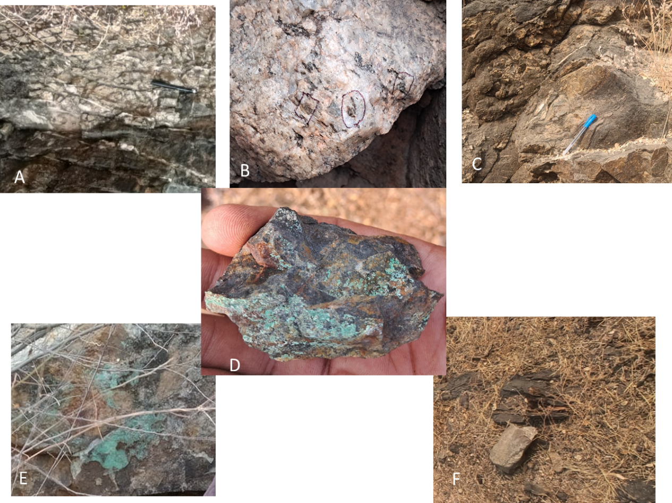

Fig. 2: Field photographs depicting various features of structure and mineralisation in the Bansiyal area, District Neem Ka Thana, Rajasthan. (A). The picture exhibits sigmoids and boudinage developed in the siliceous dolomite. (B). Portion of a quartz vein containing oxidised sulphides and oxides indicated by circles and boxes. Please note the sigmoidal shape of the vugs containing sulphides exhibiting a sheared nature. (C). ~~l~~Larger boudinage in quartzite confirming shear in the area. (D). Fragment of a Hematite from BHQ with Malachite staining, indicating Fe-Cu-S system of minerali~~z~~sation. (E). Encrustation of Malachite on the quartz vein confirming presence of ~~Chalcopyrite~~ Cu-mineralisation along the plane on which it is occurring (roughly in East-West direction). (F). Hematite partings within ~~the~~ dolomite.

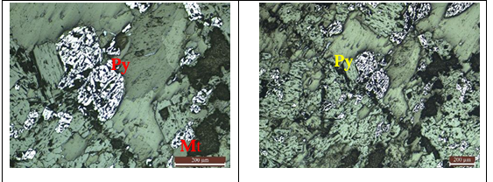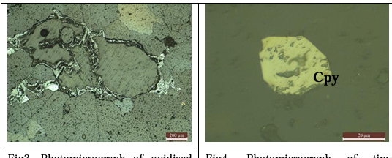

B

A

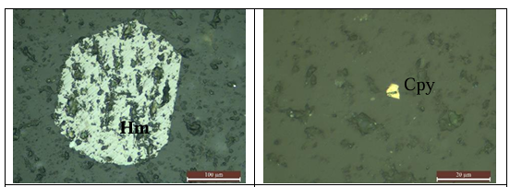

C

Fig. 3: Thin Section Photomicrographs. A: ~~Photomicrographs indicating presence of~~ Euhedral pyrite grains and irregularly shaped ~~M~~magnetite grains (Py-Pyrite, Mt-Magnetite). B: Grain boundaries of host rock are filled with iron suggesting hydrothermal solutions pervading the host rock (Left image); Chalcopyrite (Cpy) grain under reflected Light. C: ~~Photomicrographs depicting~~ Euhedral grain of Hematite being altered to Magnetite, the alteration called Martitization; in the right-hand side image, ~~A~~a ~~T~~tiny chalcopyrite grain, and dusty grains of chalcopyrite in the form of thin films are also visible in faint yellow colour in the same, (Hm-hematite, Cpy-Chalcopyrite).

It is given that the right-side images of B and C were taken in ‘reflected light’ and the rest in Fig. 3 were taken in transmitted light(?). If so, the ore minerals such as pyrite, hematite and magnetite in transmitted light should be opaque (or black), whereas in the above figures they exhibit grey and shades of white colours. Pl. check whether all the figures were taken in ‘reflected light’.

**The proposed modal for ~~m~~Mineralisation**: The Iron ore Copper Gold mineralising system popularly known as IOCG (Hitzman et al., 1992, Zu, Z., 2016) has certain typical requirements and includes larger variations in the criteria’s of classifying any mineralisation as IOCG set up. The basic requirement is presence of Iron, Copper and Gold in the mineralising system and one of these three commodities occurring significantly enriched to occur as a deposit. The other requirement is the strong structural control with hydrothermal characters of the mineralisation. Presence of Iron either in the form of ~~H~~hematite or magnetite along with High Fe/Ti ratio, higher than in most igneous rocks is other requirement. Minor association of Ni, Co, REE, Mo and other trace elements is also known in these deposits. Olympic ~~d~~Dam deposit, Australia, is ~~the~~ possibly the deposit which has brought the term IOCG in the geological literature as it was so complicated that it was needed to invoke a system which involves ~~actually~~ a combination of various earth systems with overprinting of the signatures of the earlier system to generate a huge multi-metal largest deposit in the world~~, at Olympic Dam~~.

In the Indian Context, Bhukia Gold prospect~~,~~ (Rahul Mukherjee, et~~. A~~al., 2016, 2017) ~~&~~and Khetri Copper deposit in Rajasthan~~,~~ (Dasgupta, 1970, Knight et al., 2002Li et al., 2019, Zhu, Z., 2016, Baidya et al., 2021, 2023) and Thanewasna Gold copper association in Maharashtra are classified as IOCG (Dora et al 2016). The area under study has enrichment of Cu as one of the commodities ~~is present~~ (Singh and Karunakaran, 2017) with reported Cu values of up to 1.30%~~, with~~ for 1 km strike length of mineralised zone. Another element Iron also is concentrated as a commercially viable mineral here with Fe2O3 values ranging up to 52% from the area. Minor enrichment of Cr and V (Table 3) has also been observed in the study area. It is very interesting to note here that the Fe/Ti ratio~~n~~ in the prospect ~~if~~ ranges~~ing~~ from 37.95 to 87.27(Table 3), which is certainly higher than the volcanic rocks, hence qualifying the third criteria also. The petrographic studies of the mineralised host rock from the area carried out at GSI Lab. Jaipur have confirmed the presence of Pyrite-Hematite-Magnetite and chalcopyrite, besides confirming the hydrothermal nature of mineralisation (Figs. 3 A, B &C).

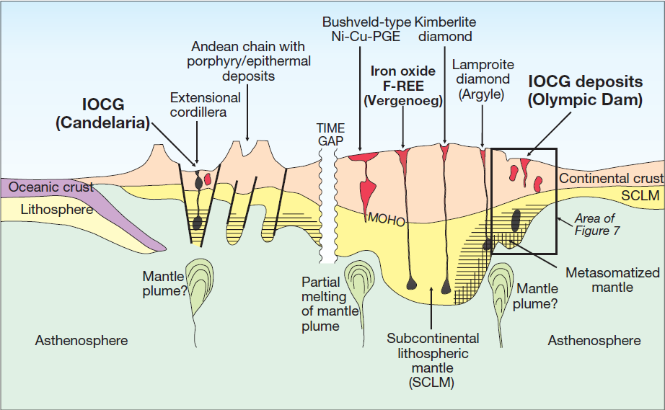

Fig. 4: Schematic diagram showing tectonic and lithospheric setting of IOCG deposits, both in the Precambrian cratons and extensional parts of Cordillerian arcs. Note the IOCG deposits form in continental crust inboard of craton margins above metasomatized mantle lithosphere, normally Archean in age. Thickness of crust exaggerated relative to lithosphere to accommodate detail. Figure adapted from Groves et al., (1987) and Groves and Bierlein (2007).

The above modal (Fig. 4) suggests the occurrences of IOCG deposits/mineralisation or the mineralising system in the Precambrian where extensional tectonics was the rule. The Aravalli and Delhi basins were opened up as rift basins during the same period and provide the litho-tectonic environment favourable for occurrence of IOCG setup. Sinha Roy (1984, 1988 and 2000) gave detailed account of tectonics by invoking Wilson ~~c~~Cycle in Rajasthan and ~~also~~ related various metallotects to the tectonics. He postulated that the Khetri basin was opened up with the opening up of the Delhi main basin in southern part while it was separated by Dausa Sambhar lineament from the main Delhi basin. This was followed by opening up of Alwar-Ajabgarh-Lalsot bayana basin. Singh (1987) classified these basins as sub-basins of North Delhi Basin based on the depositional and lithostratigraphic characteristics. He suggested Lalsot Bayana basin as the fluvio marine depositional facies while the Khetri and Ajabgarb sub-basins characterize the marine depositional sequences. The mineralisation in the Khetri and Neem Ka Thana sub basins is characterised by different signatures of mineralisation. The Khetri Basin mineralisation has been adjudged as IOCG, and has evolved from diagenetic (Dasgupta, 1970) to hydrothermal to IOCG (Knight et al., 2002, Baidya et al., 2021, 2023) the mineralisation in Neem Ka Thana sub-basin which is very adjacent to Khetri has more of syngenetic type of nature. The Bansiyal area forming part of the Khetri belt has similarity with the litho-tectonic setup of Khetri belt, hence justifies occurrence of IOCG type of mineralisation here based on the occurrence within the same metallotect, besides the field and laboratory evidence. Hence it could be convincingly concluded that the mineralisation at Bansiyal area which is hosted within the Ajabgarh meta-sediments of Delhi Supergroup of Rocks exhibits strong hydrothermal characters of mineralisation, having quite high Fe/Ti ratio and is controlled by the shear zone (structurally controlled) and shares a litho-tectonic domain akin to the IOCG deposits of India and the world, could be adjudged as an IOCG Earth system of mineralisation.

**References**

Ashok Singh (Sr. Geologist) & Karunagaran V, (Geologist): Final Report On Reconnaissance Survey ~~F~~for Copper ~~A~~and Associated Mineralization ~~I~~in Southwest ~~O~~of Bansiyal Village Jhunjhunu District, Rajasthan (Stage: UNFC G4) Item Code: MIP/WR/RAJ/2016/036 FS 2016-17.

Baidya, A.S., Saha, R., Pal, D.C. and Upadhyay, D.,  2023 - Fingerprinting alteration and mineralization in the iron oxide Cu-Au (IOCG) system using biotite chemistry and monazite geochronology: constraints from the Khetri Copper Belt, western India: in    Mineralium Deposita   v.58, pp. 1445-1476.

Baidya, A.S., Sen, A., Pal, D.C. and Upadhyay, D., 2021 - Ore-forming processes in the Khetri Copper Belt, western India: constraints from trace element chemistry of pyrite and C-O isotope composition of carbonates: *in*    *Mineralium Deposita*   v.56, pp. 957-974.

Das Gupta S P,  1970 - Sulfide deposits of Saladipura, Khetri copper belt, Rajasthan: *in*    *Econ. Geol.*   v.65 pp. 331-339.

Knight, J., Lowe, J., Joy, S., Cameron, J., Merrillees, J., Nag, S., Shah, N., Dua, G. and Jhala, K. (2002) The Khetri Copper Belt, Rajasthan: Iron Oxide Copper-Gold Terrane in the Proterozoic of NE India. In: Porter, T.M., Ed., Hydrothermal Iron Oxide Copper-Gold and Related Deposits: A Global Perspective, 2, PGC, Adelaide, 321-341.

Li, X.-C., Zhou, M.-F., Williams-Jones, A.E., Yang, Y.-H. and Gao, J.-F., 2019 - Timing and genesis of Cu-Au) mineralization in the Khetri Copper Belt, northwestern India: constraints from in situ U-Pb ages and Sm-Nd isotopes of monazite-(Ce): *in*    Mineralium Deposita   v.54, pp. 553-568.

[M.L. Dora](https://www.researchgate.net/profile/Ml-Dora), [Kirti kumar Randive](https://www.researchgate.net/profile/Kirtikumar-Randive)**,** [H M Ramachandra](https://www.researchgate.net/scientific-contributions/H-M-Ramachandra-2124246592),and [Ganji Suresh](https://www.researchgate.net/profile/Ganji-Suresh-2), 2017-Iron Oxide-Copper-Gold Mineralization at Thanewasna, Western Bastar Craton,. [Current Science](https://www.researchgate.net/journal/Current-Science-0011-3891)March 2017,112(112):1045-1050,DOI:[10.18520/cs/v112/i05/1045-1050](http://dx.doi.org/10.18520/cs/v112/i05/1045-1050).

[Rahul Mukherjee](https://www.researchgate.net/profile/Rahul-Mukherjee), ,[Venkatesh Satya Akella](https://www.researchgate.net/profile/Venkatesh-Akella), and [Fareeduddin](https://www.researchgate.net/scientific-contributions/Fareeduddin-77560679) (2016)- Albitite Hosted Gold-Sulfide Mineralization: An Example from the Paleoproterozoic Aravalli Supracrustal Sequence, Bhukia Area, Western India, December 2016,[Episodes](https://www.researchgate.net/journal/Episodes-0705-3797) 39(4):590-598, DOI:[10.18814/epiiugs/2016/v39i4/103891](http://dx.doi.org/10.18814/epiiugs/2016/v39i4/103891)

Rahul Mukherjee, A.S. Venkatesh and Fareeduddin- (2017)-[Chemistry of magnetite-apatite from albitite and carbonate-hosted Bhukia Gold Deposit, Rajasthan, western India – An IOCG-IOA analogue from Paleoproterozoic Aravalli Supergroup: Evidence from petrographic, LA-ICP-MS and EPMA studies](https://www.researchgate.net/publication/319676274_Chemistry_of_magnetite-apatite_from_albitite_and_carbonate-hosted_Bhukia_Gold_Deposit_Rajasthan_western_India_-_An_IOCG-IOA_analogue_from_Paleoproterozoic_Aravalli_Supergroup_Evidence_from_petrographi?_tp=eyJjb250ZXh0Ijp7ImZpcnN0UGFnZSI6Il9kaXJlY3QiLCJwYWdlIjoiX2RpcmVjdCJ9fQ) ORE GEOL REV. Sep 2017.

Singh, S.P. 1988. Sedimentation patterns of Proterozoic Delhi Supergroup, North Eastern Rajasthan, India, and their tectonic implications. Sedimentary Geology, v.58.79-95

Sinha Roy, S., 1984. Precambrian crustal interactions in Rajasthan, NW India. Indian Jour. Earth Sci. CEISM volume pp84-91.

Sinha Roy, S. 1988. Proterozoic Wilson cycles in Rajasthan. Mem. Geol. Soc. India, No 7. pp 95-107.

Sinha Roy, S. 2000, Crustal evolution and metallogeney in Rajasthan, Alfa Science International, Ltd., Oxford

Sharma, A.K. (1998) Exploration for Base metal in the Rampura Tonda Naila Ki Dhani area, Unpublished incorporated final report of GSI for the FS 1995-96, 1996-97, 1997-98.

Sharma, B (1976) Base metal exploration in Bhokri area, Khetri Copper Belt, Unpublished progress report of GSI for the FS 1975-76.

Srivastava, S.C et al. (1972). A report on the geology, mineralization and exploration in Papurna section Khetri copper belt, Jhunjhunu districts, Rajasthan. Unpublished progress report of GSI for the FS 1967-68 and 1970-71.

M.J. Carew, G. MARK, N.H.S. OLIVER, N. PEARSON,(2006). Trace element geochemistry of magnetite and pyrite in Fe oxide (±Cu–Au) mineralised systems: insights into the geochemistry of ore-forming fluids. Geochim. Cosmochim. Acta. (2006).

Misra, A.K. and Rao, R.S. (1994) – Geophysical anomaly Anomaly checking Surface geochemical evaluation of gossan in Bansiyal area, Sikar District Raj. Unpublished report AMSE (GSI) WR, Jaipur.

[Wei Terry Chen](https://www.researchgate.net/profile/Wei-Chen-5), [Mei-Fu Zhou](https://www.researchgate.net/profile/Mei-Fu-Zhou), [Xiaochun Li](https://www.researchgate.net/profile/Xiaochun-Li-2), [Jian-Feng Gao](https://www.researchgate.net/profile/Jian-Feng-Gao), [Kejun Hou](https://www.researchgate.net/profile/Kejun-Hou)., m(2015) [In-situ LA-ICP-MS trace elemental analyses of magnetite: Cu-(Au, Fe) deposits in the Khetri copper belt in Rajasthan Province, NW India, Ore Geol](https://www.sciencedirect.com/science/article/pii/S0169136814002509), Rev. 65. (2015) DOI:[10.1016/j.oregeorev.2014.09.035](http://dx.doi.org/10.1016/j.oregeorev.2014.09.035).

Xiaowen Huang,Xin-Fu Zhao,  Qi Liang,Mei-Fu Zhou.,(2013). ReOs and S isotopic constraints on the origins of two mineralization events at the Tangdan sedimentary rock-hosted stratiform Cu deposit, SW China. Chemical Geology, том 347, DOI: [10.1016/j.chemgeo.2013.03.020](https://doi.org/10.1016/j.chemgeo.2013.03.020).

Zhu, Z., 2016 - Gold in iron oxide copper-gold deposits: in Ore Geology Reviews   v.72, pp. 37-42.