**Tolerance of Plantain Banana [Musa paradisiaca L., (Musaceae)] to Water Deficit: Agro-morphological and Physiological Responses under Greenhouse Conditions~~.~~**

**Abstract:**  
Plantain, a monocotyledon belonging to the Musaceae family, is a key crop in Côte d’Ivoire. It plays an essential role in food security and income diversification, contributing significantly to poverty reduction, especially in rural areas. However, in the face of climate change and decreasing rainfall, identifying drought-tolerant varieties has become a priority. Nine ~~(09)~~ plantain cultivars, including seven ~~(7)~~ traditional and two ~~(2)~~ improved ones, were selected at the nursery stage. They were then grown under controlled greenhouse conditions and subjected to different watering regimes to identify those with drought tolerance traits, based on the evaluation of vegetative growth and physiological parameters. Daily watering led to a significantly higher average number of living leaves (3.78) compared to the low watering regime (3.49). The cultivar Pita 3 recorded the greatest plant heights, with 3.57 cm under daily watering and 3.47 cm with watering every two weeks. In contrast, the lowest values (2.27 cm and 2.11 cm) were observed with French Sombre. The cultivar Zakoi stood out with a larger collar diameter (4.01 cm), compared to values ranging from 1.35 cm to 2.3 cm in other cultivars. Regarding leaf area, Pita 3 (382.37 cm²) and Zakoi (367.59 cm²) outperformed the others, while French Sombre had the lowest values (224.99 cm²). The study revealed that the lifespan of the plantlets varied significantly among the cultivars, ranging from 47.46 days (Banadyshie and French Sombre) to 63.46 days (Fhia 21). Finally, daily watering resulted in a higher average nitrogen content (18.84 mg/g) and lower leaf moisture (17.95%) compared to the biweekly watering regime, which showed 17.67 mg/g and 21.48%, respectively. These results indicate that the cultivars Pita 3 and Zakoi exhibit better drought tolerance and could be prioritized in drought adaptation strategies.

**Keywords:** Plantain, Drought tolerance, Growth, Physiology.

# INTRODUCTION

Plantain cultivation in Côte d'Ivoire is of paramount importance for ensuring food security and holds a significant place in the country’s agriculture. In addition to playing a crucial role in the livelihood of rural and urban communities (Orella et al., 2002), this crop is a vital source of income, particularly for women, who represent nearly 80% of the active workforce in this sector. Côte d'Ivoire is also a major supplier to the sub-region and the African diaspora in Europe, exporting between 30,000 and 50,000 tons of plantain annually. However, since March 2022, the country has decided to suspend all plantain exports (Republic of Côte d'Ivoire, 2020).

With an estimated production of 1,677,000 tons, plantain ranks fourth among staple food crops in Côte d'Ivoire, after yam, cassava, and rice. The country is the third-largest supplier of plantain in West Africa, behind Nigeria and Ghana (Thiémélé et al., 2017; FAO, 2018). Nevertheless, this quantity remains insufficient due to ever-increasing demand and the volume exported to the sub-region and Europe. As part of the first strategic objective of the National Agricultural Investment Plan (PNIA), aimed at "Promoting strategic products for food security and sovereignty," the Ivorian government has designated plantain as a national strategic crop.

The government's goals are clear: (i) achieve a national production of 3 million tons by 2030; (ii) increase yields to at least 15 tons per hectare; (iii) meet at least 80% of the population's plantain consumption needs; and (iv) reduce post-harvest losses, currently estimated at 40% during periods of abundance, by half (MINADER, 2021).

Therefore, Côte d'Ivoire must increase its production to meet its own needs. Agronomic research must support the development of this sector by providing high-performing cultivars that are tolerant to water deficit and drought, and adapted to the production environment in the context of climate change.

This study aims to evaluate the effect of water stress on the growth of young plantain cultivars in a greenhouse setting. The specific objectives of this work are, on the one hand, to assess vegetative growth parameters and plant lifespan, and on the other hand, to characterize their physiological status.

# MATERIALS AND METHODS

## Study Site

The study was conducted under greenhouse conditions at the Central Biotechnology Laboratory (CBL), located within the Directorate General of the National Center for Agronomic Research (CNRA). This laboratory is situated in the city of Abidjan (Côte d’Ivoire), specifically in Adiopodoumé Km 17, Yopougon municipality (5°20’N; 4°7’W).

## Plant Material

The plant material consisted of plantlets from nine (09) plantain cultivars of various origins (Table I). The plantlets were obtained through multiplication on pared corms (MSD method), following the protocol described by Kouakou *et al.* (2019).

**Table I:** Characteristics of the Different Plantain Cultivars Studied.

|  |  |  |  |  |
| --- | --- | --- | --- | --- |
| Types | Cultivars | Origins | General characteristics | Biological cycle duration and yield |
| French | Zakoi | Nigeria | * Complete inflorescence, large male bud present at maturity, varied color of the pseudostem and bunch (green, red, brown, etc.), tolerant to cercospora leaf spot (black streak disease) * 6 to 10 hands, 60 to 180 fingers. Length: 12 to 27 cm. Circumference: 11–18 cm | * 11 to 12 months * Yield: 20–35 t/ha |
| Pita 3* | Nigeria |
| French Sombre | Cameroun |
| Fhia 21* | Honduras |
| False horn | Banadyshie | Côte d’Ivoire | * Inflorescence with reduced male bud at maturity * 4 to 7 hands, length: 15 to 30 cm, circumference: 13–12 cm | * 11 to 12 months * Yield: 15 to 30 t/ha |
| Corne 1 | Côte d’Ivoire |
| Orishélé | Nigeria |
| Big Ebanga | Cameroun |
| Mule | Saci | Côte d’Ivoire | * Intermediate between French and False Horn, tolerant to cercospora leaf spot (black streak disease) * 5 to 8 hands, 60 to 150 fingers, length: 14 to 32 cm, circumference: 12–20 cm | * 12 to 14 months * Yield: 18 to 30 t/ha |

(*) : Hybrid

## Other Materials

The growing substrate used consisted exclusively of potting soil placed in black perforated polyethylene bags measuring 29 cm deep and 23 cm in diameter. The field capacity of these bags was determined using a water volume of 700 ml, following the weighing method of Klute (1986).

First, the combined weight of the bag and dry substrate was measured to obtain the initial weight (P1). Then, the substrate was watered to full saturation and left to rest for 24 hours. A second weighing was performed to measure the saturated weight (P2). The field capacity of the bags was calculated as the difference between P2 and P1, corresponding to the amount of water retained by the soil. This quantity was then applied at each watering using a watering can throughout the experiment.~~.~~

## Methods

### Experimental design

The experimental design adopted under greenhouse conditions was a split-plot with two factors: watering frequency (main factor) and plantain cultivars (secondary factor). Two watering frequencies were evaluated: daily watering (T1) and watering every fifteen days (T2) (in the mornings). Nine plantain cultivars were studied, with their characteristics presented in Table I.

The experimental setup thus consisted of two blocks corresponding to the two watering frequencies. Within each block, the cultivars constituted the elementary plots. Each plot contained three rows of 5 plants or repetitions. The elementary plots consisted of three rows of 5 plantain plants spaced 0.5 m apart both within and between rows. The dimensions of each elementary plot were 2.5 m in length and 1.5 m in width. Spacing between elementary plots was 0.5 m. The area of each block was 45 m². Considering the spacing between the two blocks, the total trial area was 135 m².

Average greenhouse temperatures were 28 °C at 7 a.m, 40 °C at 1 p.m., and 33 °C at 5 p.m., resulting in a daily average temperature of 34 °C.~~.~~

### Evaluation of Vegetative Growth and Plant Lifespan

#### Vegetative Growth

Vegetative growth was evaluated every two weeks throughout the experiment using the following parameters:

* Pseudostem height, measured with a tape measure from the base (collar) to the shoot apex, at the “V” formed by the last two functional leaves;
* Collar diameter (CD), measured with à caliper;
* Number (Nb) of living leaves, determined by counting;
* Leaf area (LA), measured using the CI-202 Portable Laser Leaf Area Meter **(Figure 1).** The leaf area value is read directly on the device by passing the leaf from base to tip between the clamps.

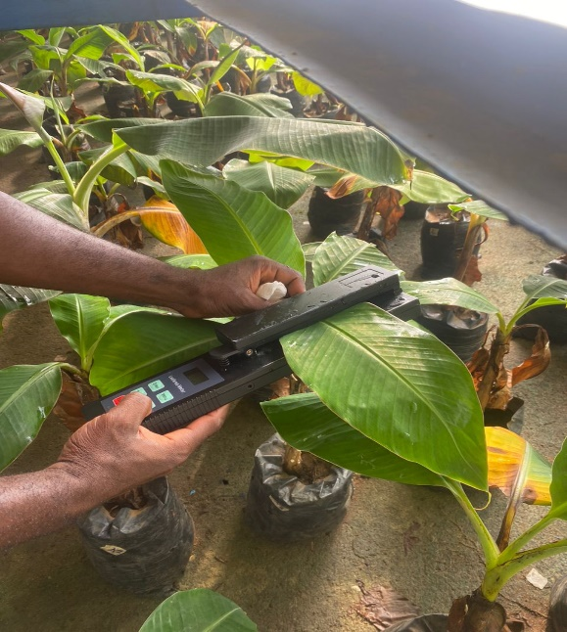

**Figure 1:** Measurement of leaf area using the CI-202 Portable Laser Leaf Area Meter.

#### Lifespan of the plants

The leaves of each plant were monitored daily until their senescence or complete drying, which marked the end of the plant’s life (death). The survival durations of the plants were then determined.

### Characterization of the Physiological Status of the Plants

The physiological status of the plantlets was evaluated at regular intervals of seven (7) days by measuring leaf temperature, humidity, and nitrogen content . These three parameters were all assessed using the third leaf, with the help of the Chlorophyll Content Meter CCM-200 (Silla *et al.,* 2010) **(Figure 2).** The third leaf was identified by counting from the base to the top of the plant. The values were automatically provided by the device when the leaf was placed between its clamps, precisely at one of the greenest parts.

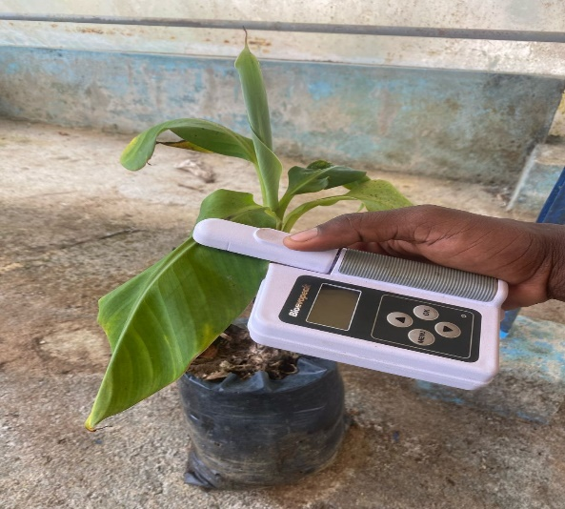

**Figure 2:** Measurement of physiological parameters using the Chlorophyll Content Meter CCM-200

## Statistical Analysis of Data

All data collected on the effect of water deficit on the physiological and vegetative growth parameters of banana plants in the greenhouse were analyzed using R software version 4.4.1. Analysis of variance (ANOVA) was performed to compare the mean values of the treatments studied. When significant differences were found, the Newman-Keuls test at a 5% significance level was used to group treatments into homogeneous classes.

In addition to the ANOVA, a principal component analysis (PCA) was conducted based on the vegetative growth and physiological parameters to identify the most relevant variables for distinguishing between banana cultivars.

# RESULTS AND DISCUSSION

## Results

### Effect of Watering Frequency on the Vegetative Growth of the Plants

#### Number of Living Leaves

The results presented in **Table II** indicate that the highest mean number of living leaves (4.7) was recorded in the control treatment of the Big Ebanga cultivar. This value differs significantly from those of the other cultivars, which ranged from 4.26 to 3.26.

Under the low watering regime (every fifteen days), the highest mean number of living leaves (4.05) was also observed in the Big Ebanga cultivar. However, this value is not significantly different from those recorded for the Banadyshie, FHIA21, Orishele, Saci, and Corne 1 cultivars, which ranged from 3.89 to 3.56. The Zakoi cultivar recorded the statistically lowest mean number of living leaves (3.20).

Overall, daily watering led to a significantly higher mean number of leaves (3.78) compared to that observed in banana plants subjected to the low watering regime (3.49)..

#### Plant Height

The average plant heights are presented in **Table II**. The PITA 3 variety stands out significantly from the others with the highest heights regardless of the watering frequency. These values were 3.57 cm and 3.47 cm for plants watered daily and every fifteen days, respectively. In contrast, the lowest values were recorded for the French Sombre variety (2.27 cm and 2.11 cm).Overall, no significant difference was observed between the plant heights under the two watering treatments (2.76 cm and 2.71 cm).~~.~~

#### Collar Diameter

The analysis of the results presented in **Table II** showed that under daily watering conditions, the Zakoi variety was the most performant. Indeed, the largest collar diameter, significantly measured at 4.01 cm, was recorded on the plants of this cultivar. The collar diameters of all the other cultivars were statistically similar across both watering regimes, ranging from 2.3 cm to 1.35 cm.

#### Leaf Area

The average leaf areas of the plants are presented in **Table II**. The PITA 3 and Zakoi varieties stand out significantly from the others, with the highest leaf areas regardless of the watering frequency. For PITA 3, the observed values are 382.37 cm² for plants watered daily and 371.64 cm² for those watered every fifteen days. For Zakoi, the leaf areas reach 367.59 cm² and 331.35 cm² under the same conditions, respectively. In contrast, the lowest values were recorded for the French Sombre variety, with 224.99 cm² under daily watering and 197.24 cm² under watering every fifteen days.

**Table II:** Growth parameters of plants subjected to different watering regimes

|  |  |  |  |  |  |  |  |  |
| --- | --- | --- | --- | --- | --- | --- | --- | --- |
| Varieties | Nb of living leaves | | Plant height (cm) | | CD (cm) | | LA (cm2) | |
| T1 | T2 | T1 | T2 | T1 | T2 | T1 | T2 |
| Big Ebanga | 4.70 a | 4.05 bc | 3.14 b | 3.01 bc | 1.35 b | 1.95 b | 284.62 d | 283.68 d |
| Saci | 4.26 b | 3.56 defgh | 2.94 bc | 2.73 cde | 2.09 b | 1.80 b | 261.17 def | 252.92 def |
| Corne 1 | 4.03 bc | 3.65 cdefg | 2.85 bcd | 2.42 fg | 1.73 b | 1.45 b | 279.86 de | 239.39 efg |
| Orishélé | 3.79 cdef | 3.68 cdefg | 2.60 def | 2.42 fg | 1.62 b | 1.59 b | 254.88 def | 217.34 fg |
| Pita 3 | 3.79 cdef | 3.46 efgh | 3.57 a | 3.47 a | 2.30 b | 2.27 b | 382.37 a | 371.64 ab |
| Fhia 21 | 3.34 fgh | 3.77 cdef | 2.85 bcd | 2.50 efg | 1.76 b | 1.65 b | 325.62 c | 255.89 def |
| Banadyshie | 3.94 bcd | 3.89 bcde | 2.92 bc | 2.45 fg | 1.99 b | 1.76 b | 296.99 cd | 220.10 fg |
| Zakoi | 3.26 gh | 3.20 h | 2.89 bc | 2.56 ef | 4.01 a | 1.69 b | 367.59 ab | 331.35 bc |
| French Sombre | 3.71 cdefg | 3.42 fgh | 2.27 gh | 2.11 h | 1.41 b | 1.35 b | 224.99 fg | 197.24 g |
| *P<* | *0.001* | | *0.001* | | *0.1* | | *0.001* | |
| Mean | 3.78 a | 3.49 b | 2.76 a | 2.71 a | 2.01 a | 1.66 b | 288.13 a | 272.75 b |
| *P<* | *0.001* | | *0.1* | | *0.05* | | *0.05* | |

NB = Number; DC = Collar Diameter of the plants; SF = Leaf Area

For the same parameter, values followed by the same letter are not significantly different according to the Newman-Keuls test at the 5% significance level.

### Effect of watering regime on the lifespan of plantlets

The lifespan of the plantlets varies from 47 to 63 days depending on the genotype **(Table III).** Analysis of variance indicates differences in the varieties’ sensitivity to water deficit. The comparison of means using the Newman-Keuls test (α = 5%) allowed classification of the varieties into three distinct groups based on their survival duration under water stress. The varieties Fhia 21 and Orishélé have statistically identical lifespans (63.46 days and 62.2 days), which are significantly longer than those of Banadyshie and French Sombre (47.46 days). The other cultivars recorded intermediate lifespans between these two groups.

**Table III:** Average lifespan of plantlets of the different studied cultivars

|  |  |
| --- | --- |
| Varieties | Survival time  of plantlets (days) |
| Fhia 21 | 63.46 a |
| Orishélé | 62.20 a |
| Zakoi | 58.06 ab |
| Big Ebanga | 57.40 ab |
| Pita3 | 56.46 ab |
| Corne 1 | 56.33 ab |
| Saci | 53 ab |
| Banadyshie | 47.46 b |
| French sombre | 47.46 b |
| *P<* | *0.01* |

In one column, means followed by the same letter are not significantly different at the 5% level (Newman-Keuls test).

### Effect of Watering Frequency on the Physiological Status of the Plants

#### Leaf Temperature

The analysis of the results presented in **Table IV** showed that under daily watering conditions, the Banadyshie variety stood out with the significantly highest leaf temperature (62.95 °C). All other cultivars were statistically similar, regardless of watering regime, with average leaf temperatures ranging from 29.05 °C to 30.40 °C.

#### Leaf humidity

Leaf humidity of the plants is presented in **Table IV.** The highest value (29.72%) was recorded for the Banadyshie variety under the biweekly watering treatment. For the Zakoi, Pita 3, and Corne 1 varieties, a significant difference was observed between the two treatments. In each case, leaf humidity was higher under the low watering regime. Conversely, for the other cultivars, leaf humidity did not vary significantly between the two treatments.Overall, daily watering resulted in a significantly lower average leaf humidity (17.95%) compared to the low watering regime (21.48%).

#### Nitrogen content

The nitrogen contents of the different varieties according to the watering frequency are presented in **Table IV.** Regardless of the water condition, the nitrogen contents of the Zakoi cultivar were the lowest (16.48 mg/g and 16.10 mg/g). Overall, daily watering resulted in a significantly higher average nitrogen content (18.84 mg/g) compared to that observed under the low watering regime (17.67 mg/g).~~.~~

**Table IV:** Physiological parameters of plants pubjected to different watering regimes

|  |  |  |  |  |  |  |
| --- | --- | --- | --- | --- | --- | --- |
| Varieties | Leaf temperature (°C) | | Leaf humidity (%) | | Nitrogen content  (mg/g) | |
| T1 | T2 | T1 | T2 | T1 | T2 |
| Big Ebanga | 29.73 b | 30.21 b | 16.26 efg | 17.17 def | 19.20 ab | 17.79 fgh |
| Saci | 29.88 b | 29.93 b | 24.60 abc | 24.83 abc | 19.65 a | 18.02 efgh |
| Corne 1 | 29.05 b | 29.81 b | 15.72 efg | 22.94 bcd | 18.37 cdef | 18.25 defg |
| Orishélé | 29.49 b | 29.99 b | 10.71 gh | 9.77 h | 18.94 abcd | 17.50 gh |
| Pita 3 | 30.12 b | 30.53 b | 20.95 cde | 27.55 ab | 19.48 ab | 17.84 fgh |
| Fhia 21 | 30.05 b | 30.43 b | 16.84 def | 18.92 cde | 18.99 abcd | 17.36 h |
| Banadyshie | 62.95 a | 30.59 b | 23.81 abc | 29.72 a | 19.07 abc | 17.68 fgh |
| Zakoi | 29.45 b | 29.89 b | 12.13 fgh | 22.94 bcd | 16.48 i | 16.10 i |
| French Sombre | 30.40 b | 30.44 b | 21.02 cde | 20.77 cde | 19.34 ab | 18.71 bcde |
| *P<* | *0.1* | | *0.05* | | *0.01* | |
| Mean | 33.05 a | 30.21 a | 17.95 b | 21.48 a | 18.84 a | 17.67 b |
| *P<* | *0.1* | | *0.001* | | *0.001* | |

For the same parameter, values followed by the same letter are not significantly different according to the Newman-Keuls test at the 5% significance level.

### Principal Component Analysis of the Various Agro-Physiological Variables of Plantain

The studied variables were distributed on the biplot formed by axes 1 and 2, according to their respective contributions **(Figure 3).** It appears that leaf area (LA), collar diameter (CD), nitrogen content (N), and plant survival duration (PSD) were correlated with axis 1, which explains 39.4% of the variance. The varieties associated with this axis are Zakoi and French Sombre **(Figure 4).** Leaf humidity (LH), plant height (PH), and leaf temperature (LT) were correlated with axis 2, which explains 26.5% of the variance **(Figure 3).** The varieties associated with this axis are Orishélé, Banadyshie, and Pita 3 **(Figure 4).**

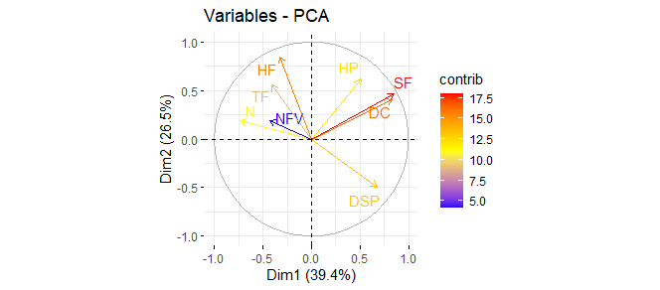

**Figure 3:** Correlation circle from the PCA showing the representativeness

of the agro-physiological variables in the plane formed by axes 1 and 2.

TF: Leaf temperature; NFV: Number of living leaves; HP: Plant height; N: Nitrogen content;

SF: Leaf area;DC: Stem base diameter; DSP: Plant survival duration

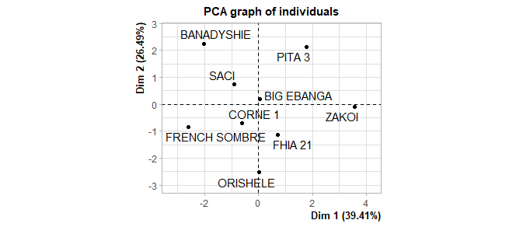

**Figure 4:** Correlation circle from the PCA showing the representation of individuals in the plane defined by axes 1 and 2

## Discussion

The data analysis shows that the number of living leaves is significantly influenced by the watering frequency. Plants watered daily have à higher average number of living leaves (3.78) than those watered every fifteen days (3.49). This result confirms that water is a critical limiting factor for banana growth, as it maintains cell turgor, promotes cell division, and supports photosynthesis (Souza *et* *al.,* 2018). The variety Big Ebanga stands out with an average of 4.7 leaves under daily watering, a value significantly higher than the other varieties. Even under water stress, this variety retains a higher number of leaves than the others, suggesting better drought tolerance. In contrast, the variety Zakoi shows the poorest performance with only 3.20 leaves under low watering frequency. These results corroborate those of Rahman *et al.* (2019), who demonstrated that reducing irrigation frequency significantly decreases leaf production in sensitive species.

Plant height did not vary significantly between the two watering regimes (2.76 cm vs. 2.71 cm). However, certain varieties such as Pita 3 maintain greater heights under both conditions, suggesting morphological adaptability. This stability could be attributed to deeper rooting or more efficient water use, as highlighted by Zhang *et al.* (2019), who emphasized that some varieties can compensate for reduced water availability through internal physiological mechanisms. Conversely, the variety French Sombre remained significantly smaller, indicating increased sensitivity to water deficit.

Collar diameter is a good indicator of plant vigor. In this study, the Zakoi cultivar had the largest collar diameter (4.01 cm) under daily watering. This performance could be linked to better resource mobilization toward conductive and supportive tissues. Rahman *et al.* (2019) reported that water availability directly influences secondary tissue growth, especially in young Musa spp. plants. The absence of significant differences for other cultivars may reflect a slower effect of water stress on this parameter, which is often more stable in the short term.

Leaf area is one of the traits most sensitive to water deficit because it is directly linked to photosynthetic capacity. The cultivars Pita 3 and Zakoi stood out with the largest leaf areas regardless of watering frequency. This result may indicate good resilience of these cultivars to water stress and an ability to maintain light interception area. According to Afolayan *et al*. (2002), leaf area reduction is a common adaptive mechanism in plants subjected to drought, thereby limiting water loss through transpiration. The variety French Sombre, on the other hand, exhibits the smallest leaf areas, confirming its vulnerability to stress. This finding aligns with observations by Nkendah *et al*. (2010), who also highlighted French Sombre’s sensitivity to drought conditions, with marked reductions in vegetative growth and leaf production under water deficit.

Variability in plant lifespan can be attributed to genetic differences among genotypes. Indeed, drought tolerance often varies according to the genetic characteristics of varieties, as demonstrated by Lamy *et al.* (2018), where different genotypes responded variably to drought. These results are consistent with those of Sasaki *et al.* (2017), who observed that some banana and plantain varieties were more drought-resistant than others. The varieties Fhia 21 and Orishélé, with respective lifespans of 63.46 days and 62.2 days, were more tolerant to water stress compared to Banadyshie and French Sombre, which had significantly shorter lifespans (47.46 days). This phenomenon may be related to the resistant varieties' ability to better maintain rigidity and physiological functions under water deficit, as described by Moulin *et al.* (2019). These authors showed that some varieties exhibit mechanisms regulating transpiration and optimizing water use. Similar results were reported by Dixon *et al.* (2016), who demonstrated that differences in drought response can also be attributed to stress management at the root system and leaf tissue structure levels.

Leaf temperature is an important indicator of transpiration and the plant’s water status. Our results reveal a significantly higher leaf temperature (62.95 °C) in the variety Banadyshie under daily watering. This temperature increase may indicate stomatal closure, reducing transpiration and thus limiting leaf cooling (Jones, 1999). Abnormally high temperatures can also result from heat stress caused by limited thermal regulation capacity. According to Costa *et al.* (2007), leaf temperature is influenced by the water balance, and its increase is generally associated with reduced evapotranspiration, a consequence of stomatal closure.

The results show that plants watered every fifteen days generally present higher leaf humidity (21.48 %) than those watered daily (17.95 %). This trend is significant, particularly for the varieties Zakoi, Pita 3, and Corne 1. This phenomenon may seem paradoxical but is explained by an adaptive strategy in plants subjected to moderate water stress, leading to stomatal closure, which limits water loss and locally increases relative humidity in the leaf tissue (Taiz *et al.,* 2017). However, for some varieties, no significant difference is observed, suggesting a variable response depending on the genotype. These observations confirm the findings of Luu *et al.* (2013), who reported that leaf humidity response to water stress strongly depends on each cultivar’s specific adaptation capacity.

Nitrogen is an essential nutrient for vegetative growth, especially because it is part of chlorophyll and proteins. Analysis of the results indicates that nitrogen content is significantly influenced by the watering regime. Indeed, a higher average content (18.84 mg/g) is observed in plants watered daily, compared to 17.67 mg/g under reduced watering. This finding aligns with that of Barros *et al.* (2012), who showed that water availability improves nutrient uptake and their translocation to the leaves. The low nitrogen content observed in the Zakoi cultivar may indicate a physiological limitation in mineral absorption under water stress. According to Sinclair (2005), water stress reduces the efficiency of root absorption, thereby affecting the assimilation of essential nutrients, including nitrogen.

# CONCLUSION

This study highlighted the differential effects of watering frequency on the agro-morphological and physiological performance of several plantain varieties. The results show that water is a major limiting factor for banana development, significantly influencing key parameters such as the number of living leaves, leaf area, nitrogen content, and leaf moisture. In general, daily watering promoted better vegetative growth and more efficient nitrogen assimilation, while less frequent watering induced variable adaptive responses depending on the genotype. Some varieties, notably Fhia 21, Orishele, Pita 3, and Saci, demonstrated better tolerance to water stress through an enhanced ability to maintain turgor, effective thermal regulation, and conservation of physiological potential. Others, such as Zakoi, Banadyshie, and French Sombre, proved more sensitive to water deficit, reflecting lower efficiency in compensatory mechanisms. Ultimately, this research underscores the need to select drought-tolerant varieties to strengthen the resilience of tropical agricultural systems, especially in the context of increasing climate variability. The promotion of these genotypes, combined with appropriate management practices, could represent an effective strategy to secure plantain production. However, further investigations, including advanced molecular and physiological approaches, are necessary to better understand the adaptation mechanisms and to guide sustainable varietal selection.

# REFERENCES

**Afolayan S. O., Igbeka J. C., & Babalola O. (2002).** Effects of irrigation frequency on soil moisture potential and chemical properties, growth and shoot yield of large green. Nigerian Journal of Horticultural Science, 6(1), 41–47.

**Barros M. W., Silva E. C., Nogueira R. J. M. C., & Santos V. F. (2012).** Effect of water deficit on the physiological parameters and productivity of cowpea plants. Revista Brasileira de Engenharia Agrícola e Ambiental, 16(1), 76–82.

**Carr M. K. V. (2009).** The water relations and irrigation requirements of banana (Musa spp.): A review. Experimental Agriculture, 45(3), 333–371. https://doi.org/10.1017/S0014479709007582

**Costa J. M., Ortuño M. F., & Chaves M. M. (2007).** Deficit irrigation as a strategy to save water: physiology and potential application to horticulture. Journal of Integrative Plant Biology, 49(10), 1421–1434. <https://doi.org/10.1111/j.1672-9072.2007.00556.x>

**Dixon A. G. O., Asiedu R., & Tenkouano A. (2016).** Genotypic responses of Musa spp. to drought stress. International Journal of Plant Physiology, 23(1), 55–67.

**Gomez K. A., & Gomez A. A. (1984).** Statistical Procedures for Agricultural Research (2nd ed.). New York: Wiley-Interscience, 680 p.

**Husson F., Le S., & Pagès J. (2011).** Exploratory multivariate analysis by example using R. Chapman and Hall/CRC.

**Jolliffe I. T., & Cadima J. (2016).** Principal component analysis: A review and recent developments. Philosophical Transactions of the Royal Society A: Mathematical, Physical and Engineering Sciences, 374(2065), 20150202. https://doi.org/10.1098/rsta.2015.0202

**Jones H. G. (1999).** Use of infrared thermometry for estimation of stomatal conductance as a possible aid to irrigation scheduling. Agricultural and Forest Meteorology, 95(3), 139–149.

**Klute A. (Ed.). (1986).** Methods of Soil Analysis. Part 1: Physical and Mineralogical Methods (2nd ed.). Madison, WI: American Society of Agronomy – Soil Science Society of America, 1188 p.

**Kouakou K. R., Koné T., Aby N., Traoré S., Dogbo D. O., & Koné M. (2019).** Comparative performances of vivo plants from two propagation techniques in three plantain banana cultivars [Musa paradisiaca, (Musaceae)] in Azaguié. Agronomie Africaine, 31(1), 1–13.

**Lamy C., Tixier P., & Risède J. M. (2018).** Impact of genotypic variability on banana plant response to water deficit. Field Crops Research, 226, 70–79. https://doi.org/10.1016/j.fcr.2018.07.012

**Luu D. T., Maurel C., & Santoni V. (2013).** Regulation of plant aquaporin function under drought stress. Plant, Cell & Environment, 36(2), 198–206.

**MINADER (Ministry of Agriculture and Rural Development) (2021).** National Agricultural Investment Plan – Second Generation (PNIA 2), 2018–2025. Abidjan, Côte d’Ivoire: Government of the Republic of Côte d’Ivoire. https://www.agriculture.gouv.ci

**Moulin M., Bouchet J. P., & Dorel M. (2019).** Water use efficiency and transpiration dynamics in drought-tolerant banana cultivars. Journal of Agricultural Water Management, 218, 74–82. https://doi.org/10.1016/j.agwat.2019.03.002

**Nkendah R., Temple L., & Tomekpe K. (2010).** Agronomic performance of some plantain varieties under water stress conditions in Central Africa. Cahiers Agricultures, 19(3), 175–181.

**Orella P. P., Bermudez C. I., Garcia R. L., & Veitia N. (2002).** Evaluation of agronomic characteristics of plantain banana hybrids (Musa spp.). Infomusa, 11(1), 34–35.

**Rahman M. A., Haque M. A., & Kabir M. H. (2019).** Vegetative Growth of Banana as influenced by Deficit Irrigation and Irrigation Interval. Fundamental and Applied Agriculture, 4(4), 1047–1053. https://doi.org/10.5455/faa.68092

**Republic of Côte d'Ivoire (2020).** Rural Sector Development Strategy and National Agricultural Investment Plan 2020-2030. Ministry of Agriculture and Rural Development, 108 p.

**Sasaki S., Kobayashi Y., & Inoue Y. (2017).** Genetic variation in drought tolerance among banana genotypes. Euphytica, 213(5), 110–119. https://doi.org/10.1007/s10681-017-1889-3

**Silla F., González-Gil A., González-Molina M. E., Mediavilla S., & Escudero A. (2010).** Estimation of chlorophyll in Quercus leaves using a portable chlorophyll meter: effects of species and leaf age. Annals of Forest Science, 67(1), 108. https://doi.org/10.1051/forest/2009093

**Sinclair T. R. (2005).** The theoretical analysis of the role of nitrogen in crop responses to water stress. Agronomy Journal, 97(3), 798–803.

**Sinclair T. R., & Ludlow M. M. (1985).** Who taught plants thermodynamics? The unfulfilled potential of plant water potential. Australian Journal of Plant Physiology, 12(3), 213–217.

**Souza Santos A., Amorim E. P., Ferreira C. F., & Pirovani C. P. (2018).** Water stress in *Musa spp.:* A systematic review. PLoS ONE, 13(12), e0208052. https://doi.org/10.1371/journal.pone.0208052

**Taiz L., Zeiger E., Møller I. M., & Murphy A. (2017).** Plant Physiology and Development (6th ed.). Sinauer Associates, 761 p.

**Thiémélé D. E. F., Traoré S., Aby N., Gnonhouri P., Yao N., Kobenan K., Konan E., Adiko A., & Zakra N. (2017).** Diversity and participatory selection of productive local plantain varieties in Côte d’Ivoire. Journal of Applied Biosciences, 114, 11324–11335**.**

**Turner N. C. (2001).** Optimizing water use in Mediterranean agriculture. Environmentalist, 21(1), 93–101.

**Zhang H., Xie Z., Wang Y., & Zhang L. (2019).** Effect of irrigation level and irrigation frequency on the growth of mini Chinese cabbage and residual soil nitrate nitrogen. Sustainability, 11(1), 111. https://doi.org/10.3390/su11010111