Pathogenic Diversity in Fusarium oxysporum: A Comparative Isolate Analysis

Abstract
Fusarium oxysporum is a significant fungal pathogen responsible for wilt diseases across a wide range of host plants. Understanding the pathogenic diversity within its isolates is critical for developing effective disease management strategies. This study investigates the pathogenic variability among diverse isolates of F. oxysporum collected from different geographic regions and host plants. Pathogenicity tests were conducted under controlled conditions. Pathogenicity tests were conducted by seed inoculation technique and soil inoculation method. Among all the tests FO1 (Fusarium oxysporum-1) was found to be more virulent and FO4 (Fusarium oxysporum-4) was least virulent. Correlations between pathogenicity and specific isolate characteristics, such as origin and host specialization, were also identified. These findings underscore the importance of recognizing isolate-specific pathogenic traits for designing targeted interventions, including resistant crop varieties and region-specific management practices.
Keywords: Soybean, Fusarium oxysporum, Pathogenicity test, seed inoculation technique, soil inoculation method
Introduction
Soybean has been grown in an area of about 113.09 lakh ha with a production of 129.95 lakh tonnes in India (Anon, 2022). The major states that cultivate soybean are Madhya Pradesh, Chhattisgarh, Bihar, Gujarat, Himachal Pradesh, Maharashtra, Karnataka, Rajasthan and Uttar Pradesh. The major soybean-growing districts in Chhattisgarh are Kawardha, Bemetara, Rajnandgaon, Durg, Mungeli, Bilaspur and Raipur (Anon, 2022). In Chhattisgarh, soybean is grown during Kharif season and it suffer from a number of diseases such as many fungal, bacterial, viral, nematode and abiotic diseases which are responsible for low production. F. oxysporum is one of the most destructive seed-borne as well as soil-borne fungus which can cause wilt and root rot disease in soybean plants. The species Fusarium oxysporum is well represented among the communities of soil-borne fungi, in every type of soil all over the world (Burgess, 1981). Fusarium oxysporum f. sp. glycines (FOG) is one of the fungal species most commonly isolated from soybean roots in the soybean-producing regions of North America (Díaz et al., 2013). F. oxysporum has been associated with soybean damping-off, seedling root rot, and vascular wilt (Armstrong and Armstrong, 1965). F. oxysporum f. sp. glycines has been found to significantly reduce seed germination and seedling survivability by up to 40% and it is known to cause pre-emergence damping-off of seedlings (Begum et al., 2007).
Materials and Methods

- Pathogenicity test of different isolates of F. oxysporum by seed inoculation technique
In this test, the seeds were coated with ten days old culture of Fusarium oxysporum isolates. Inoculated seeds were sown in pots containing sterile soil (10 seeds per pot). The trial included four replicates, so each isolate was used to inoculate 40 seeds in total. The pots were kept in a greenhouse at 22-24°C and watered according to their need. Used as the control treatment were the seeds dipped in sterile water and then planted in sterile soil. The number of wilted plants was recorded 15-20 days after planting.
- Pathogenicity test of different isolates of F. oxysporum by soil inoculation technique
The above mentioned fungus F. oxysporum was multiplied on potato dextrose agar in Petri dishes. Mass inoculum of F. oxysporum was prepared on wheat grains. The 50 gm wheat grains were soaked in distilled water for overnight in a 250 ml polythene bags. The floating wheat seed and debris were removed. Then after, the grains were washed with tap water for three to five times. Excess water from grains was drained and autoclaved for 60 min at 121°C on consecutive days and allowed to cool. After cooling, 5 disc of 5 mm diameter, containing mycelial of F. oxysporum on PDA were added to the polythene bags. The polythene bags was incubated at 25±2ºC in BOD for fifteen days.
The plastic pots (12 × 10 cm) were taken and filled with 80% sterilized soil which was previously treated by 4% formalin. Soil was infested by placing the test fungus colonized wheat grain. The soil of pots was infested by placing of 3 gm infested wheat grains and were distributed in a layer in each pot then covered with 2 cm layer of sterilized soil. Then after 10 soybean seeds were planted in each pot and covered with 2 cm of soil, each pot representing 1 replicate and four replications were used. Observations on wilt incidence were recorded on the basis of seedling mortality per cent after 21 days of planting.
Results and Discussion
- Pathogenicity test of different isolates of F. oxysporum by seed inoculation technique
All isolates of F. oxysporum f. sp. glycines were found to be pathogenic when compared to the control and results are presented in Table Each isolate exhibited typical wilt symptoms, including chlorosis, necrosis and seedling mortality. Chlorosis symptoms developed after 15 days of inoculation, with the highest seedling mortality observed after 21 days of inoculation (DAI). Among the isolates, FO4 had the highest average number of germinated seeds (7.25), followed by FO3 (6.75), FO5 (6.50), FO2 (5.75) and the lowest in FO1 (5.25).
Additionally, FO3 (3.75) and FO1 (3.00) had the highest average number of pre-emergence infections, followed by FO5 (2.75), with the minimum observed in FO2 and FO4 (both 2.25). FO1 had the highest average number of post-emergence infections (3.50), followed by FO5 (2.25), FO3 (2.00), FO2 (1.50) and the lowest in FO4 (1.25).
The total average number of infected plants was highest in FO1 (6.50) and FO3 (5.75), followed by FO5 (5.00), FO2 (3.75) and the lowest in FO4 (3.50).
In the uninoculated soil method, the average number of germinated plants was highest at 8.25 compared to the inoculated soil method. The average number of pre-emergence and post-emergence infections was not observed, indicating lower infection rates compared to treated plants.
Jasnic et al. (2005) described Fusarium wilt symptoms as wilting of the apical portion of the plant, necrosis of the root and lower stem and eventual wilting of the entire plant. Isolates from diseased soybean plants included Fusarium avenaceum, F. equiseti, F. oxysporum and F. poae. Pathogenicity tests under artificial infection conditions demonstrated F. oxysporum f. sp. glycines as the most pathogenic among the investigated species, corroborating the findings of the present study.

Table:1 Pathogenicity test of different isolates of F. oxysporum by seed inoculation technique
S.No. | Isolates | Average no. of  germinated plants | Average no. of pre-emergence infection | Average no. of post- emergence infection | Total Average no. of infected plants
1. | FO1 | 5.25 | 3.00 | 3.50 | 6.50
2. | FO2 | 5.75 | 2.25 | 1.50 | 3.75
3. | FO3 | 6.75 | 3.75 | 2.00 | 5.75
4. | FO4 | 7.25 | 2.25 | 1.25 | 3.50
5. | FO5 | 6.50 | 2.75 | 2.25 | 5.00
6. | Control | 8.25 | 00 | 00 | 00
*Average of four replications

Fig:1 Pathogenicity test of different isolates of F. oxysporum by seed inoculation technique

FO1 | 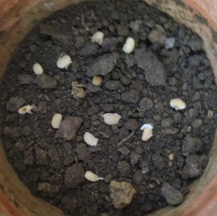 | 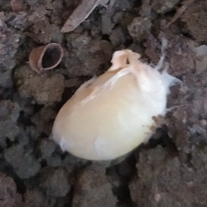 | 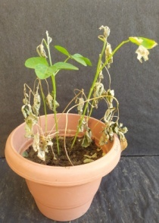 | 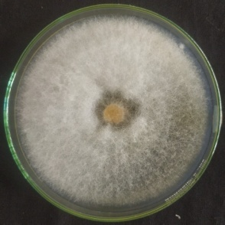
FO2 | 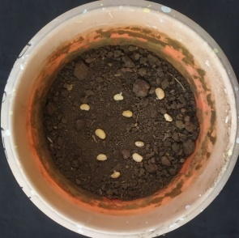 | 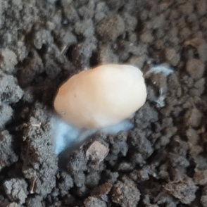 | 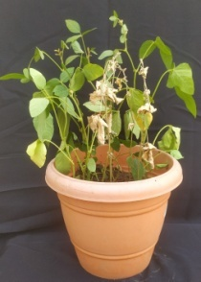 | 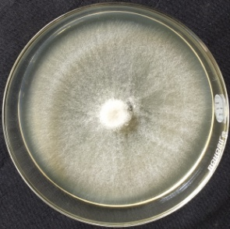
FO3 | 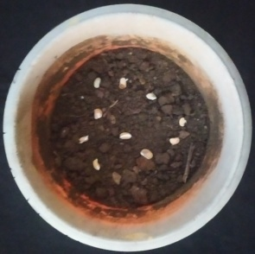 | 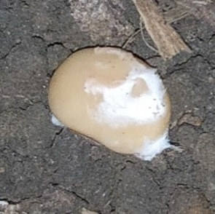 | 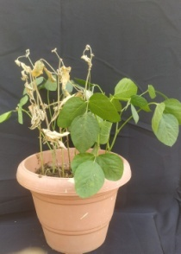 | 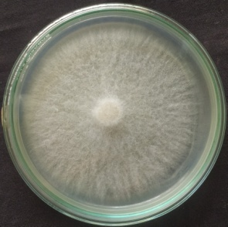
FO4 | 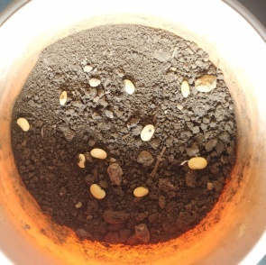 | 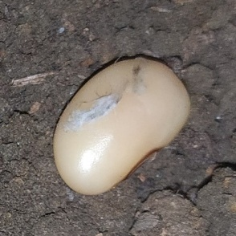 | 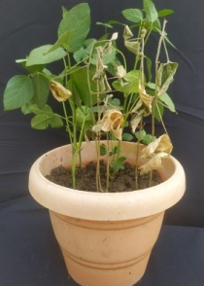 | 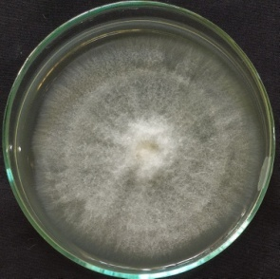
FO5 | 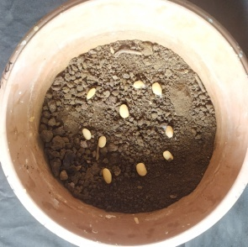 | 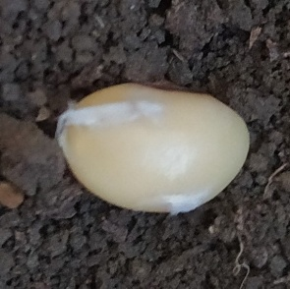 | 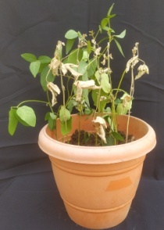 | 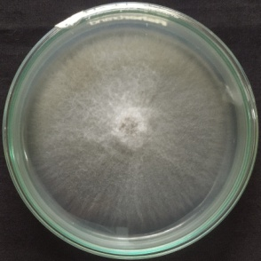
Control |  |  | 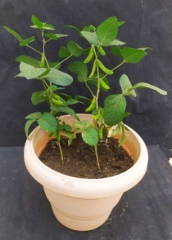
Plate:1 Pathogenicity test of different isolates of F. oxysporum by seed inoculation
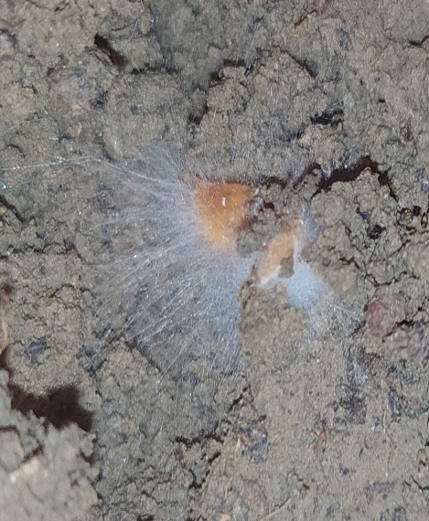 | 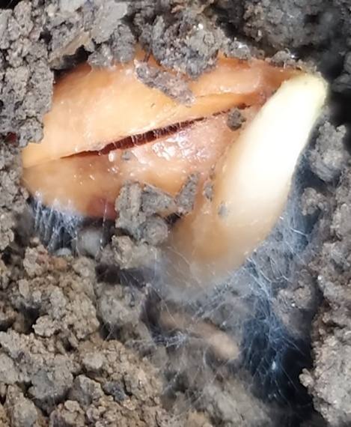 | 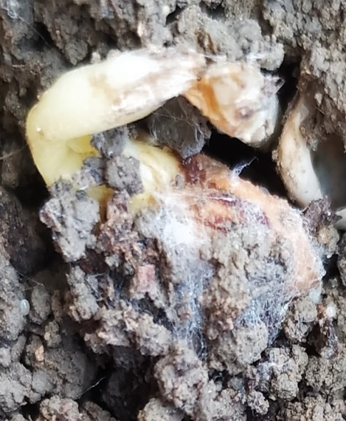
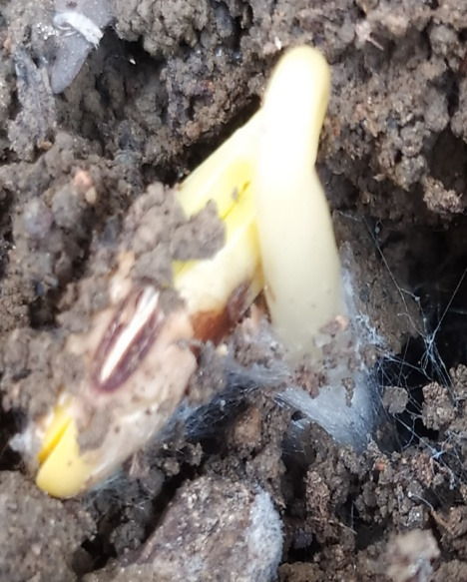 | 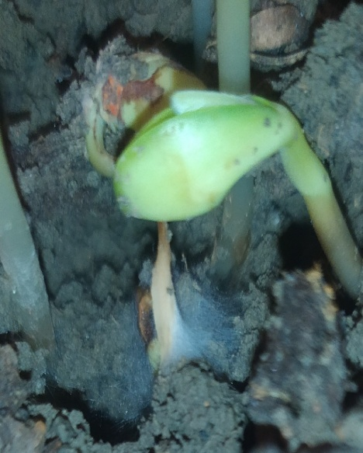 | 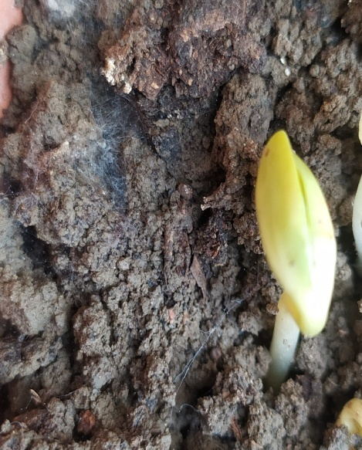
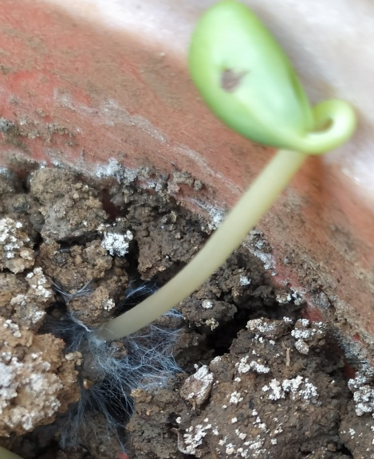 | 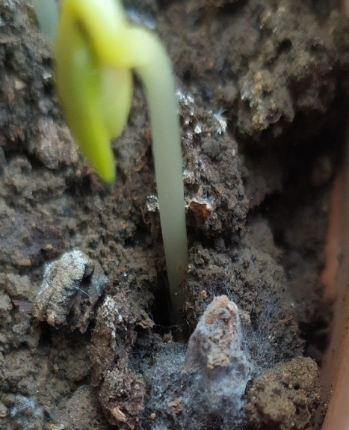 | 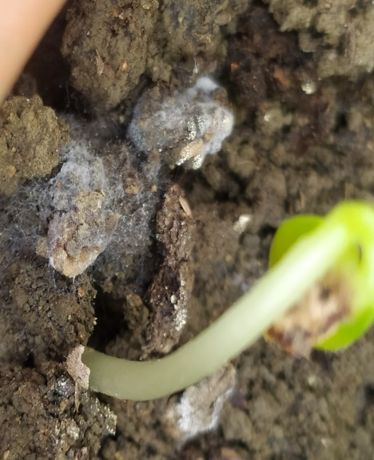
Plate:2 Seedlings showing development of infection during seed inoculation technique

- Pathogenicity test of different isolates of F. oxysporum by soil inoculation method
All isolates of F. oxysporum f. sp. glycines demonstrated pathogenicity compared to the control, as shown in Table. Each isolate induced typical wilt symptoms, including chlorosis, necrosis and seedling mortality. Chlorosis symptoms appeared after 15 days of inoculation, with the highest seedling mortality observed after 21 days post-inoculation (DAI).
Among the isolates, FO4 (7.25) and FO2 (6.00) exhibited the highest average number of germinated seeds, followed by FO3 (5.75) and FO5 (5.75), with the lowest observed in FO1 (5.25), FO3 (3.00) and FO1 (2.75) had the maximum average number of pre-emergence infections, followed by FO5 (2.50) and FO2 (2.25), with the lowest in FO4 (2.00). The maximum average number of post-emergence infections was recorded in FO1 (3.25) and FO5 (3.00), followed by FO3 (2.50), with the minimum observed in FO2 and FO4 (both 2.25).
The total average number of infected plants was highest in FO1 (6.00), followed by FO3 and FO5 both (5.50), FO2 (4.50) and the lowest in FO4 (4.25).

In the uninoculated soil method, the average number of germinated plants was highest at 8.25 compared to the inoculated soil method. No average number of pre-emergence infections was observed, while the average number of post-emergence infections was 1.00, the lowest compared to the treated plants.
According to Stevan (2005) find out the Fusarium isolates had no significant influence on seed germination. F. oxysporum, isolate S/1 had the highest level of pathogenicity in the soil inoculation method. Scandiani et al. (2011) the soil infestation method yielded more aggressive results for F. oxysporum compared to other methods. Talekar (2024) assess the pathogenicity of Fol isolates and observed mortality rates ranging from 51.05% to 94.65% in the sick soil method.

Table:2 Pathogenicity test of different isolates of F. oxysporum by soil inoculation method
S.No. | Isolates | Average no. of germinated plants | Average no. of pre-emergence infection | Average no. of post- emergence infection | Total Average no. of infected plants
1. | FO1 | 5.25 | 2.75 | 3.25 | 6.00
2. | FO2 | 6.00 | 2.25 | 2.25 | 4.50
3. | FO3 | 5.75 | 3.00 | 2.50 | 5.50
4. | FO4 | 7.25 | 2.00 | 2.25 | 4.25
5. | FO5 | 5.75 | 2.50 | 3.00 | 5.50
6. | Control | 8.25 | 1.00 | 00 | 00
*Average of four replications

Fig 2: Pathogenicity test of different isolates of F. oxysporum by soil inoculation method

 | FO1 | FO2 | FO3 | FO4 | FO5 | Control
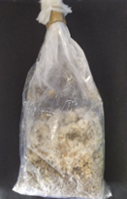 | 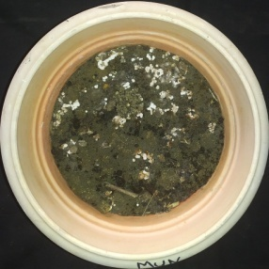 | 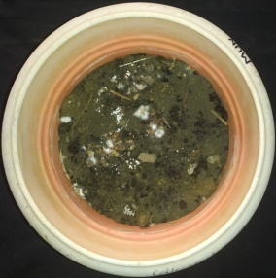 | 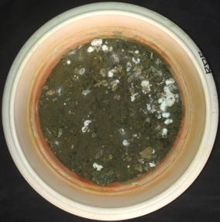 | 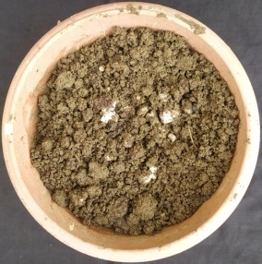 | 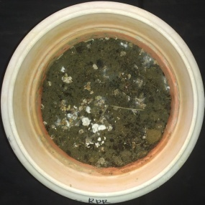
 | 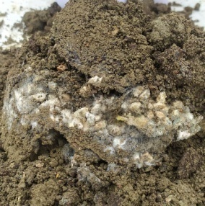 | 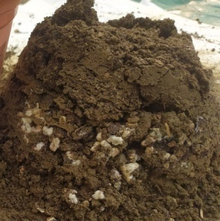 | 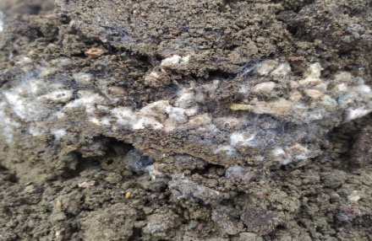 | 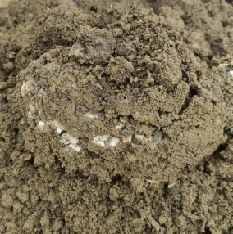 | 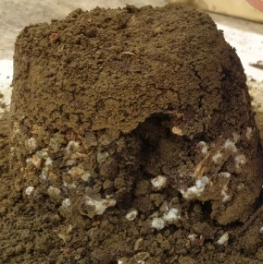
 | 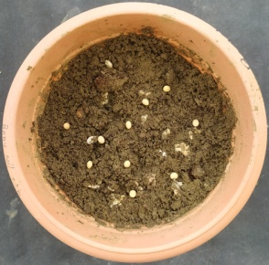 | 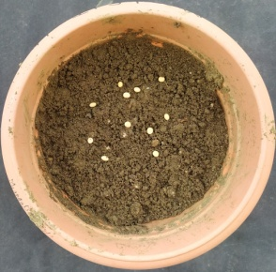 | 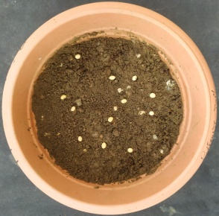 | 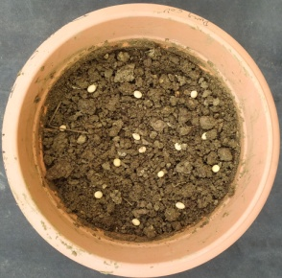
 | 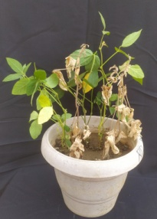 | 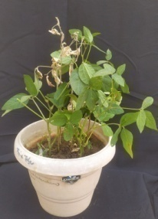 | 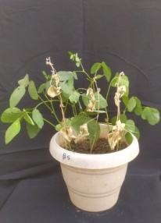 | 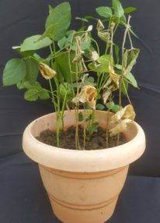 | 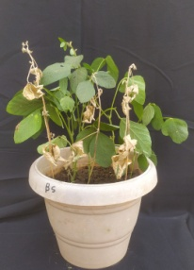 | 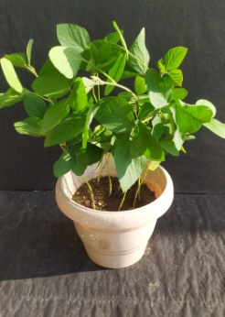
 | 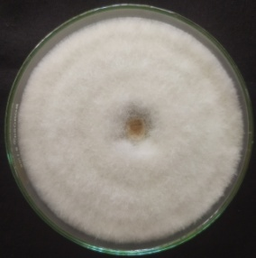 | 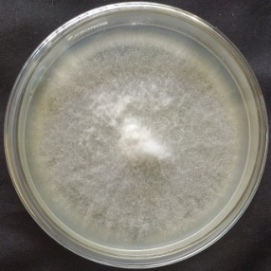 | 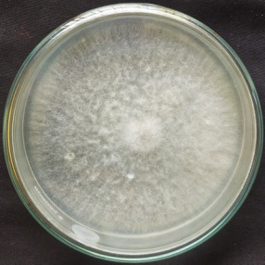 | 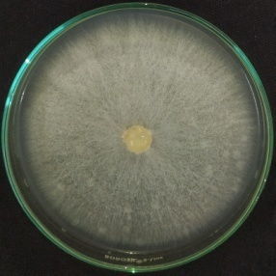 | 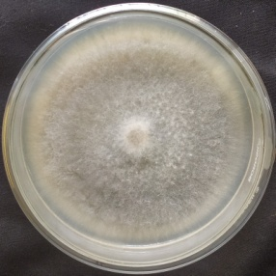
Plate:3 Pathogenicity test of different isolates of F. oxysporum by soil inoculation method

Conclusion
This study highlights the significant pathogenic diversity among Fusarium oxysporum isolates, emphasizing the need for targeted management strategies tailored to the virulence profiles of specific isolates. Among all the tests FO1(Fusarium oxysporum-1) was found to be more virulent. The findings provide a foundation for breeding resistant crop varieties and implementing region-specific disease control measures, contributing to more effective mitigation of F. oxysporum-induced crop losses globally.
References
Anonymous, 2020. Directorate of Agriculture, Raipur C.G., Agriculture Development and Farmers Welfere and Bip-Technology Department.
Anonymous, 2022. Fourth advance estimates of production of food grains, Ministry of Agriculture and Farmers Welfare, Department of Agriculture, Cooperation and Farmers Welfare, Directorate of Economics and Statistics.
Armstrong, J. K. and Armstrong, G. M. 1965. A race of the cotton-wilt Fusarium causing wilt of Yelredo soybean and flue-cured tobacco. Dis. Rep. 42:147-151.
Begum, M.M., Sariah, M., Zainal, A.M.A., Puteh, A.B. and Rahman, M.A. 2007. Histopathological studies on soybean seed infected by Fusarium oxysporum f. sp glycines and screening of potential biocontrol agent. Research Journal of Microbiology, 2(12): 900-909.
Burgess, LW. 1981. General Ecology of the Fusaria. In: Nelson PE, Toussoun TA, Cook RJ, eds. Fusarium: diseases, biology and taxonomy. University Park, PA, USA: The Penn. State Uni. Press, 225– 235.
Diaz Arias, M. M., Leandro, L. F. and Munkvold, G. P. 2013. Aggressiveness of Fusarium species and impact of root infection on growth and yield of soybeans. Phytopath. 103:822-832.
Jasnić, S., Vidić, M., Bagi, F. and Đorđević, V. 2005. Pathogenicity of Fusarium species in soybean. Zbornik Matice srpske za prirodnenauke, (109):113-121.
Jasnić, S.M., Vidić, M.B., Bagi, F.F. and Đorđević, V.B. 2005. Pathogenicity of Fusarium species in soybean. Zbornik Matice srpske za prirodne nauke, (109): 113-121.
Scandiani, M.M., Ruberti, D.S., Giorda, L.M., Pioli, R.N., Luque, A.G., Bottai, H. and Donnell, K.O. 2011. Comparison of inoculation methods for characterizing relative aggressiveness of two soybean sudden-death syndrome pathogens, Fusarium virguliforme and F. tucumaniae. Tropical Plant Pathology, 36(3): 133–140.
Talekar, S.B., Pawar, S.V., Sontakke, P.L. and Korde, P.P. 2024. Isolation, identification, prove the pathogenicity and pathogenic variability of Fusarium oxysporum f. sp. lycopersici. Int. J. Adv. Biochem. Res. 8(10):1319-1325.

