“GROWING OF TENDER WHEATGRASS UNDER PYRAMID TYPE SOLAR STRUCTURE AND COMPARATIVE EVALUATION OF TRAY AND SOLAR TUNNEL DRYING METHODS FOR POWDER PRODUCTION"
"

ABSTRACT
The experiments were conducted for the observation of growth parameter for the tender wheat grass under pyramid type of solar structure. A triangular-shaped structure was designed to cultivate wheat grass using five plastic trays. The overall dimensions of the structure were 1.1 meters by 1.5 meters, and it included two supporting base frames to hold the trays. Each tray was placed at a height difference of 50 cm to allow proper growth space for the wheat grass. Once the frame was assembled, it was covered with 200-micron UV-stabilized plastic film to improve germination during the initial growth phase. The various environmental parameter like inside temperature, humidity, solar radiation and ambient temperature as well as growth parameter were observed during the study. During the no-load testing inside the pyramid structure, the highest average temperature recorded was 37.6 °C at 12:00 p.m., with a solar intensity of 710 W/m². At that time, the relative humidity inside the structure was 36.5%, while the outside relative humidity measured 33%. In the load test condition, the maximum average temperature reached 36.2 °C at 1:00 p.m., with a solar intensity of 315 W/m². The ambient temperature was 31.6 °C, internal humidity was 35.9%, and external humidity was 31.5%. Wheatgrass grown inside the pyramid structure reached a height of 7 inches in 16 days, whereas the same growth took 20 days in the tray placed outside the structure. It was also observed that seed loss was higher in the outside tray compared to the one inside the pyramid. Additionally, germination occurred earlier within the pyramid structure, where sprouting began within two days, as compared to delayed germination outside.

INTRODUCTION
Wheatgrass is recognized as a highly nutritious food, offering a wide range of essential nutrients that surpass many other food sources. Its juice is known for various health and wellness advantages, including aiding digestion, purifying the bloodstream, and boosting the immune system. Research has also indicated its potential benefits in managing certain health conditions like thalassemia and distal ulcerative colitis. Currently, wheatgrass is available in different commercial forms such as powders, extracts, and tablets used as dietary supplements. However, in India, the availability of fresh wheatgrass juice is limited and often comes at a high cost. One ounce (approximately 29.5 mL) of wheatgrass juice contains over 100 nutrients including vitamins, minerals, and amino acids. Despite its benefits, cultivating wheatgrass in open areas poses challenges such as uneven germination, inconsistent growth height, and color variation. To address these issues, a study was conducted to observe wheatgrass growth under a cost-effective protective structure. This structure was developed by the Department of Renewable Energy Engineering, CAET, Dediapada. It was fabricated with dimensions of 1.1 meters by 1.5 meters, including two base frames designed to hold five plastic trays with a 50 cm height difference between levels. To improve germination during the initial stage, the entire frame was covered with UV-stabilized 200-micron plastic film, as shown in Fig. 1.

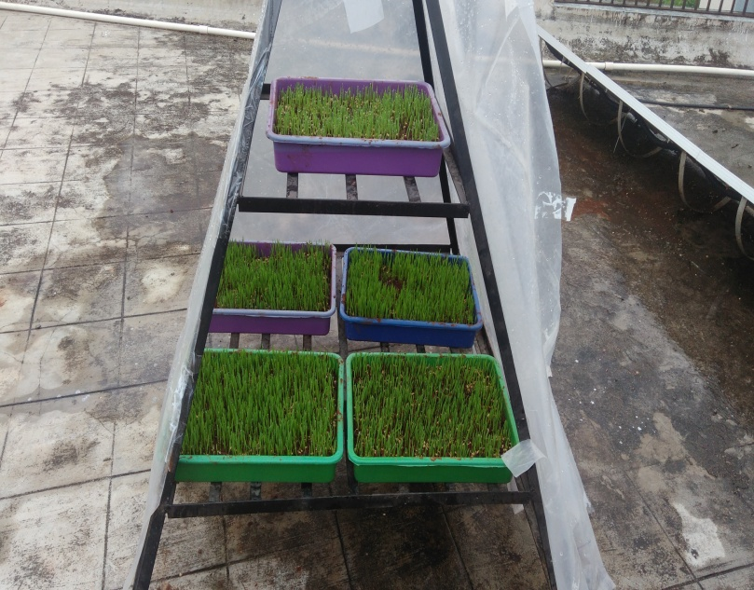 | 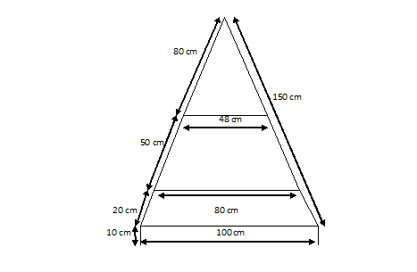

Fig.: 1 Pyramid structure for growing of wheat grass

MATERIALS AND METHODS
Growing of wheat grass
To cultivate wheatgrass, 600 grams of wheat seeds along with rectangular plastic trays were purchased from the local market in Dediapada. Red soil and cow dung manure were also collected from nearby areas for use as a growing medium. Before soaking, the wheat seeds were washed thoroughly with tap water three to four times. Following this, the seeds were soaked in water containing one tablespoon of baking powder for a period of 18 hours, following the method described by Singhal Ashish et al. (2012). After soaking, the seeds were drained and allowed to rest for another 18 hours, during which sprouting was observed. For preparing the trays, red soil and cow dung manure were mixed in a 2:1 ratio. The sprouted seeds were then evenly distributed across the surface of the prepared soil in both trays, ensuring minimal overlapping and maintaining close but separate placement to promote uniform growth.
Sowing
The sowing process was carried out in five steps:
- Seed Selection and Soaking: 100 grams of wheat seeds were chosen for each tray, totaling 600 grams for six trays. The seeds were then soaked in water for 18 hours in a plastic container.
- Soil Preparation: The soil was mixed with cow dung in a 2:1 ratio. This mixture was then added to the growing trays, creating a layer about 1.5 inches thick.
- Seed Spreading: The pre-soaked wheatgrass seeds were evenly distributed on the surface of the prepared organic soil in each tray. Wheatgrass thrives in warm, sunny days with moderate humidity and cool nights.
- Covering Seeds: A light layer of organic soil was sprinkled on top of the wheatgrass seeds. The soil was lightly moistened, and the tray was covered with a vented lid or an inverted draining tray to keep the seeds in darkness until the seedlings sprouted into light green wheatgrass.
- Observation and Harvesting: Daily observations were made to track the height and color of the wheatgrass. Once the wheatgrass reached a height of 7 inches, it was harvested either for juice extraction or dried for powder production.
M.C determination Method (Air oven method)
The moisture content of the samples at each stage of the process was determined using the hot air oven method (Nilamani, 1970). Approximately 10 grams of the test sample was weighed and placed in a hot air electric oven. After heating, the sample was cooled in a desiccator to reach ambient temperature. The weight change was recorded using an electronic balance with a least count of gram. The moisture content was then calculated and expressed either as kg of moisture per kg of wet matter (wet basis, wb) or kg of moisture per kg of dry matter (dry basis, db). The average moisture content from four samples was reported throughout the study.
The moisture content calculation formula used was:
MC (% wb) = (W1 - W2) / W1 × 100
Where:
- W1 = Initial weight of the test sample (g)
- W2 = Final weight of the test sample (g)
Drying of tender wheatgrass:
The harvested wheatgrass was dried using a solar tunnel dryer to observe various parameters. Both the initial and final moisture content were measured for the wet and dry wheatgrass samples. After the drying process, the tender wheatgrass was ground into powder.
Preparation of powder from dried wheatgrass:
The dried wheatgrass sample was placed into the grinding bowl, filling it to half of its depth. The grinder with the sample was then kept in the refrigerator for 10 to 15 minutes to cool it down. Grinding was carried out for 10 to 15 seconds. Any further increase in grinding time caused slight heating of the sample, so the grinding duration was limited to 10-15 seconds. After each grinding session, the grinder and sample were allowed to rest for 10 to 15 minutes to cool down. This process was repeated 10 to 12 times or until the grinding was complete. The ground material was then sieved through a fine mesh (106 μ). Approximately 60 to 70% of fine powder was obtained from the dried wheatgrass sample. The fine powder was then packed in airtight 100g HDPE bags for storage.
RESULTS AND DISCUSSION
Growing of wheatgrass
The economic and health feasibility of the developed pyramid structure, with dimensions of 1 meter by 1.5 meters (1 m² base area and 1.5 meters in height), was assessed for growing wheatgrass. In this study, both the height and color of wheatgrass were observed and compared between plants grown inside and outside the structure. The pyramid structure featured two shelves: the bottom shelf could accommodate four trays, while the upper shelf held one tray. Each tray measured 40 cm by 28 cm. The trays were filled with a prepared soil mixture to a depth of 3 to 4 cm.-Soaked wheat seeds were evenly spread over the soil surface in the tray, ensuring they did not overlap, followed by a layer of soil to cover the seeds.
No load testing of structure:
The highest average temperature recorded during the no-load test in the pyramid structure was 37.6°C at 12:00 p.m., when the solar intensity was 710 W/m². At that time, the relative humidity inside the structure was 36.5%, while the outside humidity was 33%. The data obtained from the no-load performance test is presented in Fig. 2(a, b). As shown in Fig. 2(a), the temperature inside the pyramid structure rose with the increase in solar intensity until 12:00 p.m., after which it began to decrease as the day progressed.

Fig. 2(a) Fig. 2(b)

Fig. 2(a) internal temperature variation under no load
Fig. 2(b) Comparative relative humidity inside and outside the pyramid structure.

Growth parameter
More seeds germinated and the growth was more even inside the pyramid structure compared to the outside tray after six days. This happened because the temperature and humidity were higher inside the pyramid, as shown in Plate 1.
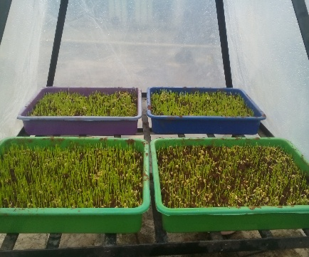
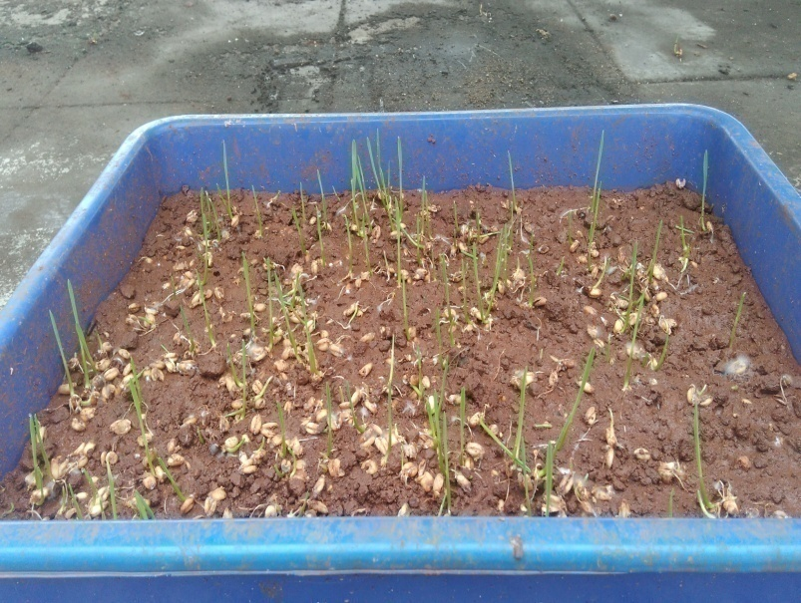

Inside wheatgrass outside wheatgrass
Plate 1: Seed germination inside and outside the structure.

Subsequently, the height of the wheatgrass inside and outside was monitored daily, as shown in Fig. 3. The wheatgrass inside the pyramid structure reached a height of 7 inches in 16 days, while it took 20 days for the same height to be achieved in the outside tray. This variation in growth was influenced by changing environmental conditions. Four key environmental factors—temperature, humidity, solar radiation, and the time required to reach the target height—were found to be crucial for the growth of wheatgrass, as depicted in Figs. 3-5. It was also noted that more seed loss occurred in the outside tray compared to the one inside the pyramid structure. Once the wheatgrass reached a height of 7 inches, it was considered ready for harvesting, as its nutrient content peaked at this stage.

Fig.3 Inside and outside height obtain for wheat grass

Fig. 4. Relation between Temperatures and Time | Fig.5.Relation between humidity and Time

Drying of wheatgrass
Various drying methods, including solar tunnel drying and conventional tray drying, were examined for drying wheatgrass. The wheatgrass samples were evenly spread across the trays. Throughout the experiment, measurements such as weight, temperature, relative humidity, and other relevant parameters were taken at regular intervals.
Solar tunnel dryer
The solar tunnel dryer was positioned in the East-West direction. Key parameters such as temperature, humidity, and weight were recorded at one-hour intervals during the experiment. The highest temperature reached inside the solar tunnel dryer was 49.6°C, while the outside ambient temperature was 36.5°C. The maximum humidity levels inside and outside were observed at 42% and 62%, respectively, during the morning hours, with the lowest levels recorded around noon. The peak solar intensity measured was 775 W/m² at 2:00 p.m., as shown in Table 1.

Table 1 Data observing during drying of wheatgrass in solar tunnel dryer
Time  (h) | Wt. of  sample1  (gm.) | Wt. of  sample2  (gm.) | Ti  (°c) | To  (°c) | Rho  (%) | Rhi  (%) | Ih  (w/m²)
10:00 | 110 | 110 | 29.5 | 27.2 | 62 | 42 | 554
11:00 | 78 | 75 | 39.5 | 31.2 | 49 | 34 | 735
12:00 | 60 | 55 | 44.6 | 32.5 | 58 | 30 | 741
13:00 | 43 | 38 | 46.5 | 33.6 | 56 | 28 | 768
14:00 | 28 | 25 | 48.7 | 36.1 | 55 | 22 | 775
15:00 | 17.5 | 19.6 | 49.6 | 36.5 | 52 | 25 | 760
16:00 | 17.3 | 19.5 | 49.3 | 35.9 | 54 | 26 | 650

Relation between drying rate versus average moisture content
Moisture Content
The percentage of moisture content was calculated using the following formula (A.O.A.C., 1980):
;
Where,
W₁ = weight of the sample before drying (grams)
W₂ = weight of the completely dried sample (grams)
Drying Rate
The drying rate (g/h/100g of bone-dry weight) for the green leaf samples during the drying process was determined using the formula:
Where,
ΔW = weight loss in a one-hour interval (g/100g of bone-dry weight)
ΔT = time interval (hours)
Wheatgrass harvested from both inside and outside the pyramid structure was dried in the solar tunnel dryer. Observations such as weight loss, moisture content, and drying rate were recorded until the weight became constant, and the corresponding data are shown in Figures 6–9. Initially, the moisture removal rate and drying rate were found to be high but gradually decreased as drying progressed, as illustrated in Figure 6.

Fig. 6 Relation between moisture content (% db) and drying rate (%)

Fig. 7 Relation between Time and drying rate in solar tunnel dryer

Fig. 8 Relation between moisture content Fig.9 Relation between Weight loss and and time time in solar tunnel dryer
Conventional Tray dryer
The wheatgrass was evenly spread in trays, ensuring that the layers did not overlap. These trays were then placed inside a conventional dryer and dried at a low temperature of 50°C. The weight of the wheatgrass was recorded at intervals of 30 minutes. Drying was continued until a constant weight was achieved, indicating complete drying. Data on moisture content and drying rate were collected during the conventional drying process. It was observed that as the moisture content decreased, the drying rate also declined. This relationship is illustrated in Figures 10–13.

Fig. 10 Relation between moisture content and drying rate in tray dryer

Fig. 11 Relation between Time and drying rate in tray dryer

Fig.12 Relation between Weight loss and Time in Tray dryer

Fig.13 Relation between moisture content and Time in Tray dryer

CONCLUSIONS
- Wheat seeds soaked for 18 hours showed good germination and healthy growth when cultivated in a pyramid structure with a base area of 1 m² and a height of 1.5 m.
- Wheatgrass grew successfully under controlled environmental conditions inside the pyramid structure. This design made efficient use of partially shaded areas, as wheatgrass primarily requires early morning sunlight with solar radiation ranging between 300 to 740 W/m² and an optimal temperature of 28–38 °C. During the afternoon, the temperature inside the structure often exceeded 45 °C, which caused heat stress and potential burning of the wheatgrass. Therefore, temperatures above 45 °C and high humidity were found unsuitable for its growth.
- The pyramid-shaped solar structure provides an effective microclimate for wheatgrass cultivation, enhancing growth rates and uniformity.
- In this study, the tray dryer and the solar tunnel dryer were compared for their effectiveness in drying tender wheatgrass for powder production. The tray dryer, being an electrically operated controlled drying system, provided uniform and controlled temperature conditions (typically 50°C). This resulted in faster drying (3 hours), consistent moisture removal, and better powder quality due to ease in grinding and uniform particle size. The enclosed design also reduced contamination risks, making it ideal for hygienic powder production. On the other hand, the solar tunnel dryer, while being energy-efficient and eco-friendly, relied on solar radiation, leading to some fluctuations in temperature (ranging from 29.5 °C to 49.6 °C). Although the drying was faster than open tray drying (6 hours), it was slightly less consistent than the tray dryer in terms of powder texture and uniformity. However, it still produced acceptable quality powder and is suitable for low-cost, sustainable processing where electric supply is limited.
- For commercial, high-quality wheatgrass powder production, the tray dryer is more reliable due to its controlled environment, shorter drying time, and finer powder output. However, the solar tunnel dryer offers a cost-effective and eco-friendly alternative, especially suitable for small-scale or rural setups where electricity access is limited.

Referances

- Anonymous, (2009a) Method of growing and presenting wheatgrass nutrient.
- Acnanva, S. N. 1989. Germination response of two alpine grasses from the Rocky Mountains of Alberta. Can. J. Plant Sci. 69: 1165-1177
- Becker, wanger and hanners (2007) compositional, nutritional and functional of intermediate wheatgrass.PP 63-77
- Burbade R.G. And Pardeshi I.L., (2009). Dehydration of tender wheatgrass to ease its adaptability. The unpublished M. Tech. thesis. Department of Agricultural Process Engineering, Faculty of Agricultural Engineering, Dr. PanjabraoDeshmukhKrishiVidyapeeth, Akola (Maharashtra) .PP 1-10.
- Ben-Ayre, E., Goldin, E., Wengrower, D., Stamper, A., Kohn, R., Berry, (2002) Wheat grass juice in the treatment of active distal ulcerative colitis: a randomized double-blind placebo-controlled trial. Scand. J. Gastroenterology. 37:444-449
- Bansal D, Marwaha R, K Kaur S, Trehan A.,(2004). Wheat grass juice reduces transfusion requirement in patients with thalassemia major: a pilot study. Indian Pediat .PP 716-720.
- Chauhan, 2014, a pilot study on wheatgrass juice for its phytochemical, nutritional &therapeutic potential on chronic diseases, PP 456 to 465
- LaxmiB.,andVimla V., (2000). Nutritive value of green leafy vegetable powder. Post-Graduate and Research Center, Faculty of Home Science, Acharya N.G. Ranga Agricultural University, Rajendranagar, Hyderabad-500 030, India. PP 465-471
- Mujoriya R., (2011) A study on wheatgrass and its nutrition value, Food Science And Quality Management, PP 515 to 525
- Rana S. and Gandhi, 2011, Living life the natural way-wheatgrass & health. Department of Gastroenterology, Post Graduate Institute of Medical Education and Research, Chandigarh, India PP 444 to 456
- Ranganna, s.(1986) Handbook of analysis of fruit and vegetable product. Tata McGraw hill publishing Co. Ltd. New Delhi.
- Shingal A., and Singh R., (2012).Wheatgrass: An alternative household nutrional food security, International Research Journal of Pharmacy , PP 246-250.
- Tanushri and M. A. Salam, 2014, Asian catfish fry (Clariasbatrachus) rearing with wheatgrass powder mixed formulated feed in plastic half drum, Department of Aquaculture Bangladesh Agricultural University, Mymensingh-2202.PP 162-168
- Vasundhara M., and Patil B.N.,(2011).Study on potting media in growth and development wheatgrass. Asian J. Hort, 6(1):210-214

