Original Research Article
Variation in canopy temperature, air temperature and relative humidity within wheat and mustard canopies under sole and intercropped situations

ABSTRACT
A two year field experiment was conducted at the B.C.K.V., Mohanpur, West Bengal (Lat. 22˚58' N and long 88˚31' E) to study the diurnal variation of air temperature, canopy temperature and Relative humidity within crop canopy under wheat and mustard intercropping system. Wheat and mustard were sown in five different combinations (T₁- sole wheat, T₂- sole mustard, T₃- two wheat rows alternated with six mustard rows, T₄- four wheat rows alternated with four mustard rows and T₅- six wheat rows alternated with two mustard rows) in a plot of 54 m² with six replications in a RBD. Results revealed a gradual increase in canopy temperature of both the crops till 11.30 h and thereafter declined. There was no significant variation between sole and intercropped treatments on most of the dates of observation indicating a conducive environment under intercropping rather than stress. Air temperature above the crop was marginally higher than temperature within the canopy. In mustard, air temperature within the canopy was marginally higher. Relative humidity within the canopy was higher under intercropping than sole crops of wheat and mustard. During 65 to 80 DAE, mean relative humidity increased to a great extent within mustard canopy as compared to above the canopy.
Key words: canopy temperature, air temperature, relative humidity. wheat-mustard intercropping

1.INTRODUCTION
All climatic variables like temperature, humidity etc. are affected by each other ( Givoni, B. 1976). The changes in the relative humidity and temperature have a direct impact on the photosynthesis process; thus, it will influence the growth and development of plants. Therefore, it is important to control the environmental parameters such as relative humidity and air temperature to improve plant growth.
Temperature and humidity profiles within a crop canopy vary with the crop density, foliage architecture, spacing between the crops etc. Besides, association of component crops with physiological and morphological differences, differ in the way they utilize the resources and invites a change in the water evaporation and air saturation, leading to the change in humidity and temperature inside the canopy to that of surrounding atmosphere. High transpiration rates cool the plant surface relative to ambient conditions (Gates, 1968), whereas low rates of transpiration and net positive energy balance result in more energy partitioned to sensible heat flux, resulting in canopy temperatures exceeding air temperature. Differences between plant and air temperature can therefore be used to infer plant water stress and down-regulation of physiological processes. To understand the interrelation between vegetation and its surroundings, it is necessary to consider how sources and sinks of heat, mass and momentum are distribute within a canopy. However, literature available in this aspect is meagre. Hence, to address this gap in information, a two year experiment was conducted on wheat and mustard intercropping system (2009-10 and 2010-11) with an objective to study the variation in temperature and humidity inside and outside the crop canopy as well as under sole and intercropping system
2.MATERIALS AND METHODS
2.1 Experimental site
The experiment was carried out during rabi (November-February) seasons of 2009-10 and 2010-11 at the Instructional Farm, Jaguli, Bidhan Chandra Krishi Viswavidyalaya (Lat. 22º 58' N and long 88º 31' E), West Bengal, India. The study site is located at an altitude of 9.75 m above mean sea level (AMSL).
2.2 Experimental soil
As per USDA modern taxonomical classification, the experimental soil is under the order of Entisol and the great group is under Fluvaquents. The texture of soil was sandy loam with a pH of 6.75.The experimental soil contains 0.54% organic carbon, 0.053% total N, 15 kg ha⁻¹ available P₂O₅ and 153.57 kg ha⁻¹ available K2O.
2.3 Treatment combinations and layout
There are five treatment combinations comprising of two sole crop treatments (T₁: sole wheat and T₂: sole mustard) and three intercrop treatments (T₃ : two wheat rows combined with six mustard rows, T₄: four wheat rows alternated with four mustard rows, T₅: six wheat rows alternated with two mustard rows) where two crops were associated in different row ratios. The experiment was conducted in a RBD with six replications and the each plot measured 54m² (9m×6m).
2.4 Agronomic practices
The experimental plot was thoroughly cultivated with cultivator. At the interface of wheat and mustard rows, a furrow of 0.5m width was given to prevent irrigation water flow from wheat and mustard blocks and vice-versa. In case of T₃ treatments, in each block, there are two wheat rows and six mustard rows and in their interface there was a furrow. In this treatment, there were three blocks comprising of six wheat rows and 18 mustard rows. In T₄ treatments, four rows of wheat were associated with four rows of mustard, having a furrow in between them. There are twelve rows of wheat and twelve rows of mustard in this treatment. In T₅ treatment, the scenario of T₃ was mirrored. The wheat (cv. PBW-343) and mustard (cv. Seeta i.e. B 85) were sown in the pre-fertilized plots which received the recommended doses of fertilizers [(120 kg N, 60 kg P₂O₅ and 40 kg K₂O per hectare) and mustard crop (60 kg N, 40 kg P₂O₅ and 40 kg K₂O per hectare)]. The mustard rows received two irrigations of 5cm each at pre-bloom and siliqua development stages whereas, the wheat rows received four irrigations, 5cm each at crown root initiation, late-jointing, flowering and milking stages.
2.5 Observation
Air temperature, canopy temperature and relative humidity (RH) were measured from 7.30 to 15.30 h at two hour interval during 30 to 80 days after emergence (DAE) at weekly interval with Assman’s psychrometer and Infrared tele-thermometer (AG-42 Telatemp infra-red thermometer, Australia). Air temperature and relative humidity were measure both inside and outside the canopy.
3. RESULTS AND DISCUSSION
3.1 Variation in canopy temperature of wheat under wheat-mustard intercropping system:
Result revealed, a gradual increase in canopy temperature of wheat from 7 30h to 11 30h, thereafter it declined upto 15 30h irrespective of treatments, dates of observation (Table 1). Maximum canopy temperature was observed during 11 30h, when the sun remained at zenith.
The mean canopy temperature of wheat in two different years indicated, higher wheat canopy temperature under intercropped situation, when compared with that of sole crop. Higher wheat temperature under intercropped situation might be due to restricted air flow and prevalence of high humidity which reduced the transpiration cooling. Although there was an increment in canopy temperature of wheat under intercropping, however the treatment differences remained non significant indicating lesser impact of canopy temperature under intercropping system when crop growth is considered. Among the intercropped treatments,T₄ and T₅ treatments recorded higher canopy temperature on some dates of observation. Higher interception of radiation may be the cause for increasing temperature for the above two treatments.
3.2 Variation in canopy temperature of mustard under wheat-mustard intercropping system:
Variation in canopy temperature of mustard with the progress of time in a day followed the similar trend as that of wheat (Table 2). However, mustard recorded lower canopy temperature as compared to wheat throughout the growth period. This might be attributed to higher foliage volume of mustard crop, which was capable to reradiate more heat due to emission (Thom, 1975; Gates 1981; Monteith and Unsworth, 2001; Jena et al, 2009). Result showed lower canopy temperature of mustard under sole stand as compared with intercropped situation. Higher radiation interception under intercropping situation might be one of the reasons behind the increasing canopy temperature. In the present situation, the reflected radiation from the wheat canopy was absorbed by the lower surface of mustard leaf, thus resulted in a increased canopy temperature of mustard under intercropping situation. However, no significant canopy temperature difference for mustard was observed under sole and intercropped situation on majority of dates. This showed, compatibility of wheat and mustard to be grown under intercropping situation.
3.3 Variation in Relative humidity(RH) (%) under wheat-mustard intercropping system:
Result suggested a gradual decline in RH from 7 30h to 11 30h, thereafter it recorded a slight increase at 15 30h (Fig.1), irrespective of treatments and dates of observation. This might be attributed to variation in diurnal cycle of atmospheric temperature. The reduction in RH at 11 30h was related to the increased radiation as well as higher ambient temperature at that time; simultaneously RH above the crop or within canopy increased due to lesser temperature at 7 30 or 15 30h.There was an increasing trend in relative humidity both under sole and intercropped situation upto 58 DAE, thereafter it recorded a gradual decrease. However, percent relative humidity measure under sole wheat stand showed an increasing trend at the later phase of crop growth. On the other hand, during the later stage of crop growth (65 DAE onwards), shedding of leaves in mustard resulted in reduced RH within the mustard canopy. In addition, under intercropping system, RH recorded a very nominal increase with the increase in number of wheat rows in the system. Humidity under intercropping system was more, because of difference in transpiration behaviour of wheat and mustard leaf. Increased RH within crop canopy may have a negative impact on yield due to high vapour pressure which may affect the functioning of stomatal aperture (Nath and Chakraborty, 2000).
The higher values of RH within a crop layer than the free air might be due to lower temperature as well as restricted air movement within the crop canopy. The RH in air and within crop canopy may differ and the differences are emanated from the crop height, foliage volume and the spacing between two rows of crop (Biswas, 2008;Parya, 2009). During the earlier stages of crop growth (upto 58 DAE), sole mustard recorded higher RH values than sole wheat because of higher foliage density of mustard.
The profile of RH difference was found to be more in case of sole wheat, whereas little variation was observed under intercropping. The RH within sole wheat stand was lower than intercrop during the active growth phase. The low RH might be the reason for accelerated growth in sole wheat than the intercrop wheat. Although the RH under sole stand increased at the later stage, crop growth was not hampered because of shifting of the vegetative phase to reproductive phase.
3.4 Variation in air temperature under wheat-mustard intercropping system:
Air temperature showed an increasing trend from 7 30h to 11 30h and reached its peak at 11 30h (Fig.2). Thereafter, it recorded a slight decline. However, at the later stage of crop growth, air temperature at 15 30h remained either same or little higher than 11 30h. The reason might be attributed to profuse leaf fall in mustard, which enhanced the penetration of solar radiation and heating of soil surface, which emitted long wave radiation. This radiation was partially bound at the lower tier increasing the temperature.
On majority of dates, temperature above the crop canopy remained higher than temperature within the crop canopy, although the difference was very small at the later phase. Air temperature under intercropping was higher than their respective sole crop during early phase of growth. Among intercrop treatments, T₄ recorded higher temperature than the remaining two treatments (T₃ and T₅). Higher air temperature under intercropping might be due to lesser wind movement within the canopy. When two component crops: wheat and mustard were considered together, it was observed that sole mustard recorded lower temperature than sole wheat, which might be attributed to dense foliage development in mustard, in comparison to wheat. Jena et al (2009) also observed lower canopy temperature under intercropping which is a crop surface phenomenon.
4. CONCLUSION
Under a heterogeneous crop mixture like intercropping, micro environment inside the crop canopy is quite altered as compared to that of a monocrop due to complex interaction among the component crops. This alteration in microenvironment may have a direct or indirect influence on crop growth and yield. In the present investigation, although canopy temperature was nominally higher under intercrop situation for both the component crops: wheat and mustard, it did not create any significant impact on either of the crop, indicating synergy and feasibility of growing wheat and mustard together. Similarly temperature and relative humidity inside intercropping system remained slightly higher than their respective sole stand. This study of variation of temperature and humidity in sole and intercropping situation of wheat and mustard is very important as it reflects the balance between water uptake, transpiration and energy exchange and hence can be used for assessing crop performance.
DISCLAIMER (ARTIFICIAL INTELLIGENCE)
Author(s) hereby declare that no generative AI technologies such as Large Language Models (ChatGPT, COPILOT, etc) and text-to-image generators have been used during writing or editing of this manuscript.
5. REFERENCES
Biswas, M. 2008. Analysis of biophysical environment and productivity of sesame under different dates of sowing in open and agroforestry system. Ph.D. Thesis submitted to B.C.K.V., Mohanpur, Nadia, West Bengal, India
Gates, D. M. 1981. Biophysical Ecology. Narosa Publishing house, New Delhi, pp. 215-224.
Gates D. M. (1968). Transpiration and leaf temperature. Annu. Rev. Plant Physiol. 19, 211–238. 10.1146/annurev.pp.19.
Givoni B. (1976), Man, Climate and Architecture, Van Nostrand Reinhold Company, London.
Jena, S., Nath, R. and Chakraborty, P. K. 2009. Optical properties of sesamum and greengram under sesamum-greengram intercropping system. Journal of Agrometeorology, 11(Sp. Issue) : 85-89.
Nath,R.and Chakraborty,P.K. 2000.Study on the variation in temperature and humidity profiles within sesamum canopy and their effect on biological parameters of sesamum when sown on different dates. .4(1):45-66.
Parya, M., 2009.Studies on the variation in physical environment and its effect on the growth and yield of wheat cultivars (Triticum aestivum L.) under different dates of sowing. Ph. D. Thesis submitted to B.C.K.V., Mohanpur, W.B., India.
Thom, A. S. 1975. Momentum, mass and heat exchange of plant communities. In: Vegetation and the Atmosphere, Vol. I. Principle L., pp. 57-109. Academic Press, London.

Table 1. Variation in Canopy Temperature of wheat under wheat-mustard intercropping (Pooled mean of two years)
Treatment | Date 1 (30 DAE) |  |  |  |  | Date 2 (37 DAE) |  |  |  |  | Date 3 (44 DAE) |  |  |  |  | Date 4 (51 DAE)
Treatment | 7 30 | 9 30 | 113030 30 | 13 30 | 15 30 | 7 30 | 9 30 | 11 30 | 13 30 | 15 30 | 7 30 | 9 30 | 11 30 | 13 30 | 15 30 | 7 30 | 9 30 | 11 30 | 13 30 | 15 30
T₁(Sole W) | 21.3 | 29.0 | 37.2 | 37.0 | 25.2 | 17.7 | 17.8 | 19.3 | 19.0 | 19.3 | 13.5 | 19.0 | 23.3 | 23.5 | 20.7 | 11.2 | 17.7 | 22.8 | 21.8 | 19.7
T₃(2W:6M) | 21.2 | 30.0 | 37.8 | 37.3 | 24.8 | 17.7 | 18.3 | 19.8 | 19.5 | 19.8 | 13.2 | 19.5 | 23.0 | 23.8 | 20.3 | 11.2 | 17.7 | 22.0 | 22.0 | 19.8
T₄(4W:4M) | 21.2 | 28.8 | 37.5 | 37.0 | 25.0 | 18.0 | 18.2 | 20.2 | 19.5 | 20.2 | 13.7 | 19.3 | 22.8 | 24.3 | 20.8 | 11.5 | 17.3 | 22.0 | 21.8 | 19.8
T₅(6W:2M) | 21.3 | 29.3 | 36.7 | 36.5 | 25.3 | 17.7 | 18.2 | 19.7 | 19.2 | 19.7 | 13.5 | 19.5 | 22.3 | 24.3 | 20.0 | 11.7 | 18.0 | 22.7 | 22.2 | 19.8
CD(0.05) | NS | 0.54 | NS | NS | NS | NS | NS | 0.75 | NS | 0.75 | NS | NS | NS | NS | NS | 0.57 | NS | NS | NS | NS
Treatment | Date 5 (58 DAE) |  |  |  |  | Date 6 (65 DAE) |  |  |  |  | Date 7 (72 DAE) |  |  |  |  | Date 8 (80 DAE)
Treatment | 7 30 | 9 30 | 11 30 | 13 30 | 15 30 | 7 30 | 9 30 | 11 30 | 13 30 | 15 30 | 7 30 | 9 30 | 11 30 | 13 30 | 15 30 | 7 30 | 9 30 | 11 30 | 13 30 | 15 30
T₁(Sole W) | 13.8 | 20.3 | 24.5 | 25.3 | 20.5 | 11.0 | 17.2 | 24.0 | 21.5 | 19.5 | 6.5 | 15.0 | 21.7 | 23.2 | 17.7 | 14.3 | 19.7 | 25.5 | 25.8 | 24.5
T₃(2W:6M) | 13.7 | 20.7 | 25.2 | 25.2 | 20.8 | 11.5 | 16.8 | 23.8 | 21.5 | 20.0 | 6.8 | 15.2 | 20.7 | 23.3 | 18.0 | 14.0 | 20.2 | 26.0 | 27.2 | 24.0
T₄(4W:4M) | 13.7 | 21.7 | 24.2 | 25.0 | 20.3 | 11.0 | 16.3 | 23.5 | 20.8 | 18.7 | 7.2 | 15.0 | 20.0 | 23.3 | 18.2 | 14.5 | 19.8 | 26.8 | 25.3 | 25.0
T₅(6W:2M) | 13.8 | 20.7 | 24.8 | 25.2 | 19.5 | 11.3 | 17.3 | 23.3 | 21.3 | 20.0 | 7.7 | 14.8 | 20.8 | 23.3 | 18.8 | 14.2 | 20.5 | 27.7 | 26.3 | 25.2
CD(0.05) | NS | 1.34 | NS | NS | 1.22 | NS | 0.63 | NS | 0.70 | 1.35 | 0.68 | NS | 0.98 | NS | 0.66 | NS | NS | NS | NS | 1.14
Table 2. Variation in Canopy Temperature of mustard under wheat-mustard intercropping (Pooled mean of two years)
Treatment | Date 1 (30 DAE) |  |  |  |  | Date 2 (37 DAE) |  |  |  |  | Date 3 (44 DAE) |  |  |  |  | Date 4 (51 DAE)
Treatment | 7 30 | 9 30 | 11 30 | 13 30 | 15 30 | 7 30 | 9 30 | 11 30 | 13 30 | 15 30 | 7 30 | 9 30 | 11 30 | 13 30 | 15 30 | 7 30 | 9 30 | 11 30 | 13 30 | 15 30
T₂(Sole M) | 15.2 | 21.3 | 24.0 | 23.8 | 20.3 | 15.3 | 23.2 | 25.7 | 26.5 | 22.5 | 14.7 | 20.3 | 24.8 | 25.2 | 24.2 | 12.3 | 17.7 | 22.3 | 23.3 | 23.3
T₃(2W:6M) | 15.7 | 21.3 | 24.3 | 21.3 | 20.5 | 15.5 | 22.8 | 26.5 | 26.5 | 23.0 | 14.5 | 20.7 | 24.3 | 25.8 | 23.7 | 12.5 | 18.2 | 22.7 | 23.3 | 23.7
T₄(4W:4M) | 15.2 | 21.5 | 24.0 | 22.0 | 20.2 | 15.5 | 23.0 | 26.7 | 26.0 | 23.5 | 14.3 | 21.0 | 24.8 | 25.7 | 23.7 | 11.8 | 17.8 | 22.5 | 22.8 | 24.0
T₅(6W:2M) | 15.3 | 21.2 | 24.5 | 22.0 | 20.3 | 15.5 | 23.2 | 25.7 | 25.7 | 23.5 | 14.5 | 20.7 | 25.3 | 25.5 | 23.8 | 11.7 | 17.8 | 22.5 | 22.3 | 24.2
 | NS | NS | NS | NS | NS | NS | NS | 1.15 | 0.77 | NS | NS | NS | 0.63 | NS | NS | NS | NS | NS | NS | NS
Treatment | Date 5 (58 DAE) |  |  |  |  | Date 6 (65 DAE) |  |  |  |  | Date 7 (72 DAE) |  |  |  |  | Date 8 (80 DAE)
Treatment | 7 30 | 9 30 | 11 30 | 13 30 | 15 30 | 7 30 | 9 30 | 11 30 | 13 30 | 15 30 | 7 30 | 9 30 | 11 30 | 13 30 | 15 30 | 7 30 | 9 30 | 11 30 | 13 30 | 15 30
T₂(Sole M) | 9.0 | 14.5 | 23.7 | 24.2 | 19.8 | 9.5 | 14.3 | 21.7 | 21.2 | 20.0 | 11.7 | 13.7 | 20.3 | 22.2 | 19.8 | 13.8 | 21.2 | 26.8 | 25.0 | 26.3
T₃(2W:6M) | 9.5 | 14.7 | 23.0 | 25.3 | 19.8 | 9.7 | 14.0 | 21.0 | 21.3 | 19.3 | 11.5 | 14.0 | 20.3 | 23.5 | 19.7 | 14.3 | 21.3 | 27.0 | 25.0 | 26.3
T₄(4W:4M) | 9.8 | 13.8 | 24.2 | 25.2 | 19.2 | 9.5 | 13.2 | 20.7 | 21.5 | 19.5 | 11.7 | 13.5 | 20.5 | 22.2 | 20.2 | 14.8 | 22.8 | 28.7 | 26.2 | 25.2
T₅(6W:2M) | 9.7 | 13.3 | 23.5 | 25.5 | 19.0 | 8.7 | 13.3 | 20.2 | 21.3 | 19.3 | 11.7 | 13.8 | 19.8 | 22.7 | 19.3 | 14.8 | 20.3 | 28.0 | 26.0 | 26.3
 | NS | NS | NS | NS | NS | 1.03 | NS | NS | NS | NS | NS | NS | NS | NS | NS | NS | NS | 1.78 | NS | 1.19

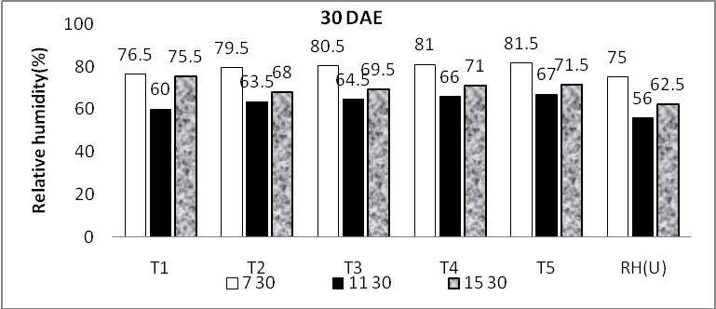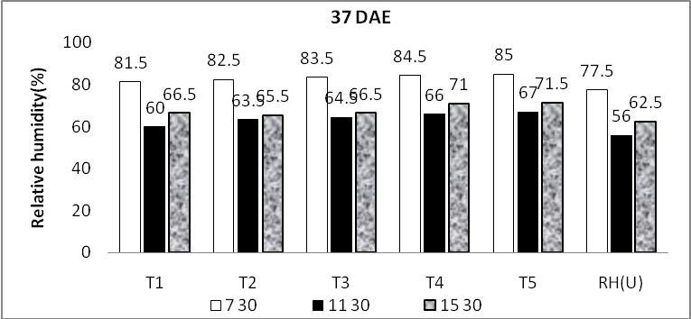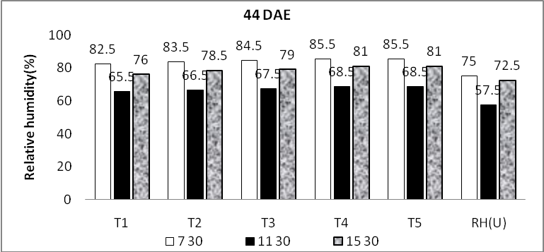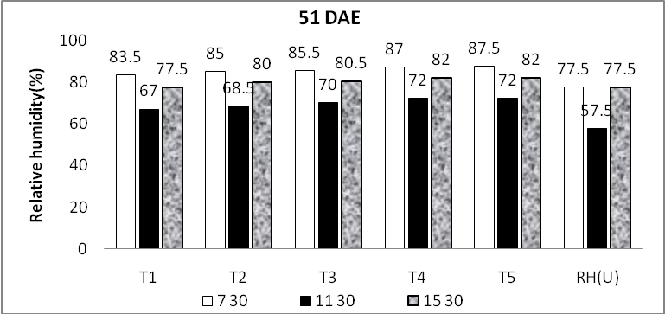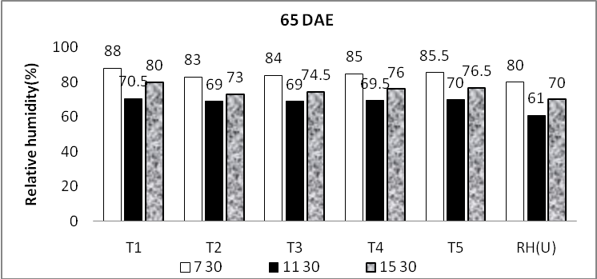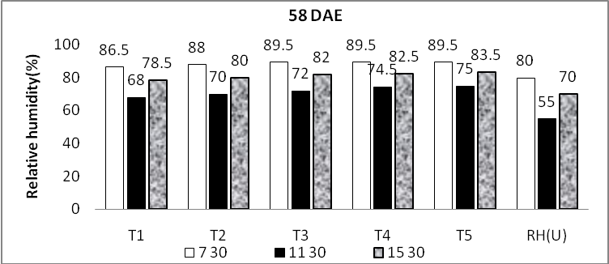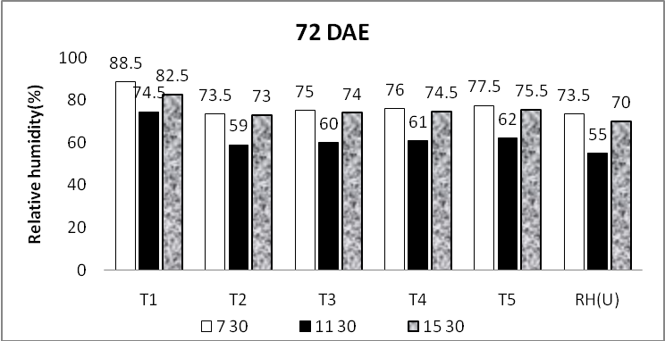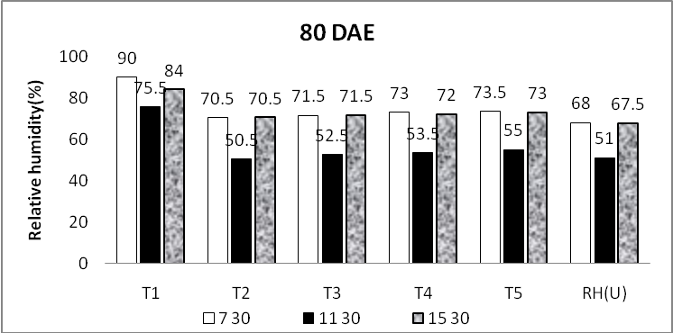

Fig 1 Variation in Relative humidity(%) (mean) under wheat-mustard intercropping system (2009-10 and 2010-11)
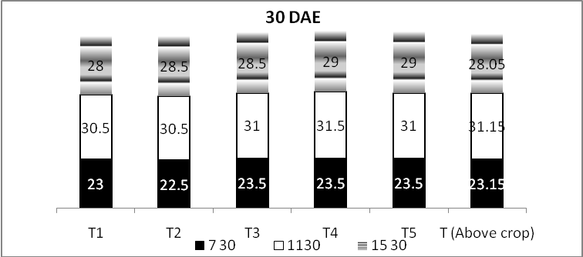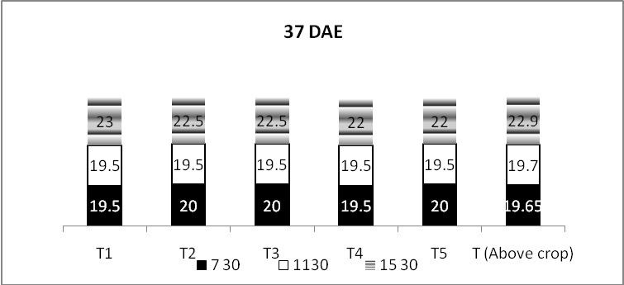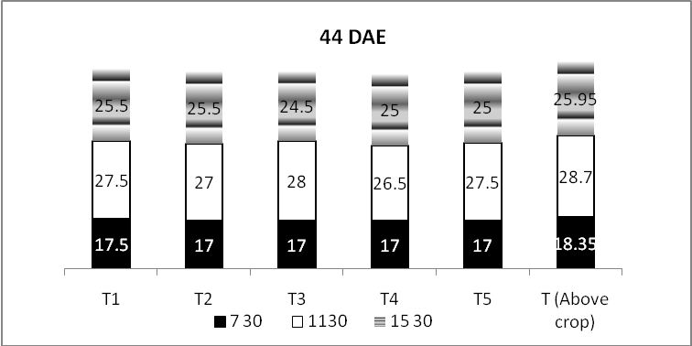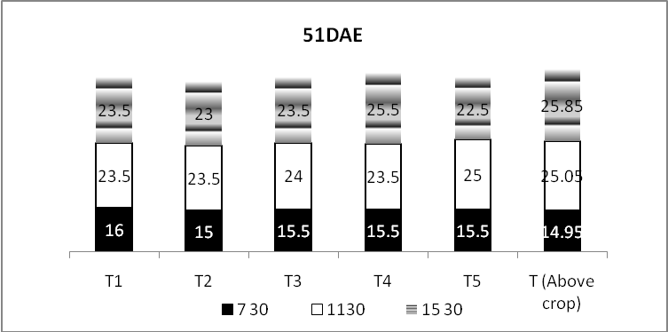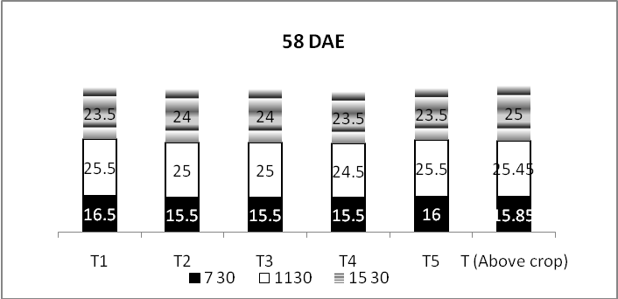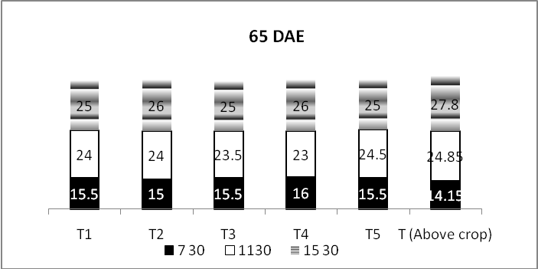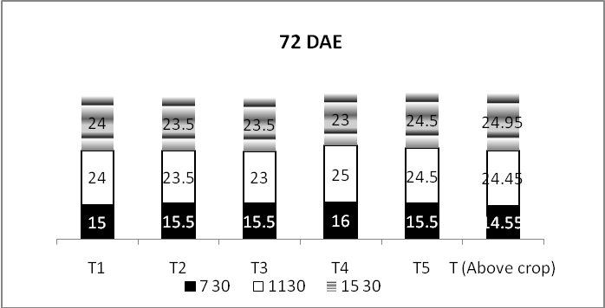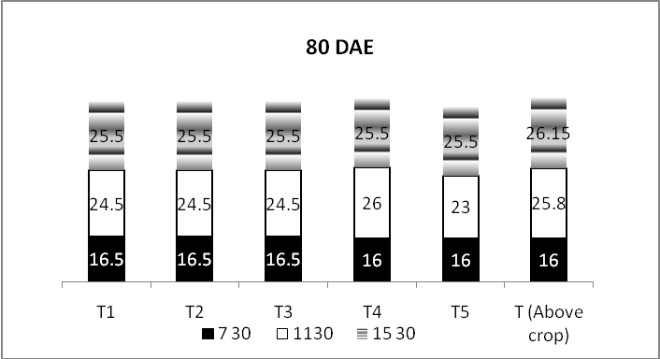
Fig 2 Variation in air temperature (⁰C) (mean) under wheat-mustard intercropping system ((2009-10 and 2010-11)

