Use of Trichoderma spp. as biocontrol agents to enhance disease tolerance in tomatoes

ABSTRACT

There is growing interest in the use of Trichoderma spp., beneficial soil fungi, as a sustainable alternative to chemical plant protection products in the cultivation of tomato (Solanum lycopersicum). This study aimed to evaluate the efficacy of three Trichoderma species (T. hamatum, T. virens, and T. asperellum), isolated from the rhizosphere of tomato plants in Côte d'Ivoire, as biocontrol agents to enhance tomato tolerance to various pathogens. The isolates were characterized through morphological observations and molecular analyses. Phylogenetic analysis revealed a high degree of similarity between the locally isolated species and those previously identified in China. The impact of these Trichoderma strains on tomato plant roots was assessed, showing a significant increase in root dry matter, with results comparable to those obtained using chemical fertilizers, relative to the untreated control. Symptoms of wilting and chlorosis were observed in both control plants and those treated with either Trichoderma isolates or a chemical plant protection product. However, plants treated with T. asperellum exhibited a higher incidence of wilt. In contrast, T. virens and T. hamatum contributed to enhanced disease resistance and greater tolerance to abiotic stresses in tomato plants.

Keywords: Tomato, Trichoderma spp., morphological characterisation, molecular characterisation, disease resistance

1. INTRODUCTION

Tomato (Solanum lycopersicum L.), a member of the Solanaceae family, is an annual herbaceous plant. It ranks second worldwide in both production and consumption, after the potato (INRA, 2010). Tomato consumption provides essential minerals, vitamins, amino acids, sugars, and dietary fiber (Camille, 2009). As such, tomatoes are important for human health and have been linked to reduced risks of several diseases, including prostate cancer and heart disease (Wilcox et al., 2003). It is the most widely consumed vegetable in the world (Djidji et al., 2010).
In Côte d'Ivoire, tomato is the second most consumed vegetable after chili pepper (Bancal and Tano, 2019). In 2022, its production was estimated at 44,578.83 tons (FAOSTAT, 2023). Despite this significant output, tomato cultivation is under threat from numerous parasitic attacks. These infections cause considerable damage to tomato crops and economic losses for farmers. Among the main constraints, fungal, bacterial and viral diseases are the most harmful to tomato development (Fondio et al., 2013).
To combat these diseases, some producers have relied heavily on synthetic fertilizers and plant protection products, often used in an unregulated and excessive manner (Francesco et al., 2008). However, these products are expensive, harmful to the environment and leave toxic residues on harvested crops (Naseby et al., 2000). In response to increasingly stringent environmental regulations set by the international agricultural community, the search for alternatives to synthetic fertilizers is actively encouraged. One promising approach for managing bacterial, viral and fungal diseases is the use of biological control agents such as antagonistic fungi like trichoderma, etc.
The genus Trichoderma includes fungi that are widespread in various ecosystems, especially in soils, the rhizosphere and decaying plant material (Elkhateeb et al., 2021). Certain Trichoderma strains exhibit strong rhizosphere competence, which is essential for establishing beneficial interactions with plants, promoting plant growth and biocontrol of pathogens (Ansari and Ahmad, 2018). Trichoderma species are among the most widely used biological control agents against plant pathogens and are also a source of enzymes and secondary metabolites with biotechnological potential (Sadfi et al., 2008). The presence of Trichoderma spp. in the soil contributes to both preventive and curative effects on plant health (Harman et al., 2004).
The abundance of Trichoderma spp. in ecosystems is largely due to their ability to produce various bioactive compounds and enzymes, making them a key player in biological networks (Mohamed, 2006). Healthy and abundant roots provide a favorable environment for the proliferation of Trichoderma spp. (Woo and Pepe, 2018). These fungi have developed multiple mechanisms not only to attack other fungi but also to enhance plant and root development (Harman, 2006). New models describing the direct mechanisms of Trichoderma action against pathogenic fungi emerged in the early 2000s (Harman et al., 2004). Their multifaceted activity includes direct interactions such as antibiosis and mycoparasitism, as well as indirect mechanisms like competition for nutrients and space, induction of systemic resistance (ISR), and overall improvement of plant health (Thangaraj et al., 2025).
Antibiosis is a key strategy used by Trichoderma species, involving the production of antimicrobial compounds to inhibit or eliminate neighboring microorganisms (Giraud, 2018). This allows them to colonize ecological niches ahead of potential pathogens (Meriem, 2010). Trichoderma can thrive under low-nutrient conditions compared to other fungi (Giraud, 2018). Their strains are also capable of secreting hydrolytic enzymes such as glucanases, chitinases and proteases to degrade the cell walls of phytopathogenic fungi (Howell, 2003). Once established, Trichoderma spp. can have a stimulating effect on plant morphological traits (Sood et al., 2020). These capabilities make Trichoderma a valuable ally in strengthening plant disease tolerance, particularly within the framework of sustainable agriculture.
This study was conducted to evaluate the effectiveness of three Trichoderma species (T. hamatum, T. virens and T. asperellum), isolated from the rhizosphere of tomato plants in Côte d'Ivoire, as biocontrol agents for enhancing tomato tolerance to various pathogens.

2. material and methods

2.1 Isolation and Identification of Trichoderma Species
Three species of Trichoderma (T. hamatum, T. virens and T. asperellum) were isolated from tomato rhizosphere soils collected from four peri-urban cultivation areas in Côte d’Ivoire (Abidjan, Yamoussoukro, Bouaké, and Korhogo). The fungi were isolated using a sorghum grain trapping method and cultured on Potato Dextrose Agar (PDA) medium. Fungal strains were purified through three successive subcultures (Compaoré et al., 2016), then characterized based on morphological traits such as colony color, growth rate, and conidiophore structure. Identification was confirmed by PCR amplification of the Internal Transcribed Spacer (ITS) regions of ribosomal DNA.

2.2 Phylogenetic Analysis
Sequence alignment was performed according to the method of Kumar et al. (2018) to assess genetic similarities and differences between the consensus sequences and those listed in GenBank. Sequences were aligned using the "ClustalW" algorithm in MEGA X software (version 11.0.13). A phylogenetic tree was constructed using FigTree software.

2.3 Evaluation of the Effects of Trichoderma Species on Tomato Plants

2.3.1 Experimental Design
The experiment was conducted using five 54 m² plots (3 m × 18 m) . Three plots received treatments with spore suspensions of Trichoderma, while one served as a chemical control (NPK 12-22-22) and another as an organic control (Agri-bionat). Each plot contained 45 tomato plants arranged in three rows, totaling 225 plants.
Thirty days after sowing, only healthy and vigorous seedlings were transplanted at a spacing of 50 cm on 10-meter ridges. A 2-meter distance was maintained between plots. Trichoderma spore suspensions (10⁸ conidia/mL) were applied both to the soil and to the foliage at the time of transplanting and reapplied every two weeks.
Chemical fertilizer was applied at a rate of 60 g of NPK (15-15-15) per plot one day before transplanting. Organic amendment (Agri-bionat) was applied at a rate of 50 kg per plot for both the organic control and Trichoderma-treated plots. Watering was done daily after transplanting, then reduced to every three days starting from day 30.

2.3.2 Foliar and Root Dry Matter
Sixty days after transplanting, tomato plants were dried in an oven at 27°C for 7 days. After drying, root biomass was weighed using a precision balance.

2.3.3 Disease Symptom Identification
Symptoms were observed and recorded 15, 30 and 45 days after inoculation. The prevalence of symptoms was determined by counting the number of plants showing each symptom and dividing that number by the total number of plants in the population, following the method of Banito et al. (2021).

Prevalence = Pi /Pt x 100 Pi: number of plants exhibiting a specific type of symptom
Pt: total number of symptomatic plants

2.3.4 Statistical Analyses
The Kruskal-Wallis ANOVA test was used to analyze the effect of the most effective Trichoderma species on root dry matter and symptom prevalence in tomato plants. When a significant difference was detected at the 5% level, pairwise comparisons were performed using the Mann-Whitney U test to identify statistically homogeneous groups.
All data analyses in this study were conducted using RStudio software, version 4.2.2 (R Core Team, 2022).

3. results and discussion

3.1 Morphological Characterization of the Three Trichoderma Species (T. hamatum, T. virens, and T. asperellum)

After three days of incubation on PDA medium, the three Trichoderma species (T. hamatum, T. virens, and T. asperellum) developed white fungal colonies. From the fifth day of culture, T. virens and T. asperellum exhibited a color change, gradually shifting from white to green. In contrast, the colony of T. hamatum remained white with a slight beige tint (Table 1). This result could be explained by its adaptation to the culture medium, temperature, lighting, or humidity. Togbé et al. (2024) showed that temperature highly influences the mycelium color, reverse color, the presence or absence of a ring, and mycelial growth of all isolates.
Microscopic observation of the three Trichoderma species revealed similar morphological characteristics, particularly in the shape and coloration of the conidia. Branched mycelia were observed, grouped in clusters of 2 to 4, along with phialides bearing conidia at their tips (Fig. 1). These conidia were round and green in color. This result is consistent with that of Muljowati et al. (2025). According to these authors, the main characteristic of Trichoderma species is their branched conidiophores bearing conidia. The morphological characterization allowed us to confirm the presence of the genus Trichoderma. However, it was necessary to identify the different species of Trichoderma, which is why molecular analysis was used. Indeed, according to Togbé et al. (2024), molecular characterization is essential to determine the species derived from Trichoderma sp. isolates.

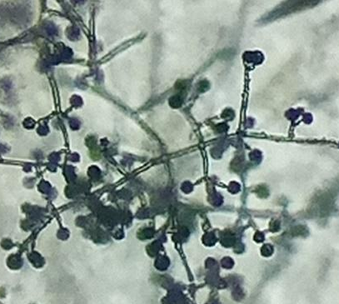
conidium
phialides
GX 40
Fig. 1 : Microscopic Characteristics of Trichoderma asperellum
Table 1 : Morphological Characterization of Trichoderma Species (T. asperellum, T. virens, and T. hamatum)
Trichoderma Species | Macroscopic Features |  | Microscopic Features | Descriptions
Trichoderma Species | Face | Reverse | Microscopic Features | Descriptions
Trichoderma Asperellum | 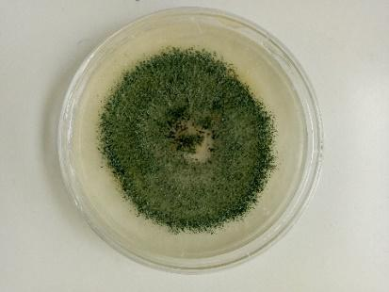  3 cm | 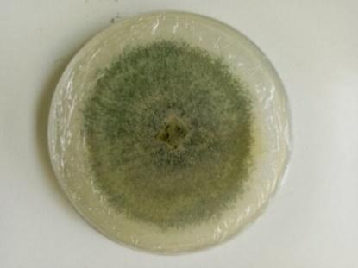  3 cm | 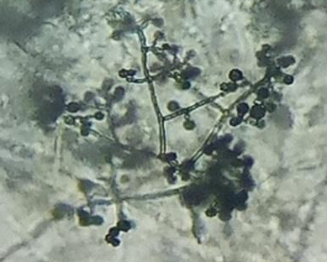  GX 40 | Thallus color: green;  Structure: dense central condensation in the fungal colony;  Reverse side: translucent;  General appearance: powdery.
Trichoderma virens | 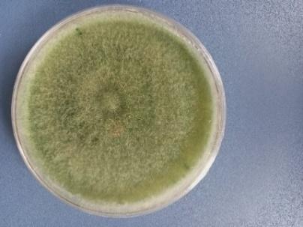  3 cm | 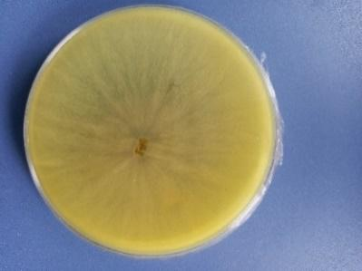  3 cm | 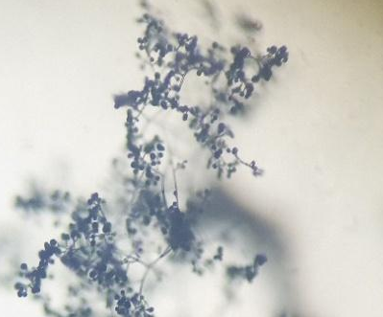  GX 40 | Thallus color: green  Features: presence of green concentric rings  Reverse side: translucent  General appearance: cottony
Trichoderma Hamatum | 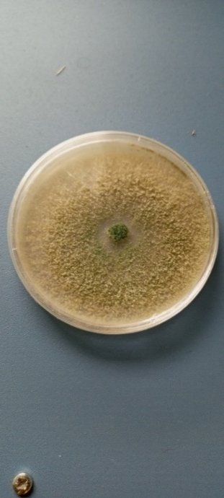  3 cm | 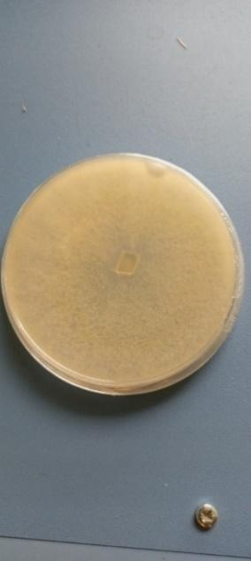  3 cm | 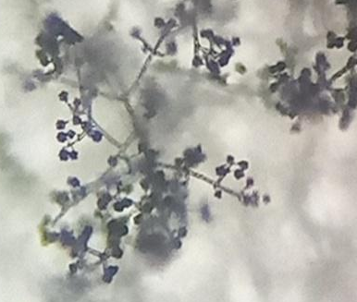  GX 40 | Thallus color: beige  Features: presence of green pustules  Reverse side: beige  General appearance: cottony

3.2 Molecular characterization of the three Trichoderma Species (T. hamatum, T. virens, And T. asperellum)
The sequences of the three Trichoderma species (T. hamatum, T. virens, and T. asperellum) isolated from the rhizosphere of tomato plants showed similarities with those previously identified in the NCBI (National Center for Biotechnology Information) database (Table 2). Raja et al. (2017) indicated that the attribution of a species name based on results obtained from GenBank BLAST search is made when the coverage rate is greater than or equal to 80% and the similarity rate is greater than or equal to 97%.

3.3 Phylogenetic analysis
The phylogenetic tree, constructed from the three Trichoderma species sequences and sequences available in the NCBI (National Center for Biotechnology Information) database, was rooted on the Trichoderma virens sequence described in Malaysia (OP797633.1). The structure of the tree revealed the presence of two clades (Fig. 2).
The first clade included the Trichoderma virens sequence described in China (MK870715.1 and MT102393.1), Indonesia (OK336353.1), and in this study (PQ159271).
The second clade grouped the Trichoderma asperellum sequences described in China (MT102403.1, OP794016.1, OQ657936.1, MK210235.1, and OP794023.1), Egypt (LC738840.1), India (KT582304.1), and in this study (PQ159275), along with the Trichoderma hamatum sequence (PQ159273) described in this study.
Considering the phylogenetic distance, the Trichoderma virens sequence identified in this study was found to be closer to the one described in China (MT102393.1). The Trichoderma asperellum sequence identified in this study was closer to the one described in China (OP794016.1). The Trichoderma hamatum sequence identified in this study was closer to the Trichoderma asperellum sequence (MT102403.1) described in China.
This result could also be explained by intercontinental exchanges facilitated by human activities such as the trade of seeds and plants. Nakkeeran et al. (2021) emphasized that the introduction of exogenous microorganisms, particularly through biocontrol commercial products or in scientific research, constitutes an increasing threat to the indigenous microbiota. The proximity between T. hamatum isolated from the tomato rhizosphere in this study and T. asperellum on the phylogenetic tree could be explained by very similar sequences in certain genetic regions. Chaverri and Samuels (2013) explain that the ecological evolution of these species of Trichoderma results from a combination of mutations, duplications, and gene losses that occurred in the common ancestor of Ascomycota and Basidiomycota.

Table 1 : Percentage of Homology of DNA Sequences of Trichoderma Species Obtained from GenBank
Trichoderma Morphotypes | Similar Accession Number | Coverage Rate (%) | Homology Percentage (%) | GenBank Accession Number
Trichoderma virens | MK791709 | 100 | 99,83 | PQ159271
Trichoderma asperellum | OP794016 | 100 | 99,50 | PQ159275
Trichoderma hamatum | MT111894 | 100 | 100 | PQ159273

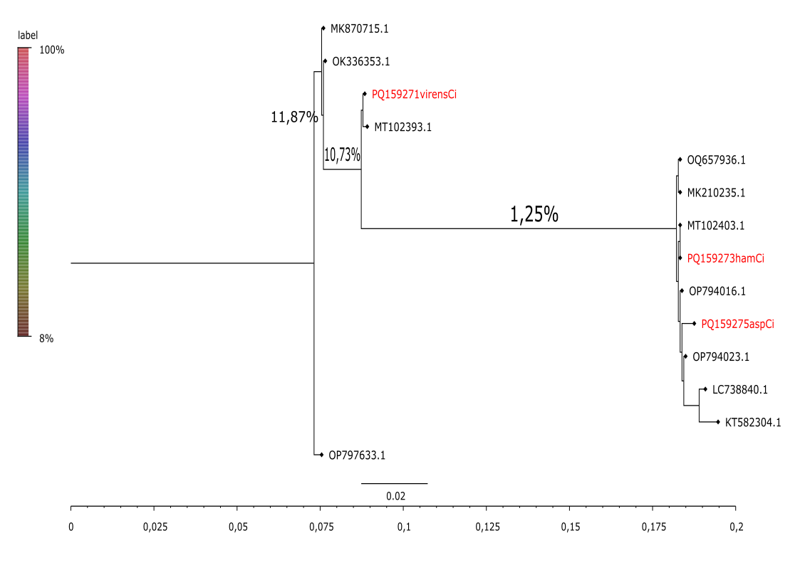
Fig. 2 : Phylogenetic Tree of Trichoderma spp.

3.4 Effect of the three Trichoderma species (hamatum, virens, and asperellum) on root dry matter
The Trichoderma species T. asperellum, T. hamatum, and T. virens, as well as the chemical treatment, demonstrated greater effectiveness in terms of tomato root dry matter compared to the control, which consisted of organic compost (Fig. 3). Among the treatments, T. hamatum was found to be the most effective in stimulating tomato root dry matter. However, statistical analysis revealed no significant difference (P > 0.05) in root dry mass among the tomato plants across treatments.
The species of Trichoderma represent an effective alternative to chemical inputs in tomato cultivation, due to their high potential in agriculture (Waghunde et al., 2016).
This result could be explained by the ability of Trichoderma spp. strains to stimulate the roots of tomato plants. However, several factors may explain why the difference was not significant. Indeed, environmental conditions (pH, temperature, humidity) can influence the effectiveness of the strains. Al-Ani (2018) showed that temperature has a more pronounced influence on Trichoderma than other factors such as pH, water potential, or the type of nutrient substrate. According to Renata et al. (2022), root colonization by Trichoderma spp. is closely associated with the production of cellulolytic, proteolytic, pectinolytic, and xylanolytic enzymes, which facilitate the degradation of plant cell walls and thereby promote the establishment of the fungus in the rhizosphere. However, water potential and pH significantly influence enzyme production by Trichoderma species (Kredics et al., 2004). Nieto-Jacobo et al. (2017) highlighted that abiotic factors such as pH and temperature influence the biosynthesis of indole-3-acetic acid (IAA) in fungi.

3.5 Symptoms observed on tomato plants
Various symptoms were observed on tomato plants throughout the experiment. These included yellowing and curling of the leaves, necrotic spots, wilting, and in some cases, complete plant collapse. The symptoms appeared progressively, and their intensity varied depending on the treatment. Plants from the control plot (treated only with organic compost) showed the highest prevalence of symptoms, while those treated with Trichoderma spp. exhibited fewer and less severe symptoms. The chemical treatment also reduced symptom expression, though not as effectively as certain Trichoderma strains.

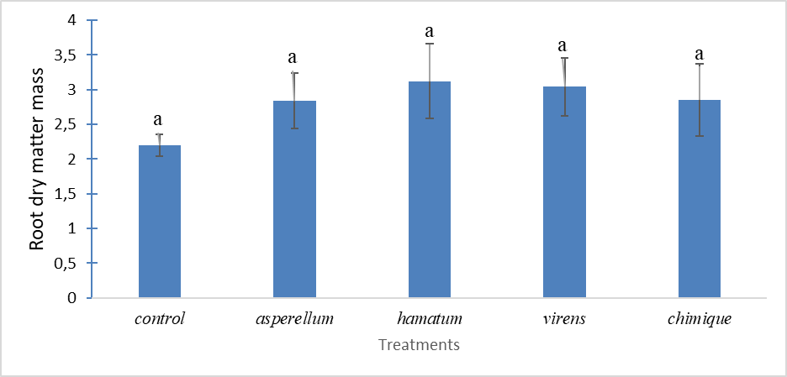
Fig. 3 : histogram showing the effect of Trichoderma species on the root dry weight of tomato plants.
Values followed by the same letter are not significantly different at the 5 % significance level.

3.6 Prevalence of disease symptoms on tomato plants
The prevalence of wilting symptoms ranged from 1.67% to 10%. The highest percentage of wilt symptom prevalence was observed in tomato plants treated with Trichoderma asperellum, while the lowest prevalence was recorded in plants treated with the chemical product. The latter could result from insufficient water supply to the roots, possibly linked to the high temperatures recorded in the cultivation area. Performance differences between Trichoderma spp. strains can also be explained by the variability of interactions with the targeted pathogens. Indeed, not all Trichoderma strains have the same antagonistic capacity, and their effectiveness can vary depending on the species or strain of the pathogen present (Alfiky et al., 2024). Moreover, unfavorable environmental conditions can worsen the physiological state of the plants. Hanaka et al. (2021) showed that abiotic stresses such as excessive temperature or water stress can alter the photosynthesis process, disrupt nutrient translocation, and imbalance the hormonal system of plants. These disturbances can induce cellular damage, thereby favoring the appearance of symptoms such as chlorosis and wilting. Statistical analysis revealed a significant difference in wilt symptom prevalence between treatments, with three homogeneous groups (P < 0.05) (Fig. 4).
The prevalence of chlorosis symptoms ranged from 3.6% to 11.6%. The highest prevalence was observed in plants treated with Trichoderma asperellum, whereas the lowest was found in those treated with Trichoderma virens. These results are consistent with the work of Olowe et al. (2022), who highlighted the central role of certain Trichoderma spp. strains in inducing plant defense mechanisms, either through the activation of systemic responses or by direct attack on pathogens. This induction of resistance is generally associated with an increase in the production of defensive metabolites and specific enzymes involved in plant defense mechanisms (Sood et al., 2020). Furthermore, Studholme et al. (2013) showed that the Trichoderma hamatum strain is capable of activating biological control mechanisms against soilborne pathogens, both in the pre- and post-emergence phases. It can also induce systemic resistance to foliar pathogens, thereby enhancing the overall protection of the plant. According to Renata et al. (2022), the success of Trichoderma spp. as biological control agents in soil ecosystems is based on their rapid growth, ability to exploit a wide range of organic substrates, and resistance to various toxic compounds, including some fungicides. Statistical analysis showed a significant difference in chlorotic leaf symptoms across treatments (P < 0.05), forming four homogeneous groups (Fig. 5).

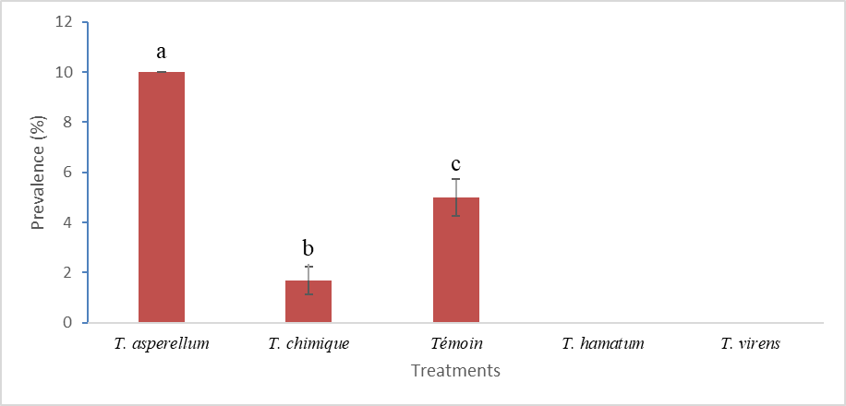

Fig. 4 : prevalence of wilting symptoms based on treatments
Values marked with the same letter are statistically equal at the 5% level.
Témoin = Control

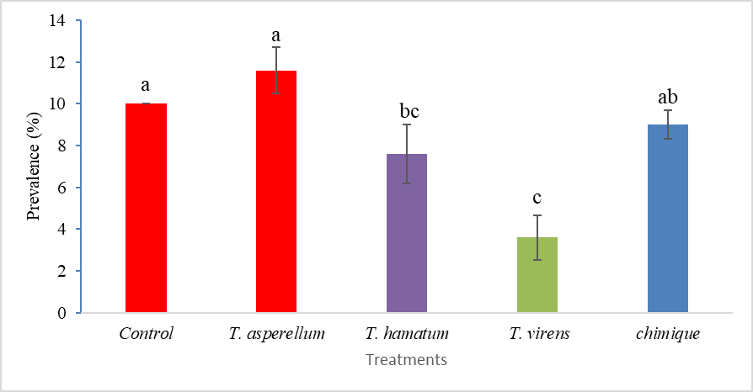

Fig. 5 : prevalence of chlorosis symptoms based on treatments
Values marked with the same letter are statistically equal at the 5% level.
Témoin = Control

4. Conclusion
The goal of this study was to evaluate the effectiveness of three Trichoderma species (T. hamatum, T. virens, and T. asperellum), isolated from the rhizosphere of tomato plants in Côte d'Ivoire, as biocontrol agents to enhance the tomato's tolerance to various pathogens.
These three species were distinguishable starting from the fifth day of culture based on the color of their colonies: T. virens and T. asperellum formed green colonies, while T. hamatum had a slightly beige colony. Microscopic observation revealed similar morphological characteristics among the three species, particularly in the conidiophores.
Molecular identification confirmed the affiliation of these isolates to the mentioned species, with a homology percentage ranging from 99.50% to 100%. Phylogenetic analysis showed a strong proximity between the sequences of the studied isolates and those of strains described in China.
In agronomic terms, treatments with T. asperellum, T. hamatum, and T. virens improved the root dry matter of tomato plants, with performances comparable to those achieved with chemical fertilizers, compared to the untreated control. However, statistical analysis did not reveal significant differences between the Trichoderma treatments and the control.
Symptoms of wilting and chlorosis were observed both in control plants and those treated with Trichoderma isolates or a chemical pesticide. Plants treated with T. asperellum exhibited a higher prevalence of symptoms, particularly wilting. In contrast, T. virens and T. hamatum contributed to improving the tomato plants' resistance to diseases and tolerance to abiotic stress.

References
Al-Ani, L. K. T. (2018). Trichoderma from Extreme Environments: Physiology, Diversity, and Antagonistic Activity. Springer, 8, 389-403.
Alfiky, A., Abou, M. E., De Vrieze, M., L’Haridon, F., & Weisskopf, L. (2024). Newly Isolated Trichoderma spp. Show Multifaceted Biocontrol Strategies to Inhibit Potato Late Blight Causal Agent Phytophthora infestans both In Vitro and In Planta. Phytobiomes Journal, 8, 70-84.
https://doi.org/10.1094/PBIOMES-01-23-0002-R.
Ansari, F., & Ahmad, I. (2018). Biofilm Development, Plant Growth Promoting Traits and Rhizosphere Colonization by Pseudomonas entomophila FAP1: A Promising PGPR. Advances in Microbiology, 8, 235-251. DOI : 10.4236/aim.2018.83016
Bancal, V., & Tano, K. (2019). Etude des Modalités de Réduction des Pertes Après Récolte dans les Cultures Maraichères en Côte d’Ivoire. Projet (PRO2M), 1-91.
Banito, A., Kpemoua, E. K., Dayiwo, R. K., Tedihou, E., & Sikirou, R. (2021) Inventaire des maladies de l’anacardier (Anacardium occidentale L.) dans la préfecture de Tchamba au Togo. International Journal of Biological and Chemical Sciences, 15(6), 2514-2525.
DOI : 10.4314/ijbcs.v15i6.21
Camille., (2009). Les virus des cultures de melon et de courgette de plein champ. PHM-Revue horticole, 324, 15-25.
Chaverri, P., & Samuels, G. J. (2013). Evolution of habitat preference and nutrition mode in a cosmopolitan fungal genus with evidence of interkingdom host jumps and major shifts in ecology. Evolution, 67(10), 2823-2837. https://doi.org/10.1111/evo.12169.
Compaoré, H., Lingani, H. S., Savadogo, A., Dianou, D., & Traore, A. S. (2016). Isolement et caractérisation morphologique de moisissures productrices de substances antibactériennes à partir d’aliments locaux au Burkina Faso. International Journal Biological. Chemical Sciences, 10(1), 198-210. 10.4314/ijbcs.v10i1.15.
Djidji, A. H., Zohouri, G. P., Fondio, L., N’zi, J. C., & Kouamé, N. C. (2010). Effet de l’abri sur le comportement de la tomate (Solanum lycopersicum L.) en saison pluvieuse dans le Sud de la Côte-d’Ivoire. Journal of Applied Biosciences, 25, 1557-1564.
Elkhateeb, W. A., Elnahas, M. O., Daba, G. M., & Zohri, A. N. A. (2021). Biotechnology and environmental applications of Trichoderma spp. Research Journal of Pharmacognosy and Phytochemistry. 13(3), 101-109. http://dx.doi.org/10.52711/0975-4385.2021.00025.
FAOSTAT. (2023). Food and Agriculture Organization of the United Nations. Consultable à https://www.fao.org/faostat/fr/#data/QCL le 13-06-2024 à 12 h 19 min.
Fondio, L., Djidji, H. A., N’gbesso., F. P. M., & Kone, D. (2013). Evaluation de neuf variétés de tomate (Solanum Lycopersicum L.) par rapport au flétrissement bactérien et à la productivité dans le Sud de la Côte d’Ivoire. International Journal of Biological and Chemical Sciences, 7(3), 1078-1086. 10.4314/ijbcs.v7i3.15.
Francesco, V., Krishnapillai, S., Emilio, L. G, Roberta, M., Sheridan, L. W., & Matteo, L. (2008). Trichoderma - Interactions plantes - pathogènes. Biologie et biochimie des sols, 40, 1-10.
Giraud, R., (2018). Trichoderma une solution de biocontôle. Clinique du gazon, http://cliniquedugazon.fr/index.php/2018/08/10/trichoderma-une-solution-de-biocontrole/ consulté le 04/06/2021.
Hanaka A., Ozimek E., Reszczynska E., Jaroszuk-Sciseł J., & Stolarz M. (2021). Plant Tolerance to Drought Stress in the Presence of Supporting Bacteria and Fungi: An Efficient Strategy in Horticulture. Horticulturae, 7(390), 1-21.
https://doi.org/10.3390/horticulturae7100390.
Harman, G. E. (2006). Trichoderma spp. Including T. harzianum, T. viride, T. kongii, T. hamatum and other spp. Deuteromycetes, Moniliales (asexual classification system). Biological Control, https://biocontrol.entomology.cornell.edu/pathogens/trichoderma.php consulté le 11/06/2021.
Harman, G.E., Howell, C.R., Viterbo, A., Chet, I., & Lorito, M. (2004). Trichoderma species-opportunistic, a virulent plant symbiont. Nature Reviews Microbiology, 2, 43-56.
Howell, C.R. (2003). Mechanisms employed by Trichoderma species in the biological control of plant diseases: The history and evolution of current concepts. Plant Disease, 87, 4-10.
https://doi.org/10.1094/PDIS.2003.87.1.4.
INRA. (2010). Légumes. Ephytia.inra.fr/tomate/importance économique. Consulté le 24/06/2016.
Kredics, L., Antal, Z., Manczinger, L., Szekeres, A., Kevei, F., & Nagy, E. (2003). Influence of Environmental Parameters on Trichoderma Strains with Biocontrol Potential. Food Technology and Biotechnology, 41, 37-42.
Kredics, L., Manczinger, L., Antal, Z., Pénzes, Z., Szekeres, A., Kevei, F., & Nagy, E. (2004). In vitro water activity and pH dependence of mycelial growth and extracellular enzyme activities of Trichoderma strains with biocontrol potential. Journal of Applied Microbiology, 96, 491-498. https://doi.org/10.1111/j.1365-2672.2004.02167.x.
Kumar, S., Stecher, G., Li, M., Knyaz, C., & Tamura, K., (2018). MEGA X: Molecular Evolutionary Genetics Analysis across Computing Platforms. Molecular Biology and Evolution, 35 (6), 1547-1549.
Meriem, M. (2010). Développement et extraction des métabolites secondaires de Trichoderma viride et leurs effets biologiquement actifs. Université Mentouri Constantine Faculté des Sciences de la Nature et de la Vie Département de Biochimie et Microbiologie (Mémoire de Master), 2-17.
Mohamed, B. M. (2006). Evaluation du risque fongique en zones conchylicoles : substances toxiques de souches marines du genre Trichoderma. Université de Nante : Faculté des sciences pharmaceutiques (Thèse de Doctorat), 9-13.
Muljowati, J. S., Oedjijono, O., Dewi, R. S., Mariana, A., & Chemeltorit, P. (2025). Exploration and morphological characterization of Trichoderma spp from organic waste at TPST Rempoah-Baturraden, Banyumas Regency. Web of Conferences, 1-3.
https://doi.org/10.1051/e3sconf/202560901003:
Nakkeeran, S., Marimuthu, T., Renukadevic, P.​, Brindhadevic, S.​, & Jogaiah, S. (2021). Exploring the biogeographical diversity of Trichoderma for plant health. In Biocontrol agents and secondary metabolites. Woodhead Publishing, 537-571.
https://doi.org/10.1016/B978-0-12-822919-4.00024-7.
Naseby, D. C., Pascual, J. A., & Lynch, J. M. (2000). Effect of biocontrol strains of Trichoderma on plant growth, Pythium ultimum population, soil microbial communities and soil enzyme activities. Journal of Applied Microbiology, 88, 161-169.
Nieto-Jacobo, M. F., Steyaert J. M., Salazar-Badillo, F. B., Nguyen, D. V., Rostás, M., Braithwaite, M., De Souza J. T., Jimenez-Bremont, J. F., Ohkura, M., Stewart, A., & Mendoza-Mendoza, A. (2017). Environmental Growth Conditions of Trichoderma spp. Affects Indole Acetic Acid Derivatives, Volatile Organic Compounds, and Plant Growth Promotion. Frontiers in Plant Science, 8, 1-18. https://doi.org/10.3389/fpls.2017.00102.
Olowe, M. O., Nicola, L., Asemoloye, M. D., Akanmu, A. O., & Babalola, O. O. (2022). Trichoderma: Potential bio-resource for the management of tomato root rot diseases in Africa. Microbiological Research, 257, 1-14. https://doi.org/10.1016/j.micres.2022.126978.
R Core Team. (2022). R: A language and environment for statistical computing. R Foundation for Statistical Computing, Vienna, Austria. URL: https: //www.R-project.org/.
Raja, H. A., Miller, A. N., Pearce, C. J., & Oberlies, N. H. (2017). Fungal Identification Using Molecular Tools: A Primer for the Natural Products Research Community. Journal of Natural Products, 80, 756-770. https://doi.org/10.1021/acs.jnatprod.6b01085.
Renata, T., Artur, N., Ewa, O., & Jolanta, J. S., (2022). Trichoderma: The Current Status of Its Application in Agriculture for the Biocontrol of Fungal Phytopathogens and Stimulation of Plant Growth. International Journal of Molecular Sciences, 23(29), 1-28.
Sadfi, Z. N., Rouaissi, M., Essghaier, B., Hajlaoui, M. R., Hermosa, M. R., & Boudabous, A. (2008). Identification morphologique et moléculaire d’espèces du genre Trichoderma isolées de différents sols Tunisiens. Microbiologie et Hygiène Alimentaire, 20(57), 9-15.
Sood, M., Kapoor, D., Kumar, V., Sheteiwy, M. S., Ramakrishnan, M., Landi, M., Araniti, F., & Sharma, A. (2020). Trichoderma: The “Secrets” of a Multitalented Biocontrol Agent. Plants, 9(762), 1-25. https://doi.org/10.3390/plants9060762.
Studholme, D. J., Harris, B., Le Cocq, K., Winsbury, R., Perera, V., Ryder, L., Ward, J., Beale, M. H., Thornton, C. R., & Grant, M. (2013). Investigating the beneficial traits of Trichoderma hamatum GD12 for sustainable agriculture—insights from genomics. Frontiers in Plant Science, 4, 1-13. https://doi.org/10.3389/fpls.2013.00258.
Thangaraj, P., Balamurali, A. S, & Muthusamy, N. (2025). Biological control of Trichoderma spp.: Mechanisms of action against phytopathogens, insect pests, and its multifaceted roles in agro-ecosystems. Environment Conservation Journal, 26(1), 302-314.
https://doi.org/10.36953/ECJ.28922909.
Togbé, E. C., Badou, A. A., Mensah, E. J-P. A., & Ahohuendo, B. C. (2024). Caractérisation phénotypique des espèces locales de Trichoderma sous différentes températures dans les systèmes de culture à base de plantain au Sud Bénin. Afrique Science, 24(1), 83-97.
Waghunde, R. R., Shelake, R. M., & Sabalpara, A. N. (2016). Trichoderma: A significant fungus for agriculture and environment. African Journal of Agriculture Research, 11(22), 1952-1965.
https://doi.org/10.5897/AJAR2015.10584.
Wilcox, J. K., Catignani, G. L., & Lazarus, S. (2003). Tomates and cardiovascular health. Critical Reviews in Food Science and Nutrition, 43, 451-4.
Woo, S. L., & Pepe, O. (2018). Microbial consortia: promising probiotics as plant biostimulants for sustainable agriculture. Frontiers in Plant Science, 9, 1-6.
https://doi.org/10.3389/fpls.2018.01801.
Zhao L., Wang F., Zhang Y., Zhang J., (2014). Involvement of Trichoderma asperellum strain T6 in regulating iron acquisition in plants. Journal of Basic Microbiology, 54: 115-124.
https://doi.org/10.1002/jobm.201400148.

