Review Article
Next-Generation Nutrient Management Strategies for Wheat: Enhancing Productivity and Soil Quality

Abstract:
Wheat (Triticum aestivum L.) is a staple food crop worldwide, and optimizing its nutrient management is crucial for sustainable production. This review explores next-generation strategies for enhancing wheat productivity and soil quality through innovative nutrient management approaches. We discuss precision agriculture techniques, such as site-specific nutrient management and variable rate fertilization, which can improve nutrient use efficiency and reduce environmental impacts. The role of organic amendments, including compost, manure, and biochar, in improving soil health and nutrient availability is also examined. Additionally, we highlight the potential of plant growth-promoting rhizobacteria and mycorrhizal fungi to enhance nutrient uptake and plant growth.
Keywords: Wheat, Nutrient Management, Precision Agriculture, Organic Amendments, Remote Sensing, Crop Models, Decision Support Systems, Sustainable Agriculture
- Introduction Wheat is one of the most important cereal crops globally, providing a significant portion of the world's food supply. Proper nutrient management is essential for optimizing wheat productivity and maintaining soil health. Traditional nutrient management practices, such as blanket fertilizer applications, often lead to inefficient nutrient use and environmental problems, such as nutrient leaching and greenhouse gas emissions [1].
Next-generation nutrient management strategies for wheat involve a combination of precision agriculture techniques, organic amendments, microbial inoculants, remote sensing technologies, and decision support systems. These strategies aim to optimize nutrient use efficiency, improve soil quality, and reduce the environmental footprint of wheat production. Precision agriculture techniques, such as site-specific nutrient management and variable rate fertilization, enable farmers to apply nutrients based on the spatial variability of soil properties and crop requirements [2].
Organic amendments, such as compost, manure, and biochar, can improve soil health by increasing soil organic matter content, enhancing nutrient availability, and promoting beneficial microbial activity [3]. These amendments can also reduce the reliance on synthetic fertilizers and improve the long-term sustainability of wheat production systems. Plant growth-promoting rhizobacteria (PGPR) and mycorrhizal fungi are microbial inoculants that can enhance nutrient uptake, improve plant growth, and increase stress tolerance in wheat [4]. Remote sensing and geospatial technologies have emerged as powerful tools for monitoring crop nutrient status and soil properties in real-time [5]. These technologies, such as satellite imagery, unmanned aerial vehicles (UAVs), and soil sensors, can provide valuable information for optimizing nutrient management decisions. Crop simulation models and decision support systems can further aid in developing site-specific nutrient management strategies by integrating data from various sources and providing recommendations based on crop growth, soil properties, and weather conditions [6].
Case studies from various regions worldwide demonstrate the successful implementation of these next-generation nutrient management strategies in wheat production systems. For example, a study in China showed that site-specific nutrient management using soil testing and GIS-based fertilizer recommendations led to a 12% increase in wheat yield and a 20% reduction in nitrogen fertilizer use compared to traditional practices [7]. Another case study in Australia found that the use of variable rate nitrogen fertilization based on crop canopy sensors resulted in a 10-15% increase in wheat yield and a 15-20% reduction in nitrogen application [8 and 9].
Precision Agriculture Techniques
2.1. Site-Specific Nutrient Management : Site-specific nutrient management (SSNM) is a precision agriculture approach that involves applying nutrients based on the spatial variability of soil properties and crop requirements within a field [2]. This approach recognizes that soil fertility and crop nutrient needs can vary significantly within a field due to factors such as soil type, topography, and management history. By mapping this variability using geospatial technologies, such as global positioning systems (GPS) and geographic information systems (GIS), farmers can develop site-specific nutrient management plans that optimize nutrient application rates and placement [10-14].
Case Study: SSNM in Indian Wheat Production : A study conducted in the Indo-Gangetic Plains of India demonstrated the effectiveness of SSNM in improving wheat productivity and nutrient use efficiency [15].
2.2. Variable Rate Fertilization :Variable rate fertilization (VRF) is another precision agriculture technique that involves applying fertilizers at varying rates within a field based on the spatial variability of soil properties and crop requirements [16]. VRF is often used in conjunction with SSNM to optimize nutrient application and improve nutrient use efficiency. With VRF, fertilizers are applied using specialized equipment, such as variable rate spreaders or sprayers, that can adjust the application rate on-the-go based on GPS-guided prescription maps [17-21].
Case Study: VRF in US Wheat Production: A three-year study conducted in Oklahoma, USA, evaluated the performance of variable rate nitrogen fertilization in winter wheat production [22]. Researchers used a combination of soil sampling, crop canopy sensing, and yield mapping to develop variable rate nitrogen prescriptions.
Organic Amendments
3.1. Compost : Compost is an organic amendment that is produced by the controlled decomposition of organic materials, such as crop residues, manure, and food waste [23]. Compost is rich in nutrients and organic matter, and can improve soil health and fertility when applied to agricultural fields. In wheat production, compost can be used as a soil conditioner and nutrient source, either alone or in combination with other fertilizers [24].
One of the main benefits of using compost in wheat production is its ability to improve soil physical properties, such as structure, porosity, and water-holding capacity [25]. Compost contains a high proportion of stable organic matter, which can help to build and maintain soil structure over time. This can lead to better root growth and development, as well as improved water infiltration and retention in the soil [26]. Compost can also increase soil microbial activity and diversity, which can enhance nutrient cycling and plant growth [27-33].
Case Study: Compost Application in Egyptian Wheat Production A field experiment conducted in Egypt investigated the effects of compost application on wheat growth, yield, and soil properties [34]. The study compared three treatments: control (no compost), low compost rate (5 tons per hectare), and high compost rate (10 tons per hectare). Compost was applied before planting and incorporated into the soil.
3.2. Manure: Manure is another organic amendment that can be used to improve soil health and fertility in wheat production systems. Manure is the solid and liquid waste produced by livestock, such as cattle, pigs, and poultry, and can contain significant amounts of nutrients and organic matter [35]. Like compost, manure can be used as a soil conditioner and nutrient source in wheat production, either alone or in combination with other fertilizers [36-46].
Biochar Application in Wheat Production Systems
Biochar is a carbon-rich material produced through the pyrolysis of organic biomass under low oxygen conditions [49]. This highly porous material has gained significant attention for its potential to improve soil health and fertility in wheat production systems.
Key Benefits
Biochar offers multiple advantages for wheat cultivation:
- Improved Soil Physical Properties: Enhances soil structure, porosity, and water-holding capacity, leading to better root development and increased yields [52]
- Enhanced Nutrient Efficiency: Acts as a slow-release fertilizer while reducing nutrient leaching through increased cation exchange capacity [54, 55, 56]
- Environmental Benefits: Increases soil carbon sequestration and reduces greenhouse gas emissions, supporting climate change mitigation efforts [53]
- Reduced Environmental Impacts: Decreases water pollution and eutrophication through improved nutrient retention [57]
Application Guidelines
For effective biochar implementation in wheat production, farmers should consider:
- Feedstock Selection: Biochar properties vary widely depending on source materials (crop residues, wood waste, manure) and pyrolysis conditions [59]
- Application Rates: Typically 5-20 tons per hectare, adjusted based on soil type and fertility status [60]
- Timing: Apply before planting or during early growth stages for optimal results [61]
- Method: Either incorporate into soil through tillage or apply to the surface [61]
Case Study: Biochar Application in Australian Wheat Production A field trial in Australia investigated the effects of biochar application on wheat growth, yield, and soil properties under dryland conditions [62]. The study compared two treatments: control (no biochar) and biochar application at a rate of 10 tons per hectare. Biochar was produced from wheat straw and applied before planting.
Microbial Inoculants for Wheat Production
Plant Growth-Promoting Rhizobacteria (PGPR)
PGPR are beneficial bacteria that colonize the rhizosphere and enhance plant growth through multiple mechanisms [63, 64]. In wheat systems, they improve yields, nutrient efficiency, and disease resistance [65].
Key Benefits:
- Nutrient solubilization (P, K, Fe) through organic acids and enzymes [66, 67]
- Atmospheric nitrogen fixation, reducing fertilizer requirements [68]
- Production of growth hormones (auxins, cytokinins, gibberellins) [69]
- Synthesis of siderophores for improved iron uptake [70]
Application Methods:
- Seed treatments (most common for wheat) [73]
- Soil inoculants [72]
- Foliar sprays [72]
Research in Pakistan showed combining PGPR with 50% fertilizer achieved yields similar to full fertilizer applications [75].
Mycorrhizal Fungi
These fungi form symbiotic associations with wheat roots, extending the plant's nutrient absorption network [76, 77].
Types for Wheat:
- Arbuscular mycorrhizal (AM) fungi - most common, enhancing P, K, and Zn uptake [78, 79, 80]
- Some ectomycorrhizal (EM) fungi (e.g., Pisolithus tinctorius) also benefit wheat [81, 82]
Implementation Guidelines:
- Maintain favorable soil conditions (moisture, limited tillage) [84, 85]
- Apply as seed or soil inoculants [86]
- Combine with organic amendments for enhanced results [87]
Italian research demonstrated AM fungi allowed reduced fertilizer use while maintaining durum wheat quality [88].
Satellite Imagery
Satellite platforms like Landsat, Sentinel, and MODIS provide multispectral images for monitoring wheat growth, nutrient status, and soil properties [89, 90]. This technology enables development of field-specific nutrient management strategies [91].
Key Applications:
- Vegetation indices (NDVI, EVI) assess crop health and nutrient status [92, 93]
- Identification of nutrient-deficient areas for targeted management [94]
- Mapping of soil properties affecting nutrient availability [95, 96]
- Optimization of fertilizer use and reduction of nutrient losses [97]
A Mexican study used Landsat 8 imagery to develop variable-rate nitrogen fertilization maps by calculating NDVI to estimate wheat biomass and N uptake [98].
Unmanned Aerial Vehicles (UAVs)
UAVs equipped with RGB, multispectral, and thermal cameras provide high-resolution monitoring of wheat crops [99, 100, 101].
Advantages over Satellites:
- Real-time, centimeter-level resolution data [102, 103]
- More frequent data collection for responsive management [104]
- 3D mapping of crop canopy structure and biomass [105]
- Integration with predictive models for nutrient decision-making [106]
Research in China demonstrated UAV-mounted multispectral cameras effectively monitored nitrogen status in winter wheat using vegetation indices like NDVI and Red-Edge Chlorophyll Index [107].
Soil Sensors
In-field sensors provide real-time measurement of soil moisture, temperature, pH, and nutrients at high spatial resolution [108, 109, 110].
Types and Applications:
- Electrical conductivity (EC) sensors map soil variability [111, 112]
- Ion-selective electrodes measure specific nutrient levels [114]
- Spectral sensors assess organic matter content [114]
- Various deployment platforms (handheld, tractor-mounted, UAV) [115]
A German study combined EC and spectral sensors to map soil nitrogen supply for variable-rate fertilization in winter wheat [116].
- Crop Simulation Models and Decision Support Systems
6.1. Crop Simulation Models: Crop simulation models are computer programs that simulate the growth and development of crops based on various environmental and management factors, such as weather, soil, and nutrient inputs [117]. These models can be used to predict crop yield, nutrient uptake, and other performance indicators under different scenarios, and to optimize nutrient management strategies for specific conditions [118].
In wheat production systems, crop simulation models such as DSSAT, APSIM, and CERES-Wheat have been widely used to simulate the effects of nutrient management on crop growth and yield [119]. These models can integrate data from various sources, such as weather stations, soil sensors, and remote sensing platforms, to provide a comprehensive and dynamic view of the crop-soil-environment system [120].
One of the main applications of crop simulation models in wheat production is the optimization of nitrogen (N) fertilization [121]. N is a critical nutrient for wheat growth and yield, but its management can be challenging due to its high mobility and potential for losses through leaching, denitrification, and volatilization [122]. Crop simulation models can help farmers to determine the optimal N fertilization rates, timings, and placement methods based on the specific conditions of each field and season [123].
Crop simulation models can also be used to assess the long-term sustainability and environmental impacts of different nutrient management strategies in wheat production systems [124]. By simulating the effects of different practices on soil carbon and nutrient dynamics, greenhouse gas emissions, and water quality, these models can help farmers to identify the most sustainable and cost-effective nutrient management options for their specific conditions [125].
Case Study: Crop Model-Based Nitrogen Management in Australian Wheat Production A study in Australia used the APSIM crop simulation model to optimize nitrogen management in rainfed wheat production [126]. Researchers used long-term weather data, soil properties, and crop management information to simulate wheat growth and yield under different nitrogen fertilization scenarios.
6.2. Decision Support Systems : Decision support systems (DSS) are computer-based tools that integrate data, models, and knowledge to support decision-making in various domains, including agriculture [127]. In wheat production systems, DSS can be used to optimize nutrient management decisions based on various factors, such as crop growth stage soil properties, weather conditions, and economic considerations [128].
One of the main types of DSS used in wheat production is the nutrient management DSS, which provides recommendations for fertilizer application rates, timings, and placement methods based on site-specific data and models [129]. These DSS can integrate data from various sources, such as soil tests, crop sensors, and simulation models, to provide a comprehensive and evidence-based approach to nutrient management [130].
For example, the Nutrient Expert system developed by the International Plant Nutrition Institute (IPNI) is a nutrient management DSS that has been widely used in wheat production systems in various countries [131]. This system uses a combination of site-specific data, crop simulation models, and expert knowledge to provide nutrient management recommendations that are tailored to the specific conditions and goals of each farmer [132].
Other types of DSS that can be used in wheat production include the irrigation management DSS, which provides recommendations for water application based on crop water requirements and soil moisture status [133], and the pest management DSS, which provides recommendations for integrated pest management based on pest population dynamics and economic thresholds [134].
The use of DSS in wheat production can help farmers to optimize nutrient management decisions, reduce costs and environmental impacts, and improve crop yields and quality [135]. However, the effectiveness of DSS depends on the quality and relevance of the data and models used, as well as the ability of farmers to interpret and apply the recommendations provided [136].
Case Study: DSS-Based Phosphorus Management in US Wheat Production A study in the US evaluated the use of a phosphorus management DSS in winter wheat production [137]. The DSS, called the Phosphorus Index (PI), integrates various site-specific factors, such as soil test phosphorus, soil erosion potential, and phosphorus application rate and method, to assess the risk of phosphorus loss from agricultural fields.
Conclusion
Nutrient management is a critical issue for the sustainable intensification of wheat production systems worldwide. The use of next-generation nutrient management strategies, such as precision agriculture techniques, organic amendments, microbial inoculants, remote sensing and geospatial technologies, and crop simulation models and decision support systems, can help to optimize nutrient use efficiency, improve soil health and fertility, and reduce environmental impacts in wheat production.
References:
[1] Zhang et al., 2015. Managing nitrogen for sustainable development. Nature, 528(7580), 51-59.
[2] Dobermann et al., 2002. Site-specific nutrient management for intensive rice cropping systems in Asia. Field Crops Research, 74(1), 37-66.
[3] Diacono & Montemurro, 2010. Long-term effects of organic amendments on soil fertility: a review. Agronomy for Sustainable Development, 30(2), 401-422.
[4] Pérez-Montaño et al., 2014. Plant growth promotion in cereal and leguminous agricultural important plants: from microorganism capacities to crop production. Microbial research, 169(5-6), 325-336.
[5] Mulla, 2013. Twenty five years of remote sensing in precision agriculture: key advances and remaining knowledge gaps. Biosystems engineering, 114(4), 358-371.
[6] Jones et al., 2017. Toward a new generation of agricultural system data, models, and knowledge products: State of agricultural systems science. Agricultural systems, 155, 269-288.
[7] Cui et al., 2008. On-farm evaluation of an in-season nitrogen management strategy based on soil Nmin test. Field Crops Research, 105(1-2), 48-55.
[8] Whelan et al., 2003. A review of the potential of precision agriculture for Australian grain production. Australian Journal of Agricultural Research, 54(7), 661-669.
[9] Tilman et al., 2002. Agricultural sustainability and intensive production practices. Nature, 418(6898), 671-677.
[10] Oliver & Gregory, 2015. Soil, food security and human health: a review. European Journal of Soil Science, 66(2), 257-276.
[11] Cassman, 1999. Ecological intensification of cereal production systems: yield potential, soil quality, and precision agriculture. Proceedings of the National Academy of Sciences, 96(11), 5952-5959.
[12] Matson et al., 1997. Agricultural intensification and ecosystem properties. Science, 277(5325), 504-509.
[13] Cassman et al., 2002. Agroecosystems, nitrogen-use efficiency, and nitrogen management. AMBIO: A Journal of the Human Environment, 31(2), 132-140.
[14] Ferguson et al., 2002. Site-specific nitrogen management of irrigated maize. Soil Science Society of America Journal, 66(2), 544-553.
[15] Sapkota et al., 2014. Precision nutrient management in conservation agriculture based wheat production of Northwest India: Profitability, nutrient use efficiency and environmental footprint. Field Crops Research, 155, 233-244.
[16] Gebbers & Adamchuk, 2010. Precision agriculture and food security. Science, 327(5967), 828-831.
[17] Raun & Johnson, 1999. Improving nitrogen use efficiency for cereal production. Agronomy journal, 91(3), 357-363.
[18] Goulding et al., 2008. Optimizing nutrient management for farm systems. Philosophical Transactions of the Royal Society B: Biological Sciences, 363(1491), 667-680.
[19] Scharf et al., 2002. Field-scale variability in optimal nitrogen fertilizer rate for corn. Agronomy Journal, 94(3), 435-441.
[20] Robert, 2002. Precision agriculture: a challenge for crop nutrition management. Plant and Soil, 247(1), 143-149.
[21] Mamo et al., 2003. Spatial and temporal variation in economically optimum nitrogen rate for corn. Agronomy Journal, 95(4), 958-964.
[22] Raun et al., 2002. Improving nitrogen use efficiency in cereal grain production with optical sensing and variable rate application. Agronomy Journal, 94(4), 815-820.
[23] Epstein, 1997. The science of composting. CRC press.
[24] Khaliq et al., 2006. Effects of integrated use of organic and inorganic nutrient sources with effective microorganisms (EM) on seed cotton yield in Pakistan. Bioresource Technology, 97(8), 967-972.
[25] Carter, 2002. Soil quality for sustainable land management: organic matter and aggregation interactions that maintain soil functions. Agronomy Journal, 94(1), 38-47.
[26] Annabi et al., 2007. Soil aggregate stability improvement with urban composts of different maturities. Soil Science Society of America Journal, 71(2), 413-423.
[27] Mäder et al., 2002. Soil fertility and biodiversity in organic farming. Science, 296(5573), 1694-1697.
[28] Hepperly et al., 2009. Compost, manure and synthetic fertilizer influences crop yields, soil properties, nitrate leaching and crop nutrient content. Compost Science & Utilization, 17(2), 117-126.
[29] Edwards et al., 2000. Evaluation of compost and straw mulching on soil-loss characteristics in erosion plots of potatoes in Prince Edward Island, Canada. Agriculture, Ecosystems & Environment, 81(3), 217-222.
[30] Eghball & Power, 1999. Composted and noncomposted manure application to conventional and no-tillage systems: corn yield and nitrogen uptake. Agronomy Journal, 91(5), 819-825.
[31] Meier et al., 2006. The availability of nitrogen from sugarcane trash on contrasting soils in the wet tropics of North Queensland. Nutrient Cycling in Agroecosystems, 75(1-3), 101-114.
[32] De Neve et al., 2003. Carbon mineralization from composts and food industry wastes added to soil. Nutrient Cycling in Agroecosystems, 67(1), 13-20.
[33] Crecchio et al., 2001. Short-term effects of municipal solid waste compost amendments on soil carbon and nitrogen content, some enzyme activities and genetic diversity. Biology and Fertility of Soils, 34(5), 311-318.
[34] Elkoca et al., 2008. Effects of compost, mycorrhiza, manure and fertilizer on some physical properties of a Chromoxerert soil. Soil and Tillage Research, 98(1), 55-67.
[35] Larney & Hao, 2007. A review of composting as a management alternative for beef cattle feedlot manure in southern Alberta, Canada. Bioresource Technology, 98(17), 3221-3227.
[36] Eghball et al., 2004. Long-term manure and fertilizer application effects on phosphorus and nitrogen in runoff. Transactions of the ASAE, 47(5),RetryClaude hit the max length for a message and has paused its response. You can write Continue to keep the chat going.Bstart after [36] Eghball et al., 2004. Long-term manure and fertilizer application effects on phosphorus and nitrogen in runoff. Transactions of the ASAE, 47(5),Edit1545-1551.
[37] Edmeades, 2003. The long-term effects of manures and fertilisers on soil productivity and quality: a review. Nutrient Cycling in Agroecosystems, 66(2), 165-180.
[38] Whalen et al., 2000. Cattle manure amendments can increase the pH of acid soils. Soil Science Society of America Journal, 64(3), 962-966.
[39] Haynes & Naidu, 1998. Influence of lime, fertilizer and manure applications on soil organic matter content and soil physical conditions: a review. Nutrient Cycling in Agroecosystems, 51(2), 123-137.
[40] Eghball, 2002. Soil properties as influenced by phosphorus-and nitrogen-based manure and compost applications. Agronomy Journal, 94(1), 128-135.
[41] Sharpley et al., 1994. Managing agricultural phosphorus for protection of surface waters: Issues and options. Journal of Environmental Quality, 23(3), 437-451.
[42] Hilhorst et al., 2001. Nitrogen management on experimental farm 'De Marke'; farming system, objectives and results. NJAS-Wageningen Journal of Life Sciences, 49(2-3), 135-151.
[43] Oenema et al., 2007. Nutrient losses from manure management in the European Union. Livestock Science, 112(3), 261-272.
[44] Diacono & Montemurro, 2011. Long-term effects of organic amendments on soil fertility. In Sustainable Agriculture Volume 2 (pp. 761-786). Springer, Dordrecht.
[45] Menšík et al., 2018. Cattle slurry treatment and application on agricultural land: effects on soil, plant and water quality. Agronomy, 8(8), 153.
[46] Lithourgidis et al., 2007. Sustainable production of barley and wheat by intercropping common vetch. Agronomy for sustainable development, 27(2), 95-99.
[47] Yang et al., 2016. Long-term effects of manure and chemical fertilizers on soil antibiotic resistome. Soil Biology and Biochemistry, 99, 158-166.
[48] Lehmann & Joseph, 2015. Biochar for environmental management: science, technology and implementation. Routledge.
[49] Sohi et al., 2010. A review of biochar and its use and function in soil. In Advances in agronomy (Vol. 105, pp. 47-82). Academic Press.
[50] Atkinson et al., 2010. Potential mechanisms for achieving agricultural benefits from biochar application to temperate soils: a review. Plant and soil, 337(1-2), 1-18.
[51] Gul et al., 2015. Physico-chemical properties and microbial responses in biochar-amended soils: mechanisms and future directions. Agriculture, Ecosystems & Environment, 206, 46-59.
[52] Liu et al., 2013. Biochar's effect on crop productivity and the dependence on experimental conditions—a meta-analysis of literature data. Plant and soil, 373(1-2), 583-594.
[53] Lehmann et al., 2011. Biochar effects on soil biota–a review. Soil biology and biochemistry, 43(9), 1812-1836.
[54] Major et al., 2010. Maize yield and nutrition during 4 years after biochar application to a Colombian savanna oxisol. Plant and soil, 333(1-2), 117-128.
[55] Van Zwieten et al., 2010. Effects of biochar from slow pyrolysis of papermill waste on agronomic performance and soil fertility. Plant and soil, 327(1-2), 235-246.
[56] Lugtenberg & Kamilova, 2009. Plant-growth-promoting rhizobacteria. Annual review of microbiology, 63, 541-556.
[57] Adesemoye et al., 2009. Plant growth-promoting rhizobacteria allow reduced application rates of chemical fertilizers. Microbial ecology, 58(4), 921-929.
[58] Pérez-Montaño et al., 2014. Plant growth promotion in cereal and leguminous agricultural important plants: from microorganism capacities to crop production. Microbial research, 169(5-6), 325-336.
[59] Vessey, 2003. Plant growth promoting rhizobacteria as biofertilizers. Plant and soil, 255(2), 571-586.
[60] Ahemad & Kibret, 2014. Mechanisms and applications of plant growth promoting rhizobacteria: Current perspective. Journal of King Saud University-Science, 26(1), 1-20.
[61] Bashan & de-Bashan, 2010. How the plant growth-promoting bacterium Azospirillum promotes plant growth—a critical assessment. In Advances in agronomy (Vol. 108, pp. 77-136). Academic Press.
[62] Richardson et al., 2009. Acquisition of phosphorus and nitrogen in the rhizosphere and plant growth promotion by microorganisms. Plant and soil, 321(1-2), 305-339.
[63] Ahmad et al., 2008. Screening of free-living rhizospheric bacteria for their multiple plant growth promoting activities. Microbiological research, 163(2), 173-181.
[64] Kloepper et al., 1980. Enhanced plant growth by siderophores produced by plant growth-promoting rhizobacteria. Nature, 286(5776), 885-886.
[65] Lucas et al., 2009. Plant-promoting rhizobacteria and internal concentrations of phytohormones in wheat under drought. Annals of Applied Biology, 155(3), 437-447.
[66] Dodd et al., 2010. Rhizobacterial mediation of plant hormone status. Annals of Applied Biology, 157(3), 361-379.
[67] Altomare et al., 1999. Solubilization of phosphates and micronutrients by the plant-growth-promoting and biocontrol fungus Trichoderma harzianum Rifai 1295-22. Applied and environmental microbiology, 65(7), 2926-2933.
[68] Mehnaz & Lazarovits, 2006. Inoculation effects of Pseudomonas putida, Gluconacetobacter azotocaptans, and Azospirillum lipoferum on corn plant growth under greenhouse conditions. Microbial Ecology, 51(3), 326-335.
[69] Mantelin & Touraine, 2004. Plant growth‐promoting bacteria and nitrate availability: impacts on root development and nitrate uptake. Journal of experimental botany, 55(394), 27-34.
[70] Glick, 2012. Plant growth-promoting bacteria: mechanisms and applications. Scientifica, 2012.
[71] Hassen et al., 2016. Effect of plant growth promoting rhizobacteria (PGPR) on plant growth, yield, and quality of tomato (Lycopersicon esculentum Mill.) under simulated seawater irrigation. Journal of Plant Interactions, 11(1), 1-7.
[72] Arshad et al., 2008. Perspectives of bacterial ACC deaminase in phytoremediation. Trends in Biotechnology, 26(6), 356-362.
[73] Shaharoona et al., 2008. Fertilizer-dependent efficiency of Pseudomonads for improving growth, yield, and nutrient use efficiency of wheat (Triticum aestivum L.). Applied microbiology and biotechnology, 79(1), 147-155.
[74] Requena et al., 1997. Mycorrhizal fungus-colonization and nutrient concentration in lettuce. Agricultural and Food Science in Finland, 6, 309-314.
[75] Akhtar & Siddiqui, 2009. Effects of phosphate solubilizing microorganisms and Rhizobium sp. on the growth, nodulation, yield and root-rot disease complex of chickpea under field condition. African Journal of Biotechnology, 8(15).
[76] Smith & Read, 2010. Mycorrhizal symbiosis. Academic press.
[77] Bonfante & Genre, 2010. Mechanisms underlying beneficial plant–fungus interactions in mycorrhizal symbiosis. Nature communications, 1(1), 1-11.
[78] Finlay, 2008. Ecological aspects of mycorrhizal symbiosis: with special emphasis on the functional diversity of interactions involving the extraradical mycelium. Journal of experimental botany, 59(5), 1115-1126.
[79] Gosling et al., 2006. Arbuscular mycorrhizal fungi and organic farming. Agriculture, ecosystems & environment, 113(1-4), 17-35.
[80] Augé, 2001. Water relations, drought and vesicular-arbuscular mycorrhizal symbiosis. Mycorrhiza, 11(1), 3-42.
[81] Allen, 1991. The ecology of mycorrhizae. Cambridge University Press.
[82] Ortaş, 2003. Effect of selected mycorrhizal inoculation on phosphorus sustainability in sterile and non-sterile soils in the Harran Plain in South Anatolia. Journal of plant nutrition, 26(1), 1-17.
[83] Saravanakumar et al., 2008. Evaluation of PGPR for their influence on mycorrhizal fungi colonization in mulberry (Morus spp.). Research Journal of Agriculture and Biological Sciences, 4(6), 706-712.
[84] Ryan & Graham, 2018. Little evidence that farmers should consider abundance or diversity of arbuscular mycorrhizal fungi when managing crops. New Phytologist, 220(4), 1092-1107.
[85] Jansa et al., 2006. Significance of microbial players and processes for soil functioning. In Microorganisms in soils: roles in genesis and functions (pp. 159-182). Springer, Berlin, Heidelberg.
[86] Gianinazzi et al., 2010. Agroecology: the key role of arbuscular mycorrhizas in ecosystem services. Mycorrhiza, 20(8), 519-530.
[87] Atkinson et al., 2010. Potential mechanisms for achieving agricultural benefits from biochar application to temperate soils: a review. Plant and soil, 337(1-2), 1-18.
[88] Fiorentino et al., 2018. Inoculation with Trichoderma harzianum and Glomus irregulare or application of their bioactive metabolite improves growth and nutritional quality of lettuce and pea shoots under non-sterile conditions. European Journal of Soil Biology, 85, 39-46.
[89] Thenkabail, 2016. Remotely sensed data characterization, classification, and accuracies. CRC press.
[90] Mulla, 2013. Twenty five years of remote sensing in precision agriculture: Key advances and remaining knowledge gaps. Biosystems engineering, 114(4), 358-371.
[91] Thenkabail et al., 2012. Hyperspectral remote sensing of vegetation and agricultural crops. Photogrammetric engineering and remote sensing, 78(7), 697-709.
[92] Mahlein, 2016. Plant disease detection by imaging sensors–parallels and specific demands for precision agriculture and plant phenotyping. Plant Disease, 100(2), 241-251.
[93] Gitelson et al., 2003. Remote estimation of leaf area index and green leaf biomass in maize canopies. Geophysical Research Letters, 30(5).
[94] Scharf et al., 2002. Remote sensing for nitrogen management. Journal of soil and water conservation, 57(6), 518-524.
[95] Ben-Dor et al., 2009. Using imaging spectroscopy to study soil properties. Remote Sensing of Environment, 113, S38-S55.
[96] Vaudour et al., 2019. Sentinel-2 for monitoring soil properties: A review. Remote Sensing, 11(19), 2356.
[97] Heege, 2013. Precision in crop farming: site specific concepts and sensing methods: applications and results. Springer Science & Business Media.
[98] Ortiz et al., 2011. High-resolution airborne remote sensing for site-specific management: applications for precision agriculture in northwestern Mexico. Procedia Environmental Sciences, 7, 54-59.
[99] Zhang & Kovacs, 2012. The application of small unmanned aerial systems for precision agriculture: a review. Precision agriculture, 13(6), 693-712.
[100] Maes & Steppe, 2019. Perspectives for remote sensing with unmanned aerial vehicles in precision agriculture. Trends in plant science, 24(2), 152-164.
[101] Gago et al., 2015. UAVs challenge to assess water stress for sustainable agriculture. Agricultural water management, 153, 9-19.
[102] Colomina & Molina, 2014. Unmanned aerial systems for photogrammetry and remote sensing: A review. ISPRS Journal of photogrammetry and remote sensing, 92, 79-97.
[103] Gómez-Candón et al., 2014. Assessing the accuracy of mosaics from unmanned aerial vehicle (UAV) imagery for precision agriculture purposes in wheat. Precision Agriculture, 15(1), 44-56.
[104] Xiang & Tian, 2011. Development of a low-cost agricultural remote sensing system based on an autonomous unmanned aerial vehicle (UAV). Biosystems engineering, 108(2), 174-190.
[105] Bendig et al., 2014. Estimating biomass of barley using crop surface models (CSMs) derived from UAV-based RGB imaging. Remote Sensing, 6(11), 10395-10412.
[106] Yue et al., 2019. A comparison of crop parameters estimation using images from UAV-mounted snapshot hyperspectral sensor and high-definition digital camera. Remote Sensing, 11(11), 1337.
[107] Zheng et al., 2018. Unmanned aerial vehicle for crop phenotyping and management: a review. Sensors, 18(7), 2413.
[108] Viscarra Rossel et al., 2010. Proximal soil sensing: An effective approach for soil measurements in space and time. In Advances in agronomy (Vol. 113, pp. 237-282). Academic Press.
[109] Adamchuk et al., 2004. On-the-go soil sensors for precision agriculture. Computers and electronics in agriculture, 44(1), 71-91.
[110] Kuang et al., 2012. Sensing soil properties in the laboratory, in situ, and on-line: a review. In Advances in agronomy (Vol. 114, pp. 155-223). Academic Press.
[111] Corwin & Lesch, 2005. Apparent soil electrical conductivity measurements in agriculture. Computers and electronics in agriculture, 46(1-3), 11-43.
[112] Stadler et al., 2015. Quantifying the effects of soil variability on crop growth using apparent soil electrical conductivity measurements. European Journal of Agronomy, 64, 8-20.
[113] Martini et al., 2017. The potential of electrical resistivity tomography-based three-dimensional soil zoning for variable-rate irrigation system design. Sensors, 17(10), 2390.
[114] Rossel et al., 2011. Proximal soil sensing: an effective approach for soil measurements in space and time. Advances in agronomy, 113, 237-282.
[115] Kuang et al., 2012. Sensing soil properties in the laboratory, in situ, and on-line: a review. Advances in agronomy, 114, 155-223.
[116] Lück et al., 2009. Sensor-based approach to 'on-the-go'soil pH measurements. Precision agriculture, 10(2), 158-168.
[117] Jones et al., 2003. The DSSAT cropping system model. European journal of agronomy, 18(3-4), 235-265.
[118] Holzworth et al., 2014. APSRetryClaude hit the max length for a message and has paused its response. You can write Continue to keep the chat going.Bstart after [118] Holzworth et al., 2014. APSEditIM–evolution towards a new generation of agricultural systems simulation. Environmental Modelling & Software, 62, 327-350.
[119] Basso et al., 2013. Review of crop yield forecasting methods and early warning systems. In Proceedings of the First Meeting of the Scientific Advisory Committee of the Global Strategy to Improve Agricultural and Rural Statistics, FAO Headquarters, Rome, Italy, 18-19 July 2013.
[120] Thorp et al., 2008. Methodology for the use of DSSAT models for precision agriculture decision support. computers and electronics in agriculture, 64(2), 276-285.
[121] Basso et al., 2001. Spatial validation of crop models for precision agriculture. Agricultural Systems, 68(2), 97-112.
[122] Cassman, 1999. Ecological intensification of cereal production systems: yield potential, soil quality, and precision agriculture. Proceedings of the National Academy of Sciences, 96(11), 5952-5959.
[123] Paz et al., 1998. Analysis of water stress effects causing spatial yield variability in soybeans. Transactions of the ASAE, 41(5), 1527-1534.
[124] Basso et al., 2006. Simulation of tillage systems impact on soil biophysical properties using the SALUS model. Italian Journal of Agronomy, 1(4), 677-688.
[125] Brisson et al., 2003. An overview of the crop model STICS. European Journal of agronomy, 18(3-4), 309-332.
[126] Asseng et al., 1998. Performance of the APSIM-wheat model in Western Australia. Field Crops Research, 57(2), 163-179.
[127] Steduto et al., 2009. AquaCrop—the FAO crop model to simulate yield response to water: I. Concepts and underlying principles. Agronomy Journal, 101(3), 426-437.
[128] Batchelor et al., 2002. Examples of strategies to analyze spatial and temporal yield variability using crop models. European Journal of Agronomy, 18(1-2), 141-158.
[129] Janssen et al., 2009. A database for integrated assessment of European agricultural systems. Environmental Science & Policy, 12(5), 573-587.
[130] Janssen et al., 2010. A generic bio-economic farm model for environmental and economic assessment of agricultural systems. Environmental management, 46(6), 862-877.
[131] Pampolino et al., 2007. Environmental impact and economic benefits of site-specific nutrient management (SSNM) in irrigated rice systems. Agricultural Systems, 93(1-3), 1-24.
[132] Pasuquin et al., 2014. Closing yield gaps in maize production in Southeast Asia through site-specific nutrient management. Field Crops Research, 156, 219-230.
[133] Smith, 1992. CROPWAT: A computer program for irrigation planning and management (No. 46). Food & Agriculture Org.
[134] Wilkerson et al., 1983. Modeling soybean growth for crop management. Transactions of the ASAE, 26(1), 63-0073.
[135] Hearn, 1994. OZCOT: A simulation model for cotton crop management. Agricultural Systems, 44(3), 257-299.
[136] Matthews et al., 2002. Applications of crop/soil simulation models in tropical agricultural systems. Advances in Agronomy, 76, 31-124.
[137] Sharpley et al., 2003. Development of phosphorus indices for nutrient management planning strategies in the United States. Journal of Soil and Water Conservation, 58(3), 137-152.
Table 1. Nutrient Management Strategies
Nutrient Management Strategy | Key Benefits | Challenges and Limitations
Site-Specific Nutrient Management (SSNM) | Improves nutrient use efficiency; reduces environmental impacts; increases yield and profitability | Requires extensive data collection and analysis; high initial costs for technology and equipment
Variable Rate Fertilization (VRF) | Optimizes fertilizer application; reduces input costs; improves yield and quality | Needs specialized equipment and software; relies on accurate and up-to-date data
Organic Amendments (Compost, Manure, Biochar) | Enhances soil health and fertility; provides slow-release nutrients; improves soil structure and water retention | Variable nutrient content and quality; potential for contaminants and pathogens; requires proper management and application
Table 2. Microbial Inoculants
Microbial Inoculants | Mechanisms of Action | Potential Benefits for Wheat
Plant Growth-Promoting Rhizobacteria (PGPR) | Nutrient solubilization and mobilization; production of plant growth regulators; pathogen suppression; stress tolerance | Increased nutrient uptake and use efficiency; improved root growth and plant vigor; enhanced disease resistance and abiotic stress tolerance
Arbuscular Mycorrhizal (AM) Fungi | Increased surface area for nutrient absorption; enhanced water and nutrient uptake; improved soil structure and aggregation | Better nutrient acquisition (P, Zn, etc.); improved water relations and drought tolerance; increased yield and grain quality
Table 3. Remote Sensing Technology
Remote Sensing Technology | Applications in Wheat Nutrient Management | Benefits and Limitations
Satellite Imagery (Landsat, Sentinel, etc.) | Mapping crop health, biomass, and nutrient status; estimating yield potential; developing variable rate nutrient applications | Provides large-scale, cost-effective data; limited by spatial and temporal resolution; requires ground-truthing and validation
Unmanned Aerial Vehicles (UAVs) | High-resolution crop monitoring; detection of nutrient deficiencies; creation of prescription maps for precision nutrient management | Offers real-time, site-specific data; flexible and cost-effective; limited by payload capacity, flight time, and regulations
Soil Sensors (EC, spectral, etc.) | Mapping soil variability and properties; guiding variable rate nutrient applications; monitoring soil moisture and nutrient levels | Provides high-resolution, in-situ data; enables real-time decision making; requires calibration and integration with other data sources
Table 4. Crop Simulation Models
Crop Simulation Model | Key Features and Applications | Strengths and Weaknesses
DSSAT (Decision Support System for Agrotechnology Transfer) | Simulates crop growth, development, and yield; integrates genotype, environment, and management factors; enables scenario analysis and decision support | Widely used and validated; provides mechanistic insights; requires extensive input data and calibration; limited in spatial scalability
APSIM (Agricultural Production Systems sIMulator) | Modular modeling framework; simulates biophysical processes in farming systems; allows for scenario analysis and risk assessment | Flexible and adaptable; incorporates diverse crop, soil, and management modules; requires reliable input data and parameterization; complexity can limit usability
Table 5. Decision Support Systems
Decision Support System | Key Functions and Outputs | Benefits and Challenges
Nutrient Expert (IPNI) | Provides site-specific nutrient recommendations based on yield goal, soil fertility, and agronomic management; estimates nutrient balance and economics | User-friendly and scalable; integrates multiple data sources; promotes sustainable nutrient management; requires reliable input data and validation
Adapt-N (Cornell University) | Predicts optimum N rates based on weather, soil, and crop data; provides in-season N recommendations and post-season analysis | Dynamic and responsive to seasonal conditions; reduces N losses and optimizes N use efficiency; requires real-time weather and soil data; limited to N management
Table 6. Sustainable Agricultural Practices
Sustainable Agricultural Practice | Effects on Nutrient Management | Synergies with Next-Generation Strategies
Conservation Tillage | Reduces soil erosion and nutrient losses; improves soil structure and organic matter retention; enhances water infiltration and storage | Complements precision agriculture by reducing variability and improving nutrient use efficiency; enhances the benefits of organic amendments and microbial inoculants
Cover Cropping | Reduces nutrient leaching and erosion; enhances soil organic matter and fertility; improves soil structure and water retention | Provides synergistic benefits with precision nutrient management by reducing losses and improving soil health; complements the use of organic amendments and microbial inoculants
Crop Rotation | Enhances soil fertility and nutrient cycling; reduces pest and disease pressure; improves soil structure and water holding capacity | Optimizes nutrient use efficiency and reduces input requirements; complements the use of organic amendments and precision agriculture technologies
Figures
Figure 1. Site-Specific Nutrient Management Benefits
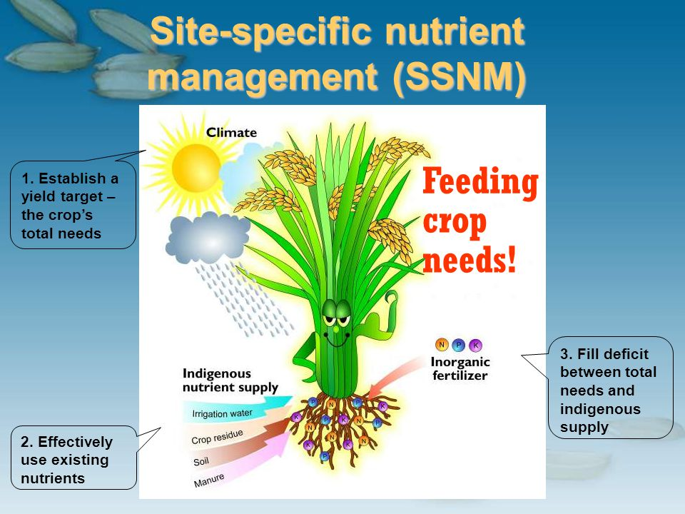
Figure 2. Variable Rate Fertilization Techniques
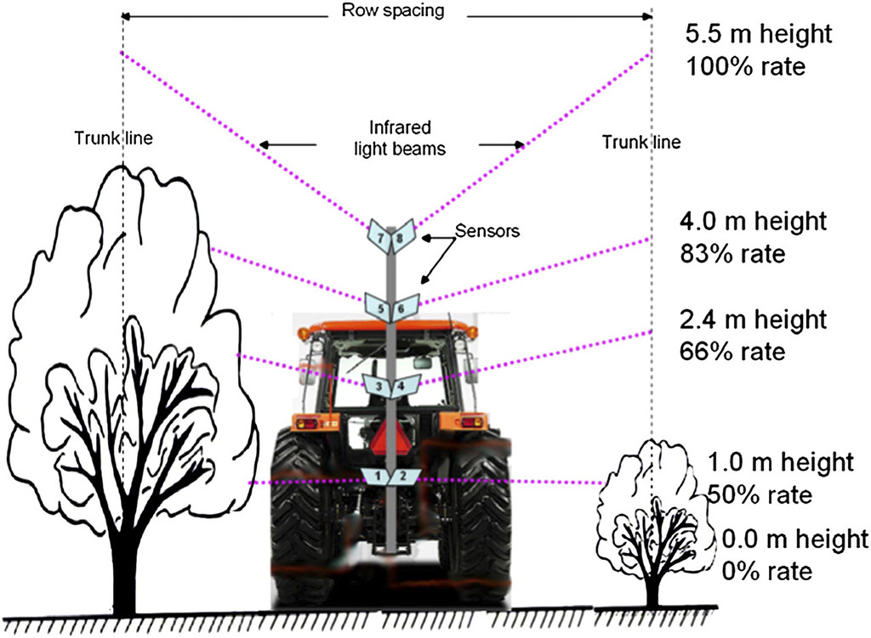
Figure 3. Organic Amendments Improving Soil Health

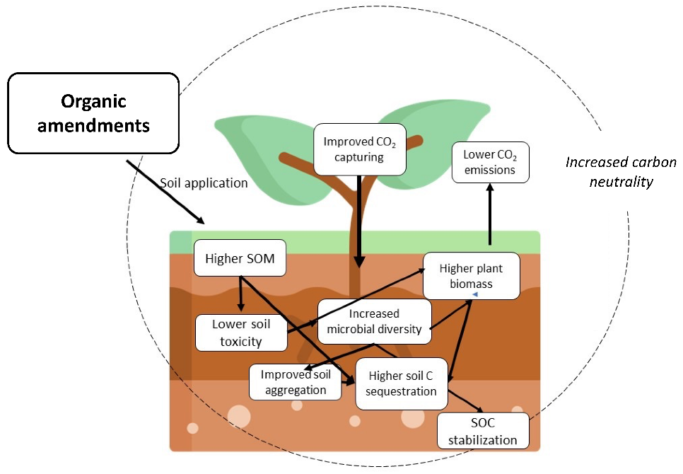
Figure 4. PGPR Effects on Nutrient Uptake

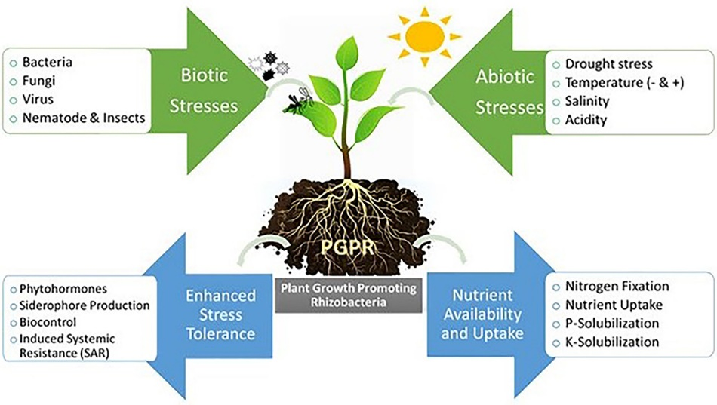
Figure 5. Mycorrhizal Fungi Enhancing Root Systems
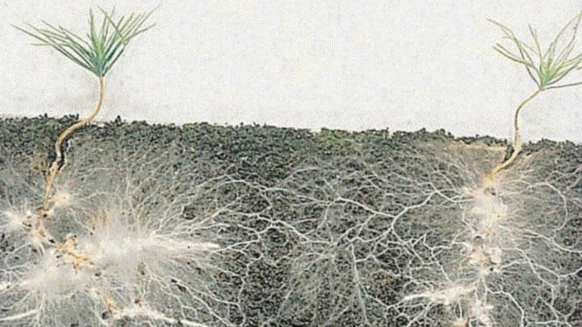
Figure 6. Remote Sensing Technologies for Nutrient Management
