Assessment of Growth Indices and Forage Quality in Cowpea Based Intercropping Systems: A Study on Quality-Economics Relationship

Abstract
An experiment was conducted to study the impact of fertilization and intercropping on growth, quality and relative economics of cowpea-based intercropping systems. The experiment was laid in RCBD with three levels of fertilization treatment (0% RDF, 75% RDF, and 100% RDF) and five intercropping systems (sole cowpea, sole sorghum, sole maize, sorghum + cowpea (1:1), and maize + cowpea (1:1)), replicated thrice. The key parameters assessed during the study were CGR, RGR, quality and along with economic indices. The data revealed that the treatment F₂I₁ consistently performed good with respect to quality parameters. However, relative economics of the treatments of indicated that 100 % RDF along with intercropping of sorghum + cowpea and maize + cowpea resulted in higher net returns and BCR of (3.19 and 2.73) and (2.98 and 2.65) respectively. The interaction effects were also significant indicating a strong relationship between fertilization and cowpea-based intercropping. Furthermore, clustering and correlation showed a good relation between quality parameters and economic indices. Overall, the study demonstrated that intercropping of fodder cereals with cowpea under 100% RDF resulted in improved forage quality while making it economically viable fodder production strategy under temperate conditions.
Keywords: correlation, CGR, forage quality, maize, relative economics, RGR, sorghum
Introduction
Since ancient times, maize is one of the important fodder crops grown at higher altitudes as well as plain regions of the UT of J&K due to its wide range of climatic adaptability and production of high biomass. It produces high quality energy-rich and nutritious fodder with high palatability and digestibility (Soe-Htet et al., 2021). The crop is rich in carbohydrates that makes it suitable for silage and can be preserved for future use (Chaudhary et al., 2014). Sorghum is another important fodder crop. It is drought-tolerant, and can withstand high temperatures and low rainfall, making it well-suited for cultivation in areas with limited water availability. It is also a prolific biomass producer, with high yields of green fodder upto 30 t ha⁻¹ under temperate conditions (ICAR-IGFRI, 2021). In addition to its high biomass production, sorghum can be used to produce high-quality forage. It has a high fiber content and a reasonable protein content (11 %), making it an ideal feed for ruminants such as cattle, sheep, and goats (Mohapatra et al., 2017). In general, the farming community makes the selection of fodder crops on the basis of their adaptability and generation of huge biomass but fodder quality is not provided due attention that further decreases the productivity of livestock. Although cereal forages provide a significant source of feed to livestock by yielding high amount of dry matter, but often have a low protein content which limits their nutritional value for livestock (Uher et al., 2019). By intercropping cereal forage with legumes, it is possible to improve the fodder quality as legumes are supposed to possess characteristic feature of nitrogen fixation and provide a good source of protein for livestock. Cowpea (Vigna unguiculata), is a short duration leguminous crop that can be intercropped with cereal forages to balance the production of protein from the unit area while being a valuable source of fodder for livestock (Kulkarni et al., 2018), which can increase farmers' income. To develop an understanding of interaction between grass-legume a study was conducted to investigate the effect of grass-legume intercropping on growth indices, forage quality and relative economics under varied fertilization treatments.
Materials and Methods
A study was carried out during Kharif 2023 and 2024 at Agronomy Research Farm, Faculty of Agriculture SKUAST-K, Wadura, Sopore. The experiment followed a factorial randomized complete block design (RCBD) consisting of two factors: Fertilization treatment (F₀: Absolute control, F₁: 75 % RDF and F₂: 100 % RDF) and Intercropping systems (I₁: Sole cowpea; I₂: Sole sorghum; I₃: Sole maize; I₄: Sorghum + Cowpea (1:1) and I₅: Maize + Cowpea (1:1)) making 15 treatment combinations which were replicated thrice. The varieties used were MP chari in Sorghum, SFM-1 in Maize and UPC-625 in Cowpea. The experiment was conducted over two consecutive years and the data were pooled across years after verifying homogeneity of variance using Bartlett’s test. The data was subjected to statistical analysis using Microsoft excel and RStudio (2023.12.1). Residual diagnostic plots were used to check the assumptions of normality and homoscedasticity. A linear model was fitted using lm() function with given model: Response variable ~ Fertilization treatment × Intercropping systems. LSD was calculated for treatment comparisons (α = 0.05).
Experimental findings
Crop Growth Rate
Among the fertilization treatments, the numerically higher CGR was consistently recorded under 100% RDF, which was 4.24 and 3.43 g m⁻² day⁻¹ at 20-40 DAS, 5.71 and 6.15 g m⁻² day⁻¹ at 40-60 DAS showing significant variation at this stage, and 3.79 and 3.57 g m⁻² day⁻¹ at 60-80 DAS during 2023 and 2024, respectively (Table 1a). This was followed by 75% RDF, while the lowest CGR was observed under the absolute control. Regarding intercropping systems, sole cowpea exhibited the significantly higher CGR at all growth stages in both years, attaining 5.86 and 4.66 g m⁻² day⁻¹ at 20-40 DAS, 7.80 and 8.59 g m⁻² day⁻¹ at 40-60 DAS, and 5.96 and 5.87 g m⁻² day⁻¹ at 60-80 DAS during 2023 and 2024, respectively. Among intercropping systems, sorghum in sorghum + cowpea (1:1) attained maximum values of 3.69 and 3.71 g m⁻² day⁻¹ and maize in maize + cowpea (1:1) attained highest values of 3.67 and 4.03 g m⁻² day⁻¹ at 60-80 during 2023 and 2024 respectively (Table 1b). Sole sorghum recorded the highest CGR across all the stages in both years and, achieving higher values of 36.89 and 24.64 g m⁻² day⁻¹ at 60-80 DAS during 2023 and 2024, respectively. This was followed by sole maize where maximum CGR of 28.94 and 22.32 g m⁻² day⁻¹ at 60-80 DAS during 2023 and 2024, respectively. Among the intercropping treatments, sorghum + cowpea (1:1) recorded higher CGR than maize + cowpea (1:1) throughout the growth period.
The increase in CGR of cowpea under higher fertilization levels could be attributed to better nutrient availability, which supports enhanced leaf area, photosynthesis, and biomass production, ultimately reflecting in higher crop growth rate. These observations are in line with the findings of Gupta et al. (2019) and Jadav et al. (2018), who reported that application of 100% RDF significantly enhanced CGR and dry matter accumulation in maize and legumes under Indian rainfed conditions. Similarly, Kumar et al. (2016) reported that balanced fertilization improved crop growth rate and green fodder yield of maize and cowpea. Intercropping systems exhibited a suppressive effect on CGR of crops as compared to their respective sole cropping, which can be explained by the competition for light, space, and nutrients among the crops. Among the intercropping systems, sorghum + cowpea (1:1) exhibited higher CGR compared to maize + cowpea (1:1), indicating the superior competitive ability and growth potential of sorghum under intercropping situations. These findings are consistent with Ginwal et al. (2019) and Singh et al. (2023), who reported that intercropping of legumes with cereals reduced the CGR of the legumes due to shading and resource competition.
Table 1a: Impact of fertilization treatment and intercropping systems on crop growth rate of cowpea.

Crop growth rate (g m⁻² day⁻¹)
Treatments | 20-40 DAS |  | 40-60 DAS |  | 60-80 DAS
 | 2023 | 2024 | 2023 | 2024 | 2023 | 2024
Fertilization treatment
F₀: Absolute control | 8.66 | 7.52 | 14.09 | 11.89 | 19.86 | 14.18
F₁: 75 % RDF | 13.16 | 12.05 | 16.54 | 16.14 | 22.02 | 15.84
F₂: 100 % RDF | 15.90 | 13.98 | 17.67 | 18.27 | 23.49 | 17.63
SE(m)± | 0.45 | 0.32 | 0.79 | 0.72 | 0.59 | 0.67
CD (p ≤ 0.05) | 1.31 | 0.94 | 2.32 | 2.12 | 1.74 | 1.98
Intercropping systems
I₁: Sole cowpea | - | - | - | - | - | -
I₂: Sole sorghum | 23.61 | 20.45 | 18.90 | 18.74 | 36.89 | 24.64
I₃: Sole maize | 14.15 | 11.60 | 17.82 | 17.91 | 28.94 | 22.32
I₄: Sorghum + Cowpea (1:1) | 8.85 | 8.84 | 14.06 | 12.59 | 12.30 | 8.77
I₅: Maize + Cowpea (1:1) | 3.69 | 3.84 | 13.63 | 12.50 | 9.03 | 7.80
SE(m)± | 0.57 | 0.42 | 1.02 | 0.94 | 0.77 | 0.87
CD (p ≤ 0.05) | 1.69 | 1.22 | 3.00 | 2.74 | 2.24 | 2.55

Crop growth rate (g m⁻² day⁻¹)
Treatments | 20 DAS |  | 40 DAS |  | 60 DAS80 DAS
 | 2023 | 2024 | 2023 | 2024 | 2023 | 2024
Fertilization treatment
F₀: Absolute control | 3.64 | 2.54 | 4.09 | 4.47 | 3.14 | 2.79
F₁: 75 % RDF | 3.92 | 3.01 | 5.36 | 5.70 | 3.45 | 3.26
F₂: 100 % RDF | 4.24 | 3.43 | 5.71 | 6.15 | 3.79 | 3.57
SE(m)± | 0.16 | 0.17 | 0.31 | 0.27 | 0.48 | 0.24
CD (p ≤ 0.05) | NS | 0.52 | 0.93 | 0.80 | NS | NS
Intercropping systems
I₁: Sole cowpea | 5.86 | 4.66 | 7.80 | 8.59 | 5.96 | 5.87
I₂: Sole sorghum | - | - | - | - | - | -
I₃: Sole maize | - | - | - | - | - | -
I₄: Sorghum + Cowpea (1:1) | 2.69 | 2.11 | 3.69 | 3.71 | 1.76 | 1.38
I₅: Maize + Cowpea (1:1) | 3.25 | 2.21 | 3.67 | 4.03 | 2.66 | 2.37
SE(m)± | 0.20 | 0.22 | 0.40 | 0.35 | 0.61 | 0.31
CD (p ≤ 0.05) | 0.61 | 0.67 | 1.21 | 1.04 | 1.84 | 0.94
Table 1b: Impact of fertilization treatment and intercropping systems on crop growth rate of sorghum and maize.

4.6. Relative Growth Rate of crops
Among the fertilization treatments, the highest RGR was observed under absolute control during 20-40 DAS interval, with values of 0.062 and 0.050 g g⁻¹ day⁻¹ in 2023 and 2024, respectively (Table 2a), while at later stages, fertilization had no significant influence. Regarding intercropping systems, sole cowpea recorded higher RGR at maximum growth stages in both years, with no significant variations. Likewise, among the intercropping systems, no statistically significant variation was observed, however sorghum + cowpea (1:1) at 60-80 DAS recorded marginally higher RGR than maize + cowpea (1:1) at 40-60 DAS whereas maize + cowpea (1:1) recorded marginally higher RGR than sorghum + cowpea (1:1) at 60-80 DAS. The intercropping systems exhibited inconsistent pattern where sole sorghum recorded the highest RGR of 0.070 and 0.073 g g⁻¹ day⁻¹ at 20-40 DAS. In subsequent interval 40-60 DAS the maximum RGR was recorded in maize under maize + cowpea (1:1) and at 60-80 DAS, sole maize outperformed others (Table 2b).
The higher RGR at the early growth stages and the subsequent decline at later stages is a common physiological response as the crop progresses towards maturity, where dry matter accumulation shifts more towards reproductive parts rather than vegetative growth. Similar trends were reported by Kumar et al. (2016) and Gupta et al. (2019), who observed decreasing RGR with crop age in maize and legumes due to canopy closure and resource competition. In the present study, the highest RGR at 20-40 DAS was recorded under absolute control, possibly due to smaller initial plant biomass, which inherently leads to higher relative increase in biomass during early growth stages. This is in line with the findings of Ginwal et al. (2019), who reported similar trends in cowpea and maize intercropping systems. The intercropping systems had a significant negative impact on RGR of crops as compared to sole cropping at 20-40 and 60-80 DAS growth intervals. These observations corroborate with Bhagat et al. (2017) and Saad et al. (2016).
Table 2a: Impact of fertilization treatment and intercropping systems on relative growth rate of cowpea.

Relative growth rate (g g⁻¹ day⁻¹)
Treatments | 20-40 DAS |  | 40-60 DAS |  | 60-80 DAS
 | 2023 | 2024 | 2023 | 2024 | 2023 | 2024
Fertilization treatment
F₀: Absolute control | 0.062 | 0.050 | 0.028 | 0.035 | 0.014 | 0.013
F₁: 75 % RDF | 0.050 | 0.038 | 0.031 | 0.036 | 0.012 | 0.011
F₂: 100 % RDF | 0.047 | 0.038 | 0.031 | 0.034 | 0.013 | 0.012
SE(m)± | 0.002 | 0.002 | 0.002 | 0.002 | 0.002 | 0.001
CD (p ≤ 0.05) | 0.006 | 0.007 | NS | NS | NS | NS
Intercropping systems
I₁: Sole cowpea | 0.050 | 0.044 | 0.030 | 0.037 | 0.015 | 0.015
I₂: Sole sorghum | - | - | - | - | - | -
I₃: Sole maize | - | - | - | - | - | -
I₄: Sorghum + Cowpea (1:1) | 0.051 | 0.041 | 0.031 | 0.034 | 0.010 | 0.008
I₅: Maize + Cowpea (1:1) | 0.057 | 0.040 | 0.028 | 0.034 | 0.013 | 0.013
SE(m)± | 0.002 | 0.003 | 0.002 | 0.003 | 0.003 | 0.002
CD (p ≤ 0.05) | NS | NS | NS | NS | NS | 0.005
Table 2b: Impact of fertilization treatment and intercropping systems on relative growth rate of sorghum and maize.
Relative growth rate (g g⁻¹ day⁻¹)
Treatments | 20-40 DAS |  | 40-60 DAS |  | 60-80 DAS
 | 2023 | 2024 | 2023 | 2024 | 2023 | 2024
Fertilization treatment
F₀: Absolute control | 0.048 | 0.048 | 0.039 | 0.037 | 0.025 | 0.024
F₁: 75 % RDF | 0.050 | 0.056 | 0.034 | 0.036 | 0.022 | 0.018
F₂: 100 % RDF | 0.053 | 0.057 | 0.032 | 0.035 | 0.021 | 0.017
SE(m)± | 0.002 | 0.001 | 0.002 | 0.001 | 0.001 | 0.001
CD (p ≤ 0.05) | NS | 0.003 | 0.005 | NS | NS | 0.003
Intercropping systems
I₁: Sole cowpea | - | - | - | - | - | -
I₂: Sole sorghum | 0.070 | 0.073 | 0.024 | 0.027 | 0.028 | 0.022
I₃: Sole maize | 0.052 | 0.054 | 0.031 | 0.036 | 0.028 | 0.025
I₄: Sorghum + Cowpea (1:1) | 0.053 | 0.057 | 0.036 | 0.033 | 0.018 | 0.016
I₅: Maize + Cowpea (1:1) | 0.028 | 0.032 | 0.048 | 0.047 | 0.018 | 0.018
SE(m)± | 0.002 | 0.002 | 0.002 | 0.002 | 0.001 | 0.001
CD (p ≤ 0.05) | 0.007 | 0.004 | 0.006 | 0.005 | 0.004 | 0.004
Quality parameters of cowpea, sorghum, and maize
Before conducting ANOVA, the data was examined to verify the assumptions i.e. normality of residuals and homogeneity of variances. This was performed using residual diagnostic plots, including Q-Q plots and residual vs fitted plots for each quality parameter (Fig. 1). The residuals showed approximate symmetry and linearity indicating normal distribution of residuals and no deviation from homoscedasticity across treatments. The results revealed that among fertilization treatments, 100% RDF recorded the highest crude protein content (12.92 and 12.78% during 2023 and 2024, respectively), followed by 75% RDF (10.42 and 10.94%), while the lowest values were recorded under absolute control (11.92 and 11.72%) (Table 3). Crude fibre content decreased with the increase in fertilization level. The lowest crude fibre was observed under 100% RDF (22.30 and 24.40%), while the highest was recorded under absolute control (28.20 and 30.30%). Mineral ash content was significantly influenced, with the highest values recorded under 100% RDF (11.83 and 12.45%) and lowest under absolute control (9.55 and 9.81%). Nitrogen Free Extract (NFE) showed an inverse trend with crude protein, being highest in absolute control (52.72 and 54.93%) and lowest in 100% RDF (46.66 and 45.35%). Among intercropping systems, sole cowpea recorded the maximum crude protein (13.83 and 13.78%), followed by sorghum + cowpea (1:1), while the lowest was recorded in sole maize. Similarly, sole cowpea registered the lowest crude fibre content (22.90 and 24.53%) compared to higher values in sole maize (27.81 and 29.19%). Sole cowpea recorded the highest mineral ash (12.94 and 13.18%) compared to other systems. Among intercropping systems, the highest NFE was observed in sole maize (54.20 and 53.88%), while the lowest was in sole cowpea (44.72 and 44.02%).
The enhancement in crude protein and mineral ash contents under higher fertilization levels (100% RDF) could be due to enhanced nitrogen availability, promoting better synthesis of proteins and accumulation of essential minerals. This is in line with Gupta et al. (2019) and Jadav et al. (2018), who reported improvement in fodder quality attributes under balanced fertilization in maize and cowpea under Indian conditions. Similar findings were also reported by Ginwal et al. (2019), where legumes recorded superior forage quality attributes over cereals. The higher crude protein content in sole cowpea can be attributed to its nitrogen-fixing ability and lower competition for resources, while cereals (especially maize) diluted the protein concentration due to their higher carbohydrate-rich biomass. These results align with the findings of Saad et al. (2016), Bhagat et al. (2017), and Moneesa (2020), who reported reduction in forage quality in cereal-legume intercropping systems, though sorghum + cowpea recorded relatively better quality than maize + cowpea due to lesser competition and better synchrony of growth between the components.
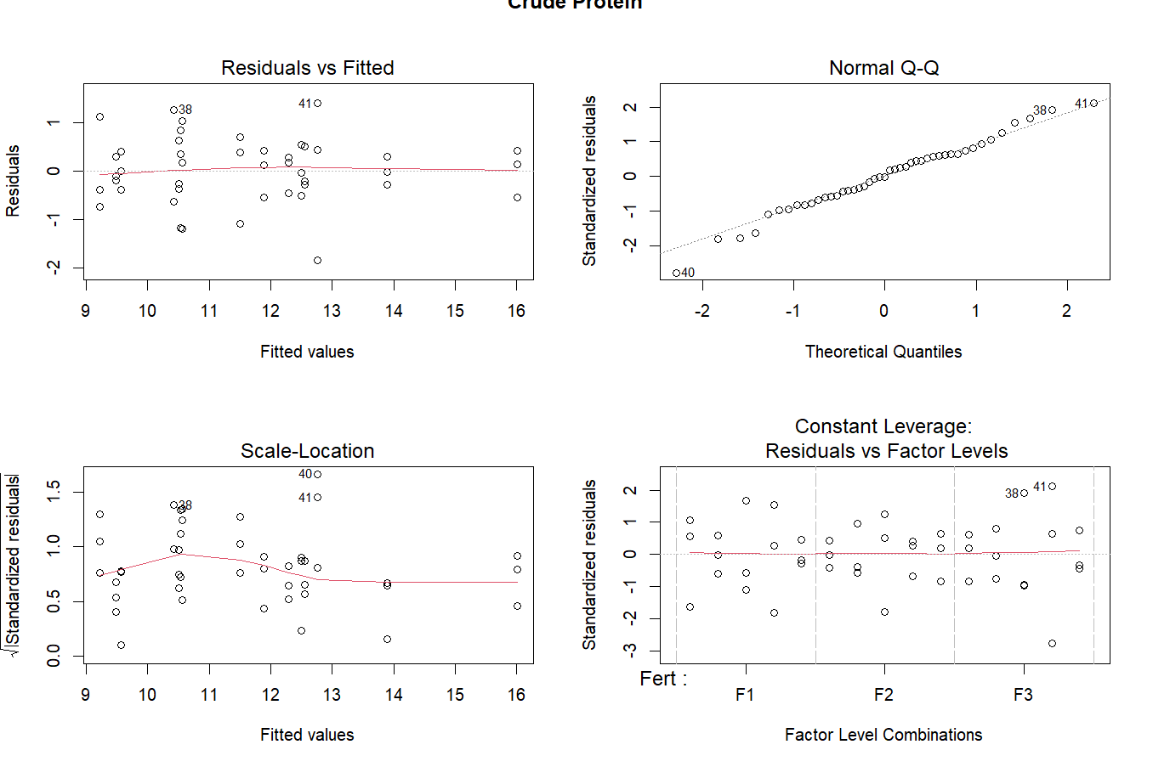 | 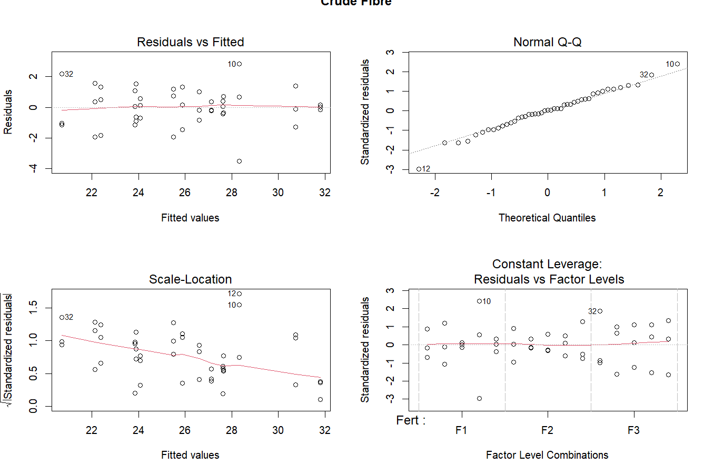
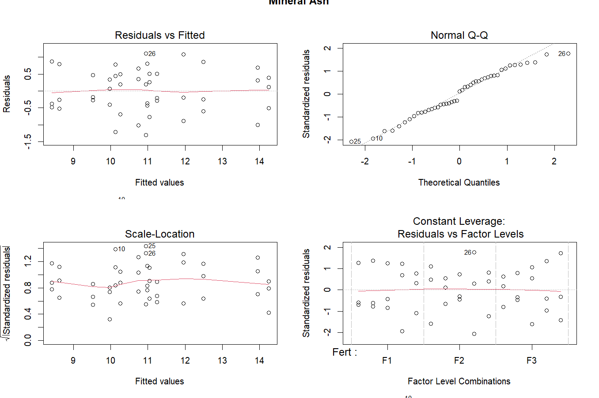 | 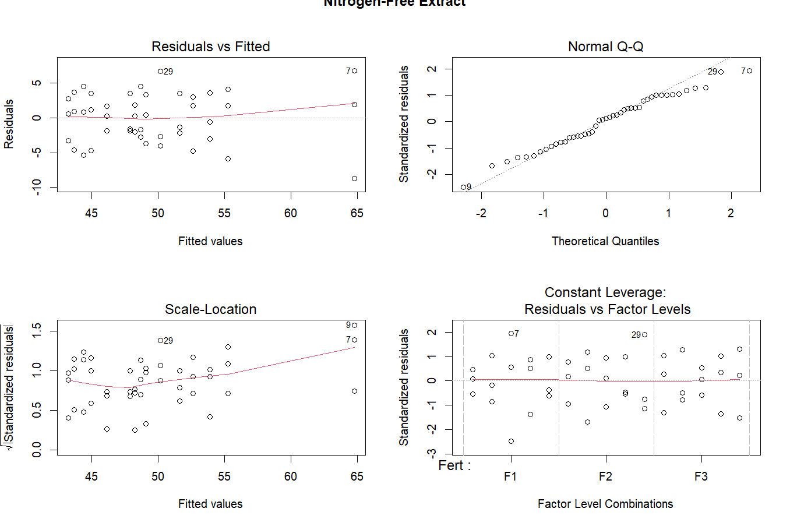
Fig. 2: Residual diagnostic plots of quality parameters assessing ANOVA assumptions.

Table 3: Impact of fertilization treatment and intercropping systems on quality of cowpea, sorghum and maize.
Treatments | Crude protein  (%) |  | Crude fibre  (%) |  | Mineral ash  (%) |  | Nitrogen free extract  (%)
 | 2023 | 2024 | 2023 | 2024 | 2023 | 2024 | 2023 | 2024
Fertilization treatment
F₀: Absolute control | 10.21 | 9.93 | 28.20 | 30.30 | 9.55 | 9.81 | 52.72 | 54.93
F₁: 75 % RDF | 11.92 | 11.72 | 24.53 | 25.98 | 10.94 | 11.23 | 49.73 | 48.54
F₂: 100 % RDF | 12.92 | 12.78 | 22.30 | 24.40 | 11.83 | 12.45 | 46.66 | 45.35
SE(m)± | 0.23 | 0.19 | 0.47 | 0.36 | 0.19 | 0.21 | 0.86 | 0.97
CD (p ≤ 0.05) | 0.67 | 0.56 | 1.36 | 1.03 | 0.55 | 0.61 | 2.50 | 2.82
Intercropping systems
I₁: Sole cowpea | 13.83 | 13.78 | 22.90 | 24.53 | 12.94 | 13.18 | 44.72 | 44.02
I₂: Sole sorghum | 10.97 | 10.74 | 26.97 | 28.39 | 10.01 | 9.74 | 51.99 | 53.27
I₃: Sole maize | 10.21 | 9.92 | 27.81 | 29.19 | 9.26 | 10.00 | 54.20 | 53.88
I₄: Sorghum + Cowpea (1:1) | 11.99 | 11.75 | 24.43 | 26.30 | 11.24 | 11.13 | 48.61 | 48.40
I₅: Maize + Cowpea (1:1) | 11.43 | 11.19 | 22.95 | 26.05 | 10.41 | 11.76 | 49.01 | 48.45
SE(m)± | 0.30 | 0.25 | 0.61 | 0.46 | 0.24 | 0.27 | 1.11 | 1.26
CD (p ≤ 0.05) | 0.87 | 0.73 | 1.75 | 1.33 | 0.71 | 0.78 | 3.23 | 3.65
Interaction effect of fertilization treatments and intercropping systems on forage quality
The interaction effect of pooled data of fertilization and intercropping systems revealed that the quality parameters of crops were significantly influenced (Fig. 2). The application of 100 % RDF to sole cowpea recorded the highest crude protein content (16.00%), followed by F₂I₄: 100 % RDF + Sorghum + cowpea (1:1) (12.76%) and F₂I₅: 100 % RDF + Maize + cowpea (1:1) (12.56%). The application of 75% RDF also enhanced crude protein in cowpea (F₁I₁: 13.90%) over absolute control followed by 12.29 % in I₄: Sorghum + cowpea (1:1)) and 11.88 % in I₅: Maize + cowpea (1:1)). Under absolute control crude protein was considerably lower ranging from 9.23 %in I₃ to 11.50 % in I₁. For crude fibre an inverse trend was noted where highest crude fibre was recorded in the absolute control plots under F₀I₃: Sole maize (No fertilizer) (31.79%) followed by F₀I₂: Sole sorghum (No fertilizer) (30.74%). With the application of 75% RDF (F₁), crude fibre reduced across treatments, with the lowest crude fibre observed in F₁I₁: 75 % RDF + Sole cowpea (23.84%). On further increasing the levels of fertilization, crude fibre declined with F₂I₁: 100 % RDF + Sole cowpea (20.71%) showing the lowest value followed by F₂I₅: 100 % RDF + Maize + cowpea (1:1) (22.12%) and F₂I₄: 100 % RDF + Sorghum + cowpea (1:1) (22.38%). The interaction effect showed a clear increase in mineral ash with higher fertilization. Under 100 % RDF, sole cowpea recorded highest mineral ash of 14.25 % which was followed by application of 75 % RDF in sole cowpea (13.95). Among intercropping systems 100 % RDF in sorghum (12.49 %) showed good response followed by maize (11.96 %). In contrast, absolute control exhibited lower mineral ash, with sorghum (8.42%). For nitrogen-free extract, an inverse relation was observed with fertilization. Under absolute control, maize recorded the higher value of nitrogen-free extract (64.78 %) followed by sorghum. The minimum nitrogen-free extract values were consistently observed in sole cowpea under fertilized treatments, indicating a shift towards protein and mineral synthesis over carbohydrate accumulation. The treatment combination of F₂I₁: 100 % RDF + cowpea recorded lowest nitrogen-free extract content of 43.71 % which was at par with F₂I₅: 100 % RDF + Maize + cowpea (1:1) 44.38 % and F₂I₄₄: 100 % RDF + Sorghum + cowpea (1:1) 44.97 %.
The interaction effects depict a clear trend where adequate fertilization (especially 100% RDF) in sole cowpea (I₁) and intercropped systems like F₂I₄ and F₂I₅ optimally enhanced quality attributes. The significant improvement in crude protein content under treatments can be attributed to enhanced nitrogen availability, which is crucial for protein synthesis through increased nitrate reductase and amino acid assimilation (Kumar et al., 2016). Additionally, balanced nutrition promoted efficient nutrient uptake and photosynthate partitioning towards economic parts. These findings align with Yadav et al. (2016) and Kumar et al. (2016). The reduction in crude fibre under fertilized treatments is a well-documented phenomenon that reflects better quality fodder, as fertilization likely supports finer cellular development over lignified structures. This inverse relationship was also highlighted by Iqbal et al. (2012) in legume-cereal intercropping systems, suggesting that improved nutrient availability reduces lignification in plant tissues. Likewise, NFE which primarily represents soluble carbohydrates, declined in sole cowpea and intercropping systems under increased level of fertilization. Thus, suggesting better nutrient allocation towards proteinaceous and assimilatory tissues under nutrient-rich conditions. This transformation is essential for fodder quality, as excessive NFE in unfertilized plants (as seen in F₀I₃) merely reflects stress-induced carbohydrate accumulation without proportional biomass conversion. Furthermore, the increment in mineral ash indicates higher mineral uptake efficiency which is possible under adequate availability of nutrients. The sole cowpea as well as its intercropping systems showed higher values of mineral ash under 100 % RDF that confirms the increased nutrient uptake facilitated by improved root growth and microbial activity in legume intercropping systems. This aligns with studies by Yadav et al. (2016), highlighting legumes’ role in enhancing rhizospheric nutrient dynamics through nitrogen fixation and root exudation.

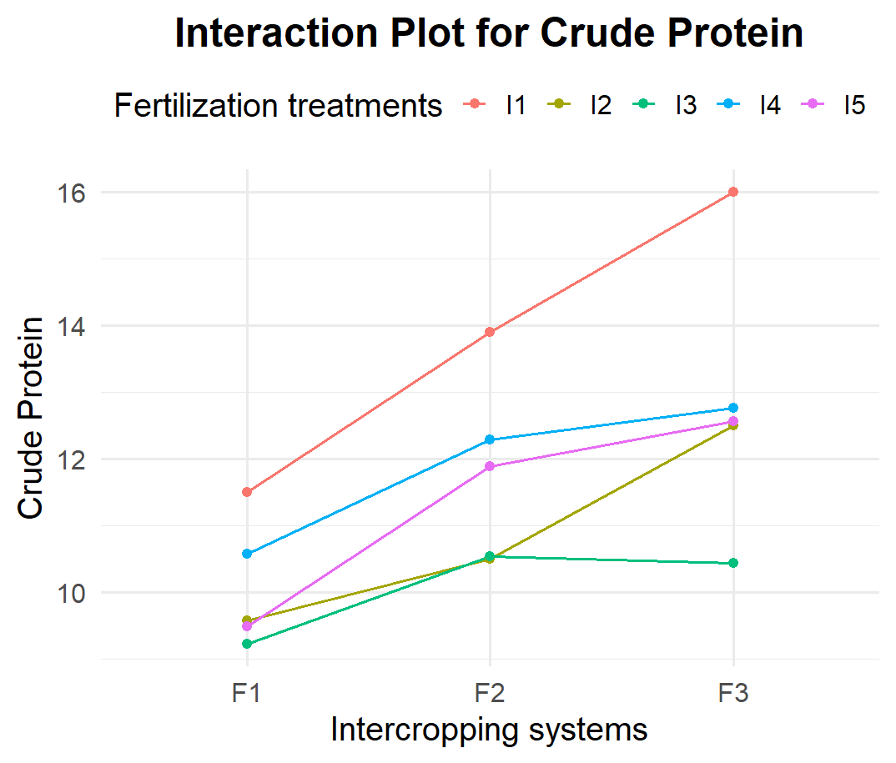 | 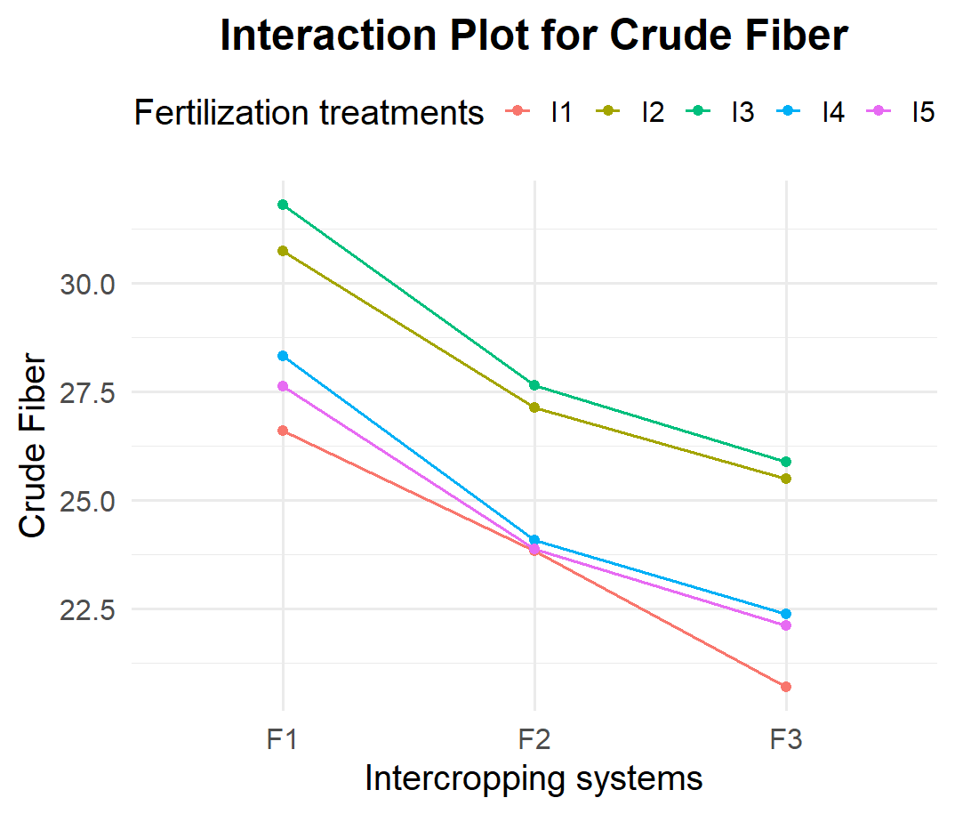
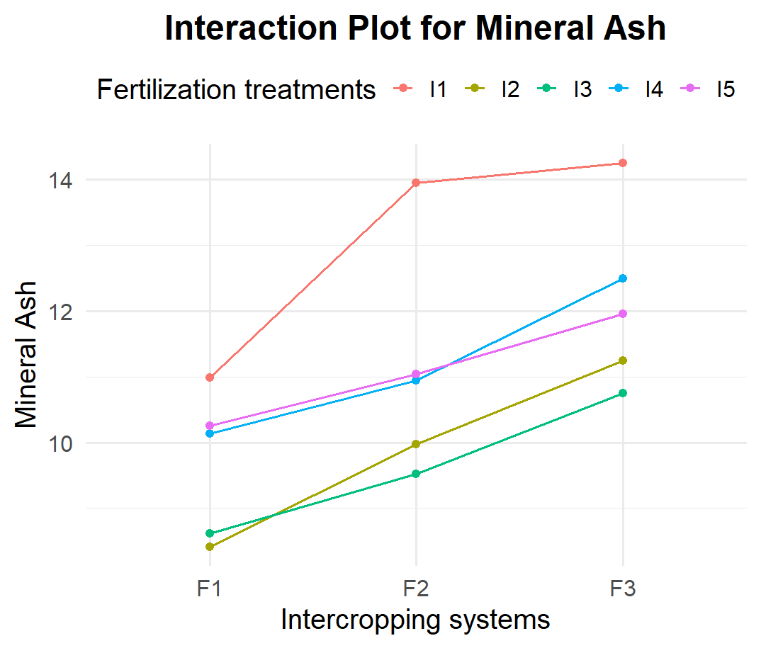 | 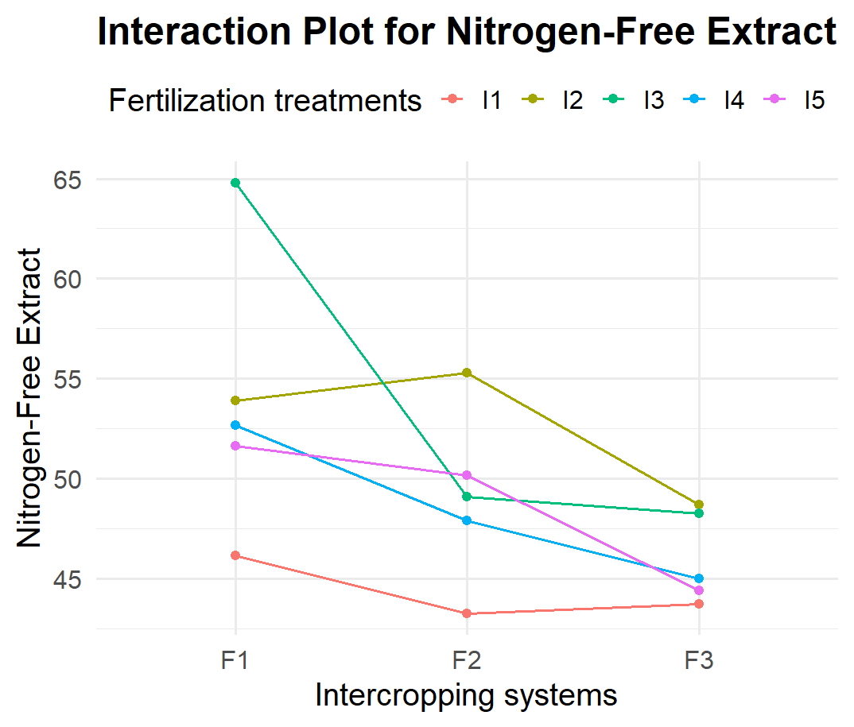
Fig. 2: Interaction effect of pooled data of fertilization levels and intercropping systems on forage quality.

Relative economics
The economic analysis reveals that the treatment combination F₂I₄ (100% RDF + sorghum + Cowpea (1:1)) secured the highest net returns (NR) and benefit-cost ratio BCR in both years (Table 4). Specifically, net returns were ₹1,20,497ha⁻¹ (2023) & ₹ 1,02,955 ha⁻¹ (2024) with corresponding BCR values of 3.19 and 2.73, respectively. Following this, F₂I₅ (100% RDF + Maize + Cowpea (1:1)) gained net returns (NR) of ₹1,13,127 ha⁻¹ (2023) & ₹ 1,00,569 ha⁻¹ (2024) with corresponding BCR values of 2.98 and 2.65, respectively. F₂I₂ (100 % RDF + Sole Sorghum) achieved net returns of ₹ 1,00,041 ha⁻¹ & ₹85,265 ha⁻¹ with BCR of 2.09 and 1.78, respectively. The lowest net returns and BCR were recorded under F₀I₃ (absolute Control + Sole Maize) with ₹47,237 ha⁻¹ & ₹34,797 ha⁻¹, and BCR values of 1,12 & 0.83, respectively.
The superior economic performance of F₂I₄ (100% RDF + sorghum + Cowpea (1:1)) is primarily attributed to the synergistic effects of optimum nutrient supply and the inclusion of legumes, which improve nitrogen availability through biological nitrogen fixation (Saad et al., 2016; Bhagat et al., 2017). The higher fodder yield under this combination directly resulted in enhanced gross returns, outweighing the marginal increase in cultivation cost. The 100% RDF application ensured adequate nutrient uptake, leading to higher biomass production and thereby higher marketable yields, a fact well supported by earlier studies (Kumar et al., 2016; Gupta et al., 2019). Furthermore, legumes like cowpea contribute organic matter and improve soil health, enhancing long-term productivity and profitability (Padhi & Panigrahi, 2006; Ummaisa & Raja, 2020). On the other hand, sole cropping systems like F₂I₂ (Sorghum) and F₂I₃ (Maize) maintained higher absolute returns due to their higher per hectare productivity. However, intercropping combinations like F₂I₄ and F₂I₅ outperformed them in terms of benefit-cost ratio due to better resource use efficiency, nitrogen economy, and cumulative biomass returns. Lower BCR in absolute control treatments (F₀I₂, F₀I₃) can be attributed to poor biomass production, nutrient deficiencies, and absence of synergistic interactions, which is consistent with findings of Sharma et al. (2008) and Ginwal et al. (2019).

Table 4: Impact of fertilization treatment and intercropping systems on relative economics.
Treatment combinations | Cost of cultivation  (₨ ha⁻¹) |  | Gross returns  (₨ ha⁻¹) |  | Net returns  (₨ ha⁻¹) |  | BCR  BCR
 | 2023 | 2024 | 2023 | 2024 | 2023 | 2024 | 2023 | 2024
F₀ I₁ | 25200 | 25200 | 66226 | 60439 | 41026 | 35239 | 1.63 | 1.40
F₀ I₂ | 40920 | 40920 | 91059 | 81843 | 50139 | 40923 | 1.23 | 1.00
F₀ I₃ | 42150 | 42150 | 89387 | 76947 | 47237 | 34797 | 1.12 | 0.83
F₀ I₄ | 30915 | 30915 | 93807 | 87589 | 62892 | 56674 | 2.03 | 1.83
F₀ I₅ | 31530 | 31530 | 90786 | 80572 | 59256 | 49042 | 1.88 | 1.56
F₁ I₁ | 29194 | 29194 | 97426 | 93778 | 68232 | 64585 | 2.34 | 2.21
F₁ I₂ | 46058 | 46058 | 131129 | 118492 | 85071 | 72434 | 1.85 | 1.57
F₁ I₃ | 46988 | 46988 | 128395 | 119300 | 81407 | 72313 | 1.73 | 1.54
F₁ I₄ | 36053 | 36053 | 139517 | 124419 | 103465 | 88366 | 2.87 | 2.45
F₁ I₅ | 36368 | 36368 | 134071 | 122607 | 97704 | 86240 | 2.69 | 2.37
F₂ I₁ | 30525 | 30525 | 113324 | 110057 | 82799 | 79532 | 2.71 | 2.61
F₂ I₂ | 47770 | 47770 | 147811 | 133035 | 100041 | 85265 | 2.09 | 1.78
F₂ I3 | 48600 | 48600 | 142547 | 134022 | 93947 | 85422 | 1.93 | 1.76
F₂ I₄ | 37765 | 37765 | 158262 | 140720 | 120497 | 102955 | 3.19 | 2.73
F₂ I₅ | 37980 | 37980 | 151107 | 138549 | 113127 | 100569 | 2.98 | 2.65
Pearson’s correlation matrix heatmap clustering
The matrix showing Pearson's correlation coefficients between variables highlights strong statistical associations which can be used to develop relation of forage quality parameters with economic efficiency. The matrix depicted that crude protein possessed a strong direct relationship with BCR (r= 0.75) while being highly significant, which can indicate that the treatments that improved crude protein also intended to give better economic output (Fig. 3). For crude fibre a strong but negative correlation was observed with respect to returns (r= -0.75) and BCR (r= -0.93) varying significantly. Mineral as showed a significant positive relationship with BCR (r= 0.77). Nitrogen-free extract possessed negative correlation with NR (r = -0.52) and BCR (r = -0.73). Among the quality parameters crude protein showed strong positive relation with mineral ash (r = 0.93) which indicates that mineral-rich forages also tend to be high in protein, suggesting nutrient synergy under good fertility conditions and showed negative relation with crude fibre (r = -0.88), as higher protein content is often associated with lower fibre content. A similar trend was noted with respect to nitrogen-free extract (r = -0.76) as energy is diverted to protein synthesis instead of carbohydrate storage. Hence it can be inferred that quality parameters like crude protein and mineral ash enhancing treatment coincided with higher economic returns thus, emphasizing the need to minimize fibre while enhancing protein and mineral content.
Further the relation of forage quality with economics was visualized using heatmap clustering approach given in Fig. 3. Heat maps provide visual depiction of variation of treatment combinations with respect to parameters using the colour gradient to identify treatment combinations performing better or poor for each parameter. The heatmap revealed that treatment combination of F₂I₂ e and F₁I₅, formed closest cluster, indicating similarity in their performance especially in terms of crude protein (CP), mineral ash (MA) and NR. F₂I₃ joined this cluster which showed moderate to high intensity with respect to mineral ash (MA), crude fibre (CF) and NR. F₂I₄ and F₂I₅ appear grouped together, possessing similarity in high intensity for crude protein (CP), crude fibre (CF) and lower intensity for nitrogen-free extract (NFE) and crude fibre (CF). These combinations also aligned with strong economic returns, as seen in their higher BCR and NR, making them optimal from both agronomic and economic perspectives. In contrast, combinations like F₀I₃, F₀I₂ and F₁I₁ were grouped in a lower-performing cluster with distinctly lighter shades under NR, BCR, crude protein (CP) and mineral ash (MA) and darker shades were noted under crude fibre (CF) and nitrogen-free extract (NFE), suggesting poor performance across most parameter with minimal economic viability. Overall, it can be inferred that treatments receiving full RDF (F₂) and intercropping with sole cowpea or cowpea-based intercropping (I₁, I₄, I₅) tend to cluster with higher values of crude protein (CP), mineral ash (MA), NR, and BCR and lower crude fibre (CF) and nitrogen-free extract (NFE), thus showing that application of fertilizers not only enhances quality but improves economic viability. Further, it supports the positive relationship between improved forage quality and economic performance.
Conclusion
The findings underscore the pivotal role of fertilization and intercropping systems in enhancing the qualitative as well as economic results of cowpea-based intercropping systems. The interaction effects further highlighted that the intercropping systems i.e. sorghum + cowpea (I₄) and maize + cowpea (I₅) responded positively to forage quality under 100 % RDF which also translated into higher net returns and BCR. Correlation matrix and clustering confirmed that forage quality parameters especially crude protein and mineral ash were positively associated with economic returns, while higher fibre content tended to lower profitability.
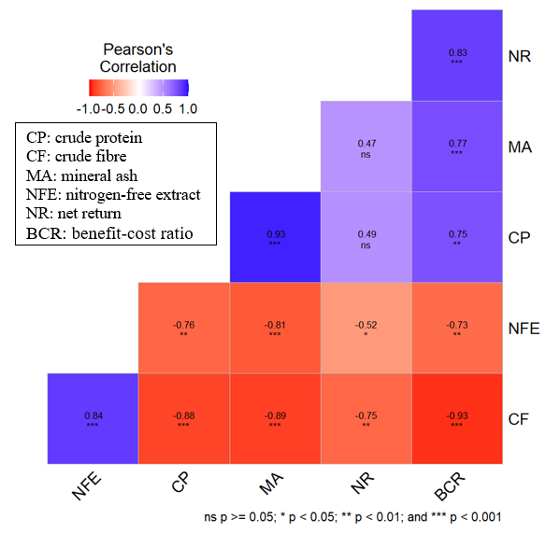 | 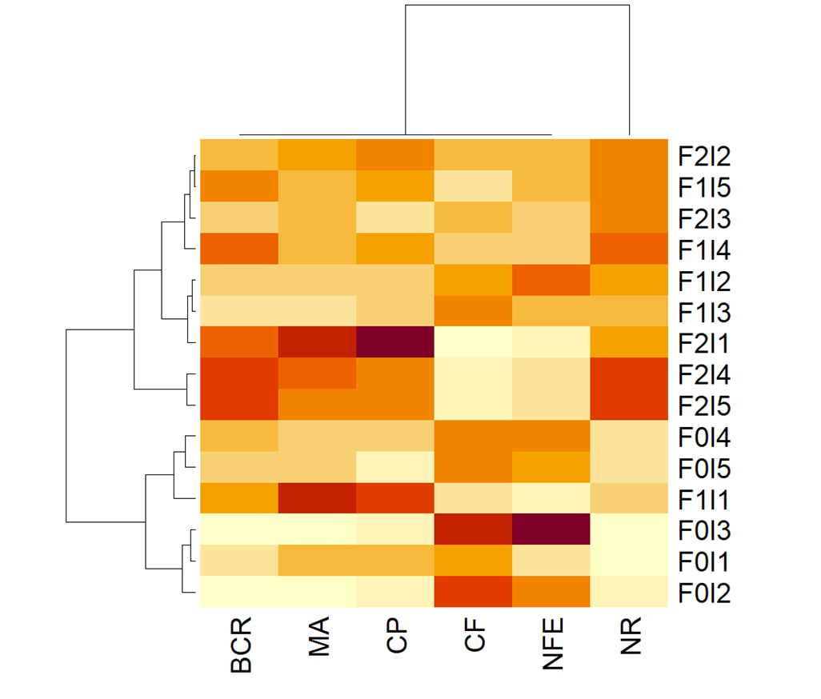
Figure 3: Correlation matrix and heatmap clustering
References
Soe-Htet, M.N., Hai, J. B., Bo, P. T., Gong, X. W., Liu, C. J., Dang, K., Tian, L. X., Soomro, R. N., Aung, K. L. and Feng, B. L. 2021. Evaluation of nutritive values through comparison of forage yield and silage quality of mono-cropped and intercropped maize-soybean harvested at two maturity stages. Agriculture 11: 452.
Chaudhary, D. P., Jat, S.L., Kumar, R., Kumar, A. and Kumar, B. 2014. Fodder Quality of Maize: Its Preservation pp. 153-160. In: Maize: Nutrition Dynamics and Novel Uses. Springer India.
ICAR-IGFRI. 2021. Fodder Resource Development Plan for Jammu and Kashmir. ICAR-Indian Grassland and Fodder Research Institute, Jhansi.
Mohapatra, D., Tripathi, M. K., Deshpande, S. and Sadvatha R. H. 2017. Sorghum Fermentation for Nutritional Improvement. Advances in Food Science and Engineering 1(4):175-195.
Uher, D., Svecnjak, Z., Svecnjak, Z., Dujmovic-Purgar, D., Jares, D. and Horvatic, I. 2019. Influence of intercropping maize with climbing bean on forage yield and quality. AGROFOR International Journal 4(3): 60-67.
Kulkarni, K. P., Tayade, R., Asekova, S., Song, J. T., Shannon, J. G. and Lee, J. D. 2018. Harnessing the Potential of Forage Legumes, Alfalfa, Soybean, and Cowpea for Sustainable Agriculture and Global Food Security. Frontiers in Plant Science 9:1314.
Gupta, M., Bhagat, S., Kumar, S., Kour, S. and Gupta, V. 2019. Production potential and quality of fodder maize (Zea mays) varieties under varying intercropping systems with cowpea (Vigna unguiculata). Range Management and Agroforestry 40(2): 243-249.
Jadav, V.M., Patel, P.M., Chaudhari, J.B., Patel, J.M. and Chaudhari, P.P. 2018. Effect of integrated nutrient management on growth and yield of rabi forage maize (Zea mays L.). International Journal of Chemical Studies 6(1): 2160-2163.
Kumar, S., Kumar, A., Singh, J. and Kumar, P. 2016. Growth indices and nutrient uptake of fodder maize (Zea mays L.) as influenced by integrated nutrient management. Forage Research 42(2): 119-123.
Ginwal, D. S., Kumar, R., Ram, H., Dutta, S., Arjun, M. and Hindoriya, P. S. 2019. Fodder productivity and profitability of different maize and legume intercropping systems. Indian Journal of Agricultural Sciences 89(9): 1451-1455.
Singh, A. K., Singh, J. B., Singh, R., Kantwa, S. R., Jha, P. K., Ahamad, S. and Prasad, P. V. 2023. Understanding soil carbon and phosphorus dynamics under grass-legume intercropping in a semi-arid region. Agronomy 13(7): 1692.
Bhagat, S., Gupta, M., Banotra, M., Sharma, A., Kumar, S. and Sharma, A. 2017. Production potential and economics of fodder maize (Zea mays) varieties sown under varying intercropping systems with cowpea (Vigna unguiculata). International Journal of Current Microbiology and Applied Sciences 6(12): 4082-4087.
Saad, A. A., Singh, U., Masood, A. and Praharaj, C. S. 2016. Productivity and economics of kharif fodder intercropping under dryland condition of temperate Kashmir valley. Range Management and Agroforestry 37(1): 108-112.
Moneesa, B. 2020. Performance of maize legume mixtures on fodder productivity and quality under temperate conditions of Kashmir. M. Sc Thesis submitted to SKUAST-K.
Yadav, M.R., Parihar, C.M., Jat, S.L., Singh, A.K., Kumar, D., Pooniya, V., Parihar, M.D., Saveipune, D., Parmar, H. and Jat, M.L. 2016. Effect of long-term tillage and diversified crop rotations on nutrient uptake, profitability and energetics of maize (Zea mays) in north-western India. Indian Journal of Agricultural Sciences 86(6): 743-749.
Iqbal, A., Akbar, N., Khan, H. Z., Abbas, R.N. and Ahmad, J. 2012. Productivity of summer legume forages intercropped with maize as affected by mixed cropping in different sowing techniques. The Journal of Animal & Plant Sciences 22(3): 758-763.
Padhi, A. K. and Panigrahi, R. K. 2006. Effect of intercrop and crop geometry on productivity, economics, energetics and soil-fertility status of maize based intercropping systems. Indian Journal of Agronomy 51(3): 174-177.
Ummaisa, R. and Raja, W. 2020. Performance of fodder sorghum with different forage legumes combination under temperate conditions of Kashmir. Forage Research 46(3): 158-162.
Sharma, R.P., Singh, A.K., Poddar, B.K. and Raman, K.R. 2008. Forage production potential and economics of maize (Zea mays) with legumes intercropping under various row proportions. Indian journal of Agronomy 53(2): 121-124.

