Review Article

Bridging Zoonotic Risks in Indian Aquaculture: Embracing a One Health Framework for Sustainable Solutions

ABSTRACT

This review synthesizes current knowledge on zoonotic risks in Indian aquaculture, examining the complex dynamics that drive the emergence and transmission of aquatic zoonotic pathogens. It highlights the diseases' significant threats to public health, animal welfare, and aquaculture sustainability
. In response, the review advocates for a comprehensive One Health framework as a critical strategy for mitigating these risks. Drawing from literature, case studies, and policy analyses, it emphasizes the importance of integrated surveillance, interdisciplinary research, and coordinated policy interventions. The feasibility of implementing One Health in India is explored through stakeholder roles, governance structures, and technological innovations. Ultimately, the review underscores the need for a unified approach that harmonizes human, animal, and environmental health to enhance food security, public health, and ecological sustainability in the Indian aquaculture sector.

Keywords: Aquaculture, Collaboration, Disease , Epidemics, Intersectional, One Health, Sustainability, Zoonoses.

1. INTRODUCTION

The global aquaculture sector faces challenges from globalization, intensified hatchery practices, and climate change, which collectively increase disease risks through interactions between wild and farmed species (Anonymous, 2020). In India, freshwater aquaculture contributes over 95% of national output (Anonymous, 2021), but faces significant threats from bacterial pathogens and public health-relevant microorganisms (George and Harini, 2019). Water quality degradation accounts for 24% of culture losses, bacterial infections affect 22% of the fish population, and other factors contribute to 8% mortality (Sahoo, 2020). Argulus species, particularly A. siamensis, have caused significant economic losses in Indian aquaculture due to mortality, stunted growth, and treatment costs (Thakur et al., 2023). Bacterial pathogens such as Aeromonas, Edwardsiella, Flavobacterium, Staphylococcus, and Pseudomonas further exacerbate fish health issues (Kumari et al., 2019). Recent surveillance in Tamil Nadu and Andhra Pradesh (2021–2022) showed high EHP incidence in Nellore and minimal in Krishna (Babu et al., 2021). IMNV was reported in most districts except Nagapattinam and Guntur (Ahmed et al., 2022). Additionally, unexplained shrimp mortalities were observed in Tamil Nadu farms (Rao and Satyanarayana, 2020).
The One Health approach acknowledges the interconnectedness of aquatic animal and human health, where diseases can rapidly transmit between species, posing significant health risks (Anonymous, 2017). Coordinated measures—such as surveillance, vaccination, and improved sanitation—are essential to control disease spread and reduce zoonotic threats. Judicious antibiotic use is also emphasized to prevent antimicrobial resistance affecting both animals and humans (Jamwal and Phulia, 2021). Environmental sustainability is integral, with aquaculture practices like water quality control, responsible feed use, and waste management shaping ecosystem health (Tucker and Hargreaves, 2009). Additionally, “stress,” though often overlooked, significantly affects fish survival, growth, and reproduction in culture systems (Suguna, 2021).
The One Health framework promotes sustainable aquaculture practices that reduce environmental degradation and preserve natural resources for future generations (Stentiford et al., 2020). Integrating multidisciplinary expertise and fostering collaboration among government agencies, researchers, farmers, and health professionals can enhance health outcomes and align aquaculture with global sustainability goals (Viatte, 2001). Common diseases caused by pathogens and environmental stressors underscore the need for robust preventive strategies and routine health surveillance.This review consolidates existing insights on zoonotic threats in India’s aquaculture sector, examining the complex interplay of factors that drive the emergence and spread of zoonotic diseases.
2. ZOONOTIC RISKS IN INDIAN AQUACULTURE
Disease patterns in Indian aquaculture vary across ponds, open-water systems, and caging practices, with Indigenous Medicinal Combinations (IMCs) enhancing species resistance. Parasitic infestations, such as protozoan ciliates (Ichthyophthiriasis, Trichodina), monogenetic trematodes (Dactylogyrus), and crustacean ectoparasites (Lernaea, Argulus), are significant challenges. Water quality fluctuations in pond cultures exacerbate these issues. Bacterial diseases, including Motile Aeromonas Septicaemia, Edwardsiellosis, and Pseudomonas, along with Myxobolus, Trichodina, and Ergasilus infections, further complicate the aquaculture environment.
2.1 Bacterial diseases
In carp culture, bacterial infections such as Edwardsiellosis (Edwardsiella tarda), Pseudomonas septicaemia (Pseudomonas fluorescens and putrefaciens), Flexibacteriosis (Flexibacter columnar), Vibriosis (Vibrio alginolyticus, V. parahaemolyticus), and bacterial gill disease are major concerns. These infections manifest with symptoms like redness, abdominal swelling, and fin necrosis, often caused by Gram-negative bacteria. Bacterial diseases continue to challenge India's aquaculture systems, affecting both fish and shrimp species. (Table 01).
Table 01: Common Bacterial diseases recorded from cultivable species of fish in India.
Agents | Disease | Symptoms | References
Aeromonas salmonicida | Furunculosis | Furuncles, Hemorrhaging, Enlarged Spleen, Soft Kidneys, Erratic Swimming | Pradhan et al., 2023
Aeromonas hydrophila | Motile Aeromonas septicemia (MAS) | Reddened Fins, Inflammation Of The Anus, Diffuse Hemorrhages On The Skin, Exophthalmia, Abdominal Swelling, Pale Gills, Bloat, Skin Ulcerations. | Semwal et al., 2023
Edwardsiella ictaluri | Enteric septicemia | Lethargic Swimming, Abnormal Behavior, Disorientation, Swimming In Spirals, Subcutaneous Hemorrhages, Darkening Of The Skin, Splenomegaly | Dubey et al., 2019
Edwardsiella tarda | Edwadsiellosis | Poor Pigmentation, Protruding And Opaque Eyes, Skin Lesions, Petechial Hemorrhage, Liquefaction And Necrosis Of Tissues And Organs, Ascites, Hernia | Joseph et al., 2019
Yersinia ruckeri | Enteric red mouth | Reddening Around The Mouth, Operculum, And Oral Cavity, Hemorrhaging, Swimming Near The Surface, Anorexia, And Exophthalmia | Ummey et al., 2019
Flavobacterium columnare | Columnaris disease | White/ Grayish Patches on The Head, Fins, Gills, Lesions On The Back That May Extend Down The Sides, Moldy Or Cottony-Looking Lesions On The Mouth, Frayed Fins | Singh et al., 2021
Pseudomonas anguilliseptica | Pseudomoniasis | Ulcerative Skin Lesions, Tail Rot, Hemorrhagic Mouth, Lethargy, Dark Skin Coloration, And Yellowish Gills With Excessive Mucus Production | Irshath et al., 2023
Vibrio anguillarum | Vibriosis | Skin And Fin Ulcerations, Body Discoloration  Lethargy, Loss Of Appetite, Internal Organ Liquefaction, Blindness, Muscle Opacity, Mortality | Ram et al., 2019
Lactococcus garvieae | Streptococcosis | Hemorrhages, Cornea Opacity, Spinning Near The Water Surface, Erosion Of The Caudal Fin, Exophthalmos (Eye Protrusion), ‘c’,’s’-Shaped Body Posturing | Swaminathan et al., 2021

2.2 Viral diseases
India reports limited cases of finfish viral diseases, with viruses like Cyprinid Herpesvirus-2 (CyHV-2), Koi Rana Viral (KIRV), and Carp Edema Virus (CEV) affecting ornamental fish. KIRV led to significant koi deaths, while CEV caused koi drowsy illness. Viral Encephalopathy and Retinopathy (VER) has been noted in seabass, though not in India. Tilapia Lake Virus (TILV) was found in tank-grown tilapia, while Indian native carps remain unaffected by these viruses, offering positive news for local aquaculture. In freshwater aquaculture, seasonal diseases like Aeromoniasis, Red Disease, and parasitic infections such as Argulosis and gill fluke are common (Table 02).

Table 02: Common viral diseases recorded from cultivable fish species in India.
Agents | Disease | Symptoms | References
Epizootic haematopoietic necrosis virus, Largemouth Bass Virus | Ranavirus | Drowsiness, Abnormal wasting, Redness of the skin, Skin ulcers or sores, Bleeding, especially from the mouth or anus, Breakdown of limbs, Eye problems | Sivasankar et al., 2017
Megalocytivirus | Megalocytivirus | Loss of appetite, Uncoordinated swimming  Lethargy, Coelomic distention, Darkening skin color, Petechiae, Fin erosion, Death | Bajpai et al., 2022
Cyprinid herpesvirus-2 (CyHV-2) | Herpes virus hematopoietic necrosis | Lethargy, Anorexia, necrosis of the body and hematopoietic organs, Gill bleeding  Eye protrusion | Bajpai et al., 2022
Carp edema virus (CEV) | koi sleepy disease (KSD) | Lethargy, clubbing of the gill filaments, hyperplasia, inflammation, and cell death. | Kushala et al., 2022;  Swaminathan et al., 2016
Tilapia Lake Virus (TiLV) | Tilapia Lake Virus (TiLV) | Skin erosion, Scale protrusion, Abdominal distension, Lethargy, Loss of appetite, Difficulty swimming, Pale gills | Behera et al., 2018
Viral nervous necrosis (VNN) | Viral nervous necrosis (VNN) | Lethargy, Anorexia, Spiral swimming  Change in pigmentation | Bajpai et al., 2022

2.3 Fungal diseases
Fungal infections in fish are less common than bacterial and parasitic diseases, but they can cause significant damage, particularly through Saprolegniasis. Fungi like Saprolegnia, Achlya, and Aphanomyces mainly affect carp, particularly in cage culture and overwintering ponds, leading to skin sores and white, cotton-wool-like growths. These fungi are opportunistic, colonizing tissues damaged by bacteria or parasites(Table 03). Epizootic Ulcerative Syndrome (EUS), caused by Aphanomyces invadans, is a severe fungal-bacterial disease affecting freshwater species like Catla, Labeo rohita, and Cyprinus carpio, leading to ulcers, hemorrhages, and high mortality. Widely prevalent in South East Asia, including India, farmers use probiotics, aqua medicines, chemicals, antimicrobials, sanitizers, and antibiotics to combat these infections. ICAR-CIFA developed CIFAX, a chemical formulation effective against EUS and other bacterial infections in pond culture.

Table 03: Common fungal diseases recorded from cultivable fish species in India.
Agents | Disease | Symptoms | References
Saprolegniasis spp. | Winter Fungus | Cotton-Like Appearance In The Gills And Body | Das et al., 2012
Branchiomycosis spp. | Branchiomycosis | Necrosis In The Gills, Anorexia, And  Marpling Appearance Of The Gills | Mondal et al., 2023, Sheikha, and Mankodi, 2021
Ichthyophonus hoferi | Ichthyophonus | Cause Sandpaper Texture On The Skin, And Curved Spines | Choudhury et al., 2014
Exophiala spp. | Edwadsiellosis | Skin Ulcers, Furuncles, And Gray or White Patches On The Skin or Gills | Verma, 2008
Lagenidium spp., Sirolpidium spp. and Haliphthoros spp. | Larval Mycosis | Cotton-Like Growth On The Skin Or Gills, Small Lesions, And White Lesions | Iqbal et al., 2023
Fusarium solani | Black Gill Disease | Black And Melanated Gills | Suresh Babu et al., 2013
Aspergillus spp. | Red Disease | Pale Gills, Impaired Blood Clotting  Anemia, Poor Growth Rates, Death | Anikuttan et al., 2018
2.4 Parasitic diseases
Parasitic diseases are a major threat to Indian freshwater aquaculture, causing significant economic losses. Common parasites include protozoan ciliates (Ichthyophthirius sp., Trichodina sp.), monogenetic trematodes (Dactylogyrus, Gyrodactylus), and crustacean ectoparasites like Lernaea, Argulus, and Ergasilus. Monogenetic trematodes, such as Gyrodactylus (skin flukes) and Dactylogyrus (gill flukes), cause irritation and impaired respiration (Jithendran, 2014). (Table 04) Ichthyophthirius leads to "Ich," while Trichodina damages gills and skin. Argulus, or freshwater fish lice, causes skin ulceration and osmotic imbalance but rarely results in mass death. Argulus infestations have a greater impact on Indian carp compared to Chinese or European carp (Subburaj et al., 2019).
Table 04: Common Parasitic diseases recorded from cultivable species of fish in India.
Agents | Disease | Symptoms | References
Ichthyopthirius multifiliis | Ich" or "white spot disease | Small white spots on the skin or fins, Bruising or scale loss, Lethargy and increased respiratory effort, Sudden death | Kumar et al., 2022
Trichodina spp. | Trichodiniasis | Sluggish movement, Loss of appetite, Black colour, Necrosis and ulcers on the body, Detached scales, Respiratory distress | Tantry et al., 2016,
Dactylogyrus | Dactylogyrusis (Gill fluke) | Pale gills, Excessive mucus production, Erratic swimming, Poor appetite, Partial suffocation, Lethargic swimming | Paul et al., 2021
Gyrodactylus salaris | Monogenean | Frayed fins, damaged gills, loss of skin epithelium, hyperplasia, and an increase in goblet cells, Small white cysts, Thinner or perforated scales, Scrubbing and flashing | Jithendran, 2014
Argulus spp. | Argulosis | Spot or pinpoint Hemorrhages, Anemia, Fin and scale loss, Increased mucus production, Lethargy, Erratic swimming, Reduced feeding, Hanging at the surface | Subburaj et al., 2019
Myxospordium spp. | Myxosporidiosis | Locomotor disturbances, Emaciation, Damaged gills, Respiratory problems, Stunting growth, Peeling scales | Tripathi, 2013
3. DISEASES IN BRACKISH WATER AQUACULTURE IN INDIA
CIBA (2016–17) reported WSD (8.9%), EHP (23.6%), MBV (2.3%), and IHHN (1.6%) in Vannamei farms of Andhra Pradesh and Tamil Nadu. Indian brackish water aquaculture lacked OIE-listed diseases like TS, YHD, AHPND, and NHP (CIBA, 2017). Poor management led to WFS (16.5%), WMS (3.4%), CMS/RMS (2.7%), and black gill (7.5%) (Alavandi et al., 2019). Issues stemmed from high stocking densities, no crop vacations, and poor pre-stocking management. Despite sensitive diagnostics, hatcheries and farmers rarely screened SPF seeds, prompting CIBA, MPEDA, and CAA to harmonize PCR testing and train lab staff.
4. ZOONOTIC INTESTINAL FLUKES
Heterophyes heterophyes, a zoonotic trematode with ventral and genital suckers, infects humans via raw mullet (Mugil cephalus) consumption in the Nile Delta (Bardhan, 2022). While symptoms often include diarrhea and abdominal pain, severe cases report cardiac damage from migrating eggs. Due to their small size, these flukes can enter the circulatory system. Haplorchis spp., including H. taichui and H. pumilio, infect humans through raw or pickled fish carrying metacercariae.
4.1 Fish-borne nematode infections
Fish eaten alive, raw, or undercooked might cause human nematode infections. Anisakidae (Anisakis and Pseudoterranova) and Gnathostomatidae (Gnathostoma and Capillaria) were fish-borne nematodes often discovered in humans. Hysterothylacium aduncum, Contracaecum spp., Eustrongylides spp. and Dioctophyme renale were other fish-borne zoonotic diseases that seldom infected humans.
4.2 Gnathostomiasis
Gnathostomiasis was another fish-borne nematodiases caused by numerous Gnathostoma nematodes. Recent visitor reports indicated this nematode spreads across Southeast Asia and South America. G. spinigerum, G. hispidum, G. doloresi, and G. nipponicum were found in China, India, Thailand, Vietnam, Europe, and Mexico. Parasites caused fever, nausea, diarrhea, itchy swellings, and could invade the CNS, lungs, or eyes. Central India reported the first intraocular case caused by third-stage larvae of G. spinigerum, with albendazole and praziquantel as treatments.
4.3 Capillariasis
It was caused by intestinal nematode Capillaria philippinensis auto-infection, disrupted gastrointestinal functioning, and worsens with the worm population. Diarrhea, vomiting, chronic malabsorption, etc., persistent electrolyte imbalance and subsequent bacterial infection. The Philippines and Thailand have endemic capillariasis. Iran, Egypt, Taiwan, Japan, Indonesia, Korea, Spain, and Italy had a few instances. One patient from Andhra Pradesh had diarrhea, vomiting, reduced urine output, ascitis, pedal oedema, hypoalbuminemia, and electrolyte imbalance. Egg-positive feces might diagnose capillariasis.
4.4 Bacterial diseases
Mycobacteriosis and nocardiosis afflicted freshwater and marine fish. Bacteria produced persistent systemic infections with internal and exterior sores. Anorexia, "popeye," skin discoloration, ulcers, nodules, and "fin rot" were symptoms in affected fish. The kidney, liver, and spleen might have greyish-white lesions post-mortem. Many of these microorganisms could infect humans. Handling contaminated fish guts caused abrasions that let germs in.
4.5 Protozoan diseases
Seafood tapeworms like Diphyllobothrium spp. have infected people for ages, with adult tapeworms laying up to 1,000,000 eggs daily (Scholz et al., 2019). India has reported only four cases, including a nine-year-old (Scholz et al., 2019). Fish-borne parasitic helminths like Chlonorchis, Opisthorchis, Diphyllobothrium, and Anisakis cause zoonotic diseases, mostly in low- and middle-income countries but now spreading globally due to trade (Sithithaworn et al., 2015). FZTs include trematodes (Opisthorchis spp., C. sinensis), cestodes (Diphyllobothrium), and nematodes (Gnathostoma, Anisakids) (Naryan et al., 2024). Snails serve as first intermediate hosts, enabling parasite development (Madsen and Stauffer, 2022). C. sinensis and O. viverrini are Class-1 carcinogens linked to bile duct cancer (Bhar, 2022).
5. ASSESSING THE CURRENT INDIAN AQUACULTURE LANDSCAPE
In Indian aquaculture, rapid industry expansion has led to overcrowded farming conditions, increasing disease transmission and antimicrobial resistance (AMR) risks due to excessive use of antibiotics and chemicals (Serwecińska, 2020; Paul, 2024;). Environmental issues like improper waste disposal and effluent contamination further elevate zoonotic pathogen spread (Sonone et al., 2020). Proximity of farms to human settlements and inadequate biosecurity measures heighten disease transmission risks (Rohr et al., 2019). Regulatory bodies such as MPEDA, FSSAI, and the Ministry of Fisheries set disease control standards; however, fragmented oversight across states leads to enforcement gaps and inconsistent protocols (Giri, 2017; Abraham et al., 2025). Strengthening inter-agency collaboration, monitoring antimicrobial use, and investing in disease surveillance and vaccines are critical steps to mitigate zoonotic risks (Saklani, 2025; Paul, 2024; Kumawat & Tyagi, 2024). Stakeholders, including government agencies, researchers, veterinarians, and fish farmers, play vital roles in managing zoonotic risks, ensuring a safer and more sustainable aquaculture industry in India (Naylor et al., 2023; Jamwal & Phulia, 2021).
6. STRATEGIES FOR IMPLEMENTING ONE HEALTH IN INDIAN AQUACULTURE
The One Health approach in Indian aquaculture fosters collaboration among government bodies, farmers, and researchers to address human, animal, and environmental health (Danasekaran, 2024). It emphasizes sustainable practices and health management strategies, supported by government initiatives (Saini et al., 2024). While farmers adopt better practices through training (Hambrey, 2017). Zoonotic disease risks require interdisciplinary surveillance for food security and public health (Vergis et al., 2021). Risk-based models and technologies improve outbreak response and biosecurity (Aly and Fathi, 2024; Ali and Fathi, 2024; Somayaji, 2025).
6.1 Biosecurity in Aquaculture
Aquatic animal illness was threatening global aquaculture profitability. Growing aquaculture, new locales, potential species, and culture techniques were causing new infections. Biosecurity was a collection of established scientific methods used to exclude diseases from culture settings and hosts to prevent pathogen establishment and dissemination. Biosecurity techniques helped decrease illness and economic losses in aqua farms. Among the biosecurity protocols are isolation, quarantine, personal hygiene, and the control of people, animals, and vectors (Bera et al., 2018).
7. HACCP APPROACH
HACCP simplified biosecurity by identifying and controlling health hazards in food-processing systems. Critical control points (CCPs) were established to prevent, eliminate, or reduce risks. The procedure included identifying hazards, establishing critical limits, ongoing monitoring, implementing corrective measures, conducting verification, and maintaining records. The shrimp industry utilized HACCP to address viral infections in research and farming.
8. SANITATION AND DISINFECTION
Cleanliness and disinfection are essential in aquaculture for minimizing disease-causing organisms and preventing their spread between systems. Effective sanitation removes foreign materials and biofilms, while disinfectants target bacteria, viruses, and fungi on surfaces and equipment. Proper disinfection of vectors like personnel and tools at key control points reduces pathogen transmission. Disinfectants must be chosen for efficacy and environmental safety, with strict adherence to operator safety regulations.
9. MEASURES FOR SANITATION AND DISINFECTION TO DECREASE SYSTEM PATHOGENS
Sanitation and disinfection measures reduced system pathogens by removing debris, disinfecting surfaces and equipment, and maintaining hygienic practices. Regular cleaning, proper disposal of dead organisms, and use of safe disinfectants help prevent pathogen buildup and cross-contamination.
9.1 Farm cleaning procedures - Involve removing debris, rinsing, soaping, and drying before disinfecting at the proper concentration. Focus on safe food sources by avoiding live food, which may introduce infections. Store prepared meals in a cold, dry place to prevent nutrient loss and pathogen growth. Maintain system hygiene with good husbandry practices, such as proper nutrition and water and soil quality management. Control surplus organic matter, clean hatchery air and water pumps, and disinfect water lines. Sanitize nets, footbaths, and equipment, and dispose of dead organisms promptly to avoid contamination.
9.2 Surveillance - Due to food insecurity and bioterrorism, monitoring and reporting are important. This will help establish control and eradication methods, early warning, risk assessment, contingency planning, and emergency preparation programs for aquatic animal illnesses and epizootics.
9.3 Vaccination - Vaccinating cultured animals to prevent infectious illnesses is another proven, cost-effective way. Vaccines minimize illness losses, antibiotic usage, product residues, and pathogen resistance. Many finfish disease vaccines are commercially available, and more are being developed. Most of the available fish vaccines are empirically designed vaccines based on inactivated or live attenuated bacterin vaccines (Anusha, 2015)
9.4 Sustainable aquaculture farm management practices
Sustainable aquaculture zoning depends on stakeholders’ perception of shared benefits, with cost–benefit analyses balancing farmer constraints and ecosystem conservation returns through coordinated monitoring and management.
9.5 What’s in it for farmers?
Reduced risk of poor stock performance, disease, and fish kills; Reduced the cost and complexity of environmental impact assessment; Laid the framework for a new approach to certification and increased market access; Improved sustainability—economic, social, and environmental—of aqua-businesses; Demonstrated good stewardship of the environment; Lower insurance rates and ease credit terms on demonstrably lower-risk investments.
9.6 What’s in it for regulators?
Credible scientific basis for decision-making on numbers, sizes, and intensities of operations in a marine/aquatic space; Credible scientific basis for aquaculture governance and all interactions with civil society; A reliable scientific foundation is essential to enhance access to both local and international markets for "green" products.
9.7 What’s in it for society?
Prudent utilization of ecosystem services; Sustainably harvested, nutritious seafood for those who require it the most; Improved and more equitable management of the resources utilized to generate aquatic food.
9.8 What’s in it for the environment?
Assured that an assessment of sustainability captured the collective impacts of all aquaculture operations in a clearly defined area; Made sure that changes attributable to aquaculture were clearly related to changes in the ecosystem; Streamlined regulation to be more cost-effective.
10. SHRIMP
10.1 Particular model for group shrimp aquaculture in paddy cum-prawn culture ("pokkali") areas using better methods
In Kerala’s Pokkali fields, a group farming initiative (1993–1996) led by CMFRI, Cochin, promoted alternating rice-shrimp farming to ensure ecological and economic sustainability (Srinath et al., 2000). The program educated farmers, especially women, on sustainable aquaculture practices and fostered collaboration among farmers, researchers, and policymakers. It emphasized seasonal shrimp farming during summer and rice cultivation during the monsoon to prevent saltwater intrusion and protect traditional livelihoods. This location-specific model highlighted the importance of integrating environmental preservation into aquaculture systems (Srinath et al., 2000).
10.2 Findings from the approach - A location-specific group farming model was implemented in a standard paddy-cum-shrimp system, utilizing padasekharam’s paddy pumping technology for effective shrimp pond preparation. This approach improved income, reduced agricultural expenses, and enhanced farmer linkages. Seasonal shrimp farming was integrated with traditional rice-shrimp rotation, supported by government bodies and NGOs.
10.3 Better Management Practices for Sustainable Small-scale Shrimp Farming - Improved Management Approaches for Sustainable Small-scale Shrimp Farming - Improved management approaches (IMAs) for shrimp farming consist of a standardized collection of farming techniques aimed at guaranteeing the environmental and financial sustainability of shrimp farming systems. Giri, S. S. (2017) The adoption of BMPs and the associated economics were studied in two districts of Andhra Pradesh, the state that leads India’s shrimp farming. BMPs are considered essential to farming systems not only for achieving efficiency but also as a tool to contain disease outbreaks.
10.4 Brood stock Multiplication Centre - Shrimp Broodstock Multiplication Centres (BMCs) raise Specific Pathogen Free (SPF) post-larvae from National Broodstock Centers (NBCs) to adult broodstock under strict biosecurity and disease surveillance protocols (Table 05). The Ministry of Agriculture, Government of India, provides guidelines for establishing and operating SPF BMCs in coastal regions to support shrimp farming (Pandit et al., 2023). These centers focus on producing SPF broodstock of Litopenaeus vannamei and Penaeus monodon as per the Coastal Aquaculture Authority Act, 2005. Future expansion may include other shrimp species based on demand.
Table 05: List of Pathogens to be omitted in the Broodstock Multiplication Centres (BMC) Pandit, N. et al. (2023)
I | OIE Listed Diseases | P. monodon | L. vannamei
1 | Infectious Hypodermal and Haematopoietic Necrosis (IHHNV) | ✓ | ✓
2 | Infectious Myonecrosis (IMNV) | ✓ | ✓
3 | Taura Syndrome (TSV) | ✓ | ✓
4 | White Spot Disease (WSSV) | ✓ | ✓
5 | Yellow Head Disease (YHV) | ✓ | ✓
6 | Acute Hepatopancreatic Necrosis Disease (AHPND)
II | Non-OIE Listed Diseases but of concerned to India | P. monodon | L. vannamei
1 | Spherical Baculovirosis (Penaeus monodon-type Baculovirus) (MBV) | ✓ | ✓
2 | Necrotizing Hepato Pancreatitis (NHP) | ✓ | ✓
3 | Laem-Singh Virus | ✓ | _
10.5 Type of vaccines - Fish vaccines are categorized into replicative (live-attenuated, DNA, vector, RNA) and non-replicative (inactivated, subunit, toxoid, peptide, anti-idiotype, edible) types, administered through injection, immersion, or oral routes to combat viral, parasitic, and bacterial diseases (20–22) (Table 06). To address disease risks, the Aquatic Animal Quarantine Unit (AAQU) and Disease Diagnostic Laboratory (DDL) were inaugurated in Chennai in 2021 by Hon’ble Minister Shri Giriraj Singh (23). Supporting shrimp farming, the NFDB-funded Aquatic Quarantine Facility in Chennai expanded with six new cubicles to maintain SPF certification for Litopenaeus vannamei broodstock (1).
Table 06: List of Vaccines (Sommerset et al., 2005)
VACCINES | SPECIES | DISEASES
Aeromonas salmonicida Bacterin | Atlantic salmon | Furunculosis
Vibrio anguillarum Ordalil-Yersinia ruckeri Bacterin | Rainbow trout | Vibriosis, yersiniosis (enteric red-mouth disease
Yersinia ruckeri Bacterin | Salmonids | Yersiniosis (enteric red-mouth disease)
Vibrio salmonicida Bacterin | Salmonids | Vibriosis
Vibrio anguillarum-salmonicida Bacterin | Salmonids | Vibriosis
Aeromonas salmonicida Bacterin | Salmonids | Furunculosis
Edwardsiella ictaluri Bacterin | Catfish | Enteric septicaemia
Spring viraemia of carp virus | Common carp | Spring viraemia of carp
Koi herpes virus (KHV) | Koi carp | Koi herpes virus (KHV) disease
Biofilm and free-cell vaccines of Aeromonas hydrophila | Indian major carps | Dropsy
Streptococcus agalactiae (group B) vaccine | Tilapia | Streptococcosis
Betanodavirus | Grouper | Betanodavirus disease
11. EXPANSION OF AQUATIC QUARANTINE FACILITY UNDER MPEDA
The NFDB-funded Aquatic Quarantine Facility (AQF) in Chennai ensures the SPF status of imported Litopenaeus vannamei broodstock, with its capacity expanded to 7,33,400 this year to meet the growing demand for shrimp seed. To address this demand, MPEDA/RGCA proposed adding six new cubicles at an estimated cost of Rs. 500 lakh. With approval from the Department of Fisheries, Ministry of Fisheries, Animal Husbandry, and Dairying, the National Fisheries Development Board (NFDB) allocated Rs. 500 lakh for construction and infrastructure expansion at AQF, Neelankarai, Chennai. Additionally, NFDB granted Rs. 230 lakh to MPEDA for civil works cost escalation and machinery procurement (1).
11.1 Aquatic Animal Health and Quality Testing Laboratory (AAH and QTL) at NFDB Campus - The Aquatic Animal Health and Quality Testing Laboratory (AAH and QTL) at NFDB, established in 2019, conducts advanced testing on aquaculture inputs and organisms to meet national and international standards (1,24). It diagnoses diseases, tests SPF seed, and detects antibiotic and pesticide residues, while also analyzing water, soil, and feed (24). The lab performs regulatory testing under the Coastal Aquaculture Authority (1,24). The ICAR-CIFE Rohtak Centre supports aquaculture in inland saline regions, offering training and disease diagnosis with NFDB funding (1,24). Additionally, the National Surveillance Programme for Aquatic Animal Diseases (NSPAAD), initiated by NFDB, monitors OIE-listed diseases across 29 institutions in 20 states. (Figure 1). NSPAAD has conducted 148 awareness programs and supports fish health initiatives through ICAR institutes and SAUs (1,24). India's NACA regional center also runs programs to support farmers and promote self-employment (1,24).
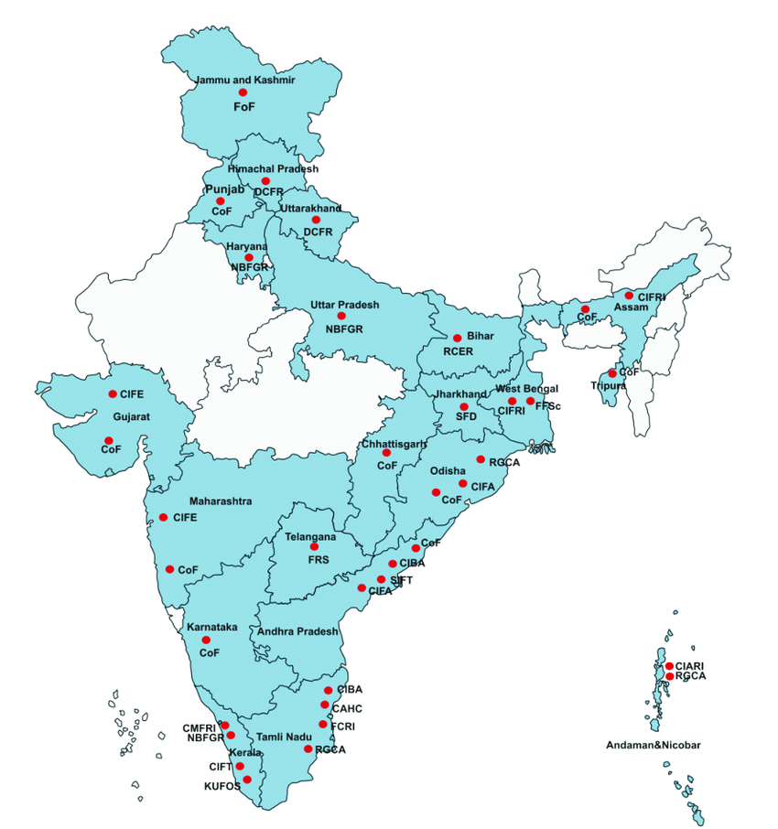Figure 1 (25): https://www.researchgate.net/figure/States-and-Union-Territories-covered-under-NSPAAD-and-respective-collaborating-centre_fig6_333089305 (Giri, S. S., 2018)

11.2 One Health approach as a sustainable solution for Zoonoses and epidemic in Indian aquaculture sector
Aquaculture affects both social and ecological systems, often causing conflicts over resource use and necessitating firm accountability through strong environmental planning (26). Historically, its health impacts were overlooked due to single-discipline research (26).The One Health approach must be extended to aquaculture, integrating research, veterinary and clinical practice, and policy to manage risks across human, animal, and environmental health (26,27) ( Figure 2). Collaboration among medical, veterinary, and public health sectors is essential (Gormaz et al., 2014). State investment in infrastructure and regulation is crucial to ensure environmental protection, clean water, and sustainable food systems beyond certification (29).
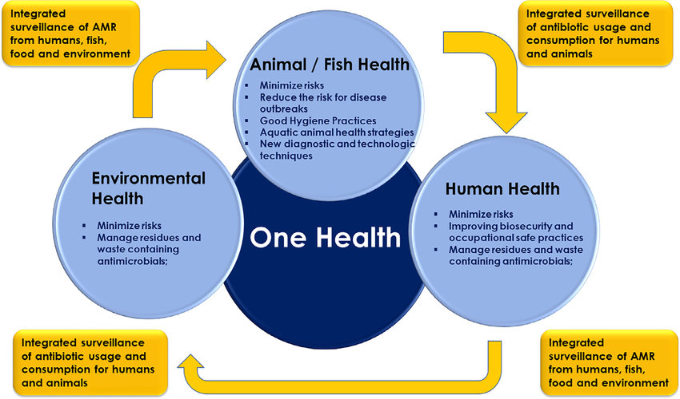
Figure 2: The One Health Aquaculture approach U.S. Geological Survey. (n.d.). https://www.usgs.gov/media/images/one-health-conceptual-diagram (96)

One Health aquaculture demands international cooperation, encompassing policies, disease surveillance, capacity building, and emergency response (28, Sasha, 2020). Secure farm-to-fork food chains are vital for public health and economic stability (30). Early assessment of public health risks aligns with One Health values (Vergis et al., 2021). Stock management must address biosecurity, zoonoses, and ecological impacts within artificial aquatic ecosystems that may foster pathogen spread (Ziarati, M., 2022) (Figure 3 and 4).

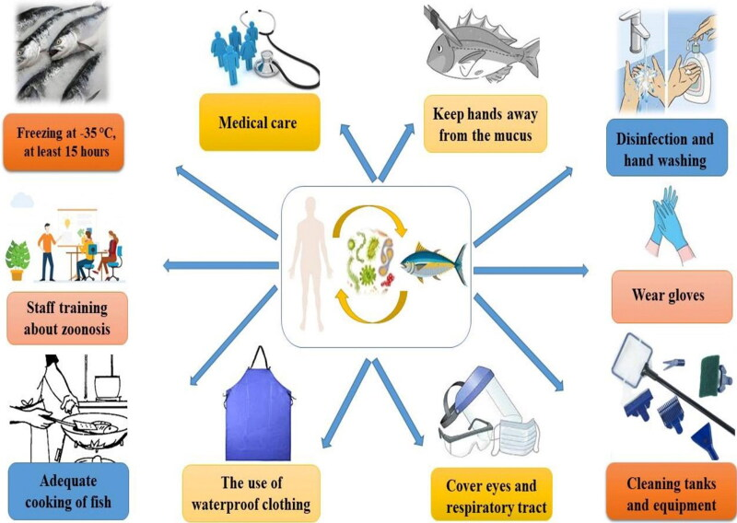

Figure 3: A schematic representation of possible methods and ways for control and prevention of zoonotic diseases.(7) Ziarati, M., (2022)

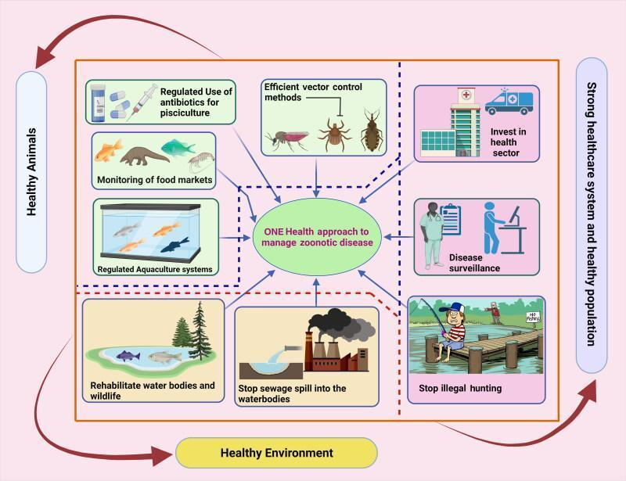

Figure 4: One Health (OH) approach in managing fish zoonotic disease. Augmentation of healthy animals with a healthy environment and healthy population along with strong health care infrastructure can prevent any potential fish zoonotic outbreaks.(7) Ziarati (2022)
12. CHALLENGES AND OPPORTUNITIES
Implementing One Health in Indian aquaculture faces challenges such as sectoral fragmentation, limited awareness, inadequate infrastructure, and policy gaps, hindering unified strategies and interdisciplinary collaboration. Coordination among government, academia, industry, and communities is essential to overcome these barriers. One Health can enhance disease management through advanced diagnostics, vaccines, and resistant breeds, improving productivity and economic stability (Sahoo et al., 2020). Eco-friendly feeds, efficient waste management, and IoT-based technologies further support sustainable practices. Collaborative research in genomics and biotechnology can improve disease resistance and growth. Ultimately, One Health reduces zoonotic risks, strengthens surveillance, and ensures safe, marketable aquaculture products.
13. CASE STUDIES
Yasobant et al. (2019a) examine global One Health collaboration strategies, comparing them to India's current approaches, and emphasize the need for sustainable partnerships to strengthen India's health system. They further highlight the importance of understanding local health dynamics in Gujarat (Yasobant et al., 2019b) and stress the urgency of early detection and control of zoonotic infections (Yasobant et al., 2020). Nambiar (2020) calls for institutionalizing One Health in India, focusing on collaborative initiatives and timely information sharing. Chaudhary et al. (2021) underscore the role of disease surveillance and molecular detection for zoonotic diseases, advocating for collaboration between veterinary and medical faculties. Dasgupta et al. (2021) push for the establishment of One Health Committees across states and ministries. Berthe et al. (2022) and Phand et al. (2022) emphasize One Health's importance in preventing pandemics, particularly post-COVID-19, while Phand et al. also advocate for expanding institutes like MANAGE to build capacity. Mor (2023) discusses the challenges governments face in responding to zoonotic diseases and calls for a reevaluation of strategies, especially considering climate change. Finally, Raut et al. (2023) and Taaffe et al. (2023) highlight the need for local-level coordination and the integration of One Health platforms to address zoonotic diseases effectively in India. The study identifies limited formal coordination among district-level veterinary, medical, and environmental professionals and recommends formalizing existing collaborative networks.

14. Conclusion
Fish-borne diseases can infect humans, highlighting the need for seafood safety. With rising consumption, research on marine zoonoses has grown, though parasite studies remain essential. Understanding pathogen morphology improves food safety and biosecurity. Proper freezing or heating of fish reduces risks. Advanced molecular tools aid in disease monitoring. Integrating control measures within the One Health approach, despite its complexity, helps prevent zoonotic outbreaks and enhances public health protection.

References

- Abraham, T. J., Bardhan, A., Hoque, F., Sarker, S. (2025). Biosecurity and Disease Management in Aquaculture Systems. In Management of Fish Diseases (pp. 409-436). Singapore: Springer Nature Singapore.
- Ahmed, J., Khan, M. H., Unnikrishnan, S., Ramalingam, K., 2022. Acute hepatopancreases necrosis diseases (AHPND) as a challenging threat in shrimp. Biointerface Research in Applied Chemistry 12(1), 978–991.
- Alavandi, S. V., Muralidhar, M., Dayal, J. S., Rajan, J. S., Praveena, P. E., Bhuvaneswari, T., Otta, S. K., 2019. Investigation on the infectious nature of Running Mortality Syndrome (RMS) of farmed Pacific white leg shrimp, Penaeus vannamei in shrimp farms of India. Aquaculture 500, 278–289.
- Aly, S. M., & Fathi, M. (2024). Advancing aquaculture biosecurity: a scientometric analysis and future outlook for disease prevention and environmental sustainability. Aquaculture International, 32(7), 8763-8789.
- Anikuttan, K. K., George, K. C., Sanil, N. K., Sobhana, K. S., 2018. Hepatic lesions associated with induced aflatoxicosis in the estuarine teleost Etroplus suratensis (Bloch, 1790). Indian Journal of Fisheries 65(3), 57–65.
- Anonymous, 2017. CIBA News Issue 4. Central Institute of Brackishwater Aquaculture, Chennai, India. Available from: http://www.ciba.res.in/Books/CIBANews%20Issue4.pdf. Accessed on: 4 July, 2017.
- Anonymous, 2021. Year End review 2021 on highlight key Initiatives and achievements pertains to Department of Fisheries, Ministry of Fisheries, Animal Husbandry and Dairying for the year 2021. PIB [Internet]. Available from: https://pib.gov.in/Pressreleaseshare.aspx?PRID=1786303. Accessed on : 2021 Dec 30 [cited 2022 Nov 8].
- Anonymous, 2020. One Health conceptual diagram. U.S. Department of the Interior. Available from: https://www.usgs.gov/media/images/one-health-conceptual-diagram. Accessed on: April 4, 2025.
- Anonymous, 2021. Annual Report 2021 [PDF]. Chennai, India: ICAR - Central Institute of Brackishwater Aquaculture. Available from: https://www.ciba.res.in/wp-content/uploads/2022/07/annualReport_english_2021.pdf. Accessed on: April 10, 2025.
- Anusha, M., Jagadeesh, T., Bagde, P., Kumari, P., Rathlavath, S., Prabhakar, P., 2024. Strategies and Techniques for Enhancing Fish Health and Averting Disease Outbreaks in Aquaculture Settings through the Use of Vaccination: A Review. International Journal of Bio-resource and Stress Management 15(Sep, 9), 01–11. https://doi.org/10.23910/1.2024.5563.
- Babu, B., Sathiyaraj, G., Mandal, A., Kandan, S., Biju, N., Palanisamy, S., Prabhu, N. M., 2021. Surveillance of disease incidence in shrimp farms located in the east coastal region of India and in vitro antibacterial efficacy of probiotics against Vibrio parahaemolyticus. Journal of Invertebrate Pathology 179, 107536.
- Bajpai, V., Pragyan, D., Suman, K., Mohanty, J., Sahoo, P. K., 2022. Viral diseases in Indian freshwater and marine water pisciculture. Current Science 122, 261–280.
- Bardhan, A., 2022. Fish-borne parasites proficient in zoonotic diseases: a mini review. Insights in Veterinary Science 6, 005–012.
- Bedekar, M.K., Kole, S., 2022. Fundamentals of fish vaccination. In: Vaccine Design: Methods and Protocols , Vaccines for Veterinary Diseases 2, 147–173.
- Behera, B. K., Pradhan, P. K., Swaminathan, T. R., Sood, N., Paria, P., Das, A., Jena, J. K., 2018. Emergence of tilapia lake virus associated with mortalities of farmed Nile tilapia Oreochromis niloticus (Linnaeus 1758) in India. Aquaculture 484, 168–174.
- Bera, K. K., Karmakar, S., Jana, P., Das, S., Purkait, S., Pal, S., Haque, R, 2018. Biosecurity in aquaculture: an overview. Aqua International 18(12), 42–46.
- Berthe, F.C.J., Avila Bedregal, L.P., Bali, S.R., Batmanian, G.J., 2022. One Health - Case Study: Assam State, India. World Bank, Washington, DC. Available from: https://documents1.worldbank.org/curated/en/099530410212241019/pdf/P17840200282d006d0948e0f126f1f887e3.pdf. Accessed on: 2022.
- Bhar, R., 2022. Opisthorchiids, Heterophyids and Aquaculture: A Brief Review. Medicon Agriculture & Environmental Sciences, 2, 10–18.
- Cavalli, L., 2015. One Health, One Aquaculture – Aquaculture under One Health Umbrella. Journal of Marine Biology and Aquaculture [Internet]1(1),1–2. https://www.researchgate.net/publication/281970855_One_Health_One_Aquaculture_Aquaculture_under_One_Health_Umbrella.
- Chaudhary, S.P., Kalorey, D.R., Awandkar, S.P., Kurkure, N.V., Narang, R., Kashyap, R.S., Barbuddhe, S. B., 2021. Journey towards National Institute of One Health in India. The Indian Journal of Medical Research 153(3), 320.
- Choudhury, T.G., Singh, S.K., Parhi, J., Barman, D., Das, B.S., 2014. Common fungal diseases of fish: a review. Environment and Ecology 32(2), 450–456.
- Danasekaran, R. (2024). One health: a holistic approach to tackling global health issues. Indian Journal of Community Medicine, 49(2), 260-263.
- Das, S.K., Murmu, K., Das, A., Shakuntala, I., Das, R. K., Ngachan, S.V., Majhi, S.K., 2012. Studies on the identification and control of pathogen Saprolegnia in selected Indian major carp fingerlings at mid hill altitude. Journal of Environmental Biology 33(3), 545.
- Dasgupta, R., Tomley, F., Alders, R., Barbuddhe, S. B., Kotwani, A., 2021. Adopting an intersectoral One Health approach in India: time for One Health committees. The Indian journal of medical research 153(3), 281.
- Dubey, S., Maiti, B., Kim, S. H., Sivadasan, S. M., Kannimuthu, D., Pandey, P. K., Munang´ andu, H. M., 2019. Genotypic and phenotypic characterization of Edwardsiella isolates from different fish species and geographical areas in Asia: Implications for vaccine development. Journal of Fish Diseases 42(6), 835–850.
- Vergis, J., Rawool, D., Singh, Malik, S., Barbuddhe, S., 2021. Food safety in fisheries: Application of One Health approach. Indian Journal of Medical Research 153(3),348.
- George, P.R., Harini, E., 2019. Fish-borne zoonotic diseases are risk to public health. Present status of fish disease management programmes in India: A review. Our Heritage, 67(November): 118–123. Available from: https://www.researchgate.net/publication/351884081_Fish-borne_Zoonotic_Diseases_Are_Risk_to_Public_Health_Present_Status_of_Fish_Disease_Management_Programmes_in_India_-Review_Our_Heritage_journal_November_2019.
- Giri, S. S. (2018). Policy Framing for Control of Transboundary Aquatic Animal Diseases. Retrieved from https://www.researchgate.net/publication/333089305_Policy_Framing_for_Control_of_Transboundary_Aquatic_Animal_Diseases​
- Giri, S. S., 2017. Best Management Practices in Aquaculture: Capacity Building and Policy Development-A Regional Overview. In: Best Management Practices in Aquaculture, 1–21.
- Gormaz, J. G., Fry, J. P., Erazo, M., Love, D. C., 2014. Public health perspectives on aquaculture. Current environmental health reports 1, 227–238.
- Gozlan, R. E., Bommarito, C., Caballero-Huertas, M., Givens, J., Mortillaro, J. M., Pepey, E., Combe, M. (2024). A one-health approach to non-native species, aquaculture, and food security. Water Biology and Security, 100250.
- Hambrey, J. (2017). The 2030 agenda and the sustainable development goals: the challenge for aquaculture development and management. FAO fisheries and aquaculture circular, (C1141).
- Hoshina, T. (1962). On a new bacterium, Paracolobacterium anguillimortiferum gen. nov., sp. nov., pathogenic to eels. Bulletin of the Japanese Society of Scientific Fisheries, 28(2), 162–164.​
- Iqbal, G., Mushtaq, S., Singh, L.S., Ganpatbhai, A.V.K., 2023. Fungal diseases in aquaculture: A review. The Pharma Innovation Journal, 12(7S): 1959-1962. Available from: https://www.thepharmajournal.com/special-issue?ArticleId=21757&issue=7S&vol=12&year=2023.​
- Irshath, A. A., Rajan, A. P., Vimal, S., Prabhakaran, V. S., Ganesan, R., 2023. Bacterial pathogenesis in various fish diseases: Recent advances and specific challenges in vaccine development. Vaccines 11(2), 470.
- Jamwal, A., Phulia, V., 2021. Multisectoral one health approach to make aquaculture and fisheries resilient to a future pandemic‐like situation. Fish and Fisheries 22(2), 449–463.
- Jimenez, C. E. P., Keestra, S., Tandon, P., Cumming, O., Pickering, A. J., Moodley, A., Chandler, C. I. (2023). Biosecurity and water, sanitation, and hygiene (WASH) interventions in animal agricultural settings for reducing infection burden, antibiotic use, and antibiotic resistance: a One Health systematic review. The Lancet Planetary Health, 7(5), e418-e434.
- Jithendran, K. P., 2014. Parasites and parasitic diseases in fish culture system. Veterinary Parasitology 331–376.
- Joseph, T. C., Dinesh, R., Shaheer, P., Murugadas, V., Rekha, M., Lalitha, K. V., 2019. Outbreak of Edwardsiella tarda in cultured Pangasius hypophthalmus (Sauvage, 1878). Fishing Technology 56 (2).
- Kumar, V., Das, B. K., Swain, H. S., Chowdhury, H., Roy, S., Bera, A. K., Behera, B. K., 2022. Outbreak of Ichthyophthirius multifiliis associated with Aeromonas hydrophila in Pangasianodon hypophthalmus: The role of turmeric oil in enhancing immunity and inducing resistance against co-infection. Frontiers in immunology 13, 956478.
- Kumari, M., Khurana, S., Bhardwaj, N., Malhotra, R., Mathur, P., 2019. Pathogen burden & associated antibiogram of Pseudomonas spp. in a tertiary care hospital of India. The Indian Journal of Medical Research 149(2), 295.
- Kumawat, T., Tyagi, L. K. (2024). National Legislations: Best Practices and Challenges in India for Sustainable Management of Fish Genetic Resources. In Sustainable Management of Fish Genetic Resources (pp. 267-295). Singapore: Springer Nature Singapore.
- Kushala, K. B., Nithin, M. S., Girisha, S. K., Dheeraj, S. B., Sowndarya, N. S., Puneeth, T. G., Vinay, T. N., 2022. Fish immune responses to natural infection with carp edema virus (Koi sleepy disease): An emerging fish disease in India. Fish and Shellfish Immunology 130, 624–634.
- Llarena, E. D. (2019). An integrated communication approach to address zoonotic diseases (Doctoral dissertation, Murdoch University).
- Madsen, H., Stauffer, J. R. (2022). Zoonotic trematode infections; their biology, intermediate hosts and control. In Parasitic Helminths and Zoonoses-From Basic to Applied Research. IntechOpen.
- Modeel, S., Dolkar, P., Siwach, S., Yadav, P., & Negi, R. K. (2024). Role of Science and Technology for Sustainable Aquaculture Development and Aquatic Ecosystem Management. In Role of Science and Technology for Sustainable Future: Volume 1: Sustainable Development: A Primary Goal (pp. 277-301).
- Mondal, H., Thomas, J., Chandrasekaran, N., Mukherjee, A., 2023. Isolation and Identification of Branchiomyces demigrans from Fishes. In: Aquaculture Microbiology. New York, NY: Springer US, pp. 73–76.
- Mor, N., 2023. Organising for One Health in a developing country. One Health 17, 100611.
- Nambiar, P., 2020. India to envision One Health movement for confronting emerging health threats: From concept to approach toward institutionalization. International Journal of One Health 6(2), 165–176.
- Narayan, K. G., Sinha, D. K., Singh, D. K. (2024). Epidemiology of Fish-Borne Zoonotic Trematodiasis. In Handbook of Management of Zoonoses (pp. 889-895). Singapore: Springer Nature Singapore.
- Pandit, N., Brahmchari, R. K., Nayak, S. K., Mogalekar, H. S., Singh, M. K. 2023. Specific Pathogen-Free (SPF) Fish/Shellfish Stocks: Reducing Disease Risk in Aquaculture. Chronicle of Aquatic Science 1(5): 49-57.
- Paul, A., Mohanty, J., Rajendran, K. V., Tripathi, G., Sahoo, P. K., 2021. First report of Dactylogyrus scorpius infection in Indian major carp, Labeo rohita from India: Host specificity and kinetics of immune gene expression in gills. Aquaculture 536, 736453.
- Paul, R. (2024). AMR in aquaculture: Enhancing Indian shrimp exports through sustainable practices and reduced antimicrobial usage (No. 209). Research Paper.
- Phand, S., Kumari, V., Phand, S., 2022. One Health Approach: Researchable Areas for Stakeholders. Journal of Agricultural Extension Management 23(2), 107.
- Pradhan, S. K., Devi, R., Khan, M. I. R., Kamilya, D., Choudhury, T. G., Parhi, J., 2023. Isolation of Aeromonas salmonicida subspecies salmonicida from aquaculture environment in India: Polyphasic identification, virulence characterization, and antibiotic susceptibility. Microbial Pathogenesis 179, 106100.
- Raja, S., Kumaran, M., Ravichandran, P., 2013. Implementation of biosecurity measures in commercial shrimp hatcheries in India. Israeli Journal of Aquaculture - Bamidgeh, 65: 881–886. Available from: https://www.researchgate.net/publication/263966940_Implementation_of_Biosecurity_Measures_in_Commercial_Shrimp_Hatcheries_in_India. Accessed on: January, 2013.
- Ram, M. K., Kumar, B. N., Poojary, S. R., Abhiman, P. B., Patil, P., Ramesh, K. S., Shankar, K. M., 2019. Evaluation of biofilm of Vibrio anguillarum for oral vaccination of Asian seabass, Lates calcarifer (BLOCH, 1790). Fish and Shellfish Immunology 94, 746–751.
- Rao, P.S. and Satyanarayana, T. (2020). Unexplained mortality events in vannamei and tiger shrimp farms in Tamil Nadu: A case study. Indian Journal of Agricultural Research, 54(3): 362–367.
- Raut, J., Joshi, A., Mudey, A., Mehendale, A. M., 2023. The Past, Present, and Future of One Health in India: A Narrative Review. Cureus 15(9).
- Rohr, J. R., Barrett, C. B., Civitello, D. J., Craft, M. E., Delius, B., DeLeo, G. A., Tilman, D. (2019). Emerging human infectious diseases and the links to global food production. Nature sustainability, 2(6), 445-456.
- Saklani, P., Prabhakar, P., Thakur, A., Siddhnath. (2025). Antimicrobial Resistance in Fish and Fishery Products: An Emerging Threat for Public Health. In Antibiotic Residue and Resistance in Seafood Safety and Quality (pp. 73-87). Singapore: Springer Nature Singapore.
- Sahoo, P. K., Mukherjee, S. C., Mahapatra, K. D., Maiti, N. K., Mandal, R. K. (2020). Incidences of infectious diseases in freshwater aquaculture farms of eastern India: A passive surveillance based study from 2014–2018. Journal of Aquaculture Research and Development, 11(1), Article 579.
- Saini, V. P., Chandrahas, Singh, A. K., Paul, T., Thakur, A., Singh, M., (Eds.). 2024. Souvenir Book on Advances in Environment Management for Sustainable Fisheries & livestock production. College of Fisheries, Kishanganj, Bihar Animal Sciences University, India. pp. 94.
- Sanjib, S., Gadadhar, D., 2021. Zoonotic Vibrio diversity and diseases in mudcrab fishery: impacts on public health in India. Uttar Pradesh Journal of Zoology 42(19), 48–58.
- Sasha. S., 2020. The Role of One Health in Aquaculture [Internet]. Aquatic Network. https://www.aquanet.com/blog/the-role-of-one-health-in-aquaculture
- Semwal, A., Kumar, A., Kumar, N., 2023. A review on pathogenicity of Aeromonas hydrophila and their mitigation through medicinal herbs in aquaculture. Heliyon 9 (2023), e14088
- Serwecińska, L. (2020). Antimicrobials and antibiotic-resistant bacteria: a risk to the environment and to public health. Water, 12(12), 3313.
- Scholz, T., Kuchta, R. (2016). Fish-borne, zoonotic cestodes (Diphyllobothrium and relatives) in cold climates: a never-ending story of neglected and (re)-emergent parasites. Food and waterborne parasitology, 4, 23-38.
- Sheikha, G. F., Mankodi, P. C., 2021. A Case Report of Branchiomyces Sp. Infection in Carp (Catla Catla) from Vadodara, Gujarat. In: National Conference on Present Day Biology: Recent Advancements in Biological Sciences, p. 34.
- Sithithaworn, P., Saijuntha, W., Andrews, R. H., Petney, T. N. (2015). Clonorchis, Opisthorchis, and Metorchis. In Biology of Foodborne Parasites (pp. 275-297). CRC Press.
- Singh, S., Mallik, S. K., Kala, K., Shahi, N., Pathak, R., Giri, A. K., Patiyal, R. S., 2021. Characterization of Flavobacterium columnare from farmed infected rainbow trout, Oncorhynchus mykiss (Walbaum, 1792) of Central Indian Himalayan region, India. Aquaculture 544, 737118.
- Sivaraman, I., Krishnan, M., Radhakrishnan, K., 2019. Better Management Practices for sustainable small-scale shrimp farming. Journal of Cleaner Production 214, 559–572.
- Sivasankar, P., John, K. R., George, M. R., Mageshkumar, P., Manzoor, M. M., Jeyaseelan, M. P., 2017. Characterization of a virulent ranavirus isolated from marine ornamental fish in India. VirusDisease 28, 373–382.
- Sommerset, I., Krossøy, B., Biering, E., Frost, P., 2005. Vaccines for fish in aquaculture. Expert review of vaccines 4(1), 89–101.
- Sonone, S. S., Jadhav, S., Sankhla, M. S., & Kumar, R. (2020). Water contamination by heavy metals and their toxic effect on aquaculture and human health through food Chain. Lett. Appl. NanoBioScience, 10(2), 2148-2166.
- Sood, N., Pradhan, P. K., Swaminathan, T. R., Rathore, G., Jena, J. K., Lal, K. K., 2021. National surveillance programme for aquatic animal diseases—a stepping stone for establishing disease governance system in India. Current Science 120(2), 273–277.
- Srinath, K., Sridhar, M., Kartha, P. N. R., Mohanan, A. N., 2000. Group farming for sustainable aquaculture. Ocean and Coastal Management 43(7), 557–571.
- Stentiford, G.D., Bateman, I.J., Hinchliffe, S.J., Bass, D. Hartnell R, Santos, E.M., 2020. Sustainable aquaculture through the One Health lens. Nature Food, Springer Nature 1, 468–474.
- Subburaj, R., Venmathi Maran, B. A., Arasu, A. R. T., Kailasam, M., Elangeshwaran, S., Kumar, P., Sukumaran, K., 2019. First report on infection of Argulus quadristriatus (Arthropoda: Crustacea: Branchiura) on marine fish cobia in brood stock pond culture. National Academy Science Letters 42, 205–208.
- Suguna T. Management of Stress in Culture Fish. IJBSM [Internet]. 2021 Jan. 13 [cited 2025 Apr. 10];11(Dec, 6):607-12. Available from: https://ojs.pphouse.org/index.php/IJBSM/article/view/4059
- Suresh Babu, P.P., Razvi, S.S.H., Venugopal, G., Rami Reddy, M.M.P., Srinivasa Rao, P., Acharyulu, V.N., 2013. Organic load induced black gill discoloration in farmed Litopenaeus vannamei and its mitigation using a pond sanitizer. Fishery Technology, 50(2): 214–217.
- Swaminathan, T. R., Kumar, R., Dharmaratnam, A., Basheer, V. S., Sood, N., Pradhan, P. K., Jena, J. K., 2016. Emergence of carp edema virus in cultured ornamental koi carp, Cyprinus carpio koi, in India. Journal of General Virology 97(12), 3392–3399.
- Swaminathan, T. R., Nithyanantham, S. R., Narendrakumar, L., Dharmaratnam, A., Sood, N., Pradhan, P. K., Lal, K. K., 2021. Co-infection of Lactococcus garvieae and Tilapia lake virus (TiLV) in Nile tilapia Oreochromis niloticus cultured in India. Diseases of Aquatic Organisms 147, 127–140.
- Taaffe, J., Sharma, R., Parthiban, A. B. R., Singh, J., Kaur, P., Singh, B. B., Parekh, F. K. (2023). One Health activities to reinforce intersectoral coordination at local levels in India. Frontiers in Public Health 11, 1041447.
- Tantry, T. A., Nazir, R., Chishti, M. Z., Ahmad, F., Dar, G. H., Dar, J. S., 2016. A report on the incidence of Trichodina heterodentata from fishes of Jammu, J and K India. Journal of Parasitic Diseases 40, 524–527.
- Thakur, K., Sharma, A., Sharma, D., Brar, B., Choudhary, K., Sharma, A. K., Kumar, R., 2023. An insight into the interaction between Argulu s siamensis and Labeo rohita offers future therapeutic strategy to combat argulosis. Aquaculture International 31(3), 1607–1621.
- Tripathi, Y. R., 1952. Studies on Parasites of Indian Fishes, I, Protozoa Myxosporidia Together with a Check List of Parasitic Protozoa Described from Indian Fishes. Records of the Zoological Survey of India, 63–88.
- Tucker, C. S., Hargreaves, J. A., 2009. Environmental best management practices for aquaculture, John Wiley and Sons, 3–54.
- U.S. Geological Survey. (2023, November). One Health conceptual diagram. U.S. Department of the Interior. Retrieved April 10, 2025, from https://www.usgs.gov/media/images/one-health-conceptual-diagram
- Ummey, S., Khan, S., Vijayakumar, P. P. N., Ramya, A., 2021. Enteric Red Mouth disease and its causative bacterium, Yersinia ruckeri, in Indian Major Carps from culture ponds in Andhra Pradesh, India. Aquaculture and Fisheries 6(3), 289–299.
- Vergis, J., Rawool, D. B., Malik, S. V. S., & Barbuddhe, S. B. (2021). Food safety in fisheries: Application of One Health approach. Indian Journal of Medical Research, 153(3), 348-357.
- Verma, V. (2008). Fungus disease in fish, diagnosis and treatment. Veterinary World 1(2), 62.
- Viatte, G., 2001. Adopting technologies for sustainable farming systems: an OECD perspective. In: Adoption of Technologies for Sustainable Farming Systems Wageningen Workshop Proceedings, , Paris, France: OECD Vol. 14, pp. 14–23.
- Wakabayashi, H., Egusa, S. (1973). Edwardsiella tarda (Paracolobacterium anguillimortiferum) associated with pond-cultured Japanese eels (Anguilla japonica). International Journal of Systematic Bacteriology, 23(2), 37–44.
- Xu, T., Zhang, X.-H. (2014). Edwardsiella tarda: An intriguing problem in aquaculture. Aquaculture, 431, 129–135. https://doi.org/10.1016/j.aquaculture.2013.12.001
- Yasobant, S., Bruchhausen, W., Saxena, D., Falkenberg, T. (2019a). One health collaboration for a resilient health system in India: Learnings from global initiatives. One Health 8, 100096.
- Yasobant, S., Bruchhausen, W., Saxena, D., Falkenberg, T., 2020. ‘One Health’Actors in Multifaceted Health Systems: An Operational Case for India. Healthcare, MDPI 8(4), 387.
- Yasobant, S., Patel, K., Saxena, D., 2019b. Hastening One health collaboration in Gujarat, India: A SWOT analysis. Journal of Public Health Policy and Planning 3(2), 22–24.
- Ziarati, M., Zorriehzahra, M. J., Hassantabar, F., Mehrabi, Z., Dhawan, M., Sharun, K., Shamsi, S., 2022. Zoonotic diseases of fish and their prevention and control. Veterinary Quarterly, 42(1), 95–118.
- Ziarati, M., Zorriehzahra, M. J., Hassantabar, F., Mehrabi, Z., Dhawan, M., Sharun, K., Shamsi, S.. 2022. Zoonotic diseases of fish and their prevention and control. Veterinary Quarterly 42(1), 95–118. https://doi.org/10.1080/01652176.2022.2080298

