Review Article

The Role of Variable Rate Technology (VRT) in Modern Agriculture: A Review

Abstracts
The main aim of this publication is to discuss the concept of variable rate technology (VRT), and its components associated with variable rate application of water, fertilizer, and other agricultural inputs. Fertilizer application is influenced by soil parameters as well as geographical variation in the field. The nutrient management depends on selection of nutrient, application rate and placement of nutrient at the optimal distance from the crop and soil depth. Variable rate technology (VRT) is an input application technology that allows for the application of inputs at a certain rate, time, and place based on soil properties and spatial variation in the field or plants. There are two approaches for implementing VRT, one is sensor based and another is map based. The sensor-based approach; with suitable sensors, measures the soil and crop characteristics on-the-go calculating the amount of nutrients required per unit area/plant and micro controlling unit which uses suitable algorithms for controlling the flow of fertilizer with required amount of nutrient. In map based approach; Grid sampling and soil analysis are used to create a prescription map. According to the soil and crop conditions, the microcontroller regulates the desired application rate. The sensor-based VRT system includes a fertilizer tank, sensors, GPS, microcontroller, actuators, and other components, whereas the map-based system does not require an on-the-go sensor. Both approaches of VRT for fertilizer application in orchards and field crops are reviewed in this paper.
Key Words: Variable Rate Technology (VRT), precision agriculture., farming systems, climate change, precision farming, soil sampling.
1. Introduction
Variable Rate Technology (VRT) is a precision agriculture method that uses the application of inputs (like seeds, fertilizers, and pesticides) at variable rates in a field based on the specific needs of different areas. VRT employs data-driven insights for precise and efficient use of resources. The concept of VRT has changed since its beginning in the late 20th century. Advancements have led it in technology and data analytics. VRT has become a sore component of intelligent farming, using smart integration of GPS technology, real-time data collection, and sophisticated algorithms to make agricultural operations efficient. The main aim of this publication is to discuss the concept of variable rate technology (VRT), and its components associated with variable rate application of water, fertilizer, and other agricultural inputs. This publication also provides an example of the control system for variable rate application of agricultural inputs in row and tree crops. The document provides useful information on VRT to students, research scientists, Extension agents, growers, agricultural consultants, and state agency personnel.
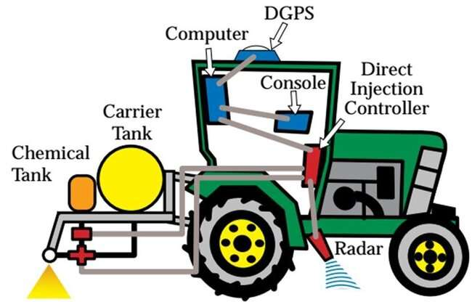
Figure 1: Variable rate technology in Agriculture
In traditional agriculture, the same amount of agricultural input is applied across the field regardless of within-field variability, such as topography, variation in soil type, texture, or organic matter content, etc. This “one size fits all” approach to applying inputs may lead to either under- or over-applications of inputs, and consequently, variations in yield across the field, but it further impacts environmental sustainability and farm economics (Lark and Stafford 1997). In the last two decades, successful advancements in precision agriculture technologies such as VRT have enabled the site-specific (i.e., individual plant or management unit) application of water, fertilizer, and other inputs such as herbicides or pesticides to manage spatial and temporal variabilities in yields within agricultural fields. According to the USDA Agricultural Resource Management Survey, the current adoption rate of VRT in the United States has increased by 69% across major commodity crops (corn: 71%, soybean: 76%, cotton: 74%, winter wheat: 68%, and sorghum: 57%) (USDA 2023). Survey results from 2016–2019 also indicated the increase in the use of VRT from 3.9% to 8.6% of crop planted acres in pesticide application, 9% to 25.3% of crop planted acres in seeding rate, and 8% to 28.2% of planted acres in fertilizers/lime application. Recent developments in artificial intelligence (AI) and sensor technologies have boosted adoption of VRT in the U.S. and worldwide. The Variable Rate Technology (VRT) Market size was valued at USD 4.62 Billion in 2023 and is expected to grow to USD 11.7 Billion By 2031 and grow at a CAGR of 12.4 % over the forecast period of 2024-2031.
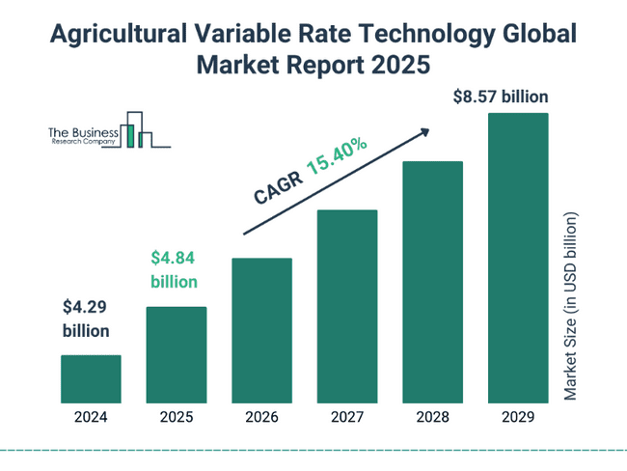
Figure 2: The agricultural variable rate technology market size has grown rapidly in recent years. It will grow from $4.29 billion in 2024 to $4.84 billion in 2025 at a compound annual growth rate (CAGR) of 12.8%.
The Variable Rate Technology (VRT) market is rapidly evolving, driven by the increasing demand for precision agriculture solutions that enhance crop productivity and resource efficiency. VRT allows farmers to apply inputs such as fertilizers, pesticides, and water at variable rates across a field, tailored to the specific needs of different zones within the field. This technology relies on data from various sources, including GPS, remote sensing, and soil sampling, to make informed decisions. As a result, VRT helps in optimizing input usage, reducing waste, and improving overall farm profitability. The market is witnessing significant growth due to advancements in agricultural machinery, the integration of Internet of Things (IoT) devices, and the adoption of big data analytics in farming.
In addition to improving agricultural efficiency, the VRT market is also being propelled by environmental concerns and regulatory pressures. By enabling more precise application of inputs, VRT contributes to sustainable farming practices, reducing the environmental impact of agriculture. This is particularly important in regions facing water scarcity and soil degradation. Governments and regulatory bodies are increasingly promoting the adoption of VRT through subsidies and support programs, recognizing its potential to enhance food security while minimizing environmental harm.
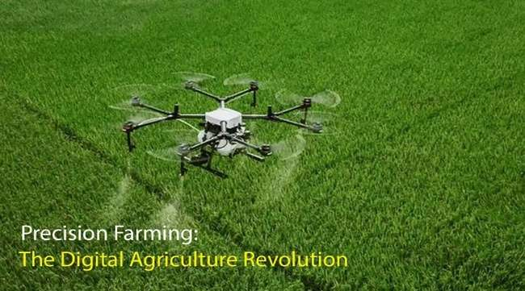
Fig 3: Precision Farming: A Digital Agriculture Revolution
The VRT enables growers and their crop advisors to precisely apply the agricultural inputs (such as water, nutrients, chemicals, etc.) at variable rates in response to the spatial variability within the field. This can be achieved by integrating VRT into different farming practices like seeding, irrigation, fertilization, and pesticide/fungicide application. VRT can be adopted into farming practices in two methods: (1) map-based (Figures 1, 2, and 3), and (2) sensor-based (Figure 4). When used appropriately, both techniques assist growers and other agricultural players to optimize crop yields, reduce input and labor costs, increase farm net revenue, and minimize environmental degradation (Grisso et al. 2011; Campos et al. 2020).
Understanding Precision Agriculture
Precision farming is a kind of agricultural management that makes use of cutting-edge technology to enhance several elements of farming. To make informed decisions about crop production, livestock management, and resource allocation, data must be gathered, analyzed, and used. Farmers may optimize efficiency, production, and sustainability by using this data-driven strategy to customize their operations to particular circumstances.
The Cutting-Edge Technologies
Precision farming relies on an array of cutting-edge technologies, each contributing to its success:
Global Positioning System (GPS): Precision farming is greatly aided by GPS technology, which offers precise location data that enables farmers to precisely map and manage their fields. Accurate planting, fertilizing, and harvesting are all made possible with GPS-guided tractors and equipment.
Remote Sensing: Real-time information on soil moisture, nutrient levels, crop health, and insect infestations is provided through drones, satellite and aerial photography, ground-based sensors, and sensors. Farmers can use this information to decide when to use irrigation, fertilizer, and pest control.
Variable Rate Technology (VRT): Based on data-driven recommendations, VRT systems modify the application of inputs including fertilizers, herbicides, and water. By preventing waste and reducing usage, this helps the environment and saves money.
IoT and Sensors: Real-time monitoring and control of numerous farming activities is made possible by the Internet of Things (IoT) technology, which connects sensors implanted in machinery and equipment. Data about temperature, humidity, soil conditions, and other variables is gathered by these sensors.
Data Analytics and Machine Learning: To produce useful insights, sophisticated algorithms analyze the enormous amounts of data gathered from many sources. Crop yields, disease outbreaks, and the best dates to grow a crop can all be predicted using machine learning algorithms.
The Payoffs of Precision Farming: The adoption of precision farming offers numerous advantages, both for farmers and the environment:
Increased Efficiency: Precision farming maximizes the use of resources, which lowers input costs and increases yields. With fewer resources, farmers can accomplish more, which eventually boosts their profitability.
Environmental Sustainability: It lessens the negative effects on the environment caused by soil erosion, nutrient runoff, and water pollution by avoiding the overuse of pesticides, fertilizers, and water. It advocates for ecologically sound agriculture methods.
Improved Crop Quality: Farmers can more efficiently monitor and manage crop health thanks to precision farming. Produce of superior quality results from this, which can fetch a higher price on the market.
Risk Mitigation: Farmers can predict and respond to weather-related occurrences, diseases, and other dangers with the aid of data-driven decision-making. This lowers crop losses and guarantees a more consistent income.
Conservation of Resources: Effective resource management, such as conserving water and using less energy, helps to ensure that natural resources are used responsibly.
Why Indian Farmers Should Embrace Precision Farming
India's agriculture farmlands’ problems are distinctive. Farmers are under tremendous pressure to increase food production while preserving resources due to a big population and limited arable land. Here are some persuasive arguments in favour of precision farming for Indian farmers:
Optimized Land Use: Indian farmers use precision farming to increase the productivity of their small plots of land. They can increase yields without increasing their land holdings by adapting farming techniques to certain situations.
Water Scarcity Mitigation: Water scarcity is a serious problem in this part of the world. With the use of precision irrigation technologies, farmers can use water more effectively, cutting down on water wastel and maintaining a reliable supply of water for agriculture.
Increased Profitability: Small landholdings are a hallmark of Indian agriculture, and many farmers struggle to make ends meet. They may increase yields and lower input costs with precision farming, which will increase profitability.
Climate Resilience: With more unpredictable weather patterns due to climate change, Indian agriculture is seriously threatened. Farmers can quickly adjust to shifting conditions and reduce risks associated with climate change thanks to precision farming's data-driven methodology.
2. Variable Rate Technology (VRT Market Drivers)
2.1. Increasing Demand for Precision Farming
Variable Rate Technology (VRT) is a key component of precision farming, which involves using data to optimize crop production. VRT allows farmers to apply inputs, such as fertilizer, pesticides, and water, at variable rates across a field. This can lead to significant cost savings and environmental benefits. The growing adoption of precision farming practices is a major driver of the VRT market. According to a report by Research and Markets, the global precision farming market is expected to reach $12.2 billion by 2026, growing at a CAGR of 12.5%.This growth is expected to continue to drive demand for VRT systems. In addition to cost savings and environmental benefits, VRT can also help farmers to improve crop yields. By applying inputs at the right rate and in the right place, farmers can maximize plant growth and reduce the risk of crop damage. This can lead to significant increases in profitability. The increasing demand for precision farming is being driven by a number of factors, including the rising cost of inputs, the need to improve crop yields, and the growing awareness of the environmental benefits of precision farming. As a result, the VRT market is expected to continue to grow in the coming years.
2.2. Government Support for Precision Agriculture
Many governments around the world are providing support for precision agriculture initiatives, including VRT. This support is often in the form of financial incentives, such as grants and tax breaks. In the United States, for example, the USDA provides a number of programs to support precision agriculture, including the Environmental Quality Incentives Program (EQIP) and the Conservation Stewardship Program (CSP). Government support for precision agriculture is driven by a number of factors, including the need to improve agricultural productivity, reduce environmental impacts, and ensure the sustainability of food production can help to achieve all of these goals. By providing financial incentives for the adoption of VRT, governments can help to accelerate the growth of the VRT market. In addition to financial incentives, governments are also providing support for precision agriculture through research and development programs. This research is focused on developing new and innovative VRT technologies, as well as on improving the understanding of how VRT can be used to improve crop production. Government support for research and development is essential for the continued growth of the VRT market.
Variable-Rate Technology (VRT): Promise and Paradox
1.Introduction
Farming faces a quiet shift. Data-driven steps guide each move. Variable-Rate Technology (VRT) fuels this change. It promises precision, efficiency, and growth. But promises aren't always kept. Beneath the surface, challenges churn. Farmers tread carefully, balancing risk and reward.
2.Core Data Analysis Techniques in VRT
1. Geostatistics
Soil hides stories beneath its crust. Geostatistics reveals them, mapping nutrient flows. Kriging creates maps like treasure charts. Each map guides farmers with precision. Every zone tells a tale of need.
2. Geographic Information Systems (GIS)
GIS layers data like a quilt. Soil maps and yield maps combine. They reveal patterns once unseen. Farmers see fields in vivid clarity.
3. Regression Analysis
Yields are not random results. Regression analysis links soil, weather, and output. It reveals hidden patterns and connections. This foresight helps farmers make better choices.
4. Machine Learning
The farm now has a mind. Machine learning reads and learns from data. It spots patterns humans often miss. Over time, it sharpens its insights.
3. From Data to Actionable Insights
3.1. Data Collection
Data is the root of insight. Sensors, satellites, and tests collect vital data. Each source offers a fresh view. Combined, they reveal the field’s specific needs.
3.2. Data Analysis
Analysis turns data into usable insight. Geostatistics, GIS, and machine learning unite. They divide fields into unique zones. Each zone has distinct requirements and needs.
3.3. Prescription Map Creation
Maps become guides for precision farming. Colours on maps signal input needs. Farmers follow them like captains follow charts.
3.4. Implementation
The plan takes shape on fields. GPS-guided tractors move with purpose. Spreaders release inputs with pinpoint precision. Each plot gets exactly what it needs.
Example of VRT in Practice
3.5. Soil Sampling
Farmers collect soil from several spots. Each sample tells a story of nutrients.
3.6. Analysis
Lab tests reveal soil's hidden secrets. Farmers learn where nutrients are low.
3.7. Mapping
Insights turn into maps of zones. Farmers see which areas need help.
Prescription Map
The map becomes a guidebook for action. Input rates are assigned to each zone.
3.8. Application
Machines follow GPS-guided paths precisely. Spreaders release just enough, cutting waste.
Barriers to VRT Adoption
3.9. High Initial Investment
- Precision has a steep price tag. VRT tools, sensors, and machines are costly. For small farms, this price feels immense.
- Data Management Complexity
- Data floods in from every source. Farmers face an overwhelming data deluge. Managing it requires time, skill, and effort.
3.10. Skill Requirements
- Farmers become operators of complex tech. GPS, AI, and software must be mastered. Learning curves slow the pace of adoption.
- Limited Access to Technology and Data
- Not all farmers have equal access. Remote farms face connectivity and access gaps. Without it, VRT stays out of reach.
- Return on Investment (ROI) Uncertainty
- Will it pay off? Nobody knows. Weather, crop types, and market shifts affect returns.
4. Data Privacy and Security Concerns
Data is gold, but it’s vulnerable. Sharing farm data raises serious privacy fears. Farmers risk losing control of their information.
5. Economic Inequities
Bigger farms adopt VRT faster and cheaper. Small farms struggle to keep pace. The wealth gap grows wider and deeper.
6. Technological Advancements in VRT
6.1. AI & ML
AI sharpens the farm’s mind. It blends data into powerful insights. Fields become smarter, learning with each season.
6.2. Robotics and Automation
Robots roam fields with quiet precision. They plant, spray, and harvest with care. Farmers watch while machines do the work.
6.3. High-Resolution Sensors and Imaging
Sensors and drones see beyond human sight. They detect crop health, moisture, and stress. These "eyes in the sky" offer essential insights.
6.4. Internet of Things (IoT)
The farm becomes a “smart system.” Sensors, cameras, and weather stations connect. Real-time updates sharpen decision-making.
6.5. Blockchain Technology
Blockchain builds trust through transparency. It tracks each seed’s journey from field to fork. Supply chains become clear and credible.
7. Future Directions of VRT
7.1. Climate Adaptation
Climate-smart farming becomes a necessity. VRT helps farmers face floods and droughts. Predictive analytics offer foresight, not hindsight.
Advanced Sensors and Data Analytics
Sensors get smarter with each innovation. They track biodiversity, soil health, and ecosystem change. Farmers see a fuller view of their land.
7.2. Climate-Smart Agriculture
Resilient farming goes beyond fleeting trends. VRT optimizes inputs to match changing weather. Fields shift from reactive to resilient.
2.3. Technological Advancements
The VRT market is also being driven by a number of technological advancements. These advancements include the development of new sensors, data management systems, and application technologies. New sensors are making it possible to collect more accurate and detailed data about crops and soil conditions. This data can then be used to create more precise variable rate application maps. Data management systems are also becoming more sophisticated, making it easier for farmers to manage and analyze the large amounts of data that are generated by VRT systems. Application technologies are also improving, making it possible to apply inputs more accurately and efficiently. For example, new nozzle technologies are making it possible to apply inputs at variable rates across a field, even at high speeds. These technological advancements are making VRT systems more affordable, easier to use, and more effective. As a result, the VRT market is expected to continue to grow in the coming years.
2.4. Variable Rate Technology Market Overview:
The rapid rise in population and increased demand for food have promoted technological development in the agricultural sector to increase efficiency and lower costs. Big data's capabilities are the collection and compilation of data and

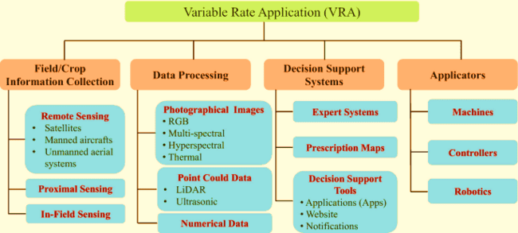
Chart 1. Variable rate application (VRA)
subsequent processing of that data to make it worthwhile for decision-making and problem-solving. Big data is expected to play a significant role in smart farming, with benefits extending throughout the supply chain and markets. Agriculture is getting more complex, and many factors influence it.
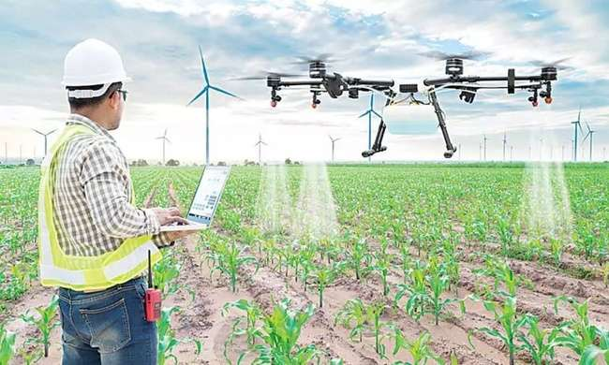
Figure 4: The 5G will revolutionise the agriculture sector by realising precision agriculture, achieving best cost realisation, optimising utilisation of crop and livestock resources
In precision agriculture, variable rate application (VRA) is a method that focuses on the automated application of resources to a particular terrain. Data obtained by sensors, maps, and GPS determines how the materials are applied. Fertilizers, chemicals, and seeds are examples of these substances, and they all aid in crop output optimization. Variable-rate application for precision agriculture employs various technologies such as drones and satellites, as are artificial intelligence (AI) and hyperspectral imaging. Because certain places have varying nutritional requirements due to their location, crops may not always require a uniform application (soil properties, sunlight). Variable-rate fertilizer spreaders can use a global positioning system to increase or decrease fertilizer application rates.
3. Agriculture Variable Rate Technology Market Dynamics:
3.1. Increasing Population Driving Demand for Food.
The annual rise in the number of live humans peaked in 1989 at 88.0 million, then gradually decreased to 73.9 million in 2003, before rising to 75.2 million in 2006. In 2017, the world's population grew by 83 million people. Developed countries' growth rates have slowed in recent decades; however, yearly growth rates in the Middle East and Sub-Saharan Africa and South Asia, Southeast Asia, and Latin America have remained above 2%. In 2030, the global population is expected to exceed 8.5 billion people, rising to 9.7 billion in 2050 and 11.2 billion in 2100. Like any other sort of projection, these most recent demographic forecasts are subject to some uncertainty. In contrast, by 2050, the populations of 55 countries or areas of the world are anticipated to decline, with 26 experiencing a ten percent decrease. Bosnia and Herzegovina, Bulgaria, Croatia, Hungary, Japan, Latvia, Lithuania, Republic of Moldova, Romania, Serbia, and Ukraine are among the countries whose populations are anticipated to decline by more than 15% by 2050.
Food demand for world cereal equivalent (CE) food is expected to be around 10,094 million tonnes in 2030 and 14,886 million tonnes in 2050, with a marginal surplus of 10,120 million tonnes in 2030 and 15,970 million tonnes in 2050. India and China are absorbing a significant portion of world food demand. Thus, the rising demand for food is expected to drive the global agriculture variable rate technology market during the forecast period.
3.2. Government Initiatives and Development in Agriculture Technology:
Governments across the globe have undertaken various initiatives in the agriculture sector to increase productivity and reduce costs to meet increasing food demand. The AIA is a department-wide initiative to align USDA's resources, programs, and research to give farmers the tools they need and position American agriculture as a leader in meeting future food, fiber, fuel, feed, and climate demands. USDA will specifically encourage innovation so that American agriculture can meet its goal of boosting agricultural production by 40% while halving its environmental footprint by 2050.
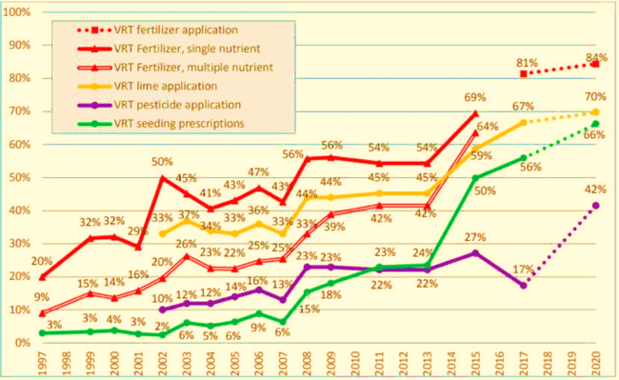
Figure 5: in agriculture, economic incentive and immediate need are two primary drivers for precision ag adoption, including VRT. By the end of 2017, for example, nearly 80 percent of U.S.
Recent revisions to replace intervention pricing for key crops with direct payments based on the planted area are a step toward rebalancing the policy portfolio in favor of measures that reflect China's policy orientation toward long-productivity development and sustainability. The recent transformation of the maize purchasing and storage system to direct payments has reduced the cost of public stockholding, which accounts for most general services support expenditure. These reforms could be gradually expanded to encompass rice and wheat. Suppose direct payments to farmers are to be preserved in the long run; in that case, the relationship between them and production decisions can be further loosened by making payments based on historical area and 'greened' by making them conditional on ecologically friendly practices.
Agriculture has been shaped significantly by technological advancements over time. Humans have found innovative techniques to make farming more efficient and raise more food, from the invention of the plow to the global positioning system (GPS) driven precision agricultural equipment. We're always trying to develop innovative techniques to irrigate crops or develop disease-resistant kinds. These iterations are critical for feeding the world's ever-growing population while freshwater supplies dwindle. Artificial intelligence is a significant advancement in agriculture (AI). Data collection is aided by modern AI-based technology technologies, which benefit precision farming and informed decision-making. Drones, remote sensors, and satellites collect data on weather patterns in and around the fields 24 hours a day, seven days per week, supplying farmers with critical information on temperature, rainfall, soil moisture, and other factors.
Fig .6 Variable rate technology (VRT) adoption in selected crops,1996-2019
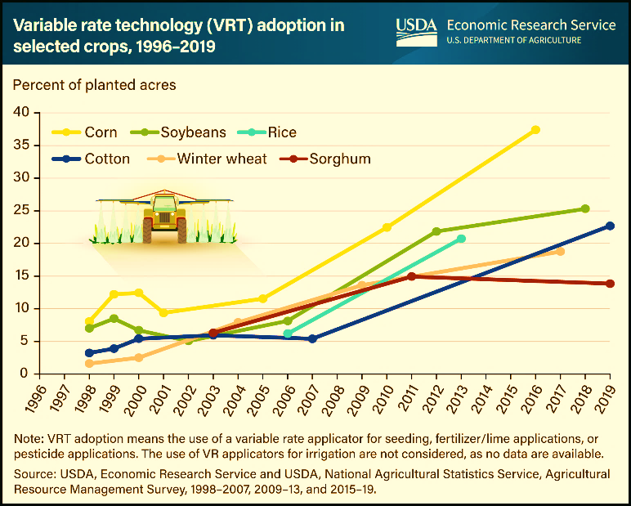
4. Variable Rate Technology Vrt Market Segment Insights
The Variable Rate Technology (VRT) market is segmented by technology type into single-variable VRT, multi-variable VRT, and Artificial Intelligence (AI)-enabled VRT. Multi-variable VRT systems control the application rate of multiple inputs based on multiple variables, such as soil moisture, plant height, and yield potential. AI-enabled VRT systems use artificial intelligence to analyze data from multiple sensors and make real-time decisions about the application rate of inputs. The demand for VRT is increasing due to the growing need for precision agriculture and the rising adoption of sustainable farming practices.VRT helps farmers optimize their input use, reduce environmental impact, and improve crop yields. The increasing availability of data from sensors and the development of AI algorithms are further driving the growth of the VRT market. Among the different technology types, single-variable VRT systems currently hold the largest market share due to their lower cost and ease of use. However, multi-variable VRT systems are expected to witness the highest growth rate during the forecast period due to their ability to provide more precise control over input applications.AI-enabled VRT systems are still in the early stages of development but have the potential to revolutionize the VRT market in the coming years.
4.1. Map-Based VRT
Map-based VRT requires spatial data collection, and processing aimed at generating prescription maps using data from sensors (such as soil moisture sensors, soil electrical conductivity [EC] sensors, or drone/satellite sensors) as proxies of spatial variability of the parameter of interest. The prescription maps are then converted into a set of instructions that control the actual variable rate application system. The basic steps involved in the map-based
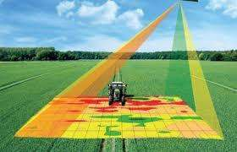
Fig 7: VRT mapping technology in Agriculture
4.2. VRT include:
- A process of investigating the field conditions — soil topography, soil types, soil properties, soil moisture variation, existing crop data, yield, biomass variation using soil sampling, remotely sensed images, or historical yield/biomass data.
- Generating the site-specific maps for the property of interest.
- Using a computer algorithm to develop the site-specific application map also known as a prescription map.
- Uploading the prescription map to the variable rate applicator to control the variable rate application of inputs.
Growers and their crop advisors can adopt different techniques, such as simple use of soil maps from Web Soil Survey (https://websoilsurvey.nrcs.usda.gov/app/), grid soil sampling, EC mapping (Veris Technologies), or remote sensing, to assess the field variability. Each of these methods has advantages and disadvantages and varies in cost. In grid soil sampling, the field is divided into different grids, and soil samples are collected from each grid and analyzed for desired soil property. For detailed information on grid soil sampling, refer to Ask IFAS publication SL 190, “UF/IFAS Nutrient Management Series: Soil Sampling Strategies for Precision Agriculture.” The Veris EC mapping can be used to understand a field’s soil texture and organic matter variability. However, these datasets are often collected at the point scale. For simplicity, constant values of the measured property (such as soil EC) are assigned to each sampling area or grid for variable rate application of agricultural inputs .
Precise application of agricultural inputs requires a continuous, varying map at high resolution. Geographic Information System (GIS) interpolation techniques (Sharma et al. 2013) can be used to develop the continuous variability map (Figure 2). However, proper training is necessary to develop these maps through such techniques. Alternatively, multispectral images collected using drones or satellites can be used as proxies of parameters of interest (e.g., normalized difference vegetation index [NDVI] and other vegetation indices [VI]) to capture the within-field spatial variability (Figure 3). For more information on drone images, refer to Ask IFAS publication AE565,
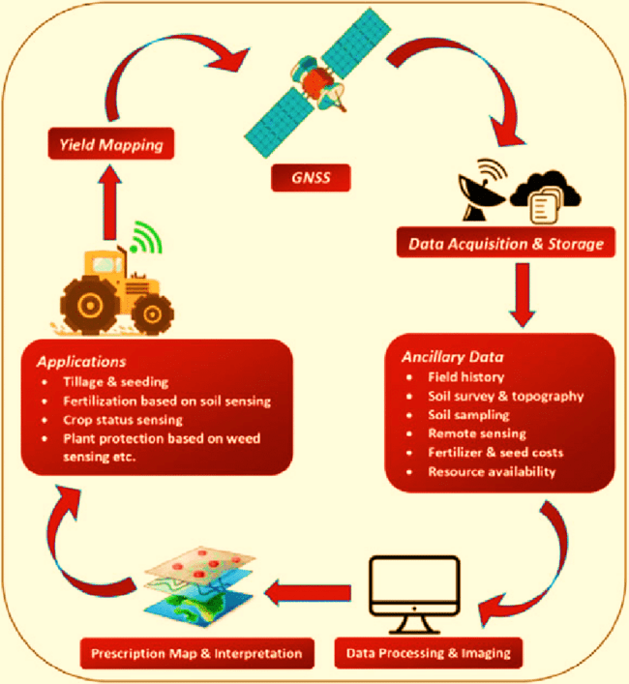
Figure 8: Flow diagram depicting precision agriculture in crop production
Once maps of in-field variability have been generated, they are converted to prescription maps that will be read by variable rate applicators using different algorithms. These algorithms are based on standard irrigation and fertilizer recommendation formulas, such as water balance approach, canopy temperature-based irrigation scheduling, soil electrical conductivity (EC), and NDVI-based nitrogen management. These prescription maps generally contain the application rate based on the spatial variability in the field. Lastly, these prescription maps are transferred to the variable rate control panel system to deliver the proper rate of agricultural inputs at different locations in the field. In this whole process, a positioning system (e.g., Differential Global Positioning System [DGPS], which provides latitude and longitude information) is used continuously to identify the vehicle’s locations in the field.
Two types of prescription maps are generally used in the VRT: Static Prescription Maps (SPM) and Dynamic Prescription Maps (DPM) (O’Shaughnessy et al. 2013). As the name suggests, the SPM remains static throughout the growing season. These maps are generally based on parameters such as historical yield maps, soil texture, soil electrical conductivity, etc., and are often applied at the beginning of the crop season. However, many variables, such as irrigation and fertilizer requirements, are greatly affected by in-situ temperature and moisture conditions and fluctuate considerably within the growing season and between years. The DPM resulting from continuous monitoring and assessment of within-season field variability can be used for the dynamic prescription. Figure 3 represents the within-field and within-season variation of NDVI. These different maps can be used to develop DPM in conjunction with VRT to apply different amounts of agricultural inputs at different times within the growing season. Among the existing techniques, variable rate or site-specific irrigation (VRI) technology on a mechanical sprinkler irrigation system is an advanced irrigation management tool that uses map-based VRT and has the potential to optimize water use efficiency. VRI is a process in which VRT gets integrated with the pivot or lateral move irrigation system which lets farmers irrigate based on the variability of field conditions. Commercially, companies including Valley Irrigation (Valmont Industries, Inc., Omaha, NE), Zimmatic (Lindsay Corporation, Omaha, NE), and Reinke (Reinke Manufacturing Co., Inc., Deshler, NE) provide VRI technologies for both center pivot and lateral move irrigation systems. This technology enables farmers to change the irrigation rates in a zone or for individual sprinklers with respect to the field conditions. Developing the prescription map is one of the most efficient ways to adopt the VRT for irrigation.
4.3. Sensor-Based VRT
Another name for sensor-based VRT is on-the-go VRT. In contrast to map-based technology, sensor-based technology does not require prior collection of field conditions; rather, as the system advances, sensors built into it decide how much input to apply in the field. At the same time, sensor-based VRT enables a high density of sampling (e.g., at a high resolution of plant scale) which can help to precisely quantify the within-field variation. In sensor-based VRT, real-time measurements of soil properties and crop characteristics are made, processed, and used as a source of input in the variable rate applicator in real time. This method is mostly used for herbicides, pesticides, fungicides, and fertilizer applications. Table 1 provides a summary of the map-based and sensor-based VRT. The next section discusses the real-time application of sensor-based VRT in row crops and tree crops. In addition, a brief description is provided on the use of AI techniques in VRT.
4.4. Map-Based Variable Rate Application
- Most of the current site-specific variable rate technologies in different cropping systems utilize map-based VRT.
- Pre-data analysis by an expert user, including grid soil sampling, lab analysis, and generation of the prescription map, is required.
- Multispectral remote sensing images provide an alternative for the development of prescription maps.
- Differential Global Positioning System (DGPS) is used continuously to identify the different locations in the field.
- Technical and operational skills, including knowledge of software such as GIS, are required to generate prescription maps.
- The sampling size is based on the zones within the field.
- Travel speed needs to be altered during the application.
- Prior knowledge of agricultural inputs for the variable application is needed.
- There is a high cost associated with soil sampling and analysis.
4.5. Sensor-Based Variable Rate Application
- The adoption rate is increasing. More accurate in-situ sensing mechanisms are required to differentiate soil-plant-weed within the field.
- Pre-data analysis is not required. Field information is generally collected in real time for variable application of agricultural inputs.
- Multispectral remote sensing images are not required.
- DGPS is not required.
- Lab analysis of soil/plant samples is not required.
- Initial investment is high.
- The sampling size is the individual plant.
5. Application of Sensor-Driven Decision Support System
Over the years, many technological solutions and sensing mechanisms have been developed to synchronize the sensor's measurement with the desired application rate on-the-go. In general, the system consists of a sensing mechanism, a control interface, a display and control module, a GPS unit, and a variable rate applicator unit. The sensing mechanism is typically mounted in front of the application unit to provide the variable rate applicator enough time to adjust the rate before the applicator units pass the sensed location. A sensing mechanism must be installed directly over the target (crop, soil, weeds, etc.) facing downward. For effective data collection, it is advisable to mount the sensing mechanism 2.5 ft to 3.5 ft above the target. Currently, most commercially available on-the-go sensing mechanisms are based on active light sensors. The sensors emit their own light on the target and measure the light reflected by the target. In most cases, these in-house light sources are unaffected by clouds, shadows, sunlight, and other interfering light sources. They enable use of these sensors in varying solar conditions, even in the night. This reflected signal is used to calculate certain properties of the target, which is further used in conjunction with an algorithm and variable rate unit to apply agricultural inputs variably.
Sensor-based variable rate fertilizer applicators have also been developed for row crops. One example of an active sensor that emits red and infrared light is the Green Seeker sensor. It calculates the NDVI values based on the light the plant reflects. The sensor continues to sample the scanned area and provide an average NDVI reading (ranging from 0.00 to 0.99. The NDVI generated by the sensor provides an input data source for the electronic circuit, which consists of a microcontroller system and transfers the data based on the sensor algorithm to a proportional solenoid valve. A proportional solenoid valve changes the liquid flow rate by varying the voltage provided for the valve by the microcontroller. A nozzle is attached to one end of the solenoid valve to dispense foliar spray. The complete system is mounted and operated by a tractor.
Fig .9 Inputs and outcomes associated with precision irrigation
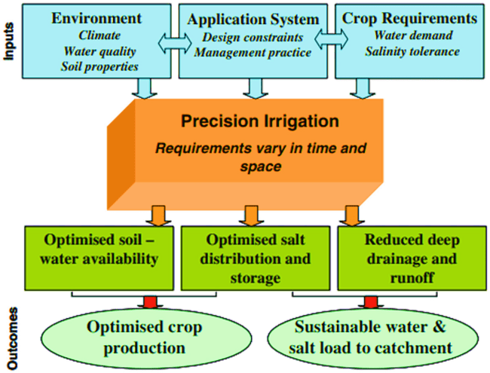
5.1. Sensor-Based Fertilizer Applicator for Row Crops
In general, the algorithm is a set of equations that will convert sensor readings into an application rate. Although some custom functions are available for different crops, it is advisable to develop a site-specific algorithm for the relevant crop and region. To develop an algorithm, the first step is to develop a relationship between the sensor measurements (e.g., NDVI) and the crop properties of concern (e.g., yield, leaf nitrogen content, chlorophyll content, etc.). Once the relationship (equation) is developed, the next step is to determine the application rate as a function of sensor reading. Figure 4 represents the schematic of the sensor-based variable rate fertilizer application system. Often, developing this relationship and determining the variable application rate require research-based data and vary considerably based on management practices, etc. An alternative approach is the use of nitrogen-rich strips or ramped calibration strips. The idea is to compare the spatial variability of the crop growth within the field to crop growth from the nitrogen-rich strip, where nitrogen is not a yield-limiting factor. Consequently, as the variable rate applicator covers the field, it compares the sensors-measured NDVI values with the NDVI values of the nitrogen-rich strip and adjusts the nitrogen application rate accordingly. For example, if the NDVI value of the nitrogen-rich strip was 0.6, and the NDVI value at the particular location in the field was 0.7, no nitrogen would be applied because sufficient nitrogen was available. However, if the NDVI value sensed by the sensor was below 0.6 (e.g., 0.4) at another location, then nitrogen would be applied at that location. Compared to a nitrogen-rich strip, the ramped calibration strip is used to create a continuous gradient (e.g., low to high nitrogen levels) so that sensors or measuring devices can be calibrated to detect and measure variations in the environment across a range of conditions (Raun et al. 2008).
5.2. Sensor-Based Sprayers for Tree Crops
Sensor-based variable rate sprayers utilize sensing systems to detect the presence of an object (e.g., a tree) and its height. Based on that information, they control individual spraying nozzles or zones of nozzles. In one example, Chemical Containers Inc. (Lake Wales, FL) developed the CC-Eye 8000 Tree Sense Control System, which utilizes GPS, six infrared “eye” sensors, and a system able to control 6 or 8 spraying zones. When a tree (object) is detected by the eye sensor in a particular zone, the Tree Sensing System (software) sends a signal to turn on the respective “spraying” zone(s) at the correct time to ensure accurate delivery of the application to the target tree. If a tree (or any other object) is not detected, then the software shuts off all nozzles to reduce waste of chemicals, environmental pollution, etc. This control system can also be used for fertilizer spreaders. Another sensor-based and smart tree crop sprayer was developed at UF/IFAS. It utilizes sensor fusion (i.e., two RGB cameras, a Lidar, and a GPS) and AI to detect trees, estimate tree height and canopy leaf density, and apply the right amount of chemicals at a tree level, minimizing waste of chemicals and spray drift (Partel et al. 2021). This AI-enabled sensing system can distinguish a tree from other objects (e.g., poles, pumps, etc.) and only spray on trees based on their canopy height and leaf density. At the same time, it can detect and count fruits (video demo: https://www.youtube.com/watch?v=qRd4g44b2lk) for yield prediction purposes (Vijayakumar et al. 2023), and develop spray and fruit heat maps (Costa and Ampatzidis 2022).
6. AI-Based Smart Sprayers for Precision Weed Management
Traditional sprayers apply herbicides uniformly, even though the distribution of weeds is typically patchy. Uniform applications of herbicides could increase costs, risk of crop damage, environmental pollution, and contamination of edible products. To address this issue, several AI-enabled, target-based technologies have been developed for the precision management of weeds in row and specialty crops (Vijayakumar et al. 2023). These technologies utilize machine vision and AI to distinguish weeds from crops and only target individual weeds. Examples of these technologies include the “see and spray” technology developed by Blue River Technology and John Deere, which utilizes herbicides to target individual weeds, and the Carbon Robotics Laser Weeder, which uses lasers to kill weeds. UF/IFAS developed another AI-enhanced technology for precision weed management, which can detect and classify weeds (i.e., grass, broadleaf, and other), and if needed, spray only a specific type of weeds (Partel et al. 2019; Ampatzidis 2018).
7. Significance of VRT in Modern Agriculture
In precision agriculture, VRT plays the leading role. It boosts the ability to accurately manage crops, leading to various benefits. VRT boosts crop yields, reduces input costs, and minimizes environmental impact. By customizing the application of inputs to the specific needs of different fields, farmers can make their operations efficient and boost productivity.
Additionally, VRT advocates sustainable farming practices, which reduce the overuse of fertilizers and pesticides, thus reducing adverse environmental effects.
This technology is important as global food demand is increasing, but farmers must produce more with limited resources.
8. Components of VRT
8.1. Sensors
VRT depends on different sensors that collect data about the field conditions. Soil sensors measure soil moisture, temperature, and nutrient levels, while crop sensors assess plant health and growth status.
These sensors are vital for gathering accurate data needed for VRT. Modern sensors can detect exact nutrient deficiencies and pest infestations, providing timely information so farmers can handle these issues proactively. Weather sensors also help predict irrigation needs by measuring precipitation.
8.1.1. Application Equipment
Application equipment, such as speeders, sprayers, and irrigation systems, is manufactured to apply materials at variable rates. These machines are embedded with technology to adjust the application rates, ensuring that each field part receives the required input. Modern machinery often integrates GPS and real-time kinematic (RTK) positioning to boost precision. For example, variable-rate speeders can adjust planting depth and seed spacing in real-time, managing plant population density for different soil conditions within a single field.
8.1.2. Data Analysis Tools
VRT software solutions are necessary to evaluate the data that sensors gather. These tools process data and generate information that may be utilized using models and algorithms. John Deere Operations Center, Ag Leader, and Trimble are well-known VRT software solutions. They include extensive data visualization, mapping, and decision support functions. They allow farmers to model various input situations, make prescription maps, and monitor field conditions in real time. These technologies integrate AI and machine learning, making suggestions accurate.
8.2. Satellite Imagery
Satellite imagery provides detailed data about field conditions, essential for creating accurate prescription maps for VRT. High-resolution images can show minor variations in crop and soil characteristics that are not otherwise detected at ground level.
Advances in remote sensing technology have made it possible to capture detailed images frequently, increasing the timeliness of data for VRT applications.
8.2.1. Drones and UAVs
Drones and unmanned aerial vehicles (UAVs) provide high-resolution images and real-time data collection, increasing the precision of VRT. They can cover large areas quickly and provide detailed information on field conditions. Fitted with multispectral and thermal cameras, drones can detect plant stress, water deficiencies, and pest infestations. This ability enables timely interventions, improving crop health and yield.
8.2.2. Ground-Based Data Collection
Ground-based data collection methods supplement satellite data, such as manual soil sampling and on-field sensors. This combination ensures a deep understanding of the field.
Portable sensors and mobile apps enable farmers to collect data on the go, enhancing flexibility and responsiveness. Merging these data sources into a single platform helps create a more accurate picture of field conditions.
8.3. How VRT Works
8.3.1. Data Collection
Accurate data collection is the core of VRT. Sensors, drones, and satellites gather detailed information on soil, crop health, and other parameters. This data is then processed, analyzed, and sent to VRT applications. Integrating IoT (Internet of Things) devices in farming has further enriched data collection, enabling continuous monitoring and real-time data sharing.
8.3.2. Data Analysis
Big data and artificial intelligence (AI) are used in VRT to analyze data and spot patterns. Making decisions for input applications that are accurate and specific to the unique needs of different field areas.
Advanced analytics can predict insect infestations, improve irrigation plans, and estimate crop yields. When farmers know these trends, they can implement preventative measures to reduce the risk of crop loss and increase overall farm efficiency.
8.4. Prescription Maps
Prescription maps are made based on analyzed data. These maps guide the VRT equipment, specifying the variable rates at which inputs should be applied across different field parts. They are important for effectively implementing VRT.
These maps can be altered during the growing season in response to changes in field conditions. Advances in GIS (Geographic Information Systems) technology, which enables highly detailed spatial analysis, have improved their precision.
8.5. Application of VRT
8.5.1. Variable Rate Seeding
Variable-rate seeding involves modifying the seeding rate based on soil fertility. This ensures a good plant population and harvest. By altering seeding rates to match the specific conditions of each field zone, farmers can maximize seed usage. This approach also reduces plant competition for nutrients and water, leading to healthier crops.
8.5.2. Variable Rate Fertilization
Farmers can match the nutrient application to the specific needs of each field area by applying fertilizers at variable rates. Thus, reducing waste and boosting crop growth. This precise technique ensures that crops receive nutrients at the right time, improving nutrient use efficiency. It also reduces the risk of nutrient runoff, which can cause environmental problems such as water pollution.
8.5.3. Variable Rate Irrigation
Variable-rate irrigation modifies water application according to the moisture needs of different areas within a field, resulting in efficient water use. Using soil moisture data and weather forecasts, irrigation schedules can be adjusted to prevent over- or under-watering. This practice saves water and enhances crop resistance to drought and other stress conditions.
8.5.4. Variable Rate Pesticide Application
This technique applies pesticides where they are most needed, reducing chemical usage and minimizing environmental footprint. Targeted pesticide application helps manage pest attacks and protect beneficial insects.
8.6. Benefits of VRT
8.6.1. Economic Benefits
The most significant advantage of VRT is cost savings on inputs. By applying seeds, fertilizers, and pesticides using a targeted method, farmers can reduce input costs. Additionally, VRT often leads to increased harvests, boosting profitability.
The efficiency of using VRT also results in lower labor and fuel costs, as fewer passes over the field are required. Furthermore, better crop management through VRT can lead to higher-quality crops, which can get better prices in the market.
8.6.2. Environmental Benefits
VRT helps reduce farming’s environmental footprint by reducing the over-application of chemicals. This leads to better soil health and sustainability and decreases runoff and pollution. By improving nutrient use efficiency, VRT helps reduce greenhouse gas emissions. Moreover, the precise application of inputs supports biodiversity by minimizing disturbance to surrounding ecosystems.
8.6.3. Operational Efficiency
Farming operations become more effective when resources are used effectively and time and effort needs are reduced. Thanks to VRT, farmers can now manage wider regions with less work and more accuracy. Input application automation lowers the possibility of human mistakes and improves farming techniques. Moreover, real-time monitoring and adjustment of processes enable more responsive and flexible farm management.
8.7. Challenges and Limitations of VRT
8.7.1. Technical Challenges
The effectiveness of VRT depends on the accuracy of the sensors and other hardware. Any errors may result in unsuitable input applications. Integrating and guaranteeing compatibility across different data sources and devices might also be challenging. Technical expertise is needed for the calibration and maintenance of VRT equipment, and any failure could affect the accuracy of input applications. Another issue is data management, as VRT may produce enormous amounts of data that are difficult to handle and evaluate without the right tools.
8.7.2. Economic Barriers
The initial investment cost for VRT equipment and software can be high. Farmers must consider the return on investment (ROI) and determine whether the long-term benefits outweigh the initial expenses. Small and medium-sized farms may find it difficult to afford the technology. However, VRT technology costs are decreasing, and financing options and government subsidies are becoming available to support farmers in making this move.
8.7.3. Knowledge and Skills
Implementing VRT requires expertise and training. Farmers must understand how to use VRT tools and interpret the data. Adoption rates can be slow if farmers lack the skills or support. Training programs play an essential role in bridging this knowledge gap. Moreover, partnerships with agronomists and technology providers can offer guidance and support to farmers adopting VRT.
9. Case Studies and Real-world Applications
9.1. Successful Implementations
Various farms have successfully implemented VRT and gained benefits. For instance, a farm in Iowa reported a 20% increase in corn yield and a 15% reduction in fertilizer use after adopting VRT. Another example is a wheat farm in Australia with a 25% decrease in water usage and a 30% increase in crop quality.
These case studies show the potential of VRT to change traditional farming practices, leading to higher productivity and sustainability. They highlight how VRT can be adapted to different crops and farming environments.
9.2. Lessons Learned
Continuous learning and adaptation overcame challenges such as data integration and equipment accuracy. Best practices of VRT include starting with small-scale trials, investing in quality sensors, and using expert advice.
Moreover, successful farmers emphasize the importance of staying updated about technological advancements. Collaborating with other farmers can also provide valuable knowledge.
10. Future Trends in VRT
10.1. Technological Advancements
The latest technologies, such as machine learning, IoT, and blockchain, will further revolutionize VRT. These advancements will accelerate data accuracy, improve decision-making, and organize the entire process. Machine learning algorithms can assess historical and real-time data to predict the best input rates. IoT devices can automate data collection and equipment adjustments, making VRT more efficient and user-friendly. Blockchain technology can enhance transparency and traceability in the supply chain, ensuring that agricultural practices meet regulatory standards and consumer expectations.
10.2. Market Trends
The VRT market is expected to grow exponentially due to the increasing demand for sustainable farming practices and technological innovations. Adoption trends show a growing interest among farmers globally due to improved accessibility to VRT tools and resources.
Additionally, the increased focus on climate-smart agriculture and the need to adapt to changing environmental conditions will increase the demand for VRT.
10.3. Regulatory and Policy Considerations
Regulations and policies play an important role in the adoption of VRT. Governments and agricultural organizations recognize precision agriculture’s benefits and provide support through subsidies, grants, and training programs.
These initiatives are expected to boost VRT adoption. Policies promoting sustainable farming practices and using advanced technologies will drive VRT’s future growth. Additionally, international collaborations and knowledge-sharing platforms can help support its global adoption.
11. Challenges and the Future
While the benefits of VRT and VRA are substantial, implementing these technologies does come with challenges. The cost of equipment and technology can be high, and there can be a steep learning curve for farmers unfamiliar with the technology. Connectivity issues in rural areas can also pose problems. Despite these challenges, the future of VRT and VRA looks bright. As technology advances and becomes more affordable, more farmers are likely to adopt VRT and VRA. Furthermore, growing awareness of the need for sustainable farming practices is likely to drive further adoption of these technologies. Variable-Rate Technology (VRT) and Variable Rate Application (VRA) represent a significant step forward in precision agriculture. These technologies allow farmers to optimize the use of resources, improve yields, and promote sustainability. With continued investment and development, they are set to transform the future of agriculture.
Variable Rate Technology (VRT) in modern agriculture is groundbreaking. It provides advantages for operations, the economy, and the environment by enabling accurate input applications. Farmers should consider investing in variable rate technology (VRT) due to its long-term benefits, even with its drawbacks, such as high initial costs and the requirement for specialized skills. By reducing its adverse effects on the environment, VRT increases crop yields, lowers input costs, and encourages sustainable agricultural practices. Integrating VRT into farming operations will be more advantageous as technology develops. In precision farming is more than simply a farming technique; it's a revolutionary strategy that holds the answer to solving some of agriculture's most critical problems. Precision farming offers a route to sustainable and prosperous agriculture in India and beyond with its cutting-edge technologies, data-driven decision-making, and countless advantages. Indian farmers can safeguard their livelihoods while also advancing environmental protection and global food security by embracing this agricultural revolution. It's time for Indian agriculture to embark on this exciting journey toward a more sustainable and fruitful future since the future of farming is clear
15. References
- Ampatzidis, Y. 2018. “Applications of Artificial Intelligence for Precision Agriculture: AE529, 12/2018.” EDIS 2018 (6). https://doi.org/10.32473/edis-ae529-2018
- Campos, J., M. Gallart, J. Llop, P. Ortega, R. Salcedo, and E. Gil. 2020. “On-Farm Evaluation of Prescription Map-Based Variable Rate Application of Pesticides in Vineyards.” Agronomy 10 (1): 102. https://doi.org/10.3390/agronomy10010102
- Costa, L., S. Kunwar, Y. Ampatzidis, and U. Albrecht. 2022. “Determining Leaf Nutrient Concentrations in Citrus Trees Using UAV Imagery and Machine Learning.” Precision Agriculture:1–22. https://doi.org/10.1007/s11119-021-09864-1
- Costa, L., J. McBreen, Y. Ampatzidis, J. Guo, M. R. Gahrooei, and M. A. Babar. 2022. “Using UAV-Based Hyperspectral Imaging and Functional Regression to Assist in Predicting Grain Yield and Related Traits in Wheat Under Heat-Related Stress Environments for the Purpose of Stable Yielding Genotypes.” Precision Agriculture 23 (2): 622–642. https://doi.org/10.1007/s11119-021-09852-5
- Grisso, R. D., M. M. Alley, W. E. Thomason, D. L. Holshouser, and G. T. Roberson. 2011. “Precision Farming Tools: Variable-Rate Application.” Virginia Cooperative Extension. https://www.researchgate.net/publication/309121121_Precision_farming_tools_Variable-rate_application
- Kakarla, S. C., and Y. Ampatzidis. 2021. “Types of Unmanned Aerial Vehicles (UAVs), Sensing Technologies, and Software for Agricultural Applications: AE565, 10/2021.” EDIS 2021 (5). https://doi.org/10.32473/edis-ae565-2021
- Lark, R. M., and J. V. Stafford. 1997. “Classification as a First Step in the Interpretation of Temporal and Spatial Variation of Crop Yield.” Annals of Applied Biology 130 (1): 111–121. https://doi.org/10.1111/j.1744-7348.1997.tb05787.x
- Mylavarapu, R. S., and W. S. D. Lee. 2020. “UF/IFAS Nutrient Management Series: Soil Sampling Strategies for Precision Agriculture: SL 190, 02/2020.” EDIS. https://edis.ifas.ufl.edu/ss402
- O’Shaughnessy, S. A., S. R. Evett, P. D. Colaizzi, M. A. Andrade, T. H. Marek, D. M. Heeren, F. R. Lamm, and J. L. LaRue. 2019. “Identifying Advantages and Disadvantages of Variable Rate Irrigation: An Updated Review.” Applied Engineering in Agriculture 35 (6): 837–852. https://doi.org/10.13031/aea.13128
- Partel, V., L. Costa, and Y. Ampatzidis. 2021. “Smart Tree Crop Sprayer Utilizing Sensor Fusion and Artificial Intelligence.” Computers and Electronics in Agriculture 191:106556. https://doi.org/10.1016/j.compag.2021.106556
- Partel, V., S. C. Kakarla, and Y. Ampatzidis. 2019. “Development and Evaluation of a Low-Cost and Smart Technology for Precision Weed Management Utilizing Artificial Intelligence.” Computers and Electronics in Agriculture 157:339–350. https://doi.org/10.1016/j.compag.2018.12.048
- Raun, W. R., J. B. Solie, R. K. Taylor, D. B. Arnall, C. J. Mack, and D. E. Edmonds. 2008. “Ramp Calibration Strip Technology for Determining Midseason Nitrogen Rates in Corn and Wheat.” Agronomy Journal 100 (4): 1088–1093. https://doi.org/10.2134/agronj2007.0288N
- Sharma, V., D. R. Rudnick, and S. Irmak. 2013. “Development and Evaluation of Ordinary Least Squares Regression Models for Predicting Irrigated and Rainfed Maize and Soybean Yields.” Transactions of the ASABE 56 (4): 1361–1378. https://doi.org/10.13031/trans.56.9973
- United States Department of Agriculture (USDA). 2023. “Precision Agriculture in the Digital Era: Recent Adoption on U.S. Farms.” Economic Information Bulletin No. (EIB-248). https://ers.usda.gov/publications/pub-details/?pubid=105893
- Vijayakumar, V., Y. Ampatzidis, and L. Costa. 2023. “Tree-Level Citrus Yield Prediction Utilizing Ground and Aerial Machine Vision and Machine Learning.” Smart Agricultural Technology 3:100077. https://doi.org/10.1016/j.atech.2022.100077
- Vivek Sharma, Uday Bhanu Prakash Vaddevolu, Shiva Bhambota, Yiannis Ampatzidis, Haimanote Bayabil, and Aditya Singh,2025. Variable Rate Technology and Its Application in Precision Agriculture, January 23, 2025 DOI: https://doi.org/10.32473/edis-AE607-2025, Critical Issue: 1. Agricultural and Horticultural Enterprises
- He, L. (2023). Variable rate technologies for precision agriculture. In Encyclopedia of Digital Agricultural Technologies (pp. 1533-1542). Cham: Springer International Publishing.
- Masi, M., Di Pasquale, J., Vecchio, Y., & Capitanio, F. (2023). Precision farming: Barriers of variable rate technology adoption in Italy. Land, 12(5), 1084.
- Kumar, S. V., Singh, C. D., & Upendar, K. (2020). Review on IoT Based Precision Irrigation System in Agriculture. Current Journal of Applied Science and Technology, 39(45), 15–26. https://doi.org/10.9734/cjast/2020/v39i4531156
- Singh, V. (2024). Advances in Precision Agriculture Technologies for Sustainable Crop Production. Journal of Scientific Research and Reports, 30(2), 61–71. https://doi.org/10.9734/jsrr/2024/v30i21844

***********

