**The Complex World of Citrus: A Review of Diversity, Adaptation, and Evolution**

**Abstract**

Citrus ranks among the most varied and extensively grown fruit crops worldwide, with a complex evolutionary history and diverse adaptations to various environments. This review seeks to deliver a thorough summary of citrus diversity, adaptation, and evolution, emphasizing existing understanding and prospective avenues of study. We discuss the taxonomy and phylogeny of citrus, the genetic and phenotypic diversity of citrus species, and the adaptations that enable citrus to thrive in diverse environments. We also explore the evolutionary processes that have shaped citrus diversity and the impact of human activities on citrus evolution. Finally, we highlight the importance of citrus diversity for sustainable agriculture and food security and discuss future research directions for improving citrus production and conservation.

**Introduction**

Citrus is a genus of flowering plants in the family Rutaceae, comprising some of the most widely cultivated and economically important fruit crops globally. Citrus species, such as oranges, lemons, limes, and grapefruits, are grown in diverse environments and are an essential source of nutrition, income, and cultural identity for millions of people (ref). The complexity of citrus diversity, adaptation, and evolution is a fascinating area of study, with implications for citrus breeding, conservation, and sustainable production. Citrus taxonomy and phylogeny are very complicated, controversial and confusing, mainly due to sexual compatibility between Citrus and related genera, the high frequency of bud mutations and the long history of cultivation and wide dispersion (Nicolosi *et al.,* 2000). In addition, the level of difference in relation to species status in Citrus is uncertain. Citrus taxonomy was based on mainly morphological and geographical data in the past and many classification systems have been formulated. Two of these systems suggested by Swingle & Reece (1967) and Tanaka (1977) have been the most widely accepted. The number of recognized species is the major difference between two systems. Swingle recognized 16 species in the genus Citrus, whereas Tanaka (1977) recognized 162 species. Scora (1975) and Barrett & Rhodes (1976) suggested that there are only three ‘basic’ true species of Citrus within the subgenus Citrus as follow: citron (*C. medica L*.), mandarin (*C. reticulata Blanco*), and pummelo (*C. maxima L. Osbeck*). Later, Scora (1988) added *C. halimi* as another true species. Other cultivated species within Citrus were derived from hybridization between these true species or closely related genera followed, mainly, by natural mutations. Recently, this thesis has gained support from various biochemical and molecular studies (Federici *et al.,* 1998). Clarifying interrelations, classification, and variety is crucial for developing breeding strategies, conserving biodiversity, and improving breeding efficiency. Also understanding genetic variability in citrus is critical for characterizing germplasm, controlling genetic erosion and the registration of new cultivars (Herrero *et al.*, 1996; Barkley *et al.,* 2006). Use of molecular markers has more advantages than that of morphologically based phenotypic characterization, because molecular markers are generally unaffected by external impact. It is possible to compare accessions of a collection at any time of year using molecular markers, while phenotypic characteristics can be influenced by environmental or cultural affects (The Citrus and Date Crop Germplasm Committee, USA, CDCGC, 2004). Regarding to germplasm management molecular characterization has a number of applications such as relationships between accessions, characterizing newly acquired germplasm, monitoring shifts in population genetic structure in heterogeneous germplasm, exploiting associations among traits of interest and genetic markers and genetic enhancement (Bretting and Widrlechner, 1995, as cited in The Citrus and Date Crop Germplasm Committee, USA, CDCGC, 2004).

**Taxonomy and Phylogeny**

Citrus taxonomy has been a subject of debate, with different classification systems proposed over the years. Molecular phylogenetic studies have provided valuable insights into citrus evolution and relationships among species. Citrus is believed to have originated in Southeast Asia, with subsequent dispersal and diversification across the globe.

**A general view of genetic relationships among cultivated citrus species:**

It is suggested that the cultivated citrus derived from the three true species, citron, pummelo, and mandarin (Barrett & Rhodes, 1976). These three species reproduce sexually and if different cultivars within the species are intermated, the progeny are similar to their parents. The other important types (orange, grapefruit, lemon, and lime) are believed to have originated from one or more generations of hybridization between these ancestral genera. Most of the cultivars of orange, grapefruit, and lemon are believed to have originated from nucellar seedlings or budsports. Currently citrus fruits have high level of morphological variations and various fruit characteristic because of inter and intraspecific interaction. Consequently, the amount of genetic diversity within these groups is relatively low, in spite of there being many named varieties. Conversely, mandarins, pummelos, and citrons have higher levels of genetic diversity since many of the cultivars have arisen through sexual hybridization (The Citrus and Date Crop Germplasm Committee, USA, CDCGC, 2004).

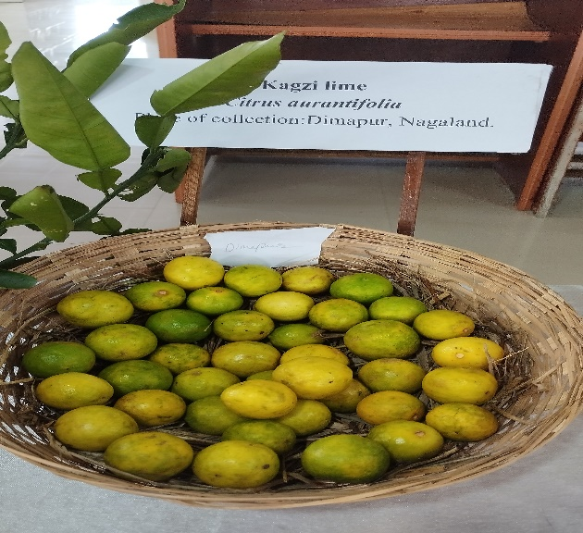 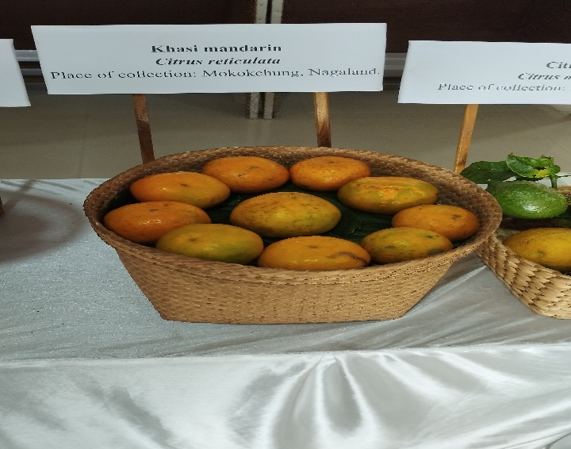

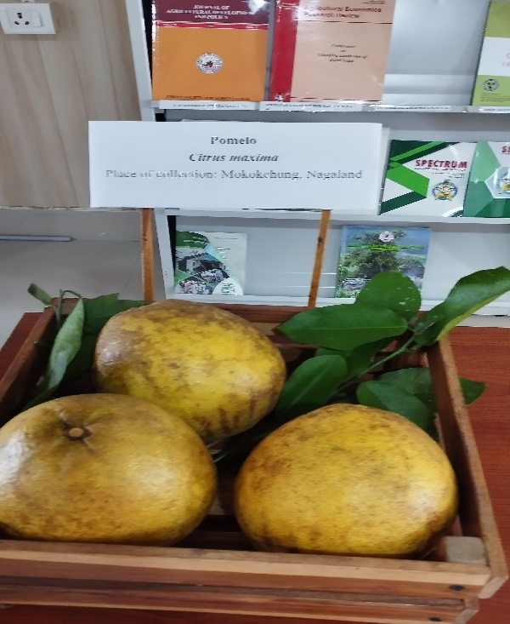 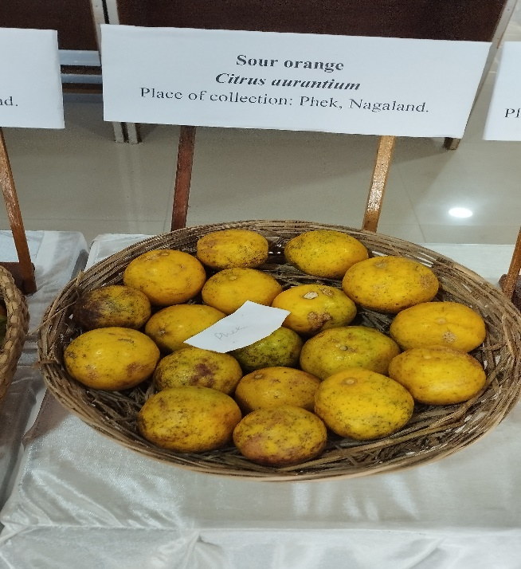

Plate 1. Different citrus Fruits

**Genetic and Phenotypic Diversity**

Citrus species exhibit remarkable genetic and phenotypic diversity, with variations in traits such as fruit size, shape, color, and flavor. This diversity is attributed to factors like genetic mutation, hybridization, and human selection. Citrus germplasm collections play a crucial role in conserving and utilizing this diversity for breeding and improvement programs. Sweet orange, mandarin, sour orange, pummelo and grapefruit nested in same large group in previous study (Uzun *et al.,* 2009). This group separated two subgroup at similarity level of 0.64. The first subgroup included sweet oranges, mandarins and sweet oranges were separated from mandarins at 0.78. Parental sweet orange tree was a hybrid of pummelo and mandarin (Scora, 1975; Barrett and Rhodes, 1976), which was later supported by Nicolosi *et al.* (2000). Barkley *et al.* (2006) suggested that sweet orange has a majority of its genetic makeup from mandarin and only a small proportion from pummelo. The second subcluster included pummelo, grapefruit and sour orange. In this subcluster, pummelos and grapefruits were separated from sour oranges with a similarity value of 0.68. Pummelos and grapefruits showed a similarity level of 0.83. Grapefruit was reported as a hybrid of pummelo and sweet orange (Barrett and Rhodes, 1976; Nicolosi *et al.,* 2000), and all grapefruit cultivars originated from single parent through mutations (Corazza-Nunes *et al.,* 2002). Pummelo was indicated as one of the ‘true basic species’ in cultivated Citrus (Barrett and Rhodes, 1976). On the other hand, sour orange was reported as a hybrid of mandarin and pummelo in previous studies (Barrett and Rhodes, 1976; Barkley *et al.,* 2006; Abkenar *et al.,* 2007). ‘Rangpur’ lime (*C. limonia*) and bergamot (*C. bergamia*) were nested in the same branch and closely related to sour orange (Uzun *et al.,* 2009). Sour orange was reported as a hybrid of mandarin and pummelo in previous studies (Barrett and Rhodes, 1976; Barkley *et al.,* 2006; Abkenar *et al.,* 2007). Low level of genetic variation was found among sour oranges (Uzun, 2009). On the other hand, there was no polymorphism in sour oranges based on leaf isozymes (Torres *et al.,* 1978) and SSR markers (Luro *et al.,* 2000). Torres *et al.* (1978) reported that ‘Rangpur’ lime is quite different morphologically and genotypically from limes and was listed under *C. reticulata*. Nicolosi *et al.* (2000) indicated that ‘Rangpur’ was a hybrid of citron and mandarin and clustered with the citrons. According to Barkley *et al.* (2006), Webber (1943) believed that rangpurs were more similar to mandarins therefore, the origin and parentage of the rangpurs has been unclear, but they have generally been classified with mandarins in most previous studies. Hodgson (1967) suggested origin of bergamot was obscure, but probably related to sour orange. This accession was identified as a hybrid of citron and sour orange (Nicolosi *et al.,* 2000) and clustered with sour orange (Federici *et al.,* 1998).

**Genetic diversity in orange**

In the cultivated citrus, sweet orange (*C. sinensis L.* Osbeck) originated as a natural hybrid between mandarin and pummelo (Barrett and Rhodes, 1976), showed low level of genetic diversity according to lots of previous studies (Luro *et al.,* 1995; Novelli *et al.,* 2000; Novelli *et al.,* 2006; Uzun, 2009). It is notified that most of sweet oranges obtained by mutation from one ancestor tree. So despite of differences in morphological characters, genetic variation of sweet orange was low (Fang and Roose, 1997).

**Genetic diversity in mandarin**

Mandarin was considered as one of the true citrus species (Barrett & Rhodes, 1976) and this idea supported by following researches (Nicolosi *et al.,* 2000; Barkley *et al.,* 2006; Uzun *et al.,* 2009a). Mandarin group has great number of cultivars and some of them originated from hybridization and the others derived from mutation. So, in the mandarins obtained from hybrid origin there was clear genetic variation. On the other hand, low level of diversity observed in the cultivars occurred by mutation such as Satsuma.

**Genetic diversity in lemon and relatives (*citron, rough lemon*, *C. volkameriana*)**

Citron that major progenitor of some commercial Citrus cultivars such as all true lemons and rough lemon was reported as one of the “basic” true Citrus species and (Barrett and Rhodes 1976; Gulsen and Roose 2001). Lemon (*C. limon* (L.) *Burm. f.*) was accepted as a species by two important taxonomic systems (Swingle and Reece 1967; Tanaka, 1977), but it has been reported as a hybrid by other studies (Barrett and Rhodes 1976; Torres *et al.,* 1978; Herrero *et al.,* 1996). Besides, lemon was notified as a hybrid of citron and sour orange (*C. aurantium L*.) in recent studies (Nicolosi *et al.* 2000; Gulsen and Roose 2001). Most lemons have highly similar morphological and biochemical characters, and some are reported to have originated by mutation from a single parental lemon tree. Rough lemon (*Citrus jambhiri Lush*) was reported to be closely related with the citrons in previous studies (Federici *et al.,* 1998; Nicolosi *et al.,* 2000; Barkley *et al.,* 2006; Pang *et al.,* 2007) and was also reported as a hybrid of mandarin and citron (Scora 1975; Nicolosi *et al.,* 2000; Barkley *et al.,* 2006). *Citrus volkameriana* was reported as a hybrid between citron and sour orange (Nicolosi *et al.,* 2000).

**Genetic diversity in grapefruit and pummelo**

The grapefruit (*C. paradisi Macf*.) was notified as a natural hybrid between pummelo (*Citrus maxima* *(Burm.) Merr*.) and sweet orange (*C. sinensis L. Osb*). It originates from Barbados in the Caribbean islands and was first named as *Citrus paradisi Macf.* by *James Macfedyan* in 1837 (Scora *et al.,* 1982; Scora, 1988). Grapefruits are highly polyembryonic, therefore they are of nucellar and mutation origin. Genetic variation among common grapefruit cultivars was reported to be very low due to their mutation origin (Fang and Roose 1997; Corazza- Nunes *et al.,* 2002).

**Adaptations**

Citrus species have evolved various adaptations to thrive in diverse environments, including:

**1. Drought tolerance:** Some citrus species have developed drought-tolerant traits, such as deep root systems and water-conserving mechanisms. xx On imposition of drought the plants directly affect rates of photosynthesis due to less availability of Carbon dioxide as stomata closes under drought stress to conserve water and impaired the plant growth. An increase in leaf soluble sugar and sucrose content and decrease in starch content is observed during water stress. S Plants also started accumulating proteins under drought stress to cope up against the stress conditions. There are many types of proteins, among them heat shock proteins (HSP) is the most commonly found (Balfagon *et al.* 2018). Their protective role is to prevent other proteins from denaturalization during stress conditions regulating refolding, localization and accumulation as well as preventing agglomeration and degradation. To study the plant water status relative to soil water content, it is time consuming and can’t be automated. Therefore, a technique is used which acts as a reliable indicator for soil water deficit. The amount of water needed by irrigation can be easily determined by assessing the canopy temperature using infrared thermometry. The canopy temperature usually increases with a decrease in soil moisture but when plants are well watered, the leaf temperature lowers due to the dissipation of energy in the form of latent heat (Viera and Ferrarezi 2021). As currently available techniques can’t detect water stress at early stages, a sensor for early detection of environmental stress is required for rapid control measures and management. Nowadays several studies focus on using thermal cameras to monitor overall canopy temperature, identify water stress and estimate stomatal conductance by (Viera and Ferrarezi 2021). Natural drought tolerant plants prevent themselves from the detrimental effects of drought stress using varieties of metabolites and low molecular weight proteins

**2. Cold hardiness:** Certain citrus species can tolerate low temperatures, allowing them to grow in cooler climates and are the least cold hardy of the citrus trees and are killed or damaged when temps are in the high 20s. and are slightly more tolerant and can withstand temperatures in the mid 20's before succumbing. Citrus trees that are cold tolerant down into the low 20s, such as  and, are the most optimistic choice for planting cold climate citrus trees. When growing citrus trees in cold climates, the degree to which damage may occur is related not only to the temperature but a number of other factors. The duration of a freeze, how well the plant has hardened prior to a freeze, the age of the tree, and overall health will all affect if and how much a citrus is affected by a drop in temperature. Sucrose is the main photosynthetic product in plants and is involved in various abiotic stresses responses and helps plant growth and development under adverse stress conditions (Yanli *et al.* 2020) stress.

**3. Disease resistance:** Some citrus species possess genetic traits that confer resistance to diseases like citrus canker and greening. Genetic transformation is one of the important methods of choice for protecting susceptible citrus cultivars against canker or HLB caused by related bacterial pathogens in a shorter time. Therefore, transgenic approaches introducing exogenous genes, such as plant resistance genes, key positive regulators of SAR genes, antimicrobial peptide genes, plant metabolic genes, pathogenic genes, and kinase genes, have been applied to generate transgenic citrus crops resistant to canker or HLB infections through Agrobacterium-mediated transformation.

Citrus canker, caused by the bacterial pathogen Xanthomonas citri ssp. citri (Xcc), is one of the most destructive citrus cultivar diseases reported all over the world . Citrus canker acts citrus production, leading to yield losses, a poor fruit quality, and trade barriers. Strategies like eradication and pathogen exclusion have been mainly used to manage the disease. At present, cultural practices and chemical controls are the main methods used to manage citrus canker. Among the chemicals, copper-based chemicals have been expressed an adequate control of Xcc due to prolonged residual activity compared to other contact bactericides such as copper oxychloride, copper hydroxide, copper sulphate, and ammonia-copper carbonate, which have been found to be highly efective against Xcc. However, a continuous reliance on these compounds can cause mutations and the emergence of aggressive races of Xcc.

**Evolution**

Citrus evolution has been shaped by various factors, including:

**1. Hybridization:** Citrus species have undergone extensive hybridization, resulting in the creation of new cultivars and species. Citrus hybridization involves combining different citrus varieties or species to create new cultivars with desirable traits. This process is often used to improve fruit quality, yield, disease resistance, and other commercially important attributes. Somatic hybridization, a technique using protoplast fusion, is also employed to create hybrids that may be difficult or impossible to obtain through traditional sexual crosses.

**2. Human selection:** Human activities, such as breeding and selection, have influenced citrus evolution and diversity. Human selection has played a crucial role in shaping the variety and characteristics of citrus fruits we know today. Over thousands of years, humans have selectively bred and hybridized citrus plants, resulting in a wide array of varieties with diverse flavors, sizes, and other traits. This process has been driven by human preferences for sweeter, juicier, and larger fruits, as well as by the desire to adapt citrus to different climates and growing conditions. The micro grafting methodology has been efficiently used for whole plant generation from shoots derived from organogenesis as well as from germinated somatic embryos (Niedz *et al.,* 2003; ).

**3. Environmental pressures**: Citrus species have adapted to diverse environments, leading to the development of new traits and characteristics. Under natural conditions, citrus trees often experience multiple stresses at the same time so there are direct and indirect interactions between salinity and almost all physical abiotic stresses that include flooding, drought, , high irradiance, high temperature, and high atmospheric . In addition, salinity stress also has direct effects on roots predisposing trees to biotic environmental stresses including attack by root rot, nematodes and bacterial disease. The agronomical and of citrus exposed to two or more stress factors, can differ depended on stress intensity or duration. Since citrus leaf Cl− accumulation has been linked to water use.

**Conservation and Utilization**

Conserving citrus diversity is essential for sustainable agriculture and food security. Citrus germplasm collections and breeding programs play a crucial role in utilizing this diversity for improving citrus production and addressing emerging challenges. Citrus conservation and evaluation involve both in situ (on-site) and ex situ (off-site) approaches. In in situ conservation, efforts focus on protecting natural citrus habitats and their genetic diversity, while ex situ methods include field gene banks and cryopreservation for long-term storage of germplasm. Evaluation involves assessing the genetic diversity and characteristics of different citrus varieties to identify valuable traits for breeding and improvement.

**In situ Conservation**

**Protecting natural habitats:**

This involves safeguarding wild citrus relatives and their natural environments to preserve genetic diversity and adaptation to specific ecological conditions.

**Monitoring and management:**

This includes tracking population sizes, distribution, and health status of wild citrus populations, as well as implementing management practices to mitigate threats like habitat loss and disease.

**Ex situ Conservation:**

**Field gene banks:**

These are collections of citrus plants maintained in controlled environments, allowing for long-term storage and access to germplasm.

**Cryopreservation:**

This involves freezing citrus tissues at extremely low temperatures to preserve their genetic material for extended periods, offering a cost-effective and space-efficient storage solution.

**In vitro conservation:**

This method involves growing citrus plants in a sterile environment on nutrient-rich media, facilitating propagation and long-term maintenance of valuable germplasm.

Evaluation of Citrus Genetic Resources:

**Phenotypic evaluation:**

Assessing the observable traits of different citrus varieties, such as fruit size, yield, disease resistance, and tolerance to environmental stress.

**Molecular characterization:**

Using genetic markers (e.g., SSRs) to determine genetic diversity, identify relationships between varieties, and track the flow of genetic material.

**Pathogen status assessment:**

Evaluating the susceptibility of citrus varieties to common diseases and identifying resistant or tolerant genotypes for use in breeding programs.

**Data management:**

Developing and maintaining databases to store information on citrus collections, including their origin, characteristics, and pathogen status, facilitating access and use by researchers and breeders.

**Benefits of Citrus Conservation and Evaluation**

**Breeding and improvement:**

Identifying valuable traits for breeding new citrus varieties with improved yields, disease resistance, and adaptation to changing environmental conditions.

**Biodiversity conservation:**

Protecting the genetic diversity of citrus, including wild relatives and traditional cultivars, to ensure the sustainability of citrus production.

**Economic benefits:**

Supporting the citrus industry by providing access to improved varieties, reducing disease losses, and promoting sustainable production practices.

**Food security:**

Ensuring the availability of nutritious and diverse citrus fruits for human consumption.

**Conclusion**

The complex world of citrus is characterized by remarkable diversity, adaptation, and evolution. Understanding citrus diversity and evolution is essential for improving citrus production, conservation, and sustainability. By exploring the genetic, phenotypic, and ecological diversity of citrus, we can develop new strategies for breeding, conservation, and utilization, ultimately contributing to global food security and sustainable agriculture.

**Reference**

Abkenar, A.A.; Isshiki, S. and Matsumoto, R. (2007). Comparative analysis of organelle DNAs acid citrus grown in Japan using PCR-RFLP method. Genet. Res. Crop. Evol. 55: 487– 492.

Balfagon D, Zandalinas SI, Muriach M, Gomez CA (2018) Involvement of ascorbate peroxidase and heat shock proteins on citrus tolerance to combine conditions of drought and high temperatures. Pl Physiol Biochem 127:194-199.

Barkley, N.A.; Roose, M.L.; Krueger, R.R. and Federici, C.T. (2006). Assessing genetic diversity and population structure in a citrus germplasm collection utilizing simple sequence repeat markers (SSRs). Theor. Appl. Genet. 112, 1519–1531.

Barrett, H.C. and Rhodes, A.M. (1976). A numerical taxonomic study of affinity relationships in cultivated Citrus and its close relatives. Syst. Bot. 1: 105–136.

Corazza-Nunes, M.J.; Machado, M.A.; Nunes, W.M.C.; Cristofani, M. and Targon, M.L.P.N. (2002). Assessment of genetic variability in grapefruits (*Citrus paradisi Macf.*) and pummelos (*C. maxima Burm. Merr*.) using RAPD and SSR markers. Euphytica 126:169–176.

Fang, D.Q. and Roose, M.L. (1997). Identification of closely related Citrus cultivars with intersimple sequence repeat markers. Theor. Appl. Genet. 95: 408–417.

Federici, C.T.; Fang, D.Q.; Scora, R.W. and Roose, M.L. (1998). Phylogenetic relationships within the genus Citrus (Rutaceae) and related genera as revealed by RFLP and RAPD analysis. Theor. Appl. Genet. 96: 812–822.

Gulsen, O. and Roose, M.L. (2000). The origin of Interdonato lemon inferred from cpRFLP, SSR, isozyme and ISSR markers. Proc. Int. Soc. Citricult. IX Congr. pp. 158–159.

Gulsen, O. and Roose, M.L. (2001). Lemons: diversity and relationships with selected citrus genotypes as measured with nuclear genome markers. J. Am. Soc. Hort. Sci. 126: 309–317.

Herrero, R.; Asins, M.J.; Carbonell, A.E. and Navarro, L. (1996). Genetic diversity in the orange subfamily Aurantioideae. I. Intraspecies and intragenus genetic variability. Theor. Appl. Genet. 92: 599–609.

Hodgson, R.W. (1967). Horticultural varieties of citrus. In: Reuther, W., Webber, H.J., Batchelor, L.D. (Eds.), The Citrus Industry, vol. 1. University of California Press, Berkeley, pp. 431–591.

Luro, F.; Rist, D. and Ollitrault, P. (2000). Sequence tagged microsatellites polymorphism: an alternative tool for cultivar identification and evaluation of genetic relationships in Citrus. Proc. Int. Soc. Citricult. IX. Congr. Florida, USA. pp: 170–171.

Nicolosi, E.; Deng, Z.N.; Gentile, A.; La Malfa, S.; Continella, G. and Tribulato, E. (2000). Citrus phylogeny and genetic origin of important species as investigated by molecular markers. Theor. Appl. Genet. 100: 1155–1166.

Pang, X.M.; Hu, C.G. and Deng, X.X. (2007). Phylogenetic relationship within Citrus and related genera as inferred fromAFLPmarkers. Genet. Res. Crop. Evol. 54: 429–436.

Scora, R.W. (1975). On the history and origin of Citrus. Bull. Torr. Bot. Club. 102: 369–375.

Scora, R.W. (1988). Biochemistry, taxonomy and evolution of modern cultivated Citrus. Proc. Int. Soc. Citricult. VI. Congr. vol. 1. Margraf Publishers, Weikersheim, Germany, pp. 277–289.

Scora, R.W.; Kumamoto, J.; Soost, R.K. and Nauer, E.M. (1982). Contribution to the origin of the Grapefruit, *Citrus paradisi* (Rutaceae). Syst. Bot. 7:170-177.

Swingle, W.T. and Reece, P.C. (1967). The botany of citrus and its wild relatives. In: Reuther,

Tanaka, T. (1977). Fundamental discussion of Citrus classification. Stud. Citrol. 14: 1–6.

Torres, A.M.; Soost, R.K. & Diedenhofen, U. (1978). Leaf isosymes as genetic markers in Citrus. Am. J. Bot. 65: 869–881.

Turkish)

University of Cukurova, Institute of Natural and Applied Sciencies. p. 369. (in

Uzun, A. (2009). Turunçgillerde genetik çeşitliliğin SRAP markırları ile karakterizasyonu (Characterization of genetic diversity of Citrus by SRAP markers) Ph.D. Thesis.

Viera GHS, Ferrarezi RS (2021) Use of thermal imaging to assess water status in citrus plants in greenhouses. Horticulturae 7:249.

W., Webber, H.J., Batchelor, L.D. (Eds.), The Citrus Industry, vol. 1.University of California Press, Berkeley, CA, USA, pp. 389–390.

Webber, H.J. (1943). Cultivated varieties of citrus. In: Webber HJ, Batchelor LD (eds) The Citrus Industry, vol 1. University of California Press, Berkeley. pp: 475–668. 50.

Yanli D, Zhao, Q, Chen L, Yao X, Xie F (2020) Effect of drought stress at reproductive stages on growth and nitrogen metabolism in soybean. Agronomy 10 (2): 302.