Original Research Article
Unveiling drought tolerance biomarkers in Cocoa: A comparative study under controlled and field conditions

Abstract:
Drought stress poses a significant threat to cocoa (Theobroma cacao L.) cultivation, particularly as climate variability disrupts traditional rainfall patterns in expanding cocoa growing regions of India. This study aimed to identify reliable biochemical biomarkers indicative of drought tolerance in cocoa by comparing biochemical responses of eleven hybrids under controlled nursery and field-imposed drought conditions. Four key biochemical parameters including proline, nitrate reductase activity (NRA), superoxide dismutase (SOD), and glycine betaine were quantified and analysed using paired t-tests. Results revealed statistically significant differences in SOD and glycine betaine levels between nursery and field conditions, while proline and NRA exhibited consistent responses across environments. Tolerant hybrids maintained higher proline and NRA levels under drought, highlighting their potential as predictive biomarkers for early-stage drought screening. This comparative approach bridges the gap between controlled and field research, offering a practical strategy for accelerating the selection of drought-resilient cocoa genotypes. The findings underscore the utility of integrating biochemical markers into breeding programs to enhance climate resilience in cocoa cultivation.
Keywords: Cocoa, Biomarkers, Drought, NRA, Proline
Introduction:
Cocoa (Theobroma cacao L.), revered as the 'food of the gods,' is a valuable crop within the Malvaceae family. As a crucial component in chocolate production, cocoa beans have become a sought-after commodity, empowering small-scale farmers through their participation in the global value chain. It is the smallest yet most impactful soft commodity globally, exerting significant influence on the food, confectionery, and retail industries. India leads the world in cocoa productivity, outpacing other major producers (DCCD., 2024). Now the production is expanding to non-traditional areas in Karnataka, Tamil Nadu, and Andhra Pradesh. International Market Analysis Research and Consulting Group forecasts that India's chocolate market will expand from $2.6 billion in 2023 to $5.3 billion by 2032, driven by a robust compound annual growth rate of 7.7%, indicating a promising future for the industry. However, a divergence from this anticipated outcome can arise by the potential disruption to India's summer monsoon due to rising temperatures and inadequate rainfall, given its requirement for 1500-3000 mm annual rainfall and 24 liters of water per day in summer (Prasannakumari et al., 2009).
Water availability is a primary constraint on plant growth, influencing vegetation patterns worldwide, and causing drought stress when soil water is insufficient or transpiration losses exceed compensation. The impact of drought stress is modulated by the duration and severity of the stress event. The movement of water through plants is driven by natural gradients of pressure and chemical potential. Severe drought disrupts water transport by increasing evaporative demand, leading to xylem embolism and reduced water flow through the plant (Tyree and Sperry 1989; Kaack et al. 2021). Embolism spread through the xylem network reducing hydraulic conductivity, ultimately leading to plant mortality (Johnson et al. 2020; Guan et al. 2021). Phloem transport is compromised during drought due to increased sugar concentration and viscosity, leading to nutrient starvation and impaired growth (Hölttä et al., 2009; Nikinmaa et al 2013). Prolonged water stress further triggers cellular desiccation, disrupts metabolic pathways and impairs photosynthesis (Bohnert and Jensen., 1996). Plants have developed diverse adaptations to counter water scarcity, including stress avoidance and tolerance mechanisms, enabling them to survive and grow in challenging environments. Water stress resilience is deeply rooted in an array of morpho-physio-biochemical and molecular mechanisms. Roots perceive water deficit, activating a stress response to mitigate cellular damage. Under requisite amounts, reactive oxygen species (ROS) are the major signaling molecule, but at higher concentrations, it possess lethality. The efficacy of the tolerance response to drought stress is contingent upon the integrity of stress perception and signaling pathways. Research on Theobroma cacao under a controlled environment suggests that the accumulation of osmolytes and antioxidants counteract ROS toxicity and regulate water homeostasis (Dzandu et al., 2021; Juby et al., 2021; Suchithra et al., 2023). However, the relevance of these results to cocoa trees under field conditions remains to be determined.
This study aims to discover biomarkers associated with drought tolerance, which can serve as reliable predictive indicators through a comprehensive comparative analysis among cocoa hybrids under both controlled and field conditions. By leveraging this robust approach, researchers can expedite the identification of drought tolerant cocoa hybrids at the nursery level, thereby circumventing the limitations and practical constraints of field based abiotic stress research.
Materials and methods:
Experimental site and water stress imposition
Drought-tolerant genotypes identified during the preliminary study (Binimol, 2005) were used to develop hybrids, which were screened for their tolerance at 40 per cent and 100 per cent field capacities (Juby et al., 2021). Based on this, eleven hybrids including seven tolerant (H101, H113, H102, H103, H119, H85, and H74) and four susceptible (H8, H49, H55, H65) were selected and established in the field. The field was managed to induce drought conditions by controlling irrigation and applying plastic mulches.
Biochemical analysis
Biochemical parameters including proline (µg g⁻¹) (Bates et al., 1973), glycine betaine (µmol g⁻¹ dw⁻¹) (Grieve and Grattan, 1983), nitrate reductase activity (mmol nitrite g⁻¹hr⁻¹) (Evans and Nason, 1953), and superoxide dismutase (units⁻¹ mg protein⁻¹g⁻¹) (Dhindsa et al., 1981) were analysed under drought stress conditions using standard procedures.
Results and discussion:
Biomarkers are molecular messengers providing critical insights into an organism’s cellular state in response to external stimuli and its level varies significantly from the baseline found in healthy ones (Paniagua-Michel and Olmos-Soto, 2016, and Bodaghi et al., 2023). Its significant variation during abiotic and biotic stress factors can be exploited for the development of stress tolerant crops. During drought, the plant employs biochemical adaptation strategies involving the accumulation of osmoprotectants and antioxidants along with the regulation of nitrate assimilation.
When the hybrids were forwarded to field-level drought screening, an increase in proline, glycine betaine, SOD, and NRA was observed for both tolerant and susceptible hybrids. Comparative analysis of biochemical parameters between nursery and field levels based on paired t-test emphasizes that a statistical significance at 1% probability was found with SOD activity (4.56*), glycine betaine content (11.80*) while proline content (0.28) and NRA activity (0.46) were non-significant (Table 1). The hybrids exhibited similar biochemical responses with respect to proline and NRA activity in both environments under drought stress. Studies have shown that leaf proline increases significantly with decreasing levels of soil moisture (Darwish et al., 2016). Proline, a key compatible solute is synthesized in foliar tissues and allocated to roots, where it facilitates the maintenance of cellular balance and stability (Wang et al., 2022). Beyond its established function in osmoprotection and homeostatic regulation, it is involved in the maintenance of subcellular integrity, enhancement of antioxidant capacity through redox modulation, and optimization of photosynthetic efficiency via regulation of photosystem II and chlorophyll metabolism (Arshaf and Foolad, 2007, and Altuntas et al., 2020). Drought-induced proline accumulation has been found in diverse crops including wheat (Mwadzingeni et al., 2016), coffee (Patil et al., 2019), tea (Rahimi et al., 2019), and cotton (Tisarum et al., 2024). A direct association between proline and relative water content is observed in cocoa, highlighting its role in maintaining cellular turgidity during water-limited scenarios (Dzandu et al., 2021).
Nitrate reductase (NR) is a pivotal enzyme in nitrogen metabolism, serving as a rate-limiting step (Campbell, 1988; Caravaca et al., 2004) that directly regulates the reduction of nitrate to nitrite (Chamizo-Ampudia et al., 2017; Han et al., 2022), ultimately influencing the efficiency of plant nitrogen utilization (Han et al., 2022). Drought stress led to marked changes in enzyme levels, with nitrate reductase activity exhibiting a progressive decline as drought severity increased (Foyer et al., Zhou et al., 2022). Research has revealed that hybrids with increased tolerance to osmotic stress tend to have elevated NR activity, implying that high NR activity is a key component of stress tolerance mechanisms (Baroowa and Gogoi 2014) which is in complement with tolerant cocoa hybrids recording the highest NR. Hence, a minimal decrease in activity has been correlated with increased drought tolerance, indicating that the ability to maintain enzyme function under drought conditions is a critical component of plant resilience (Chandra et al. 2004). Variations in NR activity can serve as a sensitive indicator of the severity of water stress (Caravaca et al., 2005, and May et al., 2011). Due to its responsiveness to the internal metabolic and physiological status, NR has emerged as a widely used biomarker for stress detection in plant biology research (Srivastava., 1980). The results suggest that proline and NRA can serve as a reliable indicator of drought tolerance at nursery screening enabling breeders to select promising varieties efficiently.
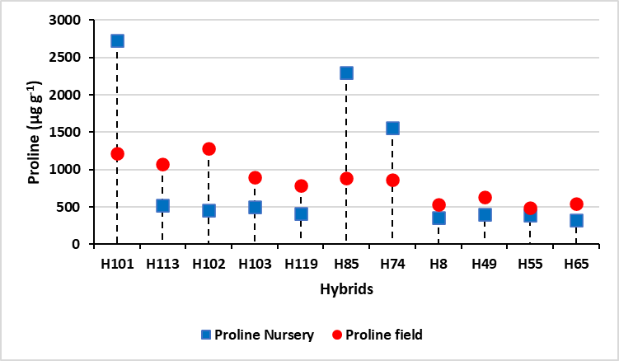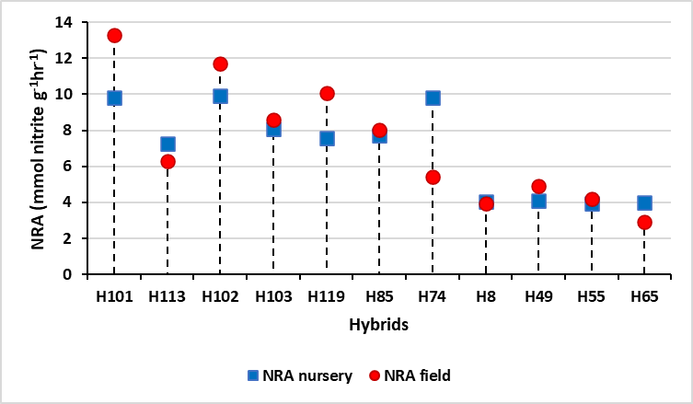
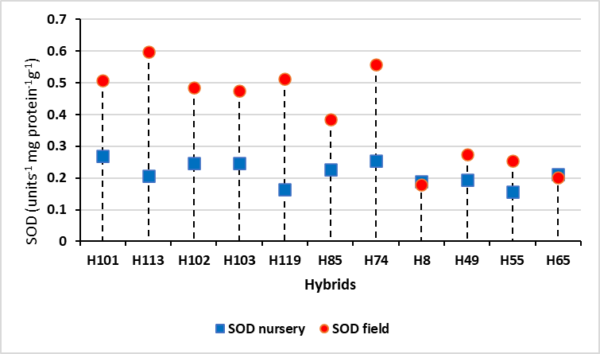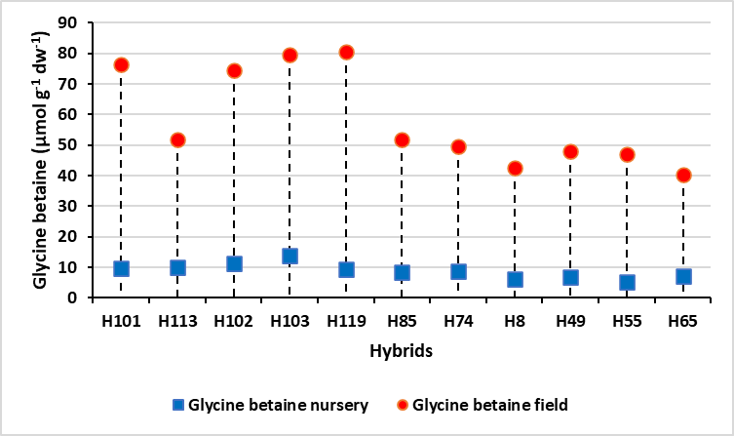
Figure1. Showing the variation among cocoa hybrids towards drought stress at nursery and field level a. Proline (µg g⁻¹) b. NRA (mmol nitrite g⁻¹hr⁻¹) c. SOD (units⁻¹ mg protein⁻¹g⁻¹) d. Glycine betaine (µmol g⁻¹ dw⁻¹).
Hybrids | Proline (µg g⁻¹) |  | t-Test | NRA (mmol nitrite g⁻¹hr⁻¹) |  | t-Test | SOD (units⁻¹ mg protein⁻¹g⁻¹) |  | t-Test | Glycine betaine (µmol g⁻¹ dw⁻¹) |  | t-Test
Hybrids | Nursery | Field | t-Test | Nursery | Field | t-Test | Nursery | Field | t-Test | Nursery | Field | t-Test
H101 | 2726.81 | 1220.35 | 0.28 | 9.8 | 13.297 | 0.46 | 0.27 | 0.508 | 4.56* | 9.7 | 76.36 | 11.80*
H113 | 520.85 | 1070.13 | 0.28 | 7.24 | 6.305 | 0.46 | 0.207 | 0.599 | 4.56* | 9.93 | 51.86 | 11.80*
H102 | 454.25 | 1281.63 | 0.28 | 9.9 | 11.722 | 0.46 | 0.248 | 0.485 | 4.56* | 11.31 | 74.38 | 11.80*
H103 | 500.87 | 892.24 | 0.28 | 8.09 | 8.588 | 0.46 | 0.247 | 0.476 | 4.56* | 13.79 | 79.57 | 11.80*
H119 | 412.95 | 789.45 | 0.28 | 7.56 | 10.073 | 0.46 | 0.163 | 0.513 | 4.56* | 9.23 | 80.56 | 11.80*
H85 | 2293.88 | 888.28 | 0.28 | 7.72 | 8.008 | 0.46 | 0.227 | 0.384 | 4.56* | 8.43 | 51.86 | 11.80*
H74 | 1555.89 | 860.61 | 0.28 | 9.83 | 5.436 | 0.46 | 0.254 | 0.557 | 4.56* | 8.85 | 49.63 | 11.80*
H8 | 354.34 | 536.45 | 0.28 | 4.04 | 3.969 | 0.46 | 0.188 | 0.178 | 4.56* | 6.15 | 42.71 | 11.80*
H49 | 400.96 | 633.3 | 0.28 | 4.12 | 4.911 | 0.46 | 0.193 | 0.275 | 4.56* | 6.87 | 48.15 | 11.80*
H55 | 386.31 | 487.03 | 0.28 | 3.92 | 4.204 | 0.46 | 0.156 | 0.255 | 4.56* | 5.36 | 47.16 | 11.80*
H65 | 325.7 | 546.33 | 0.28 | 4 | 2.918 | 0.46 | 0.213 | 0.202 | 4.56* | 7.11 | 40.48 | 11.80*

Table 1. t-test comparison between nursery and field level quantification of proline, NRA, SOD, and Glycine betaine during drought stress.
Conclusion
This study successfully identified and validated key biochemical biomarkers, namely proline content and nitrate reductase activity, as reliable indicators of drought tolerance in cocoa hybrids under both controlled and field conditions. While SOD activity and glycine betaine content showed environment-specific variation, their overall elevated levels in tolerant hybrids further support their auxiliary role in stress mitigation. The consistent performance of certain hybrids across conditions underscores the potential for early-stage nursery screening to accurately predict field-level drought resilience. Ultimately, our research bridges the gap between laboratory insights and field applicability, laying the groundwork for a more sustainable and scientifically guided strategy for managing abiotic stress in cocoa and potentially other perennial crops.
Acknowledgments: The authors thank Kerala Agricultural University and Mondelez Foods India Pvt. Ltd. for their support
References
Prasannakumari, A. S., Nair, V.R., Lalithabai, E.K., Mallika, V.K., Minimol, J.S., & Koshy Abraham. 2009.Cocoa In India. Kerala Agricultural University, Thrissur, 72p.
Tyree, M.T. & Sperry, J.S., 1989a. Characterization and propagation of acoustic emission signals in woody plants: towards an improved acoustic emission counter. Plant, Cell & Environment, 12(4), pp.371-382.
Kaack, L., Weber, M., Isasa, E., Karimi, Z., Li, S., Pereira, L., Trabi, C.L., Zhang, Y.A., Schenk, H.J., Schuldt, B. & Schmidt, V., 2021. Pore constrictions in intervessel pit membranes provide a mechanistic explanation for xylem embolism resistance in angiosperms. New Phytologist, 230(5), pp.1829-1843.
Johnson, K.M., Brodersen, C., Carins-Murphy, M.R., Choat, B. & Brodribb, T.J., 2020. Xylem embolism spreads by single-conduit events in three dry forest angiosperm stems. Plant Physiology, 184(1), pp.212-222.
Guan, X., Pereira, L., McAdam, S.A., Cao, K.F. & Jansen, S., 2021. No gas source, no problem: proximity to pre‐existing embolism and segmentation affect embolism spreading in angiosperm xylem by gas diffusion. Plant, Cell & Environment, 44(5), pp.1329-1345.
Hölttä, T., Mencuccini, M. & Nikinmaa, E., 2009. Linking phloem function to structure: analysis with a coupled xylem–phloem transport model. Journal of theoretical biology, 259(2), pp.325-337.
Nikinmaa, E., Hölttä, T., Hari, P., Kolari, P., Mäkelä, A., Sevanto, S. & Vesala, T., 2013. Assimilate transport in phloem sets conditions for leaf gas exchange. Plant, Cell & Environment, 36(3), pp.655-669.
Bohnert, H.J. & Jensen, R.G., 1996. Strategies for engineering water-stress tolerance in plants. Trends in biotechnology, 14(3), pp.89-97.
Dzandu, E., Enu-Kwesi, L., Markwei, C.M. & Ayeh, K.O., 2021. Screening for drought tolerance potential of nine cocoa (Theobroma cacao L.) genotypes from Ghana. Heliyon, 7(11).
Juby, B., Minimol, J.S., Suma, B., Santhoshkumar, A.V., Jiji, J. & Panchami, P.S., 2021. Drought mitigation in cocoa (Theobroma cacao L.) through developing tolerant hybrids. BMC Plant Biology, 21(1), p.594.
Suchithra, M., Suma, B., Minimol, J.S., Mathew, D. & Kumar, A.S., 2023. Biochemical Response of Cocoa (Theobroma cacao L.) Genotypes to Water Deficit Stress Condition. Environment and Ecology, 41(2), pp.824-830.
Binimol B. Identification of drought tolerant cocoa types. Thrissur: M.Sc. (Ag.) Thesis, Kerala Agricultural University; 2005. p. 95.
Bates, L.S., Waldren, R.P.A. & Teare, I.D., 1973. Rapid determination of free proline for water-stress studies. Plant and soil, 39, pp.205-207.
Grieve, C.M. & Grattan, S.R., 1983. Rapid assay for determination of water soluble quaternary ammonium compounds. Plant and soil, 70, pp.303-307.
Evans, H.J. & Nason, A., 1953. Pyridine nucleotide-nitrate reductase from extracts of higher plants. Plant physiology, 28(2), p.233.
Dhindsa, R.S., Plumb-Dhindsa, P.A.M.E.L.A. & Thorpe, T.A., 1981. Leaf senescence: correlated with increased levels of membrane permeability and lipid peroxidation, and decreased levels of superoxide dismutase and catalase. Journal of Experimental botany, 32(1), pp.93-101.
Paniagua-Michel, J. & Olmos-Soto, J., 2016. Modern approaches into biochemical and molecular biomarkers: key roles in environmental biotechnology. J Biotechnol Biomater, 6(216), p.2.
Bodaghi, A., Fattahi, N. & Ramazani, A., 2023. Biomarkers: Promising and valuable tools towards diagnosis, prognosis and treatment of Covid-19 and other diseases. Heliyon, 9(2).
Darwish, D.S., Shrief, S.A., Fahmy, G.M., Madany, M.M.Y., Saleh, A.M. & Al-Juboori, R.M., 2016. Influence of three soil moisture levels on early growth and proline content of some faba bean genotypes. International Journal of Chem. Tech Research, 9, p.0.
Wang, Z., Yang, Y., Yadav, V., Zhao, W., He, Y., Zhang, X. & Wei, C., 2022. Drought-induced proline is mainly synthesized in leaves and transported to roots in watermelon under water deficit. Horticultural Plant Journal, 8(5), pp.615-626.
Ashraf, M.F.M.R. & Foolad, M.R., 2007. Roles of glycine betaine and proline in improving plant abiotic stress resistance. Environmental and experimental botany, 59(2), pp.206-216.
Altuntaş, C., Demiralay, M., Sezgin Muslu, A. & Terzi, R., 2020. Proline-stimulated signaling primarily targets the chlorophyll degradation pathway and photosynthesis associated processes to cope with short-term water deficit in maize. Photosynthesis Research, 144, pp.35-48.
Mwadzingeni, L., Shimelis, H., Tesfay, S. & Tsilo, T.J., 2016. Screening of bread wheat genotypes for drought tolerance using phenotypic and proline analyses. Frontiers in plant science, 7, p.1276.
Patil, S., Umesh, D.K. & Rudragouda, C., 2019. Rootstock scion interaction effects on biochemical and gas exchange drought tolerant traits in arabica (Coffea arabica L.) coffee. Plant Physiology Reports, 24(3), pp.316-327.
Rahimi, M., SafaeiChaeikar, S., Seraji, A. & Azadi, R., 2019. Evaluation tea clones based on drought tolerance indices and multivariate analysis. Int J Mod Agric, 8(2), pp.27-35.
Tisarum, R., Theerawitaya, C., Praseartkul, P., Chungloo, D., Ullah, H., Himanshu, S.K., Datta, A. & Cha-Um, S., 2024. Screening cotton genotypes for their drought tolerance ability based on the expression level of dehydration-responsive element-binding protein and proline biosynthesis-related genes and morpho-physio-biochemical responses. Protoplasma, 261(4), pp.783-798.
Campbell, W.H., 1988. Nitrate reductase and its role in nitrate assimilation in plants. Physiologia Plantarum, 74(1), pp.214-219.
Caravaca, F., Figueroa, D., Barea, J.M., Azcon-Aguilar, C. & Roldan, A., 2004. Effect of mycorrhizal inoculation on nutrient acquisition, gas exchange, and nitrate reductase activity of two Mediterranean-autochthonous shrub species under drought stress. Journal of plant nutrition, 27(1), pp.57-74.
Chamizo-Ampudia, A., Sanz-Luque, E., Llamas, A., Galvan, A. & Fernandez, E., 2017. Nitrate reductase regulates plant nitric oxide homeostasis. Trends in plant science, 22(2), pp.163-174.
Han, R.C., Li, C.Y., Rasheed, A., Pan, X.H., Shi, Q.H. & Wu, Z.M., 2022. Reducing phosphorylation of nitrate reductase improves nitrate assimilation in rice. Journal of Integrative Agriculture, 21(1), pp.15-25.
Foyer, C.H., Valadier, M.H., Migge, A. & Becker, T.W., 1998. Drought-induced effects on nitrate reductase activity and mRNA and on the coordination of nitrogen and carbon metabolism in maize leaves. Plant Physiology, 117(1), pp.283-292.
Zhou, H., Hou, L., Lv, X., Yang, G., Wang, Y. & Wang, X., 2022. Compensatory growth as a response to post-drought in grassland. Frontiers in Plant Science, 13, p.1004553.
Baroowa, B. & Gogoi, N., 2014. Biochemical changes in black gram and green gram genotypes after imposition of drought stress. Journal of Food Legumes, 27(4), pp.350-353.
Chandra, A., Pathak, P.S., Bhatt, R.K. & Dubey, A., 2004. Variation in drought tolerance of different Stylosanthes accessions. Biologia plantarum, 48, pp.457-460.
Caravaca F., Alguacil M.M., Hernández J.A., Roldán A. (2005): Involvement of antioxidant enzyme and nitrate reductase activities during water stress and recovery of mycorrhizal Myrtus communis and Phillyrea angustifolia plants. Plant Science, 169: 191–197
May S.K., Gu L.J., Cheng H.M. (2011): The role of nitrate reductase and nitrite reductase in plants. Advances in Biotechnology, 1: 159–164.
Srivastava, H.S., 1980. Regulation of nitrate reductase activity in higher plants. Phytochemistry, 19(5), pp.725-733.

