*Case report*

Beyond myositis-The systemic complications of Antisynthetase syndrome: A case report

ABSTRACT

|  |
| --- |
| **Aims:** This case report aims to highlight the systemic complications and clinical challenges associated with Antisynthetase Syndrome (ASyS), a rare autoimmune condition characterized by antibodies targeting aminoacyl-tRNA synthetases.  **Presentation of Case:**A 65-year-old woman with a history of diabetes and hypertension presented with progressive muscle weakness, bilateral leg swelling, and respiratory symptoms. Diagnostic evaluations—including MRI, HRCT, muscle biopsy, and laboratory tests—confirmed necrotizing myositis and interstitial lung disease (ILD), consistent with ASyS. Despite treatment with high-dose corticosteroids and intravenous immunoglobulin (IVIG), the patient experienced persistent quadriparesis, respiratory compromise, and gastrointestinal bleeding due to gastric ulcers.  **Discussion:**This case illustrates the complex clinical spectrum of ASyS, with concurrent myositis, ILD, systemic inflammation, cardiac involvement, and gastrointestinal complications. Elevated muscle enzymes, severe anemia, leukocytosis, and the presence of mechanic’s hands supported the diagnosis. Management involved immunosuppressive therapy, broad-spectrum antibiotics, antifungal prophylaxis, and supportive measures. The patient’s partial response to treatment underscores the chronic, relapsing nature of ASyS. A multidisciplinary approach was essential for comprehensive care.  **Conclusion:**ASyS poses significant diagnostic and therapeutic challenges due to its multisystem involvement and variable presentation. Early recognition, aggressive immunosuppressive therapy, infection control, and organ-specific management are critical. Long-term multidisciplinary follow-up is necessary to monitor disease progression, mitigate complications, and improve patient outcomes. |

*Keywords: Antisynthetase syndrome, interstitial lung disease, myositis, autoimmune disease, intravenous immunoglobulin, multidisciplinary management.*

1. INTRODUCTION

Antisynthetase syndrome (ASyS) is a rare autoimmune disorder characterized by the presence of autoantibodies targeting aminoacyl-transfer RNA (tRNA) synthetases, which are essential enzymes in protein synthesis (Witt et al., 2017). Clinically, ASyS presents with a constellation of features, including interstitial lung disease (ILD), inflammatory myopathy (myositis), non-erosive arthritis, Raynaud's phenomenon, mechanic's hands, and unexplained fever (Patel et al., 2024)(Clevelend clinic, 2023)(Alfraji et al., 2021).

The heterogeneity in clinical manifestations often poses diagnostic challenges, necessitating a multidisciplinary approach for accurate identification and management (Wells et al., 2022). The hallmark of ASyS is the detection of antisynthetase antibodies, with anti-Jo-1 being the most prevalent (Witt et al., 2017). These autoantibodies are directed against specific aminoacyl-tRNA synthetases and are instrumental in diagnosing the syndrome (Wells et al., 2022). The presence of these antibodies correlates with distinct clinical phenotypes, influencing disease prognosis and therapeutic responses (Zanframundo et al., 2020)(Medicover hospitals, 2025).

Interstitial lung disease is a predominant and often initial manifestation of ASyS, significantly impacting morbidity and mortality. Pulmonary involvement can range from asymptomatic to progressive respiratory failure, underscoring the need for vigilant respiratory assessment in affected individuals (Patel et al., 2024).

Muscle inflammation, presenting as symmetrical proximal muscle weakness, is another core feature of ASyS. This myopathy can impair daily activities and quality of life, necessitating early intervention to prevent irreversible muscle damage (Opinc et al., 2021)(Tanboon et al., 2023).

The etiology of ASyS remains incompletely understood, with genetic predisposition, environmental exposures, and immune dysregulation implicated in its pathogenesis (Patel et al., 2024)(Galindo-Feria et al., 2022). Research continues to elucidate the mechanisms driving autoantibody production and tissue-specific manifestations (Galindo-Feria et al., 2022)(Medicover hospitals, 2025).

Management of ASyS is tailored to individual clinical presentations, primarily involving immunosuppressive therapies such as corticosteroids and disease-modifying antirheumatic drugs (DMARDs). Early and aggressive treatment is crucial, especially in cases with significant pulmonary involvement, to mitigate disease progression and improve outcomes (Zanframundo et al., 2020).

Given the complexity and potential severity of ASyS, a comprehensive, multidisciplinary approach is essential for optimal patient care. Regular monitoring and a personalized treatment strategy are pivotal in managing this multifaceted syndrome (Chan et al., 2024)(Rasendrakumar et al., 2022).

2. Presentation of case

A 65-year-old female, non-alcoholic, non-smoker with a mixed diet and a history of diabetes mellitus for five years managed on regular insulin therapy (Inj. Mixtard 14U – x – 10U s/c) and hypertension for five years controlled with Telmisartan (T. Telma 40mg OD), presented with complaints of right leg pain for one and a half months and bilateral leg swelling for fifteen days. The patient has been morbidly obese and bedridden for the past month due to progressive muscle weakness, which significantly affected her daily functioning. Given her worsening condition, she was evaluated at another hospital, where she was diagnosed with necrotizing myositis (immune-mediated), hepatopathy, coagulopathy, and right-sided pneumonia. In light of her deteriorating state, she was referred to this facility for further management, including intravenous immunoglobulin (IVIG) therapy.

On admission, the patient exhibited progressive paraparesis in bilateral lower limbs, along with truncal and neck muscle weakness, which raised suspicions of an underlying autoimmune or inflammatory muscle disorder.

Extensive investigations were performed, including MRI of the spine which revealed degenerative disc thecal sac indentation from D6-D7 to D9-D10, causing compressive myelopathy, a potential contributor to her weakness. Muscle biopsy further confirmed necrotizing myositis, reinforcing the autoimmune-mediated muscle destruction.

High-resolution CT (HRCT) of the chest showed centrilobular nodules with patchy areas of consolidation in the right upper and middle lobes, along with segmental consolidation in the right lower lobe, suggestive of an infective etiology, specifically pneumonia.

An electrocardiogram (ECG) revealed sinus tachycardia, poor R-wave progression, and low QRS voltages, which raised concerns regarding possible cardiac involvement. Additionally, arterial blood gas (ABG) analysis reflected respiratory alkalosis with hypoxia, indicating respiratory compromise.

Laboratory investigations revealed several abnormalities. The patient was found to be anemic with hemoglobin levels fluctuating between 6.0 to 11.0 g/dL, requiring multiple packed cell transfusions during her hospitalization. Leukocytosis was evident, with white blood cell counts ranging from 19.8k to 32k, suggestive of a systemic inflammatory response. Further hematological analysis indicated neutrophilic leukocytosis with a left shift, indicating ongoing infection or inflammation and vitamin D deficiency. Coombs test results were negative, ruling out autoimmune hemolytic anemia. Elevated muscle enzyme levels, including creatine phosphokinase (CPK) ranging between 4435 to 6664 U/L, were indicative of severe muscle damage. Urine analysis revealed glucosuria, proteinuria, ketonuria, and bilirubinuria, with the presence of plenty of budding yeast forms, raising concerns about a possible secondary fungal infection, which necessitated antifungal prophylaxis.

Additional symptoms were developed during hospitalization, including suspected mechanic hands, shortness of breath on exertion, persistent cough, and arthralgia. These symptoms further reinforced the suspicion of Antisynthetase syndrome.

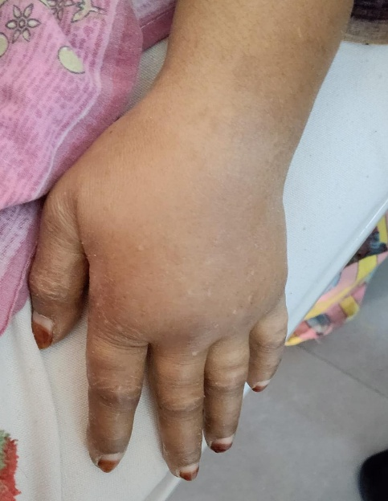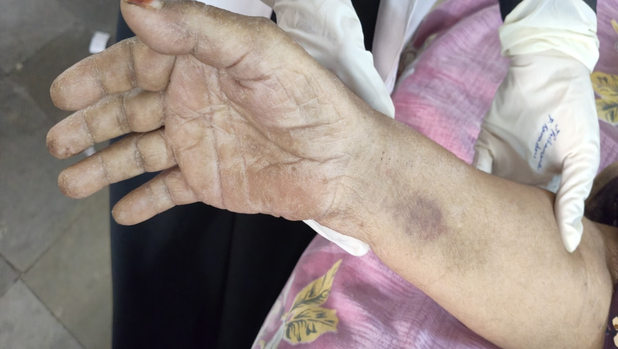

**Fig. 1. *Mechanic’s hands, a characteristic cutaneous manifestation of ASyS***

Given the multisystem involvement, treatment was initiated promptly. The patient was started on IVIG therapy at a dose of 0.4g/kg/day for several days, along with high-dose corticosteroids (Prednisolone 60mg OD and Methylprednisolone 60mg IV OD) to control immune-mediated muscle inflammation. Despite this, she continued to exhibit progressive quadriparesis with worsening truncal and neck muscle weakness, further supporting the diagnosis of antisynthetase syndrome or overlap myositis. The presence of persistent leukocytosis warranted the initiation of broad-spectrum antibiotics, including Meropenem (1g IV TID) and Ciprofloxacin (100ml IV BD), to cover for bacterial infections, especially given her respiratory compromise due to pneumonia. The patient also developed respiratory symptoms, requiring oxygen support and nebulization with Budecort. Blood cultures remained negative throughout, suggesting a non-bacterial cause of systemic inflammation, further pointing towards an underlying autoimmune process.

The patient also developed significant gastrointestinal symptoms, including upper gastrointestinal bleeding, which was later confirmed via endoscopy. The Upper Gastrointestinal Endoscopy (UGIE) revealed two gastric ulcers with clear bases (1 x 1 cm and 0.5 x 0.5 cm) and erosive duodenitis, explaining the episodes of melena. She was managed with a combination of proton pump inhibitors (Pantoprazole 40mg IV BD) and mucosal protective agents (Sucralfate 15ml TID) to facilitate ulcer healing and prevent further bleeding. In addition to her gastric complications, she also developed symptoms of a urinary tract infection (UTI), prompting a nephrology referral. The presence of persistent burning micturition and urine abnormalities required additional antibiotics to prevent further complications.

Throughout the hospital course, her diabetes was managed using HAI insulin according to a sliding scale, and Telma 40mg OD was continued for hypertension. She was also prescribed Pregabalin 75mg OD for neuropathic pain and physiotherapy to prevent muscle wasting and aid in maintaining some level of mobility despite her profound weakness.

By the time of discharge, the patient had shown mild improvement in muscle strength, with upper limb power improving to 3/5 and lower limb power at 2/5. However, she remained quadriparetic with persistent truncal and neck muscle weakness. Due to the nature of her condition, she was discharged with a planned tapering regimen of corticosteroids, beginning with Prednisolone 60mg OD for one week, gradually reducing over the following weeks to mitigate withdrawal symptoms and control disease activity. She was also prescribed ongoing supportive therapy, including Pantoprazole for gastric protection, Sucralfate for ulcer healing, Ciprofloxacin for UTI management, Spironolactone for edema management, Buscopan (hyoscine butyl bromide) for abdominal cramps, and iron supplementation (IFA PO OD) for anemia correction.

This case highlights the complex nature of antisynthetase syndrome, a rare autoimmune disorder characterized by myositis, interstitial lung disease, and systemic inflammation. The patient required intensive immunosuppressive therapy, infection control, metabolic regulation, and supportive measures, all of which played a crucial role in her stabilization. Given the high risk of disease relapse, infections, and steroid-related complications, long-term follow-up is essential to monitor her muscle function, respiratory status, and metabolic parameters. Continuous physiotherapy and immunosuppressive management will be crucial in maintaining functional status and preventing disease progression. A multidisciplinary approach, including rheumatology, pulmonology, nephrology, and rehabilitation teams, will be essential to ensure optimal long-term outcomes for this patient.

3. discussion

Antisynthetase syndrome (ASyS) is a complex and rare autoimmune disorder characterized by the presence of antisynthetase antibodies and a constellation of clinical manifestations, including interstitial lung disease (ILD), myositis, arthritis, and cutaneous features such as mechanic’s hands (Witt et al., 2017). The presented case highlights the diagnostic and therapeutic challenges associated with ASyS, particularly in cases with multi-system involvement.

The patient’s clinical course underscores the severity of muscle inflammation in ASyS. The confirmed diagnosis of necrotizing myositis, supported by muscle biopsy findings, is consistent with the literature, where myopathy is a hallmark feature in approximately 70–90% of ASyS cases (Tanboon et al., 2023). The elevated creatine phosphokinase (CPK) levels, ranging from 4435 to 6664 U/L, reflect severe muscle damage, in line with previous reports of elevated muscle enzymes in ASyS patients (Witt et al., 2017).

Pulmonary involvement is another prominent feature of ASyS, as evidenced by the patient’s ILD with patchy consolidation and centrilobular nodules on HRCT, indicating early pulmonary fibrosis. Studies have demonstrated that ILD is a major determinant of morbidity and mortality in ASyS, with nearly 70% of patients presenting with ILD at diagnosis (Patel et al., 2024). Early intervention with immunosuppressive therapy, including corticosteroids and intravenous immunoglobulin (IVIG), is critical to prevent irreversible pulmonary fibrosis and respiratory failure (Zanframundo et al., 2020).

The systemic inflammatory response, evident from persistent leukocytosis (WBC 19.8k–32k), anemia, and elevated inflammatory markers, highlights the autoimmune and inflammatory nature of ASyS. The patient’s broad-spectrum antibiotic therapy with meropenem and ciprofloxacin aimed to address potential secondary infections. Despite antibiotic coverage, the sterile blood cultures and persistent systemic inflammation suggested an ongoing autoimmune process rather than a bacterial infection, consistent with findings (Rasendrakumar et al., 2022).

Gastrointestinal complications, including upper GI bleeding secondary to gastric ulcers, posed additional management challenges. The use of proton pump inhibitors (PPIs) and sucralfate was necessary to promote ulcer healing. This case also demonstrated the multi-organ impact of ASyS, with urinary tract involvement requiring nephrology intervention. The presence of glucosuria, proteinuria, and ketonuria indicated potential renal compromise, a less commonly reported feature of ASyS(Alfraji et al., 2021).

Management of ASyS requires a multidisciplinary approach, as seen in this case. Immunosuppressive therapy with IVIG and corticosteroids formed the cornerstone of treatment, while infection control, respiratory support, and physiotherapy were essential for stabilization and recovery. Long-term management strategies are necessary to prevent disease relapse and monitor for complications, as recurrent ILD and progressive myositis are common (Wells et al., 2022)(Sawal et al., 2021).

4. Conclusion

Antisynthetase syndrome (ASyS) is a complex autoimmune disorder with variable clinical manifestations, including myositis, interstitial lung disease, and systemic inflammation. This case highlights the diagnostic challenges associated with ASyS due to its heterogeneous presentation. The patient required aggressive immunosuppressive therapy, infection management, and supportive care to stabilize her condition. Despite partial neurological recovery, her persistent muscle weakness and respiratory compromise emphasize the chronic and potentially disabling nature of ASyS. Long-term follow-up with a multidisciplinary approach, including rheumatology, pulmonology, and rehabilitation specialists, is essential to optimize patient outcomes and prevent disease progression.

Consent

All authors declare that ‘written informed consent was obtained from the patient (or other approved parties) for publication of this case report and accompanying images. A copy of the written consent is available for review by the Editorial office/Chief Editor/Editorial Board members of this journal.

Abbreviations

**ASyS**: Antisynthetase syndrome

**ILD**: Interstitial lung disease

**IVIG**: Intravenous immunoglobulin

**tRNA**:Targeting aminoacyl-transfer RNA

**DMARDs**: Disease-modifying antirheumatic drugs

**CPK**: Creatinine phosphokinase

**UGIE**: Upper gastrointestinal endoscopy

References

1. Witt LJ, Curran JJ, Strek ME (2017). The diagnosis and treatment of antisynthetase syndrome. Clin Pulm Med., 23(5), 218-226. PMCID: PMC5006392 NIHMSID: NIHMS800523 PMID: [27594777](https://pubmed.ncbi.nlm.nih.gov/27594777/)
2. Patel P, Marinock JM, Ajmeri A, Brent LH (2024). A review of antisynthetase syndrome-associated interstitial lung disease. Int J Mol Sci., 25(8), 4453. PMCID: PMC11050089 PMID: [38674039](https://pubmed.ncbi.nlm.nih.gov/38674039/)
3. Cleveland Clinic (2023). Antisynthetase syndrome. Cleveland Clinic. <https://my.clevelandclinic.org/health/diseases/25159-antisynthetase-syndrome>
4. Alfraji N, Mazahir U, Chaudhri M, Miskoff J (2021). Anti-synthetase syndrome: a rare and challenging diagnosis for bilateral ground-glass opacities—a case report with literature review. BMC Pulm Med., 21(1), 11. PMCID: PMC7787399 PMID: [33407281](https://pubmed.ncbi.nlm.nih.gov/33407281/)
5. Wells M, Alawi S, Thin KYM, Gunawardena H, Brown AR, Edey A, et al. A multidisciplinary approach to the diagnosis of antisynthetase syndrome (2022). Front Med (Lausanne), 9, 959653. PMID: 36186825 PMCID: [PMC9515890](https://pmc.ncbi.nlm.nih.gov/articles/PMC9515890/) DOI: [10.3389/fmed.2022.959653](https://doi.org/10.3389/fmed.2022.959653)
6. Sawal N, Mukhopadhyay S, Rayancha S, Moore A, Garcha P, Kumar A, et al. (2021). A narrative review of interstitial lung disease in anti-synthetase syndrome: a clinical approach. J Thorac Dis., 13(9), 5556-5571. PMID: 34659821 PMCID: [PMC8482343](https://pmc.ncbi.nlm.nih.gov/articles/PMC8482343/) DOI: [10.21037/jtd-20-3328](https://doi.org/10.21037/jtd-20-3328)
7. Zanframundo G, Marasco E, La Carrubba C, De Stefano L, Volpiano L, Tirelli C, et al. (2020). Update on treatment of antisynthetase syndrome: a brief review. Curr Treat Options in Rheum., 6, 18-28. DOI: <https://doi.org/10.1007/s40674-020-00139-w>
8. Medicover Hospitals (2025). Antisynthetase syndrome: Know the symptoms and treatment options. <https://www.medicoverhospitals.in/diseases/antisynthetase-syndrome/>
9. Opinc AH, Makowska JS (2021). Antisynthetase syndrome – much more than just a myopathy. Semin Arthritis Rheum., 51(1), 72-83. DOI: [10.1016/j.semarthrit.2020.09.020](https://doi.org/10.1016/j.semarthrit.2020.09.020). PMID: 33360231.
10. Tanboon J, Inoue M, Hirakawa S, Tachimori H, Hayashi S, Noguchi S, et al. (2023). Muscle pathology of antisynthetase syndrome according to antibody subtypes. Brain Pathol. 33(4), e13155. PMID: 36882048 PMCID: [PMC10307527](https://pmc.ncbi.nlm.nih.gov/articles/PMC10307527/) DOI: [10.1111/bpa.13155](https://doi.org/10.1111/bpa.13155).
11. Galindo-Feria AS, Notarnicola A, Lundberg IE, Horuluoglu B (2022). Aminoacyl-tRNA synthetases: on anti-synthetase syndrome and beyond. Front Immunol., 13, 866087. PMID: 35634293 PMCID: [PMC9136399](https://pmc.ncbi.nlm.nih.gov/articles/PMC9136399/) DOI: [10.3389/fimmu.2022.866087](https://doi.org/10.3389/fimmu.2022.866087)
12. Chan AR, Osman M, Yacyshyn E, Gniadecki R (2024). Cutaneous manifestations of anti‐synthetase syndrome: case series and review of the literature. JEADV Clinical Practice, 3(4), 1148-56. DOI: <https://doi.org/10.1002/jvc2.443>
13. Rasendrakumar A, Khanna A, Bakhai S (2022). Early recognition and successful treatment of anti-synthetase syndrome. Cureus., 14(1), e21786. PMID: 35251856 PMCID: [PMC8890853](https://pmc.ncbi.nlm.nih.gov/articles/PMC8890853/) DOI: [10.7759/cureus.21786](https://doi.org/10.7759/cureus.21786)