**Original Research Article**

**Impact of Land Use Systems on Soil Chemical Properties in Semi-Arid Tropics of Western Maharashtra**

**Abstract**

The study was conducted across eight districts of western Maharashtra during 2020–21 to assess the impact of diverse land use patterns on key soil chemical properties and carbon sequestration potential. Soil samples were collected from seven major land use systems (agriculture, forest, fallow, pasture, salt-affected, horticulture, and agroforestry) at two depths (0–15 cm and 15–30 cm) and analyzed for pH, electrical conductivity (EC), organic carbon, calcium carbonate (CaCO₃), and available nitrogen (N), phosphorus (P), and potassium (K). Results revealed significant variation in soil chemical properties across land use types. Forest and agroforestry systems showed higher organic carbon and nitrogen contents, while salt-affected soils exhibited elevated pH and EC. Organic carbon and nutrient levels generally declined with soil depth. Strong correlations were observed among organic carbon, nitrogen, and phosphorus, indicating their interdependence under different land management regimes. These findings highlight the critical role of sustainable land use in enhancing soil health and carbon storage in semi-arid tropical regions.

**Keywords:** Land use systems, soil chemical properties, soil fertility, semi-arid tropics, Western Maharashtra

1. **Introduction**

Soil degradation is a critical issue worldwide, with over a quarter of the Earth’s land area affected by declining soil quality (IPCC, 2019., Kumar et al., 2024, Pasumarthi et al., 2024). In semi-arid tropical regions, soil organic carbon (SOC) loss is closely linked to land degradation and reduced fertility (Saravia-Maldonado et al., 2024, Sawargaonkar et al., 2024, Manasa et al., 2024). Land use plays a pivotal role in this problem: changes in land cover can drastically alter soil properties and carbon storage. For instance, converting forests to croplands or pastures often depletes SOC and nutrients, turning soils from carbon sinks into carbon sources (Sharma et al., 2019). Conversely, natural forests and tree-based systems (e.g. agroforestry) generally maintain higher SOC and better nutrient status than continuously cultivated or degraded lands (Sahoo et al., 2019). Studies in India have shown that forest soils can hold nearly double the SOC of nearby intensively grazed or farmed soils, and that deforestation leads to significant losses of soil nitrogen and other nutrients (Choudhury et al., 2021). Given these challenges, the present study aims to compare key soil chemical properties pH, electrical conductivity (salinity), organic carbon, CaCO₃ content, and available N, P, K across different land use systems in western Maharashtra. By assessing these properties at two soil depths, we intend to evaluate how land use and soil depth interact to influence soil health in this semi-arid tropical region.

1. **MATERIALS AND METHODS**

The study was conducted during 2020–21, across eight districts of western Maharashtra, covering diverse land use patterns. The study involved site selection, sampling procedures, and analytical techniques, as detailed below.

**Agroclimatic Zones and Soil-Climate Characteristics**

The study region spans four agroclimatic zones of western Maharashtra, categorized based on rainfall, soil types, and vegetation:

* **Western Ghat Zone**: Predominantly lateritic, acidic soils with high rainfall (2750–6050 mm).
* **Sub-Montane Zone**: Reddish-brown to greyish-black soils, slightly acidic to neutral; rainfall 700–2500 mm.
* **Plain Zone**: Greyish-black soils, neutral to alkaline; rainfall 700–1250 mm.
* **Scarcity Zone**: Medium to deep black, calcareous, alkaline soils; rainfall <750 mm, bimodal distribution.

**Location and Extent**

The study was conducted in eight districts of western Maharashtra with different land use patterns.

TABLE 1. The selected eight districts of western Maharashtra with different land use patterns

|  |  |  |
| --- | --- | --- |
| **Land Use Patterns** | **Location** | **Agroclimatic Zones** |
| Agriculture | Solapur | Scarcity zone |
| Borgoan | Sub-montane |
| Igatpuri | Western ghat |
| Rahuri | Scarcity |
| Forest | Mahabaleshwar | Western ghat |
| Radhanagri | Western ghat |
| Borgoan, Satara | Sub-montane zone |
| Nandurbar | Western ghat |
| Fallow | Solapur | Scarcity |
| Kolhapur | Sub-montane |
| Pune | Plain zone |
| Rahuri | Scarcity |
| Pasture | Shirval | Sub-montane |
| Kolhapur | Sub-montane |
| Igatpuri | Western ghat |
| Rahuri | Scarcity |
| Salt affected | Kasbe Digraj | Scarcity |
| Padegaon | Sub-montane |
| Savalivihir | Scarcity |
| Rahuri | Scarcity |
| Horticulture | Kolhapur | Sub-montane |
| Ganeshkhind | Plain zone |
| Igatpuri | Western ghat |
| Rahuri | Scarcity |
| Agroforestry | Kolhapur | Sub-montane |
| Igatpuri | Western ghat |
| Solapur | Scarcity |
| Rahuri | Scarcity |

**Figure 1. Steps involved in Experimental Details** (One composite soil sample from each land use pattern, irrespective of soil types)

**2.1 Soil sampling**

Soil samples were collected from each land use system using a systematic sampling approach. Sampling was performed at a depth of 0-15 and 15-30 cm. Care was taken to avoid contamination from surface debris, vegetation, or other external sources. The collected samples were then air-dried and powdered with a wooden hammer to pass through a 2-mm sieve and stored in a plastic container for chemical analysis.

* + 1. **Laboratory analysis**

The methodology followed for estimating various parameters as furnished below.

TABLE 2. The method used for measuring selected parameters

|  |  |  |
| --- | --- | --- |
| **Parameter measured** | **Method** Description | **Reference** |
| pH | The soil pH was measured by a glass electrode using a soil-water suspension ratio of 1:2 | Rhoades, 1996 |
| EC | The soil electrical conductivity (EC) was measured by a calomel electrode using a soil-water suspension ratio of 1:2 after settling the sample overnight using an EC meter | Rhoades, 1996 |
| Organic carbon | Soil samples were ground to pass through a 0.25-mm sieve for organic carbon analysis by Walkley-Black method | Nelson 1996 |
| Exchangeable bases | Exchangeable bases viz., K, Ca, and Mg were determined using the neutral normal ammonium acetate method | Okalebo et al., 2002 |
| Available P | Available P in acidic soils was estimated by using Brays extractant no 1- 0.03*M* NH4F in 0.025*M* HCl.    Available P in alkaline soils was estimated by using sodium bicarbonate (NaHCO3) of pH 8.5 as an extractant for soils respectively. | Bray, 1945  Olsen, 1982 |
| Available K | Available potassium in the soil was extracted using neutral normal ammonium acetate (1N NH₄OAc) solution at pH 7.0. The potassium concentration in the filtrate was then determined using a Flame Photometer. | Jackson, 1973 |

**2.3 Statistical Analysis**

All data were statistically analyzed using R software (version 4.4.2). A two-way analysis of variance (ANOVA) was conducted to evaluate the effects of land use systems and soil depth on soil chemical properties. Mean comparisons were performed using Tukey’s Honest Significant Difference (HSD) test at a 5% significance level. Results are presented as mean ± standard deviation.

1. **Result and discussion**

**Effect of Different Land Use Patterns on Depth-wise Soil Chemical Properties**

The data pertaining to soil chemical properties as affected by different land use patterns, i.e., forest land, agroforestry, pasture, salt affected, fallow, agriculture, and horticulture land.

**Soil pH**

Soil reaction is crucial, categorized by pH as acidic, alkaline, or neutral. Higher plants significantly react to soil pH as it influences their chemical environment and nutrient availability. Soil pH varies by land use; salt-affected soils are most alkaline, while forest land is more acidic. Fallow and agricultural lands also show higher pH levels, while pasture, horticulture, and agroforestry soils have moderate values. pH remains consistent at varying depths (Figure 2). The high pH in salt-affected areas could be due to high Na in the clay complex, precipitation of Ca2+ and Mg2+ as carbonates, insufficient rainfall that prevents leaching, and high evaporation rates that concentrate salts in the root zone. Katariya (2011) recorded similar results in soil from the water management project Block A, central campus, MPKV, Rahuri. Most samples were moderately alkaline, likely because deep to medium black soils have been irrigated for long periods, leading to alkaline conditions. The increasing pH trend with depth may result from organic acid release during organic matter decomposition, which lowers the surface soil pH. This pH variation is linked to parent material, leaching, calcium carbonate presence, and exchangeable sodium. Basavaraju et al. (2005) and Thangasamy et al. (2005) observed related outcomes.

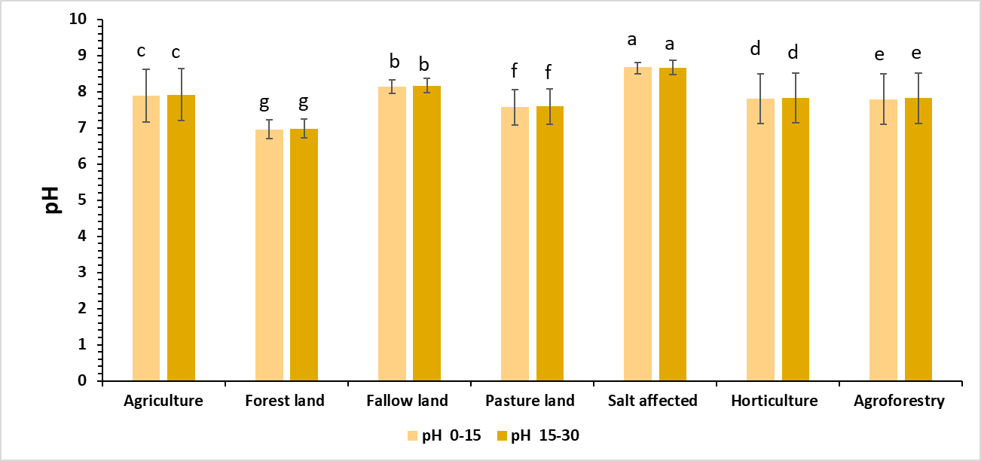

**Figure 2. Soil pH in surface (0–15 cm) and subsurface (15–30 cm) layers under different land use systems. Error bars indicate standard deviation. Different lowercase letters above bars denote significant differences (p < .05) among land use types based on Tukey's HSD test.**

**3.2 Electrical Conductivity (EC)**

The data with respect to electrical conductivity (EC) are presented in Figure 3. The electrical conductivity of seven land use patterns ranged between 0.11 and 1.91 dSm-1 and 0.10 and 1.88 dSm-1 at soil depths of 0-15 and 15-30 cm, respectively. The EC values were found in the normal to high category.

Increased EC in agricultural land might be due to the accumulation of salts, while the lowest EC values are due to leaching, washing out, or erosion of salts. Higher EC was recorded in salt affected land this may be due to excess use of irrigation water with high EC and basin topography of characterized area where the water table is high and also due to seepage of water along with soluble salts and carbonates of Ca2+ and Mg2+ might have increased EC more than 1 dSm-1 indicating saline features which affect seed germination. Similar results were also revealed by Padole and Mahajan (2003) in swell-shrink soils of the Vidharbha region.

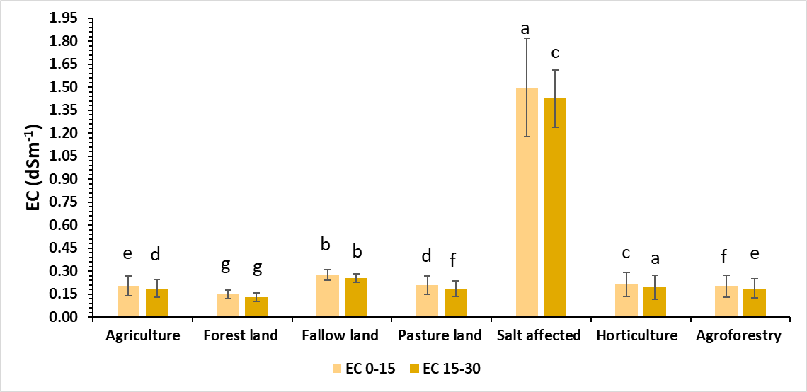

**Figure 3. Soil electrical conductivity (EC, dS m⁻¹) in surface (0–15 cm) and subsurface (15–30 cm) layers under different land use systems. Error bars indicate standard deviation. Different lowercase letters above bars denote significant differences (p < .05) among land use types based on Tukey's HSD test.**

**3.2 Soil Organic Carbon**

The organic carbon content in various land use patterns ranged from 0.28 to 2.15 percent, classified from low to very high. Forest land exhibited significantly high organic carbon levels, likely due to continuous inputs of above-ground biomass, high microbial diversity, minimal soil disturbance, high rainfall, and cooler temperatures, which slowed SOM decomposition (Figure 4). Ramakrishnan et al. (2021) reported similar findings, noting that the guava + pasture land use system led to higher organic carbon build-up (0.86 – 34 %) at a depth of 0-15 cm compared to other systems. The low organic carbon in agricultural land could stem from the low turnover rate of OM and direct sunlight exposure, increasing organic matter oxidation. Salt-affected land recorded lower organic carbon, likely due to high salt deposition, which raises osmotic pressure, limiting water and nutrient uptake by plant roots, leading to oxidative stress and reduced photosynthesis. Tropical conditions, which hasten organic matter degradation and low vegetation cover, may also account for reduced organic carbon. Similar results were noted by Sharma et al. (2001) and Nayak et al. (2002) in the Kathiawar region and Central Research Station (OUAT), Bhubaneswar. All land use patterns displayed a decrease in organic carbon with depth, attributed to plant residues and farm yard manure added to surface horizons, leading to higher organic carbon content at the surface than in lower layers. This aligns with findings from Basavaraju et al. (2005) in Chandragiri Mandal, Andhra Pradesh, and studies by Nayak et al. (2002), Kirmani et al. (2013), and Wani et al. (2016).

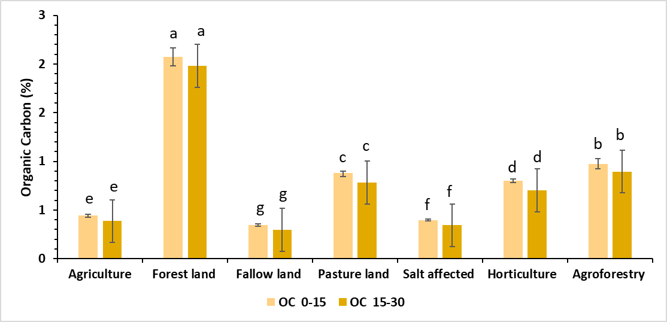

**Figure 4. Soil organic carbon (%) in surface (0–15 cm) and subsurface (15–30 cm) layers under different land use systems. Error bars indicate standard deviation. Different lowercase letters above bars denote significant differences (p < .05) among land use types based on Tukey's HSD test.**

**3.3 Calcium Carbonate (CaCO3)**

The CaCO3 content of soil under different land use patterns varied between 0.88 to 10.56 per cent at 0-15 cm and 1.12 to 11.69 per cent at 15-30 cm soil depth (figure 5).

The calcium carbonate content in soil was influenced by soil depth, irrespective of land use patterns. The result showed the numerically increasing trend of CaCO3 content with respect to increased soil depth.

The data indicated that more CaCO3 content was found in the lower layer (15-30 cm) than in the upper layer. Narsaiah *et al*. (2018) also reported that high CaCO3 contents were in the lower layer of most of the soil, which might be due to high clay content, which led to impeded leaching, resulting in the accumulation of CaCO3 in the lower horizons. Further, the higher CaCO3 content in the soil might also be due to the semi-arid climate in the study area, which is responsible for the pedogenic processes leading to depletion of Ca2+ ions from the soil solution in the form of caliches (Kumar & Prasad, 2010).

**3.4 Soil Available Nitrogen**

Perusal of the data presented in Figure 6 revealed that available nitrogen content of different land use patterns ranged between 122 and 393 kg ha-1 at 0-15 cm soil depth and 106 and 379 kg ha-1 at 15-30 cm soil depth. The available N content in different land use patterns of the Western Maharashtra region is observed to be low to moderate in range.

The significantly highest available nitrogen content was recorded in forest land, which was evidenced by the highest carbon storage in soil and standing biomass, which is a major source of organic nitrogen. The increase in nitrogen content in the soil is due to the high litter fall and its decomposition. Available nitrogen content in soil was maximum in surface soil and found decreasing with increasing depth, possibly due to the imprisonment of falling plant residues and debris and the rhizosphere of plants with decreasing content of organic carbon with depth. Similar results were reported by Todmal *et al*. (2008). In general, the surface soils were found to contain more nitrogen than sub-surface soils; this may be owed to higher organic matter content in surface soils.

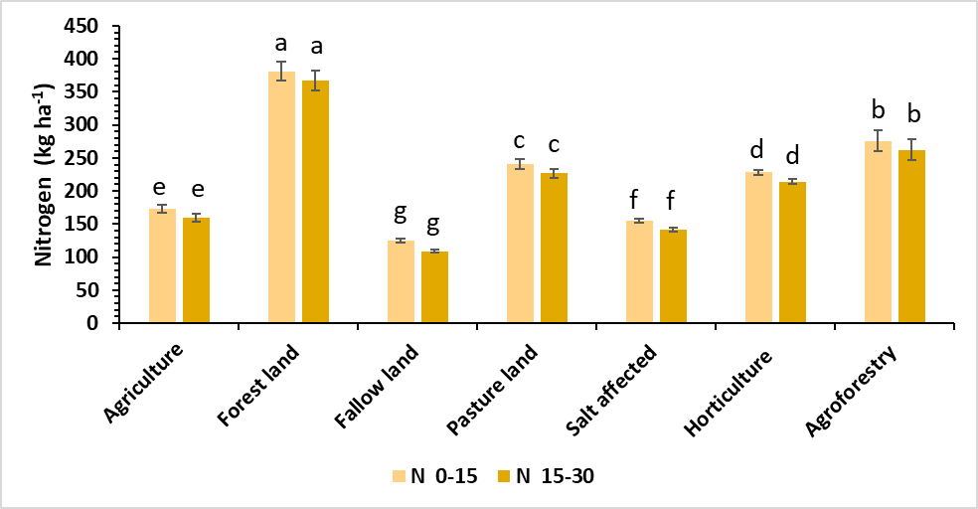

**Figure 6.** Soil nitrogen content (kg ha⁻¹) in surface (0–15 cm) and subsurface (15–30 cm) layers under different land use systems. Error bars indicate standard deviation. Different lowercase letters above bars denote significant differences (p < .05) among land use types based on Tukey's HSD test.

**3.5 Soil Available Phosphorus**

The data pertaining to available phosphorus content in soil as influenced by the different land use patterns is presented in Figure 7. Available phosphorus values were found variable in the range of 6.41 to 30.71 kg ha-1 in surface soils and 5.11 to 29.65 kg ha-1 in subsurface soils. It was observed that the soil available phosphorus of different land use patterns of the western Maharashtra region ranged from low to high content.

The available phosphorus content was increased in forest soil; this may be attributed to comparatively higher SOM with enhanced phosphatase activity under a plantation crop system as compared to an open field condition and other agroclimatic zones.

The data shows varying levels of available phosphorus in these soils. The surface layer has higher phosphorus content than the sub-surface, likely due to its organic matter and phosphatic fertilizer applications. Lower phosphorus in subsurface horizons may result from phosphorus fixation by clay minerals and iron and aluminum oxides (Thangasamy et al., 2005). The swell-shrinking soils of Maharashtra also vary in available phosphorus. Low phosphorus content may stem from alkaline reactions and the calcareous nature of the soil, supporting findings by Dhage et al. (2000), Vaidya et al. (2014), and Mane et al. (2015).

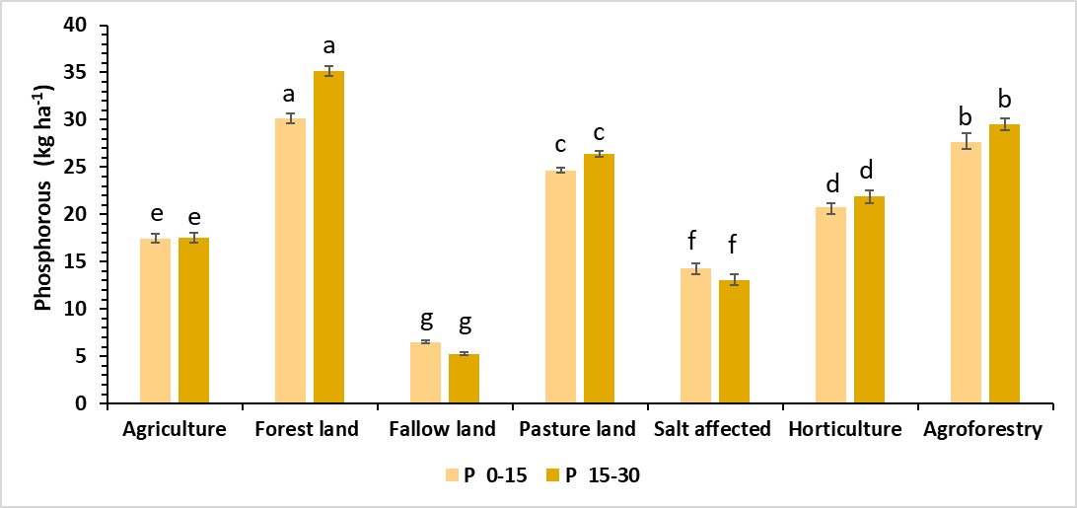

**Figure 7.** Soil phosphorus content (kg ha⁻¹) in surface (0–15 cm) and subsurface (15–30 cm) layers under different land use systems. Error bars indicate standard deviation. Different lowercase letters above bars denote significant differences (p < .05) among land use types based on Tukey's HSD test.

**3.6 Soil Available Potassium**

The data presented in Figure 8 show that available potassium in soils under different land use patterns ranged between 176 and 621 kg ha-1 in surface soils and 158 to 593 kg ha-1 in subsurface soils.

The highest K content was recorded in plain and scarcity zones, and this may be due to the fact that K is mainly related to clay mineralogy and high clay content, and the dominant clay mineral is montmorillonite, having a high specific surface area, surface charge, and CEC.

The adequate available potassium in the soils may be attributed to the prevalence of potassium-rich minerals like Illite and Feldspar (Sharma 2008). In general, the available potassium status of soils of scarcity and plain zone is very high, which could be attributed to the dissolution and diffusion of K from the mineral crystal lattice of silicate clay minerals. Further, it might also be due to high clay content and dominant clay mineral Montmorillonite having a high specific surface area, surface charge, and CEC. A similar trend of available potassium was also reported by Katariya (2011) in soils of the water management project in Central Research Farm, MPKV, Rahuri.

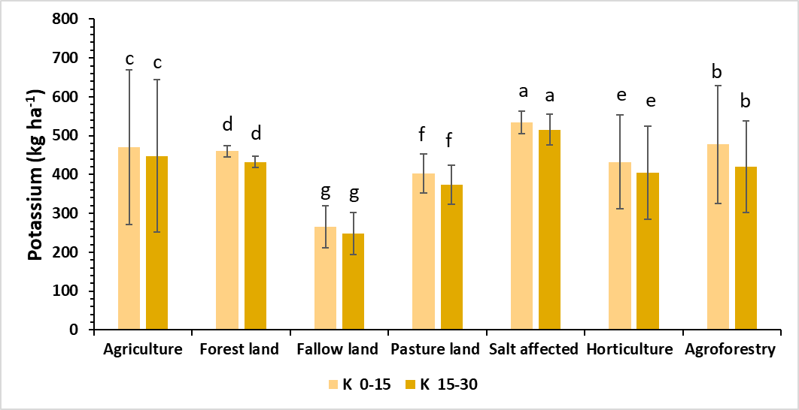

**Figure 8.** Soil potassium content (kg ha⁻¹) in surface (0–15 cm) and subsurface (15–30 cm) layers under different land use systems. Error bars indicate standard deviation. Different lowercase letters above bars denote significant differences (p < .05) among land use types based on Tukey's HSD test.

**Figure 9.** Correlation heatmap of soil parameters across different land use patterns.

**3.7 Correlation coefficient of soil chemical properties**

To understand the interrelationship among key soil properties, a Pearson correlation analysis was performed for the topsoil (0–15 cm) data across different land use patterns. The correlation matrix is depicted in Figure 9.

Soil pH had a strong positive correlation with CaCO₃ content (r = 0.97), suggesting calcareous conditions contribute to alkalinity. Conversely, pH correlated negatively with organic carbon (r = –0.87), nitrogen (r = –0.87), and phosphorus (r = –0.76), indicating that acidic to neutral conditions favor higher organic matter and nutrient availability. Electrical Conductivity (EC) was positively related to pH (r = 0.76) and CaCO₃ (r = 0.69), implying higher salt concentrations may associate with calcareous soils. EC also had a moderate positive correlation with potassium (r = 0.46), likely due to the mobility of K⁺ ions in saline soils. CaCO₃ showed strong negative correlations with OC (r = –0.89), N (r = –0.93), and P (r = –0.88), indicating calcareous soils may hinder nutrient accumulation or availability, possibly due to microbial inhibition or nutrient fixation. Organic Carbon (OC) had strong positive correlations with nitrogen (r = 0.97) and phosphorus (r = 0.81), demonstrating OC's role as a nutrient source and sink, supporting microbial-mediated nutrient cycling. Nitrogen (N) and Phosphorus (P) were highly correlated (r = 0.92), reinforcing the influence of organic matter and biological processes on their availability. N also had a moderate positive correlation with potassium (r = 0.31). Potassium (K) showed the weakest correlations, yet still displayed positive relationships with phosphorus (r = 0.49) and nitrogen (r = 0.31), possibly reflecting root absorption dynamics in vegetated systems.

1. **Conclusion**

The study revealed that land use type has a significant influence on soil chemical properties in western Maharashtra. Forest and agroforestry systems maintained higher organic carbon and nitrogen levels, contributing positively to soil fertility. Salt-affected soils exhibited higher pH and EC values, indicating salinity-related constraints. Across all systems, soil nutrient contents were generally higher in surface layers and decreased with depth, highlighting the importance of surface management.

The strong correlation between organic carbon and available N and P emphasizes the role of organic matter in nutrient cycling and availability. Enhancing carbon inputs through sustainable land use practices, especially agroforestry and forest conservation, can improve soil health and long-term productivity. These findings support the adoption of integrated land management strategies for soil resource sustainability and climate resilience in semi-arid regions.

**DISCLAIMER (ARTIFICIAL INTELLIGENCE)**

The author(s) hereby declare that no generative AI technologies such as Large Language Models (e.g., ChatGPT, Copilot) or text-to-image generators were used in the content creation, interpretation, or drafting of this manuscript. Only grammar and language enhancement tools (e.g., Grammarly) were used to improve clarity and readability, without altering the scientific content or interpretation.

**References**

Basavaraju, D., Naidu, M.V., Ramavataram, N., Venkaiah, K., Ramarao, G., and Reddy, K.S. (2005). Characterization, classification, and evaluation of soils in Chandragiri mandal of Chittor district, Andhra Pradesh. *Agropedology*, 15(1), 55–62.

Brady, N.C., & Weil, R.R. (1999). *The Nature and Properties of Soils*. 14th Ed., Prentice Hall, Upper Saddle River, New Jersey, pp. 446–490.

Choudhury, B. U., Ansari, M. A., & Chakraborty, M. (2021). Effect of land-use change along altitudinal gradients on soil nutrients in the Eastern Himalayas. Scientific Reports, 11(1), 14279. DOI: 10.1038/s41598-021-93509-1.

Dhage, A.R., Mane, S.R., and Adsule, R.N. (2000). Available micronutrients in the soils of Shevgaon tahsil (Ahmednagar dist.) in relation to soil characteristics. *Journal of Maharashtra Agricultural Universities*, 25(1), 97–98.

IPCC (2019). Climate Change and Land: An IPCC Special Report on climate change, desertification, land degradation, sustainable land management, food security, and greenhouse gas fluxes in terrestrial ecosystems. Geneva: Intergovernmental Panel on Climate Change.

Jackson, M.L. (1973). *Soil Chemical Analysis*. Prentice Hall of India Pvt. Ltd., New Delhi, pp. 498–501.

Katariya, P.C. (2011). Characterization and classification of soils of the water management project, MPKV, Rahuri. *M.Sc. (Agri) Thesis*, Mahatma Phule Krishi Vidyapeeth, Rahuri, Maharashtra, India.

Kirmani, N.A., Wani, M.A., and Sofi, J.A. (2013). Characterization and classification of Alfisols under lesser Himalayan Temperate region. *Agropedology*, 23(2), 118–121.

Kumar, N. V., Sawargaonkar, G., Rani, C. S., Pasumarthi, R., Kale, S., Prakash, T. R., & Chandra, M. S.(2024). Harnessing the potential of pigeonpea and maize feedstock biochar for carbon sequestration, energy generation, and environmental sustainability. Bioresources and Bioprocessing, 11(1), 5.

Manasa, R., Devi, R. S. J., Vemana, K., John, K., Rao, G. R., Anubhava, P. J., & Sudini, H. K. (2024). Biochar as a strategy to manage stem rot disease of groundnut incited by Sclerotium rolfsii. Frontiers in Agronomy, 6, 1470194.

Mane, R.D., Vaidya, P.H., Dhawan, A.S., and Pawar, Y.S. (2015). Characterization and classification of grape (Vitis vinifera) growing soils in Osmanabad district (Maharashtra). *Annals of Plant and Soil Research*, 545–549.

Nelson, D. W., & Sommers, L. E. (1996). Total carbon, organic carbon, and organic matter. Methods of soil analysis: Part 3 Chemical methods. 5, 961-1010.

Okalebo, J. R., Gathua, K. W., & Woomer, P. L. (2002). Laboratory methods of soil and plant analysis: a working manual second edition. Shectared Africa, Nairobi. 21, 25-26.

Olsen, S. R., & L. E. Sommers. (1982). Phosphorus. In: A.L. Page, R.H. Miller, and D.R. Keeney (eds.), Methods of Soil Analysis. 2nd ed. Agronomy Series No. 9, Part 2. *Soil Science Society of America*, Inc., Madison, WI., 403-430.

Padole, V. R., & Mahajan, S. B. (2003). Status and release behaviour of potassium in some swell-shrink soils of Vidarbha, Maharashtra.

Pasumarthi, R., Sawargaonkar, G., Kale, S., Kumar, N. V., Choudhari, P. L., Singh, R., & Jat, M. L. (2024). Innovative bio-pyrolytic method for efficient biochar production from maize and pigeonpea stalks and their characterization. Journal of Cleaner Production, 448, 141573.

Ramakrishnan, S., Kumar, S., Chaudhary, M., Govindasamy, P., Yadav, M., Prasad, M., ... & Prajapati, K. (2021). Silvopastoral system for resilience of key soil health indicators in semi-arid environment. *Archives of Agronomy and Soil Science*, *67*(13), 1834-1847.

Rhoades, J. D. (1996). Salinity: Electrical conductivity and total dissolved solids. Methods of soil analysis: Part 3 Chemical methods. 5, 417–435.

Sahoo, U. K., Singh, S. L., Gogoi, A., Kenye, A., & Sahoo, S. S. (2019). Active and passive soil organic carbon pools as affected by different land use types in Mizoram, Northeast India. PLoS ONE, 14(7), e0219969. DOI: 10.1371/journal.pone.0219969.

Saravia-Maldonado, S. A., Rodríguez-González, M. Á., Ramírez-Rosario, B., & Fernández-Pozo, L. F. (2024). Change in land use affects soil organic carbon dynamics and distribution in tropical systems. Soil Systems, 8(3), 101. DOI: 10.3390/soilsystems8030101

Sawargaonkar, G., Pasumarthi, R., Kale, S., Choudhari, P., Rakesh, S., Mutnuri, S., Singh, A., Sudini, H., Ramaraju, M., Singh, R., Padhee, A. K., & Jat, M. L. (2024). Valorization of peanut shells through biochar production using slow and fast pyrolysis and its detailed physicochemical characterization. Front. Sustain. 5:1417207. doi: 10.3389/frsus.2024.1417207.

Sharma, G., Sharma, L. K., & Sharma, K. C. (2019). Assessment of land use change and its effect on soil carbon stock using multitemporal satellite data in semiarid region of Rajasthan, India. Ecological Processes, 8(1), 42. DOI: 10.1186/s13717-019-0193-5.

Thangasamy, A., Naidu, M. V. S., Ramavatharam, N., & Reddy, C. R. (2005). Characterisation, classification and evaluation of soil resources in Sivagiri micro-watershed of Chittoor District in Andhra Pradesh for sustainable land use planning. *Journal of the Indian Society of Soil Science*, *53*(1), 11-21.