**EXAMINING THE IMPACT OF TECHNOLOGY-FACILITATED GENDER-BASED VIOLENCE ON THE MENTAL HEALTH AND WELLBEING OF ADOLESCENTS**

**ABSTRACT**

|  |
| --- |
| **Objective:** This study examines the impact of Technology- Facilitated Gender based Violence (TFGBV) on the mental health and well-being of adolescents. This research shows the complex intersection between digital environments and gender-based violence, focusing on the psychological and emotional repercussions experienced by young individuals globally.  **Study Design:** A detailed review of existing literature, case studies, and industry reports between 2018 and 2025 to assess the recent trends and impact of TFGBV.  **Methodology:** The research draws from peer-reviewed journal articles, technology, health and civic industry analyses. It follows a qualitative review approach, including data visualization to highlight the need for proactive collaboration to curb the effect of TFGBV on adolescents.  **Results:** Findings reveal that TFGBV are in different forms and highlight the profound mental health challenges faced by adolescents, including anxiety, depression, social withdrawal, and a decline in self-esteem. A global study by Plan International (2020) surveying 14,000 girls across 22 countries found that 58% had experienced online harassment, with most incidents occurring on major social media platforms. The psychological toll of this form of TFGBV is profound, reportedly resulting in anxiety (38%), low self-esteem (25%), and mental distress (18%).  **Conclusions:** This review paper discusses the sociocultural and systemic factors that exacerbate vulnerabilities and hinder effective intervention.  It emphasizes the need for comprehensive strategies, advocates for policy frameworks, educational initiatives, and digital literacy programs to mitigate the impacts of TFGBV. The study concludes by calling for a collaborative, global effort involving educators, healthcare professionals, policymakers, and digital platform developers to create safer online spaces and support adolescent mental health.  . |

***Keywords:*** *TFGBV, Cyberbullying, Doxxing, Sextortion, Gender-Based Violence, Online Violence, Social media*

1. **INTRODUCTION**

In this era of rapid digital advancements, technology presents great opportunities for innovation, employment, education, leisure, creativity, and community building for women and girls, and yet it also introduces new vulnerabilities, one of which is Technology-facilitated Gender-Based Violence. [1]. The term TFGBV is often used interchangeably with technology-facilitated violence against women, technology-based abuse, technology-facilitated abuse, online violence against women and girls, online abuse, digital violence, and digital abuse [2]. Until recently, the international community lacked a shared definition of TFGBV, which has been one of the foremost challenges to collecting data and producing comparable research on this type of gender-based violence. Technology- facilitated gender- based violence (TFGBV) was recently defined as ‘any act that is committed, assisted, aggravated or amplified by the use of Information and Communication Technologies (ICTs) or other digital tools, that results in or is likely to result in physical, sexual, psychological, social, political or economic harm, or other infringements of rights and freedoms [3].

TFGBV includes a spectrum of behaviors perpetrated online (and then often taken offline) through a range of everyday technological advances, such as mobile devices, social media platforms, interactive computer games, text messaging, email or any other related technologies. Common behaviors and tactics include cyberbullying, defamation, sexual harassment, image- based abuse, cyberstalking, cyber- grooming, doxing, impersonation, hate speech and gender trolling. [4].

Globally, there has been a measurable rise in TFGBV incidents. A 2020 study by Plan International found that 58% of girls and young women had experienced online harassment on social media platforms, with 42% of them reporting long-term mental health effects such as anxiety and depression. Teenagers between the ages of 12 and 17 are particularly susceptible, as they are among the most active internet users and often lack the digital literacy and emotional resilience to effectively navigate or respond to such abuse. This trend is especially troubling given the growing body of research indicating a strong correlation between TFGBV exposure and adverse mental health outcomes, including suicidal ideation, social withdrawal, and declining academic performance [5].

Although the concept of gender-based violence is not new, its technology-facilitated form enhances its reach, permanence, and psychological impact. Unlike traditional GBV, TFGBV is often anonymous, instantaneous, and omnipresent traits that intensify the power imbalance between aggressors and victims and complicate reporting and legal redress. In contrast to unknown perpetrators, some reported cases stated how known and trusted persons are perpetrators and target women on online platforms [6]. Furthermore, perpetrators often exploit platform algorithms and weak content moderation systems to target and re-target victims, perpetuating cycles of harm.[7]. Studies by the European Institute for Gender Equality (2022) underscore the urgency of addressing TFGBV, highlighting that 1 in 10 women in the EU have experienced some form of cyber violence since the age of 15.

For the past few years there has been an explicitly robust advancement in the field of technology which has ultimately given rise to the need of legislation in this field as well. It is well understood that where technology has opened doors to opportunities thereby it has created path to the new offences and Gender Based Violence rank among these. The world observing the rising rate of the Online Gender Based Violence (OGBV) has legislated the laws internationally and nationally. For decades various countries have enacted laws dealing with the TFGBV. Greater Cooperation is made towards control of TFGBV by Governments, NGOs, and Law enforcement. The general concept that should be followed is whether the offence occurs in physical space or cyberspace, relevant law should be applied regardless of such fact. For example, in Pakistan, the Prevention of Electronic Crimes Act, 2016 was passed addressing the cybercrimes. Several sections of PECA prohibit harassment, child pornography, cyberstalking and unauthorized access to personal data. PECA has covered substantial aspects of TFGBV, but it is subject to certain limitations as well. [8].

From a mental health perspective, the effects of TFGBV on adolescents are profound. Exposure to online harassment has been linked to increased levels of cortisol, a biological marker of stress, and disruptions in sleep and cognitive functioning [9]. A study found that adolescents who experienced cyber abuse were twice as likely to develop symptoms of post-traumatic stress disorder (PTSD) compared to their peers. Compounding this is the lack of age-appropriate mental health services tailored to survivors of digital abuse. particularly in low- and middle-income countries. [1]. Girls in rural or economically disadvantaged regions often lack access to safe online spaces, educational resources, and trusted adults who can guide them through experiences of TFGBV. The most recent surveys show a prevalence of TFGBV ranging from 16% to 58% depending on the question asked, and the demographic features of respondents such as age and gender. [10].  
  
This review paper examines how Technology-Facilitated Gender-Based Violence (TFGBV) impacts the mental health of Adolescents, using insights from science, law, and public health. It looks at how often TFGBV happens among adolescents, its psychological effects, and what social factors contribute to it. By highlighting the severity of harm from TFGBV, the paper stresses the need for youth-friendly solutions. Such solutions might include making online platforms more responsible for controlling harmful content and offering mental health support in schools. As digital spaces change, focusing on understanding and tackling TFGBV is essential to protect the mental and emotional well-being of the younger generation.

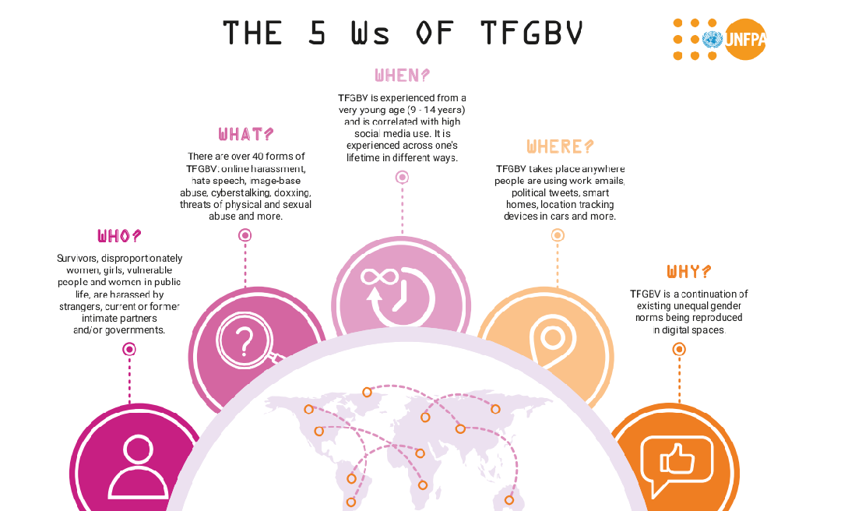

**Fig. 1: The 5 Ws of Technology-Facilitated Gender-Based Violence [11]**

1. **METHODOLOGY**

This research employs a systematic literature review approach to examine the impact of technology-facilitated gender-based violence (TFGBV) on the mental health and well-being of adolescents. The primary objective is to explore the complex intersection between digital environments and gender-based violence, focusing on the psychological and emotional repercussions experienced by young individuals globally. The research states how various forms of TFGBV, such as cyberbullying, online harassment, non-consensual sharing of intimate images, and other forms of abuse, disproportionately impact adolescents, influencing their mental health and overall well-being, causing depression, anxiety, and suicidal thoughts.

An extensive search of a variety of academic databases was carried out. The following digital repositories, including ScienceDirect, PubMed, SpringerLink, IEEE Xplore, Scopus, Web of Science, Google Scholar, and Wiley Online Library, were searched. The purpose was to find peer-reviewed articles, reports, and industry-relevant articles from the years 2018 to 2025. This effort aimed to present a well-grounded and data-driven argument on TFGBV and the impact it has on adolescents. To guide the search, different combinations of search terms were used along with operators like AND and OR. Some of these terms were “technology-facilitated gender-based violence,” “cyberbullying,” “online harassment,” “non-consensual sharing of intimate images,” “adolescent mental health,” “depression,” “anxiety,” “self-esteem,” and “suicidal ideation.” Specific filters were used to focus only on full-text articles written in English.

To ensure relevance and quality, the following inclusion criteria were applied: research studies published between 2018 and 2025; research focusing on adolescents aged 10–19 years; empirical studies examining the impact of TFGBV on women and adolescent mental health, including outcomes such as anxiety, depression, self-esteem, and suicidal ideation; and peer-reviewed articles published in English.​ Excluded were **s**tudies published before 2018, research not involving adolescents or not addressing TFGBV, and non-peer-reviewed content, such as blog posts and opinion pieces.

The initial search yielded a substantial number of articles. After removing duplicates, titles and abstracts were screened for relevance to the topic. Subsequently, full-text articles were assessed against the inclusion and exclusion criteria. This process resulted in a final selection of 30 studies that met all inclusion criteria. Extracted information included study characteristics, sample size and demographics, study design and methodology, forms of TFGBV examined, mental health outcomes assessed, and key findings. A narrative synthesis approach was employed to summarize and interpret the findings. Key themes were identified, including the prevalence of various forms of TFGBV, the psychological and emotional impacts on adolescents, and the moderating factors influencing these effects.

It is important to note that, while the approach used ensured a thorough and high-quality examination of the current literature, there were certain limitations, such as the reliance on only English-language sources, which may have excluded relevant research published in other languages, and the relatively low number of studies included in the final evaluation, which restricts the inclusivity of the findings. Also, some of the most important studies may be paywalled or not available in publicly accessible databases. However, even then, this study remains a detailed and organized examination of the impact of TFGBV on the mental health of women and adolescents.

1. **RESULTS AND DISCUSSION**

|  |  |  |
| --- | --- | --- |
| **Type of TFGBV** | **Definition** | **Prevalence** |
| Astroturfing | A coordinated effort to share damaging content as widely as possible across multiple channels. | 58 percent of women globally report experiencing this |
| Cyber-harassment | The repeated use of text and images (frequently sexual or misogynistic in nature) to instill fear in and intimidate the victim. | 66 percent of women globally report experiencing this. |
| Deepfakes | False images created using the likeness of a real person. | 96 percent of deepfakes are nonconsensual sexual deepfakes; of those, 99 percent are of women. |
| Doxxing | The nonconsensual sharing of real-world information, such as an address, phone number, or legal name, to perpetrate violence. | 55 percent of women globally report experiencing this |
| Hacking and stalking | The nonconsensual interception of an individual’s data, whereabouts, and communications. | 63 percent of women globally report experiencing this. |
| Image-based sexual abuse (IBSA) | The nonconsensual sharing of private and intimate images or videos for the purpose of harming the victim. | 57 percent of women globally report experiencing this. |
| Sextortion | Threatening to expose sexual images in order to coerce a person to do something. | 66 percent of victims are girls under the age of 16. |

**Table 1: Prominent types of TFGBV [12]**

**Forms of TFGBV**

Technology-Facilitated Gender-Based Violence (TFGBV) refers to harmful actions using digital tools to target people, especially women and adolescent girls. Research shows that TFGBV can take different forms and often occurs across various online platforms. Common types include cyberbullying, doxxing, sextortion, image-based sexual abuse (IBSA), deepfake pornography, and online sexual harassment. These behaviors may look different depending on where they happen, cultural differences, and the digital sites they are on. Despite this, they all lead to mental stress, making victims withdraw from social life and hesitant to engage online.

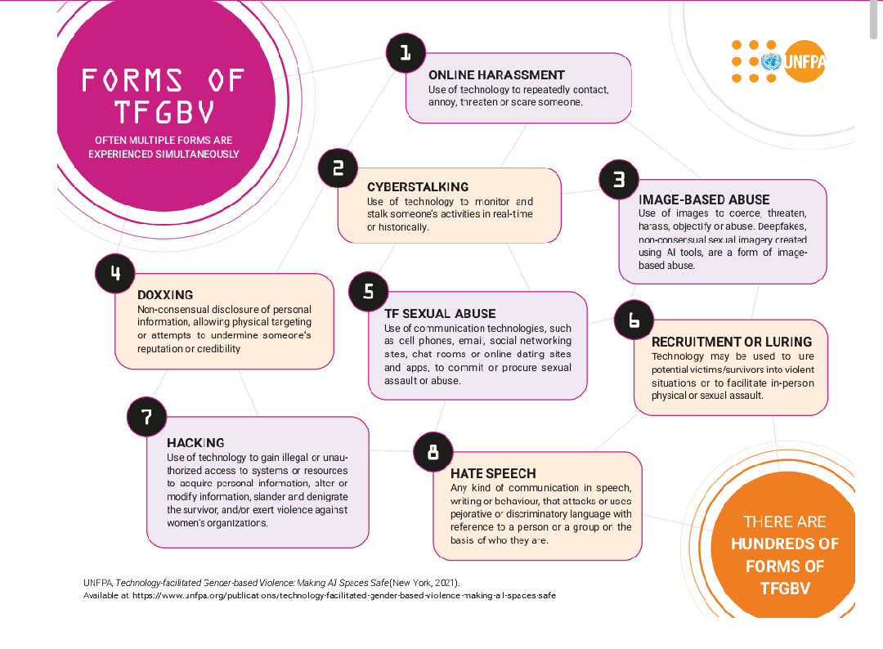

**Fig 2. Forms of TFGBV [11]**

### Cyberbullying and Gendered Harassment

Cyberbullying is among the most prevalent forms of TFGBV, especially among adolescents. It refers to repeated, intentional aggression conducted through digital channels like messaging apps, forums, and social media. While not always gendered, literature shows a clear gendered pattern in both the nature and impact of this abuse on adolescents. Girls are more likely to experience cyberbullying in the form of sexual shaming, appearance-based insults, and threats of sexual violence, while boys often encounter homophobic or physical intimidation [1]

A global study by Plan International (2020) surveying 14,000 girls across 22 countries found that 58% had experienced online harassment, with most incidents occurring on major social media platforms. The psychological toll of this form of TFGBV is profound, reportedly resulting in anxiety (38%), low self-esteem (25%), and mental distress (18%).

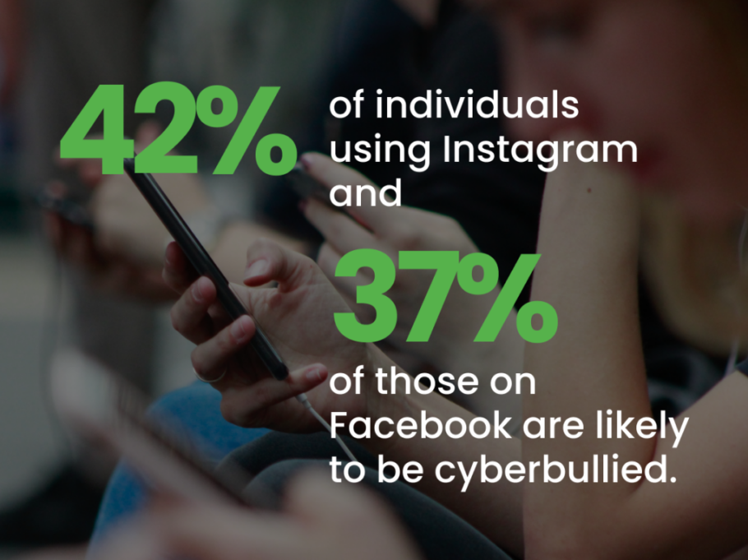

**Fig 3: Statistics on Cyberbullying, according to WebPurify**

### Image-Based Sexual Abuse (IBSA)

IBSA is also known as non-consensual image sharing or “revenge porn.” it involves the distribution of intimate images or videos without the subject’s consent. Adolescents, especially girls, are particularly vulnerable due to social and peer pressure around sexting. According to research by Patel and Roesch, nearly 1 in 5 adolescents reported either experiencing or knowing someone who experienced non-consensual image sharing, with significant psychological consequences such as shame, isolation, and suicidal thoughts. [5]

The permanent and viral nature of digital content heightens the trauma associated with IBSA, as victims often feel that the abuse is inescapable [13].

**Sextortion and Online Grooming**

Sextortion involves someone threatening to share private sexual content unless their demands are met. These demands often include asking for more pictures, sexual acts, or money. [14] This problem has been growing quickly, especially among teenagers who use apps like Snapchat, WhatsApp, and Instagram. People committing sextortion often pretend to be friends to gain the victim's trust online before they start making threats. This abuse is very harmful because it involves playing with emotions, causing feelings of betrayal, fear, and shame. Research by Henry in 2023 found that victims of sextortion often experience PTSD symptoms more than those who have suffered physical or sexual assault [1]. This is because digital content can be permanent, and the threat of blackmail adds more stress.

**Doxxing and Threats to Digital Safety**

Doxxing happens when someone shares another person's private details, like their home address, school, or phone number, online in a harmful way, usually retaliating. This act can seriously endanger young people by exposing them to real-world dangers such as stalking or harassment in person. Girls who are active in activism or speak out against gender discrimination are more frequently targeted. [15].

 According to reports by UNFPA in 2024 and UN Women in 2023, doxxing is often used to silence young girls, mainly those in leadership positions. This behavior supports current power structures and discourages girls from participating in online discussions and activities.

**Platform-Specific Dynamics**

Technology-Facilitated Gender-Based Violence, doesn’t just happen on its own. It is influenced by how digital platforms are designed and managed. Research indicates that certain features of these platforms, such as allowing users to remain anonymous, not having enough moderation, and offering autosuggestions, can increase the chances and intensity of abuse. Let's look at some specific examples: Instagram and Snapchat are often involved in cases of Image-Based Sexual Abuse (IBSA) and sextortion. This is largely due to their focus on visual content and messages that vanish after a short time. [16]. WhatsApp is frequently used for group-based abuse and for spreading content without consent at a rapid pace. [17] [18]. TikTok’s algorithms can make harassment spread quickly, particularly when victims try to tell their stories or share emotional experiences. [19].

**Psychological Consequences of TFGBV on Adolescents**

* **Anxiety, Depression, Self-Harm, and Suicidal Ideation**: Recent studies show that mental health problems are on the rise among teenagers. A study conducted by Danzo et al. in 2024 focused on young adolescents aged 11 to 13. This study showed a 42.9% increase in depression symptoms during the pandemic period, when the usage of social media increased radically. Meanwhile, feelings of anxiety and suicidal thoughts remained consistently high. [20]. What's particularly concerning is that girls and Hispanic youths are experiencing the highest rates of these mental health issues. [21]. This data highlights the urgent need for attention and intervention to address these growing challenges faced by young people. In Nigeria, a cross-sectional survey revealed that 36.4% of adolescents experienced anxiety, 30.7% suffered from depression, and 8.4% reported suicidal ideation. [22]. The study highlighted that older adolescents and females were more susceptible to these mental health challenges.
* Post-Traumatic Stress Disorder (PTSD) Symptoms: Exposure to TFGBV can result in PTSD among adolescents. Approximately 5% of adolescents between the ages of 13 and 18 are affected by PTSD, with higher rates observed in girls. Symptoms include flashbacks, nightmares, emotional numbness, and difficulties in concentration. And if left untreated, PTSD can lead to chronic sleep disturbances, depression, substance abuse, and suicidal thoughts [23].
* Disrupted Sleep and Academic Decline: Sleep disturbances are both a symptom and a contributing factor to adolescent mental health issues. A program implemented at Mansfield Senior High School in Ohio introduced a sleep curriculum to address this concern. The initiative aimed to improve students' sleep hygiene, recognizing that poor sleep is linked to mental health issues, impaired judgment, academic decline, and behavioral problems. Furthermore, educational reforms emphasizing increased grading and testing have contributed to heightened academic stress among students. This pressure has been associated with increased anxiety and mental health issues, particularly among female adolescents. [24].
* Gendered and Age-Specific Vulnerabilities: Gender and age are important when thinking about how likely someone is to have mental health problems because of TFGBV. The CDC's Youth Risk Behavior Survey from 2023 showed that almost one in three students had poor mental health. Female students were about twice as likely to face mental health issues and risks related to suicide compared to male students. LGBQ+ students were also two to three times more at risk of experiencing these issues than their straight peers. [25]. In a study focusing on adolescents aged 11–14, it was found that 30.1% reported suicidal thoughts, with higher prevalence among girls (35.5%) compared to boys (23.0%). Additionally, non-binary participants exhibited higher scores on all mental health questionnaires, indicating increased vulnerability. [26].

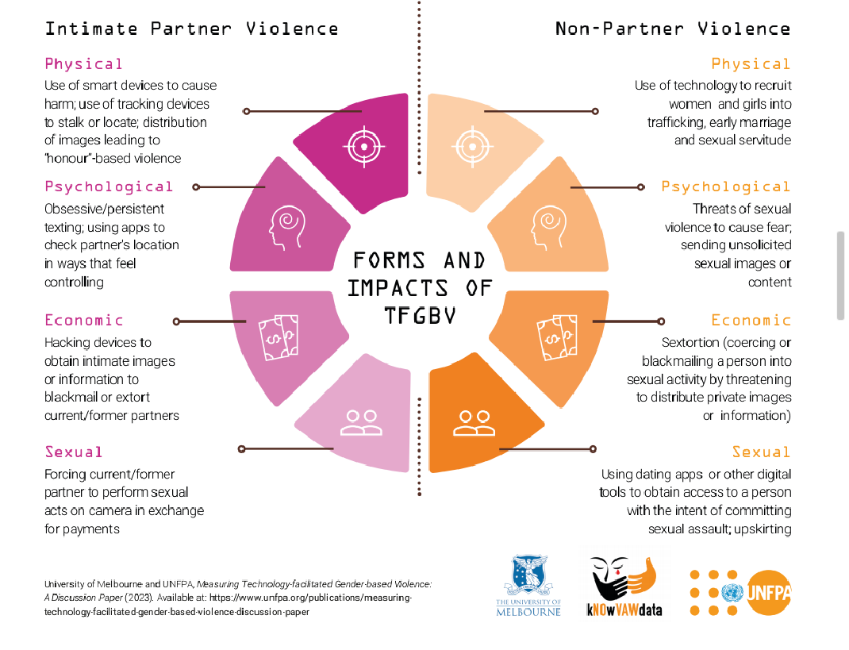

**Fig 4: Forms and Impacts of TFGBV [11]**

**INTERVENTION**

Technology-Facilitated Gender-Based Violence (TFGBV) has become a pressing problem for young people worldwide. As digital technology advances and platforms don't always offer adequate protection, adolescents, especially girls and those from marginalized groups, are at greater risk of online abuse. This situation highlights the increased dangers faced by adolescents, the lack of effective protection on digital platforms, and the urgent need for all relevant stakeholders around the world to collaborate and address this issue together. Here are some proposed strategic interventions to reduce the impact of TFGBV.

* **Digital Literacy and Empowerment Programs**: It's important to teach adolescents how to use the internet safely and recognize Technology-Facilitated Gender-Based Violence (TFGBV). Schools can help by adding lessons about digital literacy and online safety to their classes. These lessons should focus on critical thinking, managing privacy, and being respectful online. We can also start peer education programs where adolescents who have been trained lead conversations about TFGBV. This creates a supportive environment to share experiences and come up with strategies together. Additionally, developing resources and workshops for parents is crucial. These can help parents understand the risks of the digital world and how to support their children's online activities. In a recent study, Information and Communication Technology (ICT) programs were found to be effective in preventing and responding to sexual and gender-based violence in low- and middle-income countries. [27]. This shows how important digital literacy is in giving young people the power to protect themselves and others.
* **Technology-Based Support Services**: By offering easy-to-use, private, and youth-friendly services online can be very helpful. Virtual counseling with trained professionals provides psychological help to TFGBV victims, those hurt by technology-facilitated gender-based violence. Apps can help young people report problems secretly, find helpful resources, and connect with support groups. AI-powered chatbots can give quick help and information on TFGBV issues. A review by Huang et al. (2022) brings together digital health strategies that help with sexual and reproductive health and work to stop gender-based violence among young people in low- and middle-income countries. This shows how technology-based methods can make a big difference. [27].
* **Policy Development and Legal Frameworks**: To tackle Technology-Facilitated Gender-Based Violence (TFGBV), we need strong and effective laws. The Model Law by the Follow-up Mechanism to the Belém do Pará Convention (MESECVI) serves as a crucial guide. It provides detailed steps for countries to follow to prevent TFGBV, protect victims, offer support, conduct thorough investigations, and ensure that offenders are punished. Additionally, the law sets out specific responsibilities for technological companies. [28]. These guidelines aim to ensure that digital practices are fair, inclusive, and transparent. In Uganda, advocacy efforts by organizations like the Collaboration on International ICT Policy for East and Southern Africa (CIPESA) have led to proposals for including TFGBV in the Sexual Offences Bill. These proposals emphasize the need for explicit definitions and provisions addressing online sexual offences, aiming to bridge legal gaps and ensure justice for survivors

1. **CONCLUSION**

In this technological age, where everything is online, adolescents are using the internet more than ever. Digital technology offers many opportunities for learning and making connections, but it can also be harmful, particularly through Technology-Facilitated Gender-Based Violence (TFGBV). This review covers the various aspects of TFGBV, including its types, frequency, mental health effects, differences across platforms, and the shortcomings in our current laws and institutional responses.

The facts are clear: adolescents, especially girls, and those from less advantaged backgrounds, face greater risks online. TFGBV can include cyberbullying, sextortion, image-based abuse, doxxing, and grooming, causing serious and long-lasting mental health issues like anxiety, depression, PTSD, self-harm, and problems with school and friendships. [29]. Teenage years are already challenging, involving identity development and brain changes, which have become even more difficult with ongoing online harassment and lack of support.

Though there are growing interests, research, and advocacy around these issues, responses from tech companies and governments are still fragmented and not strong enough. Yet, there is hope. New solutions are emerging, such as school programs teaching internet safety, AI tools to monitor online content, community strategies focused on gender equality, and trauma-aware online support. The reviewed work shows these approaches work better when multiple sectors collaborate, seeing TFGBV not just as a tech issue but also as a public health and human rights concern. Still, these solutions must be expanded, tailored to different contexts, and regularly checked for effectiveness. [30].

Lastly, to end the digital vulnerabilities that enable gender-based violence, we need significant changes in laws, technology, institutions, and societal thinking. Only then can we ensure that the internet empowers young people instead of endangering them, safeguarding every adolescent’s mental health and well-being both online and offline.

COMPETING INTERESTS DISCLAIMER:

Authors have declared that they have no known competing financial interests OR non-financial interests OR personal relationships that could have appeared to influence the work reported in this paper.

**REFERENCES**

1. Henry, N., & Powell, A. (2018). Technology-Facilitated Sexual Violence: A Literature Review of Empirical Research. *Trauma, Violence, & Abuse*, 19(2), 195–208. DOI: [10.1177/1524838016650189](https://doi.org/10.1177/1524838016650189).
2. A. Sharda, M. Rathore, and A. Joshi, “Technology facilitated gender-based violence in low- and middle-income countries: Appeal for psychosocial response,” *Journal of Mental Health and Human Behaviour*, vol. 29, no. 2, pp. 115–116, Jul. 2024, doi: 10.4103/jmhhb.jmhhb_172_24.
3. S. Hameed, B. Tyabashe-Phume, E. Tunggal, X. Hunt, L. Ned, and K. Soldatić, “Technology-facilitated gender-based violence against women with disabilities in low- and middle-income countries: a scoping review protocol,” *BMJ Open*, vol. 15, no. 3, p. e093988, Mar. 2025, doi: 10.1136/bmjopen-2024-093988.
4. Backe EL, Lilleston P, McCleary- Sills J. Networked Individuals, Gendered Violence: A Literature Review of Cyberviolence. Violence Gend 2018;5:135–46.
5. U. Patel and R. Roesch, “The Prevalence of Technology-Facilitated Sexual Violence: A Meta-Analysis and Systematic Review,” *Trauma Violence & Abuse*, vol. 23, no. 2, pp. 428–443, Sep. 2020, doi: 10.1177/1524838020958057.
6. T. Tasnima, M. A. M. Syed, R. Padzil, and S. H. A. B. Ah, “Women, Technology and Gender-Based Violence in Bangladesh,” *Jurnal Komunikasi Malaysian Journal of Communication*, vol. 39, no. 4, pp. 166–182, Dec. 2023, doi: 10.17576/jkmjc-2023-3904-09.
7. C. Nyman, L. Evertsson, and A.-S. Henrikson, “Digitally facilitated economic abuse in the age of digital financial services – new risks for economic abuse in intimate partner violence,” *Journal of Gender-Based Violence*, vol. 7, no. 3, pp. 368–382, Aug. 2023, doi: 10.1332/239868023x16909576356057.
8. T. Nazakat and F. E. Malik, “Empowering Justice through AI: Addressing Technology-Facilitated Gender-Based Violence with Advanced Solutions,” *Journal of Law & Social Studies*, vol. 7, no. 1, pp. 26–42, Mar. 2025, doi: 10.52279/jlss.07.01.2642.
9. B. Keles, N. McCrae, and A. Grealish, “A systematic review: the influence of social media on depression, anxiety and psychological distress in adolescents,” *International Journal of Adolescence and Youth*, vol. 25, no. 1, pp. 79–93, Mar. 2019, doi: 10.1080/02673843.2019.1590851.
10. J. Hicks, “Global Evidence on the Prevalence and Impact of Online Gender-based Violence (OGBV),” Oct. 2021. doi: 10.19088/k4d.2021.140.
11. “An infographic Guide to Technology-facilitated Gender-based Violence (TFGBV),” *United Nations Population Fund*. <https://www.unfpa.org/publications/infographic-guide-technology-facilitated-gender-based-violence-tfgbv?>
12. Kristine Baekgaard, Technology-Facilitated Gender-Based Violence An Emerging Issue in Women, Peace and Security, 2023-2024 Hillary Rodham Clinton Fellow, *Georgetown Institute for Women, Peace and Security.*
13. F. C. Rindestig, K. G. Gådin, L. Jonsson, C.-G. Svedin, Å. Landberg, and I. Dennhag, “A latent class analysis of technology-facilitated sexual violence: Associations to other victimizations, psychiatric symptoms, and gender,” *Child Abuse & Neglect*, vol. 161, p. 107309, Feb. 2025, doi: 10.1016/j.chiabu.2025.107309.
14. G. Kirkman, D. Willmott, D. Boduszek, and A. Debowska, “Introduction and validation of the Modern Adolescent Dating Violence Attitude (MADVA) scale: A contemporary tool for assessing adolescent attitudes towards dating violence in offline and online environments,” *International Journal of Law, Crime and Justice*, vol. 80, p. 100705, Nov. 2024, doi: 10.1016/j.ijlcj.2024.100705.
15. N. Koukopoulos, M. Janickyj, and L. M. Tanczer, “Defining and Conceptualizing Technology-Facilitated Abuse (‘Tech Abuse’): Findings of a global Delphi study,” *Journal of Interpersonal Violence*, Jan. 2025, doi: 10.1177/08862605241310465.
16. D. Eranutrise, R. Baiduri, and N. Rosramadhana, “Netnographic Study: Caring for Online Gender-Based Violence on Instagram @awaskbgo,” *Formosa Journal of Sustainable Research*, vol. 3, no. 10, pp. 2101–2108, Oct. 2024, doi: 10.55927/fjsr.v3i10.11807.
17. G. L. G. P. Ferreira, “Technology as Both a Facilitator of and Response to Youth Intimate Partner Violence: Perspectives from Advocates in the Global-South,” in *Emerald Publishing Limited eBooks*, 2021, pp. 427–446. doi: 10.1108/978-1-83982-848-520211032.
18. P. Saha, B. Mathew, K. Garimella, and A. Mukherjee, “‘Short is the Road that Leads from Fear to Hate’: Fear Speech in Indian WhatsApp Groups,” *arXiv (Cornell University)*, Jan. 2021, doi: 10.48550/arxiv.2102.03870.
19. Schmerz, Grace, "An Exploratory Research on the Sexualization of Young Women on TikTok" (2024). *CUNY Academic Works.*<https://academicworks.cuny.edu/jj_etds/310>
20. S. Danzo *et al.*, “Anxiety, depression, and suicidal ideation among early adolescents during the COVID‐19 pandemic,” *Journal of Adolescence*, vol. 96, no. 6, pp. 1379–1387, Apr. 2024, doi: 10.1002/jad.12333.
21. M. Orri *et al.*, “Mental health problems and risk of suicidal ideation and attempts in adolescents,” *PEDIATRICS*, vol. 146, no. 1, Jun. 2020, doi: 10.1542/peds.2019-3823.
22. C. A. T *et al.*, “The unique contributions of depression and anxiety to suicidal ideation among Nigerian secondary school students: a cross-sectional survey,” *African Health Sciences*, vol. 23, no. 4, pp. 537–550, Dec. 2023, doi: 10.4314/ahs.v23i4.57.
23. Barnett E, Hamblen J. [PTSD in Children and Adolescents](https://www.ptsd.va.gov/professional/treat/specific/ptsd_child_teens.asp). National Center for PTSD. Updated September 16, 2019.
24. P. McGorry, H. Gunasiri, C. Mei, S. Rice, and C. X. Gao, “The youth mental health crisis: analysis and solutions,” *Frontiers in Psychiatry*, vol. 15, Jan. 2025, doi: 10.3389/fpsyt.2024.1517533.
25. J. V. Verlenden *et al.*, “Mental health and suicide risk among high school students and protective factors — Youth Risk Behavior Survey, United States, 2023,” *MMWR Supplements*, vol. 73, no. 4, pp. 79–86, Oct. 2024, doi: 10.15585/mmwr.su7304a9.
26. C. Scheiner, J. Grashoff, N. Kleindienst, and A. Buerger, “Mental disorders at the beginning of adolescence: Prevalence estimates in a sample aged 11-14 years,” *Public Health in Practice*, vol. 4, p. 100348, Dec. 2022, doi: 10.1016/j.puhip.2022.100348.
27. K.-Y. Huang, M. Kumar, S. Cheng, A. E. Urcuyo, and P. Macharia, “Applying technology to promote sexual and reproductive health and prevent gender based violence for adolescents in low and middle-income countries: digital health strategies synthesis from an umbrella review,” *BMC Health Services Research*, vol. 22, no. 1, Nov. 2022, doi: 10.1186/s12913-022-08673-0.
28. Suzie Dunn, “*The Emerald International Handbook of Technology-Facilitated Violence and Abuse,”* 2021. doi: 10.1108/9781839828485.
29. Y. Deol and M. Lashai, “Impact of Cyberbullying on Adolescent Mental Health in the midst of pandemic – Hidden Crisis,” *European Psychiatry*, vol. 65, no. S1, p. S432, Jun. 2022, doi: 10.1192/j.eurpsy.2022.1096.
30. Ranjith PJ, Vranda MN, Kishore MT. Barriers to Mental Health Support in Cyberbullying: A Thematic Analysis of What Mental Health Professionals and Cyber Experts Think. Indian Journal of Psychological Medicine. 2024;0(0). doi:10.1177/02537176241253390