A REVIEW ON ROLE OF INSECTS IN AGROFORESTRY

ABSTRACT
Insects are considered to be one of the most diverse and prominent creatures existing in this mother earth. They are the interesting creatures which existed about 350-500 million years ago in the Devonian era.They have withstood almost every of the natural calamities and successfully survived in it by their natural wide adaptations. They are one of the most valuable features in an agroecological system. In a general preference to enhance the production and productivity of an agroforestry system, man have always introduced plant species as well as the insects. Previously very little preference was given to such studies but now it is a under the broad umbrella of biological control. In agroforestry systems, different insect life phases are linked to different stages. Due to other concerns, the insect-pest component received less attention in previous agroforestry studies. The rise of significant insect issues in promising agroforestry systems, along with other related hazards, is now more widely recognized and understood. It has become common practice to incorporate trees and other plants from various places into agroforestry systems in order to increase productivity and provide a variety of applications. The growth and diversity of beneficial insects, such as pollinators, predators, and soil arthropods, which occasionally may lessen pest loads, is another possible outcome in the context of agroforestry systems.
KEYWORDS
Agroforestry, Beneficial Insects,beetles, biodiversity, Entomology, Guardians, Natural Enemy
- INTRODUCTION
The most diverse group are considered to be as insects and with the pace of time and evolution they have created a mutualistic relation with the environment. Entomology can be referred as the scientific study of insects with respect to their habitat and their relation with the environment. Based on the damaging potential, the classification and categorisation of insects as potential pest has led to subjective research [15,16]. Insects on other hand can be considered as pest when it causes destruction in an economical way. The insects can feed on several herbs, shrubs and trees and eventually turned into a severe potential pathogen and cause economical loss to mankind [17,18]. Not only on plants, insects also turn to provide economical loss to stored harvested foods and also to animals related to agriculture and Entomology here turns into a wide aspect and the role of entomologist flourish here with the pace of nature[7].Particularly when considering pest biology and ecology, the effects of insects on conventional agroforestry systems or practices were mainly disregarded [19,20]. But as agroforestry developed into a recognized field, it became clear that a thorough knowledge of insect biology, ecology, and related biodiversity was crucial for the farm area. Furthermore, relevant observations made outside of the farm region are highly relevant.
1.1 ROLE OF AGROFORESTRY
Agroforestry system can be linked as the most sustainable systems as they link both agriculture and forestry with much more advanced technology respectively and provide a more adequate and diverse way in terms of productivity and production[8]. Thus, Agroforestry can be considered as the healthiest and economically sound system as they provide better outcomes with respect to the most diverse fields. The economical outcomes of any system irrespective of any field can be only maintained when there is a prominent rise in the production level or there is a reduction in any type of losses [14]. To achieve a profitable economics yet not compromising in the sustainability of the systems it has to be kept in mind that the losses are prevented. The diverse and dynamic insect fauna is due to different components of Agroforestry systems. To achieve a sustained production the management and proper control of insect pest is considered as crucial. In early 1990’s ICRAF considered pest mitigation as the major element and made general awareness regarding this and also considered it as the major research area [6]. Insect pest regulation is the result of interaction of different components of agroforestry systems. When there is prominent diversity among the plant sources then there are generally reduced pest intensities while the taxonomically same plant species can have more diverse pest sources and may also share common pests. According to Andow, the population of herbivores insects generally reduce in more diverse systems as compared to polyphagous pest[2]. These insect’s host may vary and it is due to the phenomenon known as the odour masking typically of plants also these trees prevent pest to enter into the crop fields[11]. The knowledge on the agroforestry systems and the pest management should be updated, furthermore more emphasis should be given to those in context. The impact of agroforestry and pest management were largely ignored in the past but now when the system emerged as a major discipline major importance has been given specially to the pest biology, its ecology and also the species biodiversity. Introduction of woody perennial create major dimensions in insect pest problems and also add a different feature to entomology in the agroforestry systems[Figure 1]. In Agroforestry systems there is amalgamation of annual crops and trees which will mature with time, and thus it creates a major environment complex to harbour insects[13].
The Insect Community in an agroforestry system can be influenced by several factors such as
- Complex Biological interaction and it may be due to related taxonomy and diverse in botanical composition
- Introduction of exotic Species

Figure1: Factors related to insect ecology for maintaining a productive Agroforestry system
2 FACTORS RELATED TO INSECT ECOLOGY IN AN AGROFORESTRY SYSTEM
2.1 ECOLOGICAL INTERACTION
In natural plant systems, plants have developed a inbuilt resistance to insect and pest attack. In agroforestry the interaction among parts or even components of the system can be either negative, positive, or can be considered as neutral similarly is the impact on insect attacks.With these we can also consider the biology of pest which also plays an important role. There are major possibility or tendency that the polyphagous pest will feed on the taxonomically related plant species. Monophagous will feed and multiply on the monocrops[12]. The host range of some insect pest may also vary that the immature stage will feed on one part and the mature stages on the other. For example, if we consider the biology of chaffer beetle, the immature stages or the grubs generally feed on the crops while the adult stage feeds on the woody perennials or woody components of the agroforestry systems. To build up the insect fauna it is essential that we consider suitability of the insects by providing them adequate food, habitat and climatic conditions[10]. Tri-trophic interactions of predators, insects and vegetation influence the dynamics and diversity of the pests[Figure 2].The first trophic level is created by the plants as the primary producers and it includes forms such as trees, weeds and crops and they may be attacked by the herbivores which eventually turn as the primary consumers and thus form the second trophic level. The Third trophic level is of these herbivores which are now eventually attacked by different set groups of natural enemies and they form the secondary consumers. The predators, parasites, pathogen and also the vertebrates and thus contribute a dynamic role in the insect pest population of an agroforestry systems and also act as natural enemies of the system. Characteristics like natural control of pest and also the role of pollinators can also contribute significantly to enhance or improve the productivity in the system[13].
2.2 AGROFORESTRY AND INSECT PEST – STATUS
Agroforestry enhances the introduction of plant species and related diversity in the desired piece of land, with subsequent time and overall space it is assumed that the insect pest of the system will be reduced. In addition, it cannot be the scenario in each of the case as the reduction in desired pest populations depends on several factors. The system may also be pest specific as well as site specific and in the course of time it may also be affected by different abiotic factors.Some of the insect shelter in woodlands, in hedge rows and also in the forest lands. When the environmental conditions become favourable, they invade the production systems. Sucking pests like aphids sustain in one or many wild host plants before switching to crop plants. In the same contexts bruchids are generally the seed feeders and pests of leguminous grains but they generally feed on wild relatives of woody legumes plants[4]. When the flowering plants of wild nature are incorporated with the hedge rows as in the agricultural systems then the pollen as well as the nectar sources enhances and also the pollinators andparasites get enhanced. The woody plants which survive for about more than two years (perennials) also becomes the physical enclosed barriers and which decrease the movements or dispersal of such pests. Some of the plants have the capability to mask the volatile signals as a result which can also surprise as well as puzzle the pests which use the volatile like signals to find the host. Indigenous and exotic plants which are planted to regain the soil fertility also tend to harbour and aggregate the herbivores insect pest. The insect pest activity can also be influenced by the swap in the micro - climate of systems. In such a way there may positive and negative influence on the systems as well as the pest complex[Figure 2][9].
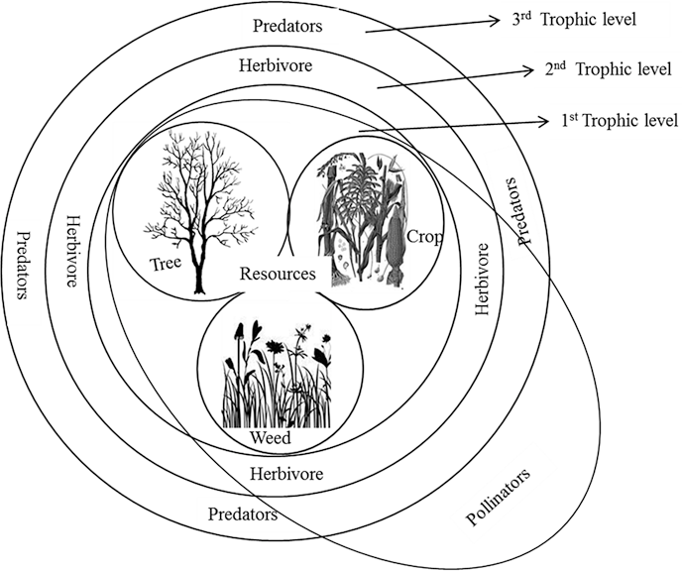
Figure 2: Trophic Interaction in the Systems
- SYSTEM DESIGNING FOR THE INSECT PEST COMPLEX
Different components play a major functional role in the biodiversity as well as the ecosystem. The biodiversity in the agroforestry system can be summarised as the inherent design which include the inclusion of trees with agricultural crops as well as livestock as surplus to the farmers and the second may be the insect pest and their natural enemies which live in the agro-ecosystems by forming different colonies and finally, it also includes the insect pest harbouring outside the systems. The Agroforestry and its ecosystems consist of three biotic components and this include the productive biota which provisions different services and furnishes the biological control and pollination as well as the productivity of the system. The resource biota is the most suited examples is of wasp which visits the nectar in flowers of the related trees and also acts mainly as the natural parasitoids of the crop pests and further the destructive biota which is generally managed by the farmers in order to prevent the productivity from the economic losses[1].These are totally related to each other and hence provide the various functions in an ecosystems. Agroforestry systems are generally multi-faced and have great potential to reduce the pest population as they have greatest source biocontrol agents and their efficiency when increased can serve as the major ailment in the pest control but these provide us a brief idea that the biodiversity may be utilised perfectly in order to manage the pest population[Figure 3]. If the systems are designed perfectly then they can also stabilise the insect community and also support the natural enemy population. In hilly regions, North-eastern states of India it is seen that there is lowest record of herbivore insect population by the prominent natural enemies in the system. By the research it has been thus concluded that due to the areas which lack tillage generally at the base of trees, undisturbed vegetation and habitat thereby provides a better natural enemy’s condition or can be summed as the Fauna predatory population. They are generally well maintained in the low scales with conventionally of very low input of chemical fertilisers and pesticides. Farmers of Brazil tends to create and sustain on their own made system like they choose crops, fruit crops and non-crop species according to their experience and in such a way that they can get the medicines, timber as well as other product being completely rely on the forest system. These systems were chosen so that it can adapt to soil and climatic conditions [Table 1][5].

Figure 3: Detailed relationships between Agroforestry system and Plant-Insect biodiversity functions.

3.1 INSIGHTFUL FINDINGS FROM DETAILED OBSERVATIONS IN THE CONTEXT OF MANAGING AGROFORESTRY INSECT PEST
 | General Interactions | Brief Effects
 | Tree species which are in Fallow lands or in periphery  (Harbouring beneficial Insect species) | May increase the damage caused by Pests
 |  | Predator and Pollinators population nay tend to increase
 | Insects being sheltered on trees as alternative host to insect pest and also to the Disease vectors | There may be increased pests damage on crops
 | When the trees and crop belong to same taxonomic group, they can share common pests | Pest Problems can be increased
 | When trees dominate the Agricultural crops by competing for different kind of resources | The vigour decreases of the crop as a result there may be susceptibility of pest attacks
 | Trees as food source and shelters to natural enemies | Population of pest may decrease
 | Trees limiting the lifecycle and movement of insects | Insect Population may be reduced
 | Trees as mechanical barriers to insect pests, vectors and plant pathogen | Pest Colonisation is reduced
 | When the N is adequately available | The crop attains its vigour and thus can have the power to withstand the attack
 | When the N is adequately available | Increase in Vigour can lead to susceptibility to other pests.
 | Trees when provide microclimate in adverse climate | Buildup pest and pathogen complex
 | Tree Litters when the decrease the soil temperature and thereby increases soil humidity | Increase the soil borne insects
 | When weeds use up the nutrients | Makes crop susceptible and increase the pest attack
 | When weeds serve as the insect habitat and also shelters and turns ass the food sources for pest and natural enemies | Gradual reduction of pest in the field

Table 1 : Influence of trees on related Insect Pest.

3.2 BENEFICIAL ARTHROPODS AND FOREST SOIL MICRO FAUNA
Soil is considered to be the spontaneous and natural living medium housing different numbers of organisms, soil arthropods are one among them. There has been a close association between the plant, soil and the adjacent microorganism since the plant life originated in this mother earth. Almost one fourth of the terrestrial land spaces is covered by Grasslands. The mixtures of crops and trees which has the capability to fix the nitrogen is common in agroforestry system. Generally, most of the living forms remain in the top soil layer[Figure 6]. An edaphon is referred as the organic layer where the organism inhabits. The permanent inhabitants of the soil are Geobionts whereas geophile is considered to be the one which complete a part of their life stages in soil. Generally, orders like Coleoptera, Diptera, Thysanoptera and Heteroptera represent the following group. Further the geophiles are divided into active and inactive ones. The Microarthropods work as supporters in different ecosystem services such as nutrient cycling and even soil formation[Figure 4 and 5] [3].

Figure 4: 0.5% of Total Soil Volume is Occupied by the Soil Organisms

Figure 5: Living Content of 1g Forest Soil

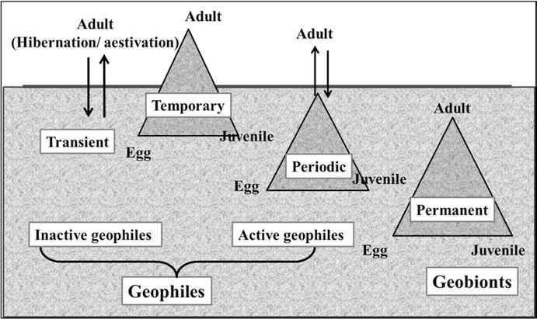
Figure 6 : Classification of Soil Arthropods on the basis of their presence in soil
3.3 ROLE OF BENEFICIAL ARTHROPODS IN FOREST ECOSYSTEM
- Acquire nutrients through the mycorrhiza
- Regulate the flow of nutrients
- Helps in organic matter breakdown
- Also modify structure of soil and influence availability of water to the plants
- Can modify the plant health conditions by the phenomenal action of pathogens and parasites.
- Due to the presence of microarthropods in the soil enhances the detrimental activity by about 23%[Figure7].
- The Soil of agroforestry system is rich and diverse with the presence of arthropods. Plant diversity, climate and land use are considered to be the most influential factors to enrich the soil micro-arthropods. A perfect balance can be then understood by the concept of Forest Stability but it is a mystical term and it works by keeping Homeostasis and Balance of nature as the Backbone. A stable ecosystem is the one which can remain in the closed equilibrium state. also in the term of abundance and number of the species.
- The Most important tool is the use of natural enemies for the management of newly introduced pests. Conservation of natural enemies is the main part which has to be considered in the effective management of the pest[13].
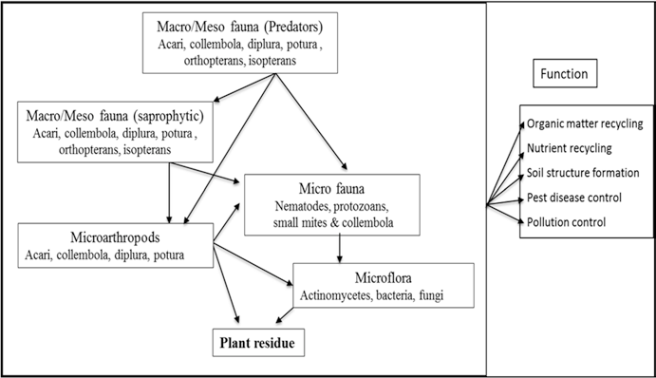
Figure 7: Micro Arthropods in Forest Ecosystem
Conclusion: -
The main factor which make the biological control as more successful in forest is the natural stability and the complexity. This biological management provides us a promising future in the field of research and technologies. This will also summarise the fact that no natural enemies is being harmed as a result the guardians of the systems remains unaffected and safe and it is such an approach that draw theory and practice all together. The natural enemies are to be conserved and the fact that the entomopathogens are to be preserved in order to maintain a proper balance. For agroforestry systems to remain viable and produce consistently, insect pests must be controlled. Complex interactions exist between the different agroforestry components, such as the biological (plant disease or insect) and physical (shade, microclimate). In addition to being overly detailed, biological connections are far more intricate than physical ones. Compared to agriculture or forestry systems, agroforestry offers a greater chance of arthropod variety and a lower population of pests. By altering the environment for pest and disease organisms and their natural enemies, well-designed agroforestry systems can significantly lower crop stress and increase crop tolerance to pests and diseases.
References :
- Altieri, M., & Nicholls, C. (2018). Biodiversity and pest management in agroecosystems. CRC press.
- Andow, D. A. (1991). Vegetational diversity arthropod population. Annu. rev. entomol, 36, 561-566.
- Classen, A., Peters, M. K., Ferger, S. W., Helbig-Bonitz, M., Schmack, J. M., Maassen, G., ... & Steffan-Dewenter, I. (2014). Complementary ecosystem services provided by pest predators and pollinators increase quantity and quality of coffee yields. Proceedings of the Royal Society B: Biological Sciences, 281(1779), 20133148.
- Girma, H., Rao, M. R., Day, R., & Ogol, C. K. P. O. (2006). Abundance of insect pests and their effects on biomass yields of single vs. multi-species planted fallows. Agroforestry systems, 68, 93-102.
- Harterreiten-Souza, E. S., Togni, P. H. B., Pires, C. S. S., &Sujii, E. R. (2014). The role of integrating agroforestry and vegetable planting in structuring communities of herbivorous insects and their natural enemies in the Neotropical region. Agroforestry Systems, 88, 205-219.
- ICRAF (1990) ICRAF strategy to the year 2000. ICRAF, Nairobi
- ISPM (2006) Glossary of phytosanitary terms. International Standard for Phytosanitary Measures No. 5. FAO, Rome. http://www.eppo.org
- Jose, S. (2009). Agroforestry for ecosystem services and environmental benefits: an overview (pp. 1-10). Springer, Dordrecht.
- Lalnunsangi, R., Paul, D., & Jha, L. K. (2014). Natural enemy complex of some agroforestry systems of Aizawl and their implications in insect pest management. Energy and Environment Research, 4(2), 29.
- Lundin, O., Smith, H. G., Rundlöf, M., &Bommarco, R. (2013). When ecosystem services interact: crop pollination benefits depend on the level of pest control. Proceedings of the Royal Society B: Biological Sciences, 280(1753), 20122243.
- Ramert, B., Lennartsson, M., & Davies, G. (2002). The use of mixed species cropping to manage pests and diseases–theory and practice. In Proceedings of the UK organic research 2002 Conference (pp. 207-210). Organic Centre Wales, Institute of Rural Studies, University of Wales Aberystwyth.
- Rao, M. R., Singh, M. P., & Day, R. (2000). Insect pest problems in tropical agroforestry systems: Contributory factors and strategies for management. Agroforestry Systems, 50, 243-277.
- Roy, S., Roy, M. M., Saxena, P., & Bano, R. (2017). Role of Entomology in Sustaining Agroforestry Productivity. Agroforestry: Anecdotal to Modern Science, 691-704.
- Tang, G. B., Song, B. Z., Zhao, L. L., Sang, X. S., Wan, H. H., Zhang, J., & Yao, Y. C. (2013). Repellent and attractive effects of herbs on insects in pear orchards intercropped with aromatic plants. Agroforestry Systems, 87, 273-285.
- Adhikari, S., &Menalled, F. D. (2020). Supporting beneficial insects for agricultural sustainability: The role of livestock-integrated organic and cover cropping to enhance ground beetle (Carabidae) communities. Agronomy, 10(8), 1210.
- Jankielsohn, A. (2023). Sustaining insect biodiversity in agricultural systems to ensure future food security. Frontiers in Conservation Science, 4, 1195512.
- Jankielsohn, A. (2018). The importance of insects in agricultural ecosystems. Advances in Entomology, 6(2), 62-73.
- Jarpla, M., Kumari, P., Pawar, P., Reddy, N. A., Bhargavi, C., Samreen, Aniket, & E, V. (2024). A Review on Role of Beneficial Insects in Sustainable Crop Production Systems. Journal of Experimental Agriculture International, 46(10), 687–699.
- T, C., Vakayil, S., R, V., S N, N., Khayum, A., K, C., K B, C. K., & Venkatesh, C. (2024). From Pollinators to Pests: The Dual Roles of Insects in Shaping Agricultural Landscapes. Journal of Scientific Research and Reports, 30(7), 647–663.
- Afroz, M. S., Ashraf, S. K., Rana, M. T., Ripta, S. K., Asha, S. B. R., Urmi, S. S. T., ... & Islam, K. K. (2025). Agroforestry: A Sustainable land-use practice for enhancing productivity and carbon sequestration in Madhupur Sal Forest, Bangladesh. Sustainability, 17(8), 3697.

