Evaluation of Abiotic Stress Tolerance and Compatibility With Other Biocontrol Agents of Native Isolates of Trichoderma spp. of Kasargod District

ABSTRACT

.
Aims: Evaluation of selected native Trichoderma spp. of Kasaragod district for abiotic stress tolerance and compatibility test
Study design: CRD
Place and Duration of Study: Department of Plant Pathology, College of Agriculture, Padannakkad, between November 2023 and November 2024.
Methodology: The selected native isolates of Trichoderma spp. (Tr-5, Tr-12, Tr-41, and Tr-43 (T. asperellum) and Tr-40 (T. lixii) were subjected to various abiotic stresses, namely low (4°C, 10°C and 15°C) and high (30°C, 45°C and 55°C) temperatures, salinity (0.5M, 1.5M and 2.5 M NaCl) and drought (10%, 30% and 40% PEG). The PDA was embedded with different NaCl and PEG concentrations to test the salinity and drought tolerance. A control was kept for all the treatments for comparison. After 4 days of inoculation (DAI), radial growth of Trichoderma spp in treatments and controls was recorded. The compatibility of these Trichoderma isolates was checked with the other bio-control agents viz., Pseudomonas fluorescens, Metarhizium anisopliae, Lecanicillium lecanii and Beauveria bassiana using the dual culture technique.
Results: In the temperature tolerance study, the selected isolates did not show any radial growth at 4°C, 10°C, 45°C, and 55°C.At 15°C, slight mycelial growth was observed, and the optimal range was found to be 30°C for good mycelial growth. The tolerance to salinity was up to 0.5M NaCl, but only in Tr-5 (0.83cm), Tr-12 (0.91), and Tr-40 (0.8) isolates, the mycelial growth was observed at 1.5M NaCl. At 10% PEG, the radial growth of isolates was on par with the control. Upon increasing concentration, radial growth of Trichoderma spp. was decreased/ absent along with sporulation. In the compatibility study, Trichoderma isolates were found to be compatible with P. fluorescens, M. anisopliae, L. lecanii and B. bassiana. But with fungal biocontrol agents, only Tr-40 showed incompatibility with M. anisopliae (66.67%), L. lecanii (33.58%)
Conclusion: In this study, all five native isolates of Trichoderma spp. Tr-5, Tr-12, Tr-40, Tr-41 and 43 showed high tolerance to abiotic stresses at an optimum range of temperature (30⁰C), NaCl (0.5M), and PEG (10%). The isolates of Trichoderma spp. were compatible with bacterial and fungal bio-control agents except Tr-40.

Keywords: Trichoderma spp., Bio-control agents, soil borne pathogens, abiotic stresses

1. INTRODUCTION

The farmers of Kasaragod district mostly rely on vegetable crops, especially solanaceous crops (Brinjal, tomato, chilli, amaranthus, etc.), which fulfil their basic style of food. Unfortunately, the crop is affected by numerous soil pathogens, which may seriously threaten the livelihood of farmers. By repeated application of the same chemical or unscientific use, most soil-borne pathogens (Pythium spp., Phytophthora spp., Rhizoctonia spp., Fusarium spp.) have started developing resistance. An alternate method is to be put forth for this problem. A natural, ecological solution to the issues brought on by conventional chemical techniques of plant protection is biological control, which involves using particular microbes that obstruct plant diseases and pests. Among the biocontrol agents, Trichoderma is one of the agents that has an opportunistic effect on most soil-borne pathogens (Kucuk et al., 2017). The competitive saprophytic ability of Trichoderma spp. overwhelms pathogens for nutrients and space (Leo Daniel et al., 2011). These species of Trichoderma produce many enzymes and volatile substances to suppress the growth of the pathogen by the mechanism of mycoparasitism. Moreover, they have the potential to improve plant growth. In this study, the native isolates of Trichoderma spp., which were already isolated and identified, were used to study their abiotic stress tolerance and check their compatibility with other biocontrol agents.

2. Materials and Methods
The Trichoderma isolates Tr-5, Tr-12, Tr-41, Tr-43 (T. asperellum) and Tr-40 (T. lixii), which were isolated from the soils of two different Agro-ecological units (11 and 15) of Kasargod district, were selected for the study of abiotic stress tolerance. The tolerance level of these isolates was compared with the KAU reference culture collected from the College of Agriculture, Padannakkad. These isolates were identified based on molecular characterization using ITS and RAPD markers.
In vitro evaluation of Trichoderma Isolates to abiotic stress tolerance
Evaluation of temperature tolerance: Isolates were subjected to different temperatures (4⁰C, 10⁰C, 15⁰C, 30⁰C,45⁰C and 55⁰C). A fungal disc measuring 5mm was placed in the center of a Petri plate containing PDA (potato dextrose agar), as mentioned by Leo Daniel et al. (2011) and kept in a BOD incubator, exposed to the required temperature and the control plate was also maintained by keeping it at room temperature (RT). Four days later, observations on the radial growth, pattern of growth, colour and texture of the colony and number of days for sporulation were recorded.
Evaluation of salinity and drought tolerance: The salinity tolerance of these isolates was studied at three different concentrations, viz., 0.5M, 1.5M and 2.5 M of NaCl. The sodium chloride (NaCl) was embedded in the prepared and autoclaved PDA media, according to the concentration and plated in Petri plate. After solidification, a 5mm fungal disc was placed at the center of each plate and incubated at room temperature (Zehra et al., 2016; Muthuvaduganathan et al., 2023). Polyethylene glycol (PEG 6000 Da) was used to check the tolerance level to drought, which will induce stress. This experiment was carried out with three different concentrations of PEG, viz., 10%, 30% and 40%. The prepared and autoclaved PDA media were embedded with varying concentrations of PEG and plated on a petri dish. Later, a 5mm fungal disc was placed at the center of the plate and incubated at room temperature. The control plates were also maintained for each experiment without adding NaCl and PEG. The observations were recorded as mentioned above.
Compatibility of Trichoderma isolates. with other bio-control agents:
The compatibility of the Trichoderma isolates. was checked with other popular bio-control agents. Cultures of bio-control agents viz., Pseudomonas fluorescens, Metarhizium anisopliae, Lecanicillium lecanii and Beauveria bassiana collected from the College of Agriculture, Padannakkad were used for this study.
Bacterial bio-control agent: The study examined the compatibility of Trichoderma isolates with P. fluorescens. The bacterial bio-control agent, Pseudomonas fluorescens was streaked onto the Kings B media. Later, 1 ml of bacterial suspension was prepared by inoculating a loopful of Pseudomonas fluorescens with 1 ml sterile water. A 5mm fungal disc of Trichoderma isolates was placed in the center of the plate containing PDA which was already seeded with 10µl of bacterial suspension and was further incubated at room temperature (Kumar et al., 2012). The control plate was maintained without inoculating P. fluorescens. The radial growth of Trichoderma spp. in the treatment and control plates was recorded.
Fungal bio-control agents: Compatibility of five native isolates of Trichoderma spp. was checked with the fungal bio-control agents viz., M. anisopliae, L. lecanii and B. bassiana using the dual culture technique (Kumar et al., 2012). The per cent compatibility was calculated using the following formula:
Per cent inhibition = (C-T/C *100), where C is the radial growth of Trichoderma spp. in control plate, and T is the radial growth of Trichoderma spp. in treatment plates
Per cent compatibility = 100 – per cent inhibition
Statistical analysis: The statistical analysis was done using the GRAPES software developed by Kerala Agricultural University.
3. results and discussion
The isolates of Trichoderma spp. have saprophytic ability and are thriving to withstand different abiotic stresses, such as temperatures, salinity, and drought. Low-temperatures at 4 ⁰C and 10 ⁰C, none of these five native isolates of Trichoderma spp. and KAU isolate showed radial growth of mycelium, but at 15 ⁰C, slight growth was observed (fig-1). The average growth per day in Tr-40 was high (0.8cm) compared to other isolates, followed by Tr-41, Tr-12, Tr-43 and Tr-5, where the least growth was seen in the KAU isolate (0.3cm). A similar study by Duzniewska (2004) showed that mycelial growth and sporulation were inhibited at 5 to 15 ⁰C. The temperature, 30⁰C, is found to be the optimum temperature for the mycelial growth of the Trichoderma isolates (Fig. 2).
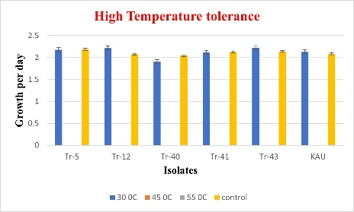
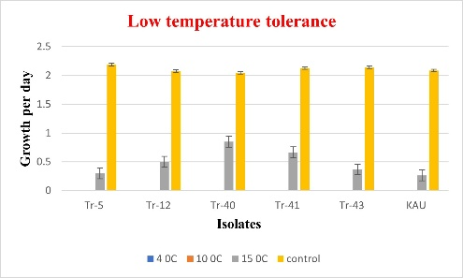
Figure 1,2: Tolerance of Trichoderma spp. to low (4⁰C,10⁰C and 15⁰C) and high (30⁰C, 45⁰C and 55⁰C) temperatures

A similar investigation was carried out by Singh and Kumar (2009) to determine the ideal temperature for the growth of Trichoderma spp. They discovered that most of the isolates of Trichoderma spp. thrived between 25°C and 30°C. According to Leo Daniel et al. (2011), at 30°C, T. viride performed good mycelial growth with 1.2x10⁸ cfu/g. The isolate of T. longibrachiatum exhibited good mycelial growth by showing a 70 mm colony diameter and sporulation at an optimum temperature of 30°C (Shahid et al., 2011). growth and sporulation of the fungus. Domingues et al., (2016) reported that Trichoderma isolates mycelial radial growth was not observed at 7⁰C. At low-temperature (15°C), the growth of the isolates of Trichoderma spp. was slow with detaining sporulation. However, between these temperatures, 25-35°C, two isolates, T. asperellum and T. hamatum, showed good growth and sporulation (Zehra et al., 2016). In this present study, at 30°C the Trichoderma spp. showed good mycelial growth with regular margins and exhibited sporulation within 2 to 3 days.

Sl. No | Isolate | Colony characteristics
Sl. No | Isolate | 15⁰C |  |  |  |  | 30⁰C
Sl. No | Isolate | Radial growth (cm) | Pattern of growth | Colour of the colony | Texture of the colony | Number of days for sporulation | Radial growth (cm) | Pattern of growth | Colour of the colony | Texture of the colony | Number of days for sporulation
1 | Tr-5 | 0.30^{d} | Circular with irregular margin | Light white | Very light fluffy | 0 | 2.176^{bc} | Circular with regular margin | Greenish white | Medium fluffy | 2
2 | Tr-12 | 0.50^{c} | Circular with irregular margin | Light white | Very light fluffy | 0 | 2.218^{ab} | Circular with regular margin | Greenish white | Medium fluffy | 2
3 | Tr-40 | 0.85ª | Circular with irregular margin | Light white | Light fluffy | 0 | 2.142^{cd} | Circular with regular margin | Yellowish white | Medium fluffy | 3
4 | Tr-41 | 0.66^{b} | Circular with irregular margin | Light white | Light fluffy | 0 | 2.118^{d} | Circular with regular margin | Greenish white | Medium fluffy | 2
5 | Tr-43 | 0.36^{cd} | Circular with irregular margin | Light white | Very light fluffy | 0 | 2.224ª | Circular with regular margin | Greenish white | Medium fluffy | 2
6 | KAU | 0.26^{d} | Circular with irregular margin | Light white | Very light fluffy | 0 | 2.168^{c} | Circular with regular margin | Greenish white | Medium fluffy | 2
CD (0.05) |  | 0.07 |  |  |  |  | 0.04
Table 1. Evaluation of native isolates of Trichoderma spp. for temperature tolerance at 15⁰C and 30⁰C P<0.05

The pattern of growth, texture and colour of the colony were mainly circular with regular margins, medium fluffy and greenish white at 30⁰C (Table 1). However, in Tr-40, the colour of the colony is yellowish-white. Moreover, at 45⁰C and 55⁰C, no isolates showed growth. Similarly, Kucuk (2017) observed that Trichoderma spp. waved good mycelial growth at 30⁰C and even at the high-temperature stress (45 ⁰C), the isolates T1, T3, T4, T15 and T17 proliferated the mycelial growth upon the stress. The time required for the sporulation was 2 DAI in all native isolates of Trichoderma spp. except Tr-40 which took 3 days for sporulation. No sporulation was observed at 4⁰C, 10⁰C,15⁰C,45⁰C, and 55⁰C in all the Trichoderma isolates.
In the study for salinity tolerance, the isolates showed good growth at 0.5M concentration of NaCl, which was almost on par with the control plates. The growth of isolates was found to be reduced at 1.5M concentration of NaCl. At that concentration, three isolates (Tr-5, Tr-12, and Tr-40) showed slight growth and no growth was shown by isolates (Tr-41, Tr-43, and KAU) whereas at a concentration of 2.5M NaCl, growth was completely absent.

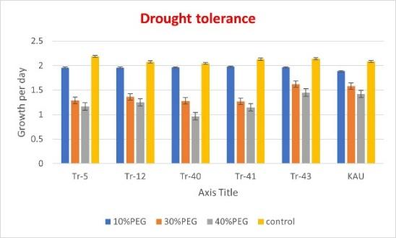
Figure 3,4: Evaluation of Trichoderma spp. for the tolerance of salinity and drought
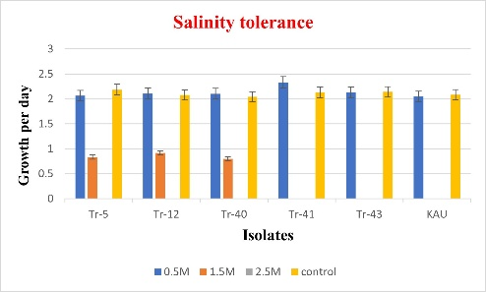
Table 2. Colony characteristics of Trichoderma spp. for salinity tolerance at 0.5M NaCl
Sl.no | Isolate | Colony characteristics
Sl.no | Isolate | 0.5 M NaCl
Sl.no | Isolate | Radial growth (cm)/day | Pattern of growth | Colour of the colony | Texture of the colony | Number of days for sporulation
1 | Tr-5 | 2.06^{b} | Circular with regular margin | Greenish white | Medium fluffy | 3
2 | Tr-12 | 2.11^{b} | Circular with regular margin | Greenish white | Medium fluffy | 3
3 | Tr-40 | 2.10^{b} | Circular with regular margin | Yellowish white | Medium fluffy | 3
4 | Tr-41 | 2.24ª | Circular with regular margin | Greenish white | Medium fluffy | 2
5 | Tr-43 | 2.13^{ab} | Circular with regular margin | Greenish white | Medium fluffy | 2
6 | KAU | 2.05^{b} | Circular with regular margin | Greenish white | Dense fluffy | 2
CD (0.05) |  | -

Table 3. Evaluation of Trichoderma spp. for salinity tolerance at 1.5 and 2.5 M NaCl (P=0.05)
Sl.no | Isolate | Colony characteristics
Sl.no | Isolate | 1.5 M NaCl |  |  |  |  | 2.5 M NaCl
Sl.no | Isolate | Radial growth (cm)/day | Pattern of growth | Colour of the colony | Texture of the colony | Number of days for sporulation | Radial growth (cm)/day | Pattern of growth | Colour of the colony | Texture of the colony | Number of days for sporulation
1 | Tr-5 | 0.83^{b} | Circular with irregular margin | Light white | Light fluffy | - | 0 | - | - | - | -
2 | Tr-12 | 0.91ª | Circular with irregular margin | Light white | Light fluffy | - | 0 | - | - | - | -
3 | Tr-40 | 0.80^{b} | Circular with irregular margin | Light yellow | Light fluffy | - | 0 | - | - | - | -
4 | Tr-41 | 0 | - | - | - | - | 0 | - | - | - | -
5 | Tr-43 | 0 | - | - | - | - | 0 | - | - | - | -
6 | KAU | 0 | - | - | - | - | 0 | - | - | - | -
CD (0.05) |  | 0.07 |  |  |  |  | -

The pattern of growth, texture and colour of the colony were mainly circular with regular margins, medium fluffy and greenish white at 0.5 M NaCl except in Tr-40 where the colour of the colony is yellowish-white (Table 2). The growth pattern was circular in three isolates, Tr-5, Tr-12, and Tr-40. No sporulation was observed at 1.5M and 2.5M concentrations of NaCl (Table 3 and Fig 3). The native isolates of Trichoderma sp. exhibited good mycelial growth at 70 mM NaCl, but at 350 mM, most of the isolates showed less mycelial growth (Kucuk., 2017). Under in vitro conditions T. harzianum (T103) isolate tolerated salinity at 1000 mM NaCl concentration with no sporulation (Mishra et al., 2016). In our study, the mycelial growth of Trichoderma spp. was highest at 0.5M NaCl and mycelial growth was utterly inhibited at 2.5M NaCl. At a concentration of 1.5M NaCl, the isolates Tr-5, Tr-12 and Tr-40 could exhibit slight mycelial growth.
For the study on drought tolerance, isolates of Trichoderma spp. were grown at three different concentrations of PEG viz., 10%, 30%, and 40%. Efficient mycelial growth was observed in Tr-40 (2.04 cm) among all the Trichoderma spp. at 10% PEG concentration which was almost on par with the control (Table 4). At the concentrations of 30% and 40% PEG, KAU culture showed 2.0 cm and 1.58 cm radial growth respectively (Table 5 and Fig. 4).

Table 4. Colony characteristics of Trichoderma spp. for drought tolerance at 10% PEG
Sl.no | Isolate | Colony characteristics
Sl.no | Isolate | 10 % PEG
Sl.no | Isolate | Radial growth (cm)/day | Pattern of growth | Colour of the colony | Texture of the colony | No of days for sporulation
1 | Tr-5 | 1.95^{ab} | Circular with regular margin | Greenish white | Medium fluffy | 2
2 | Tr-12 | 1.95^{ab} | Circular with regular margin | Greenish white | Medium fluffy | 2
3 | Tr-40 | 2.04ª | Circular with regular margin | Yellowish white | Medium fluffy | 3
4 | Tr-41 | 1.97^{ab} | Circular with regular margin | Greenish white | Medium fluffy | 2
5 | Tr-43 | 1.96^{ab} | Circular with regular margin | Greenish white | Medium fluffy | 2
6 | KAU | 1.88^{b} | Circular with regular margin | Greenish white | Medium fluffy | 2
CD (0.05) |  | -

At 10% PEG concentration, the growth pattern was circular with a regular margin, and the texture was medium fluffy. However, at 30% and 40% PEG, the growth pattern was irregular, and the texture was feeble. The sporulation was not affected with 10% PEG, but at 30 % and 40% PEG, the density of the sporulation was affected, and the period was three days for sporulation. According to Leo Daniel et al. (2011), the isolates showed tolerance to drought at 10%PEG and 20% PEG was 99% and 94.3% respectively and later, there was a gradual decrease in the growth of the isolates upon an increase in the concentration of PEG. Sporulation was abundant at 10% PEG concentration. However, it became sparse at 25% and 30% PEG concentrations, and at 35% PEG concentration, no sporulation was observed.

Table 5. Colony characteristics of Trichoderma spp. for drought tolerance at 30% and 40% PEG
Sl.no | Isolate | Colony characteristics
Sl.no | Isolate | 30 % PEG |  |  |  |  | 40% PEG
Sl.no | Isolate | Radial growth (cm)/day | Pattern of growth | Colour of the colony | Texture of the colony | No. of days for sporulation | Radial growth (cm)/day | Pattern of growth | Colour of the colony | Texture of the colony | No of days for sporulation
1 | Tr-5 | 1.29^{bc} | Circular with irregular margin | Greenish white | Medium fluffy | 2 | 1.16^{cd} | Circular with irregular margin | Light greenish white | Light fluffy | 3
2 | Tr-12 | 1.36^{b} | Circular with irregular margin | Greenish white | Medium fluffy | 2 | 1.25^{bc} | Circular with irregular margin | Light greenish white | Light fluffy | 3
3 | Tr-40 | 1.3^{bc} | Circular with irregular margin | Yellowish white | Light fluffy | 4 | 0.96^{d} | Circular with irregular margin | Light yellowish white | Very light fluffy | 0
4 | Tr-41 | 1.27^{c} | Circular with irregular margin | Greenish white | Medium fluffy | 2 | 1.23^{bc} | Circular with irregular margin | Light greenish white | Light fluffy | 3
5 | Tr-43 | 1.98ª | Circular with irregular margin | Greenish white | Medium fluffy | 2 | 1.42^{ab} | Circular with irregular margin | Light greenish white | Light fluffy | 2
6 | KAU | 2.0ª | Circular with irregular margin | Greenish white | Medium fluffy | 2 | 1.58ª | Circular with irregular margin | Light greenish white | Light fluffy | 2
CD (0.05) |  | 0.07 |  |  |  |  | 0.24

In the same way, Kucuk et al. (2017) reported that at 10% PEG, all isolates showed mycelial growth and also noted that an increase in PEG concentrations can decline the growth. They also observed that only T13 (68%) and T10 (37%) were identified as the most drought-resistant isolates. In the current study, at 10% PEG, all five native isolates exhibited good mycelial growth and sporulation. It is also observed that the strength of the mycelium of these isolates became feeble upon increasing the concentration of PEG.

Compatibility of Trichoderma isolates with bio-control agents
The average radial growth of the isolates in the compatibility study of native isolates of Trichoderma spp. with P. fluorescens was 8.9cm in Tr-5, Tr-12, KAU culture; and 8.8cm in the isolates, Tr-40, Tr-41 and Tr-43. The compatibility percentage of Tr-5 and Tr-12 isolates with P. fluorescens was 99.3%, followed by the KAU culture. All the isolates were found to be compatible with P. fluorescens (Table 6 and Fig. 5). A similar study was carried out on the compatibility between microbial pesticides (T. viride and P. fluorescens) by Nandini (2018). In their study, the radial growth of T. viride was 6.24 cm by recording 12.4 per cent inhibition. Seven days after inoculation, T. viride overgrew over P. fluorescens in the culture plate and it was concluded that T. viride and bacterial isolates were incompatible. Similarly, the bacterial biocontrol agent (PGPR strain), P. fluorescens, was reported to be compatible with T. harzianum (Th15 and Th16) due to the absence of an inhibition zone (Shobha, 2018).

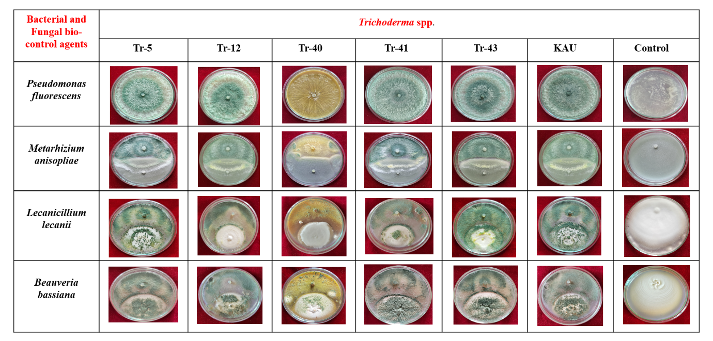
Figure -5: Compatibility of native isolates of Trichoderma spp. with bacterial and fungal biocontrol agents

Table 6. Compatibility of native isolates of Trichoderma spp. with P. fluorescens

Sl. No. | Isolates | Average Radial growth of the isolates in the treatment plates (cm) | Per cent inhibition over control | Per cent  Compatibility  with P. fluorescens
1 | Tr-5 | 8.93ª | 0.7 | 99.3ª
2 | Tr-12 | 8.93ª | 0.7 | 99.3ª
3 | Tr-40 | 8.83ª | 1.8 | 98.2ª
4 | Tr-41 | 8.86ª | 1.5 | 98.5ª
5 | Tr-43 | 8.86ª | 1.5 | 98.5ª
6 | KAU | 8.9ª | 1.1 | 98.9ª
7 | Control | 9 | - | 0
 | SE(d) | 0.43 | - | 0.47
 | SE(m) | 0.30 | - | 0.33
 | CD (0.05) | - | - | -

Table 7. Compatibility of native isolates of Trichoderma spp. with M. anisopliae and L. lecanii
Sl. no. | Isolate | Compatibility with M. anisopliae |  |  | Compatibility with L. lecanii
Sl. no. | Isolate | Average Radial growth of the Trichoderma spp. in the treatment plate (cm) | Per cent inhibition over control plate | Per cent compatibility over M. anisopliae | Average Radial growth of the Trichoderma spp. in the treatment plate (cm) | Per cent inhibition over control plate | Per cent compatibility over L. lecanii
1 | Tr-5 | 5.3^{ab} | 18.46 | 81.54^{ab} | 6.66ª | 1.33 | 98.76ª
2 | Tr-12 | 5.36^{ab} | 17.43 | 82.56^{ab} | 6.56^{ab} | 2.81 | 97.27^{ab}
3 | Tr-40 | 4.33^{c} | 33.32 | 66.67^{c} | 2.26^{c} | 66.51 | 33.58^{c}
4 | Tr-41 | 5.2^{b} | 19.98 | 80.00^{b} | 6.46^{b} | 4.29 | 95.79^{b}
5 | Tr-43 | 5.23^{ab} | 17.94 | 82.05^{ab} | 6.63ª | 1.78 | 98.27ª
6 | KAU | 5.67ª | 12.81 | 84.90ª | 6.63ª | 1.78 | 98.26ª
 | Control | 6.5 | 0 | 0 | 6.75 | - |  | 0
 | SE(d) | 0.12 | - | 1.91 | 0.07 | - |  | 1.10
 | SE(m) | 0.08 | - | 1.35 | 0.05 | - |  | 0.78
 | CD (0.05) | 0.25 | - | 4.18 | 1.55 | - |  | 2.40

The compatibility of isolates of Trichoderma spp. with other fungal bio-control agents viz., M. anisopliae, L. lecanii and B. bassiana was also checked. Here, the isolates of Trichoderma spp. have overgrown the cultures of M. anisopliae, L. lecanii and B. bassiana without interfering their growth and hence showed less per cent inhibition over the control (Table 7, 8 and Fig 5). The isolate, Tr-40 (T. lixii) showed antagonistic effect over the two fungal biocontrol agents M. anisopliae (33.32%) and L. lecanii (66.51%); hence Tr-40 is not found to be compatible with these two fungal bioagents. A similar study was carried out by Sumalatha et al. (2017), in which they reported that T. viride showed the highest per cent inhibition over V. lecanii and were reported as incompatible. Upamanya et al. (2020) observed the compatibility of entomopathogens (B. bassiana and M. anisopliae) with the isolates of Trichoderma spp. viz., T. harzianum and T. asperellum.
Table 8. Compatibility of native isolates of Trichoderma spp. with B. bassiana
Sl.  no. | Isolate | Average Radial growth of the Trichoderma spp. in the treatment plates (cm) | Per cent inhibition over control | Per cent compatibility with B. bassiana
1 | Tr-5 | 6.60ª | 2.22 | 97.77ª
2 | Tr-12 | 6.63ª | 1.78 | 98.26^{aa}
3 | Tr-40 | 6.63ª | 1.78 | 98.27ª
4 | Tr-41 | 6.63ª | 1.78 | 98.26ª
5 | Tr-43 | 6.56ª | 2.81 | 97.28ª
6 | KAU | 6.7ª | 0.74 | 99.25ª
 | Control | 6.75 | 0 | 0
 | SE(d) | 0.08 | - | 1.24
 | SE(m) | 0.05 | - | 0.87
 | CD (0.05) | - | - | -

4. Conclusion
In this study, all the five native isolates of Trichoderma spp. Tr-5, Tr-12, Tr-43 (T. asperellum) Tr-14, Tr-40 (T. lixii) showed high tolerance to abiotic stresses at an optimum range of temperature (30⁰C), NaCl (0.5M), and PEG (10%). The isolates of Trichoderma spp. were found to be compatible with fungal bio-control agents viz., Metarhizium anisopliae, Lecanicillium lecanii and Beauveria bassiana and bacterial bio-control agent, Pseudomonas fluorescens. Their ability to adapt to environments with various stress factors is a crucial evolutionary mechanism that enhances their effectiveness as biocontrol agents against plant pathogens. Further studies must be conducted to prove the biocontrol efficacy of these isolates to manage the soil-borne pathogens under in vivo conditions.

References

1. Domingues, M.V.P.F., Moura, K.E., Salomao, D., Elias, L.M. and Patricio, F.R.A. Effect of temperature on mycelial growth of Trichoderma, Sclerotinia minor and S. sclerotiorum, as well as on mycoparasitism. Summa phytopathologica, (2016);42(3): 222-227
2. Duzniewska, J. Effect of incubation temperature on development and biotic relations between Trichoderma spp. and pathogenic fungi. Acta Scientiarum Polonorum Agricultura, (2004);3(2): 257-262
3. Kumar, R.M., Rao, M.S., Gavaskar, J. and Sowmya, D.S., Evaluation of compatibility and effect of Trichoderma harzianum and Pseudomonas fluorescens against the disease complex of tomato. International Journal of Innovative Horticulture, (2012);1(2):135-143
4. I, C., In vitro antagonistic activity against fusarium species of local Trichoderma spp. isolates J. Biol. Environ. Sci., (2017);11(32): 67-74
5. Leo Daniel, A. E., Praveen Kumar, G., Desai, S., & Mir Hassan, A. S. K. In vitro characterisation of Trichoderma viride for abiotic stress tolerance and field evaluation against root rot disease in Vigna mungo L. J Biofertil Biopestici, (2011);2(3):1-5. doi:10.4172/2155-6202.1000111
6. Muthuvaduganathan, N., Peter, A. J., Thirumalai, S., & Maiti, S. Isolation of Trichoderma spp. from arid and semi-arid conditions and screening for its in vitro bio-efficacy and abiotic stress tolerance J. Mycopathol. Res. (2023);61(2): 217-226 doi. 10.57023/JMycR.61.2.2023.217
7. Mishra, N., Khan, S.S. and Sundari, S.K., Native isolate of Trichoderma, a biocontrol agent with unique stress tolerance properties. World Journal of Microbiology and Biotechnology, (2016);32: 1-23.
8. Nandini, B., Compatibility and virulence studies of microbial pesticides commonly used in Telangana, j. of entomology and Zoology studies., (2019); 7(1): 244-249
9. Shahid, M., Singh, A., Srivastava, M., Mishra, R. P., & Biswas, S. K. Effect of temperature, pH and media for growth and sporulation of Trichoderma longibrachiatum and self-life study in carrier-based formulations. Annals of Plant Protection Sciences, (2011);19(1):147-149
10. Singh, O.P. and Kumar, S. Trichoderma spp. Growth as influenced by Temperatures. Annals of Plant Protection Sciences, (2009);17(1): 261p
11. Sumalatha, J., Rahman, S.J., Rahman, S.M.A.S. and Prasad, R.D. Compatibility of entomopathogenic fungi Verticillium lecanii with other biopesticides in laboratory conditions. The Pharma Innovation Journal, (2017);6(9):264-266.
12.Shobha, M.S., 2018. Effect of Endophytic and plant growth promoting rhizobacteria against foot rot disease of Piper nigrum L. International Journal of Environment, Agriculture and Biotechnology, (2018);3(6):268282p.
13. Sharma, M., Idong, S., Sharma, R., & Singh, P. Isolation and Evaluation of Temperature-Tolerant Trichoderma. International Journal of Current Microbiology and Applied Sciences, (2020);9(3):1164-1171.https://doi.org/10.20546/ijcmas.2020.903.136
14. Upamanya GK, Bhattacharyya A, Dutta P. Consortia of entomopathogenic fungi and bio-control agents improve the agroecological conditions for brinjal cultivation of Assam. 3 Biotech. (2020);10(10):450.
15. Zehra, A., Dubey, M. K., Meena, M., & Upadhyay, R. S. Effect of different environmental conditions on growth and sporulation of some Trichoderma species. Journal of Environmental Biology, (2017);38(2): 197.

