Clinical Image

Corneal perforation after use of topical non-steroidal anti-inflammatory drugs

**Abstract**

We report the case of a 67-year-old with a type 2 diabetis on insulin therapy followed for moderete proliferative diabetic retinopathy undergoing panretinal photocoagulation ( PRP) who suffered from ocular redness and pain after application of Non-steroidal anti-inflammatory drugs (indomethacine ) post PRP.

Slit lamp examination, a corneal perforation was noted on the inferotemporal side of the right eye, with iris that seals the perforation

We performed an anterior segment optical coherence tomography (OCT) of the right eye revealed corneal perforation with iris plugging the perforation and re-epithelialization of the defect.

**Keywords** : optical coherence tomography, photocoagulation, corneal perforation, epithelial defects

**Introduction**

Non-steroidal anti-inflammatory drugs (NSAIDs) are commonly used to manage both acute and chronic pain and inflammation. Topical NSAIDs have proven effective in relieving ocular inflammation following cataract surgery, argon laser trabeculoplasty, and in the treatment of cystoid macular edema [1]

Despite the increasing use of topical NSAIDs in post-operative care, corneal complications due to these drugs remain rare. However, reported adverse effects include superficial punctate keratitis, subepithelial and stromal infiltrates, immune rings, persistent epithelial defects, and corneal melt. These ophthalmic conditions can lead to corneal perforation and potential vision loss. Such complications are most commonly observed in patients with a previously compromised ocular surface, such as those with glaucoma, severe dry eye, or those who have undergone keratoplasty. [2] [3]

**Conclusion**

Awareness of these serious side effects, along with their risk factors and the importance of prompt intervention—such as discontinuing NSAIDs—are essential for preventing long-term damage.

References  :

1. Flach AJ. Corneal melts associated with topically applied nonsteroidal anti-inflammatory drugs. Trans Am Ophthalmol Soc. 2001;99:205‑12.

2. Lin JC, Rapuano CJ, Laibson PR, Eagle RC Jr, Cohen EJ. Corneal Melting Associated With Use of Topical Nonsteroidal Anti-inflammatory Drugs After Ocular Surgery. Archives of Ophthalmology. 1 août 2000;118(8):1129‑32.

3. Rigas B, Huang W, Honkanen R. NSAID-induced corneal melt: Clinical importance, pathogenesis, and risk mitigation. Survey of Ophthalmology. 1 janv 2020;65(1):1‑11.

4. Nicoară SD, Damian I. Controversy of indomethacin eye drops in the treatment of rheumatoid arthritis-induced corneal ulceration: a case report. J Med Case Reports. 4 mars 2021;15(1):116.

Figures :

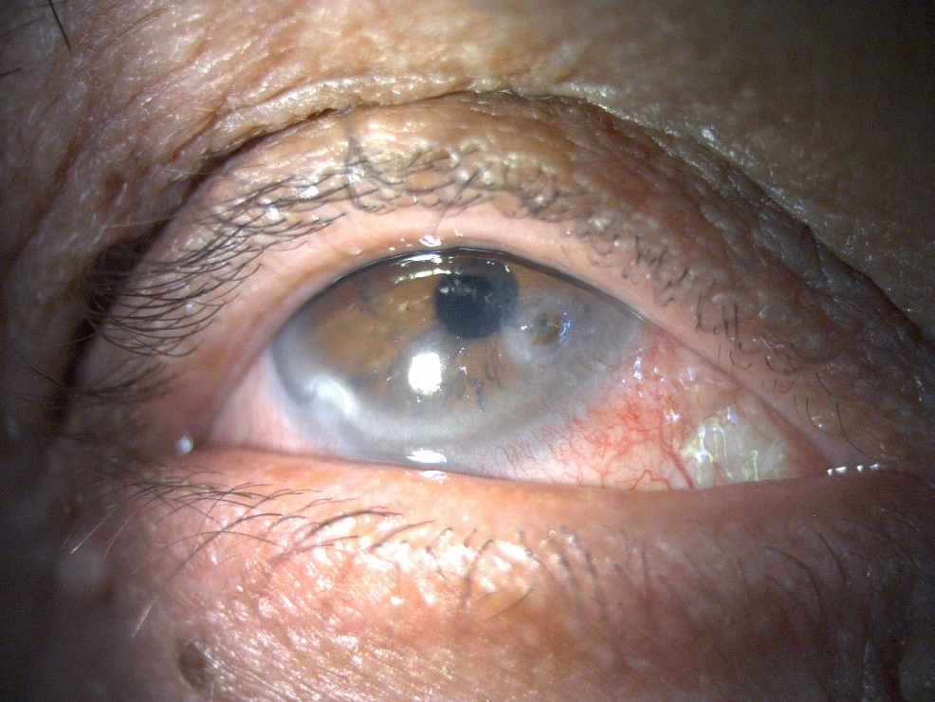 (a)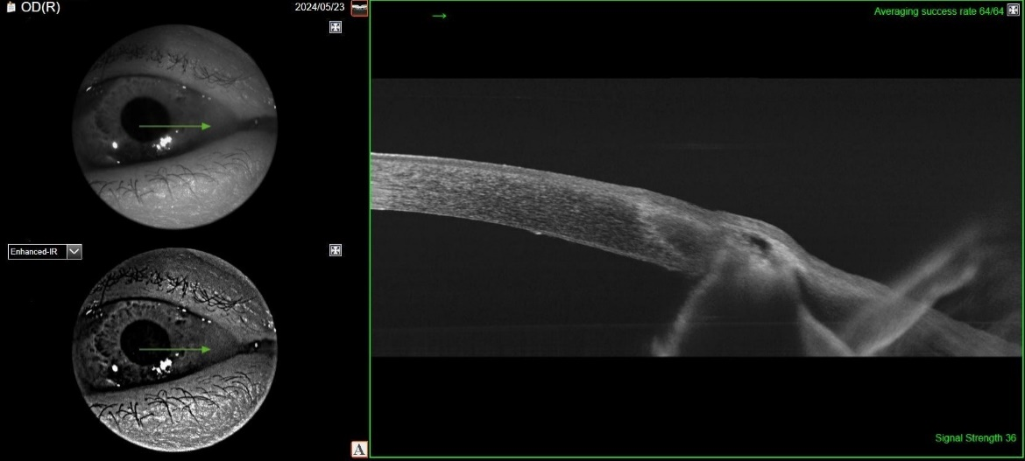 (b)

Figure 1 (a,b) : Corneal perforation sealed by iris at slit lamp and re-epithelialization of the defect at the OCT