Comparison for Climatic factors and Phytochemical analysis of Gymnema sylvestre R.Br in Davangere and Chitradurga District

**ABSTRACT**

*Gymnema sylvestre* R.Br. (Apocynaceae),is a woody shrub, found in the tropical and subtropical regions in India [1,2]. It is also known as “Madhunashini” in Kannada[3,4], literally meaning the “Sweet destroyer”[5,6].Phytochemical analysis of two different locally available plant parts was done in Methanol and petrolium ether extract.Phytochemicals are bioactive chemicals of plant. The most important bioactive constituents of plants are terpenoids,saponin,alkaloid,steroids,flavonoids,and phenolic compounds [7].

**KEYWORDS**

*Gymnema sylvestre*, Gymnemic acid,Extraction,Phytochemistry,Pharmacognosy,HPLC,Soil,macronutrients,

micronutrients.pH,EC.

**INTRODUCTION**

The Apocynaceae family of medicinal plants, *Gymnema sylvestre*, exists in tropical forests in China, India, and Australia [8].*Gymnema sylvestre* is associated to plenty of phytochemical varieties.

Gymnemic acids, which belong to the triterpene saponins, are among the phytochemicals that have the ability to reduce sweets.One official medication for the treatment of diabetes mellitus is *Gymnema sylvestre*.

The phytoconstituent's stimulatory impact on pancreatic cells and its potential to treat type I and type II diabetes have made it popular among researchers. Reports estimate that *G. sylvestre* is the second-best-selling medicinal herb worldwide.

The major phytoconstituent are gymnemic acid,gymnemagenin. In general most plants grow by absorbing nutrients from the soil. The quantity of nutrients that plants can get depends on the composition and pH of the soil. Fertility and soil stability are two characteristics of soil that are beneficial to plant growth [9]. There are two categories of nutrients found in soil: macronutrients and micronutrients.Primary and secondary nutrients are further subdivided from macronutrients.

Nitrogen, phosphorus, and potassium are examples of primary nutrients that plants utilize in significant amounts. Sulfur, calcium, and magnesium are secondary nutrients. Micronutrients, such as boron, copper, iron, magnesium, and zinc, are required in extremely minute levels [10].

Normal plant development and reproduction depend on having the proper amount of nutrients. One of the most important soil characteristics that controls nutrient availability is pH [11].

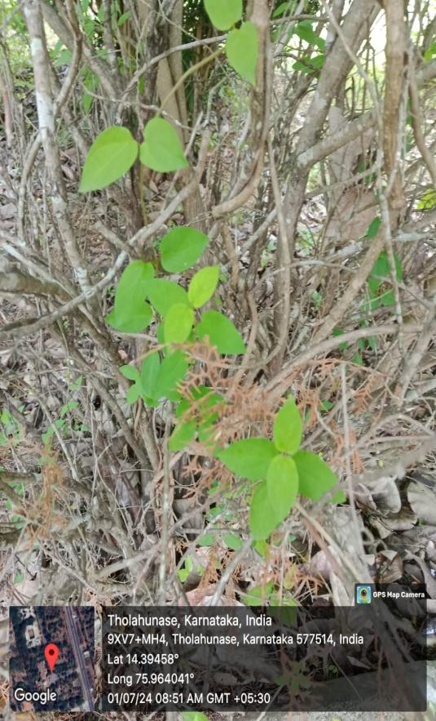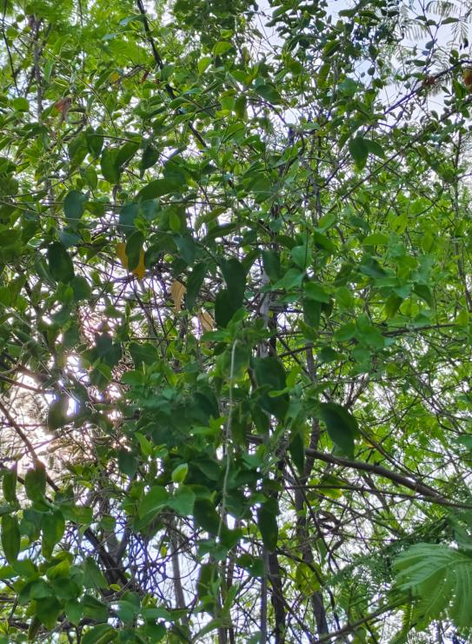

**Figure 1: Davangere sample Figure 2: Chitradurga sample**

**Chemical Components**

Gymnemic acid is an important component of Gymnema sylvestre.

The main active ingredients are a class of triterpenoid saponins of the oleanane type called gymnemic acid.

|  |  |
| --- | --- |
| Name | Gymnemic acid |
| Structure | gymnemic acid 1 |

**PHARMACOLOGICAL ACTIVITIES**

**Anti-diabetic activity**

The research has determined that *G. sylvestre* provides its anti-diabetic effects through a variety of mechanisms. These effects could be distinct or comparable to those caused by oral hypoglycemic medications [12].

Several components in *G. sylvestre* have been shown in experiments to be in charge of reducing the small intestine's absorption of glucose [13]. Glycogen synthesis, gluconeogenesis, glycolysis, glucose uptake, plasma protein reversal, and hemoglobin-lycosylation, for example, have all advanced in experimental research [14].

Additionally, *G. sylvestre* may improve glycemic control by inducing the release of insulin from the pancreatic islets of Langerhans [15]. The antidiabetic potential of gymnema extract is confirmed by its inhibitory effects on the activity of α-amylase, an enzyme involved in the hydrolysis of glucosides to glucose [16].

*G. sylvestre* generates proteins that interact with dipeptidyl peptidase to create complexes. thereby prevents the dipeptidyl peptidase enzyme from acting, which controls the actions of the glucose-dependent insulinotropic polypeptide [17,18].

|  |  |
| --- | --- |
| Chemical constituent | *Medicinal uses* |
| Gymnemic acid | Gymnema sylvestre lowers blood sugar, which aids in the management of diabetes.[19,20] |
| Gurmarin | Both internal and external organs, including the liver, pancreas, spleen, and skin, benefit from its ability to lessen edema.[21,22] |
| Gymnemagenol | anticancer properties[23] |
| Gymnemagenin | Anti-diabetic, Anti-viral.[24] |
| Gymnemasin | Inhibition of glucose absorption[25]. |
| Gymnemoside | Suppression of sugar[26]. |

**Table:1 List of Chemical components of *Gymnema sylvestre***

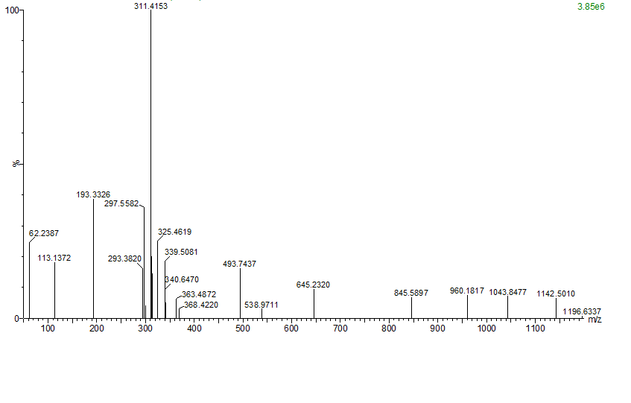

**Figure 3: LCMS Data for *Gymnema sylvestre***

**MATERIAL AND METHODS**

*Gymnema sylvestre plant are* collected from Davangere and Chitradurga District, in Karnataka june, 2024 and was authenticated with the help of various Floras [27].

**Plant Materials Processing**

Each ecotype's 50g of cleaned leaves has been dried in the shade, ground into powder, and then sealed in a ziplock bag for further use. Methanol (polar) and petroleum ether (non-polar) were used in Soxhlet extraction for continuous hot extraction of the dried powdered material.

**Gymnemic acid extraction by using Hoopers' method [28]**

**Step 1: Using petroleum ether for extraction**

An uncontaminated Soxhlet extraction apparatus was filled with 25 g of dry leaf powder.6 to 8 hours were needed for all the components to dissolve in the petroleum after 300 ml of petroleum ether (60 to 80°C) was added. A distillation device was used to gather and distill petroleum ether extract. Next, petroleum ether extracts with a net weight of 3.5 g were extracted.

**Step2: Using 90% methanol for extraction**

90% methanol was used to extract the dry powdered material. After adding 90% methanol, the extraction process was run for 12 hours to produce the full methanol-soluble extract. After distilling the methanol-soluble extract, 4 grams of the thick paste were subsequently obtained.

**Step3: Pure gymnemic acid extraction from methanol extract**

Pure gymnemic acid was isolated from methanol by dissolving 4 g of paste in 1% aqueous KOH solution while stirring constantly for 30 to 40 minutes.

After the filter was removed, the filtrate was treated with diluted HCl, which was applied gradually while being continuously stirred until the gymnemic acid precipitate was being seen.To get gymnemic acid, the precipitate was filtered and allowed to dry at room temperature.

**HPLC (High-Performance Liquid Chromatography) for quantification of Gymnemic acid**

The Chromatographic seperation of other phytochemical constituents of *Gymnema sylvestre* from Gymnemic acid quantitatively estimate, identifiying and separating using HPLC. After passing through a Sartorius RC-membrane syringe filter (0.20µm), 20µl of the leaf extracts were injected. The Shimadzu HPLC (Model SPD-10 UV-VIS Detector) and Supelcosil LC-18 C18 column (25 cm x 4.6 mm, 5µm) were used for the chromatography, and the mobile phase was made up of acetonitrile:water:acetic acid (50:50:0.1). Back pressure was 250 psi, the flow rate was 1.0 ml/min, and the chemicals were detected using a UV detector at 210 nm. Although 40 minutes was the overall run time, it is better to increase it to 60 minutes [29].

**Soil sampling**

Soil samples were collected from Davangere and Chitradurga district where *Gymnema sylvestre* plant were collected.

**Strategy of Sampling**

Dead furrow, old manure, and wet places need to be removed from the sample during the collection. Areas that were below or next to trees were avoided. A V-shaped hole approximately 20 to 25 cm deep was dugout, and soil from top to bottom that was 1.5 cm thick was gathered and put in a clean plastic bag. Two samples were taken from two different locations.

**Bulk sample reduction**

This was accomplished by dividing the 500g soil sample in half. The combined soil was quartered by separating it into four equal portions and then throwing away two of them. The process was repeated until the necessary little amount was obtained after the two quarters were mingled and once more separated into four parts, discarding two.

**Drying**

Drying was carried out in a shaded area with adequate circulation of air.

**Transportation and Storage of Samples**

After being marked with the location from where the sample was taken, the soil samples were packed in ziplock bags.

**DETERMINATION OF MACRONUTRIENTS**

**DETERMINATION OF AVAILABLE NITROGEN IN SOIL**

**~~INTRODUCTION:~~**

The majority of the nitrogen (N) in the soil was found in organic matter. Microbial strategies in the soil solution eventually convert organic N into ammonical (NH₄⁺), nitrite (NO¯₂), and nitrate (NO¯₃) -N. Since organic nitrogen cannot be absorbed by plants, it is of very little service to them in and of itself. Therefore, an estimation of the various kinds of accessible or mineralized N is required. Together, NO₃-N and NO₂-N barely make up more than 1% of the total N in typical soil.

Organic carbon is typically employed in soil testing labs to determine the amount of accessible nitrogen. A portion of the total nitrogen in the soil that has been transformed into forms that plants may use is referred to as available nitrogen. On average, this barely makes about 0.5% to 2.5% of the total nitrogen in a soil at any given time. The available N in soils is determined using the following techniques [30].

**(Subbiah and Asija, 1956) Alkaline Potassium Permanganate (KMnO4) Method**

**Principle :**

A specific weight of soil that has been treated with too much alkaline KMnO₄. In an alkaline medium, KMnO₄ acts as an oxidizing agent. The nascent oxygen released by KMnO₄ in the presence of NaOH oxidizes the organic matter in the soil, and the ammonia that is released is distilled and absorbed in a known volume of standard boric acid mixed indicator solution. This is titrated against a standard acid in excess. This method's predicted N is taken into consideration as potentially available N.

**Procedure:**

Fill an 800 ml dry Kjeldahl flask with 10g of dirt. Pour in 10 milliliters of purified water.   
To avoid bumping and frothing, add a few glass beads and 1 milliliter of liquid paraffin. Fill the Kjeldahl flask with 100 ml of each of the 2.5% NaOH solution and 0.32% KMnO₄ solution, and then immediately fit it into the distillation apparatus. In a 250 ml conical flask, pipette out 20 ml of the boric acid mixed indicator solution, then dip the delivery tube's end into it. The contents should be steadily distilled, and the released NH₃ should be collected in a conical flask with mixed indicator and H₃BO₃.

The pinkish color changes to bluish green as NH₃ is absorbed. Distill until approximately 100 milliliters of distillate are obtained. The ammonia distillation process is finished if the color of the red litmus paper does not change. To restore the original pink color, titrate the distillate against a standard acid (0.05 N H₂SO₄).

**DETERMINATION OF AVAILBLE PHOSPHORUS IN NEUTRAL, ALKALINE AND CALCAREOUS SOILS**

**~~INTRODUCTION~~**

The inorganic form of phosphorus found in soil solutions, which is nearly solely "Orthophosphate," is referred to as accessible phosphorus. There are various types and combinations of this orthophosphate.

Plants may only be able to use only a small percentage of the total amount provided, which is directly relevant when determining the "P" fertility level. Heterogeneous equilibria control the concentration of phosphate in solution [31].

P adsorbed in solid phase ⥨ P in soil solution $⥨$ P precipitated

**Methods of Determination :**

Olsen’s method (1954) has been found widely applicable for neutral, alkaline and calcareous soils.

**~~A)~~Extracting:**

**Principle :**

0.5 M sodium bicarbonate (pH 8.5) is used to shake the soil. Ca-bound P is released when the HCO₃¯ion precipitates Ca as CaCO₃ and inhibits the activity of Ca in soils. Dispersed organic matter in soil is absorbed by activated P-free charcoal (Darko-G-60), which also renders the filtrate colorless.

Ca₃(PO₄)₂ + 6 NaHCO₃→3 CaCO₃ + 2H₃PO₄ + 3Na₂CO₃.(0.5).

1. **Methodology for estimating solution P [Colour Development]:**

**Principle :**

A heteropoly phosphomolybdate compound is created when released phosphate in solution interacts with acidified ammonium molybdate. Stannous chloride further reduces this complex, which is initially yellow in color, to produce a partially reduced bluish-colored solution. The amount of P present in the solution has a direct correlation with the intensity of the blue color that forms.

**Procedure :**

1. **Extraction :**

A heteropoly phosphomolybdate compound is created when released phosphate in solution integrates with acidified ammonium molybdate. Stannous chloride further reduces this complex, which is initially yellow in color, to produce a partially reduced bluish-colored solution. The amount of P present in the solution has a direct correlation with the intensity of the blue color that forms.

1. **Colour development :**

5 ml of the soil extract and 5 ml of ammonium molybdate should be pipetted into a 25 ml or 50 ml volumetric flask. flasks Give SnCl₂ a gentle shake, let it stand for 10 minutes, and then dilute it to 40 milliliters. Pour in 0.5 or 1 milliliter of SnCl₂ working solution, then top it off with purified water.

**Identifying the amount of potassium present in the soil**

**~~INTRODUCTION~~**

The range of a soil's total potassium (K) level is 0.05 to 2.5%. 90–98% of the total K is in the form of minerals (lattice K), 1–10% is fixed or non-exchangeable, and 1-2 percent is exchangeable plus water soluble. On average, exchangeable K accounts for 1-3% of the total cation exchange capacity and 2-15% of the sum of exchangeable bases. The plant is best suited for both exchangeable and water-soluble K. According to a study on plant response correlation, K extracted by this extractant is regarded as a good indicator of K availability in the majority of soils. Of the total K, 92 to 98% is generally unavailable, 1 to 10% is slowly available, and less than 1% is readily available.

**Principle :**

This method is based on the equilibrium of soils with an exchanging cation made of the neutral normal NH₄OAC solution in a specific soil. During equilibrium, the ammonium ions in the solution exchange places with the absorbed K ions or easily exchangeable K in the soil.

**Procedure:**

Ten grams of soil should be transferred to a 250 ml conical flask. Pour in 50 milliliters of standard, neutral ammonium acetate. After five minutes of shaking on an electric shaker, strain through Whatman no. 40 filter paper. Add another 50 ml of ammonium acetate to the soil to leach it, then use NH₄OAC to get the amount up to 100 ml. Use NH₄OAC solution to dilution-appropriately feed NH₄OAC soil extracts to the flame photometer.Find the sample reading that indicates the K concentrations in the NH₄OAC extract on the standard curve.

**DETERMINATION OF AVAILABLE CALCIUM IN SOIL (SECONDARY NUTRIENTS)**

One of the fundamentally important components of plant cell walls is calcium. maintains the plant's strength and the regular movement and retention of other components. Furthermore, the it reduces the effects of organic acids and alkali salts in a plant [18].

For the preparation of a calcium standard stock solution (1000 mg/l), 2.4973 g of dry CaCO₃ was dissolved in 200 ml of distilled water adding 5 ml of strong HCl. Afterwards heating to remove CO₂, the solution was cooled to a volume of 1000 milliliters. To create working standards with concentrations varying from 1 to 100 mg/l, the stock was diluted.

**DETERMINATION OF MICRONUTRIENTS**

**Analysis of Copper Determination**

0.3930 grams of CuSO₄.5H₂O had been dissolved in distilled water to generate a stock solution of Cu standard (100 mg/l), that was subsequently diluted to 1000 milliliters. For obtaining a working range of 0-5.0 mg/l, an intermediate of 10 mg/l was made and then further diluted.

**Analysis of Iron Determination**

By dissolving 0.1 g of iron with 10 ml of warmed 10% H₂SO₄, a stock solution of Fe standard was prepared. It was diluted to 1000ml once it was cooled. The working range of 0–20 mg/l was achieved by diluting the stock solution[32].

**SOIL REACTION DETERMINATION (Soil pH)**

**~~INTRODUCTION~~**

The most significant chemical feature affecting a variety of soil physical and chemical characteristics is soil response. pH is used to measure soil response.The degree of acidity, alkalinity, or neutrality of a solution is indicated by the numbers on the pH scale. Sorenson (1909) coined the word pH, which is the negative logarithm of the hydrogen ion concentration in grams per liter. Pouvior hydrogene, which translates to "power of hydrogen," is the French word from which pH is derived.

pH= -log(H+)

Or, pH = -log a (H+)

pH value ranges 0-14, where pH 0 represents the highest degree of acidity and 14 represents the highest degree of alkalinity and neutrality is represented by pH 7.00 i.e., H+ ion concentration is 1 x 10^-7 gms/litre.

**Principle :**

The soil pH is measured by glass electrode. The glass electrode employs glass membrane. Across the glass membrane develops electric potential that is in proportion to the difference in pH of 0.1 M HCl filled inside the glass bulb (Ah¹⁺) and the pH of soil water suspension outside the glass bulb(Ah²⁺). The pH dial is calibrated to the potential difference in relation to soil pH.

**Procedure:**

1.Fill a 100 ml beaker with a 20 g soil sample. Pour in 40 milliliters of purified water.For half an hour, stir the suspension sporadically.Use a pH meter to record the pH.

**DETERMINATION OF TOTAL SOLUBLE SALTS (ELECTRICAL CONDUCTIVITY [ EC ] )**

Soils contain varying amounts of water soluble salts and differ in their total salt content. The water soluble salts in soils consists of various cations and anions and the predominant cations are Na⁺ ,K⁺, Ca⁺⁺, Mg⁺⁺,H⁺ and Al⁺⁺⁺ and the anions are CO₃⁼, HCO¯₃, Cl¯,So⁼₄.Small quantities of NO¯₃, PO⁼₄and boron also occur in soils. These soluble salts when present in optimum concentration serve as nutrients to the growing plants, but in excessive amounts are harmful to plant growth.High salt content in soil solution leads to exosmosis and plasmolysis leading to inhibition of water and nutrient uptake by plant roots. Some ions like Cl¯ ,Na⁺,B and fluorine are toxic to plants.Based on the TSS content and crop tolerance to salinity ,the soils are classified as follows.

**Procedure**

Fill a 100 ml beaker with 20 g of soil. Stir intermittently for 30 minutes after adding 50ml of purified water. Give the suspension an hour to settle. Using an EC bridge, determine the EC in the supernatant solution. Measure the EC in the filtrate or leachate after filtering the suspension using filter paper if the supernatant solution is opaque.

**RAINFALL**

**~~Introduction~~** ~~:~~

One of the most significant variables influencing soil fertility and rain-fed plant productivity is rainfall. Rainfall is one of the many distinct climatic factors that affect plant growth. Water is necessary for the maintenance of physiological and chemical processes within plants, and its availability is often a limiting factor in plant development.

**TEMPERATURE**

Throughout their life cycle, plants are subjected to a broad range of temperatures, thus they must constantly adjust. daily and seasonal variations in temperature, as well as variations brought on by climate change. There are a number of physiological, biochemical, morphological, and developmental reactions to rising temperatures that enable plants to counteract the detrimental effects of rising global temperatures.

**Results And Discussion**

The methods used to extract gymnemic acid were the primary focus of the research done on this plant. Gymnemic acid was detected via HPLC. The extractions were performed using several solvent systems, such as petroleum ether and methanol, which were extracted in a Soxhlet apparatus using continuous hot extraction. Gymnemic acid will be extracted using 90% methanol, which will produce the highest yield of the two solvents tested. Table 2 shows the predicted yields of gymnemic acid from the two ecotypes.

**Table: 2:Gymnema sylvestre ecotypes are gathered from various regions of Karnataka, and the percentage of Gymnemic acid is determined.**

|  |  |  |  |
| --- | --- | --- | --- |
| **SL. NO.** | **Name of the ecotype** | **Place of collection** | **% of Gymnemic acid** |
| 1. | DAVANGERE | Davangere university campus | 0.02 |
| 2. | CHITRADURGA | Jogimatti | 0.26 |

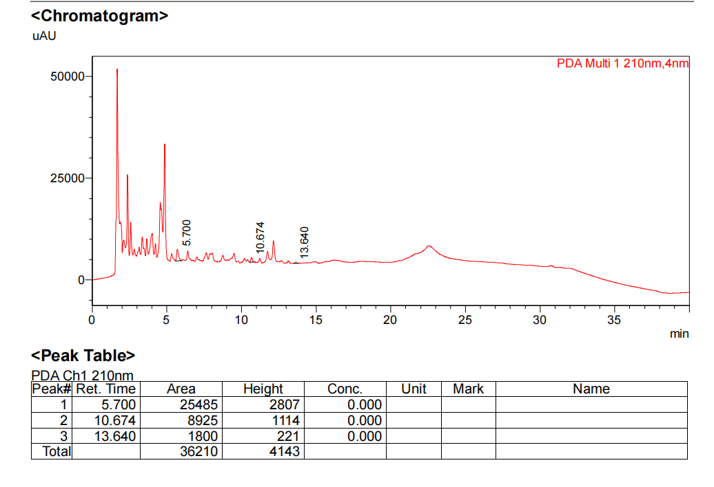

**Figure 4:HPLC Chromatogram for Davangere District**

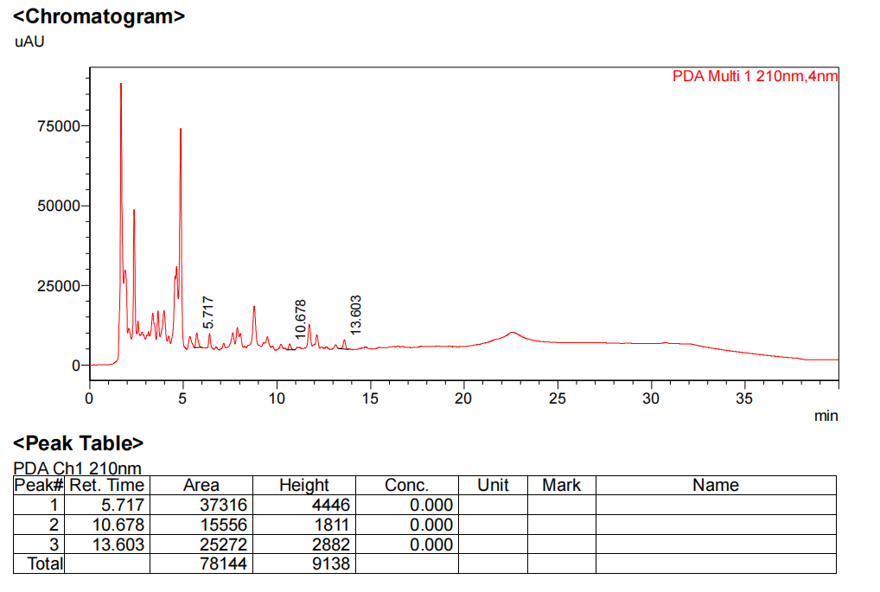

**Figure 5:HPLC Chromatogram for Chitradurga District**

The active component samples utilized in this investigation were taken from dried leaves and subjected to HPLC analysis (Shimizub et al., 1997). G. sylvestre extract samples are shown in an HPLC chromatogram (Figure 4,5).

1. *Gymnema sylvestre* R.Br. (Davangere) concentrations of Gymnemic acids: 1.47% (Figure 4).
2. *Gymnema sylvestre* (Chitradurga) concentrations of Gymnemic acids: 3.29% (Figure 5).

The total extract of active ingredients from the *G. sylvestre* leaf sample was eluted using HPLC in this investigation.

Climatic data (Soil,rainfall,temperature) also play very important role for growing plant and quantity of secondary metabolites. A significant number of plants grow through absorbing in nutrients from the soil. The qualities of the soil determine their abilities to do this.

The quantity of soil nutrients are listed in the data table below.

**Table:3 Measurements of macro and micronutrients,pH,EC from soil sample**

|  |  |  |  |  |  |  |  |  |  |
| --- | --- | --- | --- | --- | --- | --- | --- | --- | --- |
| **SL.NO.** | **PLACE** | **Na**  **(ppm)** | **P₂O₅**  **(ppm)** | **K**  **(ppm)** | **Ca**  **(ppm)** | **Cu**  **(ppm)** | **Fe**  **(ppm)** | **pH** | **EC**  **(ds/m)** |
| **1.** | **DAVANGERE** | **62** | **5** | **227** | **1180** | **0.9** | **1.7** | **8.4** | **0.17** |
| **2.** | **CHITRADURGA** | **73** | **14** | **272** | **2177** | **1.8** | **14** | **7.2** | **1.12** |

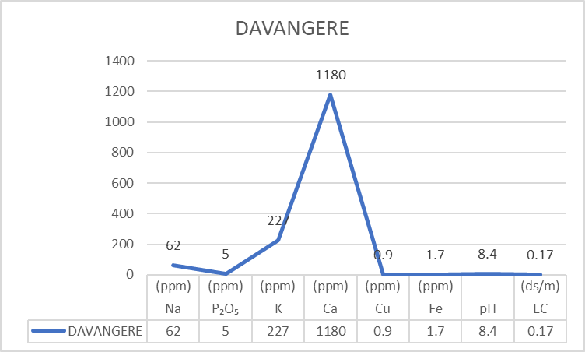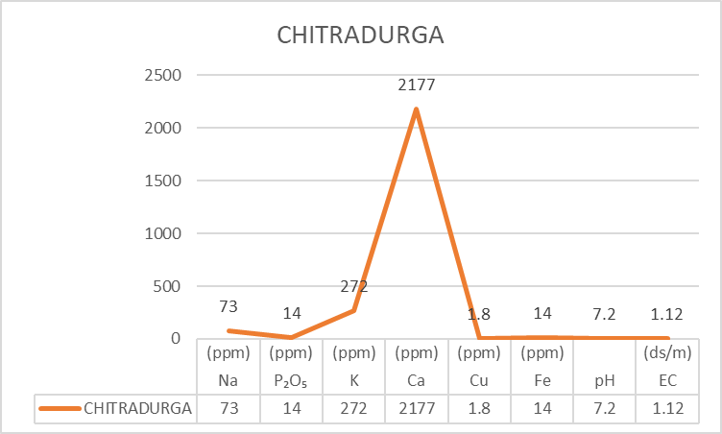

Figure 6:Soil pH in Davangere Figure 7:Soil pH in Chitradurga

Table 3: It is abundantly recognized that potassium, phosphorus, and nitrogen are essential nutrients.

The availability of these three nutrients, which are the main macronutrients, are essential for appropriate plant development.

All samples had sufficient amounts of nitrogen, phosphorus, and potassium, and some even above the necessary limits. In every soil sample, calcium was the most prevalent macronutrient.

In comparison with macronutrients, micronutrients are trace elements that get utilized in less quantities. The lower concentration values from all the samples, as indicated in Table 3, in contrast to the high levels of the macronutrients, provide proof of this. According to Table 3, iron was the most abundant micronutrient while copper was the least.   
It is recommended that pH levels be between 7.2 and 8.4 for beneficial plant growth.

Every soil sample was both alkaline and acidic.

Davangere having the highest pH (8.4), even though Chitradurga recorded a neutral pH (7.2).

**Table: 4 Climatic data collection from Davangere and Chitradurga District**

|  |  |  |  |  |  |
| --- | --- | --- | --- | --- | --- |
| SL.NO. | **Place name** | **Latitude and longitude** | **Altitude**  **(mts)** | **Rainfall**  **(mm)** | **Temperature(℃)** |
| **1.** | **Davangere** | **14º46'47"N 75º92'33"E** | **602.5** | **659** | **30** |
| **2.** | **Chitradurga** | **14º23'10"N 76º38'63"E** | **1159** | **540** | **31** |

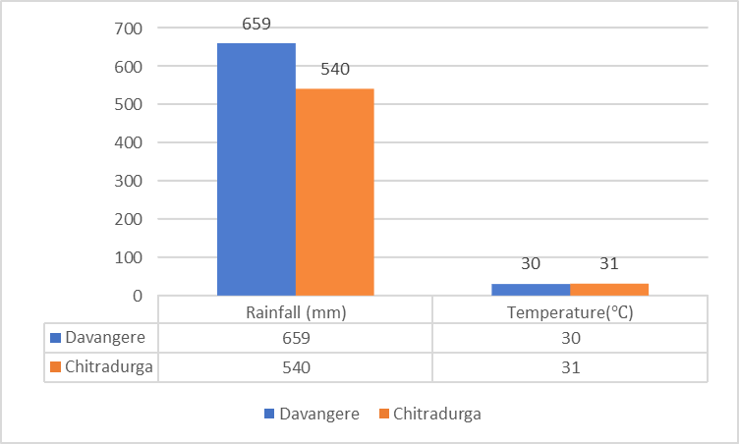

Figure 8:Temperature data collection from Davangere and Chitradurga District

Temperature and rainfall have a significant impact on the development of secondary metabolites and plant growth. Secendary metabolites are more susceptible to moderate temperatures and rainfall.

**CONCLUSION**

Based on the current study's findings, it was determined that the maximum yield of gymnemic acid was obtained by using 90% methanol in a continuous hot extraction process in a Soxhlet apparatus. With HPLC, the resulting gymnemic acid can be further identified. Gymnemic acid analysis and the standardization of herbal medications can both benefit from the accuracy, precision, and rapidity of HPLC procedures.The study clearly shows the quantity of Gymnemic acid is varied from place to place, it is due to changes in climatic as well as edaphic factors that indicated in the based table 2. on the above results we concluded that the *Gymnema sylvestre* grows well in moderate rainfall (540mm) and moderate temperature (31º) and Macronutrients play a very important role in plant growth and development. Based on the above study the Chitradurga sample shows potential than Davangere sample.

concentration of every nutrient under investigation, both macro and micro, within the range needed for healthy plant growth.

**REFERENCES**

Ankit Saneja, Chetan Sharma, K. R. Aneja, Rakesh Pahwa (2010). Gymnema sylvestre (Gurmar): A Review . ~~2010~~;2(1):275-281.

Farzana Khan, Md . Moklesur Rahaman Sarkar, Long Chiau Ming, Isa Naina Mohamed, Chao Zhao, Bassem Y. Sheikh, Hiew Fei Tsong and Mohammad A. Rashid (2019). Comprehensive Review on Phytochemicals,Pharmacological and Clinical Potentials of Gymnema sylvestre.~~2019~~:1-41.

Prajawal E.R., Girija K., Lakshman K. and Vinutha Bhat, Gymnema sylvestre R.Br. (2018). A Comprehensive Review on phytochemical and analytical study. ~~2018~~:136-143.

1. Dr. B. K. Prashant, M.D.(Ayu), PhD., Gudmar Gymnema sylvestre Benefits, Remedies, Research, Side Effects.
2. Tahira Anjum, Dr. Ziaul Hasan, Gymnema sylvestre plant used by peoples of Vidisha District for the Treatment of Diabetes. 2013; 2-98.
3. Ankit Saneja , Chetan Sharma, K. R. Aneja, Rakesh Pahwa, Gymnema sylvestre (Gurmar): A Review. 2010;2(1): 275-281.
4. Bone K. Official home page of Gymnema: A key herb in the management of diabetes.

<https://www.townsendletter.com,22july,2014.>

8.Stocklin, W. (1969) Chemistry and physiological properties of gymnemic acid, the antisaccharine principle of the leaves of Gymnema sylvestre. J. Agric. Food chem.17: 704-708.

9.Thomas et al, 1967

10. O.B Harry and N.C Brady, The Nature and properties of soils; 7th ed 1969, pp 20-33.

11. R.I. Donahue, R. W. Miller and J. C. Shickjuna, Introduction to soil and plant growth, 5th ed, Library of Congress, New York, 1983,pp23

12.Leach, M. J. (2007). Gymnema sylvestre for diabetes mellitus: a systematic review. The Journal of Alternative and Complementary Medicine, 13(9), 977- 983

13.Porchezhian, E., &Dobriyal, R. M. (2003). An overview on the advances of Gymnema sylvestre: chemistry, pharmacology and patents. Die PharmazieAn International Journal of Pharmaceutical Sciences, 58(1), 5-12

14. Shanmugasundaram, E. R. B., Venkatasubrahmanyam, M., Vijendran, N., &Shanmugasundaram, K. R. (1988). Effect of an isolate from Gymnema sylvestre, R. Br. in the control of diabetes mellitus and the associated pathological changes. Ancient science of life, 7(3-4), 183.

15. Baskaran, K., Ahamath, B. K., Shanmugasundaram, K. R., &Shanmugasundaram, E. R. B. (1990). Antidiabetic effect of a leaf extract from Gymnema sylvestre in non-insulin-dependent diabetes mellituspatients. Journal of ethnopharmacology, 30(3), 295- 305.

16. Ramkumar, K. M., Thayumanavan, B., Palvannan, T., &Rajaguru, P. (2010). Inhibitory effect of GymnemaMontanum leaves on α-glucosidase activity and α-amylase activity and their relationship with polyphenolic content. Medicinal Chemistry Research, 19, 948-961.

17. Antonyan, A., De, A., Vitali, L. A., Pettinari, R., Marchetti, F., Gigliobianco, M. R., ... &Lupidi, G. (2014). Evaluation of (arene) Ru (II) complexes of curcumin as inhibitors of dipeptidyl peptidase IV. Biochimie, 99, 146-152.

18. Matteucci, E., &Giampietro, O. (2009). Dipeptidyl peptidase-4 (CD26): knowing the function before inhibiting the enzyme. Current medicinal chemistry, 16(23), 2943-2951.

19. Singh, V. K., Umar, S., Ansari, S. A., & Iqbal, M. (2008). Gymnema sylvestre for diabetics. Journal of herbs, spices & medicinal plants, 14(1-2), 88-106.

[20]. Patel, K., Gadewar, M., & Tripathi, R. (2012). Pharmacological and analytical aspects of gymnemic acid: a concise report. Asian Pacific Journal of Tropical Disease, 2(5), 414-416.

21.Tiwari, P., Mishra, B. N., & Sangwan, N. S. (2014). Phytochemical and pharmacological properties of Gymnema sylvestre: an important medicinal plant. BioMed research international, 2014.

22. Kamei, K., Takano, R., Miyasaka, A., Imoto, T., &Hara, S. (1992). Amino acid sequence of sweet-tastesuppressing peptide (gurmarin) from the leaves of Gymnema sylvestre. The Journal of Biochemistry, 111(1), 109-112.

23. Di Fabio, G., Romanucci, V., De Marco, A., &Zarrelli, A. (2014). Triterpenoids from Gymnema sylvestre and their pharmacological activities. Molecules, 19(8), 10956-10981

24. Murakami, N., Murakami, T., Kadoya, M., Matsuda, H., Yamahara, J., &Yoshikawa, M. (1996). New hypoglycaemic constituents in" Gymnemic acid" from Gymnema sylvestre. Chemical and pharmaceutical bulletin, 44(2), 469-471

25. Sahu, N. P., Mahato, S. B., Sarkar, S. K., & Poddar, G. (1996). Triterpenoid saponins from Gymnema sylvestre. Phytochemistry, 41(4), 1181-1185.

26.Masayuki Y, Toshiyuki, M.; Hisashi, M. (1997). Structures of new triterpene glycosides,gymnemasides C, D, E and F from the leaves of Gymnema glycosides on glucose uptake in rat small intestinal fragments. Chem. Pharm. Bull. 45:2034-2038.

27.Gamble J.S.1991. Flora of the Presidency of Madras.Reprinted Edition , Vol I-III,Bishen singh Mahendra pal Singh, Dehra Dun

28. Hooper, D. (1887). Isolation and antiviral activity of gymnemic acid. Pharm. J. Trans. 17:867-868.

29. Imoto, T.,Miyasaka, A.,Ishima, R. and Akasaka, K.(1991) A novel peptide isolated from the leaves of Gymnema sylvestre. Characterisation and its suppressive effect on the neural responses to sweet taste stimuli in the rat. Comp. Biochem. Physiol. 100a: 309-314.

30.S. E. Allen chemical analysis of Ecological material . Blackwell Scientific publication. Second Edition, 1999, pp 119-155

31.Thomas et al, 1967

32.O.B Harry and N.C Brady , the nature and properties of soils; 7th ed 1969,pp 20-33.